Supporting Information
Asymmetric Surface Charge Engineering of MXene Electrodes for Self-Discharge Suppression in Supercapacitors
Yanan Liu^{1,}*, Zhijian Liu¹, Tingting Li¹, Xiuping Ju¹, Yueyang Huo¹, Guanyu Wang¹, Jingyan Zhang¹, Yinglin Wen¹, Qing Lu¹, Jiaojiao Li¹, Yang Yuan¹, Jinghui Zhang¹, Xiaolei Jin¹, Tao Chen^{3,}*, Zongge Li^{2,}*, Jinsheng Zhao^{2,}*
¹ Department of Chemistry and Biology, Liaocheng University Dongchang College, Liaocheng, 252001, Shandong, China
² School of Chemistry and Chemical Engineering, Liaocheng University, Liaocheng, 252059, Shandong, China
⁴ Shanghai Key Lab of Chemical Assessment and Sustainability, School of Chemical Science and Engineering, Tongji University, 200092, Shanghai, China
*Corresponding author. E-mail addresses: liuyanan@lcudcc.edu.cn (Y. Liu), tchen@tongji.edu.cn (T. Chen), lizongge@lcu.edu.cn (Z. Li), j.s.zhao@163.com (J. Zhao).

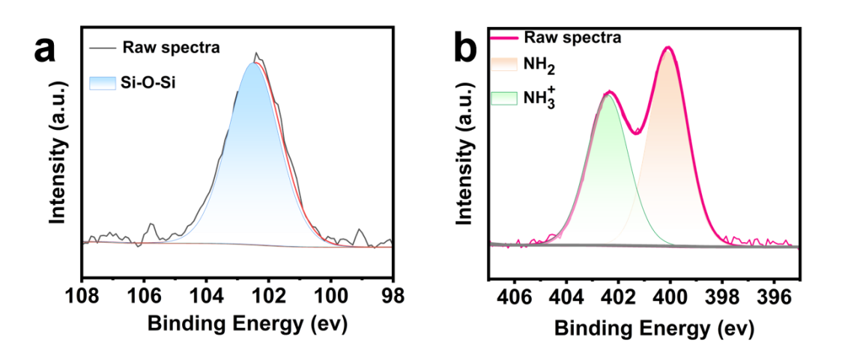
Fig. S1. (a) High resolution N 1s XPS spectrum deconvoluted into two peaks for free (400.1 eV) and protonated amines (402.3 eV). (b) High resolution XPS spectra of Si2p survey spectrum of EAPTMS-Ti₃C₂T_{x}.

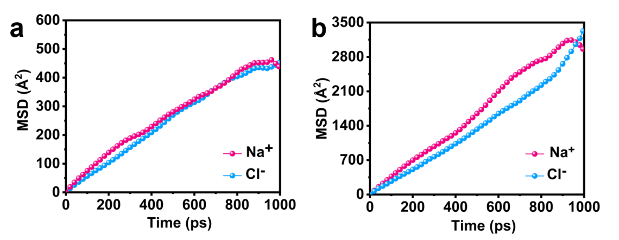
Fig. S2. Mean square displacement (MSD) curves of Na⁺ and Cl⁻ under forward connection (a) and reverse connection (b) of the supercapacitor.

Table S1 Diffusion coefficients of Na⁺ and Cl⁻ under forward and reverse connection configurations of the supercapacitor.
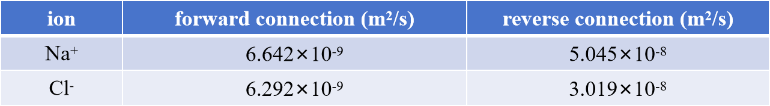

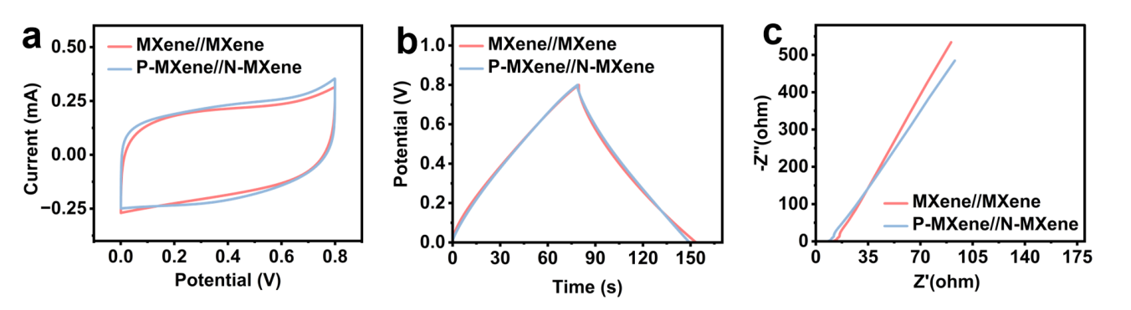
Fig. S3. Cyclic voltammetry (CV) curves (a), galvanostatic charge-discharge (GCD) curves (b), and electrochemical impedance spectra (c) of the charge-symmetric MXene//MXene device without chemical modification.
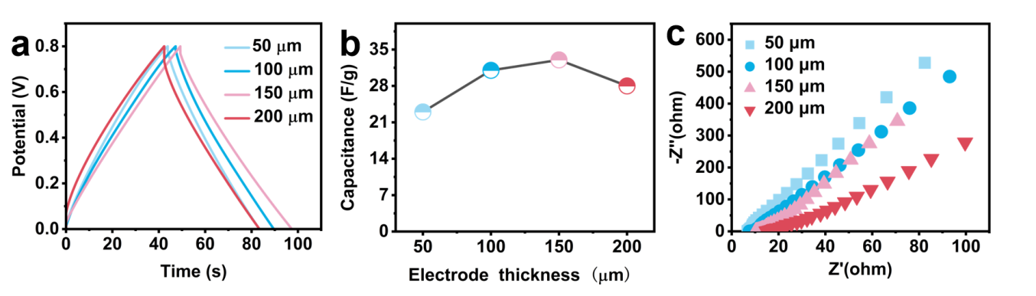Fig. S4. GCD curves (a), areal capacitances (b), and electrochemical impedance spectra (c) of the charge-asymmetric P-MXene//N-MXene devices with different electrode thicknesses.
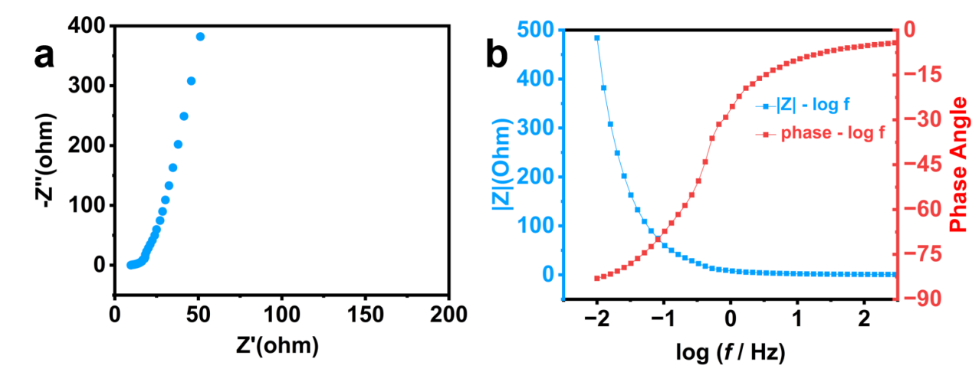
Fig. S5. Electrochemical impedance spectra (a) and Bode plot (b) of the charge-asymmetric P-MXene//N-MXene supercapacitor.
Table S2 Comparison of fitting parameters in the diffusion-controlled and activation-controlled models.
Model/  fitting parameter | -a*log(t+b)+c |  |  | -a*sqrt(t)+b
Model/  fitting parameter | a | b | c | a | b
forward configuration | 0.2116 | 1599.82 | 2.3441 | 4.7813E-3 | 0.8254
reverse configuration | 0.1318 | 115.38 | 1.4146 | 8.3705E-3 | 0.7670
Supporting Note. Computational Methodology

1. Molecular Modeling and Geometric Refinement
Fully atomistic simulations were executed using the Materials Studio suite (BIOVIA, France), employing an integrated workflow that bridges Forcite molecular mechanics with CASTEP first-principles frameworks. Preliminary geometric optimization was conducted for discrete components, including water molecules, a poly(vinyl alcohol) (PVA) chain (n = 20), a silane coupling agent, and an ethylenediaminetetraacetic acid (EDTA) molecule. These optimizations were performed within the Forcite module under the Born-Oppenheimer approximation. The SMART algorithm was utilized for structural relaxation over a maximum of 50,000 iterations, adhering to stringent convergence criteria: an energy tolerance of 1 ×10⁻⁷ kcal/mol, a force threshold of 5×10⁻⁵ kcal/(mol·Å), and an atomic displacement limit of 5 × 10⁻⁵ Å. For monatomic species (Na⁺ and Cl⁻), formal charges were assigned via CASTEP to ensure electronic configurations consistent with their isolated ionic states.

2. Surface Functionalization and Electrode Construction
A Ti₃C₂-MXene monolayer was generated in the Visualizer, with surface terminations represented by a mixed distribution of -OH, =O, and -F groups to replicate the complex chemical environment of Ti₃C₂T_{x}. The silane coupling agent was covalently tethered to the MXene surface via Si-O-Ti linkages at the silanol terminus. The distal amine group was maintained in a protonated state and electrostatically anchored to the functionalized MXene, resulting in a positively charged electrode. Simultaneously, EDTA molecules were immobilized on a secondary Ti₃C₂Tx sheet through a synergy of Ti-COO⁻ coordination, -COOH···OH hydrogen bonding, and -COOH···O intermolecular interactions, yielding a negatively charged electrode surface.

3. Nanochannel Assembly and Electrolyte Loading
The modified Ti₃C₂T_{x} plates were oriented in a parallel configuration separated by a 40 Å vacuum gap, defining a confined nanochannel for electrolyte confinement. Electrolyte constituents-comprising water, PVA chains, and pre-optimized Na⁺ and Cl⁻ ions-were introduced into the interlayer region using the Packing function within the Amorphous Cell module. The number density and species ratios were carefully calibrated to mirror experimental composition. The assembled system underwent a secondary geometric optimization in Forcite to alleviate steric hindrances and packing artifacts, utilizing the same high-precision Born-Oppenheimer protocol.

4. Molecular Dynamics (MD) Protocols
Following structural relaxation, MD simulations were performed using Forcite with fully atomistic force fields. The system was first equilibrated in the NVT ensemble at 298 K for 1000 ps to stabilize atomic velocities and dissipate internal stresses. Temperature was regulated via a Nosé-Hoover thermostat with a fluctuation tolerance of ±5%. Long-range nonbonded interactions (van der Waals and Coulombic) were computed using the Ewald summation method with an accuracy of 1 × 10⁻³ kcal/mol. Subsequently, the system transitioned to the NPT ensemble at 298 K and 1 atm for an additional 1000 ps, utilizing a Berendsen barostat to equilibrate the cell volume. All trajectories were propagated using the Velocity Verlet algorithm with a 1 fs time step; initial velocities were assigned based on a Boltzmann distribution corresponding to the target temperature.

5. Transport Property Analysis
The diffusion kinetics of Na⁺ and Cl⁻ ions were quantified using trajectory data from the production phase. For each ionic species, the mean square displacement (MSD) was calculated as a function of time and fitted within the linear diffusive regime:
$\text{MSD}\left(t\right)=\frac{1}{N}\sum_{i=1}^{N}{\left\langle {\left[r_{i}\left(t\right)−r_{i}\left(0\right)\right]}^{2}\right.}⟩$ (1)
The diffusion coefficient (D) was subsequently extracted via the Einstein relation:
$D=\frac{1}{6}\frac{d}{dt}\text{MSD}\left(t\right)$ (2)
Statistical reliability was ensured by ensemble-averaging the MSD profiles over the entire MD trajectory and across multiple independent ions to minimize uncertainties.

