Supplementary materials
Biofilm Formation and Genomic Signatures of Circulating Bordetella pertussis strains isolated in Beijing, China
Dongshan Yan¹, Jie Che¹, Hanying Dai¹, Luyao Guo¹, Jie Li¹, Bohan, Chen¹, Yuan Gao¹, Hairui Wang¹, Xueping Liu¹, Li Xu¹, Fuyi Han¹, Yunchuan Qiao¹, Maojun Zhang¹, Zhujun Shao^{1*}

1. National Key Laboratory of Intelligent Tracking and Forecasting for Infectious Diseases, National Institute for Communicable Disease Control and Prevention, Chinese Center for Disease Control and Prevention, Rd155, Changbailu, Changping, Beijing 102206, China

Corresponding author: Zhujun Shao (shaozhujun@icdc.cn)

Distribution of biofilm formation capacities across strains harboring distinct allelic genotypes
Circulating strains harboring the ptxA1/ptxP3/prn⁻/fim3-1/fim2-1/fhaB1 isolates genotype (n=39), 66.67% (26/39) were classified as strong biofilm producers, followed by 28.21% (11/39) moderate and 5.13% (2/36) weak producers, respectively (Fig. S1a). Similarly, among ptxA1/ptxP3/prn150/fim3-1/fim2-1/fhaB (n=35), 74.29% (26/35) were classified as strong biofilm producers, whereas 17.14% (6/35) and 8.57% (3/35) were moderate and weak producers, respectively (Fig. S1b). Among ptxA1/ptxP1/prn1/fim3-1/fim2-1/fhaB3 isolates (n=7), 71.43% (5/7) were strong biofilm producers and one isolate (14.29%) showed no detectable biofilm formation (Fig. S1c).
Fig. S1 Proportion of biofilm-forming capacities among B. pertussis strains with different allelic genotypes. Pie charts showed the proportion of strains classified as strong (red), moderate (blue), weak (green) or non-biofilm forming (orange) phenotypes (a-c).

Association between biofilm formation and allelic genotypes in circulating isolates
Time-course quantification of biofilm formation over 96h revealed distinct biofilm phenotypic profiles among the isolates. At OD_{600nm}, isolates were categorized as strong biofilm-forming group range from 1.04 to 3.63 (median 1.56), followed by moderate group (0.66-1.12, median 0.81), and weak group (0.46-0.64, median 0.58) (Fig. S2a). Similar pattern was also observed for OD_{590nm} measurements, with the strong biofilm-forming group exhibiting the highest OD values, ranging from 1.26 to 3.65 (median 1.81), followed by moderate group (0.75-1.24, median 0.97), and weak group (0.54-0.75, median 0.62) (Fig. S2b). At OD_{570nm}, the strong biofilm-forming group showed OD values ranging from 1.08 to 3.66 (median 1.60), followed by moderate group (0.64-1.08, median 0.84), and weak group (0.49-0.62, median 0.51) biofilm producers (Fig. S2c).
We also measured biofilm formation levels at OD_{540nm} among strains differing in virulence genotypes and isolation years. The ptxP1/prn1strains exhibited higher biofilm-forming capacity, ranging from 0.17 to 3.59 (median 1.22), followed by ptxP3/prn150 (0.36-2.60, median 1.07) and ptxP3/prn⁻ (0.36-2.56, median 1.01). In addition, variation in biofilm formation capacity was observed among strains isolated between 2021 and 2024 (Fig. S2d). The mean OD values for biofilm formation were 1.73 (0.17-3.59) in 2021, 1.38 (0.37-2.60) in 2022, 0.99 (0.36-1.84) in 2023, and 1.00 (0.37-1.48) in 2024(Fig. S2e). No statistically significant differences were observed among strains with different allelic types or different years.
Fig. S2 Quantitative assessment and correlation analyses of biofilm formation. (a-c) Quantitative analysis of biofilm formation among strong, moderate, and weak biofilm-forming strains under different measurement conditions. (d-e) Correlation analyses between biofilm formation levels and allelic profiles or isolation years. Each dot represents an individual isolate, and horizontal bar indicate mean values. Statistical significance was determined using two-way ANOVA followed by Dunnett’s multiple comparisons test; P <0.05 (*), P <0.01(**), P <0.001 (***), and P <0.0001 (****), ns, not significant.
Characteristics of biofilm formation in fhaB deficient vaccine antigen strains
At OD_{540nm}, two fhaB⁻ isolates ID26 (allelic profile: ptxA1/ptxP3/prn150/fhaB⁻/fim3-1/fim2-1) and ID33 (allelic profile: ptxA1/ptxP3/prn⁻/fhaB⁻/fim3-1/fim2-1) both exhibited moderate biofilm-forming capacity, with OD_{540nm} values of 0.70 ± 0.03 and 0.68 ± 0.01, respectively. Both mutants showed statistically significant differences in biofilm biomass compared to the reference strain ATCC (P < 0.001; Fig. S3).
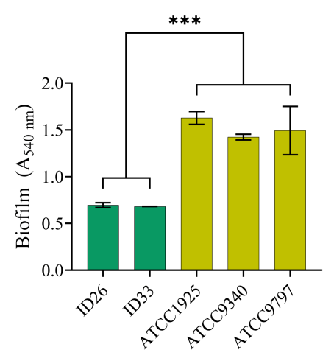
Fig. S3 Analysis of biofilm formation capacity between two natural fhaB⁻ mutants (ID26 and ID33) and the reference strain ATCC. Biofilm biomass was quantified by measuring optical density at OD₅₄₀_{nm}. Data are presented as mean ± SD from three independent experiments (n=3). Statistical significance was determined using two-way ANOVA followed by Dunnett’s multiple comparisons test; P <0.05 (*), P <0.01(**), P <0.001 (***), and P <0.0001 (****), ns, not significant.
Annotation analysis of genes significantly associated in Pan-GWAS analyses
The COG classification indicated that most candidate genes were associated with replication, recombination, and repair functions (72.00%), followed by energy production and conversion (4.67%) and cell wall/membrane/envelope biogenesis (4.00%). Genes involved in signal transduction, nucleotide transport and metabolism, and transcription each accounted for less than 3% of the identified loci.
Fig. S4 COG functional classification of biofilm-associated genes identified by two independent Pan-GWAS analyses. (a) Distribution of COG categories for PLINK-detected genes. (b) Corresponding classification for Pyseer-detected genes, allowing direct comparison of functional profiles between the two methods.

Comparative SNP-GWAS analysis of biofilm-associated genotypes using GEMMA and Pyseer.
Fig. S5 Comparative SNP-GWAS analysis of biofilm- associated genotypes using GEMMA and Pyseer. Q-Q plots comparing observed and expected −log10(P) values for GEMMA (a) and Pyseer (b), respectively. The dashed line indicates the genome-wide significance threshold. These plots assess genomic inflation and the effectiveness of population stratification correction.

