Multidimensional characteristics and ecological risks of MPs in receiving waters from
WWTP effluent
Xiu Xu^{1,2}, Wei Wang³, Xin Meng^{1,2,4*}, Jie Qi^{1,2}, Sheng Zhang^{1,2}
1. Hebei Engineering Research Center for Sewage Treatment and Resource Utilization, Hebei University of Hebei Technology Innovation Center of Water Pollution Control and Water Ecological Remediation, Hebei University of Engineering, Handan 056038, China;
2. School of Energy and Environmental Engineering, Hebei University of Engineering, Handan 056038, China.
3. Bureau of Comprehensive Development, Ministry of Water Resources of P. R. China, Beijing 100053, China.
4. Key Laboratory of Environmental Aquatic Chemistry, Research Center for Eco~Environment Science, Beijing 100085, China.

----------------------------------
* Corresponding author. E-mail: mengxin@hebeu.edu.cn
List of content:
Figure. S1 Different shaped particles extracted from the sam（a. fiber; b. film; c. fragment; d. particle）
Figure. S2 The FTIR spectrum of the main polymers present in the types of MPs

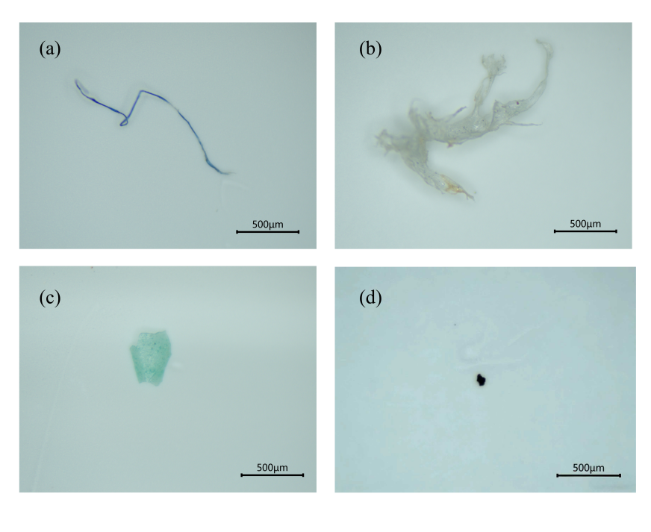
Figure. S1 Different shaped particles extracted from the samples（a. fiber; b. film; c. fragment; d. particle）
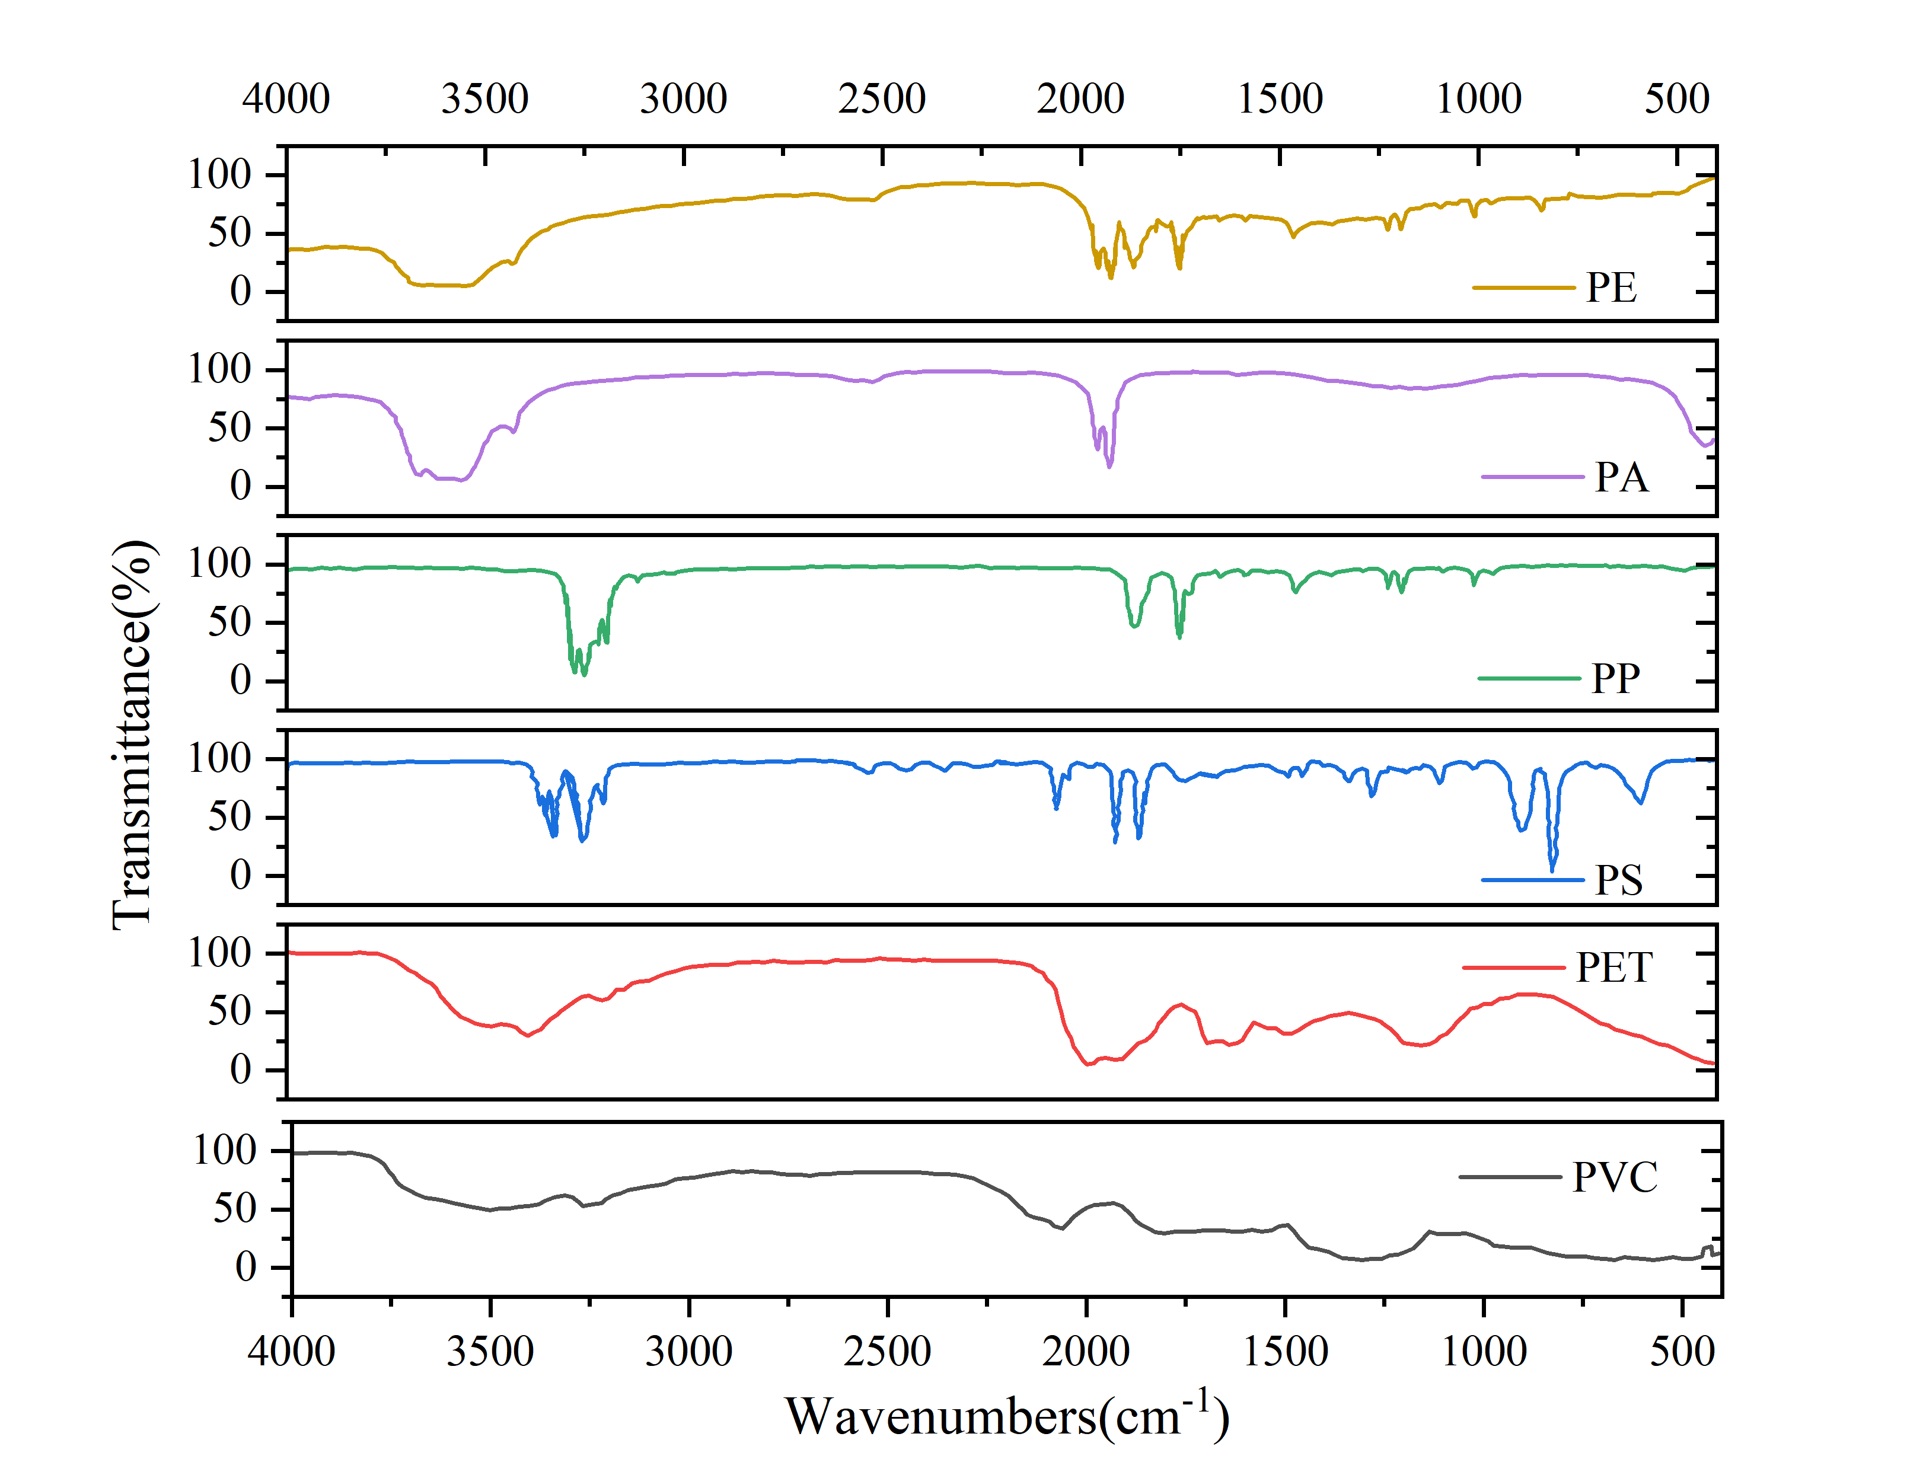
Figure. S2 The FTIR spectrum of the main polymers present in the types of MPs

