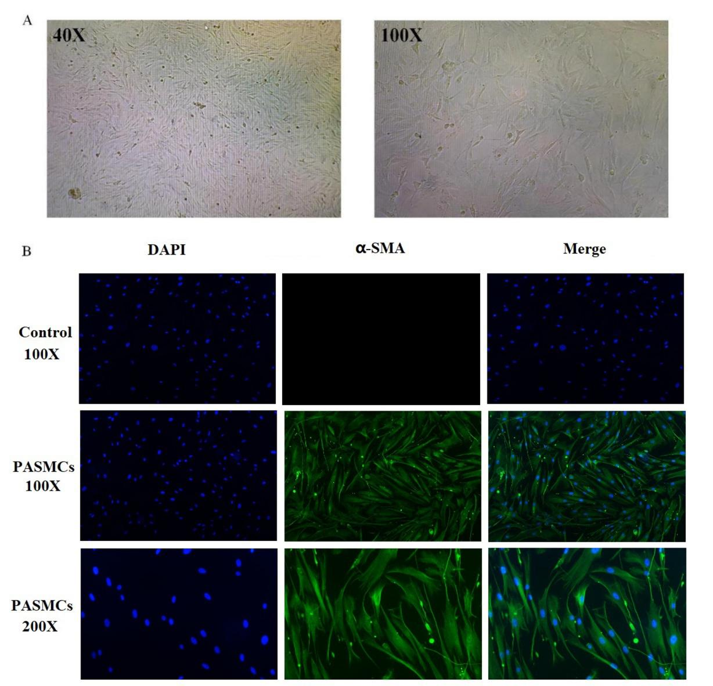
Supplementary Fig. 1 Results of the isolation and cultivation of PASMCs. Cell morphology was observed under an inverted phase-contrast microscope, and a cell growth curve was plotted by cell counting and observed under ×40 and ×100 mirrors (A). Immunofluorescence staining of α-smooth muscle actin (α-SMA) was used to assess the cell type and purity of PASMCs and A549 cells (control, CL0024, Fenghuishengwu, China), which were observed at ×100 and ×200 (B).
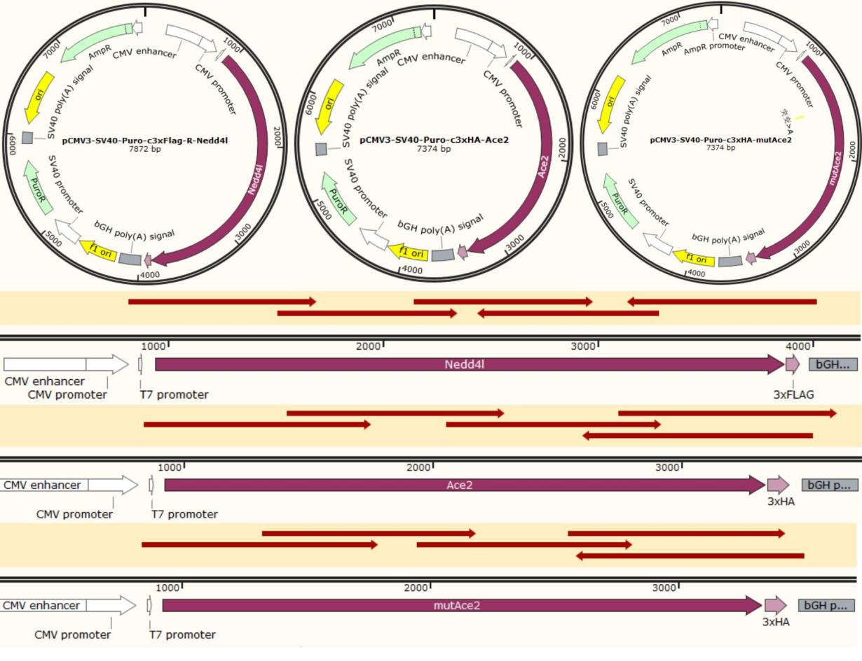
Supplementary Fig. 2 Vector maps and sequencing results of NEDD4L, ACE2, and point-mutated ACE2. To identify the ubiquitination binding site between NEDD4L and ACE2, the NEDD4L and ACE2 sequences were retrieved from the NCBI Gene database, and the ACE2 ubiquitination binding site was predicted. The NEDD4L, ACE2, and point-mutated ACE2 sequences were obtained accordingly. The Nedd4l-3xFlag sequence was cloned into the pCMV3-SV40-Puro vector via BamHI and XbaI, and the ACE2-3xHA and mutACE2-3xHA sequences were cloned into the pCMV3-SV40-Puro vector via HindIII and XhoI. The vector confers ampicillin resistance in prokaryotes. After construction, sequencing was performed, and the results confirmed that the target gene sequences were correctly inserted into the destination vector. NEDD4L, neural precursor cell-expressed developmentally down-regulated gene 4-like; ACE2, angiotensin-converting enzyme 2.
Supplementary Table S1. Sequences of Primers Used for qPCR
Target Gene | Forward/Reverse Strand | Primer Sequences
TBP | Forward | 5’-CCCACCAGCAGTTCAGTAGC-3’
TBP | Reverse | 5’-GAATTCTGGGTTTGATCATTCTG-3’
ACE2 | Forward | 5’-AAGCCACCTTACGAGCCTCCTG-3’
ACE2 | Reverse | 5’-AACAATGCCAACCACTACCGTTCC-3’
NEDD4L | Forward | 5’- CCACCAGGTTGGGAAGAAAAA-3’
NEDD4L | Reverse | 5’-TCCAAGTAGTCGTTCTGGAATTG-3’

