supplementary figures
Mouse Sample – Taken at PSI NCT beamline in 2015
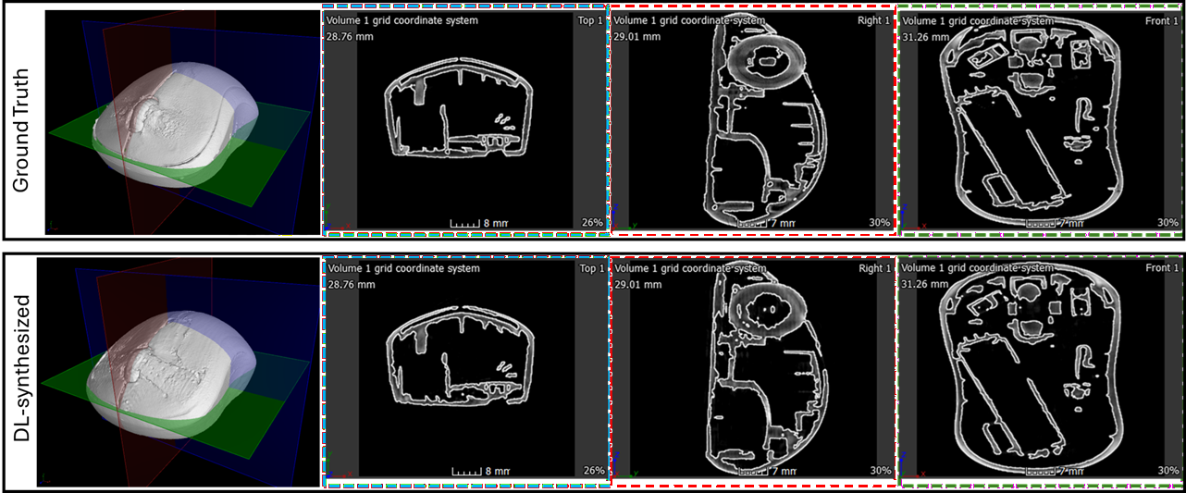
Figure 17 3D slicing image at xy (blue plane), yz(red plane), and xy (green plane) of Mouse Sample
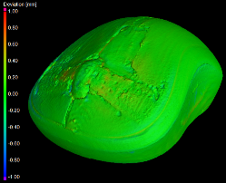
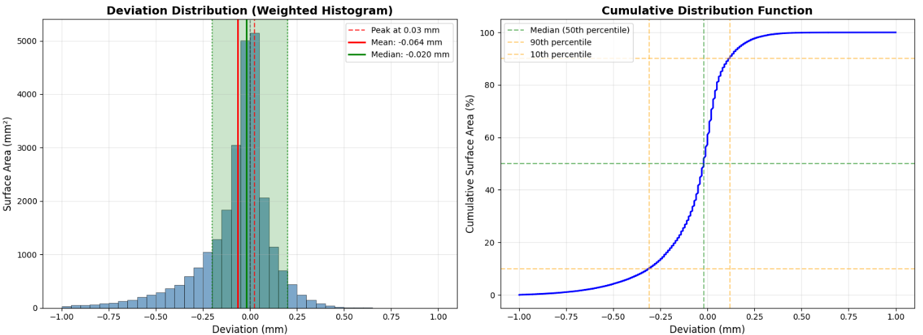
Figure 18 Deviation distribution and Cumulative distribution function of ultra sparse spacing, comparing the Ground Truth of Mouse Sample

Table 6 Nominal / actual comparison of ultra sparse spacing of Mouse Sample
Parameters | Comparison (Tolerance band ±0.2mm)
Parameters | Con_{E} Contrast
Total Surface (mm²) | 25804.13
Area Within Tolerance (mm²) | 20446.97
Area Within Tolerance (%) | 79.2
Area Ouside Tolerance (mm²) | 5357.16
Area Ouside Tolerance (%) | 20.8
Positive deviation area (mm²) | 10059.42
Positive deviation area (%) | 39
Negative deviation area (mm²) | 14518.59
Negative deviation area (%) | 56.3
Zero deviation area (mm²) | 1226.12
Zero deviation area (%) | 4.8

Berea Sandstone Sample – Taken at IMAT RAL ISIS beamline in 2024
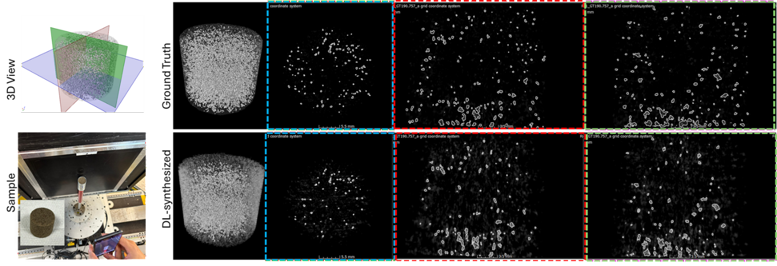
Figure 19 3D slicing image at xy (blue plane), yz(red plane), and xy (green plane) of Berea Sandstone Sample
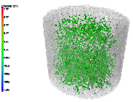
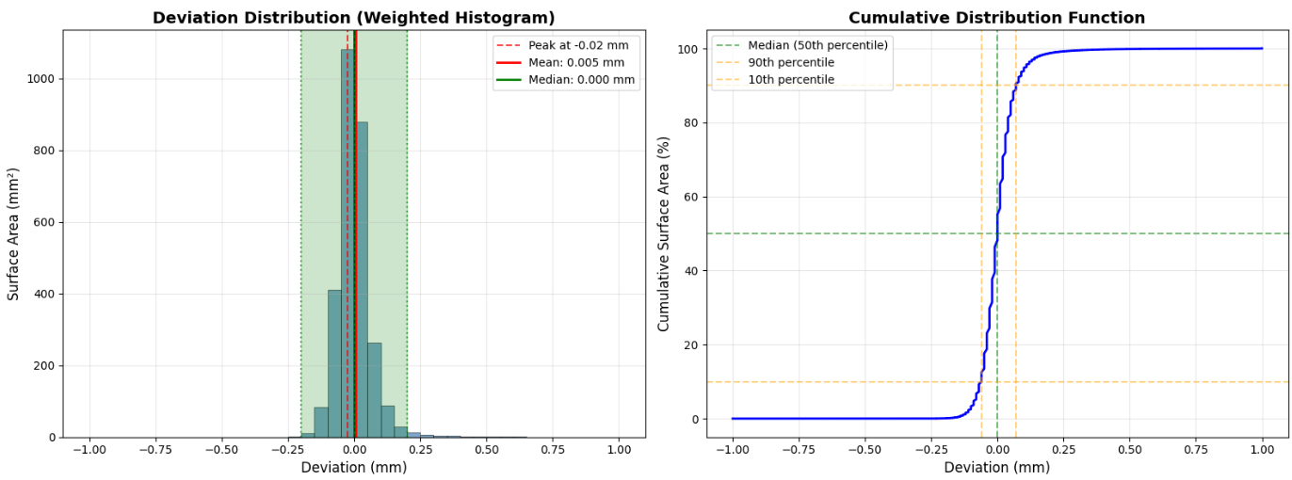
Figure 20 Deviation distribution and Cumulative distribution function of ultra sparse spacing, comparing the Ground Truth of Berea Sandstone Sample
Table 7 Nominal / actual comparison of ultra sparse spacing of Berea Sandstone Sample
Parameters | Comparison (Tolerance band ±0.2mm)
Parameters | Con_{E} Contrast
Total Surface (mm²) | 2880.65
Area Within Tolerance (mm²) | 2844.8
Area Within Tolerance (%) | 98.8
Area Ouside Tolerance (mm²) | 35.85
Area Ouside Tolerance (%) | 1.2
Positive deviation area (mm²) | 1291.58
Positive deviation area (%) | 44.8
Negative deviation area (mm²) | 1336.24
Negative deviation area (%) | 46.4
Zero deviation area (mm²) | 252.83
Zero deviation area (%) | 8.8

