Supplementary Information for:

Enhanced Electrocatalytic Oxygen Reduction to H₂O with High Selectivity via 2D 1T-MoS₂ Integrated with Functionalized Carbon Nanohorns
Mengjiao Wang,*¹ Stefania Benazzato,² Łukasz Cieszyński,³ Matteo Crisci,⁴ Micaela Pozzati,¹ Laura Calvillo,² Yongying Wang,¹ Yazhou Zhou,⁵ Enzo Menna,*^{2,6} Silvio Osella,³ Juqin Zeng,^{1,4} and Teresa Gatti*^{1,7}
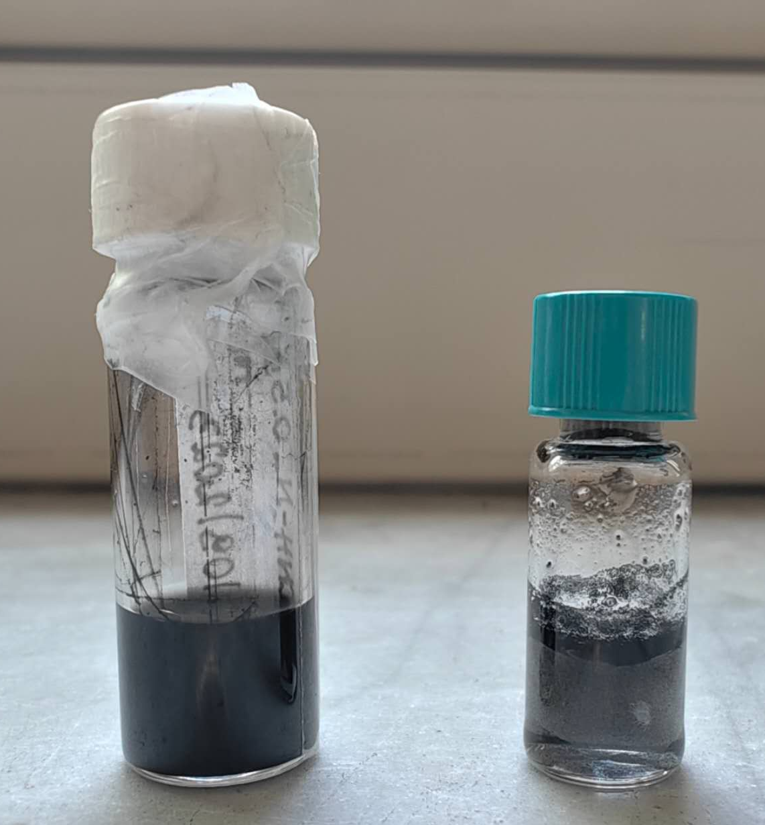
Fig S1. Optical image of aqueous solution of CNH-N (left) and CNHs (right) with the same weight concentration (4mg/mL). CNH-N shows uniform distribution and colloidal stability, while CNHs can not disperse in H2O after 1 h of sonication.
Table S1. Quantification of the fitting peaks from C 1s spectra of CNH and CNH-H.
Sample | C=C | C-C | C-OH/C-N | C=O | COOH
CNH | 57.2 % | 21.9 % | 11.5 % | 2.6 % | 6.8 %
CNH-N | 52.9 % | 27.1 % | 11.5 % | 1.8 % | 6.7 %

DFT calculations
All periodic DFT calculations were performed using VASP 6.4 within the projector-augmented wave formalism [1–3]. The exchange–correlation energy was described using the PBE functional [4], and dispersion interactions were included using Grimme D3 corrections [5,6].
A plane-wave kinetic energy cutoff of 500 eV was applied in all calculations, and the electronic self-consistency threshold was set to 10⁻⁵ eV. Geometry optimizations of catalytic intermediates were performed in a fixed simulation cell without symmetry constraints. Atomic positions were relaxed until the residual forces were below 0.01 eV Å⁻¹. Spin unpolarized calculations were used for the catalytic models.
Work function calculations were carried out as static single point calculations on the optimized structures. A dipole correction was applied along the surface-normal direction and the Hartree electrostatic potential was used to determine the vacuum potential. The work function was calculated as the difference between the vacuum electrostatic potential and the Fermi energy. Bader charge analysis was performed from static calculations using total and all-electron charge density files generated with the same energy cutoff and convergence criteria. Vibrational frequencies of adsorbed intermediates were calculated using the finite displacement method with a displacement step of 0.015 Å.
Reactions for catalytic steps used for Gibbs free energy calculations:
4e⁻ path:
1. * + 2 H₂O = *OOH + 3/2 H₂ , ΔG(*OOH)
2. * + H₂O = *O + H₂ , ΔG (*O)
3. * + H₂O = *OH + 1/2 H₂ , ΔG (*OH)

2e- path:
1. * + 2 H₂O = *OOH + 3/2 H₂ , ΔG(*OOH)
2. *OOH + H₂O = *OH + H₂O₂ , ΔG(*H₂O₂)

ΔG₁ = ΔG(*OOH) – 4.92
ΔG₂ = ΔG(*O) - ΔG(*OOH)
ΔG₃ = ΔG(*OH) - ΔG(*O)
ΔG₄ = -ΔG(*OH)
ΔG_{2e} = ΔG(*H₂O₂)

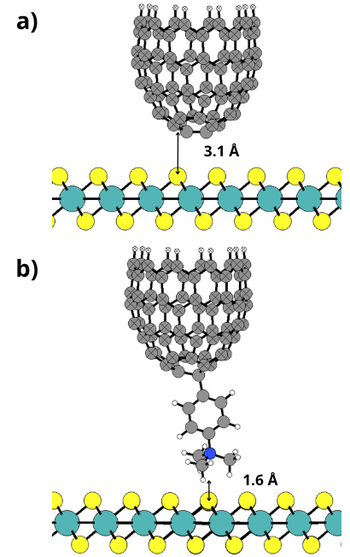

Fig S2. Relaxed geometries of: a) CNH/MoS₂, b) CNH-N/MoS₂.

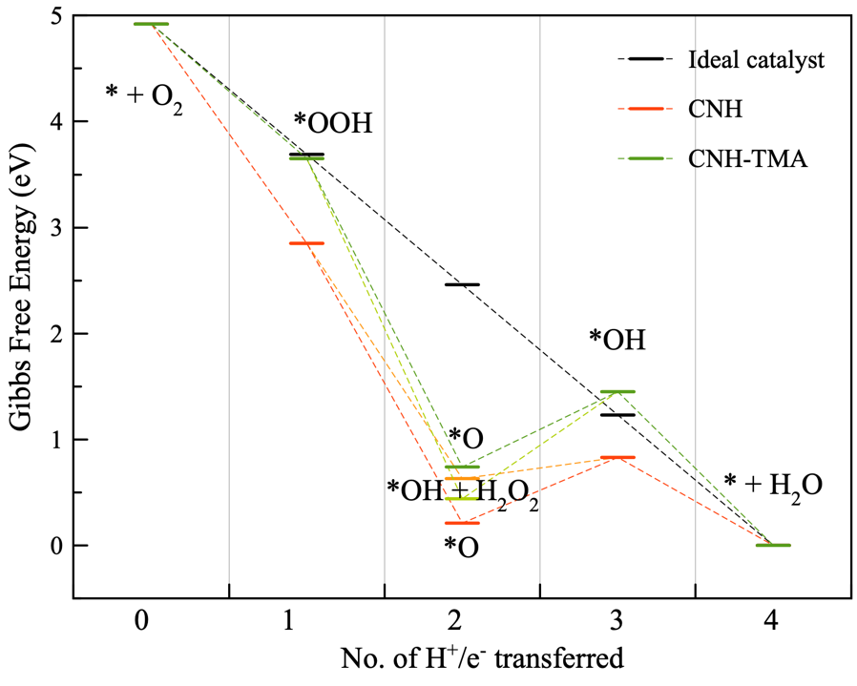
Fig S3. ORR reaction pathway without applied bias on both catalysts. Red and green lines refer to the four electron pathway, light green and orange to the two electron pathway.

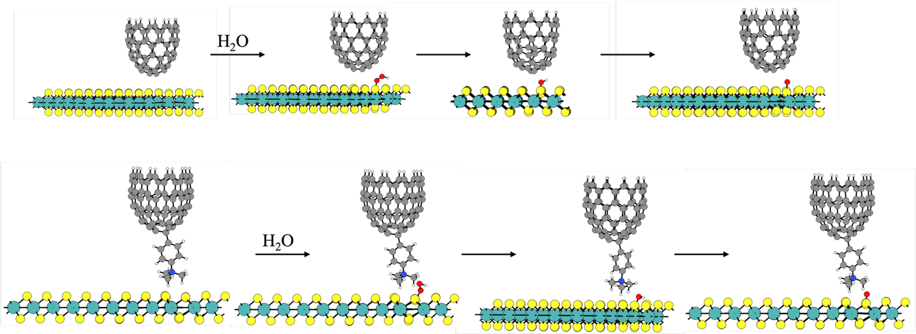
Fig S4. Optimized structures of the different intermediates of the ORR on the two different interfaces.

Table S2. Work function analyis, dipolar and CT contributions. μ_{z} refers to the dipole moment along the normal to the MoS₂.

System | E fermi [eV] | WF [eV] | WF shift [eV] | μ_{z} [e*A] | ΔV_{SAM} [eV] | CT [eV]
CNH/MoS₂ | -2,01 | 5,06 | -1,40 | -2,46 | -0,87 | -0,53
CNH-N/MoS₂ | -2,58 | 5,07 | -1,43 | -2,50 | 2,12 | -3,55

Table S3. Bond distances between the adsorbate and the MoS₂ substrate. All distances are reported in Angstrom.

CNH |  |  |  | CNH-TMA
 | S-O | O-O | O-H |  | S-O | O-O | O-H
*OOH | 1,722 | 1,450 | 0,966 | *OOH | 1,643 | 1,627 | 0,988
*O | 1,499 | - | - | *O | 1,505 | - | -
*OH | 1,660 | - | 0,983 | *OH | 1,669 | - | 0,999
Table S4. Energy contributions to the Gibbs free energy for the different intermediates studied in the ORR reaction. All values are reported in eV.

CNH | Total energy | Zero point energy (ZPE) | Enthaplic contribution (H) | Entropic contribition  (T*S) | Gibbs contribution  G(T) | Free energy
*OOH | -1445,76 | 1,18 | 1,85 | 1,20 | 0,65 | -1445,11
*O | -1438,09 | 0,80 | 1,44 | 1,14 | 0,30 | -1437,79
*OH | -1441,92 | 1,10 | 1,74 | 1,16 | 0,58 | -1441,34
* | -1432,37 | 0,69 | 1,31 | 1,15 | 0,16 | -1432,21
CNH-N
*OOH | -1580,33 | 1,15 | 1,81 | 1,17 | 0,64 | -1579,69
*O | -1573,00 | 0,83 | 1,45 | 1,09 | 0,35 | -1572,64
*OH | -1576,74 | 1,12 | 1,74 | 1,10 | 0,64 | -1576,10
* | -1567,86 | 0,73 | 1,32 | 1,05 | 0,27 | -1567,59
Gas phase
H2O | -14,22 | 0,57 | 0,67 | 0,58 | 0,09 | -14,13
H2 | -6,76 | 0,27 | 0,36 | 0,40 | -0,05 | -6,81
H2O2 | -18,15 | 0,70 | 0,81 | 0,70 | 0,11 | -18,04

References
[1] G. Kresse, J. Furthmüller, Efficiency of ab-initio total energy calculations for metals and semiconductors using a plane-wave basis set, Computational Materials Science 6 (1996) 15–50. https://doi.org/10.1016/0927-0256(96)00008-0
[2] G. Kresse, J. Furthmüller, Efficient iterative schemes for ab initio total-energy calculations using a plane-wave basis set, Physical Review B 54 (1996) 11169–11186. https://doi.org/10.1103/PhysRevB.54.11169
[3] G. Kresse, D. Joubert, From ultrasoft pseudopotentials to the projector augmented-wave method, Physical Review B 59 (1999) 1758–1775. https://doi.org/10.1103/PhysRevB.59.1758
[4] J. P. Perdew, K. Burke, M. Ernzerhof, Generalized Gradient Approximation Made Simple, Physical Review Letters 77 (1996) 3865–3868. https://doi.org/10.1103/PhysRevLett.77.3865
[5] S. Grimme, J. Antony, S. Ehrlich, H. Krieg, A consistent and accurate ab initio parametrization of density functional dispersion correction (DFT-D) for the 94 elements H–Pu, The Journal of Chemical Physics 132 (2010) 154104. https://doi.org/10.1063/1.3382344
[6] S. Grimme, S. Ehrlich, L. Goerigk, Effect of the damping function in dispersion corrected density functional theory, Journal of Computational Chemistry 32 (2011) 1456–1465. https://doi.org/10.1002/jcc.21759

