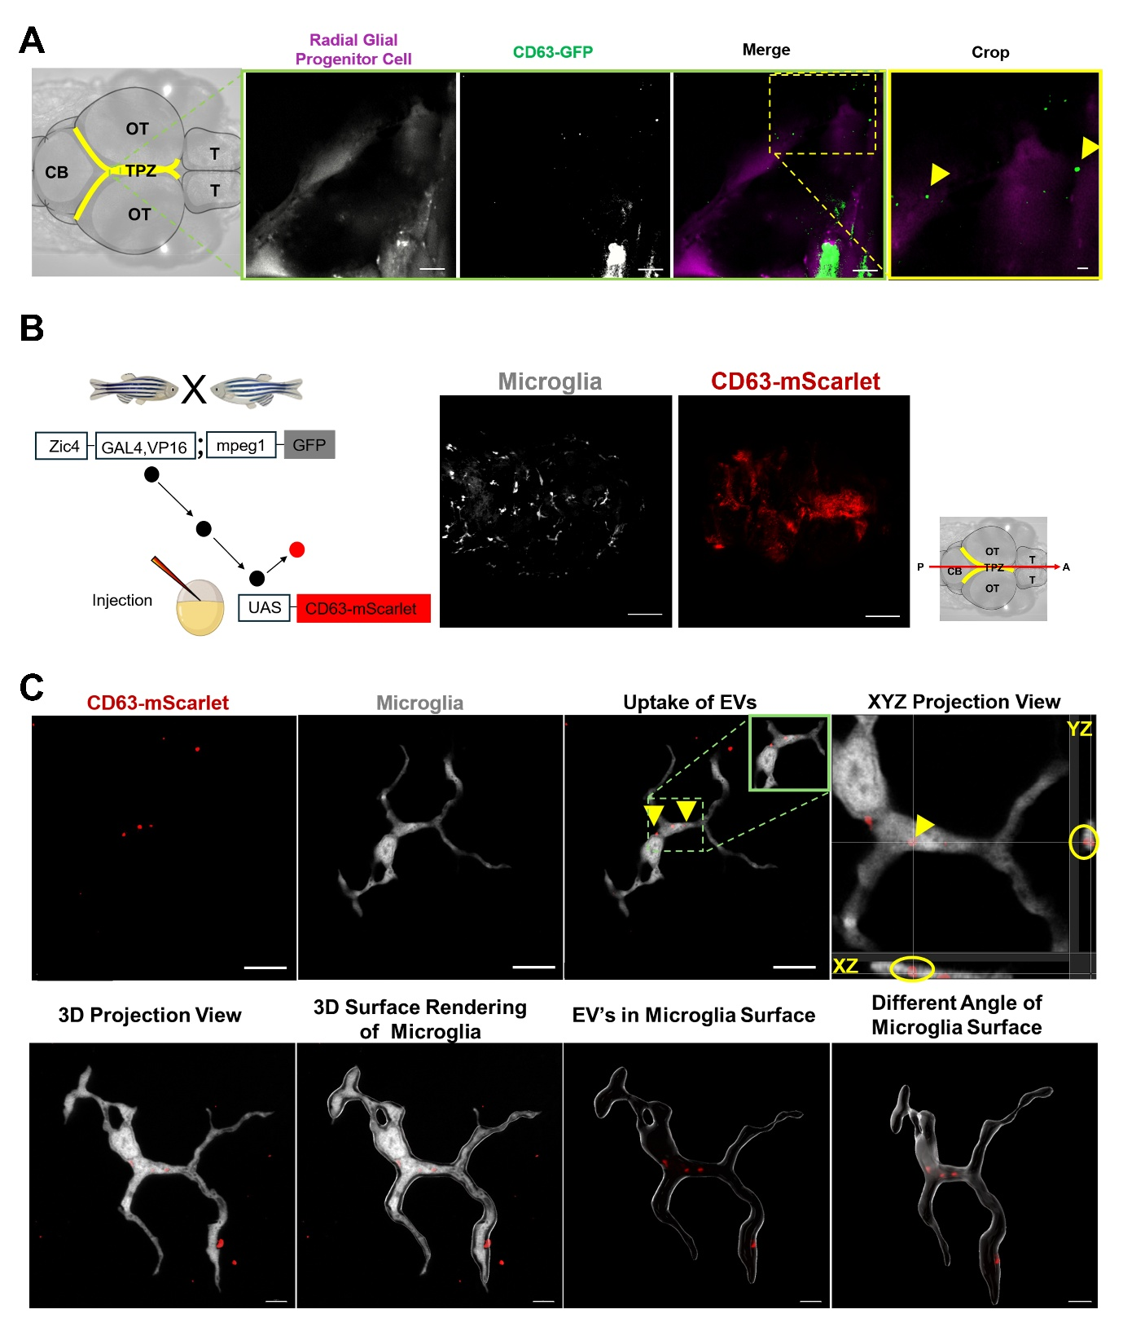Sup. Figure 1: Imaging of EV release by RGPCs and uptake by microglia in 4 dpf larval zebrafish brains. A) A schematic of an antero-posterior dorsal view of a larval zebrafish brain shows the major subdivisions: telencephalon (T), optic tectum (OT), cerebellum (CB), and the tectal proliferative zone (TPZ) highlighted in yellow. Representative confocal image of radial glial progenitor cells (magenta) and released CD63-GFP–labelled EVs (arrowheads) in 4 dpf live HRASv12− larvae. Scale bar: 10 µm; cropped data: scale bar 1 µm. B) Schematic representation of the zebrafish injection strategy used to induce CD63-mScarlet expression in HRASv12− larvae. The Zic4 promoter is used to drive expression of the transcriptional activator Gal4, which binds to the UAS sequence to induce CD63-mScarlet expression. Representative confocal images of microglia (grey) and CD63+ fluorescent signal (red) in the brains of 4 dpf HRASv12− larvae. Images were acquired using a Zeiss LSM 880 confocal microscope with a 20×/NA 0.8 objective. Scale bar: 100 µm. C) Representative confocal image (single plane) showing the uptake of released CD63-mScarlet–labelled EVs (red) by microglia (grey) in HRASv12− larvae. Orthogonal views (XY, XZ, YZ) indicate the presence of EVs within microglial cytoplasm. 3D reconstruction and surface rendering of the microglia further demonstrate the internalized EVs within the microglia. Images were acquired using a Zeiss LSM 880 confocal microscope with a 63×/1.4 NA oil-immersion objective. Scale bars: 10 µm (upper panel); 5 µm (lower panels).
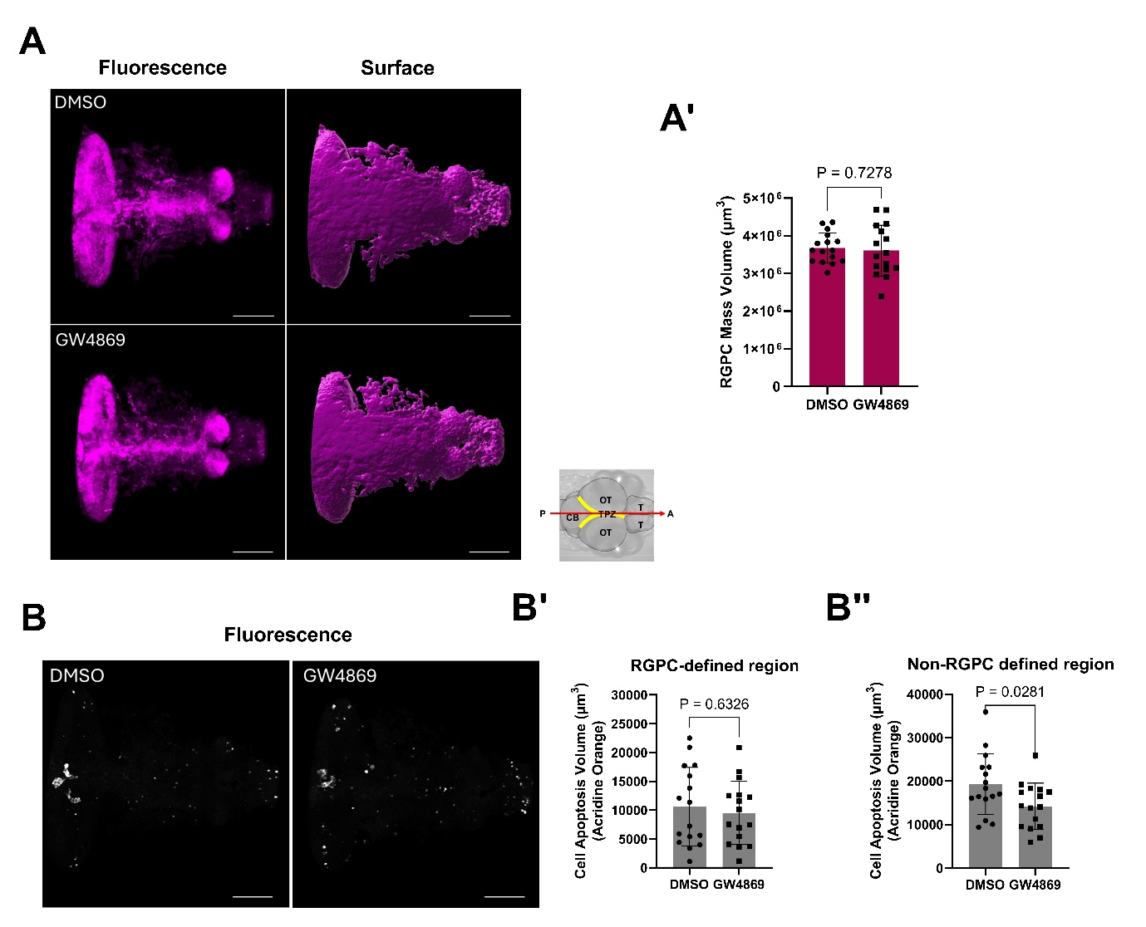Sup. Figure 2: Impact of EV formation/release inhibition on RGPC mass volume and apoptosis at 5 dpf in HRASv12− larvae. A-B) Representative confocal images (maximum intensity projections (left panels) and corresponding 3D surface renderings (right panels) illustrating A) RGPC mass and B) apoptotic cell volume within the RGPC-defined region of 5dpf HRASv12- larvae treated with either DMSO or GW4869 (20 µM). Images were acquired using a Zeiss LSM 880 confocal microscope equipped with a 20×/NA 0.8 objective lens. Scale bar: 100 µm. A schematic illustrating an anteroposterior dorsal view of the larval zebrafish brain is included. A′-B’) Quantification analysis of PNC mass volume and apoptotic cell volume in the PNC-defined region. B′′) Quantification analysis of apoptotic cell volume in the non-PNC-defined region. DMSO: n = 16; GW4869 (20 µM): n = 16; N = 2. Statistical analysis was performed using unpaired two-tailed Student’s t-tests. Error bars represent the standard error.
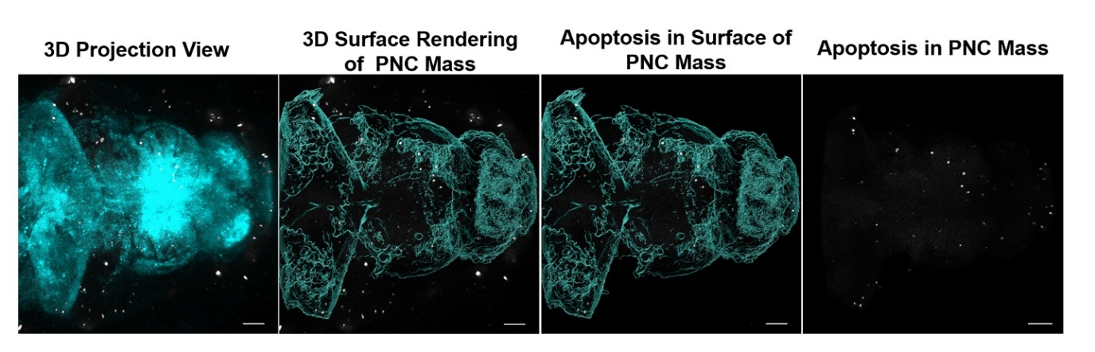Sup. Figure 3: Representative 3D reconstruction of the HRASv12⁺ preneoplastic cell (PNC) mass used to define the region of interest for apoptosis quantification. The left panel shows the original 3D projection of the PNC mass (cyan) together with apoptotic cells detected by Acridine Orange staining (grey). A surface rendering of the PNC mass was generated in Imaris to delineate the tumour volume. Acridine Orange-positive apoptotic cells located within the reconstructed PNC mass volume were subsequently identified and isolated, allowing selective quantification of apoptosis associated with the PNC mass. Scale bar: 100 µm.
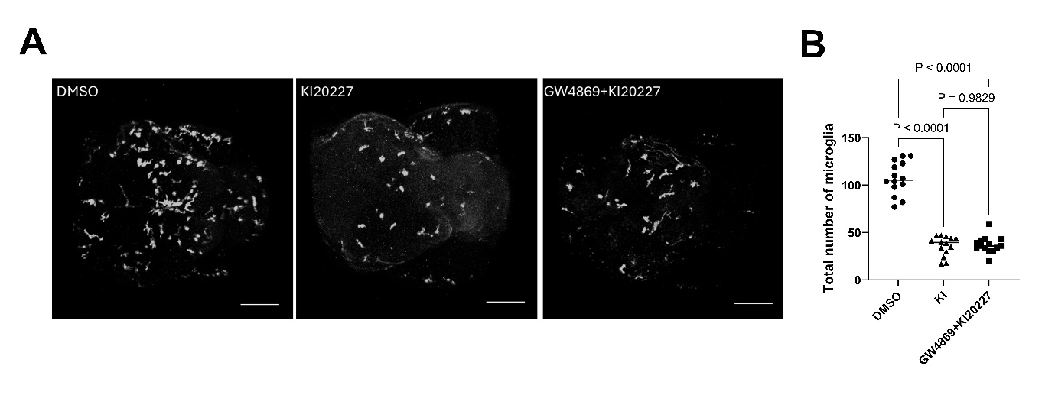Sup. Figure 4: Ki20227 treatment reduces microglia numbers in 5 dpf larval brains. Immunohistochemistry was performed using the mouse anti-Galectin 3 binding antibody (4C4), which labels microglia in both HRASv12- and HRASv12+ larvae. A) Representative confocal images (maximum intensity projections) showing the microglia population in HRASv12+ larval zebrafish brains at 5 dpf following 72 h treatment with DMSO, Ki20227, or combined GW4869 + Ki20227. B) Quantification of the total number of microglia in the whole brain. n = 16; N = 2. Statistical significance was assessed using one-way ANOVA followed by Tukey’s multiple comparisons test. P values are indicated on the graph. Error bars represent mean ± SD.

