Supplemental Table 1 Comparison of the patients and IAs characteristics among training and internal validation cohorts
Feature | Training set | Internal validation set | P-value
Age | 59.032 ± 10.52 | 58.170 ± 10.09 | 0.359
Female | 194 (29.5 %) | 82 (29.1 %) | 0.901
Hypertension | 395 (60 %) | 169 (59.9 %) | 0.977
DM | 62 (9.4 %) | 19 (6.7 %) | 0.179
AF | 8 (1.2 %) | 6 (2.1 %) | 0.290
CHD | 64 (9.7 %) | 28 (9.9 %) | 0.924
SAH | 10 (1.5 %) | 1 (0.4 %) | 0.128
Smoking | 109 (16.6 %) | 43 (15.2 %) | 0.615
Drinking | 47 (7.1 %) | 19 (7.1 %) | 0.824
PC | 52 (7.9 %) | 26 (9.2 %) | 0.502
Location at artery bifurcation | 54 (8.2 %) | 19 (6.7 %) | 0.441
Irregular shape | 269 (40.9 %) | 134 (47.5 %) | 0.060
NNA | 201 (30.5 %) | 82 (29.1 %) | 0.653
Maximum size | 4.13 ± 1.45 | 4.08 ± 1.46
Location |  |  | 0.947
ACA | 34 (5.2 %) | 17 (6.0 %)
ACOA | 117 (17.8 %) | 49 (17.4 %)
ICA | 125 (19.0 %) | 41 (14.5 %)
MCA | 86 (13.1 %) | 34 (12.1 %)
PCOA | 244 (37.1 %) | 115 (40.8 %)
PCA | 12 (1.8 %) | 7 (2.5 %)
VA | 7 (1.1 %) | 6 (2.1 %)
PICA | 8 (1.2 %) | 7 (2.5 %)
BA | 16 (2.4 %) | 2 (0.7 %)
Others | 9 (1.4 %) | 4 (1.4 %)
Ruptured IAs | 336 (51.1 %) | 144 (51.1 %) | 1.000
DM, diabetes mellitus; AF, atrial fibrillation; CHD, coronary heart disease; SAH, subarachnoid hemorrhage; PC, posterior circulation; NNA, narrow necked aneurysm; ACA, anterior cerebral artery; ACOA, anterior communicating artery; ICA, internal carotid artery; MCA, middle cerebral artery; PCOA, posterior communicating artery; PCA, posterior cerebral artery; VA, vertebral artery; PICA, posterior inferior cerebellar artery; BA, basilar artery; IA, intracranial aneurysm.

Supplemental Table 2 Patients and IAs characteristics between unruptured and ruptured groups
Feature | Unruptured IA (n=504) | Ruptured IA (n=500) | P-value
Age | 59.71 ± 10.04 | 58.41 ± 10.87 | 0.05
Female | 147 (29.2 %) | 152 (30.4 %) | 0.669
Hypertension | 331 (65.7 %) | 272 (54.4 %) | <0.001*
DM | 69 (13.7 %) | 26 (5.2 %) | <0.001*
AF | 7 (1.4 %) | 6 (1.4 %) | 1.000
CHD | 54 (10.7 %) | 46 (9.2 %) | 0.423
SAH | 7 (1.4 %) | 5 (1.0 %) | 0.571
Smoking | 85 (16.9 %) | 73 (14.6 %) | 0.324
Drinking | 36 (7.1 %) | 33 (6.6 %) | 0.734
PC | 43 (8.5 %) | 37 (7.4 %) | 0.508
Location at artery bifurcation | 37 (7.3 %) | 39 (7.8 %) | 0.784
Irregular shape | 144 (28.6 %) | 268 (53.6 %) | <0.001
NNA | 145 (28.8 %) | 160 (32.0 %) | 0.266
Maximum size | 3.75 ± 1.46 | 4.50 ± 1.33 | <0.001*
Location |  |  | <0.001*
ACA | 31 (6.2 %) | 23 (4.6 %)
PCOA | 24 (4.8 %) | 150 (30.0 %)
ICA | 168 (33.3 %) | 22 (4.4 %)
MCA | 72 (14.3 %) | 54 (10.8 %)
PCOA | 166 (32.9 %) | 214 (42.8 %)
PCA | 15 (3.0 %) | 4 (0.8 %)
VA | 8 (1.6 %) | 6 (1.2 %)
PICA | 4 (0.8 %) | 11 (2.2 %)
BA | 6 (1.2 %) | 12 (2.4 %)
Others | 10 (2.0 %) | 4 (0.8 %)
DM, diabetes mellitus; AF, atrial fibrillation; CHD, coronary heart disease; SAH, subarachnoid hemorrhage; PC, posterior circulation; NNA, narrow necked aneurysm; ACA, anterior cerebral artery; ACOA, anterior communicating artery; ICA, internal carotid artery; MCA, middle cerebral artery; PCOA, posterior communicating artery; PCA, posterior cerebral artery; VA, vertebral artery; PICA, posterior inferior cerebellar artery; BA, basilar artery; IA, intracranial aneurysm. *P-value <0.05 indicated significant differences exists in the unruptured and ruptured cohorts.

Supplemental Table 3 The results of tuning parameters based on grid research and ten-fold cross-validation
Model | Tuning parameter | Values of grid for cross-validation | Optimal hyper-parameter
RF | n_estimators | 5, 10,15,20, ......, 85, 90, 95, 100 | 40
RF | max_depth | 1, 2, 3, 4, 5,6, 7, 8, 9, 10 | 5
SVM | C | 0.01, 0.02, 0.03, ......,0.7, 0.8, 0.9, 1.0 | 1.0
XGBoost | n_estimators | 5,10, 15, 20, ......, 85, 90, 95, 100 | 5
XGBoost | Max depth | 1, 2, 3, 4, 5,6, 7, 8, 9, 10 | 5
XGBoost | learning_rate | 0.01, 0.02, 0.03, ......,0.7, 0.8, 0.9, 1.0 | 0.3
LightGBM | n_estimators | 5,10, 15, 20, ......, 85, 90, 95, 100 | 40
LightGBM | learning_rate | 0.01, 0.02, 0.03, ......,0.7, 0.8, 0.9, 1.0 | 0.1
LightGBM | max_depth | 1, 2, 3, 4, 5,6, 7, 8, 9, 10 | 2
LightGBM | num leaves | 1, 2, 3, 4, 5,6, 7, 8, 9, 10 | 4
CatBoost | iterations | 1, 2, 3, 4, ......,18, 19, 20 | 17
CatBoost | depth | 1, 2, 3, 4, 5,6, 7, 8, 9, 10 | 6
CatBoost | learning_rate | 0.01, 0.02, 0.03, ......,0.7, 0.8, 0.9, 1.0 | 0.3
Tuning parameters was performed by Ten-fold cross-validation method, and finding an optimal parameter set to maximize the mean AUC value by grid search. SVM, support vector machine; RFC, random forest classifier; LightGBM, light gradient boosting machine; XGBoost, extreme gradient boosting; CatBoost, categorical boosting.

Case 1: true positive prediction
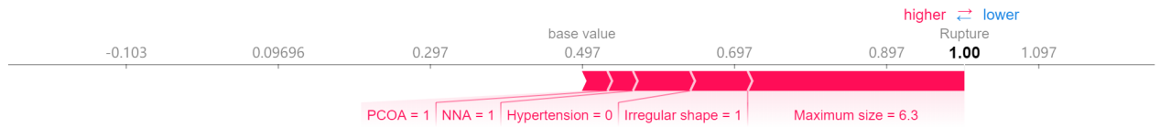
Case 2: true negative prediction
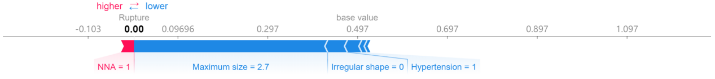
Case 3: false positive prediction
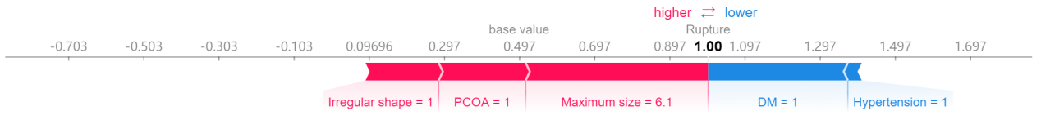
Case 4: false negative prediction
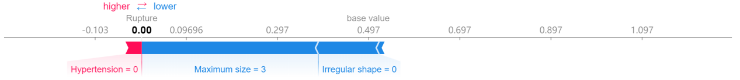

Supplemental Fig.1 Results of using SHAP algorithm to provide model interpretation for the SVM model. Two correctly predicted patients [patient 1 that predicted as true positive (ruptured IA) and patient 2 that predicted as true negative (unruptured IA)] and two incorrectly predicted patients [patient 3 that predicted as false positive and patient 4 that predicted as false negative] were applied to make model interpretation. In this figure, features connected to red bar tend to predict the rupture of IAs, while features connected to blue bar tend to predict that IAs will not rupture. The contribution of feature to prediction result was expressed by the length of the color bar, and its SHAP value was plotted in parentheses.

