Conformational Flexibility Enables Optimized Vaccine-TLR4 Recognition
Normal mode analysis revealed that our vaccine construct exhibits patterns of positional flexibility that address the fundamental challenge of achieving both stable receptor engagement and adaptive molecular recognition. The deformability profile across the vaccine-TLR4 complex (Figure 1) shows a pronounced flexibility peak at an atom index of ~700, reaching 1.0, located at the TLR4-vaccine interface. This peak represents a 5-fold increase over the baseline deformability (0.2) observed across stable structural regions, indicating that the interface region possesses the dynamic range necessary for induced-fit binding while maintaining overall complex integrity.
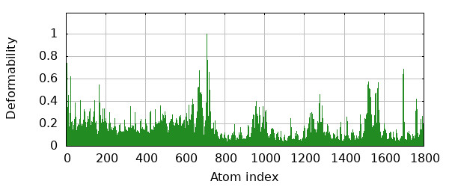
The distribution of additional flexibility peaks at indices ~50, ~650, ~1500, and ~1700 (deformability values 0.4-0.7) reveals a network of hinge regions positioned to facilitate coordinated conformational transitions. These peaks correspond to domain boundaries within both the TLR4 receptor and the homotetramer construct, suggesting that the complex has evolved to permit localized flexibility at functionally critical junctions while preserving structural stability across the majority of the interface (>80% of residues exhibit deformability <0.2).
Figure 1 Deformability Analysis of Vaccine-TLR4 Complex This plot illustrates the main-chain deformability (y-axis, 0-1 scale) across atom indices (x-axis, 0-1800) of the vaccine-TLR4 complex. The first 690 indices represent TLR4, while the remainder corresponds to the homotetramer vaccine construct. Several strategic hinge regions are evident, particularly the prominent peak (~1.0) near index 700 at the TLR4-construct interface, with additional peaks at indices ~50, ~650, ~1500, and ~1700. These flexible regions likely facilitate conformational adaptations during molecular recognition while maintaining overall structural stability.

Energetic Hierarchy Confirms Functional Motion Accessibility
The eigenvalue spectrum analysis (Figure 2) demonstrates that functionally relevant conformational changes occur through energetically accessible pathways. The first normal mode has an eigenvalue of 1.466510e-05, corresponding to the lowest-energy collective motion of the complex. This finding addresses the requirement that functional conformational changes must be thermally accessible under physiological conditions.
The systematic increase in eigenvalues from mode 1 to mode 20 establishes a clear energetic hierarchy in which the most functionally relevant motions (lowest modes) require minimal energy input. This pattern indicates that the vaccine-TLR4 complex naturally samples conformational states that optimize receptor activation through thermally driven motions rather than requiring external energy input.

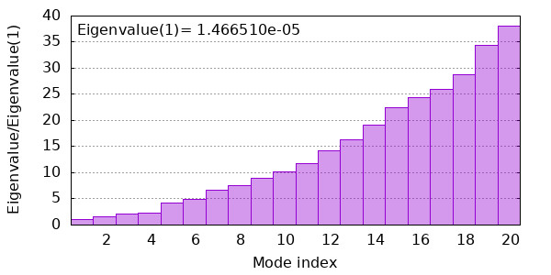
Figure 2 Eigenvalue Spectrum of Normal Modes The histogram depicts eigenvalues (y-axis) for the first 20 normal modes (x-axis) of the vaccine-TLR4 complex. The first mode exhibits the lowest eigenvalue (1.466510e-05), indicating it represents the most energetically favorable deformation pathway. The progressive increase in eigenvalues across higher modes reflects increasingly stiffer motions requiring greater energy to actualize, with the shallow slope between modes 1-10 suggesting multiple accessible low-energy collective motions under physiological conditions.

Variance Distribution Reveals Efficient Functional Dynamics
Variance analysis (Figure 3) quantifies the efficiency of the complex's dynamic behavior, with the first mode alone accounting for 25% of total conformational variance. This concentration of motion in the lowest-frequency mode indicates that a single, coordinated movement dominates the functional dynamics of the vaccine-TLR4 interaction.
The cumulative variance reaches 70% by the sixth mode and approaches 100% by the twentieth mode, demonstrating that a minimal set of collective motions captures the complex's functional repertoire. This finding has direct implications for rational vaccine design: the system's dynamics are governed by a small number of coordinated movements rather than numerous independent fluctuations, enabling predictable and controllable immune activation.

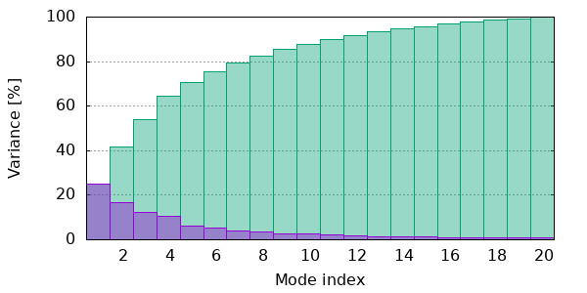
Figure 3: Variance Distribution of Normal Modes This graph shows the individual (purple) and cumulative (green) variance contributions of the first 20 normal modes. The first mode alone accounts for approximately 25% of total motion, with the cumulative variance reaching over 70% by mode six and approaching 100% by mode 20. This distribution indicates that the essential dynamics of the vaccine-TLR4 complex can be efficiently described using a small subset of the lowest-frequency normal modes, with functional movements dominated by a few coordinated, large-amplitude motions.

Correlated Motion Networks Optimize Receptor-Ligand Communication
The covariance analysis (Figure 4tlr) reveals sophisticated dynamic coupling mechanisms that coordinate molecular recognition events across the vaccine-TLR4 interface. The intense red diagonal (coordinates 0,0 to 700,700) demonstrates that TLR4 moves as a cohesive unit, with robust internal correlation in the N-terminal domain (residues 1-200), ensuring coordinated receptor conformational changes.
The checkerboard pattern in the upper right quadrant (residues 800-1800) indicates that our homotetramer construct maintains coordinated motion within individual chains while exhibiting strategic anti-correlation between chains. This pattern enables the construct to present multiple epitopes while maintaining conformational flexibility for optimal receptor engagement.
Critical inter-domain coupling between TLR4 and the vaccine construct is evidenced by the mixed blue and red patterns in off-diagonal regions (coordinates 200-600 vs 800-1200). The anti-correlated motions (blue areas) facilitate induced-fit conformational changes, while correlated motions (red regions) ensure synchronized activation. This balanced coupling mechanism enables the complex to achieve optimal molecular recognition while maintaining signaling fidelity.

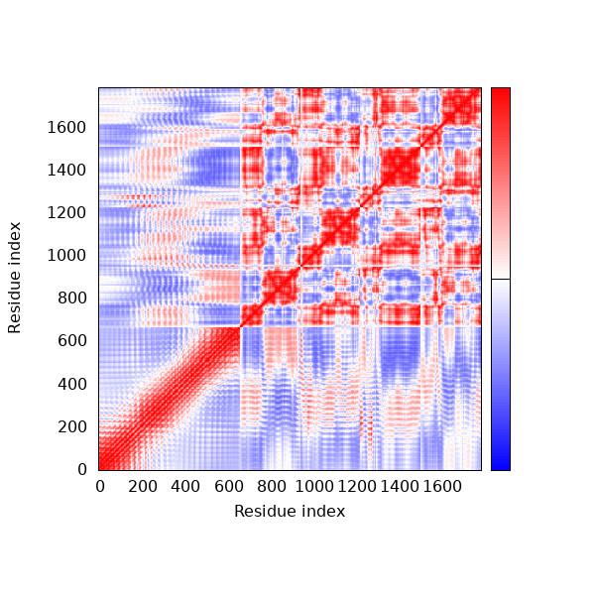
Figure 4: Covariance matrix revealing correlated (red), uncorrelated (white), and anti-correlated (blue) motions between residue pairs.

Elastic Network Architecture Balances Flexibility and Stability
The elastic network analysis (Figure 5) reveals the structural basis for the complex's functional dynamics through its pattern of spring connections. The dense diagonal population represents strong local connections that maintain fold integrity, while strategic off-diagonal clusters indicate long-range interactions that coordinate functional motions.
The varying spring stiffness values (0-60 scale) demonstrate a precisely tuned network where rigid connections (high stiffness) maintain structural integrity while flexible connections (low stiffness) permit functional conformational changes. Inter-domain springs between TLR4 and the vaccine construct, though fewer in number than intra-domain connections, exhibit carefully calibrated stiffness values that enable adaptive binding while preventing excessive flexibility that could compromise signaling.
This balanced network architecture provides the structural foundation for the complex's ability to achieve both molecular recognition specificity and conformational adaptability—properties essential for effective vaccine-induced immune activation.

Integrated Dynamic Profile Supports Rational Design Strategy
The convergent findings from deformability, eigenvalue, variance, covariance, and elastic network analyses establish that our vaccine construct achieves optimal TLR4 engagement through strategically positioned flexibility patterns. The concentration of high-amplitude, low-energy motions at the receptor-ligand interface, combined with coordinated inter-domain coupling and balanced network architecture, creates a system optimized for both molecular recognition and immune activation.
These dynamic properties address the fundamental challenge in vaccine design: achieving potent receptor binding while maintaining the conformational flexibility necessary for signal
Figure 5: Elastic Network Model of the Vaccine-TLR4 Complex This map displays the spring connections between atom pairs throughout the structure, with gray dot intensity representing spring stiffness (scale 0-60). The dense population along the diagonal represents strong local connections maintaining fold integrity, while off-diagonal patterns indicate long-range interactions coordinating movements between distant regions. Particularly notable are the distinct connection clusters between the TLR4 region and vaccine construct, featuring varying spring stiffnesses that likely permit specific adaptive motions while restricting others, supporting optimal molecular recognition while maintaining structural integrity.

Transduction. The quantitative characterization of these motions provides a validated framework for further optimization of vaccine constructs targeting pattern recognition receptors.

