Frailty and the Incidence of Major Ocular Diseases: A Prospective Cohort Study Integrating Proteomic Mediation Analysis

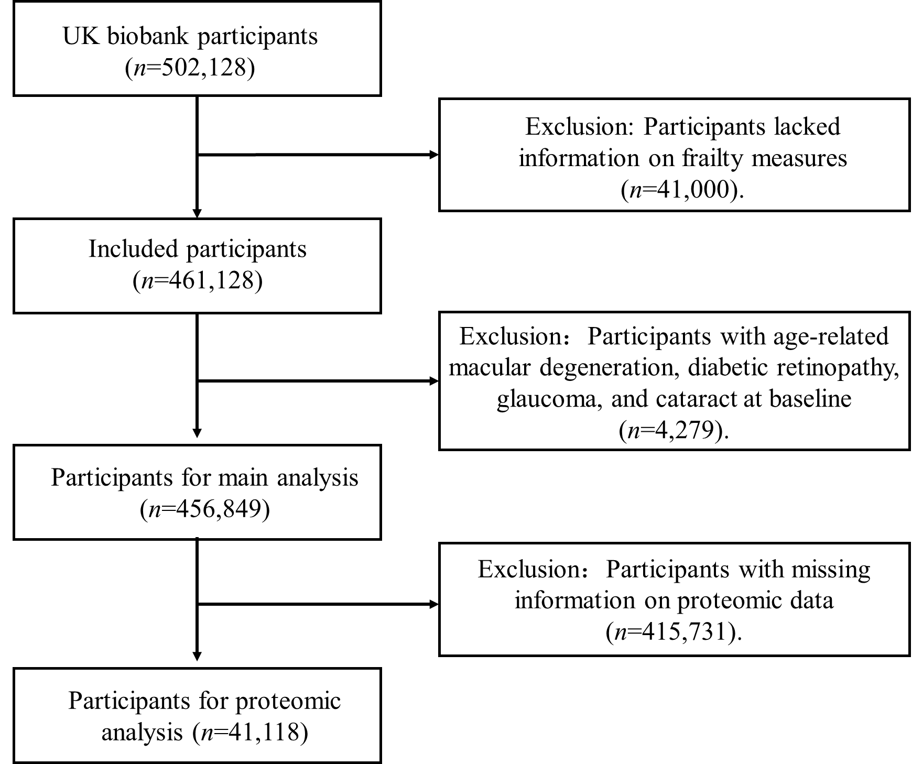
Figure S1. Flowchart of participants included in this study.

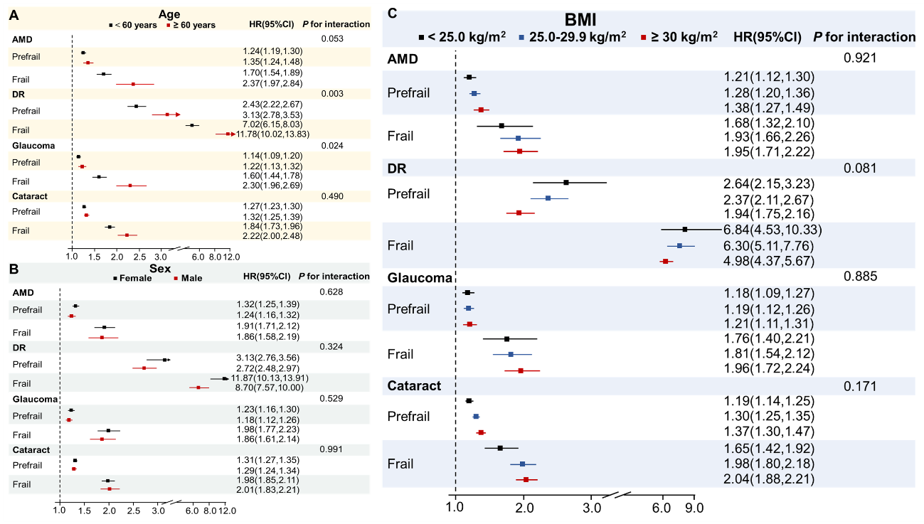
Figure S2. Stratified interaction analyses of the association between frailty phenotype and the incidence risk of four ocular diseases.
(A) Age (<60 years vs. ≥60 years); (B) Sex (female vs. male); (C) BMI (<25 kg/m² vs. 25.0-29.9 kg/m² vs. ≥30 kg/m²). Models were adjusted for age, sex, race and ethnicity, educational level, household income, Townsend deprivation index, body mass index, smoking status, alcohol intake frequency, and metabolic equivalent task. AMD, Age-related macular degeneration; DR, Diabetic retinopathy.
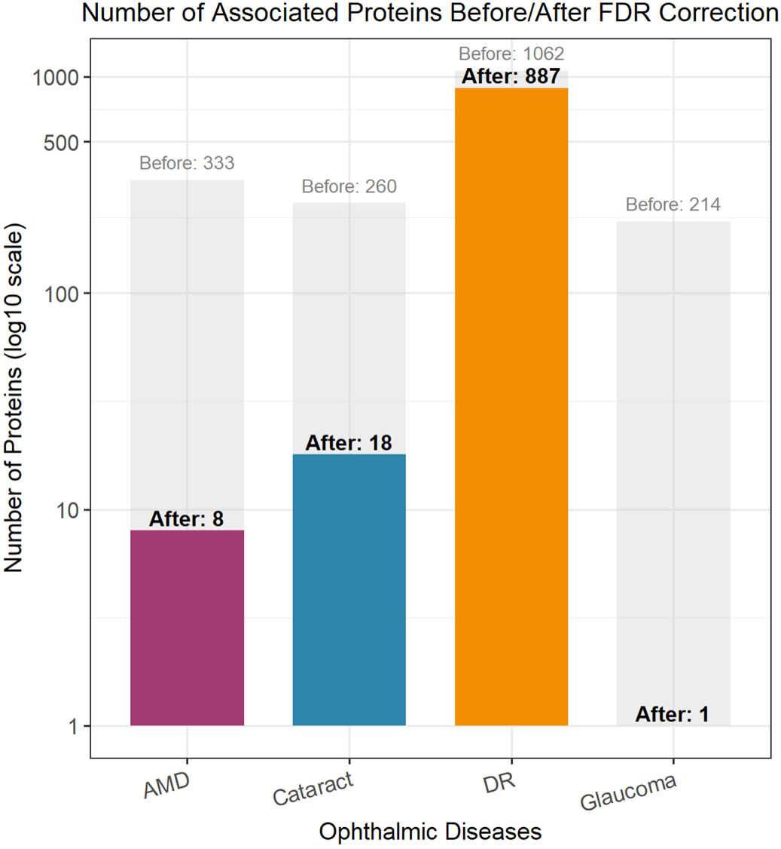
Figure S3. Number of associated proteins before/after FDR correction.

