Image Cytometry and Kinetic Modelling Reveal How Aged Leaf Biomass Dose Regulates Microbial Physiology and PAH Degradation

SUPPLEMENTARY
Model framework:
(1) Logistic Regression
$$P(y=1∣x)=\frac{1}{1+e^{-(β_{0}+\sum_{i=1}^{n}{}β_{i}x_{i})}}$$
This expresses the probability that a cell is viable based on a weighted sum of features (xᵢ).
(2) Support Vector Machine (SVM)
$$f(x)=\text{sign}(w^{T}x+b)$$
Where w is the weight vector and b are the bias term; the SVM seeks a hyperplane that maximizes the margin between viable and debris cells.
(3) Random Forest / Gradient Boosting
$$\hat{y}=\frac{1}{T}\sum_{t=1}^{T}{}h_{t}(x)$$
Both models are ensemble methods; T is the number of decision trees, and hₜ(x) represents each tree’s prediction.
4. For Gradient Boosting:
$$F_{m}(x)=F_{m-1}(x)+ηh_{m}(x)$$
where η is the learning rate and hₘ(x) the weak learner fitted to residuals of previous iterations.

Supplementary Table S1. Quantitative Features Extracted and Representative Metrics Selected for Downstream Analysis
Feature Domain | Extracted Features (Examples) | Correlation Structure | Representative Feature Used in Analysis | Functional Role in Study
Size metrics | Area, perimeter, diameter, major and minor axis lengths | Strong positive correlations among all size metrics | Area | Captures overall cell size; used to distinguish cells from debris
Shape integrity | Circularity, compactness, roundness, solidity | Moderate-to-strong correlations among compactness descriptors | Circularity, Solidity | Quantifies morphological integrity and viability-associated compactness
Shape elongation | Aspect ratio, eccentricity, elongation, axis ratio | Moderate correlations reflecting elongation characteristics | Aspect Ratio | Captures elongation changes linked to stress or debris formation
Boundary complexity | Shape index, perimeter-to-area ratio | Moderate correlations among complexity descriptors | Shape Index | Reflects morphological irregularity under stress conditions
Intensity metrics | Mean intensity, maximum intensity, intensity range, intensity per area | Weak correlations with morphology metrics | Mean Intensity | Indicates fluorescence-derived cellular activity
Focus and image quality | Focus score | Weak or independent correlation relative to morphology and intensity | Focus Score | Ensures segmentation reliability and imaging consistency
Categorical descriptors | Cell type, size class, eccentricity class | Classification outputs rather than numeric correlations | Cell Type (Viable/Debris) | Used for supervised classification and population summaries
Compact summary of extracted quantitative features and representative non-redundant metrics used for downstream statistical and machine learning analyses. Highly correlated features were consolidated to reduce redundancy, retaining representative metrics capturing size, morphology, intensity, and imaging quality characteristics for robust cell-state classification and degradation-performance analysis.

Supplementary Table S2. Morphological features distinguishing viable cells and debris populations.
Feature | Viable Cells (Mean) | Debris (Mean) | p-value | Cohen’s d | Interpretation
Area (px²) | 33.25 | 1328.34 | <0.001 | 0.84 | Debris substantially larger
Perimeter | 26.23 | 862.73 | <0.001 | 0.85 | Debris shows irregular contours
Circularity | 0.67 | 0.18 | <0.001 | 2.39 | Viable cells highly circular
Solidity | 0.63 | 0.47 | <0.001 | 2.22 | Viable cells more compact
Compactness | 0.67 | 0.18 | <0.001 | 2.39 | Strong shape integrity in viable cells
Aspect ratio | 1.91 | 2.02 | <0.001 | 0.16 | Debris slightly more elongated
Notes: Values represent group means derived from image-based measurements. Cohen’s d indicates effect size, with values >0.8 considered large. Shape descriptors provide the strongest discrimination between viable cells and debris.

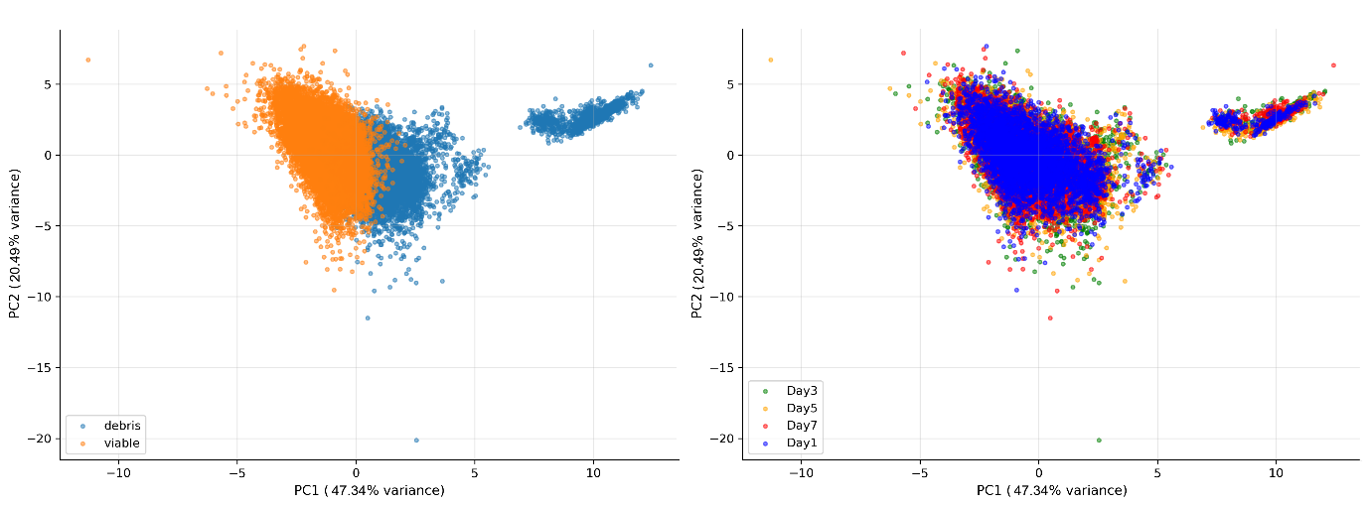
Supplementary Fig. 1 Principal Component Analysis (PCA) of image-derived morphological features distinguishing viable cells and debris populations.
Score plots illustrate separation of events based on the first two principal components derived from morphological descriptors. (A) PCA coloured by cell type demonstrates clear segregation between viable cells and debris, indicating morphology-driven discrimination primarily governed by size and shape characteristics. (B) PCA coloured by sampling day (Days 1–7) shows substantial overlap across timepoints, indicating that morphological separation between populations remains stable over time.

Supplementary Table S3. Interquartile range (IQR)–based thresholds used for automated quality control of segmented cell measurements.
Parameter (representative feature) | Q1 | Q3 | IQR | Lower bound | Upper bound | Mean ± SD
Cell area (px²) | 25 | 82 | 57 | −60.5 | 167.5 | 694.6 ± 2741.8
Circularity | 0.2649 | 0.7256 | 0.4606 | −0.426 | 1.4165 | 0.507 ± 0.313
Solidity | 0.5000 | 0.6531 | 0.1531 | 0.2704 | 0.8827 | 0.583 ± 0.114
Maximum intensity | 2890.31 | 3018.68 | 128.37 | 2697.75 | 3211.24 | 3023.7 ± 221.8
Mean intensity | 438.60 | 445.64 | 7.03 | 428.05 | 456.19 | 444.7 ± 19.6

QC summary (~450,000 cells):
Category | Percentage | Estimated cells
Normal | 70.53% | 317,385
Mild outliers | 25.44% | 114,480
Severe outliers (removed) | 4.03% | 18,135
Cells retained after QC | — | 431,865

Bounds correspond to Q1 − 1.5×IQR and Q3 + 1.5×IQR. Values are reported as mean ± standard deviation (SD). Extrapolation to the full dataset (~450,000 cells) indicates that ~4% of events were removed as severe outliers, retaining over 4.3 × 10⁵ cells for downstream analyses.

Supplementary Table S4. Performance metrics of machine learning models for classification of microbial cell states from imaging flow cytometry data.
Model | Accuracy | Precision | Recall | F1 Score | AUC-ROC
Random Forest | 0.9996 | 0.9994 | 1.0 | 0.9997 | 1.0
Gradient Boosting | 0.9999 | 1.0 | 0.9998 | 0.9999 | 1.0
Logistic Regression | 0.9659 | 0.9712 | 0.9777 | 0.9744 | 0.9948
SVM | 0.9743 | 0.9779 | 0.9837 | 0.9807 | 0.9975

Comparison of supervised classification models trained on morphology- and fluorescence-derived features for discrimination of microbial cell states. Ensemble models (Random Forest and Gradient Boosting) achieved near-perfect performance across all evaluation metrics, while Logistic Regression and Support Vector Machine (SVM) also demonstrated strong predictive capability. Metrics reported include overall accuracy, precision, recall, F1 score, and area under the receiver operating characteristic curve (AUC–ROC), calculated using stratified validation datasets.
Supplementary Table S5. Best-performing machine learning models, optimized hyperparameters, performance metrics, and probability threshold calibration for automated morphological classification tasks in imaging flow cytometry datasets.
Task | Algorithm (Best Model) | Key Hyperparameters | Accuracy / ROC-AUC | PR AUC | Calibration Method | Model File | Threshold (Youden J) | Deployment Threshold (F1-max) | Threshold (Precision ≥ 0.95) | Notes
Viable vs Debris/Dead | Gradient Boosting Classifier | learning_rate = 0.1; n_estimators = 100; max_depth = 3; loss = log_loss; criterion = friedman_mse; random_state = 42 | 99.88% / 1.00 | 1.000 | Platt (Logistic) | model_viable_gb.joblib | 0.9987 | 0.0450 | 0.0002 | Balanced or high-purity classification; best overall model. Excellent separation; intensity and compactness dominant features
Single vs Debris/Aggregates | Random Forest Classifier | n_estimators = 100; criterion = gini; max_features = sqrt; random_state = 42 | 100% / 1.00 | 1.000 | Isotonic Regression | model_single_rf.joblib | 0.3544 | 0.1748 | 0.0000 | Strong separability via size and shape features. Shape and size features drive distinction; no false positives
High vs Low GFP | Random Forest Classifier | n_estimators = 100; max_depth = None; max_features = sqrt; random_state = 42 | 100% / 1.00 | 1.000 | Platt (Logistic) | model_gfp_rf.joblib | 0.7200 | 0.2504 | 0.0637 | Mean intensity fully separates classes; calibration optional
The table summarizes model configurations and evaluation outcomes for three classification tasks: discrimination of viable versus debris/dead cells, single cells versus debris/aggregates, and high versus low GFP fluorescence populations. For each task, the best-performing algorithm, optimized hyperparameters, accuracy, ROC–AUC, precision–recall AUC, and probability calibration methods are reported, together with exported model artifacts and recommended probability thresholds for deployment. Thresholds include those maximizing Youden’s J statistic, maximizing F1-score, and achieving high-precision classification (precision ≥ 0.95) to support flexible deployment scenarios emphasizing balanced performance or high-purity classification. Associated deployment resources are provided in the accompanying package, including trained model files, feature scalers, calibration outputs, inference scripts, and threshold configuration files to enable reproducible and scalable application of morphological classification workflows across imaging flow cytometry datasets.
Abbreviations
- ROC AUC: Receiver Operating Characteristic Area Under Curve
- PR AUC: Precision–Recall Area Under Curve
- Youden J: $\text{max}(\text{TPR}-\text{FPR})$, optimal sensitivity–specificity tradeoff
- Max F1: Threshold yielding highest harmonic mean of precision and recall
- Precision ≥ 0.95: Highest recall while maintaining ≥95% precision

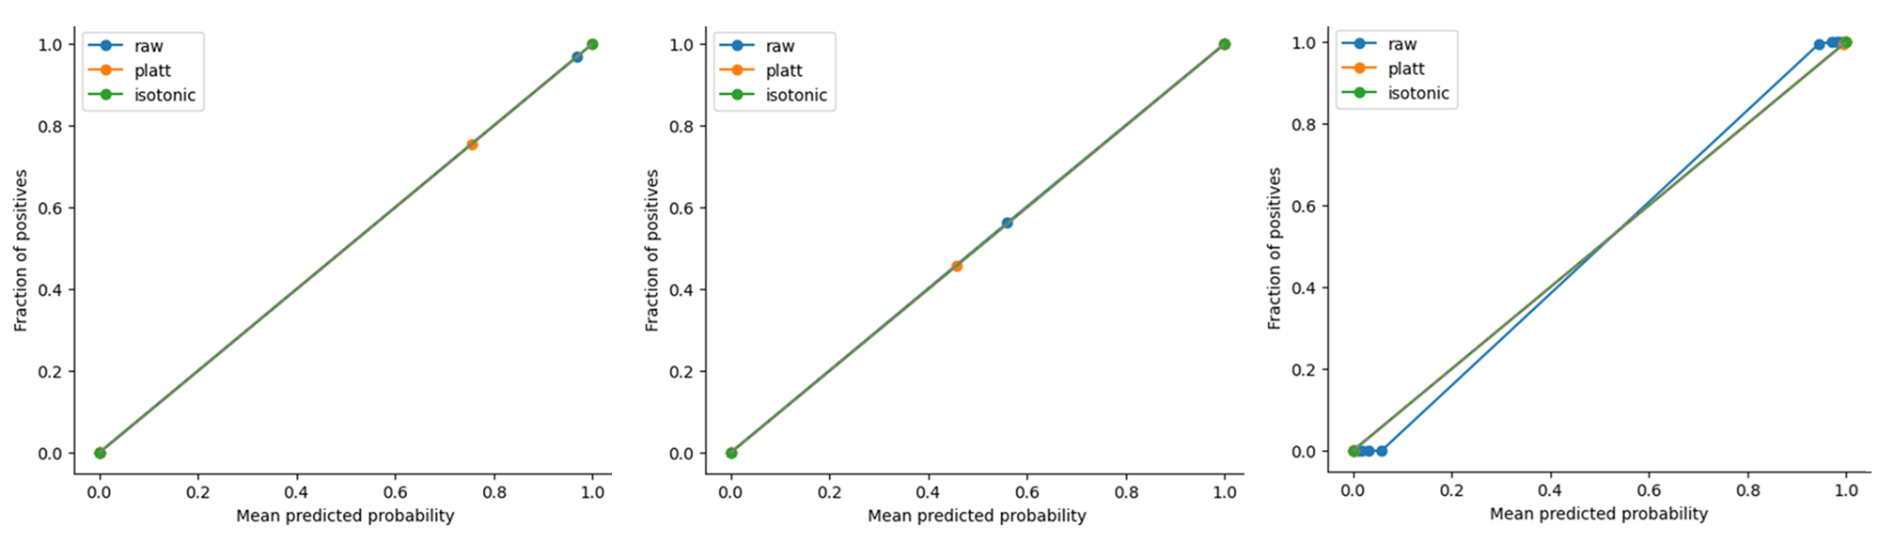
Fig. 2 Reliability diagrams evaluating probability calibration performance across morphological classification tasks.
Reliability curves compare predicted probabilities with observed class frequencies for raw model outputs and after calibration using Platt scaling and isotonic regression. Curves closely following the diagonal indicate well-calibrated predictions. (A) Viable versus debris/dead classification; (B) single cells versus debris/aggregates classification; and (C) high versus low GFP fluorescence classification. Across tasks, both calibration methods maintain or improve probability alignment with observed outcomes, confirming reliable probabilistic outputs suitable for downstream deployment and decision threshold selection.

Supplementary Table S6. Qualitative colony morphotypes observed across treatments and functional microbial groups.
Qualitatives | Asymbiotic | PAH-Bacteria | Actinomycetes | Fungi | Aerobic heterotrophic
CTRL(MSM+NS) | Whitish filamentous - WF | None | None | Green filament - GF; Golden Yeast - GY; Yeast - Y; Filamentous yeast - FY | None
10AL | Whitish filamentous - WF | Creamy mucoid colony – PC1; Transparent cream colony – PC2; Small greenish colony – PC3; Small brownish colony – PC4 | White colony - WC; Pink colony - PC; Golden colony - GC | Pink filament - PF; Green filament - GF; Golden Yeast - GY; Pink Yeast - PY | Tiny/light bluish colony; Big whitish colony; Small yellowish/milkish colony/Light green; Filamentous colony
30AL | Shining colony - SC | Creamy mucoid colony – PC1; Transparent cream colony – PC2; Small greenish colony – PC3; Small brownish colony – PC4 | White colony - WC; Pink colony - PC; Golden colony - GC | Pink filament - PF; Green filament - GF; Golden Yeast - GY; Pink Yeast - PY | Tiny/light bluish colony; Big whitish colony; Small yellowish/milkish colony/Light green; Filamentous colony
70AL | Shining colony - SC | Creamy mucoid colony – PC1; Transparent cream colony – PC2; Small greenish colony – PC3; Small brownish colony – PC4 | White colony - WC; Pink colony - PC; Golden colony - GC | Green filament - GF; Golden Yeast - GY; Pink Yeast - PY; Yeast - Y | Tiny/light bluish colony; Big whitish colony; Small yellowish/milkish colony/Light green; Filamentous colony
AL | Whitish filamentous - WF | Creamy mucoid colony – PC1; Transparent cream colony – PC2; Small greenish colony – PC3 | White colony - WC; Pink colony - PC | Green filament - GF; Golden Yeast - GY; Pink Yeast - PY; Filamentous yeast - FY | Tiny/light bluish colony; Big whitish colony; Small yellowish/milkish colony/Light green; Filamentous colony
SS | None | Creamy mucoid colony – PC1; Transparent cream colony – PC2; Small greenish colony – PC3; Small brownish colony – PC4 | White colony - WC; Pink colony - PC | Pink filament - PF; Green filament - GF | None
Colony colour, texture, and growth morphology were recorded during plate enumeration to document treatment-dependent variation in culturable microbial communities and to guide isolate selection. Distinct morphotypes corresponding to asymbiotic nitrogen fixers, PAH-degrading bacteria, actinomycetes, fungi, and aerobic heterotrophic bacteria are summarized across treatments, highlighting increased morphological diversity in leaf-litter–amended soils relative to unamended and control system.

