Figure S3 Phylogenetic analysis of HM genes.
Figure S3-1 Phylogenetic analysis of T. aestivum, Arabidopsis and rice SDG and PRMT genes.
Figure S3-2 Phylogenetic analysis of H. vulgare, Arabidopsis and rice SDG and PRMT genes.

Figure S3-3 Phylogenetic analysis of S. bicolor, Arabidopsis and rice SDG and PRMT genes.

Figure S3-4 Phylogenetic analysis of S. viridis, Arabidopsis and rice SDG and PRMT genes.

Figure S3-5 Phylogenetic analysis of S. italica, Arabidopsis and rice SDG and PRMT genes.

Figure S3-6 Phylogenetic analysis of Z. mays, Arabidopsis and rice SDG and PRMT genes.

Figure S3-7 Phylogenetic analysis of HDMA and JMJ genes.

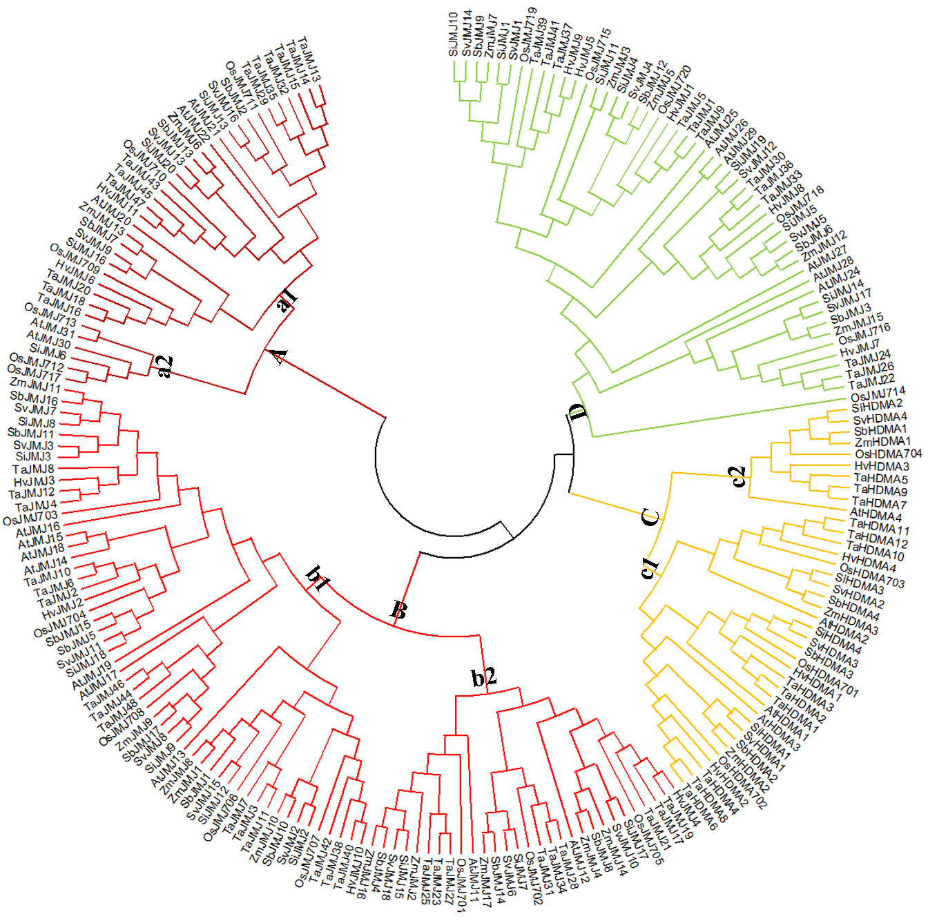
Figure S3-8 Phylogenetic analysis of HAG, HAM, HAC and HAF genes.

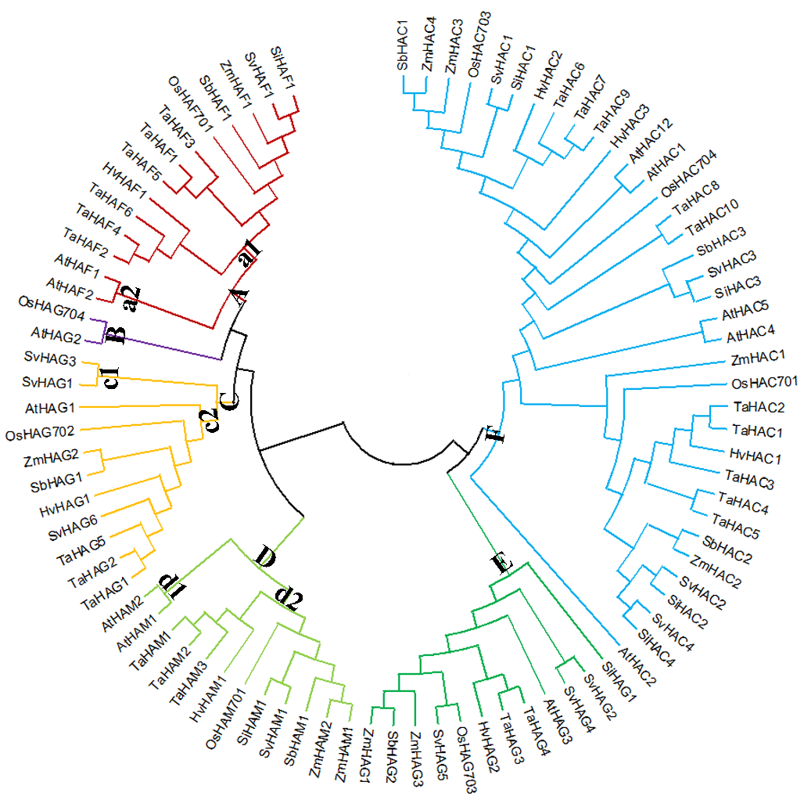
Figure S3-9 Phylogenetic analysis of HDA, SRT and HDT genes

