Figure S1 The chromosome location analysis of HM genes.
Figure S1-1 The chromosome location analysis of T. aestivum HM genes.

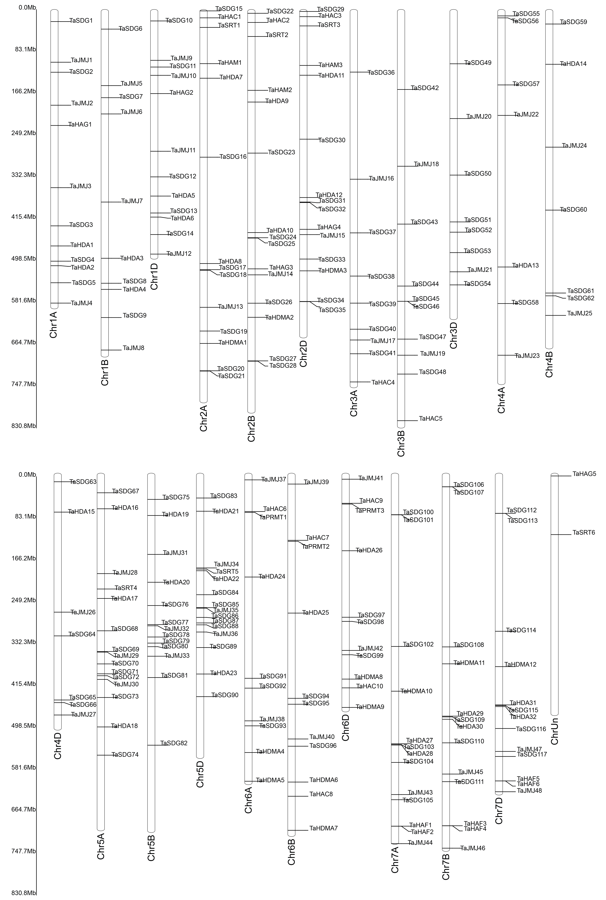
Figure S1-2 The chromosome location analysis of H. vulgare HM genes.

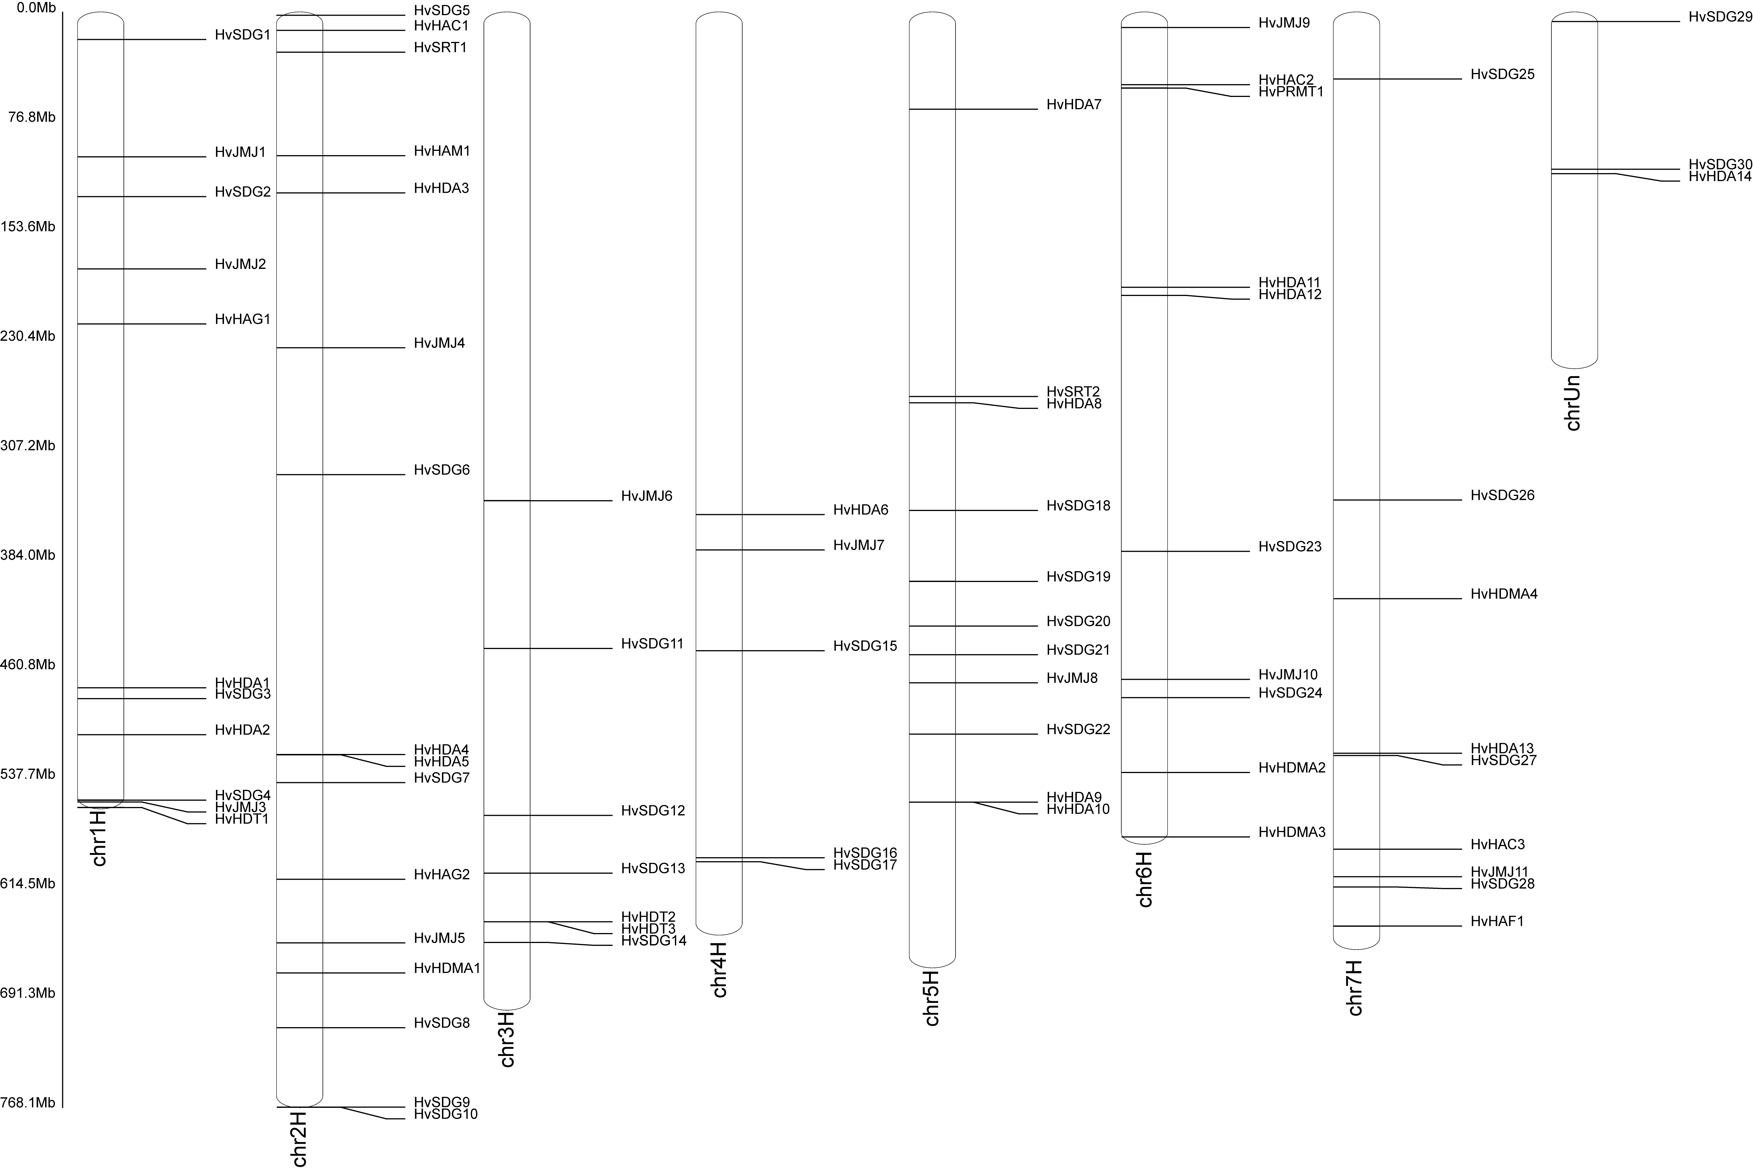
Figure S1-3 The chromosome location analysis of S. bicolor HM genes.

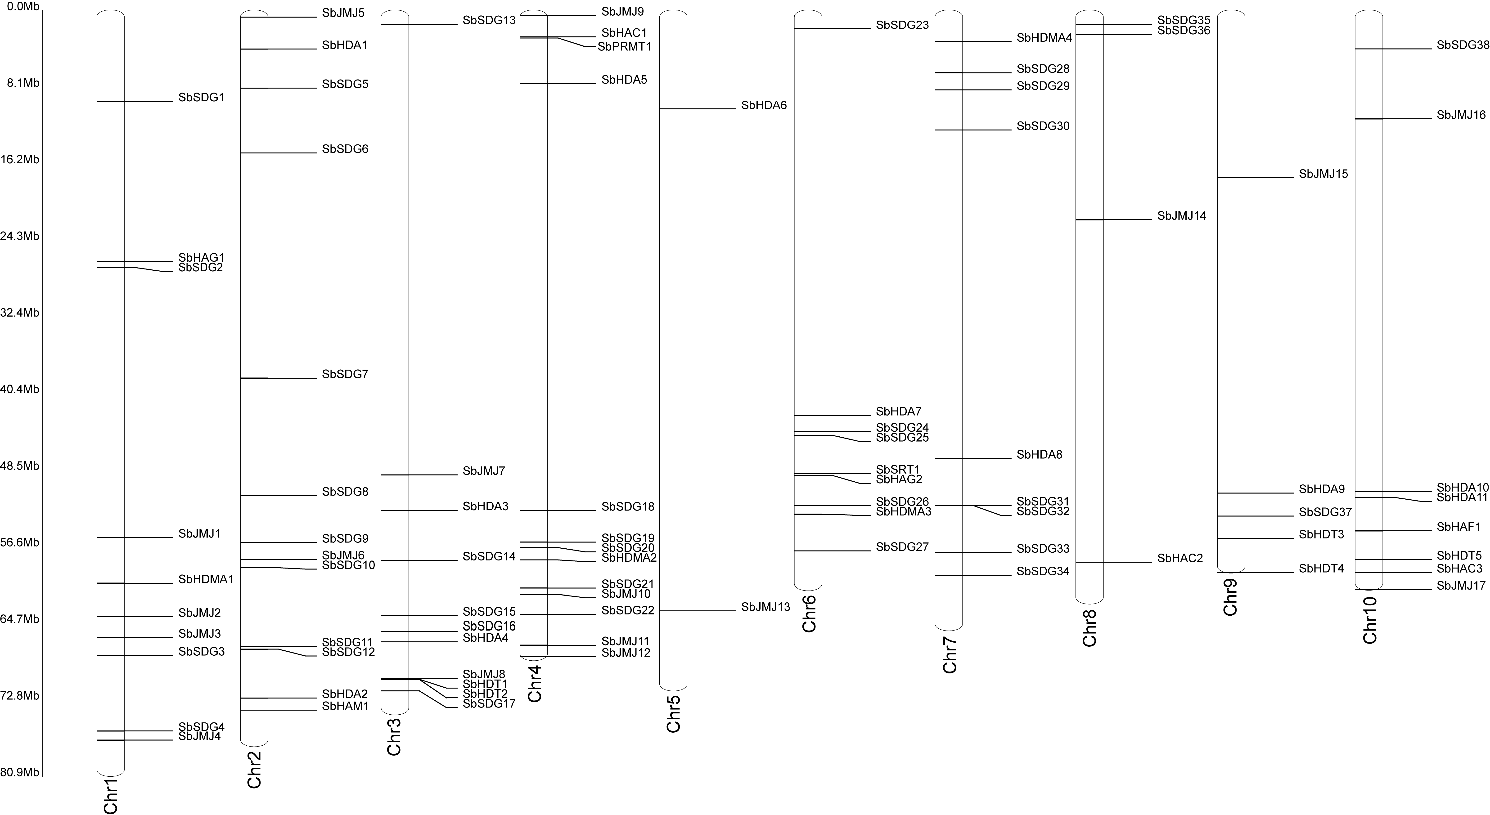
Figure S1-4 The chromosome location analysis of S. viridis HM genes.

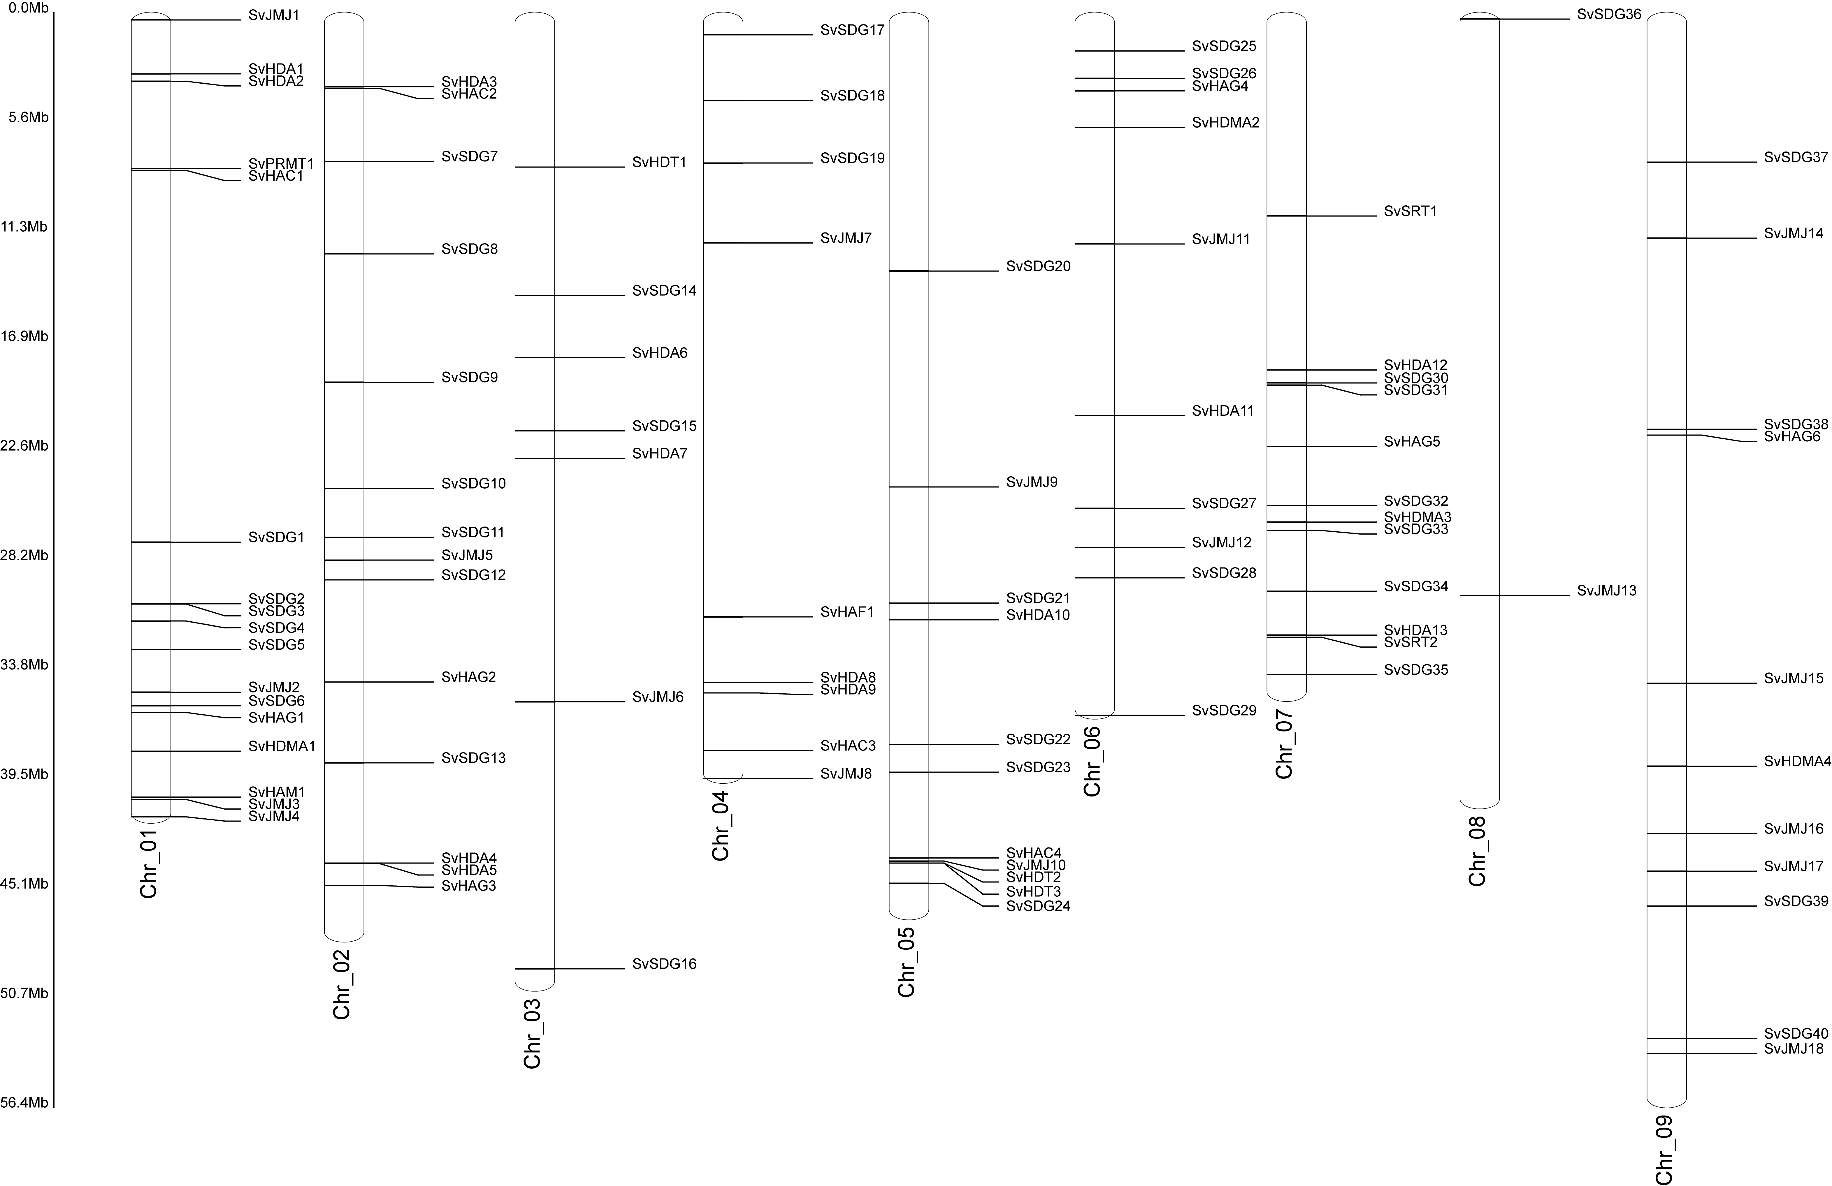
Figure S1-5 The chromosome location analysis of S. italica HM genes.

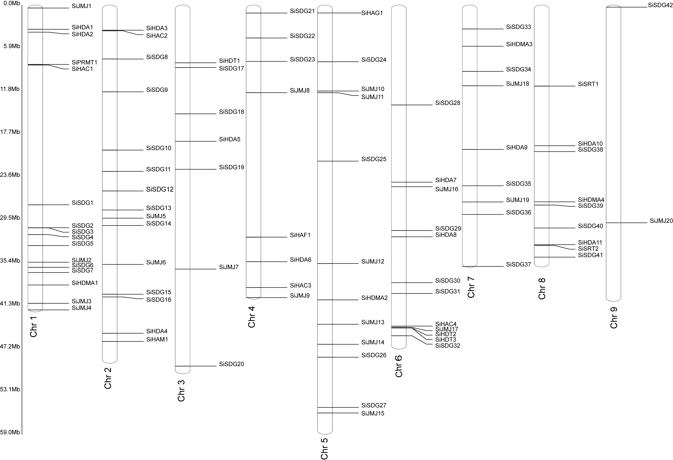
Figure S1-6 The chromosome location analysis of Z. mays HM genes.

