Figure S4 Synteny analysis of each gramineae HMs genes.
Figure S4-1 Synteny analysis of TaHMs genes.
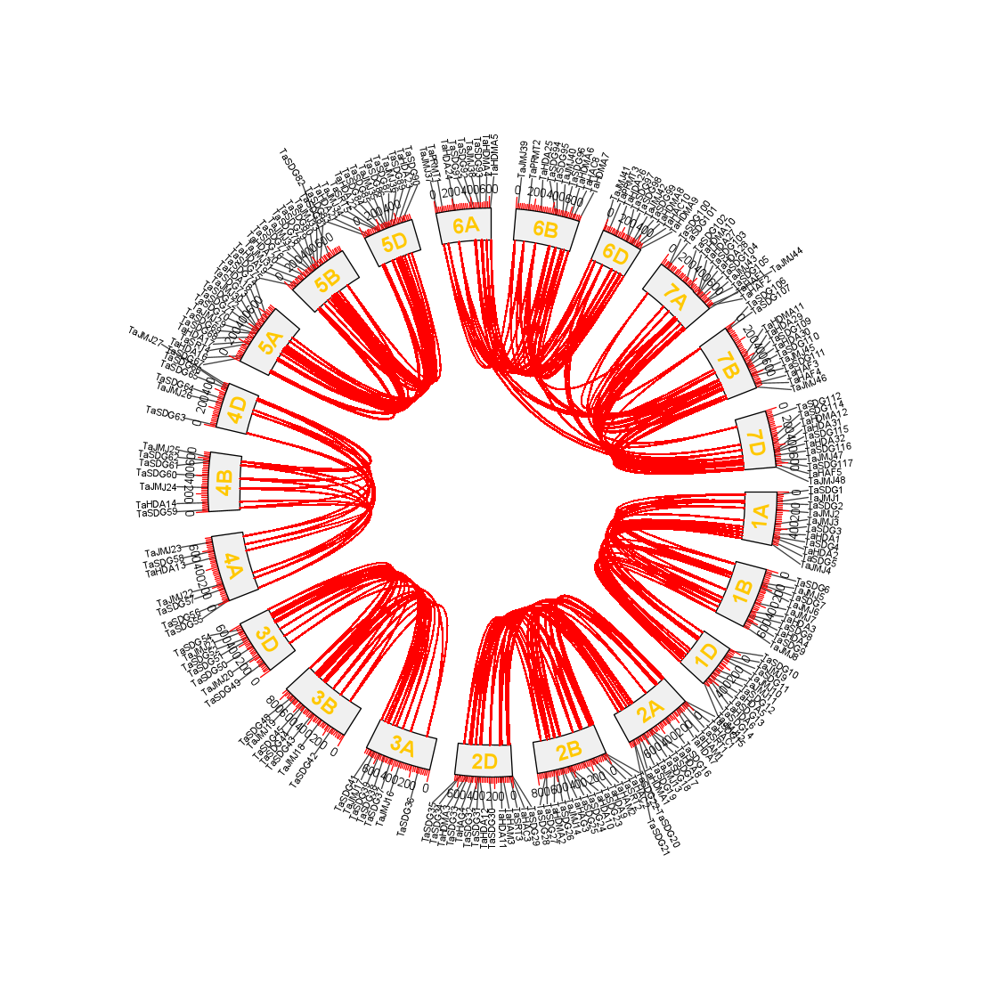
Figure S4-2 Synteny analysis of SbHMs genes.

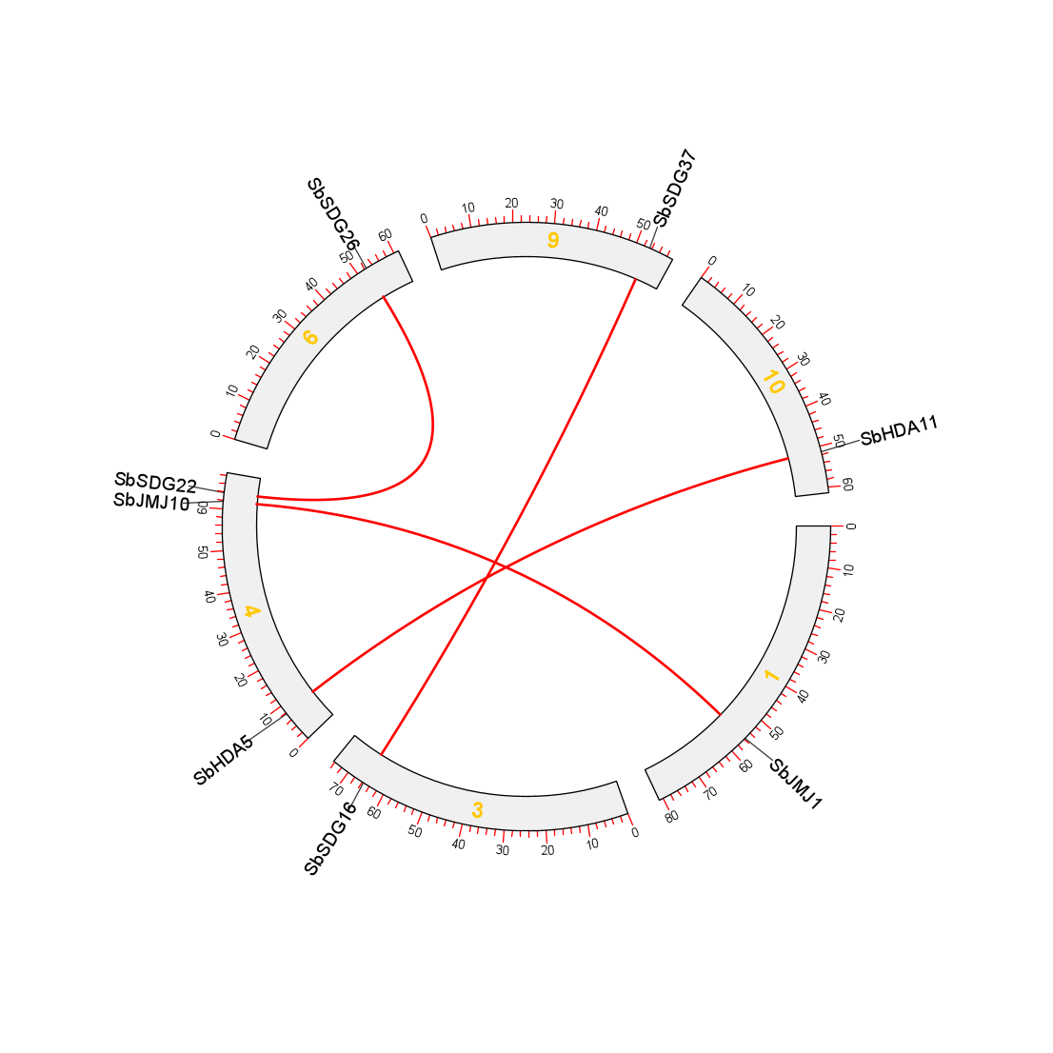
Figure S4-3 Synteny analysis of SvHMs genes.
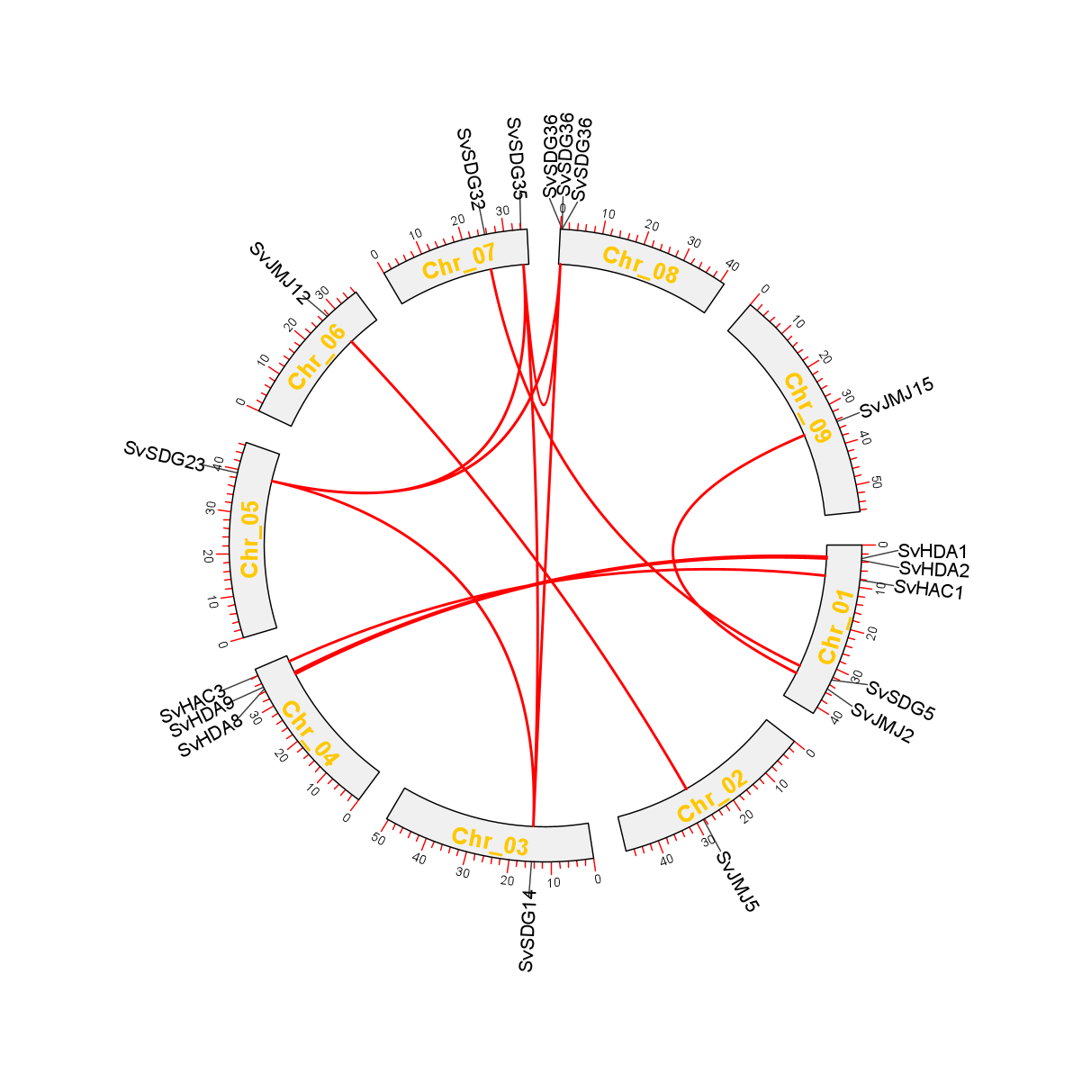
Figure S4-4 Synteny analysis of SiHMs genes.
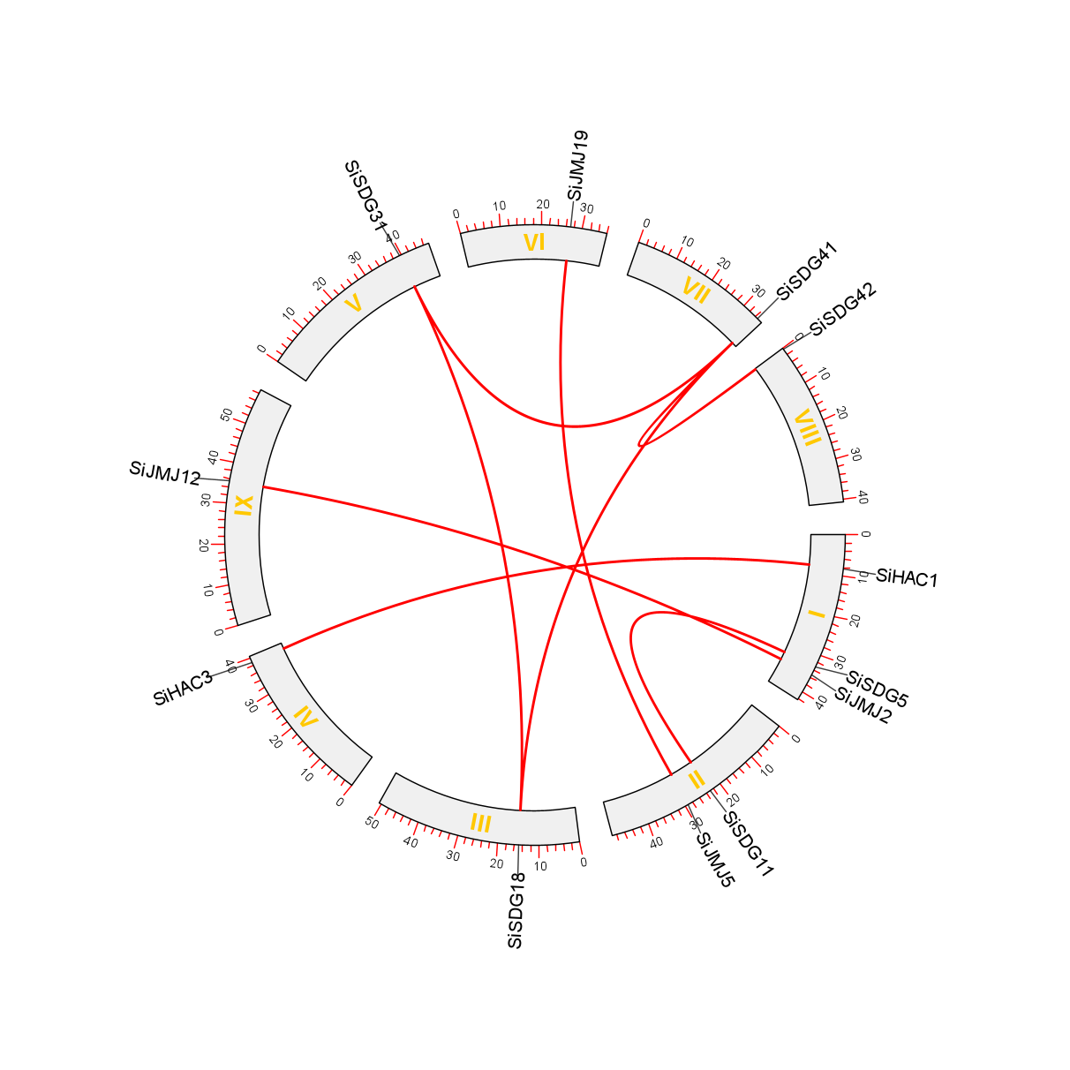
Figure S4-5 Synteny analysis of ZmHMs genes.
