Figure S2 Conserved domain analysis of HM proteins.
Figure S2-1 Conserved domain analysis of Arabidopsis and rice SDG proteins.

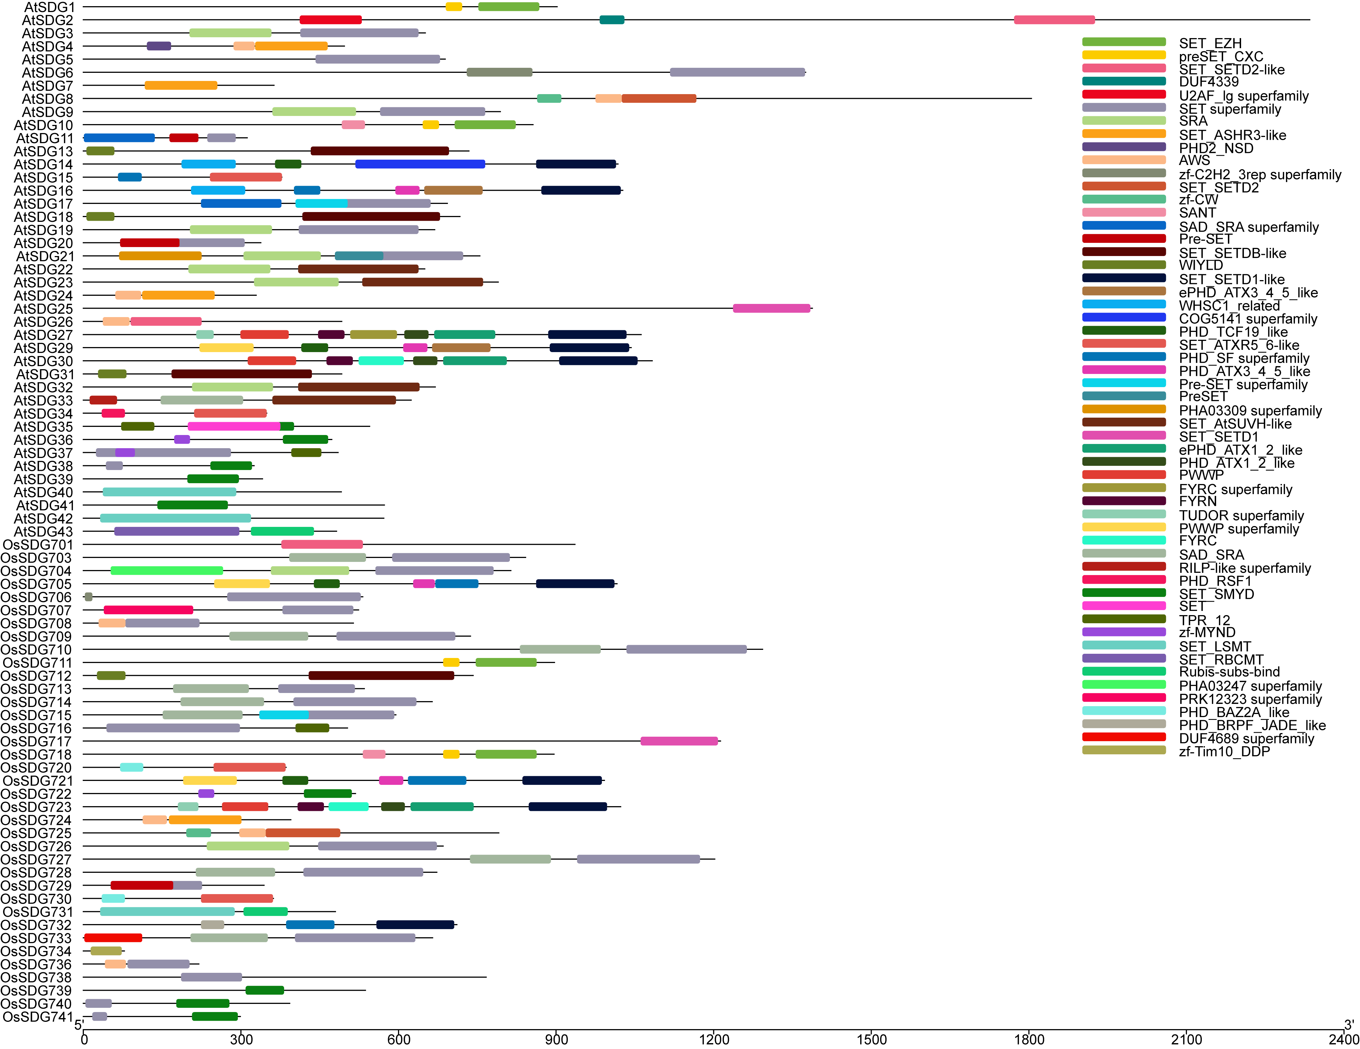
Figure S2-2 Conserved domain analysis of TaSDG proteins.

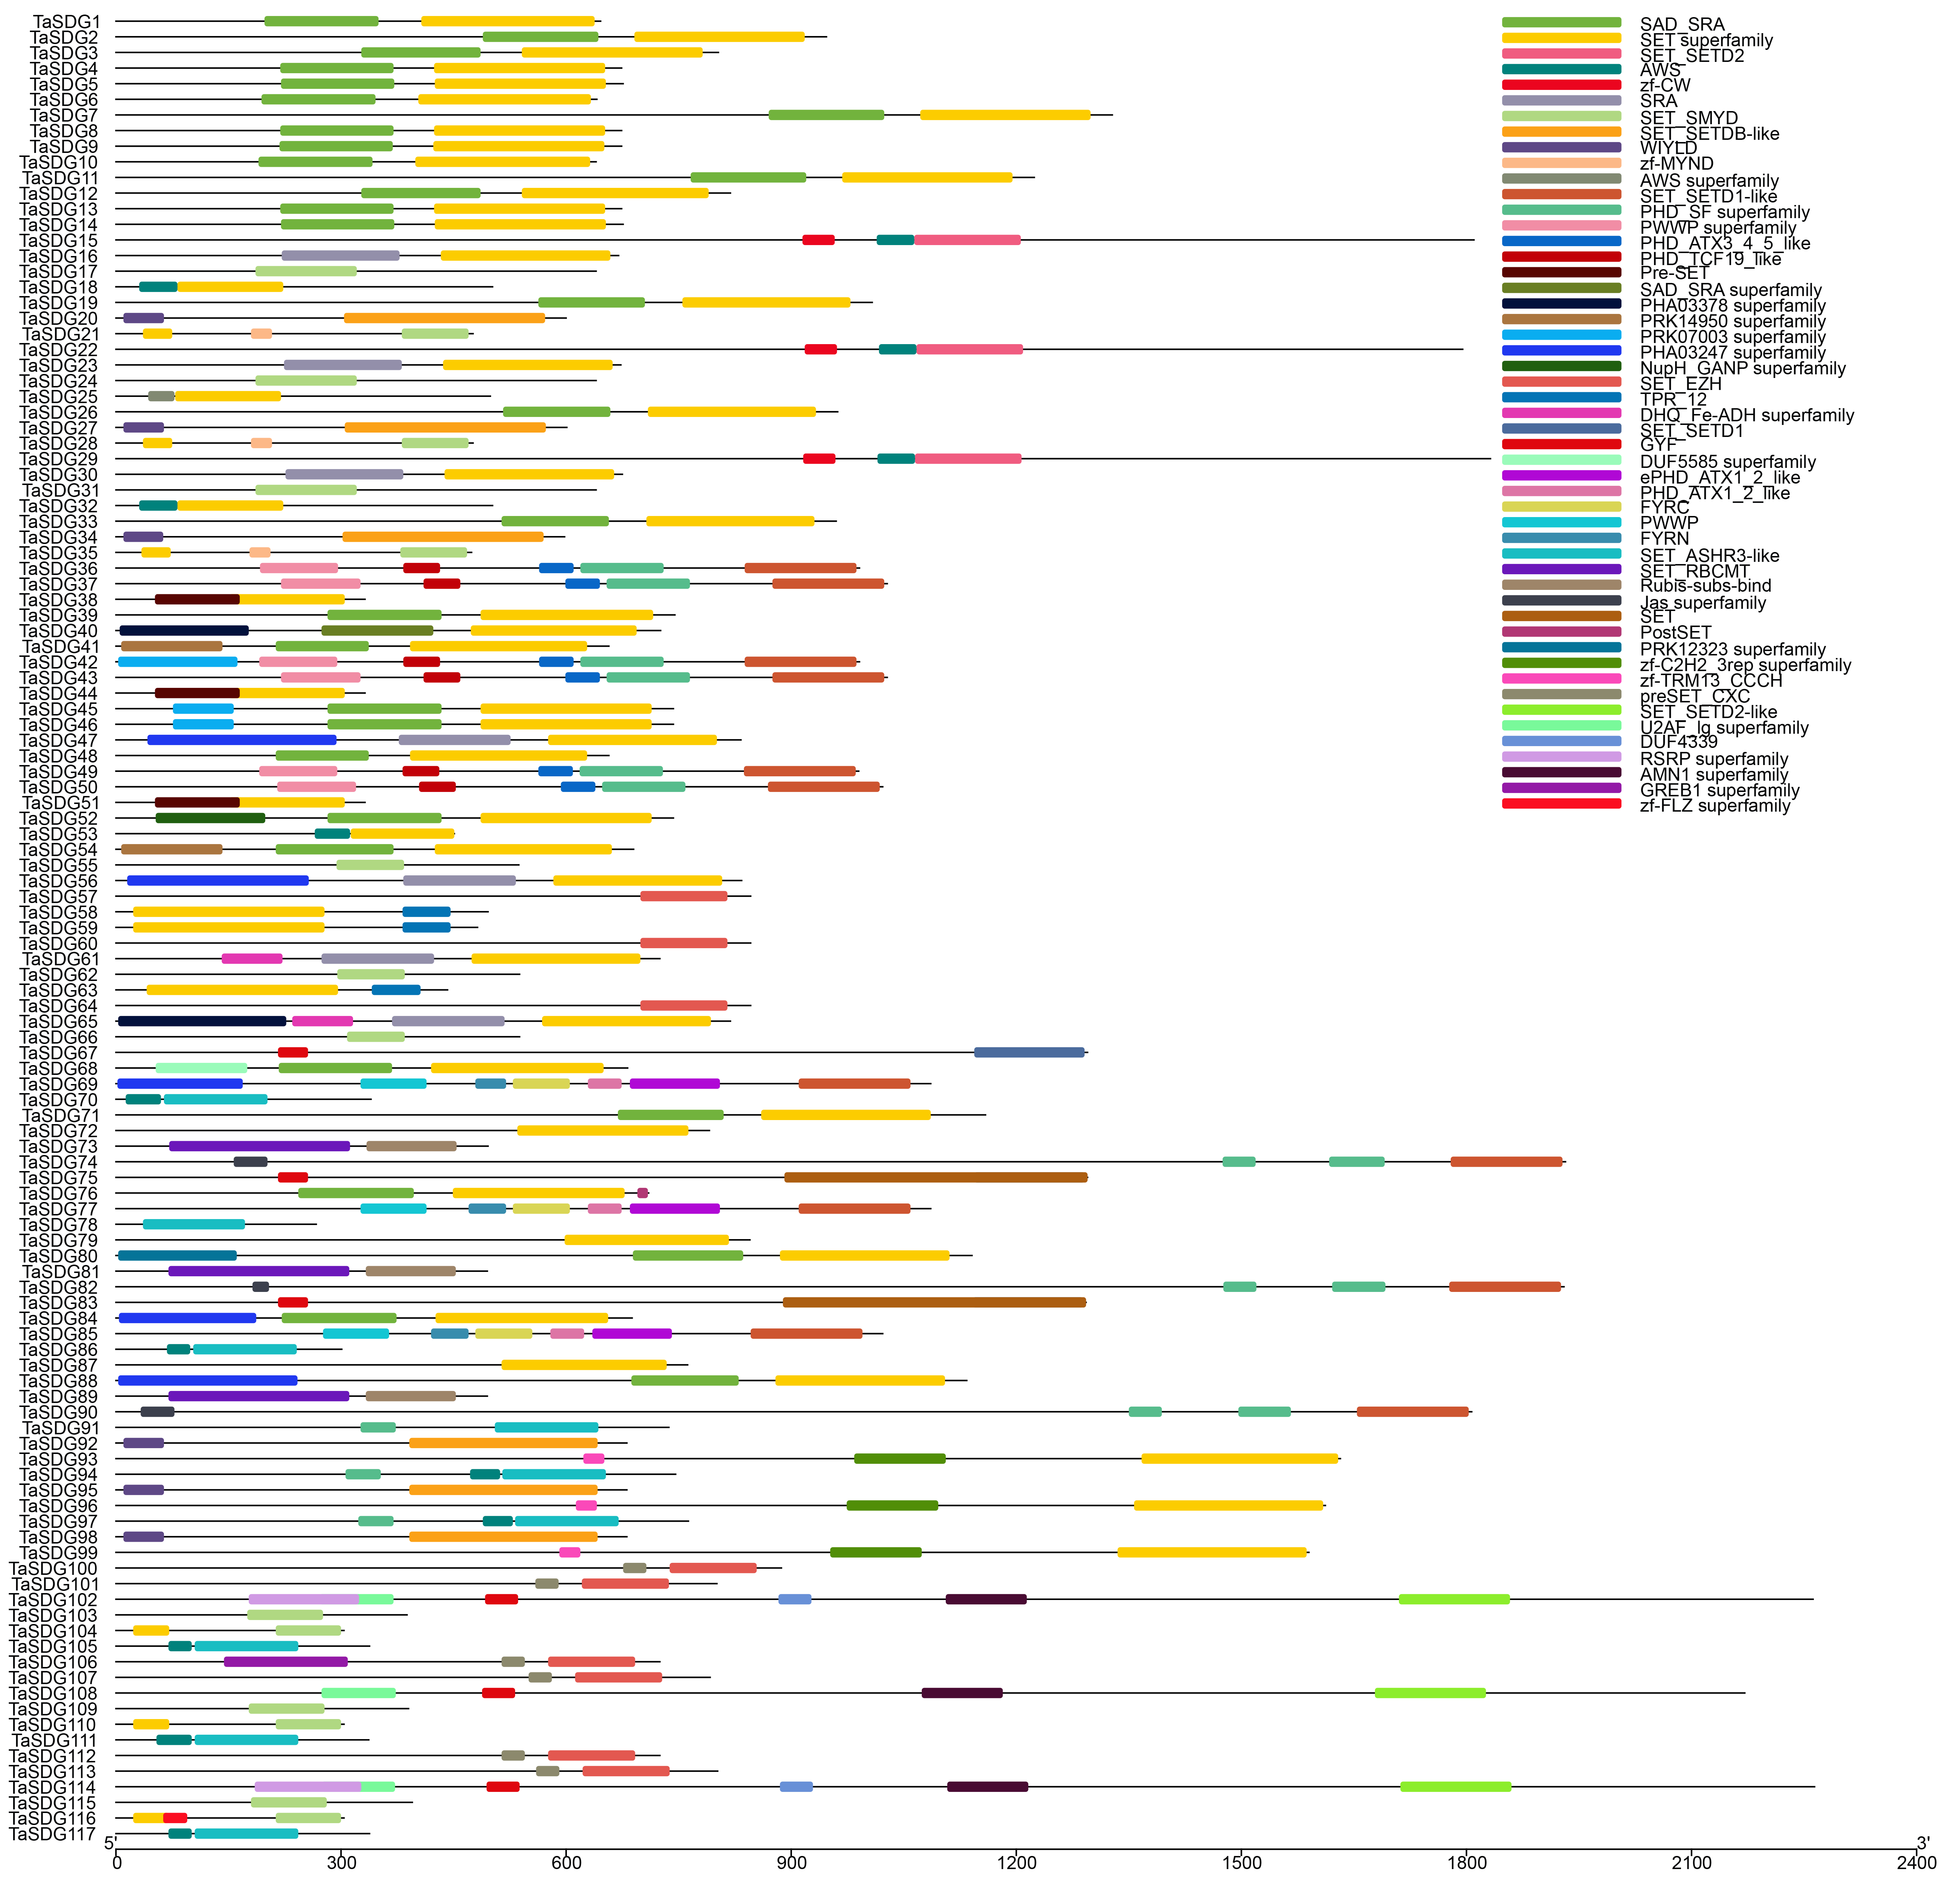
Figure S2-3 Conserved domain analysis of HvSDG proteins.

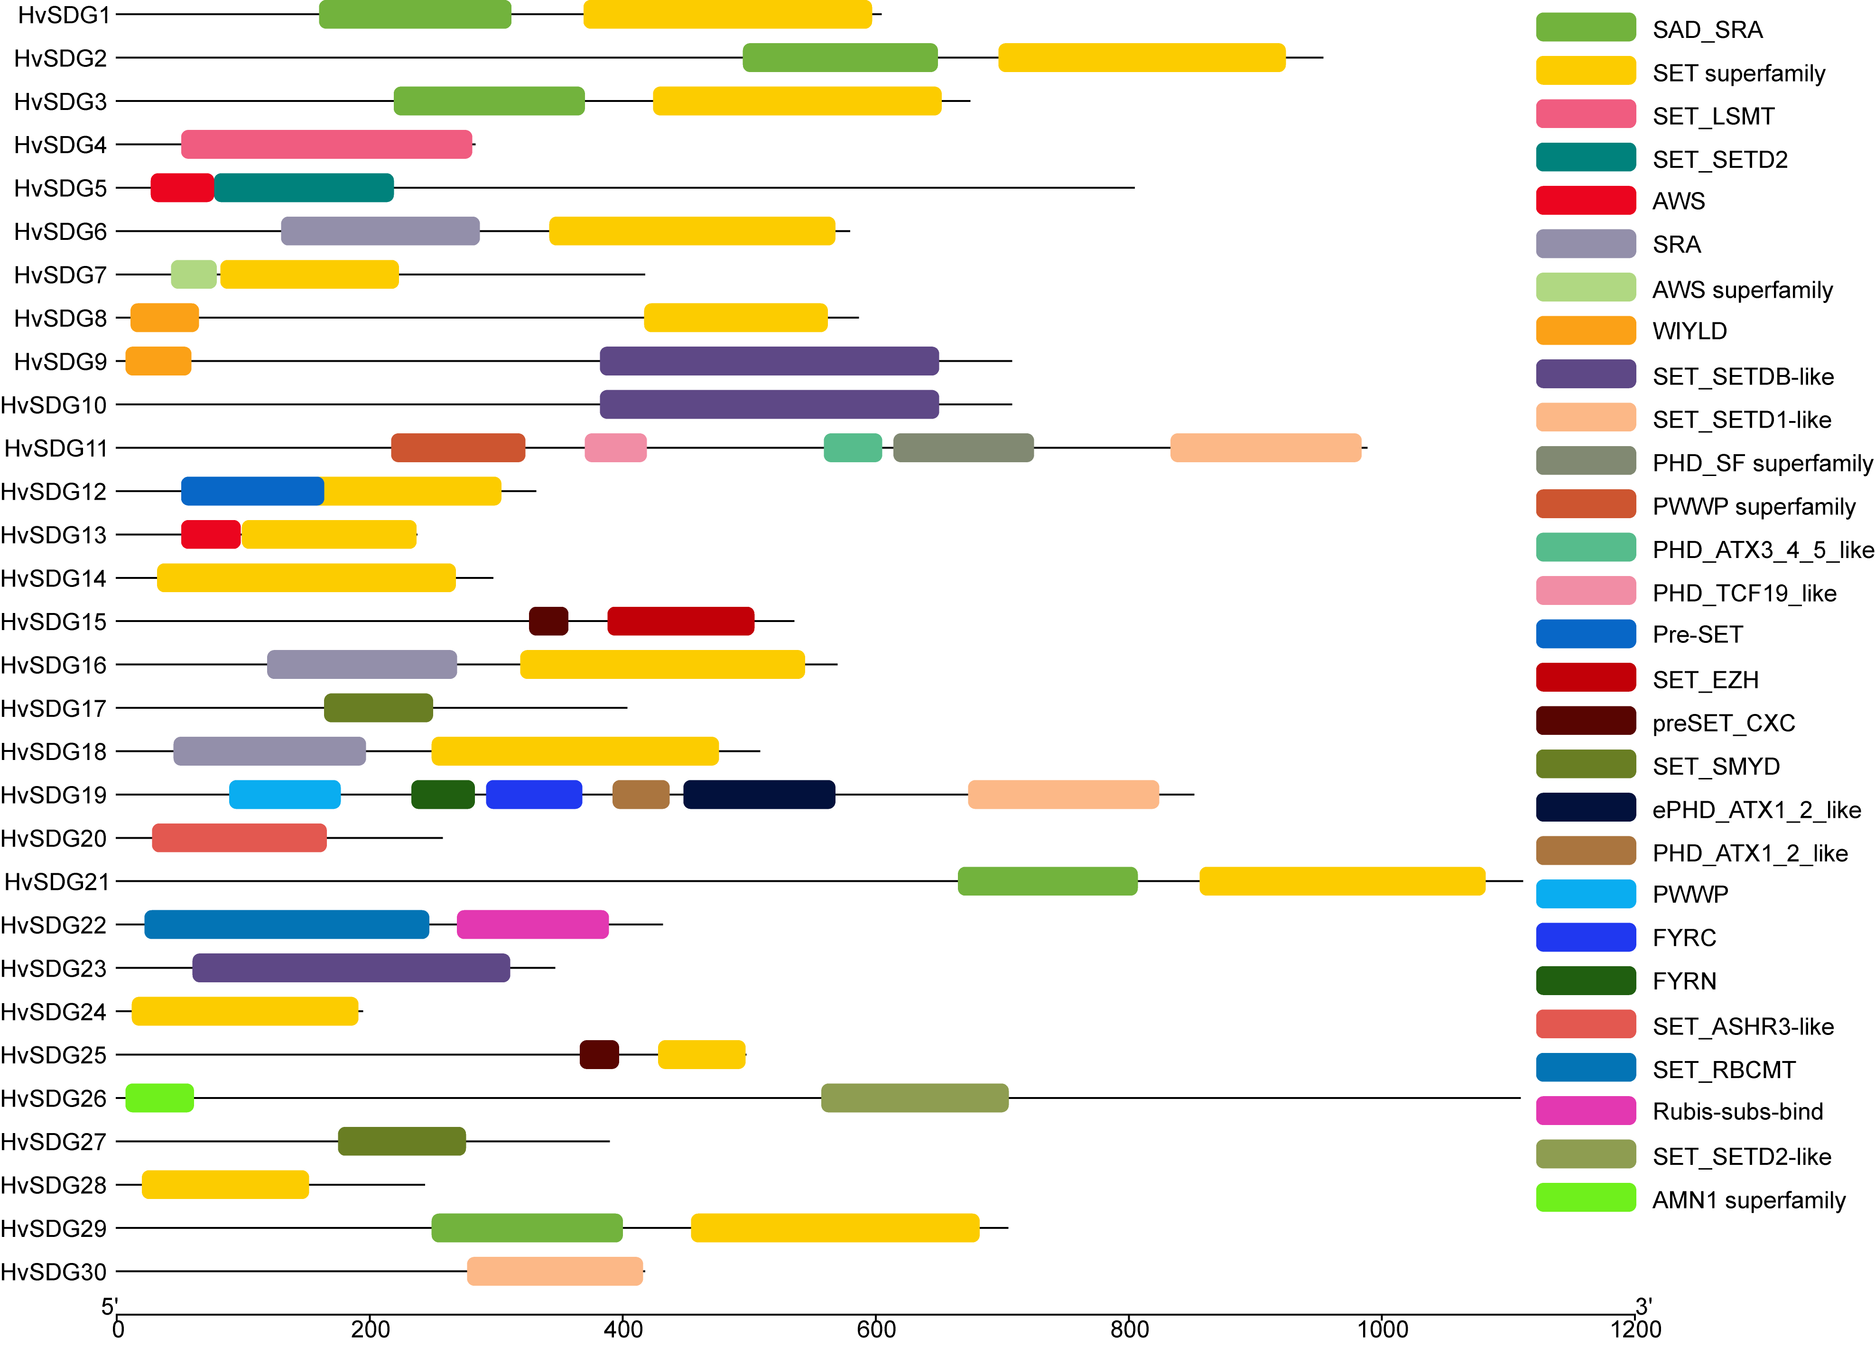
Figure S2-4 Conserved domain analysis of SbSDG proteins.

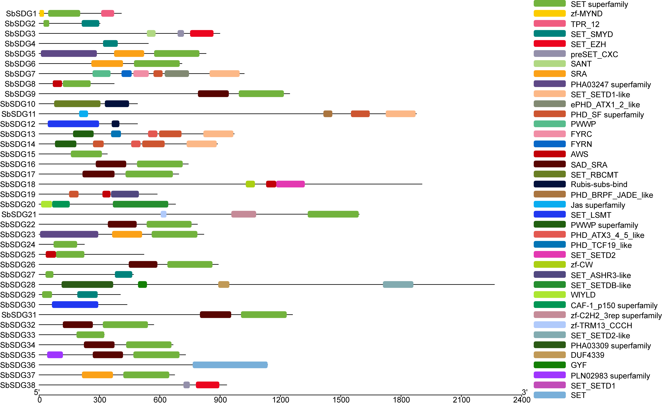
Figure S2-5 Conserved domain analysis of SvSDG proteins.

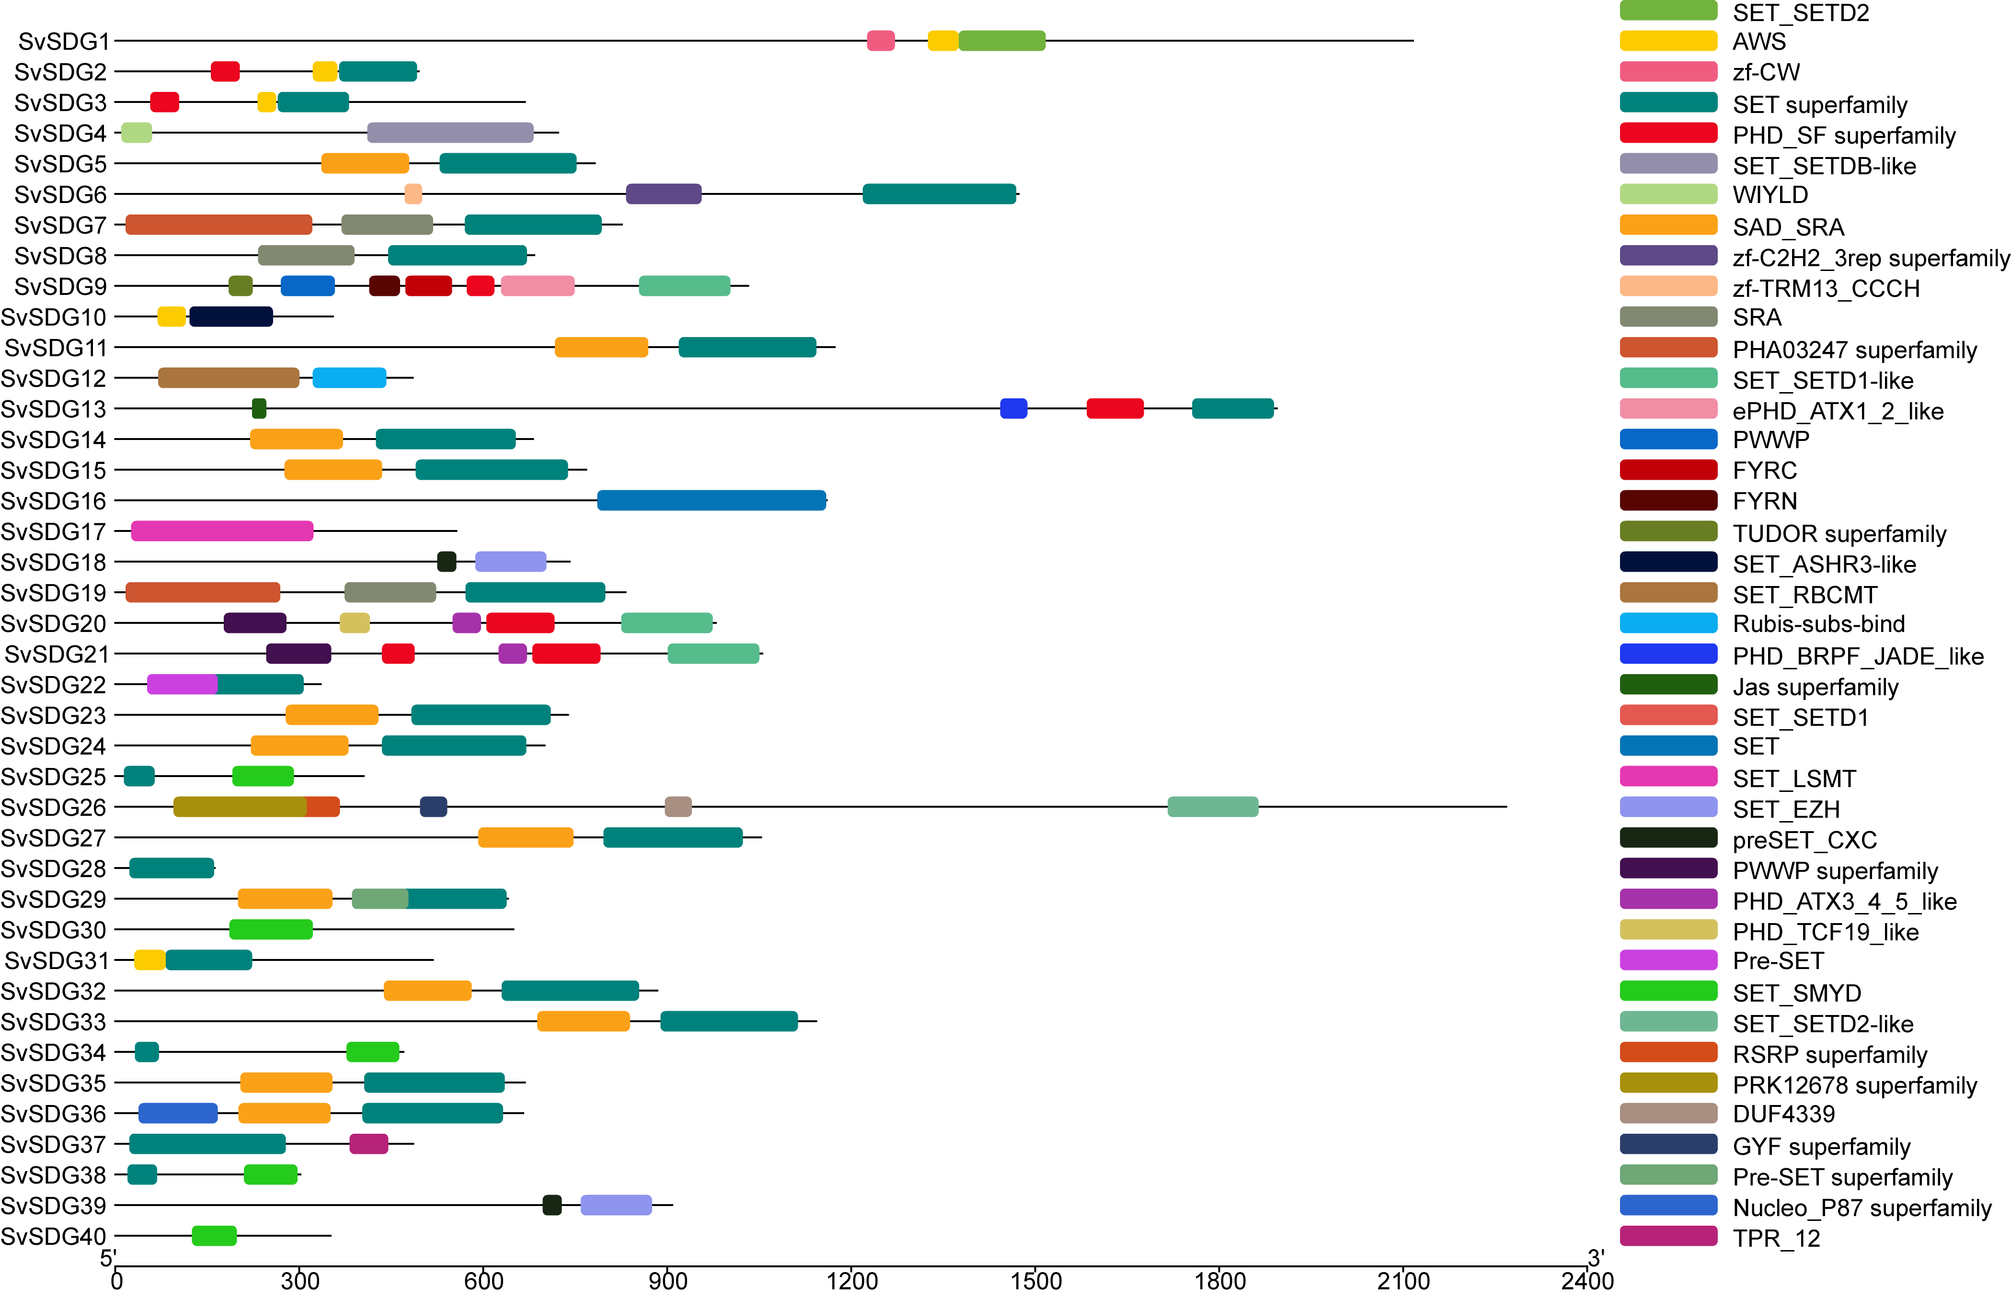
Figure S2-6 Conserved domain analysis of SiSDG proteins.

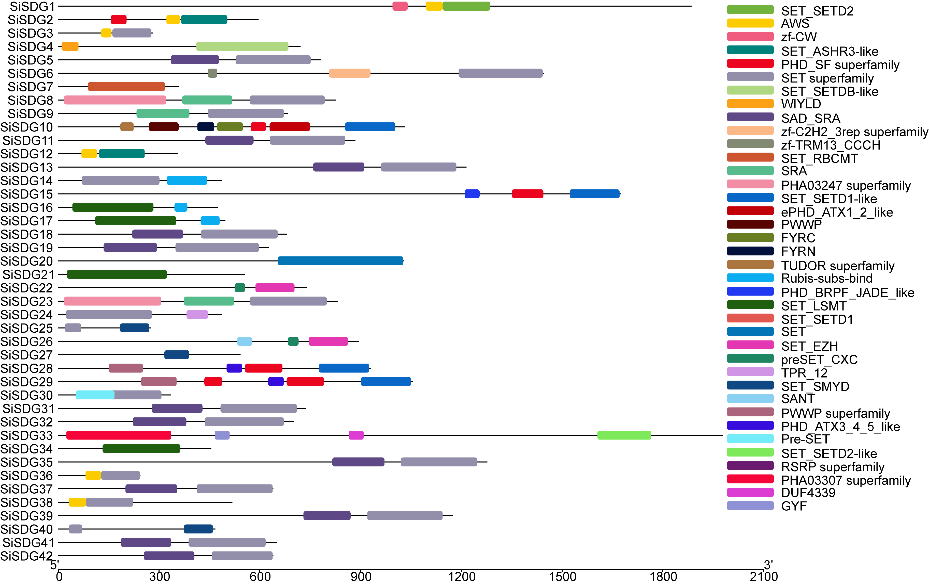
Figure S2-7 Conserved domain analysis of ZmSDG proteins.

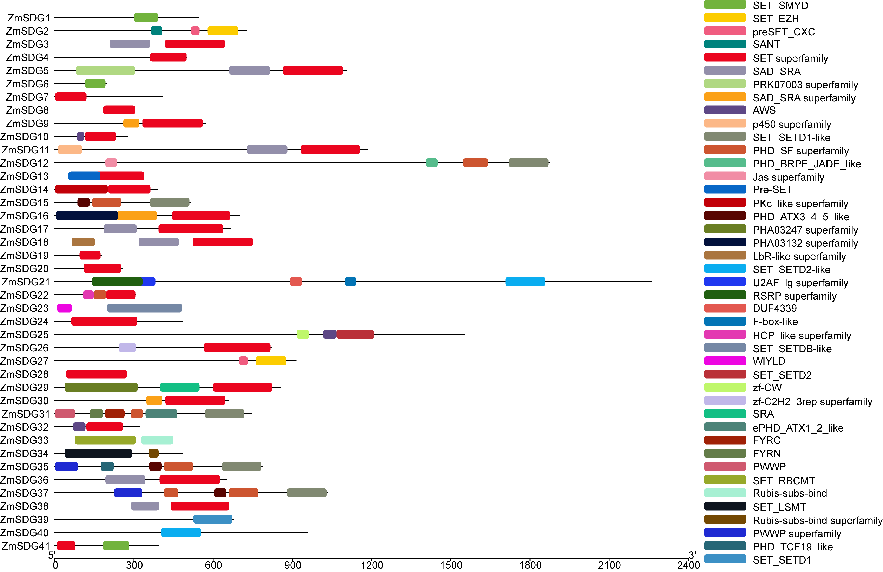
Figure S2-8 Conserved domain analysis of PRMT proteins.

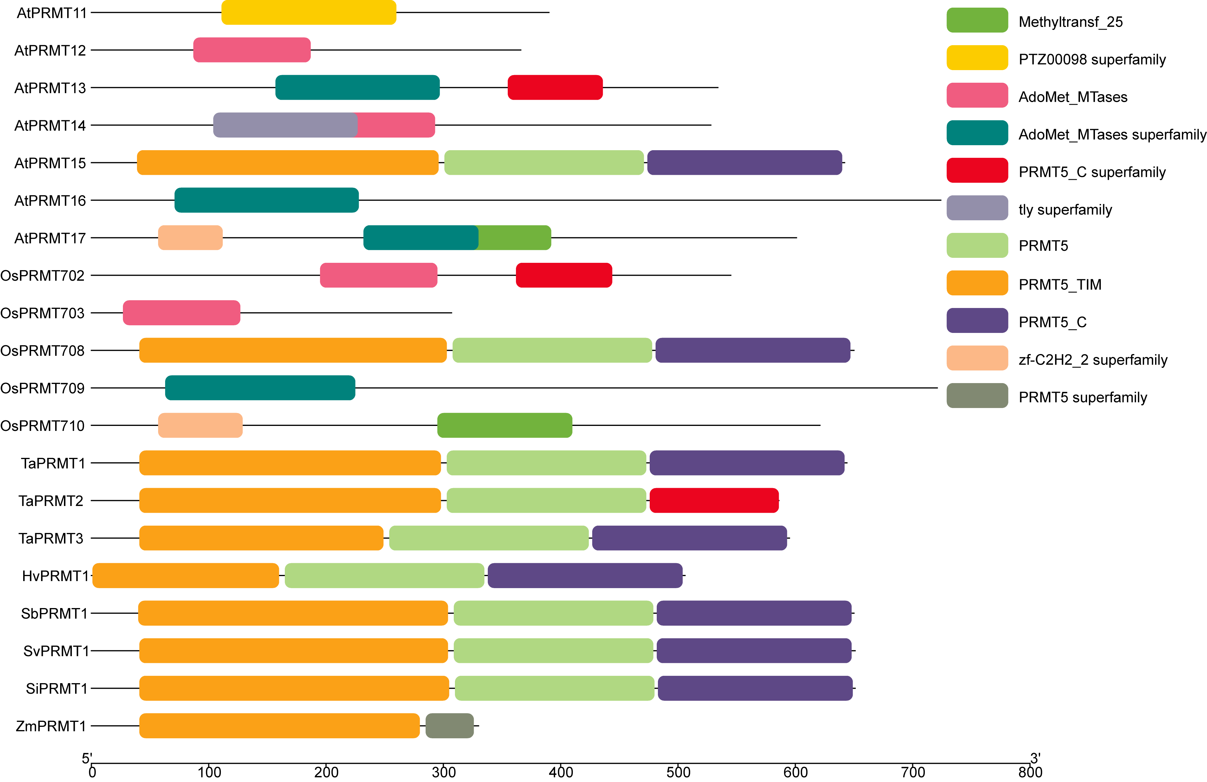
Figure S2-9 Conserved domain analysis of HDMA proteins.

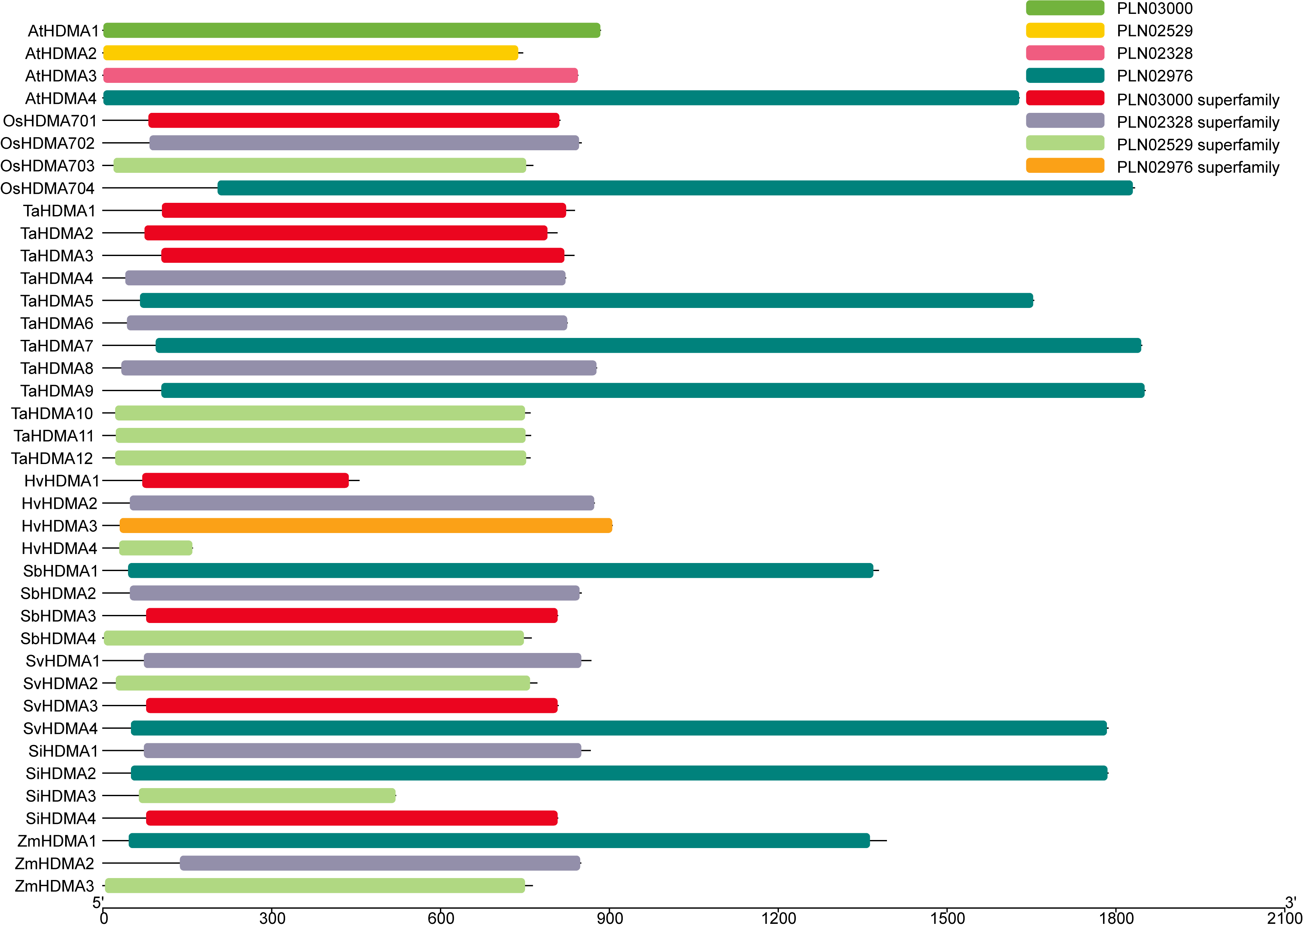
Figure S2-10 Conserved domain analysis of Arabidopsis and rice JMJ proteins.

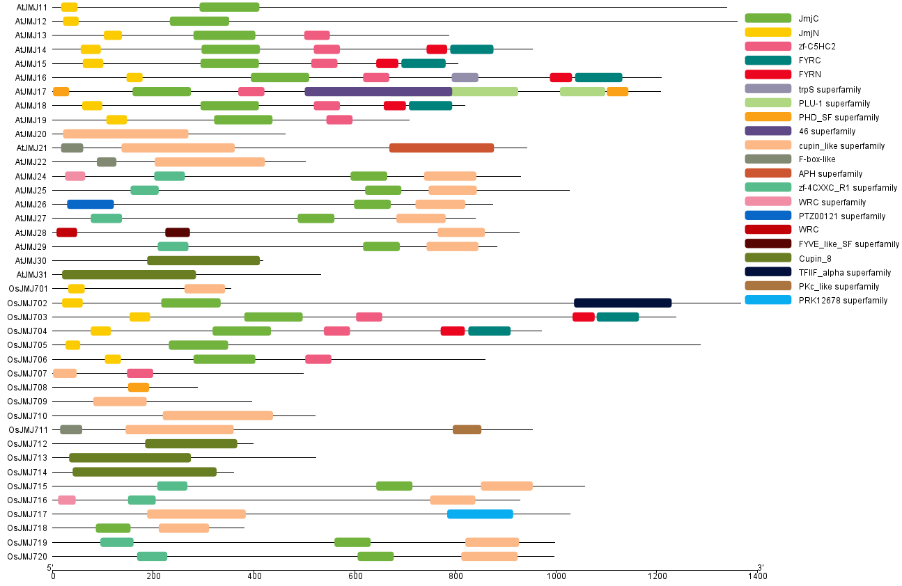
Figure S2-11 Conserved domain analysis of TaJMJ proteins.

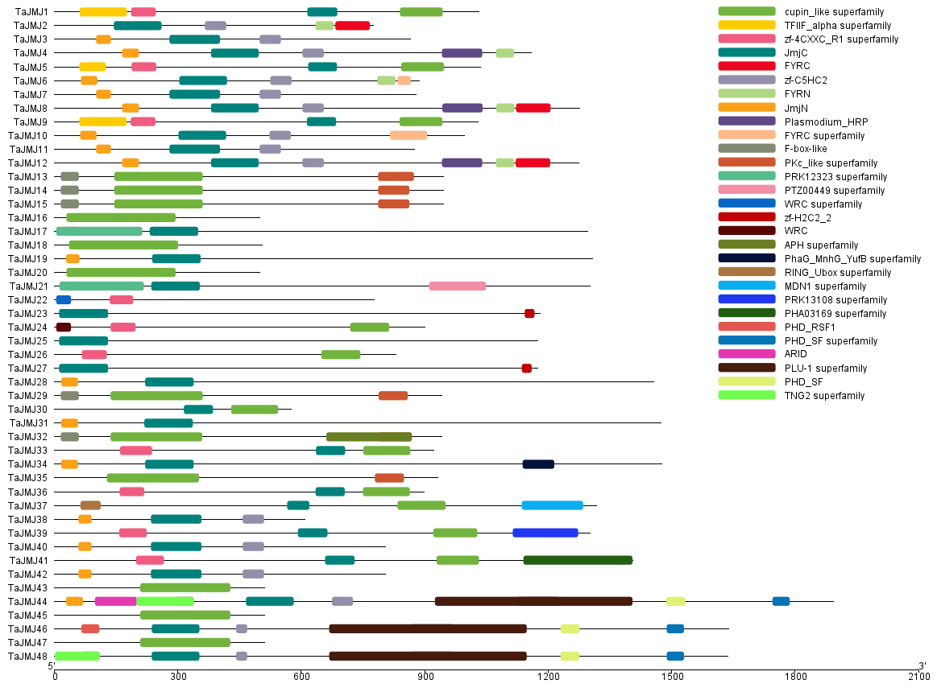
Figure S2-12 Conserved domain analysis of HvJMJ proteins.

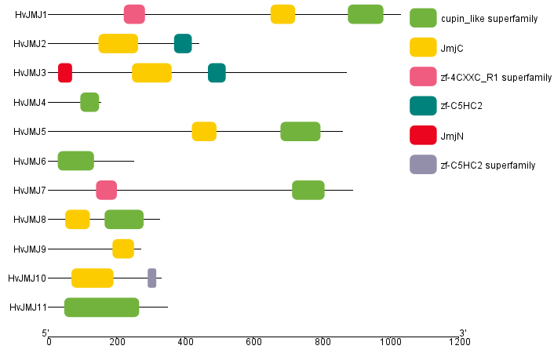
Figure S2-13 Conserved domain analysis of SbJMJ proteins.

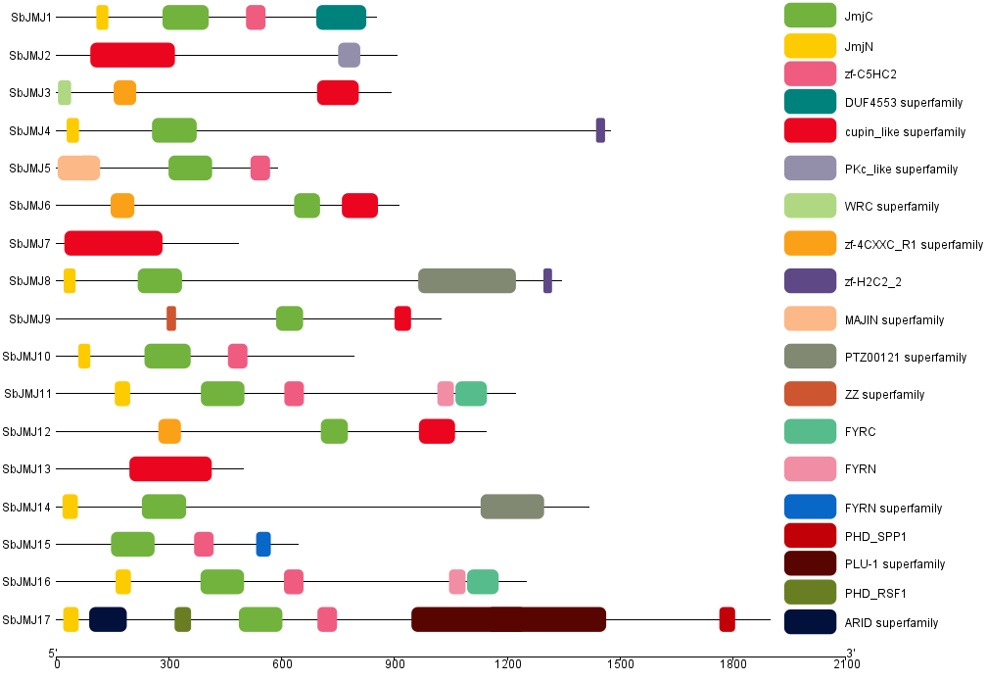
Figure S2-14 Conserved domain analysis of SvJMJ proteins.

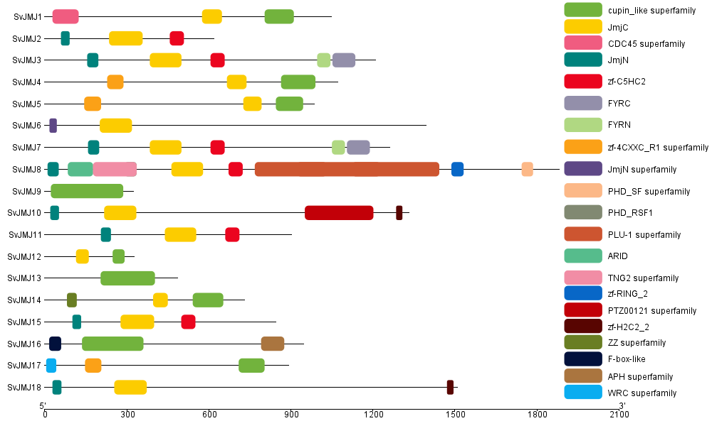
Figure S2-15 Conserved domain analysis of SiJMJ proteins.

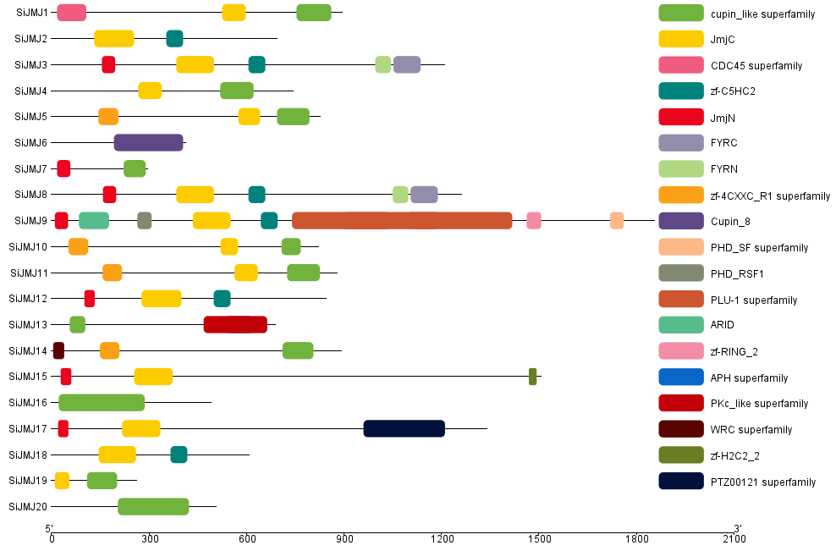
Figure S2-16 Conserved domain analysis of ZmJMJ proteins.

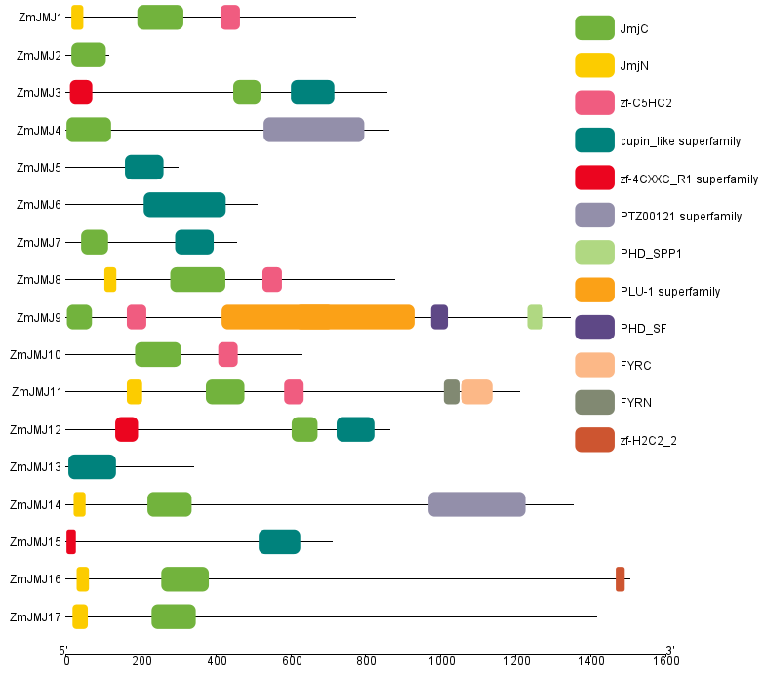
Figure S2-17 Conserved domain analysis of HAGs proteins.

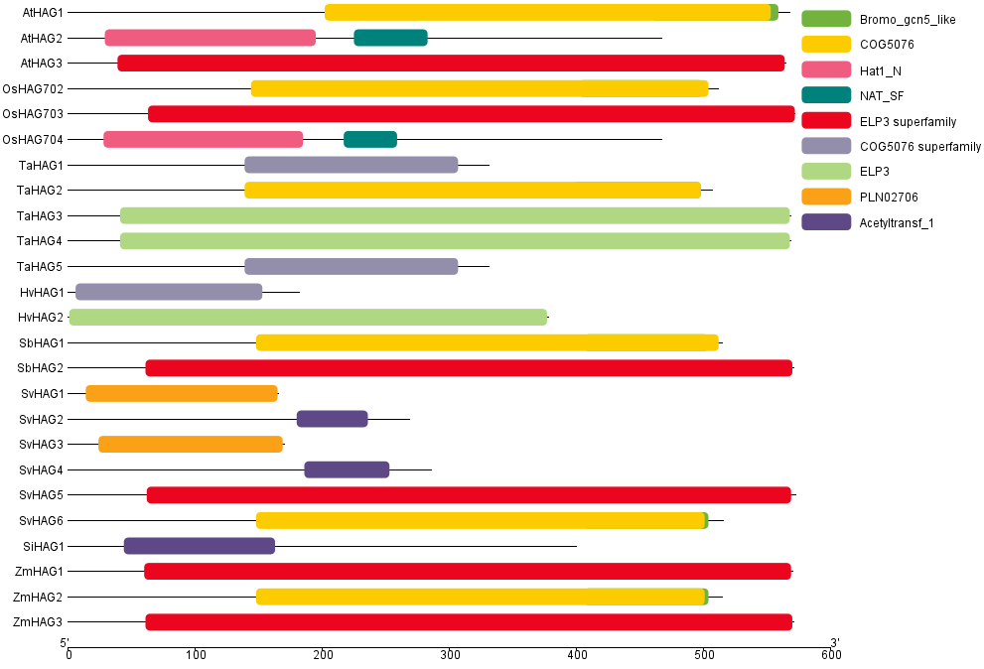
Figure S2-18 Conserved domain analysis of HAMs proteins.

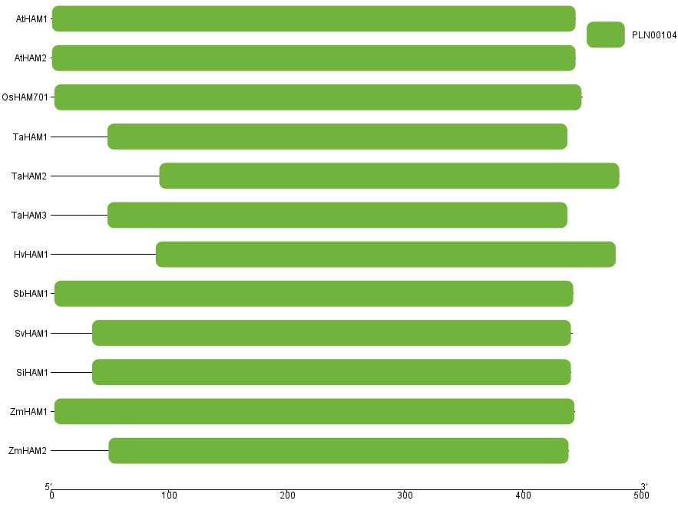
Figure S2-19 Conserved domain analysis of HAC proteins.

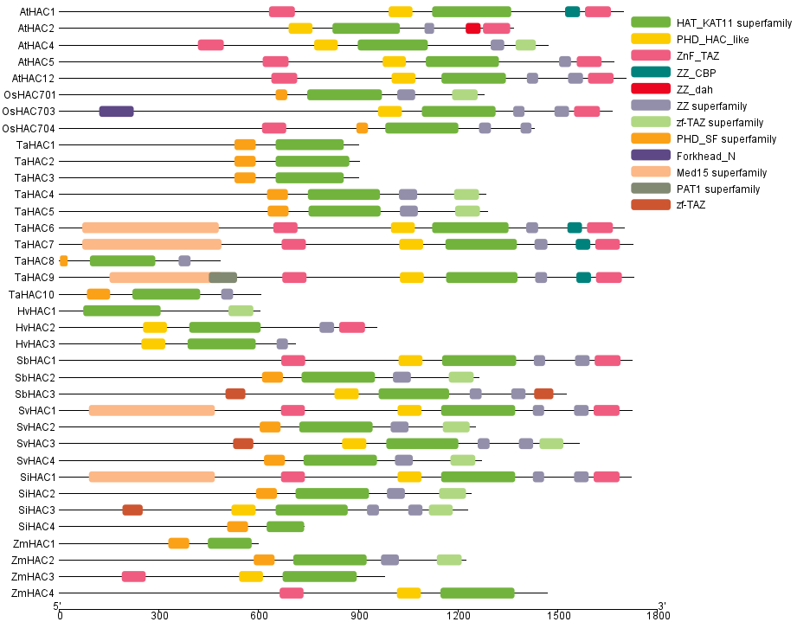
Figure S2-20 Conserved domain analysis of HAF proteins.

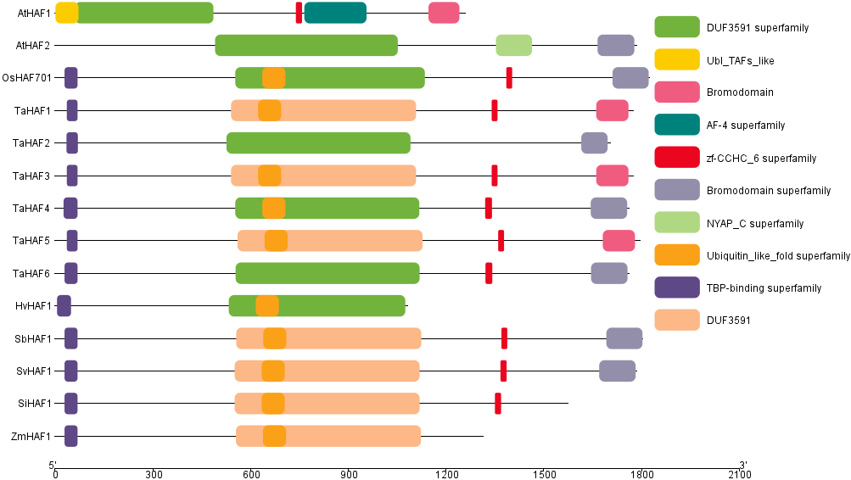
Figure S2-21 Conserved domain analysis of Arabidopsis and rice HDA proteins.

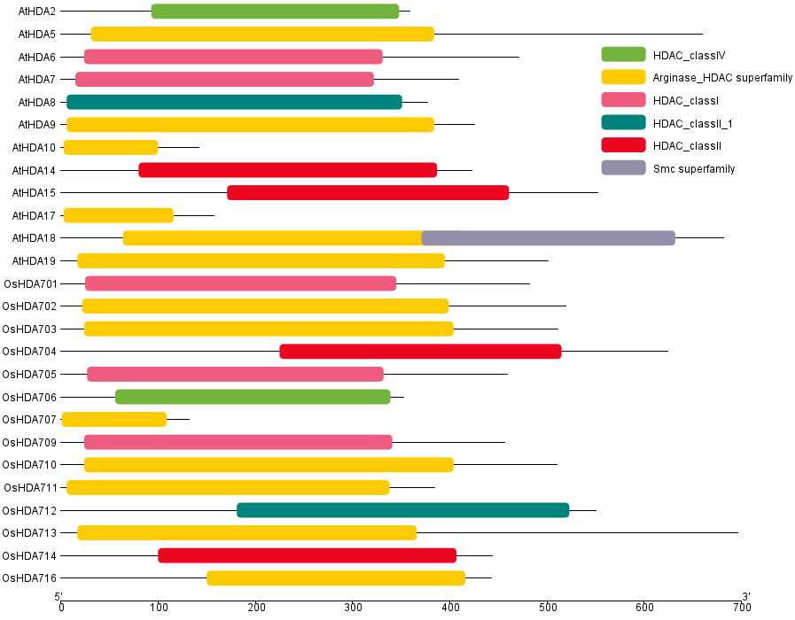
Figure S2-22 Conserved domain analysis of TaHDA proteins.

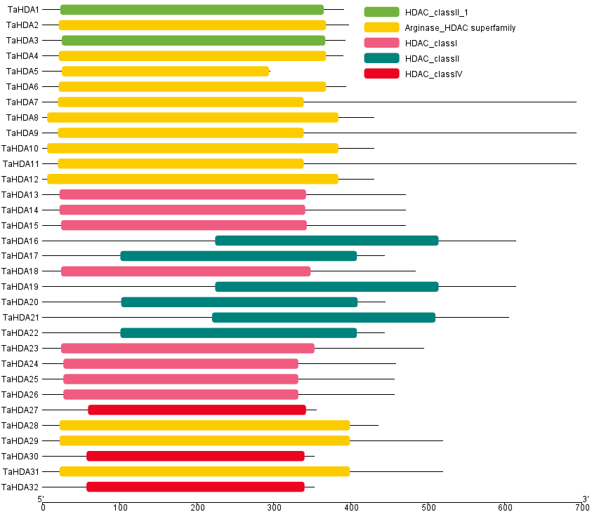
Figure S2-23 Conserved domain analysis of HvHDA proteins.

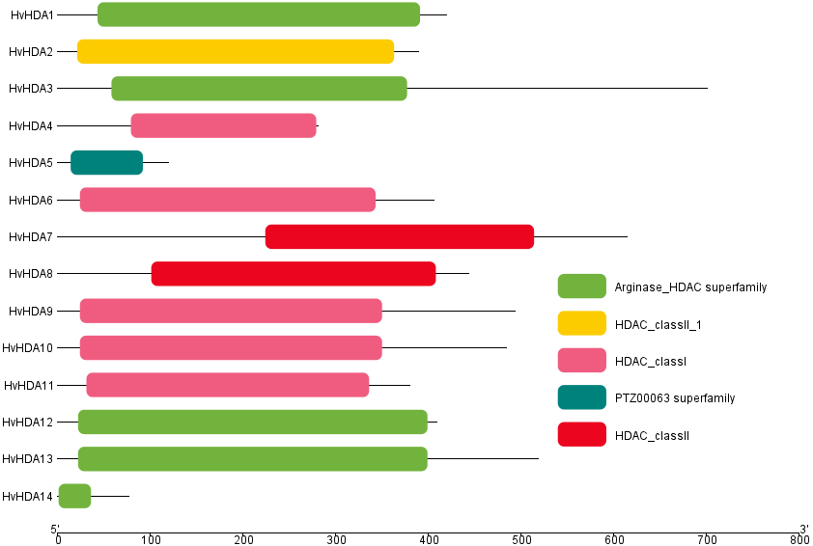
Figure S2-24 Conserved domain analysis of SbHDA proteins.

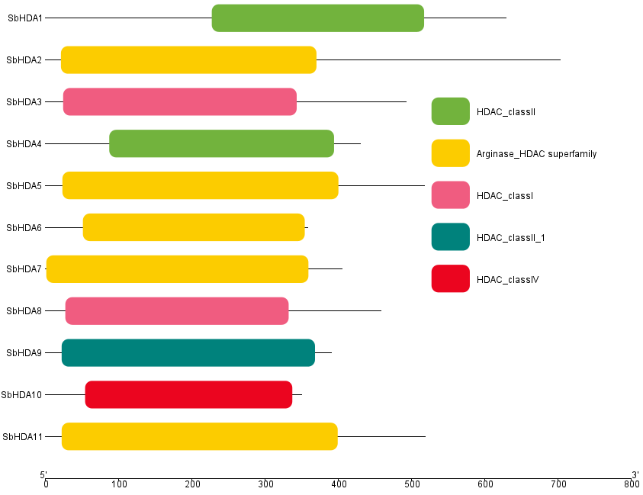
Figure S2-25 Conserved domain analysis of SvHDA proteins.

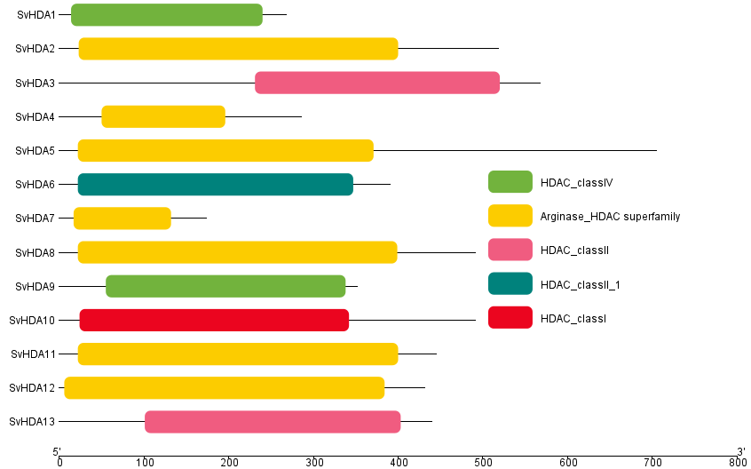
Figure S2-26 Conserved domain analysis of SiHDA proteins.

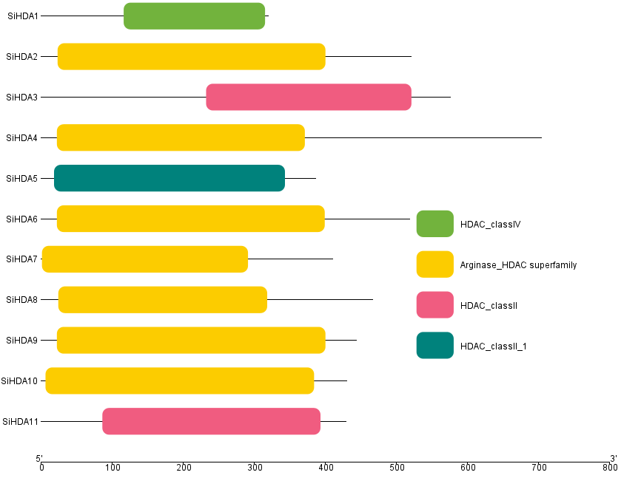
Figure S2-27 Conserved domain analysis of ZmHDA proteins.

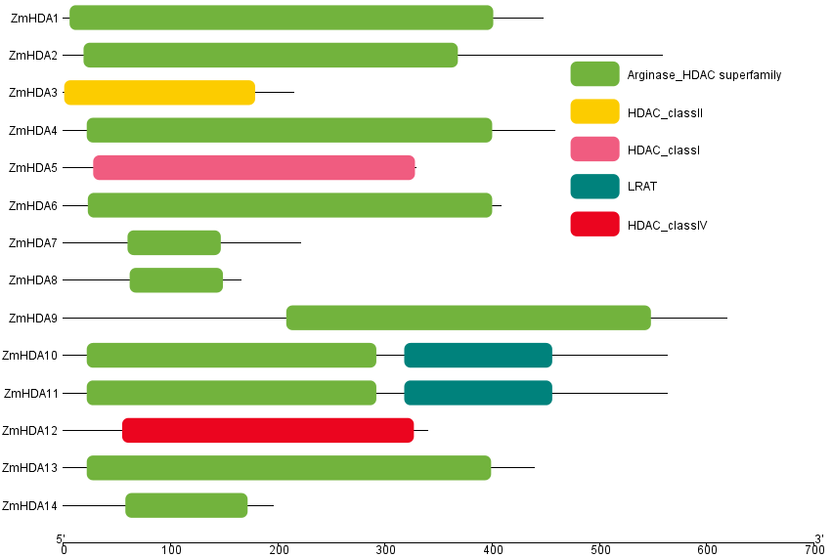
Figure S2-28 Conserved domain analysis of SRTs proteins.

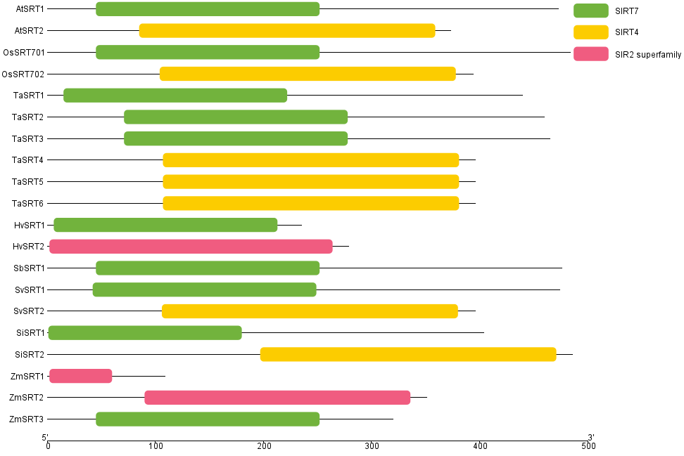
Figure S2-29 Conserved domain analysis of HDTs proteins.

