Figure S7 Promoter analysis of T. aestivum, H. vulgare, S. bicolor, S. viridis, S. italic and Z. mays HMs genes
Figure S7-1 Promoter analysis of TaSDGs and TaPRMTs genes

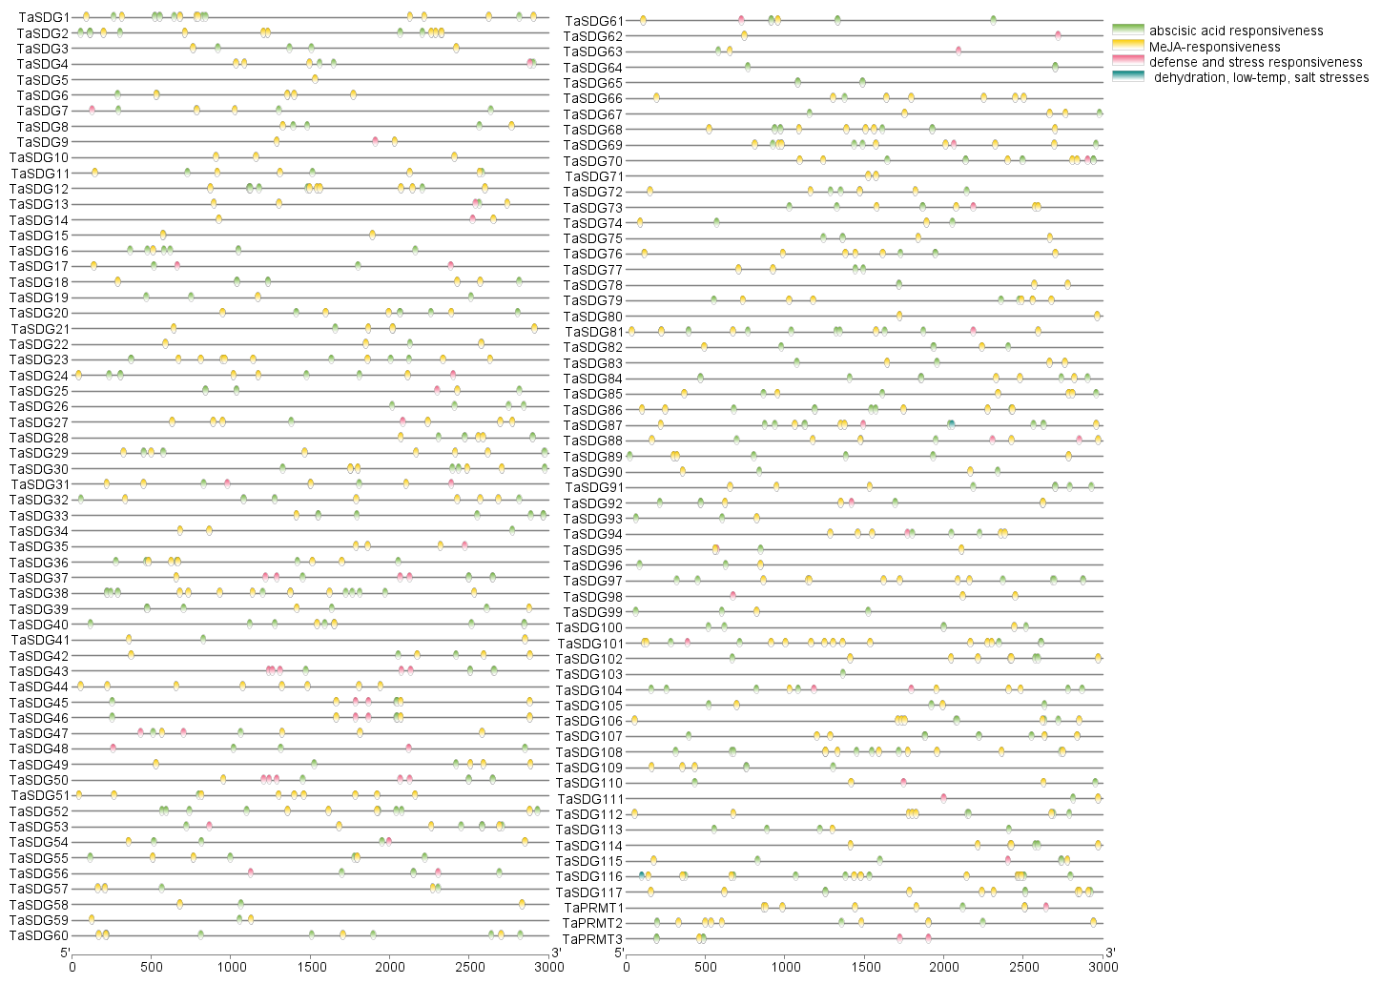
Figure S7-2 Promoter analysis of TaHDMAs and TaJMJs genes

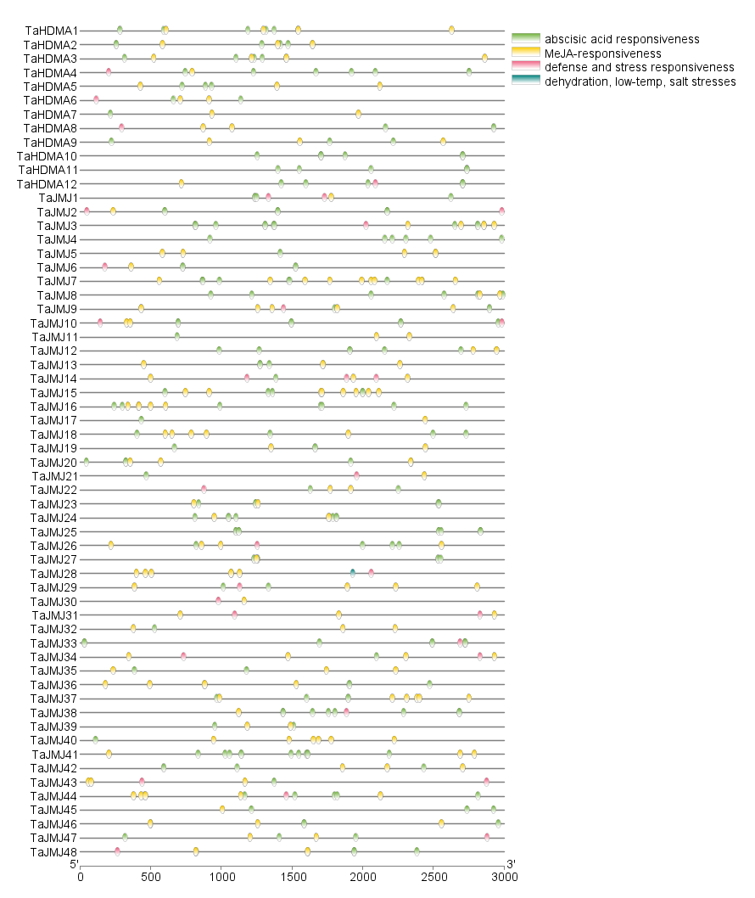
Figure S7-3 Promoter analysis of TaHAGs, TaHAMs, TaHACs and TaHAFs genes

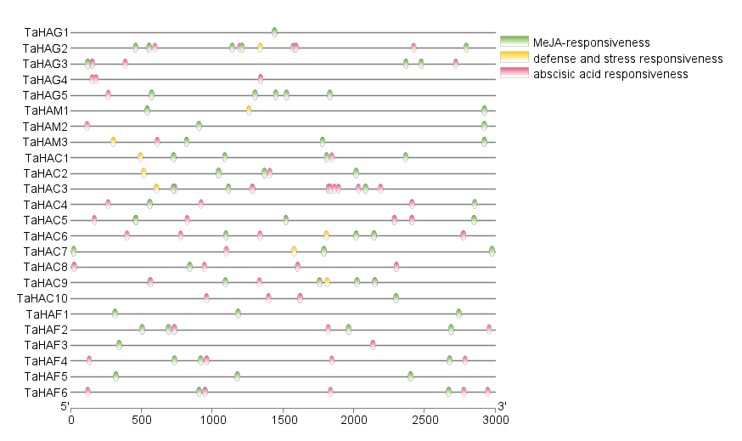
Figure S7-4 Promoter analysis of TaHDAs, TaSRTs and TaHDTs genes

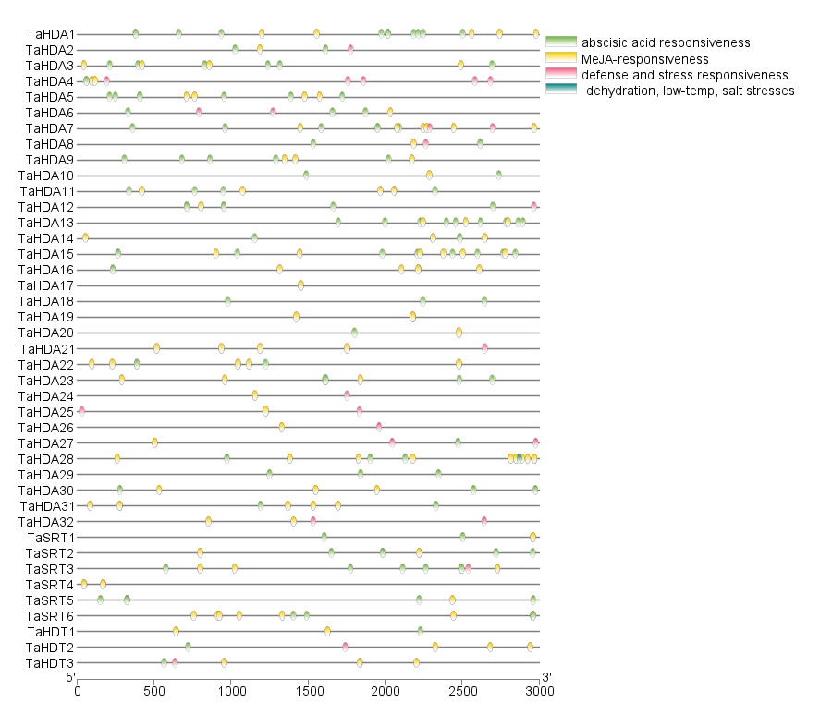
Figure S7-5 Promoter analysis of HvHMs genes

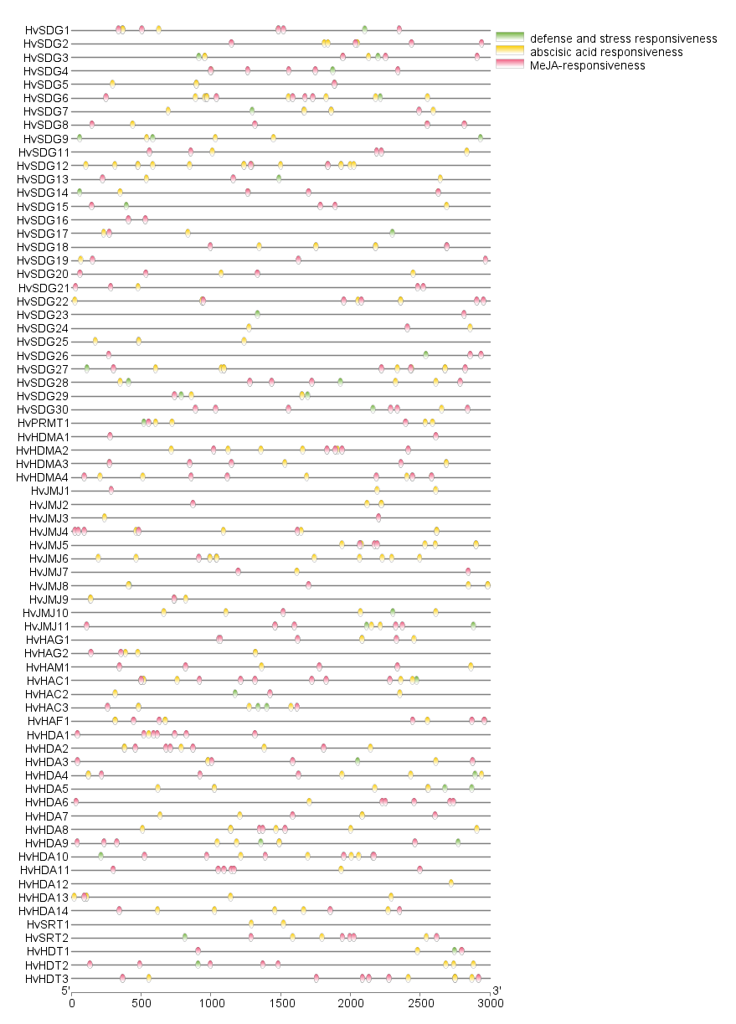
Figure S7-6 Promoter analysis of SbHMs genes
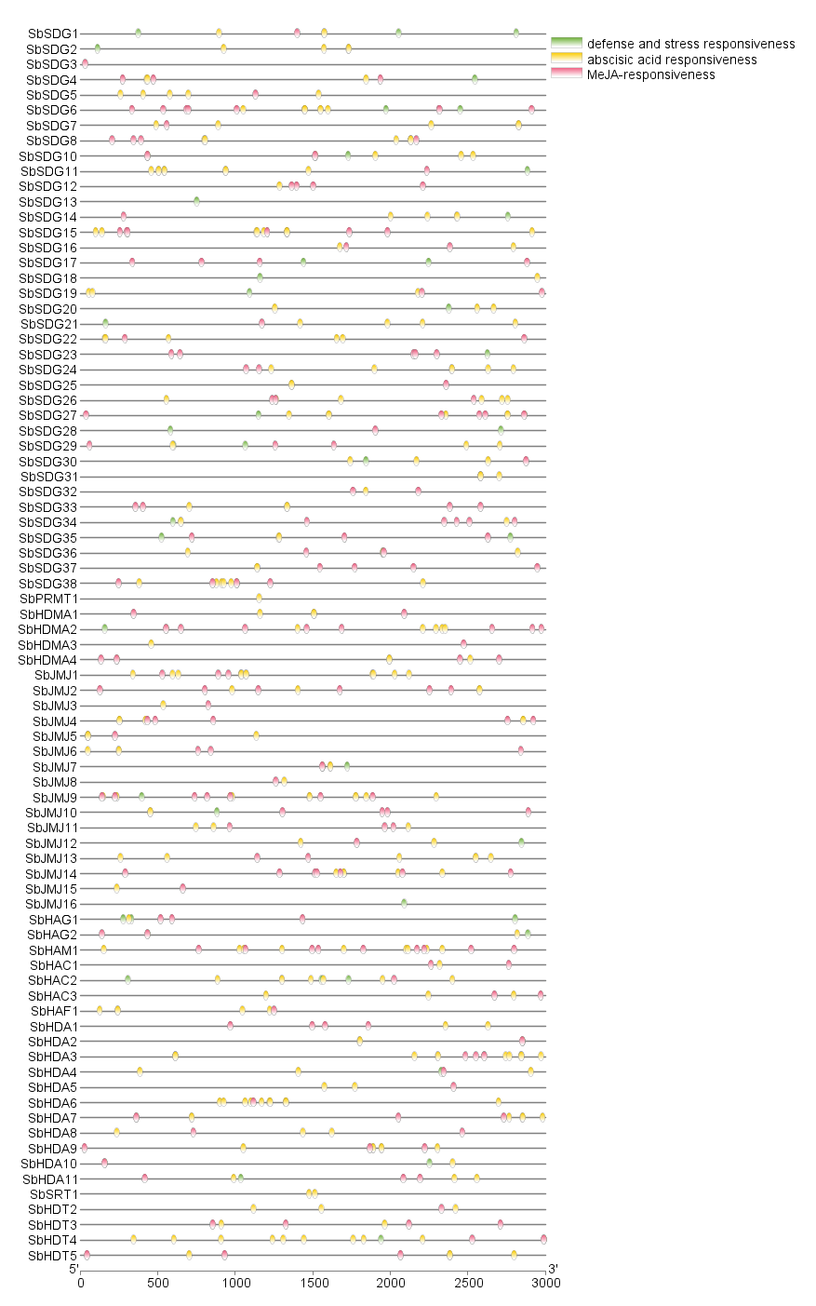
Figure S7-7 Promoter analysis of SvHM genes
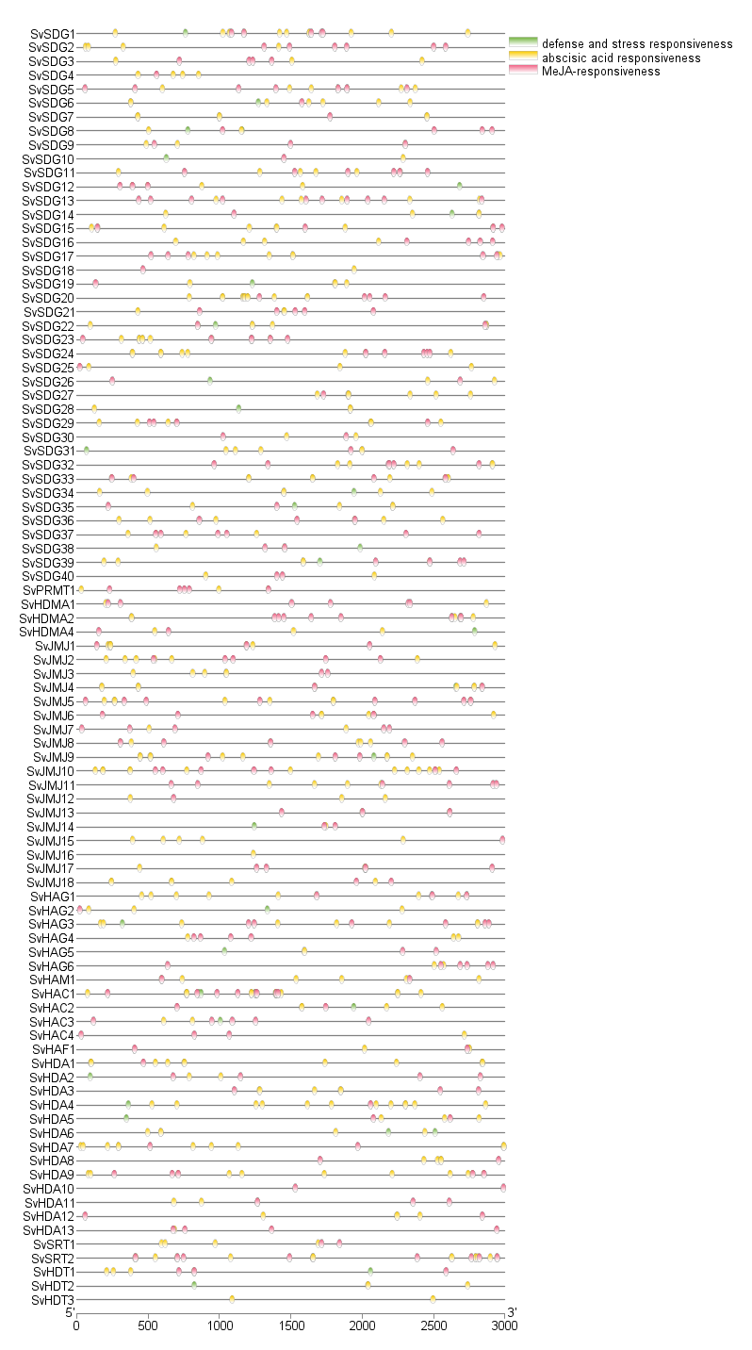
Figure S7-8 Promoter analysis of SiHM genes
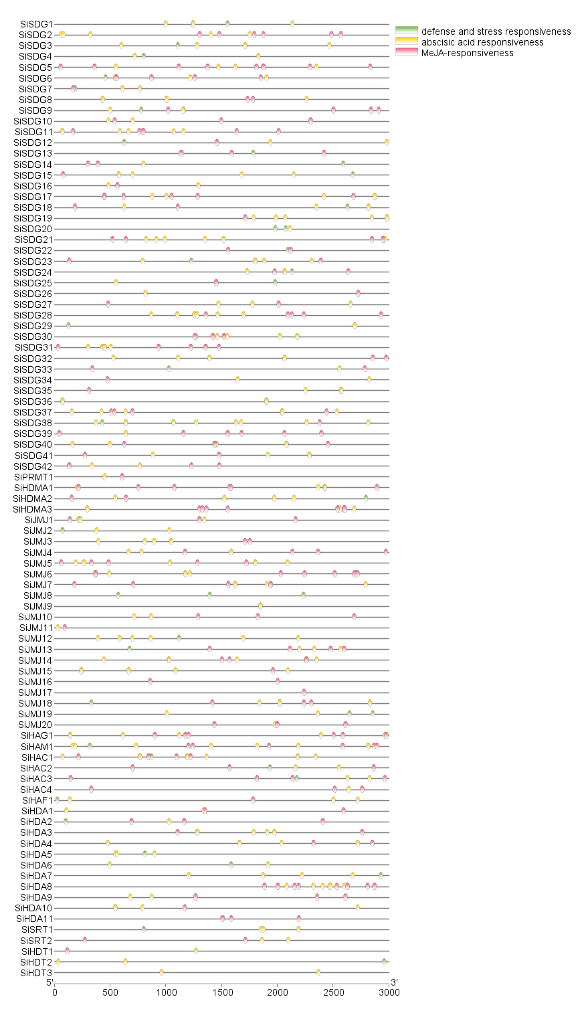
Figure S7-9 Promoter analysis of ZmHM genes

