Figure S5 Synteny analysis of HMs genes between each gramineae specie and Arabidopsis
Figure S5-1 Synteny analysis of HMs genes between T. aestivum and Arabidopsis
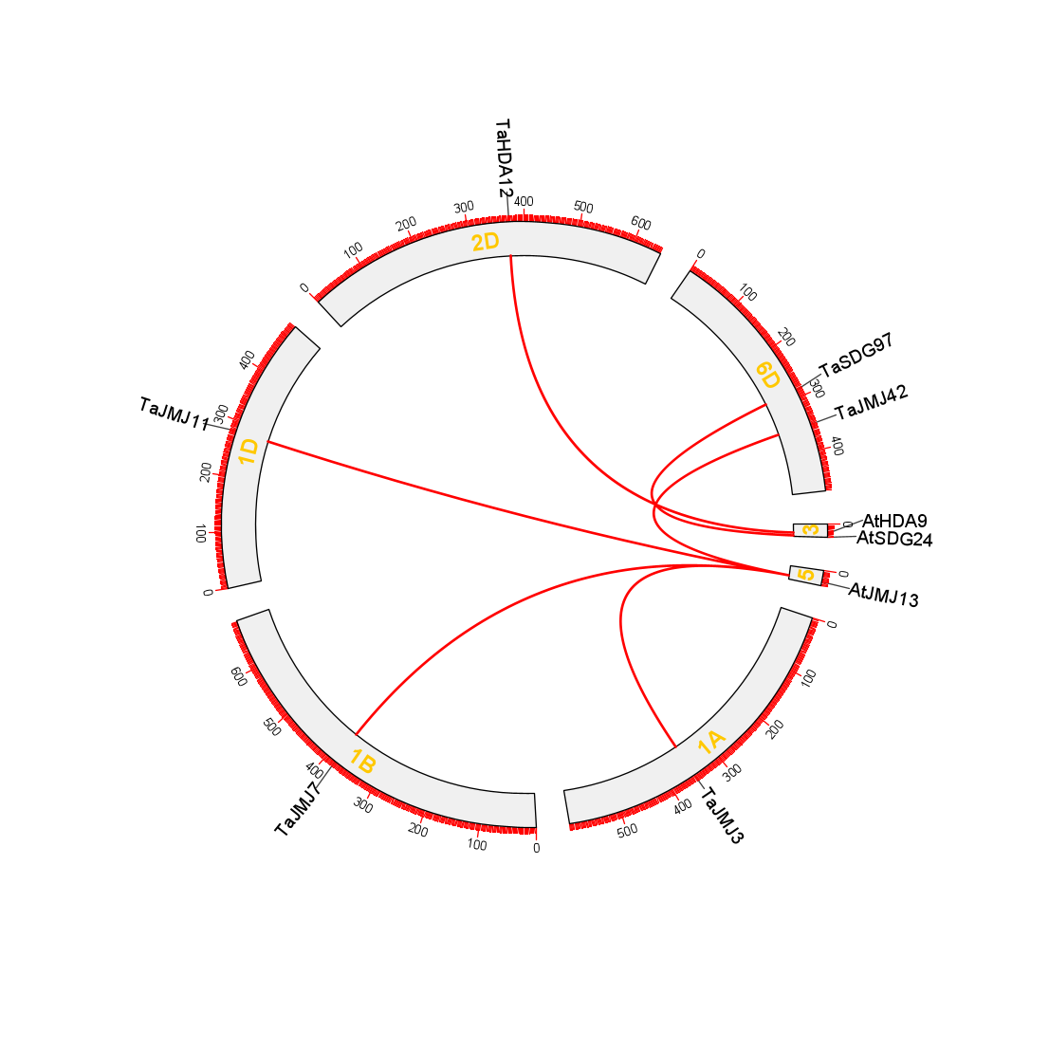

Figure S5-2 Synteny analysis of HMs genes between S. bicolor and Arabidopsis

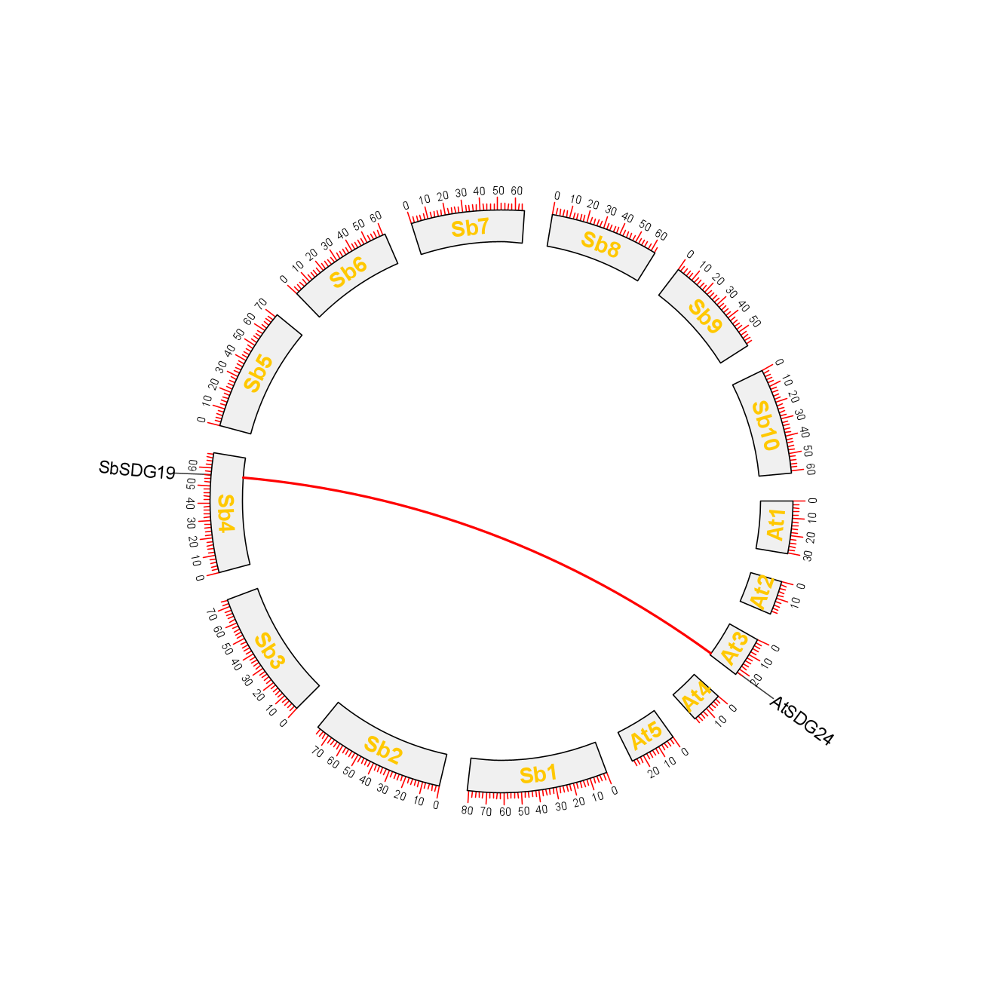
Figure S5-3 Synteny analysis of HMs genes between S. viridis and Arabidopsis
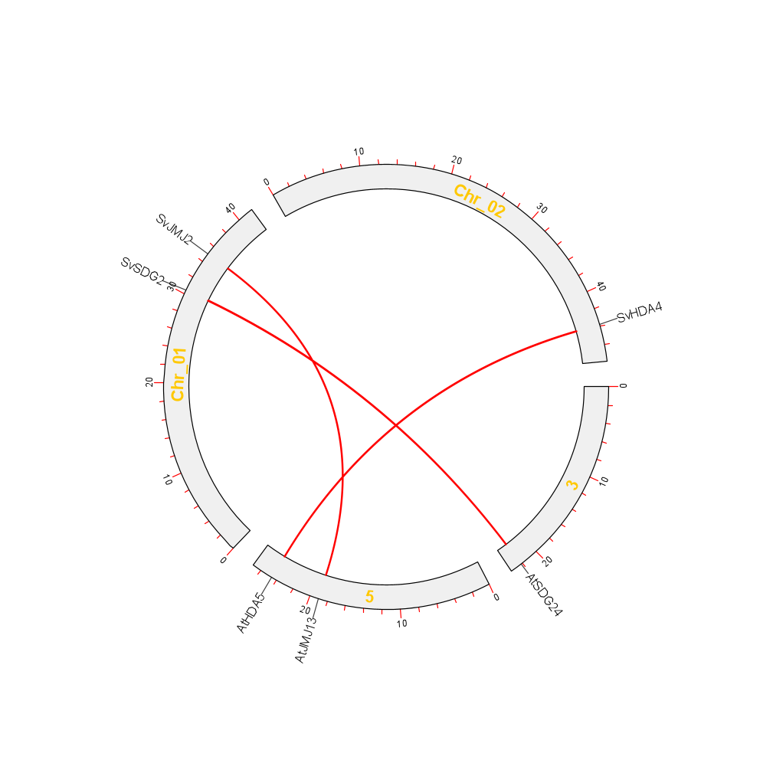
Figure S5-4 Synteny analysis of HMs genes between S. italic and Arabidopsis

