Supplementary Material
Whole-Case Artificial Intelligence for Diagnostic Escalation in Endoscopically Suspected Borrmann Type IV Gastric Cancer
Supplementary Section S1. Image Preprocessing and Training-Time Image Handling
Each patient case was represented as a set of all available upper endoscopic images from the index examination. For the internal cohorts, no additional case-level exclusion was applied after cohort construction based on image quality or the number of available images. This design was used to preserve real-world variation in routine endoscopic documentation and reduce manual curation bias.
Images were de-identified by removing non-endoscopic border regions that could contain patient identifiers or acquisition metadata. The automated cropping procedure converted each image to grayscale, applied intensity thresholding to separate the endoscopic field from the dark background, used morphological erosion to remove thin connections to peripheral artifacts, identified the largest connected image component, and then refined the crop box to remove mostly black borders. The same preprocessing approach was applied across cohorts.
For model input, processed images were resized to 336 x 336 pixels and normalized using the channel-wise statistics used for GastroFM. No manual selection of representative images was performed for patient-level inference.
During model training, cases with more than 16 available images were randomly sampled to 16 images per epoch to reduce memory use and enable efficient optimization. In contrast, validation, internal testing, and external validation used all available images from each patient case.
Training-time image augmentation included random horizontal flipping, random vertical flipping, random rotation, and color jitter. These augmentations were used only during model training and were not applied during validation, internal testing, or external validation.
Supplementary Section S2. Model Architecture
The model used GastroFM as an image-level feature extractor. Each endoscopic image in a patient case was passed through GastroFM to obtain an image-level feature vector. Attention-based multiple instance learning (ABMIL) then assigned an attention score to each image feature and aggregated image-level features into a patient-level representation. An output layer produced a patient-level B-IV AGC probability.
Two separate patient-level classification models were trained with the same GastroFM-ABMIL architecture. The primary-setting model was trained for the B-IV AGC-suspicious diagnostic setting, and the screening-setting model was trained for the broader benign gastritis comparator setting. External validation used the primary-setting model.
Supplementary Section S3. Attention-Aggregation and Spatial Heatmap Methodology
The attention-based case review used two model-derived attention measures for qualitative interpretation: an image-level ABMIL attention score and a within-image spatial attention heatmap. These measures were used for visualization and case review only and did not represent an additional model input or a separate attention architecture.
For each patient case, all available endoscopic images were represented as a bag of image-level feature vectors extracted by GastroFM. In the ABMIL module, each image feature vector was linearly projected by a learnable layer to produce an unnormalized attention logit. The image-level ABMIL attention score was then calculated by applying a softmax function across all images in the same patient case:
$$α_{i}=\frac{exp(e_{i})}{\sum_{j=1}^{N}{exp}(e_{j})}$$
where $e_{i}$ is the attention logit for image $i$, $N$ is the number of images in the patient case, and $α_{i}$ is the normalized attention weight for image $i$. The patient-level feature representation was calculated as the weighted sum of image-level feature vectors using these attention weights. Therefore, larger $α_{i}$ values indicate images that contributed more strongly to the patient-level prediction relative to other images from the same case; they should not be interpreted as independent image-level diagnostic probabilities.
For spatial heatmap visualization within selected images, we used the attention weights from the GastroFM image encoder. Specifically, the attention scores from the [CLS] token to image patch tokens were extracted across all attention heads and averaged. The averaged patch-level attention scores for each image were multiplied by the corresponding image-level ABMIL attention weight before visualization, so that spatial heatmaps from images with low contribution to the patient-level prediction were down-weighted. The resulting patch-level scores were then reshaped to the image patch grid, resized to the original image resolution, normalized for display, and overlaid on the corresponding endoscopic image. These spatial heatmaps indicate image regions receiving relatively higher model attention during image-level feature extraction in the context of the image's case-level contribution and were used as qualitative visualization rather than quantitative diagnostic outputs.
Supplementary Section S4. External False-Positive Case Review and Failure-Mode Analyses
The single false-positive case in the external validation cohort was reviewed using the same attention-based case review procedure (Supplementary Figure S1). The patient was a control for B-IV AGC but had superficial esophageal cancer. Before excluding esophageal images, the model assigned a B-IV AGC probability of 0.530, and the two highest-ranked images were esophageal views. After post hoc exclusion of esophageal views, the B-IV AGC probability decreased to 0.274, changing the case-level classification from false positive to true negative. This review suggests that non-gastric views can occasionally contribute to patient-level predictions and supports explicit handling of anatomic field-of-view during prospective workflow integration.
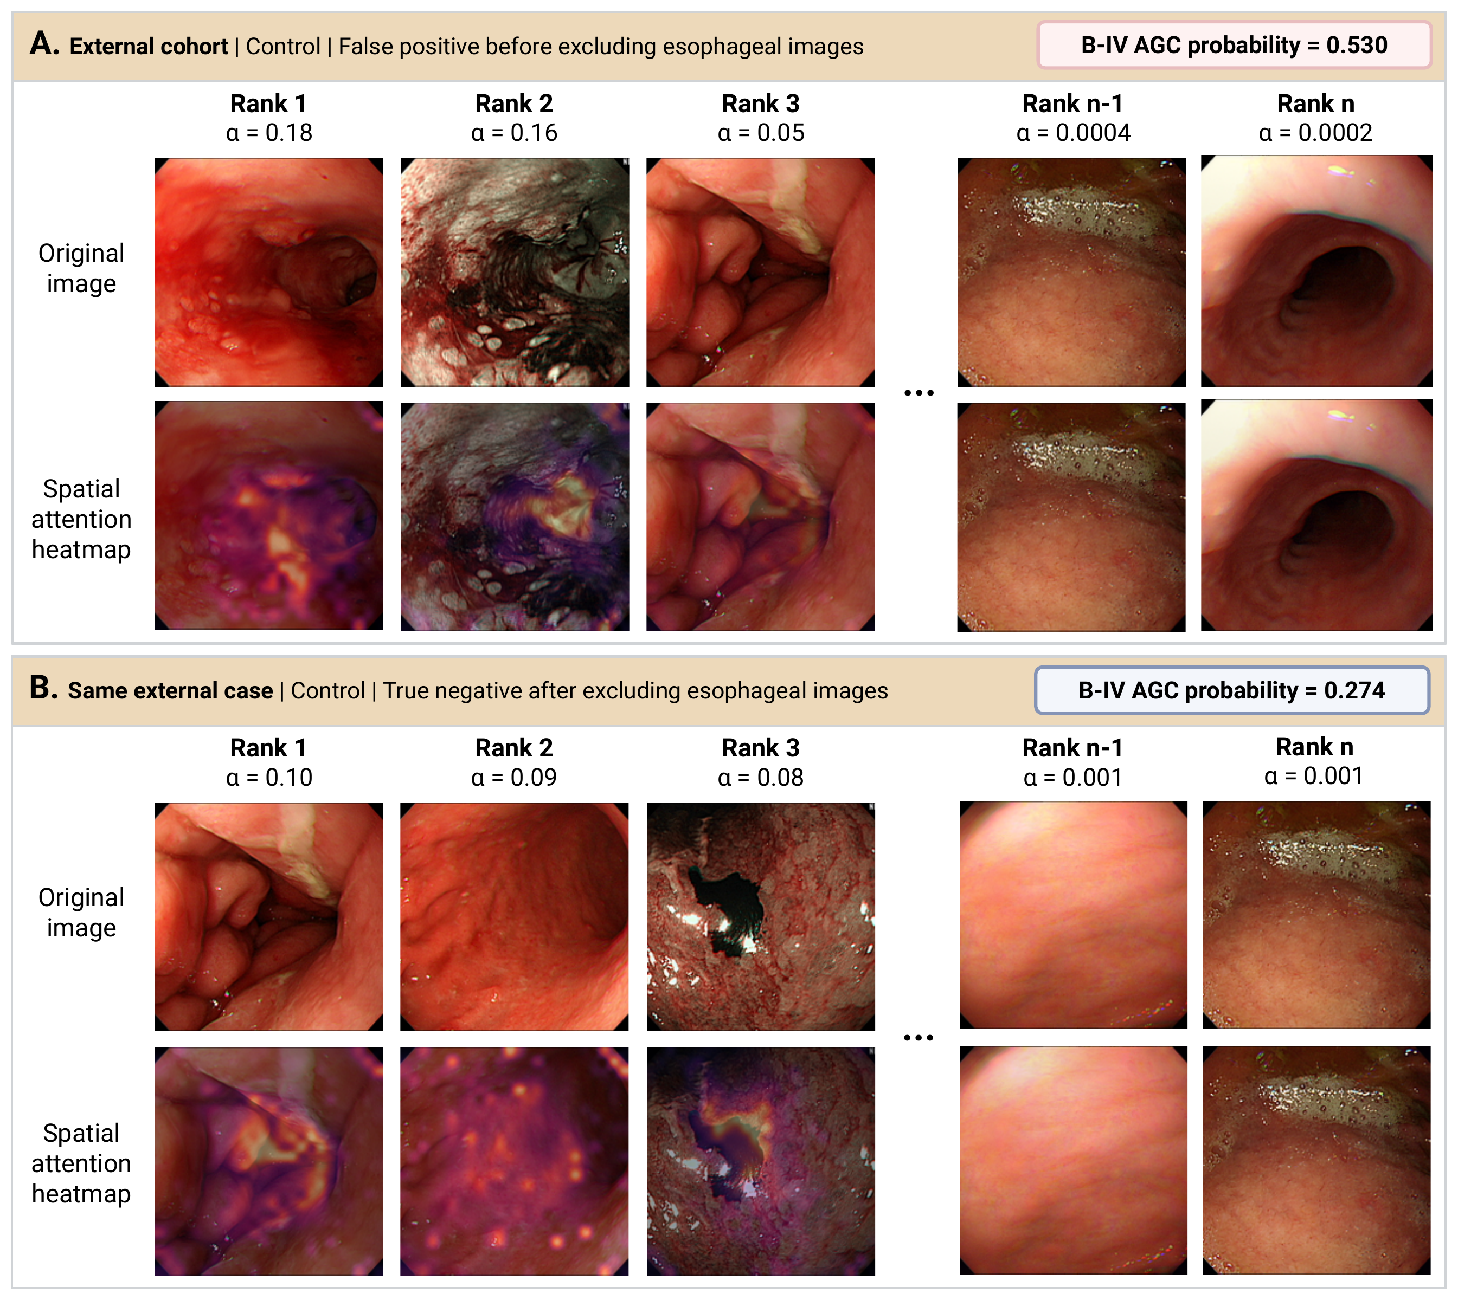
Fig. S1 Attention-based review of the single external false-positive case. (a) Before excluding esophageal images, the external control case was classified as B-IV AGC with a probability of 0.530. The two highest-ranked images by ABMIL attention were esophageal views from a patient with superficial esophageal cancer. (b) After post hoc exclusion of esophageal views, the B-IV AGC probability decreased to 0.274 and the case was correctly classified as control. ABMIL, attention-based multiple instance learning; B-IV AGC, Borrmann type IV advanced gastric cancer
Supplementary Section S5. Optimization and Model Selection
Class imbalance during training was handled with inverse class-frequency weighted random sampling. Models were optimized with AdamW and cosine learning-rate scheduling for up to 50 epochs. After each epoch, model performance was evaluated on the validation set using area under the receiver operating characteristic curve (AUROC). Training was stopped early if validation AUROC did not improve for 5 consecutive epochs. The trained model from the epoch with the highest validation AUROC was retained for final evaluation.
Supplementary Section S6. Expert-Reader Comparison and Statistical Procedures
Three expert endoscopists independently reviewed de-identified image folders from the primary held-out test set. Each folder contained all available endoscopic images for one patient case. Readers reviewed cases in randomized order using endoscopic images only and were blinded to the reference standard diagnosis, model output, and other readers' assessments. Binary B-IV AGC/non-B-IV AGC labels were recorded in a spreadsheet. The majority-reader decision was defined post hoc as B-IV AGC when at least two of the three expert readers assigned a B-IV AGC label. Because expert readers provided binary labels rather than continuous confidence scores, AUROC was not calculated for expert-reader decisions.
Inter-reader agreement was summarized using pairwise Cohen's kappa and Fleiss' kappa (Table S1). Paired correctness between the model and each expert-reader decision was compared using exact McNemar tests (Table S2).
Table S1 Inter-reader agreement among expert endoscopists
Reader comparison | Agreement, % | Kappa
Expert 1 vs Expert 2 | 85.7 | 0.634
Expert 1 vs Expert 3 | 87.6 | 0.687
Expert 2 vs Expert 3 | 91.7 | 0.759
Overall Fleiss' kappa | 88.3 | 0.689
Table S2 Paired comparison of model and expert-reader decisions in the primary cohort
Comparator | M correct/C wrong | M wrong/C correct | P value
Expert 1 | 21 | 6 | 0.006
Expert 2 | 19 | 3 | 0.0009
Expert 3 | 15 | 5 | 0.041
Expert vote | 12 | 5 | 0.143
M, model; C, comparator. P values are from exact McNemar tests comparing paired binary correctness at the patient level.
Supplementary Section S7. Threshold, Calibration, and Clinical-Utility Analyses
The patient-level diagnostic threshold of 0.5 was prespecified before any held-out test or external evaluation and was applied uniformly to all main-text binary diagnostic metrics. This default threshold yielded high sensitivity in the present study and avoided post hoc threshold optimization on held-out test or external validation data. This section summarizes three complementary descriptive analyses that characterize model behavior across operating points, on the probability scale itself, and against simple clinical reference strategies. All analyses are post hoc on retrospective data and would require prospective recalibration before clinical deployment.
S7.2. Model Calibration
We assessed how well predicted probabilities corresponded to observed B-IV AGC frequencies using three complementary measures: reliability diagrams with 10 equal-width probability bins, the Brier score, and expected calibration error (ECE) of held-out predictions. Calibration refers to agreement between predicted probabilities and observed disease frequencies. In reliability diagrams, points close to the diagonal reference line indicate better calibration (Figure S2). Brier score and ECE values are summarized in Table S3.
$$\text{Brier score}=\frac{1}{n}\sum_{i=1}^{n}{(}{\hat{p}}_{i}-y_{i})^{2}, \text{ECE}=\sum_{b=1}^{B}{\frac{n_{b}}{n}}\left|{\overset{‾}{y}}_{b}-{\overset{‾}{p}}_{b}\right|$$
Here, $n$ is the number of patients in the evaluated cohort, ${\hat{p}}_{i}$ is the predicted probability for patient $i$, and $y_{i}$ is the binary reference standard. For ECE, $B=10$ denotes the 10 equal-width calibration bins used for the reliability diagrams, $n_{b}$ is the number of patients in bin $b$, ${\overset{‾}{y}}_{b}$ is the observed B-IV AGC frequency in bin $b$, and ${\overset{‾}{p}}_{b}$ is the mean predicted probability in bin $b$. Bins with $n_{b}=0$ do not contribute to the ECE sum. These summaries were used descriptively rather than as formal recalibration analyses, particularly because the external validation cohort was modest in size.
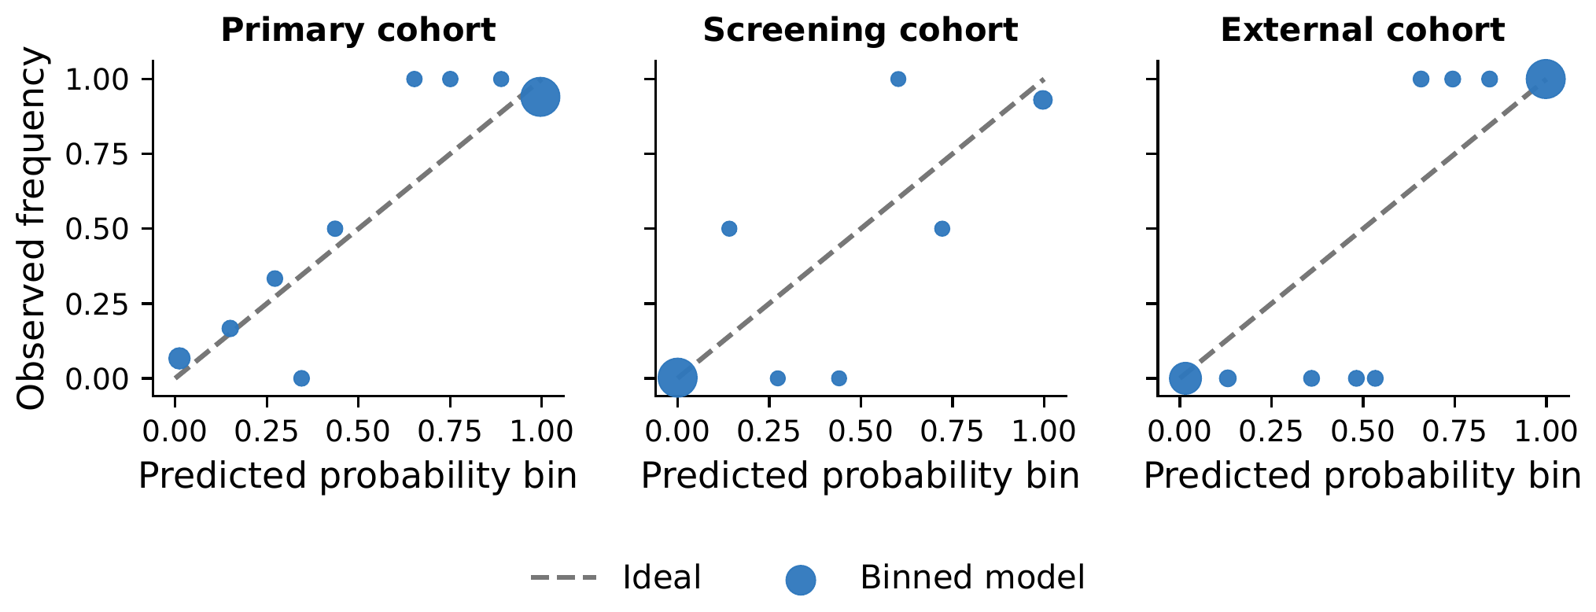
Fig. S2 Reliability diagrams across cohorts. Reliability diagrams show observed B-IV AGC frequency across predicted probability bins in the primary cohort, screening cohort, and external validation cohort. The diagonal line indicates ideal calibration. B-IV AGC, Borrmann type IV advanced gastric cancer
Table S3 Calibration metrics across cohorts. Brier scores and ECE were low across cohorts
Cohort | Brier score | ECE
Primary cohort | 0.065 | 0.063
Screening cohort | 0.012 | 0.012
External cohort | 0.011 | 0.037
ECE, expected calibration error.
Interpretation. Reliability diagrams approached the diagonal across most probability bins, with the largest deviations occurring at intermediate predicted probabilities; the model tended to be slightly overconfident in the primary cohort and well calibrated in the screening cohort. Brier scores and expected calibration error were low across all three cohorts, supporting the use of model-output probabilities for threshold-based decision support in the present data. The modest external validation cohort size limits calibration claims, however, and prospective recalibration is required before clinical deployment.

