Contents
Zn fingers 3
C2H2 3
CO/DBB 4
DOF 4
C3H 4
SQBP 6
GATA 6
VOZ 6
LSD 6
NF 6
SRS 7
MYB domains 8
MYB related 8
R2R3 9
R2R3 continued 10
ARR 11
G2/GARP 11
BHBH 11
BHLH 11
TCP 11
AP2 domain 11
ERF 11
AP2 11
HB domain 12
HD-ZIP 12
WOX 12
HDPHD 12
TALE 12
HB only 12
ZF-HD 12
B3 domain 12
ARF 12
RAV 12
LAV/B3 12
BZIP domain 12
BZIP 12
MADS domain 12
TYPE1 MADS 12
MICK - MADS 12
HMG type 12
HMG 12
ARID 12
YABBY 12
NAC 13
WRKY 14
TRIHELIX 14
FAR 14
GRAS 14
BCP 14
BES 14
LFY 14
EIL 14
CATMA 14
EF2 14
CPP 14
GRF 14
GeBP 14
HST 14
LBD 14
NZZ 14
NIN 14
S1Fa 14
SAP 15
HRT 15
WHIRLY 15

Zn finger domains

C2H2

CO/DBB

DOF
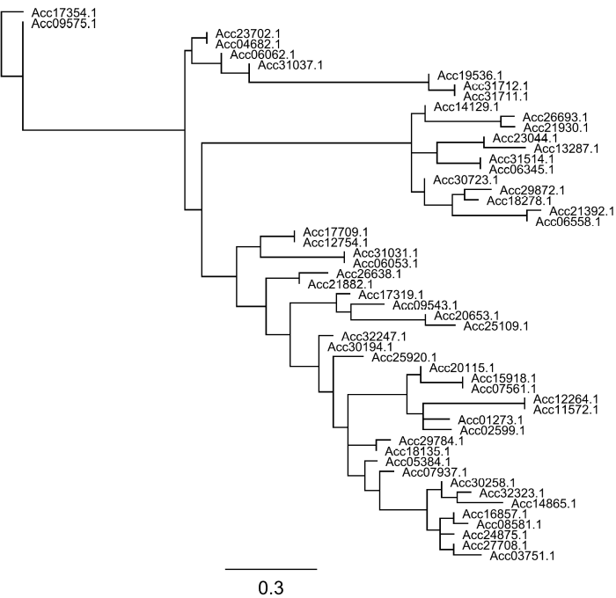

C3H

SQBP
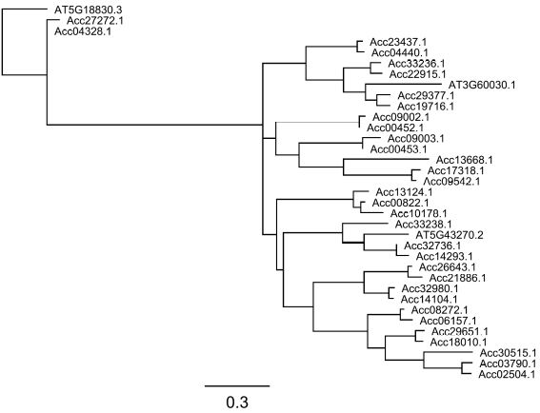

GATA

VOZ
4 genes

LSD
9 genes

NF
NFYa
NFYb

SRS

MYB domains

MYB related and GARP
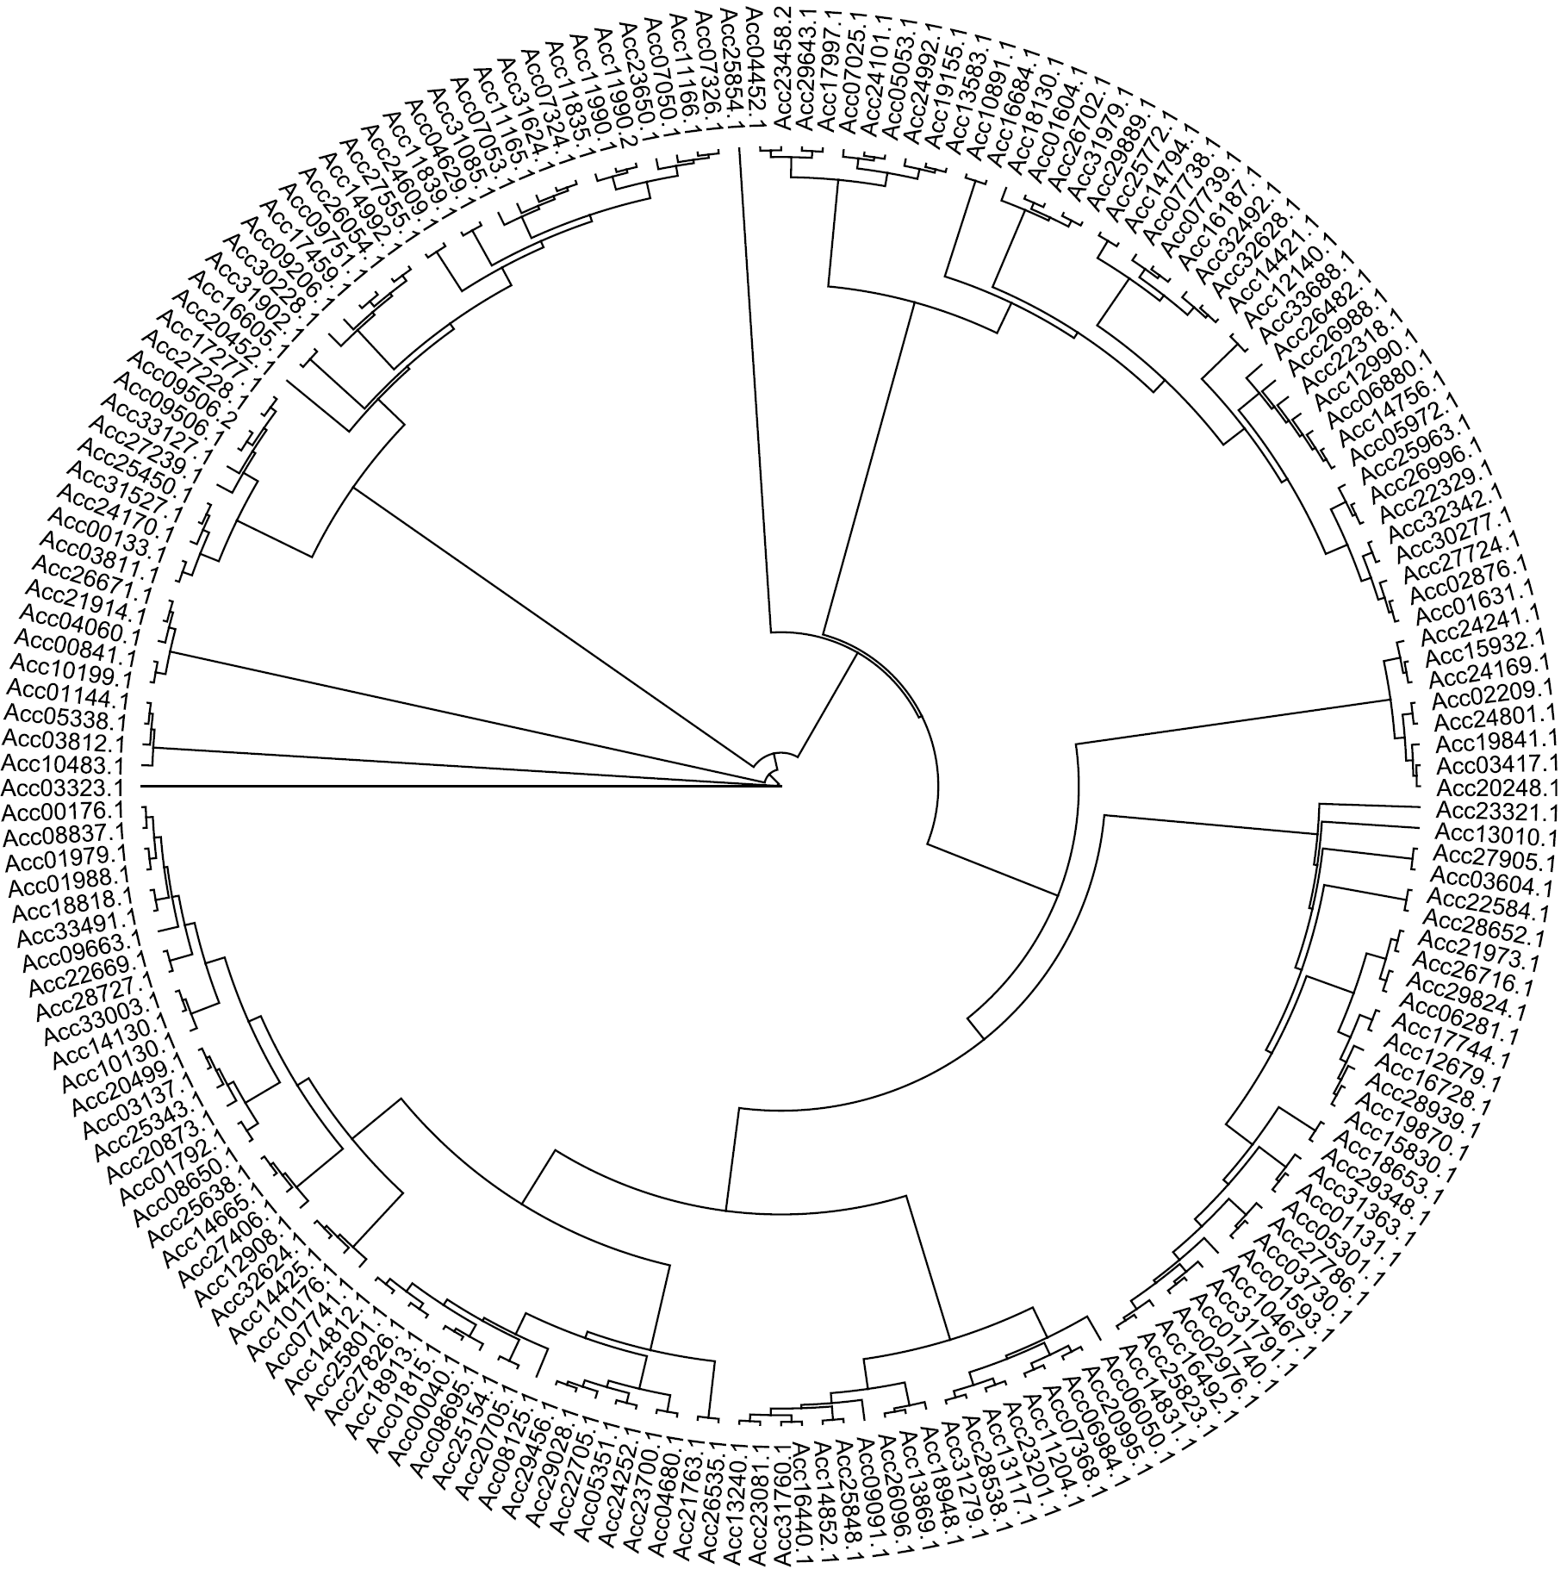

R2R3 MYB

ARR

BHLH domain

BHLH

TCP

AP2 domain
See supplemental data in Gunaseelan K, McAtee PA, Nardozza S, Pidakala P, Wang R, David K, et al. (2019) Copy number variants in kiwifruit ETHYLENE RESPONSE FACTOR/APETALA2 (ERF/AP2)-like genes show divergence in fruit ripening associated cold and ethylene responses in C-REPEAT/DRE BINDING FACTOR-like genes. PLoS ONE 14(5):e0216120. https://doi.org/10.1371/journal.pone.0216120

HB domain

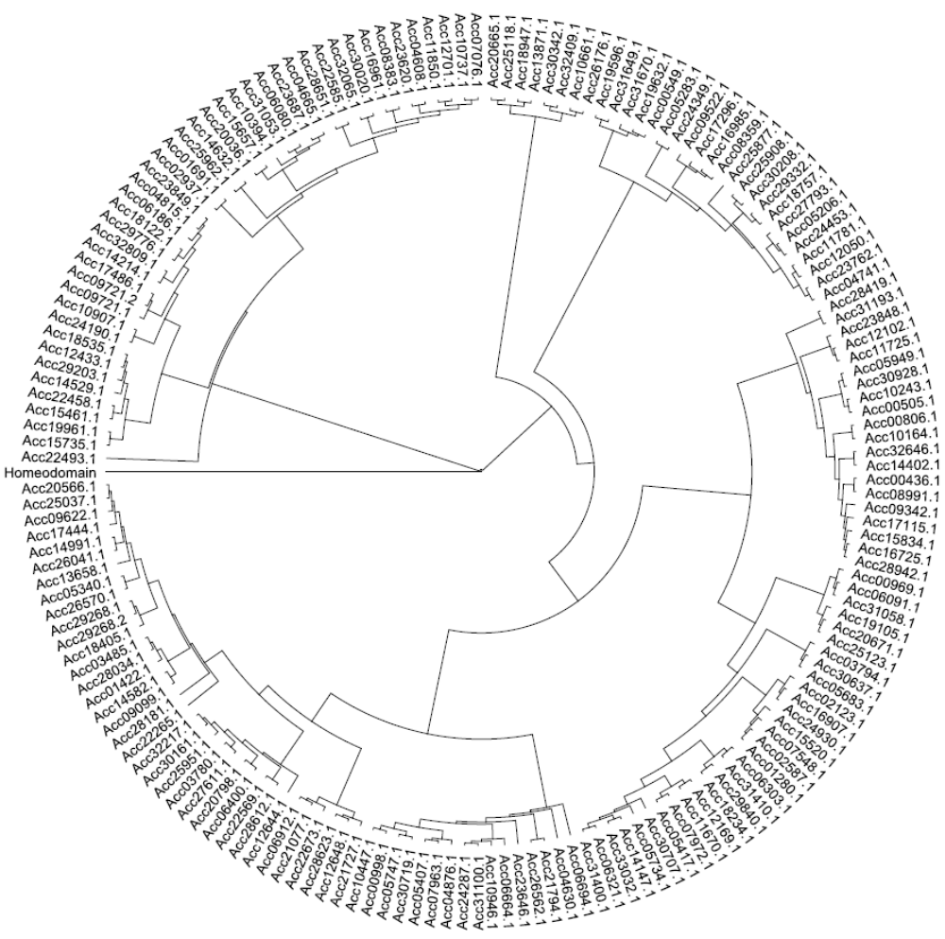

B3 domain

ARF – kiwifruit (green) aligned to Arabidopsis (Black) and Tomato (red) ARF proteins

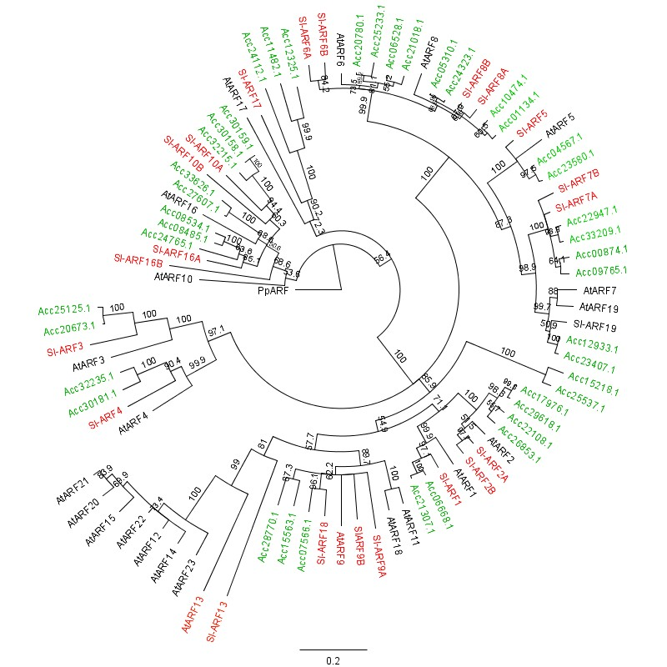

RAV
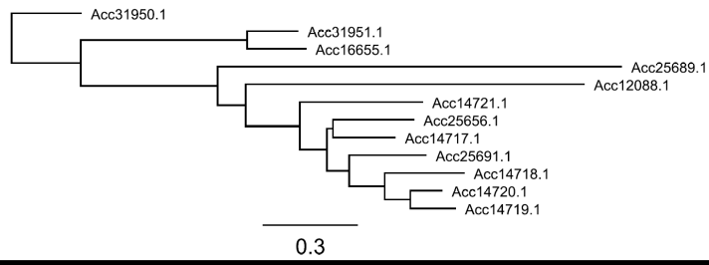

LAV/B3

BZIP domain

BZIP

MADS domain
See figure 2 in paper

HMG type

HMG, ARID and YABBY
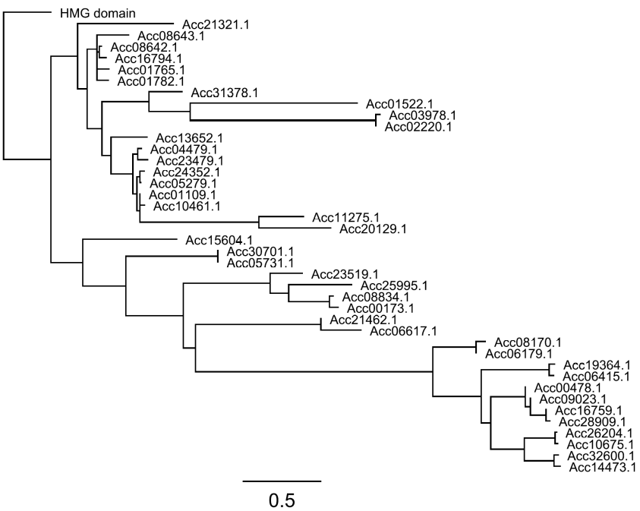

NAC
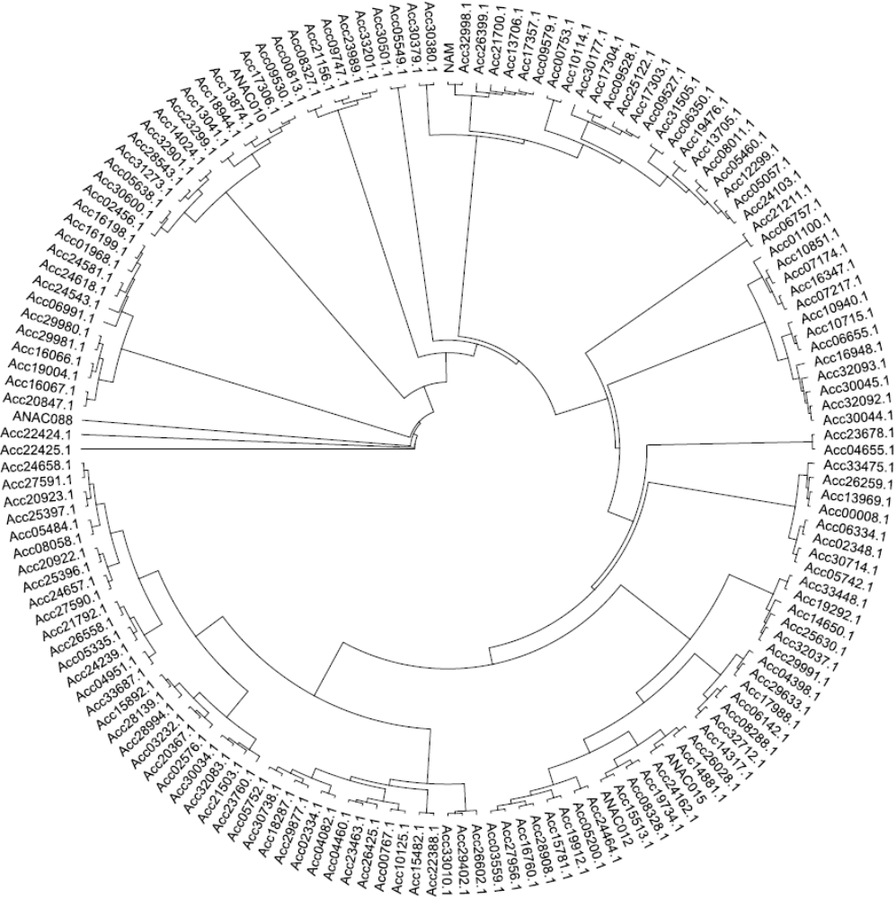

WRKY

TRIHELIX
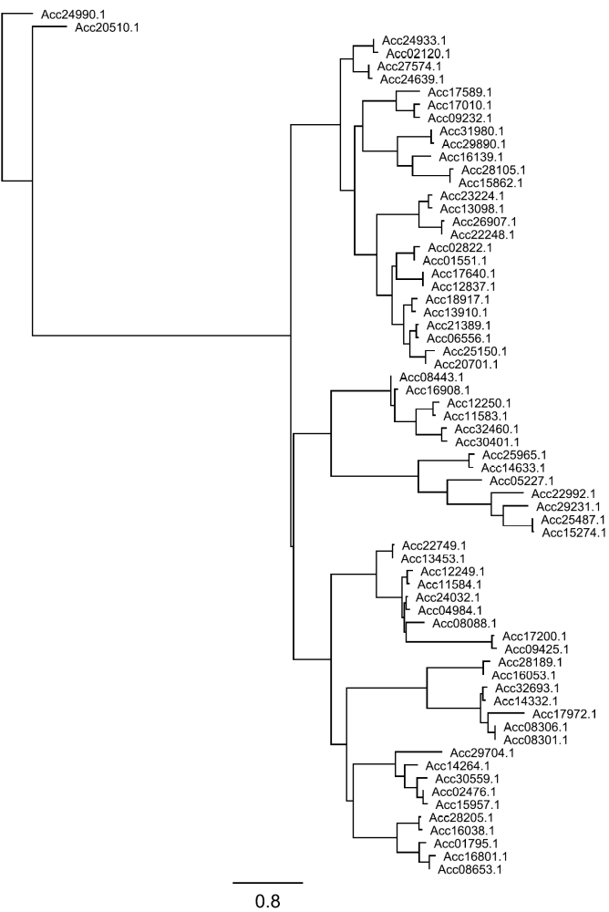

FAR
1 gene

GRAS

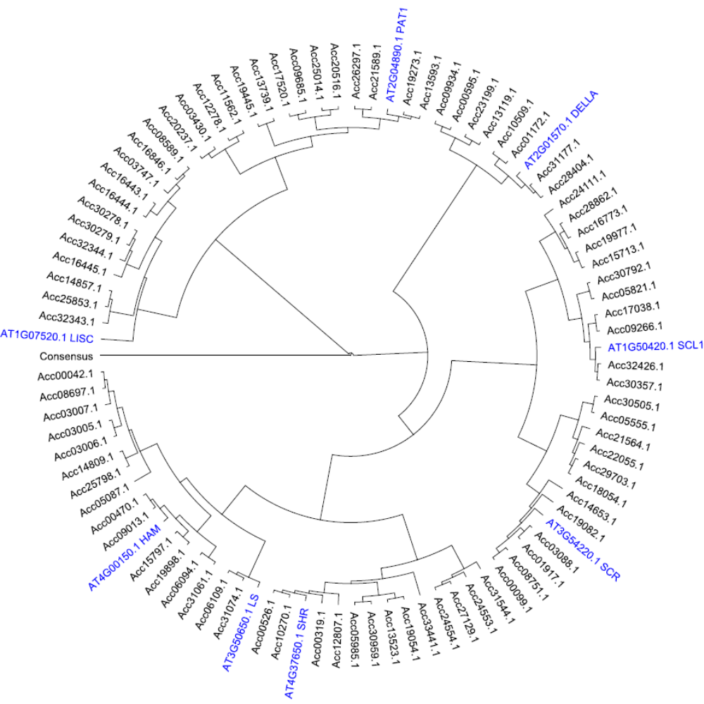

BCP

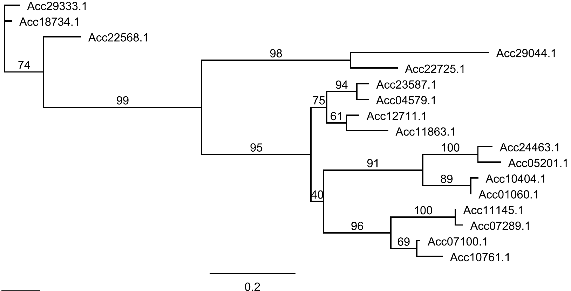

BES

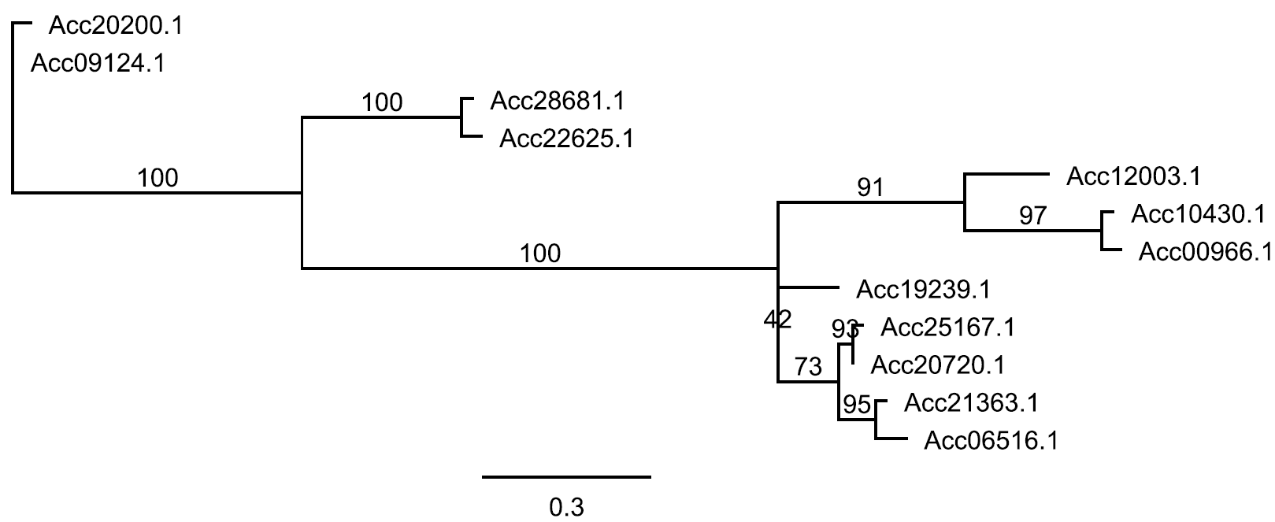

LFY
2 genes

EIL
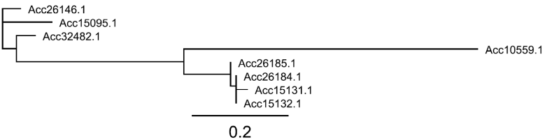

CATMA
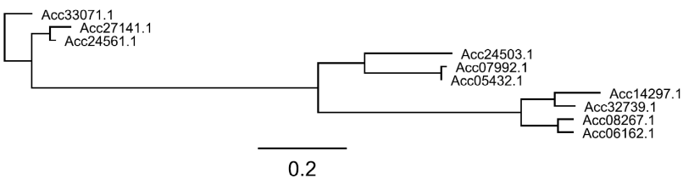

EF2
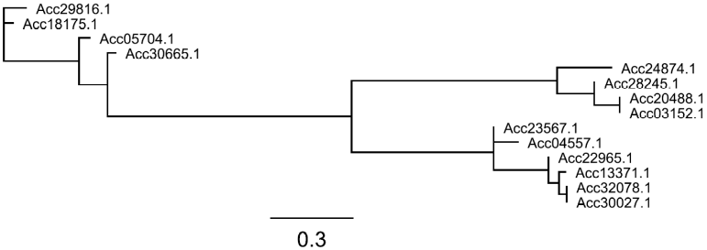

CPP
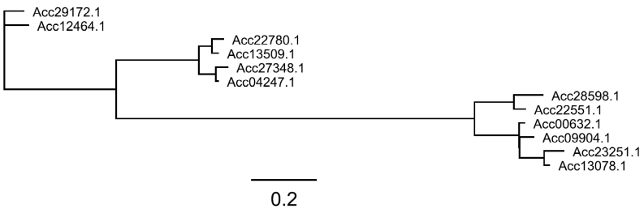

GRF
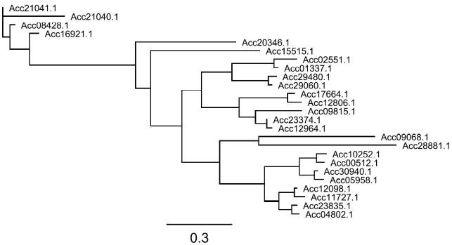

GeBP
7 genes

HST
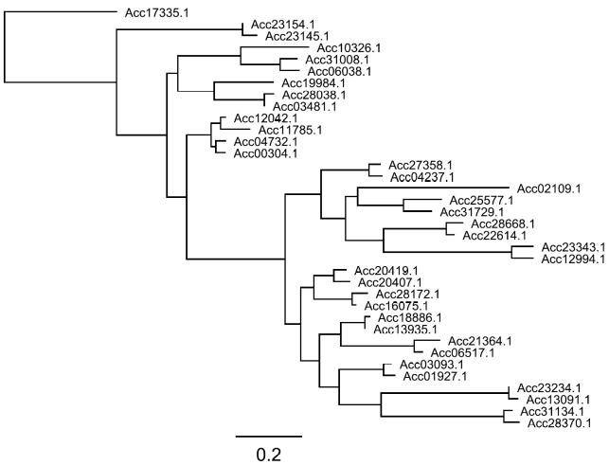

LBD
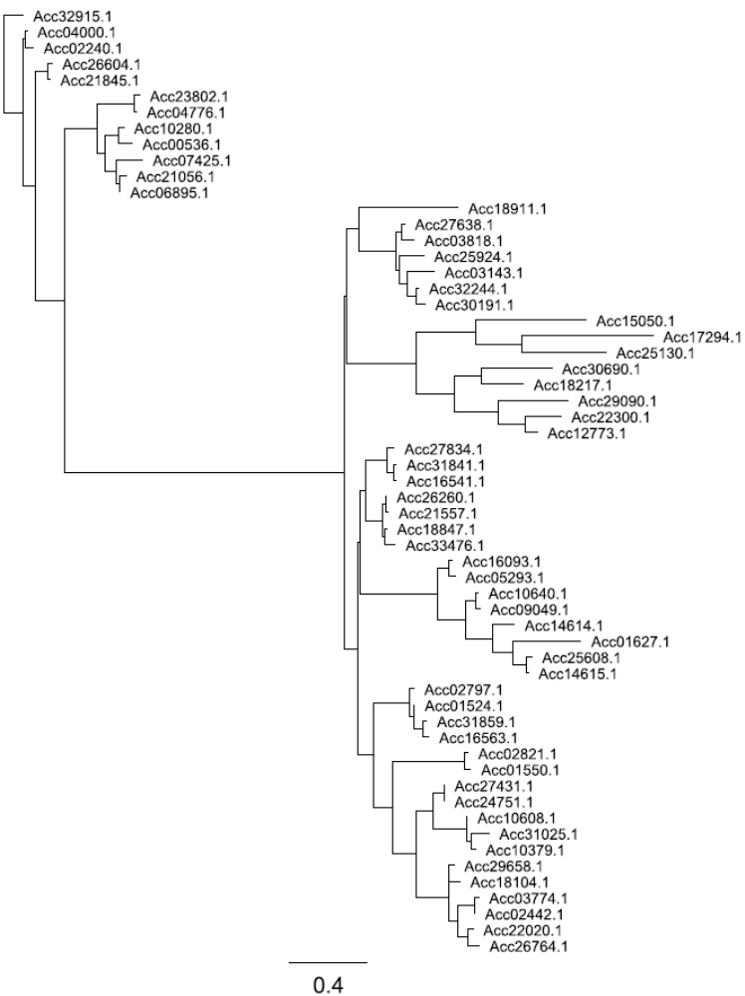

NZZ
3 genes

NIN
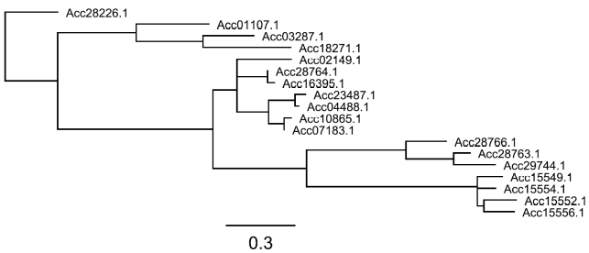

S1Fa
3 genes

SAP
2 genes

HRT
1 gene

WHIRLY
4 genes

PLATZ
