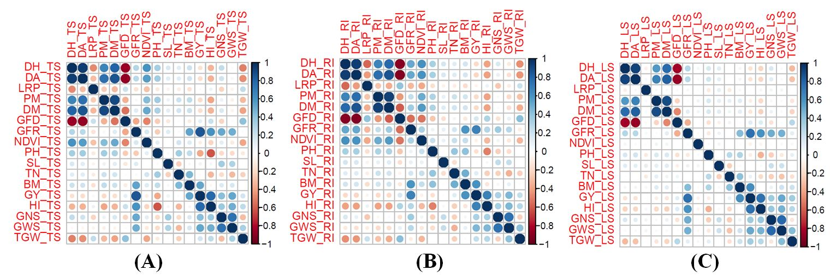 Supplementary Fig. 1: Correlation among different studied traits under A. Timely Sown Condition, B. Restricted Irrigation Condition and C. Late Sown Condition

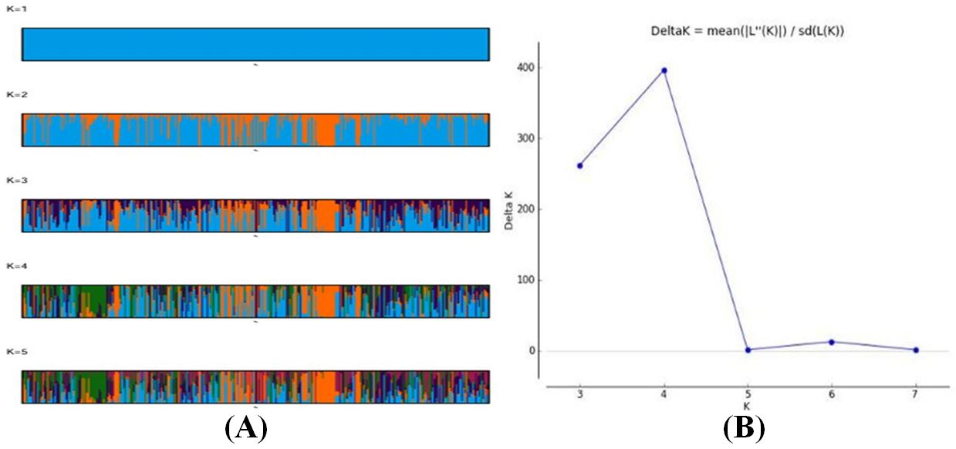
Supplementary Fig. 2: Population structure analysis of 435 diverse bread wheat genotypes using 1,784 informative SNP markers. Bayesian clustering analysis was performed using STRUCTURE v2.3.4 with an admixture model and correlated allele frequencies. Population structure was inferred for K values ranging from 1 to 5 using 10,000 burn-in iterations followed by 20,000 MCMC iterations with three independent replicates for each K. A. Admixture plots generated through CLUMPAK showing membership proportions of individual genotypes across inferred subpopulations. Each vertical bar represents a single genotype and different colors represent inferred ancestry fractions. B. Delta K plot generated using the Evanno method indicating K=4 as the optimal number of subpopulations in the GWAS panel.
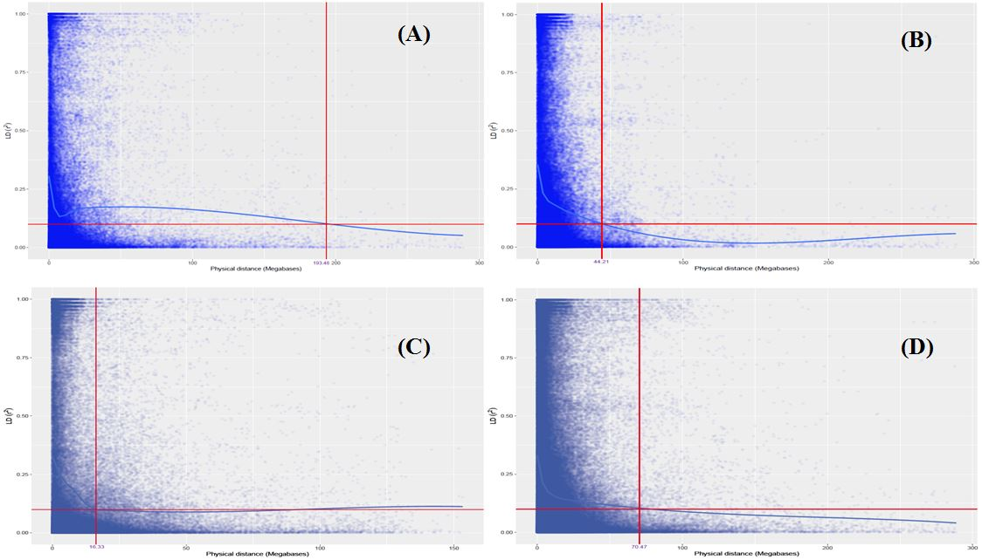
Supplementary Fig. 3: Scatter plot showing LD decay in A. A genome, B. B genome, C. C genome and D. Whole genome

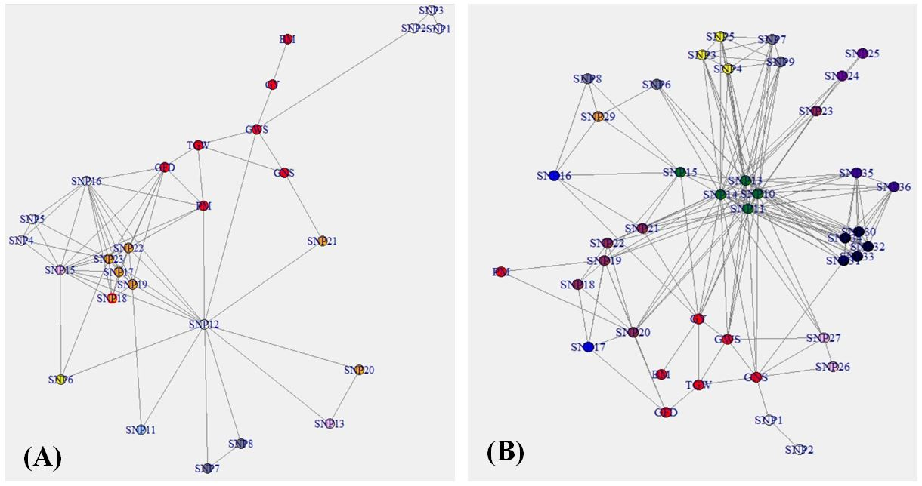
Supplementary Fig. 4: Genotype-phenotype network showing interaction among studied traits and associated SNPs in A. Restricted Irrigation Condition and B. Late Sown Condition

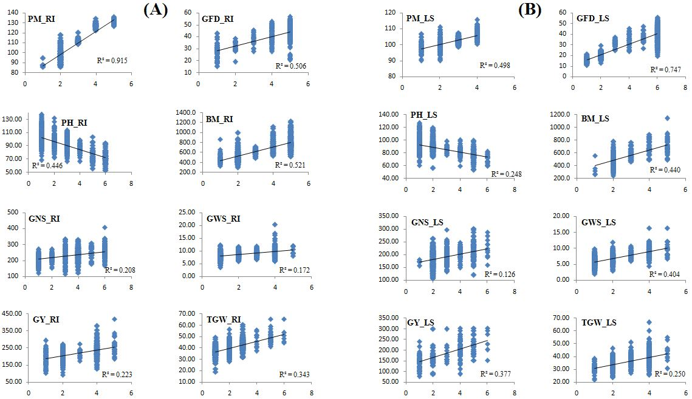
Supplementary Fig. 5: Linear regression between number of favorable alleles and BLUP values observed for selected traits under A. Restricted Irrigation Condition and B. Late Sown Condition

