Supplementary information

Orientation-controlled area-selective deposition of near-single-grain ruthenium interconnects

Eun-Hyoung Cho et al.

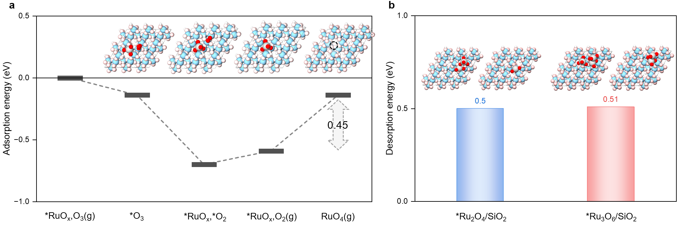
Fig. S1: DFT analysis of Ru oxidation on SiO₂ under ozone exposure.
a, O₃-induced desorption mechanism of Ru adatom on SiO₂ with an energy difference of 0.45 eV, favouring RuO₄ desorption. b, RuO₄ desorption energy of oxidised Ru₂ or Ru₃ nuclei on SiO₂. The atom colours in (a) and (b) are Ru (light grey), H (white), O (red or pink), and Si (light blue). These results demonstrate that Ru-containing species can be oxidised and desorbed as volatile RuO₄ under ozone exposure, supporting the proposed oxidation-driven removal mechanism.

To directly examine the role of periodic ozone exposure during OC-ASD, STEM images were acquired immediately before and after the ozone treatment step on both Ru and SiO₂ surfaces. On Ru, the film surface became noticeably rougher prior to ozone exposure (Fig. S2a), whereas the subsequent ozone treatment reduced the surface roughness without causing a significant change in film thickness (Fig. S2b). This observation suggests that ozone preferentially removes protruding or weakly bonded surface species while largely preserving the continuous Ru film.
In contrast, discrete Ru nuclei were observed on SiO₂ prior to ozone exposure (Fig. S2c). Following ozone treatment, these nuclei were no longer detected (Fig. S2d), indicating their complete removal from the dielectric surface. The markedly different response of Ru and SiO₂ surfaces to ozone exposure supports the proposed OC-ASD mechanism, in which periodic ozone treatment continuously eliminates parasitic Ru nucleation on SiO₂ while maintaining net Ru growth on the metallic surface. This selective removal process suppresses dielectric nucleation and enables sustained bottom-up growth from the Ru template.
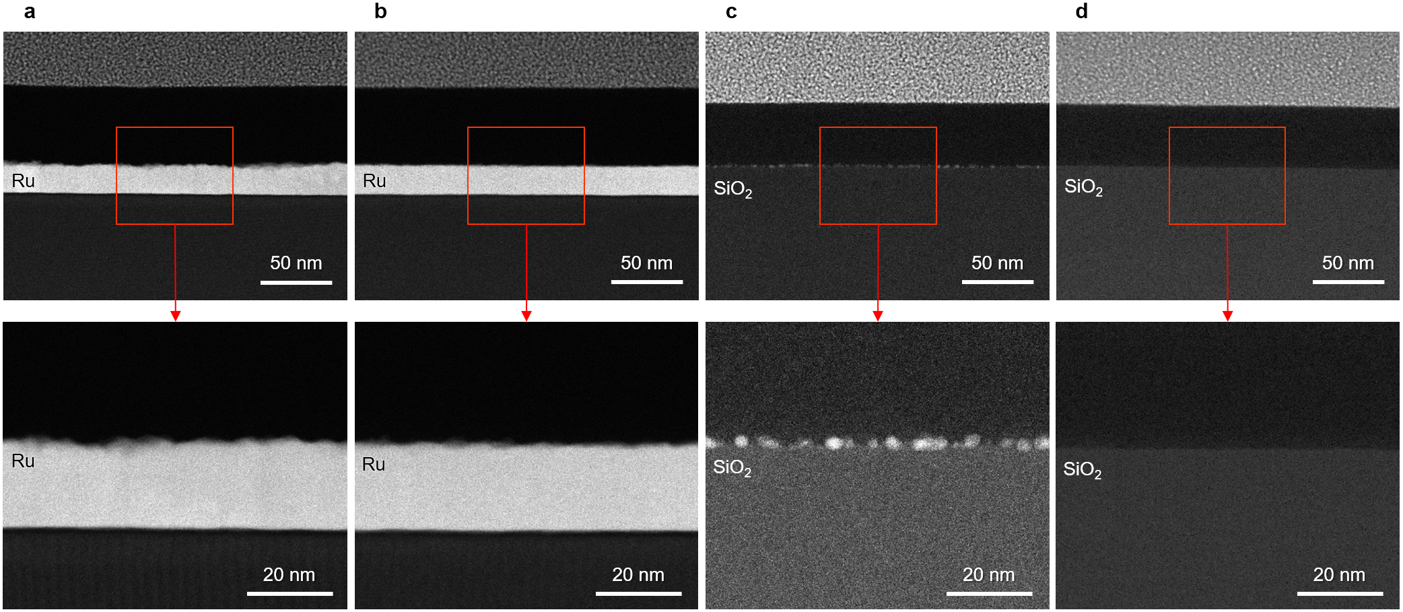
Fig. S2: Effect of periodic ozone exposure on Ru and SiO₂ surfaces during OC-ASD.
a,b, Cross-sectional STEM images of Ru surfaces after 100 cycle of OC-ASD acquired immediately before (a) and after (b) the last periodic ozone exposure step. The ozone treatment reduces surface roughness while preserving the overall film thickness. c,d, STEM images of SiO₂ surfaces after 100 cycles of OC-ASD acquired immediately before (c) and after (d) last ozone exposure. Discrete Ru nuclei are observed on SiO₂ prior to ozone treatment and are completely removed after ozone exposure.

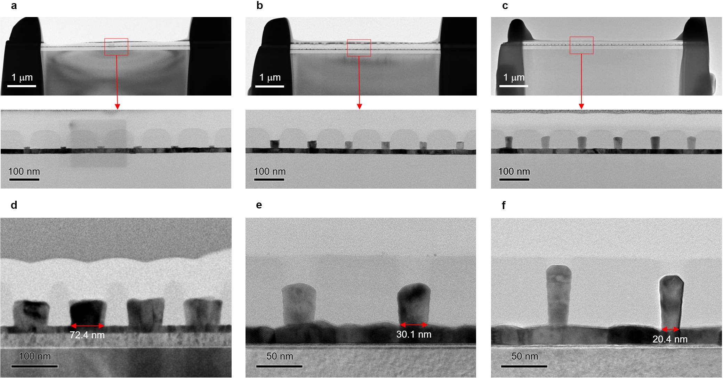
Fig. S3: Bottom-up gap filling across extended pattern areas and different sizes.
a–c, Cross-sectional TEM images of dense arrays of 20 nm CD features at the early (d), intermediate (e), and near-complete (f) stages. In both cases, Ru growth initiates from the bottom and progresses upward while suppressing sidewall nucleation, resulting in seamless filling without void formation. d–f, Cross-sectional TEM images of the Ru bottom-up gap filled with CDs of approximately 70, 30, and 20 nm. The consistent filling behaviour observed across extended areas and multiple features confirms that the bottom-up growth mechanism is highly reproducible and maintained across spatial and varying feature-sized scales.

To evaluate the long-term stability of the selective growth mechanism, OC-ASD was performed for up to 3000 cycles on substrates containing both Ru and SiO₂ surfaces. Cross-sectional SEM images acquired from Ru regions show a continuous increase in film thickness with increasing cycle number, confirming sustained net Ru growth throughout the deposition process (Fig. S4a–d).
In contrast, STEM analysis of neighbouring SiO₂ regions revealed no detectable Ru nuclei after 600, 1200, 1800, or even 3000 OC-ASD cycles. The absence of parasitic nucleation on SiO₂ despite extensive Ru accumulation on adjacent metallic surfaces demonstrates that the selective-removal mechanism remains effective over prolonged deposition times. These observations provide experimental support for the mechanism proposed in Fig. 1e, whereby periodic ozone exposure continuously eliminates incipient Ru nuclei on dielectric surfaces while maintaining net growth on Ru. The persistence of this behaviour over 3000 cycles confirms that OC-ASD is not limited to early-stage nucleation control but can sustain high growth selectivity throughout extended film deposition.
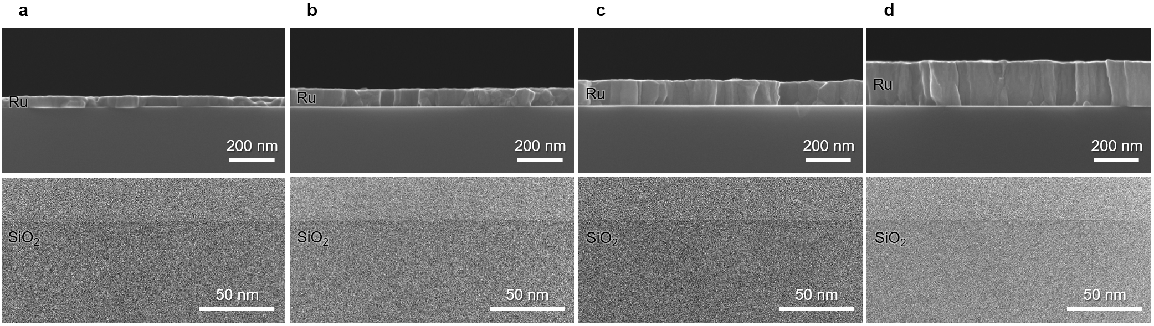
Fig. S4: Sustained growth selectivity during extended OC-ASD cycling.
a–d, Cross-sectional SEM images of Ru films grown on an initial ~8.8 nm Ru layer after 600 (a), 1200 (b), 1800 (c), and 3000 (d) cycles of OC-ASD. The Ru thickness continuously increases with cycle number, indicating sustained net growth on the metallic surface. Corresponding STEM images acquired from adjacent SiO₂ regions are shown below each SEM image. No detectable Ru nuclei are observed on SiO₂ even after 3000 OC-ASD cycles, demonstrating persistent suppression of dielectric nucleation throughout extended deposition.
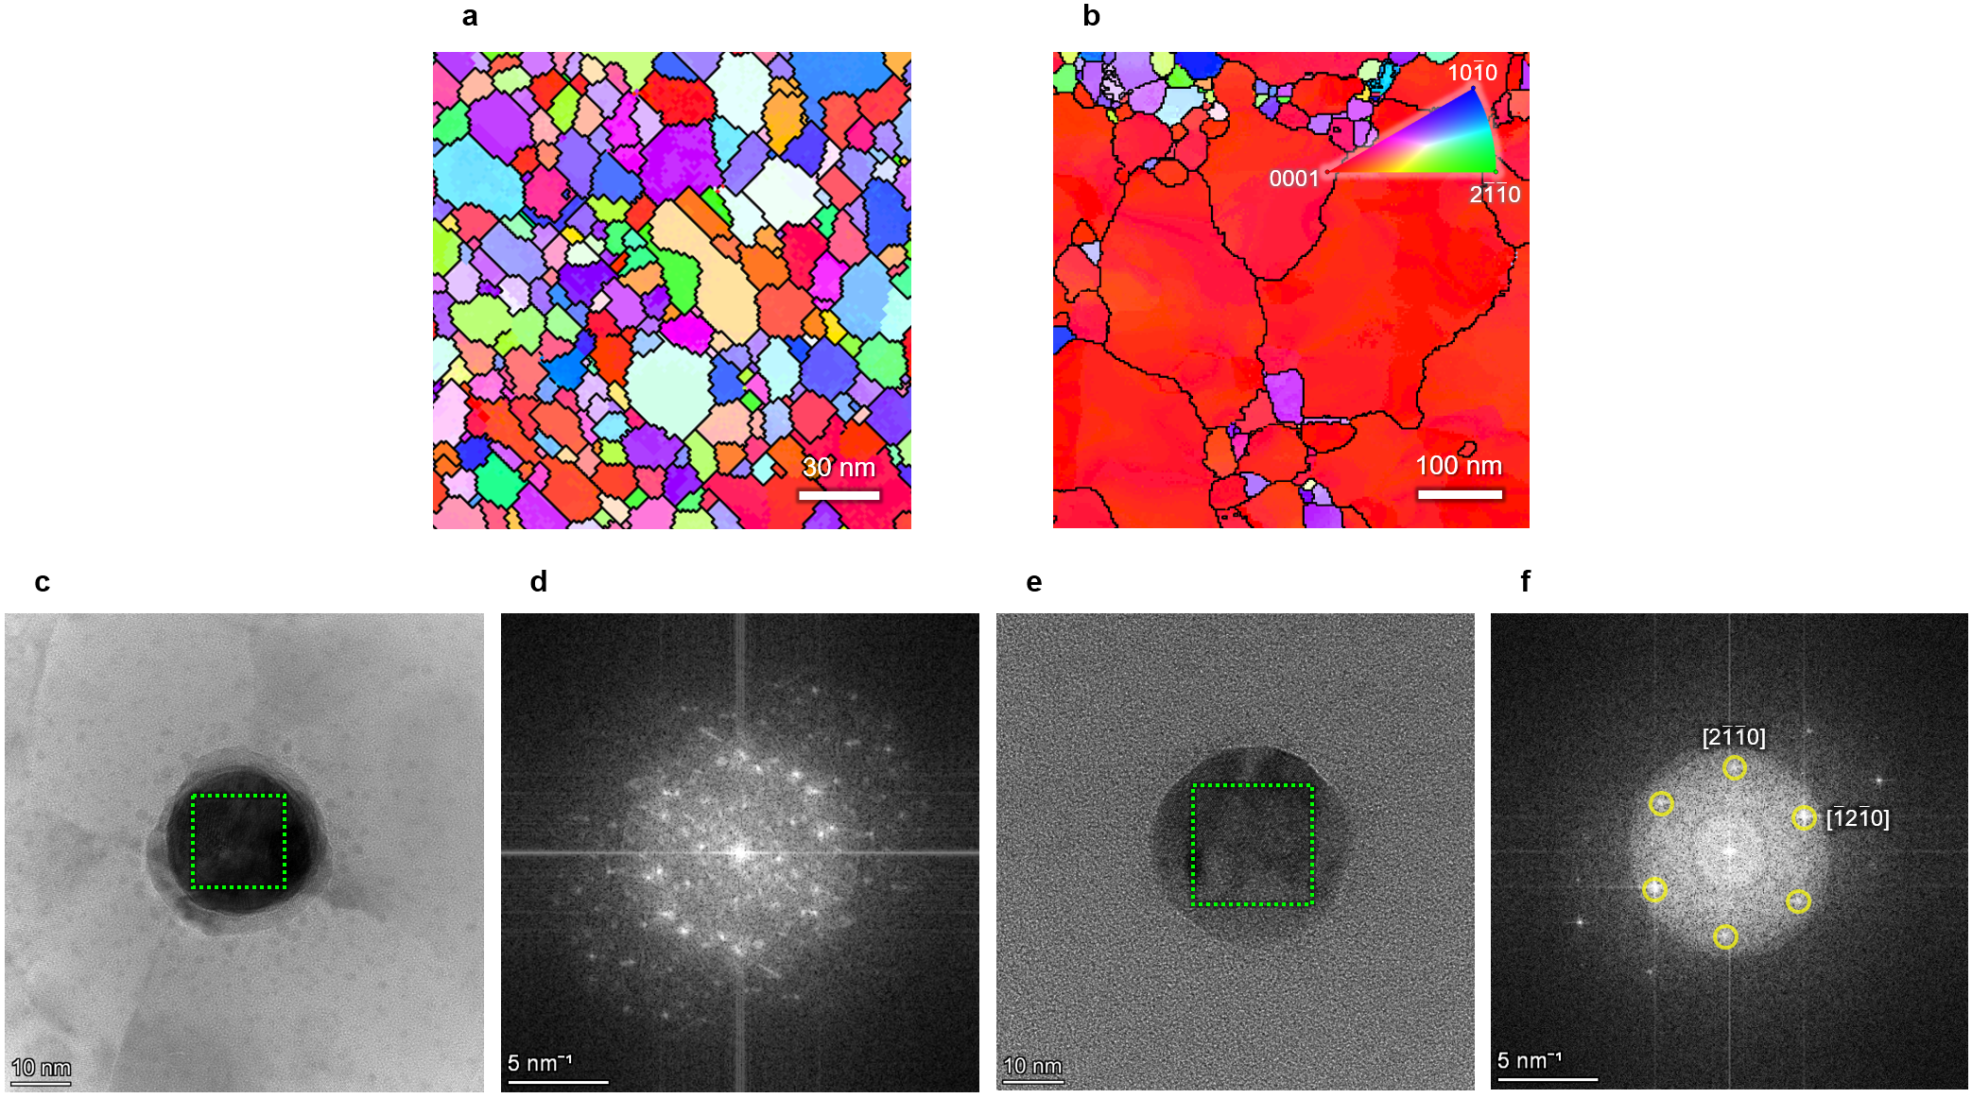
Fig. S5: Structural evolution associated with orientation-preserving bottom-up Ru growth.
a,b, PED orientation maps of the as-deposited Ru film before and after post-annealing. The as-deposited film exhibits fine grains with broadly distributed orientations, whereas post-annealing results in substantial grain growth together with the emergence of a strong (0001) alignment. c, Plan-view TEM images of the patterned region of the ALD gap-filled structures. d, FFT pattern obtained from the region indicated by the dashed box in (c), showing diffuse diffraction features characteristic of a polycrystalline structure with multiple orientations. e, Plan-view TEM images of the OC-ASD bottom-up field structure. f, Corresponding FFT pattern obtained from the patterned region in (e), exhibiting a well-defined six-fold symmetric diffraction pattern consistent with a (0001)-oriented, single-crystal-like structure.

To further verify the crystallographic orientation of the OC-ASD-filled structures, NBD patterns were acquired from multiple locations within both cross-sectional and plain-view specimens. Representative diffraction patterns are shown in Supplementary Fig. S4 together with corresponding simulations.
The diffraction patterns obtained from representative regions (Regions 1–3 in Fig. S4) showed excellent agreement with simulated patterns, confirming the crystallographic alignment. In cross-sectional regions (Regions 1 and 2), the diffraction patterns exhibited slight angular deviations from the surface normal but remained closely aligned with (0001). In the plan-view configuration (Region 3, Supplementary Fig. S4c), a clear six-fold symmetric diffraction pattern—characteristic of the basal plane of hexagonal close-packed Ru—was observed, further confirming the (0001) orientation.
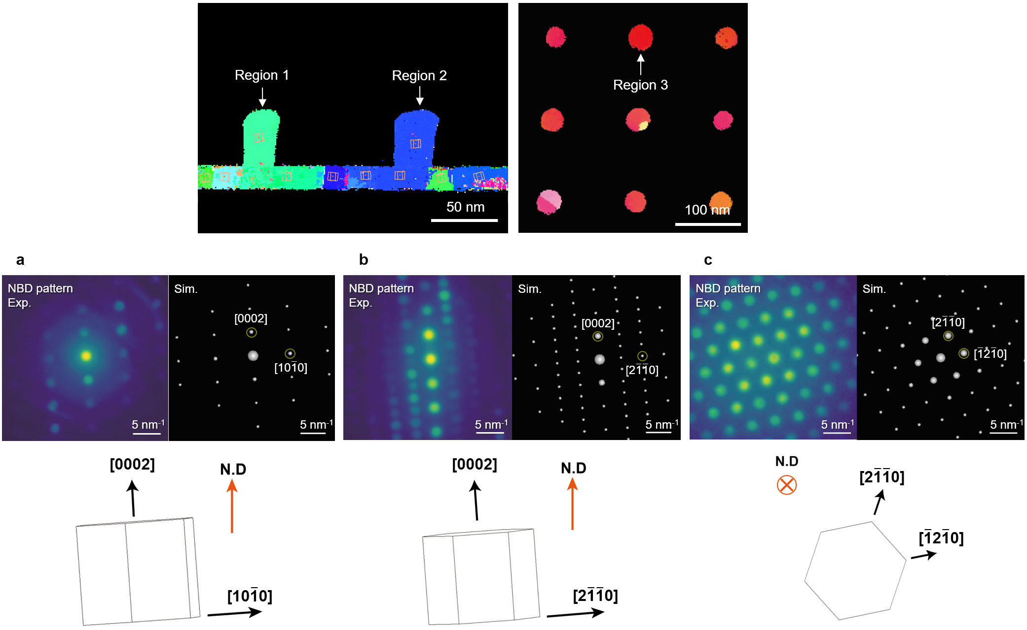
Fig. S6: NBD analysis confirms crystallographic orientation and local lattice coherence in OC-ASD-filled structures.
a,b, NBD patterns acquired from representative cross-sectional regions (Regions 1 and 2) and the corresponding simulated diffraction patterns. The experimental results show excellent agreement with the simulations and indicate that despite small angular deviations, the local crystallographic orientation remains close to the (0001) orientation. c, Plan-view NBD pattern obtained from Region 3, showing a clear six-fold symmetric diffraction pattern characteristic of the basal plane of hexagonal Ru, confirming (0001) alignment across the filled structure.

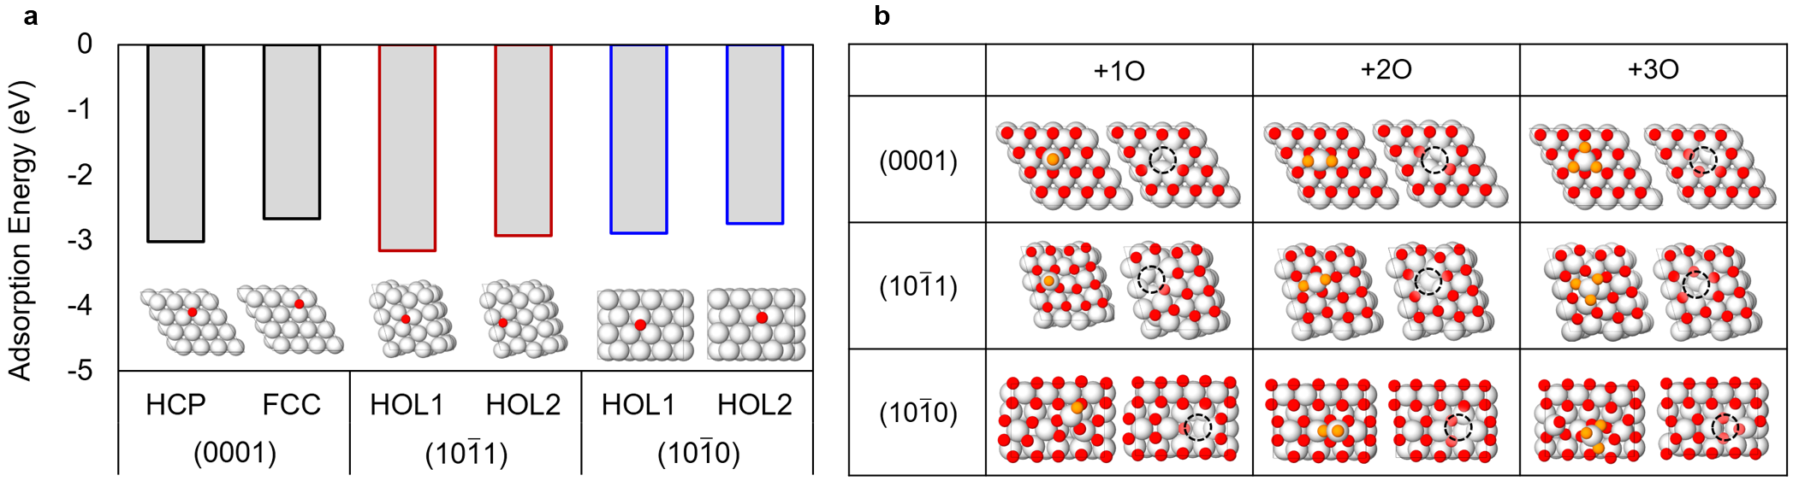
Fig. S7: DFT analysis of facet-dependent adsorption and desorption behaviour on Ru surfaces.
a, DFT-calculated adsorption energies of oxygen atoms on the Ru(0001), Ru(1011), and Ru(1010) surfaces. b, Optimized structure of RuO₄ desorbed on different Ru facets. Atom colours: Ru (light grey), O_{surface} (red), and O_{added} (orange).

