Supplementary materials
Table S1. Detailed definition of Cardiovascular-Kidney-Metabolic Syndrome
Table S2. Drug Classification and Data Coding
Table S3. Definition of Triglyceride-Glucose–Related Indices
Table S4. International Classification of Diseases codes are used to ascertain dementia
Table S5. The CKD-EPI formula for estimating GFR on a natural scale is expressed by specific sex and serum creatinine
Table S6. Measurement of healthy diet score used in the UK Biobank
Table S7. Measures of covariates at baseline in the UK Biobank
Table S8. Associations between TyG-related indices and incident Dementia in participants with CKM syndrome stages 0-3
Table S9. ROC curve analysis of different insulin resistance-related indices
Figure S1. ROC curves for various insulin resistance indicators
Figure S2. Subgroup analysis stratified by stage for the associations between TyG-related indices and dementia incidence in individuals with CKM stages 0-3
Figure S3. Subgroup analysis stratified by sex for the associations between TyG-related indices and dementia incidence in individuals with CKM stages 0-3
Figure S4. Subgroup analysis stratified by age for the associations between TyG-related indices and dementia incidence in individuals with CKM stages 0-3
Figure S5. Subgroup analysis stratified by ethnicity for the associations between TyG-related indices and dementia incidence in individuals with CKM stages 0-3
Figure S6. Subgroup analysis stratified by hypertension status for the associations between TyG-related indices and dementia incidence in individuals with CKM stages 0-3
Figure S7. Subgroup analysis stratified by adiposity status for the associations between TyG-related indices and dementia incidence in individuals with CKM stages 0-3
Figure S8. Subgroup analysis stratified by kidney function status for the associations between TyG-related indices and dementia incidence in individuals with c CKM stages 0-3
Figure S9. Sensitivity analysis of TyG-related indices and dementia risk: excluding cases within the first 2 years of follow-up
Figure S10. Sensitivity analysis for the associations between TyG-related indices and dementia incidence in individuals with CKM stages 0-4
Figure S11. Sensitivity analysis of TyG-related indices and dementia risk: using multiple imputation for missing covariates
Figure S12. Sensitivity analysis of TyG-related indices and dementia risk: accounting for the competing risk of death
Figure S13. The joint association of TyG index stages and polygenic risk scores with risk of dementia
Figure S14. The joint association of the TyG index stage and presence of APOE-ε4 with risk of dementia

Table S1. Detailed definition of Cardiovascular-Kidney-Metabolic Syndrome
Stages | Definition
Stage 0 | Stage 0 is defined as the absence of risk factors for CKM syndrome, including normal BMI (18.5-24.9 kg/m²), waist circumference, blood glucose (HbA1c <5.7%), blood pressure, lipid levels, renal function, and no evidence of CVD.
Stage 1 | Stage 1 is characterized by the presence of at least one of the following: (1) overweight/obesity (BMI ≥25 kg/m²); (2) waist circumference ≥88/102 cm in women/men; (3) prediabetes (HbA1c 5.7% to 6.4%).
Stage 2 | Stage 2 is defined as the presence of moderate to high-risk chronic kidney disease (CKD) (eGFR between 30 and 60 mL/min/1.73 m²) or one or more metabolic risk factors: (1) hypertension; (2) diabetes; (3) triglycerides (TG) ≥ 135 mg/dL; (4) diagnosis of metabolic syndrome.  The moderate to high-risk CKD was defined as an estimated Glomerular Filtration Rate (eGFR) between 30 and 60 mL/min/1.73 m², and eGFR was calculated using the CKD-EPI 2021 creatinine-based equation proposed by the Chronic Kidney Epidemiology Collaboration.  Hypertension was defined as a self-reported history of hypertension, and/or SBP ≥130 mmHg, and/or DBP ≥80 mmHg, and/or the intake of anti-hypertensive medications. Diabetes was defined as HbA1c ≥6.4%, and/or a diagnostic history of diabetes before baseline, and/or the intake of glucose-lowering medications.  Metabolic syndrome is defined as meeting at least three of the following criteria: (1) increased WC; (2) reduced high-density lipoprotein cholesterol (HDL-C < 40 mg/dL in men or < 50 mg/dL in women); (3) high TG (TG > 150 mg/dL); (4) elevated BP (SBP ≥ 130 mmHg or DBP ≥ 80 mmHg); or (5) prediabetes.
Stage3 | Stage 3 involves individuals with subclinical CVD (high predicted CVD risk based on SCORE2 model ≥10%) or advanced-stage CKD (eGFR < 30 mL/min/1.73 m²).
Stage4 | Stage 4 is defined as the presence of clinical cardiovascular disease (CVD) and at least one CKM risk factor (obesity, hypertension, diabetes, high triglycerides, metabolic syndrome, or chronic kidney disease).

Table S2. Drug Classification and Data Coding
1. Antihypertensive medication 20003;6177;6153
capozide 50mg tablets x28; lisinopril ; carace 2.5mg tablet; zestril 2.5mg tablet; quinapril; accuretic tablet; captopril; acepril 12.5mg tablet; capoten 12.5mg tablet; captopril+hydrochlorothiazide 25mg/12.5mg tablet; innovace 2.5mg tablet; innozide tablet; enalapril maleate+hydrochlorothiazide 20mg/12.5mg tablet; coversyl 2mg tablet; ramipril; staril 10mg tablet; cilazapril; vascace 250micrograms tablet; trandolapril; enalapril; fosinopril; perindopril; felodipine; losartan; cozaar half strength 25mg tablet; perdix 7.5mg tablet; valsartan; diovan 40mg capsule; ecopace 12.5mg tablet; kaplon 12.5mg tablet; losartan potassium+hydrochlorothiazide 10mg/12.5mg tablet; cozaar-comp 50mg/12.5mg tablet; irbesartan; aprovel 75mg tablet; tarka 2mg/180mg m/r capsule; trandolapril+verapamil hydrochloride; candesartan cilexetil; amias 2mg tablet; imidapril hydrochloride; tanatril 5mg tablet; felodipine+ramipril; triapin mite 2.5mg/2.5mg tablet; telmisartan; hyteneze 12.5 tablet; tensopril 12.5mg tablet; capto-co 25mg/12.5mg tablet; pralenal 2.5mg tablet; eprosartan; micardis 20mg tablet; irbesartan+hydrochlorothiazide 150mg/12.5mg tablet; coaprovel 150mg/12.5mg tablet; cozaar 25mg tablet; perindopril+indapamide; coversyl plus 4mg/1.25mg tablet; telmisartan+hydrochlorothiazide 40mg/12.5mg tablet; tritace 1.25mg tablet; caralpha 10/12.5mg tablet; Olmesartan; olmetec 10mg tablet; lopace 2.5mg capsule; ranace 1.25mg capsule;lisicostad hct 10/12.5mg tablet; valsartan+ hydrochlorothiazide 80mg/12.5mg tablet; co-diovan 80mg/12.5mg tablet; centyl 2.5mg tablet; urizide 5mg tablet; enduron 5mg tablet; esidrex k tablet; hygroton k tablet combination pack; navidrex-k tablet; serpasil-esidrex tablet; sotalol hydrochloride+hydrochlorothiazide 80mg/12.5mg tablet; metoprolol tartrate+hydrochlorothiazide 100mg/12.5mg tablet; acebutolol+hydrochlorothiazide 200mg/12.5mg tablet; methyldopa +hydrochlorothiazide 250mg/15mg tablet; quinalapril+hydrochlorothiazide 10mg/12.5mg tablet; bisoprolol fumarate+hydrochlorothiazide 10mg/6.25mg tablet; hydroflumethiazide; hydrenox 50mg tablet; mefruside; baycaron 25mg tablet; metolazone; xuret 500micrograms tablet; xipamide; diurexan 20mg tablet; aprinox 2.5mg tablet; berkozide 2.5mg tablet; neo-naclex 5mg tablet; chlorothiazide; saluric 500mg tablet; hygroton 50mg tablet; cyclopenthiazide; navidrex 500mcg tablet; hydrochlorothiazide; esidrex 25mg tablet; hydrosaluric 25mg tablet; amiloride hcl+cyclopenthiazide 2.5mg/250micrograms tablet; centyl k m/r tablet; neo-naclex k m/r tablet; neo-bendromax 2.5mg tablet; nindaxa 2.5mg tablet; chlortalidone; natramid 2.5mg tablet; opumide 2.5mg tablet; diltiazem hcl+hydrochlorothiazide 150mg/12.5mg m/r capsule; natrilix sr 1.5mg m/r tablet; triamterene+chlortalidone 50mg/50mg tablet; atenolol+chlortalidone; diuril 250mg/5ml oral suspension;Bendroflumethiazide; bendroflumethiazide+potassium 2.5mg/7.7mmol m/r tablet; nadolol+bendroflumethiazide 40mg/5mg tablet; timolol maleate+bendroflumethiazide 10mg/2.5mg tablet;atenolol+Bendroflumethiazide; brinaldix k tablet; diatensec 50mg tablet; laractone 25mg tablet; normetic tablet; synuretic tablet; vasetic co-amilozide 5/50mg tablet; pindolol; pindolol+clopamide 10mg/5mgtablet; timolol maleate+co-amilozide 10mg/2.5mg/25mg tablet; aridil 2.5mg/20mg tablet; spiro-co 25mg tablet; midamor 5mg tablet; berkamil 5mg tablet; spiroctan-m 200mg/10ml injection; spironolactone;aldactone 25mg tablet; lasix 20mg tablet; bumetanide; burinex 1mg tablet; spirospare 25mg tablet; cyclopenthiazide; navidrex 500mcg tablet; hydrochlorothiazide; esidrex 25mg tablet; hydrosaluric 25mg tablet;amiloride hcl+cyclopenthiazide 2.5mg/250micrograms tablet; centyl k m/r tablet; neo-naclex k m/r tablet; neo-bendromax 2.5mg tablet; nindaxa 2.5mg tablet; chlortalidone; natramid 2.5mg tablet; opumide 2.5mg tablet; diltiazem hcl+hydrochlorothiazide 150mg/12.5mg m/r capsule; natrilix sr 1.5mg m/r tablet; triamterene+chlortalidone 50mg/50mg tablet; atenolol+chlortalidone; diuril 250mg/5ml oral suspension;Bendroflumethiazide; bendroflumethiazide+potassium 2.5mg/7.7mmol m/r tablet; nadolol+bendroflumethiazide 40mg/5mg tablet; timolol maleate+bendroflumethiazide 10mg/2.5mg tablet;atenolol+Bendroflumethiazide; brinaldix k tablet; diatensec 50mg tablet; laractone 25mg tablet; normetic tablet; synuretic tablet; vasetic co-amilozide 5/50mg tablet; pindolol; pindolol+clopamide 10mg/5mg tablet; timolol maleate+co-amilozide 10mg/2.5mg/25mg tablet; aridil 2.5mg/20mg tablet; spiro-co 25mg tablet; midamor 5mg tablet; berkamil 5mg tablet; spiroctan-m 200mg/10ml injection; spironolactone;aldactone 25mg tablet; lasix 20mg tablet; bumetanide; burinex 1mg tablet; spirospare 25mg tablet; spiretic 25mg tablet; spiroctan 25mg tablet; spirolone 25mg tablet; triamterene+benzthiazide 50mg/25mg capsule; triam-co tablet; triamterene+chlorthalidone 50mg/50mg tablet; triamterene+frusemide 50mg/40mg tablet; lasoride tablet; delvas tablet; navispare tablet; amilmaxco 5/50 tablet; burinex a tablet;triamaxco tablet; triamterene; dytac 50mg capsule; aldactide 25 tablet; amil-co tablet; dyazide tablet; dytide capsule; frumil tablet; kalspare tablet; moduret 25 tablet; fru-co tablet; moduretic tablet; amiloride；hydrochloride+bumetanide 5mg/1mg tablet; burinex k m/r tablet; diumide-k continus m/r tablet; lasikal m/r tablet; bumetanide+potassium 500micrograms/7.7mmol m/r tablet; diuretic; amiloride; furosemide;amipramizide; zida-co 5mg/50mg tablet; co-triamterzide; co-amilozide; co-flumactone; co-amilofruse; amilamont 5mg/ml s/f oral solution; frusemek 5mg/40mg tablet; atenolol+co-amilozide; angiotensin ii receptor antagonist+diuretic; froop co 5mg/40mg tablet; komil 5/40 tablet; triamterene+furosemide 50mg/40mg tablet; furosemide+potassium 20mg/10mmol m/r tablet; inspra 25mg tablet; spiroprop tablet;metoros 95mg tablet; bedranol 10mg tablet; totamol 25mg tablet; arbralene 50mg tablet; kerlone 20mg tablet; trandate 50mg tablet; betaloc 50mg tablet; mepranix 50mg tablet; metoprolol; artrate+chlorthalidone 100mg/12.5mg tablet; secadrex tablet; sotazide tablet; penbutolol sulphate+frusemide 40mg/20mg tablet; tenoret 50 tablet; tenoretic tablet; tolerzide tablet; viskaldix tablet; timolol maleate+bendrofluazide 10mg/2.5mg tablet; timolol maleate+bendrofluazide 20mg/5mg tablet; atenixco 50mg/12.5mg tablet; beta-adalat capsule; tenif capsule; co-betaloc tablet; inderetic capsule; inderex capsule; kalten capsule; lopresoretic tablet; moducren tablet; prestim tablet; atenolol+nifedipine 50mg/20mg m/r capsule; monocor 5mg tablet; emcor 10mg tablet; celectol 200mg tablet; adalat 5mg capsule; monozide 10 tablet; antipressan 25mg tablet; angilol 10mg tablet; cardinol 10mg tablet; acebutolol; atenolol; tenormin 25 tablet; vasaten 50mg tablet; apsolol 10mg tablet; propanix 10mg tablet; betadur cr 160mg m/r capsule; beta- prograne 160mg m/r capsule; berkolol 10mg tablet; half-betadur cr 80mg m/r capsule; half-inderal la 80mg m/r capsule; half beta-prograne 80mg m/r capsule; inderal 10mg tablet; concordin 5mg tablet;betaxolol; bisoprolol; celiprolol; metoprolol; labetalol; penbutolol; sotalol; timolol; adalate 10mg capsule; avlocardyl retard 160mg m/r capsule; carvedilol; totaretic 50mg/12.5mg tablet; sloprolol 80mg m/r capsule; probeta la 160mg m/r capsule; lopranol la 160mg m/r capsule; atenix 25mg tablet; co-tenidone; atenolol+chlorthalidone; atenolol+bendrofluazide; tenben capsule; half propanix la 80mg m/r capsule; half propatard la 80mg m/r capsule; nebilet 5mg tablet; eucardic 3.125 tablet; dorzolamide+timolol; cardicor 1.25mg tablet; syprol 5mg/5ml oral solution; soloc 5mg tablet; tensomex 100mg tablet; bipranix 5mg tablet; latanoprost+timolol; rapranol sr 80mg m/r capsule; vivacor 5mg tablet; calcicard 60mg tablet; lidoflazine; clinium 120mg tablet; vasad 5mg capsule; synadrin 60mg tablet; veractil 25mg tablet; nifedipine;calcilat 10mg capsule; angiopine 5mg capsule; nifensar xl 20mg m/r tablet; coracten sr 10mg m/r capsule; tildiem 60mg m/r tablet; britiazim 60mg m/r tablet; angiozem 60mg m/r tablet; adizem-60 m/r tablet;cardene 20mg capsule; isradipine; istin 5mg tablet; lacidipine; motens 2mg tablet; half securon sr 120mg m/r tablet; securon 40mg tablet; geangin 40mg tablet; berkatens 40mg tablet; cordilox 40mg tablet;parmid 10mg tablet; nimotop 30mg tablet; nimodipine; nicardipine; univer 120mg m/r capsule; verapamil; nifelease 20mg m/r tablet; slozem 120mg m/r capsule; calanif 5mg capsule; angitil sr 90 m/r capsule;adipine mr 10 m/r tablet; kentiazem 60mg m/r capsule; unipine xl 30mg m/r tablet; adizem-xl plus m/r capsule; cardilate mr 10mg m/r tablet; tensipine mr 10 m/r tablet; plendil 2.5mg m/r tablet; nisoldipine;
syscor mr 10mg m/r tablet; fortipine la40 m/r tablet; slofedipine 20mg m/r tablet; nifedotard 20mr m/r tablet; verapress mr 240 m/r tablet; viazem xl 120mg m/r capsule; genalat retard 10mg m/r tablet;lercanidipine; zanidip 10mg tablet; mibefradil; calazem 60mg m/r tablet; optil 60mg m/r tablet; dilcardia sr 60mg m/r capsule; nifedipress mr 10 m/r tablet; nivaten retard 10mg m/r tablet; coroday mr 20mg m/r tablet; zemtard 120 xl m/r capsule; ethimil mr 240 m/r tablet; vertab sr 240 m/r tablet; nifopress retard 20mg m/r tablet; zildil sr 60mg m/r capsule; calchan mr 10mg m/r tablet; zemret 180 xl m/r capsule; bi-carzem sr 60mg m/r capsule; horizem sr 90mg m/r capsule; zolvera 40mg/5ml oral solution; disogram sr 60mg m/r capsule; ranvera mr 240mg m/r tablet; cabren 2.5mg m/r tablet; vera-til sr 120mg m/r tablet;kentipine mr 10mg m/r tablet; felotens xl 5mg m/r tablet; felogen xl 5mg m/r tablet; hypolar retard 10mg m/r tablet; valni 20 retard 20mg m/r tablet; cardioplen xl 5mg m/r tablet; amlostin 5mg tablet; neofel xl 5mg m/r tablet; parmid xl 5mg m/r tablet.
1140851692; 1140860696; 1140860706; 1140860714; 1140860728; 1140860736; 1140860750; 1140860752; 1140860758; 1140860764; 1140860776; 1140860784; 1140860790; 1140860802; 1140860806; 1140860878; 1140860882; 1140860892; 1140860904; 1140860912; 1140860918; 1140864618; 1140864910; 1140864952; 1140866078; 1140879802; 1140881706; 1140888552; 1140888556; 1140888560;
1140888646; 1140916356; 1140916362; 1140923718; 1141145660; 1141145668; 1141150328; 1141150560; 1141151016; 1141151018; 1141152998; 1141153006; 1141153316; 1141153328; 1141156836; 1141156846; 1141164148; 1141164154; 1141165470; 1141165476;
1141166006; 1141167758; 1141167822; 1141170544; 1141170870; 1141171336; 1141172492; 1141172682; 1141172686; 1141179974; 1141180592; 1141180598; 1141187788; 1141188408; 1141190934; 1141193282; 1141193346; 1141199940; 1141200698; 1141200726; 1141201038; 1141201040; 1140851332; 1140851336; 1140851338;1140851362; 1140851364; 1140851368; 1140851660; 1140860332; 1140860404; 1140860422; 1140860562; 1140860738; 1140864950; 1140866072; 1140866074; 1140866084; 1140866086; 1140866092; 1140866096; 1140866108; 1140866110; 1140866128; 1140866132; 1140866136; 1140866138; 1140866140; 1140866146; 1140866156; 1140866158; 1140866162; 1140866164; 1140866168; 1140866422;1140866440; 1140866446; 1140888918; 1140888922; 1140909706; 1140916870; 1140917068; 1140926778; 1141146378; 1141180772; 1141180778; 1141188636; 1141194794; 1141194800; 1141194804; 1141194808; 1141194810; 1140851360; 1140851418; 1140851420; 1140851428; 1140851430; 1140851436; 1140860292; 1140860322; 1140860336;1140864550; 1140864574; 1140866220; 1140866226;1140866232; 1140866236; 1140866244; 1140866248; 1140866280; 1140866282; 1140866306; 1140866308; 1140866312; 1140866318; 1140866324; 1140866328; 1140866330; 1140866332; 1140866334; 1140866340; 1140866352; 1140866354; 1140866356; 1140866360; 1140866388; 1140866390; 1140866396; 1140866400; 1140866402; 1140866404; 1140866406; 1140866410; 1140866416; 1140866418;1140866420; 1140866426; 1140866438; 1140866442; 1140866444; 1140866448; 1140881894; 1140888512; 1140909708; 1140909722; 1140922324; 1140923272; 1140923276; 1140923282; 1140923402; 1140927174; 1140928624; 1141146128; 1141150898; 1141167108; 1141181520; 1141195254; 1141195258; 1141201250; 1140851508; 1140851522; 1140851556; 1140860172; 1140860180; 1140860232;1140860250; 1140860266; 1140860278; 1140860308; 1140860314; 1140860318; 1140860320; 1140860324; 1140860328; 1140860330; 1140860338; 1140860340; 1140860342; 1140860348; 1140860356;
1140860358; 1140860386; 1140860394; 1140860396; 1140860398; 1140860402; 1140860406; 1140860410; 1140860426; 1140860434; 1140860492; 1140860498; 1140861090; 1140864176; 1140864410;1140866704; 1140866712; 1140866724; 1140866738; 1140866756; 1140866758; 1140866764; 1140866766; 1140866778; 1140866782; 1140866784; 1140866798; 1140866800; 1140866802; 1140866804; 1140867734; 1140879758; 1140879760; 1140879762; 1140879818; 1140879824; 1140879834; 1140879854; 1140879866; 1140881702; 1140881722; 1140909368; 1140916628; 1140916730; 1140916868;1140917076; 1140922930; 1140923336; 1141146124; 1141146126; 1141146184; 1141152076; 1141156754; 1141164280; 1141168498; 1141169516; 1141171152; 1141172742; 1141182904; 1141182968; 1141184324; 1141184722; 1141187048; 1141187780; 1140851730; 1140851784; 1140851786; 1140851790; 1140851800; 1140855976; 1140861088; 1140861106; 1140861110; 1140861114; 1140861120;1140861128; 1140861130; 1140861136; 1140861138; 1140861176;
1140861190; 1140861202; 1140861276; 1140861282; 1140866460; 1140866466; 1140866484; 1140866546; 1140866554; 1140868036; 1140872472; 1140872568; 1140879810; 1140881692; 1140888510; 1140911088; 1140911698; 1140916930; 1140917428; 1140923572; 1140923618; 1140926188; 1140926780; 1140927934; 1140927940;1140928212; 1140928226; 1140928234; 1141145870; 1141150500; 1141150538; 1141150926; 1141151474; 1141152600; 1141153026; 1141153032; 1141153394; 1141153454; 1141156656; 1141157136; 1141157140; 1141162546; 1141166752; 1141167832; 1141169096; 1141169710; 1141169730; 1141171804; 1141173766; 1141174684; 1141175224; 1141180238; 1141184390; 1141185444; 1141187056;1141187094; 1141187774; 1141187962; 1141188152; 1141188576;
1141188936; 1141190548; 1141199858; 1141200400; 1141200782; 1141201814
2. Antidiabetic medication 20003; 6177; 6153
Glibornuride; daonil 5mg tablet; glutril 25mg tablet; semi-daonil 2.5mg tablet; glymidine; euglucon 2.5mg tablet; gondafon 500mg tablet ; malix 2.5mg tablet ; pramidex 500mg tablet; diabetamide 2.5mg tablet;glipizide; gliclazide; glibenese 5mg tablet; diamicron 80mg tablet; minodiab 2.5mg tablet; insulin product; tolazamide; metformin; tolanase 100mg tablet; glimepiride; tolbutamide; troglitazone; glyconon 500mg tablet; romozin 200mg tablet ; rastinon 500mg tablet ; amaryl 1mg tablet ; glucophage 500mg tablet; pioglitazone; orabet 500mg tablet; actos 15mg tablet; chlorpropamide; rosiglitazone; diabinese 100mg tablet; avandia 4mg tablet; glymese 250mg tablet; rosiglitazone 1mg / metformin 500mg tablet; glibenclamide; avandamet 1mg / 500mg tablet；
1140857494; 1140874724; 1140857496; 1140874726;1140857500;1140874728; 1140857502; 1140874732; 1140857506; 1140874736; 1140874646; 1140874744; 1140874650; 1140874746; 1140874652;1140883066; 1140874664; 1140884600; 1140874666; 1141152590; 1140874674; 1141153254; 1140874678; 1141153262; 1140874680; 1141156984; 1140874686; 1141171646; 1140874690; 1141171652; 1140874706; 1141177600; 1140874712; 1141177606; 1140874716; 1141189090; 1140874718; 1141189094;

Table S3. Definition of Triglyceride-Glucose–Related Indices
Variables | Formulas
Triglyceride-Glucose (TyG) Index | TyG Index=Ln(TG× FPG/2)
Triglyceride-Glucose Body Mass Index (TyG-BMI) Index | TyG-BMI Index=TyG × BMI
Triglyceride-Glucose Waist Circumference (TyG-WC) Index | TyG-WC Index=TyG × WC
Triglyceride-Glucose Waist-to-height Ratio (TyG-WHtR) Index | TyG-WHtR Index=TyG ×(WC/Height)
TG (mg/dL), FPG (mg/dL), BMI (kg/m2), WC (cm), and Height (cm) are used in the formulas above.
Abbreviations: BMI, body mass index; FPG, fasting plasma glucose; TG, triglycerides; TyG, Triglyceride-glucose; TyG-BMI, triglyceride-glucose body mass index; WC, waist circumference(cm); TyG-WHtR, Triglyceride-Glucose Waist-to-height Ratio.

Table S4. International Classification of Diseases codes are used to ascertain dementia
ICD-10
F00, F00.0, F00.1, F00.2, F00.9, G30, G30.0, G30.1, G30.8, G30.9, F01, F01.0, F01.1, F01.2, F01.3, F01.8, F01.9,167.3, F02.0,G31.0, A81.0, F02, F02.1, F02.2, F02.3, F02.4, F02.8, F03, F05.1, F10.6, G31.1, G31.8
Abbreviations: ICD, International Classification of Diseases.

Table S5. The CKD-EPI formula for estimating GFR on a natural scale expressed by specific sex, serum creatinine
Coefficients | Sex | Serum Creatinine(mg/dL) | Equation
As, new | Female | ≤0.7 | GFR=142×(Scr/0.7)^{-0.241}×(0.9938)^{Age}×1.012
As, new | Female | >0.7 | GFR=142×(Scr/0.7)^{-1.2}×(0.9938)^{Age}×1.012
As, new | Male | ≤0.9 | GFR=142×(Scr/0.9)^{-0.302}×(0.9938)^{Age}
As, new | Male | >0.9 | GFR=142×(Scr/0.9)^{-1.2}×(0.9938)^{Age}
The CKD-EPI Creatinine-Cystatin C Age, Sex Equation (2021) can be expressed as a single equation 142 × min (Scr/k,1) α × max (Scr/k,1) -1.2×0.9938 Age × C. Where Scr is serum creatinine, k is 0.7 for females and 0.9 for males, α is -0.241 for females and -0.302 for males, C is 1.012 for females and 1 for males, min indicates the minimum of Scr/k or 1, and max indicates the maximum of Scr/k or 1.

Table S6. Measurement of healthy diet score used in the UK Biobank
Diet component | Intake goal | Field ID | Amount per serving
Fruit | ≥3 servings/day | 1309 (pieces fresh fruit/day)  1319 (pieces dried fruit/day) | 1309–1 piece  1319–5 pieces
Vegetable | ≥3 servings/day | 1289 (tablespoons cooked vegetables/day)  1299 (salad/raw vegetables/day) | 3 heaped tablespoons
Whole grains | ≥3 servings/day | 1438,1448 (whole meal/wholegrain bread slices/week)  1458,1468 (bran/oat/muesli cereal bowls/week) | 1438/1448–1 slice/day  1458/1468–1 bowl/day
Fish | ≥2 servings/week | 1329 (oily fish/week)  1339 (non-oily fish/week) | Once/week
Refined grains | ≤2 servings/day | 1438, 1448 (white, brown, other bread slices/week)  1458, 1468 (biscuit, other cereals /week) | 1438/1448–1 slice/day  1458/1468–1 bowl/day
Processed meats | ≤1 serving/week | 1349 (processed meat/week or daily)  3680 (age when last ate meat) | 1349–1 piece/day  3680–0 pieces/day if indicated, having never eaten meat
Unprocessed meats | ≤2 servings/week | 1359 (poultry/week or day)  1369 (beef/week or day)  1379 (lamb or mutton/week or day)  1389 (pork/week or day)  3680 (age when last ate meat) | 1359-1389–once/week  3680–0 pieces/day if indicated, having never eaten meat
Field IDs and serving sizes used per diet component in the UK Biobank with available data from the general baseline questionnaire. If participants achieved the intake goal, they were considered to have an adequate intake of the diet component. Scoring criteria for healthy dietary component recommendations: 1: If intake goal met; 0: If intake goal not met (Range: 0-7).

Table S7. Measures of covariates at baseline in the UK Biobank
Variable | Field ID | Question or description | Categories from raw data | Categories for the current study
Age | 21003 | Age when attended assessment centre
Sex | 31 | Sex | Female;  Male. | Female;  Male.
Ethnicity | 21000 | Ethnic background | White;  Mixed;  Asian or Asian British;  Black or Black British;  Chinese;  Other ethnic group. | Yes=White;  Non=Non-White.
Education | 6138 | Qualifications | College or University degree;  A levels/AS levels or equivalent;  O levels/GCSEs or equivalent;  CSEs or equivalent;  NVQ or HND or HNC or equivalent;  Other professional qualifications, e.g., nursing, teaching. | 0 = Others;  1 = College or university degree.
Family income | 738 | Average total household income before tax (unit: £) | Less than 18,000;  18,000 to 30,999;  31,000 to 51,999;  52,000 to 100,000;  Greater than 100,000. | <18,000  18,000-30,999  31,000-51,999  52,000-100,000  > 100,000
Townsend deprivation index | 22189 | Townsend deprivation index at recruitment | Continuous. | A higher value indicates greater deprivation.
Smoking | 20116 | The current/past smoking status of the participant. | Prefer not to answer  Never;  Previous;  Current. | Never;  Previous;  Current;
Alcohol consumption | 1558 | About how often do you drink alcohol? | Never;  Special occasions only;  One to three times a month;  Once or twice a week;  Three or four times a week;  Daily or almost daily;  Prefer not to answer. | Low;  Intermediate;  High.
Adequate physical activity | 884,894,904,914 | Number of days/week of moderate/vigorous physical activity 10+ minutes?  Duration of moderate/vigorous activity? | Continuous. | The total amount of weekly moderate and vigorous physical activity was calculated by multiplying the number of days per week by the duration per day, respectively. Adequate physical activity was defined as vigorous physical activity ≥75 min/week, or moderate physical activity ≥150min/week, or equivalent combination.  Yes = Adequate; No =Inadequate.
Sleeplessness | 1160 | About how many hours of sleep do you get in every 24 hours? (Please include naps)? | Continuous. | Never/rarely;  Sometimes;  Usually.
Systolic blood pressure (SBP) | 4080,93 | Systolic blood pressure, automated/manual reading | Continuous. | Take the average of the automatic reading and manual reading of SBP.
Diastolic blood pressure (DBP) | 4079,94 | Diastolic blood pressure, automated/manual reading | Continuous. | Take the average of the automatic reading and manual reading of DBP.
Glycated haemoglobin (HbA1c) | 30750 | Glycated haemoglobin (HbA1c) | Continuous.
Cholesterol | 30690 | Cholesterol | Continuous.

Table S8. Associations between TyG-related indices and incident Dementia in participants with CKM syndrome stages 0-3
Exposures | Incidence rate | HR(95%CI)
Per SD increment |  | 1.04(1.02-1.06)
Quartile1 | 2.94 | Reference
Quartile2 | 3.63 | 0.96(0.91-1.02)
Quartile3 | 4.15 | 0.98(0.93-1.03)
Quartile4 | 4.94 | 1.05(1.00-1.10)
TyG-BMI index
Per SD increment |  | 1.08(1.06-1.10)
Quartile1 | 2.98 | Reference
Quartile2 | 3.62 | 0.97(0.92-1.03)
Quartile3 | 4.11 | 0.99(0.94-1.04)
Quartile4 | 4.95 | 1.15(1.09-1.21)
TyG-WC index
Per SD increment |  | 1.14(1.11-1.16)
Quartile1 | 2.41 | Reference
Quartile2 | 3.42 | 1.05(0.99-1.12)
Quartile3 | 4.29 | 1.13(1.07-1.20)
Quartile4 | 5.58 | 1.29(1.22-1.37)
TyG-WHtR index
Per SD increment |  | 1.13(1.11-1.16)
Quartile1 | 2.38 | Reference
Quartile2 | 3.41 | 1.05(1.00-1.12)
Quartile3 | 4.27 | 1.14(1.07-1.20)
Quartile4 | 5.63 | 1.29(1.22-1.37)
Models were adjusted for age, sex, ethnicity, educational level, family income, smoking status, alcohol drinking, sleeplessness, physical activity, diet quality, systolic/diastolic blood pressure, HbA1c, total cholesterol, and Townsend deprivation index. Incidence rates were shown as per 1000 person-years. Abbreviations: HR, hazard ratio; CI, confidence interval; SD, standard deviation; TyG, triglyceride-glucose index; BMI, body mass index; WC, waist circumference; WHtR, weight-to-height ratio; CKM, Cardiovascular-Kidney-Metabolic.
Table S9. ROC curve analysis of different insulin resistance-related indices
Exposure | Cutoff value | AUC (95% CI) | Specificity (%) | Sensitivity (%) | Accuracy (%) | Youden index (%)
TyG | 4.195 | 0.738(0.734-0.742) | 62.294 | 73.634 | 62.879 | 35.929
TyG-BMI | 25.858 | 0.738(0.734-0.742) | 62.295 | 73.560 | 62.876 | 35.855
TyG-WC | 455.216 | 0.739(0.735-0.743) | 65.738 | 70.115 | 65.964 | 35.853
TyG-WHtR | 2.921 | 0.739(0.735-0.743) | 64.916 | 70.963 | 65.228 | 35.879
Abbreviation: TyG, triglyceride-glucose index; BMI, body mass index; WC, waist circumference; WHtR, waist-to-height ratio; TG, triglyceride; ROC, receiver operating characteristic; AUC, area under the curve.

Figure S1. ROC curves for various insulin resistance indicators
Abbreviation: TyG, triglyceride-glucose index; BMI, body mass index; WC, waist circumference; WHtR, weight-to-height ratio; ROC, receiver operating characteristic; AUC, area under the curve.

Figure S2. Subgroup analysis stratified by stage for the associations between TyG-related indices and dementia incidence in individuals with CKM 0-3
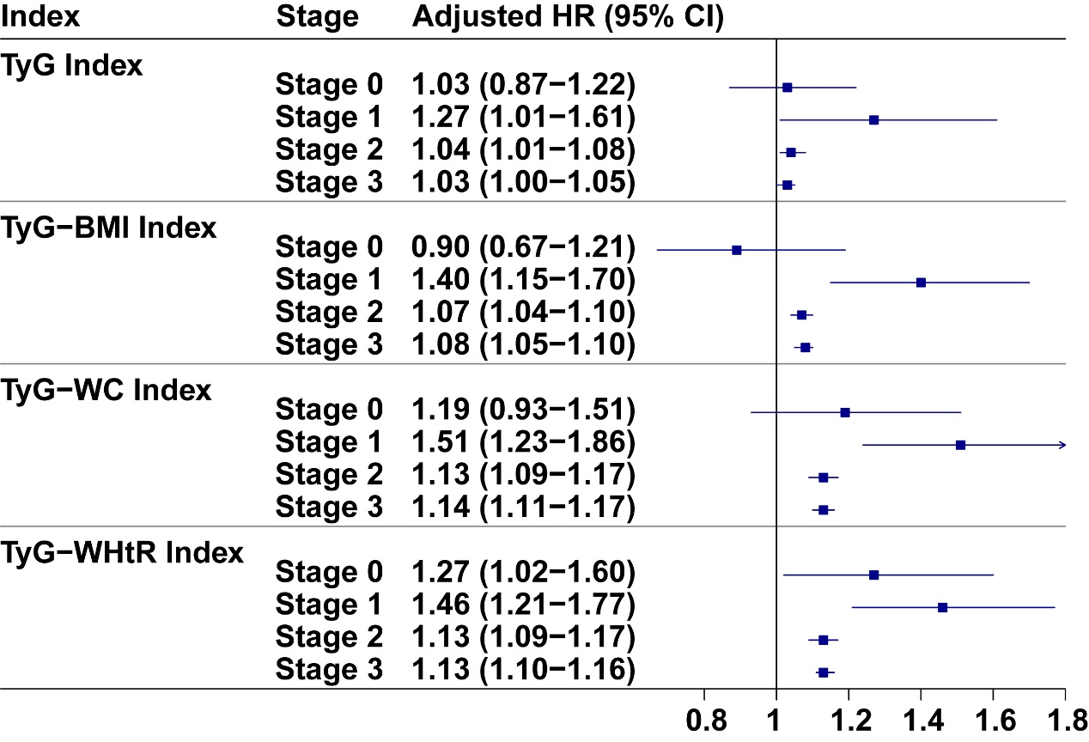
Data were presented as a hazard ratio and 95% confidence interval. Models were adjusted for age, sex, ethnicity, educational level, family income, smoking status, alcohol drinking, sleeplessness, physical activity, diet quality, systolic/diastolic blood pressure, HbA1c, total cholesterol, and Townsend deprivation index. Abbreviations: TyG, triglyceride-glucose index; BMI, body mass index; WC, waist circumference; WHtR, weight-to-height ratio.

Figure S3. Subgroup analysis stratified by sex for the associations between TyG-related indices and dementia incidence in individuals with CKM stages 0-3
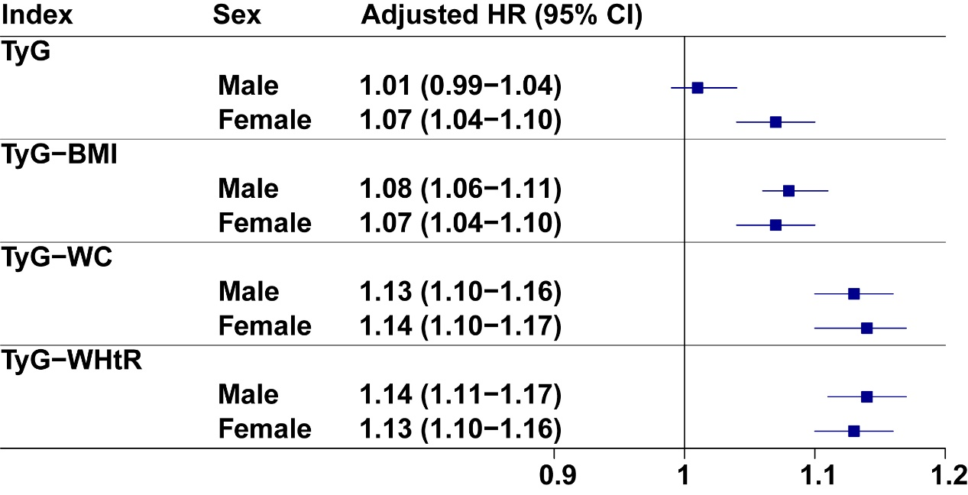
Data were presented as a hazard ratio and 95% confidence interval. Models were adjusted for age, sex, ethnicity, educational level, family income, smoking status, alcohol drinking, sleeplessness, physical activity, diet quality, systolic/diastolic blood pressure, HbA1c, total cholesterol, and Townsend deprivation index. Abbreviations: TyG, triglyceride-glucose index; BMI, body mass index; WC, waist circumference; WHtR, weight-to-height ratio.

Figure S4. Subgroup analysis stratified by age for the associations between TyG-related indices and dementia incidence in individuals with CKM stages 0-3
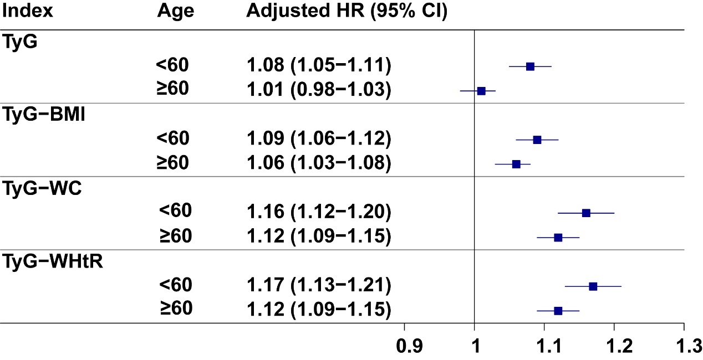
Data were presented as a hazard ratio and 95% confidence interval. Models were adjusted for age, sex, ethnicity, educational level, family income, smoking status, alcohol drinking, sleeplessness, physical activity, diet quality, systolic/diastolic blood pressure, HbA1c, total cholesterol, and Townsend deprivation index. Abbreviations: TyG, triglyceride-glucose index; BMI, body mass index; WC, waist circumference; WHtR, weight-to-height ratio.

Figure S5. Subgroup analysis stratified by ethnicity for the associations between TyG-related indices and dementia incidence in individuals with CKM stages 0-3
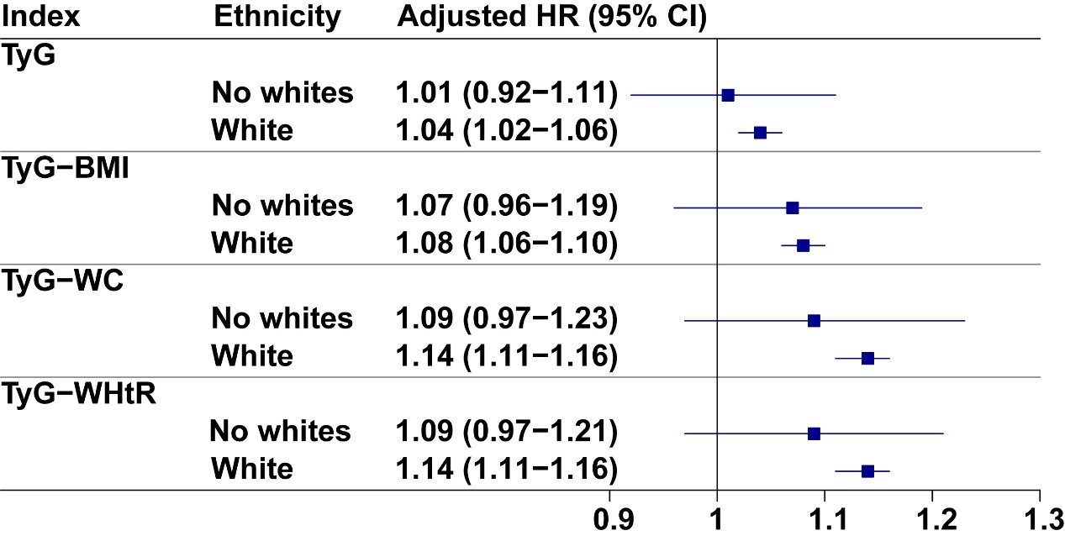
Data were presented as a hazard ratio and 95% confidence interval. Models were adjusted for age, sex, ethnicity, educational level, family income, smoking status, alcohol drinking, sleeplessness, physical activity, diet quality, systolic/diastolic blood pressure, HbA1c, total cholesterol, and Townsend deprivation index. Abbreviations: TyG, triglyceride-glucose index; BMI, body mass index; WC, waist circumference; WHtR, weight-to-height ratio.

Figure S6. Subgroup analysis stratified by hypertension status for the associations between TyG-related indices and dementia incidence in individuals with CKM stages 0-3
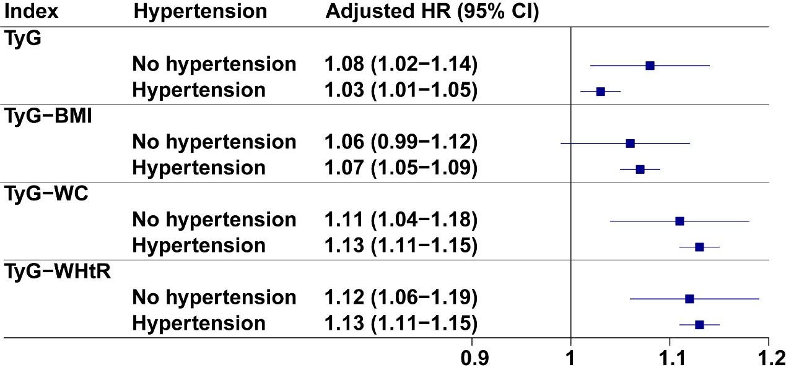
Data were presented as a hazard ratio and 95% confidence interval. Models were adjusted for age, sex, ethnicity, educational level, family income, smoking status, alcohol drinking, sleeplessness, physical activity, diet quality, systolic/diastolic blood pressure, HbA1c, total cholesterol, and Townsend deprivation index. Abbreviations: TyG, triglyceride-glucose index; BMI, body mass index; WC, waist circumference; WHtR, weight-to-height ratio.

Figure S7. Subgroup analysis stratified by adiposity status for the associations between TyG-related indices and dementia incidence in individuals with CKM stages 0-3
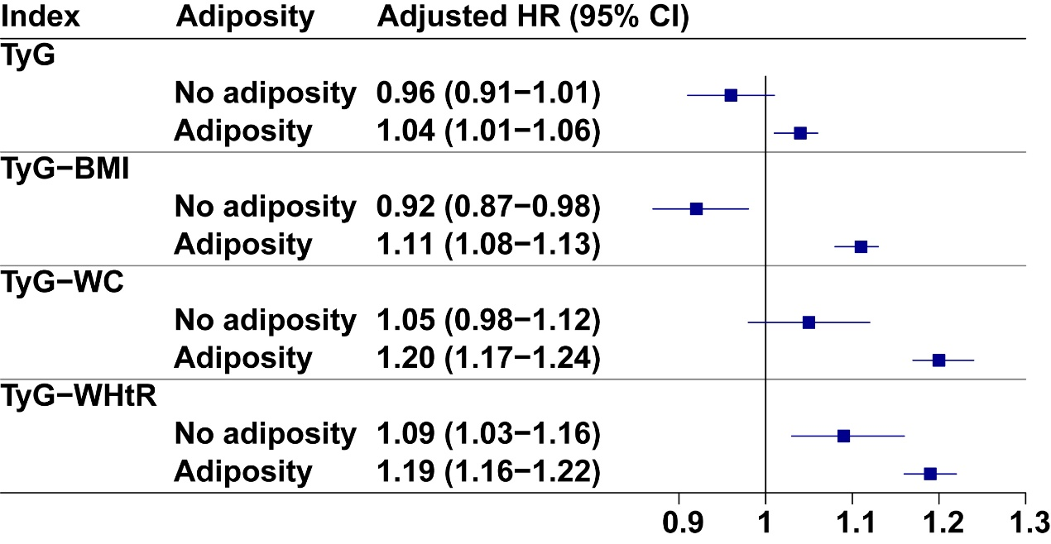
Data were presented as a hazard ratio and 95% confidence interval. Models were adjusted for age, sex, ethnicity, educational level, family income, smoking status, alcohol drinking, sleeplessness, physical activity, diet quality, systolic/diastolic blood pressure, HbA1c, total cholesterol, and Townsend deprivation index. Abbreviations: TyG, triglyceride-glucose index; BMI, body mass index; WC, waist circumference; WHtR, weight-to-height ratio.

Figure S8. Subgroup analysis stratified by kidney function status for the associations between TyG-related indices and dementia incidence in individuals with CKM stages 0-3
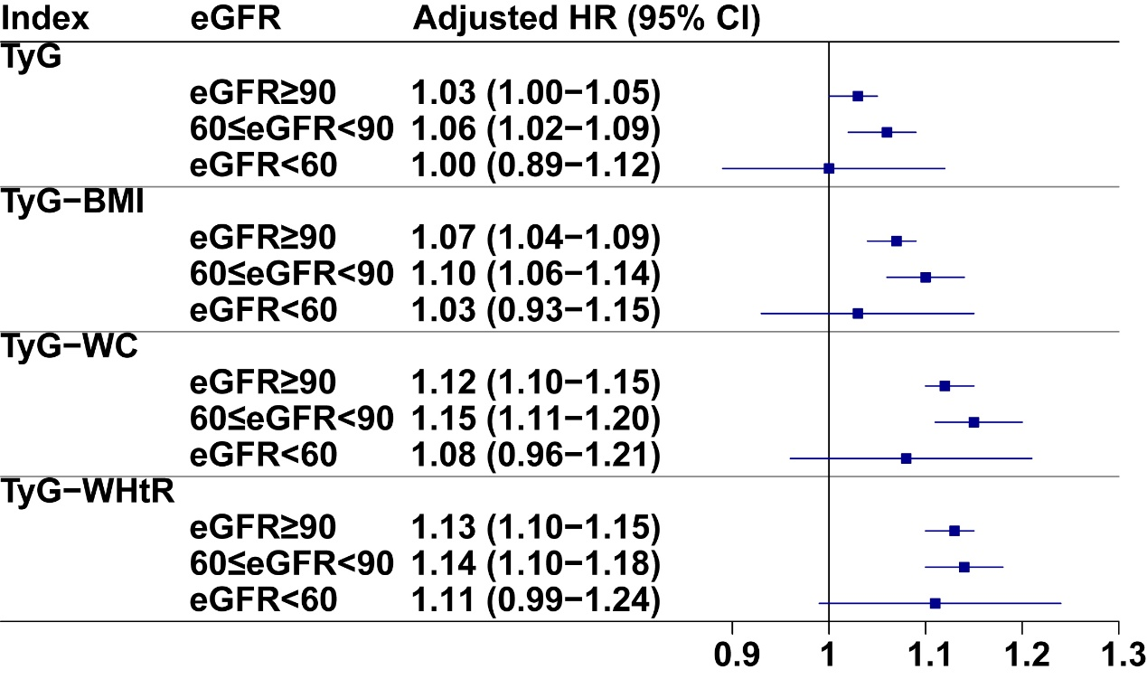
Data were presented as a hazard ratio and 95% confidence interval. Models were adjusted for age, sex, ethnicity, educational level, family income, smoking status, alcohol drinking, sleeplessness, physical activity, diet quality, systolic/diastolic blood pressure, HbA1c, total cholesterol, and Townsend deprivation index. Abbreviations: TyG, triglyceride-glucose index; BMI, body mass index; WC, waist circumference; WHtR, weight-to-height ratio; estimated Glomerular Filtration Rate.;eGFR, estimated glomerular filtration rate.

Figure S9. Sensitivity analysis of TyG-related indices and dementia risk: excluding cases within the first 2 years of follow-up
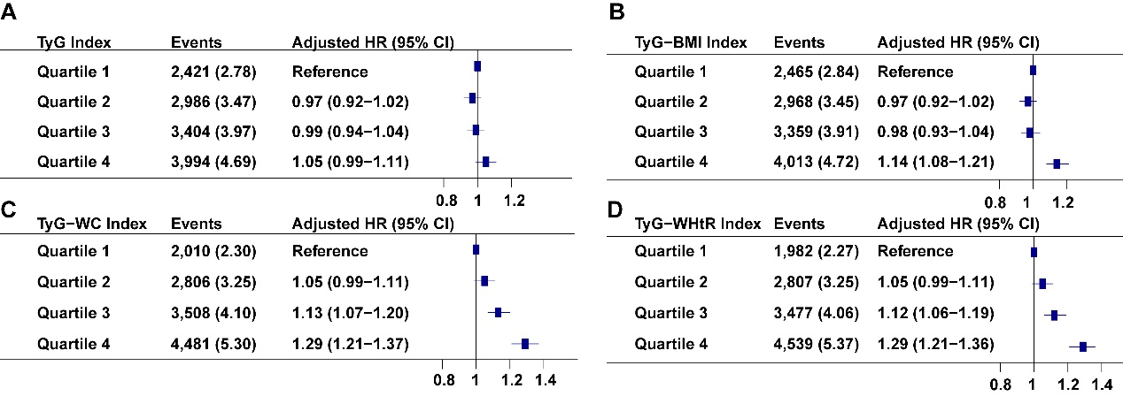
Data were presented as a hazard ratio and 95% confidence interval. Models were adjusted for age, sex, ethnicity, educational level, family income, smoking status, alcohol drinking, sleeplessness, physical activity, diet quality, systolic/diastolic blood pressure, HbA1c, total cholesterol, and Townsend deprivation index. Abbreviations: TyG, triglyceride-glucose index; BMI, body mass index; WC, waist circumference; WHtR, weight-to-height ratio.

Figure S10. Sensitivity analysis for the associations between TyG-related indices and dementia incidence in individuals with CKM stages 0-4
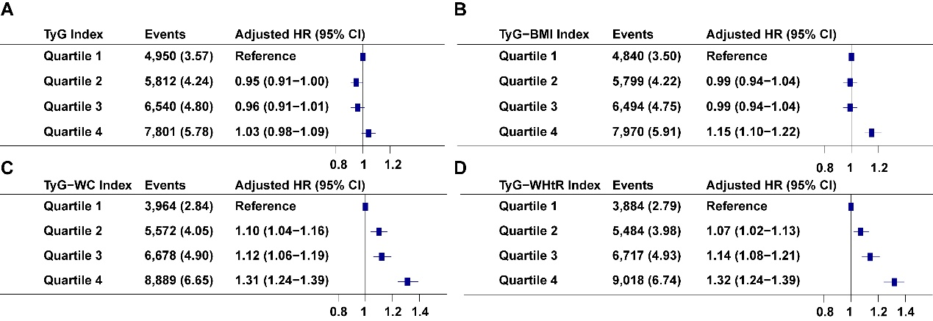
Data were presented as a hazard ratio and 95% confidence interval. Models were adjusted for age, sex, ethnicity, educational level, family income, smoking status, alcohol drinking, sleeplessness, physical activity, diet quality, systolic/diastolic blood pressure, HbA1c, total cholesterol, and Townsend deprivation index. Abbreviations: TyG, triglyceride-glucose index; BMI, body mass index; WC, waist circumference; WHtR, weight-to-height ratio.

Figure S11. Sensitivity analysis of TyG-related indices and dementia risk: using multiple imputation for missing covariates
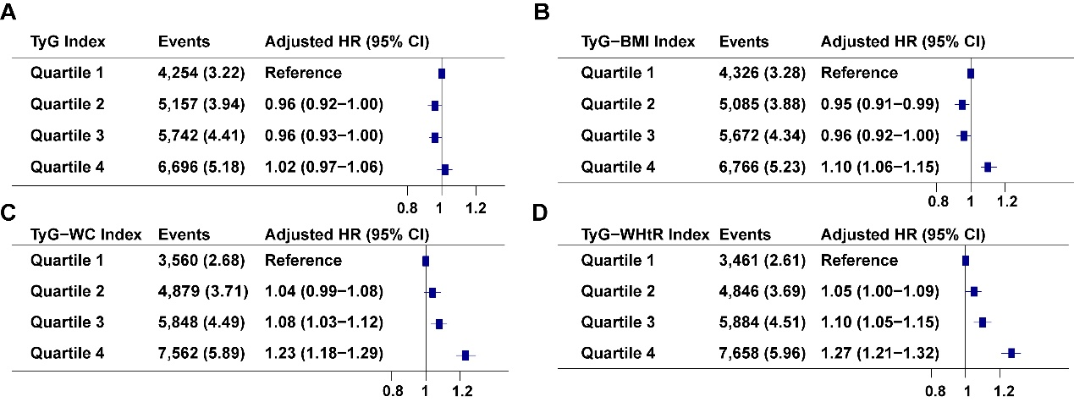
Data were presented as a hazard ratio and 95% confidence interval. Models were adjusted for age, sex, ethnicity, educational level, family income, smoking status, alcohol drinking, sleeplessness, physical activity, diet quality, systolic/diastolic blood pressure, HbA1c, total cholesterol, and Townsend deprivation index. Abbreviations: TyG, triglyceride-glucose index; BMI, body mass index; WC, waist circumference; WHtR, weight-to-height ratio.
Figure S12. Sensitivity analysis of TyG-related indices and dementia risk: accounting for the competing risk of death
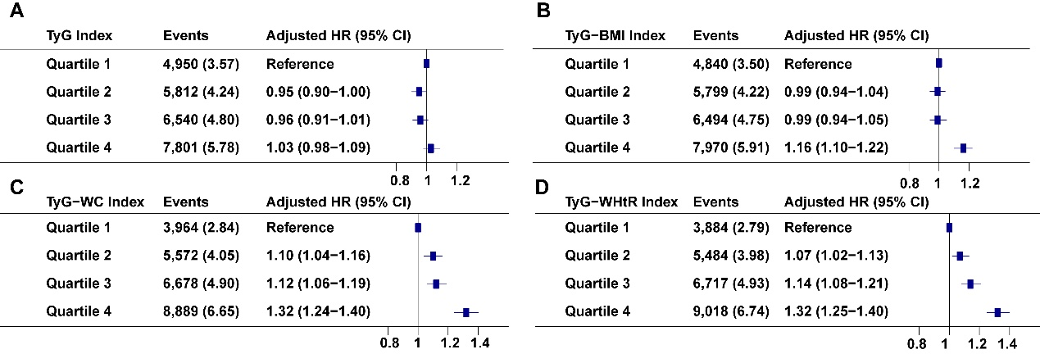
Data were presented as a hazard ratio and 95% confidence interval. Models were adjusted for age, sex, ethnicity, educational level, family income, smoking status, alcohol drinking, sleeplessness, physical activity, diet quality, systolic/diastolic blood pressure, HbA1c, total cholesterol, and Townsend deprivation index. Abbreviations: TyG, triglyceride-glucose index; BMI, body mass index; WC, waist circumference; WHtR, weight-to-height ratio.

Figure S13. The joint association of TyG index stages and polygenic risk scores with risk of dementia
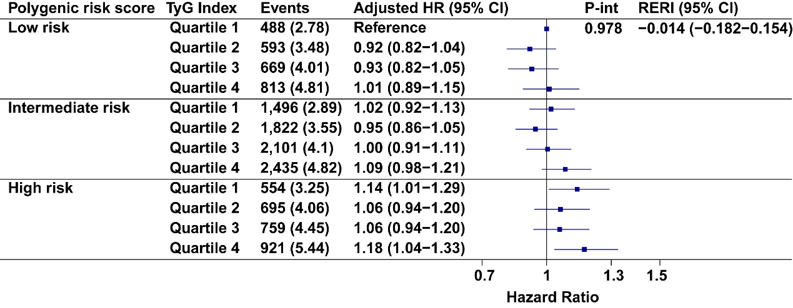
Data were presented as a hazard ratio and 95% confidence interval. Models were adjusted for age, sex, ethnicity, educational level, family income, smoking status, alcohol drinking, sleeplessness, physical activity, diet quality, systolic/diastolic blood pressure, HbA1c, total cholesterol, and Townsend deprivation index. Abbreviations: RERI, Relative Excess Risk due to Interaction; TyG, triglyceride-glucose index; int, interaction.

Figure S14. The joint association of TyG index stages and the presence of APOE-ε4 with risk of dementia
Data were presented as a hazard ratio and 95% confidence interval. Models were adjusted for age, sex, ethnicity, educational level, family income, smoking status, alcohol drinking, sleeplessness, physical activity, diet quality, systolic/diastolic blood pressure, HbA1c, total cholesterol, and Townsend deprivation index. Abbreviations: TyG, triglyceride-glucose index; int, interaction.

