Supplementary Appendix
This appendix has been provided by the authors to give readers additional information about their work.

Lin Y, Zhu G, Tan Q, et al. Platelet function testing guided antiplatelet therapy for ischemic stroke: a pilot randomized controlled trial. XXX

Contents
Table S1. List of Investigators and coordinators (site, with numbers of patients in parentheses) 3
Table S2. PATH STROKE study group 5
Table S3. Standardized operation and quality control protocol for PL 12 platelet function testing 7
Table S4. Baseline characteristics of participants by sex 9
Table S5. Baseline characteristics of young adult (≥65 years) and older adult (<65 years) participants 11
Table S6. Platelet aggregation function at randomization and during follow-up period 13
Table S7. Primary outcome in the per-protocol population 14
Table S8. Sensitivity analysis of primary, secondary and safety outcomes in the intention-to-treat population 15
Table S9. Serious adverse events (SAEs) in all patients in the intention-to-treat population 17
Figure S1 Mean differences and standard deviations in platelet aggregation function to recording time -Guided Group 18
Figure S2. Distribution of platelet aggregation function and proportion of high on-treatment platelet reactivity (HOPR) between the guidance group and the control group on Day 30. 18
Figure S3. Cumulative incidence of ischemic event. 19
Figure S4. Cumulative incidence of stroke. 19
Figure S5 Cumulative incidence of ischemic stroke 20
Figure S6 Cumulative incidence of hemorrhagic stroke 20

Table S1. List of Investigators and coordinators (site, with numbers of patients in parentheses)
Participating sites | Principal investigator and coordinators
Meishan Cardio-cerebrovascular Disease Hospital (133) | Wei Zhang, Zhi Li, Lele Zhang, Ying Chen, Jia Song
Dazhu County People's Hospital (131) | Zhaohui Li, Zhijin Yang, Anshan Chen, Guanyu Cheng, Tianyan Cai
Kaijiang People's Hospital (103) | Daijun Qiu, Chaoying Jiang, Lang Zhang, Liping Li, Xiaojing Cao
Sichuan Provincial People's Hospital, School of Medicine, University of Electronic Science and Technology of China (86) | Jie Yang, Jinzhi Zhang, Caidi Yang, Yan Lin, Xiao Zhang
The First People's Hospital of Guangyuan (75) | Zilian Fan, Chao Li, Xiaorong Liu, Shulan Yang, Haiyan Wu
Jianyang Chinese Medicine Hospital (75) | Jianming Qing, Yumin Luo, Jianguo Li, Zhisheng Huang, Rui Pan
Dazhou Central Hospital (62) | Haochun Zhang, Jin Jiang, Xiaoling Xiang, Lin He, Shenghao Zhao
Fushun People's Hospital (56) | Lijun Wu, Lingling Xu, Bing Zhang, Shijun Xie, Xia Zhou
Pengzhou Hospital of Traditional Chinese Medicine (51) | Yun Du, Li Yang, Juan Ma, Yishu Liang, Juncheng Liu
Qianwei County People's Hospital(47) | Yiqian Peng, Deping Zhu, Weichuan Wang, Zeng Peng, Xiaoqin Ma
Deyang People's Hospital, Sichuan Clinical Research Center for Neurological Diseases (45) | Hong Chen, Jing Lin, Jie Li, Yong Xie, Tao Zeng
The First Affiliated Hospital of Henan Polytechnic University (The Second People's Hospital of Jiaozuo) (42) | Lin Wang, Hang Cheng, Jiayuan Zhao, Linlin Xu, Wentao Li
Shangcai County People's Hospital (38) | Tao Xu, Hena Dong, Dengbo Zhang, Wenjie Zhang, Zhenhua Liu
The First People's Hospital of Zigong City (35) | Tao Qiu, Zonglu Jin, Min Yang, Zhijun Zhang, Rongmei Pu
Suining Central Hospital (34) | Ming Yu, Qin Chen, Li Liu, Qingrong Ouyang, Yang Du
Pujiang County People's Hospital (29) | Dandan Peng, Dan Zhang, Hankun Yang, Kai Peng
The Second Affiliated Hospital of Chengdu Medical College, Nuclear Industry 416 Hospital (26) | Xindong Liu, Wenhao Lu, Yi Zhou, Xiwen Chen, Qiuju Cao
Guanghan People's Hospital (26) | Yalan Zhu, Qin Liu, Rong Zou, Haiyan Zheng, Huan Ren
Weihai Central Hospital (23) | Xia Zhan, Xinhu Sun, Dongxiao Jiang, Yu Tao, Caixia Chen
Ziyang People's Hospital (20) | Wen Lin, Jialing Huang, Qin Yin, Rong Su, Hai Xu
The First Affliated Hospital of Traditional Chinese Medicine of Chengdu Medical College (XinDu Hospital of Traditional Chinese Medicine) (19) | Xiaoling Cao, Jing Huang, Simin Mei, Zhongwen He, Baiyang Li
The First Affiliated Hospital of Chengdu Medical College (17) | Xianwei Zou, Meiling Hu, Yizhou Liu, Bi Ma, Yanhong Li
The Fourth People's Hospital of Zigong (17) | Yunbo Chen, Fuli Wang, Lei Xu, Huan Liao
People's Hospital of Guangming District (16) | Yong Zhu, Haiming Yang, Yufei Kou, Chanchan Liu, Libo Zhang
The Sixth People's Hospital of Chengdu (9) | Mei Liu, Yali Cheng, Jizhuang Fang, Jing Zhang, Yan Yang
Chengdu Seventh People's Hospital (Affiliated Cancer Hospital of Chengdu Medical College) (9) | Baiyuan Yang, Yidan Liu, Meiwen He, Shucheng Li, Keting Liu

Table S2. PATH STROKE A study group
Trial Steering Committee (TSC)
Name | Affiliation
Jie Yang (Chair, Principal Investigator) | Sichuan Provincial People's Hospital, School of Medicine, University of Electronic Science and Technology of China, Chengdu, China
Craig Anderson (Co-Principal Investigator) | Institute of Science and Technology for Brain-inspired Intelligence, Fudan University, Shanghai, China; and The George Institute for Global Health, University of New South Wales, Sydney, Australia
Yapeng Lin (Co-Principal Investigator) | The First Affiliated Hospital of Chengdu Medical College, Chengdu, China
Advisory Committee
Name | Affiliation
Xia Wang | The George Institute for Global Health, Faculty of Medicine, University of New South Wales, Sydney, Australia
Hisatomi Arima | Faculty of Medicine, Fukuoka University, Fukuoka, Japan
Data Safety Monitoring Board
Name | Affiliation
Qingwu Yang (Chair) | The Second Affiliated Hospital of Army Medical University (Third Military Medical University)
Lili Song | Fudan University
Jiayuan Li | West China Hospital, Sichuan University
Wei Hu | The First Affiliated Hospital of University of Science and Technology of China
Simiao Wu | West China Hospital, Sichuan University
Medical Review Committee
Name | Affiliation
Fengkai Mao, Hongwei Deng | The First Affiliated Hospital of Chengdu Medical College, Chengdu, China
Guoliang Zhu, Quandan Tan, Xiaoling Chen | Sichuan Provincial People's Hospital, School of Medicine, University of Electronic Science and Technology of China, Chengdu, China
Central Coordinating Center (CCC)
Name | Affiliation
Ruijuan Gang, Pengyuan Wang, Weijia Liao, Chao Chang, Qi Xu, Genyu Qu, Hang Su, Lifan Xiao, Yujie Tang, Yun Xin, Yuetong Luo, Xiong Yu, Xi Zeng, Mengli Zhu, Qian Huang, Kehan Qin, Jingwen Xia, Chenlin Hu, Chaochen Yin, Shuqi Yang, Jingli Lin, Linjie Xie, Zhongsong Zhang, Xinran Li, Jingfeng Zhou, Mingtian Zhuang, Jiubai He, Keyi Gou, Rong Wang, Lekang Ren | The First Affiliated Hospital of Chengdu Medical College, Chengdu, China
Yaopeng Chen (Project Manager), Qiaofeng Zhong, Qin You, Feng Mao | Sichuan Provincial People's Hospital, School of Medicine, University of Electronic Science and Technology of China, Chengdu, China

Table S3. Standardized Operation and Quality Control Protocol for PL-12 Platelet Function Testing
I. Standardized Management of Testing Personnel
- Dedicated Staff: Each participating center shall assign 2–3 dedicated laboratory technicians, who shall be responsible for all testing procedures. No unauthorized replacement of personnel is allowed without approval from the project team.
- Unified Training and Certification: All technicians shall complete unified theoretical and practical training organized by the project team, covering the PL-12 testing principle, antiplatelet drug assessment logic, sample handling protocols, and quality control requirements. Only technicians who pass the assessment shall be qualified to perform tests independently.
- Periodic Retraining and Audits: The project team shall conduct retraining and on-site/remote random audits every six months to ensure procedural consistency, eliminate inter-center bias, and guarantee homogeneous and comparable data across all centers.
II. Standardized PL-12 Platelet Function Testing Procedure
The PL-12 automatic platelet function analyzer is used in this study. Arachidonic acid (AA) and Adenosine diphosphate (ADP) are used as agonists to evaluate the antiplatelet effects of aspirin and clopidogrel, respectively.
Sample Collection and Processing
- A 3 mL venous blood sample is collected using sodium citrate anticoagulant tubes specified by the project.
- Samples are gently and thoroughly mixed to avoid haemolysis or clotting, stored at room temperature under standardised conditions, and tested promptly.
Agonist Selection and Testing Logic
- AA stimulation: Used to assess the antiplatelet effect of aspirin.
- ADP stimulation: Used to assess the antiplatelet effect of clopidogrel.
- Each sample is tested separately in the AA channel and ADP channel to obtain the corresponding maximum aggregation rate (MAR).
Key Testing Procedures
- Pre-test instrument quality control is completed to confirm satisfactory performance.
- Whole blood samples and corresponding agonists are added in accordance with standard protocols.
- The instrument automatically performs platelet aggregation and data acquisition, and directly outputs MAR(AA) and MAR(ADP) results.
Result Recording and Reporting
- Raw test values are recorded in real time to ensure full traceability.
- Test results are uploaded promptly to the centralised project platform to guarantee authenticity, timeliness, and non-repudiation.

III. Calculation Principle of PL-12 Maximum Aggregation Rate (MAR)
The PL-12 utilises the Sequential Platelet Counting Method (SPCM) to calculate the maximum platelet aggregation rate by directly measuring dynamic changes in the number of free platelets:
- The instrument first performs a baseline count to obtain the baseline platelet count (total free platelets before agonist addition).
- After adding an agonist (AA/ADP), the instrument continuously monitors dynamic changes in free platelet count and captures the minimum free platelet count during aggregation.
- The instrument automatically calculates the maximum aggregation rate (MAR) using the following formula¹:
MAR =[$\frac{(\frac{1^{st} platelet count+2^{nd} platelet count}{2}) - lowest platelet count}{(\frac{1^{st} platelet count+2^{nd} platelet count}{2})}$]×100%
A lower MAR value indicates fewer remaining free platelets, stronger inhibition of platelet aggregation by the antiplatelet drug, and better therapeutic effect.
IV. Instrument Maintenance and Comprehensive Quality Control
(A) Instrument Maintenance and Calibration
- Unified Installation and Calibration: All PL-12 instruments are installed, adjusted, and calibrated by certified manufacturer engineers. Only instruments that pass calibration may be used for the study.
- Periodic Calibration: Manufacturer calibration is performed every 3 months to ensure consistent sensitivity and accuracy.
- Routine Maintenance: Instruments are cleaned and disinfected before and after daily testing; regular maintenance is performed to ensure stable performance.
(B) Multidimensional Quality Control (QC)
- Daily Instrument QC: Quality control material testing must be completed before daily testing; testing may commence only when results fall within acceptable ranges.
- Procedural QC: Strict adherence to the standard operating procedure (SOP) is enforced, with standardised sample handling, pipetting, and testing time windows to eliminate operational bias.
- Inter-center QC: The project team regularly performs blinded sample comparisons, on-site inspections, and data traceability audits to ensure homogeneity across centers.
- Data QC: Raw results are recorded in real time, double-checked, and uploaded promptly to ensure data integrity, authenticity, and full traceability.
- Ma L., et al. Comparison of VerifyNow, thromboelastography, and PL-12 in patients with minor ischemic stroke or transient ischemic attack. Aging (Albany NY) 13, 8396-8407 (2021).

Table S4. Baseline characteristics of participants by sex
Characteristic | Females |  | Males
 | Function-guided antiplatelet therapy  (n=204) | Standard antiplatelet therapy  (n=213) | Function-guided antiplatelet therapy  (n=407) | Standard antiplatelet therapy  (n=400)
Age, years | 65 ± 9 | 67 ± 9 | 62 ± 10 | 62 ± 10
Ethnicity
Han Chinese | 203/204 (99.5) | 212/212 (100.0) | 407/407 (100.0) | 398/400 (99.5)
Other | 1/204 (0.5) | 0/212 (0.0) | 0/407 (0.0) | 2/400 (0.5)
Location of residence
Urban area | 105/204 (51.5) | 118/213 (55.4) | 243/407 (59.7) | 228/400 (57.0)
Non-urban area | 99/204 (48.5) | 95/213 (44.6) | 164/407 (40.3) | 172/400 (43.0)
Body mass index,* kg/m² | 23.8 (21.4 to 26.2) | 23.9 (21.3 to 26.6) | 24.0 (22.0 to 26.1) | 24.7 (22.3 to 26.6)
Medical history
Hypertension | 161/204 (78.9) | 164/213 (77.0) | 304/407 (74.7) | 298/399 (74.7)
Diabetes mellitus | 67/204 (32.8) | 68/212 (32.1) | 121/406 (29.8) | 103/399 (25.8)
Dyslipidemia | 85/203 (41.9) | 82/209 (39.2) | 129/403 (32.0) | 118/394 (30.0)
Medications
Antihypertensive drugs | 150/203 (73.9) | 149/211 (70.6) | 270/405 (66.7) | 267/397 (67.3)
Antidiabetic drugs | 62/204 (30.4) | 61/212 (28.8) | 113/405 (27.9) | 96/398 (24.1)
Use of statins | 195/204 (95.6) | 202/212 (95.3) | 399/407 (98.0) | 385/398 (96.7)
Current smoker | 5/204 (2.5) | 11/210 (5.2) | 218/403 (54.1) | 212/399 (53.1)
Consumption of alcohol | 8/204 (3.9) | 14/210 (6.7) | 187/403 (46.4) | 178/399 (44.6)
Median time from the onset of symptoms to randomization, days | 48 (35 to 69) | 46 (37 to 61) | 44 (36 to 61) | 46 (35 to 62)
Median time from the initiation of aspirin to randomization, days | 30 (17 to 47) | 34 (24 to 47) | 31 (17 to 45) | 33 (24 to 46)
Level of disability on the modified Rankin scale†
0 | 83/204 (40.7) | 85/213 (39.9) | 166/407 (40.8) | 161/400 (40.3)
1 | 93/204 (45.6) | 101/213 (47.4) | 191/407 (46.9) | 200/400 (50.0)
2 | 28/204 (13.7) | 27/213 (12.7) | 50/407 (12.3) | 39/400 (9.8)
Median maximal aggregation rate | 20.0 (14.1-28.7) | / | 20.6 (14.8-31.3) | /
Data are mean (SD), n (%), median (IQR), or n/N (%)
*Body mass index is the weight in kilograms divided by the square of the height in meters.
†Scores on the mRS of functional recovery range from 0 (no symptoms) to 6 (death). A score of 0 indicates ‘no symptoms’ and a score 2 or less indicates functional independence. The mRS score before stroke onset was assessed by the treating physician with the use of information obtained from patients (if possible) or their family members.

Table S5. Baseline characteristics of young adult (<65 years) and older adult (≥65 years) participants
Characteristic | Age ≥65 years |  | Age <65 years
 | Function-guided antiplatelet therapy  (n=310) | Standard antiplatelet therapy  (n=330) | Function-guided antiplatelet therapy  (n=301) | Standard antiplatelet therapy  (n=283)
Sex
Female | 71/310 (22.9) | 97/330 (29.4) | 133/301 (44.2) | 116/283 (41.0)
Male | 239/310 (77.1) | 233/330 (70.6) | 168/301 (55.8) | 167/283 (59.0)
Ethnicity
Han Chinese | 310/310 (100.0) | 328/329 (99.7) | 300/301 (99.7) | 282/283 (99.7)
Other | 0/310 (0.0) | 1/329 (0.3) | 1/301 (0.3) | 1/283 (0.4)
Location of residence
Urban area | 193/310 (62.3) | 208/330 (63.0) | 155/301 (51.5) | 138/283 (48.8)
Non-urban area | 117/310 (37.7) | 122/330 (37.0) | 146/301 (48.5) | 145/283 (51.2)
Body mass index,* kg/m2 | 24.8 (22.5 to 26.7) | 25.0 (22.6 to 27.1) | 23.4 (21.3 to 25.7) | 23.5 (21.5 to 25.7)
Medical history
Hypertension | 235/310 (75.8) | 240/329 (73.0) | 230/301 (76.4) | 222/283 (78.5)
Diabetes mellitus | 106/310 (34.2) | 96/328 (29.3) | 82/300 (27.3) | 75/283 (26.5)
Dyslipidemia | 120/307 (39.1) | 110/323 (34.1) | 94/299 (31.4) | 90/280 (32.1)
Medications
Antihypertensive drugs | 215/308 (69.8) | 220/327 (67.3) | 205/300 (68.3) | 196/281 (69.8)
Antidiabetic drugs | 98/309 (31.7) | 88/328 (26.8) | 77/300 (25.7) | 69/282 (24.5)
Statins | 298/310 (96.1) | 315/328 (96.0) | 296/301 (98.3) | 272/282 (96.5)
Current smoker | 144/307 (46.9) | 137/327 (41.9) | 79/300 (26.3) | 86/282 (30.5)
Consumption of alcohol | 125/307 (40.7) | 124/327 (37.9) | 70/300 (23.3) | 68/282 (24.1)
Median time from the onset of symptoms to randomization, days | 45 (36 to 66) | 47 (35 to 64) | 45 (35 to 64) | 44 (37 to 59)
Median time from the initiation of aspirin to randomization, days | 31 (16 to 44) | 33 (22 to 48) | 31 (20 to 46) | 34 (27 to 43)
Level of disability on the modified Rankin scale†
0 | 126/310 (40.7) | 135/330 (40.9) | 123/301 (40.9) | 111/283 (39.2)
1 | 147/310 (47.4) | 163/330 (49.4) | 137/301 (45.5) | 138/283 (48.8)
2 | 37/310 (11.9) | 32/330 (9.7) | 41/301 (13.6) | 34/283 (12.0)
Median maximal aggregation rate | 19.0 (14.4-28.4) | / | 21.6 (14.9-33.1) | /
Data are mean (SD), n (%), median (IQR), or n/N (%)
*Body mass index is the weight in kilograms divided by the square of the height in meters.
†Scores on the mRS of functional recovery range from 0 (no symptoms) to 6 (death). A score of 0 indicates ‘no symptoms’ and a score 2 or less indicates functional independence. The mRS score before stroke onset was assessed by the treating physician with the use of information obtained from patients (if possible) or their family members.

Table S6. Platelet aggregation function at randomization and during follow-up period
Variable | Platelet aggregation function-guided antiplatelet therapy  (N=611) | Standard antiplatelet therapy  (N=613) | Total  (N=1224 )
Platelet aggregation function at randomization | 611 | / | /
Median (IQR) | 20.2 (14.6-30.1) | / | /
Platelet aggregation function at 30 days enrolment | 602 | 604 | 1206
Median (IQR) | 22.0 (15.5-30.4) | 22.9 (15.9-33.0) | 22.4 (15.7-31.4)
IQR=Interquartile Range.
Table S7. Primary outcome in the per-protocol population
Outcome | Platelet aggregation function-guided antiplatelet therapy  (N = 593) | Standard antiplatelet therapy  (N = 591) | Estimates  (95% CI)* | p value
Primary outcome
HOPR at 30±5 days | 93/593 (15.7) | 128/591 (21.7) | RR 0.72 (0.57 to 0.92) | 0.008
Secondary outcome
MAR at 30±5 days§ | 22.0 (15.7-30.5) | 22.9 (15.9-33.0)
Data are n/N (%) or median (IQR)
*adjusted for sex, age (≥65 vs. <65 years), and baseline mRS score (0–1 vs. 2).
HOPR=high on-treatment platelet reactivity; MAR=maximum aggregation rate; RR= relative risk
§Between-group comparison of the MAR at 30 days was performed using the Mann–Whitney U test.
Table S8. Sensitivity analysis of primary, secondary and safety outcomes in the intention-to-treat population
Outcome |  | Function-guided antiplatelet therapy  (n=611) | Standard antiplatelet therapy  (n=613) | Model 1†  Estimates (95%CI) |  | P value for Model 1 | Model 2†  Estimates (95%CI) | P value for Model 2
Primary outcome- high on treatment platelet reactivity at 30 days* |  | 93/602 (15.5) | 129/604 (21.4) | RR 0.72 (0.57 to 0.92) |  | 0.008 | RR 0.73 (0.57 – 0.93) | 0.011
Secondary outcomes
Major ischaemic events within 6 months |  | 12 (2.0) | 25 (4.1) | HR 0.47 (0.23 to 0.93) |  | 0.029 | HR 0.45 (0.23 to 0.91) | 0.025
Overall stroke within 6 months |  | 15 (2.5) | 25 (4.1) | HR 0.57 (0.30 to 1.09) |  | 0.089 | HR 0.57 (0.30 to 1.09) | 0.088
Ischemic stroke within 6 months |  | 11 (1.8) | 22 (3.6) | HR 0.48 (0.23 to 1.00) |  | 0.049 | HR 0.48 (0.23 to 0.99) | 0.046
Intracerebral hemorrhage within 6 months# |  | 4 (0.7) | 3 (0.5) | HR 1.23 (0.28 to 5.51) |  | 0.786 | HR 1.30 (0.29 to 5.84) | 0.730
Death from any cause within 6 months |  | 1 (0.2) | 2 (0.3) | HR 0.49 (0.04 to 5.39) |  | 0.557 | HR 0.46 (0.04 to 5.19) | 0.532
mRS score 3-5 at 6 months |  | 5/602 (0.8) | 6/594 (1.0) | RR 0.79 (0.24 to 2.55) |  | 0.688 | RR 0.78 (0.24 to 2.54) | 0.681
EQ-5D-3L overall health utility¶
No. of patients |  | 603 | 594
Score | 0.96 (0.96 to 0.96) |  | 0.96 (0.87 to 0.96)
Safety outcomes
BARC 2, 3, or 5 bleeding events within 6 months |  | 5/603 (0.8) | 4 /593 (0.7) | RR 1.21 (0.33 to 4.48) |  | 0.778 | RR 1.28 (0.35 to 4.74) | 0.709
BARC 1, 2, 3, or 5 bleeding events within 6 months |  | 24/603 (4.0) | 27/593 (4.6) | RR 0.89 (0.52 to 1.52) |  | 0.663 | RR 0.89 (0.52 to 1.53) | 0.676
Serious adverse events within 6 months — no. of events |  | 32/604 (5.3) | 35/596 (5.9)
At least one serious adverse event within 6 months — no. of patients (%) |  | 32/604 (5.3) | 34/596 (5.7) | RR 0.92 (0.58 to 1.47) |  | 0.727 | RR 0.91 (0.57 to 1.46) | 0.707
Data are n/N (%), effect size, mean (SD), median (IQR) or p value. RR= Relative risk, HR= Hazard ratio, CI=confidence interval, BARC=Bleeding Academic Research Consortium, mRS=modified Rankin scale. The mRS evaluates global disability, with scores ranging from 0 (no symptoms) to 6 (death). A score of 3 to 5 indicates a major degree of disability.
* High on-treatment platelet reactivity is defined as a maximal platelet aggregation rate ≥ 35%.
#Including intracerebral hemorrhage (ICH) and subarachnoid hemorrhage (SAH).
†Relative risk for binary outcomes. Mean difference for continuous outcomes. Hazard ratios for time to event in days. Model 1 adjusted for sex, age (≥65 vs. <65 years), and baseline mRS score (0–1 vs. 2); Model 2 adjusted for sex, age (≥65 vs. <65 years), baseline mRS score (0–1 vs. 2), time from onset to randomization (≥61 vs. <61 days), history of hypertension, history of diabetes mellitus, and current smoking.

Table S9. Serious adverse events (SAEs) in all patients in the intention-to-treat population
Events | Function-guided antiplatelet therapy  (n=32) | Standard antiplatelet therapy  (n=35)
Cerebral Infarction | 6 | 16*
Transient Ischemic Attack | 5 | 7
Intracerebral Hemorrhage | 4 | 3
Coronary Stenting | 0 | 1
Vascular Death | 1 | 2
Non-vascular Death | 0 | 0
Major Gastrointestinal Hemorrhage | 0 | 1
Patent Foramen Ovale Closure | 1 | 0
Hospitalization for Respiratory Disease | 1 | 0
Hospitalization for Infection | 0 | 1
Re-hospitalization for Pulmonary Nodules | 1 | 1
Re-hospitalization for Recurrent Vomiting | 1 | 0
Bladder Cancer | 1 | 0
Re-hospitalization for Cataract | 1 | 0
Hospitalization for Ocular Disease | 1 | 0
Fracture | 2 | 0
Anxiety Disorder | 1 | 0
Hospitalization for Renal Calculi | 1 | 1
Hospitalization for Chronic Kidney Disease | 1 | 0
Hospitaliszation for Leg Pain | 0 | 2
Hospitalization for Other Reasons | 4 | 0
* One patient experienced two recurrent ischemic strokes during follow-up

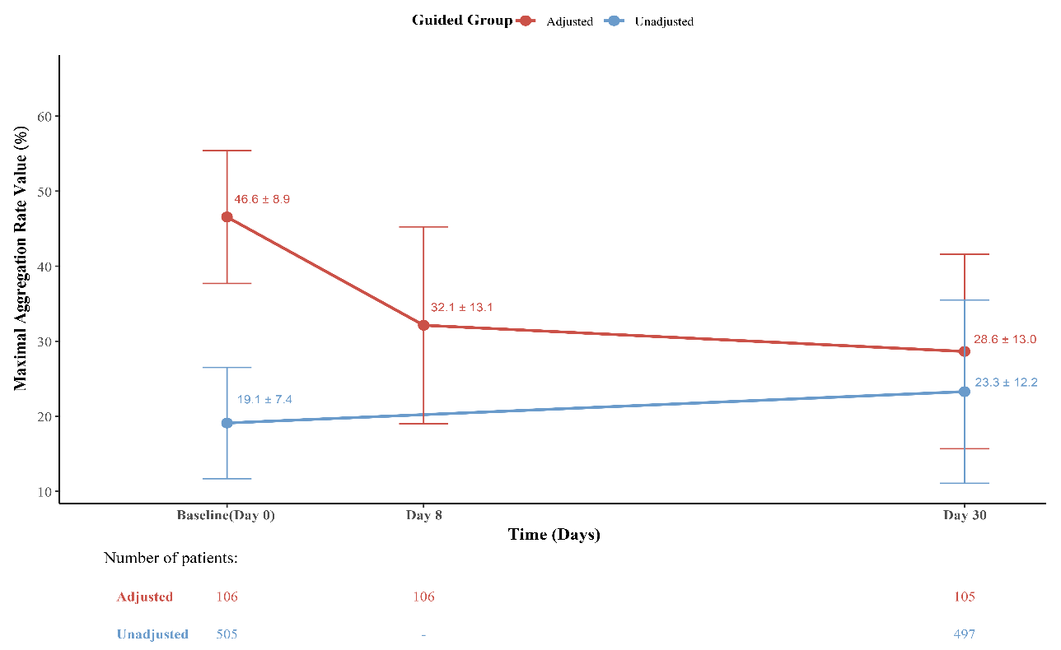
Figure S1 Mean values and standard deviations of maximal platelet aggregation rate across follow-up time in the PFT-guided group
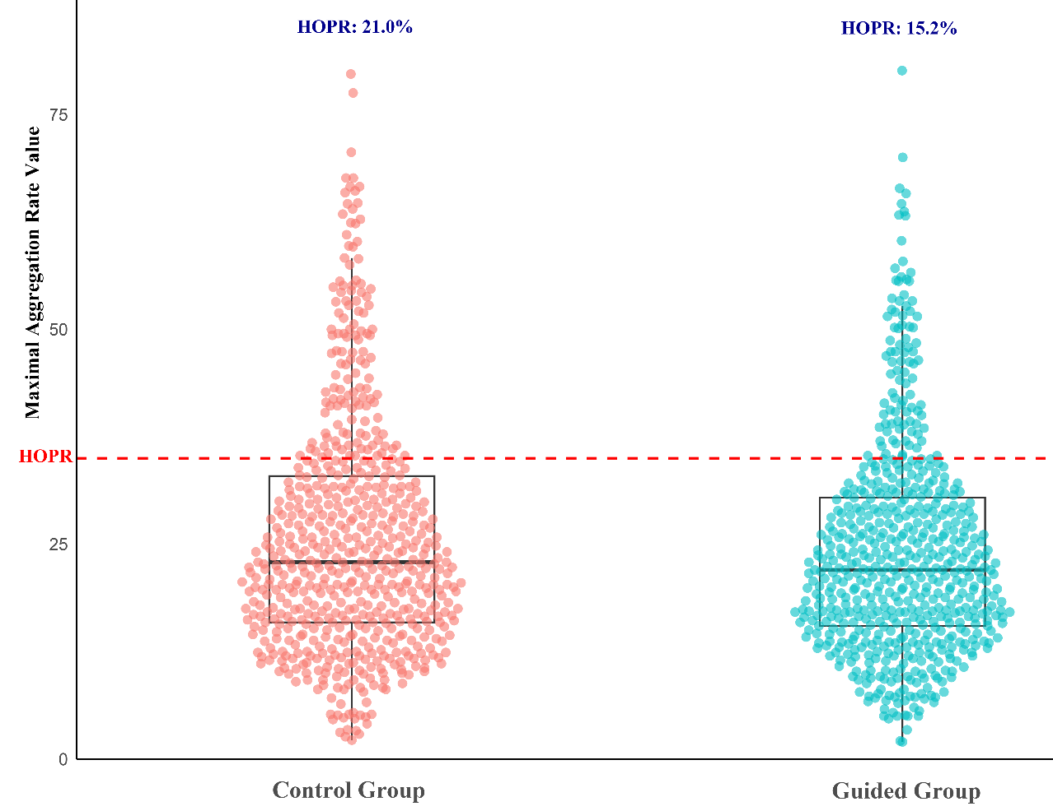
Figure S2 Distribution of platelet aggregation function and proportion of high on-treatment platelet reactivity (HOPR) between the guidance group and the control group on day 30.
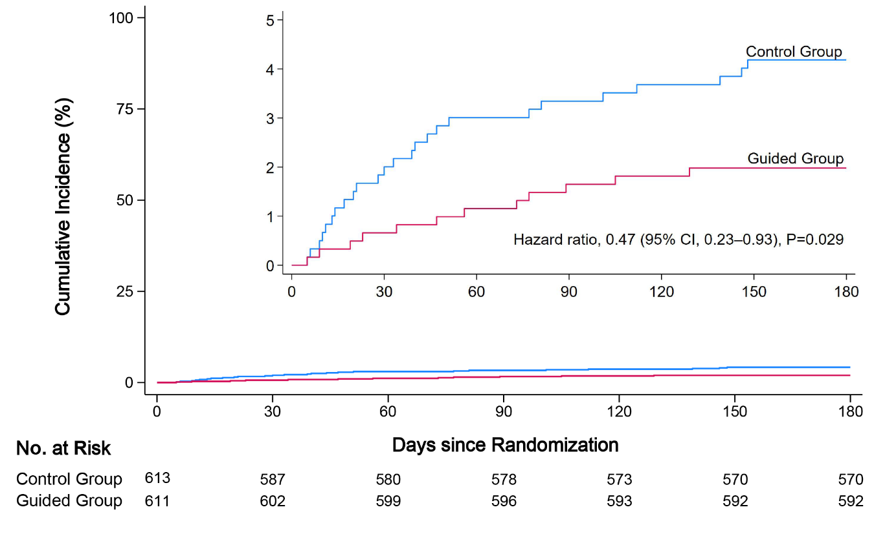
Figure S3. Cumulative Incidence of Ischemic Event.
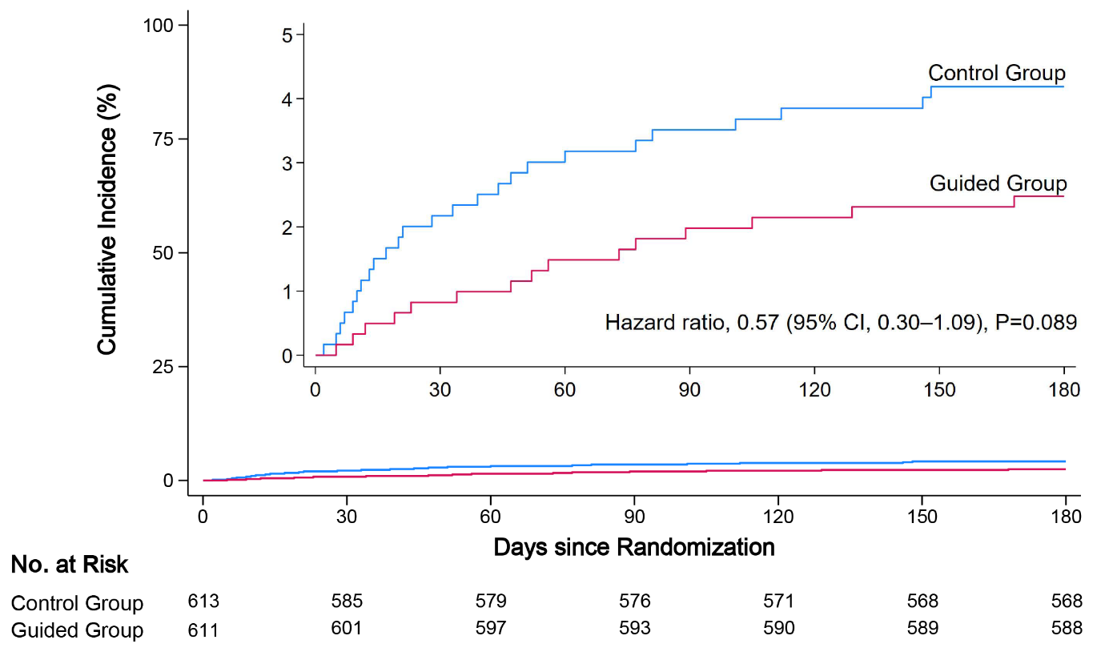
Figure S4. Cumulative Incidence of Stroke.

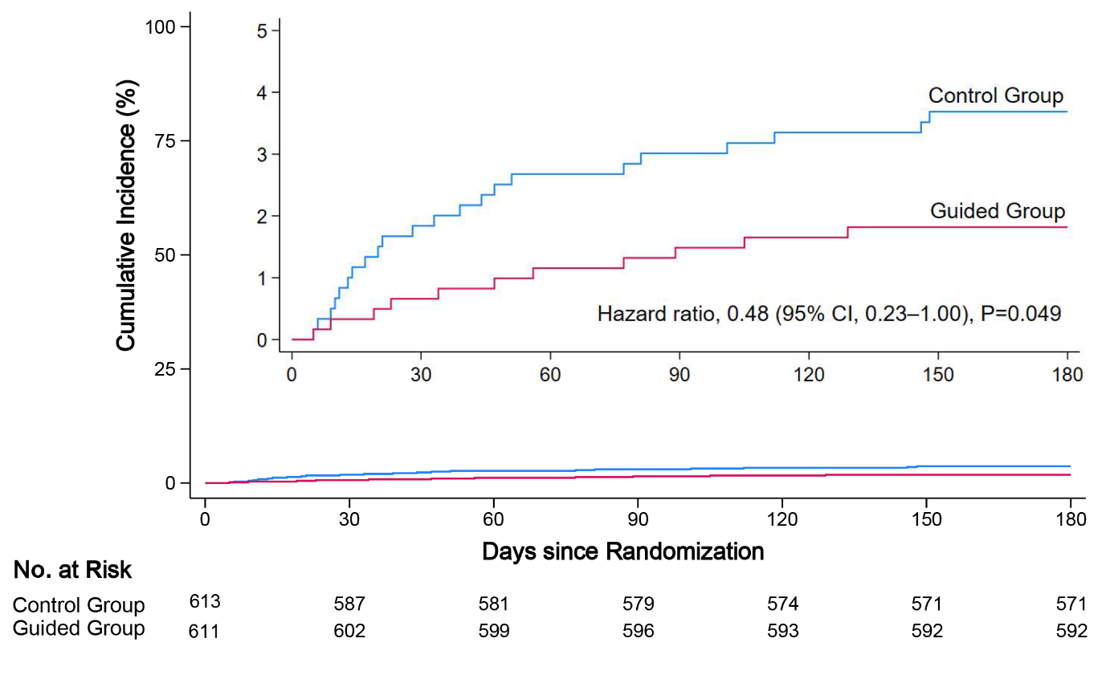
Figure S5 Cumulative Incidence of Ischemic Stroke

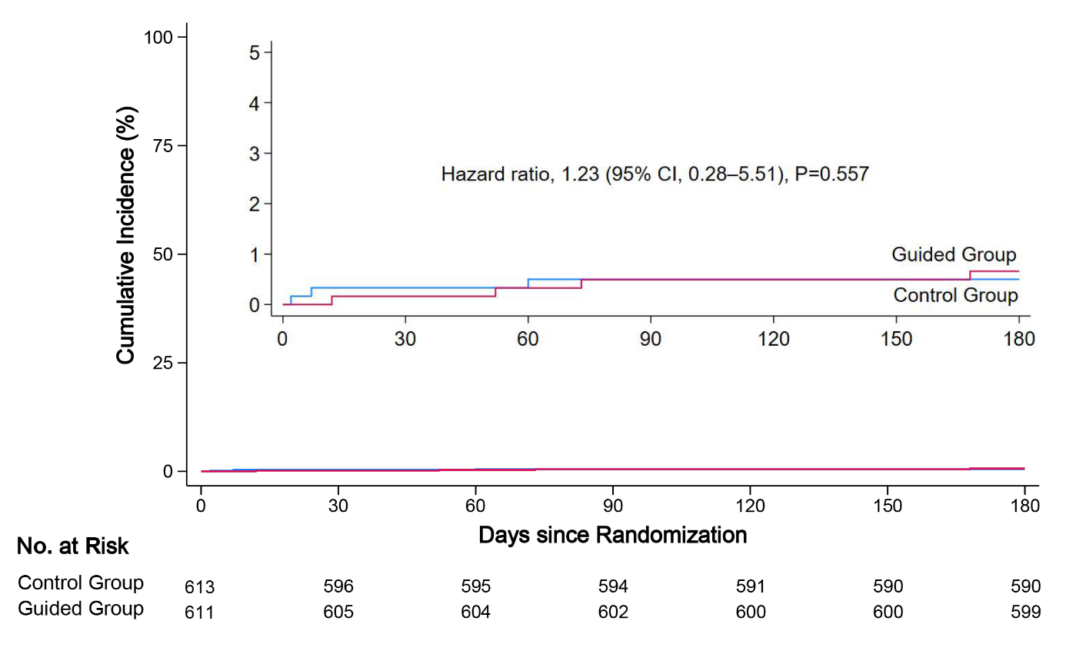
Figure S6 Cumulative Incidence of Hemorrhagic Stroke

