Graphical Abstract
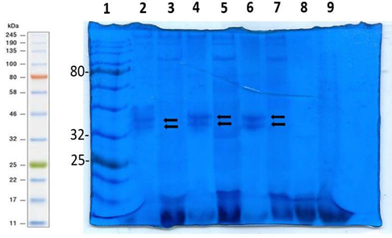
Figure 1: depicts the SDS-PAGE gel of crude enzyme protein extracted from the recombinant P. pastoris and concentrated by vacuum concentrator after Coomassie Blue Brilliant staining. The molecular marker is shown in lane 1, and the lanes 2-9 are loaded with concentrated samples from day 2 pH5, pH7, day 4 pH5, pH7, day 6 pH5, pH7 and day 6 controls pH5 and pH. The black arrows in lanes 2, 4 and 6 indicate the bands between 32 and 46 kDa

