Supplementary material
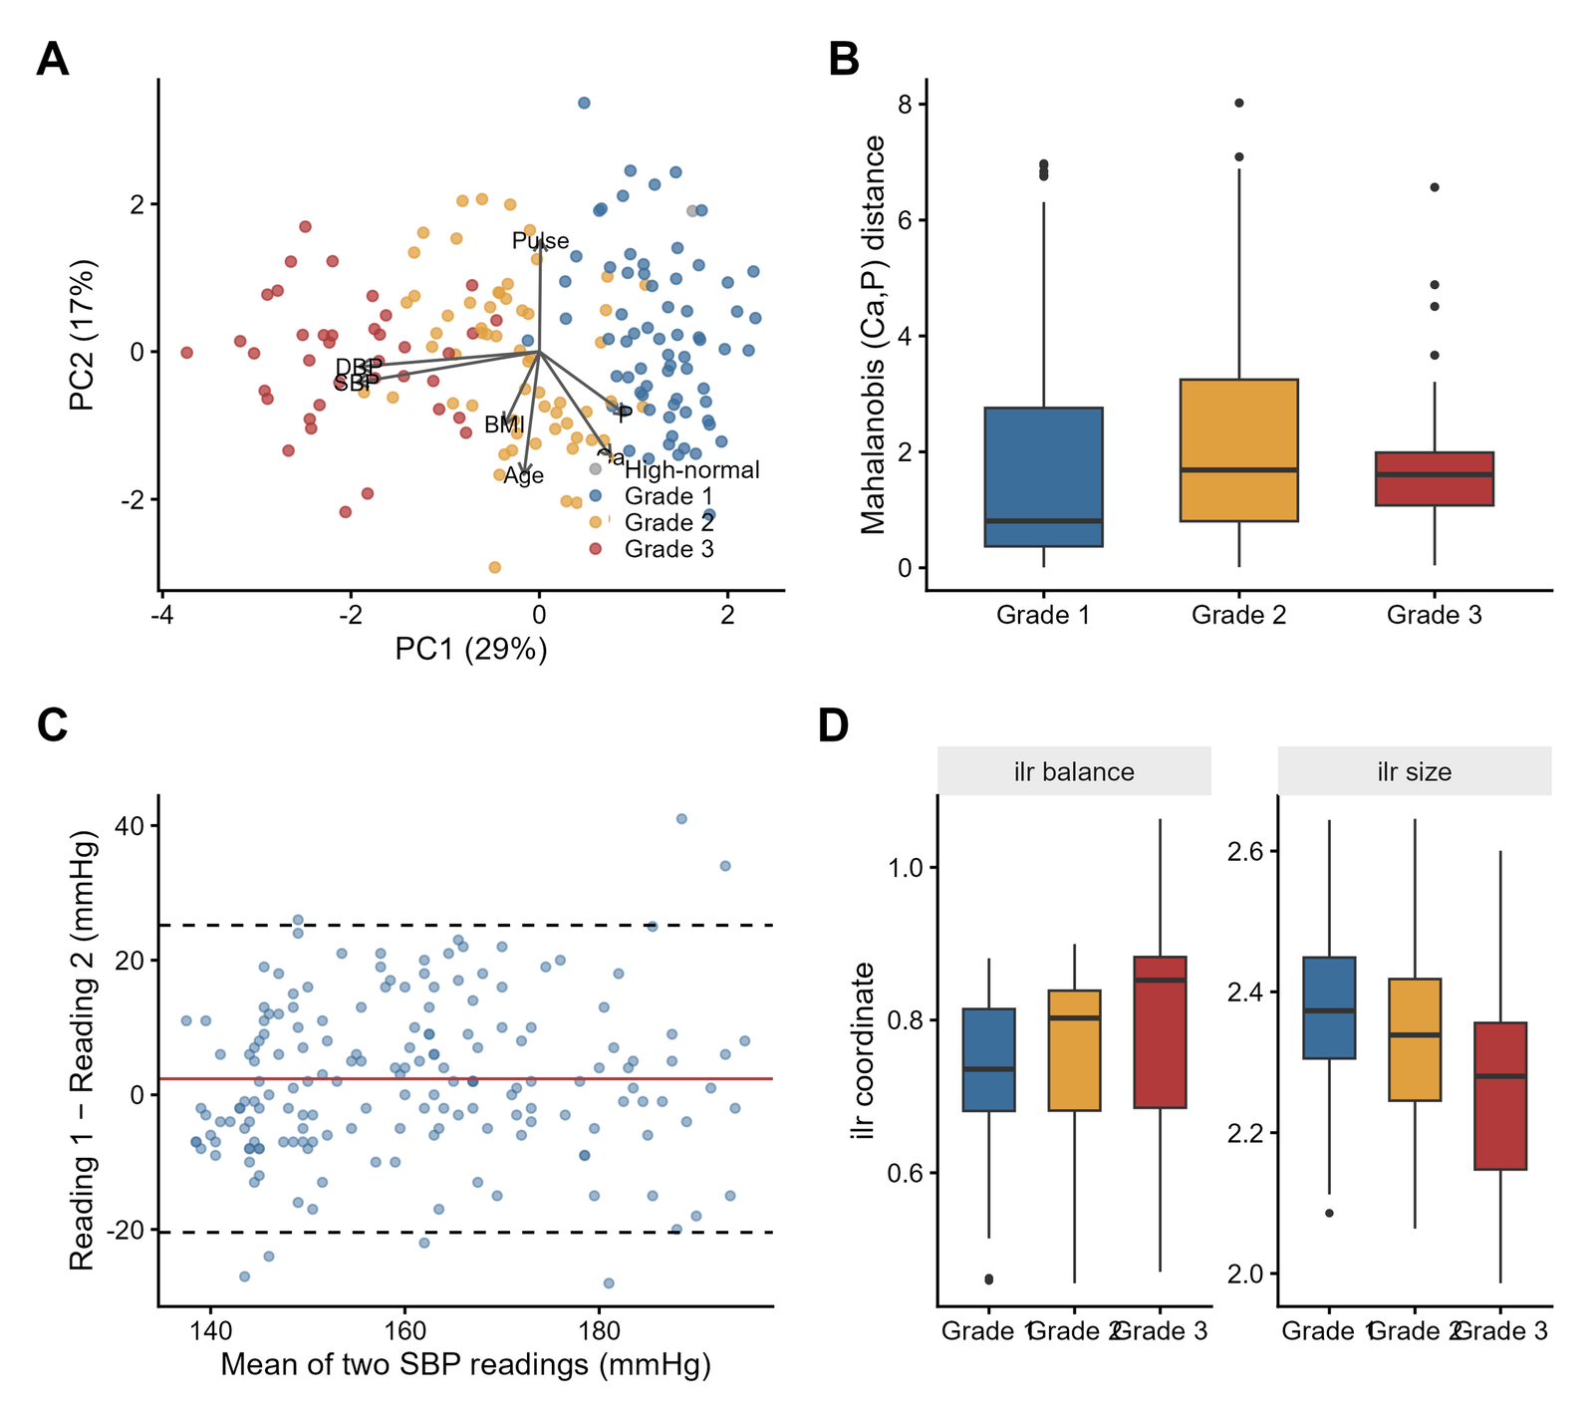
S1 Fig. Multivariate structure and measurement-quality checks. (A) Principal-component biplot coloured by blood-pressure grade. (B) Mahalanobis (calcium, phosphorus) distance across grade. (C) Bland–Altman plot of the two within-visit systolic readings. (D) Isometric log-ratio balance and size coordinates across grade.
SUPPLEMENTARY TABLES
Supplementary Table S1. Distributional normality and within-visit blood-pressure reliability
(A) Tests of normality
Variable | Shapiro–Wilk W | Shapiro p | Anderson–Darling p | Normal (α=0.05)
Age | 0.940 | 1.2e-06 | 4.3e-07 | No
Weight | 0.992 | 0.42 | 0.86 | Yes
Height | 0.995 | 0.82 | 0.75 | Yes
BMI | 0.985 | 0.070 | 0.48 | Yes
Pulse | 0.940 | 1.4e-06 | 5.9e-07 | No
Systolic BP | 0.942 | 1.9e-06 | 2.8e-07 | No
Diastolic BP | 0.963 | 1.8e-04 | 1.4e-04 | No
Pulse pressure | 0.969 | 6.8e-04 | 1.3e-03 | No
MAP | 0.940 | 1.4e-06 | 6.8e-08 | No
Calcium | 0.969 | 6.5e-04 | 1.1e-04 | No
Phosphorus | 0.888 | 4.6e-10 | 1.2e-13 | No
Ca/P ratio | 0.958 | 5.7e-05 | 1.8e-05 | No
Ca×P product | 0.953 | 1.7e-05 | 5.1e-05 | No
(B) Within-visit BP reading reliability
Metric | SBP | DBP
ICC (single, agreement) | 0.739 (0.660–0.802) | 0.587 (0.479–0.677)
Mean difference (reading 1−2) | 2.37 | 1.42
SD of difference | 11.64 | 8.47
Paired Wilcoxon p | 0.016 | —

Supplementary Table S2. Serum minerals across demographic, lifestyle and clinical subgroups, and categorical associations with grade
(A) Two-level exposures — Mann–Whitney p (significant values in bold)
Exposure | Calcium | Phosphorus | Ca/P | Ca×P
Sex | 0.429 | 0.903 | 0.474 | 0.906
Diet | 0.854 | 0.833 | 0.687 | 0.916
Smoking | 0.253 | 0.970 | 0.445 | 0.525
Alcohol | 0.640 | 0.476 | 0.886 | 0.329
Tobacco/betel-nut | 0.417 | 0.643 | 0.874 | 0.536
BMI (Asian-Indian, binary) | 0.880 | 0.257 | 0.261 | 0.359
LVH (present vs absent) | 0.525 | 0.159 | 0.187 | 0.120
ECG abnormal (vs normal) | 0.036 | 0.023 | 0.117 | 0.010
Pedal oedema | 0.438 | 0.391 | 0.293 | 0.334
Pallor | 0.032 | 0.172 | 0.800 | 0.077
(B) ≥3-level groups — Kruskal–Wallis p (ε²)
Grouping | Calcium | Phosphorus | Ca/P | Ca×P
Age group | 0.76 | 0.745 | 0.727 | 0.765
Family history of HTN | 0.748 | 0.512 | 0.368 | 0.841
BMI (WHO) | 0.396 | 0.105 | 0.189 | 0.327
BMI (Asian-Indian, 4-level) | 0.744 | 0.293 | 0.217 | 0.609
ECG interpretation | 0.067 | 0.074 | 0.272 | 0.035
Phosphorus category | 1.3e-05 | — | — | —
Ca/P category | 0.0014 | 3.5e-21¶ | — | —
¶Significant by construction (shared denominator); reported for completeness.
(C) Categorical associations with grade and ECG — test, p, Cramér's V
Pair | Test | p | Cramér's V
BP grade × phosphorus category | Fisher | 1e-04 | 0.319
BP grade × ECG interpretation | Fisher | 0.001 | 0.240
BP grade × BMI (Asian-Indian) | Fisher | 0.042 | 0.213
BP grade × calcium category | Fisher | 0.566 | 0.097
BP grade × Ca/P category | Fisher | 0.284 | 0.142
BP grade × sex | Fisher | 0.069 | 0.193
ECG interpretation × phosphorus category | Fisher | 0.016 | 0.182
ECG interpretation × calcium category | Chi² | 0.189 | 0.140
(D) Cochran–Armitage trend tests (binary outcome across ordered exposure)
Outcome | Ordered by | χ² | p | Proportions
ECG abnormal | BP grade | 15.61 | 7.8e-05 | 41% → 62% → 79%
LVH | BP grade | 5.58 | 0.018 | 28% → 40% → 50%
ST–T changes | BP grade | 4.15 | 0.042 | 13% → 22% → 29%
LVH | Ca/P category (Low→Normal→High) | 1.82 | 0.178 | 32% → 28% → 42%
ECG abnormal | Ca/P category (Low→Normal→High) | 1.11 | 0.291 | 55% → 49% → 61%

Supplementary Table S3. Full correlation matrix and supplementary regression analyses
(A) Spearman correlation matrix of continuous variables (ρ)
 | Age | BMI | Pulse | SBP | DBP | PP | MAP | Ca | P | Ca/P | Ca×P
SBP | 0.08 | 0.13 | −0.06 | 1 | 0.81 | 0.87 | 0.93 | −0.19 | −0.26 | 0.20 | −0.27
DBP | 0.04 | 0.09 | 0.01 | 0.81 | 1 | 0.45 | 0.96 | −0.17 | −0.27 | 0.22 | −0.27
MAP | 0.07 | 0.12 | −0.01 | 0.93 | 0.96 | 0.65 | 1 | −0.18 | −0.28 | 0.22 | −0.28
Ca | 0.08 | −0.05 | −0.10 | −0.19 | −0.17 | −0.13 | −0.18 | 1 | 0.27 | 0.23 | 0.65
P | 0.00 | 0.03 | −0.03 | −0.26 | −0.27 | −0.18 | −0.28 | 0.27 | 1 | −0.84 | 0.89
Ca/P | 0.05 | −0.06 | −0.04 | 0.20 | 0.22 | 0.14 | 0.22 | 0.23 | −0.84 | 1 | −0.55
Ca×P | 0.04 | 0.02 | −0.08 | −0.27 | −0.27 | −0.18 | −0.28 | 0.65 | 0.89 | −0.55 | 1
(Age/weight/height/BMI/pulse inter-correlations all |ρ|<0.15; full 13×13 matrix available on request.)
(B) Binary logistic regression of LVH — OR (95% CI), p
Model / term | OR (95% CI) | p
mL1 — Ca/P ratio | 1.606 (0.812–3.177) | 0.173
Age | 1.024 (1.002–1.046) | 0.031
Sex (male) / BMI | 0.760 / 0.967 | 0.412 / 0.399
mL2 — Calcium | 0.905 (0.566–1.447) | 0.677
Phosphorus | 0.571 (0.304–1.071) | 0.081
Age | 1.026 (1.003–1.048) | 0.023
Sex (male) / BMI | 0.750 / 0.966 | 0.393 / 0.383
(C) Multiple linear regression of BP indices on Ca, P, age, sex, BMI
Outcome | Serum Ca (p) | Serum P (p) | Model adj R²
SBP | −3.06 (0.071) | −5.40 (0.010) | 0.058
DBP | — (0.129) | — (0.015) | 0.033
MAP | — (0.082) | — (0.008) | 0.051
Pulse pressure | — (0.133) | — (0.053) | 0.041
(D) LVH prevalence across biomarker quartiles (Q1→Q4), trend p
Biomarker | Q1 | Q2 | Q3 | Q4 | Trend p
Calcium | 26/56 | 8/30 | 11/43 | 18/42 | 0.488
Phosphorus | 20/44 | 17/49 | 20/51 | 6/27 | 0.107
Ca/P ratio | 12/44 | 19/42 | 15/43 | 17/42 | 0.364
Ca×P product | 20/43 | 15/43 | 16/42 | 12/43 | 0.109

