Association of perioperative acetate-buffered balanced crystalloid solution with postoperative myocardial injury after hip replacement: A retrospective cohort study

SUPPLEMENTARY FILE

Nanbo Luo^{1,2,#}, Niannian Shuai^{1,#}, Yanling Zhang¹, Jianming Chen¹, Zhao Zhao¹, Xinping Yang¹, Xiaoyang Huang³, Wei You³, Qingsheng Xue⁴, Buwei Yu⁴, Yan Luo^{4,*}, Zhiheng Liu^{1,*}

1. Department of Anesthesiology, The First Affiliated Hospital of Shenzhen University, Shenzhen Second People’s Hospital, Shenzhen, China.
2. Department of Anesthesiology, The First Affiliated Hospital, Jinan University, Guangzhou, China.
3. Department of Orthopedics, The First Affiliated Hospital of Shenzhen University, Shenzhen Second People’s Hospital, Shenzhen, China.
4. Department of Anesthesiology, Ruijin Hospital, School of Medicine Shanghai Jiaotong University, Shanghai, China.

Table S1. Baseline characteristics of the cohort with total value and missing value.
Data are presented as n (%) unless noted otherwise. _{SD}, standard deviation; IQR, interquartile range; BMI, body mass index; ASA, American Society of Anesthesiologists; COPD, chronic obstructive pulmonary disease; ACEI, angiotensin-converting enzyme inhibitor; ARB, angiotensin Ⅱ receptor blocker; cTnI, cardiac troponin I; SPMCG, Sodium-Potassium-Magnesium-Calcium-Glucose Injection.
Variables | Total values (N=865) | Missing values (N=2223) | P-value
Demographics
Age (yr), mean (_{SD}) | 67.1 (15.1) | 64.0 (16.2) | <0.001
Sex |  |  | 0.81
Female | 527 (60.9) | 1365 (61.4)
Male | 338 (39.1) | 858 (38.6)
BMI (kg/m²), mean (_{SD}) | 23.0 (3.4) | 22.8 (3.7) | 0.07
ASA physical status |  |  | 0.001
1-2 | 486 (56.2) | 1392 (62.6)
3-5 | 379 (43.8) | 831 (37.4)
Surgery classification |  |  | 0.03
Emergency surgery | 122 (14.1) | 250 (11.2)
Elective surgery | 743 (85.9) | 1973 (88.8)
Preoperative comorbidities
Hypertension | 329 (38.0) | 711 (32.0) | 0.001
Atrial fibrillation | 37 (4.3) | 32 (1.4) | <0.001
Congestive heart failure | 10 (1.2) | 7 (0.3) | 0.005
Coronary artery disease | 86 (9.9) | 107 (4.8) | <0.001
Valvular disease | 51 (5.9) | 71 (3.2) | <0.001
Renal failure | 27 (3.1) | 28 (1.3) | <0.001
Diabetes | 149 (17.2) | 309 (13.9) | 0.02
Stroke | 102 (11.8) | 173 (7.8) | <0.001
COPD | 7 (0.8) | 13 (0.6) | 0.49
Peripheral vascular disease | 87 (10.1) | 119 (5.4) | <0.001
Active cancer | 53 (6.1) | 124 (5.6) | 0.56
Medications at baseline
ACEI/ARB | 89 (10.3) | 101 (4.5) | <0.001
Beta blocker | 45 (5.2) | 59 (2.7) | <0.001
Calcium channel blocker | 137 (15.8) | 235 (10.6) | <0.001
Diuretic | 22 (2.5) | 14 (0.6) | <0.001
Statin | 53 (6.1) | 53 (2.4) | <0.001
Preoperative laboratory date
cTnI (ng/mL)×10², (IQR) | 1.0 (0.3-1.0) | 0.7 (0.2-1.0) | <0.001
Haemoglobin (g/L), mean (_{SD}) | 123.5 (17.5) | 126.2 (17.9) | <0.001
Platelet count (cells 10⁹/L), mean (_{SD}) | 238.1 (81.9) | 236.9 (81.9) | 0.70
Hypersensitive c-reactive protein (mg/L), (IQR) | 6.0 (1.5-26.0) | 4.6 (1.2-22.3) | 0.02
Use SPMCG |  |  | 0.96
No | 101 (11.7) | 258 (11.6)
Yes | 764 (88.3) | 1965 (88.4)

Table S2. Distribution of SPMCG use and 3-day postoperative myocardial injury in different ASA physical status.
Data are presented as n (%). ASA, American Society of Anesthesiologists; SPMCG, Sodium-Potassium-Magnesium-Calcium-Glucose Injection; POD, postoperative day.
Supplementary Table S1 indicates that patients with missing data generally had milder disease severity. Specifically, most patients in the missing data cohort received SPMCG (88.4%), and 62.6% were classified as ASA physical status 1-2. Furthermore, among patients with ASA physical status 1-2, the incidence of myocardial injury on postoperative day 3 was only 2.3% (Supplementary Table S2). These findings suggest that the missing data cohort was enriched with patients who were treated with SPMCG and were at relatively low risk of postoperative myocardial injury. As a result, excluding these patients may have biased the analysis toward underestimating the potential protective association of SPMCG.
 |  | ASA physical status 1-2 | ASA physical status 3-5 | P-value
Use SPMCG |  |  |  | <0.001
No |  | 159 (8.5) | 200 (16.5)
Yes |  | 1719 (91.5) | 1010 (83.5)
POD3 MINS |  |  |  | <0.001
No |  | 475 (97.7) | 350 (92.3)
Yes |  | 11 (2.3) | 29 (7.7)

Table S3. Preoperative laboratory data of patients underwent hip arthroplasty included in the study before and after propensity score matching.
Data are presented as mean (_{SD}) or median (IQR). _{SD}, standard deviation; IQR, interquartile range; SPMCG, Sodium-Potassium-Magnesium-Calcium-Glucose Injection; cTnI, cardiac troponin I; NTproBNP, N-terminal pro-B-type natriuretic peptide; ALT, alanine aminotransferase; AST, aspartate aminotransferase; HCT, hematocrit.
Variables | Before propensity score matching |  |  |  | After propensity score matching
Variables | SPMCG (N=764) | No SPMCG (N=101) | P-value |  | SPMCG (N=216) | No SPMCG (N=72) | P-value
cTnI (ng/mL)×10² | 1.0 (0.3-1.0) | 1.0 (0.5-1.0) | 0.01 |  | 1.0 (0.8-1.0) | 1.0 (0.4-1.0) | 0.80
Myohemoglobin  (ng/mL) | 37.1 (20.0-65.0) | 47.0 (25.2-97.5) | 0.05 |  | 50.4 (28.9-83.8) | 44.0 (25.2-75.4) | 0.37
NTproBNP (pg/mL) | 105.5 (51.0-303.5) | 174.0 (86.0-728.0) | <0.001 |  | 131.5 (58.5-490.3) | 145.5 (75.5-273.8) | 0.84
Creatinine (μmol/L) | 63.6 (52.8-76.7) | 64.1 (52.7-87.1) | 0.33 |  | 65.6 (52.7-84.0) | 63.7 (52.7-77.0) | 0.62
ALT (U/L) | 22.2 (16.9) | 23.0 (17.7) | 0.53 |  | 24.8 (21.3) | 22.6 (17.8) | 0.63
AST (U/L) | 27.8 (14.9) | 30.1 (15.7) | 0.15 |  | 31.5 (21.5) | 27.9 (13.3) | 0.25
Albumin (g/L) | 39.5 (4.6) | 37.8 (5.2) | 0.006 |  | 38.7 (5.0) | 38.4 (5.2) | 0.62
Red blood cell count (cells 10¹²/L) | 4.2 (0.6) | 4.1 (0.6) | 0.20 |  | 4.2 (0.6) | 4.2 (0.6) | 0.97
Haemoglobin (g/L) | 123.7 (17.7) | 122.1 (16.2) | 0.43 |  | 123.7 (18.2) | 123.8 (15.0) | 0.93
HCT (%) | 37.8 (5.1) | 37.3 (4.7) | 0.44 |  | 37.6 (5.3) | 37.8 (4.2) | 0.82
Platelet count  (cells 10⁹/L) | 238.7 (82.6) | 233.2 (76.2) | 0.45 |  | 232.5 (83.0) | 227.5 (65.3) | 0.92
White blood cell count (cells 10⁹/L) | 7.3 (2.7) | 7.9 (2.9) | 0.07 |  | 7.8 (2.9) | 7.7 (2.7) | 0.56
Procalcitonin (ng/mL) | 7.2 (7.2-8.0) | 8.0 (7.2-16.0) | <0.001 |  | 0.1 (0.1-0.1) | 0.1 (0.1-0.1) | 0.13
Hypersensitive c-reactive protein (mg/L) | 5.0 (1.4-23.7) | 19.0 (5.0-42.8) | <0.001 |  | 9.7 (2.3-39.8) | 15.5 (2.8-32.0) | 0.91
Neutrophil count  (cells 10⁹/L) | 4.9 (2.6) | 5.7 (2.9) | 0.002 |  | 5.5 (2.9) | 5.5 (2.7) | 0.91
Lymphocyte count  (cells 10⁹/L) | 1.7 (0.7) | 1.4 (0.6) | <0.001 |  | 1.6 (0.7) | 1.5 (0.6) | 0.16

Table S4. Preoperative and postoperative sodium, potassium, magnesium, calcium and glucose of patients underwent hip replacement included in the study before and after propensity score matching.
Data are presented as mean (SD). _{SD}, standard deviation; SPMCG, Sodium-Potassium-Magnesium-Calcium-Glucose Injection.
Variables | Before propensity score matching |  |  |  | After propensity score matching
Variables | SPMCG (N=764) | No SPMCG (N=101) | P-value |  | SPMCG (N=216) | No SPMCG (N=72) | P-value
Preoperative
Sodium (mmol/L) | 140.2 (3.5) | 139.6 (3.5) | 0.09 |  | 139.7 (4.6) | 140.0 (3.5) | 0.79
Potassium (mmol/L) | 4.0 (0.4) | 4.1 (0.5) | 0.17 |  | 4.0 (0.4) | 4.1 (0.5) | 0.19
Magnesium (mmol/L) | 0.9 (0.1) | 0.9 (0.1) | 0.94 |  | 0.9 (0.1) | 0.9 (0.1) | 0.69
Calcium (mmol/L) | 2.2 (0.1) | 2.2 (0.1) | <0.001 |  | 2.2 (0.1) | 2.2 (0.1) | 0.13
Glucose (mmol/L) | 5.7 (1.9) | 7.0 (2.9) | <0.001 |  | 6.1 (2.4) | 6.7 (2.7) | 0.04
Postoperative
Sodium (mmol/L) | 138.5 (3.4) | 139.1 (4.2) | 0.13 |  | 138.6 (4.3) | 139.3 (4.2) | 0.32
Potassium (mmol/L) | 4.2 (0.4) | 4.2 (0.6) | 0.81 |  | 4.2 (0.5) | 4.2 (0.6) | 0.62
Magnesium (mmol/L) | 0.9 (0.1) | 0.9 (0.1) | 0.10 |  | 0.9 (0.1) | 0.9 (0.1) | 0.25
Calcium (mmol/L) | 2.1 (0.1) | 2.0 (0.2) | 0.06 |  | 2.1 (0.1) | 2.0 (0.2) | 0.47
Glucose (mmol/L) | 7.0 (2.3) | 7.7 (3.2) | 0.26 |  | 7.7 (3.1) | 7.3 (2.8) | 0.54

Table S5. Preoperative and postoperative sodium, potassium, magnesium, calcium and glucose of patients underwent hip arthroplasty included in the study before and after propensity score matching.
Data are presented as n (%). SPMCG, Sodium-Potassium-Magnesium-Calcium-Glucose Injection.
Variables | Before propensity score matching |  |  |  | After propensity score matching
Variables | SPMCG (N=764) | No SPMCG (N=101) | P-value |  | SPMCG (N=216) | No SPMCG (N=72) | P-value
Preoperative
Sodium (mmol/L) |  |  | 0.40 |  |  |  | 0.88
<=135 | 43 (5.6) | 9 (8.9) |  |  | 22 (10.2) | 5 (6.9)
135-145 | 640 (83.8) | 78 (77.2) |  |  | 171 (79.2) | 59 (81.9)
>145 | 18 (2.4) | 3 (3.0) |  |  | 8 (3.7) | 3 (4.2)
Missing | 63 (8.2) | 11 (10.9) |  |  | 15 (6.9) | 5 (6.9)
Potassium (mmol/L) |  |  | 0.02 |  |  |  | 0.35
<=3.5 | 61 (8.0) | 8 (7.9) |  |  | 25 (11.6) | 7 (9.7)
3.5-5.5 | 639 (83.6) | 79 (78.2) |  |  | 176 (81.5) | 58 (80.6)
>5.5 | 1 (0.1) | 2 (2.0) |  |  | 0 (0.0) | 1 (1.4)
Missing | 63 (8.2) | 12 (11.9) |  |  | 15 (6.9) | 6 (8.3)
Magnesium (mmol/L) |  |  | 0.58 |  |  |  | 0.77
<=0.75 | 13 (1.7) | 1 (1.0) |  |  | 4 (1.9) | 1 (1.4)
0.75-1.25 | 349 (45.7) | 40 (39.6) |  |  | 86 (39.8) | 33 (45.8)
>1.25 | 1 (0.1) | 0 (0.0) |  |  | 1 (0.5) | 0 (0.0)
Missing | 401 (52.5) | 60 (59.4) |  |  | 125 (57.9) | 38 (52.8)
Calcium (mmol/L) |  |  | 0.33 |  |  |  | 0.71
<=2.1 | 112 (14.7) | 19 (18.8) |  |  | 45 (20.8) | 15 (20.8)
2.1-2.6 | 592 (77.5) | 72 (71.3) |  |  | 159 (73.6) | 52 (72.2)
>2.6 | 5 (0.7) | 2 (2.0) |  |  | 2 (0.9) | 2 (2.8)
Missing | 55 (7.2) | 8 (7.9) |  |  | 10 (4.6) | 3 (4.2)
Glucose (mmol/L) |  |  | <0.001 |  |  |  | 0.39
<=7.8 | 562 (73.6) | 63 (62.4) |  |  | 151 (69.9) | 50 (69.4)
7.8-10.0 | 44 (5.8) | 9 (8.9) |  |  | 19 (8.8) | 6 (8.3)
>10.0 | 25 (3.3) | 12 (11.9) |  |  | 10 (4.6) | 7 (9.7)
Missing | 133 (17.4) | 17 (16.8) |  |  | 36 (16.7) | 9 (12.5)
Postoperative
Sodium (mmol/L) |  |  | 0.05 |  |  |  | 0.33
<=135 | 103 (13.5) | 15 (14.9) |  |  | 37 (17.1) | 10 (13.9)
135-145 | 650 (85.1) | 83 (82.2) |  |  | 174 (80.6) | 59 (81.9)
>145 | 11 (1.4) | 2 (2.0) |  |  | 5 (2.3) | 2 (2.8)
Missing | 0 (0.0) | 1 (1.0) |  |  | 0 (0.0) | 1 (1.4)
Potassium (mmol/L) |  |  | <0.001 |  |  |  | 0.07
<=3.5 | 39 (5.1) | 12 (11.9) |  |  | 12 (5.6) | 9 (12.5)
3.5-5.5 | 719 (94.1) | 86 (85.1) |  |  | 201 (93.1) | 61 (84.7)
>5.5 | 6 (0.8) | 2 (2.0) |  |  | 3 (1.4) | 1 (1.4)
Missing | 0 (0.0) | 1 (1.0) |  |  | 0 (0.0) | 1 (1.4)
Magnesium (mmol/L) |  |  | 0.02 |  |  |  | 0.02
<=0.75 | 49 (6.4) | 2 (2.0) |  |  | 14 (6.5) | 0 (0.0)
0.75-1.25 | 276 (36.1) | 27 (26.7) |  |  | 73 (33.8) | 18 (25.0)
>1.25 | 0 (0.0) | 0 (0.0) |  |  | 0 (0.0) | 0 (0.0)
Missing | 439 (57.5) | 72 (71.3) |  |  | 129 (59.7) | 54 (75.0)
Calcium (mmol/L) |  |  | 0.13 |  |  |  | 0.32
<=2.1 | 459 (60.1) | 62 (61.4) |  |  | 137 (63.4) | 44 (61.1)
2.1-2.6 | 300 (39.3) | 36 (35.6) |  |  | 77 (35.6) | 25 (34.7)
>2.6 | 2 (0.3) | 1 (1.0) |  |  | 1 (0.5) | 1 (1.4)
Missing | 3 (0.4) | 2 (2.0) |  |  | 1 (0.5) | 2 (2.8)
Glucose (mmol/L) |  |  | 0.40 |  |  |  | 0.78
<=7.8 | 278 (36.4) | 33 (32.7) |  |  | 70 (32.4) | 27 (37.5)
7.8-10.0 | 63 (8.2) | 7 (6.9) |  |  | 16 (7.4) | 6 (8.3)
>10.0 | 28 (3.7) | 7 (6.9) |  |  | 14 (6.5) | 3 (4.2)
Missing | 395 (51.7) | 54 (53.5) |  |  | 116 (53.7) | 36 (50.0)

Table S6. Subgroup analysis of the relationship between SPMCG and 3-day postoperative myocardial injury in the matched cohort.
Data are presented as n (%). SPMCG, Sodium-Potassium-Magnesium-Calcium-Glucose Injection; OR, odds ratio; CI, confidence interval; BMI, body mass index; ASA, American Society of Anesthesiologists; COPD, chronic obstructive pulmonary disease; cTnI, cardiac troponin I.
ª The analysis failed because of the small sample size.
The cTnI, hemoglobin, platelet count, and hypersensitive c-reactive protein are delimited by the median value.
Subgroup | Events/total patients, No. (%) |  | OR (95% CI) | P-value | P for interaction
Subgroup | SPMCG | No SPMCG | OR (95% CI) | P-value | P for interaction
Age (yr)
<65 | 1/73 (1.4) | 1/20 (5.0) | 0.26 (0.02, 4.42) | 0.35 | 0.96
>=65 | 7/143 (4.9) | 9/52 (17.3) | 0.25 (0.09, 0.70) | <0.01
Sex
Female | 5/124 (4.0) | 8/42 (19.0) | 0.18 (0.05, 0.58) | <0.01 | 0.38
Male | 3/92 (3.3) | 2/30 (6.7) | 0.47 (0.08, 2.97) | 0.42
BMI
<25 | 8/170 (4.7) | 9/58 (15.5) | 0.27 (0.10, 0.73) | 0.01 | 0.26
>=25 | 0/46 (0) | 1/14 (7.1) | - ª | - ª
ASA physical status
1-2 | 1/101 (1.0) | 3/33 (9.1) | 0.10 (0.01, 1.00) | 0.05 | 0.38
3-5 | 7/115 (6.1) | 7/39 (17.9) | 0.30 (0.10, 0.91) | 0.03
Surgery classification
Emergency surgery | 2/32 (6.2) | 2/10 (20.0) | 0.27 (0.03, 2.20) | 0.22 | 0.9
Elective surgery | 6/184 (3.3) | 8/62 (12.9) | 0.23 (0.08, 0.68) | <0.01
Hypertension
No | 1/115 (0.9) | 6/42 (14.3) | 0.05 (0.01, 0.45) | <0.01 | 0.05
Yes | 7/101 (6.9) | 4/30 (13.3) | 0.48 (0.13, 1.78) | 0.28
Coronary artery disease
No | 5/197 (2.5) | 8/66 (12.1) | 0.19 (0.06, 0.60) | <0.01 | 0.57
Yes | 3/19 (15.8) | 2/6 (33.3) | 0.37 (0.05, 3.06) | 0.36
Valvular disease
No | 6/203 (3.0) | 9/68 (13.2) | 0.20 (0.07, 0.58) | <0.01 | 0.49
Yes | 2/13 (15.4) | 1/4 (25.0) | 0.55 (0.04, 8.27) | 0.66
Renal failure
No | 5/204 (2.5) | 9/69 (13.0) | 0.17 (0.05, 0.52) | <0.01 | 0.35
Yes | 3/12 (25.0) | 1/3 (33.3) | 0.67 (0.04, 10.25) | 0.77
Diabetes
No | 3/164 (1.8) | 7/58 (12.1) | 0.14 (0.03, 0.54) | <0.01 | 0.32
Yes | 5/52 (9.6) | 3/14 (21.4) | 0.39 (0.08, 1.88) | 0.24
Stroke
No | 3/182 (1.6) | 9/61 (14.8) | 0.10 (0.03, 0.37) | <0.01 | 0.02
Yes | 5/34 (14.7) | 1/11 (9.1) | 1.72 (0.18, 16.59) | 0.64
Peripheral vascular disease
No | 5/191 (2.6) | 9/64 (14.1) | 0.16 (0.05, 0.51) | <0.01 | 0.17
Yes | 3/25 (12.0) | 1/8 (12.5) | 0.95 (0.09, 10.71) | 0.97
cTnI
<0.01 | 1/54 (1.9) | 1/20 (5.0) | 0.36 (0.02, 6.02) | 0.48 | 0.93
>=0.01 | 7/120 (5.8) | 9/38 (23.7) | 0.20 (0.07, 0.58) | <0.01
HB
<124 | 4/98 (4.1) | 4/35 (11.4) | 0.33 (0.08, 1.40) | 0.13 | 0.86
>=124 | 4/105 (3.8) | 6/35 (17.1) | 0.19 (0.05, 0.72) | 0.01
PLT
<229 | 4/105 (3.8) | 7/35 (20.0) | 0.16 (0.04, 0.58) | <0.01 | 0.58
>=229 | 4/97 (4.1) | 3/35 (8.6) | 0.46 (0.10, 2.16) | 0.32
hsCRP
<5.97 | 1/75 (1.3) | 1/23 (4.3) | 0.30 (0.02, 4.95) | 0.4 | 0.62
>=5.97 | 7/112 (6.2) | 8/37 (21.6) | 0.24 (0.08, 0.72) | 0.01

Table S7. Composition of the SPMCG solution.
Composition | Concentration
Sodium (mmol/L) | 140
Potassium (mmol/L) | 4
Calcium (mmol/L) | 1.5
Magnesium (mmol/L) | 1
Chloride (mmol/L) | 115
Acetate (mmol/L) | 25
Glucose (g/L) | 10
Osmolarity (mOsm/L) | 304

Fig. S1. Incidence of POD3 myocardial injury and preoperative cTnI in groups.
SPMCG, Sodium-Potassium-Magnesium-Calcium-Glucose Injection; POD, postoperative day; cTnI, cardiac troponin I.

Fig. S2. Distribution of preoperative and postoperative cTnI in groups.
SPMCG, Sodium-Potassium-Magnesium-Calcium-Glucose Injection; POD, postoperative day; cTnI, cardiac troponin I.
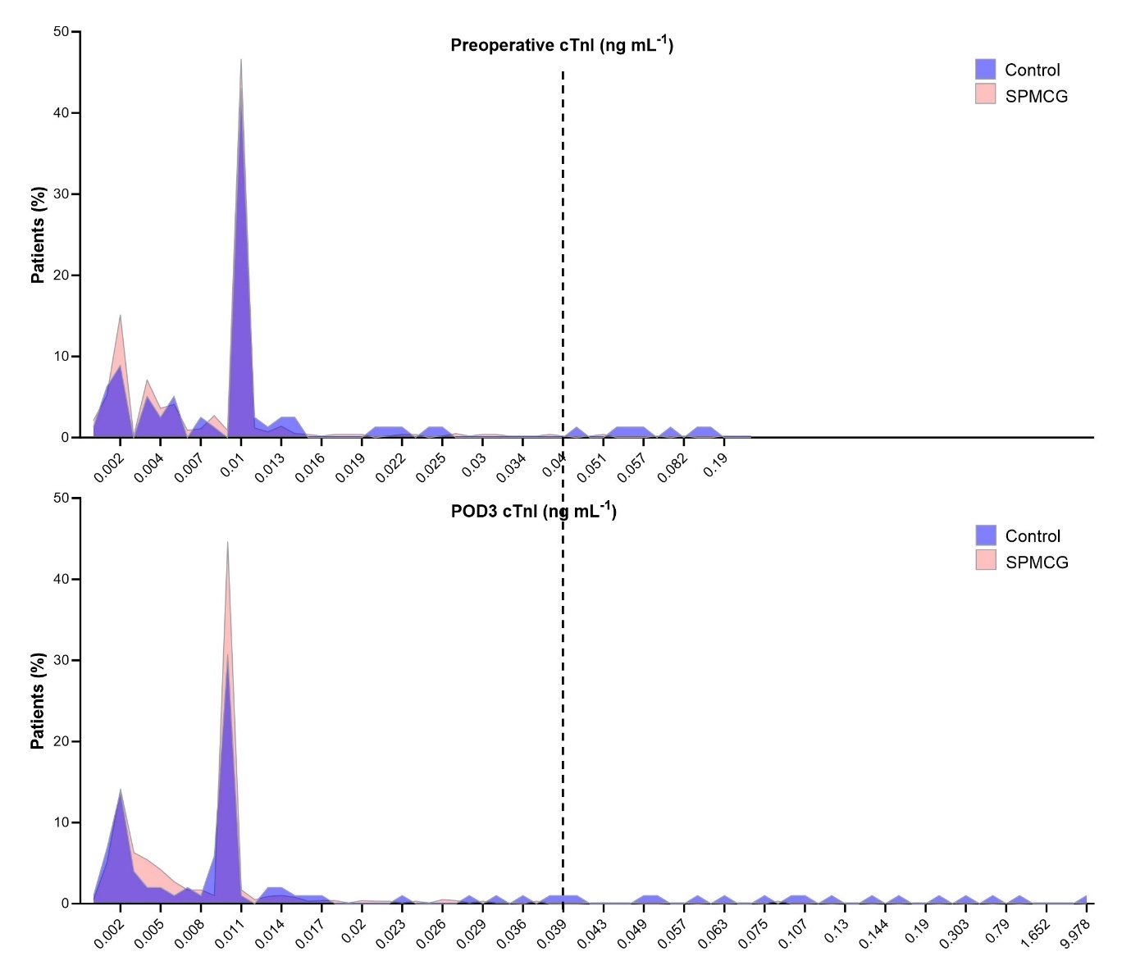
Fig. S3. Distribution of postoperative 3 days cTnI in groups.
SPMCG, Sodium-Potassium-Magnesium-Calcium-Glucose Injection; cTnI, cardiac troponin I.

