Supplementary information
Rising transnational economic risks of potential flood-induced outages at global fossil-fuelled power plants in the past decade
Jiaju Lin^{1,*}, Shuo Wang², Bingkun Wang¹, Miming Zhang¹, Chao Zhang¹, Yurong Ouyang¹, Xiongzhi Xue^{2,3}
¹ Third Institute of Oceanography, Ministry of Natural Resources, Xiamen, 361005, China
² College of environment and ecology, Xiamen University, Xiamen, 361102, China
³ Fujian Institute for Sustainable Oceans, Xiamen University, Xiamen, 361102, China

Supplementary Fig. 1 | Framework for assessing flood-induced outage risks and cascading economic losses of FPPs. The framework links plant-level fossil-fuelled power plant (FPP) data, flood-hazard exposure, outage-duration estimation and MRIO-based economic impact modelling. Global coal-, gas- and oil-fired FPPs are first matched to return-period-specific riverine flood maps after accounting for administrative and plant-level flood protection. Flood depths at exposed plants are then translated into outage durations and assigned as shocks to the corresponding fuel-specific electricity sectors. These shocks are propagated through the global production network using a dynamic inoperability input-output model based on EXIOBASE, allowing domestic and foreign business interruption costs to be quantified. Based on different flood scenarios, all economic losses are calculated into expected annual damage (EAD). Changes in losses between 2015 and 2024 are further decomposed into exposure, power-sector structure, economic scale and supply-chain propagation effects.

Supplementary Table. 1 | Plant-level flood-protection standards for FPPs across EXIOBASE regions.
EXIOBASE code | Region | Protection standard | Source
AT | Austria | RP250 | Luo et al.
BE | Belgium | RP250 | Luo et al.
BG | Bulgaria | RP250 | Luo et al.
CY | Cyprus | RP250 | Luo et al.
CZ | Czech Republic | RP250 | Luo et al.
DE | Germany | RP250 | Luo et al.
DK | Denmark | RP250 | Luo et al.
EE | Estonia | RP250 | Luo et al.
ES | Spain | RP250 | Luo et al.
FI | Finland | RP250 | Luo et al.
FR | France | RP250 | Luo et al.
GR | Greece | RP250 | Luo et al.
HR | Croatia | RP250 | Luo et al.
HU | Hungary | RP250 | Luo et al.
IE | Ireland | RP250 | Luo et al.
IT | Italy | RP250 | Luo et al.
LT | Lithuania | RP250 | Luo et al.
LU | Luxembourg | RP250 | Luo et al.
LV | Latvia | RP250 | Luo et al.
MT | Malta | RP250 | Luo et al.
NL | Netherlands | RP250 | Luo et al.
PL | Poland | RP250 | Luo et al.
PT | Portugal | RP250 | Luo et al.
RO | Romania | RP250 | Luo et al.
SE | Sweden | RP250 | Luo et al.
SI | Slovenia | RP250 | Luo et al.
SK | Slovakia | RP250 | Luo et al.
GB | United Kingdom | RP250 | Luo et al.
CH | Switzerland | RP250 | Luo et al.
NO | Norway | RP250 | Luo et al.
TR | Turkey | FLOPROS | Scussolini et al.
RU | Russia | FLOPROS | Scussolini et al.
US | United States | <400 MW: RP100; ≥400 MW: RP500 | https://www.ecfr.gov/current/title-44/chapter-I/subchapter-A/part-9/section-9.4
CA | Canada | <400 MW: RP100; ≥400 MW: RP500 | https://www.genevaassociation.org/sites/default/files/frm_canada_web.pdf
CN | China | <400 MW: RP50; ≥400 MW: RP100 | https://www.mohurd.gov.cn/gongkai/zc/wjk/art/2015/art_17339_224218.html
IN | India | RP50 | https://www.cbip.org/cearegulations/CEA%20DATA/ConstructionRegulations/ConstructionRegulation%20Cons.pdf
JP | Japan | FLOPROS | Scussolini et al.
KR | South Korea | FLOPROS | Scussolini et al.
ID | Indonesia | FLOPROS | Scussolini et al.
TW | Taiwan Province, China | FLOPROS | Scussolini et al.
AU | Australia | RP200 | https://www.statedevelopment.qld.gov.au/__data/assets/pdf_file/0021/33663/planning-resilient-electrical-infrastructure.pdf
BR | Brazil | RP100 | Sousa et al.
MX | Mexico | FLOPROS | Scussolini et al.
ZA | South Africa | RP100 | https://www.eskom.co.za/eia/gx/wp-content/uploads/migrated/Nuclear-1-EIA-Documentation/Env-Impact-Report-And-Env-Man-Plan-Doc/Nuc1Vol7/E9_Position_of_1in100Floodline.pdf
WA | Rest of Asia and Pacific | FLOPROS | Scussolini et al.
WE | Rest of Europe | FLOPROS | Scussolini et al.
WL | Rest of America | FLOPROS | Scussolini et al.
WF | Rest of Africa | FLOPROS | Scussolini et al.
WM | Rest of Middle East | FLOPROS | Scussolini et al.

Supplementary Table. 2 | An empirical flood depth disruption function for FPPs.
Threshold | Threshold notes | Vulnerability | Vulnerability notes
0 | Flood water depth (meters) | 0 | days of disruption
0.1 | Flood water depth (meters) | 1 | days of disruption
0.2 | Flood water depth (meters) | 2 | days of disruption
0.3 | Flood water depth (meters) | 7 | days of disruption
0.4 | Flood water depth (meters) | 14 | days of disruption
0.5 | Flood water depth (meters) | 30 | days of disruption
0.6 | Flood water depth (meters) | 60 | days of disruption
0.7 | Flood water depth (meters) | 180 | days of disruption
1 | Flood water depth (meters) | 365 | days of disruption

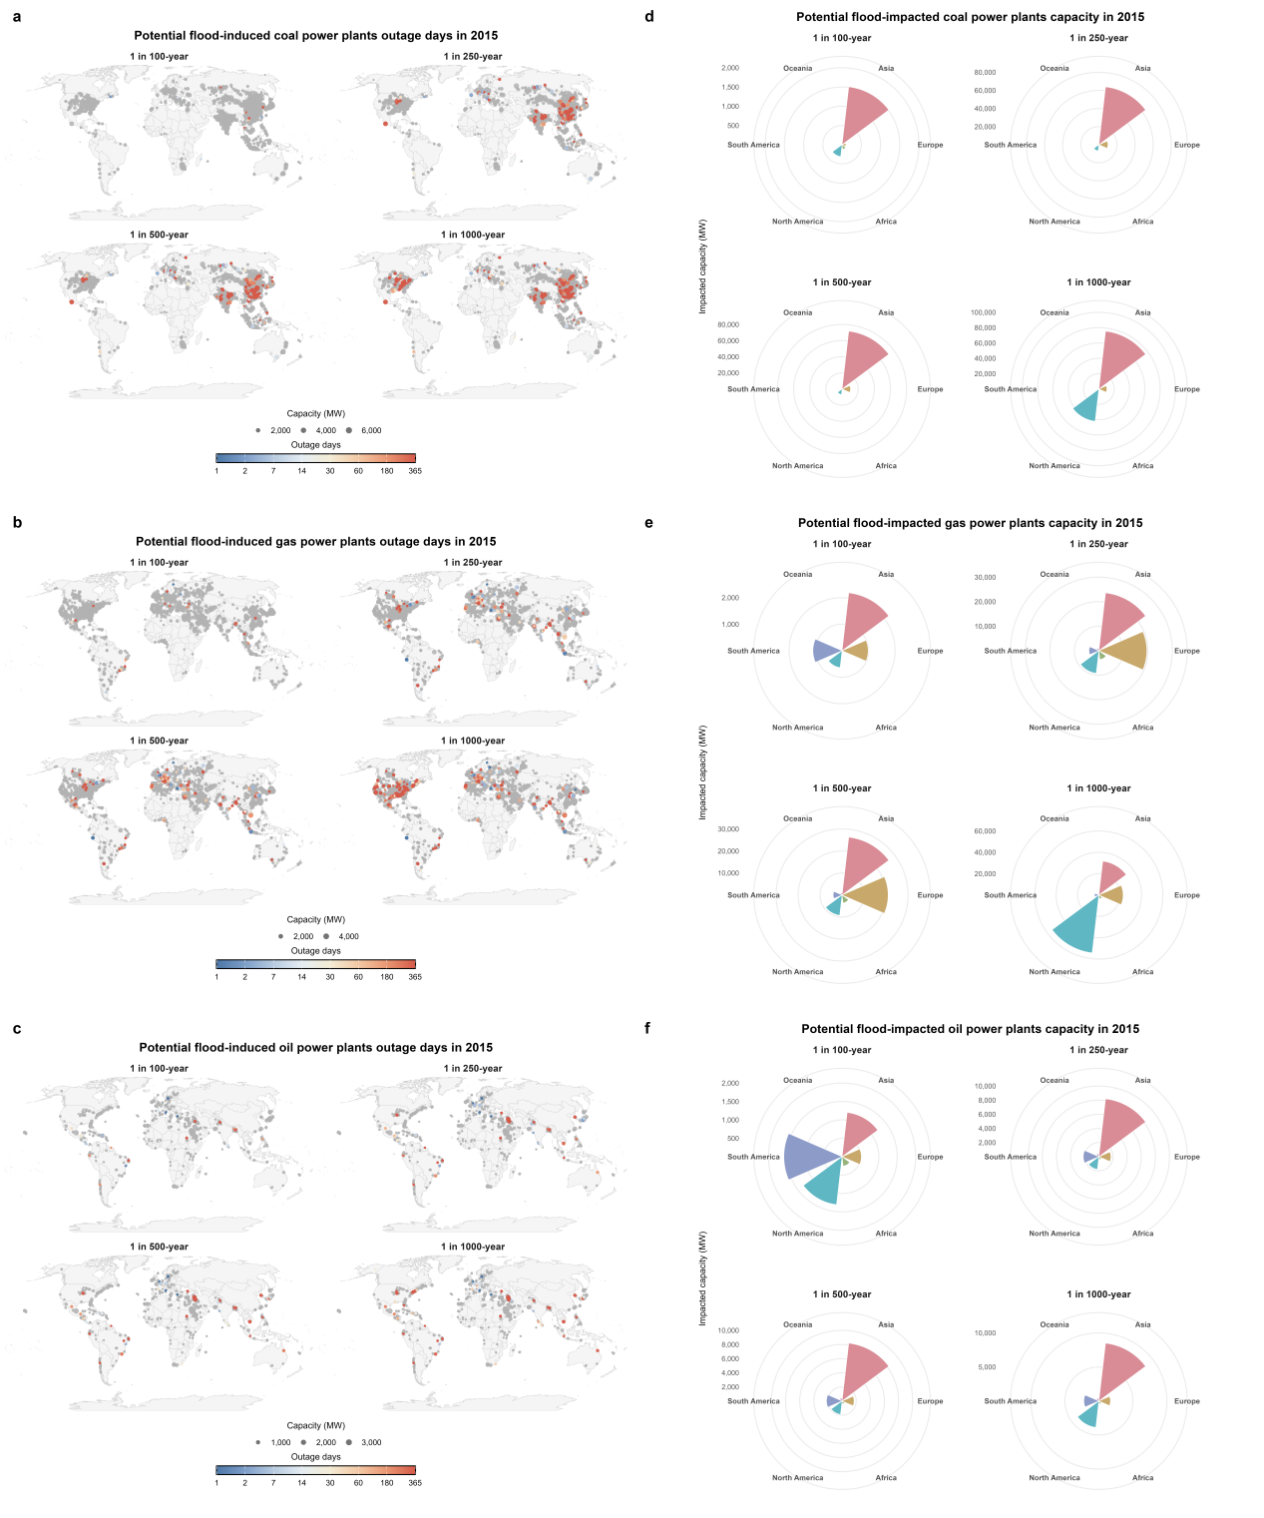

Supplementary Fig. 2 | Spatial distribution and regional aggregation of potential flood-induced FPP outage exposure in 2015. a-c, Global distribution of potentially flood-impacted coal- (a), gas- (b) and oil-fired (c) FPPs in 2015 under 1 in-100-year, 1 in-250-year, 1 in-500-year and 1-in-1000-year flood events. Points indicate affected FPPs, with point size representing installed capacity and colour indicating estimated outage duration. Grey points indicate FPPs not affected by flooding. d-f, Regional aggregation of potentially flood-impacted installed capacity for coal- (d), gas- (e) and oil-fired (f) FPPs across the same flood return periods. Polar bar charts show affected capacity by continent. All capacities are expressed in MW, and outage duration is expressed in days.
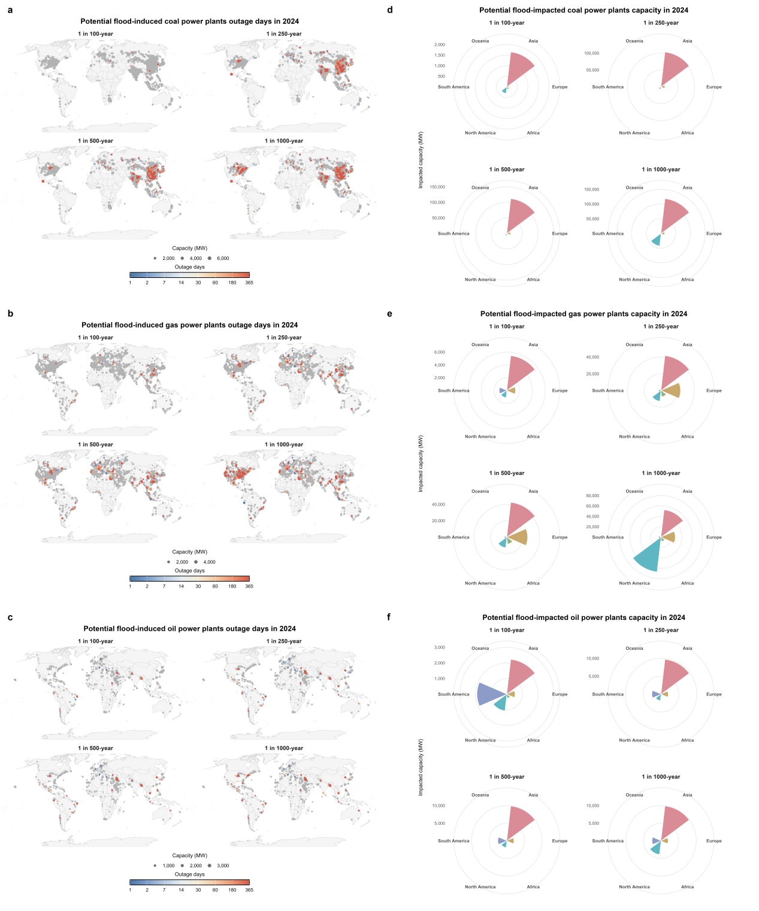

Supplementary Fig. 3 | Spatial distribution and regional aggregation of potential flood-induced FPP outage exposure in 2024. a-c, Global distribution of potentially flood-impacted coal- (a), gas- (b) and oil-fired (c) FPPs in 2024 under 1 in-100-year, 1 in-250-year, 1 in-500-year and 1-in-1000-year flood events. Points indicate affected FPPs, with point size representing installed capacity and colour indicating estimated outage duration. Grey points indicate FPPs not affected by flooding. d-f, Regional aggregation of potentially flood-impacted installed capacity for coal- (d), gas- (e) and oil-fired (f) FPPs across the same flood return periods. Polar bar charts show affected capacity by continent. All capacities are expressed in MW, and outage duration is expressed in days.

