Supplementary Material
Title: Frailty-index state life expectancy and measurement-rule robustness among middle-aged and older adults in China: a longitudinal multistate analysis

Supplementary Methods
Supplementary cohort and state-history notes
The supplementary package provides supporting detail for the primary CHARLS analysis, the prespecified measurement-rule analyses, the supportive CLHLS rank-order comparison, and the supplementary exploratory sex-stratified outputs. CHARLS remained the primary analytic cohort throughout. CLHLS was used only to examine preservation of frailty-state ordering across a non-identical frailty-index item library and was not treated as a matched cross-cohort estimate.
Supplementary measurement-rule and model notes
The primary CHARLS rule used the 48-item frailty-index library with a valid-item threshold of at least 35 items and the main state cutoffs of robust (FI less than or equal to 0.10), pre-frail (FI greater than 0.10 and less than or equal to 0.21), and frail (FI greater than 0.21). Prespecified sensitivity analyses varied the valid-item threshold to at least 39 items and the frailty cutoff to FI greater than 0.25. The stricter combined rule is retained only as supplementary supporting context.
All displayed life-expectancy and transition quantities arose from the same continuous-time multistate Markov framework described in the main manuscript. Bootstrap propagation with at least 2000 usable replicates was used for the formal main and sensitivity estimates that entered reader-facing tables and figures. Supplementary diagnostic outputs are included to document model behavior and uncertainty propagation, not to redefine the main evidence hierarchy.

Supplementary Tables

Supplementary Table S1. Sample completeness and analytic-sample construction in CHARLS and CLHLS.

Dataset | Stage | Count | Unit | Notes
CHARLS | W1 respondents with interview records | 17,596 | participants | Starting pool for baseline descriptive reporting
CHARLS | W1 with non-missing FI | 17,582 | participants | Participants with calculable FI at baseline
CHARLS | W1 valid-item count >=35 | 16,814 | participants | Baseline descriptive sample used in main-text Table 1
CHARLS | Four-wave state panel before multistate restrictions | 24,735 | participants | Unique participants contributing to the main state panel
CHARLS | At least two observations in the state panel | 21,480 | participants | Required to define at least one observed transition interval
CHARLS | Main multistate analysis sample with time-age information | 21,397 | participants | Main MSM analysis sample; 70,253 observation rows
CLHLS | 2008-2018 minimal state panel | 16,954 | participants | Unique participants in the supportive comparison panel
CLHLS | At least one assessable frailty state under Min 22 | 15,308 | participants | Participants contributing at least one evaluable state under the main CLHLS comparison definition
CLHLS | At least two assessable observations under Min 22 | 7,599 | participants | Participants eligible to contribute repeated observations under the main CLHLS comparison definition
CLHLS | Main CLHLS comparison analysis | 21,925 | usable transition pairs | Primary supportive comparison definition (minimum 22 valid items)
CLHLS | Lower-threshold CLHLS support analysis | 25,260 | usable transition pairs | Lower-threshold supportive definition (minimum 15 valid items)
CLHLS | Higher-threshold CLHLS support analysis | 20,471 | usable transition pairs | Higher-threshold supportive definition (minimum 24 valid items)

Note: This table summarizes the main sample-construction steps from the original survey panels to the analytic samples used for state definition and transition modeling. CHARLS was used as the primary analytic cohort. CLHLS was used as a supportive cohort for rank-order comparison.

Supplementary Table S2. CHARLS model-fit and BS2000 resampling summary.

Analysis definition | Participants | Observation rows | -2 logLik (reference) | -2 logLik (final) | Fit improvement | Bootstrap status | Reported reps | CI source reps
Primary analysis | 21397 | 70253 | 99063.340 | 98701.008 | 362.332 | >=2000 complete | 2000 | 2000
Valid-item threshold >=39 | 20175 | 64112 | 87227.013 | 87066.739 | 160.274 | >=2000 complete | 2000 | 2011
Frailty cutoff >0.25 | 21397 | 70253 | 97335.212 | 97061.422 | 273.790 | >=2000 complete | 2000 | 2023
Strict combined definition | 20175 | 64112 | 85997.613 | 85638.405 | 359.208 | >=2000 complete | 2000 | 2000

Note: This table reports sample size, observation rows, model-fit improvement, and the formal bootstrap reporting status for the CHARLS primary analysis, prespecified sensitivity analyses, and stricter complementary analysis. Reported reps refer to the prespecified manuscript-facing bootstrap target; CI source reps record the usable replicates retained for confidence-interval calculation.

Supplementary Table S3. CHARLS BS2000 summary for selected transition and life-expectancy estimates.

Analysis definition | Reported reps | CI source reps | 75+ frail-to-death intensity (95% CI) | Age-80 robust total LE (95% CI) | Age-80 pre-frail total LE (95% CI) | Age-80 frail total LE (95% CI)
Primary analysis | 2000 | 2000 | 0.11 (0.10, 0.13) | 13.65 (13.05, 14.53) | 12.85 (12.23, 13.64) | 10.74 (10.07, 11.37)
Valid-item threshold >=39 | 2000 | 2011 | 0.09 (0.08, 0.10) | 14.74 (14.13, 15.95) | 13.82 (13.22, 15.01) | 12.39 (11.58, 13.30)
Frailty cutoff >0.25 | 2000 | 2023 | 0.13 (0.11, 0.14) | 13.61 (13.04, 14.46) | 12.57 (12.04, 13.33) | 10.19 (9.64, 11.00)
Strict combined definition | 2000 | 2000 | 0.10 (0.08, 0.11) | 14.98 (14.08, 15.85) | 13.91 (13.14, 14.76) | 11.95 (11.33, 13.01)

Note: Values are point estimates with 95% bootstrap confidence intervals. The table includes the frail-to-death transition intensity at age 75 years and older and total life expectancy at age 80 by starting frailty state. The stricter combined definition is presented as supplementary supporting evidence and is not interpreted as co-primary.

Supplementary Table S4. CLHLS model-fit summary by comparison threshold and age band.

Comparison threshold | Usable transition pairs | Age band | Fit successful | Negative log likelihood | Iterations | Observed transitions
Lower threshold (>=15 valid items) | 25260 | 65-74 | Yes | 4718.617 | 19 | 4702
Lower threshold (>=15 valid items) | 25260 | 75-84 | Yes | 8968.269 | 14 | 6325
Lower threshold (>=15 valid items) | 25260 | 85-94 | Yes | 12282.913 | 15 | 7833
Lower threshold (>=15 valid items) | 25260 | 95+ | Yes | 8608.400 | 24 | 6400
Primary threshold (>=22 valid items) | 21925 | 65-74 | Yes | 4577.628 | 19 | 4614
Primary threshold (>=22 valid items) | 21925 | 75-84 | Yes | 8453.950 | 14 | 6005
Primary threshold (>=22 valid items) | 21925 | 85-94 | Yes | 10609.448 | 15 | 6756
Primary threshold (>=22 valid items) | 21925 | 95+ | Yes | 6080.547 | 19 | 4550
Higher threshold (>=24 valid items) | 20471 | 65-74 | Yes | 4420.337 | 19 | 4459
Higher threshold (>=24 valid items) | 20471 | 75-84 | Yes | 8078.076 | 15 | 5724
Higher threshold (>=24 valid items) | 20471 | 85-94 | Yes | 9870.905 | 16 | 6289
Higher threshold (>=24 valid items) | 20471 | 95+ | Yes | 5303.797 | 20 | 3999

Note: This table reports usable transition pairs, age bands, model-fit status, negative log likelihood, iterations, and observed transitions for the CLHLS comparison thresholds. CLHLS estimates are used to examine rank-order preservation across a non-identical frailty-index item library, not to provide numerical replication of CHARLS estimates.

Supplementary Table S5. CHARLS model-specification diagnostics for selected high-age frail-to-death transition settings.

Model specification | -2 logLik | Mean total LE difference vs primary | Age-80 frail total LE | Age-80 frail LE difference vs primary | 75+ frail-to-death intensity | 75+ frail-to-death 1-year probability | Share of all-death gain, frail-only | Share of all-death gain, non-frail-only
Primary analysis | 99063.340 | 0.00 | 10.09 | 0.00 | 0.123 | 0.110
All-death relaxation benchmark | 98730.342 |  | 10.70 |  |  |  | 1.000 | 1.000
Frail-death-only relaxation | 98733.207 |  | 10.66 |  |  |  | 0.880
Non-frail-death-only relaxation | 99049.192 |  | 10.12 |  |  |  |  | 0.133
Final fitted model | 98701.008 | 1.22 | 10.74 | 0.64 | 0.112 | 0.101
75+ targeted frail-death relaxation | 98755.883 | 1.46 | 10.69 | 0.59 | 0.114 | 0.103
75+ broader high-age relaxation | 98740.471 | 1.28 | 10.68 | 0.59 | 0.113 | 0.102
65+ targeted frail-death relaxation | 98748.363 | 1.42 | 10.70 | 0.60 | 0.113 | 0.102
65+ broader high-age relaxation | 98751.441 | 1.13 | 10.58 | 0.49 | 0.115 | 0.103

Note: This table summarizes model fit, total life expectancy at age 80 for frail participants, and age-75+ frail-to-death transition metrics under selected additional model specifications. These outputs support the model-building audit trail and do not change the main analytic hierarchy.

Supplementary Table S6. CHARLS local-profile summary for the age-75+ frail-to-death transition.

Scenario | Applied log-delta | -2 logLik | Age-80 frail total LE | 75+ frail-to-death intensity | 75+ frail-to-death 1-year probability | Delta -2 logLik vs reference | Delta age-80 frail LE vs reference | Delta intensity vs reference | Delta 1-year probability vs reference
75+ targeted relaxation reference | 0.000 | 98755.883 | 10.69 | 0.114 | 0.103 | 0.000 | 0.00 | 0.000 | 0.000
Best local-profile point | 0.007 | 98755.827 | 10.63 | 0.115 | 0.103 | -0.056 | -0.05 | 0.001 | 0.001

Note: This table summarizes the reference setting and local-profile point for the age-75+ frail-to-death transition, including model fit, total life expectancy at age 80 for frail participants, and transition metrics.

Supplementary Table S7. CHARLS one-year transition-probability matrix by age band, percentage scale.

Age band | Starting state | Robust next year (%) | Pre-frail next year (%) | Frail next year (%) | Death next year (%)
45-54 | Robust | 72.2 | 24.4 | 3.2 | 0.2
45-54 | Pre-frail | 16.2 | 65.7 | 17.9 | 0.2
45-54 | Frail | 2.0 | 16.9 | 80.4 | 0.6
55-64 | Robust | 72.5 | 23.9 | 3.2 | 0.4
55-64 | Pre-frail | 15.5 | 65.7 | 18.4 | 0.4
55-64 | Frail | 1.6 | 14.2 | 83.0 | 1.2
65-74 | Robust | 70.9 | 24.6 | 3.6 | 0.9
65-74 | Pre-frail | 12.7 | 66.3 | 20.1 | 0.9
65-74 | Frail | 1.0 | 11.3 | 84.8 | 2.9
75+ | Robust | 59.5 | 31.0 | 6.3 | 3.2
75+ | Pre-frail | 10.8 | 60.7 | 25.2 | 3.4
75+ | Frail | 0.8 | 9.3 | 79.8 | 10.1

Note: Values are one-year transition probabilities expressed as percentages and rounded to one decimal. The table shows transitions from robust, pre-frail, and frail starting states across age bands in the primary CHARLS model and supports the descriptive pre-frailty transitional-state interpretation.

Supplementary Figures

Supplementary Figure S1. CHARLS model-specification diagnostics for selected high-age frail-to-death transition settings.

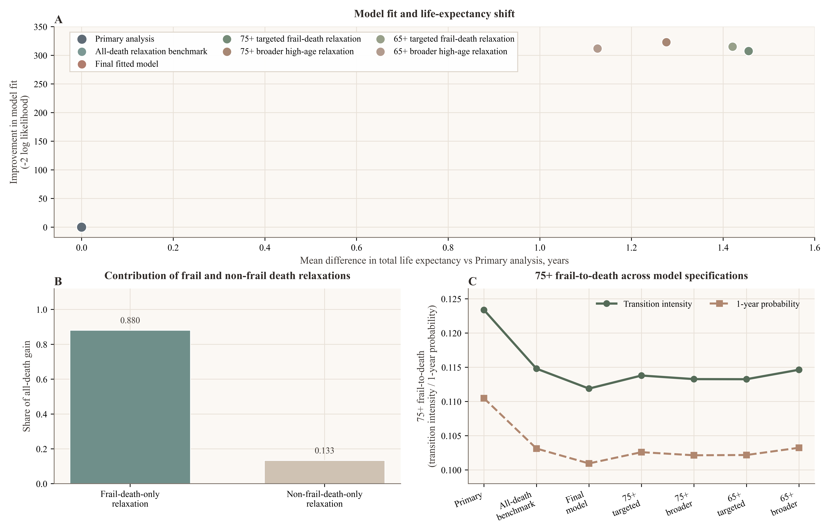

Note: Panel A shows the relationship between model-fit improvement and mean total-life-expectancy shift. Panel B shows the contribution of frail and non-frail death-transition settings to the all-death gain. Panel C shows age-75+ frail-to-death transition metrics across selected model specifications. The figure is provided as a diagnostic supplement and is not part of the main inferential display.

Supplementary Figure S2. CHARLS local-profile analysis for the age-75+ frail-to-death transition.

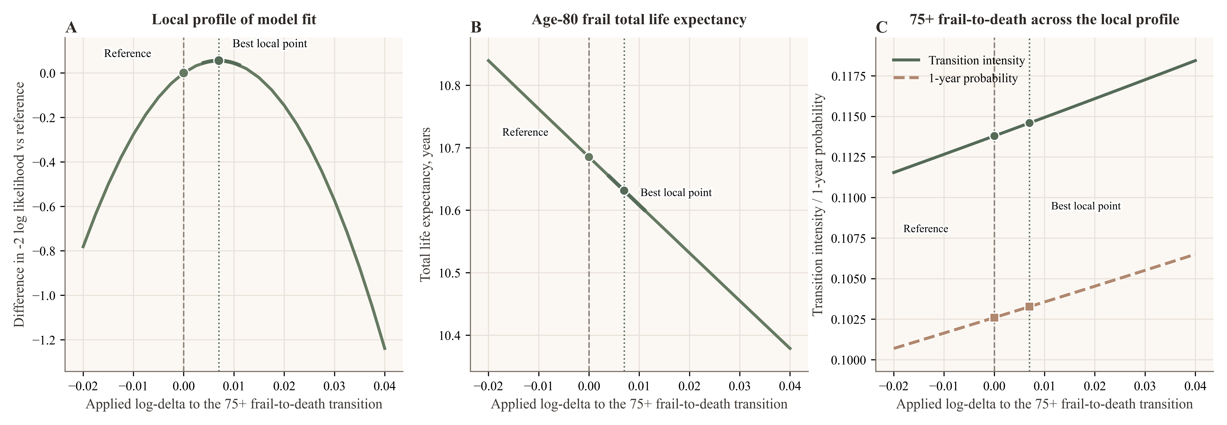

Note: Panel A shows the local-profile model-fit pattern. Panel B shows total life expectancy at age 80 for frail participants. Panel C shows the age-75+ frail-to-death transition intensity and one-year transition probability across the local profile.

Abbreviations
CHARLS, China Health and Retirement Longitudinal Study; CLHLS, Chinese Longitudinal Healthy Longevity Survey; FI, frailty index.

