SUPPLEMENTARY MATERIALS

MAOM stoichiometry and Fe-P coupling reveal soil-mediated pathways linking climate to grassland vegetation on the Mongolian Plateau
Zhihao Wang¹, Yu Zheng², Ying Sun², Liang Li², Rong Wei¹, Changwei Lü^{1, ∗}
- Inner Mongolia Key Laboratory of River and Lake Ecology, School of Ecology and Environment, Inner Mongolia University, Hohhot 010021, China
- Inner Mongolia Environmental Monitoring Center, Hohhot, 010011, China

Fig. S1 The general situation of the attitude (a), climate types (b), grassland types (c) and soil types (d) in the Mongolian Plateau

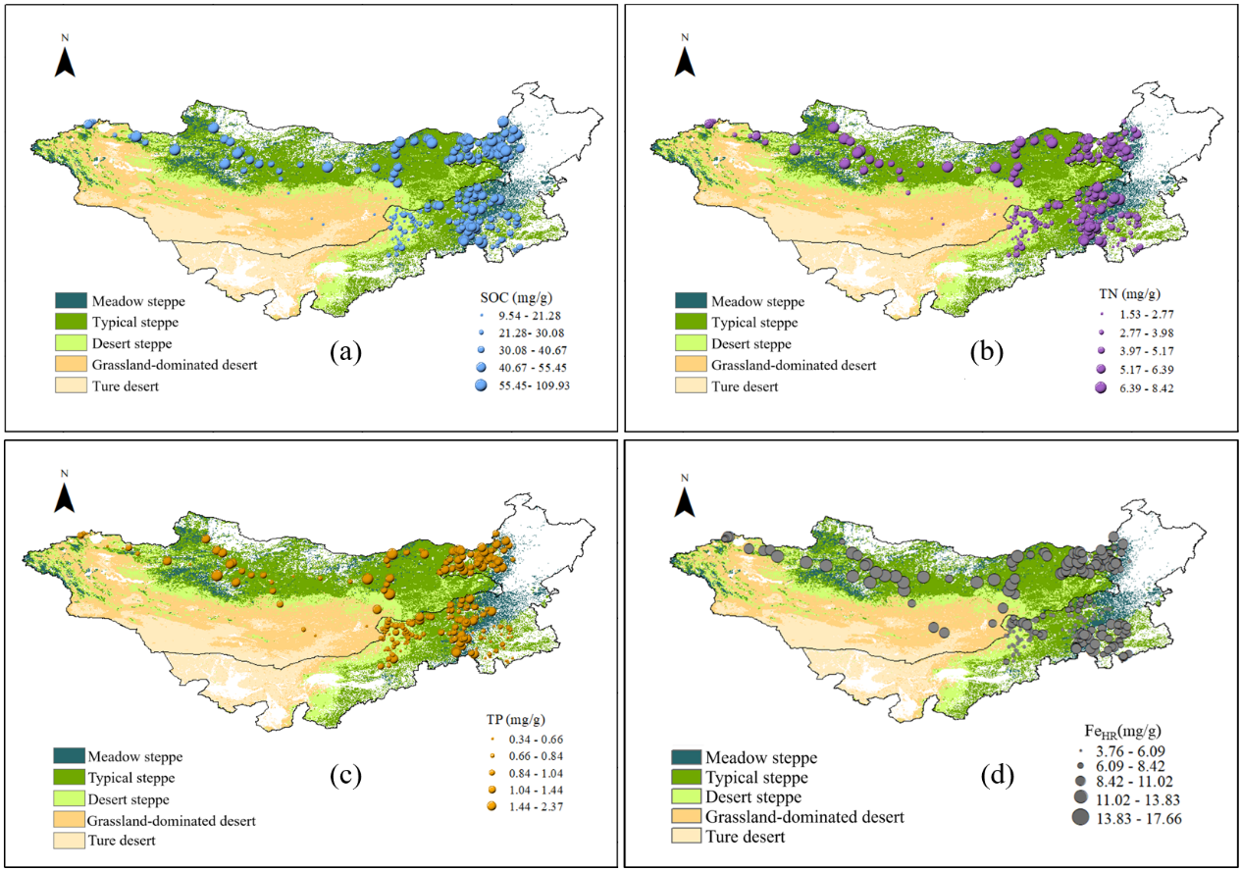
Fig. S2 The spatial distribution of soil organic carbon(a), total nitrogen(b), total phosphorus(c), and effective iron(d)

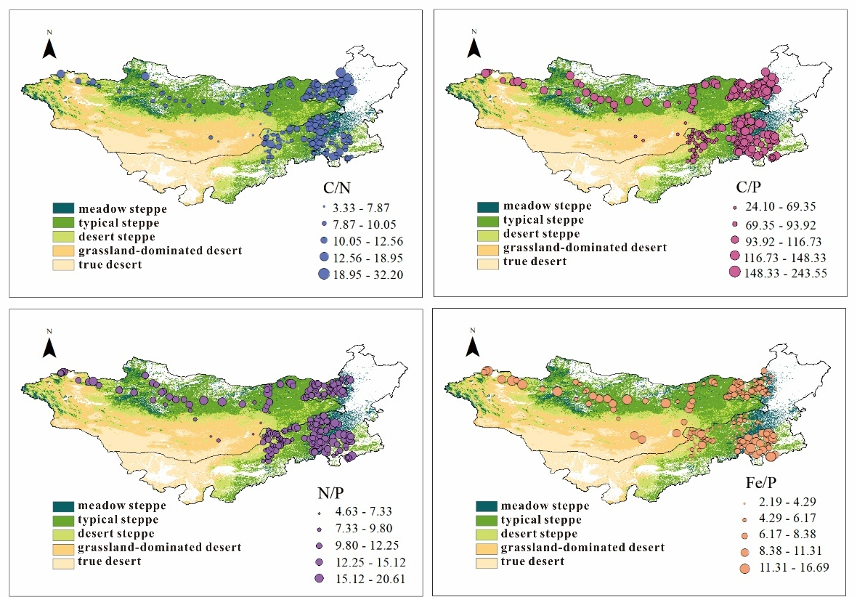
Fig. 3 The spatial distribution characteristics of soil C/N, C/P, N/P, and Fe/P

Table S1 The soil cation exchange capacity of different grassland types
 | CEC (cmol/kg)
Meadow steppe | 21.90 ± 1.25 a
Typical steppe | 14.43 ± 0.47 b
Desert steppe | 14.90 ± 0.54 b

∗ Corresponding author, Email: lcw2008@imu.edu.cn

