The community patterns and assembly mechanism varied in eukaryotic microorganisms with different cell sizes
Wei Hu¹, Yumei Qian², Zenghui zhang³, Xiaofan Zhao⁴, Xinxin Lai⁵, Kexin Zhang⁶, Pengfei Yang¹, Zongcan Yang⁷*, hanghang han^{3*}

¹College of Tobacco Science and Engineering, Zhengzhou University of Light Industry, Zhengzhou, China;
²Technology Center, China Tobacco Guangxi Industrial Co., Ltd., Nanning, China;
³Technology Center, China Tobacco Shaanxi Industrial Co., Ltd, Xian, China
⁴Technology Center, China Tobacco Hebei Industrial Co., Ltd., Shijiazhuang, China;
⁵Henan Province Engineering Technology Research Center of Water Environment and Health, Zhengzhou University of Industrial Technology, Zhengzhou, China;
⁶School of Geography and Tourism, Qilu Normal University, Ji'nan, China;
⁷Technology Center, China Tobacco Henan Industrial Co., Ltd., Zhengzhou, Henan, China;

* Corresponding author, e-mail: hanhanghang88@163.com and yangzongcan666@163.com

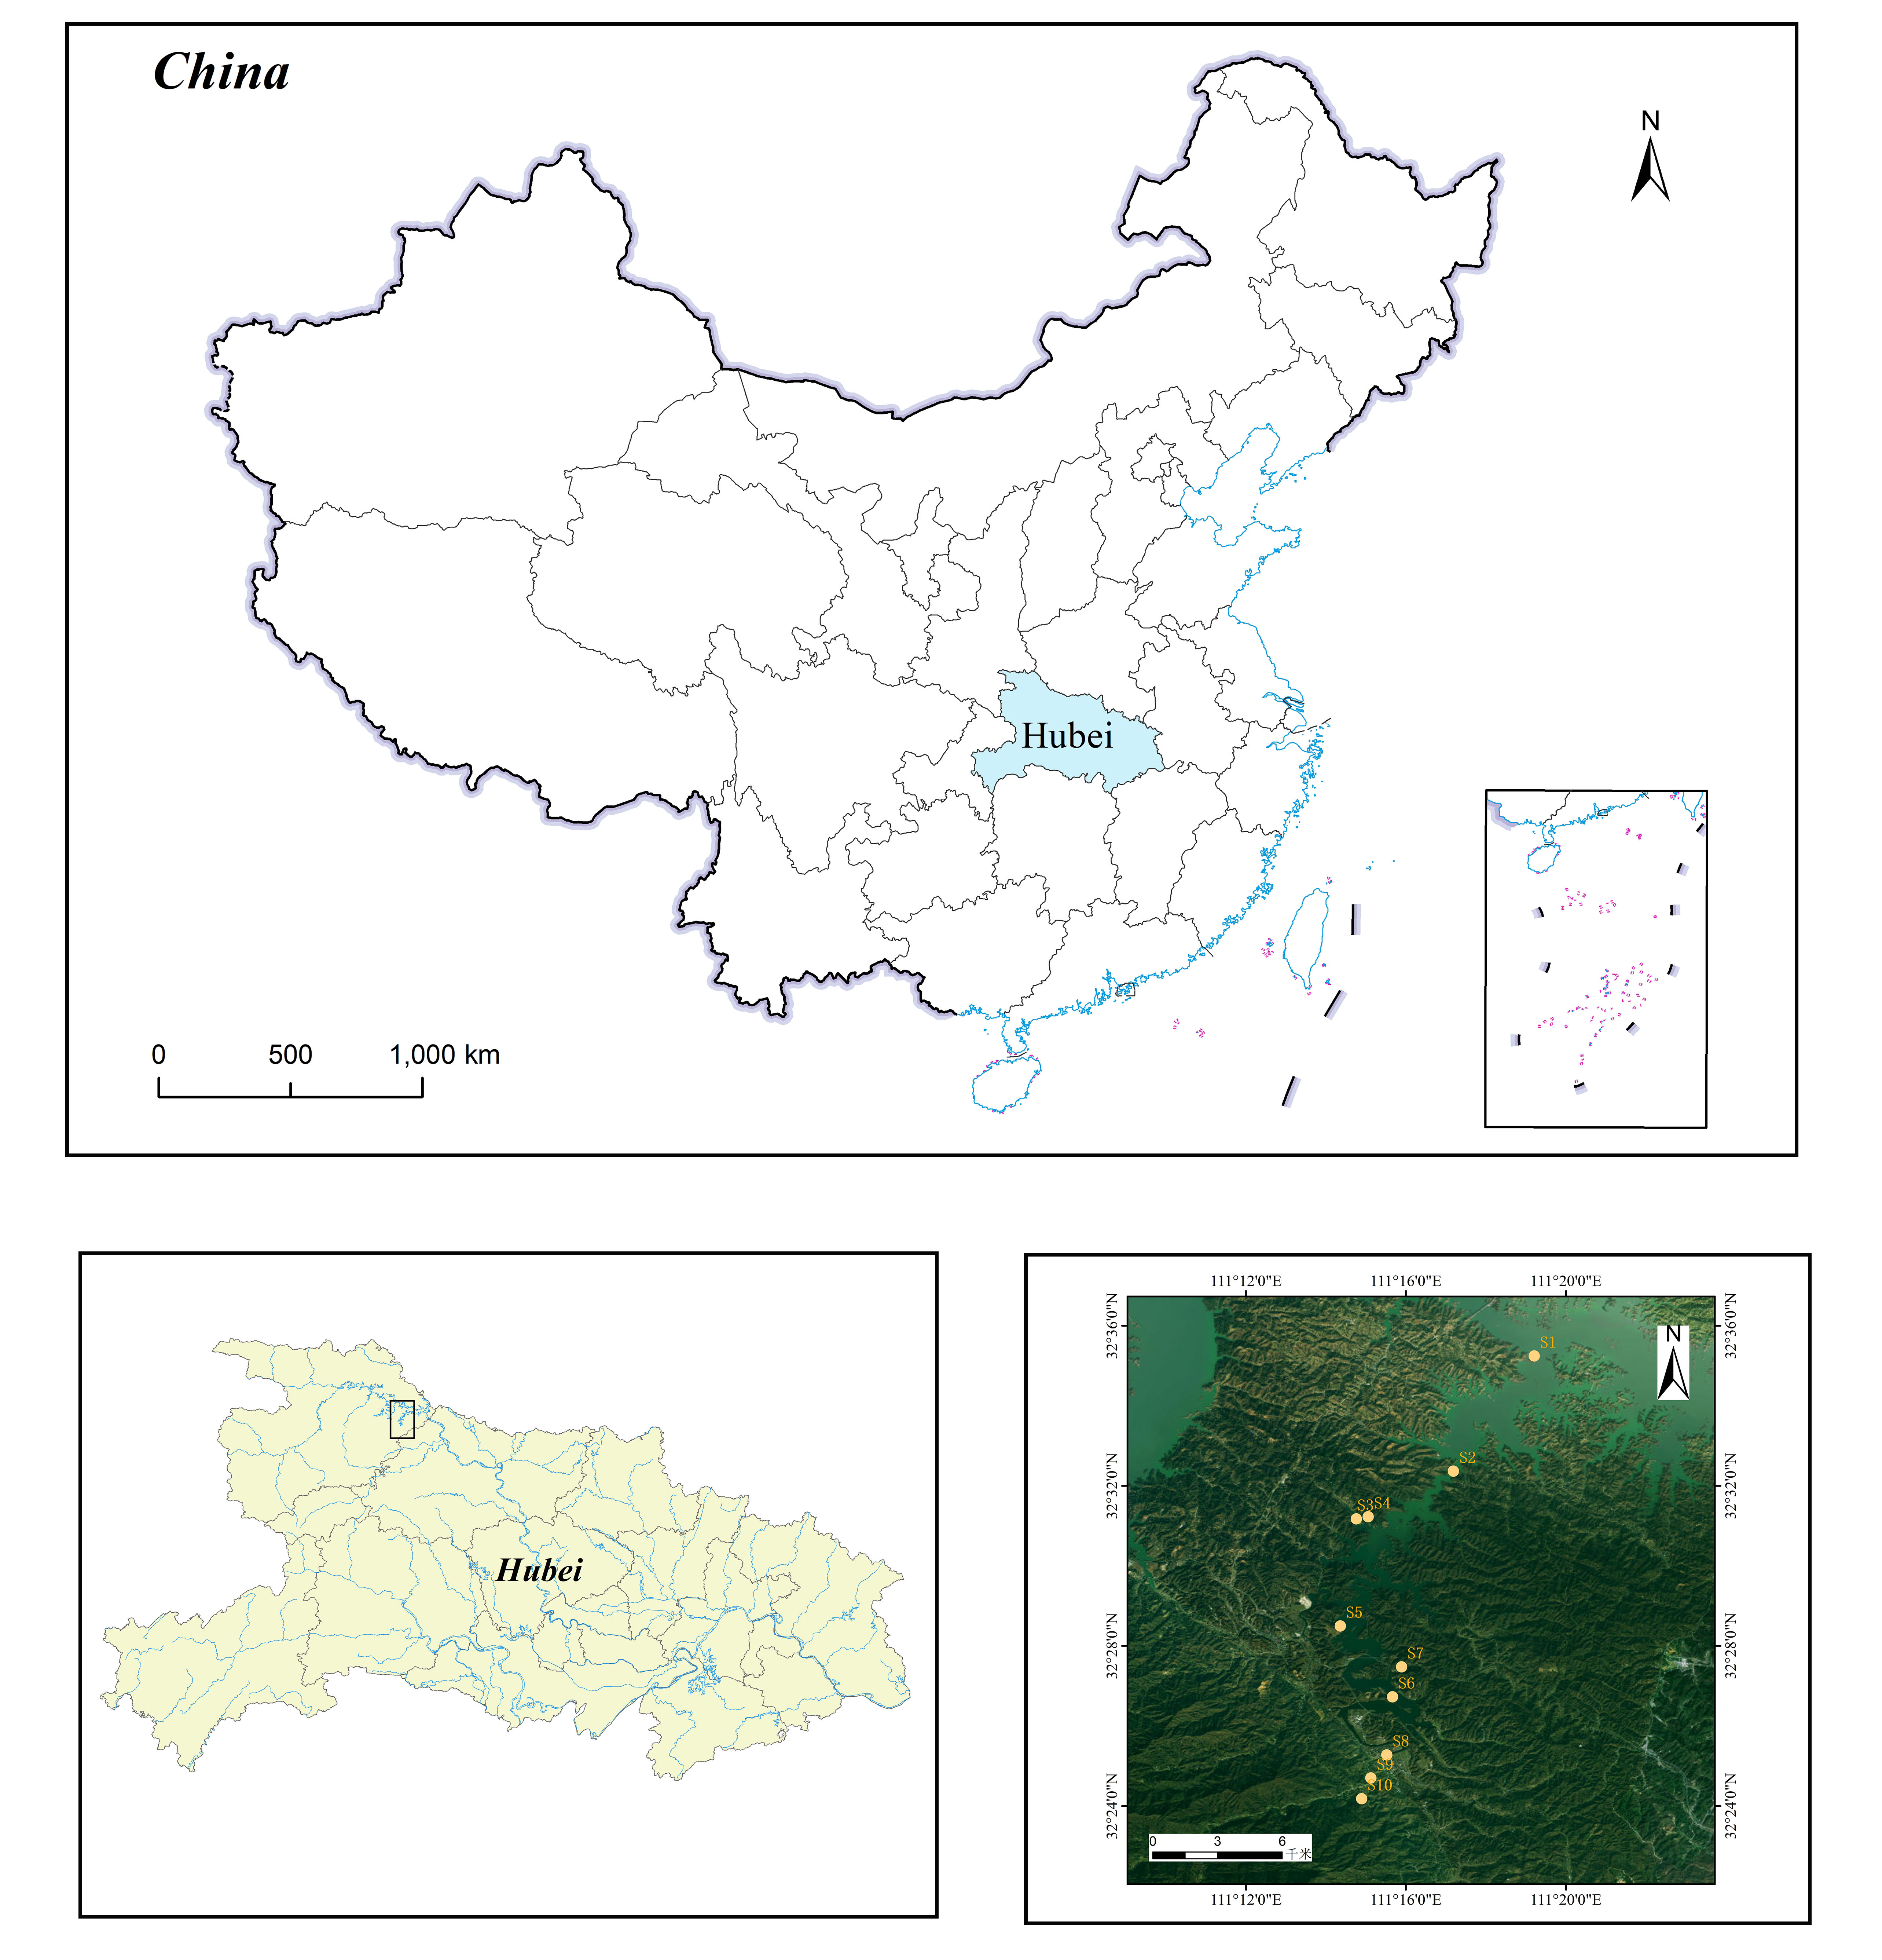
Fig. S1 Sampling map in the river

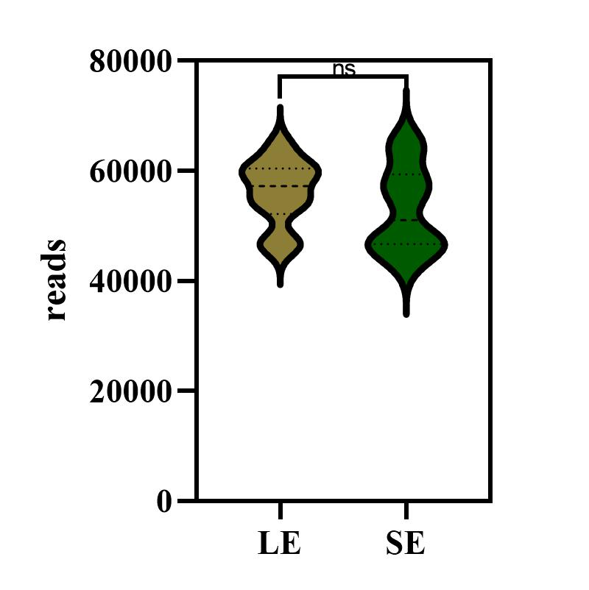
Figure S2 the reads of UB and LB

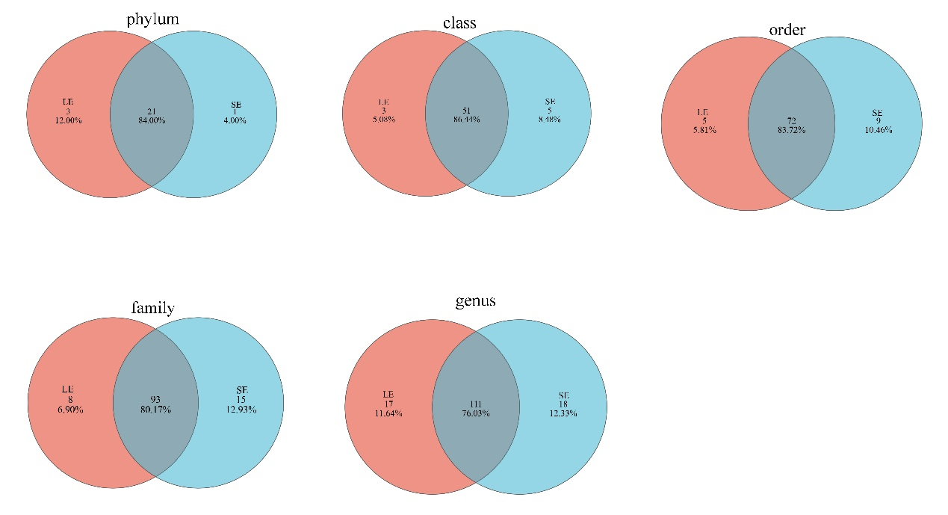
Figure S3 Venn diagram of the composition of LE and SE groups at different classification levels

Table S1 Summary of environmental factors of all samples
 | Longitude | Latitude | T | PH | DO | TOC(mg/L) | IC(mg/L) | TC(mg/L) | TN(mg/L) | TP(mg/L)
S1 | 111.320146 | 32.58745 | 15.4 | 7.855 | 7.9 | 2.95 | 23.76 | 26.73 | 0.7905 | 0.12
S2 | 111.286451 | 32.53947 | 15.7 | 7.794 | 9.7 | 1.29 | 22.7 | 23.99 | 0.703 | 0.14
S3 | 111.246043 | 32.51961 | 15.8 | 7.828 | 9.4 | 1.42 | 23.02 | 24.44 | 0.7589 | 0.14
S4 | 111.2509881 | 32.52049 | 15.7 | 7.833 | 8.68 | 3.22 | 20.48 | 23.7 | 0.9309 | 0.2
S5 | 111.239316 | 32.47499 | 15.6 | 7.905 | 8.2 | 2.43 | 20.92 | 23.35 | 0.8221 | 0.22
S6 | 111.261116 | 32.44551 | 15.6 | 7.73 | 9.06 | 1.73 | 20.59 | 22.31 | 0.9637 | 0.24
S7 | 111.264887 | 32.45797 | 15.7 | 7.948 | 9.8 | 1.3 | 21.25 | 22.55 | 1.14 | 0.45
S8 | 111.258725 | 32.42137 | 15.5 | 7.795 | 9.85 | 1.15 | 14.71 | 15.86 | 1.09 | 0.39
S9 | 111.252103 | 32.41176 | 15.6 | 7.88 | 9.16 | 1.6 | 13.88 | 15.48 | 1.23 | 0.44
S10 | 111.248257 | 32.40311 | 15.7 | 7.92 | 8.4 | 2.14 | 12.64 | 14.77 | 1.11 | 0.42

