Supplementary file
Hematoxylin and Eosin (H&E) Staining
Deparaffinized and rehydrated sections were stained following a standardized H&E protocol. Briefly, nuclei were stained with Mayer’s hematoxylin (Asiapajouhesh, Iran, Cat. 0303633) for 5 minutes, differentiated in 1% acid alcohol, and blued in running tap water. Cytoplasmic counterstaining was performed with eosin Y (Asiapajouhesh, Iran, Cat. 0303633) for 2 minutes. Sections were then dehydrated, cleared in xylene, and mounted with a synthetic resinous medium. Stained slides were examined and imaged under an Olympus BX53 light microscope at various magnifications (18×, 45×, and 180×). The staining methodology was performed in accordance with established histological practices (Hasan, Das, & Chowdhury, 2021).
Histomorphometry
Glomerular integrity was assessed on H&E-stained sections under 18× magnification. In randomly selected, non-overlapping cortical fields, renal corpuscles were categorized and counted as intact, hyper-segmented, or necrotic.
Masson’s Trichrome Staining
Interstitial collagen deposition was evaluated using Masson’s trichrome staining kit (Asiapajouhesh, Iran; Cat. No. 140011) strictly according to the manufacturer’s protocol. The process involved sequential staining with Weigert’s iron hematoxylin, Biebrich scarlet-acid fuchsin, phosphotungstic-phosphomolybdic acid, and aniline blue to differentially visualize nuclei, cytoplasm/muscle, and collagen fibers (blue), respectively (Sridharan et al., 2022). Finally, sections were dehydrated, cleared, and mounted.
Periodic Acid-Schiff (PAS) Staining
PAS staining was employed to assess basement membranes and glycogen content. After deparaffinization and rehydration, slides were oxidized in 0.5% periodic acid for 10 minutes, rinsed, and treated with Schiff’s reagent for 15 minutes in the dark. Following a wash in sulfurous acid solution to remove excess dye, sections were counterstained with Mayer’s hematoxylin, dehydrated, cleared, and mounted. This procedure follows contemporary standards for polysaccharide detection (Zakout, Abdellah, Abdallah, & Batran, 2024).
Histopathological Evaluation
A comprehensive histopathological assessment was conducted in a blinded manner using an Olympus BX53 light microscope coupled with an AmScope digital camera. Digital images were captured and analyzed using Zistrad measurement software (v97-1). Evaluations included:
- H&E-stained sections: Cortical and medullary architecture, tubular epithelial injury (vacuolization, necrosis, cast formation), glomerular alterations (Bowman's space dilation, hyper-segmentation), vascular congestion, hemorrhage, and inflammatory cell infiltration.
- PAS-stained sections: Basement membrane thickness and integrity.
- Masson’s trichrome-stained sections: Extent of interstitial fibrosis.
All observed lesions were scored semi-quantitatively (– to +++) based on established renal pathology grading schemes (Bakar, Ulucam, & Cerkezkayabekir, 2015; Mohammadi et al., 2016; Morsy, 2018; Zararsiz et al., 2007).

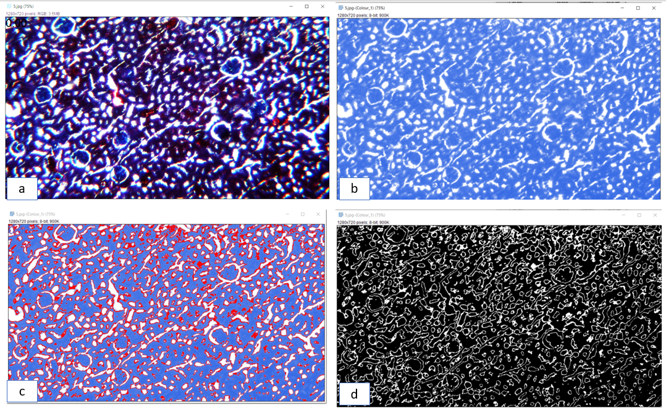
Figure S1. Quantitative assessment of renal interstitial fibrosis using Masson’s trichrome staining and Fiji/ImageJ analysis.
Representative kidney sections stained with Masson’s trichrome and analyzed at 18× magnification. (a) Original stained section; (b) isolated collagen channel obtained by color deconvolution; (c) thresholded collagen-positive areas (red) used for fibrosis quantification. (d) thresholded collagen-positive region (white) used for fibrosis quantification. five randomly selected cortical fields per animal were analyzed, and the collagen-positive area fraction (%Area) was calculated.
Supplementary Table 1: Data are presented as mean ± standard error (SEM). Intergroup comparisons were performed using the Kruskal–Wallis test, followed by Dunn’s post-hoc test when a significant difference was detected.
 | control | oil | DSF20 | PQ | PQ+DSF5 | PQ+DSF10 | PQ+DSF20 | pvalue
Cortical Disorganization | 0.2000±  0.0917 | 0.7143±  0.1200 | 0.1556±  0.0546 | 2.846±  0.0585 | 1.769±  0.1535 | 0.6667±  0.1060 | 1.147±  0.1094 | <0.0001
Necrotic Glomeruli | 0.2353±  0.1060 | 0.7027±  0.1390 | 0.7368±  0.1038 | 2.567±  0.1038 | 1.100±  0.1752 | 0.5667±  0.0920 | 1.414±  0.1448 | <0.0001
Hypersegmented Glomeruli | 0.2414±  0.0808 | 0.2759±  0.0979 | 0.9583±  0.1274 | 2.933±  0.0436 | 1.167±  0.1734 | 0.3333±  0.0875 | 0.9259±  0.1503 | <0.0001
Urinary Space Expansion in Bowman's Capsule | 0.2813±  0.0807 | 0.4375±  0.1183 | 1.069±  0.0979 | 2.893±  0.0595 | 2.143±  0.1333 | 1.111±  0.1246 | 1.683±  0.0981 | <0.0001
Vessel Congestion | 0.4348±  0.0887 | 0.7333±  0.1460 | 1.341±  0.0811 | 2.474±  0.0923 | 2.031±  0.0908 | 0.2188±  0.0817 | 1.577±  0.0868 | <0.0001
Inflammatory Cells | 0.3043±  0.0981 | 0.4545±  0.1087 | 0.3478±  0.1194 | 1.024±  0.1329 | 1.000±  0.0762 | 0.3953±  0.0754 | 0.8824±  0.2250 | <0.0001
Medullary Disorganization | 0.1429±  0.0673 | 0.2143±  0.1138 | 0.8846±  0.1395 | 2.708±  0.0947 | 2.318±  0.1378 | 1.409±  0.1259 | 1.520±  0.1541 | <0.0001
Cellular morphology | 0.2609±  0.0654 | 0.7800±  0.1222 | 0.5172±  0.0944 | 2.240±  0.0928 | 1.289±  0.1256 | 0.4667±  0.0876 | 0.9583±  0.1646 | <0.0001
Glumerular fibrosis | 0.4615±  0.0997 | 0.5909±  0.0817 | 1.042±  0.0939 | 2.213±  0.0686 | 2.029±  0.0868 | 1.190±  0.1036 | 1.529±  0.1248 | <0.0001
Interstitial fibrosis | 0.2308±  0.0842 | 0.2273±  0.0639 | 0.3750±  0.0766 | 1.737±  0.0767 | 1.229±  0.0828 | 0.3095±  0.0722 | 0.7647±  0.1611 | <0.0001
Medullary fibrosis | 0.1250±  0.0853 | 0.2500±  0.1118 | 1.267±  0.1817 | 2.938±  0.0625 | 2.333±  0.1869 | 1.118±  0.1690 | 2.100±  0.1606 | <0.0001
Perivascular fibrosis | 0.2353±  0.1060 | 0.2500±  0.1118 | 0.6316±  0.1370 | 1.941±  0.1813 | 1.250±  0.2327 | 0.4375±  0.1281 | 0.9333±  0.2063 | <0.0001
PAS | 0.08±  0.05 | 0.13±  0.07 | 1±0.1 | 2.46±  0.09 | 2.33±  0.08 | 0.84±  0.11 | 2.06±  0.14 | <0.0001

Supplementary Table 2: Statistical analysis of smad3 gene expression in renal Tissue among Treated groups. Data are presented as mean ± standard error (SEM). Intergroup comparisons were performed using the One-way ANOVA test, followed by Tukey’s multiple comparison test when a significant difference was detected.

Smad3 | Control | Oil | DSF20 | PQ | PQ+  DSF5 | PQ+  DSF10 | PQ+  DSF20 | P value  PQ and Treat
Mean ±SEM | 1 ± 0.05 | 0.85±0.11 | 0.24±0.06 | 1.51±0.16 | 0.86±0.11 | 0.7±0.08 | 0.55±0.1 | PQ vs. P+D5 P=0.0028**  PQ vs. P+D10 P=0.0002***  PQ vs. P+D20 P<0.0001****
Median | 0.9845 | 0.8571 | 0.2055 | 1.482 | 0.8812 | 0.7108 | 0.4957
IQR  (Q1, Q3) | (0.9189, 1.104) | (0.6263,  1.079) | (0.134, 0.3667) | (1.216,  1.822) | (0.6192,  1.113) | (0.5456,  0.8698) | (0.3481, 0.7863)

Supplementary Table 3: Statistical analysis of smad7 gene expression in renal Tissue among Treated groups. Data are presented as mean ± standard error (SEM). Intergroup comparisons were performed using the One-way ANOVA test, followed by Tukey’s multiple comparison test when a significant difference was detected.

Smad7 | Control | Oil | DSF20 | PQ | PQ+  DSF5 | PQ+  DSF10 | PQ+  DSF20 | P value  PQ and Treat
Mean ±SEM | 1.1±0.26 | 1.06±0.18 | 1.44±0.19 | 0.64±0.1 | 0.79±0.08 | 2.45±0.39 | 1.46±0.4 | PQ vs. P+D5 P=0.9996 ns  PQ vs. P+D10 P=0.0006***  PQ vs. P+D20  P=0.3208 ns
Median | 1.021 | 0.8706 | 1.292 | 0.5471 | 0.8409 | 2.412 | 1.223
IQR  (Q1, Q3) | (0.6688, 1.578) | (0.8222,  1.402) | (1.148, 1.806) | (0.4951,  0.8391) | (0.6005,  0.9566) | (1.729,  3.211) | (0.7402, 2.305)

