Budget impact analysis of Gastric Alimetry® in patients with chronic gastric symptoms in the United Kingdom National Health Service

Supplementary Material

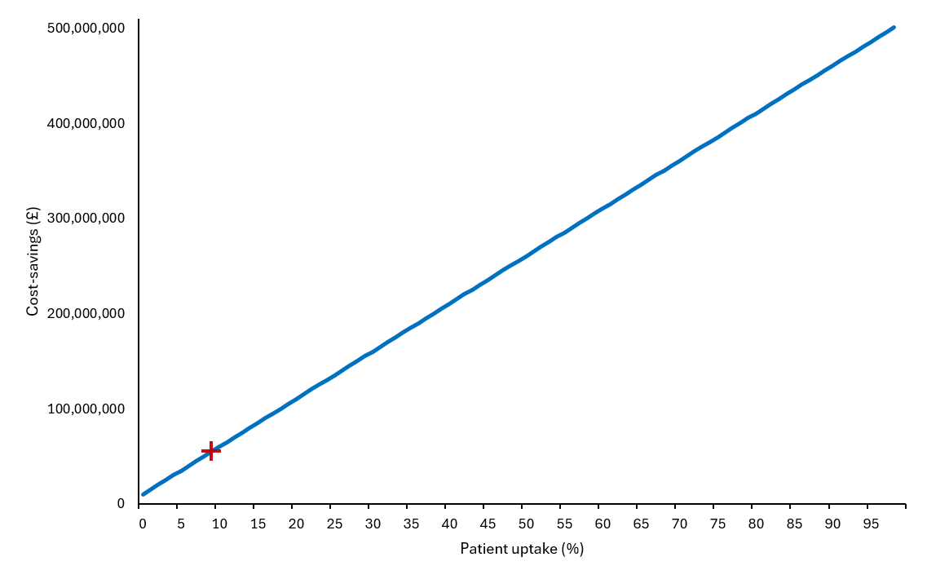
Supplementary Figure S1. Scenario analyses varying the percentage of the patient population assumed to receive a Gastric Alimetry Test over the time horizon. The red cross indicates the base case analysis.

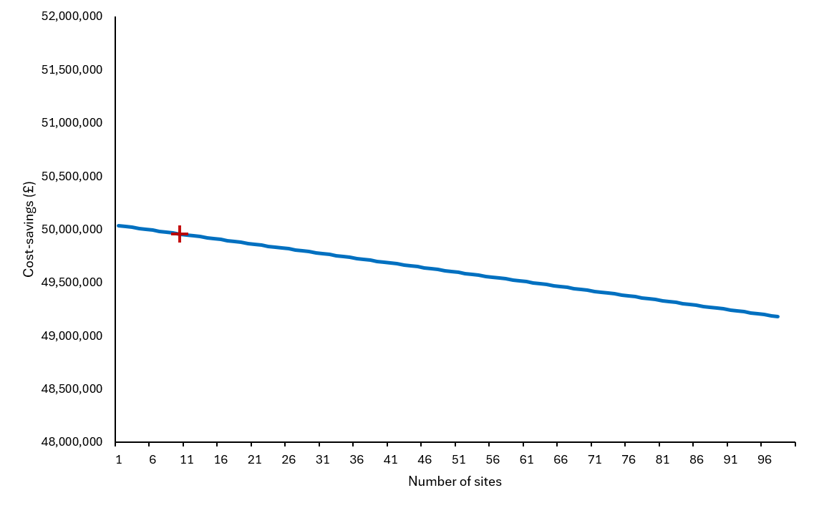
Supplementary Figure S2. Scenario analyses varying the number of sites offering a Gastric Alimetry Test over the time horizon. The red cross indicates the base case analysis.

Supplementary Table S1. Detailed cost breakdown of the scenario analyses, which included patients with chronic nausea and vomiting syndrome.
Cost Category | Standard of Care | With Gastric Alimetry | Incremental Impact
Gastric Alimetry tests | £0 | £21,324,600 | + £21,324,600
Investigations | £326,690,031 | £311,580,481 | - £15,109,550
Hospital admissions | £2,447,781,598 | £2,287,338,771 | - £160,442,827
Gastroenterology appointments | £15,606,410 | £14,784,037 | - £822,373
A&E attendance | £106,504,211 | £98,059,949 | - £8,444,262
Nutrition support | £622,804,312 | £585,691,960 | - £37,112,352
Total Net Impact | £3,519,386,564 | £3,318,779,797 | - £200,606,767  (net saving)
Note: Costs have been rounded to the nearest pound.

