Appendix
Table A-1: Number of cases affected by different assumptions about debt sharing within the household, by debt types
Scenario Description |  | No debt separation (add everything and divide by 2): Columns 2-4
Scenario Description |  | Partial debt separation (split joints + sole positive balances); Columns 2-3
Scenario Description |  | Complete debt separation (split joints); Column 1
 | No. of cases with any debt | No. of cases with exactly equal balances | No. of cases with sole positive balances | No. of cases with both positive & unequal balances
 | Column 1 | Column 2 | Column 3 | Column 4
Mortgage | 1,023 | 606 | 299 | 118
Auto | 1,284 | 280 | 617 | 387
Student | 732 | 2 | 555 | 175
Card | 1,524 | 61 | 465 | 998

Note: Table illustrates the number of observations for each debt type which are affected by each counterfactual assumption about sharing of household liabilities. Column 1 shows the overall number of cases with any debt. Column 2 shows the number of cases where individuals have exactly equal debt balances and are hence affected by the splitting of joint debts assumption. Column 3 shows the additional number of cases where there is one spouse with a positive balance and the other spouse has a zero balance, and are hence affected by the partial debt scenario assumption. Column 4 shows the number of cases additionally affected by the no debt separation assumption, and includes cases where both spouses have a positive but unequal balance.
Source: The OSU-UWCP and the Wisconsin Court Records Data.

Figure A-1: Predicted incidence and burden of overall debt by parent gender, over months since petition and months since divorce
Panel A: Months since petition
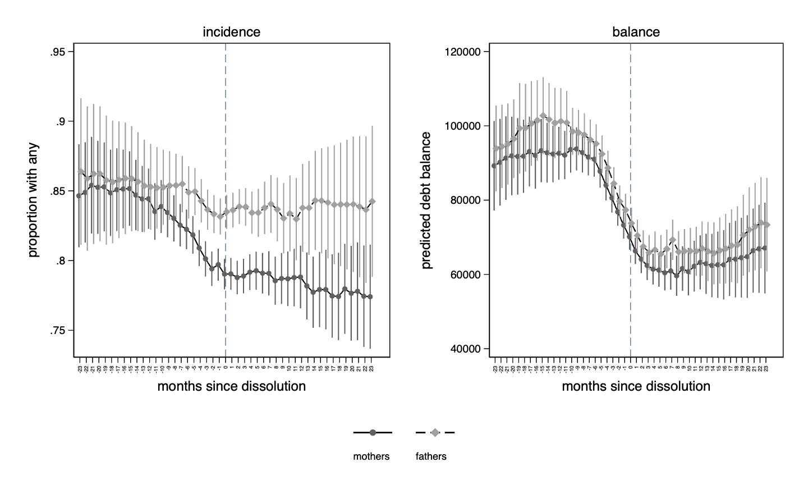
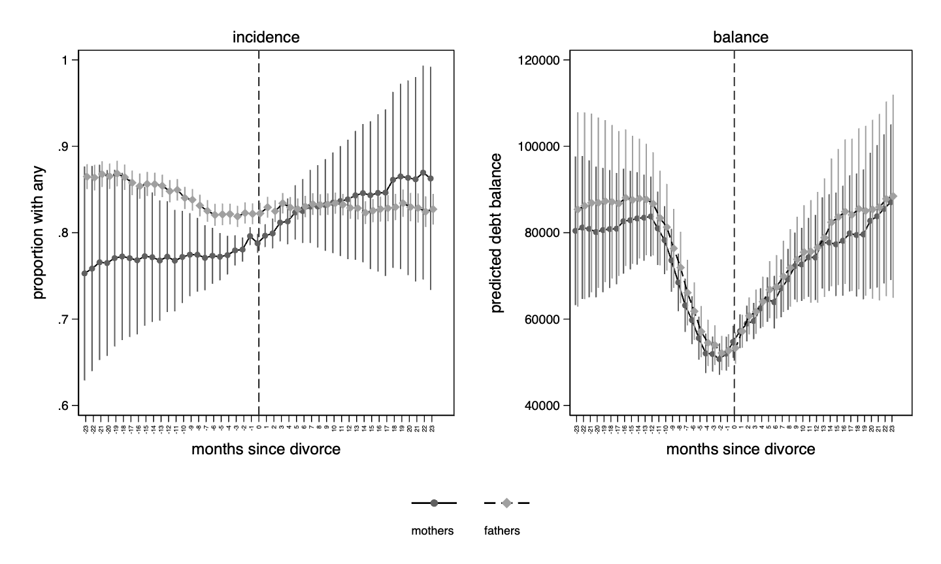
Panel B: Months since divorce

Notes: Figure plots predicted incidence and burden of overall debt across mortgage, auto, student, credit card, and personal loans over months since petition (Panel A) and months since divorce (Panel B), by parent. Models control for monthly wages, any positive wages, parent’s age, and indicators for child support receipts and payments, TANF and UI benefits receipts. Error bars show 95% confidence intervals. Errors are clustered at the unit level. Estimates are weighted to adjust for different sampling rates across counties. N = 1,834 mothers and 1,834 fathers.
Source: The OSU-UWCP, WADC, and Wisconsin CRD.

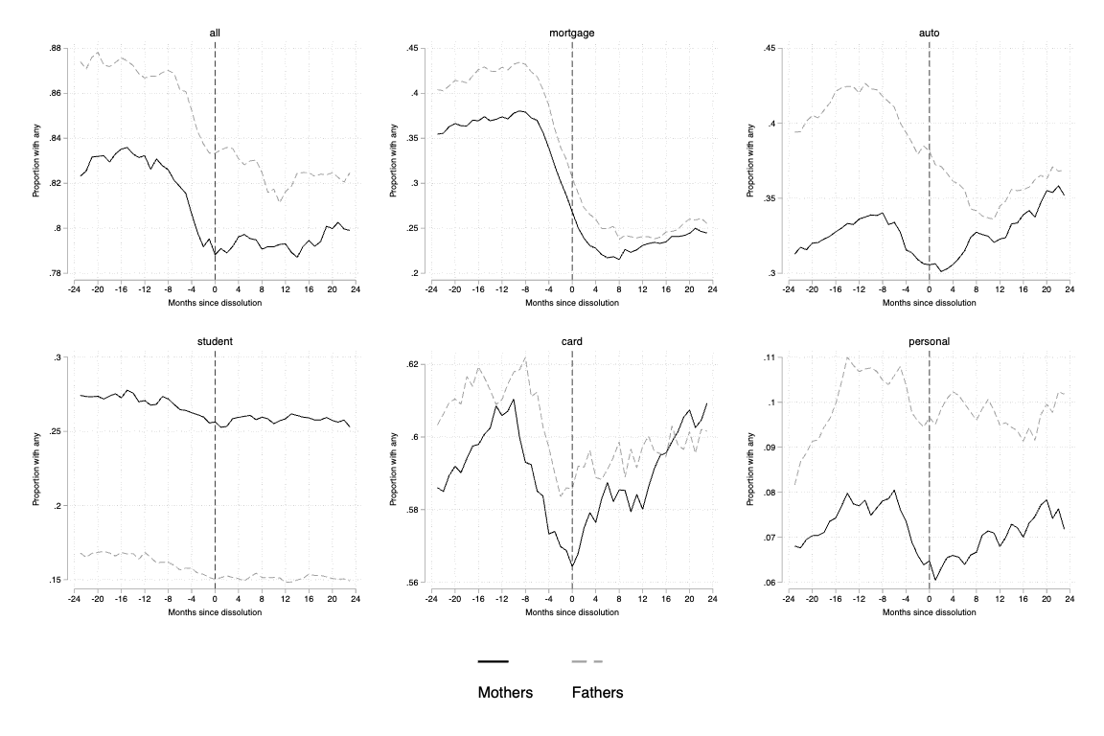
Figure A-2: Incidence of debt, by parent

Note: Figure plots proportion of individuals with any overall debt, mortgage, student loans, auto loans, credit cards or personal loans, by parent. Means are weighted to adjust for different sampling rates across counties. Source: The OSU-UWCP and the Wisconsin Court Records Data.
Figure A-3: Balance of debt, by parent
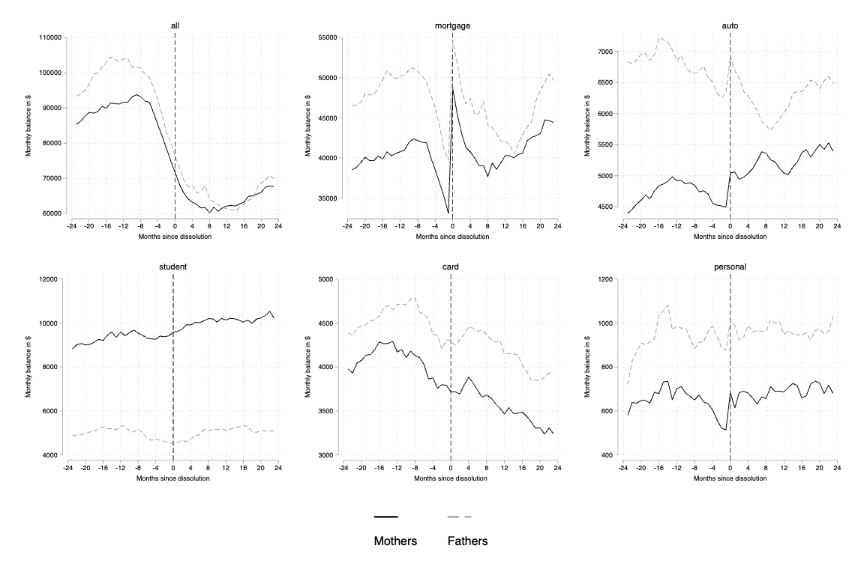
Note: Figure plots mean balance of overall debt, mortgage, student loans, auto loans, credit cards or personal loans, by parent. Means are weighted to adjust for different sampling rates across counties. Source: The OSU-UWCP and the Wisconsin Court Records Data.
Figure A-4: Balance of overall debt, by mortgage deleveraging scenarios

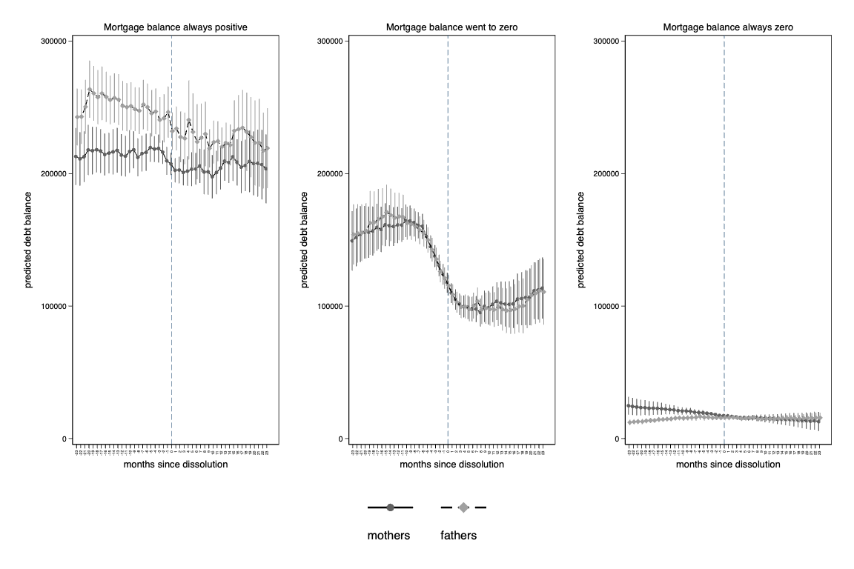
Notes: Figure plots predicted balance (in dollars) of credit card debt at each month since dissolution. Models control for monthly wages, any positive wages, parent’s age, and indicators for child support receipts and payments, TANF and UI benefits receipts. Error bars show 95% confidence intervals. Errors are clustered at the divorce case level. Means are weighted to adjust for different sampling rates across counties.
Source: The OSU-UWCP, the Wisconsin Administrative Data Core, and the Wisconsin Court Records Data.

Figure A-5: Balance of student loan debt, by mortgage deleveraging scenarios
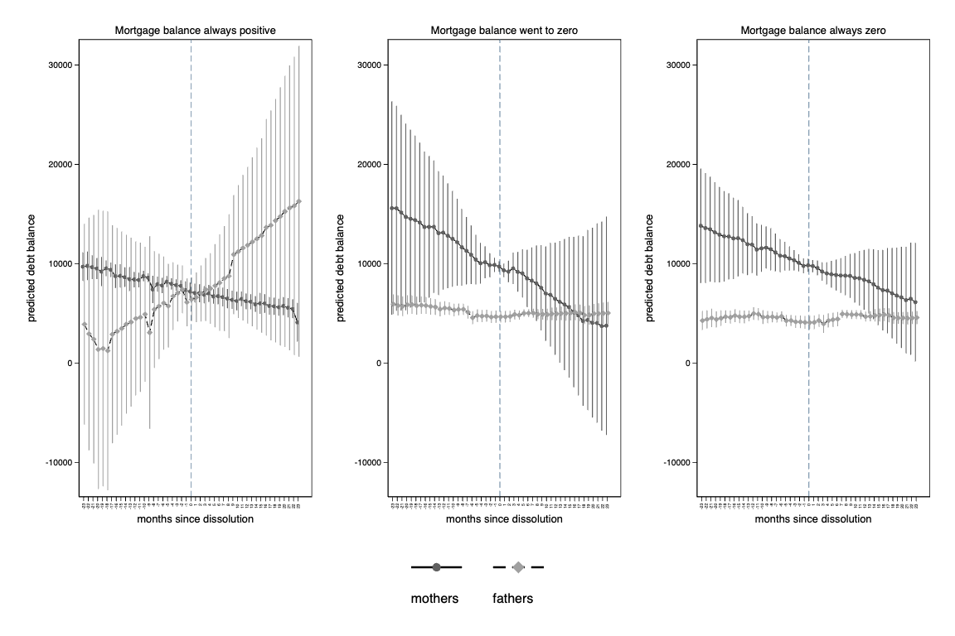
Notes: Figure plots predicted balance (in dollars) of personal loan debt at each month since dissolution. Models control for monthly wages, any positive wages, parent’s age, and indicators for child support receipts and payments, TANF and UI benefits receipts. Error bars show 95% confidence intervals. Errors are clustered at the divorce case level. Means are weighted to adjust for different sampling rates across counties.
Source: The OSU-UWCP, the Wisconsin Administrative Data Core, and the Wisconsin Court Records Data.

Figure A-6: Balance of overall debt in no debt separation and partial debt separation scenarios

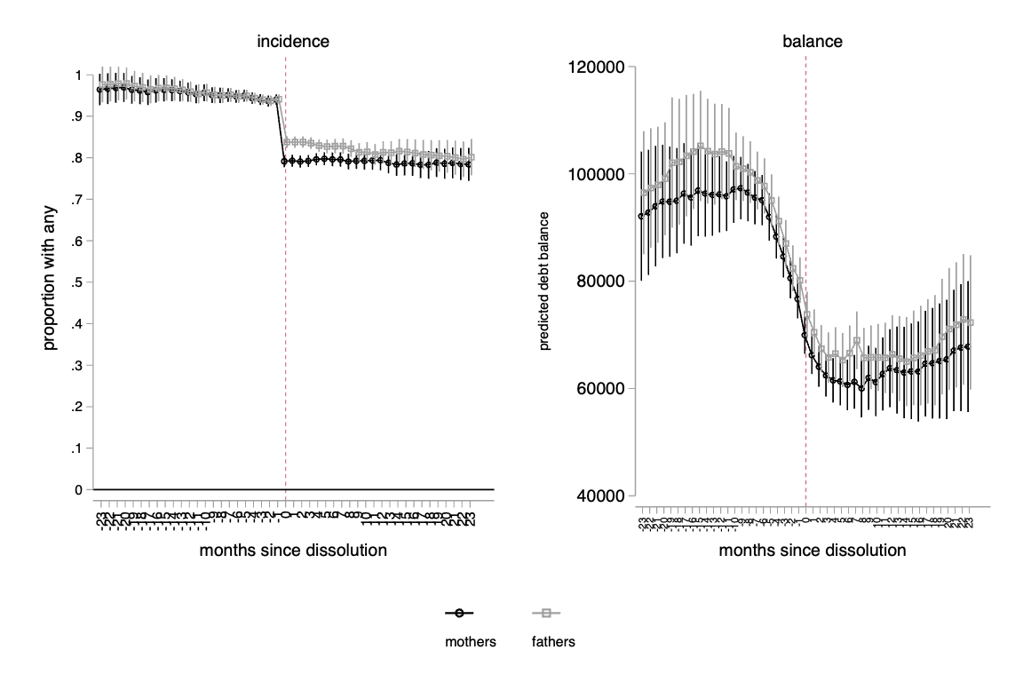
Notes: Figure plots predicted balance of overall, mortgage, auto, student, (credit) card, and personal loan debt at each month since dissolution. Models control for monthly wages, any positive wages, parent’s age, and indicators for child support receipts and payments, TANF and UI benefits receipts. Error bars show 95% confidence intervals. Errors are clustered at the divorce case level. Means are weighted to adjust for different sampling rates across counties.
Source: The OSU-UWCP, the Wisconsin Administrative Data Core, and the Wisconsin Court Records Data.

Figure A-7: Marginal effects from fixed effects models of log-transformed balances in mortgage and personal loan debt over months since dissolution
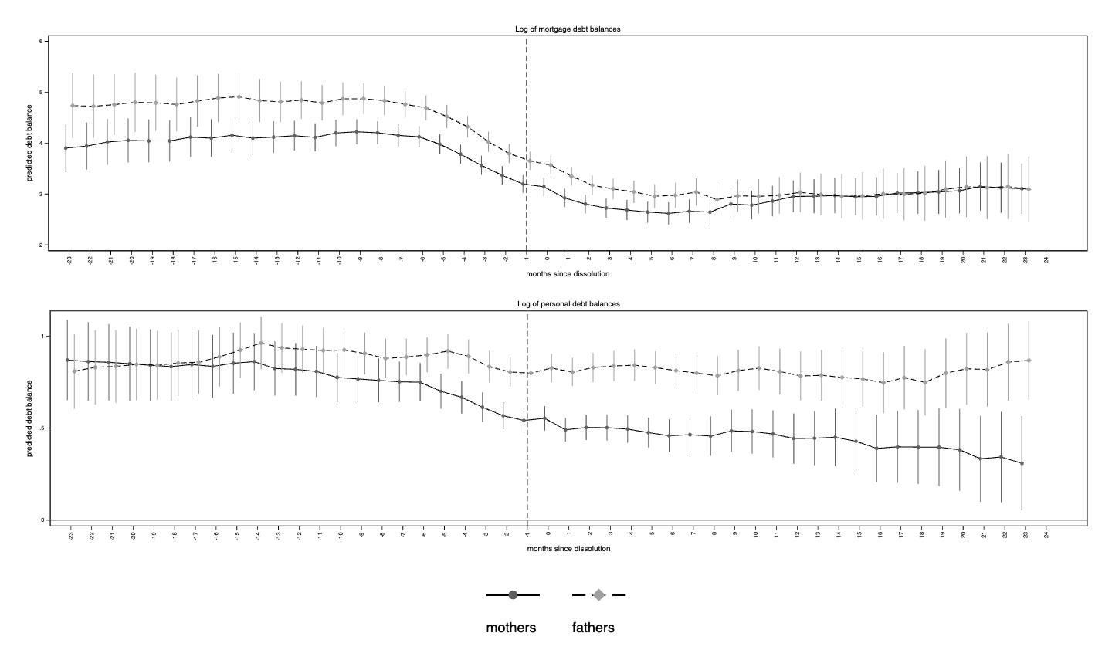
Notes: Figure plots predicted balance of overall, mortgage, auto, student, (credit) card, and personal loan debt at each month since dissolution. Models control for monthly wages, any positive wages, parent’s age, and indicators for child support receipts and payments, TANF and UI benefits receipts. Error bars show 95% confidence intervals. Errors are clustered at the divorce case level. Means are weighted to adjust for different sampling rates across counties.
Source: The OSU-UWCP, the Wisconsin Administrative Data Core, and the Wisconsin Court Records Data.

Figure A-8: Marginal effects from fixed effects models of inverse hyperbolic sine transformations of balances in mortgage and personal loan debt over months since dissolution
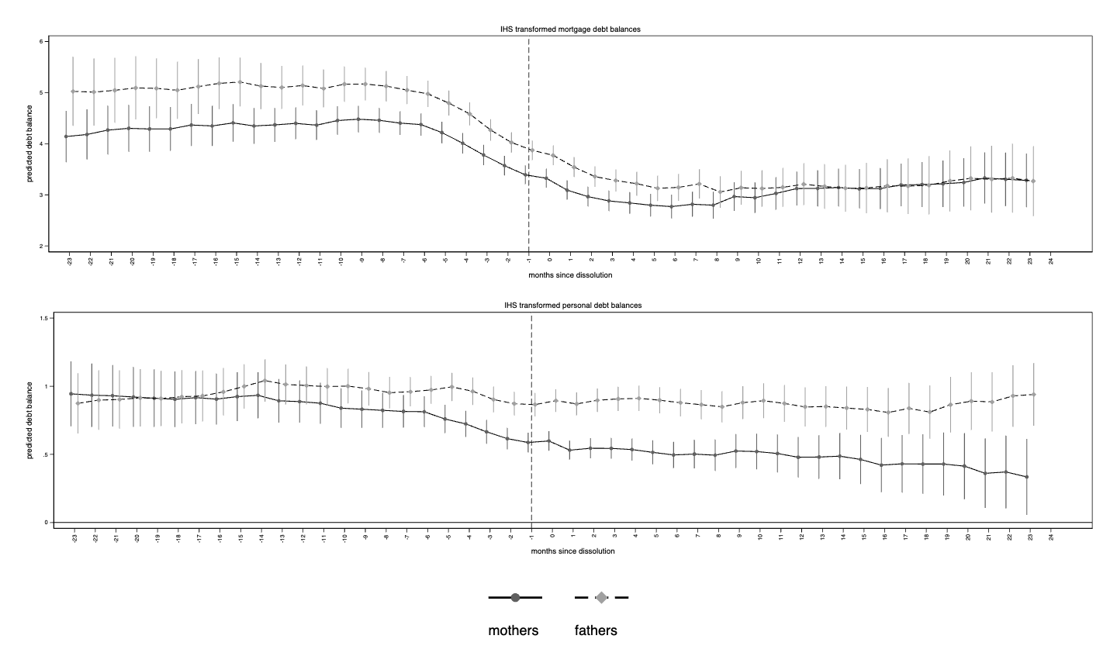

Notes: Figure plots predicted balance of overall, mortgage, auto, student, (credit) card, and personal loan debt at each month since dissolution. Models control for monthly wages, any positive wages, parent’s age, and indicators for child support receipts and payments, TANF and UI benefits receipts. Error bars show 95% confidence intervals. Errors are clustered at the unit level. Means are weighted to adjust for different sampling rates across counties.
Source: The Ohio State University-University of Wisconsin Credit Panel Data, the Wisconsin Administrative Data Core, and the Wisconsin Court Records Data.

Notes: Figure plots predicted balance of overall, mortgage, auto, student, (credit) card, and personal loan debt at each month since dissolution. Models control for monthly wages, any positive wages, parent’s age, and indicators for child support receipts and payments, TANF and UI benefits receipts. Error bars show 95% confidence intervals. Errors are clustered at the divorce case level. Means are weighted to adjust for different sampling rates across counties.
Source: The OSU-UWCP, the Wisconsin Administrative Data Core, and the Wisconsin Court Records Data.

Robustness checks

Alternative model specifications – Discussion of Appendix figures A7-A8
To check the sensitivity of our results to our preferred model specification, we estimate several alternative model specifications that explicitly consider the large number of zeros in the debt burden variables. Here we present results from our alternative specifications for the mortgage and personal debt balances, as these are the debt categories with the largest number of zero balances.
We perform two different transformations on mortgage and personal debt balance that are aimed at reducing their skewness. The first is a log transformation in which we add a small positive constant (one) to all zero values. The results from the fixed effects regressions of the log-transformed variables are shown in Appendix Figure A7, which suggests that our main results are robust to the log transformation of debt balance. However, adding a small constant to raw data to achieve a log transformed dependent variable can lead to heavy losses in the precision of estimates (Manning & Mullahy, 2001). We therefore perform a second transformation using an inverse hyperbolic sine (IHS) function, the results of which are shown in Figure A8. These results align with the results from our preferred specification as well.

