SUPPORTING INFORMATION
Attenuation of EGFR-Mediated Cellular Signaling by Sialidase-Mediated Desialylation
Hongyi Liu^{1#}, Effram Wei^{2#}, Ding Chiao Lin¹, Hui Zhang^{1, 2*}
- Department of Pathology, Johns Hopkins University School of Medicine, Baltimore, MD 21231, USA
- Department of Chemical and Biomolecular Engineering, Johns Hopkins Whiting School of Engineering, Baltimore, MD 21218, USA
* Corresponding author. Email: huizhang@jhu.edu (Hui Zhang).
# These authors contribute equally.

Table of contents
Figure S1. Experimental workflow for global proteome, phosphoproteome, and N-glycoproteome profiling.…………………………………………..……………………………………..………S3
Figure S2. Quality-control summary: principal-component analysis, sample-sample correlations, and coefficient-of-variation distributions for global proteome, phosphoproteome, and glycoproteome datasets…………………………………………………………………..………S4
Figure S3. Differential expression (DE) features across treatment contrast in each omics layer…S5
Figure S4. Fucosylation-resolved glycopeptide responses to sialidase within matched glycopeptide families stratified by sialic acid count…………………………………………...…S5

Phosphoproteomic data supporting the sialidase modulation of EGF-stimulated phosphorylation, including volcano-plot values, phosphopeptide overlap counts, kinase substrate enrichment results, EGFR-network heatmap values, GO Biological Process enrichment, and directional gene and phosphopeptide lists. (Table S1) (.csv)
Phosphopeptide comparison data for sialidase and gefitinib responses in EGF-stimulated cells, including double-logFC values, three-way overlap counts, pathway heatmap matrices, representative phosphopeptide profiles, and Venn-region phosphopeptide lists. (Table S2) (.csv)
Combined sialidase/gefitinib phosphoproteomic response data, including UpSet phosphopeptide membership, phosphopeptide log2 fold-change distributions, GO Biological Process enrichment, and combined-treatment-unique phosphopeptide lists. (Table S3) (.csv)
Glycoproteome and phospho-glyco integration data, including glycopeptide volcano values, paired glycoform response values, sialylation-by-fucose summaries, gene-level and paired phospho- glyco-proteomics comparisons, and EGFR relative-abundance trajectories. (Table S4) (.csv)
STRING/Cytoscape network support tables, including glyco-phospho node attributes and glycopeptide heatmap values for genes represented in the integrated protein-interaction analysis. (Table S5) (.csv)
Quality-control data for the supporting multi-omics QC figure, including PCA coordinates, sample correlation matrices, and coefficient-of-variation summaries for global proteome, phosphoproteome, and glycoproteome datasets. (Table S6) (.csv)
Differential response counts for phosphopeptides, glycopeptides, and global proteins across the treatment contrasts. (Table S7) (.csv)
Fucosylation-by-sialic-acid glycopeptide family data supporting the reciprocal glycan-composition analysis in Figure S2. (Table S8) (.csv)

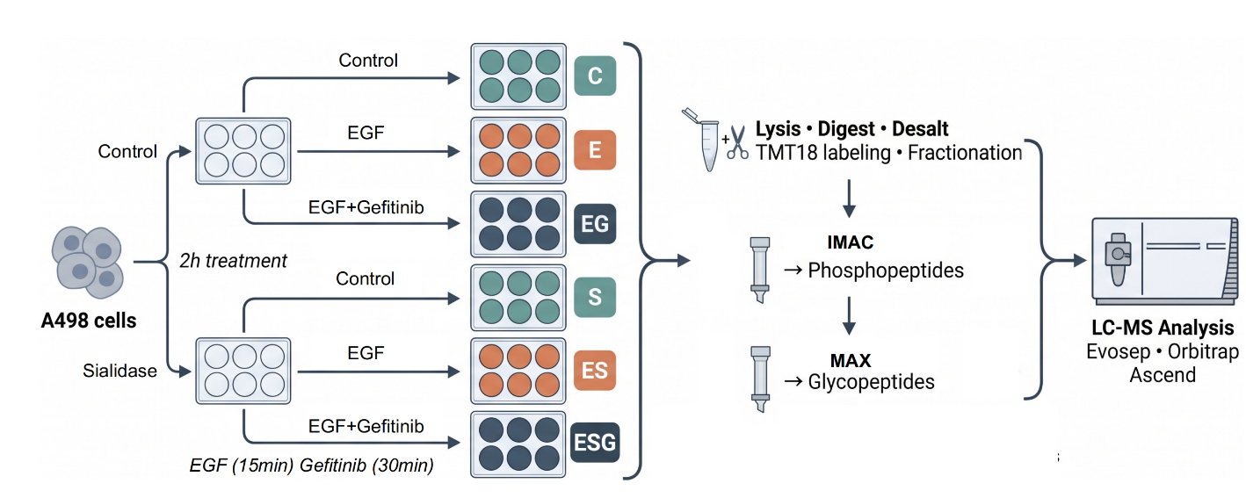
Figure S1. Experimental workflow for global proteome, phosphoproteome, and N-glycoproteome profiling.
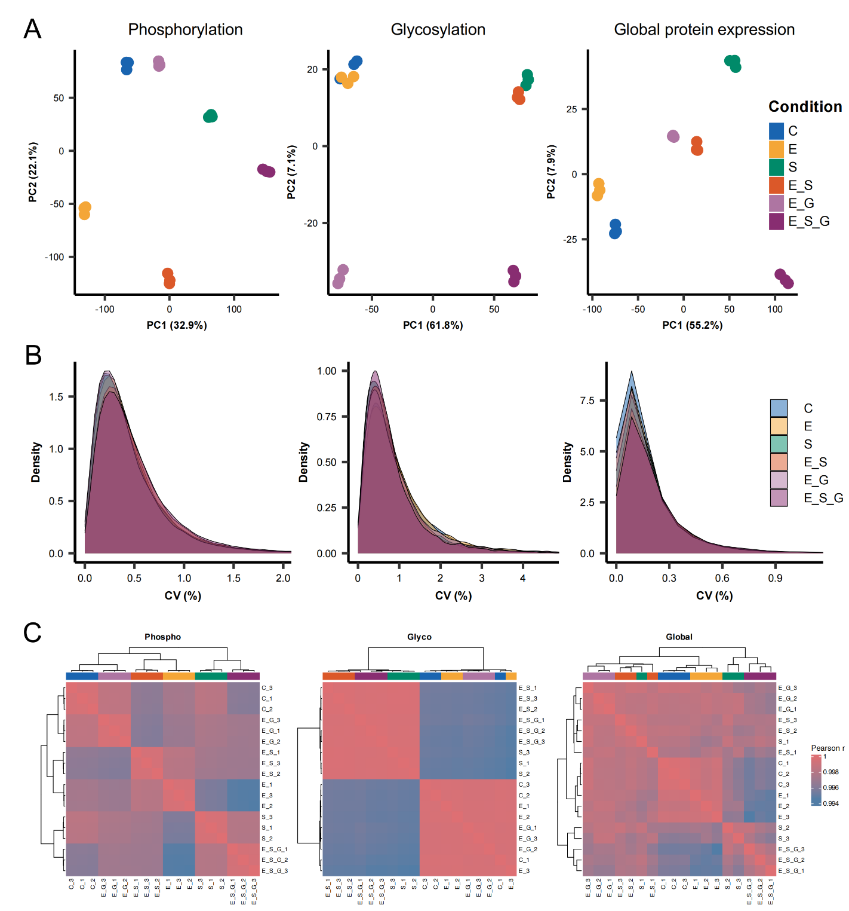
Figure S2. Quality control summary. Principal-component analysis, sample-sample correlation heatmaps, and coefficient-of-variation summaries for the phosphoproteome, glycoproteome, and global proteome.

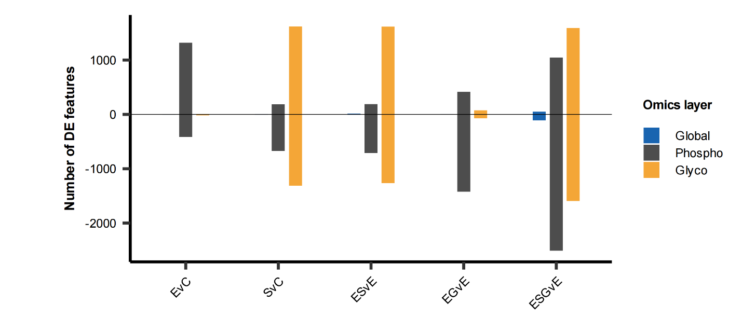
Figure S3. Differential expression (DE) features across treatment contrast in each omics layer. Positive and negative bars denote increased and decreased abundance, respectively; significance was defined as adjusted p < 0.05 and |log2 fold change| > 0.58.

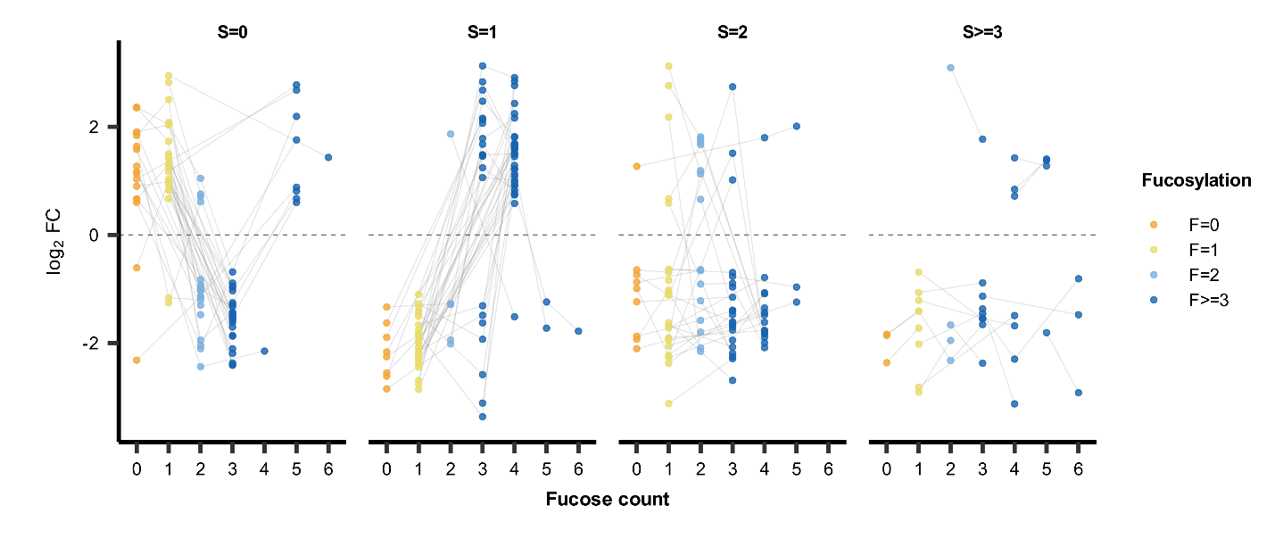
Figure S4. Fucosylation-resolved glycopeptide responses to sialidase. Fucose count plotted against sialidase-induced log2 fold change within matched glycopeptide families stratified by sialic acid count.

