Supplementary Information

A 3D spatial proteomic map of the human pancreatic islet microenvironment

Yumi Kwon¹, Shane S. Kelly², Jing Chen³, James Carson⁴, Lye Meng Markillie¹, Hu Dehong¹, Geremy Clair², James Labyer⁴, Demi Awosika-Olumo⁴, Erik Ferlanti⁴, Ronald J. Moore², Clayton E. Mathews^{3,5}, Martha Campbell-Thompson³, Ying Zhu^{1,6}, Ernesto S. Nakayasu², and Wei-Jun Qian^{2*}

¹Environmental Molecular Sciences Division, Pacific Northwest National Laboratory, Richland, WA.
²Biological Sciences Division, Pacific Northwest National Laboratory, Richland, WA.
³Department of Pathology, Immunology and Laboratory Medicine, College of Medicine, University of Florida, Gainesville, FL.
⁴The University of Texas at Austin, Texas Advanced Computing Center, Austin, TX
⁵Department of Infectious Disease and Immunology, College of Veterinary Medicine, University of Florida, Gainesville, FL
⁶Present address: Department of Proteomic and Genomic Technologies, Genentech, South San Francisco, CA.

Correspondence to:
Wei-Jun Qian
Email: Weijun.Qian@pnnl.gov.

Supplementary Table 1 | Tissue sections used for 3D spatial proteomic mapping.
Summary of serial pancreatic tissue sections used for the 3D spatial proteomics workflow.
Supplementary Table 2 | LCM pixelation scheme and tissue pixel collection information. Details of the laser capture microdissection pixelation strategy used to sample the target islet and surrounding peri-islet tissue. The table includes section information, grid positions, collection status, and the corresponding nanoPOTS sample locations used for downstream proteomic processing.
Supplementary Table 3 | Spatial proteomics identification and quantification results. Protein identification and label-free quantification results from the 3D spatial proteomics dataset.
Supplementary Table 4 | Immunofluorescence intensity measurements. Pixel-level immunofluorescence measurements from adjacent tissue sections stained for DAPI, insulin, and glucagon.
Supplementary Table 5 | Pixel-level metadata for spatial proteomics analysis.
Metadata for each analyzed tissue pixel, including pixel identifiers, tissue section information, morphological annotation, relative x, y, and z coordinates, principal component scores including PC1 and PC2, and additional spatial features used for downstream clustering and correlation analyses.
Supplementary Table 6 | Azimuth pancreas cell-type markers identified in the spatial proteomics dataset. List of pancreatic cell-type marker proteins detected in this study based on comparison with Azimuth pancreas reference annotations.
Supplementary Table 7 | Distance-based spatial correlation analysis.
Correlation analysis between protein abundance and relative distance from the islet center. Correlation coefficients are reported for all pixels, islet pixels, and acinar pixels, enabling identification of proteins with global or compartment-specific spatial abundance gradients.

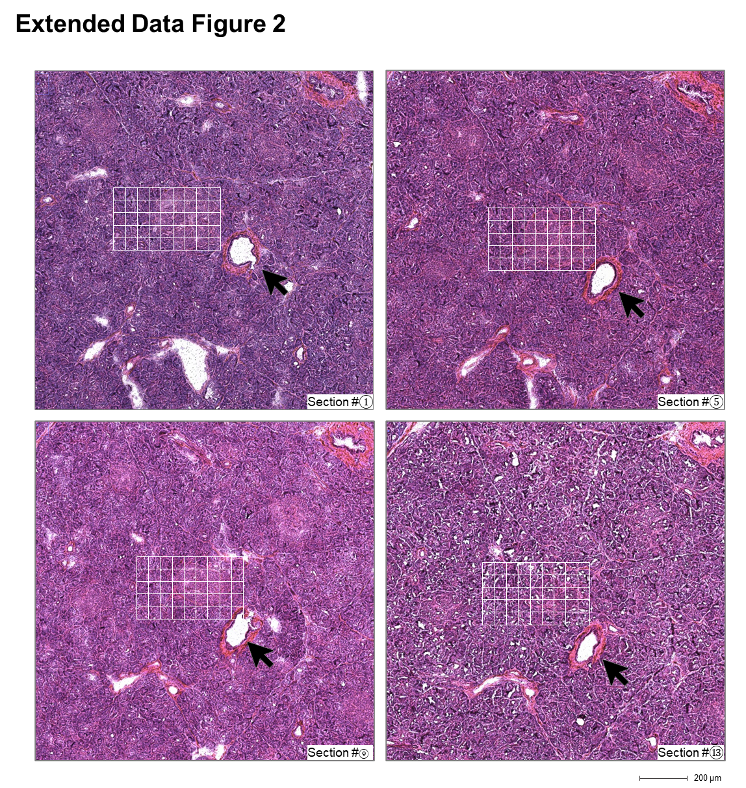
Supplementary Figure 1. Wide-field H&E staining images of tissue sections containing ROIs used for spatial proteomic analysis. H&E-stained images of each tissue section provide an overview of the ROIs selected for spatial proteomic profiling, centered around the target islets. Histological examination revealed localized features, including bottom-right corner pixels near ductal structures, offering spatial context for the proteomic analysis

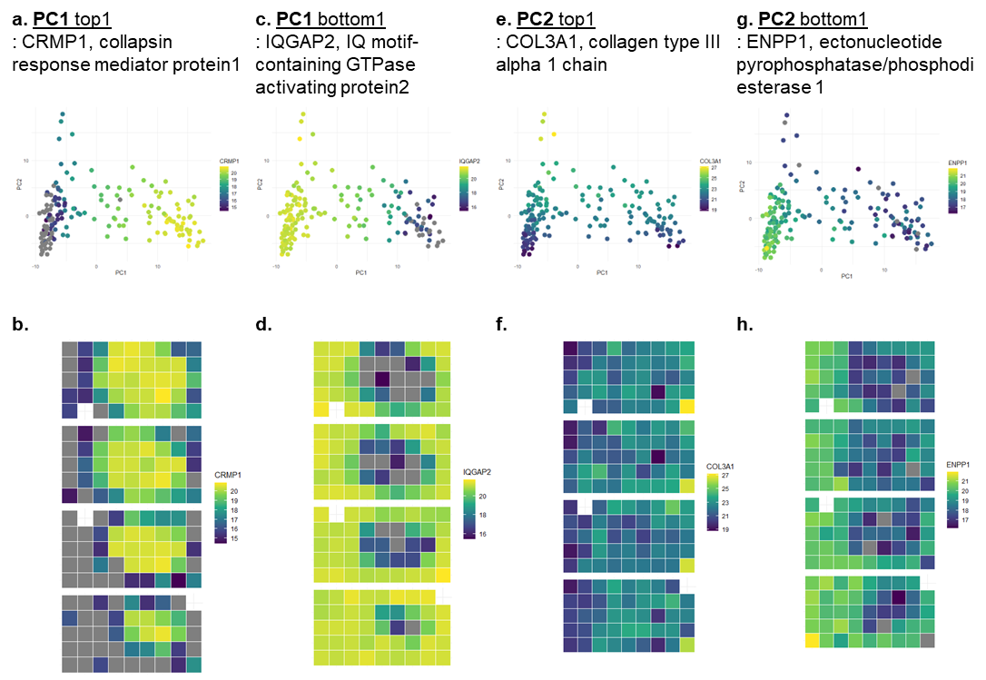
Supplementary Figure 2. Top and bottom proteins driving PCA components illustrate distinct spatial patterns in pancreatic tissue. Proteins with the highest (CRMP1, COL3A1) and lowest (IQGAP2, ENPP1) loadings for PC1 and PC2 are visualized through PCA plots and spatial heatmaps, highlighting their localization to specific pancreatic tissue compartments, including islet, acinar, and ductal regions.

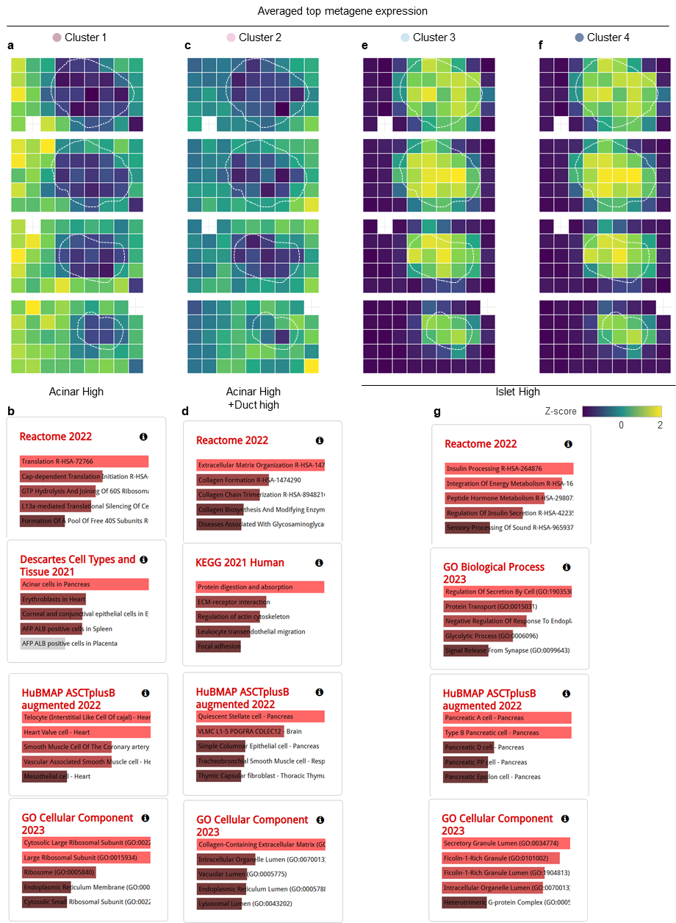
Supplementary Figure 3. Spatial and functional characterization of Leiden clusters in pancreatic tissue. (A, C, E, F) Heatmaps showing averaged top metagene abundance for each Leiden cluster mapped onto tissue grid positions. Cluster 1 exhibits high abundance of acinar markers, while Cluster 2 shows acinar markers with additional enrichment near ductal regions. Cluster 3 highlights transitional regions at the interface between islet and acinar tissue, and Cluster 4 reflects dense islet core markers. (B, D, G) Functional enrichment analyses for each cluster reveal molecular pathways associated with distinct tissue compartments. Enriched pathways for Cluster 1 reflect exocrine functions such as digestion and lipid metabolism. Cluster 2 captures both acinar and duct-associated processes, including extracellular matrix remodeling. Cluster 3, Cluster 4 shows enrichment for endocrine-specific processes, such as peptide hormone metabolism, insulin processing, and regulation of secretion. These results demonstrate the ability of spatial proteomics and unsupervised clustering to distinguish molecularly and functionally distinct compartments within pancreatic tissue.

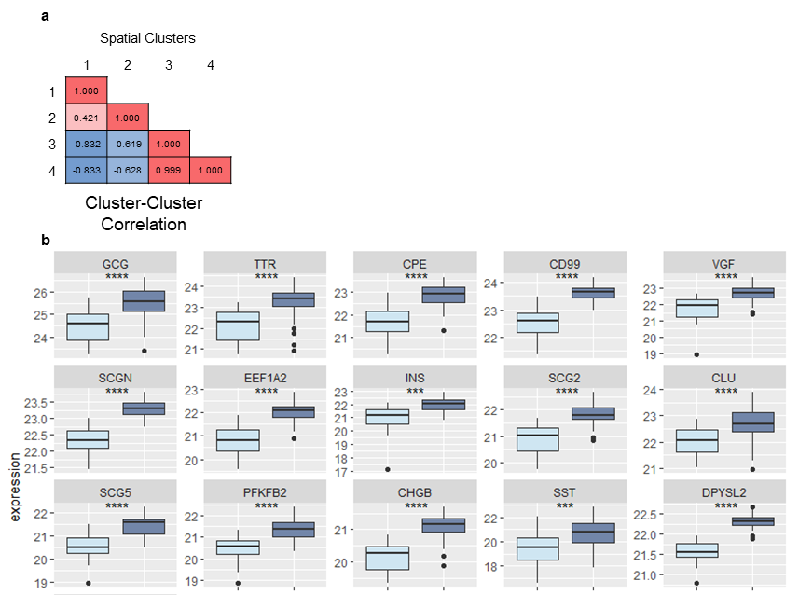
Supplementary Figure 4. Comparison of islet-associated Leiden clusters. a Cluster–cluster correlation matrix showing Pearson correlations among the four Leiden proteome clusters. Clusters 3 and 4 showed a ~1 correlation, consistent with their shared endocrine/islet-associated proteomic identity. b Boxplots showing abundance levels of representative proteins enriched in the islet-associated clusters. The comparison highlights higher abundance of endocrine hormone, secretory granule, and hormone-processing proteins in Cluster 4 relative to Cluster 3, supporting a distinction between islet-boundary and islet-core proteomic states. Statistical significance was assessed between Clusters 3 and 4. .

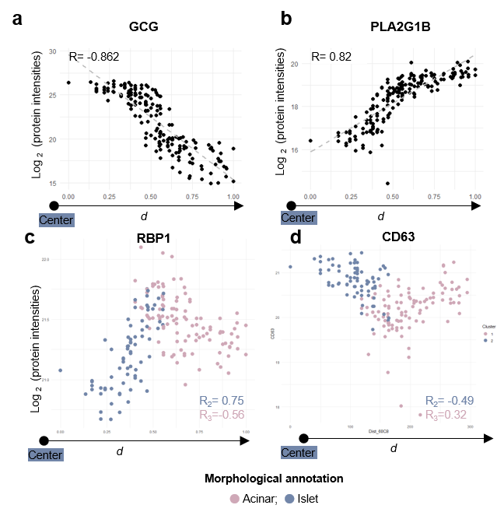
Supplementary Figure 5 | Correlation analysis of protein intensities with distance from islet core in pancreatic islet. a Scatter plot showing the negative correlation of glucagon (GCG) with distance from the islet center (R1=-0.862), suggesting reduced presence further from the core. c Positive correlation of PLA2G1B with distance (R1=0.82), indicating higher protein intensities in peripheral regions. d Heatmap of correlations across all pixels, within islet, and within acinar, highlighting proteins with reversed patterns in islet and acinar regions. c Retinol-binding protein 1 (RBP1) exhibits a positive correlation in islet pixels (R2>0) and a negative correlation in acinar pixels (R3<0). d CD63 shows an inverse pattern, with a negative correlation in islet pixels (R2<0) and a positive correlation in acinar pixels (R3>0). Morphological annotations differentiate acinar and islet regions, reflecting diverse protein roles within pancreatic microenvironments.

