Supplementary Material: The Unsustainable Development Index

Outline
This supplementary material accompanies the main text and is organised as follows:
S1. Formal structure and compensability of the SDG Index — Derives the arithmetic mean formula, the marginal rate of substitution (MRS = $-1$), and the distinction between nominal weights and effective importance. Includes the iso-index trade-off figure (Fig. S1).
S2. Signed variance-covariance contribution analysis — full derivation — Presents the general Sobol framework and its simplification for additive indices, including first-order, second-order, and total-order importance measures. Proves summation to unity and discusses the possibility of negative total-order indices.
S3. Becker importance decomposition — methods and interpretation — Defines the nonlinear Pearson correlation ratio, the decomposition into uncorrelated and correlated components, and the estimation procedure. Discusses the complementarity between the Sobol (directional) and Becker (magnitude) decompositions, with a comparison table.
S4. Becker decomposition — temporal evolution and country-level evidence — Visualises the development–sustainability trade-off at the country level (Fig. S4a), the temporal stability of the correlation structure (Fig. S4b), and the full 2000–2025 evolution of the Becker total importance (Fig. S4c), correlated component (Fig. S4d), and uncorrelated component (Fig. S4e).
S5. Correlation structure and principal component analysis — Reports the 2025 pairwise correlation matrix among the 17 SDG goal scores, then describes the PCA procedure, component retention, communalities, loadings, and sign convention. It explains how the correlation matrix reveals a dense development bloc and an opposing climate-consumption bloc, and how PCA summarises this structure into the development–sustainability axis. It also discusses the diagnostic and constructive uses of PCA, including the double-counting problem and the failure of the variance-weighted PCA index.
S6. PCA results — 2025 and 2000 — Presents the PCA index under both sign conventions for 2025 (Figs. S6a–S6b), the 2000 loadings table (Table S6a), 2000 biplots (Figs. S6c–S6d), and the 2000 PCA index under both sign conventions (Figs. S6e–S6f).
S7. Alternative aggregation methods — full equations and worked example — Presents the formal definition of the arithmetic mean, geometric mean, soft-min, and the multicriteria outranking method with a continuous sustainability floor (PROMETHEE II), plus the central hard-veto specification (S7.8). Includes all equations, the goal-specific floor calibration, a worked example, a perturbation test of residual compensability, and the hard-veto robustness check that inverts the ranking.
S8. Alternative aggregation — additional results — Presents the Spearman correlation heatmap between all nine methods, including the central hard veto (Fig. S8a) and forest plots of the top 20 and bottom 20 countries by arithmetic rank under each method (Figs. S8b–S8c).
S9. Calibration of environmental floors using external footprint sustainable corridors - Explains how the SDG 12 and SDG 13 floors are calibrated against external consumption-based sustainable corridors (a 1.5 °C carbon-budget corridor of ≈2 tCO2eq/capita for SDG 13 and a ≈6.3 t/capita material-footprint corridor for SDG 12), translated into goal-specific score floors (central F₁₂ = 80, F₁₃ = 95) by a 10th-percentile rule. Includes scatterplots mapping SDR goal scores to footprint benchmarks (Figs. S9a–S9b), a floor-grid sensitivity analysis (Figs. S9c–S9d), and tables reporting the scenario-to-floor translation and income-group rank shifts (Tables S9a–S9f).
S10. Corroboration with the SDR Spillover Index and consumption-based footprints — Defines the SDR’s consumption-based Spillover Index (S10.1) and uses it, together with external material and carbon footprints, to test whether SDG 12 and SDG 13 genuinely track cross-border environmental pressure rather than being artefacts of how the two SDR scores are constructed. Presents the extended Spearman correlation matrix across the 17 goals, the SDG Index, the Spillover Index and reversed material and carbon footprints (Fig. S10a), the ranking of goals by alignment with low spillovers (Fig. S10b), and the country-level SDG Index–Spillover relationship by income group (ρ = −0.82; Fig. S10c). Shows the SDG Index correlates negatively with all three external environmental measures, confirming the development–environment opposition is not specific to the SDR’s environmental goal scores.

S1. Formal structure and compensability of the SDG Index
The SDG Index is a linear composite indicator. Let $G_{k}$ denote the score of goal $k$ ($k=1,…,17$) for a given country in a given year. Each goal score is on a $\left[0,100\right]$ scale, where 0 denotes worst performance and 100 denotes that the target has been achieved. The scores are constructed by the SDSN by normalising indicator-level data to a common scale using min-max rescaling with expert-defined upper and lower bounds, then averaging within each goal (Lafortune et al. 2018). The composite SDG Index is then obtained by taking the arithmetic mean of the 17 goal scores with equal weights:
$$I=\sum_{k=1}^{17}{w_{k}} G_{k}, w_{k}=\frac{1}{17} \text{for all }k.$$
This can equivalently be written as
$$I=\frac{1}{17}\sum_{k=1}^{17}{G_{k}}=\frac{1}{17}\left(G_{1}+G_{2}+⋯+G_{17}\right).$$
Since the index is a weighted sum, the effect of a marginal change in any single goal score on the composite is given by the partial derivative:
$$\frac{∂I}{∂G_{k}}=w_{k}=\frac{1}{17} \text{for all }k=1,…,17.$$
This partial derivative is the same for every goal. A one-point increase in SDG 1 (no poverty) has the same marginal effect on the composite as a one-point increase in SDG 13 (climate action), or in any other goal. The index does not distinguish between goals at the margin.
Compensability and the marginal rate of substitution. The structure defined above is fully compensatory. Consider a country that loses one point on goal $k$ but gains one point on goal $j$, holding all other goals fixed. The net change in the composite is
$$ΔI=w_{j}⋅\left(+1\right)+w_{k}⋅\left(-1\right)=\frac{1}{17}-\frac{1}{17}=0.$$
The composite is unchanged. More formally, the marginal rate of substitution (MRS) between goals $j$ and $k$ is
$${\text{MRS}}_{jk}=-\frac{∂I/∂G_{k}}{∂I/∂G_{j}}=-\frac{w_{k}}{w_{j}}=-\frac{1/17}{1/17}=-1.$$
The MRS is constant, equal to $-1$, and identical for every pair of goals. The SDG Index treats all 17 goals as perfect substitutes: one point of poverty reduction can always be exchanged for one point of climate action (or biodiversity, or sustainable consumption, or any other goal) without affecting the composite score.
What the weights are and what they are not. As the OECD–JRC Handbook on Constructing Composite Indicators emphasises (OECD/JRC 2008, Step 7), in a linear index the nominal weights are trade-off parameters, not measures of how much each component actually matters for the final score. They encode the assumed rate at which one goal can be substituted for another — in this case, a rate of $-1$ for all pairs — but they do not reveal which goals effectively drive variation in the index once correlations and scaling are taken into account. A weight of $1/17$ on SDG 13 (climate action) does not mean that climate action accounts for $1/17$ of the cross-country variation in the composite. The effective importance of each goal depends on its variance, its covariance with all other goals, and the weight — not on the weight alone.
Supplementary Figure S1 illustrates the consequence for a single pair of goals. Holding all other 15 goals fixed, the set of ($G_{9}$, $G_{13}$) combinations that yield the same index score traces a straight line with slope $-1$. Country A ($G_{9}=70$, $G_{13}=70$) and Country B ($G_{9}=90$, $G_{13}=50$) receive identical composite scores. The index is indifferent between balanced performance and a pattern where industrial progress compensates for climate failure. This holds for any pair of goals, because the marginal rate of substitution $dG_{j}/dG_{k}=-w_{k}/w_{j}=-1$ is constant and uniform across the entire goal space.
Supplementary Figure S1. Iso-index trade-off: compensability with $w_{9}=w_{13}=1/17$.
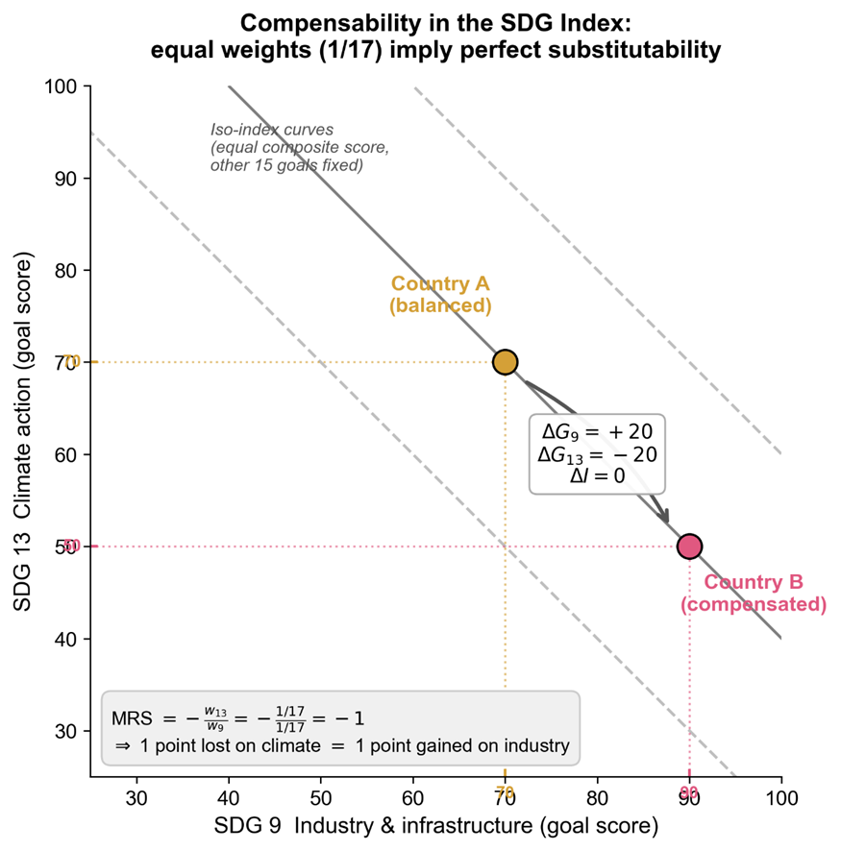

S2. Signed variance-covariance contribution analysis — full derivation
To assess which goals effectively drive variation in the SDG Index, we use the exact variance-covariance decomposition of the linear aggregate. This is a variance-based importance measure, but it is not the standard conditional-variance Sobol total-effect index. Standard Sobol first-order and total-effect indices are defined through conditional variances and are non-negative. Those definitions are appropriate for the usual variance-decomposition setting, especially under independent inputs. Here, however, the 17 SDG goal scores are empirically correlated across countries, and the quantity of interest is not a hypothetical independent-input model but the observed variance of the SDG Index itself. We therefore use a signed variance-covariance allocation that is exact for the index as constructed.
Let the SDG Index be
$$I=\sum_{i=1}^{17}{w_{i}}G_{i},$$
where $G_{i}$is the score of goal $i$and $w_{i}$is its nominal weight. The variance of the index is
$$Var(I)=\sum_{i=1}^{17}{w_{i}^{2}}Var(G_{i})+2\sum_{i<j}{w_{i}}w_{j}Cov(G_{i},G_{j}).$$
The first term assigns to each goal its own-variance component:
$$O_{i}=\frac{w_{i}^{2}Var(G_{i})}{Var(I)}.$$
This is not the Sobol first-order conditional-variance index under correlated inputs. It is the own-variance term in the exact variance-covariance decomposition of the linear index.
The pairwise covariance contribution between goals $i$and $j$is:
$$C_{ij}=\frac{2w_{i}w_{j}Cov(G_{i},G_{j})}{Var(I)}.$$
Positive values mean that the two goals reinforce each other in the cross-country distribution; negative values mean that they move in opposite directions.
To assign covariance contributions back to individual goals without double-counting, we allocate one half of each pairwise covariance term to each goal. The signed total contribution of goal $i$is therefore:
$$T_{i}=O_{i}+\frac{1}{2}\sum_{j≠i}{C_{ij}}.$$
Equivalently,
$$T_{i}=\frac{Cov(w_{i}G_{i},I)}{Var(I)}=\frac{w_{i}^{2}Var(G_{i})+\sum_{j≠i}{w_{i}}w_{j}Cov(G_{i},G_{j})}{Var(I)}.$$
By construction,
$$\sum_{i=1}^{17}{T_{i}}=1.$$
The sign of $T_{i}$is substantively important. A positive value means that variation in goal $i$reinforces the overall index ranking. A negative value means that countries scoring well on goal $i$tend to obtain lower SDG Index scores, because that goal is negatively associated with the goals that dominate the composite. This is precisely the information needed to diagnose whether the index rewards or penalises environmental performance. We therefore refer to $T_{i}$as a signed variance-covariance contribution, or signed effective importance, rather than as a standard Sobol total-effect index.

S3. Becker importance decomposition — methods and interpretation
The total-order indices reveal how much each goal contributes to the SDG Index and in which direction. However, they do not reveal why a particular goal is important. A goal can be influential in the composite for two fundamentally different reasons: either because its own variation independently shapes the index, or because it happens to co-move with other goals that do. Disentangling these two sources of influence requires a different tool.
The nonlinear Pearson correlation ratio. Following Becker et al. (2017), who extend the work of Xu and Gertner (2008), we measure the total importance of each goal using the nonlinear Pearson correlation ratio, also known in the sensitivity analysis literature as the first-order sensitivity index (Saltelli et al. 2008). For goal $i$, this is defined as
$$S_{i}=\frac{{\text{Var}}_{G_{-i}}\left[ E\left(I∣G_{i}\right) \right]}{\text{Var}\left(I\right)},$$
where $E\left(I∣G_{i}\right)$ is the expected value of the composite when goal $i$ is held fixed at a particular value, and the outer variance is taken over all possible values of $G_{i}$.
Intuitively, $S_{i}$ measures the expected reduction in composite variance if we could observe goal $i$ exactly — it tells us how much of the cross-country variation in the index is associated with variation in goal $i$. When the relationship between $G_{i}$ and $I$ is linear, $S_{i}$ reduces to the squared Pearson correlation $R^{2}$. In general, $S_{i}≥R^{2}$, because the correlation ratio captures any nonlinear dependence that $R^{2}$ misses.
This is a crucial distinction from the linear Sobol indices derived in S2. The first-order Sobol index $S_{i}^{1}$ is computed analytically from the variance-covariance matrix, assuming the additive structure of the index. The Becker $S_{i}$ is estimated empirically using nonparametric regression — specifically, penalised cubic splines or Bayesian Gaussian processes — and captures any nonlinear relationship between $G_{i}$ and $I$, whether or not the index is linear in its construction. When the index is exactly linear and the goal scores are jointly normal, the two measures coincide. In practice, they may differ because (a) the relationship between a single goal and the composite is mediated by the correlations with all other goals, which can introduce apparent nonlinearities, and (b) the empirical distributions of goal scores are not Gaussian.
A key property: $S_{i}$ and its components measure strength, not direction. Unlike the total-order Sobol index $S_{i}^{T}$ derived in S2 — which preserves the direction of a goal’s association with the composite and can therefore be negative — the Becker $S_{i}$ is always non-negative. It is defined as a variance ratio, which by construction captures the strength of the association between goal $i$ and the composite, regardless of whether that association is positive or negative. A goal that is strongly negatively correlated with the composite will have a high $S_{i}$, just as a goal that is strongly positively correlated will. The direction of the relationship is invisible in $S_{i}$.
This means that the Becker $S_{i}$ and the Sobol $S_{i}^{T}$ can tell very different stories about the same goal. A goal can simultaneously have a negative total-order Sobol contribution (countries scoring well on it rank lower overall) and a high Becker $S_{i}$ (it is strongly associated with the composite). The Sobol index says the goal works against the ranking; the Becker index says the goal matters a lot — the two are not contradictory but complementary. This combination — negative direction, high magnitude — is the signature of a goal that the index actively penalises.
The same logic extends to the components of the decomposition. The correlated component $S_{i}^{c}$ measures how much of a goal’s importance comes from its co-movement with other goals, but it does not tell you whether that co-movement is positive or negative. A goal that is strongly negatively correlated with the development cluster (like SDG 12, sustainable consumption) will have a large $S_{i}^{c}$ — because its association with the composite is strongly mediated by other goals — even though the direction of that mediation is negative. To know the direction, one must consult the total-order Sobol index or examine the bivariate relationship directly.
The decomposition: correlated and uncorrelated importance. The central contribution of Becker et al. (2017) is to decompose $S_{i}$ into two additive parts:
$$S_{i}=S_{i}^{u}+S_{i}^{c},$$
where $S_{i}^{u}$ is the uncorrelated component and $S_{i}^{c}$ is the correlated component.
The uncorrelated component $S_{i}^{u}$ captures the influence of goal $i$ that is uniquely its own — the part of its association with the composite that cannot be explained by any other goal. It is estimated in three steps:
- Regress $G_{i}$ on all other goals. Fit a nonlinear regression (using penalised cubic splines) of $G_{i}$ on $G_{-i}=\left(G_{1},…,G_{i-1},G_{i+1},…,G_{17}\right)$, yielding a predicted value ${\hat{G}}_{i}$.
- Compute the residual. The residual ${\hat{z}}_{i}=G_{i}-{\hat{G}}_{i}$ represents the part of goal $i$’s variation that is not predictable from the other 16 goals. It is, by construction, uncorrelated with $G_{-i}$.
- Compute the correlation ratio between the residual and the composite. $S_{i}^{u}$ is the correlation ratio $η^{2}$ between ${\hat{z}}_{i}$ and $I$:
$$S_{i}^{u}=\frac{\text{Var}\left[ E\left(I∣{\hat{z}}_{i}\right) \right]}{\text{Var}\left(I\right)}.$$
If $S_{i}^{u}$ is large, it means that goal $i$ carries genuinely independent information about cross-country differences that no other goal provides. If $S_{i}^{u}$ is near zero, then everything goal $i$ contributes to the composite is already captured by other goals — its weight could be set to zero without materially affecting the ranking.
The correlated component $S_{i}^{c}$ is obtained as the residual of the decomposition:
$$S_{i}^{c}=S_{i}-S_{i}^{u}.$$
It captures the additional influence that arises because goal $i$ co-varies with other goals in the index. A large $S_{i}^{c}$ means that goal $i$’s importance is largely borrowed from its correlations with the rest of the indicator set. This is the mechanism through which a linear composite can become dominated by a cluster of correlated variables: each variable in the cluster has a high total $S_{i}$, but most of that importance comes from the correlated component, not from independent variation.
Estimation. We estimate the Becker decomposition separately for each year from 2000 to 2025, using the balanced sample of 108 countries. We use penalised cubic splines as the nonlinear regression method in the total-importance regression, the residualisation step, and the uncorrelated-importance regression, following Becker et al. (2017). The spline approach is preferred over Gaussian processes for our sample size because it is computationally less demanding while providing comparable estimates. The smoothing/penalty parameter is selected by cross-validation in each spline fit. This selection is repeated in every bootstrap replication, so the bootstrap captures uncertainty from both country resampling and the two-stage nonparametric estimation procedure. Standard errors are obtained from 500 bootstrap replications by resampling countries with replacement independently within each year and recomputing the full Becker decomposition in each replication. The resulting intervals describe within-year cross-sectional sampling uncertainty only; they are not intended as inference on serial dependence, panel dynamics, or cross-year trend uncertainty.
Comparison table. The Sobol decomposition (S2) and the Becker et al. (2017) decomposition provide complementary information about the SDG Index:
 | Sobol total-order $S_{i}^{T}$ | Becker $S_{i}$ (and $S_{i}^{u}$, $S_{i}^{c}$)
What it measures | Effective share of index variance, including direction | Strength of association (magnitude only, direction-blind)
Can be negative? | Yes (goal works against composite) | $S_{i}$: never. $S_{i}^{c}$: rarely, signals structural problem
Estimation | Analytical (from covariance matrix) | Nonparametric (spline regression)
Linearity assumption | Exploits linearity of the index | Does not assume linearity
Key question answered | Which goals matter, and do they help or hurt? | Why does a goal matter — own variation or correlation?
Together, they allow us to identify not only which goals drive the SDG Index and in which direction (Sobol), but also whether their importance is genuine or borrowed from correlations with other goals (Becker).

S4. Becker decomposition — temporal evolution and country-level evidence

S4.1 The development–sustainability trade-off at the country level
Before examining the temporal evolution of the Becker decomposition, Supplementary Figure S4a visualises the relationship between the goals that dominate the SDG Index and the goals it penalises, at the country level for both endpoints of the study period.
The left panels show scatterplots of individual countries, with the horizontal axis plotting the most important goal in each year as measured by the Becker total importance — SDG 3 (health, $S_{i}$ = 0.89) in 2000 and SDG 9 (industry, $S_{i}$ = 0.89) in 2025 — and the vertical axis plotting SDG 12 (sustainable consumption), coloured by the overall SDG Index score. The negative relationship is stark in both years: countries with the highest scores on health or industry tend to have the lowest scores on sustainable consumption. The LOWESS/Becker spline (red curve) shows that the trade-off accelerates at high levels of development — beyond approximately 70 on health or industry, sustainable consumption declines sharply. The colour gradient reinforces the point: the countries with the highest SDG Index scores (yellow-green) cluster in the lower-right corner, where development performance is strong and sustainability performance is weakest. The right panels show the Becker total importance for the corresponding year, confirming that the goals most strongly associated with the composite are the same development goals that drive the negative trade-off with SDG 12.
The figure makes the mechanism diagnosed in the main text visible at the country level: the SDG Index rewards precisely the countries whose development performance comes at the expense of sustainable consumption. This is not a statistical abstraction — it is a pattern identifiable in individual country positions.
Supplementary Figure S4a. Relationship between the most important development goal and SDG 12 (sustainable consumption) at the country level, 2000 and 2025, with Becker total importance.
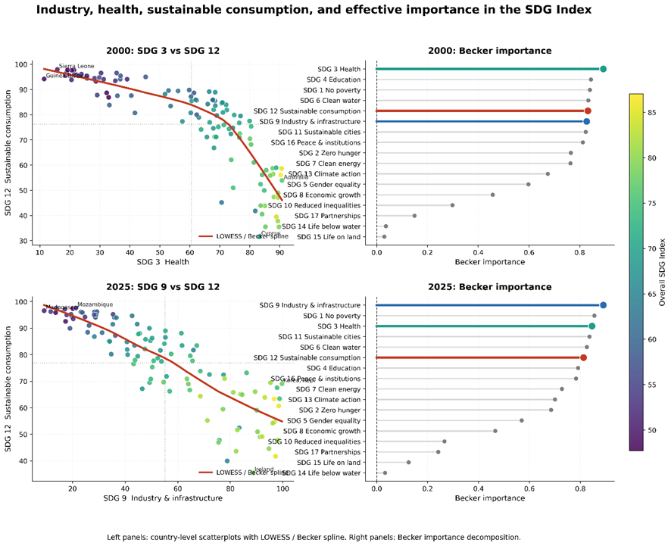

S4.2 Temporal stability of the correlation structure
Supplementary Figure S4b shows the Spearman correlation between each of the 17 SDG goal scores and the composite SDG Index for every year from 2000 to 2025, using the balanced panel of 108 countries. The development goals — SDG 3 (health), SDG 11 (sustainable cities), SDG 4 (education), SDG 6 (clean water), SDG 1 (no poverty), SDG 9 (industry), SDG 7 (clean energy) — maintain strong positive correlations with the composite throughout the entire period, appearing as a stable dark red band at the top of the heatmap. SDG 12 (sustainable consumption) and SDG 13 (climate action) maintain strong negative correlations throughout, appearing as a stable dark blue band at the bottom. SDG 14 (life below water) hovers near zero. SDG 15 (life on land) is weakly positive.
The block structure does not weaken or shift over 25 years. The development goals that the index rewards in 2000 are the same ones it rewards in 2025. The environmental goals it penalises in 2000 are the same ones it penalises in 2025. The SDG Index has measured development and penalised sustainability since at least 2000.
Supplementary Figure S4b. Spearman correlation between each of the 17 SDG goal scores and the SDG Index by year, 2000–2025.
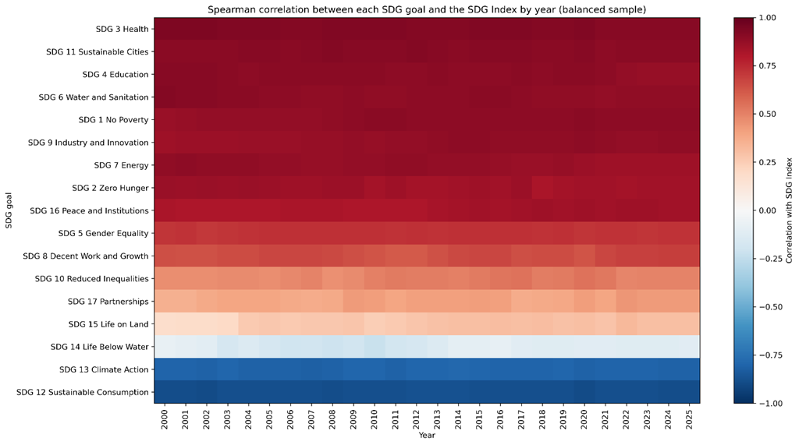

S4.3 Becker total importance ($S_{i}$), 2000–2025
Supplementary Figure S4c shows that even the goals that contribute negatively in the signed total-order decomposition can still have high importance in the Becker sense. SDG 12 (sustainable consumption) and SDG 13 (climate action) have $S_{i}$ values in the range 0.55–0.70 throughout the period. This means that these goals are strongly associated with the composite — they explain a large share of its variance — but the direction of that association is negative. A goal can be simultaneously highly important and actively penalised. This contrast between the total-order Sobol index (which is negative for SDG 12 and 13) and the Becker $S_{i}$ (which is high) is one of the most revealing findings of the analysis: the SDG Index does not ignore environmental goals — it systematically punishes them.
At the top of the ranking, SDG 3 (health), SDG 9 (industry), SDG 11 (sustainable cities), and SDG 4 (education) have $S_{i}$ values consistently above 0.80, meaning that each of these goals alone can explain more than 80% of the cross-country variance in the composite index. At the bottom, SDG 14 (life below water) and SDG 15 (life on land) have total importance below 0.10, confirming that these goals are effectively invisible in the composite. The temporal stability of this hierarchy is remarkable: the ranking barely changes across 26 years.
Supplementary Figure S4c. Heatmap: Becker total correlation ratio $S_{i}$, 2000–2025.
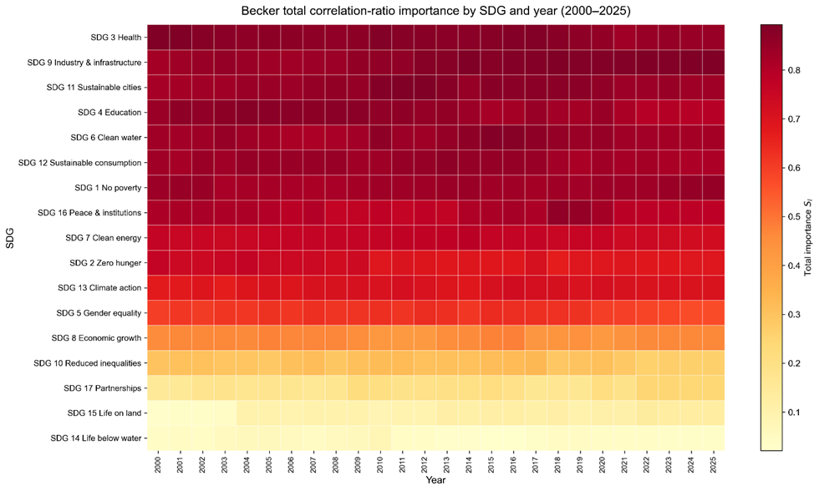

S4.4 Correlated component ($S_{i}^{c}$), 2000–2025
Supplementary Figure S4d decomposes the importance by showing the correlated component $S_{i}^{c}$ alone. The pattern is dominated by the development cluster. SDG 3 (health), SDG 9 (industry), SDG 11 (sustainable cities), SDG 4 (education), and SDG 6 (clean water) have correlated components above 0.60–0.80 throughout the period. These goals are influential in the index not primarily because of their own unique variation, but because they co-move with the broader constellation of development indicators. They are, in effect, proxies for a latent “development” factor that pervades the index structure. This is the mechanism through which the SDG Index becomes a development index: when most goals are positively correlated with each other, the arithmetic average amplifies their common signal and marginalises anything that moves differently.
SDG 12 (sustainable consumption) also shows a substantial correlated component (approximately 0.40–0.60), but recall that its total-order Sobol contribution is negative. This means that the correlation of SDG 12 with other goals works against the composite direction: countries that do well on consumption sustainability tend to do poorly on the development-oriented goals that drive the index. The correlated component is large because the association is strong — but it is a negative association. The same logic applies to SDG 13 (climate action). This is the empirical signature of what Brand and Wissen (2017) call the imperial mode of living: high-income countries that top the development cluster are the same countries with the lowest scores on SDG 12 and 13.
Supplementary Figure S4d. Heatmap: Becker correlated component $S_{i}^{c}$, 2000–2025.
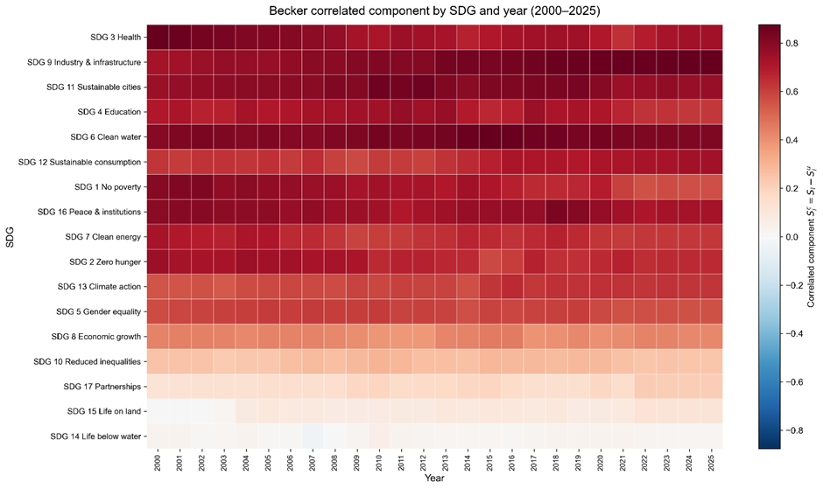

S4.5 Uncorrelated component ($S_{i}^{u}$), 2000–2025
Supplementary Figure S4e shows the uncorrelated component $S_{i}^{u}$, which isolates what each goal contributes independently of all others. The landscape looks radically different. The development goals that dominate the total importance and correlated components — health, industry, sustainable cities — have modest uncorrelated contributions, typically in the range 0.02–0.10. Their importance in the index is almost entirely borrowed from their correlations with other goals.
Two goals stand out for their high uncorrelated importance. SDG 1 (no poverty) shows a dramatic increase in $S_{i}^{u}$ from around 0.05 in the early 2000s to over 0.25 by 2025, suggesting that poverty measurement has become increasingly independent of the broader development cluster over time — perhaps reflecting the growing number of countries that have reduced poverty substantially while diverging on other dimensions. SDG 12 (sustainable consumption) and SDG 4 (education) also show relatively high uncorrelated components (0.10–0.20), meaning these goals carry genuinely independent information about country performance that is not captured by any other goal. For SDG 12, this is particularly significant: it has both high uncorrelated importance and a negative total-order contribution, meaning it contains substantial unique information about cross-country variation that the index not only fails to reward but actively penalises.
SDG 13 (climate action) presents an interesting temporal pattern in its uncorrelated component, showing moderate values (around 0.10–0.15) in the early 2000s that decline over time. This suggests that climate performance has become increasingly correlated with the broader development cluster — and since the correlation is negative, increasingly penalised by it.
Supplementary Figure S4e. Heatmap: Becker uncorrelated component $S_{i}^{u}$, 2000–2025.
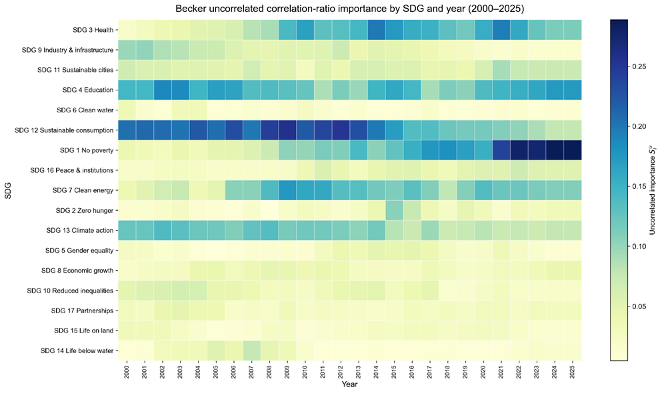

S5. Correlation structure and principal component analysis
Before applying principal component analysis, we first examine the pairwise correlation structure among the 17 SDG goal scores in the 2025 cross-section. This provides a direct view of the empirical relationships that PCA later summarises. The matrix shows a dense development bloc: SDG 1, SDG 3, SDG 4, SDG 6, SDG 7, SDG 9, SDG 11 and SDG 16 are strongly positively correlated with one another. These goals therefore carry overlapping cross-country information rather than independent signals.
The environmental goals do not form a single common bloc. SDG 14 and SDG 15 are only weakly connected to the main development cluster. By contrast, SDG 12 and SDG 13 form a distinct climate-consumption bloc. They are positively correlated with each other but negatively correlated with most development goals. This is especially clear for SDG 12, which moves in the opposite direction to the goals most associated with conventional development.
This correlation structure explains why PCA identifies a dominant development–sustainability axis. PCA does not create the opposition between development and environmental performance; it summarises a pattern already present in the raw goal-score correlations. The implication is that countries do not vary independently across the 17 goals. They vary primarily along a structure in which high scores on development goals tend to coincide with lower scores on sustainable consumption and climate action.
Supplementary Figure S5a. Pairwise correlation matrix among the 17 SDG goal scores, 2025. Colours and cell values show Pearson correlation coefficients. Positive values indicate that countries scoring high on one goal also tend to score high on the other; negative values indicate that high performance on one goal is associated with lower performance on the other
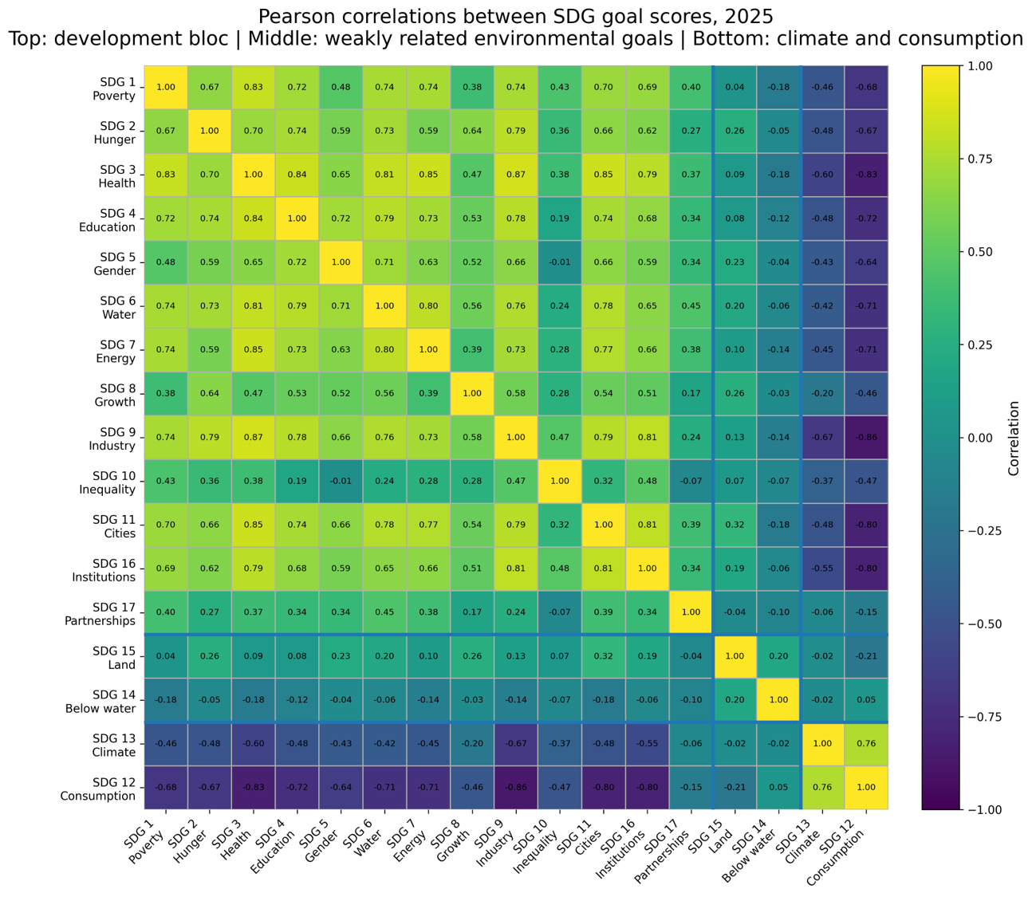
We apply principal component analysis (PCA) to the 17 SDG goal scores for the 2025 cross-section (balanced panel, $N$ = 108 countries) and replicate the analysis for the 2000 cross-section to assess temporal stability.
Procedure. Let $G_{ck}$ denote the score of country $c$ on goal $k$, where $k=1,…,17$. We standardise each goal to zero mean and unit variance and perform PCA on the resulting correlation matrix. The principal components are linear combinations of the standardised goal scores:
$$Z_{cj}=\sum_{k=1}^{17}{a_{jk}} {\tilde{G}}_{ck}$$
where ${\tilde{G}}_{ck}$ is the standardised score of country $c$ on goal $k$, and $a_{jk}$ is the loading of goal $k$ on component $j$. The components are orthogonal by construction: $\text{Cov}\left(Z_{j},Z_{m}\right)=0$ for $j≠m$.
Component retention. We retain the first three principal components, which together account for 72.0% of total variance in 2025 (PC1: 55.4%, PC2: 8.5%, PC3: 8.1%) and 73.0% in 2000 (PC1: 56.3%, PC2: 8.8%, PC3: 7.9%). The Kaiser criterion (eigenvalue > 1) supports retaining these three components.
Communalities. Communalities measure the share of each goal’s variance captured by the retained components. Formally, the communality of goal $k$ is
$$h_{k}^{2}=\sum_{j=1}^{3}{a_{jk}^{2}}$$
where $a_{jk}$ is the loading of goal $k$ on component $j$. A communality of 1.0 means the three components fully capture the goal’s cross-country variation; a low communality means the goal varies along dimensions not captured by the retained components.
Supplementary Figure S5b (communalities) shows how much of each goal’s cross-country variance is captured by the three retained components. The development goals and SDG 12 (sustainable consumption) are well represented: SDG 3 (health, 0.92), SDG 9 (industry, 0.90), SDG 12 (sustainable consumption, 0.88), SDG 6 (clean water, 0.84), SDG 11 (sustainable cities, 0.82), and SDG 4 (education, 0.80) all have communalities above 0.80, meaning that the three-component space captures more than 80% of their variation. Communalities exceed 0.60 for 15 of the 17 goals; only SDG 14 (life below water, 0.43) and SDG 8 (decent work, 0.51) fall below this threshold, consistent with their low cross-country variance in the raw data.
Supplementary Figure S5b. Communalities of SDGs in retained PCA(3) space, 2025.
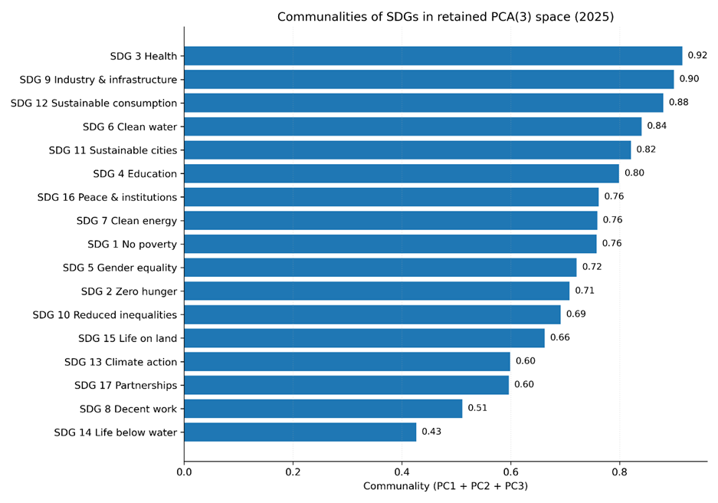
Supplementary Figure S5b (cos² representation) shows which original SDG goals are captured by each of the three retained components and therefore represented in the PCA-based analysis. The development goals — SDG 11 (sustainable cities), SDG 16 (institutions), SDG 3 (health), SDG 9 (industry), SDG 2 (zero hunger), SDG 4 (education), SDG 7 (clean energy), SDG 6 (clean water), SDG 1 (no poverty) — are almost entirely represented by PC1 (blue), with communalities exceeding 0.80. SDG 12 (sustainable consumption) is also well captured by PC1, but at the opposite pole. SDG 15 (life on land) and SDG 14 (life below water) — the two goals that were invisible in the original index — are now primarily captured by PC3 (green), with SDG 14 also drawing substantially from PC2 (orange). SDG 10 (reduced inequalities) and SDG 17 (partnerships) are captured mainly by PC2. The three components together provide good representation for most goals, with the critical exception that the goals least represented — those with the shortest total bars — are precisely those that varied least across countries in the original data (SDG 8, SDG 14, SDG 15), confirming that the issue for these goals is low cross-country variance, not correlation.
Supplementary Figure S5c. Representation of each SDG by PC1, PC2, and PC3 (cos² decomposition), 2025.
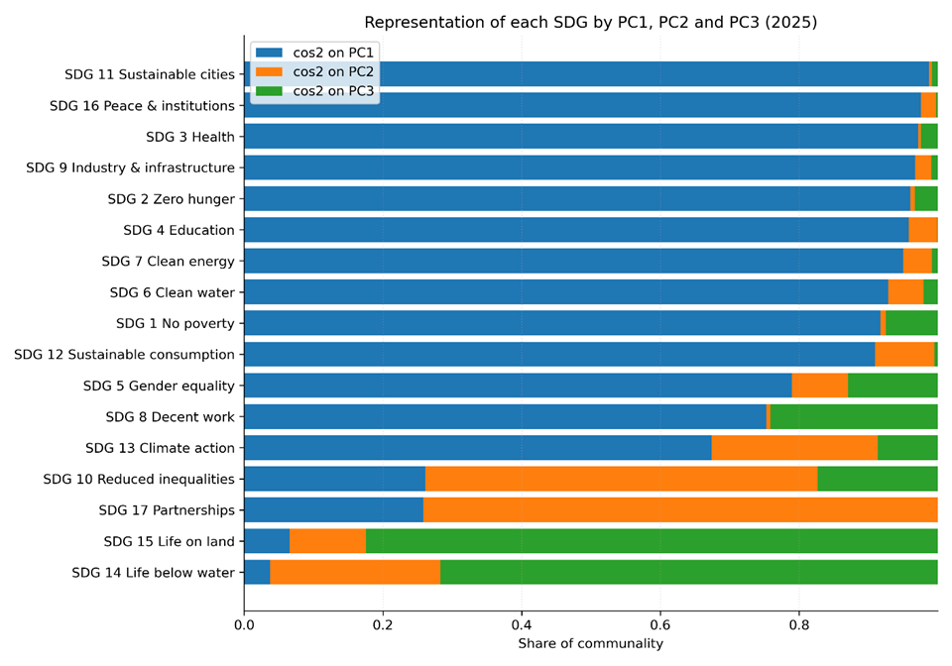
Loadings and interpretation. Loadings are reported as Pearson correlations between each goal score and the component. The sign of principal components is mathematically arbitrary — multiplying all loadings and scores of a component by $-1$ produces an equally valid decomposition. We orient the sign of each component for interpretive clarity, noting that this choice has no statistical consequence. In 2025, we orient PC1 so that development goals load negatively and SDG 12/SDG 13 load positively; in 2000, the sign happens to be reversed (development positive), reflecting the arbitrariness of the convention.
PCA as a diagnostic tool. PCA is used throughout this paper to reveal the latent structure of the 17-goal space — specifically, to identify the bipolar axis that opposes development and sustainability (PC1) and the independent dimensions of inequality/partnerships (PC2) and biodiversity (PC3). This diagnostic use follows the recommendation of the OECD–JRC Handbook on Constructing Composite Indicators (2008, Step 4), which instructs constructors to “check the underlying structure of the data” and “analyse the structure of the data set and compare this to the theoretical framework.” The Handbook specifically warns that when indicators are highly correlated, their overlapping information may be counted repeatedly in the composite, inflating the effective importance of the common dimension. Consider, for example, SDG 3 (health), SDG 9 (industry), and SDG 11 (sustainable cities), which correlate at $ρ>0.80$ with each other. In the arithmetic mean, each receives a nominal weight of 1/17 — but because all three carry largely the same cross-country information (the latent development factor identified by PC1), their shared signal enters the composite three times, giving the development dimension an effective weight far larger than 3/17. PCA makes this double-counting visible: the three goals load at $-0.94$, $-0.93$, and $-0.90$ on the same component, confirming that they are empirically near-redundant. The Becker decomposition (S3) quantifies the same phenomenon from a different angle: the uncorrelated components of these goals are 0.11, 0.01, and 0.07 respectively — virtually all of their importance is borrowed from correlation, not from independent information.
The variance-weighted PCA index and its failure. OECD/JCR (2008) also recommends PCA as a constructive tool for building composite indicators: principal components are extracted and the composite is formed by aggregating component scores weighted by their explained variance (OECD–JRC 2008, Section 6.1, Table 17, page 90). This procedure is designed to solve the double-counting problem identified above — by transforming correlated goals into orthogonal components, the mutual covariance that inflates effective importance is removed. To demonstrate why this procedure nevertheless fails for the SDG data, we follow it exactly. Let $Z_{c1}$, $Z_{c2}$, and $Z_{c3}$ denote the scores of country $c$ on the three retained components, each rescaled to $\left[0,100\right]$ using min-max transformation. The variance-weighted PCA index is:
$$I_{c}^{PCA}=\frac{λ_{1}}{λ_{1}+λ_{2}+λ_{3}}{\tilde{Z}}_{c1}+\frac{λ_{2}}{λ_{1}+λ_{2}+λ_{3}}{\tilde{Z}}_{c2}+\frac{λ_{3}}{λ_{1}+λ_{2}+λ_{3}}{\tilde{Z}}_{c3}$$
where $λ_{j}$ is the eigenvalue (explained variance) of component $j$ and ${\tilde{Z}}_{cj}$ is the min-max scaled score. Because PC1 dominates the weighting — accounting for 55.4% of total variance — the index is effectively a rescaled version of PC1. Since PC1 is a bipolar axis with development at one pole and sustainability at the other, and since its sign is mathematically arbitrary, the resulting index does not measure sustainable development. It measures either development or sustainability, depending on the sign convention adopted: one choice reproduces the original SDG Index ranking (Spearman $ρ$ = 0.97), the other inverts it entirely ($ρ$ = $-0.97$). Neither represents the integration of both dimensions that the 2030 Agenda demands.
This result is not a failure of implementation but a consequence of the data structure: when the dominant latent dimension of variation places development and sustainability in empirical opposition, no aggregation of that dimension into a single score can measure both simultaneously. The problem is analogous to asking a single number to represent both temperature and pressure when the two are inversely related — whichever you choose to call “high,” the other becomes “low.”
Recent work has identified related limitations of PCA-based composites more generally. Boudt et al. (2022) show that mixed-sign loadings — precisely the pattern we observe, with development goals loading negatively and environmental goals positively on PC1 — create fundamental interpretability problems for PCA-based indices and propose constrained solutions that force same-sign loadings. Mazziotta, & Pareto et al. (2024) demonstrate that PCA can produce incorrect results when the measurement model is formative rather than reflective. The SDG framework is formative: the 17 goals are constitutive dimensions of sustainable development, not reflections of a single latent variable. Countries do not score well on health because they are sustainably developed; rather, health performance is one of many causally independent inputs that together define sustainable development. When the measurement model is formative and the indicators include dimensions that are empirically opposed, PCA-based aggregation is not merely imprecise — it is structurally incapable of producing a valid composite.

S6. PCA results — 2025 and 2000

S6.1 The variance-weighted PCA index: both sign conventions (2025)
Supplementary Figure S6a shows the result when PC1 is signed so that the development pole is positive — “aligned” with the original SDG Index. The scatter plot compares each country’s rank in the original SDG Index (horizontal axis) with its rank in the PCA-based index (vertical axis), coloured by World Bank income group. The two rankings are strongly correlated (Spearman $ρ$ = 0.97): high-income countries (pink) remain at the top, low-income countries (blue) remain at the bottom. The PCA-based index, under this sign convention, essentially reproduces the original SDG Index. The moderate deviations from the diagonal — Australia, Chile, and Canada improve slightly; Algeria, Jordan, and Fiji decline — reflect the minor contributions of PC2 and PC3, but the overall structure is unchanged. The development bloc dominates because PC1 accounts for 55.4% of the variance and receives the largest weight.
Supplementary Figure S6a. Rank in PCA-based index vs SDG Index, 2025 (development-aligned sign convention).
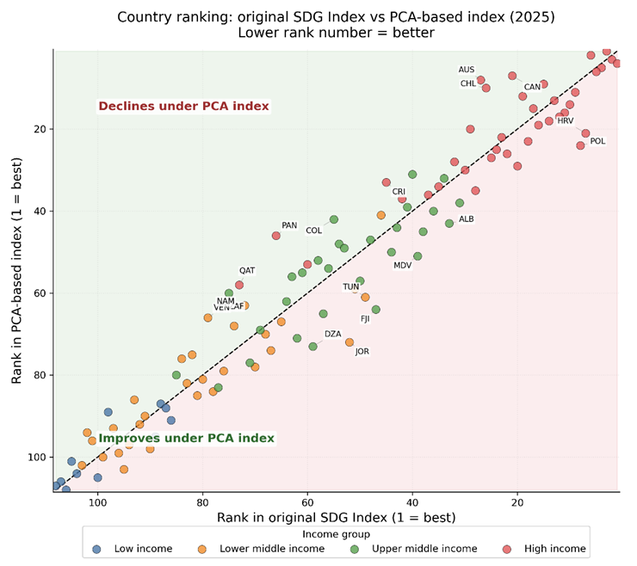
Supplementary Figure S6b shows the result when PC1 is signed so that the sustainability pole is positive — the “reversed” convention. The ranking is inverted: Finland, Sweden, Germany, Norway, Denmark, and the United Kingdom — ranked in the top 10 of the original SDG Index — collapse to the bottom of the PCA-based ranking. Yemen, Congo, Sudan, Liberia, Guinea-Bissau, Haiti, Pakistan, and Madagascar — ranked at the bottom of the original index — rise to the top. The Spearman correlation between this reversed PCA index and the original SDG Index is $-0.97$. The ranking has not been corrected; it has been mirrored.
Supplementary Figure S6b. Rank in PCA-based index vs SDG Index, 2025 (sustainability-reversed sign convention).
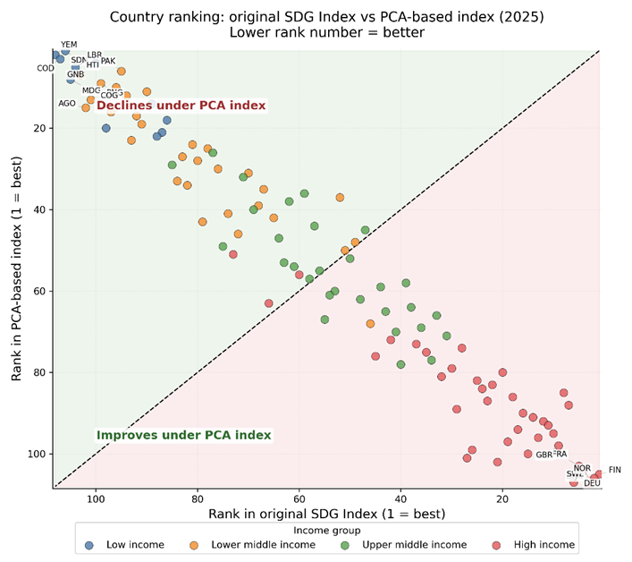
Neither sign convention produces a measure of sustainable development. The aligned version measures development (reproducing the original ranking); the reversed version measures sustainability (inverting it). The choice between them is statistically arbitrary — both are equally valid decompositions of the same variance-covariance structure. This demonstrates that the problem diagnosed in the main text cannot be resolved through PCA-based aggregation. The dominant axis of cross-country variation places development and sustainability in empirical opposition, and any composite that aggregates this axis into a single score must choose one pole or the other. PCA reveals this opposition; it cannot bridge it.

S6.2 Temporal stability: PCA 2000
To confirm that the principal component structure is not specific to the 2025 cross-section, we replicate the PCA analysis for 2000 using the balanced panel of 108 countries.
The three-component structure is virtually identical (Supplementary Table S6a). PC1 captures 56.3% of cross-country variance in 2000 (compared to 55.4% in 2025) and displays the same bipolar structure: all major development goals load strongly at one pole — SDG 3 (health, +0.94), SDG 11 (sustainable cities, +0.91), SDG 4 (education, +0.90), SDG 6 (clean water, +0.88), SDG 7 (clean energy, +0.87), SDG 1 (no poverty, +0.87), SDG 2 (zero hunger, +0.87), SDG 9 (industry, +0.86), SDG 16 (institutions, +0.84) — while SDG 12 (sustainable consumption, $-0.91$) and SDG 13 (climate action, $-0.70$) load at the opposite pole. The sign convention is reversed relative to 2025 (development positive in 2000, negative in 2025), reflecting the mathematical arbitrariness of component signs, not a change in structure.
PC2 accounts for 8.8% of variance (8.5% in 2025) and is defined by the same opposition between SDG 10 (reduced inequalities, $-0.68$) and SDG 17 (partnerships, +0.65), with secondary loadings from SDG 13 (climate action, +0.36), SDG 6 (clean water, +0.29), and SDG 7 (clean energy, +0.27). PC3 accounts for 7.9% of variance (8.1% in 2025) and captures the same biodiversity axis: SDG 15 (life on land, +0.75) and SDG 14 (life below water, +0.51), with a secondary contribution from SDG 8 (decent work, +0.47). The three components together explain 73.0% of the total variance, comparable to 72.0% in 2025.
Supplementary Table S6a. PCA loadings for the first three principal components of the 17 SDG goal scores, 2000 cross-section ($N$ = 108, balanced panel).
 |  | PC1: Development vs. Sustainability | PC2: Inequality & Partnerships | PC3: Biodiversity & Ecosystems
Goal | Label | Loading | Loading | Loading
SDG 1 | No poverty | +0.87 | +0.01 | -0.25
SDG 2 | Zero hunger | +0.87 | -0.05 | +0.13
SDG 3 | Health | +0.94 | +0.13 | -0.15
SDG 4 | Education | +0.90 | +0.16 | -0.04
SDG 5 | Gender equality | +0.77 | +0.24 | +0.27
SDG 6 | Clean water | +0.88 | +0.29 | +0.15
SDG 7 | Clean energy | +0.87 | +0.27 | -0.11
SDG 8 | Decent work | +0.63 | -0.19 | +0.47
SDG 9 | Industry & infrastructure | +0.86 | -0.24 | +0.09
SDG 10 | Reduced inequalities | +0.46 | -0.68 | -0.16
SDG 11 | Sustainable cities | +0.91 | +0.10 | +0.04
SDG 12 | Sustainable consumption | -0.91 | +0.27 | +0.10
SDG 13 | Climate action | -0.70 | +0.36 | +0.16
SDG 14 | Life below water | -0.09 | +0.16 | +0.51
SDG 15 | Life on land | +0.08 | -0.17 | +0.75
SDG 16 | Peace & institutions | +0.84 | -0.06 | -0.08
SDG 17 | Partnerships | +0.32 | +0.65 | -0.14
 | Variance explained | 56.3% | 8.8% | 7.9%
 | Cumulative | 56.3% | 65.1% | 73.0%
Note: Loadings represent Pearson correlations between each SDG goal score and the principal component. Bold values indicate loadings ≥ 0.50 in absolute value. Cells are shaded by component colour (blue = PC1, orange = PC2, green = PC3) with intensity proportional to the absolute loading. Environmental goals (SDGs 12–15) are italicised. The sign convention for PC1 in 2000 is reversed relative to 2025 (development goals load positively, sustainability goals negatively), reflecting the mathematical arbitrariness of component signs; the structure is identical. PC1 captures the development-versus-sustainability axis; PC2 captures inequality and international partnerships; PC3 captures biodiversity and terrestrial/marine ecosystems.
Source: Authors’ calculations from Sustainable Development Report 2025 (Sachs et al. 2025), retroactive time series

The biplots for 2000 (Supplementary Figures S6c–S6d) confirm the same spatial pattern as 2025. In the PC1 versus PC2 plane, high-income countries cluster at the development pole and low-income countries at the sustainability pole, with the income gradient driven by the bipolar structure of PC1. In the PC1 versus PC3 plane, income groups are dispersed vertically, confirming that the biodiversity dimension does not follow the income gradient. The country positions, the arrow directions, and the income-group clustering are indistinguishable from the 2025 results.
Supplementary Figure S6c. Biplot of PC1 and PC2 for the 2000 cross-section, with countries coloured by World Bank income group.
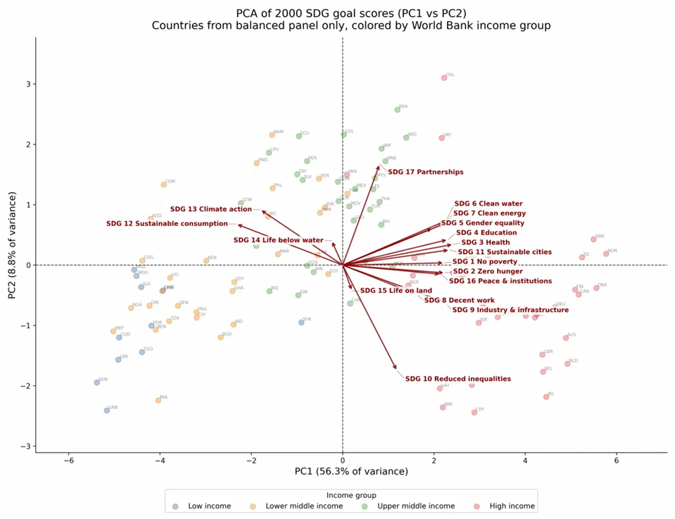
Supplementary Figure S6d. Biplot of PC1 and PC3 for the 2000 cross-section, with countries coloured by World Bank income group.
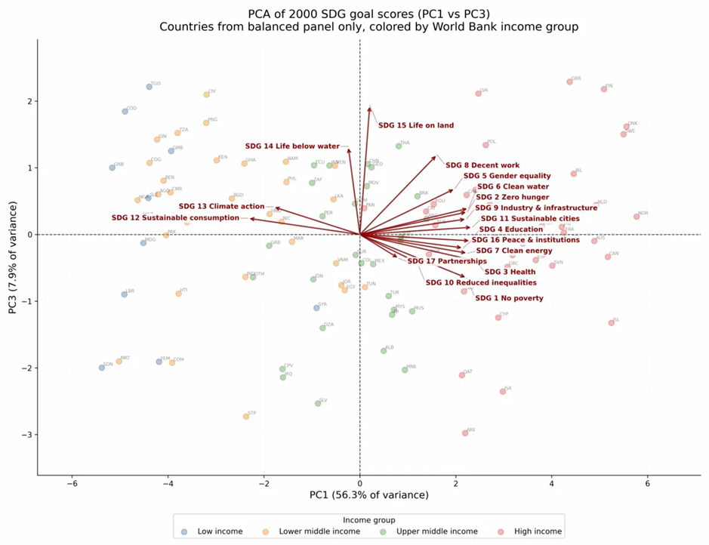
The variance-weighted PCA index constructed from the 2000 components reproduces the same sign problem identified for 2025: under one sign convention it correlates strongly with the original SDG Index (Spearman $ρ$ $≈$ 0.97), under the other it inverts the ranking ($ρ$ $≈$ $-0.97$). The bipolar structure of PC1 — and its resistance to aggregation — is not a feature of a single cross-section. It has been present since at least 2000.
Supplementary Figures S6e–S6f. Rank in PCA-based index vs SDG Index, 2000 (both sign conventions).
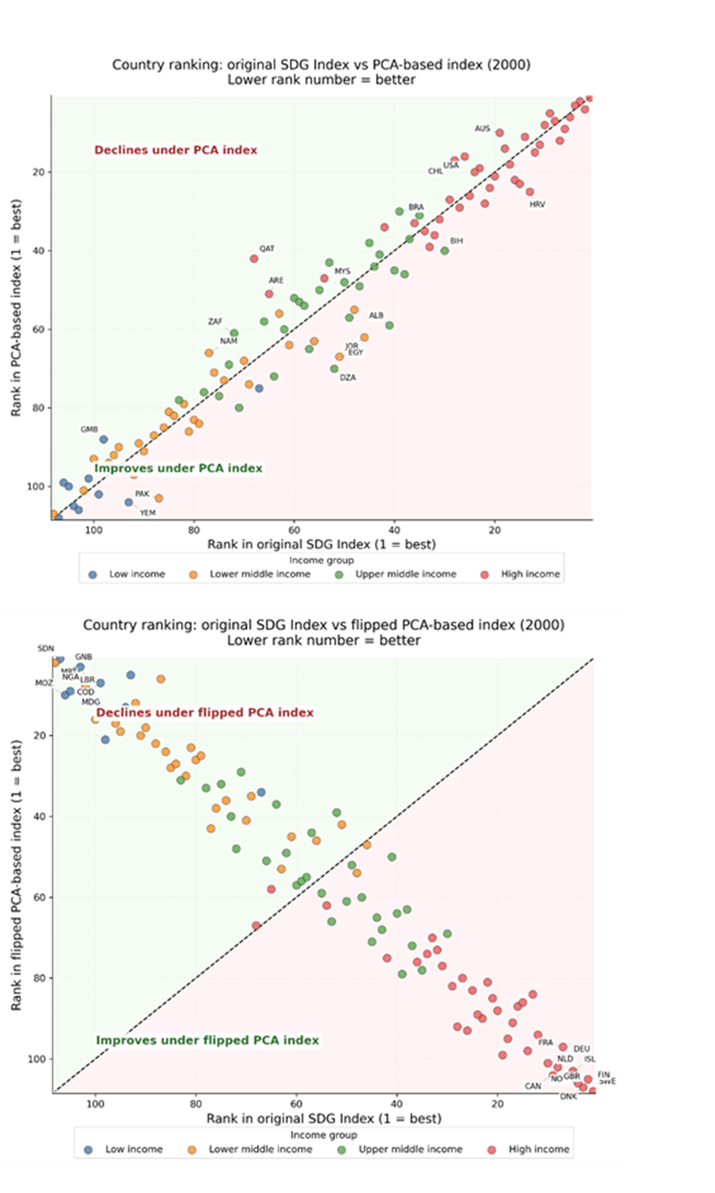

S7. Alternative aggregation methods — full equations and worked example

S7.1 Overview
We compare four methods, chosen to span the spectrum from full compensability to explicit non-compensability. All four are applied to the 2025 cross-section using the same 17 goal scores published by the SDSN. The goal scores are already normalised to a $\left[0,100\right]$ scale (Lafortune et al. 2018); no additional normalisation is applied.
The four methods can be understood as progressively tightening the degree to which strong performance on some goals can compensate for weak performance on others. If the problem diagnosed in the main text is purely an artefact of the arithmetic mean, then switching to a different compensatory formula should resolve it. If the problem persists under geometric and soft-min aggregation, then it cannot be resolved within the logic of aggregation itself — because any method that combines goal scores into a single number through a formula, however nonlinear, necessarily permits some degree of substitution between goals. Aggregation is compensability: even a geometric mean or a soft-min allows strong performance on some goals to offset weak performance on others, differing only in the rate at which substitution occurs. Only a method that abandons the aggregation logic entirely — comparing countries pairwise rather than collapsing their performance into a single score, and imposing explicit veto thresholds that no amount of development performance can override — can enforce the non-compensability that sustainable development requires.

S7.2 Method 1: Arithmetic mean (the current SDG Index)
$$I^{A}=\frac{1}{17}\sum_{k=1}^{17}{G_{k}}$$
Fully compensatory. ${\text{MRS}}_{jk}=-1$ for all pairs. A one-point gain in any goal offsets a one-point loss in any other. There is no penalty for imbalance across goals.

S7.3 Method 2: Geometric mean
The geometric mean is defined as:
$$I^{G}={\left(\prod_{k=1}^{17}{G_{k}}\right)}^{1/17},$$
where $G_{k}>0$is the score of goal $k$. Taking logarithms gives:
$$log⁡I^{G}=\frac{1}{17}\sum_{k=1}^{17}{log⁡}G_{k}.$$
Thus, in log-space, the geometric mean is an arithmetic average. In level-space, however, the marginal rate of substitution is no longer constant. Since
$$\frac{∂I^{G}}{∂G_{k}}=\frac{1}{17}\frac{I^{G}}{G_{k}},$$
the slope of an iso-index curve between goals $j$and $k$is:
$${MRS}_{jk}=\frac{dG_{j}}{dG_{k}}=-\frac{∂I^{G}/∂G_{k}}{∂I^{G}/∂G_{j}}=-\frac{G_{j}}{G_{k}}.$$
Here ${MRS}_{jk}$denotes the amount of $G_{j}$that must be given up to gain one additional unit of $G_{k}$, holding $I^{G}$constant. Unlike the arithmetic mean, this trade-off depends on the relative level of the two goal scores. When $G_{k}$is low, $∣{MRS}_{jk}∣$is large: one additional point in the weak goal $k$can compensate for a larger loss in the stronger goal $j$. The geometric mean therefore penalises imbalance across goals.
A numerical example illustrates this. Country A scores $\left(40 , 80\right)$, while Country B scores $\left(60 , 60\right)$. Both have the same arithmetic mean:
$$\frac{40+80}{2}=\frac{60+60}{2}=60.$$
But their geometric means differ:
$$I_{A}^{G}=\sqrt{40×80}=56.6,I_{B}^{G}=\sqrt{60×60}=60.0.$$
The geometric mean therefore ranks the balanced country higher, even though both countries have the same arithmetic average.
This is the aggregation adopted by the Human Development Index since 2010 (UNDP 2010). However, the geometric mean remains compensatory: a low score reduces the composite more strongly than under the arithmetic mean, but it does not impose an explicit sustainability floor or veto. It changes the shape of the trade-off, but it does not eliminate substitution across goals.

S7.4 Method 3: Soft-min
The soft-min aggregation is defined as:
$$I^{S}=-\frac{1}{β}log⁡\left(\frac{1}{17}\sum_{k=1}^{17}{exp}⁡(-βG_{k})\right),$$
where $G_{k}$is the score of goal $k$on the 0–100 scale and $β>0$controls how strongly the index is pulled toward the lowest-scoring goal. The soft-min is a smooth approximation to the minimum. As $β→∞$, $I^{S}$converges to ${min⁡}_{k}G_{k}$. As $β→0$, it converges to the arithmetic mean: using the Taylor expansion $exp⁡(-βG_{k})=1-βG_{k}+O(β^{2})$, the average inside the logarithm is $1-β\overset{ˉ}{G}+O(β^{2})$, so
$$-\frac{1}{β}log⁡\left(1-β\overset{ˉ}{G}+O(β^{2})\right)→\overset{ˉ}{G}.$$
In our implementation, $β=8$. At this value, the soft-min places overwhelming weight on the lowest-scoring goal. To illustrate, consider a country scoring 40 on one goal and 80 on the remaining 16 goals. Its arithmetic mean is:
$$\frac{40+16×80}{17}=77.65.$$
Its geometric mean is:
$$\left(40×{80}^{16})^{1/17}=76.80.\right.$$
Its soft-min is:
$$I^{S}=-\frac{1}{8}log⁡\left(\frac{exp⁡(-8×40)+16exp⁡(-8×80)}{17}\right)≈40.35.$$
The soft-min is therefore much closer to the worst-performing goal than to either the arithmetic or geometric mean. It approaches non-compensability in spirit because the composite is dominated by the weakest dimension. However, it does not impose an explicit floor or veto. Strong performance on other goals can still affect the final score, although only weakly when $β$is large.

S7.5 Method 4: Multicriteria outranking with a sustainability floor
The three methods above all share a common structure: they aggregate the 17 goal scores into a single number for each country, and then rank countries by that number. The multicriteria approach is different. Instead of first constructing a composite score, it compares countries pairwise. For each ordered pair of countries $\left(i , j\right)$, it asks: to what extent is country $i$preferred to country $j$, once we consider both its full SDG profile and its performance on the protected environmental goals?
The method follows the logic of outranking methods in multicriteria decision analysis, but we implement it in a continuous form. Countries are not excluded by a hard rule. Instead, countries with environmental shortfalls receive a continuous penalty that reduces their capacity to outrank other countries.
For each ordered pair of countries $\left(i , j\right)$, the preference of country $i$over country $j$is computed in three steps.
Step 1: Concordance across the 17 SDGs
For each goal $k$, we first compute the raw score difference between country $i$and country $j$:
$$G_{ik}-G_{jk}.$$
This difference is then transformed into a smooth preference contribution using a sigmoid function:
$$π_{k}(i,j)=σ\left[α\left(G_{ik} − G_{jk}\right)\right],$$
where
$$σ(z)=\frac{1}{1+exp⁡(-z)}$$
and
$$α=0.1.$$
The sigmoid maps each goal-level difference into the interval $\left(0 , 1\right)$. If country $i$strongly outperforms country $j$on goal $k$, then $π_{k}(i,j)$is close to 1. If country $i$strongly underperforms country $j$, then $π_{k}(i,j)$is close to 0. If the two countries have the same score, then $π_{k}(i,j)=0.5$.
The parameter $α=0.1$controls how quickly the preference function moves away from 0.5. For example, a 20-point advantage gives
$$σ(0.1×20)=σ(2)=0.881,$$
while a 50-point advantage gives
$$σ(0.1×50)=σ(5)=0.993.$$
The pairwise concordance of country $i$over country $j$is the average of these 17 goal-level preference contributions:
$$C(i,j)=\frac{1}{17}\sum_{k=1}^{17}{π_{k}}(i,j).$$
This concordance term captures the extent to which country $i$tends to outperform country $j$across the full SDG profile. Since the sigmoid is symmetric, $σ(z)+σ(-z)=1$, we also have
$$C(i,j)+C(j,i)=1.$$
Step 2: Calibrated environmental-floor penalty
The concordance term treats all 17 goals symmetrically. The environmental-floor penalty introduces limited compensation by protecting SDG 12 and SDG 13. The purpose is to prevent high scores on other goals from fully offsetting large environmental shortfalls.
The method uses goal-specific environmental floors. That is, SDG 12 and SDG 13 do not have to share the same threshold. Let
$$F_{12}$$
be the floor for SDG 12, and let
$$F_{13}$$
be the floor for SDG 13.
For SDG 12, the proportional shortfall of country $i$is
$$p_{12}(i)=max⁡\left(\frac{F_{12}-G_{i,12}}{F_{12}} , 0\right).$$
For SDG 13, the proportional shortfall is
$$p_{13}(i)=max⁡\left(\frac{F_{13}-G_{i,13}}{F_{13}} , 0\right).$$
The environmental penalty is the maximum of these two proportional shortfalls:
$$P(i)=max⁡\left[p_{12}(i),p_{13}(i)\right].$$
Equivalently,
$$P(i)=max⁡\left[max⁡\left(\frac{F_{12}-G_{i,12}}{F_{12}} , 0\right),max⁡\left(\frac{F_{13}-G_{i,13}}{F_{13}} , 0\right)\right].$$
This penalty is country-specific. It depends on whether country $i$falls below the SDG 12 or SDG 13 floor. It does not depend on the environmental score of country $j$. A country receives no environmental penalty only if it satisfies both floors:
$$G_{i,12}≥F_{12}$$
and
$$G_{i,13}≥F_{13}.$$
If a country falls below either floor, the penalty increases continuously with the size of the proportional shortfall. The method is therefore not a hard exclusion rule. Instead, it reduces the country’s pairwise preference strength in proportion to the severity of its environmental underperformance.
The central floors are calibrated from external footprint scenarios. For SDG 12, the central floor comes from the 50 Gt/year material-footprint scenario, translated into a per-capita material-footprint cap of approximately 6.3 t/cap. This maps empirically into
$$F_{12}=80.$$
For SDG 13, the central floor comes from the central 1.5C carbon-budget scenario, corresponding to approximately 2 tCO2/cap. This maps empirically into
$$F_{13}=95.$$
The central specification is therefore
$$(F_{12},F_{13})=(80,95).$$
We also report scenario-based robustness checks. The lenient specification uses
$$(F_{12},F_{13})=(75,90),$$
while the strict specification uses
$$(F_{12},F_{13})=(90,95).$$
The three specifications are summarized below.
Specification | Interpretation | SDG 12 floor $F_{12}$ | SDG 13 floor $F_{13}$
Lenient | Higher material allowance and less stringent carbon benchmark | 75 | 90
Central | 50 Gt/year material cap and central 1.5C carbon budget | 80 | 95
Strict | Lower material allowance with 1.5C-compatible carbon floor | 90 | 95
Step 3: Final pairwise preference
The final preference of country $i$over country $j$is the concordance score minus the environmental penalty of country $i$, floored at zero:
$$\text{Pref}(i,j)=max⁡\left[C(i,j)-P(i),0\right].$$
When $P(i)=0$, the preference of country $i$over country $j$is simply its concordance over $j$. When $P(i)$is positive, the environmental shortfall reduces the capacity of country $i$to outrank country $j$. If the penalty is large enough, the pairwise preference can be reduced to zero.
The important point is that the penalty applies to the country claiming preference. If country $i$has a strong development profile but falls far below the environmental floors, its preference over other countries is reduced. This is how the method limits compensation between development performance and environmental underperformance.
Ranking by net outranking flow
After computing $\text{Pref}(i,j)$for every ordered pair of countries, we compute the positive, negative, and net outranking flows.
The positive flow is
$$ϕ^{+}(i)=\frac{1}{n-1}\sum_{j≠i}{\text{Pref}(i,j).}$$
This measures how strongly country $i$outranks all other countries on average.
The negative flow is
$$ϕ^{-}(i)=\frac{1}{n-1}\sum_{j≠i}{\text{Pref}(j,i).}$$
This measures how strongly other countries outrank country $i$on average.
The net flow is
$$ϕ(i)=ϕ^{+}(i)-ϕ^{-}(i).$$
Countries are ranked by descending net flow. A country receives a high rank if it tends to outrank many other countries and is not strongly outranked by them.
The key distinction: limited compensation through calibrated floors
The critical feature of the multicriteria method is that it limits the extent to which high scores on other goals can compensate for weak performance on SDG 12 and SDG 13. The method does not remove countries from the ranking. It also does not impose a binary pass/fail rule. Instead, it reduces a country’s pairwise preference strength when it falls below the calibrated environmental floors.
This means that a country can still perform well in the multicriteria ranking if it has a strong overall SDG profile and only small environmental shortfalls. However, the more severe the shortfall on SDG 12 or SDG 13, the more difficult it becomes for performance on the other goals to compensate.
The method has one implementation parameter and two calibrated environmental floors. The implementation parameter is
$$α=0.1,$$
which controls the smoothness of the pairwise preference function. The substantive parameters are the environmental floors
$$F_{12}$$
and
$$F_{13}.$$
These floors are calibrated from external footprint scenarios and varied in the robustness analysis.
S7.6 Worked example: Spain vs Peru
To see how the new multicriteria method works, consider one real pairwise comparison: Spain versus Peru in 2025.
Spain has a higher arithmetic SDG Index score than Peru: 81.04 versus 72.67. Spain also performs better than Peru on 12 of the 17 goals. However, the pairwise concordance is not computed as a simple count of goals won. Instead, each goal difference is converted into a smooth preference contribution between 0 and 1 using the sigmoid function.
For each goal $g$, Spain’s preference contribution over Peru is
$$π_{g}(\text{Spain},\text{Peru})=\frac{1}{1+exp⁡[-0.1(G_{\text{Spain},g}-G_{\text{Peru},g})]}.$$
The purpose of this transformation is to avoid a simple win/loss count. Small differences give values close to 0.5. Large Spanish advantages give values close to 1. Large Peruvian advantages give values close to 0.
For example, on SDG 9, Spain is 38.86 points ahead of Peru. Spain’s preference contribution is therefore
$$π_{9}=\frac{1}{1+exp⁡[-0.1(38.86)]}=\frac{1}{1+exp⁡[-3.886]}=0.980.$$
By contrast, on SDG 12, Peru is 22.67 points ahead of Spain, so Spain’s difference is $-22.67$. Spain’s preference contribution on SDG 12 is therefore
$$π_{12}=\frac{1}{1+exp⁡[-0.1(-22.67)]}=\frac{1}{1+exp⁡[2.267]}=0.094.$$
The full calculation is shown below.
Goal | Spain | Peru | Spain − Peru | Preference contribution
SDG 1 | 99.30 | 86.09 | +13.21 | 0.789
SDG 2 | 69.85 | 69.10 | +0.75 | 0.519
SDG 3 | 94.90 | 79.79 | +15.11 | 0.819
SDG 4 | 97.24 | 97.58 | −0.34 | 0.492
SDG 5 | 87.50 | 74.68 | +12.82 | 0.783
SDG 6 | 85.27 | 84.19 | +1.08 | 0.527
SDG 7 | 79.16 | 74.71 | +4.45 | 0.609
SDG 8 | 81.72 | 71.00 | +10.72 | 0.745
SDG 9 | 83.90 | 45.04 | +38.86 | 0.980
SDG 10 | 82.55 | 50.88 | +31.67 | 0.960
SDG 11 | 98.09 | 63.19 | +34.90 | 0.970
SDG 12 | 65.12 | 87.79 | −22.67 | 0.094
SDG 13 | 83.64 | 94.32 | −10.67 | 0.256
SDG 14 | 55.86 | 78.60 | −22.74 | 0.093
SDG 15 | 68.08 | 54.60 | +13.48 | 0.794
SDG 16 | 76.33 | 50.72 | +25.61 | 0.928
SDG 17 | 69.12 | 73.11 | −3.99 | 0.402
The average of the last column is
$$C(\text{Spain},\text{Peru})=0.633.$$
This is Spain’s initial concordance over Peru before applying the environmental-floor penalty.
Now consider the central floor specification:
$$(F_{12},F_{13})=(80,95).$$
Spain scores 65.12 on SDG 12 and 83.64 on SDG 13. Therefore Spain is below both calibrated environmental floors.
Spain’s SDG 12 shortfall is
$$p_{12}(\text{Spain})=\frac{80-65.12}{80}=\frac{14.88}{80}=0.186.$$
Spain’s SDG 13 shortfall is
$$p_{13}(\text{Spain})=\frac{95-83.64}{95}=\frac{11.36}{95}=0.120.$$
The environmental penalty is the maximum of the two proportional shortfalls:
$$P(\text{Spain})=max⁡(0.186,0.120)=0.186.$$
Spain’s final pairwise preference over Peru is therefore
$$\text{Pref}(\text{Spain},\text{Peru})=max⁡[0.633-0.186,0]=0.447.$$
Thus, Spain’s broad advantage across the full SDG profile is reduced, but not eliminated. The reason is that Spain does fall below the SDG 12 and SDG 13 floors, but the penalty is proportional to the shortfall rather than a hard veto.
The same calculation can be done in the opposite direction. Since
$$C(\text{Spain},\text{Peru})=0.633,$$
we have
$$C(\text{Peru},\text{Spain})=1-0.633=0.367.$$
Peru scores 87.79 on SDG 12 and 94.32 on SDG 13. Peru is above the SDG 12 floor but slightly below the SDG 13 floor.
Peru’s SDG 12 shortfall is
$$p_{12}(\text{Peru})=max⁡\left(\frac{80-87.79}{80} , 0\right)=0.$$
Peru’s SDG 13 shortfall is
$$p_{13}(\text{Peru})=\frac{95-94.32}{95}=\frac{0.68}{95}=0.007.$$
Therefore,
$$P(\text{Peru})=max⁡(0,0.007)=0.007.$$
Peru’s final pairwise preference over Spain is
$$\text{Pref}(\text{Peru},\text{Spain})=max⁡[0.367-0.007,0]=0.360.$$
The central pairwise comparison is summarized below.
Direction | Concordance $C(i,j)$ | Environmental penalty $P(i)$ | Final preference $\text{Pref}(i,j)$
Spain over Peru | 0.633 | 0.186 | 0.447
Peru over Spain | 0.367 | 0.007 | 0.360
This example shows how the multicriteria method works. Spain has a stronger overall SDG profile, so its concordance over Peru is higher. However, Spain’s environmental-floor penalty is also much larger because it falls substantially below the SDG 12 and SDG 13 floors. Peru has a weaker overall concordance over Spain, but it receives almost no environmental penalty because it is above the SDG 12 floor and only slightly below the SDG 13 floor.
The result is not that Spain is automatically ruled out. Instead, Spain’s preference over Peru is reduced from 0.633 to 0.447. Peru’s preference over Spain is reduced only slightly, from 0.367 to 0.360. The difference between the two final preferences is therefore much smaller than the initial concordance gap.
This is the core logic of the multicriteria index. Countries are not excluded for failing an environmental floor. Rather, environmental shortfalls reduce their ability to outrank other countries. In the full implementation, this calculation is repeated for every ordered pair of countries. Countries are then ranked by their net outranking flow:
$$ϕ(i)=ϕ^{+}(i)-ϕ^{-}(i).$$
The Spain–Peru example illustrates the mechanism for one pairwise comparison, but the final country ranking depends on how each country compares with all other countries in the sample.

S7.7 Perturbation test for residual compensability
The multicriteria index is designed to limit compensation between strong development performance and weak environmental performance. However, because the method uses a continuous environmental-floor penalty rather than a hard veto, it is important to test whether residual compensation remains possible. We therefore implement a perturbation test that directly examines whether a deterioration in SDG 12 and SDG 13 can be offset by improvements in the other SDGs.
For each country, we construct counterfactual profiles in which both SDG 12 and SDG 13 are reduced by 5, 10, 15, 20, or 30 points. The lost points are then redistributed across the remaining 15 SDGs, subject to the 0–100 score bounds. The purpose is to create a stringent test: environmental performance deteriorates, the environmental-floor penalty increases, but the arithmetic mean is held constant whenever full compensation is feasible. We refer to these as clean perturbation cases.
For each clean perturbation, we compare the original country profile with its perturbed counterpart in the same pairwise comparison set. If the multicriteria method were fully compensatory, the perturbed profile could often preserve or improve its multicriteria score or rank despite worse performance on SDG 12 and SDG 13. Conversely, a strictly non-compensatory hard-veto method would never allow the perturbed profile to avoid a worse score or rank once the environmental-floor penalty increases.
The results are reported in Table S7.2. Across all three floor specifications and all perturbation sizes, the median change in the multicriteria score is negative. The median rank change is also always positive, meaning that countries systematically fall in the ranking after environmental deterioration. The magnitude of the effect is substantial. Under the central specification, a 10-point deterioration in SDG 12 and SDG 13 produces a median fall of 39 ranks; a 30-point deterioration produces a median fall of 89 ranks.
At the same time, the test confirms that the method is not mathematically equivalent to a hard veto. In a small number of clean cases, the perturbed profile is not worse than the original profile. These cases represent residual compensability. However, they are rare: the share of clean perturbations in which the perturbed profile avoids a worse score or rank ranges from 1.9% to 2.8%. Thus, the multicriteria index behaves overwhelmingly as a non-compensatory ranking in practice, while retaining the continuous structure of an outranking method rather than imposing a binary exclusion rule.
The same perturbation test was applied to the central hard-veto specification (S7.8). Its clean-case residual compensability remains in the same range as the three floor-only specifications (1.9%–2.8%): the within-country test — whether boosting the fifteen development goals can offset a deliberate loss on SDG 12 and SDG 13 — is largely insensitive to the hard veto, because the continuous floor penalty already removes the overwhelming majority of such compensation. The hard veto’s distinctive effect is not on this within-country measure but on the cross-country ranking: by barring any country that fails the central floor from outranking any country that passes it, it converts the graded floor into strict non-compensability between the two groups. That is what inverts the ordering (S7.8), rather than further changing the perturbation result reported here.
Table S7.2. Perturbation test for residual compensability in the multicriteria ranking.
Positive rank changes indicate that the perturbed country receives a worse rank. “Non-worse score” and “non-worse rank” report the number and share of clean perturbation cases in which the perturbed profile does not receive a worse multicriteria score or rank despite worse SDG 12 and SDG 13 performance.
Specification | Floors | SDG 12/13 drop | Clean cases | Median score change | Median rank change | Non-worse score | Non-worse rank
MC central | F12=80, F13=95 | −5 | 108 | −0.055 | +19.5 | 2 / 108 = 1.9% | 2 / 108 = 1.9%
MC central | F12=80, F13=95 | −10 | 108 | −0.110 | +39.0 | 2 / 108 = 1.9% | 2 / 108 = 1.9%
MC central | F12=80, F13=95 | −15 | 108 | −0.162 | +55.0 | 3 / 108 = 2.8% | 3 / 108 = 2.8%
MC central | F12=80, F13=95 | −20 | 108 | −0.211 | +68.0 | 3 / 108 = 2.8% | 3 / 108 = 2.8%
MC central | F12=80, F13=95 | −30 | 108 | −0.283 | +89.0 | 3 / 108 = 2.8% | 3 / 108 = 2.8%
MC lenient | F12=75, F13=90 | −5 | 73 | −0.058 | +20.0 | 2 / 73 = 2.7% | 2 / 73 = 2.7%
MC lenient | F12=75, F13=90 | −10 | 108 | −0.096 | +28.5 | 2 / 108 = 1.9% | 2 / 108 = 1.9%
MC lenient | F12=75, F13=90 | −15 | 108 | −0.151 | +44.5 | 2 / 108 = 1.9% | 2 / 108 = 1.9%
MC lenient | F12=75, F13=90 | −20 | 108 | −0.196 | +61.0 | 2 / 108 = 1.9% | 2 / 108 = 1.9%
MC lenient | F12=75, F13=90 | −30 | 108 | −0.275 | +85.5 | 3 / 108 = 2.8% | 3 / 108 = 2.8%
MC strict | F12=90, F13=95 | −5 | 108 | −0.057 | +23.0 | 2 / 108 = 1.9% | 2 / 108 = 1.9%
MC strict | F12=90, F13=95 | −10 | 108 | −0.112 | +41.0 | 2 / 108 = 1.9% | 2 / 108 = 1.9%
MC strict | F12=90, F13=95 | −15 | 108 | −0.164 | +59.0 | 2 / 108 = 1.9% | 2 / 108 = 1.9%
MC strict | F12=90, F13=95 | −20 | 108 | −0.210 | +76.0 | 3 / 108 = 2.8% | 3 / 108 = 2.8%
MC strict | F12=90, F13=95 | −30 | 108 | −0.273 | +93.5 | 3 / 108 = 2.8% | 3 / 108 = 2.8%
MC central hard veto | F12=80, F13=95 | −5 | 108 | −0.052 | +20.0 | 2 / 108 = 1.85% | 2 / 108 = 1.85%
MC central hard veto | F12=80, F13=95 | −10 | 108 | −0.106 | +38.0 | 3 / 108 = 2.78% | 3 / 108 = 2.78%
MC central hard veto | F12=80, F13=95 | −15 | 108 | −0.157 | +52.0 | 3 / 108 = 2.78% | 3 / 108 = 2.78%
MC central hard veto | F12=80, F13=95 | −20 | 108 | −0.203 | +63.0 | 3 / 108 = 2.78% | 3 / 108 = 2.78%
MC central hard veto | F12=80, F13=95 | −30 | 108 | −0.268 | +80.0 | 3 / 108 = 2.78% | 3 / 108 = 2.78%
The lower number of clean cases for the lenient specification with a 5-point perturbation reflects the fact that some country profiles do not experience an increase in the environmental-floor penalty under such a small perturbation. These cases are excluded from the clean test because the diagnostic is specifically designed to evaluate whether compensation is possible once the floor penalty increases.
Overall, the perturbation test supports the interpretation of the multicriteria index as a limited-compensation method. Environmental deterioration in SDG 12 and SDG 13 is strongly penalized even when the arithmetic mean is mechanically preserved through improvements in the other SDGs. The method is therefore not fully compensatory in practice. Nevertheless, because a very small share of perturbed profiles can avoid a worse score or rank, the index should be described as a continuous limited-compensation outranking method, not as a hard-veto or strictly non-compensatory rule.

S7.8 Central hard-veto specification (strong sustainability)
The floor-only specifications above apply a continuous penalty that limits, but does not abolish, compensation between development and environmental performance (S7.7). As the strong-sustainability specification, we add one further specification that enforces strict non-compensability — a hard veto — at the central floors (F₁₂ = 80, F₁₃ = 95). A country passes the central floor when its penalty is zero (Pᵢ = 0), that is, when it scores at or above both floors; otherwise it fails. Under the hard veto a failing country is barred from outranking any passing country, regardless of its development performance:
$$π_{ij}^{\text{HV}} = 0\text{ if }P_{i}\text{ > }0\text{ and }P_{j}\text{ = }0$$
$$π_{ij}^{\text{HV}} = \text{max}\left(C_{ij} - P_{i}, 0\right)\text{ otherwise}$$
The veto is a strict pairwise rule, not a tunable threshold: there is no gap parameter, and the tolerance used to identify floor-passers is numerical only. For all other pairs the continuous penalty of the central specification applies unchanged, and countries are ranked by descending net outranking flow as before.
This limiting case inverts the ranking. Of the complete-case countries, only 35 clear both central floors, and these are overwhelmingly low- and lower-middle-income economies whose low consumption yields high SDG 12 and SDG 13 scores. Because no failing country can outrank a passing one, the environmental goals become positively correlated with overall rank and the development goals negatively correlated — a mirror image of the arithmetic SDG Index (Table S7.3; Fig. S7.8). SDG 12 moves from −0.41 under the central floor-only specification to +0.51 under the hard veto, and SDG 13 from −0.29 to +0.68, while SDG 9 moves from +0.50 to −0.42 and SDG 3 from +0.52 to −0.40. Every high-income country fails the central floor: Finland falls from first to 25th, the United States to 95th, and Australia to 100th. The graded floor and the hard veto thus bracket the result — the former rebalances the ranking, the latter inverts it — tracing the spectrum from weak to strong sustainability, with the continuous central specification as the conservative interior point.
Table S7.3. Spearman correlation between each SDG goal score and the four multicriteria specifications (2025). The three floor-only specifications keep SDG 12 and SDG 13 negatively correlated with rank; the central hard veto reverses every sign.
SDG goal | MC lenient | MC central | MC strict | MC central hard veto
SDG 1 (No poverty) | +0.53 | +0.49 | +0.43 | −0.42
SDG 3 (Health) | +0.55 | +0.52 | +0.47 | −0.40
SDG 9 (Industry) | +0.54 | +0.50 | +0.47 | −0.42
SDG 11 (Cities) | +0.61 | +0.57 | +0.50 | −0.34
SDG 16 (Institutions) | +0.52 | +0.50 | +0.45 | −0.28
SDG 12 (Consumption) | −0.46 | −0.41 | −0.32 | +0.51
SDG 13 (Climate) | −0.35 | −0.29 | −0.25 | +0.68

Figure S7.8. Spearman correlation between each SDG goal score and each aggregation method (2025), including the central hard-veto specification (rightmost column). Under the hard veto the environmental goals SDG 12 and SDG 13 become positively correlated with rank and the development goals negatively correlated, inverting the pattern of the compensatory methods.

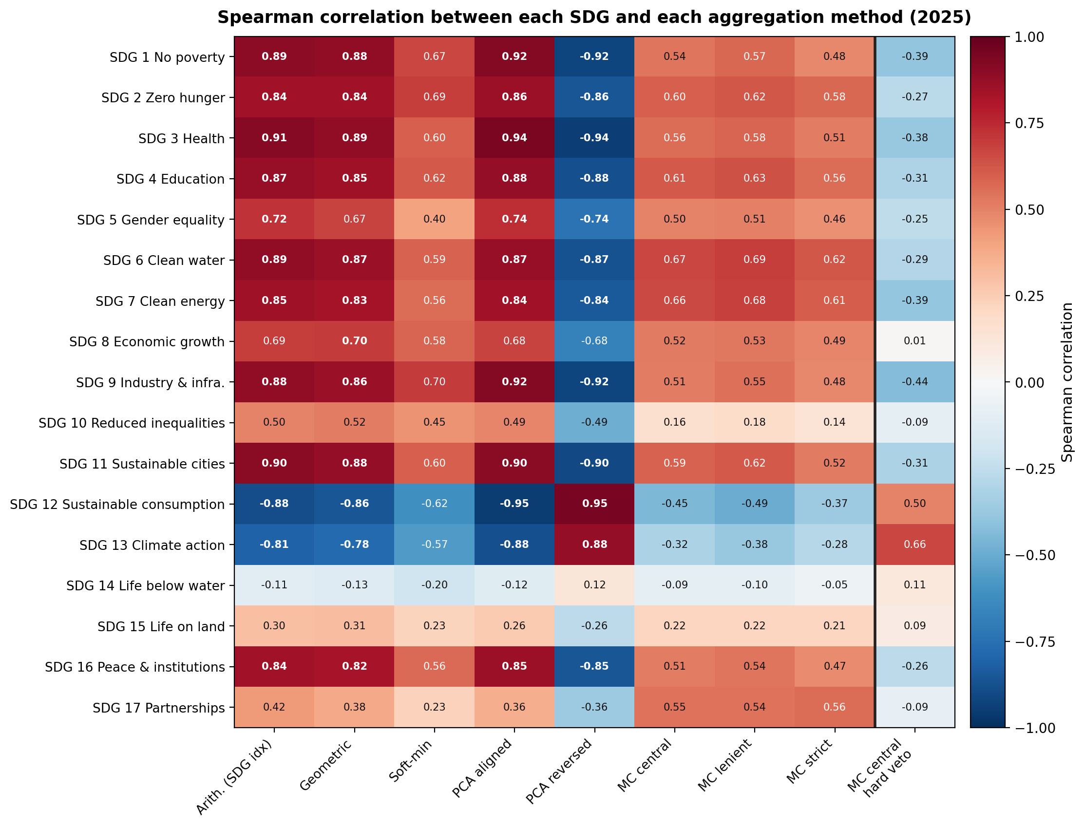
S8. Alternative aggregation — additional results
Supplementary Figure S8a presents the Spearman correlation matrix across the nine aggregation methods applied to the 2025 cross-section. The methods include five alternative score-based aggregations — arithmetic mean, geometric mean, soft-min, PCA aligned, and PCA reversed — and the three floor-only multicriteria specifications based on calibrated environmental floors (MC central, MC lenient, and MC strict), together with the central hard-veto specification (S7.8).
The heatmap shows three main patterns. First, the conventional compensatory methods form a highly correlated block. The arithmetic and geometric indices are almost identical, with a correlation of 0.99. The arithmetic index also correlates strongly with PCA aligned, at 0.97, while the geometric index correlates with PCA aligned at 0.95. The soft-min is somewhat more distinct, correlating at 0.79 with the arithmetic mean and 0.69 with PCA aligned. This reflects the greater sensitivity of the soft-min to weak performance in individual goals. Nevertheless, the soft-min remains closer to the conventional compensatory block than to PCA reversed.
Second, PCA reversed behaves as the mirror image of PCA aligned. Its correlation with PCA aligned is -1.00. It is also strongly negatively correlated with the arithmetic and geometric indices, at -0.97 and -0.95 respectively. This confirms the sign arbitrariness discussed in S5: reversing the PCA sign produces an almost perfectly opposite ordering without changing the underlying statistical construction.
Third, the three multicriteria specifications form a highly coherent block. MC central and MC lenient are almost perfectly correlated, with a correlation of 1.00. MC central correlates with MC strict at 0.98, and MC lenient correlates with MC strict at 0.97. This shows that the multicriteria ranking is internally robust across the three scenario-based floor pairs:
$$(F_{12},F_{13})=(75,90), \\ (F_{12},F_{13})=(80,95),$$
and
$$(F_{12},F_{13})=(90,95).$$
The multicriteria block is related to the conventional methods, but it remains substantively distinct. The arithmetic index correlates with MC central at 0.72, with MC lenient at 0.75, and with MC strict at 0.66. The geometric index shows a similar pattern, with correlations of 0.73, 0.75, and 0.67. PCA aligned correlates with the multicriteria specifications at 0.65, 0.68, and 0.58.
This intermediate correlation is important. The multicriteria method does not simply invert the conventional SDG ranking, as PCA reversed does. But it also does not reproduce the arithmetic SDG Index. Instead, it partially preserves the information contained in the full SDG profile while reducing the capacity of strong performance on other goals to compensate for environmental shortfalls on SDG 12 and SDG 13.
The soft-min occupies an intermediate position. It correlates with MC central at 0.70, with MC lenient at 0.72, and with MC strict at 0.67. This is consistent with its partial non-compensatory logic: by being more sensitive to low goal scores, the soft-min moves closer to the multicriteria method than the arithmetic mean does in some cases. However, it remains a single composite score and does not apply goal-specific environmental floors.
Fourth, the central hard-veto specification stands apart from every other method. Because it enforces strict non-compensability — barring any country that fails the central SDG 12 or SDG 13 floor from outranking any country that passes them — it inverts the ranking rather than rebalancing it. It correlates negatively with the arithmetic SDG Index (−0.30), close to zero with its own floor-only central counterpart (+0.08), and positively with PCA reversed (+0.40), the environmental mirror of the conventional ordering. It is reported here as a strong-sustainability specification (S7.8).
Finally, PCA reversed remains negatively associated with the multicriteria block. Its correlations with MC central, MC lenient, and MC strict are -0.65, -0.68, and -0.58. This confirms that the multicriteria rankings are not simply the reverse of the conventional SDG rankings. They reflect a distinct aggregation logic based on limited compensation for SDG 12 and SDG 13 shortfalls.
Supplementary Figure S8a. Spearman correlation heatmap of country scores by aggregation method, 2025. The heatmap reports Spearman correlations across country scores for the arithmetic mean, geometric mean, soft-min, PCA aligned, PCA reversed, the three floor-only multicriteria specifications, and the central hard-veto specification (rightmost row and column). MC lenient uses $\left(F_{12},F_{13})=(75,90\right)$, MC central uses $\left(F_{12},F_{13})=(80,95\right)$, and MC strict uses $\left(F_{12},F_{13})=(90,95\right)$.
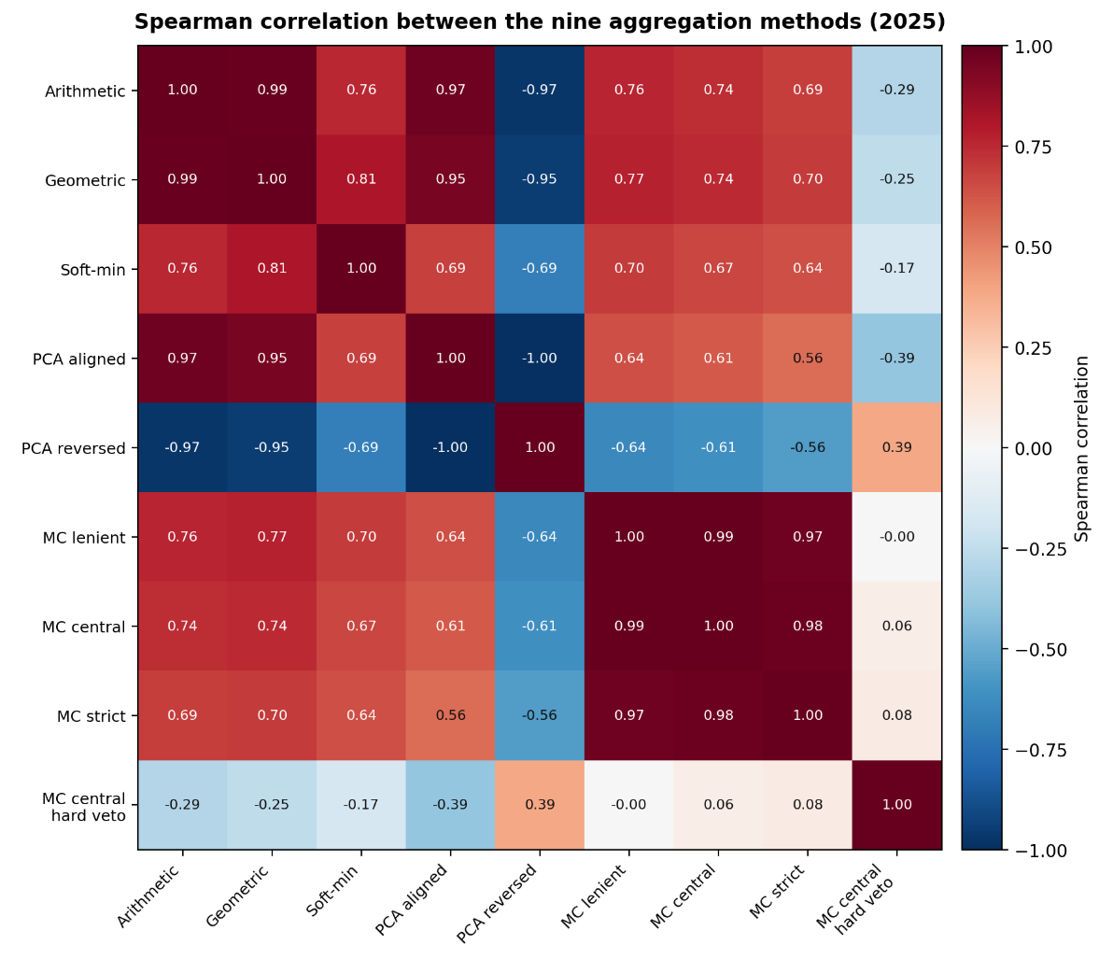

S8.2 Top 20 and bottom 20 countries by arithmetic rank
Supplementary Figures S8b and S8c show how individual country ranks change across aggregation methods. Countries are ordered by their arithmetic SDG rank. Each marker represents the country’s rank under one aggregation method. The grey horizontal line shows the range of ranks assigned to the country across methods.
Supplementary Figure S8b shows the top 20 countries by arithmetic rank. For most of these countries, the arithmetic mean, geometric mean, soft-min, and PCA aligned remain clustered near the left side of the plot. This confirms that the conventional aggregation methods largely agree on the identity of the highest-ranked countries. The central hard-veto series (red) separates sharply from the others, pushing these high-income countries far to the right, since every one of them fails the central SDG 12/13 floors.
The PCA-reversed ranking behaves very differently. It pushes almost all top-20 arithmetic countries to the far right of the plot, often close to the bottom of the ranking. This is not a substantive sustainability correction. It is the mechanical consequence of reversing the PCA orientation.
The continuous multicriteria specifications produce a more selective adjustment. Some countries that rank highly under the arithmetic index remain close to the top under the continuous floors; others fall substantially, especially where strong performance on development goals coexists with weaker SDG 12 or SDG 13 performance. This is visible for several high-income countries whose continuous multicriteria ranks move to the middle of the distribution rather than remaining in the top group. The central hard-veto specification removes this selectivity. Because every one of these high-income countries fails at least one central environmental floor, none can outrank a country that passes it, and the whole top-20 group is pushed far down the ranking regardless of how strong its development scores are.
Under the continuous floors this is an important difference from a simple reversal: the method does not automatically punish all high-income countries in the same way. Countries move down when their SDG 12 or SDG 13 performance falls below the calibrated environmental floors, but the size of the movement depends on the full pairwise outranking calculation, so a country only mildly below a floor falls less than one far below it. The hard veto removes this gradation. As the strong-sustainability specification it applies a strict pass/fail rule at the central floors, so the high-income countries that fail them are uniformly placed below every country that passes — a decisive, not a selective, demotion.
The three continuous multicriteria specifications are close to each other. This is consistent with the heatmap in Supplementary Figure S8a, where MC central, MC lenient, and MC strict form a highly correlated block, so the rank spread across the three continuous markers is much smaller than the spread between them and PCA reversed. The central hard-veto specification sits apart from all of these: it correlates negatively with the arithmetic index (−0.29) and near zero with its own continuous central counterpart (+0.06), so its markers separate sharply from the three continuous specifications, pushing the top-20 countries to the far right of the plot.
Supplementary Figure S8b. Top 20 countries by arithmetic rank: rank under each aggregation method. Countries are ordered by their arithmetic SDG rank. Each marker gives the country's rank under one aggregation method; grey lines show the range of ranks across methods. The continuous multicriteria specifications move several high-income countries toward the middle of the distribution, while the central hard-veto specification pushes the whole top-20 group sharply down the ranking, since every one of these countries fails at least one central SDG 12 or SDG 13 floor and so cannot outrank any country that passes it..
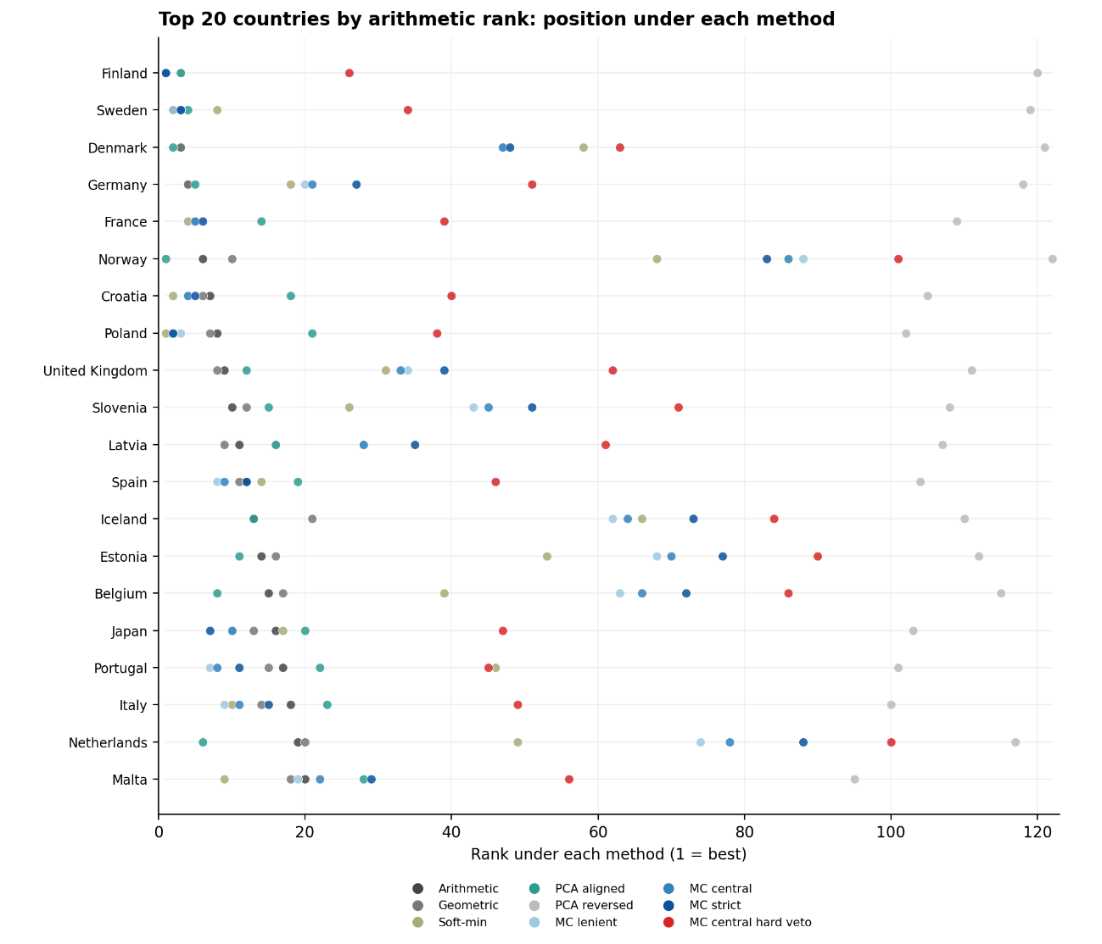

Supplementary Figure S8c shows the bottom 20 countries by arithmetic rank. The conventional methods again cluster toward the right side of the plot, indicating that arithmetic, geometric, soft-min, and PCA aligned generally agree on the lowest-ranked countries. PCA reversed moves these countries sharply toward the left, again reflecting sign inversion rather than a substantive improvement. The central hard-veto series likewise moves many of them sharply left, because the low-consumption countries that clear the environmental floors rise to the top under strict non-compensability.
The continuous multicriteria specifications produce a less extreme adjustment. Many bottom-ranked countries remain in the lower part of the ranking because their overall SDG performance is weak: the method does not reward low income or low consumption by itself. But for countries with small SDG 12 and SDG 13 penalties it can improve their position relative to the arithmetic ranking, because they are not penalised for environmental overshoot in the way that countries with high material and carbon footprints are. However, the multicriteria including the central hard-veto specification is sharper. Because most of these low-income countries clear both central environmental floors — their low consumption yields high SDG 12 and SDG 13 scores — they are no longer merely spared a penalty but are placed above every country that fails the floors. Under the hard veto, many of the countries the arithmetic index ranks last move close to the top.
Supplementary Figure S8c. Bottom 20 countries by arithmetic rank: rank under each aggregation method. Countries are ordered by their arithmetic SDG rank. Each marker gives the country's rank under one aggregation method; grey lines show the range of ranks across methods. PCA reversed moves many bottom-ranked countries toward the top because it mechanically reverses the PCA orientation. The continuous multicriteria specifications produce a more moderate adjustment based on the SDG 12 and SDG 13 floors, while the central hard-veto specification moves the bottom-ranked countries that clear both floors sharply upward — not by mechanical reversal, but because under strict non-compensability they outrank every country that fails the environmental floors.
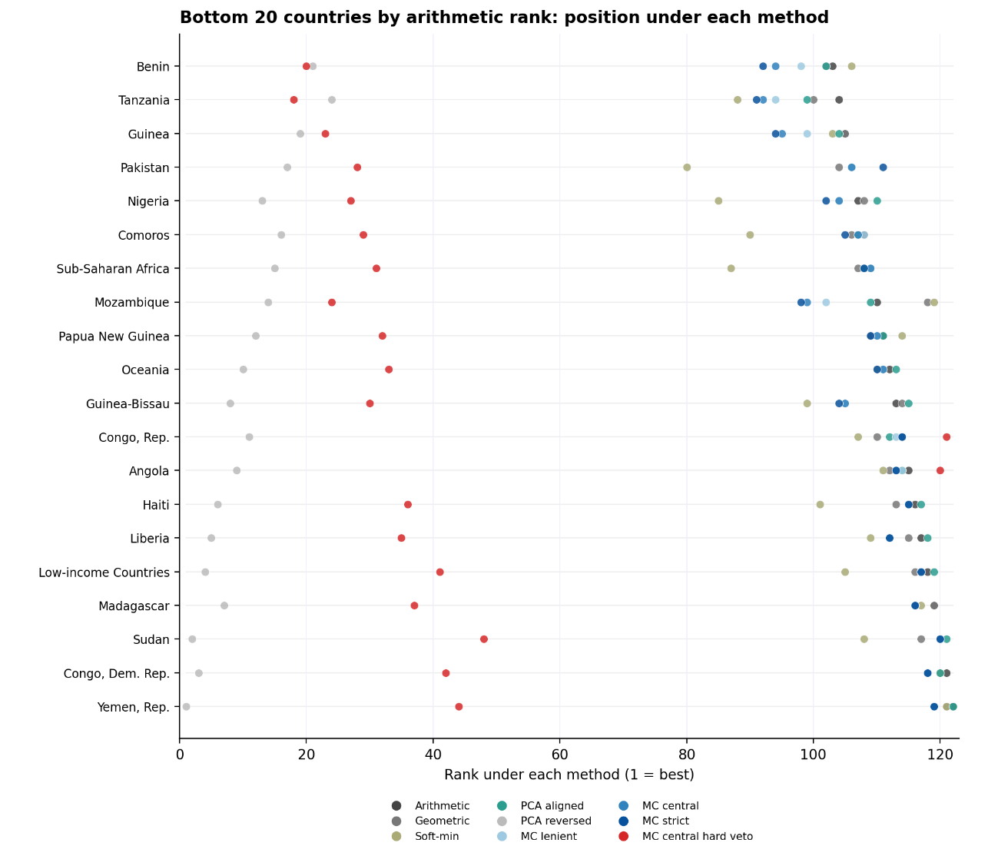

This is the central interpretation of the bottom-20 figure. Under the continuous specifications the multicriteria method does not transform the lowest-income countries into top performers; it reduces one source of disadvantage in the conventional SDG Index — the ability of high development scores to compensate for environmental shortfalls — so that some lower-ranked countries move modestly upward while many remain low-ranked because of weak performance across the other SDGs. The hard veto goes further: as the strong-sustainability specification it forbids that compensation entirely, so the low-footprint countries that clear the floors rise decisively while the high-footprint, high-development countries the arithmetic index rewards fall to the bottom. The continuous floors give a graded reordering; the hard veto gives a full inversion.

Together, Supplementary Figures S8a–S8c show that the multicriteria method is neither a minor variant of the arithmetic SDG Index nor a simple reversal of it. Under the continuous floors it remains positively correlated with the conventional methods, because it still uses the full 17-goal profile in the concordance calculation, but it changes the ranking because countries below the SDG 12 or SDG 13 floors lose part of their capacity to outrank others. The central hard-veto specification is different in kind: as the strong-sustainability specification it is negatively correlated with the arithmetic index (−0.29) and close to zero with its own continuous central counterpart (+0.06), correlating instead with PCA reversed (+0.39). It does not soften the conventional ranking but inverts it, because no country below the central floors can outrank one above them.

This explains why the continuous multicriteria results are more moderate but still substantively different from the arithmetic SDG Index — they preserve broad SDG performance while limiting compensation for environmental shortfalls — whereas the hard veto, the strong-sustainability case, replaces the development geography of the index with its mirror image. The two are the graded and the absolute expressions of the same principle: that environmental performance below critical thresholds should not be substitutable by development success.

S9. Calibration of environmental floors using external footprint sustainable corridors.
The multicriteria specification protects environmental performance through two goal-specific floors: one for SDG 12 and one for SDG 13. Instead, each floor is calibrated separately by matching external footprint scenarios to the observed SDR 0–100 goal-score scale.
The calibration has two purposes. First, it translates external footprint scenarios into SDG-score floors. Second, it makes clear that the floors used in the multicriteria analysis are not arbitrary score thresholds, but empirical translations of biophysical benchmarks into the SDR scale. The sensitivity analysis then asks a separate question: how much do the rank shifts depend on where these floors are placed?
For each environmental goal $g$, let $x_{ig}$denote the external footprint of country $i$, and let $B_{g}$denote a physical footprint cap. We define the set of countries inside the physical cap as
$$S_{g}(B_{g})=\{i:x_{ig}≤B_{g}\}.$$
We then translate the physical cap into an SDG-score floor using the 10th percentile of the SDG scores among countries inside the cap, rounded down to the nearest 5 points:
$$F_{g}(B_{g})=5\left\lfloor \frac{Q_{0.10}\left(\{G_{ig}:i∈S_{g}(B_{g})\}\right)}{5}\right\rfloor .$$
We use the 10th percentile rather than the minimum because the minimum can be driven by a single outlying country. The 10th percentile gives a conservative but more robust translation: it allows a small number of countries inside the physical cap to fall below the translated floor, while ensuring that the floor is anchored in the observed score distribution of countries satisfying the external footprint benchmark.
The resulting floors are then used in the multicriteria environmental penalty:
$$P(i)=max⁡\left[max⁡\left(\frac{F_{12}-G_{i,12}}{F_{12}} , 0\right),max⁡\left(\frac{F_{13}-G_{i,13}}{F_{13}} , 0\right)\right].$$
This penalty is continuous. It does not exclude countries from the ranking. Instead, it reduces the capacity of a country to outrank others when it falls below the calibrated floors for SDG 12 or SDG 13.
S9.1 Calibration of the SDG 13 floor
For SDG 13, we match SDR goal 13 scores to Eora consumption-based greenhouse-gas emissions per capita in 2022, the latest common year. The matched sample includes 159 countries. We consider four carbon-budget scenarios: a tight 1.5C scenario, a central 1.5C scenario, a high-budget 1.5C scenario, and a 2C benchmark.
Per-capita carbon budget thresholds derived from IPCC AR6 remaining budgets, annualised over 2020–2050

Scenario | Budget | Derivation & Source
 | (t CO2/cap/yr)
Tight 1.5 °C  (High non-CO₂ case) | 1.2 | Derived from the lower bound of the IPCC AR6 remaining carbon budget for 1.5 °C (50% probability), assuming a remaining budget of 300 GtCO₂ from 2020 onward and annualised over 2020–2050 under an equal per-capita allocation rule.  Source: IPCC AR6 WGIII SPM; AR6 Synthesis Report
Central 1.5 °C  (50%) case | 2.0 | Derived from the AR6 central remaining carbon budget of 500 GtCO₂ (50% probability), annualised over 2020–2050 under an equal per-capita allocation rule.  Source: IPCC AR6 WGIII SPM
High-budget 1.5 °C  case | 2.35 | Derived from an upper bound of the AR6 remaining carbon budget range of 600 GtCO₂ (50% probability), reflecting lower assumed non-CO₂ emissions.  Source: IPCC AR6 Synthesis Report
2 °C benchmark  (67% probability) | 4.5 | Derived from the AR6 remaining carbon budget of 1150 GtCO₂ (67% probability) for limiting warming to 2 °C, annualised over 2020–2050 under an equal per-capita allocation rule.  Source: IPCC AR6 WGIII SPM
Note: Budgets annualised assuming equal per-capita allocation over 2020–2050 and a global population of approx. 7.8–9.7 billion.
Supplementary Figure S9a plots SDG 13 scores against consumption-based greenhouse-gas footprints per capita. The x-axis reports consumption-based greenhouse-gas emissions per capita on a logarithmic scale, and the y-axis reports the SDR SDG 13 score. Vertical dashed lines show the physical carbon caps. Horizontal dashed lines show the SDG 13 floors obtained from the translation rule above.
Supplementary Figure S9a. Calibration of the SDG 13 floor from carbon-budget scenarios. Each point is a country in the matched SDR–Eora sample in 2022. The x-axis reports consumption-based greenhouse-gas emissions per capita, and the y-axis reports the SDR SDG 13 score. Vertical dashed lines mark the carbon-budget scenarios. Horizontal dashed lines mark the translated SDG 13 floors. The central 1.5C scenario corresponds to 2.00 tCO2/cap and translates into an SDG 13 floor of 95. The 2C benchmark corresponds to 4.50 tCO2/cap and translates into an SDG 13 floor of 90.
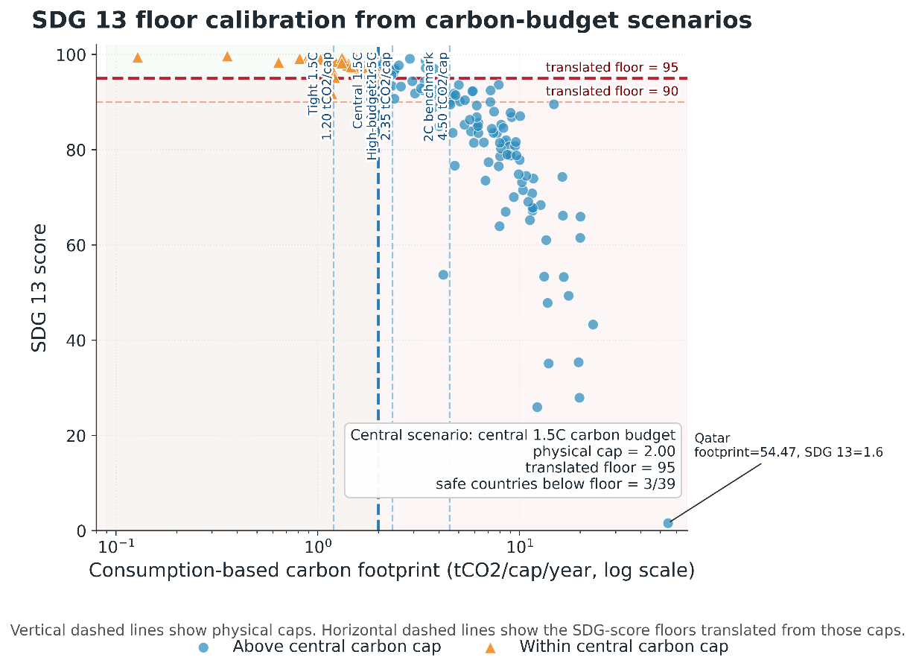

The central 1.5C scenario corresponds to a cap of 2.00 tCO2/cap. Among the 39 countries below this cap, the 10th percentile of the SDG 13 score is 95.42. Rounding down to the nearest 5 gives
$$F_{13}=95.$$
This is the central SDG 13 floor used in the multicriteria analysis. The 2C benchmark corresponds to a less stringent cap of 4.50 tCO2/cap. Among the 74 countries below this cap, the 10th percentile of the SDG 13 score is 91.49. Rounding down to the nearest 5 gives
$$F_{13}=90.$$
This value is used in the lenient specification.
Supplementary Table S9a reports the scenario-to-floor translation for SDG 13. Across the three 1.5C-compatible scenarios, the translated floor is 95. Under the less stringent 2C benchmark, the translated floor falls to 90.
Supplementary Table S9a. Translation of carbon-budget scenarios into SDG 13 floors.
Carbon scenario | Physical cap | Countries within cap | Safe-set min score | Safe-set q10 score | Safe-set q25 score | Safe-set median score | Translated SDG 13 floor | Safe countries below floor
Tight 1.5C | 1.20 tCO2/cap | 12/159 (7.5%) | 91.73 | 97.00 | 98.70 | 99.24 | 95 | 1/12 (8.3%)
Central 1.5C | 2.00 tCO2/cap | 39/159 (24.5%) | 91.73 | 95.42 | 96.99 | 98.29 | 95 | 3/39 (7.7%)
High-budget 1.5C | 2.35 tCO2/cap | 46/159 (28.9%) | 91.73 | 95.06 | 96.05 | 98.18 | 95 | 5/46 (10.9%)
2C benchmark | 4.50 tCO2/cap | 74/159 (46.5%) | 53.76 | 91.49 | 93.49 | 96.96 | 90 | 5/74 (6.8%)
Note: The translated floor is the 10th percentile of SDG 13 scores among countries within the physical cap, rounded down to the nearest 5 points. The central multicriteria specification uses $F_{13}=95$, corresponding to the central 1.5C carbon-budget scenario. The lenient specification uses $F_{13}=90$, corresponding to the 2C benchmark.
S9.2 Calibration of the SDG 12 floor
For SDG 12, we match SDR goal 12 scores to material footprint per capita in 2024. The matched sample includes 152 countries. Because material-use boundaries are more heterogeneous than carbon-budget benchmarks, we use aggregate material-footprint scenarios rather than a single fixed boundary. Specifically, we consider aggregate caps of 25, 50 and 100 Gt/year, translated into per-capita caps using global population. These scenarios correspond to approximately 3.15, 6.30 and 12.60 t/cap.
Supplementary Figure S9b plots SDG 12 scores against material footprint per capita. The x-axis reports material footprint per capita on a logarithmic scale, and the y-axis reports the SDR SDG 12 score. Vertical dashed lines show the material-footprint caps. Horizontal dashed lines show the SDG 12 floors obtained from the translation rule.
Supplementary Figure S9b. Calibration of the SDG 12 floor from aggregate material-footprint caps. Each point is a country in the matched SDR–material-footprint sample in 2024. The x-axis reports material footprint per capita, and the y-axis reports the SDR SDG 12 score. Vertical dashed lines mark the aggregate material-footprint scenarios translated into per-capita caps. Horizontal dashed lines mark the translated SDG 12 floors. The central 50 Gt/year scenario corresponds to 6.30 t/cap and translates into an SDG 12 floor of 80. The stricter 25 Gt/year scenario translates into a floor of 90, while the more lenient 100 Gt/year scenario translates into a floor of 75.
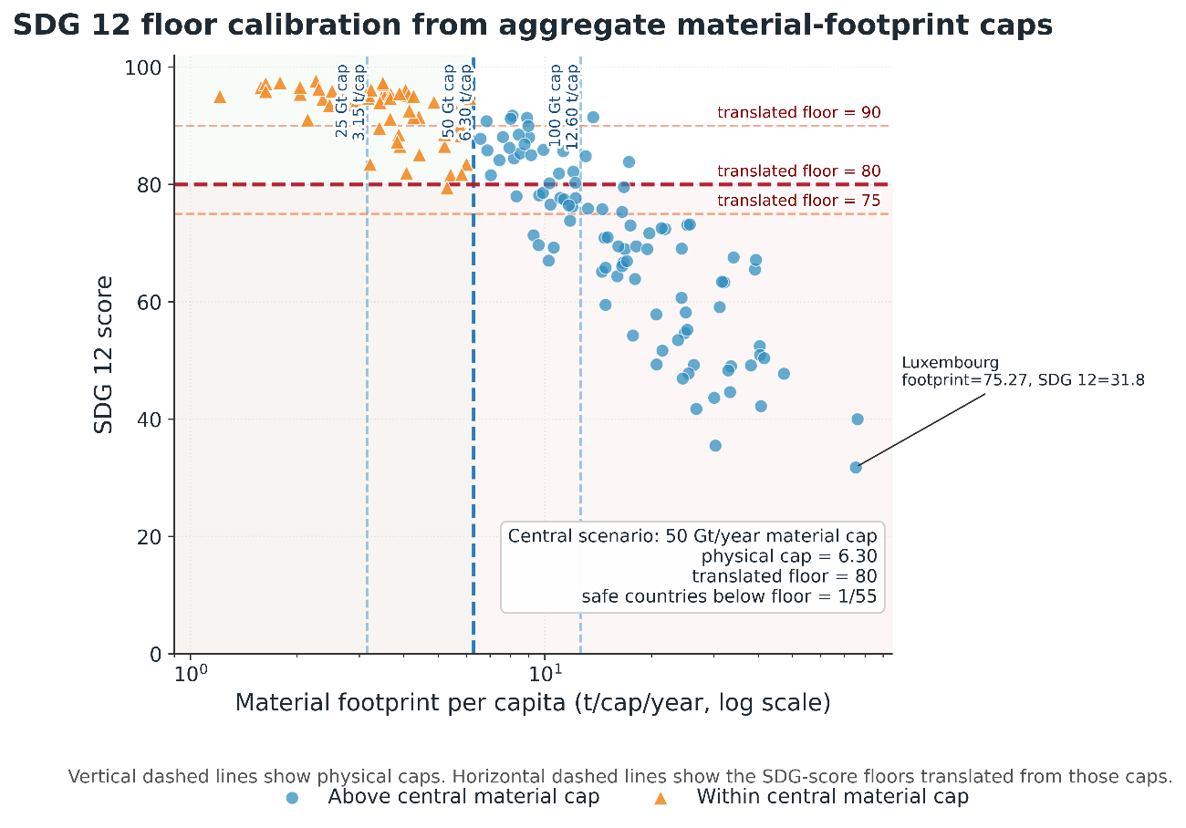

The central material scenario is the 50 Gt/year cap, equivalent to approximately 6.30 t/cap. Among the 55 countries below this cap, the 10th percentile of the SDG 12 score is 84.13. Rounding down to the nearest 5 gives
$$F_{12}=80.$$
This is the central SDG 12 floor used in the multicriteria analysis.
The stricter 25 Gt/year scenario corresponds to 3.15 t/cap. Among countries below this cap, the 10th percentile of the SDG 12 score is 93.63. Rounding down gives
$$F_{12}=90.$$
The more lenient 100 Gt/year scenario corresponds to 12.60 t/cap. Among countries below this cap, the 10th percentile of the SDG 12 score is 77.70. Rounding down gives
$$F_{12}=75.$$
Supplementary Table S9b reports the scenario-to-floor translation for SDG 12. The table shows that the central 50 Gt/year material scenario maps into an SDG 12 floor of 80, while the strict and lenient material scenarios map into floors of 90 and 75, respectively.
Supplementary Table S9b. Translation of aggregate material-footprint scenarios into SDG 12 floors.
Material scenario | Physical cap | Countries within cap | Safe-set min score | Safe-set q10 score | Safe-set q25 score | Safe-set median score | Translated SDG 12 floor | Safe countries below floor
25 Gt/year | 3.15 t/cap | 18/152 (11.8%) | 91.02 | 93.63 | 94.51 | 95.89 | 90 | 0/18 (0.0%)
50 Gt/year | 6.30 t/cap | 55/152 (36.2%) | 79.43 | 84.13 | 89.32 | 94.49 | 80 | 1/55 (1.8%)
100 Gt/year | 12.60 t/cap | 92/152 (60.5%) | 67.04 | 77.70 | 83.14 | 89.32 | 75 | 5/92 (5.4%)
Note: The translated floor is the 10th percentile of SDG 12 scores among countries within the physical cap, rounded down to the nearest 5 points. The central multicriteria specification uses $F_{12}=80$, corresponding to the 50 Gt/year material-footprint scenario.
S9.3 Floor pairs used in the multicriteria analysis
The multicriteria analysis uses floor pairs, not a single common floor. The central specification combines the central SDG 12 and SDG 13 calibrations:
$$(F_{12},F_{13})=(80,95).$$
We also report scenario-based robustness checks. The lenient specification combines the more permissive material and carbon scenarios:
$$(F_{12},F_{13})=(75,90).$$
The strict specification combines the stricter material scenario with the 1.5C-compatible SDG 13 floor:
$$(F_{12},F_{13})=(90,95).$$
Supplementary Table S9c summarizes the floor pairs used in the multicriteria analysis.
Supplementary Table S9c. Scenario-based floor pairs used in the multicriteria analysis.
MCA specification | Material scenario | Carbon scenario | SDG 12 floor $F_{12}$ | SDG 13 floor $F_{13}$
Lenient | 100 Gt/year material cap | 2C carbon benchmark | 75 | 90
Central | 50 Gt/year material cap | Central 1.5C carbon benchmark | 80 | 95
Strict | 25 Gt/year material cap | 1.5C-compatible carbon benchmark | 90 | 95
These floor pairs are then used in the environmental penalty of the multicriteria outranking model:
$$P(i)=max⁡\left[max⁡\left(\frac{F_{12}-G_{i,12}}{F_{12}} , 0\right),max⁡\left(\frac{F_{13}-G_{i,13}}{F_{13}} , 0\right)\right].$$
The central specification is therefore not based on an arbitrary common score threshold. It is obtained by translating two external footprint scenarios into the SDR score scale: a 50 Gt/year material-footprint scenario for SDG 12 and a central 1.5C carbon-budget scenario for SDG 13.
The calibration also clarifies why the two floors differ. SDG 12 and SDG 13 are measured on the same 0–100 SDR scale, but they are linked to different external physical quantities and different empirical score distributions. A common floor would therefore impose artificial symmetry across the two goals. The goal-specific calibration avoids this by allowing the SDG 12 and SDG 13 floors to reflect their own external footprint benchmarks.
S9.4 Sensitivity of the reordering to the SDG 12 and SDG 13 floors
The calibration above answers one question: which SDG-score floors correspond to external footprint scenarios? However, the magnitude of the multicriteria rank reordering can still depend on where the floors are placed. We therefore complement the calibration exercise with a full floor-grid sensitivity analysis.
The sensitivity analysis varies $F_{12}$and $F_{13}$independently over a wide range:
$$F_{12}∈\{0,20,30,40,50,60,70,75,80,85,90,95,100\},$$
and
$$F_{13}∈\{0,20,30,40,50,60,70,75,80,85,90,95,100\}.$$
This grid includes very low floor values, where the environmental penalty is nearly inert, as well as the calibrated scenario-based floor pairs. For each pair $\left(F_{12} , F_{13}\right)$, we recompute the full multicriteria ranking and compare it with the arithmetic SDG ranking. The rank shift is defined as
$$Δr_{i}=r_{i}^{MCA}-r_{i}^{arith}.$$
Positive values indicate that a country receives a worse rank under the multicriteria method than under the arithmetic SDG index. Negative values indicate that a country receives a better rank.
For each income group $h$, we summarize the distribution of rank shifts using the median rank shift:
$${\tilde{Δr}}_{h}(F_{12},F_{13})={\text{median}}_{i∈h}\left(r_{i}^{MCA}(F_{12},F_{13})-r_{i}^{arith}\right).$$
Supplementary Figure S9c maps these median rank shifts over the full $F_{12}×F_{13}$grid for the four income groups. The stars mark the three scenario-based specifications used in the main analysis: lenient $\left(75 , 90\right)$, central $\left(80 , 95\right)$, and strict $\left(90 , 95\right)$. The zero contour marks the boundary between regions where the income group improves and regions where it worsens relative to the arithmetic SDG ranking.
Supplementary Figure S9c. Sensitivity of income-group rank shifts to SDG 12 and SDG 13 floors. The figure reports median rank shifts relative to the arithmetic SDG ranking across the full $F_{12}×F_{13}$grid. Positive values indicate worse ranks under the multicriteria method, and negative values indicate better ranks. Stars mark the scenario-based floor pairs used in the main analysis: lenient $\left(75 , 90\right)$, central $\left(80 , 95\right)$, and strict $\left(90 , 95\right)$. The zero contour shows where the median rank shift changes sign.
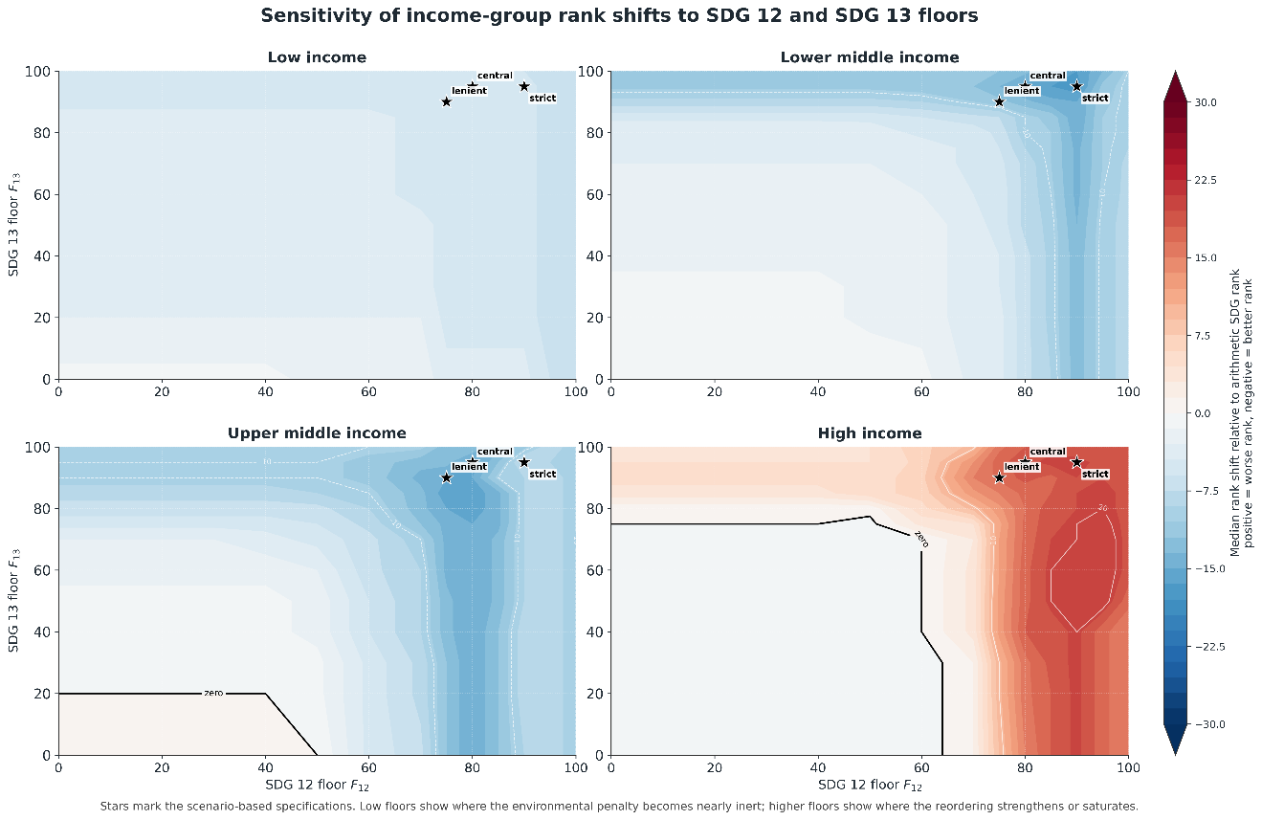
The figure shows that the reordering is not a mechanical artifact of a single chosen floor pair. When both floors are low, the environmental penalty is weak and the multicriteria ranking remains closer to the arithmetic ranking. As the floors increase, the reordering strengthens. This is expected because the method is explicitly designed to limit compensation when countries fall below SDG 12 and SDG 13 floors.
The figure also shows that the rank shifts are not identical across income groups. The largest downward movement is concentrated among high-income countries. Under the central specification, the median high-income country moves down 19 ranks relative to the arithmetic SDG ranking. By contrast, lower-middle-income and upper-middle-income countries move up by 15.5 and 16 ranks, respectively. Low-income countries also improve, but more modestly, with a median shift of 5 ranks.
Supplementary Table S9d reports the income-group shifts at the three scenario-based floor pairs.
Supplementary Table S9d. Income-group rank shifts at the scenario-based floor pairs.
MCA specification | $$F_{12}$$ | $$F_{13}$$ | Income group | Countries | Median shift | Mean shift | Mean absolute shift | Share worse by 20+ ranks | Share better by 20+ ranks
Lenient | 75 | 90 | High income | 38 | 17.0 | 19.263 | 25.632 | 47.4% | 5.3%
Lenient | 75 | 90 | Low income | 11 | -5.0 | -4.182 | 4.364 | 0.0% | 0.0%
Lenient | 75 | 90 | Lower middle income | 30 | -11.5 | -10.667 | 10.800 | 0.0% | 20.0%
Lenient | 75 | 90 | Upper middle income | 29 | -15.0 | -12.621 | 14.138 | 0.0% | 31.0%
Central | 80 | 95 | High income | 38 | 19.0 | 20.553 | 26.500 | 50.0% | 5.3%
Central | 80 | 95 | Low income | 11 | -5.0 | -5.091 | 5.091 | 0.0% | 0.0%
Central | 80 | 95 | Lower middle income | 30 | -15.5 | -12.867 | 12.867 | 0.0% | 26.7%
Central | 80 | 95 | Upper middle income | 29 | -16.0 | -11.690 | 15.069 | 0.0% | 34.5%
Strict | 90 | 95 | High income | 38 | 20.0 | 22.842 | 27.211 | 50.0% | 2.6%
Strict | 90 | 95 | Low income | 11 | -5.0 | -5.818 | 5.818 | 0.0% | 0.0%
Strict | 90 | 95 | Lower middle income | 30 | -17.5 | -16.533 | 16.733 | 0.0% | 43.3%
Strict | 90 | 95 | Upper middle income | 29 | -7.0 | -10.621 | 15.655 | 0.0% | 34.5%
Note: Rank shift is defined as multicriteria rank minus arithmetic SDG rank. Positive values indicate a worse rank under the multicriteria method; negative values indicate a better rank.
These results show that the direction of the reordering is stable across the three scenario-based specifications. High-income countries worsen in all three cases, while low-, lower-middle-, and upper-middle-income countries improve on median. However, the magnitude of the reordering is floor-dependent. The strict specification produces the largest high-income decline, while the lenient specification produces a slightly smaller decline. This is the expected behavior of the method: the stronger the environmental floors, the more difficult it becomes for high scores on other goals to compensate for weak SDG 12 or SDG 13 performance.
Supplementary Table S9e summarizes the boundary conditions.
Supplementary Table S9e. Boundary summary for the $F_{12}×F_{13}$sensitivity grid.
Condition | Share of grid
High-income median worsens | 72.2%
Low-income median improves | 100.0%
Directional reordering | 72.2%
Strong two-sided effect | 0.0%
Near-inert relative to arithmetic ranking | 52.7%
Note: “High-income median worsens” means that the median high-income rank shift is positive. “Low-income median improves” means that the median low-income rank shift is negative. “Directional reordering” means both conditions hold at the same time. “Strong two-sided effect” requires a high-income median shift of at least $+10$ranks and a low-income median shift of at most $-10$ranks. This stricter two-sided condition is not satisfied because the low-income median improvement is modest. “Near-inert” means that both the high-income and low-income median shifts are smaller than 10 ranks in absolute value.
The boundary table helps separate two claims. The first is directional: high-income countries tend to move down and lower-income groups tend to move up once the environmental floors become binding. This directional result is robust across the scenario-based specifications. The second is quantitative: the size of the movement depends on the location of the floors. This magnitude dependence is not a weakness of the method; it is exactly what the sensitivity analysis is designed to show.
The calibrated points are all located in the region where the directional reordering holds. At the central calibrated point $\left(F_{12},F_{13})=(80,95\right)$, the median high-income country falls by 19 ranks, while the median low-income country improves by 5 ranks. The gap between these two median shifts is therefore 24 ranks. The corresponding gaps are 22 ranks in the lenient case and 25 ranks in the strict case.
Supplementary Table S9f. Directional reordering at the calibrated floor pairs.
MCA specification | $$F_{12}$$ | $$F_{13}$$ | High-income median shift | Low-income median shift | Directional reordering | High-minus-low median shift
Lenient | 75 | 90 | 17.0 | -5.0 | Yes | 22.0
Central | 80 | 95 | 19.0 | -5.0 | Yes | 24.0
Strict | 90 | 95 | 20.0 | -5.0 | Yes | 25.0
The sensitivity analysis therefore qualifies the interpretation of the results. The calibrated floors are externally grounded, but the magnitude of the rank shifts is still sensitive to floor placement. The appropriate conclusion is not that the exact number of ranks is invariant. Rather, the conclusion is that the directional reordering appears once the environmental floors become binding, while the magnitude of the reordering increases with the strictness of the floors
S9.5 The floor is well-targeted, but the correction is deliberately bounded.
A natural concern is that the sustainability floor, by acting on SDR goal scores rather than on footprints directly, might penalise the wrong countries. Figure S10.3 shows it does not. Plotting each goal score against its external footprint — SDG 13 against consumption-based carbon per capita, SDG 12 against material footprint per capita — reveals a strong negative relationship in both cases (Spearman ρ = −0.93 and −0.92): the countries the floor penalises are, with few exceptions, those with the largest per-capita footprints. The floor is therefore a sound proxy for footprint overshoot, not an arbitrary score cut-off.
This clarifies why some high-footprint, high-income countries nonetheless remain near the top of the multicriteria ranking. Finland is illustrative: with roughly 12 tCO₂eq and 32 t of materials per capita it sits firmly on the high-footprint side of both panels, and the SDR scores it accordingly — 75 on SDG 13 and 63 on SDG 12, both below the floors. It is penalised. It remains first not because its environmental performance is unrecognised but because the floor penalty is continuous and bounded, and its lead across the fifteen development goals is large enough to absorb it. The multicriteria method limits compensation; it does not abolish it. A country that combines an overwhelming development advantage with a moderate — rather than catastrophic — environmental shortfall is moved down, but not out.
The goal scores, however, capture a country's own territorial and production-side environmental performance more fully than the harm its consumption imposes elsewhere. This is where the Spillover Index adds information the goal scores miss: Finland's spillover score (68 on the SDR's 0–100 scale, where lower means greater harm abroad) places it among the larger net exporters of negative cross-border effects, a dimension only weakly reflected in its SDG 13 score. The footprint scatters and the Spillover Index (Fig. S10b) are therefore complementary — the first shows the floor is correctly aimed at domestic footprint, the second shows the residual, cross-border harm that no single goal score, and hence no aggregation of goal scores, can fully internalise.
Supplementary Figure S9d. SDG 12 and SDG 13 vs Material and Carbon Footprint by income group.

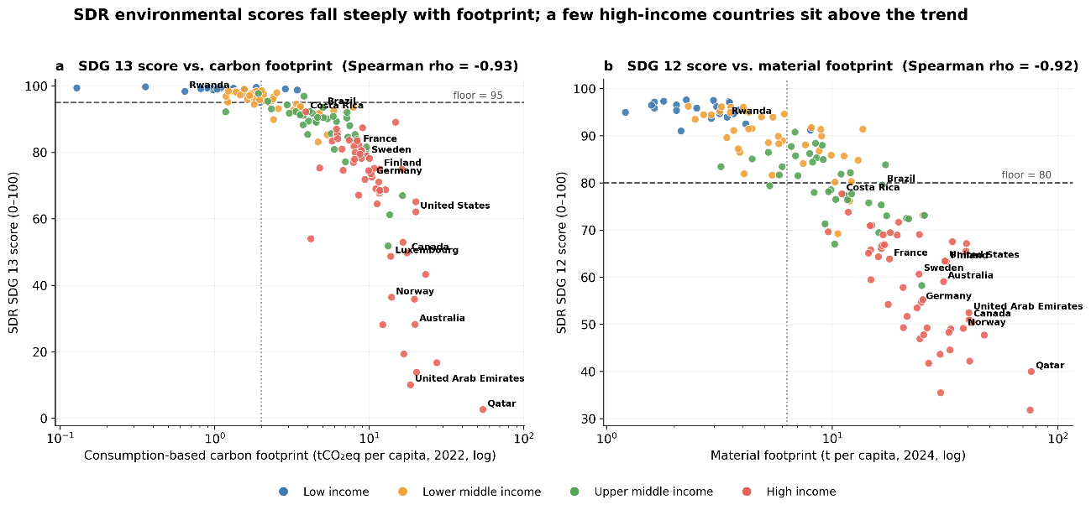

S10 Corroboration with the SDR Spillover Index and consumption-based footprints
S10.1 What the Spillover Index measures.
A spillover is an effect — environmental, social, or economic — that one country's consumption imposes on others but that is not reflected in its own territorial accounts. They arise mainly through trade: high-income countries import goods whose production generates emissions, resource extraction, water use, deforestation, and labour harms abroad, so the environmental burden of their consumption is displaced onto producing countries and does not appear in the importing country's domestic statistics. A country can therefore look clean at home while driving degradation elsewhere — what the literature terms the externalisation, or offshoring, of environmental load (Moinuddin and Olsen 2024; Wiedmann et al. 2015).
The Sustainable Development Report quantifies this with its Spillover Index, published alongside the SDG Index since 2017. It aggregates consumption-based indicators across three domains — environmental spillovers embodied in trade (e.g. CO₂, air pollution, water use, deforestation, biodiversity threats), social spillovers (e.g. accidents and labour rights violations embodied in imports), and economic and financial spillovers (e.g. profit shifting and banking secrecy) — into a 0–100 score. The bulk of the index is consumption-based: it traces impacts to the country whose final demand drives them, using multi-regional input–output accounting, rather than to the country where production physically occurs.
Direction of scale. The Spillover Index is scored so that higher is better — a high score means a country generates few negative spillovers, a low score means it imposes large ones. This matters for interpreting the correlations below: a negative correlation between the SDG Index and the Spillover Index means that higher-ranked countries have lower spillover scores, i.e. impose larger negative effects abroad. We retain the SDR's native orientation throughout and flag it on each figure to avoid sign confusion.
Why this is an internal test. The Spillover Index is the SDR's own instrument, built and published by the same team as the SDG Index, yet excluded from the headline ranking. Using it to corroborate our diagnosis therefore introduces no external construct or value judgement of ours: it asks only whether the SDR's own measure of cross-border harm agrees with our finding that the Index rewards development and penalises environmental performance.
S10.2 Corroboration with the Spillover Index and consumption-based footprints
Having defined the Spillover Index (S10.1), we use it — together with external material and carbon footprints — to test whether the goals our analysis identifies as penalised, SDG 12 and SDG 13, genuinely track cross-border environmental pressure, rather than being artefacts of how those two SDR scores are constructed. Three figures establish this, moving from the full correlation structure (Fig. S10a), to the indicators most aligned with spillovers (Fig. S10b), to what this means for countries (Fig. S10c).
The correlation structure (Fig. S10a). The Spearman correlation matrix across the 17 goals, the SDG Index, the two multicriteria rankings, the Spillover Index, and reversed material and carbon footprints reproduces the bipolar pattern of the main analysis and extends it to both the external measures and our own rankings. The development goals — SDG 1, 3, 4, 6, 7, 9, 11 and 16 — correlate strongly and positively with one another and with the SDG Index (ρ ≈ 0.8–0.9) and negatively with the footprint and spillover variables. SDG 12 and SDG 13 form the opposing pole: they correlate positively with low material footprint (0.9 and 0.9), low carbon footprint (0.9 and 1.0), and the Spillover Index (0.9 and 0.9), and negatively with the development goals. The SDG Index itself correlates negatively with all three external environmental measures — Spillover Index −0.8, low material footprint −0.8, low carbon footprint −0.8 — and SDG 9 (Industry), the goal carrying the most effective weight in the composite, shows the strongest negative correlations of any goal with low material and carbon footprints (−0.9 each). The structure is therefore not an artefact of the SDR's environmental goal scores: independent consumption-based footprints fall on the same axis, opposite the development bloc.
The two multicriteria rankings sit on this axis exactly as the weak-versus-strong-sustainability reading predicts. MC central remains weakly on the development side — positively correlated with the SDG Index (0.7) and the development goals (≈ 0.5) — but its alignment with the harmful pole is already far weaker than the Index's: it correlates only −0.4 with the Spillover Index and −0.4 and −0.3 with low material and carbon footprints, against the Index's −0.8. The multicriteria hard veto crosses to the environmental pole: it correlates negatively with the SDG Index (−0.3) and the development goals (≈ −0.3 to −0.4) and positively with SDG 12 (0.5), SDG 13 (0.7), the Spillover Index (0.5), and low material and carbon footprints (0.5 and 0.6). It is the only ranking in the matrix that sits with the low-footprint, low-spillover variables rather than against them — the same realignment reported in the main text, now visible against the SDR's own spillover measure and external footprints on the identical sample.
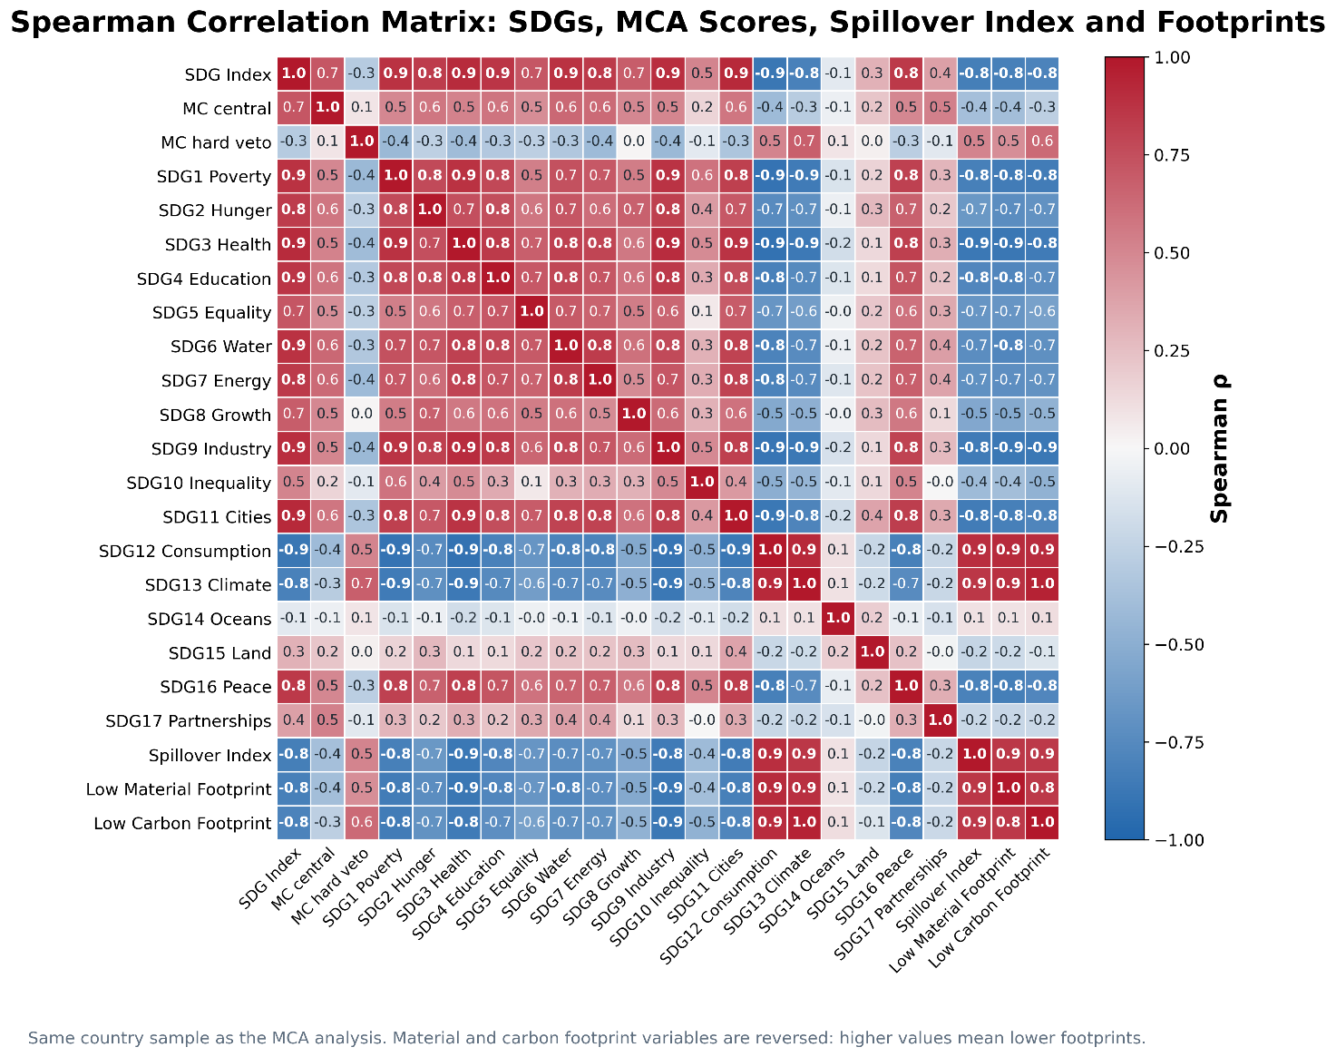

Which indicators align with low spillovers (Fig. S10b). Ranking every goal — and the two multicriteria rankings — by its correlation with the Spillover Index makes the opposition explicit. Five indicators correlate positively, that is, align with low negative spillovers: SDG 12 (Consumption, +0.89), SDG 13 (Climate, +0.86), low material footprint (+0.85), low carbon footprint (+0.85), and — alone among the rankings — the multicriteria hard veto (+0.51). Every development goal correlates negatively, meaning that strength on it is associated with imposing larger negative effects abroad: SDG 3 (Health, −0.87), SDG 9 (Industry, −0.84), SDG 11 (Cities, −0.84), SDG 1 (Poverty, −0.82), SDG 16 (Peace and institutions, −0.80), and so on through the development bloc. The SDG Index as a whole sits at −0.82, and MC central, which only attenuates the Index's compensation, at −0.38. This is the diagnosis seen from the outside: the two goals our variance analysis identifies as penalised are precisely the two — alongside the external footprints — that capture low cross-border harm, while the goals driving the Index, and the Index itself, are those associated with high harm. Only the hard veto, the strong-sustainability ranking, crosses to the low-harm side.
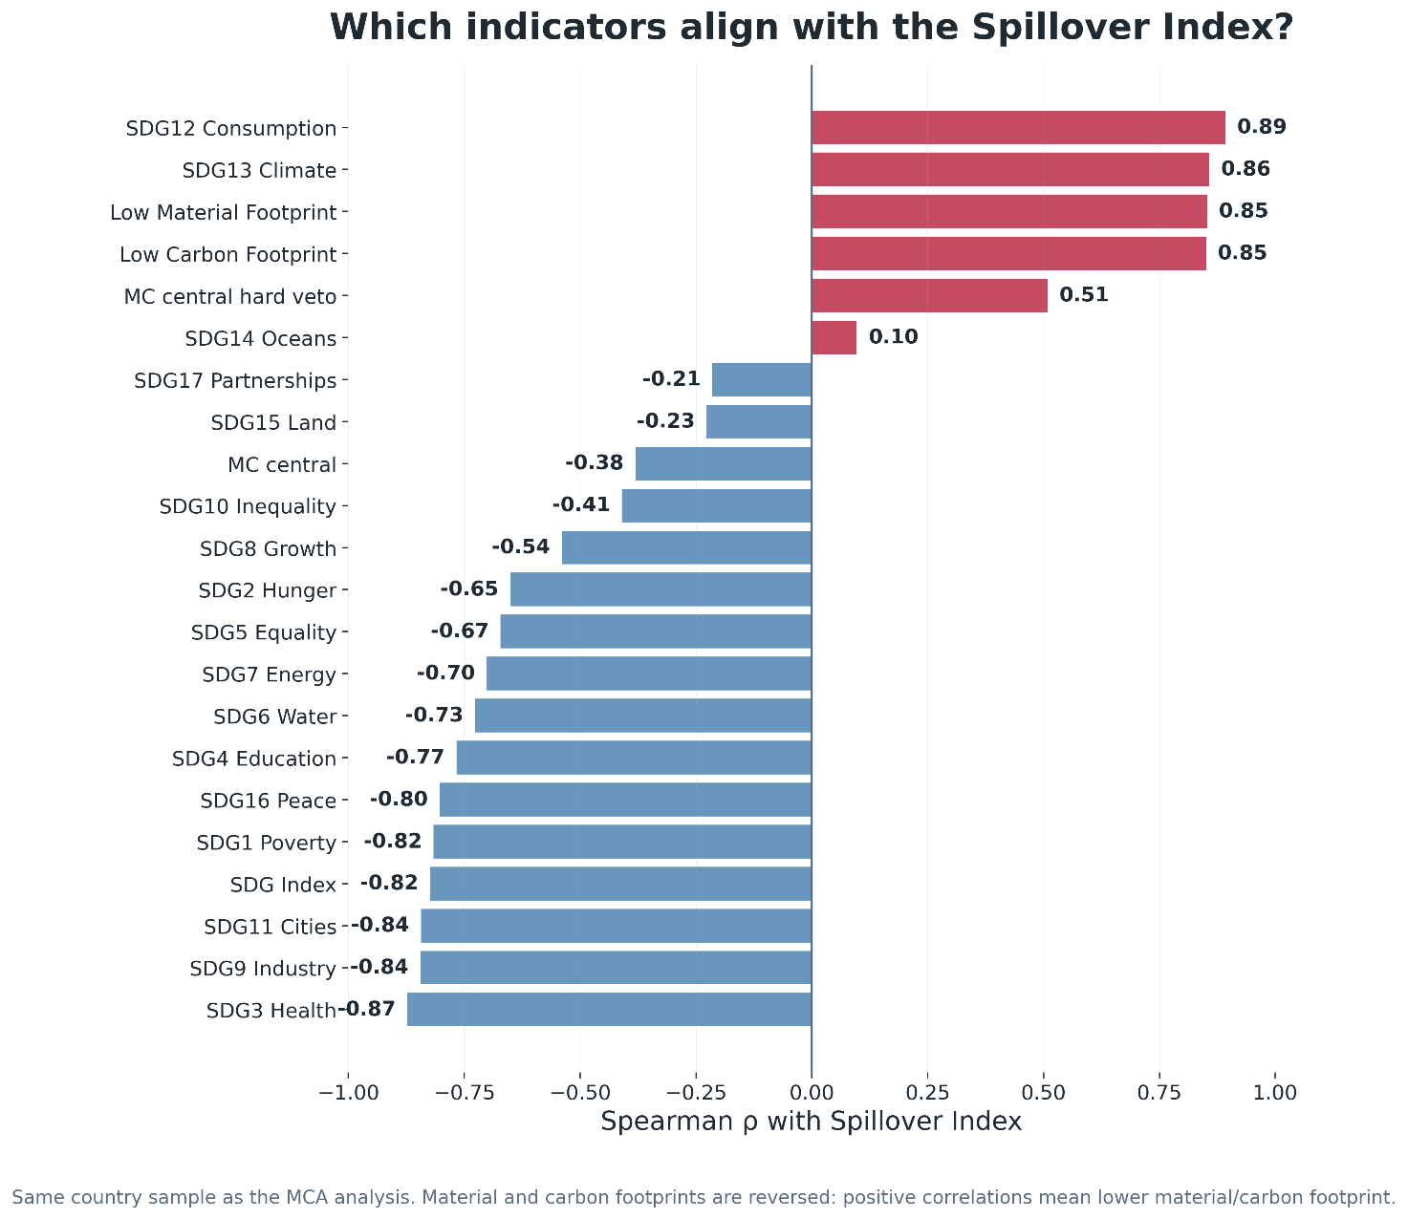

What this means for countries (Fig. S10c). Plotting the SDG Index against the Spillover Index by income group makes the contradiction concrete (ρ = −0.82). The high-income countries the Index ranks at the top — France, Finland, Sweden, Spain, Japan, Italy — cluster in the upper-left: high SDG scores combined with the weakest spillover performance, i.e. the largest negative effects displaced abroad. The lower-right holds the mirror image: lower- and low-income countries — Morocco, Vietnam, the Philippines, Comoros, Madagascar — with modest SDG scores but the fewest negative spillovers. In other words, the countries the SDG Index crowns are the ones the SDR's own spillover measure flags as imposing the greatest burden on others, and the countries it ranks lowest are those living most within their global means. The very pattern the headline ranking conceals is published, by the same institution, in the same report.
Figure S10c SDG Index vs Spillover. 2025

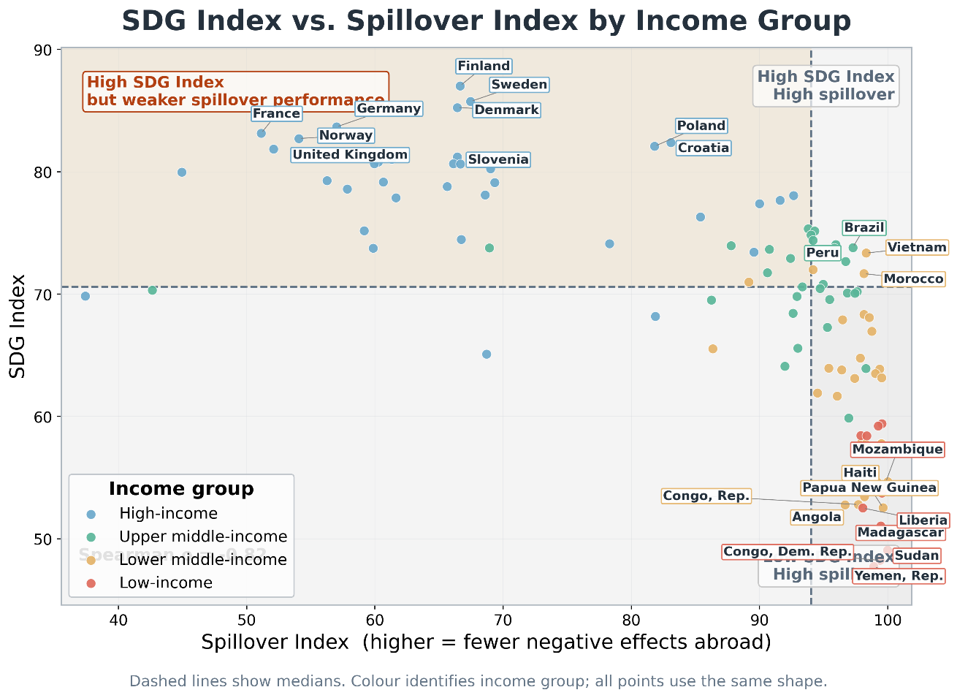
The multicriteria rankings reposition these same countries (Figs. S10d–S10e). Under the central floor (Fig. S10d, ρ = −0.38) the perversity is weakened but not removed: the high-income countries the Index crowns still score highly — France, Finland, Sweden, Spain, Japan and Portugal remain in the upper band despite their weak spillover performance — while many of the low-income countries with the fewest spillovers (Congo Dem. Rep., Haiti, Madagascar, Yemen, Sudan) are still held down, because their weak development scores drag the composite even after the floor attenuates the development advantage. The graded floor loosens the link between high rank and high cross-border harm without reversing it. Under the hard veto (Fig. S10e, ρ = +0.51) the relationship flips: the countries with the fewest negative spillovers now rise to the top — Pakistan, Comoros, Haiti, Fiji and other low-footprint economies that clear both environmental floors — while the high-income countries fall to the middle and bottom of the distribution. The reversal is not a reward for poverty: upper-middle-income countries that fail a central floor (Mexico, Iran, Iraq, Venezuela) stay low despite strong spillover scores, because the veto rewards clearing the environmental thresholds, not low income as such. Only the strong-sustainability ranking places the countries living within their global means at the top, aligning the benchmark with the SDR's own measure of who imposes harm abroad.
Figure S10d. MC central vs Spillover
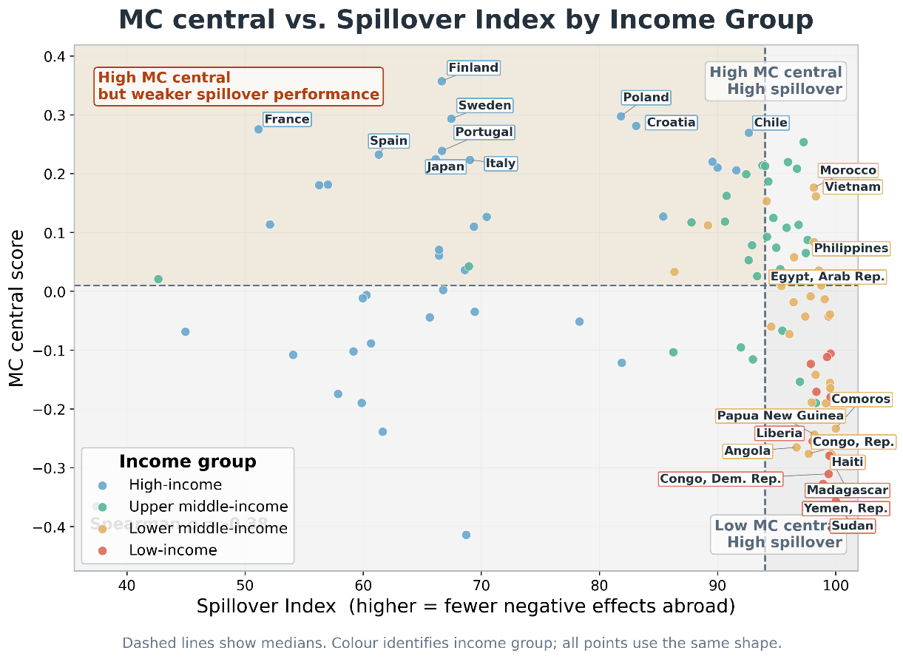
Figure S10e. MC central hard-veto vs Spillover

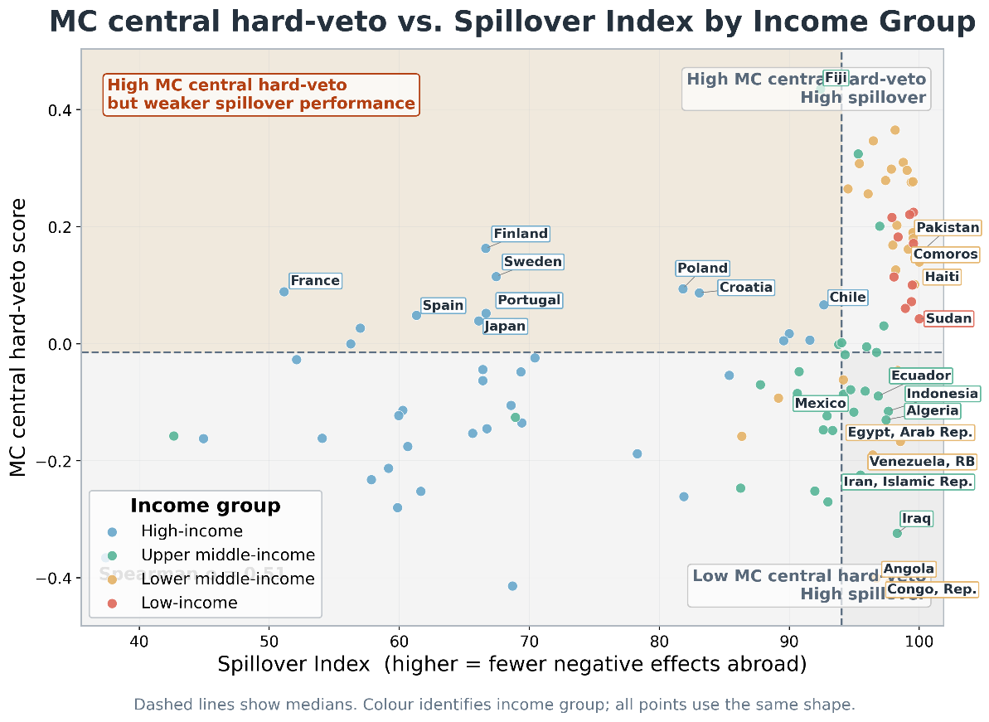

Taken together, the figures show that the penalised pole of the SDG Index is not a construction artefact of SDG 12 and SDG 13. It is corroborated by the SDR's own Spillover Index and by independent material and carbon footprints — three measures of consumption-based environmental pressure that agree on which countries, and which goals, the Index rewards and penalises. They also show the correction working: MC central weakens the Index's perverse alignment with the Spillover Index (from ρ = −0.82 to −0.38) and the hard veto reverses it (to +0.51), making it the only ranking whose top performers are the lowest cross-border harmers.
The implication runs deeper than a measurement gap. The SDR defines spillovers as effects on other countries' ability to achieve the SDGs, and the channels its Spillover Index aggregates fall disproportionately on lower-income producing countries: greenhouse-gas, air-pollution and nitrogen emissions, scarce-water use and deforestation embodied in imports; fatal work-related accidents and victims of modern slavery embodied in imports; exports of hazardous pesticides, plastic waste and major conventional weapons; and profit shifting through tax havens and financial secrecy. Several bear directly on the development goals in the countries that absorb them: emissions and air pollution embodied in rich-country consumption add to the disease and mortality burden measured under SDG 3; fatal work accidents and modern slavery embodied in imports are losses of life and rights counted under SDG 8; conventional-weapons exports flow into the conflict-affected, low-income settings whose SDG 16 scores they help to depress; and profit shifting strips the public revenue poorer states need to finance health, education and infrastructure.
A circularity follows. The development performance that lifts high-income countries to the top of the Index is achieved, in part, through consumption whose burdens are displaced abroad — and those burdens, on the SDR's own definition, lower other countries' capacity to achieve the SDGs, including the development goals on which those same countries are then scored. The Index credits a country for development partly attained at others' expense, and debits the others for deficits that this displacement helps produce. It scores the cause and the consequence of a single transfer on the same scale and in opposite directions — the high-income exporter rewarded, the low-income recipient penalised — for two ends of a flow the SDR itself measures.
We do not estimate this pathway here. The correlations are cross-sectional, and apportioning how much of any country's development deficit is attributable to imported spillovers is beyond our scope. But the mechanism is the SDR's own, and the figures show that the countries the Index rewards are those its companion measure flags as the largest net exporters of these effects. The penalised environmental pole and the rewarded development pole are therefore not independent quantities to be averaged: they are linked by a displacement of harm that the headline ranking renders invisible — and that a non-compensatory ranking makes visible again.

