Appendix A. Supplementary data

Improved the in-situ remediation effect of sediment microbial fuel cells by optimizing the anode structure

Henan Li^{a,b}, Guohong Liu^{b**}, Chao Li^{c}, Yongli Sunª, Yujie Feng^{b*}

ª North China municipal engineering design & research institute CO., LTD,. No. 99 Qixiangtai Road, Hexi District, Tianjin 300000, China
^{b} School of Environment, Harbin Institute of Technology, Harbin 150090, China
^{c} Logging & Testing Services Company of Daqing Oilfield Company LTD., Heilongjiang Daqing 163000, China

*Corresponding Author: Prof Yujie Feng
Tel: +86 451 86287017
Fax: +86 451 86287017
E-mail: yujief@hit.edu.cn
**Co- Corresponding Author: Guohong Liu
E-mail: liuguohong7@126.com

Number of figures: 1

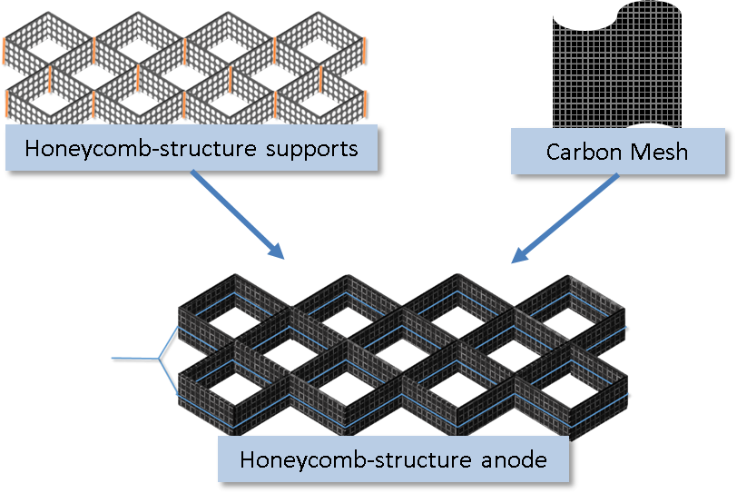
Fig.S1 Construction of the honeycomb-structure anode

