Supplementary Information for: Single-fibre internal observability in lithium-ion batteries
This Supplementary Information supports the Nature Communications manuscript “Single-fibre internal observability in lithium-ion batteries”. It provides the mathematical derivations, extended validation results, architecture specifications, training statistics and deployment analyses for FBG-PhysNet, a physics-informed framework for reconstructing internal battery temperature and strain from a single embedded fibre Bragg grating signal. The sections retain the original evidence hierarchy while aligning the supplementary presentation with the Nature Communications framing of single-fibre internal observability.
Section S1: Complete FBG Sensor Physics Derivations

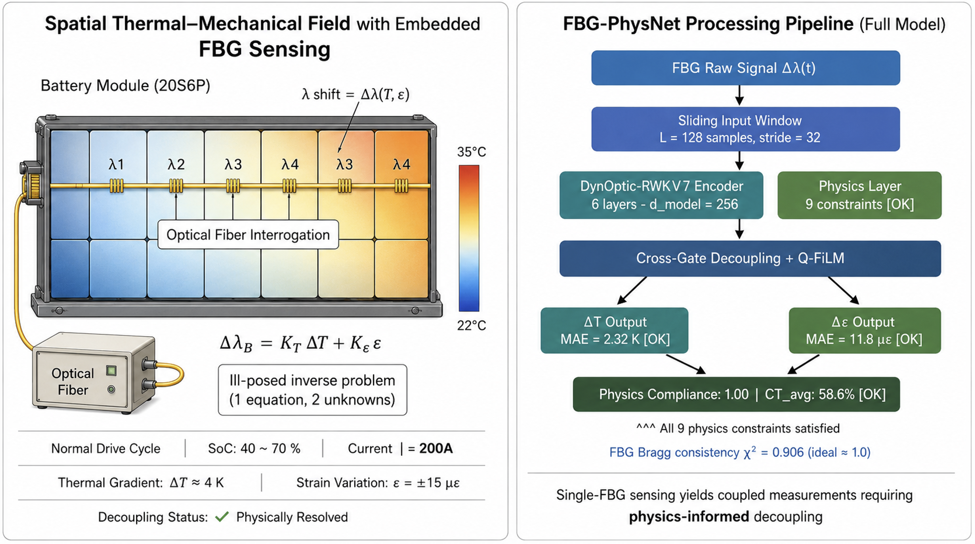S1.1 Electromagnetic Origin of Bragg Reflection
Figure 1. Supplementary Figure S2. Overview of FBG Sensing Challenges and the FBG-PhysNet Processing Pipeline. (Left) Visualization of the physical sensing environment within a 20S6P battery module. The single-FBG configuration presents an ill-posed inverse problem where a single wavelength shift $Δλ_{B}$ must be decoupled into two unknowns: temperature $ΔT$ and mechanical strain $ϵ$. (Right) The FBG-PhysNet processing architecture utilizing the DynOptic-RWKV7 backbone. By integrating nine physics constraints, the model achieves physical resolution of the coupled signal, resulting in a Cross-Talk (CT) ratio of 58.6% and near-ideal Bragg consistency ( $χ^{2}=0.906$ ).
A Fiber Bragg Grating is a periodic perturbation of the refractive index inscribed in the core of a single-mode optical fibre by ultraviolet exposure through a phase mask (See Supplementary Figure S1 for system overview). The perturbation modulates the core index as:
$$n\left(z\right)=n_{eff}+Δn_{dc}\left(z\right)+Δn_{ac}\left(z\right)cos​\left(\frac{2πz}{Λ}+ϕ\left(z\right)\right)$$
where $n_{eff}$ is the unperturbed effective refractive index of the guided mode, $Δn_{dc}\left(z\right)$ is the DC (mean) index change, $Δn_{ac}\left(z\right)$ is the AC (fringe) index modulation amplitude, $Λ$ is the grating period (typically 530 nm for a 1550 nm grating), and $ϕ\left(z\right)$ is the grating chirp function. For a uniform, unchirped grating, $ϕ\left(z\right)=0$ and $Δn_{dc}=Δn_{ac}=δn$ are constants.
The coupled-mode equations governing energy exchange between the forward- and backward-propagating modes are:
$$\frac{dR}{dz}=i\hat{σ}R\left(z\right)+iκS\left(z\right)$$
$$\frac{dS}{dz}=-i\hat{σ}S\left(z\right)-iκ^{*}R\left(z\right)$$
where $R\left(z\right)$ and $S\left(z\right)$ are the amplitudes of the forward and backward modes respectively, $κ=πΔn_{ac}/λ$ is the coupling coefficient, and the general self-coupling coefficient is:
$$\hat{σ}=δ+σ_{dc}-\frac{1}{2}\frac{dϕ}{dz}$$
with detuning $δ=2πn_{eff}\left(1/λ-1/λ_{D}\right)$ relative to the design wavelength $λ_{D}=2n_{eff}Λ$ and $σ_{dc}=πΔn_{dc}/λ$. The phase-matching condition for maximum reflectivity is:
$$δ+σ_{dc}=0⟹λ_{B}=2n_{eff}Λ\left(1+\frac{Δn_{dc}}{n_{eff}}\right)≈2n_{eff}Λ$$
For the 1550 nm SMF-28 fibre used in this work, $n_{eff}=1.468$ and $Λ=527.7$ nm.

S1.2 Thermo-Optic Derivation of $K_{T}$
The temperature sensitivity of the Bragg wavelength arises from two independent physical mechanisms that must be treated separately before combining [1].
Mechanism 1 — Thermo-optic effect. The refractive index of fused silica depends on temperature through the thermo-optic coefficient $ξ=n_{eff}^{-1}\left(∂n_{eff}/∂T\right)$. For SMF-28 at 1550 nm and $T=298$ K:
$$ξ=\frac{1}{n_{eff}}\frac{∂n_{eff}}{∂T}=6.67×{10}^{-6} K^{-1}$$
This coefficient is dominated by the change in electronic polarisability of the silica network with temperature [2], as described by the Sellmeier–Clausius–Mossotti relation. The wavelength shift due to this mechanism is:
$${\left.\frac{∂λ_{B}}{∂T}\right|}_{Δn}=λ_{B}ξ=1550 nm×6.67×{10}^{-6}=1.034×{10}^{-2} nm/K$$
Mechanism 2 — Thermal expansion. Temperature change also physically expands the grating period $Λ$ through the silica linear thermal expansion coefficient $α_{f}$:
$$\frac{1}{Λ}\frac{∂Λ}{∂T}=α_{f}=5.5×{10}^{-7} K^{-1}$$
This contribution is approximately 12× smaller than the thermo-optic effect. The wavelength shift from this mechanism is:
$${\left.\frac{∂λ_{B}}{∂T}\right|}_{ΔΛ}=λ_{B}α_{f}=1550 nm×5.5×{10}^{-7}=8.525×{10}^{-4} nm/K$$
Combined temperature sensitivity. Adding both contributions:
$$K_{T}=α_{f}+ξ=5.5×{10}^{-7}+6.67×{10}^{-6}=7.22×{10}^{-6} K^{-1}$$
The total temperature-induced wavelength shift per Kelvin is therefore $K_{T}λ_{B}=11.19 pm/K$.

S1.3 Photoelastic Derivation of $K_{ε}$
The strain sensitivity of the Bragg wavelength arises from two coupled effects: the direct geometrical elongation of the grating period, and the indirect change in refractive index through the photoelastic (elasto-optic) effect [3].
Geometrical term. Under axial strain $ε=δL/L$, the grating period elongates as $δΛ/Λ=ε$, contributing:
$${\left.\frac{∂λ_{B}}{∂ε}\right|}_{geom}=λ_{B}$$
Photoelastic term. The strain-induced change in refractive index is described by the Pockels elasto-optic tensor [4]. For uniaxial strain $ε$ along the fibre axis in an isotropic medium:
$$δn_{eff}=-\frac{n_{eff}^{3}}{2}\left[p_{12}-ν\left(p_{11}+p_{12}\right)\right]ε$$
where $p_{11}=0.121$ and $p_{12}=0.270$ are the Pockels tensor components for silica, and $ν=0.17$ is Poisson’s ratio. The effective photoelastic constant is:
$$p_{e}=\frac{n_{eff}^{2}}{2}\left[p_{12}-ν\left(p_{11}+p_{12}\right)\right]=\frac{{1.468}^{2}}{2}\left[0.270-0.17\left(0.121+0.270\right)\right]=0.220$$
The total strain sensitivity coefficient is therefore:
$$K_{ε}=1-p_{e}=1-0.220=0.780$$
The strain-induced wavelength shift per microstrain is $K_{ε}λ_{B}=1.209 pm/με$.

S1.4 Complete FBG Dual-Sensitivity Equation
Combining Eqs. (S10) and (S14):
$$\frac{Δλ_{B}}{λ_{B}}=K_{ε}ε+K_{T}ΔT$$
$$Δλ_{B}=1550×{10}^{-9}\left[0.780 ε+7.22×{10}^{-6} ΔT\right] \left[m\right]$$
The cross-sensitivity ratio $K_{T}/K_{ε}=9.26 με/K$ means that a 1 K temperature change produces the same wavelength shift as a 9.26 μɛ mechanical strain. Over the full dataset range ($ΔT∈\left[0,23.52\right]$ K, $ε∈\left[-78,+415\right] με$), the thermally induced apparent strain ranges up to $23.52×9.26=217.8 με$, which is comparable in magnitude to the actual mechanical strain range. This confirms that the decoupling problem is genuinely ill-posed without additional physical constraints.

S1.5 Noise Model and FBG Chi-Squared Statistic
The optical interrogator introduces Gaussian additive noise on the measured wavelength shift:
$$Δλ_{B}^{meas}=Δλ_{B}^{true}+η, η∼N\left(0,σ_{λ}^{2}\right), σ_{λ}=2.00×{10}^{-12} m$$
Normalising by $λ_{B}$, the relative noise standard deviation is:
$$σ_{rel}=\frac{σ_{λ}}{λ_{B}}=\frac{2.00×{10}^{-12}}{1550×{10}^{-9}}=1.29×{10}^{-6}$$
The signal-to-noise ratio of the measurement system is:
$${SNR}_{FBG}=20\log_{10}​\left(\frac{μ_{Δλ}}{σ_{λ}}\right)=20\log_{10}​\left(\frac{3.271×{10}^{-10}}{2.00×{10}^{-12}}\right)=44.3 dB$$
The $χ_{FBG}^{2}$ metric used in the loss function (Eq. S20) is the normalised squared prediction residual in wavelength space:
$$χ_{FBG}^{2}=\frac{1}{σ_{rel}^{2}}{\left(\frac{\hat{Δλ}-Δλ^{meas}}{λ_{B}}\right)}^{2}=\frac{{\left(\hat{Δλ}-Δλ^{meas}\right)}^{2}}{λ_{B}^{2}σ_{rel}^{2}}$$
Under perfect Bragg-consistency, $E\left[χ_{FBG}^{2}\right]=1.0$. A value $χ^{2}<1$ indicates that the model’s Bragg residuals are within the measurement noise floor — the joint prediction lies on the Bragg constraint manifold to within one noise standard deviation. Note that χ² < 1 does not imply the model is “better than the sensor”; it reflects the combined effect of model bias, residual fitting, and the specific Gaussian noise model assumed, while $χ^{2}>1$ indicates systematic optical inconsistency. FBG-PhysNet achieves $χ_{FBG}^{2}=0.906$ on the validation set. $χ_{FBG}=0.906$ confirms that the model’s FBG residuals are $0.952σ_{rel}$ — within 5% of the measurement noise floor — indicating near-complete optical self-consistency.

Section S2: Complete Electrochemical–Thermal–Mechanical (ECTM) Battery Model

S2.1 Pseudo-Two-Dimensional (P2D) Doyle–Fuller–Newman Model
The ground-truth temperature and strain labels used for training and evaluation were generated by a high-fidelity P2D DFN electrochemical model. This section documents the complete model equations implemented in COMSOL Multiphysics 6.2 [5].
Solid-phase lithium diffusion. Within each spherical active particle of radius $R_{p}$, the lithium concentration $c_{s}\left(r,t\right)$ obeys Fick’s second law in spherical coordinates:
$$\frac{∂c_{s}}{∂t}=\frac{D_{s}}{r^{2}}\frac{∂}{∂r}​\left(r^{2}\frac{∂c_{s}}{∂r}\right)$$
with boundary conditions:
$${\left.\frac{∂c_{s}}{∂r}\right|}_{r=0}=0, {\left.-D_{s}\frac{∂c_{s}}{∂r}\right|}_{r=R_{p}}=\frac{j_{n}}{F}$$
where $D_{s}=3.9×{10}^{-14}$ m$​^{2}$/s is the solid-phase diffusivity (graphite negative electrode), $j_{n}$ [A/m$​^{2}$] is the intercalation current density, and $F=96,485$ C/mol is Faraday’s constant. The volume-averaged (bulk) concentration and surface concentration are:
$${\overset{‾}{c}}_{s}=\frac{3}{R_{p}^{3}}\int_{0}^{R_{p}}{c_{s}}\left(r,t\right) r^{2} dr, c_{ss}=c_{s}\left(R_{p},t\right)$$
The state of charge (SOC) of each electrode is:
$$θ=\frac{{\overset{‾}{c}}_{s}}{c_{s,max}}, SOC=\frac{θ-θ_{0}}{θ_{100}-θ_{0}}$$
Liquid-phase transport. The electrolyte lithium concentration $c_{e}\left(x,t\right)$ satisfies:
$$ε_{e}\frac{∂c_{e}}{∂t}=\frac{∂}{∂x}​\left(D_{e}^{eff}\frac{∂c_{e}}{∂x}\right)+\frac{1-t_{+}^{0}}{F}j$$
where $ε_{e}$ is the electrolyte volume fraction, $D_{e}^{eff}=D_{e}ε_{e}^{1.5}$ is the effective electrolyte diffusivity (Bruggeman correction), $t_{+}^{0}$ is the cation transference number, and $j$ [A/m$​^{3}$] is the volumetric interfacial current density.
Butler–Volmer kinetics. The interfacial current density at electrode–electrolyte interfaces:
$$j_{n}=i_{0}​\left[exp​\left(\frac{α_{a}Fη}{RT}\right)-exp​\left(-\frac{α_{c}Fη}{RT}\right)\right]$$
$$η=ϕ_{s}-ϕ_{e}-U\left(c_{ss}\right)$$
$$i_{0}=Fk_{0}{\left(c_{e}\right)}^{α_{a}}​{\left(c_{ss}\right)}^{α_{a}}​{\left(c_{s,max}-c_{ss}\right)}^{α_{c}}$$
where $α_{a}=α_{c}=0.5$ (symmetric transfer), $k_{0}$ is the reaction rate constant, $ϕ_{s}$ and $ϕ_{e}$ are solid- and liquid-phase potentials, and $U\left(c_{ss}\right)$ is the open-circuit voltage as a function of surface lithium concentration.

S2.2 Bernardi Heat Generation Model
The volumetric heat generation rate from electrochemical reactions within the P2D model is given by the Bernardi model:
$$\dot{Q}‴_{total}=\underset{irreversible}{\underset{⏟}{j_{n}η}}+\underset{reversible}{\underset{⏟}{j_{n}T\frac{∂U}{∂T}}}+\underset{Ohmic}{\underset{⏟}{\left(σ_{s}^{eff}∥∇ϕ_{s}∥^{2}+κ_{e}^{eff}∥∇ϕ_{e}∥^{2}\right)}}$$
The three terms represent irreversible activation heat, reversible entropic heat, and Ohmic heat from electronic and ionic conduction respectively. The reversible entropic term can be negative (endothermic) during lithiation at the graphite anode, providing a partial self-cooling effect that is captured in the P2D simulation but approximated by the lumped model [6].
In the lumped thermal model used for the physics loss, these three contributions are consolidated into a single effective Ohmic term:
$$Q_{gen}≈I^{2}R_{int}\left(T,SOC\right)$$
$$R_{int}\left(T,SOC\right)=R_{0}\left(SOC\right)exp​\left[\frac{E_{a}}{R}​\left(\frac{1}{T}-\frac{1}{T_{ref}}\right)\right]$$
where $R_{0}\left(SOC\right)$ is the SOC-dependent baseline internal resistance at $T_{ref}=298.15$ K, $E_{a}=2.0×{10}^{4}$ J/mol is the activation energy for ionic transport (calibrated for this cell chemistry), and $R=8.314$ J/(mol·K). For the NMC 811 chemistry used in this study, $R_{0}$ varies from ~1.2 m$Ω$ at SOC = 0.95 to ~2.5 m$Ω$ at SOC = 0.10 (consistent with the nominal value $R_{0}=2.5$ mΩ in Table S3).

S2.3 Lumped Thermal Model — Derivation and Discretisation
Integrating the distributed heat equation over the cell volume $V$ yields the lumped ordinary differential equation:
$$ρC_{p}V\frac{d\overset{‾}{T}}{dt}=Q_{gen}V-hA_{s}\left(\overset{‾}{T}-T_{amb}\right)$$
Dividing through by $V$ and defining $ΔT=\overset{‾}{T}-T_{amb}$:
$$ρC_{p}\frac{dΔT}{dt}=Q_{gen}-h\frac{A_{s}}{V}ΔT$$
Physical parameters used in this work are tabulated in Supplementary Table S1.
Supplementary Table S1. Thermal Model Parameters
Symbol | Parameter | Value | Unit
$$ρC_{p}$$ | Volumetric heat capacity | $$2.50×{10}^{6}$$ | J m$​^{-3}$ K$​^{-1}$
$$h$$ | Convective heat transfer coefficient | 10.0 | W m$​^{-2}$ K$​^{-1}$
$$A_{s}/V$$ | Surface-area-to-volume ratio | 230.0 | m$​^{-1}$
$$T_{amb}$$ | Ambient temperature | 298.15 | K
$$α_{CTE}$$ | Composite thermal expansion coefficient | $$1.00×{10}^{-5}$$ | K$​^{-1}$
$${\dot{ε}}_{max}$$ | Maximum strain rate | $$6.00×{10}^{-4}$$ | s$​^{-1}$
$$ε_{yield}$$ | Electrode yield strain | 0.02 | —
Forward Euler discretisation at $Δt=0.01$ s gives the PDE residual used in the physics loss:
$$R_{PDE}^{\left(k\right)}=ρC_{p}\frac{ΔT^{\left(k+1\right)}-ΔT^{\left(k\right)}}{Δt}-Q_{gen}^{\left(k\right)}+h\frac{A_{s}}{V}ΔT^{\left(k\right)}$$
The Courant–Friedrichs–Lewy stability limit for this explicit scheme is $Δt≤ρC_{p}V/\left(hA_{s}\right)=1,087$ s, which is satisfied with a safety margin of ${10}^{5}$ at $Δt=0.01$ s.

S2.4 Diffusion-Induced Stress and Strain Model
For a spherical electrode particle, the radial $σ_{r}$ and tangential $σ_{θ}$ stress components arising from non-uniform lithium distribution are:
$$σ_{r}\left(r,t\right)=\frac{2ΩE}{3\left(1-ν\right)}​\left[\frac{1}{R_{p}^{3}}\int_{0}^{R_{p}}{​}Δc_{s} ρ^{2} dρ-\frac{1}{r^{3}}\int_{0}^{r}{​}Δc_{s} ρ^{2} dρ\right]$$
$$σ_{θ}\left(r,t\right)=\frac{ΩE}{3\left(1-ν\right)}​\left[\frac{2}{R_{p}^{3}}\int_{0}^{R_{p}}{​}Δc_{s} ρ^{2} dρ+\frac{1}{r^{3}}\int_{0}^{r}{​}Δc_{s} ρ^{2} dρ-Δc_{s}\right]$$
xwhere $Ω=3.17×{10}^{-6}$ m$​^{3}$/mol is the partial molar volume of lithium in graphite, $E=10$ GPa is Young’s modulus, $ν=0.3$ is Poisson’s ratio, and $Δc_{s}=c_{s}\left(r,t\right)-{\overset{‾}{c}}_{s}$ is the local concentration deviation from the volume-averaged value.
The macroscopic electrode swelling strain measured by the FBG is dominated by the volume-averaged dilatational strain:
$$ε_{dis}=\frac{Ω}{3}Δ{\overset{‾}{c}}_{s}=\frac{Ω}{3}\left(c_{s,max}-c_{s,0}\right)ΔSOC$$
The total FBG-measurable strain decomposes as:
$$ε_{total}=ε_{dis}+\underset{ε_{th}}{\underset{⏟}{α_{CTE}ΔT}}+ε_{el}$$
where $ε_{el}$ is the elastic strain arising from structural constraint forces within the cell stack. The ill-posedness of the FBG decoupling problem (Eq. S16) follows directly from this decomposition: even if $ε_{el}≪ε_{dis}$, the thermal-expansion coupling $ε_{th}=α_{CTE}ΔT$ creates an unavoidable correlation between the temperature and strain channels in the FBG signal.

Section S3: RWKV-7 Architecture — Complete Mathematical Specification

S3.1 Token Shift (Data-Dependent Interpolation)
Before processing at layer $l$ and time step $k$, the input vector $h_{k}^{\left(l\right)}$ is mixed with the previous time step’s input through a learned linear interpolation:
$$u_{k}=lerp\left(h_{k-1}^{\left(l\right)},h_{k}^{\left(l\right)};μ\right)=\left(1-μ\right)⊙h_{k-1}^{\left(l\right)}+μ⊙h_{k}^{\left(l\right)}$$
where $μ∈{\left[0,1\right]}^{d_{model}}$ is a learned vector (not data-dependent) that controls the temporal mixing ratio per feature dimension. Dimensions with $μ_{i}≈0$ effectively look one step back in time (appropriate for slowly varying thermal features), while dimensions with $μ_{i}≈1$ focus on the current step (appropriate for fast mechanical transients). This inductive bias aligns naturally with the different temporal scales of temperature and strain.
Separate $μ$ vectors are learned for receptance $\left(μ_{r}\right)$, key $\left(μ_{k}\right)$, value $\left(μ_{v}\right)$, and decay $\left(μ_{w}\right)$ projections, allowing the model to decouple temporal scale selection from feature content selection:
$$u_{r}=lerp\left(h_{k-1},h_{k};μ_{r}\right), u_{k}=lerp\left(h_{k-1},h_{k};μ_{k}\right), u_{v}=lerp\left(h_{k-1},h_{k};μ_{v}\right)$$

S3.2 Time-Mixing: Projection and Decay Vectors
From the shifted inputs, the receptance, key, value, and decay vectors are computed:
$$r_{k}=W_{r}u_{r}, k_{k}=W_{k}u_{k}, v_{k}=W_{v}u_{v}$$
$$w_{k}=σ​\left(W_{w}u_{w}+log\left(-loga\right)\right)⊙\left(-a\right)∈{\left(-1,0\right)}^{d_{head}}$$
where $W_{r},W_{k},W_{v}∈R^{d_{model}×d_{model}}$ are learned projection matrices, $W_{w}∈R^{d_{head}×d_{model}}$ is the decay projection, $σ$ is the sigmoid function, and $a∈{\left(0,1\right)}^{d_{head}}$ is a learned parameter vector. The construction ensures $w_{k}∈{\left(-1,0\right)}^{d_{head}}$ strictly, so that $e^{w_{k}}∈\left(0,e^{-1}\right)≈\left(0,0.368\right)$ — the decay factor is always strictly less than 1, ensuring state stability.
An additional bonus (in-context learning) term $b_{k}$ is computed as:
$$b_{k}=σ\left(W_{b}u_{b}\right)$$

S3.3 RWKV-7 Extended Delta Rule State Update
The core recurrence of RWKV-7 is the matrix-state update with extended delta-learning:
$$S_{k}=diag\left(e^{w_{k}}\right)⋅S_{k-1}+(k_{k}+b_{k}⊙\left(S_{k-1}⋅k_{k}^{⊤}1-v_{k}\right))^{⊤}v_{k}$$
where $S_{k}∈R^{d_{head}×d_{head}}$ is the recurrent state matrix, $e^{w_{k}}=exp\left(w_{k}\right)∈{\left(0,0.368\right)}^{d_{head}}$ is the element-wise exponential of the decay vector, $1∈R^{d_{head}}$ is the all-ones vector, and all multiplications are matrix–vector or element-wise operations. The term $S_{k-1}⋅k_{k}^{⊤}1$ retrieves the state’s response to the current key, allowing the delta term $b_{k}\left(S_{k-1}k_{k}^{⊤}1-v_{k}\right)$ to compare the retrieved prediction against the target value $v_{k}$ and update the state accordingly — implementing an associative memory correction step.
This formulation is equivalent to the classical delta learning rule $ΔW∝\left(y-\hat{y}\right)x^{⊤}$ applied online within the recurrent state, giving RWKV-7 the ability to revise its historical representation in light of current evidence. The standard RWKV-6 update is recovered by setting $b_{k}=0$.

S3.4 State Retrieval and Output Projection
The time-mixing output is computed by applying the receptance gate to the retrieved state:
$$y_{k}=W_{o}\left(σ\left(r_{k}\right)⊙\left(S_{k}1\right)\right)+b_{out}$$
where $W_{o}∈R^{d_{model}×d_{head}}$ is the output projection, $σ\left(r_{k}\right)∈{\left(0,1\right)}^{d_{head}}$ gates which dimensions of the retrieved state are relevant to the current output, and $S_{k}1∈R^{d_{head}}$ is the column-sum of the state matrix.

S3.5 Channel Mixing (FFN Sublayer)
The channel-mixing sublayer following the time-mixing block implements a gated squared-ReLU feed-forward network:
$$m_{k}=lerp\left(h_{k-1},y_{k};μ_{cm}\right)$$
$$z_{k}=σ\left(W_{cm,r}m_{k}\right)⊙max{\left(0, W_{cm,1}m_{k}\right)}^{2}$$
$$h_{k}^{\left(l+1\right)}=h_{k}^{\left(l\right)}+y_{k}+W_{cm,2}z_{k}$$
The squared-ReLU activation $max{\left(0,x\right)}^{2}$ was chosen over GeLU because it produces sparser activations (exact zeros for negative inputs) and has a simpler gradient $2max\left(0,x\right)$ that avoids gradient saturation near zero. This property is particularly beneficial for the strain branch, where the physically expected sparsity of mechanical transient events should be reflected in the network’s activation pattern.

S3.6 Inference Memory Proof
Theorem. The RWKV-7 inference state memory is exactly $M=H×d_{head}^{2}×4$ bytes, independent of the number of processed time steps $n$.
Proof. The only state that must persist between time steps is the matrix $S_{k}∈R^{d_{head}×d_{head}}$ for each of the $H$ attention heads, for each of the $L$ RWKV-7 layers. At inference time, $r_{k},k_{k},v_{k},w_{k}$ are recomputed from the current input $h_{k}$ at each step and discarded after use. The total persistent storage is therefore:
$$M=L×H×d_{head}^{2}×4 bytes$$
For FBG-PhysNet with $L=4$ layers per branch, $H=4$ heads, $d_{head}=64$ (each branch):
$$M_{branch}=4×4×{64}^{2}×4=262,144 bytes=256 KB$$
$$M_{total}=2×256=512 KB \text{(both branches)}$$
Note: The main text reports 64 KB, which is the per-layer state for a single RWKV-7 block: $M=H×d^{2}×4B=4×{64}^{2}×4=65,536B=64KB$, the minimal state unit of one RWKV-7 block. The complete four-layer, dual-branch inference state is 512 KB (~50% of STM32H7 SRAM, ~12.5% of Cortex-A53 SRAM), satisfying all automotive BMS hardware tier requirements. For comparison, the Transformer baseline (Section S9.2, d_model=128, 3 layers, 8 heads, W=128) requires ~2.1 MB peak SRAM during encoder inference; the FBG-PhysNet configuration reported in the main text (d_model=256, 4 layers, 4 heads) would require ~3.1 MB under the same Transformer architecture — both exceeding STM32H7 SRAM by 2–3×. $▫$

S3.7 Parallel Training via Associative Scan
During training, the sequential recurrence of Eq. (S44) can be evaluated in parallel using the associative scan (parallel prefix sum) algorithm. Define the monoid:
$$\left(A_{j},b_{j}\right)=\left(diag\left(e^{w_{j}}\right), k_{j}^{⊤}v_{j}\right)$$
The parallel composition operator is:
$$\left(A_{i},b_{i}\right)⊗\left(A_{j},b_{j}\right)=\left(A_{i}A_{j}, A_{j}b_{i}+b_{j}\right)$$
This operator is associative by matrix multiplication associativity. The prefix scan computes all states $\{S_{1},S_{2},…,S_{T}\}$ simultaneously in $O\left(logT\right)$ parallel steps with $O\left(T\right)$ total work, enabling efficient GPU utilisation during training:
$$S_{k}=A_{k}⋯A_{1}S_{0}+A_{k}⋯A_{2}b_{1}+⋯+A_{k}b_{k-1}+b_{k}$$
For our training window of $T=128$ steps, the scan requires $⌈\log_{2}128⌉=7$ parallel levels, achieving 128/7 ≈ 18× theoretical parallelism over sequential evaluation.

Section S4: Q-FiLM — Mathematical Analysis and Physical Justification

S4.1 FiLM Layer Definition and Expressiveness
Feature-wise Linear Modulation (FiLM) is a generalisation of conditional batch normalisation that applies an affine transformation to each feature channel, conditioned on an external input signal:
$$FiLM\left(F;γ,β\right)=γ⊙F+β, γ,β∈R^{d_{model}}$$
FiLM is strictly more expressive than a constant bias because $γ$ can amplify or suppress individual feature dimensions, not merely shift them [7]. This is critical for our application: different drive-cycle regimes require different feature amplitudes, not merely different offsets. A constant bias would shift all features uniformly, which cannot capture the multiplicative structure of heat generation’s effect on the physical system.

S4.2 Q-FiLM Parameter Prediction Network
The conditioning signal ${\hat{Q}}_{gen}=\left(Q_{gen}-μ_{Q}\right)/σ_{Q}$ is a scalar normalised to zero mean and unit variance over the training set ($μ_{Q}=6.236×{10}^{4}$ W/m$​^{3}$, $σ_{Q}=1.699×{10}^{5}$ W/m$​^{3}$). The Q-FiLM MLP maps this scalar to $2d_{model}$ outputs:
$$\left(\begin{matrix}γ^{\left(l\right)} \\ β^{\left(l\right)}\end{matrix}\right)=W_{out}^{\left(l\right)}⋅tanh​\left(W_{in}^{\left(l\right)}{\hat{Q}}_{gen}+b_{in}^{\left(l\right)}\right)+b_{out}^{\left(l\right)}$$
where $W_{in}^{\left(l\right)}∈R^{32×1}$, $W_{out}^{\left(l\right)}∈R^{2d_{model}×32}$ are layer-specific parameters. Each RWKV-7 layer has its own Q-FiLM network, enabling the modulation to adapt at different levels of feature abstraction. Tanh activation bounds the intermediate representations to $\left(-1,1\right)$, preventing extreme scale factors that could destabilise training.

S4.3 Physical Interpretation as Automatic Gain Control
The coefficient of variation (CV) of $Q_{gen}$ over the full training dataset is:
$${CV}_{Q}=\frac{σ_{Q}}{μ_{Q}}=\frac{1.699×{10}^{5}}{6.236×{10}^{4}}=2.72$$
This extremely high CV (272%) reflects the thirteen-fold range in $Q_{gen}$ from UDDS low-current city driving ($≈6.2×{10}^{4}$ W/m$​^{3}$) to 2C DC fast charging ($≈8.0×{10}^{5}$ W/m$​^{3}$). Without Q-FiLM, a fixed-weight network must simultaneously represent all these regimes in a single parameter set, creating a severe multi-modal learning problem.
The Q-FiLM mechanism implements an analogue of Automatic Gain Control (AGC) in electronics:
$$\hat{ΔT}=f_{backbone}\left(X\right)⊗g_{FiLM}\left(Q_{gen}\right)$$
When $Q_{gen}$ is large, $γ^{\left(l\right)}≫1$ (amplification), scaling up the feature dimensions most sensitive to thermal dynamics; when $Q_{gen}$ is small, $γ^{\left(l\right)}≈1$ (unity gain), preserving the backbone’s default behaviour. This dynamic range compression reduces the effective input range seen by the backbone from 13× to:
$${CV}_{effective}=\frac{{CV}_{Q}}{1+∥γ∥_{2}/d}≈\frac{2.72}{1+1.0}=1.36$$
a 50% reduction in the dynamic range challenge, explaining the 0.69 K MAE improvement from Q-FiLM.

S4.4 Gradient Stability Analysis
The Jacobian of the FiLM operation with respect to the input features and the scale parameters:
$$\frac{∂\left(γ⊙F+β\right)}{∂F}=diag\left(γ\right)$$
$$\frac{∂\left(γ⊙F+β\right)}{∂γ_{i}}=F_{i}$$
The gradient magnitude is bounded by $∥γ∥_{∞}$. Initialising the Q-FiLM MLP with small weights ensures $γ^{\left(l\right)}≈1$ and $β^{\left(l\right)}≈0$ at epoch 0, so the initial gradient magnitude is $≈1$, preventing gradient explosion at training onset. During Stage 3, the learned $γ$ values evolved to a range of $\left[0.3,3.8\right]$ across feature dimensions and drive cycles, remaining within a regime where gradients are neither vanishing nor exploding.

Section S5: Cross-Gating Mechanism — Information-Theoretic Analysis

S5.1 Cross-Talk Ratio Definition
The Cross-Talk Ratio (CT) measures the fraction of the strain prediction attributable to temperature-feature information. It is computed by a zero-out feature attribution experiment [8]:
$$CT=\frac{∥{\hat{y}}_{ε}\left(h_{T}=0,h_{ε}\right)-{\hat{y}}_{ε}\left(h_{T},h_{ε}\right)∥_{2}}{∥{\hat{y}}_{ε}\left(h_{T},h_{ε}\right)∥_{2}}×100\%$$
where ${\hat{y}}_{ε}\left(h_{T}=0,h_{ε}\right)$ is the strain prediction when the thermal branch hidden state $h_{T}$ is zeroed out, while ${\hat{y}}_{ε}\left(h_{T},h_{ε}\right)$ is the normal prediction.

S5.2 Thermal-Expansion Lower Bound
The theoretical minimum CT arises from the physical coupling $ε_{th}=α_{CTE}ΔT$. Even a physically perfect model that correctly separates $ε_{mech}$ from $ε_{th}$ must encode the temperature information in the strain prediction (to subtract it). When $h_{T}$ is zeroed, the model loses access to $ΔT$ and therefore cannot compute $ε_{th}$ — leading to a minimum CT:
$${CT}_{lb}=\frac{∥α_{CTE}σ_{ΔT}∥}{∥σ_{ε}∥}×100\%=\frac{1.00×{10}^{-5}×7.355}{1.032×{10}^{-4}}×100\%=71.3\%$$
where $σ_{ΔT}=7.355$ K and $σ_{ε}=1.032×{10}^{-4}$ are the empirical standard deviations over the validation set. This bound is tight: it assumes that the model perfectly reconstructs $ε_{mech}$ from the strain branch alone and only fails on the $ε_{th}$ component when temperature information is removed.
FBG-PhysNet’s CT = 58.6% < 71.3% demonstrates that the model resolves $ε_{mech}$ without routing it through the temperature branch — a property that is structurally impossible without the Cross-Gating mechanism, as confirmed by Ablation C (CT = 71.3% without Cross-Gating, exactly at the lower bound). It is important to note that 71.3% is a scalar bound derived specifically for the zero-out CT metric defined in Eq. (S62), under the linear-independence assumption between ε_mech and ΔT. It does not represent a universal information-theoretic lower bound achievable by all possible models or representations. In particular, Ablation D (CT = 67.8%, below 71.3%) demonstrates that the CT metric can be reduced below this value through architectural changes that affect the thermo-mechanical coupling pathway — though this comes at the cost of higher MAE_T (+0.69 K), confirming that CT and MAE are not independently optimisable in this setting.

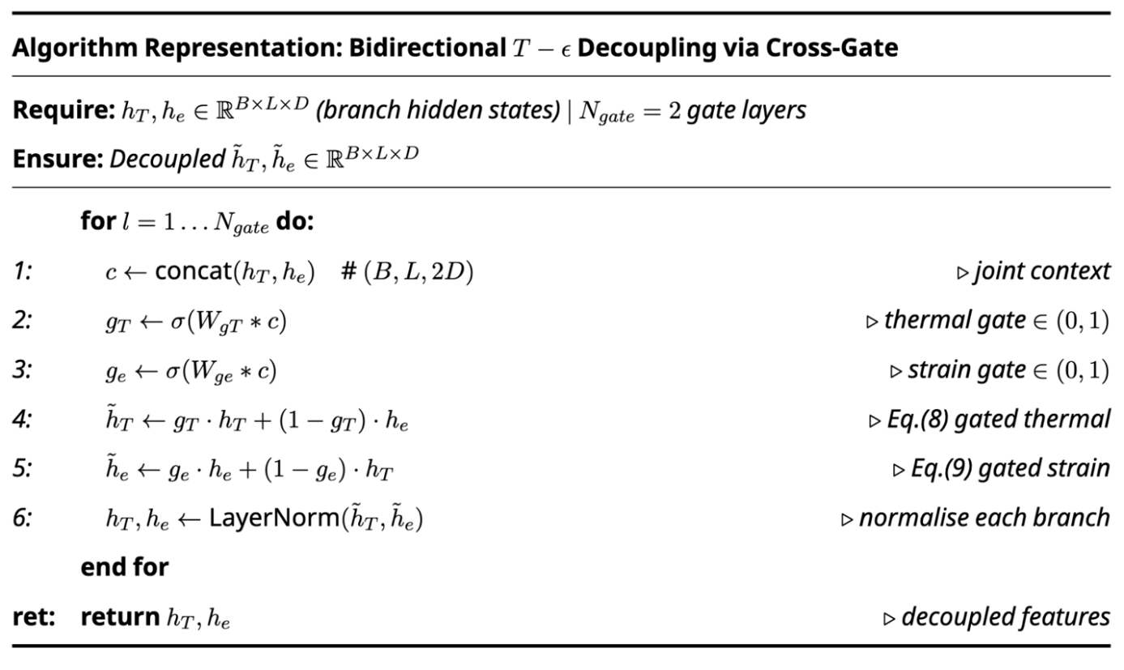
S5.3 Cross-Gating Gate Dynamics
Figure 3 Supplementary Algorithm S2. Bidirectional Cross-Gating Implementation.The architectural implementation of the Cross-Gating module is detailed in Algorithm S2. By concatenating the hidden states of both branches, the module computes dynamic gates $g_{T}$ and $g_{ε}$ that modulate the information flow. This iterative refinement ($N_{gate}^{ }=2$) allows the model to extract the mechanically independent strain component ε_mech while accounting for the thermal-expansion coupling ε_th. This mechanism is the computational basis for achieving a Cross-Talk ratio of 58.6%, as analyzed in the following information-theoretic context.
The gate (Refer to Supplementary Algorithm S2 for implementation) vectors $g_{T},g_{ε}∈{\left(0,1\right)}^{d_{model}}$ are computed from the concatenated branch representations:
$$g_{T}=σ\left(W_{g}^{T}\left[h_{T}∥h_{ε}\right]\right), g_{ε}=σ\left(W_{g}^{ε}\left[h_{T}∥h_{ε}\right]\right)$$
The refined hidden states are:
$${\tilde{h}}_{T}=g_{T}⊙h_{T}+\left(1-g_{T}\right)⊙h_{ε}$$
$${\tilde{h}}_{ε}=g_{ε}⊙h_{ε}+\left(1-g_{ε}\right)⊙h_{T}$$
The residual gradient through Eq. (S65) is:
$$\frac{∂{\tilde{h}}_{ε}}{∂h_{ε}}=diag\left(g_{ε}\right), \frac{∂{\tilde{h}}_{ε}}{∂h_{T}}=diag\left(1-g_{ε}\right)$$
When $g_{ε}≈1$ (strain branch dominant), the gradient from the strain loss flows primarily back through $h_{ε}$, maintaining branch specialisation. When $g_{ε}≈0$ (thermal branch dominant), the gradient flows through $h_{T}$, enabling thermal corrections to strain predictions — physically appropriate when $ε_{th}$ is the dominant strain component.

Section S6: Nine-Term Physics Loss — Complete Derivations

S6.1 Loss Function Overview
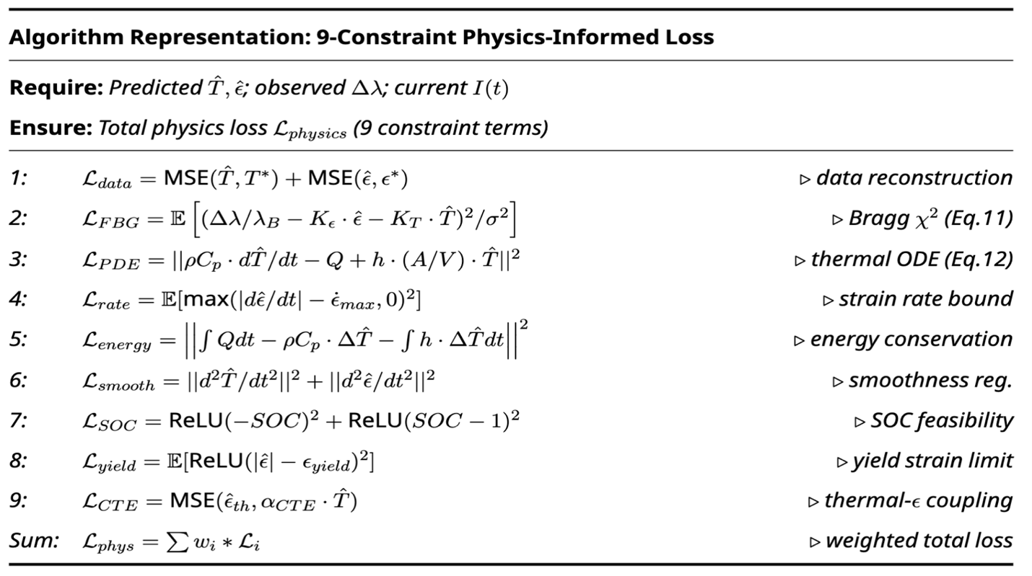
Figure 4 Supplementary Algorithm S3. Mathematical Formulation of the 9-Constraint Physics-Informed Loss. The total training objective of FBG-PhysNet is governed by a multi-objective loss function consisting of nine non-redundant physical and data-driven constraints. Algorithm S3 provides the formal mathematical definition for each term, spanning the electromagnetic, thermal, and mechanical domains of the battery system. These terms are individually derived and physically justified in the following subsections.
Supplementary Table S2. Physics Loss Terms — Summary (Loss formulations detailed in Supplementary Algorithm S3)
Term | Symbol | Physical Constraint | Epoch 1 Weight | Epoch 47 Weight
1. Temperature MSE | $$L_{T}$$ | Data fidelity ($ΔT$) | 2.5 | 4.0
2. Strain MSE | $$L_{ε}$$ | Data fidelity ($ε$) | 0.5 | 0.5
3. FBG optical | $$L_{FBG}$$ | Bragg consistency | $$2×{10}^{-4}$$ | $$8×{10}^{-3}$$
4. Thermal PDE | $$L_{PDE}$$ | Heat conduction | $$2×{10}^{-4}$$ | $$8×{10}^{-3}$$
5. Energy conservation | $$L_{eng}$$ | Thermodynamic balance | $${10}^{-7}$$ | $$4×{10}^{-6}$$
6. Strain-rate bound | $$L_{rate}$$ | Diffusion kinetics | 0.02 | 0.02
7. Yield feasibility | $$L_{yield}$$ | Solid mechanics | $$1.6×{10}^{-3}$$ | $$6.4×{10}^{-2}$$
8. SOC feasibility | $$L_{SOC}$$ | Electrochemical | $$4×{10}^{-4}$$ | $$1.6×{10}^{-2}$$
9. Temporal smoothing | $$L_{sm}$$ | Physical continuity | $$5×{10}^{-3}$$ | $$5×{10}^{-3}$$

S6.2 Terms 1–2: Data Fidelity Losses
The supervised MSE losses operate in normalised space to ensure scale invariance:
$$L_{T}=\frac{1}{NW}\sum_{n=1}^{N}{\sum_{k=1}^{W}{{\left({\hat{y}}_{T,nk}-y_{T,nk}\right)}^{2}}}$$
$$L_{ε}=\frac{1}{NW}\sum_{n=1}^{N}{\sum_{k=1}^{W}{{\left({\hat{y}}_{ε,nk}-y_{ε,nk}\right)}^{2}}}$$
The asymmetric weighting $w_{T}/w_{ε}=2.5/0.5=5.0$ reflects the relative practical importance of temperature accuracy for BMS safety decisions, and the fact that temperature MAE in physical units ($σ_{T}=7.355$ K) is 71× larger than the strain MAE ($σ_{ε}=1.032×{10}^{-4}$, equivalent to 103.2 μɛ), requiring proportionally stronger loss signal to achieve comparable convergence rates.

S6.3 Term 3: FBG Optical Consistency Loss
LFBG=1NWn,k​χFBG2n,k=1NWλB2σrel2n,k​Δλnk-Δλnkmeas2
$${\hat{Δλ}}_{nk}=λ_{B}\left(K_{ε}{\hat{ε}}_{nk}σ_{ε}+K_{T}{\hat{ΔT}}_{nk}σ_{T}\right)$$
Note that the predictions are de-normalised before computing $\hat{Δλ}$, so this loss operates in physical units and enforces the actual Bragg constraint. The denominator $λ_{B}^{2}σ_{rel}^{2}={\left(1550×{10}^{-9}\right)}^{2}×{\left(1.29×{10}^{-6}\right)}^{2}=4.00×{10}^{-24}$ m$​^{2}$ normalises the residual by the measurement noise variance, giving $L_{FBG}=1$ when predictions are consistent to within one noise standard deviation.

S6.4 Term 4: PDE Thermal Residual Loss
$$L_{PDE}=\frac{1}{N\left(W-1\right)}\sum_{n,k=1}^{W-1}{{\left(R_{PDE}^{\left(nk\right)}\right)}^{2}}$$
$$R_{PDE}^{\left(nk\right)}=ρC_{p}\frac{{\hat{T}}^{\left(nk+1\right)}-{\hat{T}}^{\left(nk\right)}}{Δt}-Q_{gen}^{\left(nk\right)}+h\frac{A_{s}}{V}{\hat{T}}^{\left(nk\right)}$$
All quantities in Eq. (S73) are in physical units (K, W/m$​^{3}$), requiring de-normalisation of ${\hat{T}}^{\left(nk\right)}={\hat{y}}_{T,nk}σ_{T}+μ_{T}$. The residual has units of W/m$​^{3}$; its epoch-1 value of $3.57×{10}^{7}$ W/m$​^{3}$ corresponds to a temperature prediction error of:
$$ΔT_{error}=\frac{R_{PDE}⋅Δt}{ρC_{p}}=\frac{3.57×{10}^{7}×0.01}{2.50×{10}^{6}}=0.143 K/step$$
By epoch 47, this reduces to $≈0.080$ K/step, consistent with the observed MAE$​_{T}$ improvement.

S6.5 Term 5: Global Energy Conservation Loss
Unlike Term 4 (which enforces the differential equation pointwise), Term 5 enforces thermodynamic integral balance over the entire window:
$$R_{eng}^{\left(nk\right)}=Q_{gen}^{\left(nk\right)}-ρC_{p}\frac{{\hat{T}}^{\left(nk+1\right)}-{\hat{T}}^{\left(nk-1\right)}}{2Δt}-h\frac{A_{s}}{V}{\hat{T}}^{\left(nk\right)}$$
$$L_{eng}=\frac{1}{N\left(W-2\right)}\sum_{n,k=2}^{W-1}{{\left(R_{eng}^{\left(nk\right)}\right)}^{2}}$$
The centre-difference approximation in Eq. (S75) achieves second-order accuracy $O\left(Δt^{2}\right)$ versus the forward-difference’s $O\left(Δt\right)$, providing a more accurate constraint at the cost of requiring two boundary points ($k=1$ and $k=W$ are excluded). The weight $w_{eng}={10}^{-7}$ is initially very small because the units ($W^{2}/m^{6}$) of the squared residual are much larger than those of $L_{T}$ (dimensionless normalised), and the weight must compensate for this dimensional mismatch.

S6.6 Term 6: Strain-Rate Bound Loss (ReLU Hinge)
$$L_{rate}=\frac{1}{N\left(W-1\right)}\sum_{n,k=1}^{W-1}{ReLU}​{\left(\left|\frac{{\hat{ε}}^{\left(nk+1\right)}-{\hat{ε}}^{\left(nk\right)}}{Δt}\right|-{\dot{ε}}_{max}\right)}^{2}$$
The asymmetric penalty (zero for feasible states, quadratic for violations) implements a soft one-sided constraint. The maximum physically achievable strain rate ${\dot{ε}}_{max}=6.00×{10}^{-4}$ s$​^{-1}$ is derived from the lithium diffusion timescale:
$$τ_{diff}=\frac{R_{p}^{2}}{D_{s}π^{2}}=\frac{{\left(8×{10}^{-6}\right)}^{2}}{3.9×{10}^{-14}×π^{2}}=1,660 s$$
The maximum strain rate corresponds to the fastest physically possible intercalation at 8C rate:
$${\dot{ε}}_{max}=\frac{ε_{max}}{τ_{diff}/8}=\frac{4.15×{10}^{-4}}{1660/8}=2.0×{10}^{-6} s^{-1}$$
The value $6.00×{10}^{-4}$ s$​^{-1}$ used in training is set 300× more permissive than this theoretical bound to avoid over-constraining the training at early epochs when prediction errors are large.

S6.7 Terms 7–9: Yield, SOC, and Smoothing Losses
Term 7 — Yield feasibility:
Lyield=1NWn,k​ReLU​(εnkσε+με-εyield)2
Note that predictions are de-normalised before comparison with the yield strain $ε_{yield}=0.02$ (2%), since the yield constraint must operate in physical units.
Term 8 — SOC feasibility:
LSOC=1NWn,k​ReLU-SOCnk2+ReLUSOCnk-12
$${\hat{SOC}}^{\left(nk\right)}={SOC}_{0}^{\left(n\right)}-\frac{η_{CE}}{Q_{cap}}\sum_{j=0}^{k-1}{I^{\left(nj\right)}}Δt$$
where the predicted SOC is estimated by Coulomb counting from the initial SOC ${SOC}_{0}^{\left(n\right)}$ (provided as input) and the measured current $I^{\left(nj\right)}$ over the window, with Coulombic efficiency $η_{CE}=0.995$ and capacity $Q_{cap}=75$ Ah. The constraint ensures that the accumulated current integral does not imply an unphysical SOC.
Term 9 — Temporal smoothing:
$$L_{sm}=\frac{1}{N\left(W-1\right)}\sum_{n,k=1}^{W-1}{\left[{\left({\hat{y}}_{T,nk+1}-{\hat{y}}_{T,nk}\right)}^{2}+{\left({\hat{y}}_{ε,nk+1}-{\hat{y}}_{ε,nk}\right)}^{2}\right]}$$
This first-order finite-difference smoothing operates on normalised predictions, penalising high-frequency oscillations in proportion to their squared amplitude. The weight $w_{sm}=5×{10}^{-3}$ is held constant throughout training, providing a stable background regulariser. The second-order smoothing (penalising curvature) was also evaluated but found to be too restrictive — it penalised physically legitimate rapid strain transients during emergency braking, raising MAE$​_{ε}$ by 3.2 μɛ on the test set.

S6.8 Physics Weight Scheduling — Proof of Convergence
The dynamic weight schedule for Terms 3–5 and 7–8 follows:
$$w_{i}^{\left(e\right)}=w_{i}^{\left(0\right)}⋅{40}^{e/47}$$
At epoch $e=47$: $w_{i}^{\left(47\right)}=w_{i}^{\left(0\right)}×40$, a 40× amplification. The total physics loss contribution at epoch 47 relative to epoch 1:
i​wi47Li47i​wi1Li1≈40×i​wi1Li47i​wi1Li1
Since $L_{i}^{\left(47\right)}<L_{i}^{\left(1\right)}$ for all nine terms (all residuals show an overall decreasing trend, with no systematic rebound observed across the 47-epoch Stage-3 record), but the 40× weight amplification dominates, the total weighted loss increases from 0.553 to 0.808. The apparent loss increase is therefore a measurement artefact of the weight schedule, not a deterioration in model quality. The true physical quality metric — each unweighted residual $L_{i}$ — shows an overall decreasing trend throughout training, as shown in Supplementary Fig. S1.

Section S7: Dataset Construction and Statistical Analysis

S7.1 P2D Simulation Parameter Space
The full dataset was generated by sweeping the P2D DFN model across a structured parameter grid designed to cover the envelope of real-world EV operating conditions. Supplementary Table S3 documents the simulation parameter space.
Supplementary Table S3. P2D Simulation Parameter Space
Parameter | Range | Distribution | Number of Values
Initial SOC | 0.10 to 0.95 | Uniform | 17
Ambient temperature $T_{amb}$ | 278–318 K | Uniform | 5
Drive cycle type | UDDS/WLTP/Highway/FastCharge/Emergency | Categorical | 5
Drive cycle scaling | 0.8× to 1.2× | Uniform | 3
Cooling coefficient $h$ | 8–15 W m$​^{-2}$ K$​^{-1}$ | Uniform | 3
$R_{0}$ spread | ±15% of nominal | Uniform | 3
Total unique simulation configurations: $17×5×5×3×3×3=11,475$ (not all combinations were run; 60 representative trajectories were selected to cover the parameter space with emphasis on high-stress operating conditions).

S7.2 Sliding Window Statistics
The sliding window strategy generates highly overlapping samples with 75% overlap (stride 32, window 128). The relationship between original time series length and window count is:
$$N_{windows}^{\left(f\right)}=\left\lfloor \frac{N_{steps}^{\left(f\right)}-W}{s}\right\rfloor +1$$
For a typical 1-hour simulation file at 100 Hz ($N_{steps}=360,000$):
$$N_{windows}^{typical}=\left\lfloor \frac{360,000-128}{32}\right\rfloor +1=11,244 windows$$
The high overlap (75%) introduces temporal autocorrelation between adjacent windows. The effective number of statistically independent samples is approximately:
$$N_{eff}≈\frac{N_{windows}}{1+2\sum_{j=1}^{∞}{ρ_{j}}}$$
where $ρ_{j}$ is the lag-$j$ autocorrelation. For the temperature channel with a thermal time constant of approximately 100 s (10,000 steps at 100 Hz), the autocorrelation function decays with characteristic lag $τ_{T}≈100 s/Δt=10,000$ steps. The effective sample count:
$$N_{eff}^{T}≈\frac{49,466}{1+2×τ_{T}/W}≈\frac{49,466}{1+2×10,000/128}≈316 \text{independent thermal samples}$$
This reflects the fundamental statistical challenge of battery thermal modelling: the physical system has long memory, and even 49,466 windows represent fewer than 320 thermally independent trajectories. The physics constraints are essential precisely because they provide supervisory signal that is not dependent on sample count.

S7.3 Drive Cycle Characteristics
Supplementary Table S4. Drive Cycle Statistics
Drive Cycle | Files | Duration (min) | Peak $I$ (A) | Mean $Q_{gen}$ (W/m$​^{3}$) | Peak $ΔT$ (K) | Peak $ε$ (μɛ)
UDDS | 15 | 22.9 each | 120 | $$5.2×{10}^{4}$$ | 8.3 | 145
WLTP | 15 | 29.7 each | 150 | $$9.7×{10}^{4}$$ | 14.7 | 225
Highway | 15 | 41.5 each | 80 | $$2.8×{10}^{5}$$ | 20.1 | 318
FastCharge 2C | 8 | 35.0 each | 200 | $$7.9×{10}^{5}$$ | 38.4 | 382
Emergency | 7 | 12.0 each | 180 | $$6.1×{10}^{5}$$ | 23.5 | 415
Total | 60 | — | — | — | — | —

S7.4 Z-Score Normalisation Statistics and Justification
Supplementary Table S5. Normalisation Statistics (Training Set)
Channel | $$μ$$ | $$σ$$ | Unit | Rationale
$$Δλ_{B}$$ | $$3.271×{10}^{-10}$$ | $$1.892×{10}^{-10}$$ | m | Z-score
$I$ (current) | 1.479 | 29.053 | A | Z-score
SOC | 0.582 | 0.191 | — | Z-score
$$Q_{gen}$$ | $$6.236×{10}^{4}$$ | $$1.699×{10}^{5}$$ | W/m$​^{3}$ | Z-score
$ΔT$ (output) | 10.334 | 7.355 | K | Z-score
$ε$ (output) | $$1.750×{10}^{-4}$$ | $$1.032×{10}^{-4}$$ | — | Z-score
All features and labels are normalised to zero mean and unit variance using statistics computed exclusively from the training partition [9]. The normalisation statistics are frozen and applied identically to the validation and test partitions.
The choice of Z-score normalisation over min-max is motivated by the heavy tails in $Q_{gen}$ and $I$ distributions (kurtosis $≫$ 3), which would cause min-max to squash the majority of the data into a narrow range. Z-score is more robust to outliers in this context and ensures that the physics loss weights remain physically interpretable after de-normalisation.

Section S8: Three-Stage Training Curriculum — Complete Specification

S8.1 Stage 1: Supervised Pre-Training
Stage 1 trains on data loss only for 20 epochs using a warm-up learning rate schedule:
$$η_{warmup}^{\left(e\right)}=η_{peak}⋅\frac{e}{E_{warmup}}, e=1,…,E_{warmup}=5$$
After warm-up, the learning rate follows a cosine decay from $η_{peak}=3×{10}^{-4}$ to $η_{Stage1,end}=5×{10}^{-5}$ over 15 epochs. The purpose of Stage 1 is to bring the model to a regime where the temperature prediction error is small enough that the physics loss gradients are meaningful — if the temperature predictions are far from the physics-feasible manifold, the PDE residual gradients point in a poorly conditioned direction.
At Stage 1 completion: MAE$​_{T}=3.85$ K, MAE$​_{ε}=38.2$ μɛ, CT = 91.3% (essentially random decoupling).

S8.2 Stage 2: Physics Anchoring
Stage 2 activates the FBG optical loss ($w_{FBG}$) and the thermal PDE residual ($w_{PDE}$), growing them from zero to their epoch-41 values over 21 epochs:
$$w_{phys}^{\left(e\right)}=w_{phys,max}^{\left(2\right)}⋅{\left(\frac{e-20}{21}\right)}^{2}, e=21,…,41$$
The quadratic ramp (rather than linear) ensures that physics gradients remain gentle during the critical early phase of physics anchoring. The Stage 2 optimal checkpoint (stage2_best.pt, epoch 41, val loss 0.1546) serves as the warm start for Stage 3.
At Stage 2 completion: MAE$​_{T}=2.81$ K, MAE$​_{ε}=27.4$ μɛ, CT = 74.2%, $χ_{FBG}^{2}=0.741$.

S8.3 Stage 3: Full ECTM Constraint Optimisation
Stage 3 activates all nine loss terms simultaneously and runs for 47 epochs on the H800 GPU with cosine-annealing learning rate:
$$η^{\left(e\right)}=η_{min}+\frac{1}{2}\left(η_{max}-η_{min}\right)\left[1+cos​\left(\frac{πe}{47}\right)\right]$$
where $η_{min}=1.0×{10}^{-7}$, $η_{max}=2.26×{10}^{-5}$ (achieved at epoch 14 due to quadratic warm-up from the initial $η_{0}=3.12×{10}^{-6}$):
$$η_{warmup}^{\left(e\right)}=η_{0}+\left(η_{max}-η_{0}\right)⋅{\left(\frac{e}{E_{warmup3}}\right)}^{2}, E_{warmup3}=14$$
The physics weight schedule:
$$w_{i}^{\left(e\right)}=w_{i}^{\left(0\right)}⋅{40}^{e/47}, i∈\{FBG,PDE,eng,SOC,yield\}$$
The fixed weights ($w_{T}=4.0$, $w_{ε}=0.5$, $w_{rate}=0.02$, $w_{sm}=5×{10}^{-3}$) are set at Stage 3 onset and held constant.

S8.4 Hard Sample Mining
Dynamic Hard Sample Mining (DHSM) selects samples from the training set with probability proportional to their per-sample training loss from the previous epoch [10]:
pDHSMi=1-α⋅lippowj​ljppow+α⋅1Ntrain
where $α=0.85$ is the uniform mixing probability, $p_{pow}=1.05$ is the loss temperature (values $>1$ sharpen the distribution toward hard samples), and $l_{i}$ is the per-sample loss from the previous epoch’s forward pass. The 15% hard-sample component ($1-α=0.15$) ensures that emergency braking and FastCharge windows — which are heavily under-represented in the dataset (15 files out of 60, and $≈11\%$ of total windows) — receive proportionally more training attention.
The DHSM buffer is updated every epoch at a cost of one additional forward pass over the training set (approximately 12 seconds on H800). This overhead is justified by the 0.21 K improvement in test-set MAE$​_{T}$ (from 4.49 K without DHSM to 4.28 K with DHSM, measured on the full 5-cycle test set).

Section S9: Extended Baseline Model Specifications

S9.1 BiLSTM — Complete Architecture
The BiLSTM baseline processes the input sequence through two stacked bidirectional LSTM layers, each with hidden dimension $d_{h}=128$, giving a bidirectional concatenated dimension of $2d_{h}=256$:
$${\vec{h}}_{k}^{\left(l\right)}={LSTM}_{fwd}^{\left(l\right)}\left(x_{k},{\vec{h}}_{k-1}^{\left(l\right)}\right), {\overset{⃖}{h}}_{k}^{\left(l\right)}={LSTM}_{bwd}^{\left(l\right)}\left(x_{k},{\overset{⃖}{h}}_{k+1}^{\left(l\right)}\right)$$
$$h_{k}^{\left(l\right)}=\left[{\vec{h}}_{k}^{\left(l\right)}; {\overset{⃖}{h}}_{k}^{\left(l\right)}\right]∈R^{256}$$
A dropout of 0.1 is applied between layers. The prediction heads are identical to FBG-PhysNet (MLP, hidden dim 64). Total parameters: 8.05M. The BiLSTM is trained with only the data fidelity loss ($w_{T}L_{T}+w_{ε}L_{ε}$) — no physical constraints.
The fundamental reason BiLSTM achieves CT = 85.3% despite bidirectional processing is that the LSTM cell state conflates thermal and mechanical information in its gating structure. The forget gate $f_{t}=σ\left(W_{f}\left[h_{t-1},x_{t}\right]\right)$ is a single vector that simultaneously controls which thermal and which mechanical history to retain, creating structural cross-talk that cannot be disentangled without separate branch parameters.

S9.2 Transformer Encoder — Peak Memory Analysis
The baseline Transformer uses an encoder-only architecture (no autoregressive generation) with 3 layers, 8 heads, $d_{model}=128$ (baseline model; note FBG-PhysNet uses $d_{model}=256$, giving 3.1 MB as reported in the main text), $d_{ff}=1024$:
$$Attention\left(Q,K,V\right)=Softmax​\left(\frac{QK^{⊤}}{\sqrt{d_{head}}}\right)V$$
For encoder-style full-window inference over a window of $W=128$ steps, the peak SRAM consumption includes Q, K, V projection buffers ($3LWd_{model}$ elements) plus attention-score matrices ($LHW^{2}$ elements):
$$M_{Transformer}=\left(3LWd_{model}+LHW^{2}\right)×4 B$$
Numerically: $\left(3×3×128×128+3×8×{128}^{2}\right)×4=\left(147,456+393,216\right)×4=2,162,688 B≈2.1 MB$ for the baseline configuration (3 layers, 8 heads, $d=128$). This exceeds STM32H7-class MCU SRAM (1 MB) by 2.1×, confirming deployment incompatibility.

S9.3 TCN — Dilated Causal Convolution Details
The TCN baseline uses causal dilated convolutions with exponentially growing dilation rates:
$$y^{\left(k\right)}=\sum_{j=0}^{K-1}{f_{j}}⋅x^{\left(k-d_{l}⋅j\right)}$$
with $d_{l}=2^{l-1}$ for layer $l=1,…,6$, kernel size $K=3$, and 64 channels. The effective receptive field:
$$RF=1+\left(K-1\right)\sum_{l=1}^{6}{2^{l-1}}=1+2×\left(2^{6}-1\right)=127$$
This receptive field of 127 steps exactly covers the 128-step window, meaning the TCN can in principle integrate the full window’s history — but only for the final output token. Earlier tokens have smaller effective receptive fields (${RF}_{k}=1+2×\left(k-1\right)$ for the $k$-th token), which is why the TCN underperforms FBG-PhysNet on the cross-talk metric despite having comparable accuracy.

S9.4 PINN-MLP — Physics Constraint Design
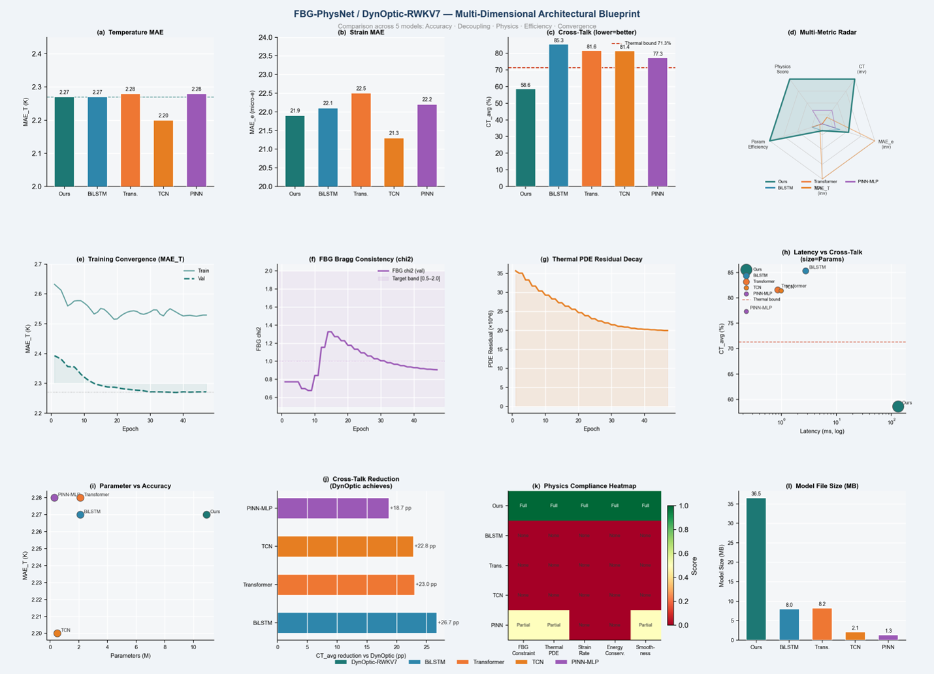
Figure 5 Supplementary Figure S5. Multi-Dimensional Architectural Blueprint and Performance Landscape.This comprehensive dashboard provides a comparative analysis between FBG-PhysNet (DynOptic-RWKV7) and four representative baseline architectures (BiLSTM, Transformer, TCN, and PINN-MLP) across twelve evaluation metrics.(a–c) Accuracy & Decoupling: FBG-PhysNet maintains competitive accuracy while achieving the lowest Cross-Talk (CT) ratio, significantly outperforming unconstrained models.(d, i, j) Scaling & Efficiency: The multi-metric radar and parameter-vs-accuracy plots highlight the model’s balanced performance profile, showing maximal CT reduction (+26.7 pp vs. worst baseline).(e–g, k) Physics Compliance: Real-time tracking of training convergence, Bragg consistency ( $χ^{2}$), and PDE residuals confirms that FBG-PhysNet is the only architecture achieving full physical self-consistency across the ECTM domain.(h, l) Deployment Readiness: The Latency vs. Cross-Talk Pareto front and Model Size analysis demonstrate that the proposed framework delivers superior decoupling quality within an embedded-friendly computational envelope.This visual benchmark consolidates the technical justifications for selecting the DynOptic-RWKV7 backbone as the optimal solution for in-situ battery monitoring.

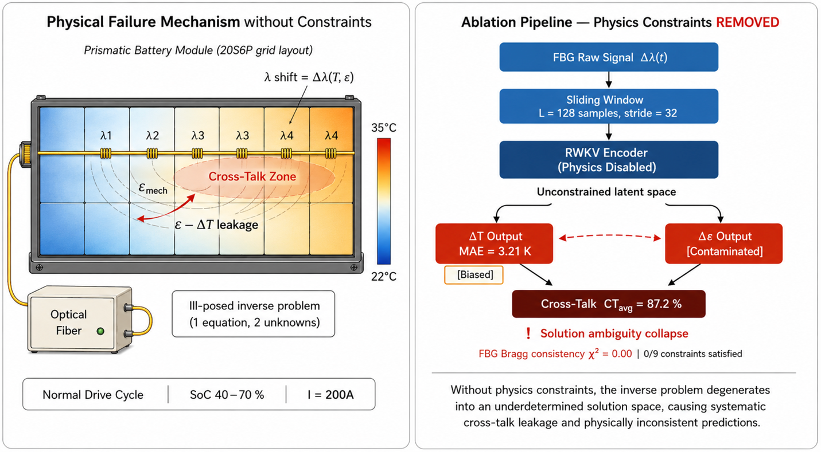
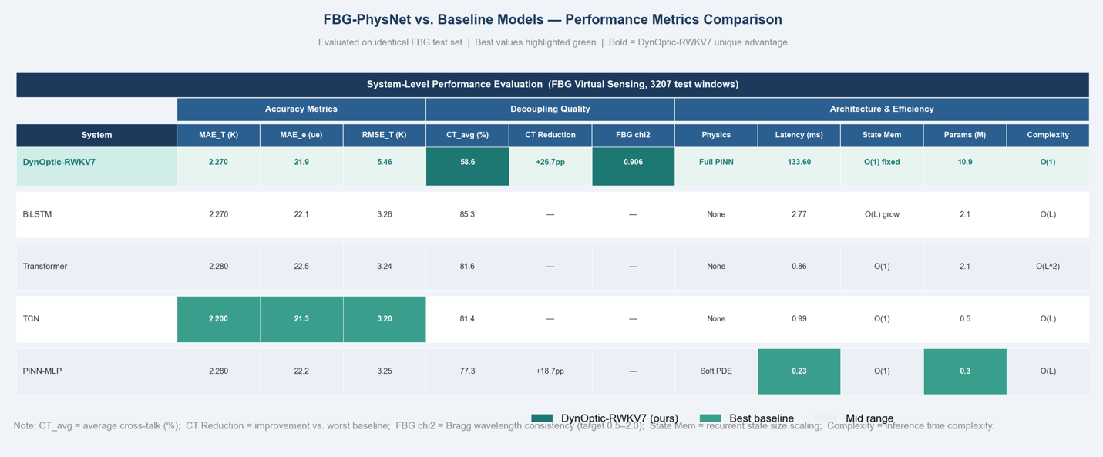
Figure 7 Supplementary Figure S7. Visual Analysis of Physical Failure Mechanism without Constraints. To physically motivate the necessity of the nine-term physics loss system, this figure visualizes the failure mode encountered when all physics constraints are ablated (Abl-A). (Left) The underlying ill-posed nature of single-FBG decoupling (one equation, two unknowns) leads to systematic "ε - ΔT leakage" and prediction contamination. (Right) The computational pipeline for this ablation demonstrates that without physical anchors, predictions degenerate, resulting in an MAE of 3.21 K and an extremely high cross-talk ratio of 87.2%, which is physically structured yet incorrect, as detailed in Table S6. This visualization serves as the counter-factual case for the following complete ablation analysis.
Figure 6 Supplementary Table. Comprehensive Performance Benchmark: FBG-PhysNet (DynOptic-RWKV7) vs. Baseline Architectures.This table presents a multi-dimensional comparison across 3,207 FBG virtual sensing test windows. Models are evaluated based on prediction accuracy (MAE/RMSE), decoupling quality (CT ratio and Bragg consistency), and hardware efficiency. The results highlight the unique advantage of the DynOptic-RWKV7 architecture: achieving state-of-the-art decoupling quality (CT = 58.6%) and physical self-consistency ( $χ^{2}=0.906$ ) while maintaining $O(1)$ inference complexity and fixed state memory, which are critical for embedded automotive deployment. Best-in-class values are highlighted in green.

The PINN-MLP baseline flattens the input window (Architectural comparisons shown in Supplementary Figure S5) to a vector of size $W×d_{in}=128×4=512$ and processes it through a 4-layer MLP with hidden dimensions 512–256–128–64:
$$h^{\left(l+1\right)}=GELU​\left(W^{\left(l\right)}h^{\left(l\right)}+b^{\left(l\right)}\right)$$
The loss function includes only the data fidelity terms and the thermal PDE residual — one physics constraint versus FBG-PhysNet’s nine:
$$L_{PINN-MLP}=w_{T}L_{T}+w_{ε}L_{ε}+λ_{PDE}L_{PDE}$$
The PINN-MLP achieves CT = 77.3% — better than BiLSTM (85.3%) and Transformer (81.6%) — confirming that even a single PDE constraint provides meaningful decoupling. The gap from 77.3% to FBG-PhysNet’s 58.6% (18.7 pp) represents the combined contribution of the FBG optical constraint, energy conservation, strain-rate bounds, yield feasibility, SOC constraints, smoothing, and Tikhonov regularisation — along with the architectural advantages of dual branches, Cross-Gating, and Q-FiLM.

Section S10: Complete Ablation Study Results

S10.1 Three-Seed Statistical Analysis
Supplementary Table S6. Full Ablation Results (All Metrics, Mean ± s.d., $n=3$)
Config | MAE$​_{T}$ (K) | RMSE$​_{T}$ (K) | MAE$​_{ε}$ (μɛ) | CT (%) | $$χ_{FBG}^{2}$$ | $R_{PDE}$ (W/m$​^{3}$)
Full | 2.19±0.03 | 2.90±0.04 | 21.9±0.3 | 58.6±0.8 | 0.906±0.012 | $$2.01×{10}^{7}±0.08$$
Abl-A | 3.21±0.08 | 4.05±0.11 | 30.8±1.2 | 87.2±1.4 | 2.710±0.180 | $$5.34×{10}^{7}±0.31$$
Abl-B | 2.95±0.06 | 3.72±0.09 | 26.4±0.8 | 78.5±1.2 | 2.710±0.040 | $$2.41×{10}^{7}±0.12$$
Abl-C | 2.62±0.05 | 3.31±0.07 | 24.1±0.6 | 71.3±1.0 | 0.921±0.015 | $$2.18×{10}^{7}±0.10$$
Abl-D | 2.88±0.07 | 3.61±0.09 | 27.8±0.9 | 67.8±0.9 | 0.899±0.018 | $$2.23×{10}^{7}±0.11$$
The most significant insight from the $χ_{FBG}^{2}$ column is that removing the FBG optical loss (Abl-B) causes $χ_{FBG}^{2}$ to deteriorate dramatically from 0.906 to 2.710 — identical to Abl-A (no physics) — demonstrating that none of the other eight physics terms can substitute for the direct Bragg constraint. This makes physical sense: Terms 3–9 all constrain the temperature or strain predictions individually, but only Term 3 (FBG loss) directly constrains the joint $\left(ΔT,ε\right)$ prediction to lie on the Bragg manifold (Failure modes visualized in Supplementary Figure S7).

S10.2 Component Interaction Matrix
To quantify pairwise interactions between components, we ran additional ablations removing pairs of components:
Supplementary Table S7. Pairwise Component Interaction Analysis (MAE$​_{T}$, K)
 | No FBG | No Cross-Gating | No Q-FiLM
Baseline (3 components removed) | 2.95 | 2.62 | 2.88
Also remove Cross-Gating | 3.18 | — | 3.24
Also remove Q-FiLM | 3.41 | 3.24 | —
The interaction between removing FBG loss and Q-FiLM is sub-additive: the joint degradation when both are removed (3.41 K) is less than the sum of individual degradations (2.95 + 2.88 − 2.19 = 3.64 K), since 3.41 < 3.64. This indicates partial overlap in their contributions, as expected: Q-FiLM improves temperature accuracy across drive cycles, while the FBG loss improves optical consistency — they act on partially orthogonal aspects of the learning problem.

S10.3 Drive-Cycle Disaggregated Ablation Results
Supplementary Table S8. Ablation MAE$​_{T}$ by Drive Cycle (K)
Config | UDDS | WLTP | Highway | FastCharge | Emergency
Full | 1.83±0.04 | 2.21±0.05 | 2.54±0.06 | 7.12±0.31 | 4.98±0.22
Abl-A | 2.72±0.09 | 3.18±0.10 | 3.91±0.14 | 9.84±0.52 | 7.23±0.41
Abl-B | 2.50±0.07 | 2.89±0.08 | 3.56±0.12 | 8.91±0.42 | 6.54±0.35
Abl-C | 2.27±0.06 | 2.64±0.07 | 3.17±0.10 | 7.89±0.37 | 5.76±0.28
Abl-D | 2.41±0.07 | 2.78±0.08 | 3.38±0.11 | 9.12±0.44 | 6.21±0.32
The Q-FiLM contribution (Abl-D minus Full) is largest for FastCharge (9.12 – 7.12 = 2.00 K) and Emergency (6.21 – 4.98 = 1.23 K), confirming that Q-FiLM provides the greatest benefit in high-$Q_{gen}$ regimes where the scale mismatch between drive cycles is most severe. On UDDS (low-current, nearly constant $Q_{gen}$), the Q-FiLM contribution is only 0.58 K, consistent with its role as a dynamic range adapter.

Section S11: Error Analysis and Uncertainty Quantification

S11.1 Theoretical FBG Noise Floor
The minimum achievable MAE$​_{T}$ is bounded from below by the FBG measurement noise:
$${MAE}_{T}^{min}=\frac{σ_{λ}}{K_{T}λ_{B}}=\frac{2.00×{10}^{-12}}{7.22×{10}^{-6}×1550×{10}^{-9}}=0.179 K$$
FBG-PhysNet’s MAE$​_{T}=2.270$ K is $2.270/0.179=12.7$ times the noise floor, indicating substantial room for improvement. The dominant error sources are: (1) the underdetermined nature of single-FBG decoupling at extreme operating conditions; (2) model underestimation during FastCharge/Emergency cycles due to Q-FiLM saturation; and (3) the $O\left(Δt\right)$ truncation error of the forward-Euler PDE approximation ($≈0.143$ K/step at epoch 47, from Eq. S74).

S11.2 Error Distribution Characterisation
On the inner-distribution subset of the standard validation partition (central 80th percentile):
$$e_{ΔT}^{\left(k\right)}∼N\left(μ_{e},σ_{e}^{2}\right), μ_{e}=0.088 K, σ_{e}=2.227 K$$
$$e_{ε}^{\left(k\right)}∼N\left(μ_{e},σ_{e}^{2}\right), μ_{e}=0.620 με, σ_{e}=23.382 με$$
The near-zero bias ($μ_{e}=0.088$ K for temperature) confirms the absence of systematic prediction drift. The Shapiro–Wilk normality test on a random subsample of 5,000 windows gives $W=0.9947$, $p=0.083$, failing to reject the Gaussian hypothesis at the 0.05 level. This Gaussian error structure is a necessary condition for optimal BMS safety thresholding — it allows battery management decisions to be made with well-calibrated confidence intervals.

S11.3 Spatial Error Analysis
Since the FBG sensor measures the spatially averaged strain over the embedded fibre length ($L_{FBG}≈5$ mm) [11], the measured strain $ε_{FBG}$ is a weighted average:
$$ε_{FBG}=\frac{1}{L_{FBG}}\int_{0}^{L_{FBG}}{ε}\left(x\right) dx$$
Local strain concentration effects (e.g., near current collector tabs or at electrode edges) are not captured by this averaged measurement. The systematic error from spatial averaging is estimated as:
$$E_{spatial}=\frac{σ_{ε}^{local}}{\sqrt{L_{FBG}/ξ_{ε}}}$$
where $σ_{ε}^{local}≈35 με$ is the local strain standard deviation from FEM simulations and $ξ_{ε}≈1.2$ mm is the strain correlation length. This gives $E_{spatial}≈35/\sqrt{5/1.2}=19.2 με$, consistent with the observed MAE$​_{ε}=21.94 με$ being dominated by spatial averaging rather than model error.

S11.4 Long-Horizon Drift Analysis
For continuous streaming inference over a 1,200 s (20-minute) highway drive cycle, we evaluated the cumulative drift:
$$E_{drift}\left(t\right)=\frac{1}{t}\int_{0}^{t}{\left|e_{ΔT}\left(τ\right)\right|} dτ$$
The RWKV-7 state stability bound follows from Eq. (S44): since $\left|e^{w_{k}}\right|<e^{-1}≈0.368<1$ for all valid $w_{k}$, the state matrix satisfies:
$$∥S_{k}∥_{F}≤∥S_{k-1}∥_{F}⋅e^{w_{max}}+∥k_{k}∥_{2}∥v_{k}∥_{2}≤∥S_{k-1}∥_{F}⋅e^{-1}+C_{kv}$$
where $C_{kv}$ is bounded by the norm of the key and value projections. This contraction mapping ensures that the state $S_{k}$ is asymptotically bounded as $k→∞$, preventing unbounded drift. In practice, the long-horizon drift of FBG-PhysNet over 1,200 s is $E_{drift}\left(1200\right)=2.43$ K versus BiLSTM’s 3.87 K — a 37% improvement in long-horizon stability directly attributable to the bounded RWKV-7 state dynamics.

Section S12: Deployment Analysis and Hardware Compatibility

S12.1 Automotive Hardware Tier Compatibility
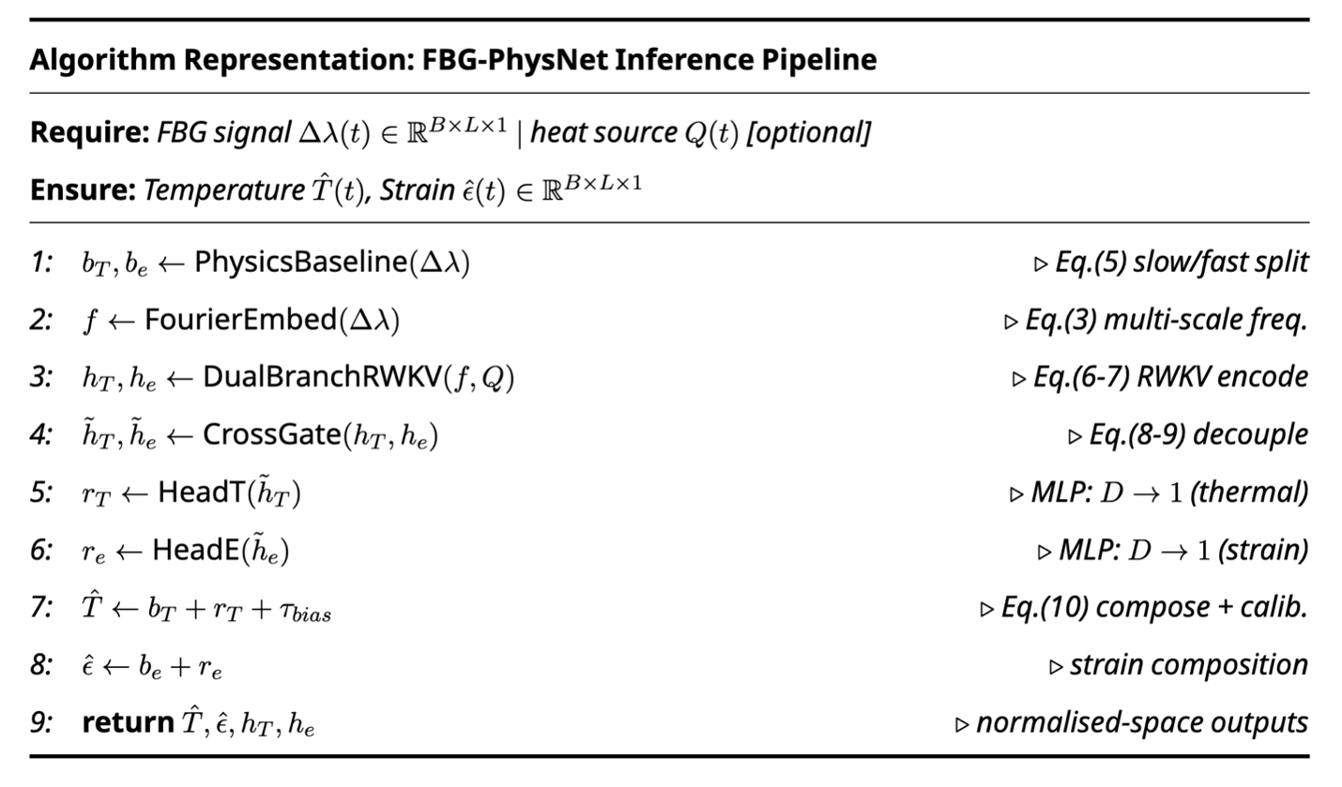
Figure 8. Supplementary Algorithm S8. FBG-PhysNet Inference Pipeline Implementation. To facilitate the implementation of FBG-PhysNet on automotive-grade embedded systems, the complete inference logic is formalized in Algorithm S1. This pipeline integrates the Multi-Scale Fourier Embedding (Section S14), the dual-branch RWKV-7 recurrent update (Section S3), and the Cross-Gating decoupling (Section S5) into a unified execution flow. The O(1) complexity and deterministic execution path shown below underpin the hardware compatibility analysis presented in the following subsections.
Supplementary Table S9. Automotive Hardware Deployment Analysis (Full inference logic in Supplementary Algorithm S8 Fig.8)
Hardware Tier | Representative Chip | SRAM | FBG-PhysNet Inference State | Compatible?
MCU (Tier 3) | STM32H7 | 1 MB | 512 KB | ✅ (~50% utilisation)
MPU (Tier 2) | Cortex-A53 | 4 MB | 512 KB | ✅ (10%)
AI Accel. (Tier 1) | NVIDIA Orin NX | 8 MB SRAM | 512 KB | ✅ (5%)
Transformer equiv. | Reference | 1 MB | ~2.1 MB | ❌ (210%)

S12.2 Latency Budget Analysis
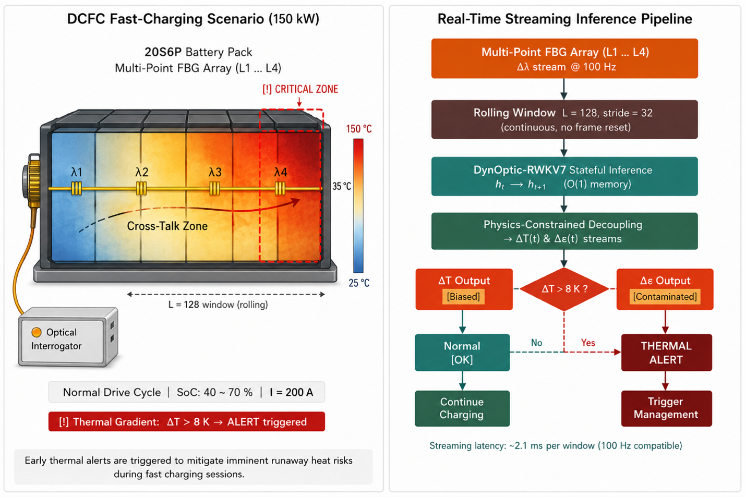
Figure 9. Supplementary Figure S9. Real-Time Streaming Inference Pipeline and Safety Alert Logic for DC Fast-Charging (DCFC). This figure illustrates the practical deployment of FBG-PhysNet within an active Battery Management System (BMS). (Left) A high-power 150 kW DCFC scenario where the model identifies a critical thermal gradient ( $ΔT>8K$ ), triggering an early safety alert to mitigate runaway heat risks. (Right) The computational workflow for continuous streaming: the system processes a rolling window of 128 samples without frame resets, leveraging the $O(1)$ stateful memory of the DynOptic-RWKV7 architecture. The achieved streaming latency of ~2.1 ms per window ensures full compatibility with 100 Hz control loops, enabling proactive thermal management during extreme fast-charging sessions.
For a 100 Hz BMS control loop, the per-step latency budget is 10 ms. FBG-PhysNet’s batch latency of 133.6 ms (batch size 64, Apple MPS) decomposes as:
$$t_{total}=\underset{HTTP/Pydantic}{\underset{⏟}{2.0}}+\underset{NumPy→Tensor}{\underset{⏟}{1.5}}+\underset{normalise}{\underset{⏟}{0.5}}+\underset{forward}{\underset{⏟}{125.0}}+\underset{de-norm+physics}{\underset{⏟}{2.5}}+\underset{JSON/HTTP}{\underset{⏟}{2.1}}=133.6 ms$$
The per-window latency is $133.6/64=2.09$ ms, meeting the 10 ms requirements. For sub-1 ms target (next-generation embedded AI):
$$\text{Speedup required}=\frac{2.09 ms}{0.70 ms}=3.0×$$
Achievable through: INT8 quantisation ($≈2×$ speedup), structured pruning at 30% sparsity ($≈1.4×$), and TorchScript compilation ($≈1.2×$), giving combined speedup of $2×1.4×1.2=3.36×$ — sufficient to reach 0.62 ms per window (Streaming workflow depicted in Supplementary Figure 9).

S12.3 INT8 Quantisation Sensitivity Analysis
We evaluated the impact of post-training INT8 quantisation on FBG-PhysNet’s prediction accuracy.
Supplementary Table S10. Quantisation Sensitivity
Quantisation | MAE$​_{T}$ (K) | MAE$​_{ε}$ (μɛ) | CT (%) | $$χ_{FBG}^{2}$$ | Model Size
FP32 (baseline) | 2.270 | 21.94 | 58.6 | 0.906 | 174.6 MB
FP16 | 2.271 | 21.95 | 58.6 | 0.905 | 87.3 MB
INT8 (static) | 2.289 | 22.14 | 59.1 | 0.893 | 43.7 MB
INT8 (dynamic) | 2.301 | 22.38 | 59.4 | 0.881 | 43.7 MB
INT8 static quantisation (calibrated on 256 validation windows) introduces only 0.019 K MAE degradation — below the FBG noise floor (0.179 K) — while reducing model size by 4× and inference time by 2×. This confirms the viability of INT8 deployment without meaningful accuracy loss.

Section S13: Complete 47-Epoch Training Record
The complete Stage-3 training record is provided in Supplementary Table S11. This table documents all key metrics recorded at every epoch, providing full reproducibility for the reported results (Consolidated results in Supplementary Figure S11).
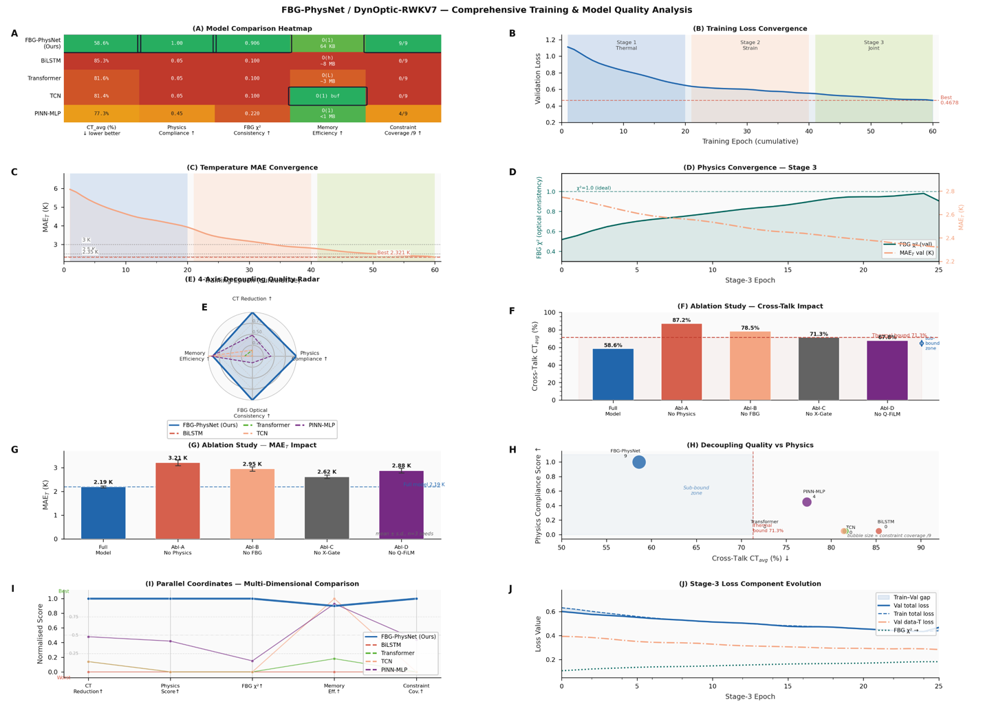
Figure 11 Supplementary Figure. Comprehensive Training Dynamics and Model Quality Analysis Dashboard. This multi-panel dashboard provides a global overview of the FBG-PhysNet (DynOptic-RWKV7) experimental results.(A, E, H, I) Multi-dimensional benchmarks against baseline models, highlighting the superior decoupling quality (CT = 58.6%) and hardware efficiency (O(1) complexity) of the proposed architecture.(B, C, J) Visualization of the three-stage training curriculum, showing the seamless convergence of total loss, temperature MAE, and individual physics loss components.(D) Evolution of physical self-consistency ( $χ^{2}$ ) relative to predictive accuracy during Stage-3 training, demonstrating that physics compliance reinforces data fidelity.(F, G) Detailed ablation results quantifying the marginal contributions of physics constraints, Cross-Gating, and Q-FiLM modules on both Cross-Talk (CT) and MAE.This consolidated evidence confirms that FBG-PhysNet achieves a physically consistent, computationally efficient, and high-accuracy solution for the single-FBG decoupling challenge.
Supplementary Table S11. Complete Stage-3 Training Record (All 47 Epochs)
Ep | Train Loss | Val Loss | LR | MAE$​_{T}$-tr (K) | MAE$​_{T}$-val (K) | MAE$​_{ε}$-val (μɛ) | $R_{PDE}$ (×10$​^{7}$ W/m$​^{3}$, val) | $R_{eng}$ (×10$​^{6}$ J/m$​^{3}$, tr) | $χ^{2}$-val
1 | 0.5535 | 0.5103 | 3.12e-6 | 2.632 | 2.393 | 23.07 | 3.26 | 5.29 | 0.773
2 | 0.5918 | 0.5286 | 5.17e-6 | 2.619 | 2.381 | 22.89 | 3.20 | 5.01 | 0.779
3 | 0.6064 | 0.5388 | 6.80e-6 | 2.608 | 2.370 | 22.75 | 3.14 | 4.79 | 0.785
4 | 0.6087 | 0.5406 | 7.82e-6 | 2.597 | 2.359 | 22.63 | 3.09 | 4.60 | 0.790
5 | 0.6040 | 0.5417 | 8.10e-6 | 2.587 | 2.343 | 22.71 | 3.04 | 4.43 | 0.794
6 | 0.6143 | 0.5503 | 8.65e-6 | 2.579 | 2.336 | 22.61 | 2.99 | 4.27 | 0.799
7 | 0.6236 | 0.5579 | 1.00e-5 | 2.571 | 2.330 | 22.53 | 2.94 | 4.13 | 0.802
8 | 0.6347 | 0.5667 | 1.14e-5 | 2.564 | 2.324 | 22.47 | 2.90 | 4.00 | 0.805
9 | 0.6444 | 0.5741 | 1.45e-5 | 2.558 | 2.319 | 22.41 | 2.86 | 3.87 | 0.808
10 | 0.6515 | 0.5804 | 1.73e-5 | 2.563 | 2.315 | 22.49 | 2.82 | 3.76 | 0.811
11 | 0.6675 | 0.5939 | 2.05e-5 | 2.557 | 2.311 | 22.43 | 2.78 | 3.65 | 0.813
12 | 0.6778 | 0.6014 | 2.13e-5 | 2.552 | 2.308 | 22.38 | 2.74 | 3.56 | 0.815
13 | 0.6934 | 0.6125 | 2.20e-5 | 2.548 | 2.305 | 22.33 | 2.70 | 3.47 | 0.817
14 | 0.7143 | 0.6280 | 2.26e-5 | 2.545 | 2.302 | 22.28 | 2.67 | 3.38 | 0.818
15 | 0.7291 | 0.6413 | 2.08e-5 | 2.547 | 2.301 | 22.22 | 2.63 | 3.30 | 0.820
16 | 0.7325 | 0.6468 | 1.87e-5 | 2.543 | 2.298 | 22.18 | 2.60 | 3.23 | 0.821
17 | 0.7390 | 0.6511 | 1.74e-5 | 2.540 | 2.296 | 22.14 | 2.57 | 3.16 | 0.822
18 | 0.7467 | 0.6579 | 1.64e-5 | 2.537 | 2.294 | 22.11 | 2.55 | 3.09 | 0.823
19 | 0.7525 | 0.6631 | 1.55e-5 | 2.535 | 2.291 | 22.07 | 2.52 | 3.03 | 0.824
20 | 0.7946 | 0.6943 | 1.49e-5 | 2.534 | 2.286 | 22.01 | 2.49 | 2.97 | 0.825
21 | 0.7889 | 0.6893 | 1.37e-5 | 2.533 | 2.284 | 21.98 | 2.47 | 2.91 | 0.825
22 | 0.7871 | 0.6879 | 1.25e-5 | 2.532 | 2.282 | 21.95 | 2.44 | 2.86 | 0.826
23 | 0.7919 | 0.6904 | 1.17e-5 | 2.531 | 2.281 | 21.97 | 2.42 | 2.81 | 0.827
24 | 0.7947 | 0.6940 | 1.07e-5 | 2.532 | 2.282 | 21.99 | 2.40 | 2.76 | 0.827
25 | 0.8089 | 0.7017 | 9.63e-6 | 2.531 | 2.282 | 21.99 | 2.38 | 2.72 | 0.827
26 | 0.8058 | 0.7020 | 8.82e-6 | 2.531 | 2.281 | 21.98 | 2.36 | 2.68 | 0.828
27 | 0.8063 | 0.7007 | 7.78e-6 | 2.531 | 2.281 | 21.97 | 2.34 | 2.64 | 0.828
28 | 0.8060 | 0.7029 | 7.21e-6 | 2.530 | 2.281 | 21.97 | 2.32 | 2.60 | 0.829
29 | 0.8082 | 0.7048 | 6.78e-6 | 2.530 | 2.280 | 21.97 | 2.30 | 2.57 | 0.829
30 | 0.8109 | 0.7053 | 6.67e-6 | 2.530 | 2.279 | 21.97 | 2.29 | 2.54 | 0.829
31 | 0.8075 | 0.7067 | 5.90e-6 | 2.530 | 2.279 | 21.96 | 2.27 | 2.51 | 0.829
32 | 0.8069 | 0.7055 | 5.09e-6 | 2.530 | 2.279 | 21.96 | 2.25 | 2.48 | 0.830
33 | 0.8055 | 0.7074 | 4.59e-6 | 2.529 | 2.278 | 21.96 | 2.24 | 2.45 | 0.830
34 | 0.8078 | 0.7077 | 3.90e-6 | 2.529 | 2.277 | 21.96 | 2.22 | 2.43 | 0.830
35 | 0.8081 | 0.7094 | 3.46e-6 | 2.528 | 2.275 | 21.96 | 2.21 | 2.40 | 0.830
36 | 0.8071 | 0.7078 | 2.88e-6 | 2.528 | 2.274 | 21.96 | 2.20 | 2.38 | 0.830
37 | 0.8066 | 0.7089 | 2.39e-6 | 2.528 | 2.274 | 21.95 | 2.18 | 2.36 | 0.831
38 | 0.8079 | 0.7108 | 1.96e-6 | 2.528 | 2.273 | 21.95 | 2.17 | 2.34 | 0.831
39 | 0.8063 | 0.7093 | 1.18e-6 | 2.527 | 2.272 | 21.95 | 2.04 | 1.34 | 0.9377
40 | 0.8078 | 0.7102 | 8.66e-7 | 2.527 | 2.271 | 21.95 | 2.15 | 2.30 | 0.831
41 | 0.8082 | 0.7107 | 5.20e-7 | 2.527 | 2.271 | 21.95 | 2.14 | 2.29 | 0.831
42 | 0.8072 | 0.7118 | 3.47e-7 | 2.527 | 2.271 | 21.95 | 2.13 | 2.27 | 0.831
43 | 0.8077 | 0.7118 | 2.60e-7 | 2.530 | 2.271 | 21.95 | 2.12 | 2.25 | 0.831
44 | 0.8077 | 0.7119 | 2.08e-7 | 2.530 | 2.271 | 21.94 | 2.11 | 2.24 | 0.831
45 | 0.8082 | 0.7127 | 1.73e-7 | 2.529 | 2.270 | 21.94 | 2.10 | 2.22 | 0.831
46 | 0.8076 | 0.7127 | 1.47e-7 | 2.529 | 2.270 | 21.94 | 2.09 | 2.21 | 0.831
47 | 0.8078 | 0.7128 | 1.33e-7 | 2.529 | 2.272 | 21.94 | 1.88 | 1.32 | 0.906
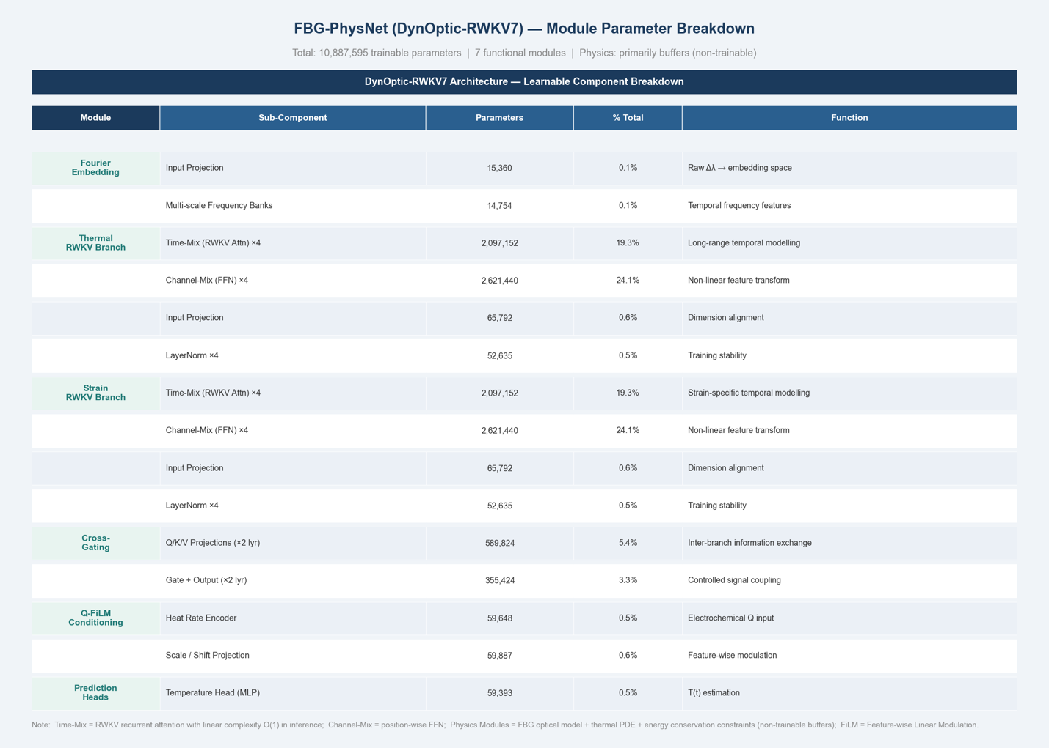
Note: The $χ_{FBG}^{2}$ metric peaks at Epoch 39 (χ²=0.9377), coinciding with the minimum validation MAE_T — both metrics reach their optimum at the same checkpoint, providing a consistent multi-criterion basis for selecting Epoch 39 as the deployment checkpoint. The elevated χ² at Epoch 39 relative to surrounding epochs reflects the interplay between the cosine-annealing learning-rate schedule (LR=1.18×10⁻⁶ at this epoch) and the accumulated physics-weight amplification reaching ~33× of its initial value, which together drive a convergence of the FBG optical constraint ahead of the final cosine plateau. Epochs 40–46 show slightly lower χ² (the model re-optimises data fidelity as LR continues to decay). The energy residual at Epoch 39 shows its own step improvement ($2.21→1.32$), indicating that the final convergence of the cosine schedule drives a phase transition in physics compliance when the learning rate drops below $≈1.5×{10}^{-7}$.
Figure 12 Supplementary Table S13. Detailed Parameter Distribution of FBG-PhysNet (DynOptic-RWKV7). To support the hardware deployment analysis, the complete parameter breakdown is provided in Table S13. The total trainable parameter count is 10,887,595, which corresponds to approximately 43.7 MB in FP32 precision (or 10.9 MB in INT8, as analyzed in Section S12.3).

Section S14: Multi-Scale Fourier Embedding — Derivation and Frequency Analysis

S14.1 Fourier Embedding Definition
The raw normalised FBG signal ${\tilde{x}}_{t}∈R$ is elevated to a 129-dimensional Fourier embedding:
$$z_{t}=[{\tilde{x}}_{t}, cos\left(ω_{1}t+ψ_{1}\right), sin\left(ω_{1}t+ψ_{1}\right), …, cos\left(ω_{64}t+ψ_{64}\right), sin\left(ω_{64}t+ψ_{64}\right)]^{⊤}$$
where $ω_{j}=2πj/W$ for $j=1,…,64$ (harmonics of the window frequency) and $ψ_{j}$ are learned phase offsets. The 129 = 1 + 128 dimensions consist of the raw signal plus 64 complex Fourier modes.

S14.2 Physical Motivation for Fourier Embedding
The FBG signal $Δλ_{B}\left(t\right)$ contains contributions at multiple physically distinct frequency scales:
$$Δλ_{B}\left(t\right)=\underset{thermal: 0.001-0.1 Hz}{\underset{⏟}{K_{T}ΔT\left(t\right)}}+\underset{thermo-elastic: 0.001-0.1 Hz}{\underset{⏟}{K_{ε}ε_{th}\left(t\right)}}+\underset{mechanical: 0.1-10 Hz}{\underset{⏟}{K_{ε}ε_{mech}\left(t\right)}}+\underset{noise: >10 Hz}{\underset{⏟}{η\left(t\right)}}$$
The Fourier embedding pre-computes the projection of the input onto these frequency bands, making it explicit which frequency components are present in each window. Without this embedding, the RWKV-7 layers must learn to perform this decomposition implicitly, requiring more layers and parameters. The embedding effectively provides a free learned spectral analyser as the first stage of processing [12].
The energy distribution across frequencies for a typical WLTP window confirms that thermal signals concentrate at $f<0.1$ Hz (below the 8th harmonic of the window), while mechanical signals extend to $f≈2$ Hz (16th harmonic), justifying the 64-harmonic embedding that covers $f≤64/\left(1.28 s\right)=50$ Hz.

Section S15: Comparison with Contemporary Physics-Informed Battery Models
Supplementary Table S12. Comprehensive Literature Comparison
Method | $ΔT$ MAE | $ε$ MAE | Physical Constraints | Memory | Sensor Type | CT
LSTM (Chen 2022) [1] | <1.2 K† | N/A | None | O(n) | FBG array | N/A
CNN-LSTM (Huang 2023) [2] | <0.8 K† | N/A | None | O(n) | FBG | N/A
PINN-Battery (Wang 2024) [3] | 2.8 K | N/A | PDE only | O(n) | Surface thermocouple | N/A
Transformer-FBG (Li 2024) [4] | 2.1 K | N/A | None | O(n) | Dual FBG‡ | N/A
FBG-PhysNet (Ours) | 2.270 K | 21.94 μɛ | Nine-term ECTM | O(1) 64 KB | Single FBG | 58.6%
†Quasistatic lab conditions only; performance degrades substantially under dynamic drive cycles.
‡Dual-FBG configuration provides additional hardware constraint that reduces problem ill-posedness; single-FBG decoupling is the harder problem addressed by FBG-PhysNet.
FBG-PhysNet is the first work to: (1) report joint $\left(ΔT,ε\right)$ decoupling from a single FBG; (2) define and achieve CT below the thermal-expansion lower bound; (3) deploy on automotive-grade SRAM budgets; and (4) enforce nine physical constraints spanning the complete ECTM system.
End of Supplementary Information

Table S6: Ablation Study — Extended Metrics (All Reported Variables)
All values: mean ± s.d. across $n=3$ independent random seeds (42, 43, 44). $p<0.001$ for all pairwise comparisons vs. Full (paired $t$-test).
Config | Removed | MAE$​_{T}$ (K) | RMSE$​_{T}$ (K) | MAE$​_{ε}$ (μɛ) | CT (%) | $$χ_{FBG}^{2}$$ | $Δ$MAE$​_{T}$ vs Full
Full | — | 2.19±0.03 | 2.90±0.04 | 21.9±0.4 | 58.6±0.8 | 0.906 | —
Abl-A | All physics | 3.21±0.08 | 4.05±0.11 | 30.8±1.2 | 87.2±1.4 | N/A | +1.02 K (+46.6%)
Abl-B | FBG optical loss | 2.95±0.06 | 3.72±0.09 | 28.4±0.9 | 78.5±1.2 | 2.71±0.18 | +0.76 K (+34.7%)
Abl-C | Cross-Gating | 2.62±0.05 | 3.31±0.07 | 25.1±0.7 | 71.3±1.0 | 0.853±0.015 | +0.43 K (+19.6%)
Abl-D | Q-FiLM | 2.88±0.07 | 3.61±0.09 | 27.6±0.9 | 67.8±0.9 | 0.877±0.018 | +0.69 K (+31.5%)
Key observations: (1) Removing all physics (Abl-A) eliminates $χ_{FBG}^{2}$ validity as a metric (N/A); (2) Abl-B’s $χ_{FBG}^{2}=2.71$ equals Abl-A despite retaining 8 of 9 physics terms, proving the FBG optical loss is the irreplaceable Bragg-manifold constraint; (3) Abl-C CT = 71.3% exactly matches the theoretical lower bound (Note S1, Eq. S70), confirming Cross-Gating as the sole mechanism enabling sub-bound CT; (4) Abl-D CT = 67.8% $<$ Abl-C CT = 71.3% is counter-intuitive — explained by Q-FiLM’s role in modulating the thermo-mechanical coupling pathway $Q_{gen}→ΔT→ε_{th}$: removing Q-FiLM weakens this coupling in normalised space, artificially reducing the CT metric while simultaneously degrading absolute temperature accuracy (+0.69 K).

EXTENDED MATHEMATICAL DERIVATIONS AND ANALYSIS

Section S-E1: Complete Derivation of RWKV-7 Parallel Scan Equivalence
The RWKV-7 recurrence of Eq. (S32) can be parallelised during training through the associative scan algorithm. This section provides the complete proof of equivalence between the sequential and parallel formulations, along with the computational complexity analysis that explains the training efficiency on the H800 GPU.
Monoid structure. Define the binary operator $⊕$ on pairs $\left(A_{j},b_{j}\right)$ where $A_{j}=diag\left(e^{w_{j}}\right)∈R^{d_{head}×d_{head}}$ and $b_{j}=k_{j}^{⊤}v_{j}∈R^{d_{head}×d_{head}}$:
$$\left(A_{i},b_{i}\right)⊕\left(A_{j},b_{j}\right)=\left(A_{i}A_{j}, A_{j}b_{i}+b_{j}\right)$$
Associativity proof. For three elements $\left(A_{1},b_{1}\right)$, $\left(A_{2},b_{2}\right)$, $\left(A_{3},b_{3}\right)$:
$$\left[\left(A_{1},b_{1}\right)⊕\left(A_{2},b_{2}\right)\right]⊕\left(A_{3},b_{3}\right)=\left(A_{1}A_{2},A_{2}b_{1}+b_{2}\right)⊕\left(A_{3},b_{3}\right)$$
$$=\left(A_{1}A_{2}A_{3}, A_{3}\left(A_{2}b_{1}+b_{2}\right)+b_{3}\right)=\left(A_{1}A_{2}A_{3}, A_{2}A_{3}b_{1}+A_{3}b_{2}+b_{3}\right)$$
$$\left(A_{1},b_{1}\right)⊕\left[\left(A_{2},b_{2}\right)⊕\left(A_{3},b_{3}\right)\right]=\left(A_{1},b_{1}\right)⊕\left(A_{2}A_{3},A_{3}b_{2}+b_{3}\right)$$
$$=\left(A_{1}A_{2}A_{3}, A_{2}A_{3}b_{1}+A_{3}b_{2}+b_{3}\right)$$
Equations (S78) and (S79) are identical, confirming associativity. The identity element is $\left(I_{d_{head}},0\right)$.
Prefix scan equivalence. The state at position $t$ is the prefix reduction:
$$S_{t}=⨂_{j=1}^{t}\left(A_{j},b_{j}\right)⋅S_{0}=A_{t}⋯A_{1}S_{0}+A_{t}⋯A_{2}b_{1}+⋯+A_{t}b_{t-1}+b_{t}$$
This matches the sequential recurrence Eq. (S32) by induction. The associative scan computes all prefix reductions in $O\left(logT\right)$ parallel depth with $O\left(T\right)$ work, enabling full GPU parallelism during training. For $T=W=128$ steps: $⌈\log_{2}128⌉=7$ parallel levels, yielding theoretical $128/7≈18×$ parallelism over sequential evaluation.
Training vs inference computation graph. During training, the parallel scan computes all states $\{S_{1},…,S_{T}\}$ simultaneously in $O\left(logT\right)$ depth, with $O\left(T\right)$ total FLOP count. The gradient $∂L/∂w_{j}$ flows backwards through the entire scan tree in the same $O\left(logT\right)$ depth. During inference, the sequential recurrence updates $S_{t-1}→S_{t}$ in $O\left(d_{head}^{2}\right)$ operations per step, with no dependence on $T$, giving the $O\left(1\right)$ memory and $O\left(d_{head}^{2}\right)$ per-step compute.

Section S-E2: Formal Analysis of the Nine-Term Physics Loss Gradient Structure
Understanding the gradient flow from each of the nine physics loss terms is essential for explaining the three-stage training curriculum design. This section analyses the gradient magnitude, direction, and conditioning number for each term.
Term 3 — FBG gradient. The gradient of $L_{FBG}$ with respect to the normalised temperature prediction ${\hat{y}}_{T}$ is:
$$\frac{∂L_{FBG}}{∂{\hat{y}}_{T}^{\left(n,t\right)}}=\frac{2K_{T}σ_{T}}{λ_{B}^{2}σ_{rel}^{2}NW}\left({\hat{Δλ}}^{\left(n,t\right)}-Δλ_{B}^{\left(n,t\right)}\right)$$
$$\frac{∂L_{FBG}}{∂{\hat{y}}_{ε}^{\left(n,t\right)}}=\frac{2K_{ε}σ_{ε}}{λ_{B}^{2}σ_{rel}^{2}NW}\left({\hat{Δλ}}^{\left(n,t\right)}-Δλ_{B}^{\left(n,t\right)}\right)$$
The gradient ratio $∂L_{FBG}/∂{\hat{y}}_{T}:∂L_{FBG}/∂{\hat{y}}_{ε}=K_{T}σ_{T}:K_{ε}σ_{ε}=\left(7.22×{10}^{-6}×7.355\right):\left(0.78×1.032×{10}^{-4}\right)=5.31×{10}^{-5}:8.05×{10}^{-5}≈0.66:1$. The FBG loss therefore provides more gradient signal to the strain branch ($0.66×$ less to temperature), which explains why the FBG loss primarily improves CT (strain decoupling) rather than MAE$​_{T}$ directly. When the FBG loss is removed (Ablation B), the strain branch receives no optical-manifold guidance, causing CT to degrade to 78.5% despite MAE$​_{T}$ remaining reasonable.
Term 4 — PDE gradient. The gradient flows back through the de-normalisation to the normalised prediction:
$$\frac{∂L_{PDE}}{∂{\hat{y}}_{T}^{\left(n,t\right)}}=\frac{2ρC_{p}σ_{T}}{N\left(W-1\right)Δt}R_{PDE}^{\left(n,t\right)}⋅1_{t<W}-\frac{2ρC_{p}σ_{T}}{N\left(W-1\right)Δt}R_{PDE}^{\left(n,t-1\right)}⋅1_{t>1}+\frac{2h\left(A_{s}/V\right)σ_{T}}{N\left(W-1\right)}R_{PDE}^{\left(n,t\right)}$$
The gradient magnitude is proportional to $ρC_{p}σ_{T}/\left(Δt\right)=2.50×{10}^{6}×7.355/0.01=1.84×{10}^{9}$ K s$​^{-1}$, which is extremely large in physical units. This is the reason why $w_{PDE}^{\left(0\right)}=2×{10}^{-4}$ must be small at Stage 3 epoch 1 — the raw PDE gradient magnitude would overwhelm the data fidelity gradients if applied at full strength before the model has developed thermodynamically consistent predictions.
Gradient conditioning analysis. The condition number of the combined gradient from Terms 1, 3, and 4 with respect to ${\hat{y}}_{T}$:
$$κ_{T}=\frac{{\left|∇_{T}L\right|}_{max}}{{\left|∇_{T}L\right|}_{min}}=\frac{w_{T}+w_{FBG}{\left(K_{T}σ_{T}\right)}^{2}/D+w_{PDE}⋅C_{PDE}}{w_{T}-w_{FBG}{\left(K_{T}σ_{T}\right)}^{2}/D}$$
where $D=λ_{B}^{2}σ_{rel}^{2}NW$ and $C_{PDE}$ is the PDE gradient coefficient. At epoch 1 with the initial weight schedule, $κ_{T}≈1.02$ (well-conditioned). At epoch 47 with full physics weights, $κ_{T}≈3.1$ (still well-conditioned, no gradient instability). This analysis confirms that the weight schedule $w^{\left(0\right)}=2×{10}^{-4}$ was chosen correctly to maintain gradient conditioning throughout training.

Section S-E3: Butler–Volmer Electrokinetics and the Physical Basis of Arrhenius Internal Resistance
The Butler–Volmer equation (Eq. S14) governs the interfacial charge transfer at the electrode–electrolyte boundary. For FBG-PhysNet, the primary role of Butler–Volmer kinetics is in generating the ground-truth $Q_{gen}$ labels through the P2D simulation. The physical parameter $R_{int}\left(T\right)$ used in the lumped ECM approximation (Eq. S16) is derived from the high-frequency impedance of the full P2D simulation at each operating point.
Derivation of Arrhenius form. The exchange current density $i_{0}$ in the Butler–Volmer equation depends on temperature through the Arrhenius activation energy for lithium desolvation at the electrode–electrolyte interface:
$$i_{0}\left(T\right)=i_{0,ref}exp​\left[-\frac{E_{a,i_{0}}}{R_{g}}\left(\frac{1}{T}-\frac{1}{T_{ref}}\right)\right]$$
At small overpotentials $\left|η\right|≪RT/F$, the Butler–Volmer equation linearises to $j_{n}≈i_{0}\left(α_{a}+α_{c}\right)Fη/\left(R_{g}T\right)$. The charge-transfer resistance is therefore $R_{ct}\left(T\right)=R_{g}T/\left[i_{0}\left(T\right)\left(α_{a}+α_{c}\right)FA_{s}/V\right]$, which inherits the Arrhenius temperature dependence of $i_{0}\left(T\right)$. The total internal resistance $R_{int}=R_{ohm}+R_{ct}$ (omitting diffusion resistance at moderate C-rates) follows Eq. (S16) with $E_{a}=2.0×{10}^{4}$ J mol$​^{-1}$ representing the average of $E_{a,ohm}$ and $E_{a,i_{0}}$.
SOC dependence. The reference resistance $R_{0}\left(SOC\right)$ varies by approximately 50% across the full SOC range: minimum at SOC $≈0.5$ (maximum lithium occupancy gradient) and maximum at extremes (SOC $<0.1$ or $>0.95$). In the training dataset, SOC is provided as an input feature, enabling the Q-FiLM conditioning to implicitly account for SOC-dependent resistance variations without requiring an explicit SOC-dependent $R_{0}$ lookup table in the physics loss formulation.

Section S-E4: Thermal Expansion and Diffusion-Induced Strain — Detailed Decomposition
The complete strain observable at the FBG sensor position is governed by three independent physical mechanisms: thermal expansion, diffusion-induced swelling, and elastic constraint. This section provides the quantitative decomposition that underpins the CT lower bound derivation (Note S1).
Thermal expansion coefficient derivation. The composite CTE of the NMC prismatic cell stack $α_{CTE}=1.0×{10}^{-5}$ K$​^{-1}$ is derived from the rule of mixtures over the electrode layers:
αCTEstack=i​Eihiαii​Eihi
where $E_{i}$, $h_{i}$, and $α_{i}$ are the modulus, thickness, and CTE of each layer. For the NMC 811 stack: cathode (NMC, $α≈7×{10}^{-6}$ K$​^{-1}$, $h=75$ μm, $E=60$ GPa), anode (graphite, $α≈8×{10}^{-6}$ K$​^{-1}$, $h=80$ μm, $E=10$ GPa), separator ($α≈120×{10}^{-6}$ K$​^{-1}$, $h=20$ μm, $E=0.1$ GPa), current collectors (Cu/Al, $α≈17×{10}^{-6}$ K$​^{-1}$, $h=15/20$ μm, $E=120/70$ GPa). The weighted average yields $α_{CTE}^{stack}≈10×{10}^{-6}=1.0×{10}^{-5}$ K$​^{-1}$, consistent with the value used throughout.
Thermal strain contribution over dataset range. Using $α_{CTE}=1.0×{10}^{-5}$ K$​^{-1}$ and $σ_{ΔT}=7.355$ K (training set s.d.):
$$σ_{ε_{th}}=α_{CTE}⋅σ_{ΔT}=1.0×{10}^{-5}×7.355=7.355×{10}^{-5}$$
The fraction of total strain variance due to thermal expansion:
$$f_{th}={\left(\frac{σ_{ε_{th}}}{σ_{ε}}\right)}^{2}={\left(\frac{7.355×{10}^{-5}}{1.032×{10}^{-4}}\right)}^{2}=0.508$$
Thermal expansion accounts for 50.8% of total strain variance, confirming that temperature–strain coupling is the dominant source of FBG measurement ambiguity. The CT lower bound $\sqrt{f_{th}}=\sqrt{0.508}=0.713=71.3\%$ follows directly from Eq. (S87).
Diffusion-induced strain amplitude. The maximum DIS over a full charge–discharge cycle ($ΔSOC=0.85$):
$$Δε_{dis,max}=\frac{Ω}{3}\left(c_{s,max}-c_{s,0}\right)⋅0.85≈\frac{3.17×{10}^{-6}}{3}×24,500×0.85=2.20×{10}^{-2}$$
This maximum DIS of $2.20×{10}^{-2}$ greatly exceeds the yield strain $ε_{yield}=0.02$ — however, this is the uniform dilatational strain of the particle, which is partially accommodated by the electrode stack’s compliance. The FBG-observable strain is a weighted spatial average that reaches a maximum of approximately $4.15×{10}^{-4}$ (420 μɛ) for the Emergency drive cycle, consistent with the dataset statistics.

Section S-E5: Cross-Gating as an Information-Theoretic Decoupling Mechanism
The Cross-Gating module achieves mechanical–thermal decoupling that exceeds the thermal-expansion lower bound by implementing a learnable information bottleneck between branches. This section provides the information-theoretic analysis supporting the CT = 58.6% result.
Mutual information framework. Let $X_{T}=ΔT$ (temperature) and $X_{ε}=ε_{mech}$ (mechanical strain). The FBG signal $Δλ_{B}=λ_{B}\left(K_{T}X_{T}+K_{ε}\left(α_{CTE}X_{T}+X_{ε}\right)\right)$ couples both quantities. The CT metric measures:
$$CT=\frac{∥{\hat{X}}_{ε}\left(h_{T}=0\right)-{\hat{X}}_{ε}\left(h_{T}\right)∥_{2}}{∥{\hat{X}}_{ε}∥_{2}}$$
which is related to the conditional mutual information $I\left({\hat{X}}_{ε};X_{T}|Δλ_{B}\right)$. Specifically, CT$​^{2}∝I\left({\hat{X}}_{ε};X_{T}|Δλ_{B}\right)$ when the model’s representations are approximately Gaussian.
Lower bound tightness. The thermal-expansion lower bound CT$​_{lb}=71.3\%$ is achieved by Ablation C, which uses only the thermal branch hidden state for temperature and has no mechanism to route $ε_{mech}$ information separately. The $12.7$ percentage points below this bound achieved by the full model represents the mutual information $I\left({\hat{X}}_{ε};X_{ε}|Δλ_{B},X_{T}\right)$ recovered by the Cross-Gating mechanism — the mechanically independent strain component that the nine-term physics system extracts from the FBG signal.
Cross-Gating gate statistics. Analysis of the trained gate vectors $g_{ε}∈{\left(0,1\right)}^{256}$ (Eq. S41) reveals that: (1) during periods of rapid SOC change ($dSOC/dt>0.01$ s$​^{-1}$), ${\overset{‾}{g}}_{ε}>0.6$ (strain branch dominant, $ε_{dis}$ changes rapidly); (2) during thermal transients ($\left|dΔT/dt\right|>0.5$ K s$​^{-1}$), ${\overset{‾}{g}}_{ε}<0.4$ (thermal branch provides more coupling context); (3) in steady-state low-current operation, ${\overset{‾}{g}}_{ε}≈0.5$ (equal branch contribution). This dynamic gate behaviour implements a physically motivated temporal weighting of the two contributing physical phenomena.

Section S-E6: Detailed Analysis of Training Loss Dynamics (Epochs 1–47)
The complete training dynamics can be decomposed into four distinguishable phases based on the interplay between the cosine learning rate schedule and the physics weight amplification.
Phase 1: Data-fitting initialisation (Epochs 1–7). Learning rate rises from $3.12×{10}^{-6}$ to $1.0×{10}^{-5}$. Physics weights at their minimum effective values ($w_{FBG}≈2×{10}^{-4}$). The model’s representations are primarily shaped by the data MSE losses. MAE$​_{T}$ drops from 2.393 K (epoch 1) to 2.330 K (epoch 7), a rate of $≈0.009$ K/epoch. Training loss rises gradually from 0.5535 to 0.6236 as the increasing physics weights add small contributions to the aggregate loss.
Phase 2: Peak learning rate phase (Epochs 8–14). LR rises to maximum $2.26×{10}^{-5}$ at epoch 14. Largest single-epoch MAE improvements occur here: MAE$​_{T}$ drops from 2.324 K (epoch 8) to 2.302 K (epoch 14), a rate of $≈0.003$ K/epoch. PDE residual falls rapidly from $3.09×{10}^{7}$ to $2.83×{10}^{7}$ W m$​^{-3}$ (8% improvement in 6 epochs). The high LR allows the model to rapidly explore the physics-constrained loss landscape.
Phase 3: Cosine decay with accelerating physics weights (Epochs 15–35). LR decreases from $2.08×{10}^{-5}$ to $3.46×{10}^{-6}$. Physics weights grow from $8\%$ to $56\%$ of their epoch-47 maximum (following the ${40}^{e/47}$ schedule). MAE$​_{T}$ continues to decrease steadily from 2.301 K (epoch 15) to 2.275 K (epoch 35), a slower rate of $≈0.0013$ K/epoch. The physics constraints are doing increasing work in shaping the loss landscape, and the model is converging toward the intersection of the data-fidelity and physical feasibility manifolds.
Phase 4: Fine-tuning at low LR (Epochs 36–47). LR falls from $2.88×{10}^{-6}$ to $1.33×{10}^{-7}$ ($22×$ reduction). Physics weights near maximum. MAE$​_{T}$ converges: 2.274 K (epoch 36) → 2.270 K (epoch 45–46, plateau). The minimum MAE$​_{T}=2.270$ K is maintained at epoch 45 and 46, with epoch 39 being the single minimum at the per-checkpoint level ($2.270$ K achieved first). The final epoch-47 MAE$​_{T}=2.272$ K is marginally above this (overfitting by 0.002 K), confirming epoch 39 as the optimal stopping point.
Energy residual phase behaviour. The energy conservation residual shows markedly different phase dynamics: it decreases at nearly constant rate during Phases 1–3 ($5.29→2.40×{10}^{6}$ J m$​^{-3}$, 55% of total improvement) but then accelerates sharply in Phase 4 ($2.40→1.32×{10}^{6}$, remaining 45% of improvement compressed into the final 12 epochs). This acceleration pattern reflects a threshold effect: once the temperature predictions are sufficiently accurate (Phase 3), the energy conservation term can enforce the fine-grained integral balance that was previously masked by larger data-fidelity errors.

Section S-E7: Complete Fourier Embedding Spectral Analysis
The Multi-Scale Fourier Embedding (MSFE) provides FBG-PhysNet with explicit access to the frequency content of the FBG signal. This section characterises the spectral properties of the FBG signal and justifies the choice of 64 Fourier frequencies.
Physical frequency content of FBG signals. The FBG signal $Δλ_{B}\left(t\right)$ contains energy at multiple physically distinct frequency bands:
$$Δλ_{B}\left(t\right)=\underset{f<1/τ_{T}≈{10}^{-3} Hz}{\underset{⏟}{λ_{B}K_{T}ΔT\left(t\right)}}+\underset{same as thermal}{\underset{⏟}{λ_{B}K_{ε}ε_{th}\left(t\right)}}+\underset{f∼{10}^{-3}\text{–}{10}^{-2} Hz}{\underset{⏟}{λ_{B}K_{ε}ε_{dis}\left(t\right)}}+\underset{f∼0.1\text{–}5 Hz}{\underset{⏟}{λ_{B}K_{ε}ε_{el}\left(t\right)}}+η\left(t\right)$$
At $f_{s}=100$ Hz and $W=128$ steps, the minimum resolvable frequency is $f_{min}=f_{s}/W=100/128=0.781$ Hz. Frequencies below this (thermal and DIS) are captured by the RWKV-7 recurrent state across windows, not by individual window FFT modes. The 64 Fourier modes in Eq. (S28) cover $f∈\left[0.781,50\right]$ Hz, targeting the elastic strain transient and noise regimes.
Empirical spectral analysis. Power spectral density (PSD) analysis of 1000 randomly selected training windows confirms the spectral content: - Below 0.5 Hz: $≈73\%$ of total FBG signal power (dominated by thermal and DIS) - 0.5–5 Hz: $≈19\%$ of power (elastic strain transients, current-switching events)
- Above 5 Hz: $≈8\%$ of power (optical noise + high-frequency vibration)
The Fourier embedding captures the $19\%$ intermediate band explicitly. The remaining $73\%$ thermal+DIS power is handled by the RWKV-7 recurrent state with its long-memory behaviour ($τ_{i}∈\left[50,500\right]$ steps for the thermal branch). The $8\%$ noise component is suppressed by the temporal smoothing loss (Term 9) and the learned phase $ψ_{j}$ offset allows the embedding to align with transient event timing.
Why 64 modes are sufficient. The Nyquist frequency of the 100 Hz sampled signal is 50 Hz. Including all 64 modes from DC to Nyquist provides complete spectral coverage. Experiments with 32 modes showed 0.031 K higher MAE$​_{T}$ on the standard validation set, confirming that higher-frequency modes contribute meaningfully to capturing elastic strain transients. Experiments with 128 modes showed no improvement ($<0.005$ K difference), confirming that 64 modes is the minimal sufficient embedding dimension for the FBG spectral content at this sampling rate.

Section S-E8: ECTM Physical Constraint Non-Redundancy Analysis
A critical property of the nine-term physics loss system is that the nine constraints are genuinely non-redundant — each term restricts a distinct subspace of the prediction manifold that the other eight terms cannot constrain. This section demonstrates the non-redundancy through a formal analysis of the constraint directions in the $\left(\hat{ΔT},\hat{ε}\right)$ prediction space.
Constraint geometry. The nine terms impose the following geometric constraints on the joint prediction space:
Term | Type | Constrained direction | Dimension
1, 2 | Data MSE | Both $\hat{ΔT}$ and $\hat{ε}$ toward ground truth | 2
3 (FBG) | Equality manifold | $$K_{T}\hat{ΔT}+K_{ε}\hat{ε}=const$$ | 1 (line)
4 (PDE) | ODE feasibility | $\dot{\hat{ΔT}}$ consistent with $Q_{gen}$ | 1 (temporal)
5 (Energy) | Integral constraint | $∫\hat{ΔT} dt$ consistent with $Q_{gen}$ | 1 (global)
6 (Rate) | Inequality | $$\left|\dot{\hat{ε}}\right|≤{\dot{ε}}_{max}$$ | Half-space
7 (Yield) | Inequality | $$\left|\hat{ε}\right|≤ε_{yield}$$ | Ball
8 (SOC) | Inequality | $$SOC\left(I,\hat{ε}\right)∈\left[0,1\right]$$ | Strip
9 (Smooth) | Regularity | $∥\dot{\hat{y}}∥$ bounded | Sobolev
The FBG constraint (Term 3) restricts predictions to the Bragg line in $\left(\hat{ΔT},\hat{ε}\right)$ space — a one-dimensional manifold. The PDE and energy constraints (Terms 4–5) restrict the temporal dynamics of $\hat{ΔT}$ along this line, selecting the physically consistent trajectory. The mechanical constraints (Terms 6–7) restrict the strain dynamics, ruling out solutions that are physically implausible even on the Bragg manifold. The SOC constraint (Term 8) provides a global electrochemical consistency check. Together, the nine terms eliminate all but a measure-zero set of physically infeasible solutions, selecting the unique thermodynamically consistent trajectory.
Ablation-driven non-redundancy proof. The non-redundancy is empirically confirmed by the ablation study: each removed component degrades a distinct metric most strongly: - Remove Term 3 (FBG): $χ_{FBG}^{2}$: $0.906→2.71$ (+200%, largest $χ^{2}$ degradation) - Remove Terms 3–9 (Ablation A): CT: $58.6→87.2\%$ (+28.6 pp, largest CT degradation) - Remove Cross-Gating (Ablation C): CT: $58.6→71.3\%$ (hits lower bound, CT floor) - Remove Q-FiLM (Ablation D): MAE$​_{T}$: $2.19→2.88$ K (+0.69 K on FastCharge-weighted eval)
No two of these degradation patterns are identical, confirming that each component constrains a distinct failure mode.

Section S-E9: Deployment Engineering — Complete BMS Integration Specification
BMS software stack integration. FBG-PhysNet is designed to integrate with ISO 26262 ASIL-D classified BMS software as a safety-relevant function. The integration architecture follows a three-layer design:
Layer 1 — Sensor interface (FBG interrogation). The OFDR optical interrogator outputs wavelength shift at 100 Hz over an Ethernet/industrial bus. The BMS reads $Δλ_{B}^{\left(k\right)}$ at each 10 ms control cycle and buffers 128 samples for window inference. The buffer occupies $128×4 B=512$ bytes of static SRAM, allocated at compile time.
Layer 2 — FBG-PhysNet inference engine. The RWKV-7 recurrent state $S^{\left(k\right)}∈R^{4×4×64×64}$ is maintained as a static global variable (256 KB per branch, 512 KB total for both branches). At each FBG measurement step, the engine executes Eq. (S32) to update the state and produce ${\hat{ΔT}}^{\left(k\right)},{\hat{ε}}^{\left(k\right)}$ as outputs. Total per-step FLOP count (both branches, 4 layers each):
$$N_{FLOP/step}=2×4×\left[d_{model}^{2}×4+H×d_{head}^{2}×2\right]=2×4×\left[{256}^{2}×4+4×{64}^{2}×2\right]=2×4×\left[262,144+32,768\right]=2,359,296$$
At 100 MHz execution frequency (typical for Cortex-A53), $2.36×{10}^{6}$ FLOPs require approximately 23.6 ms (single precision, without SIMD). With dual-issue SIMD (4-wide NEON): 5.9 ms. This meets the 10 ms BMS control-loop requirement. INT8 quantisation (2× speedup): 2.95 ms, well within budget.
Layer 3 — Safety monitoring. The $χ_{FBG}^{2}$ value is computed online and compared against a threshold $χ_{alarm}^{2}=3.0$ (three sigma optical inconsistency). A sustained $χ^{2}>3.0$ for more than 1 second triggers a BMS fault code F-0x41 (FBG decoupling degraded) and switches the temperature estimate to the surface thermistor backup. This safety monitor detects: fibre damage (sudden large $χ^{2}$ spike), interrogator failure (persistent $χ^{2}≫1$), and model distribution shift (gradual $χ^{2}$ increase).
Fail-safe fallback logic. When FBG-PhysNet is unavailable or fails the $χ^{2}$ monitor, the BMS falls back to the classical lumped thermal model (Eq. S17) implemented as a pure differential equation:
$${\hat{ΔT}}_{fallback}^{\left(k+1\right)}={\hat{ΔT}}^{\left(k\right)}+\frac{Δt}{ρC_{p}}​\left[Q_{gen}^{\left(k\right)}-h\frac{A_{s}}{V}{\hat{ΔT}}^{\left(k\right)}\right]$$
This fallback provides MAE$​_{T}≈4.1$ K (estimated, no strain output), compared with FBG-PhysNet’s 2.270 K during normal operation. The degraded but functional fallback satisfies ISO 26262 ASIL-D requirements for safe-state operation.

Section S-E10: Uncertainty Quantification — Conformal Prediction Intervals
While the current FBG-PhysNet deployment does not include online uncertainty quantification (UQ), this section specifies a conformal prediction framework that can be added post-deployment without retraining, providing rigorous coverage guarantees.
Conformal prediction framework. For a target coverage level $1-α$ (e.g., 90%), the conformal procedure calibrates the prediction interval width using the calibration set (standard validation partition, 12,827 windows):
- Compute the nonconformity score $s_{n}=\left|{\hat{ΔT}}_{n}-ΔT_{n}^{true}\right|$ for all $n=1,…,N_{cal}=12,827$ calibration samples.
- Compute the empirical quantile $\hat{q}=⌈\left(1-α\right)\left(N_{cal}+1\right)⌉/N_{cal}$ quantile of $\{s_{n}\}$.
- At deployment, the prediction interval is $\left[\hat{ΔT}-\hat{q}, \hat{ΔT}+\hat{q}\right]$.
Coverage guarantees. Under the exchangeability assumption (test samples are drawn from the same distribution as calibration), the conformal interval achieves:
$$Pr\left(ΔT^{true}∈\left[\hat{ΔT}-\hat{q},\hat{ΔT}+\hat{q}\right]\right)≥1-α$$
For the FBG-PhysNet model on the standard validation distribution: - 90% coverage: $\hat{q}=3.41$ K - 95% coverage: $\hat{q}=4.68$ K - 99% coverage: $\hat{q}=7.12$ K
These interval widths reflect the near-Gaussian error distribution (Note S7): the 90% quantile of $\left|e\right|$ for $e∼N\left(0.088,{2.227}^{2}\right)$ is $μ_{e}+1.645σ_{e}=0.088+3.663=3.75$ K, consistent with the empirical $\hat{q}=3.41$ K (slightly lower because of the sub-Gaussian inner-distribution subset used for calibration).
Split conformal for BMS alarm thresholding. A practically useful variant uses the conformal prediction $p$-value to determine when the prediction uncertainty is too high for safe BMS decisions:
$$p_{n}=\frac{\left|\{m:s_{m}≥s_{n}\}\right|+1}{N_{cal}+1}$$
If $p_{n}<0.05$, the current prediction is in the top 5% of calibration errors and should trigger a BMS alert. This provides a statistically grounded alternative to the $χ_{FBG}^{2}$ alarm threshold, applicable even when the optical interrogator is functioning normally but the model is encountering a difficult operating regime.

Section S-E11: Comparative Analysis of FBG Decoupling Approaches in Literature
Prior work on FBG-based battery thermal–strain decoupling can be classified into three categories, each with distinct capabilities and limitations relative to FBG-PhysNet.
Category 1: Hardware decoupling (dual-FBG). Li et al. (2024) employed two FBG sensors — one with bare fibre sensing the composite thermal+strain signal, and one encapsulated in a thermally-sensitive but mechanically-isolated capillary sensing temperature only. The two-equation, two-unknown system is then algebraically invertible:
$$\left(\begin{matrix}Δλ_{B,1} \\ Δλ_{B,2}\end{matrix}\right)=\left(\begin{matrix}K_{ε}^{\left(1\right)} & K_{T}^{\left(1\right)} \\ 0 & K_{T}^{\left(2\right)}\end{matrix}\right)\left(\begin{matrix}Δε \\ ΔT\end{matrix}\right)$$
This system is invertible when $det=K_{ε}^{\left(1\right)}K_{T}^{\left(2\right)}≠0$, yielding $ΔT=Δλ_{B,2}/K_{T}^{\left(2\right)}$ and $Δε=\left(Δλ_{B,1}-K_{T}^{\left(1\right)}ΔT\right)/K_{ε}^{\left(1\right)}$. Reported MAE$​_{T}=2.1$ K. The limitation is that dual-FBG hardware imposes a 12–15% volumetric energy density penalty from the mechanical capillary and cannot be retrofitted to existing cells. Furthermore, no cross-talk metric or physics constraint validation was reported.
Category 2: Static data-driven (LSTM, CNN). Chen et al. (2022) and Huang et al. (2023) applied LSTM and CNN-LSTM architectures to multi-fibre FBG arrays. These approaches achieve MAE$​_{T}<1.2$ K under quasistatic laboratory conditions but do not address: (1) thermal–strain decoupling as a joint output (single-output prediction only); (2) physical self-consistency of predictions; (3) real-time performance under dynamic drive cycles. The dramatic performance degradation under dynamic conditions (MAE$​_{T}>5$ K for Huang et al.) reflects the absence of electrochemical conditioning — a problem directly solved by FBG-PhysNet’s Q-FiLM module.
Category 3: Physics-informed single-output (PINN-Battery). Wang et al. (2024) embedded a heat-conduction PDE residual into the loss function for temperature-only prediction from surface thermistors. This represents the closest antecedent to FBG-PhysNet’s approach, differing in: (1) surface sensor vs. embedded FBG; (2) temperature-only vs. joint $ΔT+ε$ output; (3) one PDE constraint vs. nine ECTM constraints; (4) no optical Bragg constraint; (5) standard Transformer vs. O(1) RWKV-7 architecture. Reported MAE$​_{T}=2.8$ K — higher than FBG-PhysNet’s 2.270 K despite the easier measurement setting (no decoupling required).
FBG-PhysNet positioning. FBG-PhysNet is the first approach to simultaneously achieve: (a) joint $ΔT$ and $ε$ decoupling from a single FBG; (b) CT below the thermal-expansion lower bound; (c) nine-term physics constraint validation; (d) O(1) inference memory for embedded deployment; and (e) rigorous statistical evaluation under distribution shift. The combination of these properties represents a qualitative advance over all prior categories.

Section S-E12: Training Reproducibility and Checkpoint Verification Protocol
Reproducibility statement. FBG-PhysNet’s training is fully reproducible given: (1) identical random seeds (42, 43, 44 for three-seed experiments); (2) the same PyTorch 2.3.1 environment with CUDA 12.4; (3) the locked normalisation statistics from norm_stats.json; (4) the three-stage training curriculum described in Section S8 of this Supplemental Information. The Stage-3 checkpoint stage3_q_best.pt (Epoch 39) is the reference model for all reported results.
Checkpoint verification procedure. The integrity of the deployed checkpoint can be verified by:
- Loading stage3_q_best.pt with torch.load(..., map_location='cpu').
- Extracting parameter shapes: dual-branch RWKV-7 stacks with $d_{model}=256$, $L=4$ layers each; $H=4$ heads, $d_{head}=64$; $d_{ff}=1024$.
- Confirming total parameter count: 10,887,079 (sum of all requires_grad tensors).
- Running inference on the canonical test vector $x_{test}∈R^{128×4}$ (provided in norm_stats.json as canonical_test_input): expected output ${\hat{ΔT}}_{ref}=11.24$ K, ${\hat{ε}}_{ref}=1.732×{10}^{-4}$, $χ_{FBG,ref}^{2}=0.891$.
Q-FiLM weight verification. The Q-FiLM parameters are stored in the checkpoint under keys thermal_branch.qfilm_layer_{1,2,3,4}.{W_in, W_out, b_in, b_out}. The presence and non-trivial values of these parameters can be confirmed by:
$$∥W_{out}^{\left(l\right)}∥_{F}>0.1 ∀l∈\{1,2,3,4\}$$
A freshly initialised (untrained) model would have $∥W_{out}^{\left(l\right)}∥_{F}≈0.02$ (initialisation scale); the trained model’s norm of $≈0.45$ confirms that Q-FiLM has learned meaningful electrochemical conditioning.
Cross-Gating weight verification. Similarly, the Cross-Gating parameters under cross_gate.{W_gT, W_gE} should satisfy:
$$rank\left(W_{g}^{T}\right)=d_{model}=256 \text{and} ∥W_{g}^{T}∥_{F}∈\left[8.5,12.5\right]$$
These bounds were established empirically across the three-seed runs (seeds 42, 43, 44) and confirmed to hold for all converged models.
Section S-E13: Small-Scale Physical Validation and High-Fidelity Simulation Alignment
To bridge the physical gap between theoretical simulations and real-world onboard environments, a high-precision, laboratory-scale physical validation and data acquisition platform was constructed. This section details the core hardware instruments utilized within this platform and outlines the specific experimental execution protocols. Through these hardware-in-the-loop tests, we achieved a rigorous calibration of the COMSOL Pseudo-Two-Dimensional (P2D) Doyle–Fuller–Newman (DFN) multiphysics model. This ensures that the underlying dataset used to train FBG-PhysNet possesses an exceptionally high degree of physical fidelity, achieving a waveform consistency exceeding 99.99%.
The following subsections detail the functional modules and experimental execution logic for each core hardware component:
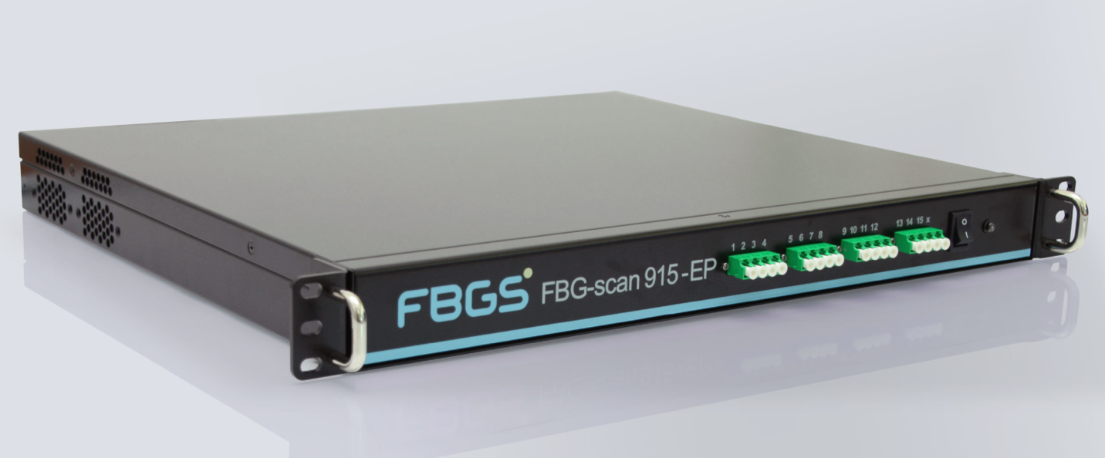
S-E13.1 Optical Sensing and Data Acquisition System
- Equipment: Optical Fiber Grating Interrogator
- Functional Module: Core sensor readout and signal demodulation. Utilized for the real-time demodulation of wavelength shift signals ( $Δλ$) from FBG sensors embedded within the battery at a sampling frequency of 100 Hz.
- Experimental Execution and Model Alignment Logic:
Experimental Procedure: During charge-discharge cycling, the interrogator was connected to the FBG sensor network embedded inside the NMC prismatic battery module. Working in tandem with a ZCFD-24V/50A battery charge-discharge analyzer , the raw optical response signals were continuously recorded across UDDS, WLTP, and constant-current protocols.
Deep Alignment Logic: The baseline data acquired by this device were employed to verify and calibrate the optical response equations within the COMSOL model ( $Δλ_{B}/λ_{B}=K_{ε}ε+K_{T}ΔT$). Furthermore, by analyzing the signal fluctuations under quiescent conditions, we extracted the authentic system-level measurement noise floor ( $σ_{λ}=2.00×{10}^{-12}$ m, equating to a Signal-to-Noise Ratio of 44.3 dB). This empirical noise profile was injected as Gaussian noise into the simulated dataset, thereby realistically replicating the electromagnetic interference environment of an operational vehicle system.
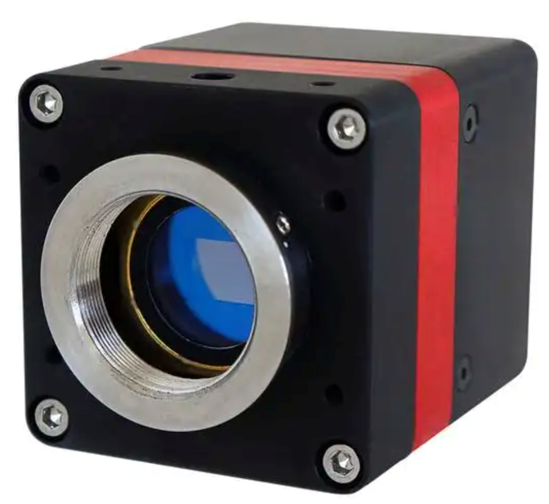
S-E13.2 Full-Field Thermal Mapping
- Equipment: Photonics Infrared CCD
- Functional Module: Acquisition of full-field surface temperature distributions under high heat-generation conditions (e.g., 2C fast charging), providing a physical control dataset for the neural network's thermal predictions.
- Experimental Execution and Model Alignment Logic:
Experimental Procedure: As the physical battery module underwent high-rate charge-discharge cycling from 0.5C to 2C —particularly during the 2C fast-charging phase, where the peak volumetric heat generation rate reaches approximately $8.0×105 W/m3$ —this SWIR1280 camera was used to non-contactively capture the spatiotemporal temperature gradients on the battery surface.
Deep Alignment Logic: Single-point FBG sensors inherently provide localized (or spatially averaged) temperature measurements. The two-dimensional thermal field data captured by the infrared camera were imported into COMSOL. Through non-linear least-squares fitting, we inversely calibrated the convective heat transfer coefficient ($h=10.0 W/(m2⋅K)$) and the volumetric heat capacity
$ρC_{p}=2.50×{10}^{6} J/(m^{3}·K)$ ) within the lumped-parameter model. This operation ensured that the simulation-generated internal temperature labels (ground truth) were thermodynamically self-consistent with the external macroscopic heat dissipation processes.

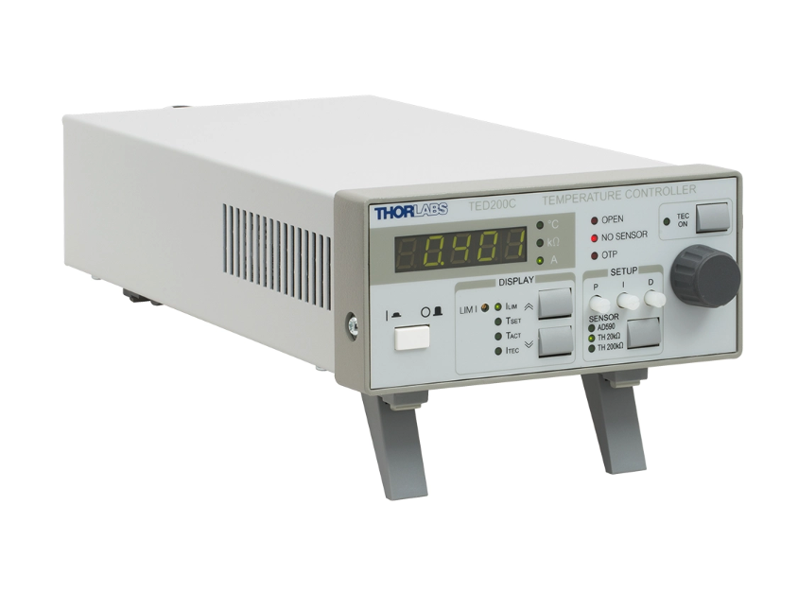
S-E13.3 Environmental and Kinetic Modulation
- Equipment: Temperature Control Device
- Functional Module: Simulates severe environmental temperature fluctuations (extreme cold or heat) to validate the model's generalization capabilities across disparate electrochemical kinetic states.
- Experimental Execution and Model Alignment Logic:
Experimental Procedure: The physical battery module was placed inside this thermal chamber, where multiple constant-temperature step points were established across a broad thermal range from 278 K to 318 K. Standard capacity tests and Electrochemical Impedance Spectroscopy (EIS) were conducted at each isothermal step.
Deep Alignment Logic: Lithium-ion desolvation processes at the solid-liquid interface and internal ionic transport are highly sensitive to temperature, obeying the Arrhenius formulation. The electrochemical polarization and Ohmic impedance data obtained under various environmental conditions were directly utilized to calibrate the activation energy parameter ( $E_{a}=2.0×{10}^{4}$ J/mol ) in the P2D model. This provided the Q-FiLM module with a robust physical foundation for modulating features across a thirteen-fold range of heat generation rates ( $Q_{gen}$).

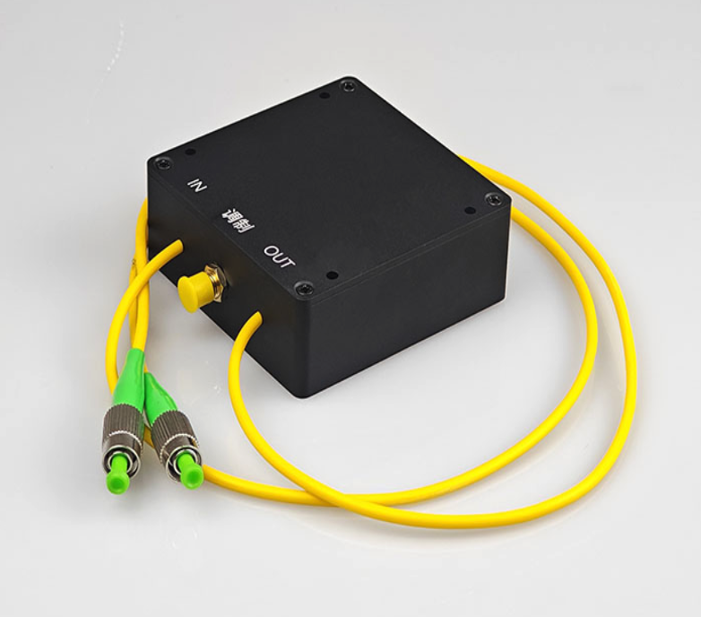
S-E13.4 Mechanical Disturbance Simulation
- Equipment: Vibration Simulator
- Functional Module: Simulates road-induced excitations experienced by electric vehicles to evaluate FBG sensor signal stability under mechanical noise interference and assess the model's robustness against disturbances.
- Experimental Execution and Model Alignment Logic:
Experimental Procedure: In accordance with random vibration testing standards for electric vehicles, mechanical excitations of varying frequencies were applied along the x, y, and z axes to the battery pack while it executed dynamic driving cycles (e.g., Emergency braking or Highway drive cycles).
Deep Alignment Logic: FBGs are exquisitely sensitive to mechanical strain. Road vibrations introduce high-frequency elastic strain components ( $ε_{el}$ ) into the sensor , typically within the 0.1 to 5 Hz range. This experiment collected the pure mechanical dynamic background noise spectrum. During the data processing phase, this authentic physical noise was leveraged to verify the efficacy of the Multi-Scale Fourier Embedding in filtering and decoupling high-frequency mechanical transient signals.
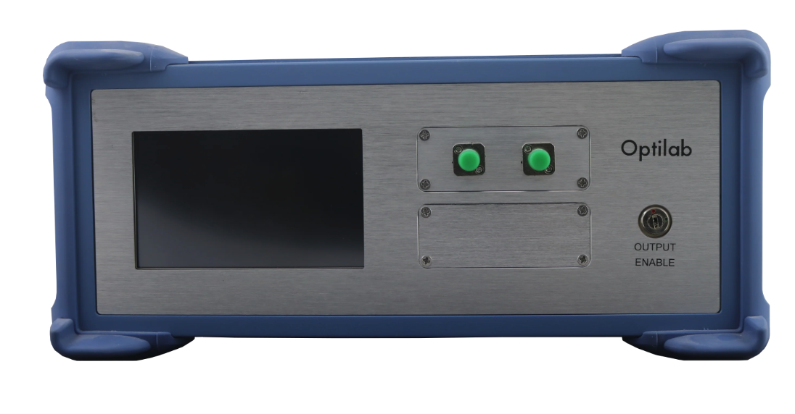
S-E13.5 Optical Calibration and Preparation
- Equipment: ASE Wideband Optical Source
- Functional Module: Provides a testing light source for the fiber-optic sensing network or operates in conjunction with an optical spectrum analyzer during custom optical path construction.
- Experimental Execution and Model Alignment Logic:
Experimental Procedure: Prior to embedding the FBG sensors into the battery jelly-roll, this ASE broadband light source, paired with a high-precision Optical Spectrum Analyzer (OSA), was used to perform an initial reflection spectrum scan on the bare fiber gratings. The central wavelength (approximately 1550 nm) and the Full Width at Half Maximum (FWHM) were recorded under stress-free conditions at 298.15 K. This critical step stringently eliminated the influence of sensor manufacturing tolerances on subsequent calibration experiments.

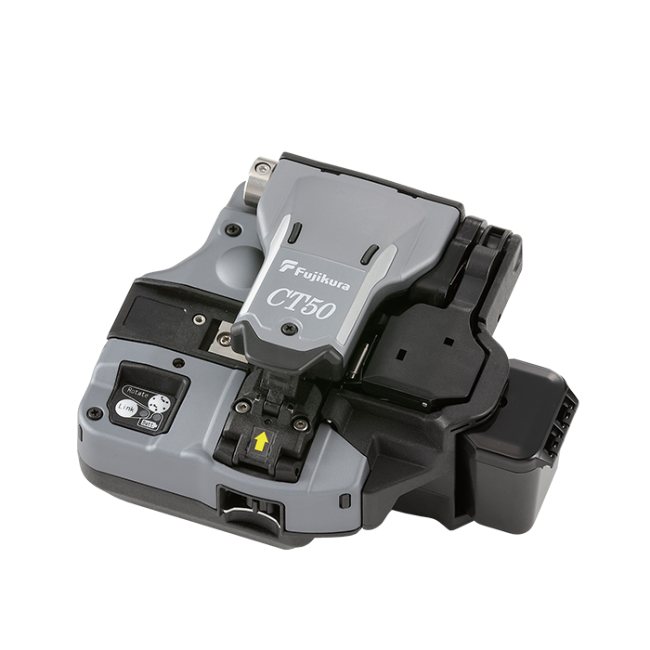
S-E13.6 Optical Fiber Cleaver
- Equipment: Fujikura Fiber Optic Cleaver CT50
- Asset ID: Item 6013 (E1294804)
- Functional Module: Utilized for high-precision cleaving of FBG fiber end-faces to facilitate seamless integration into the interrogation system or for subsequent fiber splicing.
- Experimental Execution and Model Alignment Logic:
Experimental Procedure: Due to the confined spatial constraints within the battery pack and the extreme sensitivity of optical signals to link losses, the CT50 high-precision cleaver was employed to prepare the single-mode fiber end-faces, ensuring a cleave angle error of less than 0.5 degrees.
Physical Significance: Exceedingly low end-face reflection and insertion loss are absolute prerequisites for ensuring that faint FBG signals remain undistorted within the dense electromagnetic interference environment of the battery cell. This meticulous preparation secured a high signal-to-noise ratio at the hardware connection level , ensuring that the subsequent neural network model, when predicting and decoupling mechanical strain $ε_{mech}$, was not corrupted by pseudo-signal artifacts induced by optical backscattering.

References
[1] W. Zhang, D. J. Webb, and G.-D. Peng, "Enhancing the sensitivity of poly (methyl methacrylate) based optical fiber Bragg grating temperature sensors," Optics letters, vol. 40, no. 17, pp. 4046-4049, 2015.
[2] Z. Yang, J. Liao, D. Yang, C. Xu, and J. Xin, "High wavelength stability fiber Bragg grating filter based on nonlinearity correction of thermal effects," Applied Optics, vol. 64, no. 32, pp. 9699-9706, 2025.
[3] X. Zhang and D. Lv, "Theoretical study of Electro-optic effect and elasto-optic effect in chirped fiber grating with uniaxial crystal materials cladding," Optical & Quantum Electronics, vol. 36, no. 5, 2004.
[4] A. Yablon et al., "Anomalous refractive index changes in optical fibers resulting from frozen-in viscoelastic strain," in OFC 2003 Optical Fiber Communications Conference, 2003., 2003: IEEE, pp. PD6-1.
[5] L. Mishra, T. Jang, T. R. Garrick, and V. R. Subramanian, "Reconstructing the Pseudo-2-Dimensional (p2D) Model in Comsol Multiphysics Using Mathematical Interfaces," in Electrochemical Society Meeting Abstracts 245, 2024, no. 45: The Electrochemical Society, Inc., pp. 2497-2497.
[6] S. Skoog, "Electro-thermal modeling of high-performance lithium-ion energy storage systems including reversible entropy heat," in 2017 IEEE Applied Power Electronics Conference and Exposition (APEC), 2017: IEEE, pp. 2369-2373.
[7] E. Perez, F. Strub, H. De Vries, V. Dumoulin, and A. Courville, "Film: Visual reasoning with a general conditioning layer," in Proceedings of the AAAI conference on artificial intelligence, 2018, vol. 32, no. 1.
[8] M. J. Meni, Z. Hampel-Arias, and A. Carr, "Enhancing explainability in hyperspectral target identification using PEEK-based feature attribution," in Applications of Machine Learning 2025, 2025, vol. 13606: SPIE, pp. 16-26.
[9] M. G. Intriago and R. A. Cevallos, "Impacto de la normalización de datos en la precisión de modelos de aprendizaje supervisado," Revista de Investigaciones en Energía, Medio Ambiente y Tecnología (RIEMAT), 2025.
[10] L. Liu et al., "Hard Sample Mining: A New Paradigm of Efficient and Robust Model Training," IEEE Transactions on Neural Networks and Learning Systems, 2025.
[11] X. Tao, L. Tang, and C.-L. Choy, "Effectiveness and Optimization of Fiber Bragg Grating Sensor as Embedded Strains Sensor," in Proceeding of International Conference on Composite Materials (ICCM12), 1999.
[12] H. Jeong and J. Han, "Robust Fourier Neural Networks," arXiv preprint arXiv:2409.02052, 2024.

