Timing and tempo of pubertal development in relation to self-harm and suicidality in adolescents: a Danish population-based follow-up study

Anne Marie Ladehoff Thomsenª, Andreas Ernst^{a,b}, Katrine Strandberg-Larsen^{c}, Charlotte Ulrikka Rask^{b,d}, Trine Madsen^{c,e}, Anne Gaml-Sørensenª, Thea Emily Benson, MHScª, Onyebuchi A.
Arah^{a,f,g,h}, Cecilia Høst Ramlau-Hansenª

ª Department of Public Health, Research Unit for Epidemiology, Aarhus University.
^{b} Department of Clinical Medicine, Aarhus University, 8200 Aarhus N, Denmark
^{c} Department of Public Health, Section of Epidemiology, University of Copenhagen.
^{d} Department of Child and Adolescent Psychiatry, Research Unit, Aarhus University Hospital.
^{e} Danish Research Institute for Suicide Prevention, Bispebjerg and Frederiksberg Hospital,
2900 Hellerup, Denmark
^{f} Department of Epidemiology, Fielding School of Public Health, UCLA.
^{g} Department of Statistics and Data Science, Division of Physical Sciences, UCLA College.
^{h} Practical Causal Inference Lab, UCLA.

Supplementary material

Supplementary Fig. 1. Flowchart for the eligible study populations (1 and 2) for the main analysis with self-harm and suicidality in adolescent girls and boys in the Puberty Cohort, the Danish National Birth Cohort (DNBC), 2000-2022.

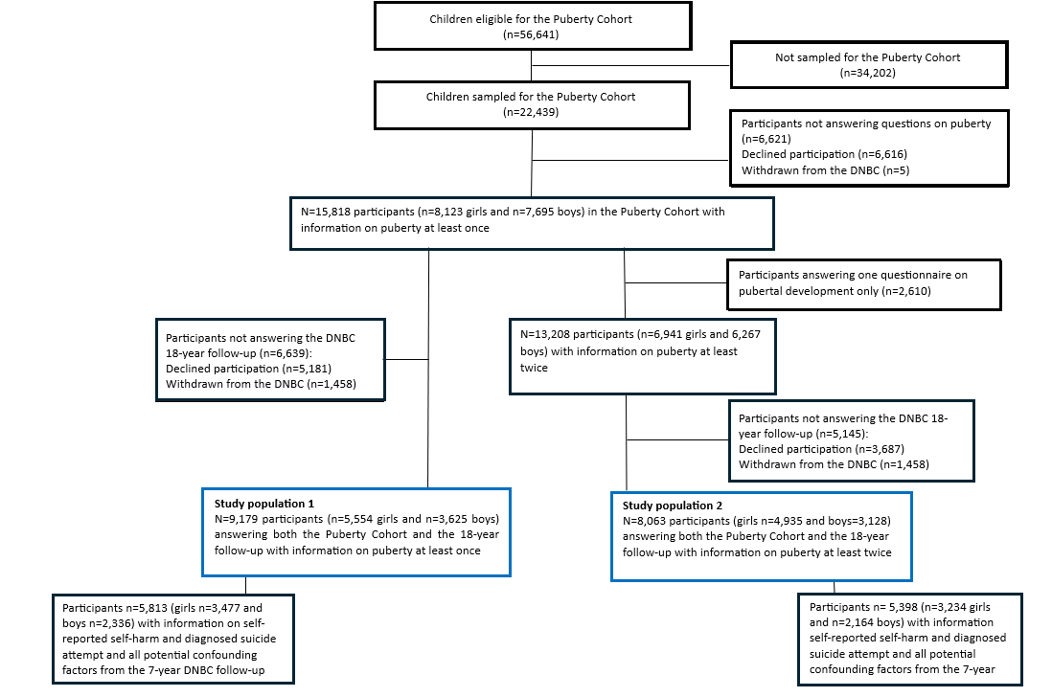

Supplementary Fig. 2. Directed acyclic graph used to guide the selection of confounding factors for the potential effect of pubertal timing and tempo on self-harm and suicidality in girls and boys, the Puberty Cohort, the Danish National Birth Cohort, 2000-2022.

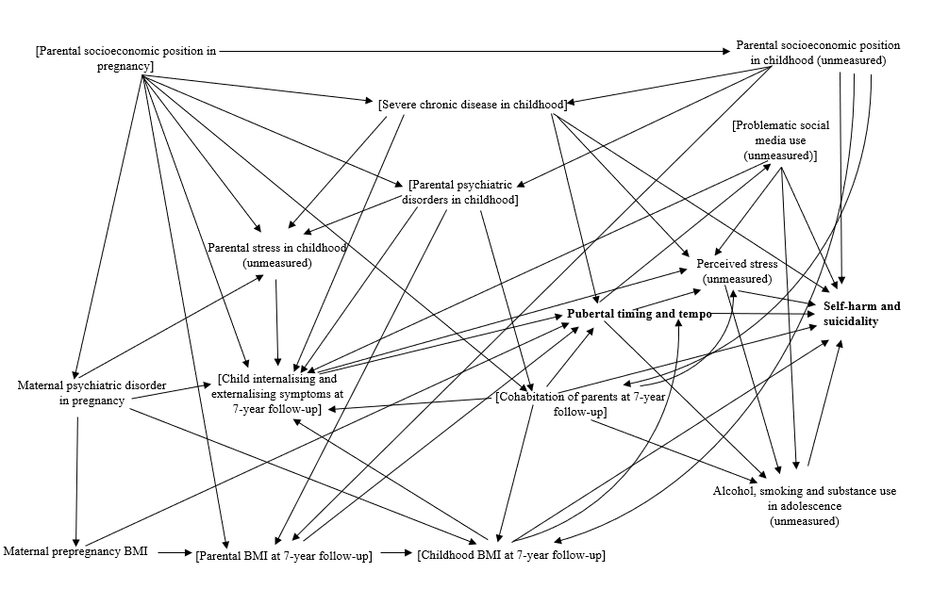

Supplementary Fig. 3. Sampling and selection weights for girls and boys.

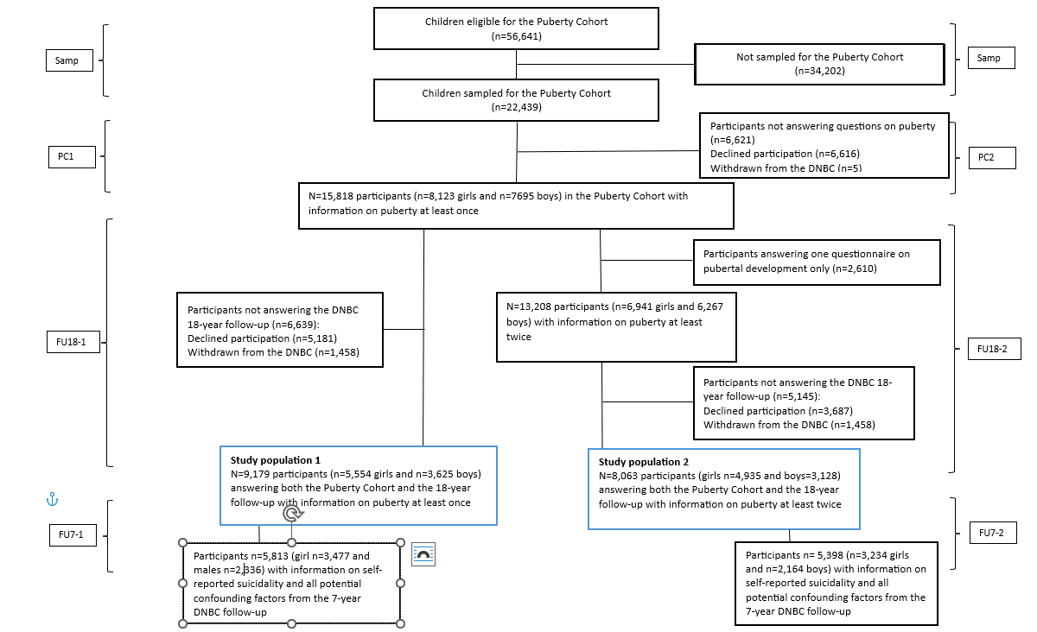

Abbreviations: (Samp): Sampling weight, (FU7-1 and FU7-2): Participation in the 7-year Danish National Birth Cohort (DNBC) follow-up (yes/no), and whether the participants had answered one (FU7-1) or at least two pubertal questionnaires (FU7-2), (PC1 and PC2): Participation in the Puberty Cohort (yes/no), and whether the participants had answered one (PC-1) or at least two pubertal questionnaires (PC-2), (FU18-1 and FU18-2) Participation in the DNBC 18-year follow-up (yes/no), and whether the participants had answered one (FU18-1) or at least two pubertal questionnaires (FU18-2).

Supplementary Fig. 4a. Main analyses for girls. Adjusted odds ratiosª of suicidality, with 95% confidence intervals (CIs), according to tempo of pubertal milestones, the Puberty Cohort, the Danish National Birth Cohort, 2000-2022.

a) Adjusted for the highest socio-economic position of parents in the first trimester, cohabitation of parents, parental BMI, childhood BMI, childhood internalizing and externalizing symptoms from the 7-year follow-up, and maternal and paternal psychiatric disorders, and severe chronic somatic illnesses in childhood from the Danish National Patient Register.

Supplementary Fig. 4b. Main analyses for boys. Adjusted odds ratiosª of suicidality, with 95% confidence intervals (CIs), according to tempo of pubertal milestones, the Puberty Cohort, the Danish National Birth Cohort, 2000-2022.

a) Adjusted for the highest socio-economic position of parents in the first trimester, cohabitation of parents, parental BMI, childhood BMI, childhood internalizing and externalizing symptoms from the 7-year follow-up, and maternal and paternal psychiatric disorders, and severe chronic somatic illnesses in childhood from the Danish National Patient Register.
Supplementary Table 1. The methodology used for multiple imputation (MI) of the pubertal milestones data (age at menarche, age at voice break, and first ejaculation).

 | Methodology
Censored pubertal milestones | Every six months throughout puberty, the participants provided information on their exact age (in years and months) at attaining menarche, or first ejaculation. Most participants provided this information, with 81% for age at menarche and 63% reporting age at first ejaculation. For the remaining participants, the exact timing of these milestones was unknown, because data were left, interval-, or right censored.  Moreover, the exact timing of age at voice break was also unknown, because this milestone was reported every six months.
Imputation for missing data | We used multiple imputation (MI) to estimate the exact timing of the pubertal milestones when exact timing was missing.
Stata’s -mi- package | MI using chained equations was performed with Stata’s -mi- package and conducted separately for girls and boys.
Assumptions of missing information | We assumed that missing information was missing at random. We assumed that residuals were normally distributed to model censored pubertal milestones (age at menarche in girls, or age at first ejaculation and voice break in boys).
Covariates for imputation | The timing of the pubertal milestones was imputed using potential confounders from the Danish National Birth Cohort (DNBC) follow-ups (Supplementary Figure 2), including covariates from baseline data, the 7-year follow-up, timing and tempo of the Tanner stages and self-harm, suicidal ideation, suicidal plans and suicide attempts at age 18 years.
Regression models for imputation of variables | Logistic regression:  Binary variables used: Parental psychiatric disorders and severe chronic disease in childhood were derived from the Danish National Patient Register (yes, no), cohabitation of parents at age 7 years (yes, no), and self-harm, suicidal ideation, suicidal plans, and suicide attempts at age 18 years (yes, no).  Multinomial logistic regression:  Categorical variables used: Maternal age at menarche compared to peers (earlier, same time, later), highest parental socio-economic position in first trimester (high grade professional, low grade professional, skilled worker, unskilled worker, student or unemployed) according to occupation and level of education based on the Danish International Standard Class of Occupation and Education codes (ISCO-88 and ISCED).  Linear regression:  Maternal, paternal and child body mass index (BMI), all measured when the child was 7 years, pubertal timing and tempo, Strength and Difficulties Questionnaire (SDQ) internalising and externalising subscales assessed at age 7 years were included as normally distributed variables.  Interval-censored regression:  Age at menarche in girls, or age at first ejaculation and voice break in boys.
The imputation process | The imputation process involved 100 burn-in iterations and 100 imputed datasets.

Supplementary Table 2. Outcome and covariate information from the Danish National Birth Cohort and the Danish National Patient Register.

Self-reported outcomes with questions (items) from the 18-year DNBC follow-up
Self-harm:
“Have you ever harmed or hurt yourself on purpose?”. Reply options: yes/ no/ do not know.

Suicidal ideation:
“Have you ever thought about taking your own life (even though you would not do it)?”. Reply options: yes/ no/ do not know.

Suicidal plans:
“Have you ever had plans to kill yourself (considered method, done preparations)? Reply options: yes/ no/ do not know.

Suicide attempts:
“Have you ever tried to kill yourself?”. Reply options: yes/ no/ do not know

Outcome information from the Danish National Patient Registry (ICD-10 codes)

The outcome of suicide attempts (a composite measure comprising self-reported suicide attempts and classifications of register-based suicidality, i.e. clinically diagnosed suicide attempts):
- All hospital contacts with a main or supplementary ICD-10 diagnosis of X60-X84 or where reason of contact code for “suicide attempt”
- Main diagnosis accidental intoxication with weak analgesic drugs, antiepileptics, sleeping pills, antiparkinsonian drugs, psychotropics, and carbon monoxide (ICD-10: T39, T40 except T40.1, T42, T43, T58).
- Main diagnosis of psychiatric disorder diagnosis (ICD-10: F99) in combination with a sub-diagnosis of intoxication with drugs and biological substances (ICD-10: T36-T50, T52-T60).
- Main diagnosis of psychiatric disorder diagnosis (ICD-10: F00-F99) in combination with a sub-diagnosis of injuries to the lower forearm (ICD-10: S51, S55, S59, S61, S65, S69).

Covariate information about “severe chronic disease in childhood” from the Danish National Patient Register (ICD-10 codes)
Chapter number and name  II: Neoplasms  III: Blood  IV: Endocrine  VI: Neurology  IX: Circulatory  X: Respiratory  XI: Digestive  XIII: Musculoskeletal  XIV: Genitourinary  XVI: Perinatal  XVII: Malformations | ICD-10 codes  C00.0–C99.1  D61.0; D61.3; D61.8–D61.9; D76.2; D80.0–D82.9  E10; E25; E70.0–E73.0; E74.0–E84.9  G12; G31.0; G31.8–G31.9; G37.0–G37.9; G40; G60; G70.2; G71.0–G71.3; G73.6; G80; G81.1; G82.1; G82.4; G91; G94.1  I12; I27.0–I27.9; I30.0–I52.8  J44.8; J84  K21; K50.0–K51.9; K70.0–K77.8; K90  M30.0–M35.9  N03–N05; N07; N13; N18.0–N19.9; N25.0–N27.9  P27; P57.0–P57.9; P91.0–P91.2; P94.1–P94.9  Q01–Q07; Q20.0–Q26.9; Q30.0–Q32.4; Q33.0–Q33.9; Q34.0–Q37.9; Q39.0– Q45.3; Q60.0–Q64.9; Q79.0; Q79.2– Q79.3; Q86.0; Q87; Q90.0–Q99.9

Supplementary Table 3. Inverse probability weights (IPWs) used in the study.
 | Methodology
Source population | The total number of eligible children for invitation to the Puberty Cohort: 56,641 live-born singletons whose mothers were enrolled in the Danish National Birth Cohort (DNBC) and completed the first-trimester baseline questionnaire and had not withdrawn by May 2012.
Invited sample | A total of 22,439 children were selected for invitation based on prenatal exposures which were hypothesized to influence pubertal development. Moreover, 8,000 randomly selected children were sampled to ensure that all children could be sampled at least once.
Sampling weights | We applied sampling weights to all analyses to ensure that the invited sample represented the total eligible population of 56,641. We reweighted the invited sample to a pseudo-population corresponding to the source population (“Samp” in Figure 1).
Participation rates | Of the 22,439 invited, 15,818 children (70%) had at least one assessment of pubertal development after exclusion of those who withdrew their consent to participate in the Puberty Cohort.
Selection weights | Selection weights were calculated to adjust for non-participation based on the assumption that data were missing at random. This assumption was that participants and non-participants had the same outcome distribution after conditioning on a set of observed variables.  Applying selection weights to the analyses ensured that the 15,818 participants represented all invited children, thus generating a pseudo-population corresponding to the invited population.  We calculated selection weights separately for girls and boys. We first identified covariates that were potentially associated with participation in the different follow-up waves of the DNBC. These covariates were derived from the first pregnancy interview in the DNBC, the Danish Medical Birth Register (DMBR), the 7-year DNBC follow-up, and the Puberty Cohort.  We relied on participants to provide information on potential confounders from the 7-year DNBC follow-up, exposure data from the Puberty Cohort, and outcome data from the DNBC 18-year follow-up. Accordingly, we derived three selection weights, one for each follow-up, and whether the participants had answered one or at least two pubertal questionnaires.
Explanatory variables | The first pregnancy interview in the DNBC:  Highest socio-occupational position of the parents in the first trimester, cohabitation of parents during pregnancy, maternal smoking in first trimester, maternal alcohol intake in first trimester, maternal pre-pregnancy body mass index (BMI), maternal age at menarche relative to peers (earlier, same time, later), any maternal mental disorder, and maternal worries in first trimester.  DMBR:  Maternal age at delivery and parity.  7-year DNBC follow-up:  Childhood BMI, cohabitation of parents, internalising symptoms, externalising symptoms, maternal, paternal smoking, and any maternal psychiatric diseases.  The Puberty Cohort:  Timing and tempo of Tanner breast/genital development, timing and tempo of Tanner pubic hair development, age at menarche, age at first ejaculation, and voice break.
The 7-year DNBC follow-up IPWs | The first selection weight was estimated as the inverse probability of participation in the 7-year DNBC follow-up (yes/no), conditional on explanatory variables from the first DNBC interview and the DMBR, and whether the participants had answered one (FU7-1) or at least two pubertal questionnaires (FU7-2) (Supplementary Figure 3)
The Puberty Cohort IPWs | The second selection weight was estimated as the inverse probability of participation in the Puberty Cohort (yes/no), conditional on explanatory variables from the first DNBC interview, the DMBR, and the 7-year DNBC follow-up, restricted to participants in the 7-year DNBC follow-up, and whether the participants had answered one (PC-1) or at least two pubertal questionnaires (PC-2) (Supplementary Figure 3).
The 18-year DNBC follow-up IPWs | The third selection weight was estimated as the inverse probability of participation in the DNBC 18-year follow-up (yes/no), conditional on explanatory variables from the first DNBC interview, the DMBR, the 7-year DNBC follow-up, and the Puberty Cohort. We restricted to participants in both the 7-year DNBC follow-up and the Puberty Cohort and whether the participants had answered one (FU18-1) or at least two pubertal questionnaires (FU18-2) (Figure 1).
Multiplication of selection and sampling weights | We multiplied the sampling weight with the three selection weights, and whether the participants had answered one or at least two pubertal questionnaires:  - Samp*FU7-1*FU18-1*PC-1  - Samp*FU7-2*FU18-2*PC-2  Using these weights, the participants were reweighted to be representative of the 56,641 children (source population) eligible for the Puberty Cohort, based on the assumption that participation was missing at random.

Supplementary Table 4. Multidimensional bias analysis conducted for the unmeasured confounder, parental stress in childhood, under different scenarios for the prevalence of self-harm in both sexes in the study.

 | Methodology
Purpose | To examine the potential impact of the unmeasured confounder (parental stress in childhood) on the association between pubertal timing and self-harm, we conducted a multidimensional bias analysis using a simplified approach suggested by VanderWeele and Arah (1).
Multidimensional bias analysis | We conducted the multidimensional bias analysis on estimates from Figure 1a (girls) and Figure 1b (boys), including continuous timing of Tanner breast and genital stage 3. We chose these associations because it was easier to refer to previous evidence.  First, we derived the observed odds ratios (OR_{obs}) and assumed that parental stress in childhood was the single unmeasured confounder associated with both exposure and outcome.  Then we calculated the bias-adjusted estimate as:  log(OR_{𝑎𝑑𝑗}) = log(OR_{obs}) − 𝛾𝛿  where 𝛾 represented the log OR for the association between parental stress in childhood and self-harm, and δ represented the difference (in years) in pubertal timing associated with parental stress.  We interpreted the bias factor (𝛾𝛿) as the magnitude of bias due to the unmeasured confounder. The standard error of the log-transformed estimate was derived from the observed 95% confidence interval.  We specified realistic parameters for γ based on assumptions from a cohort study (2). In this study, the associations between parental stress or early psychosocial adversity and adolescent self-harm or nonsuicidal self-injury were investigated, and the ORs were reported in the range of approximately 1.5–4.0 to reflect both realistic and more extreme scenarios.  We used another cohort study to specify realistic parameters for δ (3). The difference in pubertal timing among adolescents exposed to high maternal life stress and emotional distress was found to be approximately 1 to 2 months earlier in both girls and boys. To consider both realistic and more extreme scenarios, we specified δ as 0.05, 0.1, and 0.2 years.
References | 1. Vanderweele TJ, Arah OA. Bias formulas for sensitivity analysis of unmeasured confounding for general outcomes, treatments, and confounders. Epidemiology. 2011;22(1):42-52. doi:10.1097/EDE.0b013e3181f74493  2. Wichstrøm T, Wichstrøm L. Childhood Predictors of Nonsuicidal Self-Injury in Adolescence: A Birth Cohort Study. J Am Acad Child Adolesc Psychiatry. 2024;63(11):1114-1122. doi:10.1016/j.jaac.2023.12.013  3. Gaml-Sørensen A, Brix N, Henriksen TB, Ramlau-Hansen CH. Maternal stress in pregnancy and pubertal timing in girls and boys: a cohort study. Fertil Steril. 2024;122(4):715-726. doi:10.1016/j.fertnstert.2024.06.001

Supplementary Table 5. Numbers of cases and analytical samples for self-harm and suicidality according to pubertal timing and tempo in girls and boys, the Puberty Cohort, the Danish National Birth Cohort, 2000-2022.

 | Girls  Tanner stage 3ª  n/N (%) | Girls  Menarche^{b}  n/N (%) | Boys  Tanner stage 3ª n/N(%) | Boys  First ejaculation/ voice break^{b} n/N (%)
Outcome
Self-harm | 774/3,159 (25%) | 845/3,393 (25%) | 203/2,079 (10%) | 221/2,240 (10%)
Suicidal ideation | 1,193/3,157 (38%) | 1,280/3,391 (38%) | 626/2,075 (30%) | 662/2,234 (30%)
Suicidal plans | 266/2,927 (9%) | 294/3,140 (9%) | 111/1,947 (6%) | 119/2,097 (6%)
Suicide attempt | 103/<3,234 (3%)^{c} | 129/<3,477 (4%)^{c} | 41/<2,164 (2%)^{d} | <46/<2,336 (2%)^{d}
a) Analytical samples and number of cases for Tanner stage 3 timing analyses and pubertal tempo analyses.
b) Analytical samples and number of cases for timing analyses of menarche, first ejaculation, and voice break.
c) <5 girls with clinically diagnosed suicide attempts before reaching Tanner stage 3 were excluded from the analyses.
d) <5 boys with clinically diagnosed suicide attempts before reaching Tanner stage 3 were excluded from the analyses.

Supplementary Table 6. Multidimensional bias analysis of the association between pubertal timing and self-harm in 3,159 girls and 2,079 boys in the Puberty Cohort and the 18-year follow-up within the Danish National Birth Cohort, 2000-2022.

GIRLS
OR_{obs} = 1.22 (95% CI: 1.12;1.33)
 | OR = 1.50  γ (log OR) = 0.41 |  | OR = 2.75  γ (log OR) = 1.01 |  | OR = 4.00  γ (log OR) = 1.39
δ | OR_{adj} | 95% CI | OR_{adj} | 95% CI | OR_{adj} | 95% CI
0.2 years | 1.12 | 1.03; 1.23 | 1.00 | 0.91; 1.09 | 0.92 | 0.85; 1.01
0.1 years | 1.17 | 1.08; 1.28 | 1.10 | 1.01; 1.20 | 1.06 | 0.98; 1.16
0.05 years | 1.20 | 1.10; 1.30 | 1.16 | 1.06; 1.26 | 1.14 | 1.04; 1.24
BOYS
OR_{obs} = 1.10 (95% CI: 0.96–1.26)
 | OR = 1.50  γ (log OR) = 0.41 |  | OR = 2.75  γ (log OR) = 1.01 |  | OR = 4.00  γ (log OR) = 1.39
δ | OR_{adj} | 95% CI | OR_{adj} | 95% CI | OR_{adj} | 95% CI
0.2 years | 1.01 | 0.89; 1.16 | 0.90 | 0.79; 1.03 | 0.83 | 0.73; 0.95
0.1 years | 1.06 | 0.92; 1.21 | 0.99 | 0.87; 1.14 | 0.96 | 0.84; 1.10
0.05 years | 1.08 | 0.94; 1.23 | 1.05 | 0.91; 1.20 | 1.03 | 0.90; 1.18

