Supplementary Figure S1. Lollipop plots of TP53 (a), NFE2L2 (b), ZNF750 (c), KMT2D (d), LRP1B (e), and NOTCH1 (f).
Supplementary Figure S2. Affected oncogenic signaling pathways in our cohort.
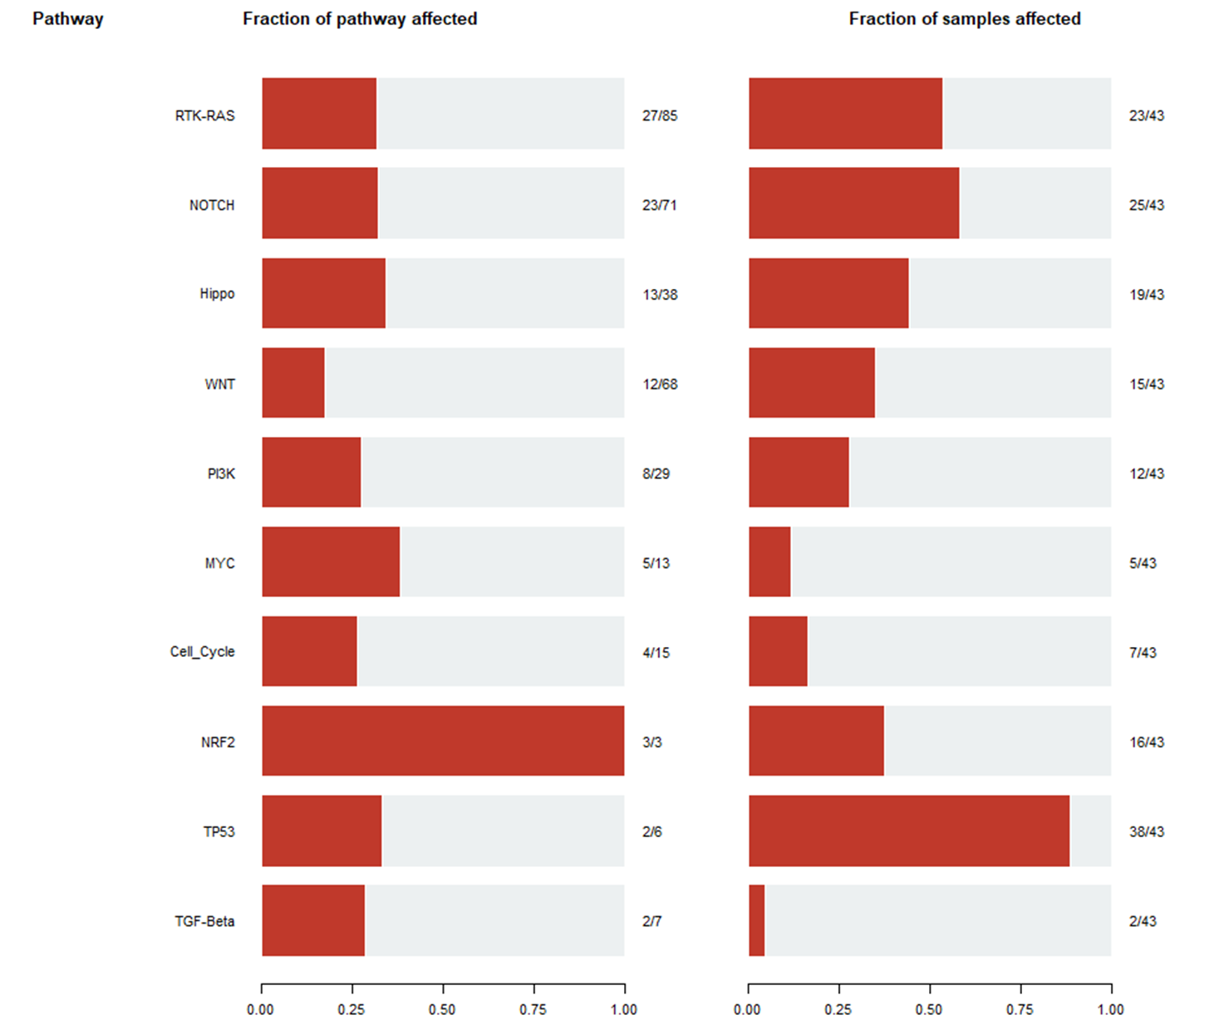

Supplementary Figure S3. Recurrence-free survival according to LRP1B mutation status. Kaplan–Meier survival curves for patients with LRP1B mutations or the wild type in our cohort. The p-value was computed using the log-rank test.

Supplementary Table S1. Top five mutated protein domains in ESCC.
Subtype | Domain Label | nMuts | nGenes | pfam | Description
ESCC | COG5048 | 72 | 63 | NA | FOG: Zn-finger (general function prediction only)
ESCC | 7tm_1 | 64 | 61 | pfam00001 | 7-Transmembrane receptor (rhodopsin family)
ESCC | FN3 | 34 | 22 | One of three types of internal repeats found in the plasma protein fibronectin. | Fibronectin type 3 domain
ESCC | Cadherin_repeat | 30 | 26 | cd11304 | Cadherin tandem repeat domain
ESCC | P53 | 29 | 1 | cd08367 | P53 DNA-binding domain
nMuts, number of mutations; nGenes, number of genes; pfam, protein family

Supplementary Table S2. Mutated genes found in over 10% of the ESCC samples in previous reports and this study.
Chinese ESCC (Lin et al.)⁷ |  | Chinese ESCC (Gao et al.)⁶ |  | Japanese ESCC (Sawada et al.)⁸ |  | Indian (Mangalaparthi et al.)⁵ |  | Korean ESCC (This study)
Gene | Percentage of mutated samples (%) | Gene | Percentage of mutated samples (%) | Gene | Percentage of mutated samples (%) | Gene | Percentage of mutated samples (%) | Gene | Percentage of mutated samples (%)
TP53 | 60 | TP53 | 93 | TP53 | 93 | TP53 | 71 | TP53 | 88
TTN | 37 | TTN | 35 | TTN | 39 | TTN | 64 | TTN | 37
MLL2 | 18 | MLL2 | 19 | NOTCH1 | 19 | CSMD3 | 43 | NFE2L2 | 30
MUC16 | 14 | NOTCH1 | 14 | MUC16 | 19 | SYNE1 | 28 | ZNF750 | 23
SYNE1 | 13 | CSMD3 | 13 | MLL2 | 18 | LRP1B | 25 | NOTCH1 | 21
FAT1 | 12 | RYR2 | 12 | NFE2L2 | 16 | PIK3CA | 25 | FSIP2 | 19
CSMD3 | 11 | FAT1 | 11 | ZNF750 | 16 | MUC16 | 25 | KMT2D | 16
GPR98 | 11 | FAT3 | 11 | FAT1 | 15 | HYDIN | 25 | LRP1B | 16
LRP1B | 10 | MUC16 | 11 | CSMD3 | 15 | DNAH5 | 21 | MUC16 | 16
PCLO | 10 | EP300 | 10 | ZNF717 | 14 | COL19A1 | 21 | ZFHX4 | 16
XIRP2 | 10 | DMD | 10 | XIRP2 | 14 | NOTCH1 | 14 | DNAH11 | 14
 |  | SYNE1 | 10 | USH2A | 12 | KMT2D | 14 | GRIN2B | 12
 |  |  |  | FSIP2 | 12 | ZFHX4 | 14 | NOTCH3 | 12
 |  |  |  | SYNE1 | 11 | KMT2C | 14 | RYR2 | 12
 |  |  |  | PIK3CA | 10 | FAT4 | 14
 |  |  |  | PCLO | 10 | NOTCH1 | 14
 |  |  |  | FRG2C | 10 | FMN2 | 14
 |  |  |  | UNC13C | 10 | ASTN1 | 14
 |  |  |  |  |  | PTPN12 | 11
 |  |  |  |  |  | OBSCN | 11
 |  |  |  |  |  | MEGF11 | 11
 |  |  |  |  |  | EP300 | 11
 |  |  |  |  |  | USP8 | 11
 |  |  |  |  |  | SLIT2 | 11
 |  |  |  |  |  | TMEM132C | 11
 |  |  |  |  |  | NF1 | 11
 |  |  |  |  |  | FAT1 | 11

