Supporting information

Fig. S1 To explore the optimal M0 induction condition, two different concentrations of 1.0 × 10⁵ cells/ml and 2.5 × 10⁵ cells/ml THP-1 cells were induced by four concentrations of PMA (5 ng/ml, 50 ng/ml, 100 ng/ml, and 200 ng/ml) for 48h or 72h. A: Representative morphological images of M0 after 48h induction in different induction conditions (scale bar = 100 μm). B: The viability of M0 induced by different conditions evaluated by CCK-8 assays in 48h. Normal complete media was used as a control. C: Representative morphological images of M0 after 72h induction in different induction conditions (scale bar = 100 μm). D: The viability of M0 induced by different conditions evaluated by CCK-8 assays in 72h. Normal complete media was used as a control. Data are shown as mean ± SEM. *p<0.05, **p<0.01, ***p<0.001.
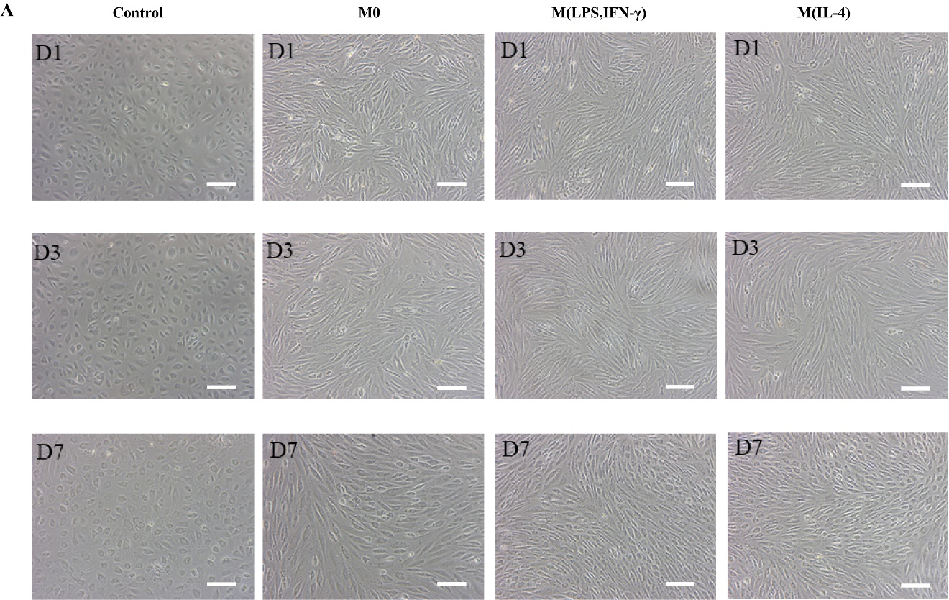
Fig. S2 Representative morphological images of HUVECs on the Matrigel in normal EBM or condition media on 1, 3, 7 days (scale bar = 100 μm).

