Supplementary Materials

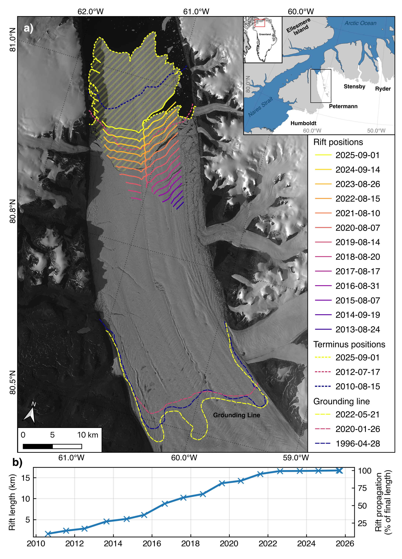
Supplementary Figure 1. a) Propagation of the downstream (earlier) rift and terminus positions of Petermann Glacier, northwest Greenland. Rift traces mapped between 2010 and 2025 are shown as coloured solid lines. Terminus positions from 2010, 2012, and 2025 are shown as dotted lines, and grounding line positions from 1996, 2020, and 2022 as dashed lines (Ciracì et al., 2025). Background Sentinel-2 scene acquired on 31 August 2025. (b) Evolution in the downstream rift length between 2010 and 2025.

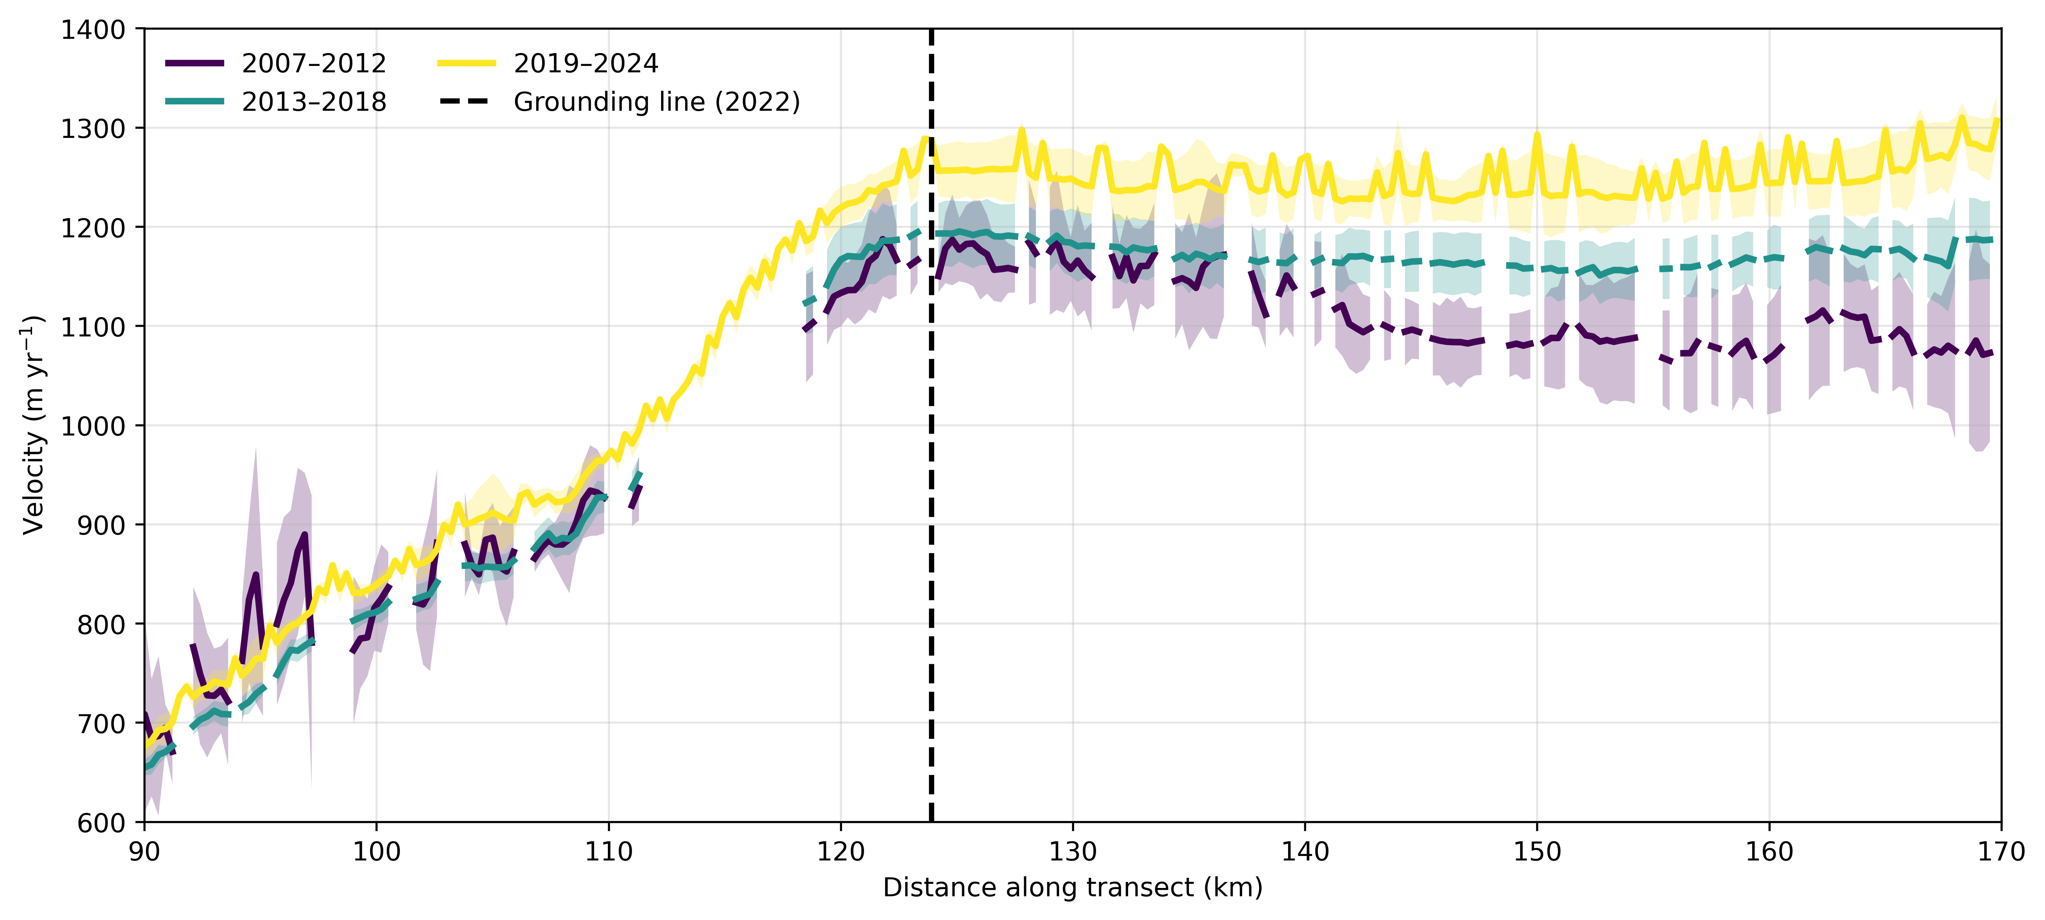

Supplementary Figure 2: Mean (coloured lines) and standard deviation (shaded areas) of ice velocities extracted along a centreline transect (shown as a grey line in Figures 2a and 2b) for the periods 2007-2012, 2013-2018 and 2019-2024. For 2007-2014 we use ice velocities from the NASA MEaSUREs ITS_LIVE dataset (Gardner et al., 2025). The 2022 grounding line position is shown as a black dashed line

Figure S2 shows the temporal change in the longitudinal rate of ice flow on the ice shelf for the period from 2007-2024. Prior to 2015, ice velocities are taken from the NASA MEaSUREs ITS_LIVE annual velocity mosaics (Gardner et al., 2025). We find that during the 2007-2012 epoch, ice decelerated as it flowed from the grounding line to the ice front. This suggests a ‘confined ice shelf’ regime, whereby resistive stresses, for example along the ice shelf's lateral margins, served to impart a buttressing effect on upstream ice flow at that time. Throughout the following decade however, our observations indicate that the longitudinal gradient in ice flow switched from negative to positive, indicating a progressive loss of buttressing.

Supplementary Reference
Gardner, A. S., Fahnestock, M. A. & Scambos, T. A. ITS_LIVE Regional Glacier and Ice Sheet Surface Velocities: Version 2. National Snow and Ice Data Center. https://doi:10.5067/6II6VW8LLWJ7 (2025).

Supplementary Video Caption: Time lapse video of Sentinnel-2 RGB scenes over Petermann Ice Shelf from 2016 to 2026 showing the formation and propagation of the rifts.

