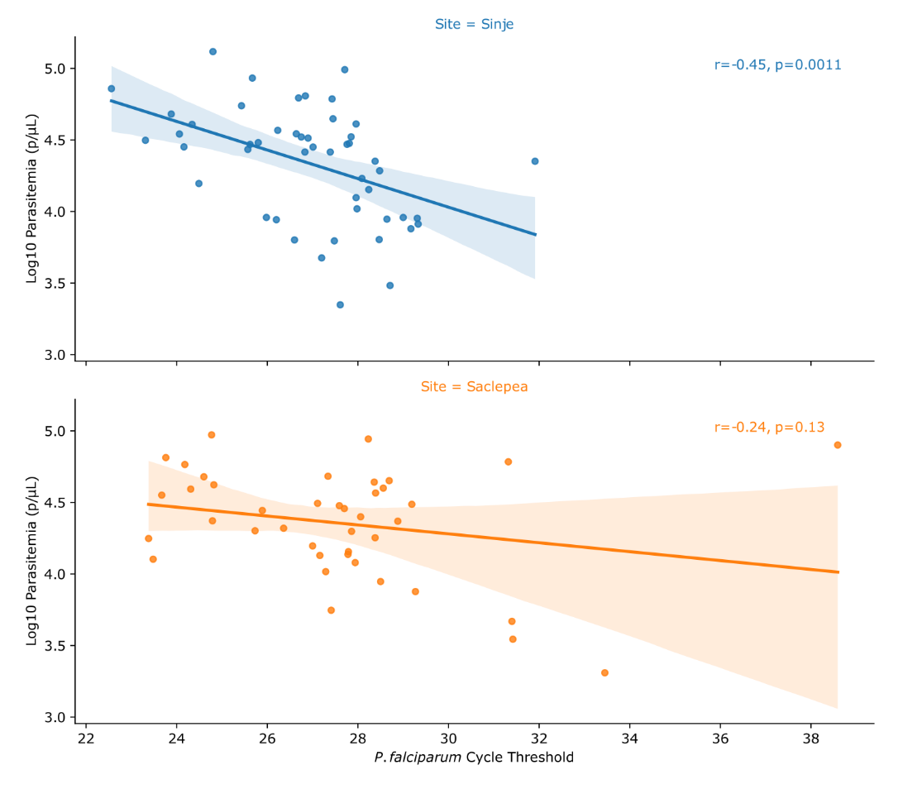
Supplemental Figure 1. Correlation between counted parasitemia and extracted P. falciparum DNA quantified by PET-PCR. Scatter plots compare the logarithmic (log10) value of the microscopy counted parasitemia, parasites per microliter (p/µL), (y-axis) and the cycle threshold identified using PET-PCR for the P. falciparum target. This is shown by all of the samples evaluated from Sinje (blue) and Saclepea (orange). The Pearson correlation (r) and p-value (p), probability of obtaining a correlation coefficient at least as extreme as the one computed from the plotted data, indicate the correlation between the data points and the line of regression for each study site plotted using Seaborn’s multiple linear regression plot (lmplot).
Supplemental Table 3. Number of samples sequenced and observed Pfcrt haplotypes from four recurrent samples.
Supplemental Table 1. Gel Electrophoresis Results
Pf PET-PCR CT | Sample | Pfcrt | Pfcytb | Pfdhfr | Pfdhps | Pfk13 | Pfmdr1 | How Many Pass
26.84 | GM23_LR0200 | Pass | Pass | Pass | Pass | Pass | Pass | 6
29 | GM23_LR0201 | Pass | Pass | Pass | Pass | Pass | Pass | 6
26.64 | GM23_LR0242 | Pass | Pass | Pass | Pass | Pass | Pass | 6
26.75 | GM23_LR0243 | Pass | Pass | Pass | Pass | Pass | Pass | 6
31.91 | GM23_LR0297 | Pass | Pass | Pass | Pass | Pass | Pass | 6
27.61 | GM23_LR0298 | Pass | Pass | Pass | Pass | Pass | Pass | 6
27.39 | GM23_LR0308 | Pass | Pass | Pass | Pass | Pass | Pass | 6
26.83 | GM23_LR0309 | Pass | Pass | Pass | Pass | Pass | Pass | 6
27.43 | GM23_LR0322 | Pass | Pass | Pass | Pass | Pass | Pass | 6
No CT | GM23_LR0323 | Fail | Fail | Fail | Fail | Fail | Fail | 0
28.06 | GM23_LR0007 | Pass | Pass | Pass | Pass | Pass | Pass | 6
27.7 | GM23_LR0008 | Pass | Pass | Pass | Pass | Pass | Pass | 6
28.69 | GM23_LR0009 | Pass | Pass | Pass | Pass | Pass | Pass | 6
28.56 | GM23_LR0010 | Pass | Pass | Pass | Pass | Pass | Pass | 6
31.4 | GM23_LR0011 | Pass | Pass | Pass | Pass | Pass | Pass | 6
31.32 | GM23_LR0015 | Pass | Pass | Pass | Pass | Pass | Pass | 6
28.38 | GM23_LR0020 | Pass | Pass | Pass | Pass | Pass | Pass | 6
23.67 | GM23_LR0037 | Pass | Pass | Pass | Pass | Pass | Pass | 6
28.23 | GM23_LR0041 | Pass | Pass | Pass | Pass | Pass | Fail | 5
27.78 | GM23_LR0043 | Pass | Pass | Pass | Pass | Pass | Pass | 6
27.94 | GM23_LR0044 | Pass | Pass | Pass | Pass | Pass | Pass | 6
27.79 | GM23_LR0047 | Pass | Pass | Pass | Pass | Pass | Pass | 6
28.5 | GM23_LR0055 | Pass | Pass | Pass | Pass | Pass | Pass | 6
23.76 | GM23_LR0058 | Pass | Pass | Pass | Pass | Pass | Pass | 6
28.39 | GM23_LR0062 | Pass | Pass | Pass | Pass | Pass | Pass | 6
27.86 | GM23_LR0063 | Fail | Pass | Pass | Pass | Pass | Pass | 5
28.88 | GM23_LR0064 | Pass | Pass | Pass | Pass | Pass | Pass | 6
29.19 | GM23_LR0067 | Pass | Pass | Pass | Pass | Pass | Pass | 6
27.34 | GM23_LR0071 | Pass | Pass | Pass | Pass | Pass | Pass | 6
24.77 | GM23_LR0076 | Pass | Pass | Pass | Fail | Pass | Pass | 5
38.59 | GM23_LR0078 | Fail | Pass | Pass | Pass | Pass | Fail | 4
24.79 | GM23_LR0079 | Pass | Pass | Pass | Pass | Pass | Pass | 6
24.31 | GM23_LR0080 | Pass | Pass | Pass | Pass | Pass | Pass | 6
27.41 | GM23_LR0090 | Pass | Pass | Pass | Pass | Pass | Pass | 6
28.36 | GM23_LR0097 | Pass | Pass | Pass | Pass | Pass | Pass | 6
31.42 | GM23_LR0098 | Pass | Pass | Pass | Pass | Pass | Pass | 6
24.82 | GM23_LR0102 | Pass | Pass | Pass | Pass | Pass | Pass | 6
24.6 | GM23_LR0104 | Pass | Pass | Pass | Pass | Pass | Pass | 6
24.18 | GM23_LR0105 | Pass | Pass | Pass | Pass | Pass | Pass | 6
33.45 | GM23_LR0109 | Fail | Pass | Pass | Fail | Pass | Fail | 3
27.59 | GM23_LR0115 | Pass | Pass | Pass | Pass | Pass | Pass | 6
27.29 | GM23_LR0119 | Pass | Pass | Pass | Pass | Fail | Pass | 5
27 | GM23_LR0122 | Pass | Pass | Pass | Pass | Pass | Fail | 5
29.27 | GM23_LR0127 | Pass | Pass | Pass | INC | Fail | Pass | 4
23.48 | GM23_LR0132 | Pass | Pass | Pass | Pass | Pass | Pass | 6
27.11 | GM23_LR0134 | Pass | Pass | Pass | Pass | Pass | Pass | 6
23.38 | GM23_LR0139 | Pass | Pass | Pass | Pass | Pass | Pass | 6
26.36 | GM23_LR0140 | Pass | Pass | Pass | Pass | Pass | Pass | 6
25.73 | GM23_LR0143 | Pass | Pass | Pass | Pass | Pass | Pass | 6
25.89 | GM23_LR0145 | Pass | Pass | Pass | Pass | Pass | Pass | 6
27.16 | GM23_LR0152 | Pass | Pass | Pass | Pass | Pass | Fail | 5
23.31 | GM23_LR0156 | Pass | Pass | Pass | Pass | Pass | Pass | 6
29.17 | GM23_LR0190 | Pass | Pass | Pass | Pass | Pass | Pass | 6
24.34 | GM23_LR0193 | Pass | Pass | Pass | Pass | Pass | Pass | 6
28.71 | GM23_LR0195 | Pass | Pass | Pass | Pass | Pass | Pass | 6
26.9 | GM23_LR0196 | Pass | Pass | Pass | Pass | Pass | Pass | 6
24.49 | GM23_LR0199 | Pass | Pass | Pass | Pass | Pass | Pass | 6
25.57 | GM23_LR0202 | Pass | Pass | Pass | Pass | Pass | Pass | 6
26.69 | GM23_LR0210 | Pass | Pass | Pass | Pass | Pass | Pass | 6
22.56 | GM23_LR0215 | Pass | Pass | Pass | Pass | Pass | Pass | 6
27.2 | GM23_LR0217 | Fail | Pass | Pass | Pass | Pass | Pass | 5
26.2 | GM23_LR0220 | Pass | Pass | Pass | Pass | Pass | Pass | 6
24.16 | GM23_LR0221 | Pass | Pass | Pass | Pass | Pass | Pass | 6
26.6 | GM23_LR0225 | Pass | Pass | Pass | Pass | Pass | Pass | 6
23.88 | GM23_LR0240 | Pass | Pass | Pass | Pass | Pass | Pass | 6
25.98 | GM23_LR0276 | Pass | Pass | Pass | Pass | Pass | Pass | 6
25.8 | GM23_LR0277 | Pass | Pass | Pass | Pass | Pass | Pass | 6
28.47 | GM23_LR0278 | Pass | Pass | Pass | Pass | Pass | Pass | 6
24.06 | GM23_LR0281 | Pass | Pass | Pass | Pass | Pass | Pass | 6
25.43 | GM23_LR0286 | Pass | Pass | Pass | Pass | Pass | Pass | 6
28.48 | GM23_LR0287 | Pass | Pass | Pass | Pass | Pass | Pass | 6
28.24 | GM23_LR0289 | Pass | Pass | Pass | Pass | Pass | Pass | 6
27.48 | GM23_LR0296 | Pass | Pass | Pass | Pass | Pass | Pass | 6
27.76 | GM23_LR0300 | Pass | Pass | Pass | Pass | Pass | Pass | 6
27.98 | GM23_LR0302 | Pass | Pass | Pass | Pass | Pass | Pass | 6
28.64 | GM23_LR0303 | Pass | Pass | Pass | Pass | Pass | Pass | 6
29.33 | GM23_LR0304 | Pass | Pass | Pass | Pass | Pass | Pass | 6
27.96 | GM23_LR0305 | Pass | Pass | Pass | Pass | Pass | Pass | 6
26.23 | GM23_LR0310 | Pass | Pass | Pass | Pass | Pass | Pass | 6
27.01 | GM23_LR0311 | Pass | Pass | Pass | Fail | Pass | Pass | 5
28.38 | GM23_LR0312 | Pass | Pass | Pass | Pass | Pass | Pass | 6
27.71 | GM23_LR0313 | Pass | Pass | Pass | Pass | Pass | Pass | 6
27.85 | GM23_LR0314 | Pass | Pass | Pass | Pass | Pass | Pass | 6
24.8 | GM23_LR0315 | Pass | Pass | Pass | Pass | Pass | Pass | 6
27.45 | GM23_LR0316 | Pass | Pass | Pass | Pass | Pass | Pass | 6
27.96 | GM23_LR0317 | Pass | Pass | Pass | Pass | Pass | Pass | 6
27.81 | GM23_LR0318 | Pass | Pass | Pass | Pass | Pass | Pass | 6
25.62 | GM23_LR0319 | Pass | Pass | Pass | Pass | Pass | Pass | 6
29.31 | GM23_LR0320 | Pass | Pass | Pass | Pass | Pass | Pass | 6
28.09 | GM23_LR0321 | Pass | Pass | Pass | Pass | Pass | Pass | 6
25.67 | GM23_LR0325 | Pass | Pass | Pass | Pass | Pass | Pass | 6
Supplemental Table 2. Variant allele frequencies and sequencing coverage.
StudyID | GENE | SITE | DayCategory | Tmnt | DayDT | TREATMENT_DAY | SeqType | YEAR | COVERAGE
GM23-LR0007 | Pfk13 | Saclepea | D0 | AL | D0-AL | 0 | individual | 22 | 3164
GM23-LR0007 | Pfk13 | Saclepea | D0 | AL | D0-AL | 0 | individual | 22 | 3152
GM23-LR0007 | Pfk13 | Saclepea | D0 | AL | D0-AL | 0 | individual | 22 | 2897
GM23-LR0007 | Pfk13 | Saclepea | D0 | AL | D0-AL | 0 | individual | 22 | 2680
GM23-LR0007 | Pfk13 | Saclepea | D0 | AL | D0-AL | 0 | individual | 22 | 2592
GM23-LR0007 | Pfk13 | Saclepea | D0 | AL | D0-AL | 0 | individual | 22 | 2592
GM23-LR0007 | Pfk13 | Saclepea | D0 | AL | D0-AL | 0 | individual | 22 | 3085
GM23-LR0007 | Pfk13 | Saclepea | D0 | AL | D0-AL | 0 | individual | 22 | 2818
GM23-LR0007 | Pfk13 | Saclepea | D0 | AL | D0-AL | 0 | individual | 22 | 2955
GM23-LR0007 | Pfk13 | Saclepea | D0 | AL | D0-AL | 0 | individual | 22 | 3453
GM23-LR0007 | Pfk13 | Saclepea | D0 | AL | D0-AL | 0 | individual | 22 | 3220
GM23-LR0007 | Pfk13 | Saclepea | D0 | AL | D0-AL | 0 | individual | 22 | 3186
GM23-LR0007 | Pfk13 | Saclepea | D0 | AL | D0-AL | 0 | individual | 22 | 3195
GM23-LR0007 | Pfk13 | Saclepea | D0 | AL | D0-AL | 0 | individual | 22 | 3191
GM23-LR0007 | Pfk13 | Saclepea | D0 | AL | D0-AL | 0 | individual | 22 | 3267
GM23-LR0007 | Pfk13 | Saclepea | D0 | AL | D0-AL | 0 | individual | 22 | 2955
GM23-LR0007 | Pfk13 | Saclepea | D0 | AL | D0-AL | 0 | individual | 22 | 2643
GM23-LR0007 | Pfk13 | Saclepea | D0 | AL | D0-AL | 0 | individual | 22 | 2577
GM23-LR0007 | Pfk13 | Saclepea | D0 | AL | D0-AL | 0 | individual | 22 | 2960
GM23-LR0007 | Pfk13 | Saclepea | D0 | AL | D0-AL | 0 | individual | 22 | 2986
GM23-LR0007 | Pfk13 | Saclepea | D0 | AL | D0-AL | 0 | individual | 22 | 3095
GM23-LR0007 | Pfk13 | Saclepea | D0 | AL | D0-AL | 0 | individual | 22 | 2968

