Addition file 1
Supplementary methods
Environmental and economical sustainability feed indices: Fish-In-Fish-Out-ratio (FIFO) which measures the amount of marine ingredients used in the feed, was calculated as follows: FIFO = FCR × (%fishmeal and soluble inclusion + %squid meal inclusion + %fish oil inclusion)/ marine resources yield (22.5%) + fish oil yield (5%)), where FCR is the feed conversion ratio for each feed (https://www.iffo.com/fifo-data).
Relative Economic Conversion Ratio (rECR), which measures the cost-effectiveness of fish feed, is expressed in relative terms using feed FH10 as a reference, i.e., the feed with the highest price and is calculated as follows: rECR = (Cost of diet (€/kg) × FCR)/ (Cost of FH10 (€/kg) × FCR FH10) ×100, where FCR is the feed conversion ratio for each feed.

Supplementary tables and figures
Table S1 Protein and lipid content (% as fed), essential amino acid composition (g/kg as fed) of ingredient used to formulate the test diets for European seabass juveniles, along with estimated fish-in-fish-out ratio (FIFO) and relative economic conversion ratio (ECR) for each diet. The ECR is expressed in relative terms using feed FH10 as a reference, i.e., the feed with the highest price.
Protein origin, % | CV | VH10 | VH10P30 | FH10 | CF
Fish | 15 | 15 | 15 | 85 | 85
PBM | - | - | 30 | - | -
Hermentia illucens | - | 10 | 10 | - | 10
Protein from veg mix + AA | 85 | 75 | 45 | 15 | 5
Amino acid (AA) composition, g/kg
Essential AA composition
Arginine | 27.4 | 26.9 | 29.4 | 24.0 | 24.7
Histidine | 10.7 | 10.7 | 10.1 | 11.3 | 11.2
Isoleucine | 18.5 | 17.7 | 15.5 | 16.1 | 16.7
Leucine | 38.0 | 36.4 | 31.8 | 28.8 | 29.2
Lysine | 25.2 | 25.5 | 23.3 | 29.3 | 29.4
Methionine + cysteine | 18.1 | 17.8 | 16.8 | 13.0 | 13.0
Phenylalanine +tyrosine | 35.7 | 35.5 | 31.4 | 35.3 | 34.8
Threonine | 16.2 | 16.3 | 17.1 | 16.6 | 16.4
Tryptophan | 4.4 | 4.4 | 4.5 | 4.8 | 4.7
Valine | 20.4 | 20.9 | 20.8 | 20.3 | 19.6
Non-essential AA composition
Aspartic acid | 34.5 | 35.9 | 39.4 | 35.7 | 34.0
Glutamic acid | 91.3 | 84.6 | 75.5 | 49.8 | 53.5
Alanine | 20.8 | 21.9 | 25.6 | 26.2 | 24.3
Glycine | 20.0 | 20.6 | 28.8 | 28.7 | 27.8
Proline | 31.7 | 30.6 | 29.6 | 20.3 | 20.1
Serine | 21.1 | 20.8 | 19.8 | 16.6 | 16.4
Lipid origin, %
Fish | 34 | 34 | 34 | 66 | 66
Lipid from alternate ingredients | 66 | 66 | 66 | 34 | 34
Sustainability indices
FIFO | 1.00 | 0.69 | 0.75 | 4.06 | 3.88
rECR | 89.3 | 68.9 | 60.1 | 100.0 | 87.8

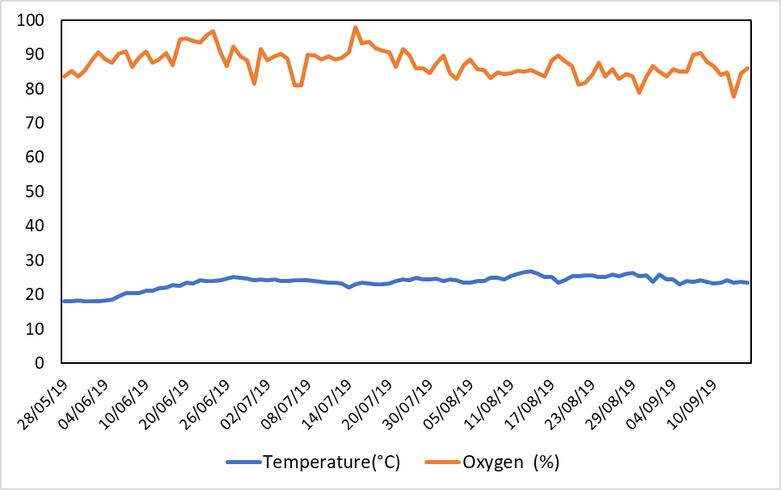
A
B
Fig. S1 (A) Seawater temperatures and oxygen concentrations in the experimental tanks during the juvenile seabass feeding trial. Each tank was supplied with 15 L/min of flow-through, mechanically pre-filtered marine water, obtained from an adjacent coastal pump station and aerated with air pumps. The artificial day cycle of 8 h (from 8 am until 16 pm) was followed. Average water temperature was 23.6 ± 2.0 °C, dissolved oxygen content ranged from 77 to 97%, and salinity ranged from 37.2 to 38‰ during the trial. (B) Average body weight and growth of fish during the 125-d feeding trial. Feeding trials were conducted in three replicate tanks for each experimental diet (CV, VH10, VH10P30, CF, FH10). Body weight was calculated for each diet as the mean across replicate tanks (± SE).

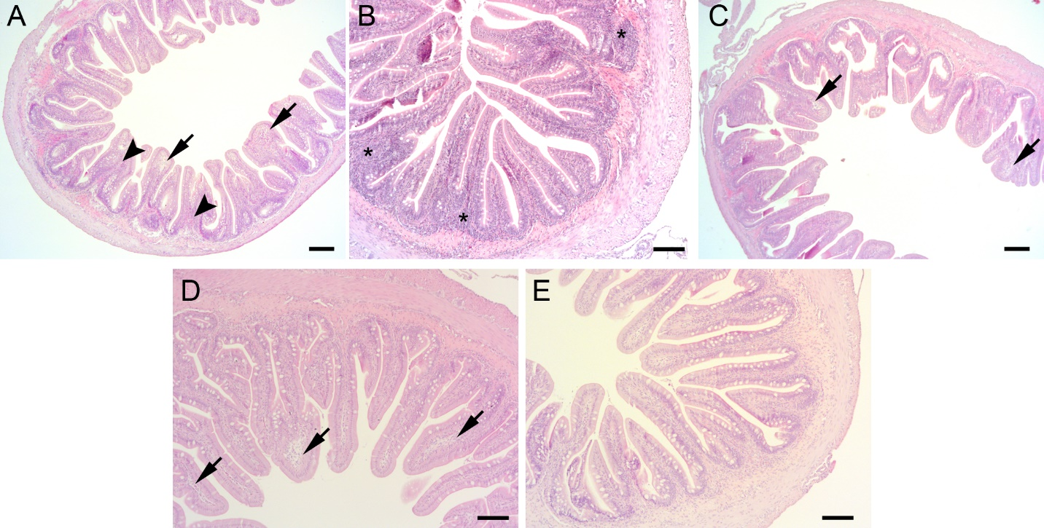
Fig. S2 Representative microscopic images of histological sections of the distal intestine of fish fed different diets. (A) CV diet, irregularly shaped villi with partial lateral fusion of neighbouring villi (arrowheads) and moderate to extensive multifocal oedema of the lamina propria in the apical parts of the villi (short arrows); (B) VH10 diet, elongated villi with largely normal morphology and no obvious signs of vacuolisation of the enterocytes, but with hypercellular lamina propria (asterisks); (C) VH10P30 diet, irregularly shaped villi with no signs of enterocyte vacuolisation but with multifocal moderate oedema of the lamina propria in the apical part of the villi (short arrows); (D) CF diet, regularly shaped villi without signs of vacuolisation of the enterocytes and with multifocal moderate to focal extensive oedema of the lamina propria (short arrows); (E) FH10 diet, villi with normal morphology, no signs of vacuolisation of the enterocytes and only slight oedema of the lamina propria in the apical parts. HE staining, scale bar A, C=100 µm, B, D, E=50 µm.

