Supplementary Information: Trails data model and temporalization assumptions
This supplementary information accompanies the manuscript "A graph-matrix hybrid approach for deep temporalization in time-explicit LCA". It documents the data structures and assumptions needed to reproduce the demonstrations, with emphasis on the temporal distributions added to exchanges before Trails performs temporal routing and year-wise matrix solves.
Usage examples and API details are maintained in the package documentation and are not repeated in full here. See the local quickstart, user guide, theory notes, LCIA method notes, impact dashboard notes, and API reference. Example notebooks are in the repository examples folder.
Table of Contents
1. Computational pathway 2
2. Datapackage consumed by Trails 3
2.1 Temporal distributions 5
2.2 Amount semantics 8
2.3 Annual resolution 8
3 Temporal routing and year-wise solving 8
4 Temporal distributions added by Premise 9
4.1 Tags and direct effects 11
4.2 Biomass growth and biogenic uptake 13
4.3 Stock assets and fleet vintages 18
4.4 Maintenance 21
4.5 End-of-life 23
4.6 Long-term biosphere emissions 24
4.7 Lifetime and CPC-code patterns 26
4.8 Throughput processes 31
5 Validation against limiting cases 32
6 Depth sensitivity and computational cost for a direct-air-capture case 35
7 Coupling Trails inventories with FaIR 36
8 Reproducibility notes 40
9 Solver stress test for deeply temporalised technosphere systems 40
10. Adaptive-routing Sankey diagrams 44
11. Routing-comparison plots for all case-study indicators 48
Battery electric vehicle 49
CCU polyol 62
Marine fuel switch 75
Direct air capture and carbon storage 88
References 101

Computational pathway
Trails treats a prospective LCA data package as a set of connected scenario-year matrices. Each year has a standard technosphere matrix and a standard biosphere matrix. Temporal exchange metadata then determines whether a technosphere demand or biosphere flow remains in the anchor year or is routed to other years.
This section expands the computational pathway illustrated in Figure 1 and introduced in the main-text Method sections "Scenario-year matrix tensors", "Temporal routing graph", and "Year-wise solving and inventory accumulation".
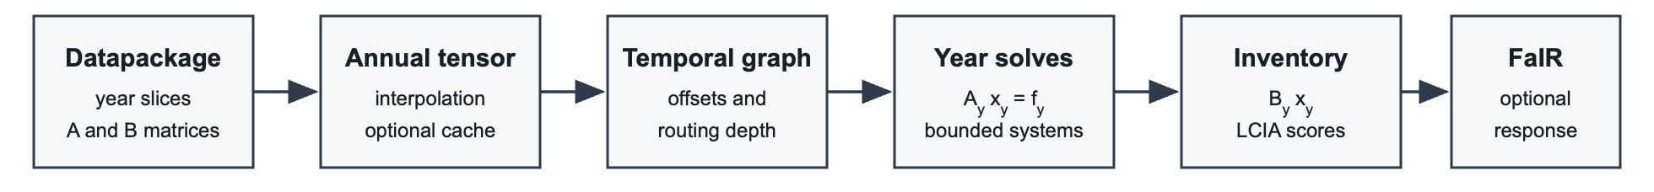
Figure 1 - Computational pathway implemented in Trails. A Frictionless datapackage provides scenario-year technosphere and biosphere matrices; optional annual interpolation builds annual matrix tensors; temporal exchange metadata is converted into routing offsets; routed frontier demands are solved as bounded year-specific systems; and annual inventories, LCIA scores, and optional FaIR responses are accumulated.
The workflow illustrated in Figure 1 separates temporal propagation from matrix solving. The temporal graph carries cross-year information, while the LCA solver only sees bounded year-specific matrix systems. Section S8 evaluates this design choice against a monolithic time-expanded matrix representation.
In a typical run, Trails:
- loads the Frictionless data package;
- optionally interpolates the matrix slices to annual resolution;
- reads temporal columns from the technosphere and biosphere matrix files;
- routes temporal exchanges through an activity-year graph;
- solves the resulting frontier demands year by year;
- aggregates inventories, characterised scores, and optional FaIR perturbation responses.
Usage examples are provided in the quickstart and user guide. The API reference provides the full argument lists for Trails, temporal_routing, lca, plotting functions, and run_fair_delta_rf.

Datapackage consumed by Trails
This section gives the file-level representation of the time-indexed databases discussed in the main-text section "Connected time-indexed databases". It also provides the data-package counterpart to the tensor notation introduced in the main-text Method section "Scenario-year matrix tensors".
Trails reads a Frictionless data package. The package descriptor is datapackage.json, and model, pathway, and year arrange the inventory resources:
- datapackage.json
- inventories/
  - <model>/
    - <pathway>/
      - <year>/
        - A_matrix.csv
        - A_matrix_index.csv
        - B_matrix.csv
        - B_matrix_index.csv

The resource path is part of the model. Trails extracts the scenario year from paths such as:
inventories/remind/NPi/2050/A_matrix.csv
The technosphere file A_matrix.csv contains non-zero technosphere coefficients. The biosphere file B_matrix.csv contains non-zero biosphere exchange coefficients. Their index files map integer matrix positions back to activity names, reference products, units, locations, and biosphere flow metadata.
The matrix files can contain standard Brightway-style uncertainty columns and, optionally, Trails temporal columns. Trails uses the temporal fields listed in Table 1, when they are present in the exchange metadata.

Column | Meaning
temporal_distribution | Integer code for the temporal profile.
temporal_loc | Location parameter, such as pulse year, mean, median, or mode.
temporal_scale | Scale parameter, such as standard deviation or lognormal sigma.
temporal_min | Minimum integer year offset.
temporal_max | Maximum integer year offset.
temporal_offsets | Explicit offset list for empirical discrete profiles.
temporal_weights | Explicit weight list for empirical discrete profiles.
temporal_amount_source | Whether routed amounts are ported from the anchor row or re-read from the target-year matrix.
Table 1 – Temporal metadata fields read by Trails from technosphere and biosphere matrix files. The fields define the distribution code, support, parameters, explicit empirical offsets and weights, and whether exchange amounts are taken from the anchor-year port or target-year matrix.
When temporal_distribution is blank, the exchange is treated as a standard exchange. For technosphere exchanges, temporal offsets move demand to other years. For biosphere exchanges, temporal offsets shift the emission or removal.
Data packages generated by Premise harmonise activity and flow indices across all exported years before being zipped. This step is required because future databases may not contain the same activity set in activities each year. If an activity is absent from a year slice, Premise inserts a neutral diagonal placeholder row with value = 1 and flip = 0. The placeholder is structural; it is not a process assumption.
For the exact import behaviour, interpolation options, and Excel inventory format, see the user guide.

Temporal distributions
Temporal distributions are annual offset profiles. An offset of 0 means that the exchange remains in the anchor year. A positive offset delays it. A negative offset places it before the anchor year. The negative convention is important for biomass growth and fleet-age distributions, in which part of the relevant physical process precedes the modelled activity.
This section expands the main-text Method sections "Temporal exchange distributions" and "Interpreting Temporally Distributed Exchange Amounts". The main text introduces the notation; this section documents the concrete distribution codes and parameter fallbacks used by Trails. The available distribution types are illustrated in Figure 2.
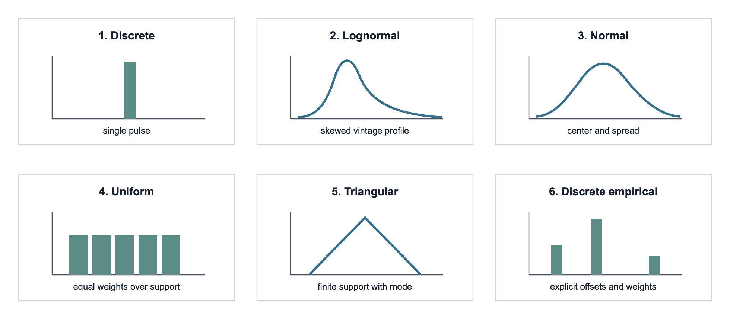
Figure 2 - Temporal distribution families supported by Trails. The horizontal axis shows annual offsets relative to the anchor year and the vertical axis shows normalized weights; negative offsets represent prior events such as biomass growth or fleet vintages, while positive offsets represent delayed events such as maintenance or end-of-life treatment.
Trails currently recognises six distribution codes, listed in Table 2.

Code | Distribution | Typical use in the manuscript workflow
1 | Discrete | A single pulse at temporal_loc.
2 | Lognormal | Fleet-age or vintage profiles, usually with negative offsets.
3 | Normal | Broad uncertain profiles where the center and spread are known.
4 | Uniform | Constant allocation over a lifetime or growth period.
5 | Triangular | Stock or vintage distributions with a mode and finite support.
6 | Discrete empirical | Explicit pulses, for example an end-of-life event at lifetime.
Table 2 – Distribution types recognized by Trails and their typical use in the manuscript workflow. Each integer code is converted to normalized annual offset-weight pairs before being applied to temporalized exchanges.
All profiles are converted to normalised (offset, weight) pairs—the weights sum to one over the retained integer offsets. Invalid profiles are skipped. Unknown distribution codes fall back to a uniform profile over the declared support.
Table 3 separates the parameters needed for a meaningful profile from those that are optional or have fallbacks in the code. In all cases, temporal_amount_source is optional and defaults to port.

Code | Needed parameters | Optional parameters and fallbacks
1 discrete | temporal_distribution; an offset support through temporal_min and temporal_max, unless a single default pulse at offset 0 is intended. | temporal_loc selects the pulse offset. If it is missing, Trails uses offset 0 when it lies inside the support, otherwise the nearest available offset.
2 lognormal | temporal_distribution; an offset support; a positive age or offset domain for the lognormal kernel. temporal_loc is the median-like location and temporal_scale is the lognormal sigma. | If temporal_loc is missing or not positive, Trails uses the geometric midpoint of the positive support. If temporal_scale is missing, it uses a support-based default. In the premise table, fleet-age lognormal profiles are written with negative offsets to place prior vintages before the anchor year; the parameters describe the age profile being mirrored into past time.
3 normal | temporal_distribution; temporal_min and temporal_max to define support. | temporal_loc defaults to 0; temporal_scale defaults to 1 if missing or non-positive.
4 uniform | temporal_distribution; temporal_min and temporal_max. | temporal_loc and temporal_scale are ignored.
5 triangular | temporal_distribution; temporal_min and temporal_max. | temporal_loc gives the mode and defaults to 0; temporal_scale is ignored.
6 discrete empirical | temporal_distribution; matching temporal_offsets and temporal_weights lists for an explicit empirical profile. | If offsets or weights are missing, empty, or inconsistent, Trails falls back to the discrete-pulse behavior using temporal_loc and the declared support.
Table 3 – Required parameters and fallback rules for each temporal distribution family. Support limits define the integer offset domain, while missing location, scale, offset, weight, or amount-source fields are handled according to the listed defaults.

Amount semantics
Trails distinguishes the timing profile from the exchange amount. The default amount source is the port. In this case, the anchor-year matrix value is distributed over the target years. This convention is appropriate when the coefficient belongs to the object or cohort whose timing is being distributed.
The alternative source of the amount is the matrix. In this case, the temporal profile selects target years, but the coefficient is read from the target-year matrix. This convention is appropriate when the year of occurrence should determine which prospective technology coefficient applies.
This distinction is methodological. A delayed exchange with port and the same delayed exchange with matrix answer different questions.

Annual resolution
Trails work at an annual resolution. It does not model hourly, seasonal, or within-year dynamics. If those dynamics control the result, the present annual time step is too coarse.

Temporal routing and year-wise solving
Trails represent temporal propagation as a graph of activity-year states. A node identifies an activity, a year, and a traversal depth. Standard exchanges remain in the current year. Temporal exchanges create one or more child demands in target years.
This section provides implementation details for the main-text Method sections "Temporal routing graph" and "Year-wise solving and inventory accumulation". It also defines the computational structure used to generate the routing-depth results reported in the main-text Results section.
Routing can be controlled either by fixed depth or by adaptive score potential. In the current default mode, Trails uses adaptive routing with max_depth=None and adaptive_relative_score_cutoff=1e-4 (i.e., 0.01%). For each candidate child branch, the routed activity scaling is converted back to a positive reference-product demand Q_{(j,y)}. The estimated branch potential is $p_{(j,y)}=Q_{j,y}\max_{m}\left|s_{m\left(j,y\right)}\right|$, where $s_{m\left(j,y\right)}$is the static score of activity j in year y per unit reference product. The effective threshold is the relative cutoff multiplied by the functional unit's static score potential. Branches at or below this threshold are retained as frontier demands; they are not discarded and still enter the year-wise matrix solve.
Frontier demands are not solved as one global matrix. Instead, Trails collects frontier demands by year and solves standard annual systems as in Eq. E1.
$$\begin{aligned}A_{y}x_{y}=f_{y} \#E1\end{aligned}$$

Where A_{y} is the technosphere matrix for year y, f_{y} is the routed frontier demand vector, and x_{y} is the supply vector. The corresponding biosphere inventory is obtained from Eq. E2.
$$\begin{aligned}G=B_{y}x_{y} \#E2\end{aligned}$$
Here, direct temporal biosphere exchanges added in the years defined by their own profiles.
When root attribution is enabled, Trails stores which first-depth activity contributed to later routing and solving. This is used for diagnostic graphs, contribution plots, and the optional FaIR allocation. For usage examples and plotting calls, see the quickstart and user guide.

Temporal distributions added by Premise
The largest modelling step upstream of Trails is adding temporal distributions to exchanges in the time-indexed databases. In the workflow used here, this is done by Premise before the matrices are exported. Premise does not create a separate temporal database for Trails. Instead, it annotates selected technosphere-biosphere exchanges with the temporal columns described in Section S3. Trails then reads these columns from the exported matrix files and applies the temporal routing described in Section S4.
This section documents the exchange-level assumptions behind the temporalised time-indexed databases used in the manuscript. It complements the main-text sections "Connected time-indexed databases" and "Temporal exchange distributions" by specifying which exchanges were given temporal distributions, which lifetimes or rotation times were used, and which sources or heuristic labels support those choices.
The source table used by Premise is located at the following location:
https://github.com/polca/premise/data/trails/temporal_distributions.csv
As of Premise 2.5.0, the temporal-distribution table used contains 9,668 rows. It is keyed by dataset name and reference product for technosphere and biomass rows, and by biosphere-flow selectors for long-term emission rows. Each active row can play one of four roles, as illustrated in Figure 3. First, it can provide temporal parameters that are copied directly to a matched exchange, as for stock_asset rows and for the Carbon dioxide, in air biosphere exchange in biomass_growth rows. Second, it can mark a supplier as maintenance or end-of-life, in which case timing is computed from the lifetime of the activity that calls that supplier. Third, it can assign empirical profiles to matched long-term biosphere emissions. Throughput, market, and blank rows document reviewed processes for which no special temporal distribution is assigned.
This distinction is important when reading the rows. A lifetime recorded for a dataset does not always mean that an exchange in that dataset is shifted by that lifetime. For stock assets and biomass growth, the row contains the applied temporal distribution. For maintenance and end-of-life suppliers, the row identifies the supplier type, while the relevant lifetime is usually inherited from the calling dataset. For long_term_emission rows, the lifetime field documents the 1000-year long-term horizon; the applied timing is the empirical offset-weight profile selected by the biosphere-flow selector.
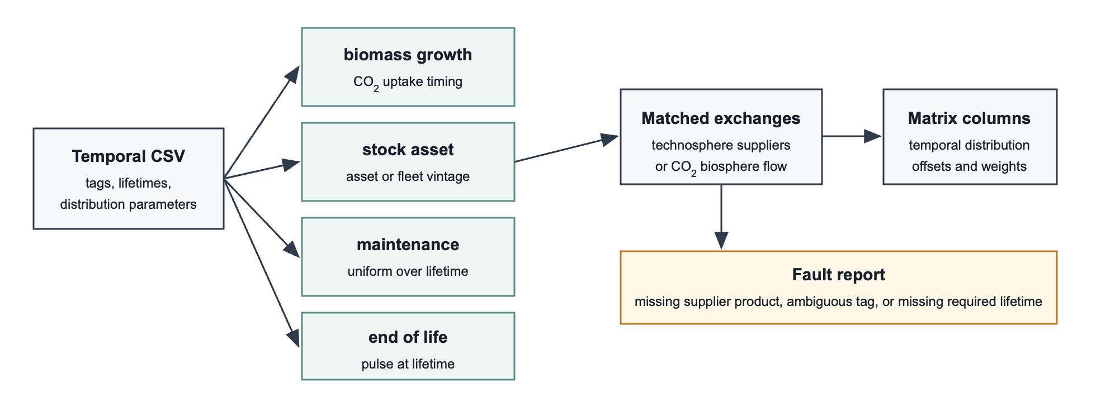
Figure 3 - Premise workflow for assigning temporal metadata to exchanges. Rows in the temporal-distribution CSV are interpreted as biomass-growth, stock-asset, maintenance, or end-of-life assumptions, matched to technosphere or biosphere exchanges, and written to the matrix temporal columns; unmatched or ambiguous rows are reported separately.

Tags and direct effects
The temporal-distribution table contains the tag and exchange-level effects describe in Table 4. The tag counts are visualized by Figure 4.
Tag | What is matched | Where the temporal distribution is written
stock_asset | A technosphere supplier whose name and reference product match the row. | The technosphere exchange to that supplier receives the row's temporal parameters.
biomass_growth | A dataset whose name and reference product match the row. | The dataset's biosphere exchange named Carbon dioxide, in air receives the row's temporal parameters.
long_term_emission | A biosphere-flow selector. The row name matches the flow name, and the reference product field is parsed as compartment|subcompartment|unit; wildcards are allowed. | The matched biosphere exchange receives a 32-bin empirical profile over the 100-1000 year long-term window.
maintenance | A technosphere supplier marked as maintenance. | The technosphere exchange to that supplier is spread uniformly from year 0 to the lifetime of the calling dataset.
end_of_life | A technosphere supplier marked as end-of-life treatment or decommissioning. | The technosphere exchange to that supplier is moved to a one-year pulse at the lifetime of the calling dataset.
throughput_process | A reviewed process-throughput dataset. | No special temporal distribution is assigned from this tag.
market | A reviewed market or market-like dataset. | No special temporal distribution is assigned from this tag.
*blank* | Rows without an active temporal tag. | No special temporal distribution is assigned.
Table 4 – Premise tag semantics for writing temporal metadata. The table distinguishes what each tag matches, such as a supplier, dataset, or biosphere-flow selector, from the exchange or matrix column where the resulting temporal parameters are written.
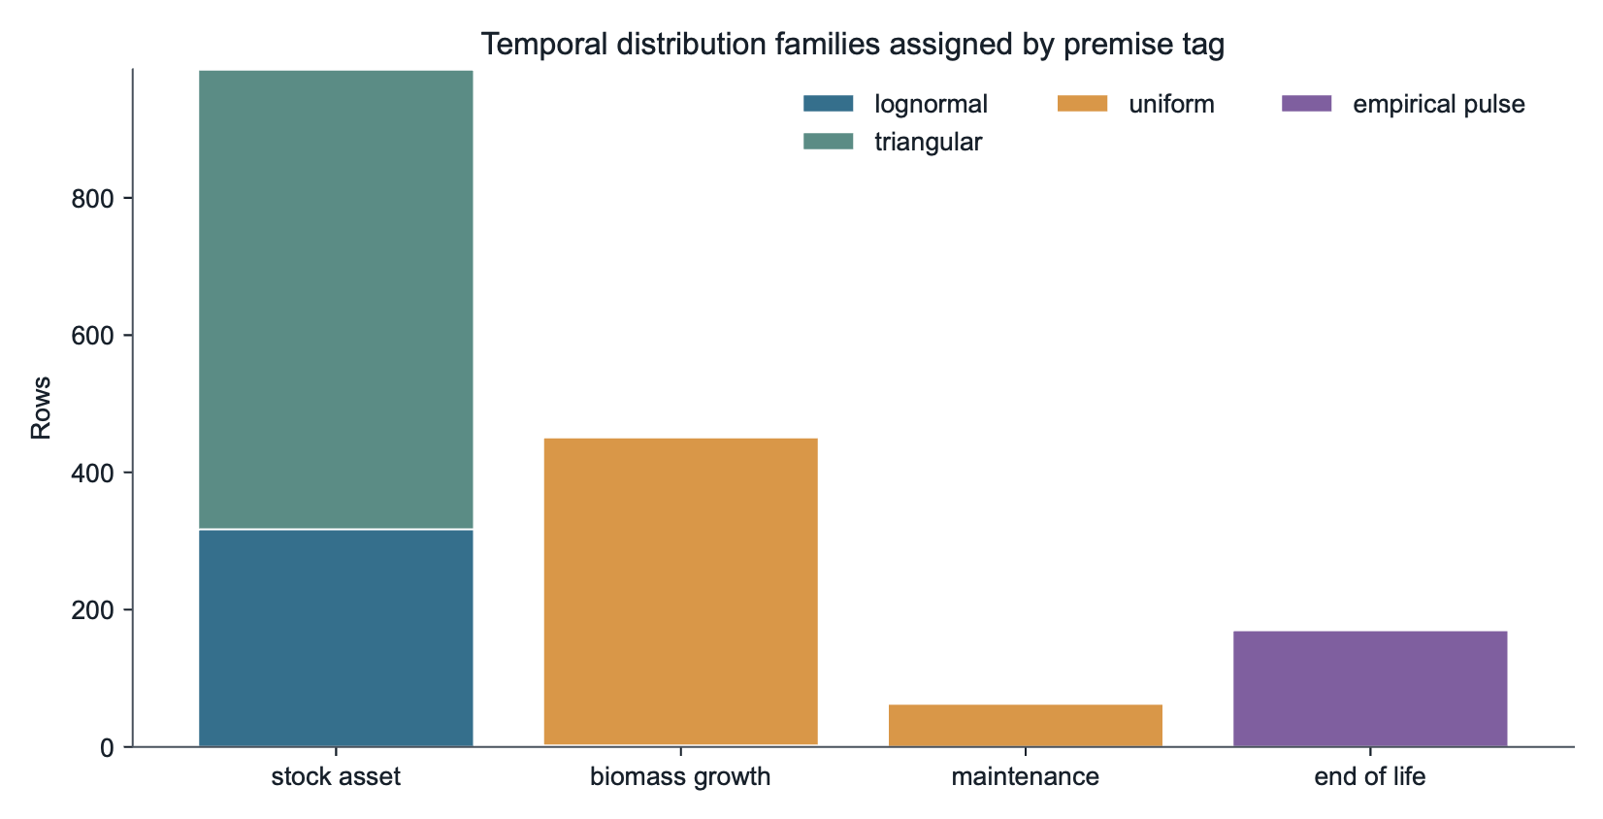
Figure 4 - Active temporal-distribution rows by Premise tag and distribution family. Bars count rows in the temporal-distribution file that assign temporal parameters, with colours indicating the distribution family used for stock assets, biomass growth, maintenance, and end-of-life timing.
For technosphere exchanges, matching is performed against the supplier named in the exchange, using the supplier name and product. This means that the temporal profile is attached to the exchange in the calling activity, not to all exchanges inside the supplier dataset. For example, if an activity uses a technosphere input whose supplier is a photovoltaic plant construction dataset, the exchange to that plant construction dataset can receive the stock-asset profile. The production exchanges inside the photovoltaic plant construction dataset are not individually temporalized by this matching step.
For biomass growth, the matching is different. The row identifies the biomass production dataset itself, and Premise looks inside that dataset for the biosphere exchange named Carbon dioxide, in air. That biosphere exchange is then given a temporal distribution, usually with negative offsets so that uptake occurs before the activity year.

Biomass growth and biogenic uptake
Biomass growth rows mainly assign negative offsets to the biosphere flow Carbon dioxide, in air. The point is to place uptake before harvest, processing, or fuel production when the ecoinvent exchange is otherwise booked in the activity year.
This tag is used for activities whose reference product is biological material or a product directly tied to biological growth. The table includes annual crops, grassland and forage products, perennial crops, forestry operations, roundwood, pulpwood, cork, and selected land-use or land-cover change rows. In these cases, the exchange being temporalized is the Carbon dioxide, in air exchange.
The result is that biogenic uptake is placed over the assumed growth period before the activity year. In the exported matrix, this means that the biosphere row Carbon dioxide, in air carries the temporal distribution.
In the temporal_distribution file Premise uses, biomass_growth tags use a uniform distribution (temporal_distribution = 4). Two use a triangular distribution. The lifetime values range from 1 to 180 years. Lifetimes and distributions used for the biomass_growth tags are described in Table 5.
Process group | Typical lifetime values in the CSV | Offset support | Sources and assumptions
Annual crops, legumes, grassland, and forage | 1 year | Usually from -1 to 0. | Estimated.
Short-rotation biomass | 2 years | Usually from -2 to 0. | Forest Research short-rotation coppice willow harvest-cycle estimate: https://www.forestresearch.gov.uk/tools-and-resources/fthr/biomass-energy-resources/fuel/energy-crops-3/; FAO bamboo culm harvest-age lower-bound estimate: https://www.fao.org/4/x5390e/x5390e05.htm.
Perennial orchard, nut, vine, and palm crops | 20 years | Usually from -20 to 0. | Estimated.
Forestry, wood products, cork, and roundwood | 15, 20, 25, 32, 40, 50, 60, 80, 120, or 180 years depending on species or product class | Usually from -lifetime to 0. | Species-specific rotation sources including Wald-Prinz (https://www.wald-prinz.de/umtriebszeit-wie-lange-benotigt-ein-baum-bis-zur-hiebsreife/3697), ABARES eucalypt sawlog rotation (https://www.agriculture.gov.au/sites/default/files/sitecollectiondocuments/abares/publications/logSupply.pdf), FAO tropical forestry Azobe (https://www.fao.org/4/t0404e/t0404e00.pdf), and IPB Shorea leprosula (https://repository.ipb.ac.id/handle/123456789/55537).
Selected land-use or land-cover change rows | 80 to 100 years | Long negative support, sometimes ending at -1. | Land-tenure and land-conversion assumptions.
Table 5 – Lifetime values and offset supports used for biomass-growth tags. Negative offset windows place biogenic CO2 uptake before the activity year, with source notes documenting the assumptions used for crops, forestry products, and land-use-related rows.
Table 6 lists the main biomass-growth categories and wood species represented in the tempoeral_distributions file. Unless otherwise stated, the distribution is uniform over the negative interval from -lifetime to 0, so the value in the rotation-time column is also the width of the uptake window before the activity year.
Biomass type or species | Representative rows in the table | Rotation time or lifetime
Annual cereal crops and straw | Barley, wheat, maize, rice, straw, and cereal-straw outputs. | 1 year
Annual oil, fibre, root, and industrial crops | Rapeseed, seed-cotton, sugar beet, potato, peanut, and similar annual crop rows. | 1 year
Annual legumes and pulses | Soybean, pea, chickpea, lentil, fava bean, and similar legume rows. | 1 year
Grassland, forage, and silage crops | Alfalfa-grass mixtures, alfalfa/grass silage, phacelia silage, clover seed, switchgrass, fodder beet, and grass products. | 1 year
Perennial fruit, nut, and vine crops | Almond, apple, grape, palm date, and similar orchard or perennial crop rows. | 20 years
Bamboo | bamboo forestry, sustainable forest management for bamboo culm. | 2 years
Short-rotation coppice willow | willow production, short rotation coppice for willow wood chips and particles. | 2 years
Generic pulpwood and wood chips without species-specific source | Mixed hardwood or softwood pulpwood, bark chips, and wood-chip rows where no species-specific rotation source is recorded. | 15 years
Generic mixed roundwood without species-specific source | Mixed hardwood or softwood sawlogs, veneer logs, cleft timber, and green wood rows where no species-specific rotation source is recorded. | 40 years
Cork oak | cork forestry rows for raw cork and cleft timber. | 25 years
Eucalyptus spp. | Planted and sustainable hardwood forestry, eucalyptus ssp. rows for cleft timber and sawlog/veneer log products. | 20 years
Meranti, represented by Shorea leprosula | hardwood forestry, meranti and meranti sawlog/veneer-log rows. | 32 years
Parana pine, represented by Araucaria angustifolia | softwood forestry, parana pine, sustainable forest management rows. | 40 years
Azobe | hardwood forestry, azobe and azobe sawlog/veneer-log rows. | 50 years
Birch | hardwood forestry, birch, sustainable forest management rows for sawlogs, pulpwood, wood chips, cleft timber, and energy wood. | 60 years
Pine and spruce | softwood forestry, pine and softwood forestry, spruce rows for sawlogs, pulpwood, wood chips, fuel wood, and energy wood. | 80 years
Beech | hardwood forestry, beech, sustainable forest management rows for sawlogs, pulpwood, wood chips, and cleft timber. | 120 years
Oak | hardwood forestry, oak, sustainable forest management rows for sawlogs, pulpwood, wood chips, and cleft timber. | 180 years
Selected land-use or land-cover change rows | Land-tenure and conversion rows for arable land, pasture, forest, and afforested land. | 80 to 100 years
Table 6 – Biomass-growth categories represented in the temporal-distribution file. Rows group crop, forage, orchard, forestry, and land-use classes and report the assumed lifetime or rotation period used to time biogenic uptake.
The distribution is generally uniform because Premise does not attempt to model species-specific growth curves. A one-year annual crop profile, therefore, means that uptake is spread over the year before harvest, while a 60-year roundwood profile spreads uptake over the preceding 60 years. This is a deliberate simplification: the timing represents an average carbon uptake window attached to the life-cycle inventory exchange, not a detailed forest or crop growth model.
Examples of biomass-growth distributions are listed in Table 7.
Dataset | Lifetime | Distribution and support | Sources and assumptions
cork forestry | 25 years | Uniform, -25 to 0. | EUFORGEN cork oak first-harvest estimate: https://www.euforgen.org/fileadmin/bioversity/publications/pdfs/1323_Cork_oak__Quercus_suber_.pdf.
debarking, hardwood, azobe | 50 years | Uniform, -50 to 0. | FAO tropical forestry Azobe rotation lower-bound estimate: https://www.fao.org/4/t0404e/t0404e00.pdf.
debarking, hardwood, meranti | 32 years | Uniform, -32 to 0. | IPB Shorea leprosula first-rotation estimate: https://repository.ipb.ac.id/handle/123456789/55537.
hardwood forestry, beech, sustainable forest management | 120 years | Uniform, -120 to 0. | Wald-Prinz Umtriebsalter lower-bound source: https://www.wald-prinz.de/umtriebszeit-wie-lange-benotigt-ein-baum-bis-zur-hiebsreife/3697.
Table 7 – Representative biomass-growth assignments with species- or product-specific rotation assumptions. Each example reports the dataset, lifetime, negative support interval, and source used for the timing assumption.
These values should be read as timing assumptions rather than biological measurements for each exchange. The table combines default biomass-growth classes with species-specific rotation-age estimates where available.

Stock assets and fleet vintages
The stock_asset tags describe suppliers interpreted as long-lived assets, installed equipment, infrastructure, vehicles, buildings, or other stock-like items. When such a supplier appears in a technosphere exchange, the exchange receives the distribution parameters from the CSV.
This tag applies to technosphere exchanges, not to biosphere flows. A row in the table identifies a supplier dataset such as a vehicle production dataset, an infrastructure construction dataset, a battery production dataset, a pipeline construction dataset, or an installed equipment dataset. When another activity has a technosphere exchange with that supplier, Premise copies the supplier's temporal distribution to the exchange. In Trails, that exchange is then interpreted as a demand for an asset whose production or vintage is distributed over time instead of occurring entirely in the activity year.
The negative support used for these profiles reflects the perspective of the calling activity. The activity year is the year in which the service or product system is evaluated. If a plant, vehicle, building, or equipment item already exists at that time, the production of that asset can be represented as having occurred in earlier years. A triangular profile from -30 to -1, for example, places the asset history over the 30 years before the activity year.
Two distribution families dominate, as listed in Table 8.
Distribution | Interpretation
Lognormal (2) | Fleet-age or vintage profiles, especially vehicles. The parameters use a negative-offset convention and many rows use sigma = 0.55. Sources and assumptions include fleet age lognormal (mu_log from provided medians, sigma=0.55; negative loc convention), Typical passenger car lifetime, Typical urban/coach bus lifetime assumption, and Heavy truck typical lifetime.
Triangular (5) | Construction, installation, capital equipment, and infrastructure profiles over a finite lifetime. Sources and assumptions include Typical PV system lifetime; triangular vintage distribution, small wind turbine lifetime, distribution pipeline lifetime, industrial building lifetime, and LFP rechargeable battery product lifetime.
Table 8 – Distribution families used for stock assets and fleet vintages. Lognormal profiles represent fleet-age or vintage histories with negative offsets, whereas triangular profiles represent finite construction, equipment, or infrastructure lifetime windows.
The stock-asset lifetimes range from 1.5 to 200 years, with a median of 20 years, as illustrated in Figure 5. Examples include short-lived filters and lamps at 1.5 to 2 years, lorry tires at 4 years, reverse-osmosis modules at 5 years, batteries around 10 to 15 years, passenger cars around 14.74 years, trucks around 16 years, wind turbines around 20 years, photovoltaic systems around 30 years, buildings around 35 to 60 years, pipelines around 40 to 50 years, and selected long-lived infrastructure at higher values.
For triangular stock profiles, the support is typically negative and finite, for example, from -30 to -1 for a 30-year photovoltaic installation. This places the asset production or vintage history before the service represented by the calling activity. For lognormal fleet profiles, the same negative offset convention represents the age distribution of a fleet or technology stock.
The source information is mixed. Some stock lifetimes are represented by explicit class assumptions, such as passenger-car, bus, heavy-truck, photovoltaic-system, wind-turbine, industrial-building, pipeline, and battery lifetimes. Other rows use a common fleet-age lognormal parameterisation, with sigma = 0.55 and the lognormal location convention recorded in the table. The table should therefore be interpreted as a transparent set of timing assumptions for stock-like exchanges, not as an exhaustive component-level asset lifetime database.
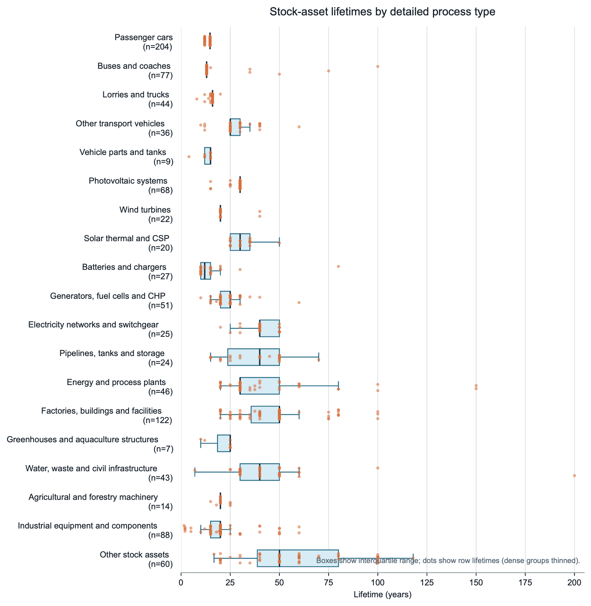
Figure 5 – Stock-asset lifetimes by detailed process subtype. Points show individual temporal-distribution rows and boxplots summarize lifetime ranges within interpretive subtypes derived from dataset names, reference products, and source labels; n gives the number of rows in each subtype.
Subtypes in this figure are interpretive groups derived from dataset names, reference products, and source labels in the temporal-distribution table. They are used to make the stock-asset lifetime patterns readable; they are not a separate classification exported by Premise.
Examples of stock-asset tags are listed in Table 9.
Dataset | Reference product | Lifetime | Distribution and support
photovoltaic plant construction, 570kWp, multi-Si, on open ground | photovoltaic plant, 570kWp, multi-Si, on open ground | 30 years | Triangular, -30 to -1.
wind turbine construction, 2.3MW, precast concrete tower, onshore | wind turbine, 2.3MW, onshore | 20 years | Triangular, -20 to -1.
passenger car production, petrol/natural gas | passenger car, petrol/natural gas | 14.74 years | Lognormal fleet-age profile, approximately -15.28 to -1.
lorry production, diesel hybrid, 3.5 metric ton | truck | 16 years | Lognormal fleet-age profile, -16 to -1.
pipeline construction, natural gas, long distance, low capacity, onshore | pipeline, natural gas, long distance, low capacity, onshore | 40 years | Triangular, -40 to -1.
battery production, Li-ion, LFP, rechargeable | battery, Li-ion, LFP, rechargeable | 10 years | Triangular, -10 to -1.
Table 9 – Examples of stock-asset temporalization. Each row gives the matched supplier dataset, reference product, assumed lifetime, and profile support written to the calling technosphere exchange.

Maintenance
Maintenance entries do not usually carry their own lifetime. They identify suppliers that should be interpreted as maintenance demand when a stock-like dataset calls them. The lifetime is taken from the calling dataset.
The exchange being temporalised is a technosphere exchange with a maintenance or repair supplier. Typical examples include datasets from vehicle maintenance, electric-scooter maintenance, road maintenance, transmission-network maintenance, aircraft maintenance, ship maintenance, mine maintenance, or energy-system maintenance. These suppliers do not define the lifetime of the maintained system. Instead, they define the type of exchange that should be spread through time when it appears in a dataset with a known lifetime, as illustrated in Figure 6.
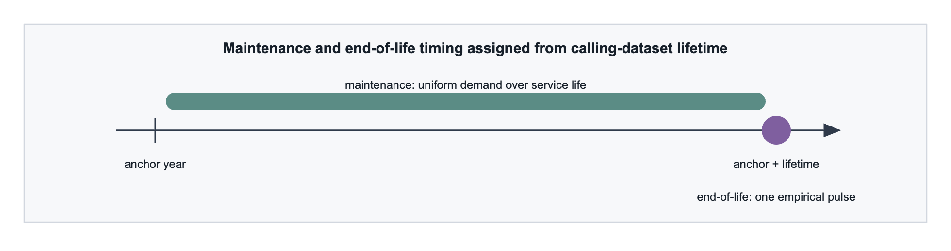
Figure 6 – Timing convention for maintenance and end-of-life exchanges. Maintenance demand is distributed uniformly from the anchor year through the inherited lifetime of the calling stock-like dataset, whereas end-of-life demand is represented as a pulse at the end of that lifetime.
Maintenance is therefore applied uniformly from the anchor year through the end of the calling dataset’s lifetime. If a 30-year stock activity calls a maintenance supplier, the maintenance exchange is spread from year 0 to year 30. If a 20-year stock activity calls the same supplier, the same maintenance supplier is instead spread from year 0 to year 20. The temporal profile reflects the exchange between stock activity and the maintenance supplier; it is not a fixed property of the maintenance supplier alone.
Typical maintenance-type entries include vehicle maintenance, road maintenance, transmission-network maintenance, and selected reused or refurbished components. They are on the lifetime of the activity that calls the maintenance exchange. The provenance information for maintenance is, therefore, mostly heuristic and class-level. Examples include maintenance_ship_default, maintenance_energy_system_default, maintenance_aircraft_default, maintenance_mine_default, and maintenance_road_vehicle_default.
Representative supplier datasets include maintenance, passenger car, maintenance, electric scooter, without battery, road maintenance, transmission-network maintenance for high-voltage direct-current land cables, and maintenance, bus. These rows make the maintenance exchange time-dependent only when they are used by a calling dataset for which a lifetime is available. If no calling-dataset lifetime is available, premise does not guess one; it reports the exchange in temporal_distribution_faulty_exchanges.csv.

End-of-life
End-of-life entries identify suppliers that should occur after a stock-like activity reaches the end of its lifetime. As with maintenance, the relevant lifetime is generally taken from the calling dataset. When a lifetime is available, Premise writes an empirical one-pulse distribution:
temporal_distribution = 6
temporal_offsets = [<calling dataset lifetime> + 1]
temporal_weights = [1.0]
The exchange being temporalised is a technosphere exchange to an end-of-life, treatment, dismantling, recycling, closure, disposal, or decommissioning supplier. The pulse is placed at the end of the calling dataset's lifetime. Thus, if a 40-year power-plant construction dataset calls a dismantling supplier, the dismantling exchange is assigned to year 41. If a 10-year battery stock calls a battery treatment supplier, the treatment exchange is assigned to year 11.
End-of-life entries include battery deactivation, battery module disassembly, recycling steps, container disposal, deep-well closure, power plant dismantling, and decommissioning datasets. The largest group consists of waste, residue, and treatment-related rows under the CPC prefix 39. Still, the tag also appears in battery-related rows, construction and decommissioning rows, and selected machinery or chemical-treatment datasets.
Most end-of-life timing is inherited from the calling dataset. Some end-of-life treatment datasets also carry a 1-year heuristic lifetime in the table. These values document short-delay treatment assumptions and can be used when such a dataset is itself the calling dataset for another marked exchange. They do not replace the general rule that an end-of-life supplier is normally placed at the lifetime of the activity that calls it.
The source content associated with these rows is primarily heuristic. Common labels include end_of_life_short_delay_default, rule-based market/EoL pattern, and rows auto-added from temporal_distribution_faulty_exchanges.csv. Representative supplier datasets include battery cell deactivation for LiS batteries, battery module disassembly for LiS batteries, deep-well closure for geothermal power, dismantling, BIGCC power plant 450MW, and EPR decommissioning. As for maintenance, unresolved cases with no calling-dataset lifetime are written to temporal_distribution_faulty_exchanges.csv instead of being assigned a default pulse time.

Long-term biosphere emissions
The long_term_emission tags extend the same temporal-column mechanism to direct biosphere flows that ecoinvent labels as long-term emissions.
All long-term profiles are written as empirical discrete distributions (temporal_distribution = 6). The 100-1000 year support is discretised into 32 bins with midpoint offsets from 105 to 975 years and normalised weights. The 100-year lower bound follows the ecoinvent convention that waste emissions occurring after 100 years are reported as long-term; the 1000-year upper bound is a pragmatic Trails routing horizon for the scenarios used here, not a claim that the source is exhausted after 1000 years. Profiles such as mobile_metal, sorbed_metal, conservative_washout, ammonium_plateau, and uniform_100_1000 map to coarse leaching or persistence types rather than site-specific fate modelling (Hischier et al., 2010; Doka, 2003).
The profiles should be read as source-release timing assumptions for already-quantified long-term exchanges, not as independent estimates of the total amount ultimately emitted. Premise first preserves the exchange amount reported in the exported biosphere matrix and then redistributes it across the 100-1000-year support. This choice keeps the mass balance of the original inventory unchanged while making the timing explicit for Trails. It also separates two modelling questions that are often conflated in landfill inventories: how much material belongs to the long-term emission category, which is inherited from ecoinvent, and when that long-term amount is released or reaches the receiving compartment, which is represented here by the empirical offset-weight profile.
The profile families follow the dominant mechanisms reported in landfill source-term and leachate-plume literature. The conservative_washout profile is used for chloride because chloride is commonly treated as a mobile conservative tracer whose source term is controlled mainly by leachate generation and flushing, consistent with LandSim-style source-term modelling and landfill plume reviews (Environment Agency, 2003; Christensen et al., 2001; Kjeldsen et al., 2002). The ammonium_plateau profile represents the observation that ammonium can remain elevated for decades in methanogenic landfill leachate and then decline slowly, with attenuation depending on aerobic nitrification potential (Kjeldsen et al., 2002; Zhao et al., 2017). The metal profiles distinguish relatively mobile divalent or oxidised species, such as Cd, Ni, Zn, and Cr(VI), from more strongly sorbed, precipitated, or redox-sensitive species, such as Pb, Cu, Hg, Cr(III), and As. This distinction is supported by reviews showing strong pH, redox, dissolved organic carbon, precipitation, and sorption controls on metal mobility, and by long-term leaching studies indicating that metal release can extend over centuries or longer rather than behaving as a single short pulse (Baun and Christensen, 2004; Astrup et al., 2006; U.S. EPA, 1999, 2004).
Applied with ecoinvent 3.12 cut-off and the REMIND SSP2-NPi 2025 scenario, these selectors matched 37,068 exchange rows in 1,296 calling datasets and 47 unique biosphere flow/category/unit combinations, described in Table 10.
Profile | Matched rows | Main matched flows | Timing summary | Sources and rationale
uniform_100_1000 | 27,442 | Generic long-term groundwater fallback for 37 flow names. | Uniform mass over the 100-1000 year window; 44.4% of mass is assigned at offsets <=500 years. | Hischier et al. (2010); Doka (2003); Environment Agency (2003)
mobile_metal | 4,261 | Cadmium II, Nickel II, Zinc II, and Chromium VI. | Front-loaded metal leaching surrogate; 67.1% of mass is assigned at offsets <=500 years. | Kjeldsen et al. (2002); Baun and Christensen (2004); Christensen et al. (2001); Astrup et al. (2006); U.S. EPA (1999)
sorbed_metal | 4,117 | Arsenic ion, Copper ion, Lead II, and Mercury II. | Delayed and persistent metal surrogate; 58.7% of mass remains beyond 500 years. | Baun and Christensen (2004); Christensen et al. (2001); Astrup et al. (2006); U.S. EPA (1999, 2004)
conservative_washout | 786 | Chloride. | Conservative washout profile with 67.9% of mass assigned at offsets <=500 years. | Environment Agency (2003); Christensen et al. (2001); Kjeldsen et al. (2002)
ammonium_plateau | 462 | Ammonium. | Plateau followed by slow decline; 55.6% of mass is assigned at offsets <=500 years. | Kjeldsen et al. (2002); Zhao et al. (2017); Christensen et al. (2001)
Table 10 – Screening-level temporal profiles assigned to long-term biosphere emissions. The table reports matched rows and flows, release-timing summaries over the 100-1000 year window, and literature rationale; the exchange amounts are inherited from the original inventory.
The profile rows should therefore be interpreted as transparent screening-level timing priors for the long-term inventory category. They are not fitted to individual landfill sites, waste compositions, cap histories, water fluxes, pH-redox trajectories, or aquifer travel times. The 32-bin profiles also do not explicitly model the liquid-to-solid-ratio axis, chemical speciation, retardation, or degradation; those processes are only represented through the coarse profile choice. Generic fallback rows, such as uniform_100_1000, are deliberately conservative in that they avoid unsupported contaminant-specific kinetics, but they are less informative than contaminant-specific profiles. The matched row counts in Table 10 are scenario-specific diagnostics for the ecoinvent 3.12 cut-off and REMIND SSP2-NPi 2025 export, not universal coverage statistics for all possible Premise databases.

Lifetime and CPC-code patterns
The temporal parameter table is not evenly distributed across the product classification space. Active temporal rows are concentrated in a small number of CPC two-digit prefixes. The most frequent active prefixes are CPC 49 (transport equipment), CPC 53 (construction), and CPC 01 (agricultural products). They correspond to different lifetime regimes: vehicle and fleet profiles are mostly in the 8 to 40-year range, construction and power-plant rows are longer-lived, and agricultural biomass rows are usually annual or short-cycle.
The lifetime column is central to how Premise turns a qualitative temporal tag into numerical Trails columns. For biomass_growth, the lifetime defines the length of the negative uptake window: a 1-year crop places uptake between -1 and 0, while a 120-year beech row places uptake between -120 and 0. For triangular stock_asset rows, the lifetime usually defines the finite negative support of the asset-vintage profile, for example, -30 to -1 for a 30-year photovoltaic plant. For lognormal stock rows, the lifetime and recorded fleet-age assumptions define the location and scale of a negative fleet-vintage profile. For maintenance and end-of-life, the supplier row usually does not provide its own timing. Instead, Premise reads the lifetime of the calling stock-like dataset and uses it either as the upper bound of a uniform maintenance distribution or as the pulse time of an end-of-life exchange.
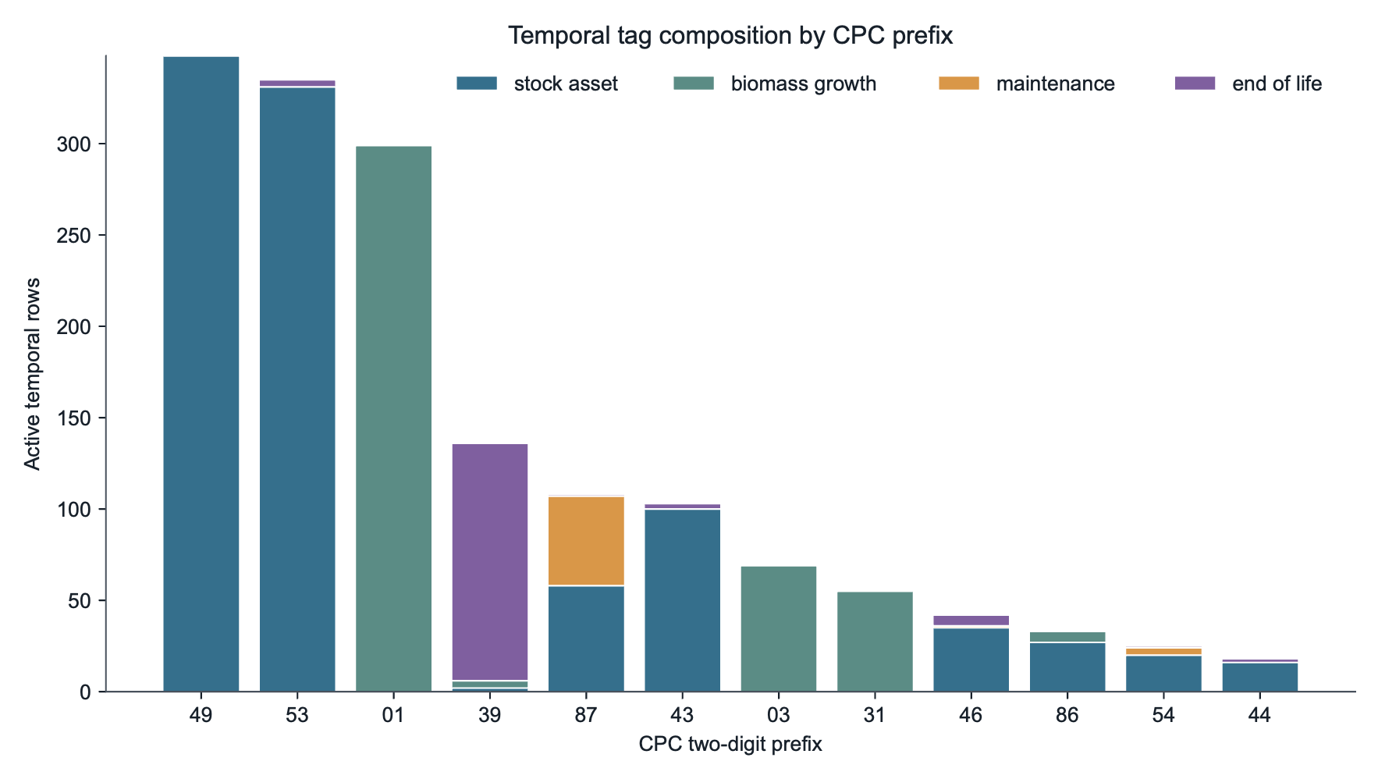
Figure 7 – Composition of active temporal tags by CPC two-digit prefix. Bars count active temporal-distribution rows by Central Product Classification prefix, with colours indicating whether the rows describe stock assets, biomass growth, maintenance, or end-of-life timing.

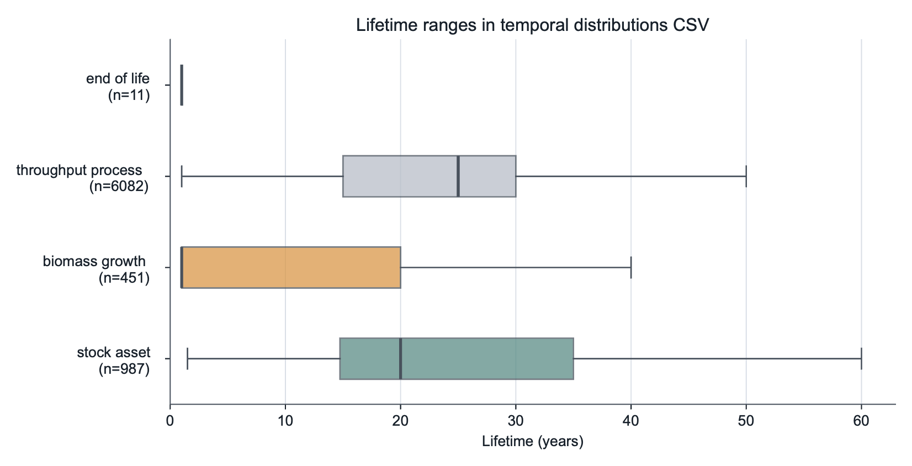
Figure 8 – Lifetime ranges by temporal-distribution tag. Boxplots summarize rows with available lifetime values in the temporal-distribution CSV, including active tags and reviewed throughput-process rows that document processes left untemporalized.
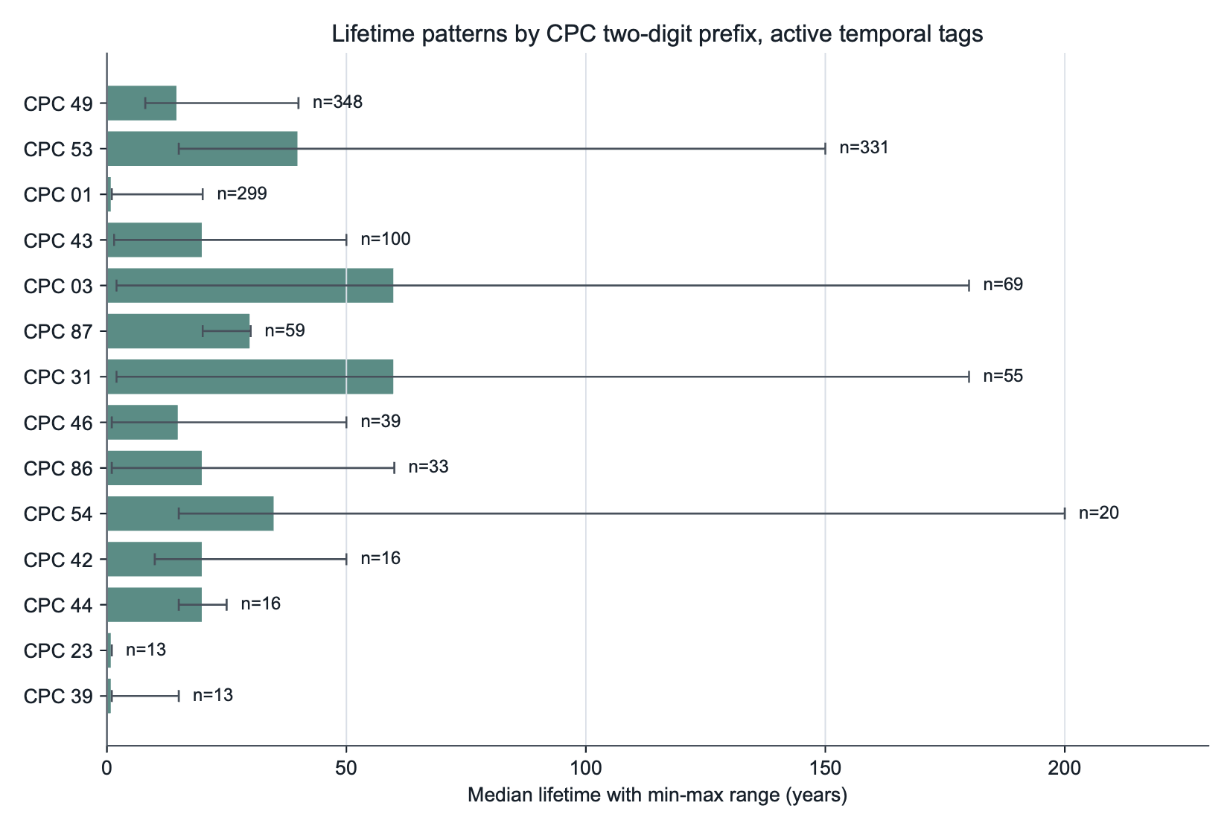
Figure 9 – Lifetime patterns by CPC two-digit prefix for active temporal tags. Bars show median lifetime and horizontal ranges show minimum and maximum values; labels report the number of rows per prefix
Figure 7, 8 and 9 should be read together. Figure 7 shows which temporal tags are present in each CPC prefix. It therefore indicates where the table mainly contains stock assets, biomass-growth rows, maintenance rows, and end-of-life tags. Figure 8 shows how the assumed lifetimes differ by temporal role. Figure 9 shows the lifetime ranges for active temporal rows within the most frequent CPC prefixes. A CPC prefix with many reviewed rows does not necessarily have many active temporal exchanges.
The CPC labels in the two CPC figures are two-digit prefixes from the Central Product Classification. They correspond to the product or service groups listed in Table 11.
CPC prefix | Main group represented in the figures
01 | Agricultural products, crops, straw, forage, and live plants.
03 | Forestry products, logs, cork, and natural gums.
23 | Grain-mill products, starches, animal feed preparations, sugar, and related food-processing outputs.
31 | Wood, sawn wood, wood chips, plywood, and related wood products.
39 | Wastes, residues, scrap materials, sewage sludge, and ash.
42 | Fabricated metal products such as tanks, containers, frames, and coated metal products.
43 | Machinery and equipment, including furnaces, filters, generators, refrigeration equipment, and heat pumps.
44 | Agricultural, forestry, domestic, and other special-purpose machinery.
46 | Electrical machinery, batteries, accumulators, and related parts.
49 | Transport equipment, including passenger vehicles, buses, lorries, motorcycles, aircraft, and parts.
53 | Constructions, including power plants, manufacturing facilities, treatment plants, mining constructions, and civil engineering works.
54 | Construction services, painting, heating-equipment installation, and civil-engineering services.
86 | Agricultural, forestry, logging, crop-support, and extraction-support services.
87 | Maintenance, repair, and installation services.
Table 11 – CPC two-digit prefixes used to interpret Figures 7 and 9. The labels translate numerical Central Product Classification prefixes into the product and service groups represented among active temporal-distribution rows.
Among rows with active temporal tags and available lifetimes, the dominant CPC prefixes and associated lifetime values are described in Table 12.
CPC prefix | Median lifetime | Associated datasets in ecoinvent | Sources and assumptions
49 | 14.8 years | Passenger cars, buses, lorries, and other transport equipment; mostly fleet-age or vehicle-stock timing. | Fleet-age lognormal notes, typical passenger-car lifetime, bus lifetime, and heavy-truck lifetime assumptions.
53 | 40 years | Buildings, power plants, and other constructions; mostly long-lived stock assets. | Typical PV system lifetime, wind-turbine lifetime, power-plant construction, industrial building, and pipeline lifetime notes.
01 | 1 year | Crops, straw, forage, and other agricultural biomass rows; mostly biomass-growth timing. | biomass_growth_default_annual crops_from_co2_list, biomass_growth_default_grassland/forage_from_co2_list, and perennial crop defaults.
43 | 20 years | Machinery, furnaces, and equipment; mostly stock assets. | Equipment lifetime notes such as filters, modules, heat exchangers, furnaces, pumps, and common component lifetimes.
03 | 60 years | Logs and forestry products; mostly biomass-growth timing over forestry rotation periods. | Forestry and roundwood defaults, with species-specific sources such as Wald-Prinz, FAO, ABARES, IPB, and EUFORGEN where recorded.
87 | 30 years | Installation services, especially electrical machinery and apparatus. | Installation-service rows, often associated with PV, electrical machinery, or infrastructure lifetime assumptions.
31 | 60 years | Wood products; mostly forestry and wood-related biomass timing. | Wood, sawnwood, pulpwood, and roundwood defaults, with rotation-age sources where recorded.
Table 12 – Dominant CPC prefixes among active temporal rows and their associated lifetime assumptions. Median lifetimes summarize rows with available lifetime values, while dataset and source notes explain the timing assumptions for each product group.
The patterns are consistent with the intended scope of temporalization. Transport equipment datasets are mostly stock assets with fleet-age profiles. Construction projects are mostly long-lived assets such as power plants, industrial facilities, pipelines, and civil engineering works. Agricultural and forestry prefixes mostly contain biomass-growth rows, in which the temporal profile is tied to biogenic carbon uptake rather than to technosphere exchange. Maintenance and repair services appear mostly as suppliers, with timing inherited from the maintained stock. Waste and treatment datasets appear mainly as end-of-life suppliers or as reviewed throughput processes, depending on whether they represent a delayed terminal event or an immediate treatment process.
At full CPC-code resolution, the largest active groups are motor vehicles designed for passenger transport, power plants, waste-treatment outputs, manufacturing constructions, public-transport vehicles, non-coniferous logs, cereal straw, electrical installation services, sawn or chipped wood, furnaces, forage products, batteries, wheat, transport-equipment maintenance, and civil engineering works.

Throughput processes
The throughput_process tag is important because it prevents over-temporalising standard production. Most of these cases have no active distribution parameters. They document datasets that were reviewed and treated as immediate production or processing rather than as stock construction, maintenance, end-of-life, or direct biomass uptake.
This category includes many activities that are durable or treatment-related, but whose exchange timing should remain immediate in the exported inventory. Examples include use-phase transport services, standard chemical production, concrete and clinker production, waste treatment processes that are already the foreground activity, market-like operations, and process-throughput datasets where the exchanged product is consumed or produced in the activity year.
For Trails, this means that a throughput row can still appear in the inventory as a normal technosphere or biosphere exchange, but it will not carry temporal_distribution, temporal_min, temporal_max, temporal_offsets, or temporal_weights because of the throughput_process tag. If the same dataset appears elsewhere as a supplier, it is treated as a standard immediate supplier unless it is also matched by one of the active tags described above. This conservative rule avoids spreading routine production, operation, or treatment flows over time without a specific temporal interpretation.

Validation against limiting cases
We validated the graph-matrix hybrid calculation against four limiting cases using the simple car example data package. The purpose was to test whether Trails reproduces known or hand-calculated results when temporal complexity is removed, restricted, or made analytically transparent. The validation script is found under https://github.com/Laboratory-for-Energy-Systems-Analysis/trails/tree/main/dev/publication/validate_limiting_cases.py and uses independent dense matrix calculations as references; it writes both JSON and CSV result files. All comparisons used an absolute tolerance of 1e-9.
The first case removes temporal behaviour entirely. All temporal distributions are replaced by a single pulse at offset zero, annual interpolation is disabled, and the 2050 matrix slice is solved. Under these conditions, the graph-matrix calculation should reduce to conventional static-matrix LCA. The independent reference is the dense static solve for the same functional unit and matrix year.
The second case keeps temporal behaviour only for exchanges attached to the functional-unit activity. This isolates foreground temporalisation from deeper background temporalisation. The reference calculation accumulates the root activity biosphere exchanges in their temporal years, expands only the first-tier child demands according to the foreground temporal distributions, and solves those child frontier demands statically in their target years.
The third case tests whether Trails separates timing effects from changing prospective background coefficients. All scenario-year technosphere and biosphere slices are replaced in memory by the same 2050 matrices. The calculation is then run once with anchor-year coefficients and once with target-year coefficients. Because all matrix slices are identical, both modes should yield the same time-resolved inventory; any difference would indicate that the coefficient-year logic, rather than the timing profile alone, affected the result.
The fourth case turns the illustrative anchor-versus-target example from the main text into a formal hand-calculation test. The example package is patched in memory to contain one foreground exchange with coefficient values 10, 8, and 6 in years 2030, 2031, and 2033, respectively, and temporal weights 0.5, 0.3, and 0.2. In anchor-year mode, the 10-unit coefficient from 2030 is distributed as 5.0, 3.0, and 2.0. In target-year mode, each pulse uses the target-year coefficient, giving 5.0, 2.4, and 1.2. The patched child activity has a unit biosphere coefficient, so the inventory time series equals the hand-calculated child demands.
The results are summarised in Table 13.
Validation case | Limiting condition and reference | Reference result | Trails result | Maximum absolute difference
Zero-offset static equivalence | All temporal distributions replaced by offset-zero pulses; non-interpolated 2050 matrix compared with independent dense static solve. | Fossil CO₂ = 0.139366962 kg; non-fossil CO₂ = 0 kg; non-zero inventory year = 2050. | Fossil CO₂ = 0.139366962 kg; non-fossil CO₂ = 0 kg; non-zero inventory year = 2050. | 5.55e-17
Foreground-only temporalisation | Only exchanges attached to the functional-unit activity retain temporal distributions; manual reference accumulates root biosphere exchanges and solves first-tier child frontiers by target year. | Fossil CO₂ total = 0.140989101493 kg; non-fossil CO₂ total = 0.001260000000 kg; non-zero years = 2034-2066. | Fossil CO₂ total = 0.140989101493 kg; non-fossil CO₂ total = 0.001260000000 kg; non-zero years = 2034-2066. | 1.73e-18
Identical-matrix timing-only case | All scenario-year A and B slices replaced by the 2050 slice; anchor-year and target-year coefficient modes compared. | Anchor and target modes identical; fossil CO₂ total = 0.139366962 kg; non-fossil CO₂ total = 5.64e-18 kg; non-zero years = 2034-2074. | Anchor and target modes identical; fossil CO₂ total = 0.139366962 kg; non-fossil CO₂ total = 5.64e-18 kg; non-zero years = 2034-2074. | 0.00e+00
Anchor-versus-target toy system | One patched foreground exchange with values 10, 8, and 6 in 2030, 2031, and 2033 and weights 0.5, 0.3, and 0.2; compared with hand calculation. | Anchor-year mode: 5.0, 3.0, 2.0. Target-year mode: 5.0, 2.4, 1.2. | Anchor-year mode: 5.0, 3.0, 2.0. Target-year mode: 5.0, 2.4, 1.2. | 2.22e-16
Table 13 – Validation edge cases for Trails limiting behaviour. Independent or hand-calculated reference results are compared with Trails outputs for static equivalence, foreground-only temporalization, timing-only matrices, and anchor-versus-target coefficient modes.
All four limiting cases passed. The first case confirms that Trails reduces to standard static matrix LCA when temporal distributions and year variation are removed. The second case verifies the explicitly routed foreground boundary. The third case confirms that, when matrices are identical, temporal distributions affect only the timing of inventory contributions and not their coefficient values. The fourth case verifies the anchor-year and target-year coefficient conventions against transparent hand calculations.

Depth sensitivity and computational cost for a direct-air-capture case
We additionally tested the effect of temporalisation depth on both runtime and score for the direct-air-capture case study and described the results in Table 14. The functional unit was 20 billion kg of captured CO₂ in 2025 for the activity "carbon dioxide, captured, with a solvent-based direct air capture system, 1MtCO2". The calculation used the SSP2-PkBudg1000 Trails data package produced by Premise 2.4.5 using ecoinvent 3.12 cut-off as source database, the same foreground inventories as the depth-sweep notebook, a routing cutoff of 0.1%, and the EF v3.1 particulate matter formation indicator. The static matrix LCA score was 97.98 disease incidences.
The experiment was designed as a computational sensitivity test rather than as a recommended production setting. Depth 1 routes only the first temporalised layer below the functional unit, whereas larger depths allow temporal distributions to be followed further into the background supply chain before remaining frontier demands are solved with year-specific matrices.
Depth | Routed nodes | Routed edges | PM score | Deviation from static | Deviation (%) | Routing time (s) | LCA time (s)
Static | - | - | 97.98 | - | - | - | 5.2
1 | 197 | 196 | 82.28 | -15.7 | -16.0 | 0.2 | 16.9
2 | 1,918 | 2,036 | 82.65 | -15.3 | -15.7 | 0.3 | 29.7
3 | 12,215 | 46,138 | 90.8 | -7.2 | -7.3 | 0.6 | 56.5
4 | 57,324 | 239,994 | 91.21 | -6.8 | -6.9 | 5.8 | 64.9
5 | 181,875 | 1,140,604 | 93.26 | -4.7 | -4.8 | 67.0 | 77.2
6 | 429,838 | 3,162,649 | 94.7 | -3.3 | -3.4 | 408.2 | 75.3
7 | 814,993 | 7,386,657 | 93.5 | -4.5 | -4.6 | 2913.4 | 168.5
Adaptive routing (0.01%) | 49,905 | 118,050 | 92.7 | -5.3 | -5.4 | 89.6 | 72.8
Table 14 – Depth sensitivity and runtime for the direct-air-capture case study. Static, fixed-depth, and adaptive routing settings are compared by routed graph size, EF v3.1 particulate-matter score, deviation from the static result, routing time, and LCA solve time..
The routed graph grew strongly with temporalisation depth. The number of routed nodes increased from 197 at depth 1 to 814,993 at depth 7, while the number of edges increased from 196 to 7,386,657. Routing time, therefore, dominated the high-depth calculations: at depth 7, routing took 2913 s (48.6 min), whereas the subsequent LCA solve and scoring step took 169 s. This behaviour is almost consistent with an exponential worst-case expansion of the process-year routing graph.
The score deviation from the static result decreased substantially between the static score and intermediate depths, from -16% at depth 1 to -3.4% at depth 6. The depth-7 score was 93.5 disease incidence, corresponding to a -4.6% deviation from the static score. The small, non-monotonic change between depths 5, 6 and 7 (i.e., from -4.7% to -3.3% back to -4.5%) shows that increasing depth is not a simple numerical convergence parameter: additional routed paths can shift contributions across years in both directions, although often in a marginally decreasing way, thereby changing both the timing and the target-year background coefficients of the assessed inventory.
Fixed-depth routing is shown here for sensitivity analysis, but it is not the default; the default is score-based adaptive routing. The last row uses this adaptive approach with a 0.01% relative cutoff: branches are explicitly expanded until their estimated static score potential falls below 0.01% of the functional-unit static score, after which they are retained as frontier contributions rather than further expanded, reducing both routing and LCA runtimes compared with the deepest fixed-depth run.

Coupling Trails inventories with FaIR
The FaIR coupling is optional. It converts a stored Trails inventory into a perturbation of a baseline FaIR scenario and reports the difference between the perturbed and baseline climate response.
This section expands the main-text Method section "Optional dynamic impact assessment". The main text describes the perturbation approach; the present section lists the exact LCA-flow-to-FaIR species mapping and the sign conventions used in the calculation.
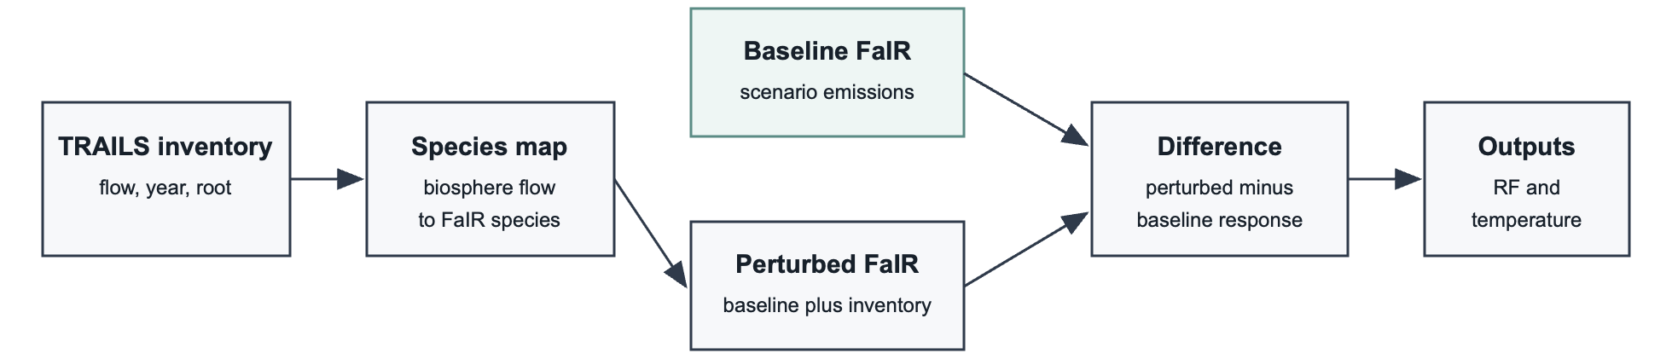
Figure 9 – Optional coupling of Trails inventories with FaIR. Aggregated Trails biosphere flows are mapped to FaIR species, added as perturbations to a baseline scenario, and evaluated as differences between perturbed and baseline radiative forcing and temperature responses.
The inventory is first aggregated over activities. Atmospheric biosphere flows are then mapped to FaIR species using fair_species_map.yaml. The complete default mapping is described in Table 15.
LCA biosphere flow | FaIR species | Sign used in FaIR perturbation
Carbon dioxide, fossil | CO2 FFI | positive (1)
Carbon dioxide, non-fossil | CO2 AFOLU | positive (1)
Carbon dioxide, from soil or biomass stock | CO2 AFOLU | positive (1)
Carbon dioxide, to soil or biomass stock | CO2 AFOLU | negative (-1)
Carbon dioxide, non-fossil, resource correction | CO2 AFOLU | negative (-1)
Carbon dioxide, in air | CO2 AFOLU | negative (-1)
Methane, fossil | CH4 | positive (1)
Methane, non-fossil | CH4 | positive (1)
Methane, from soil or biomass stock | CH4 | positive (1)
Dinitrogen monoxide | N2O | positive (1)
Carbon monoxide, fossil | CO | positive (1)
Carbon monoxide, non-fossil | CO | positive (1)
Carbon monoxide, from soil or biomass stock | CO | positive (1)
NMVOC, non-methane volatile organic compounds | VOC | positive (1)
VOC, volatile organic compounds | VOC | positive (1)
Nitric oxide | NOx | positive (1)
Nitrogen oxides | NOx | positive (1)
Dinitrogen tetroxide | NOx | positive (1)
Sulfur hexafluoride | SF6 | positive (1)
Sulfur oxides | Sulfur | positive (1)
Sulfur | Sulfur | positive (1)
Sulfur trioxide | Sulfur | positive (1)
Sulfuryl fluoride | SO2F2 | positive (1)
Tetrafluoromethane | CF4 | positive (1)
Hexafluoroethane | C2F6 | positive (1)
Trifluoromethane | HFC-23 | positive (1)
1,1,1-Trifluoroethane | HFC-143a | positive (1)
1,1-Difluoroethane | HFC-152a | positive (1)
1,1,1,2-Tetrafluoroethane | HFC-134a | positive (1)
1,1,2-Trichloro-1,2,2-trifluoroethane | CFC-113 | positive (1)
1,2-Dichloro-1,1,2,2-tetrafluoroethane | CFC-114 | positive (1)
Bromochlorodifluoromethane | Halon-1211 | positive (1)
Bromotrifluoromethane | Halon-1301 | positive (1)
Bromomethane | CH3Br | positive (1)
Chlorodifluoromethane | HCFC-22 | positive (1)
Dichlorodifluoromethane | CFC-12 | positive (1)
Dichloromethane | CH2Cl2 | positive (1)
Difluoromethane | HFC-32 | positive (1)
Trichlorofluoromethane | CFC-11 | positive (1)
Pentafluoroethane | HFC-125 | positive (1)
Ammonia | NH3 | positive (1)
Sulfur dioxide | Sulfur | positive (1)
Table 15 – Default mapping from Trails atmospheric biosphere flows to FaIR species. The sign convention indicates whether each inventory flow is added to or subtracted from the baseline FaIR emissions perturbation.
The sign column is applied after aggregation. The negative sign is used for flows that represent uptake or storage rather than an emission to air; for example, Carbon dioxide, in air is treated as a negative contribution because it is uptake from air.
Trails runs FaIR once for the baseline scenario and again after adding the Trails inventory perturbation to the relevant species-year rows. The reported output is the difference between the two runs. When multiple FaIR configurations are used, Trails stores quantiles across the ensemble.
Small product-system perturbations can be hard to separate numerically from a large global baseline. Trails therefore supports scaling before the FaIR run and can validate that the added emissions match the expected inventory perturbation after unit conversion. The resulting response can then be scaled back to the original functional unit, provided that the scaling factor remains within a range where the FaIR response is approximately linear. In practice, this can be checked by repeating the calculation with different perturbation scales and verifying that radiative forcing and temperature responses scale proportionally.

Reproducibility notes
TRAILS supports Python versions >= 3.10 and < 3.12. Key runtime dependencies include Brightway packages, bw_processing, sparse, xarray, plotly, datapackage, and fair. scikit-umfpack is optional and enables UMFPACK support.
These notes support the reproducibility statements in the main text and identify the local software and data requirements needed to rerun the supplementary demonstrations.
The manuscript workflow is expected to be reproducible from the scripts, notebooks, generated result files, and data packages in the repository. Use of ecoinvent-derived data packages requires appropriate local access to licensed ecoinvent data.
Annual interpolation can be cached under the platform-specific user-data directory for application name trails, in a cache/ subdirectory. The cache should be cleared or regenerated when the data package, interpolation settings, value dtype, or index dtype change.
Debug output is controlled with standard Python logging. During tests, debug artefacts are written to .pytest-debug by default, or to the directory specified by PYTEST_DEBUG_DIR.

Solver stress test for deeply temporalised technosphere systems
This experiment documents the computational reason for the graph-matrix hybrid strategy used in Trails. The input was a Frictionless data package generated with Premise for the REMIND SSP2-PkBudg1000 scenario, extended with temporal technosphere exchanges, and intended for loading by Trails. Trails interpolated the package to an annual grid from 2004 to 2101, giving 98 year-specific technosphere systems of size 42,300 × 42,300. The loaded three-dimensional technosphere array contained 49.16 million non-zero entries and occupied 1.28 GiB in sparse coordinate form.
We compared two mathematically comparable solution pathways. In the monolithic pathway, annual technosphere matrices were stitched along a block diagonal and temporal technosphere exchanges were inserted as off-diagonal links, following the time-expanded matrix logic used by tools such as bw_timex (Diepers et al., 2026). The resulting sparse matrix was solved with UMFPACK. In the Trails pathway, the same temporal system was handled by routing temporal exchanges through the graph and solving standard year-specific technosphere systems sequentially. For the reduced one-, two-, three-, and four-year comparisons, Trails first performed the same uncapped adaptive routing from the functional unit and then solved the routed frontier demands that fell within the selected horizon. Adaptive routing used adaptive_relative_score_cutoff=1e-4 and the IPCC 2021 GWP100 method for score screening. The benchmark used activity index 31,387, demand 1, and start year 2025. Benchmarks were run on a MacBook Pro with an Apple M1 Pro chip, 8 CPU cores, 16 GB unified memory, macOS 26.3, and arm64 architecture.
The temporal links row in Table 16 reports only cross-year entries inserted in the equivalent time-expanded matrix. It excludes same-year remnants of temporal distributions and offsets outside the selected horizon, so the one-year case has no cross-year temporal links in this table. In the memory row, paired monolithic values report the LU numeric object size and peak factorisation memory. Paired Trails values report the maximum per-year LU numeric object size and peak factorisation memory observed during sequential annual solves. For the 98-year monolithic system, memory is a conservative extrapolated lower bound.
 | 1 year |  | 2 years |  | 3 years |  | 4 years |  | 98 years
 | Monolithic LU | Trails | Monolithic LU | Trails | Monolithic LU | Trails | Monolithic LU | Trails | Monolithic LU | Trails
Years | 2025 | 2025 | 2024–2025 | 2024–2025 | 2023–2025 | 2023–2025 | 2022–2025 | 2022–2025 | 2004–2101 | 2004–2101
Matrix / solve size | 42,300 × 42,300; 482,387 nnz | 42,300 × 42,300 | 84,600 × 84,600; 997,882 nnz | 42,300 × 42,300 | 126,900 × 126,900; 1,517,500 nnz | 42,300 × 42,300 | 169,200 × 169,200; 2,037,270 nnz | 42,300 × 42,300 | 4,145,400 × 4,145,400; 56,222,969 nnz | 98 systems; 49,162,344 nnz in the Trails A tensor
Cross-year temporal entries | 0 | 0 | 13,834 | 13,834 | 31,791 | 31,791 | 49,900 | 49,900 | 10,422,112 | 10,422,112
Sparse matrix storage | 5.68 MiB | 5.90 MiB | 11.74 MiB | 5.90 MiB | 17.85 MiB | 5.90 MiB | 23.96 MiB | 5.90 MiB | 659.23 MiB | 1.28 GiB
LU / memory footprint | 62.10 MiB / 222.99 MiB | 88.16 MiB / 457.68 MiB | 206.18 MiB / 731.73 MiB | 98.65 MiB / 477.38 MiB | 383.30 MiB / 1.78 GiB | 98.65 MiB / 477.63 MiB | 15.31 GiB / 19.51 GiB estimate | 98.76 MiB / 477.63 MiB | ≥375 GiB / ≥478 GiB estimate | 99 MiB / 478 MiB
Routing time | not applicable | 62.86 s; 1,562 nodes | not applicable | 0.23 s; 1,562 nodes | not applicable | 0.04 s; 1,562 nodes | not applicable | 7.62 s; 1,562 nodes | not applicable | 0.03 s; 1,562 nodes
Solving time | 1.65 s | 3.56 s | 12.50 s | 7.68 s | 29.66 s | 10.20 s | failed during numeric factorisation | 11.83 s | not attempted | 64.20 s
Outcome | solved | solved | solved | solved | solved | solved | failed | solved | estimated impractical | solved
Table 16 – Benchmark comparing a monolithic time-expanded LU solve with the Trails graph-matrix hybrid solve. Horizons from 1 to 98 years are compared by matrix size, temporal links, sparse storage, LU memory, solve status, and runtime.
The benchmark reported in Table 16 indicates that sparse storage of the time-expanded matrix is not the limiting factor. In this rerun, the three-year monolithic system still solved, but the four-year time-expanded matrix failed during UMFPACK numeric factorisation. The four-year matrix occupied only 23.96 MiB as a CSC matrix, yet UMFPACK estimated a 15.31 GiB LU numeric object and 19.51 GiB peak factorisation memory before failing. Trails avoids this fill-in by never factorising the global time-expanded system. Its memory footprint is therefore governed by the largest standard annual technosphere solve and by the temporal routing data structures, while the full 98-year deeply temporalised case remains solvable on the test machine.
A conservative linear extrapolation from the four-year UMFPACK failure gives an approximate lower bound of 375 GiB for the LU numeric object and 478 GiB peak memory for a 98-year monolithic direct solve. This should be read as a lower bound rather than a prediction: the observed LU fill-in already grew much faster than sparse-matrix storage did between the three- and four-year cases.
Diepers et al. (2026) describe embedding time directly within a technosphere-biosphere matrix as a computational advantage. A unified time-expanded matrix can be convenient for integration with existing matrix LCA software (e.g., Brightway) and for representing flexible temporal resolution. However, for deep temporalisation, where temporal exchanges can occur throughout the background supply chain, the global matrix becomes impractical before the full system is represented. In this benchmark, the limiting factor is not the number of sparse entries in the time-expanded matrix, but the fill-in and memory required by direct factorisation. Trails therefore treats the temporal graph and the annual matrix as separate but coupled operations: temporal routing carries the time dimension, while bounded year-specific solves retain the numerical advantages of conventional matrix LCA.

Adaptive-routing Sankey diagrams
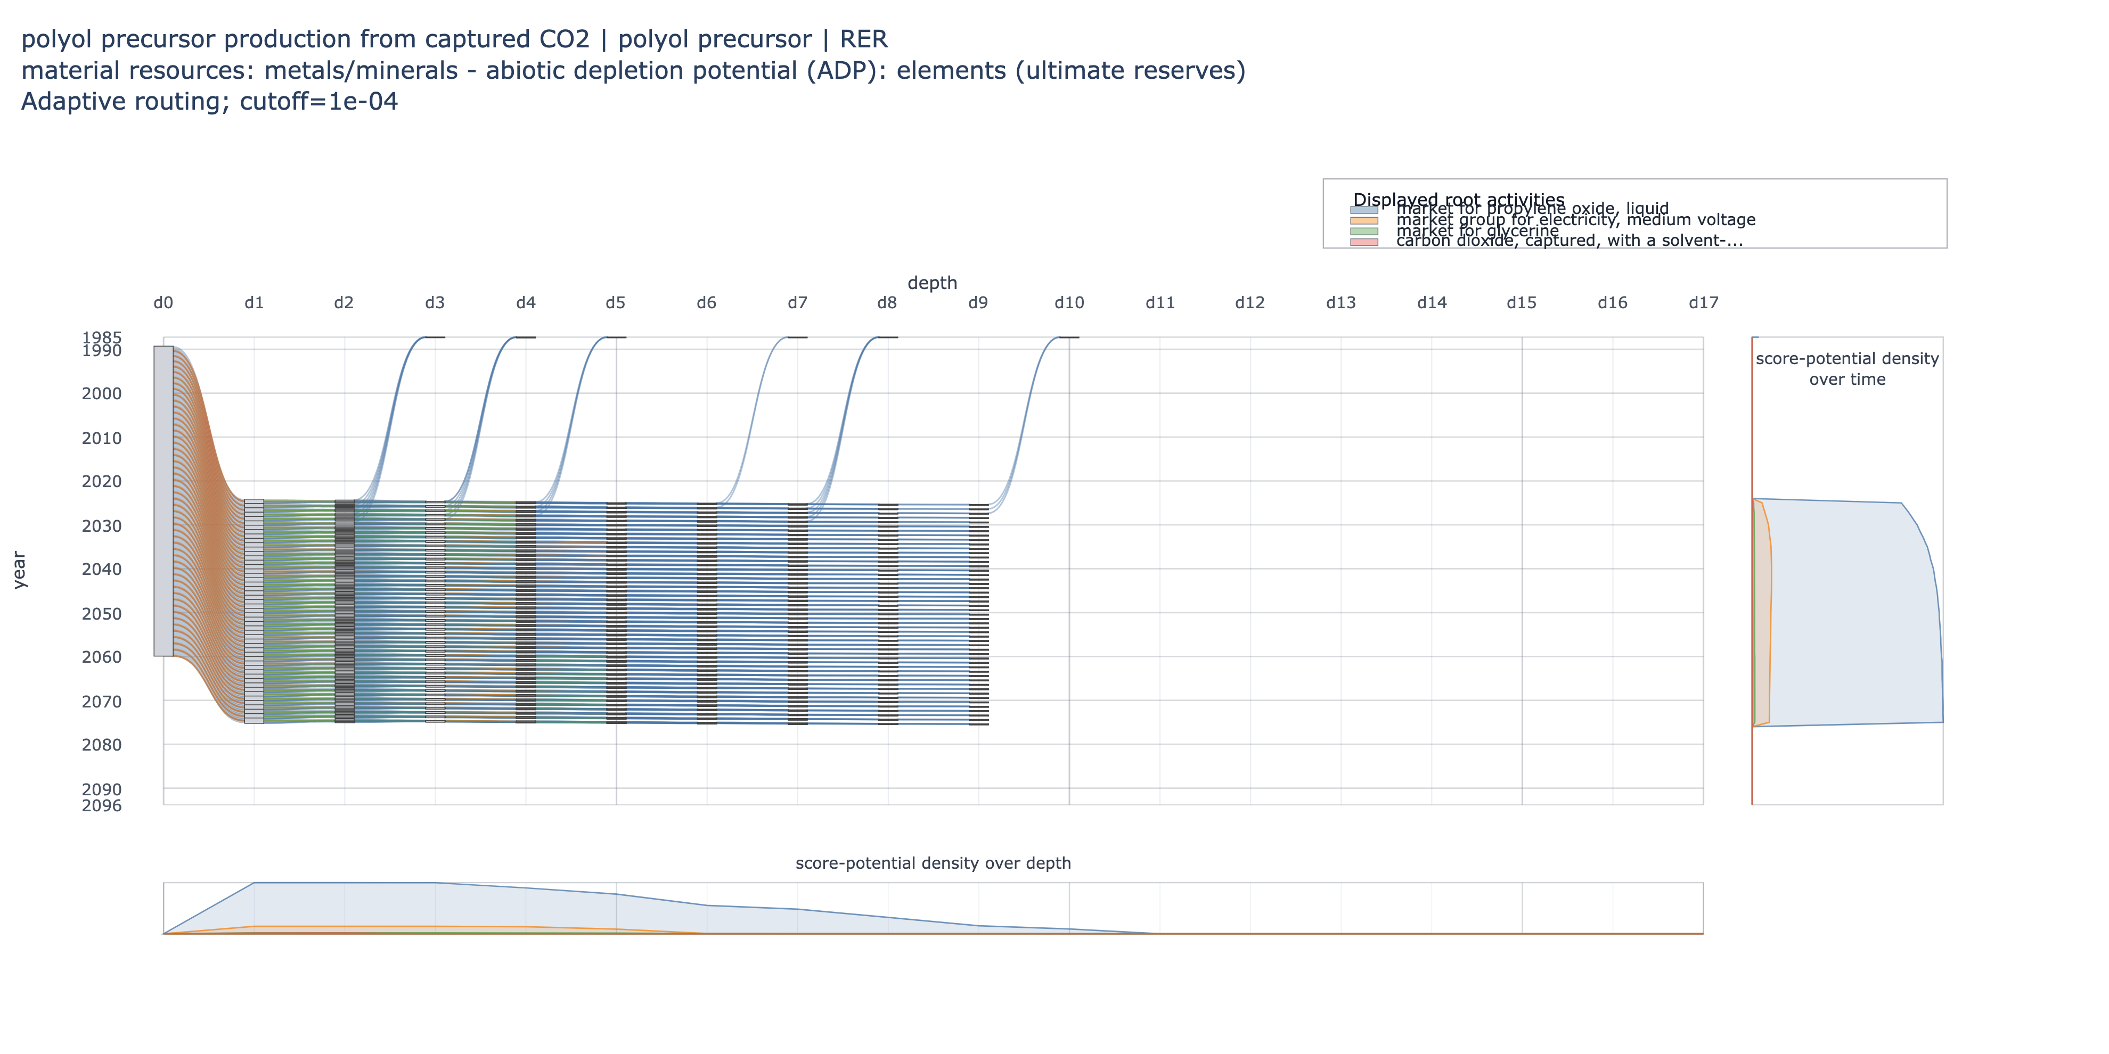
Figure S10.1. Adaptive-routing Sankey diagram for the polyol case (EF v3.1 material resources: metals/minerals, abiotic depletion potential). Nodes are positioned by routing depth from left to right and by year from top to bottom; flow widths are proportional to the functional unit's score potential. A 0.1% root-branch visual cutoff is applied. The right-side panel shows transparent, unstacked branch density areas over time, and the lower panel shows transparent, unstacked branch density areas over routing depth; each density panel uses a common scale across displayed branches.

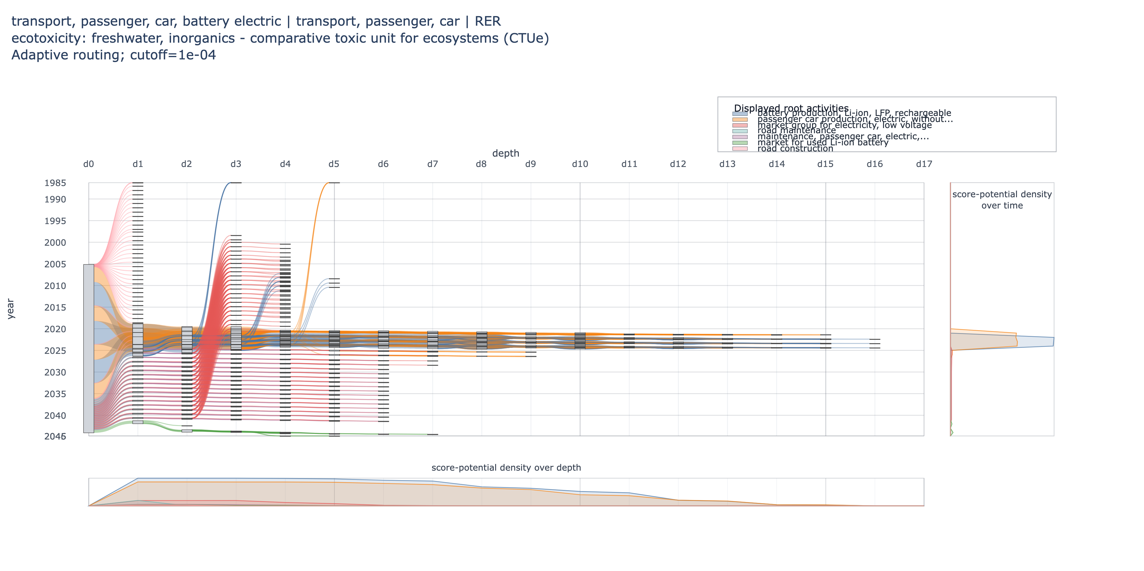
Figure S10.2. Adaptive-routing Sankey diagram for the battery-electric passenger car case (EF v3.1 freshwater ecotoxicity, CTUe). Nodes are positioned by routing depth from left to right and by year from top to bottom; flow widths are proportional to the functional unit's score potential. A 0.1% root-branch visual cutoff is applied. The right-side panel shows transparent, unstacked branch density areas over time, and the lower panel shows transparent, unstacked branch density areas over routing depth; each density panel uses a common scale across displayed branches.

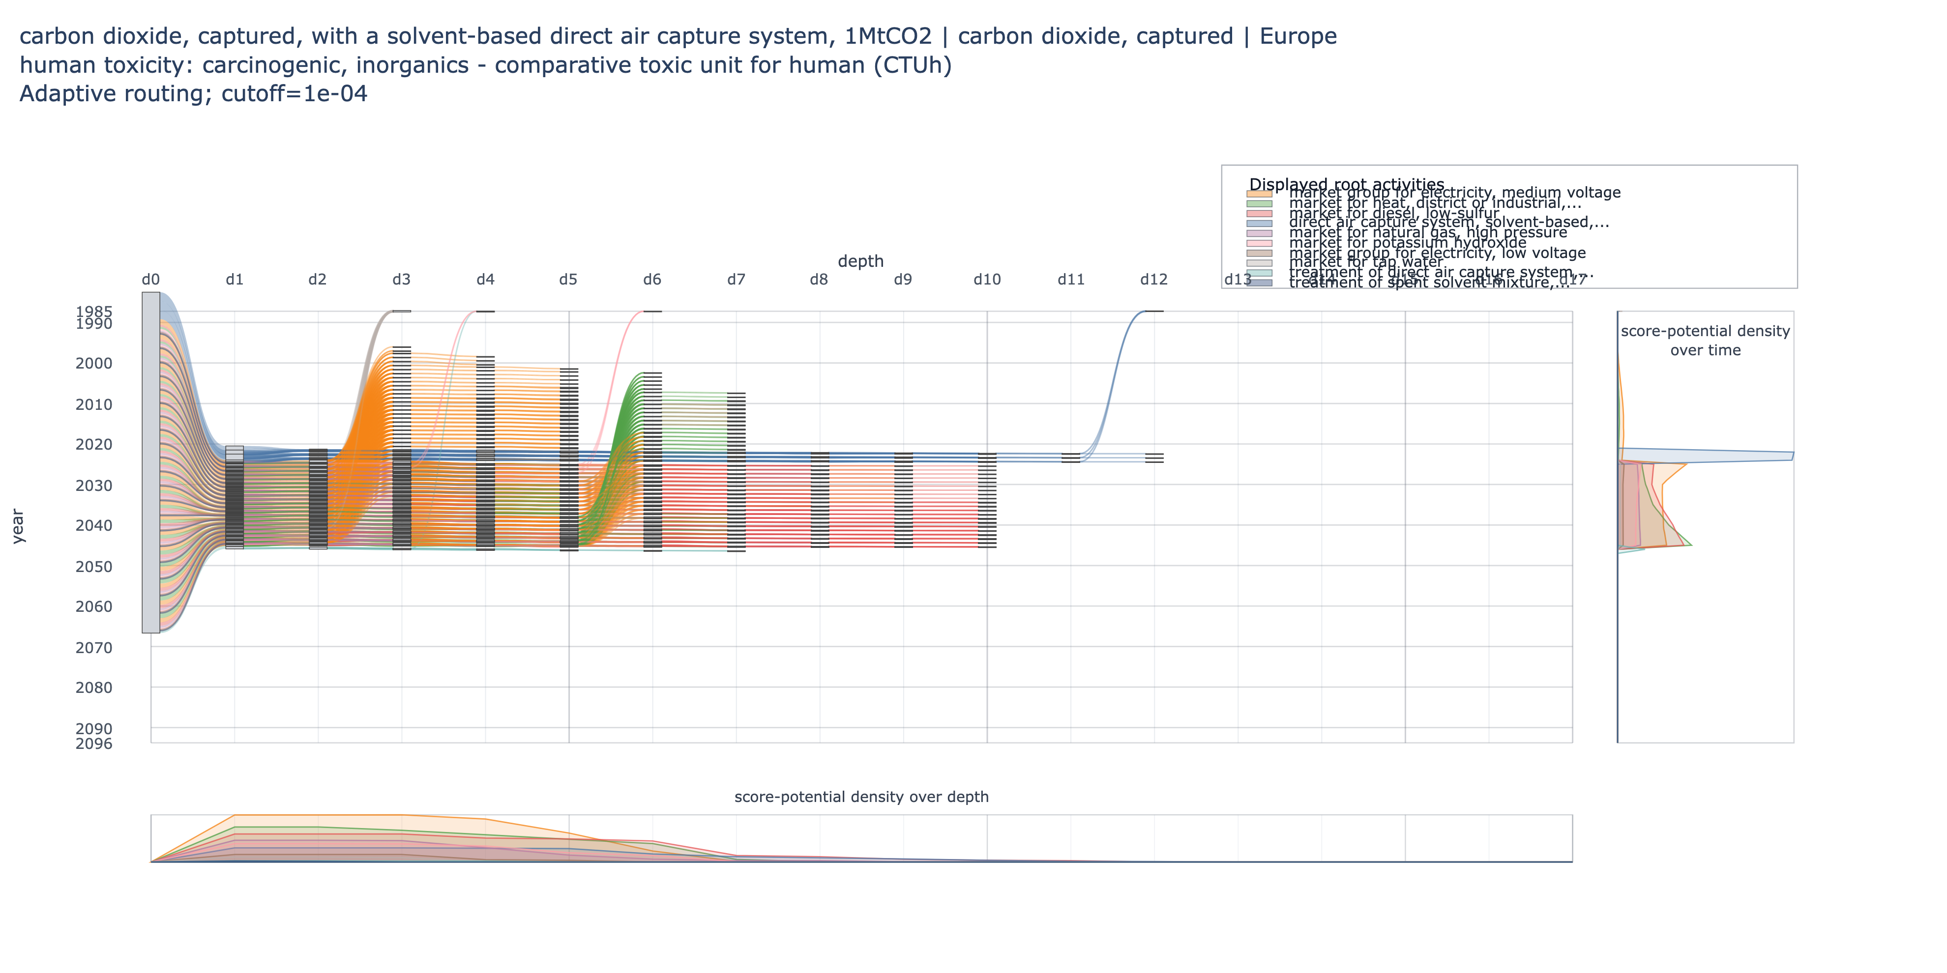
Figure S10.3. Adaptive-routing Sankey diagram for the direct-air-capture case (EF v3.1 ozone depletion potential). Nodes are positioned by routing depth from left to right and by year from top to bottom; flow widths are proportional to the functional unit's score potential. A 0.1% root-branch visual cutoff is applied. The right-side panel shows transparent, unstacked branch density areas over time, and the lower panel shows transparent, unstacked branch density areas over routing depth; each density panel uses a common scale across displayed branches.

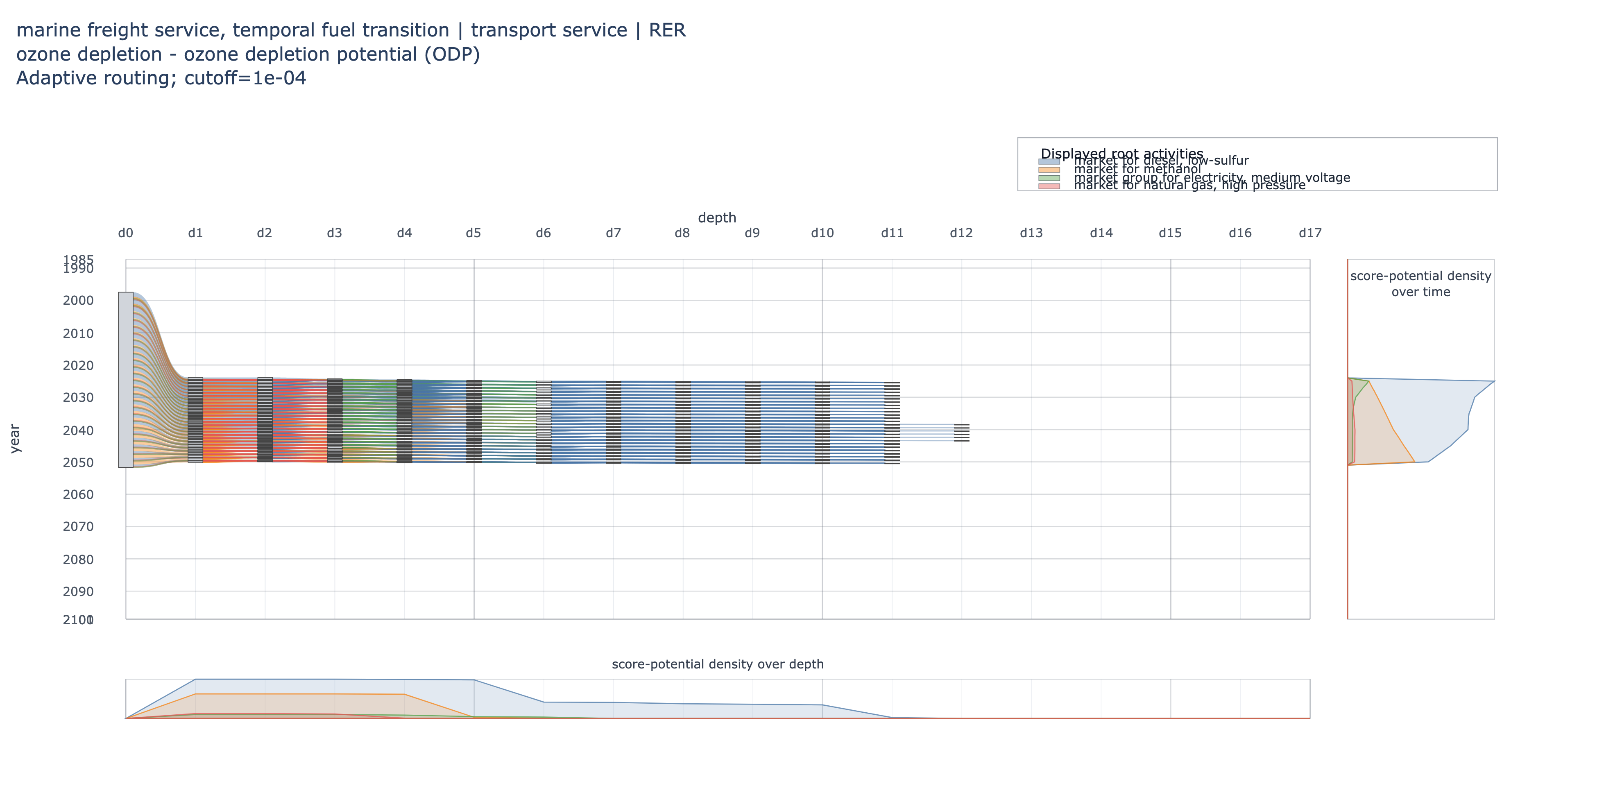
Figure S10.4. Adaptive-routing Sankey diagram for the marine shipping case (EF v3.1 human toxicity, carcinogenic, CTUh). Nodes are positioned by routing depth from left to right and by year from top to bottom; flow widths are proportional to the functional unit's score potential. A 0.1% root-branch visual cutoff is applied. The right-side panel shows transparent, unstacked branch density areas over time, and the lower panel shows transparent, unstacked branch density areas over routing depth; each density panel uses a common scale across displayed branches.

Routing-comparison plots for all case-study indicators
This appendix reports the routing-comparison plots generated for all European Footprint v3.1 indicators in each case study. Each row pairs the unstacked annual-impact view with the corresponding stacked annual-impact view. The cumulative foreground-only, adaptive-routing, and static reference scores are shown as in the main case-study figures.

Battery electric vehicle
Unstacked annual impacts | Stacked annual impacts
Figure S-routing-bev-01. acidification - accumulated exceedance (AE).
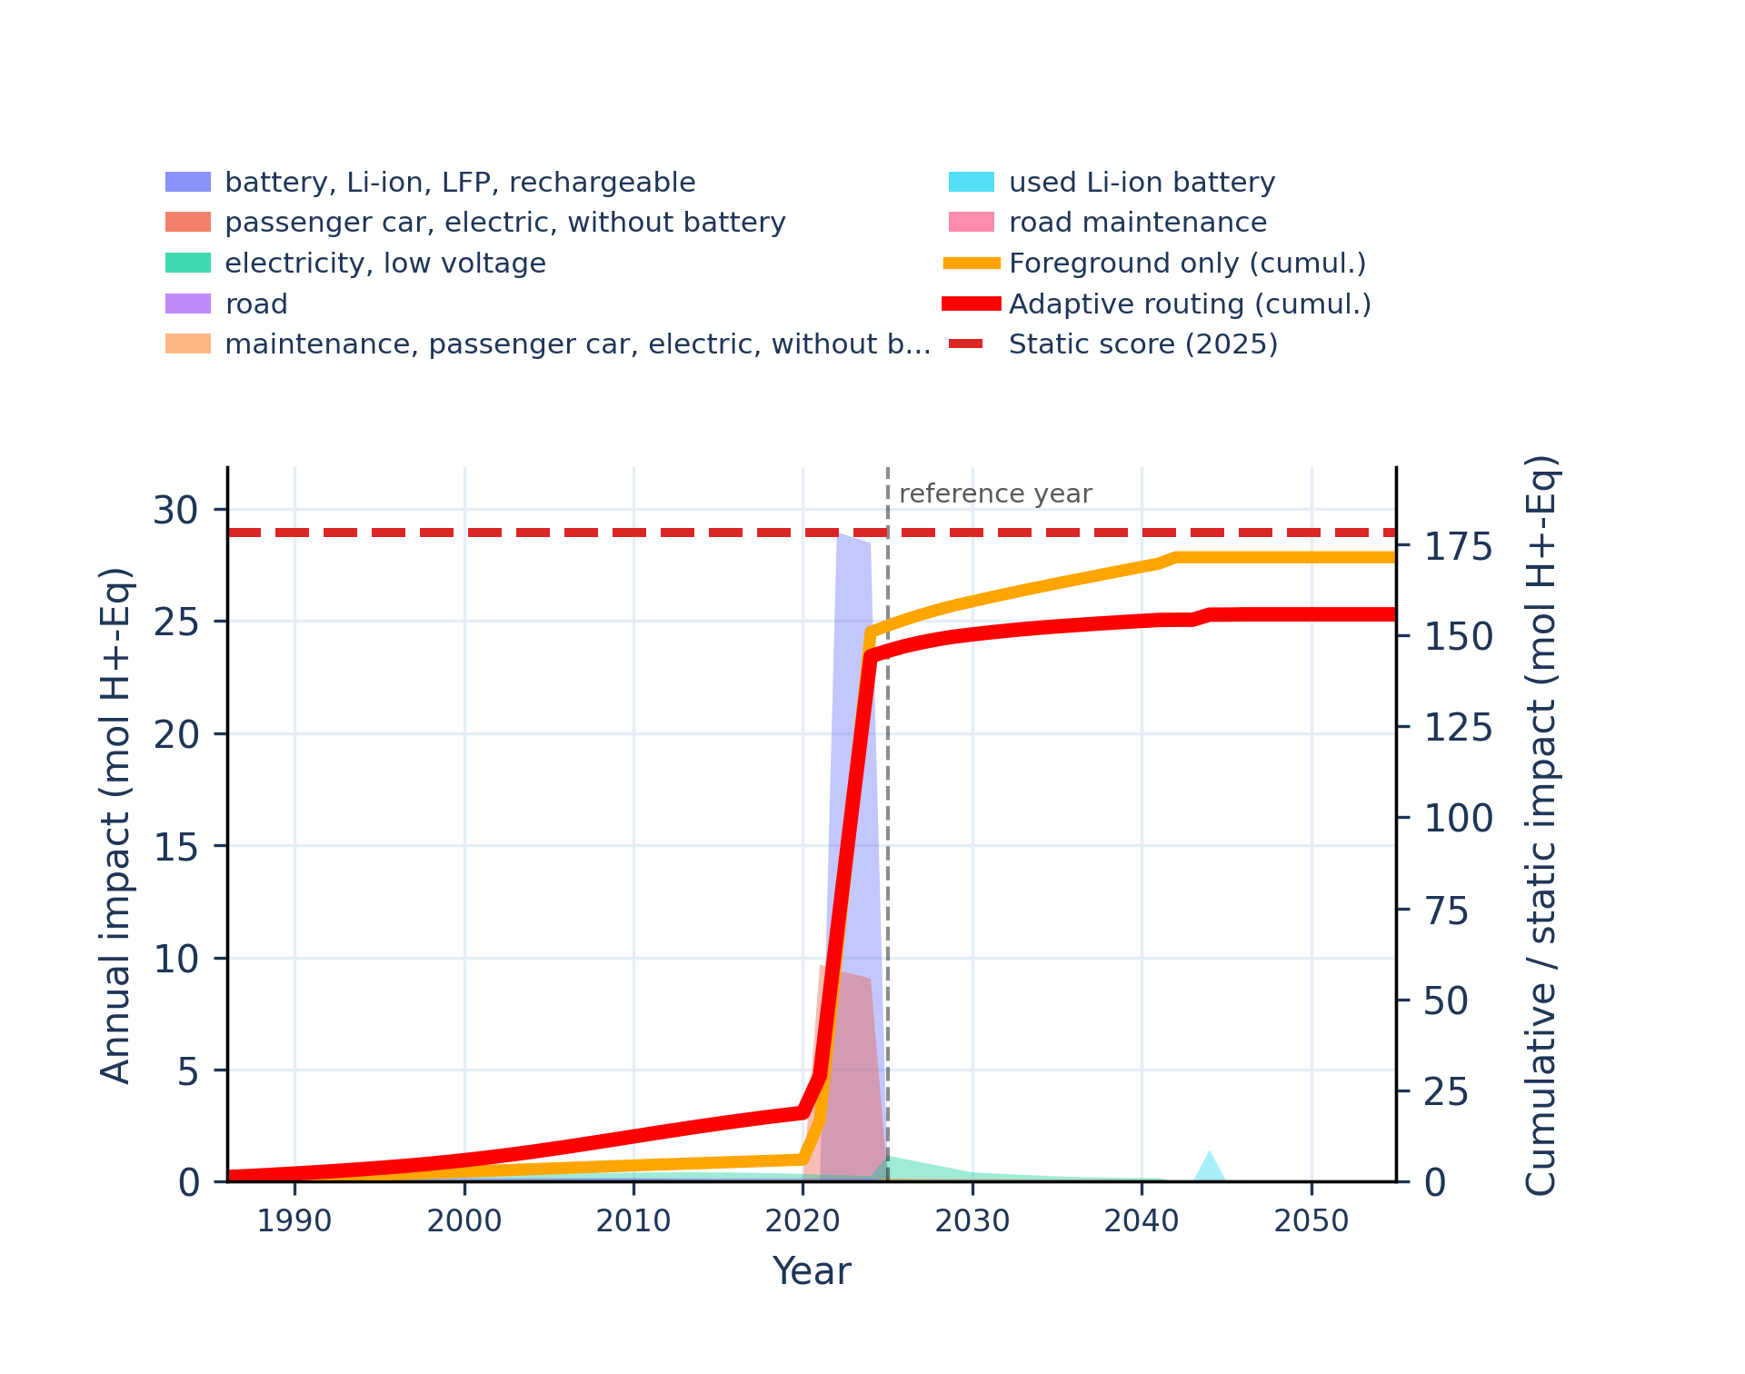 | 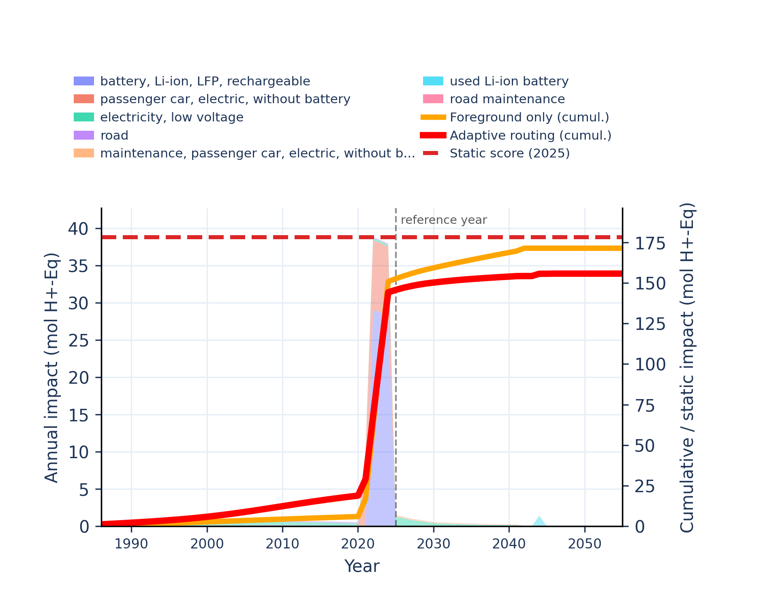
Figure S-routing-bev-02. climate change - global warming potential (GWP100).
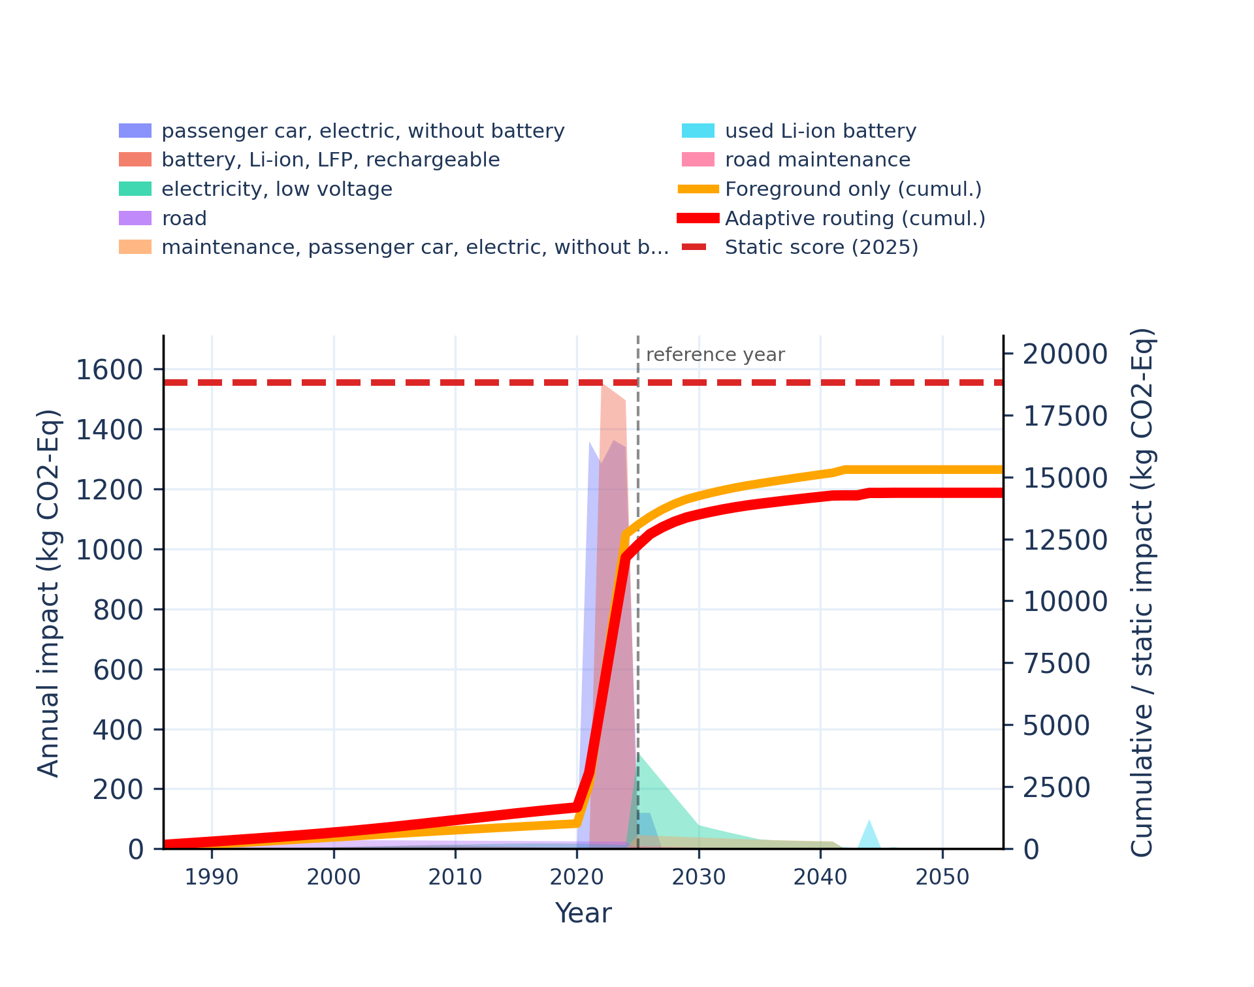 | 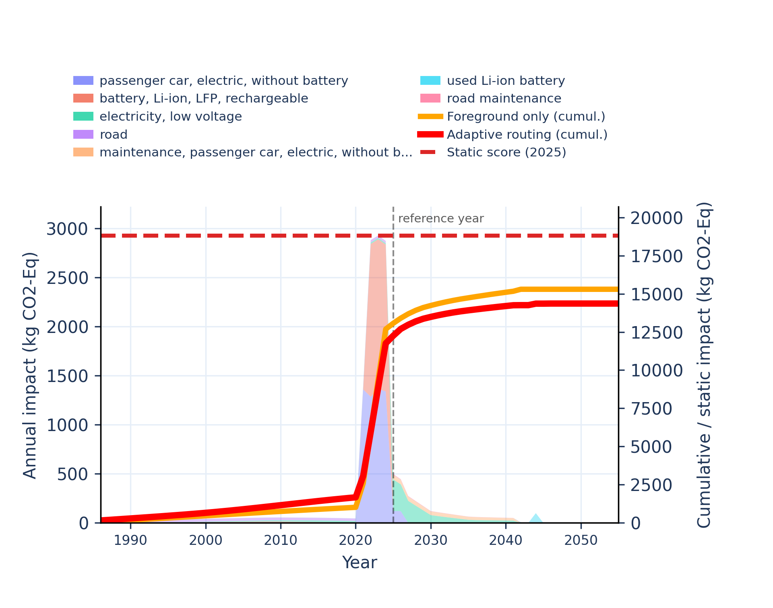
Figure S-routing-bev-03. climate change: biogenic - global warming potential (GWP100).
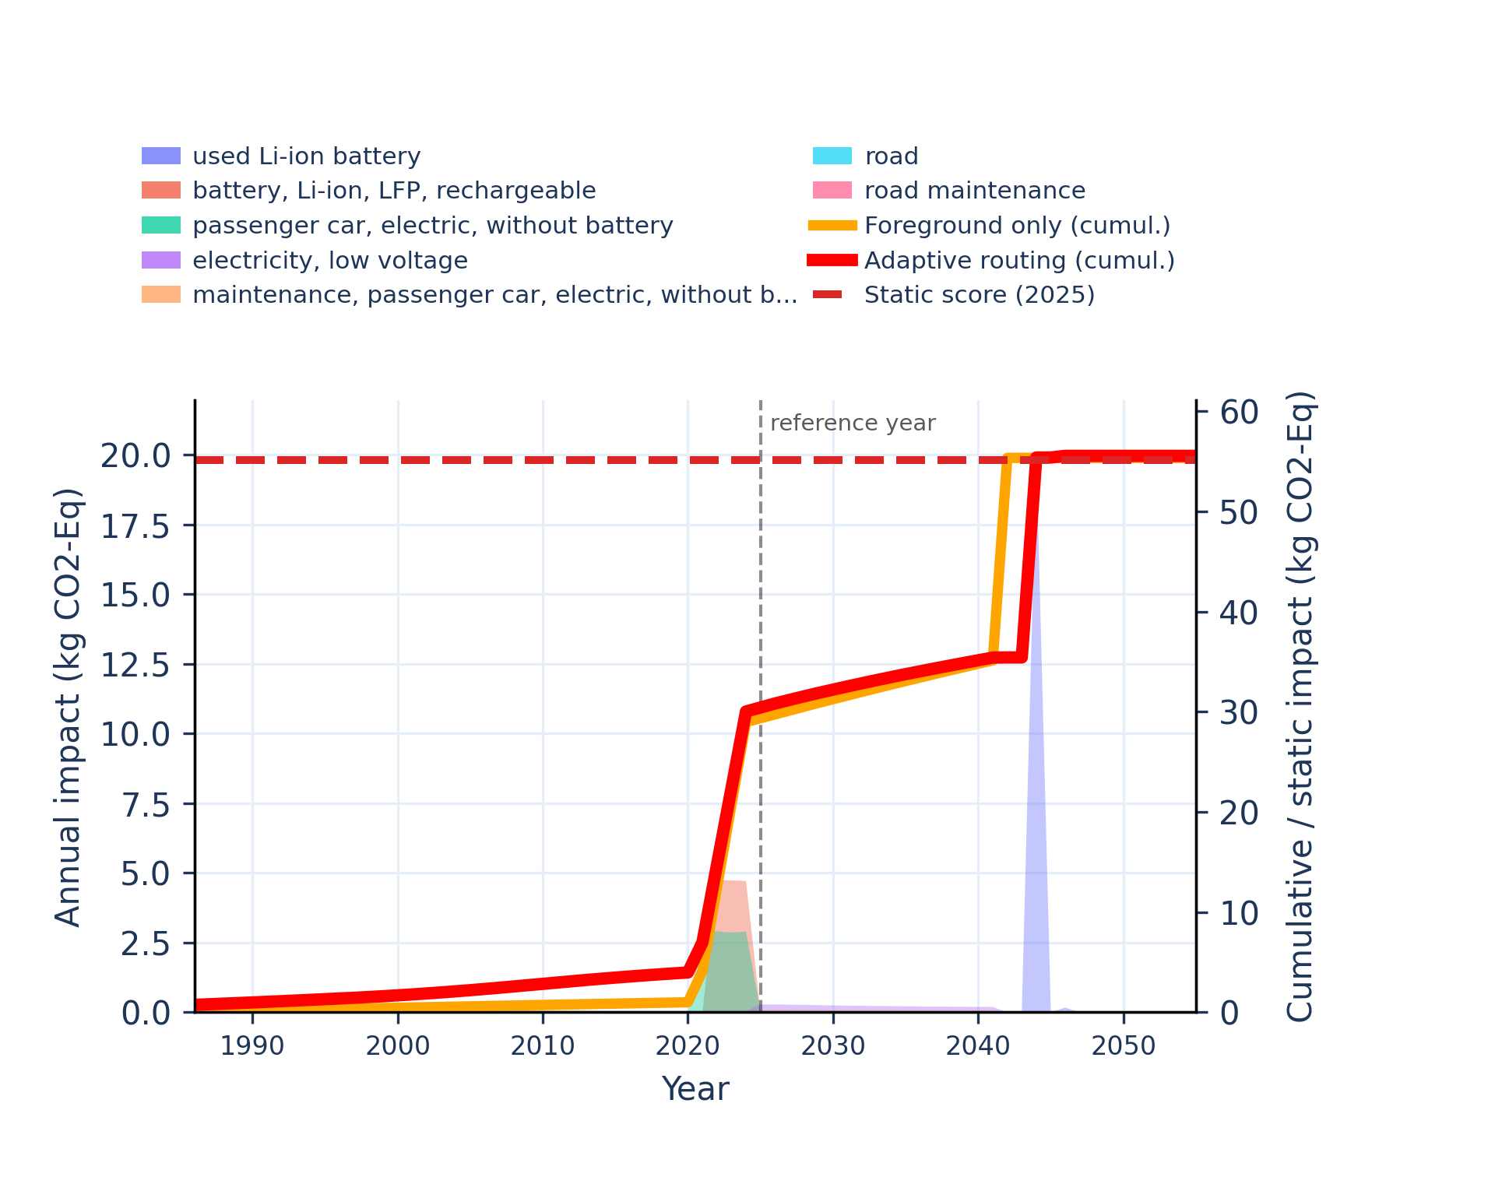 | 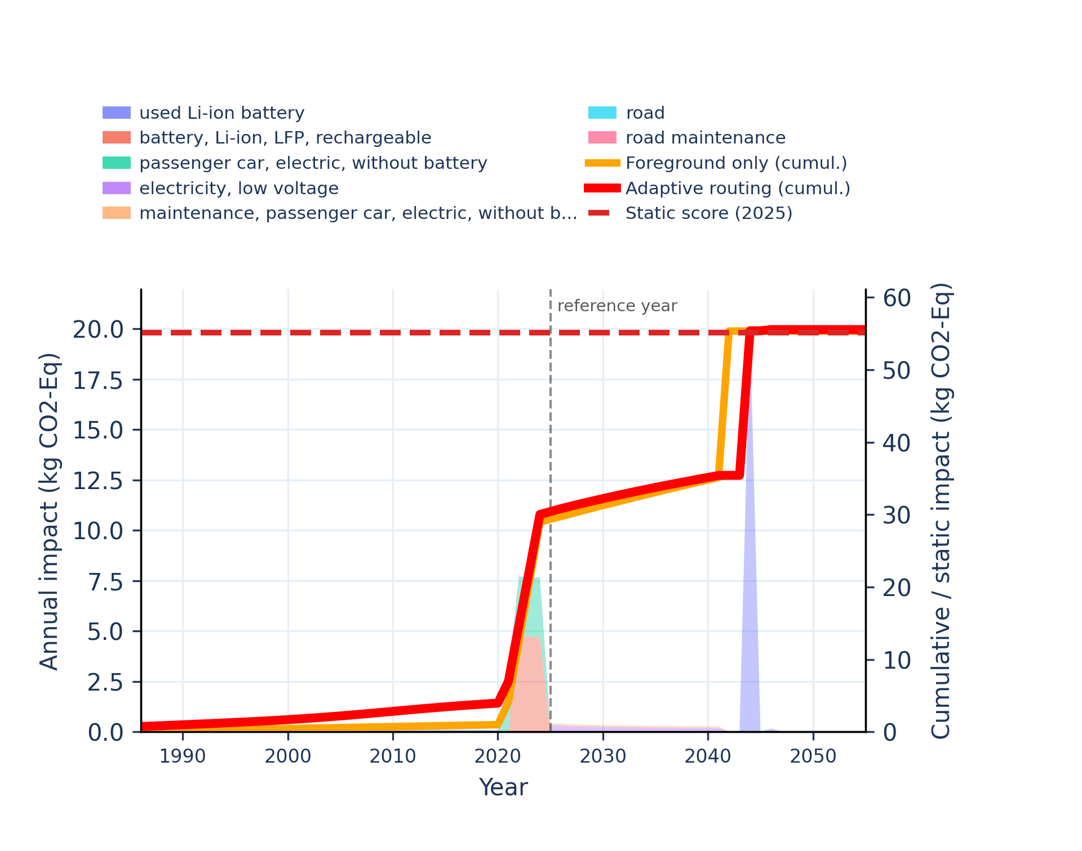
Figure S-routing-bev-04. climate change: fossil - global warming potential (GWP100).
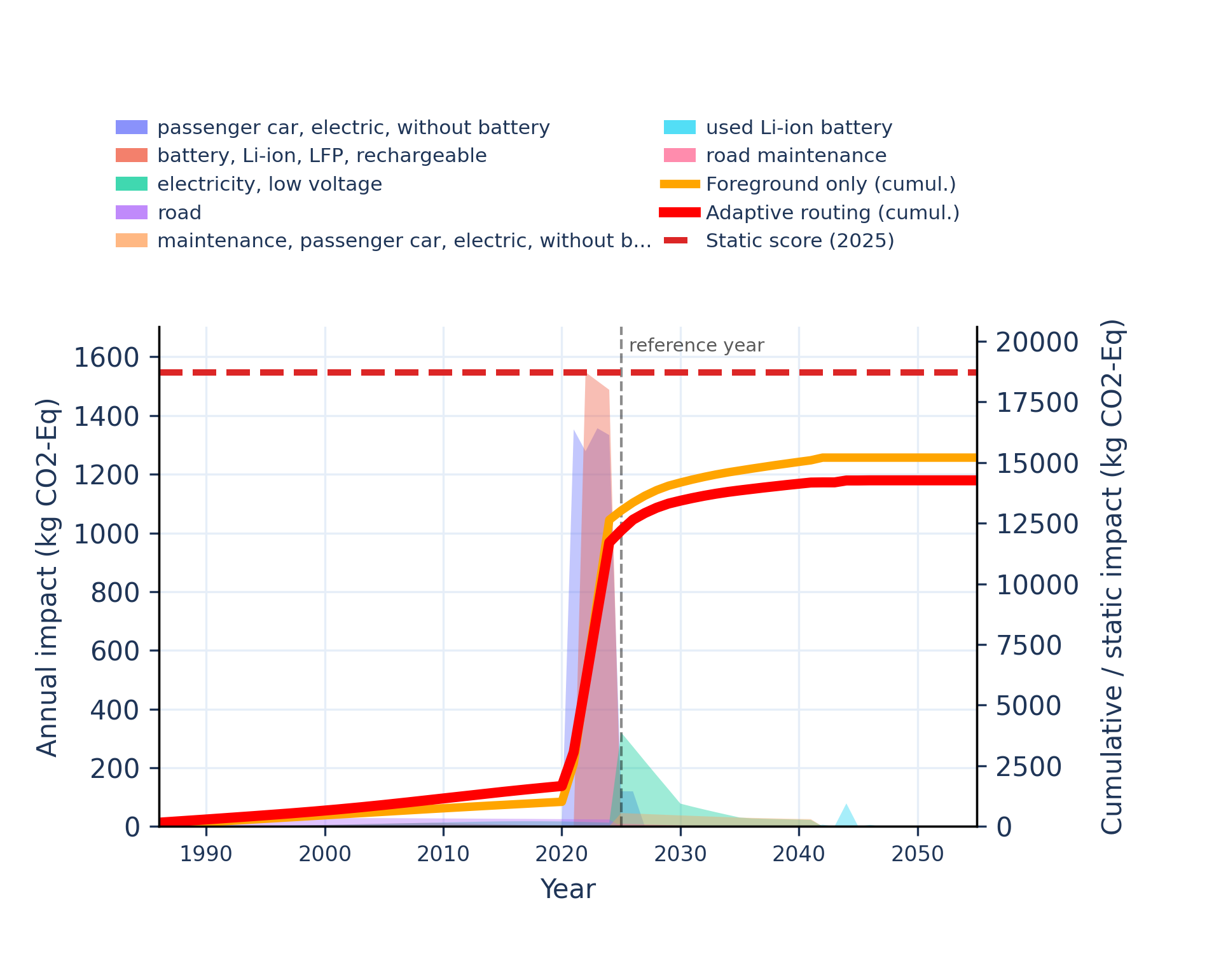 | 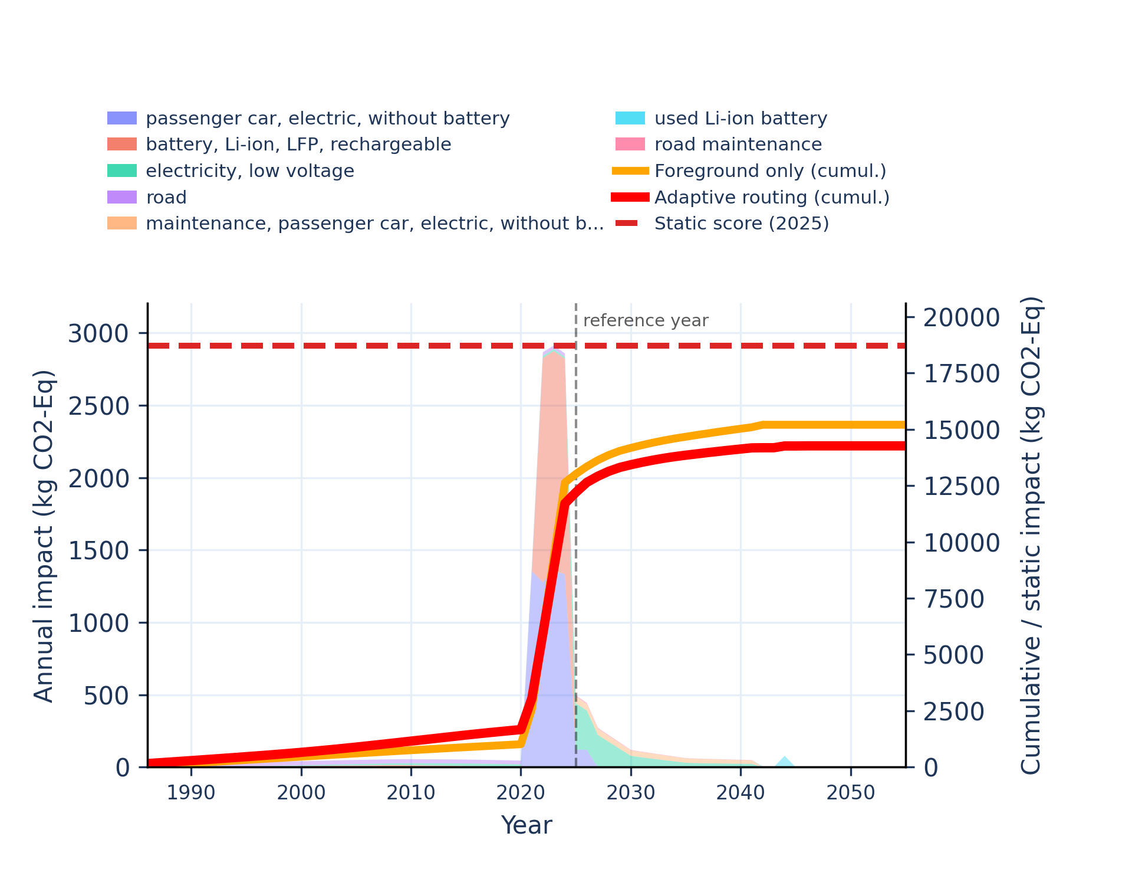

Figure S-routing-bev-05. climate change: land use and land use change - global warming potential (GWP100).
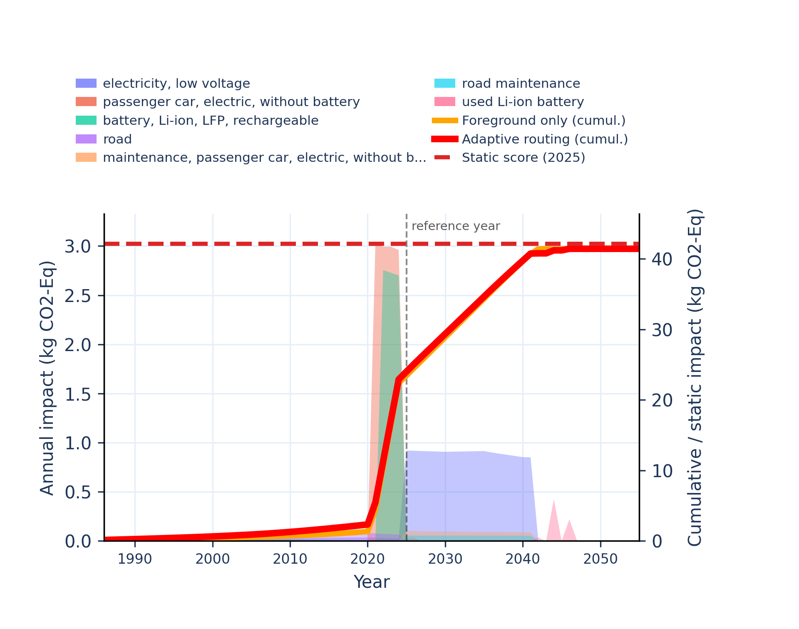 | 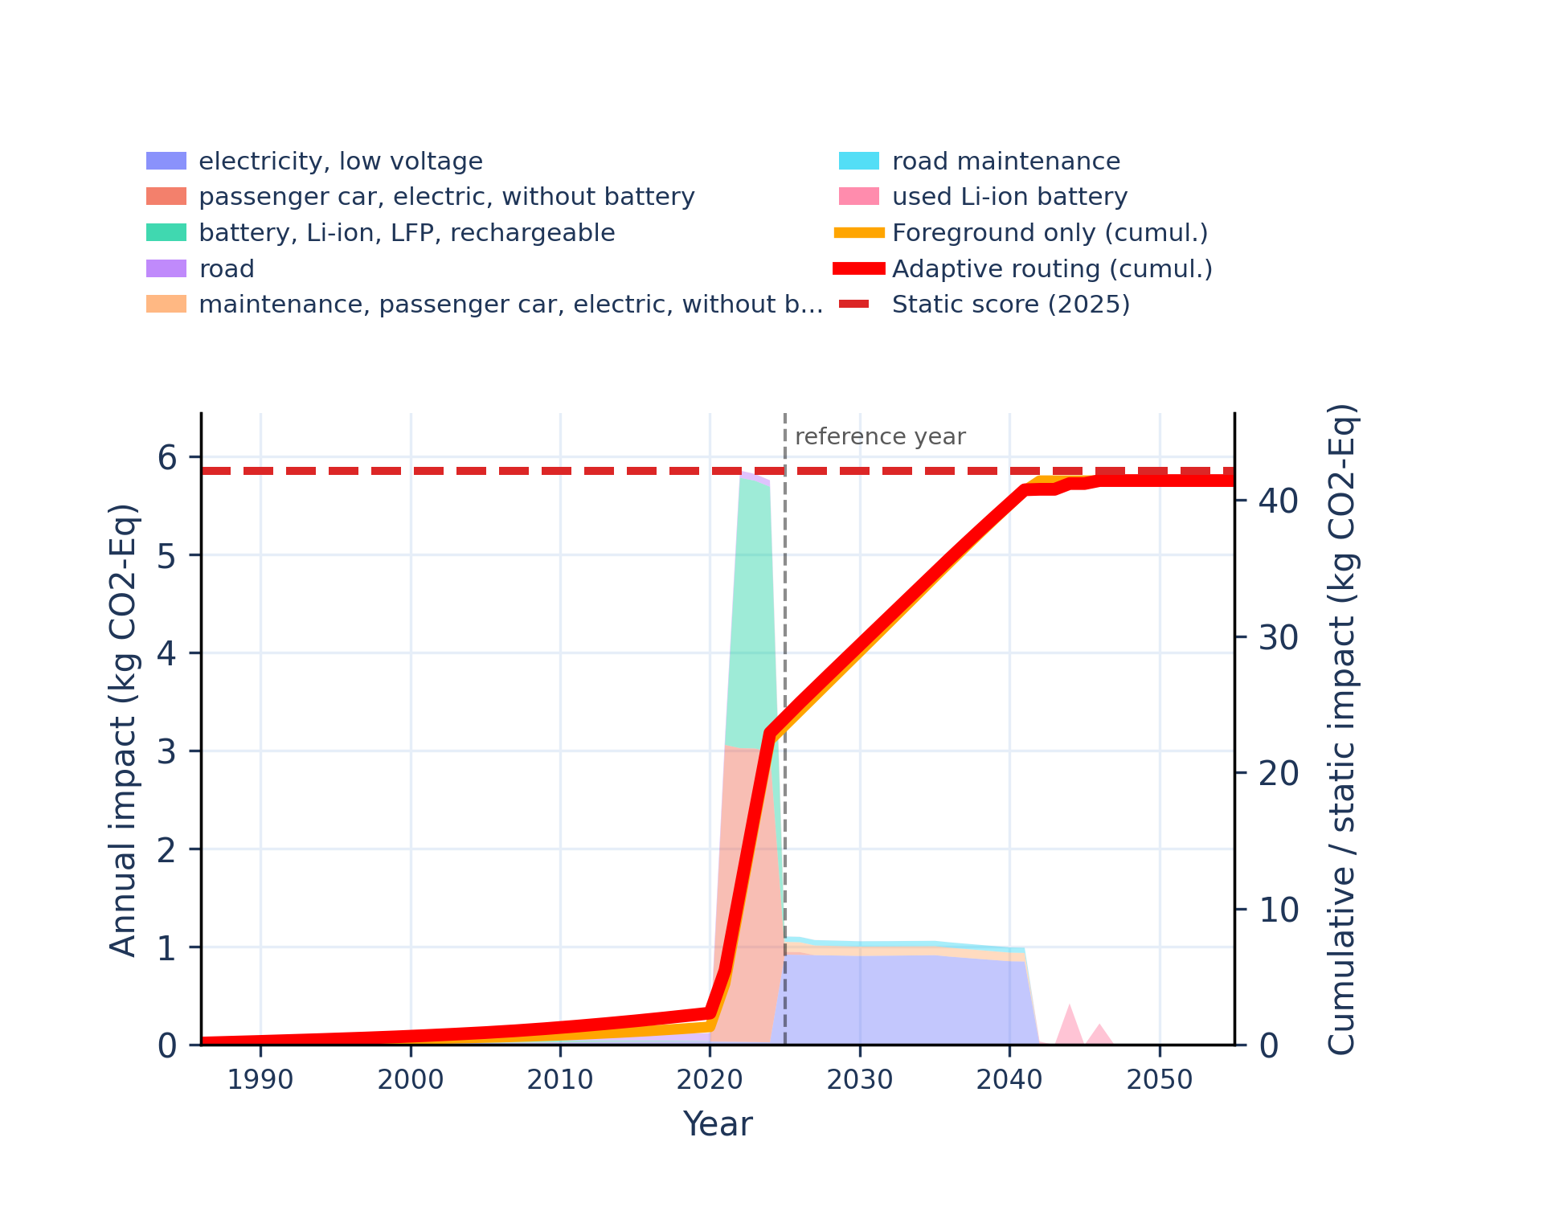
Figure S-routing-bev-06. ecotoxicity: freshwater - comparative toxic unit for ecosystems (CTUe).
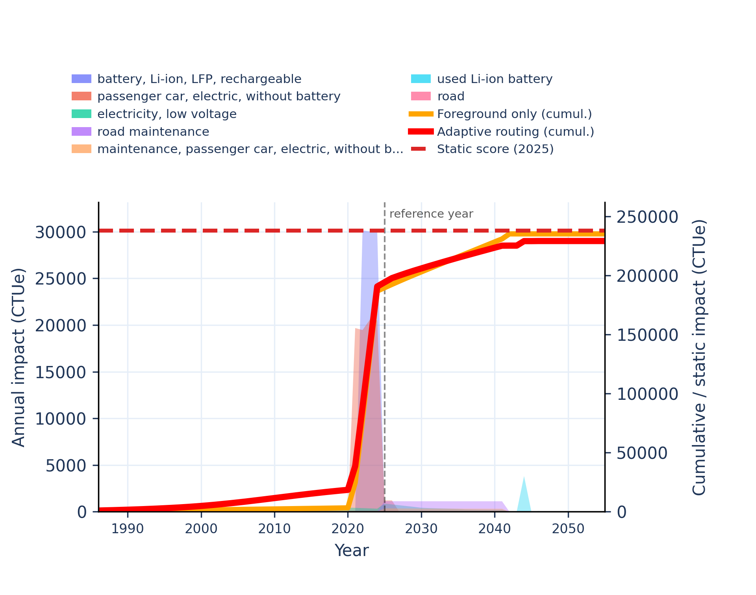 | 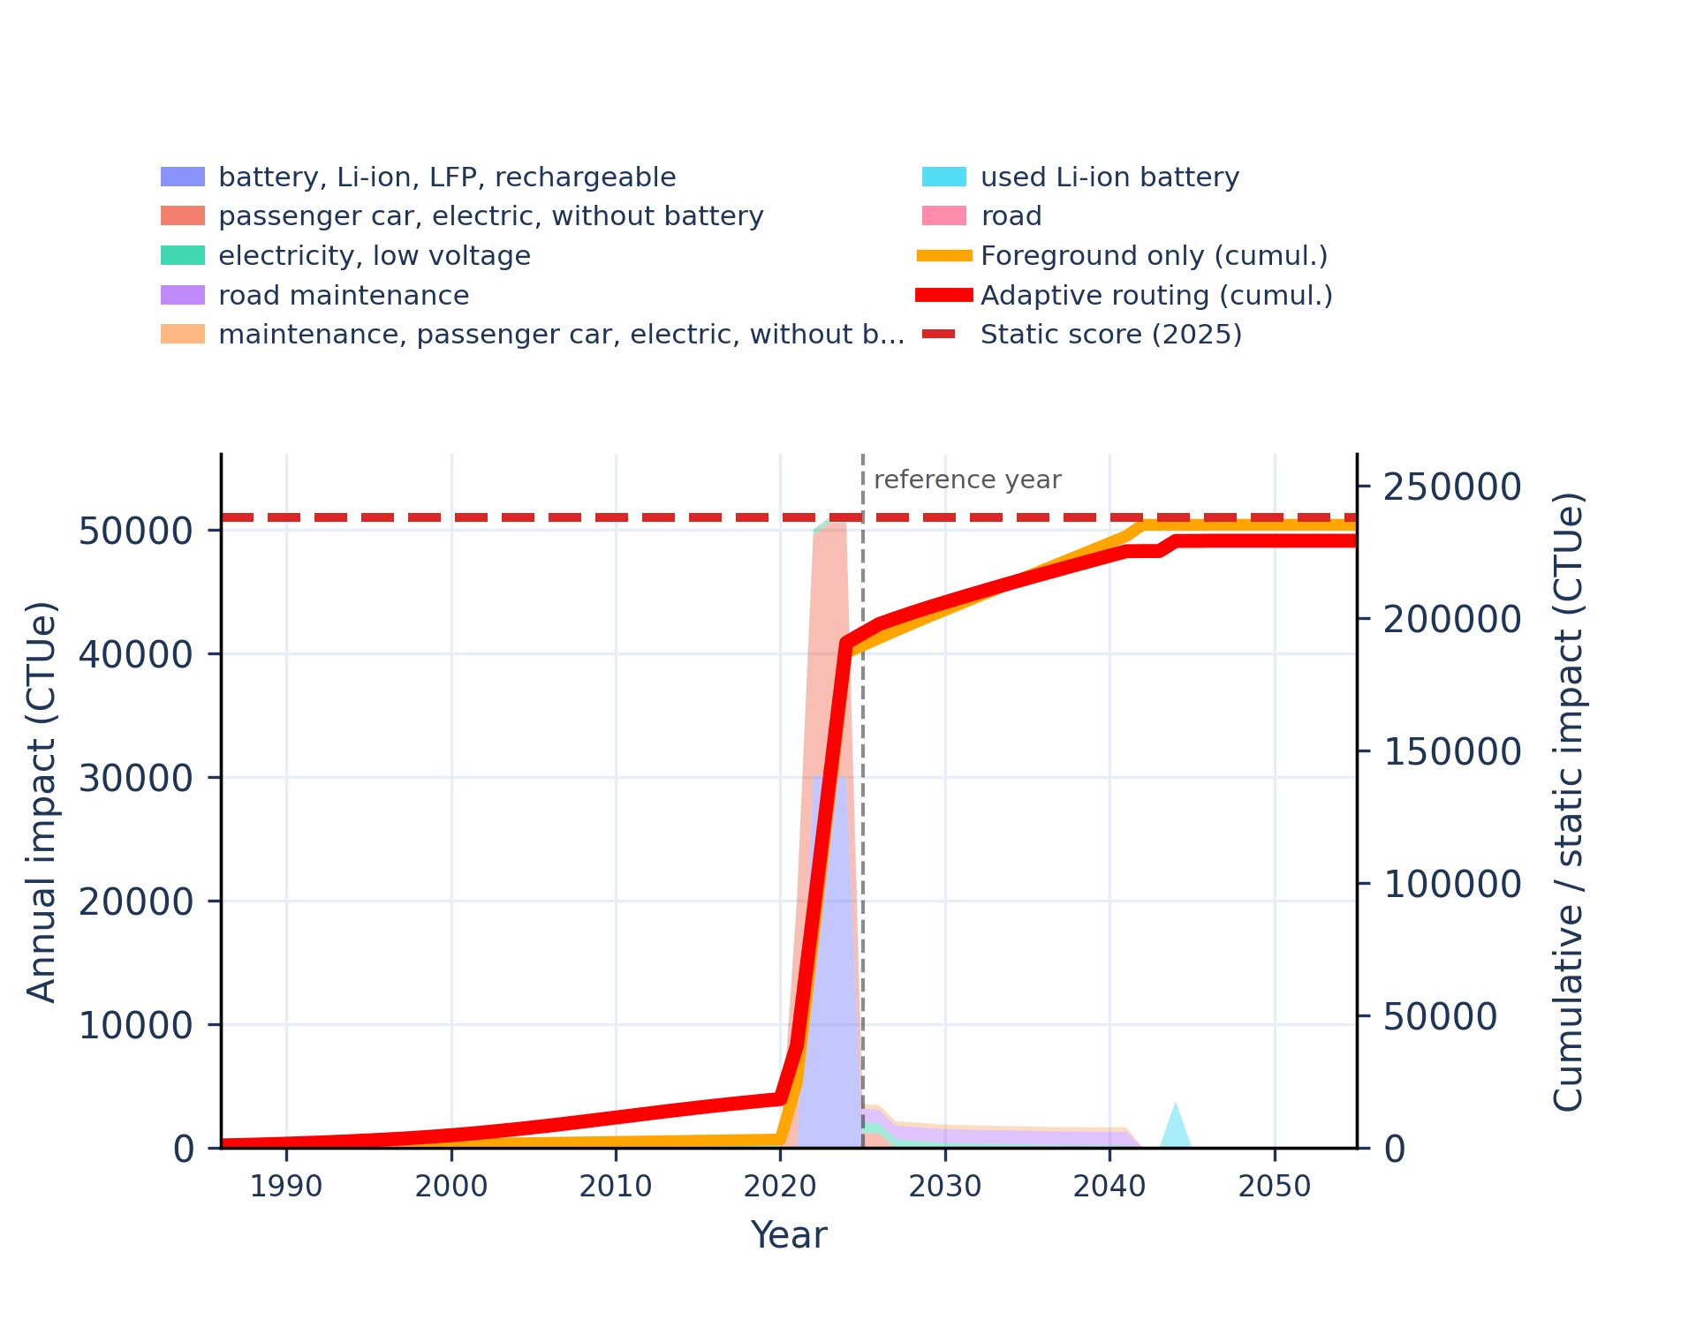

Figure S-routing-bev-07. ecotoxicity: freshwater, inorganics - comparative toxic unit for ecosystems (CTUe).
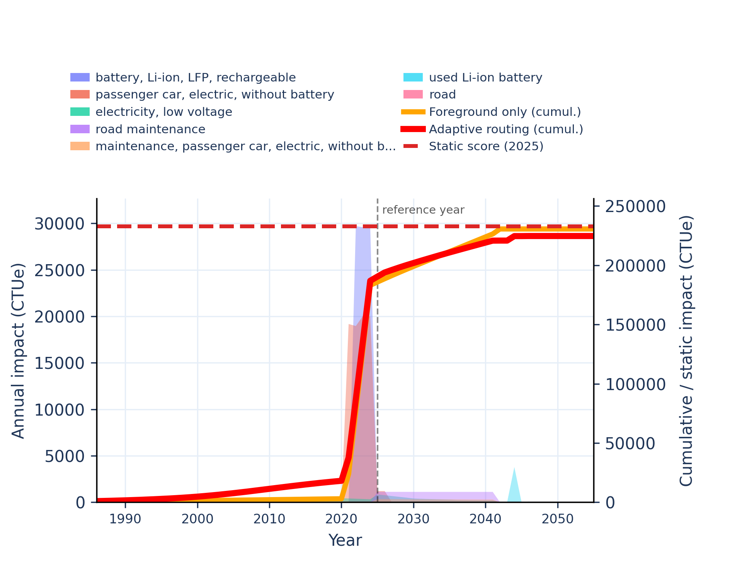 | 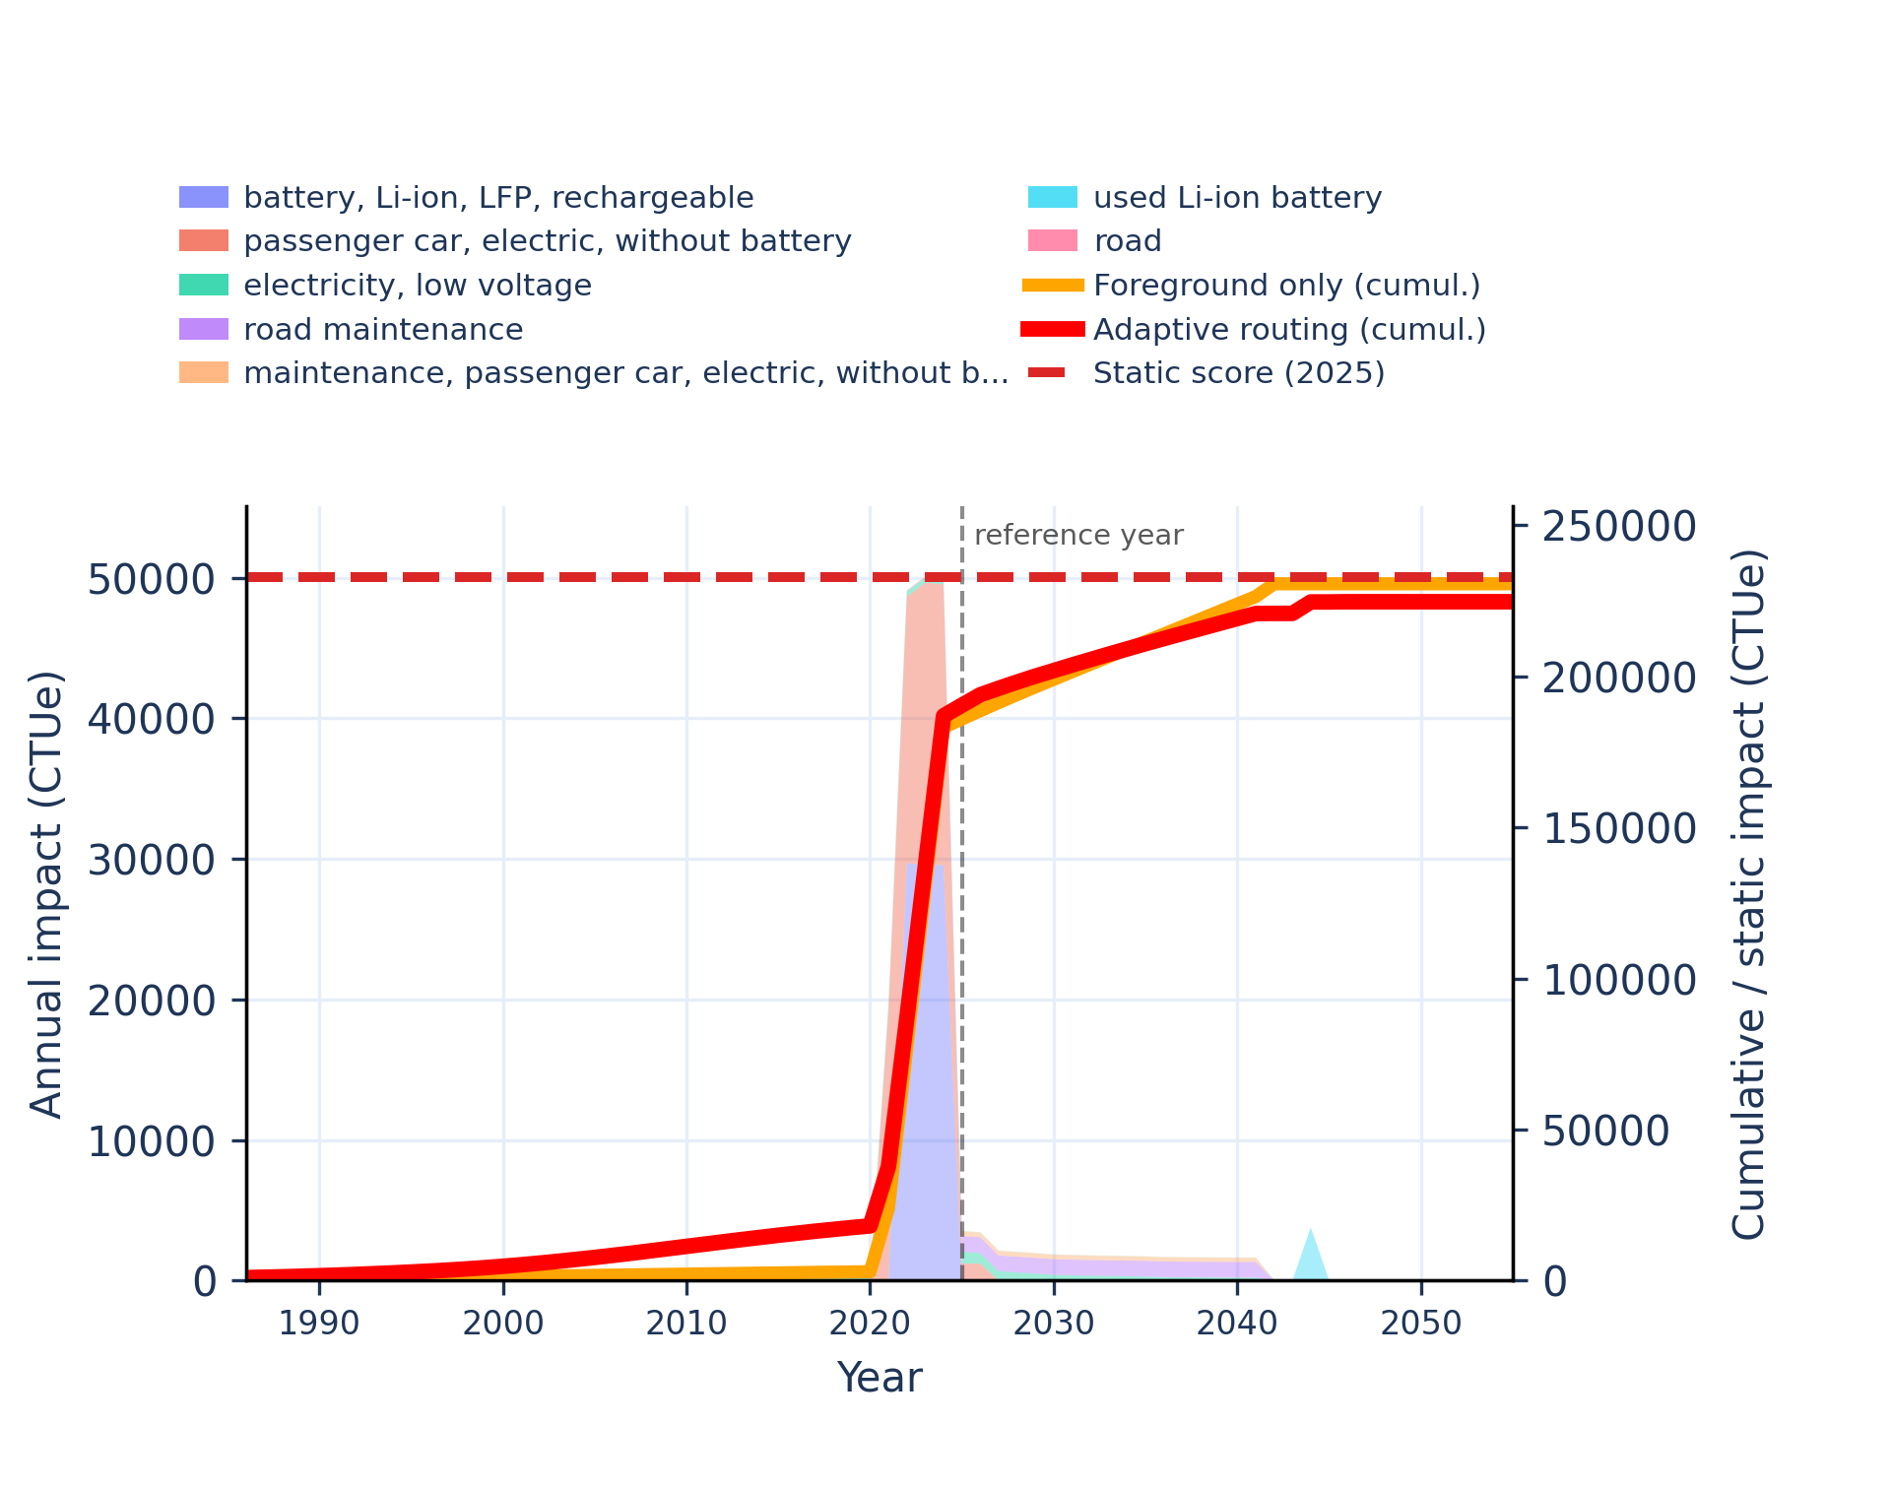
Figure S-routing-bev-08. ecotoxicity: freshwater, organics - comparative toxic unit for ecosystems (CTUe).
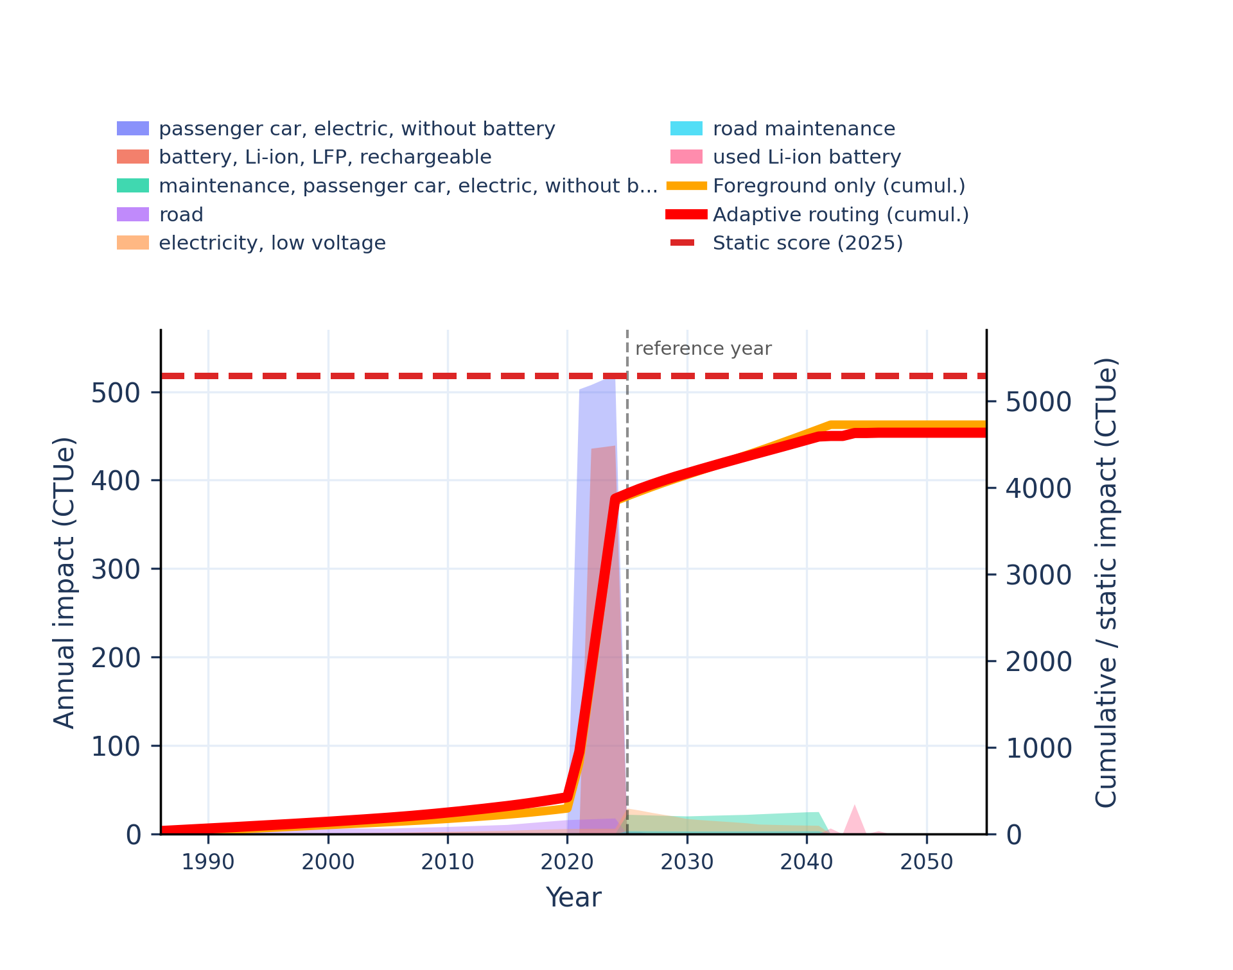 | 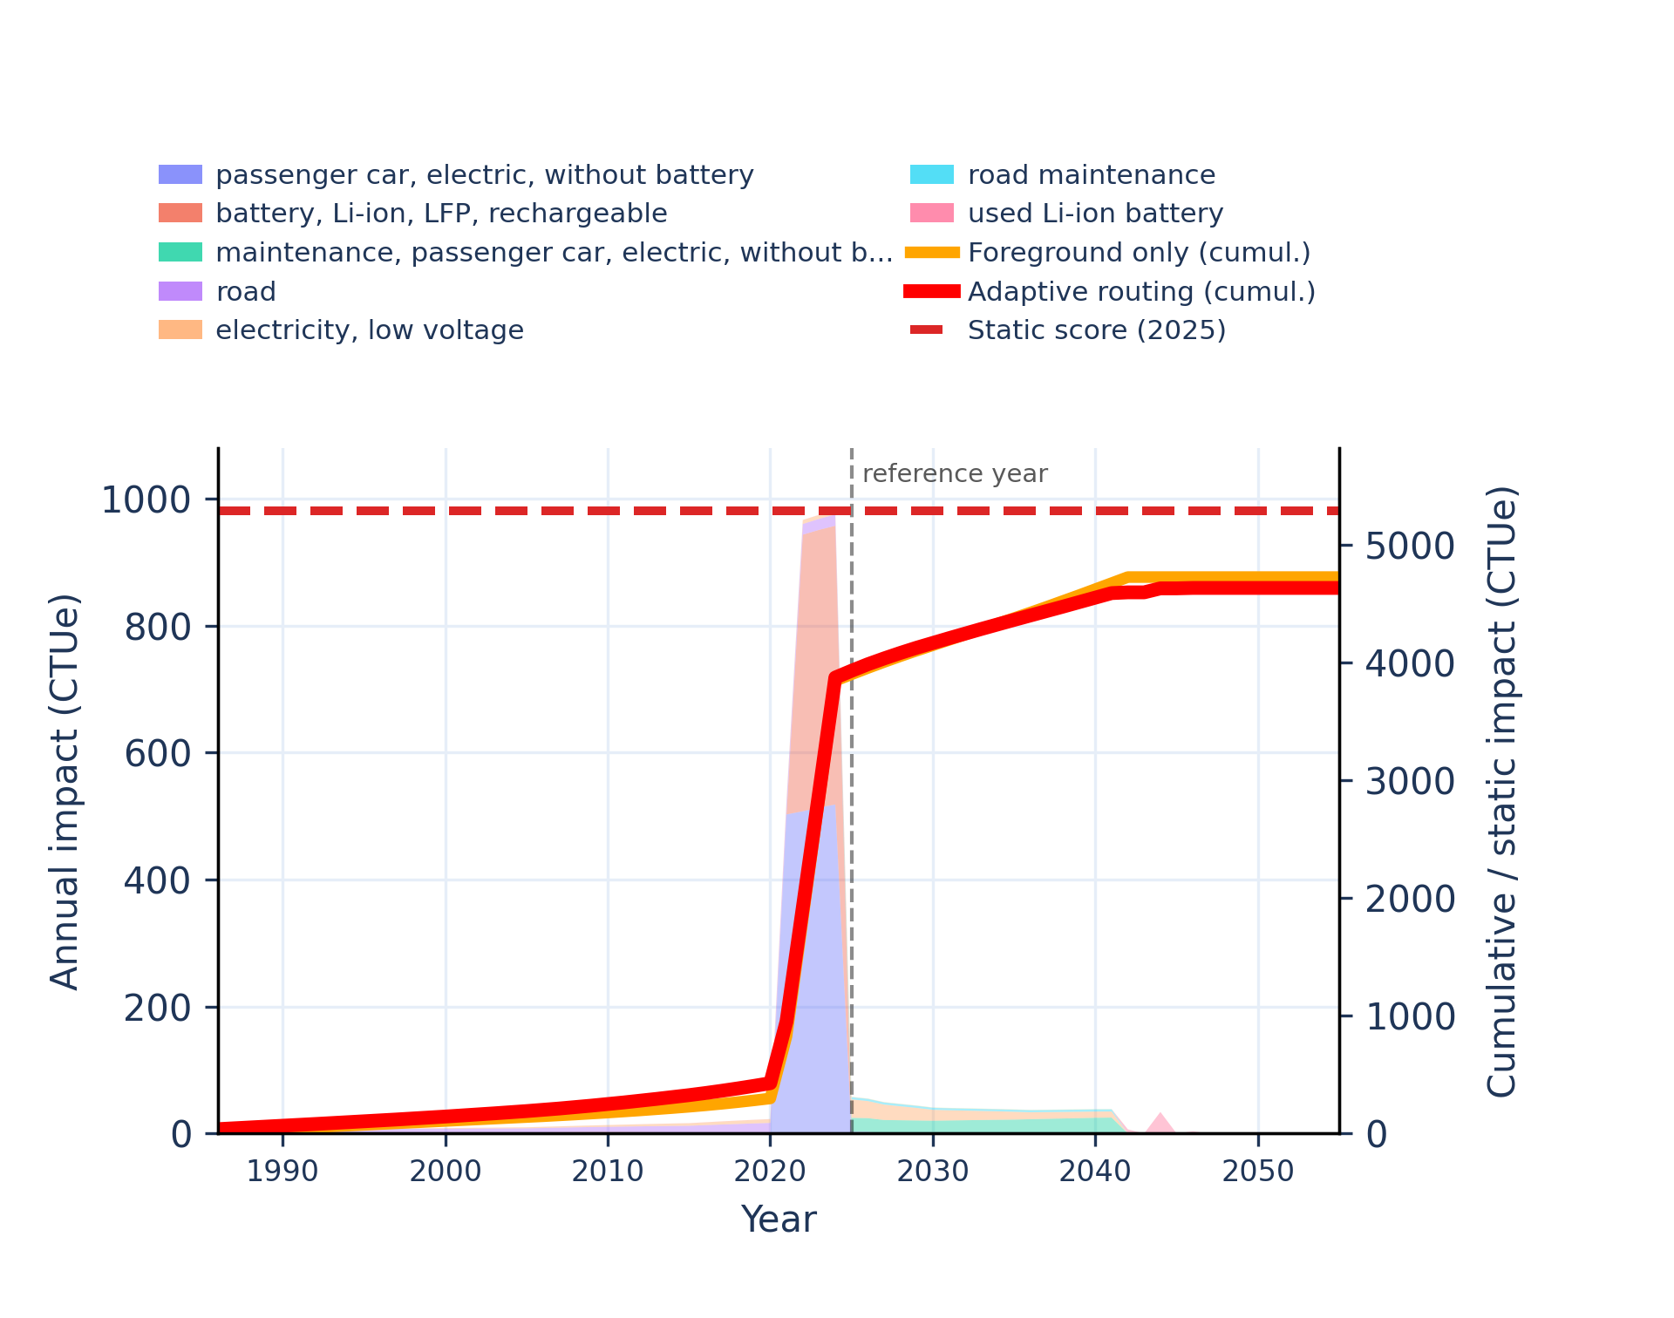
Figure S-routing-bev-09. energy resources: non-renewable - abiotic depletion potential (ADP): fossil fuels.
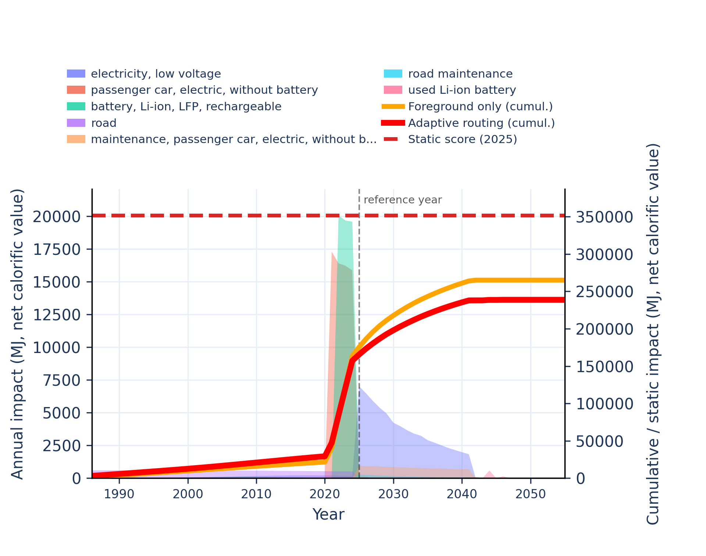 | 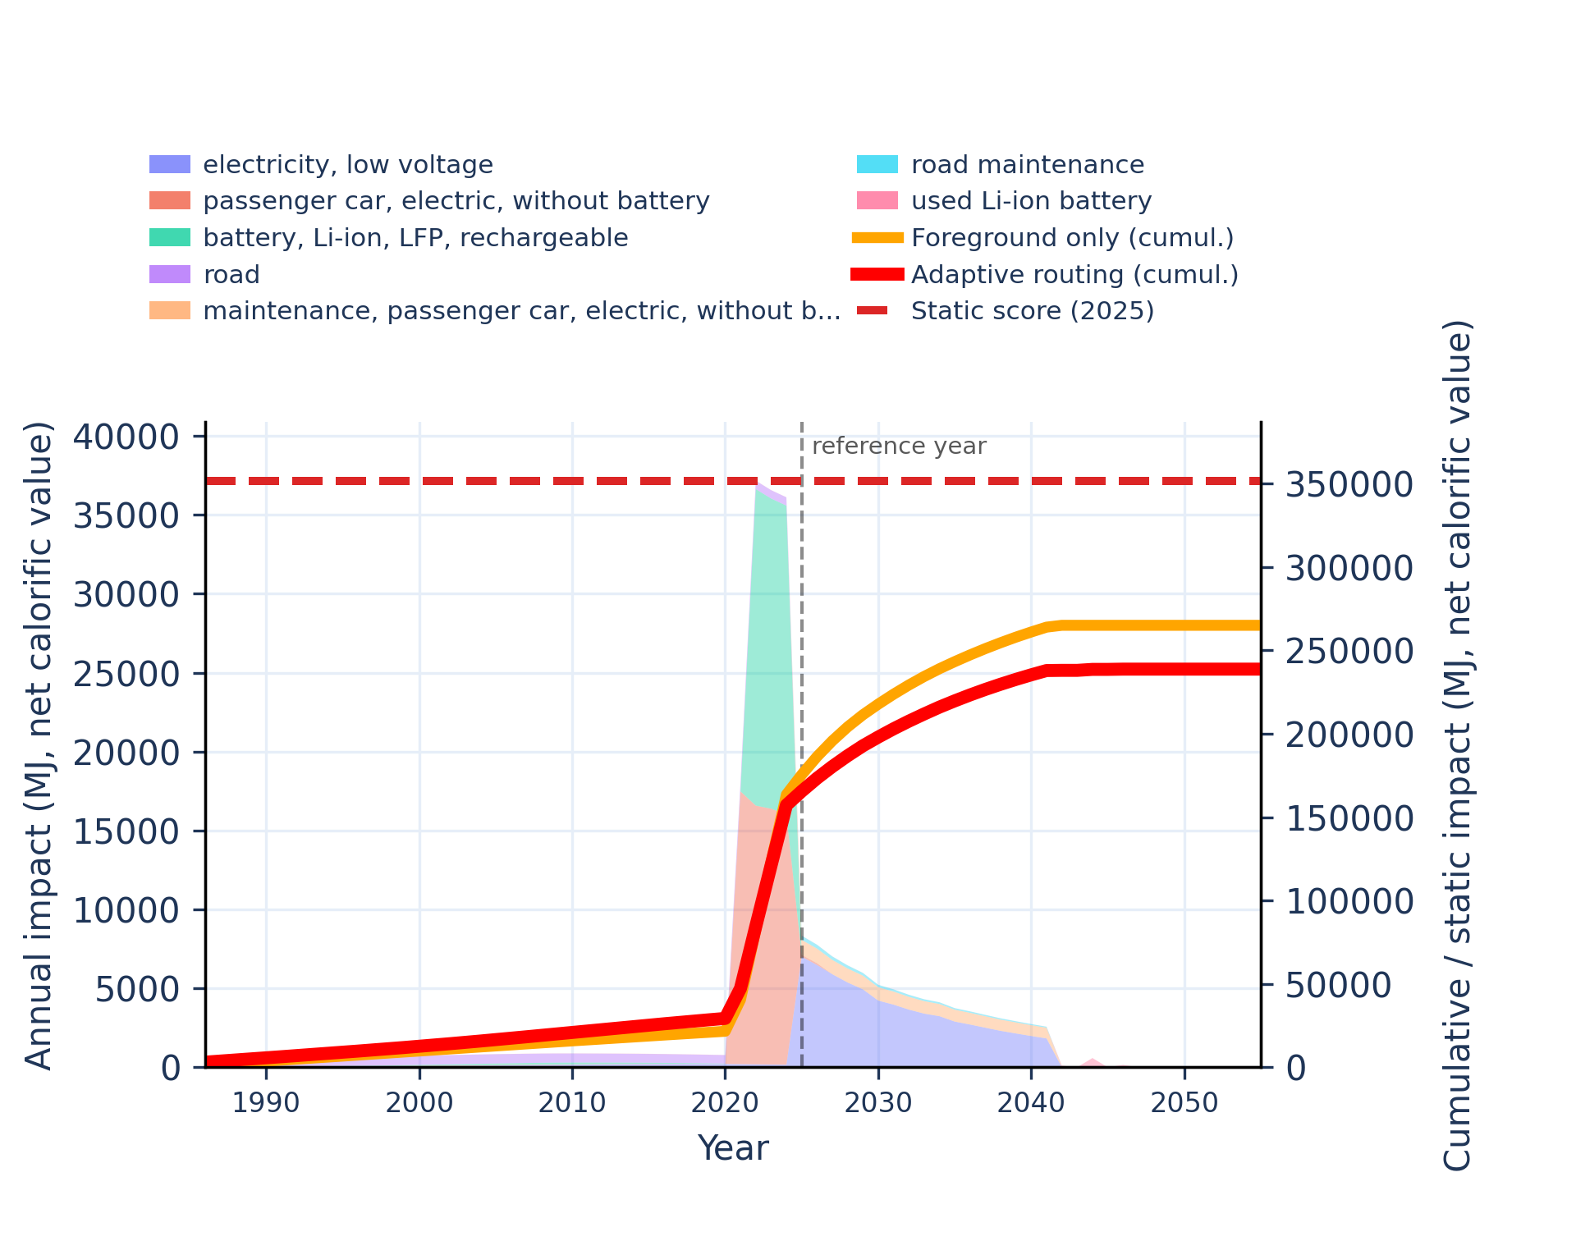
Figure S-routing-bev-10. eutrophication: freshwater - fraction of nutrients reaching freshwater end compartment (P).
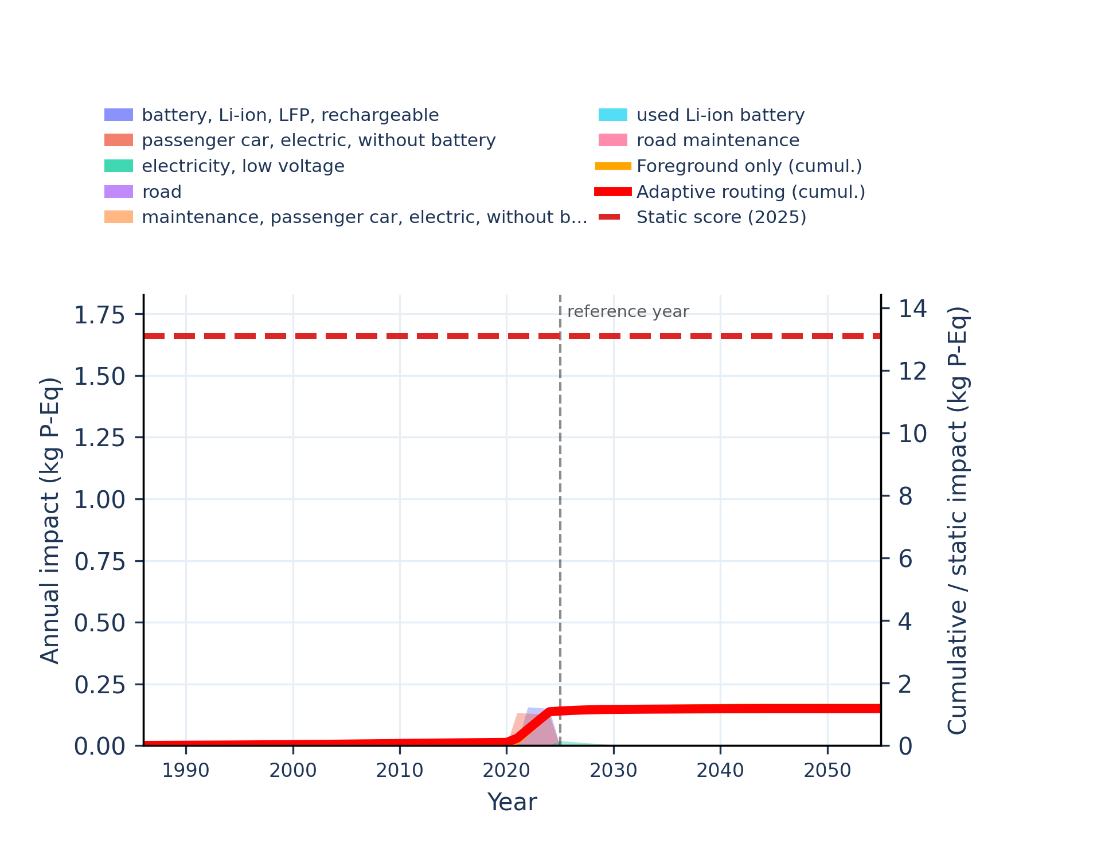 | 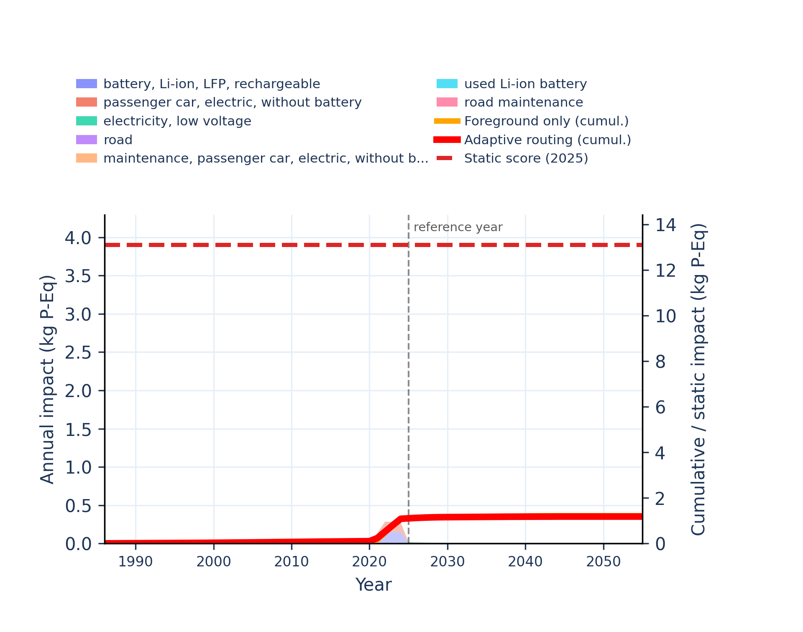
Figure S-routing-bev-11. eutrophication: marine - fraction of nutrients reaching marine end compartment (N).
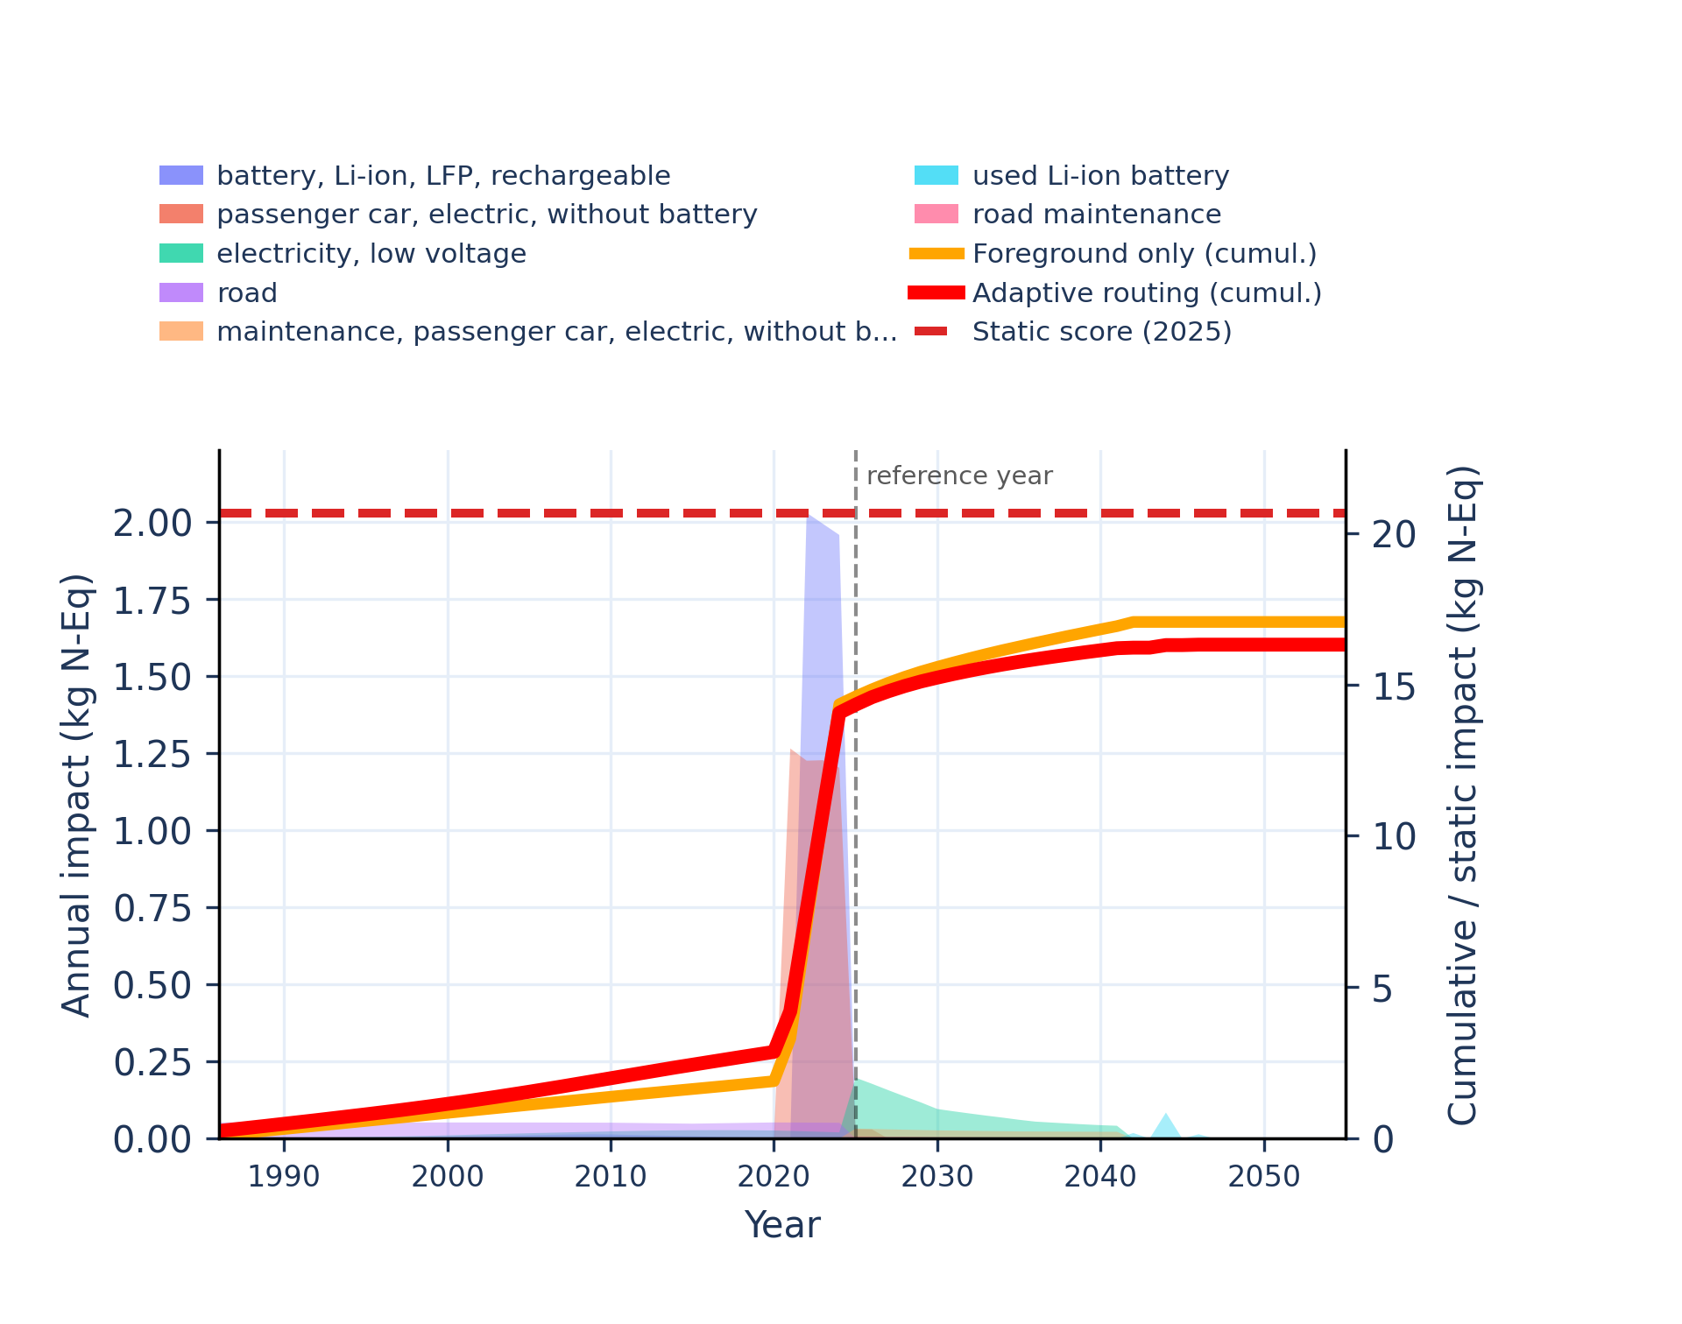 | 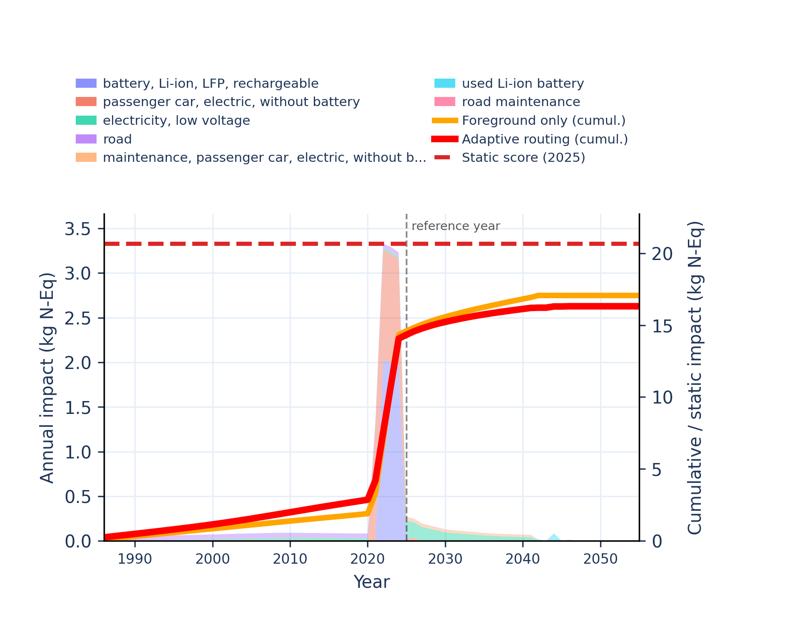
Figure S-routing-bev-12. eutrophication: terrestrial - accumulated exceedance (AE).
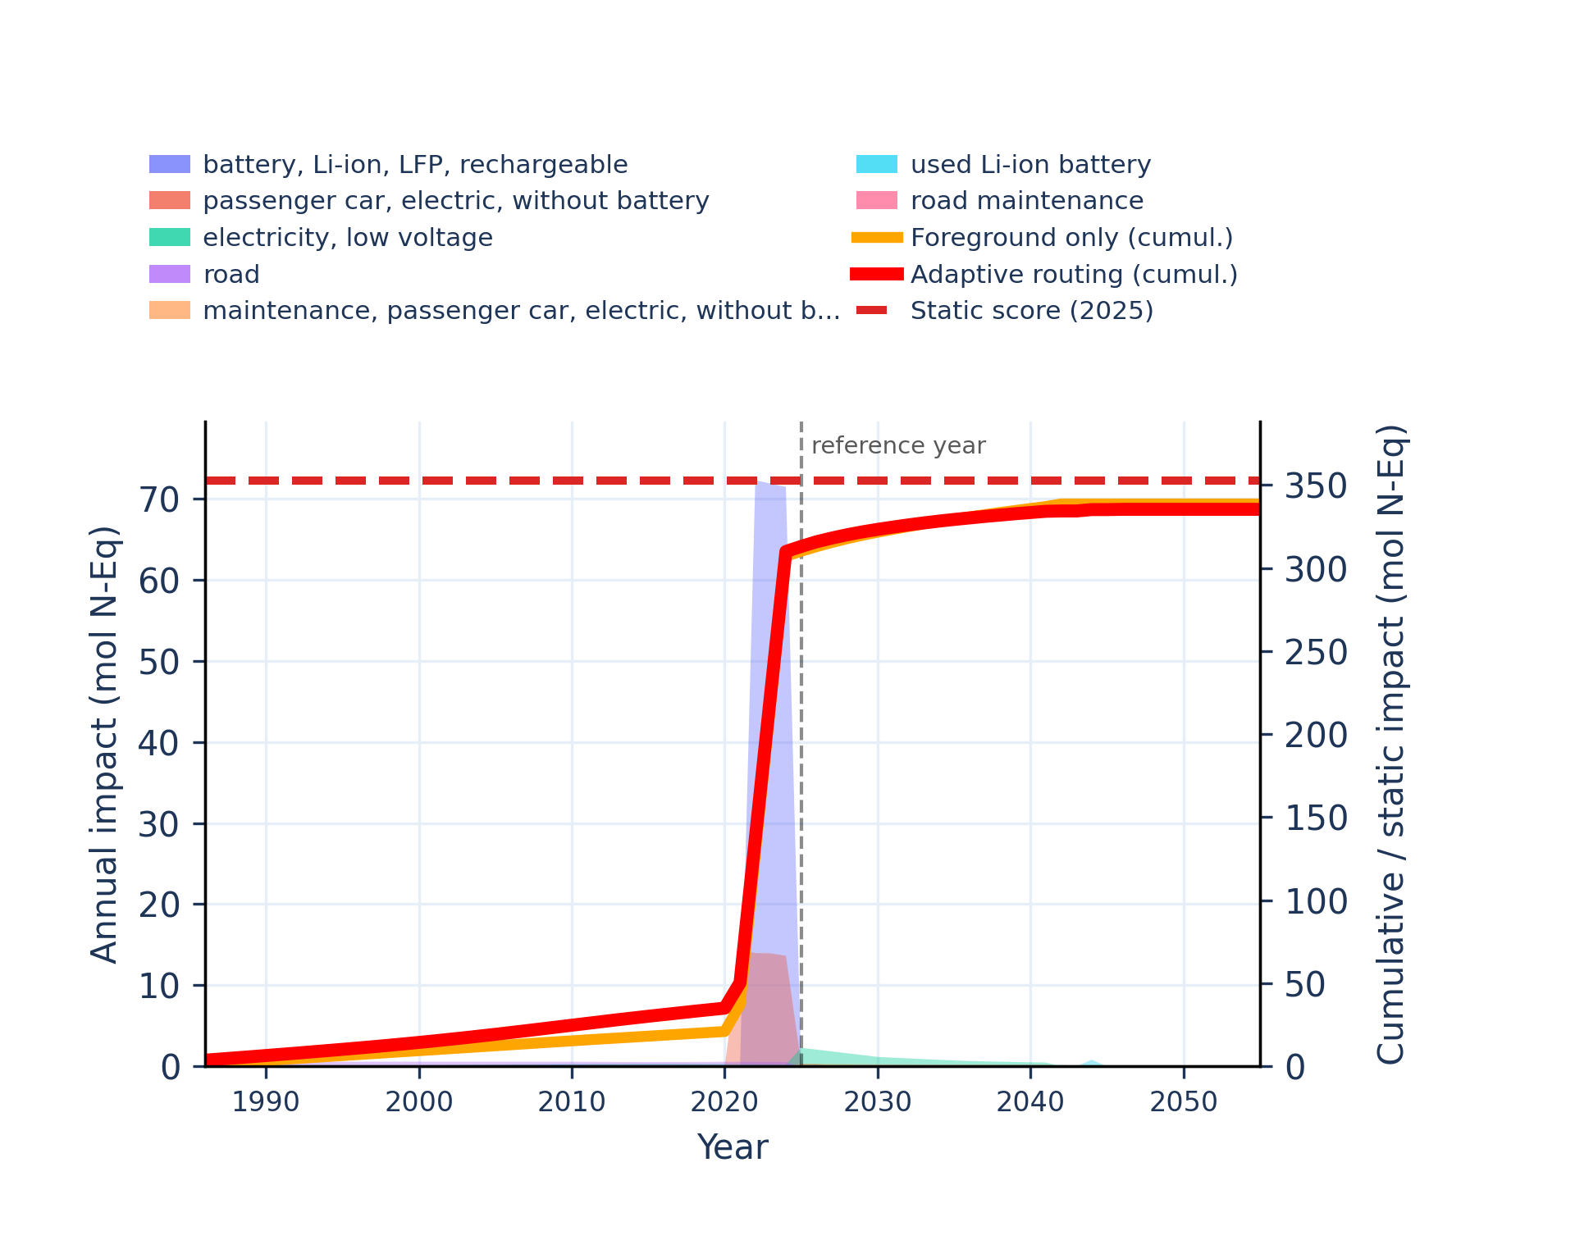 | 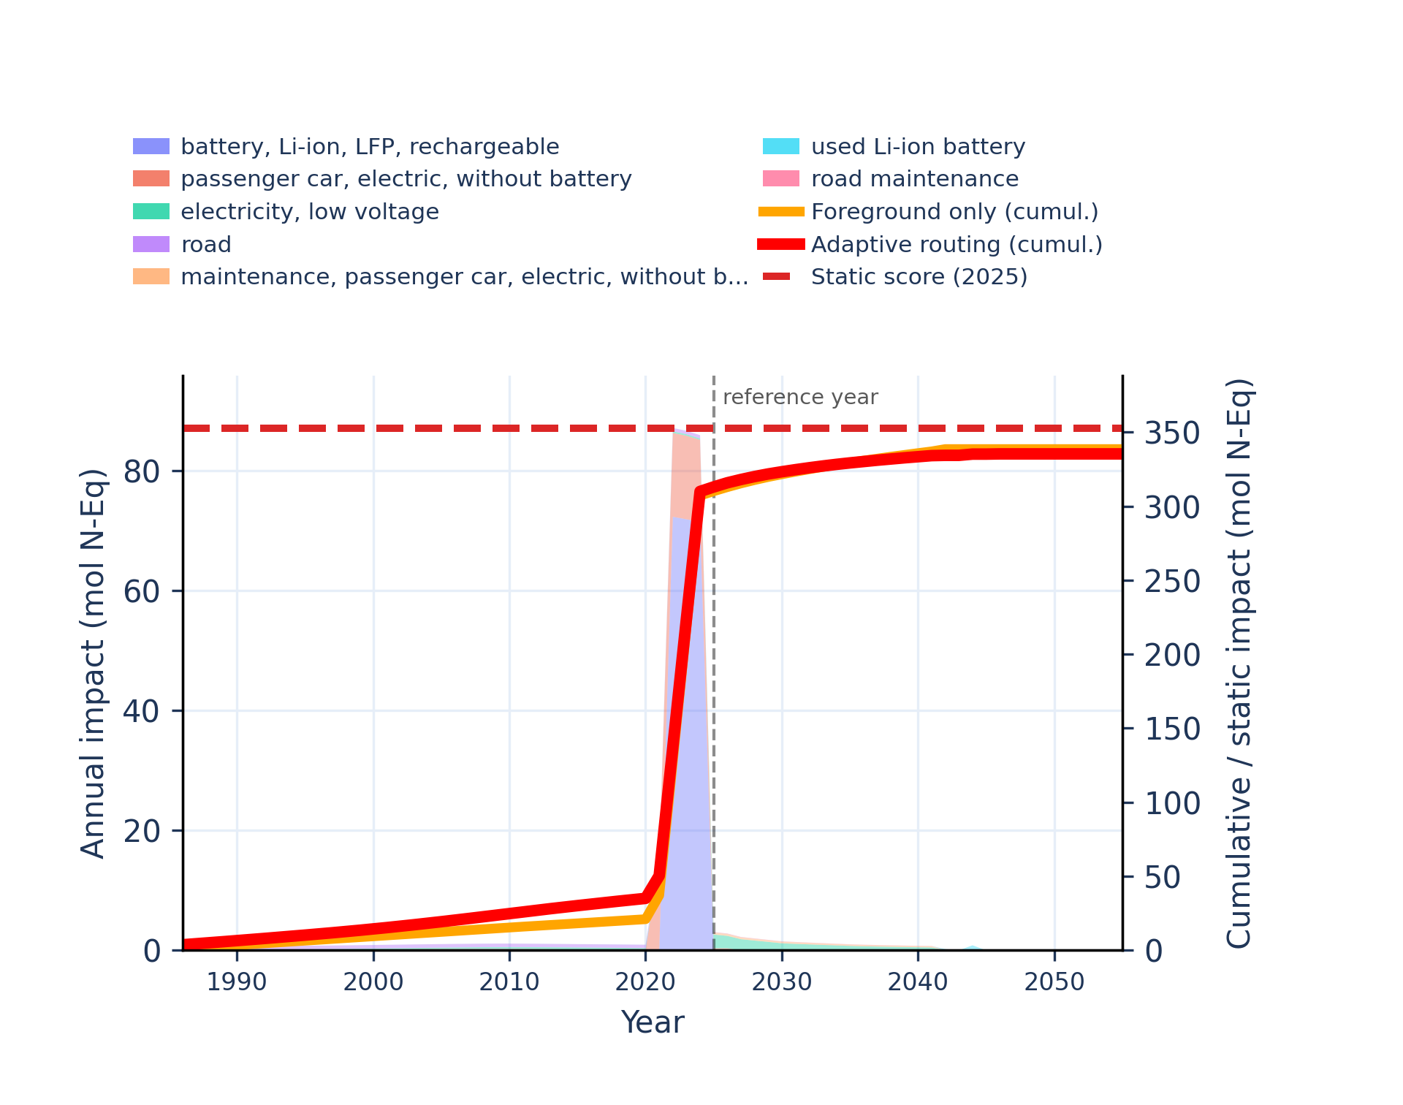
Figure S-routing-bev-13. human toxicity: carcinogenic - comparative toxic unit for human (CTUh).
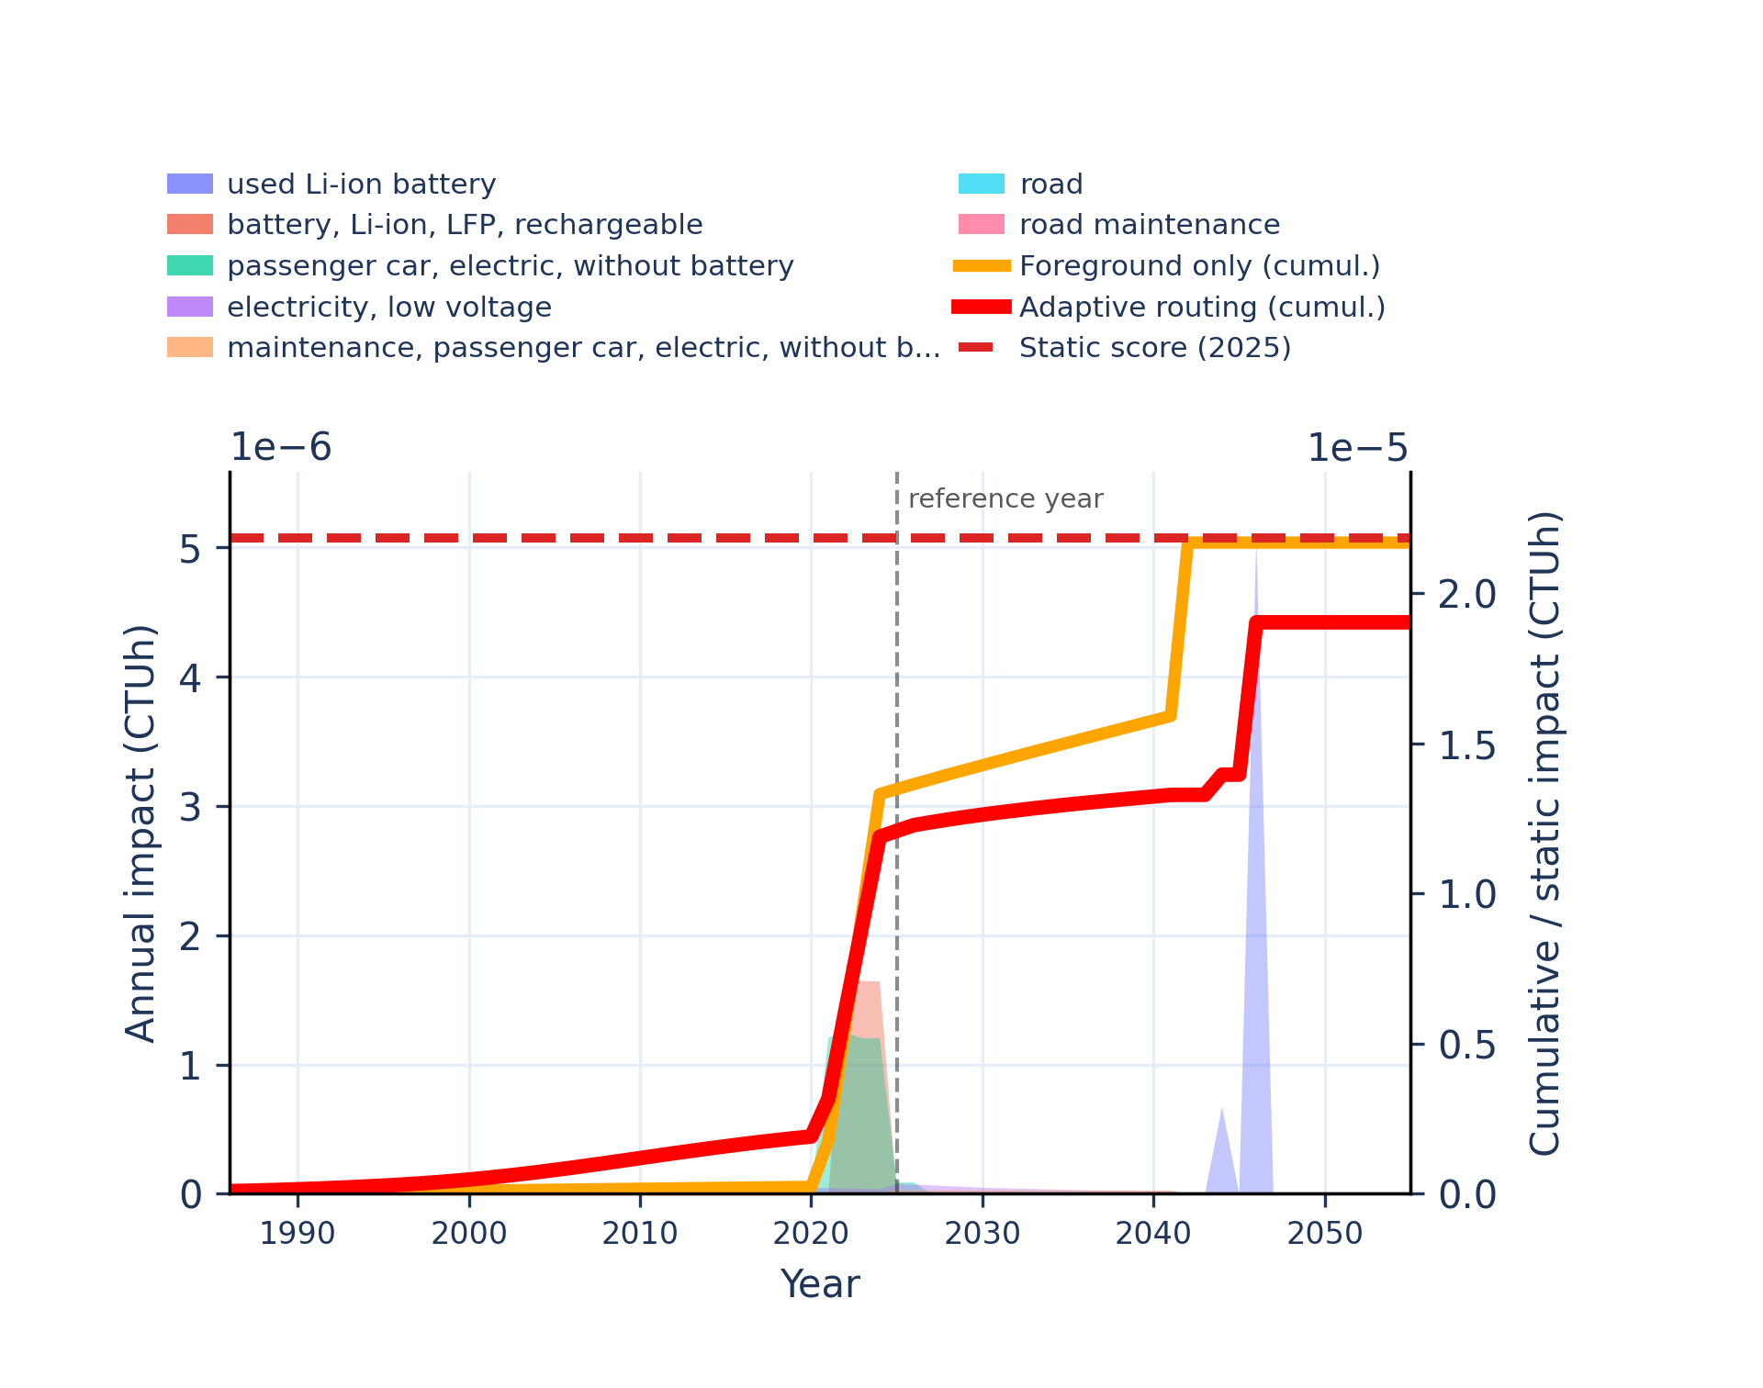 | 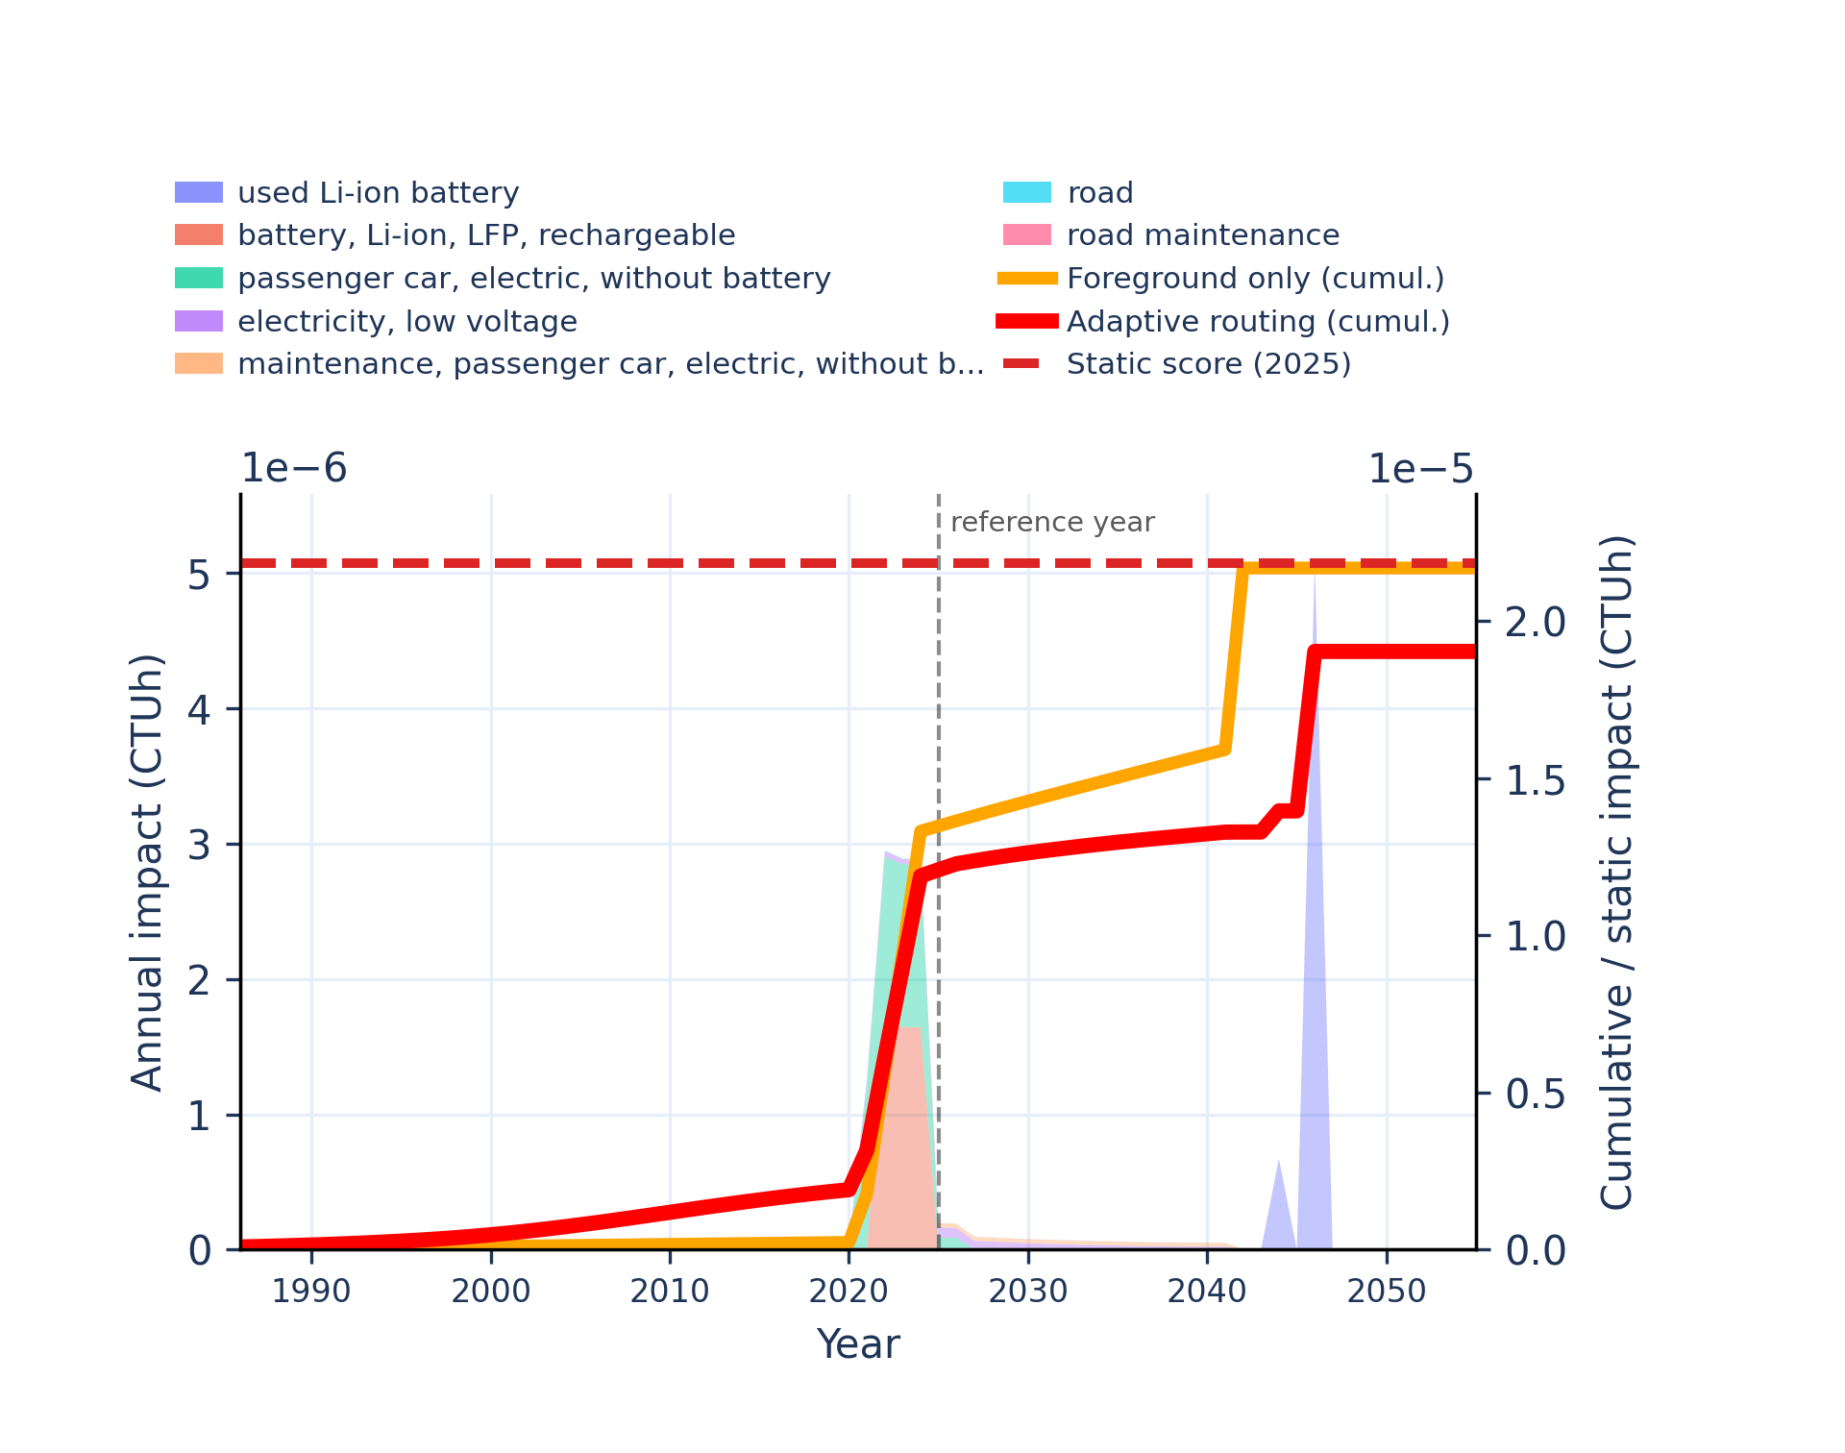
Figure S-routing-bev-14. human toxicity: carcinogenic, inorganics - comparative toxic unit for human (CTUh).
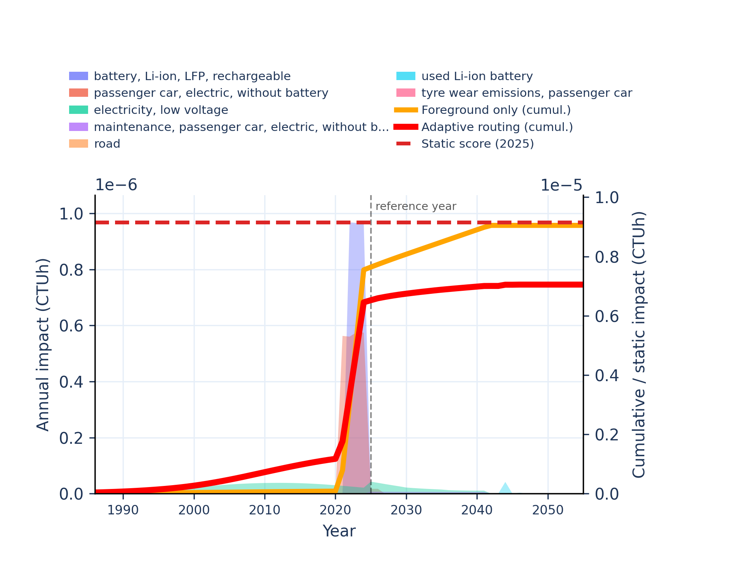 | 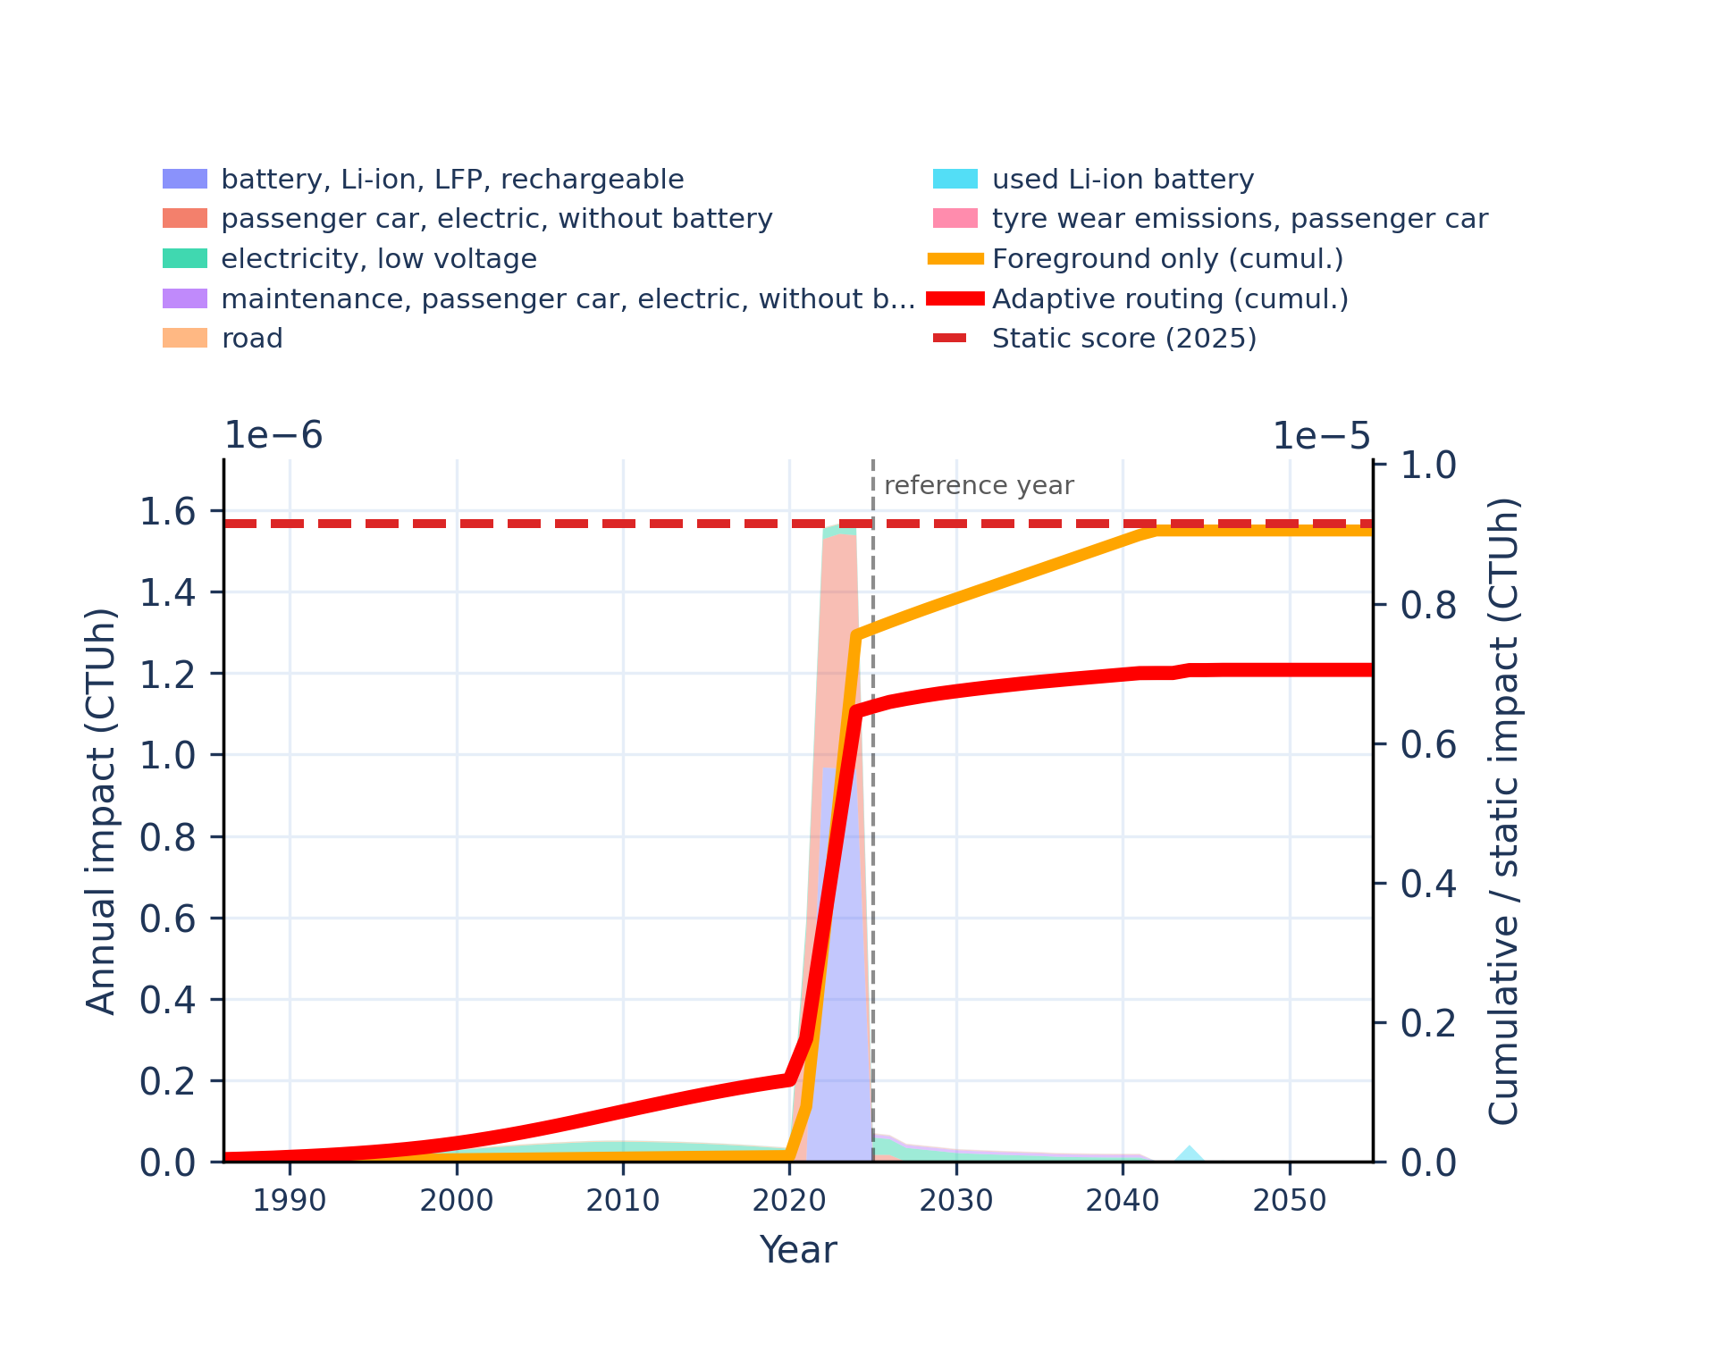
Figure S-routing-bev-15. human toxicity: carcinogenic, organics - comparative toxic unit for human (CTUh).
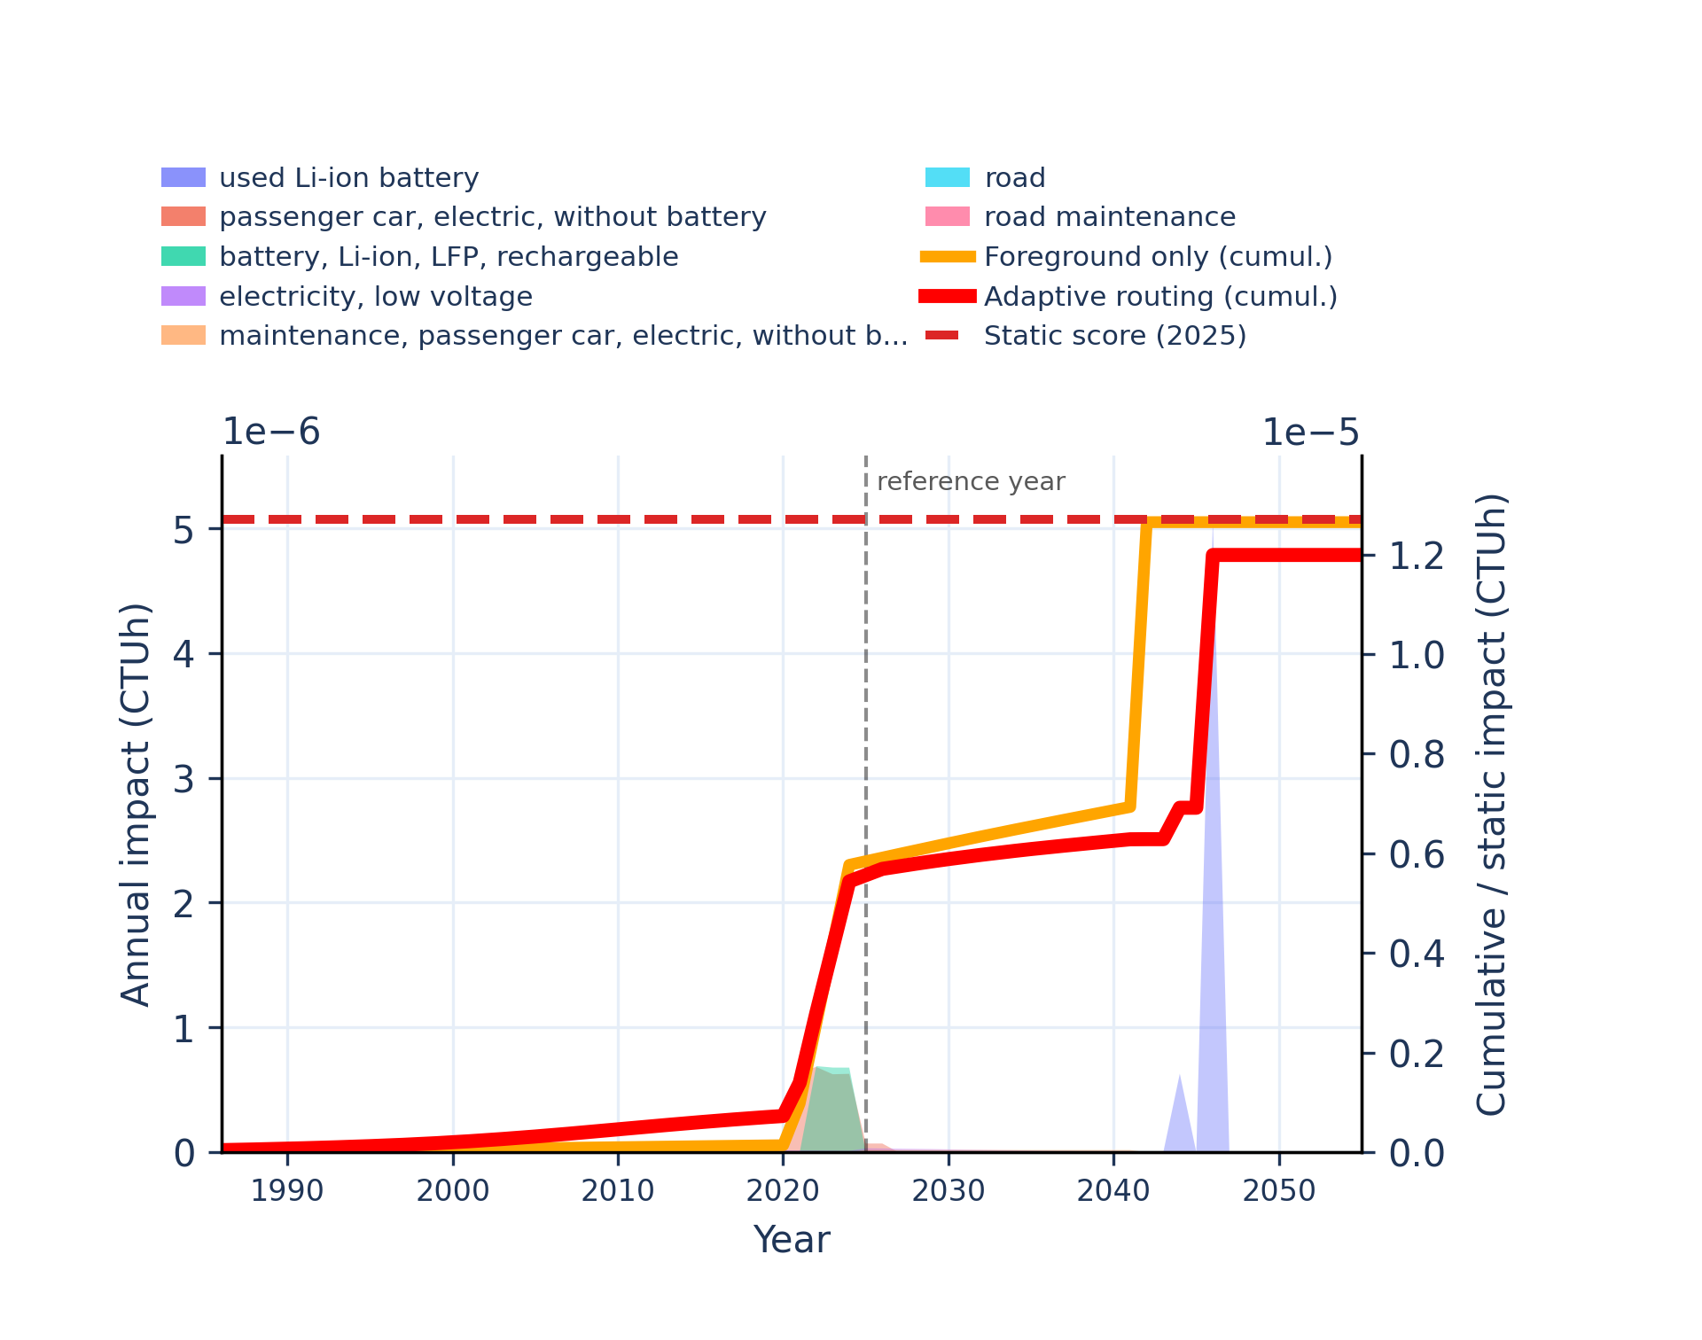 | 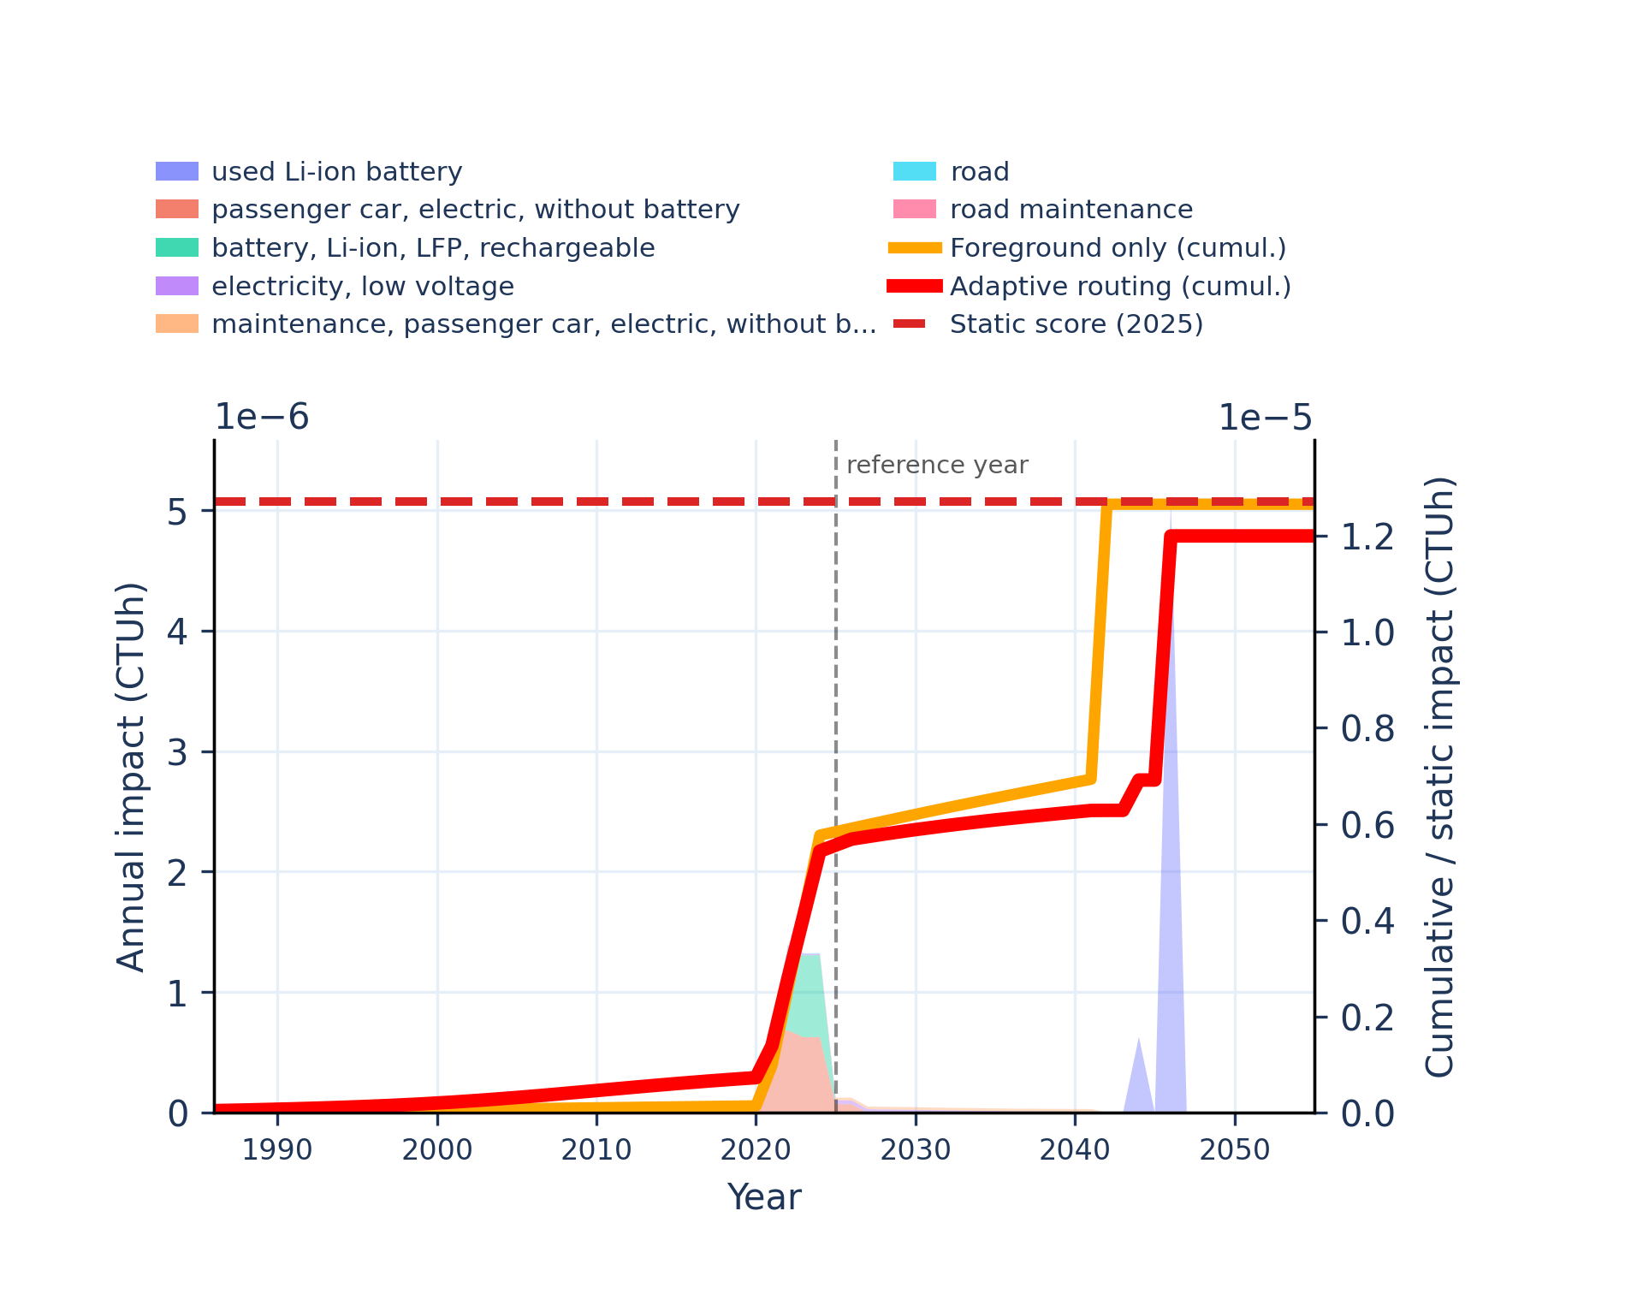
Figure S-routing-bev-16. human toxicity: non-carcinogenic - comparative toxic unit for human (CTUh).
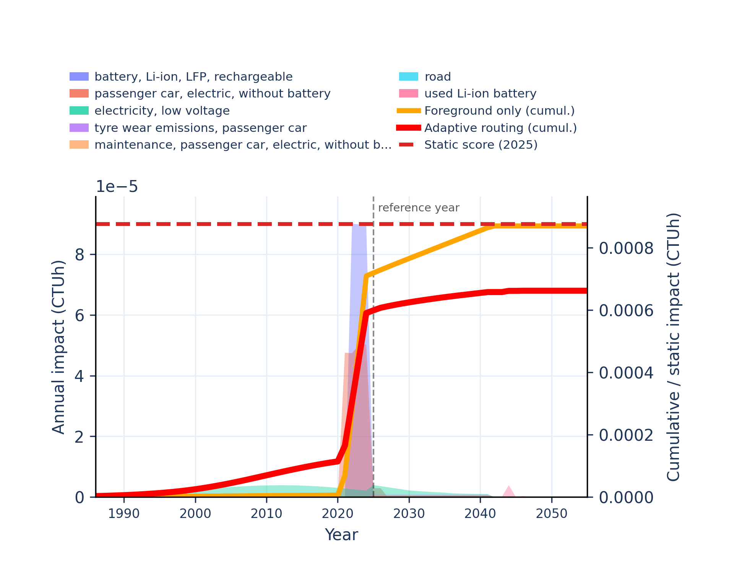 | 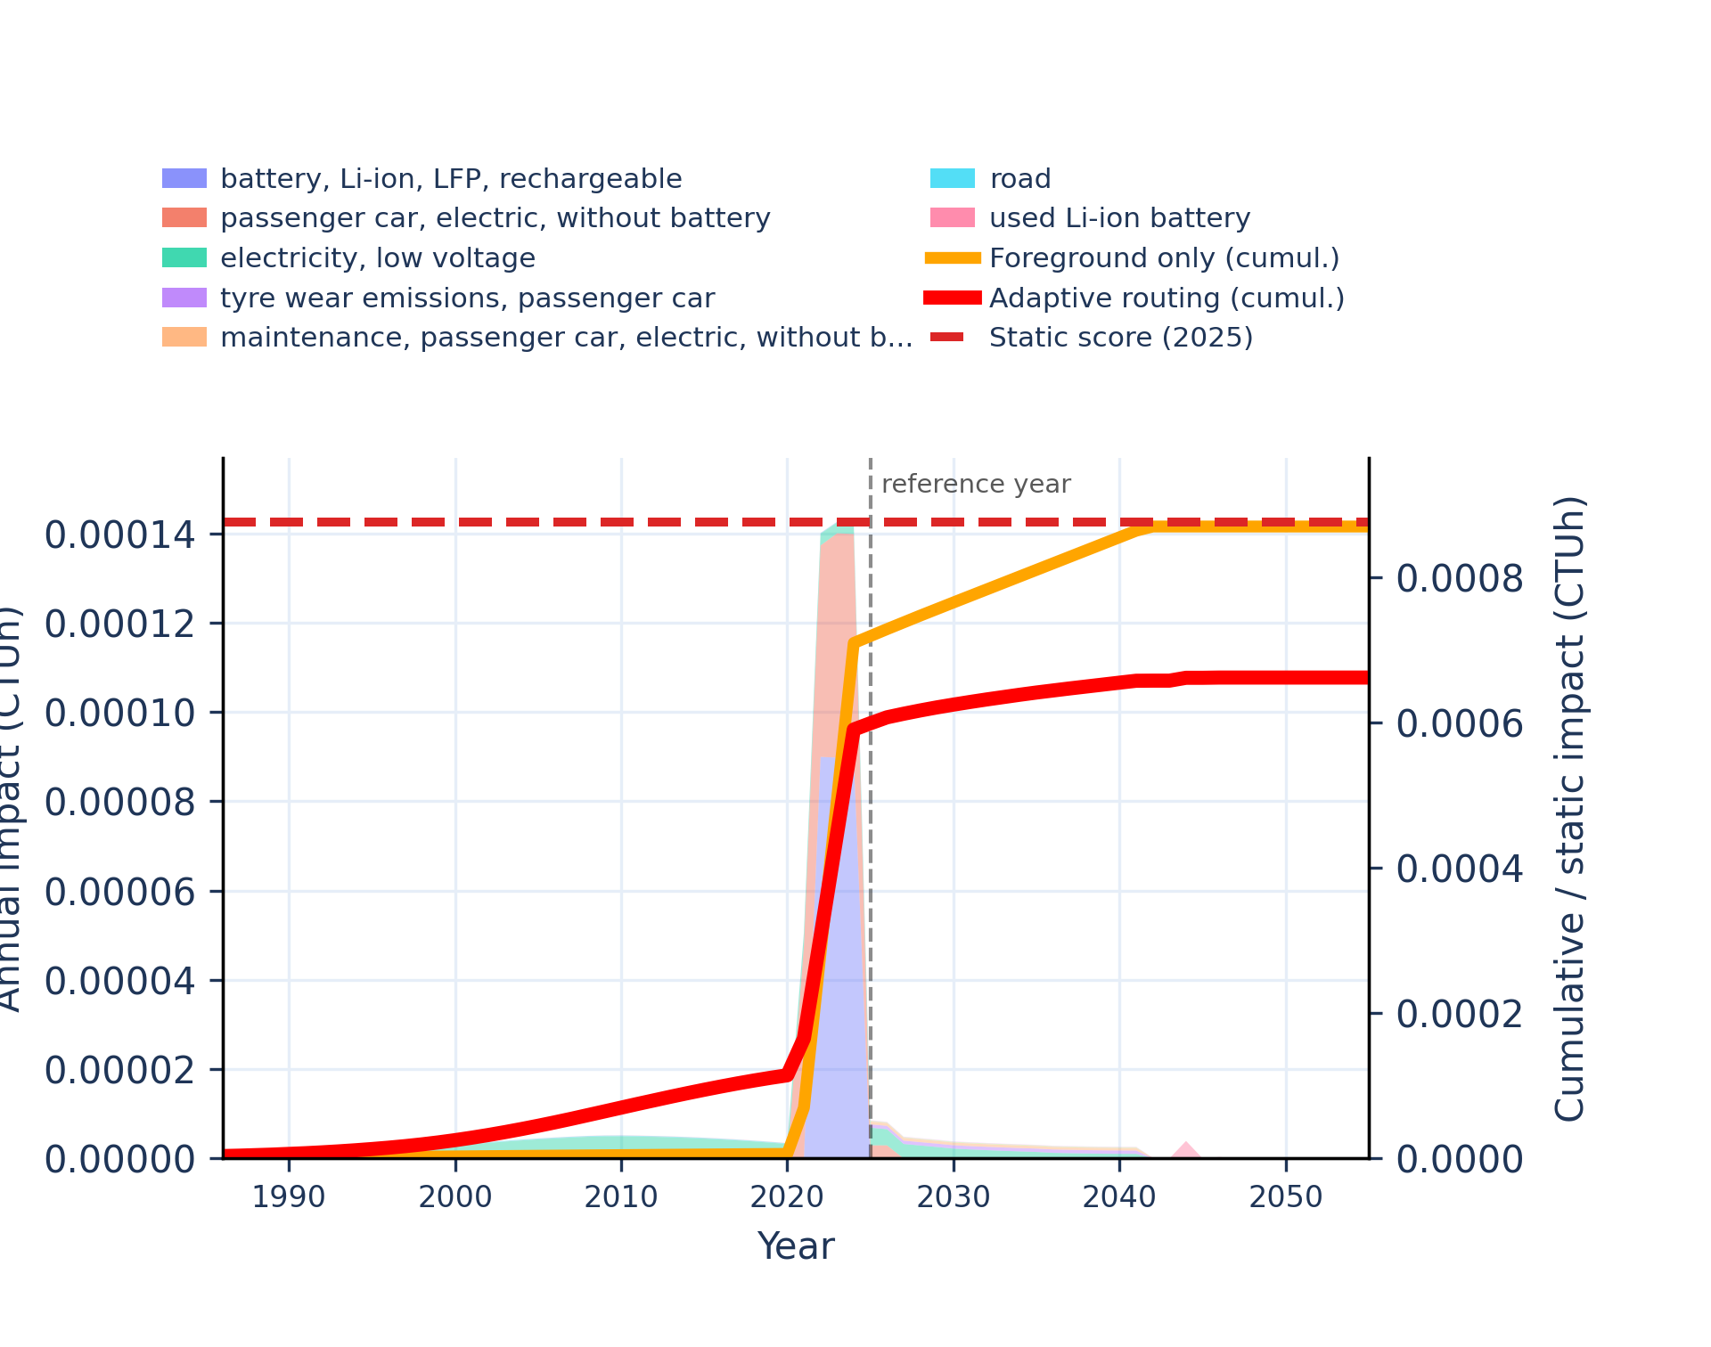
Figure S-routing-bev-17. human toxicity: non-carcinogenic, inorganics - comparative toxic unit for human (CTUh).
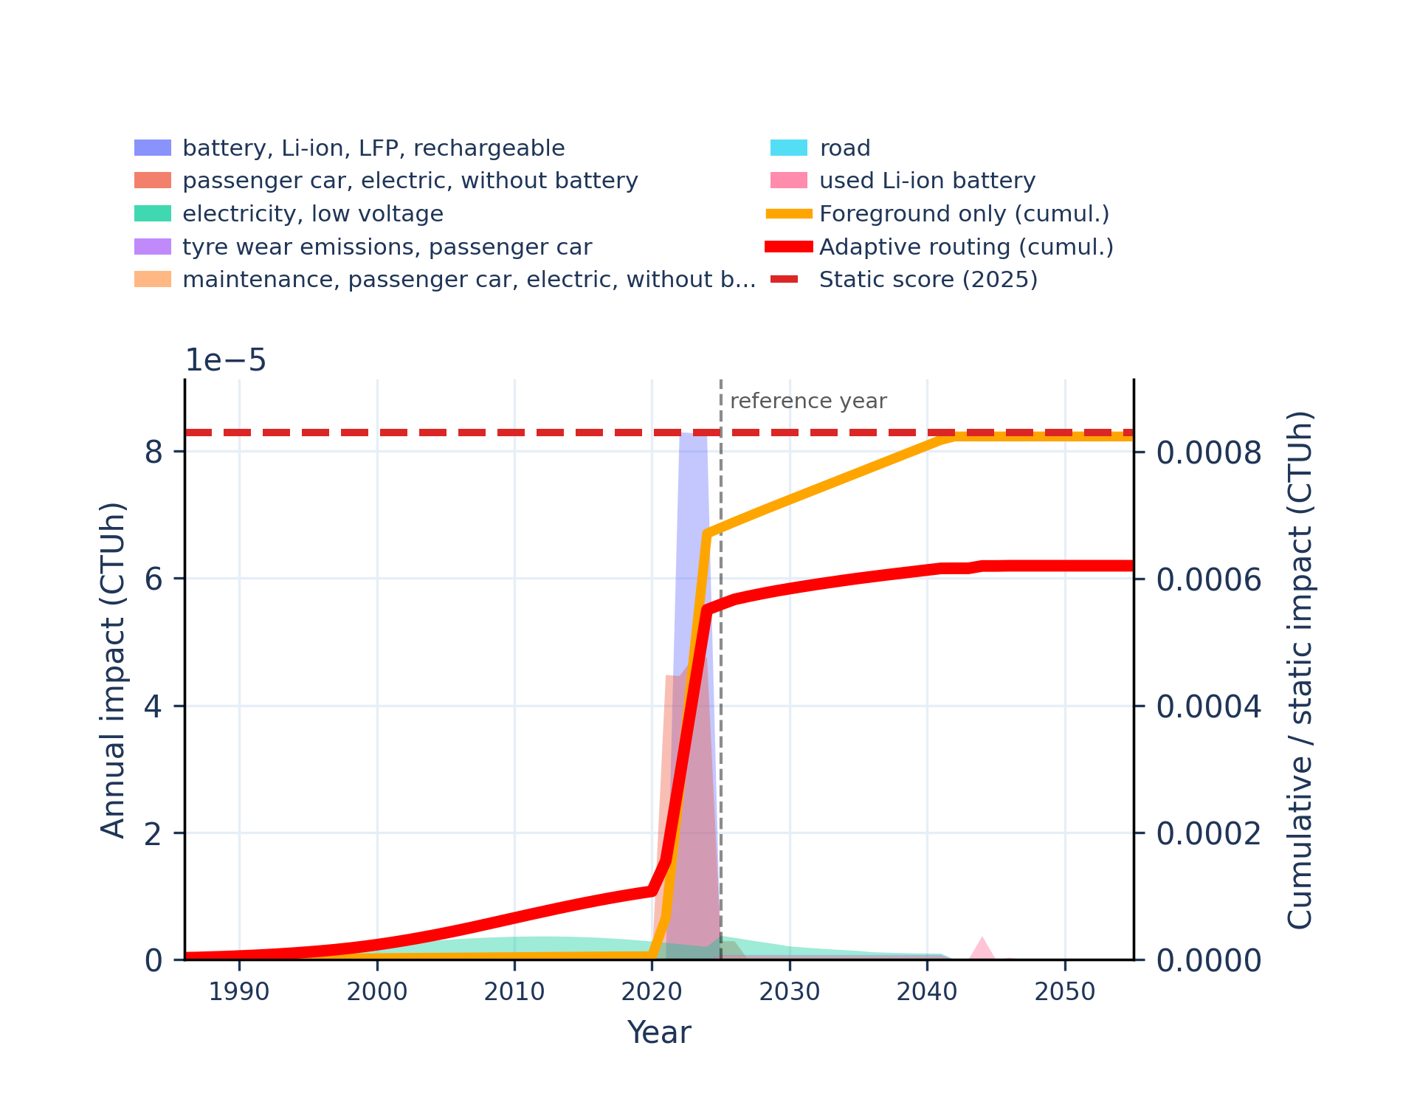 | 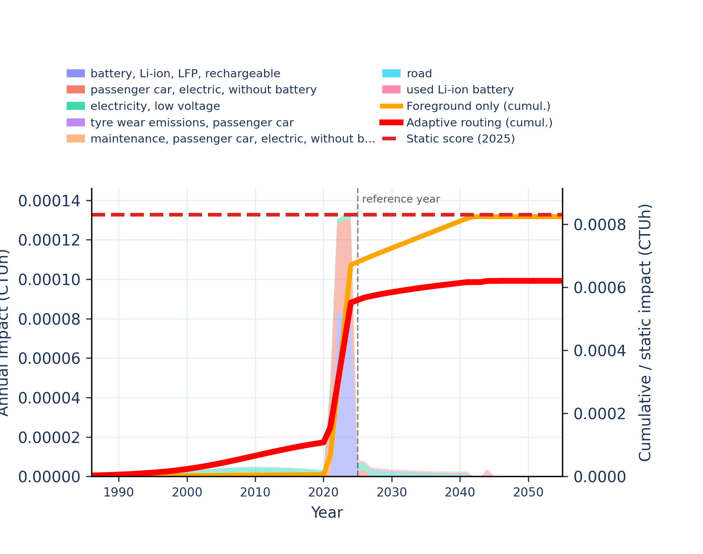
Figure S-routing-bev-18. human toxicity: non-carcinogenic, organics - comparative toxic unit for human (CTUh).
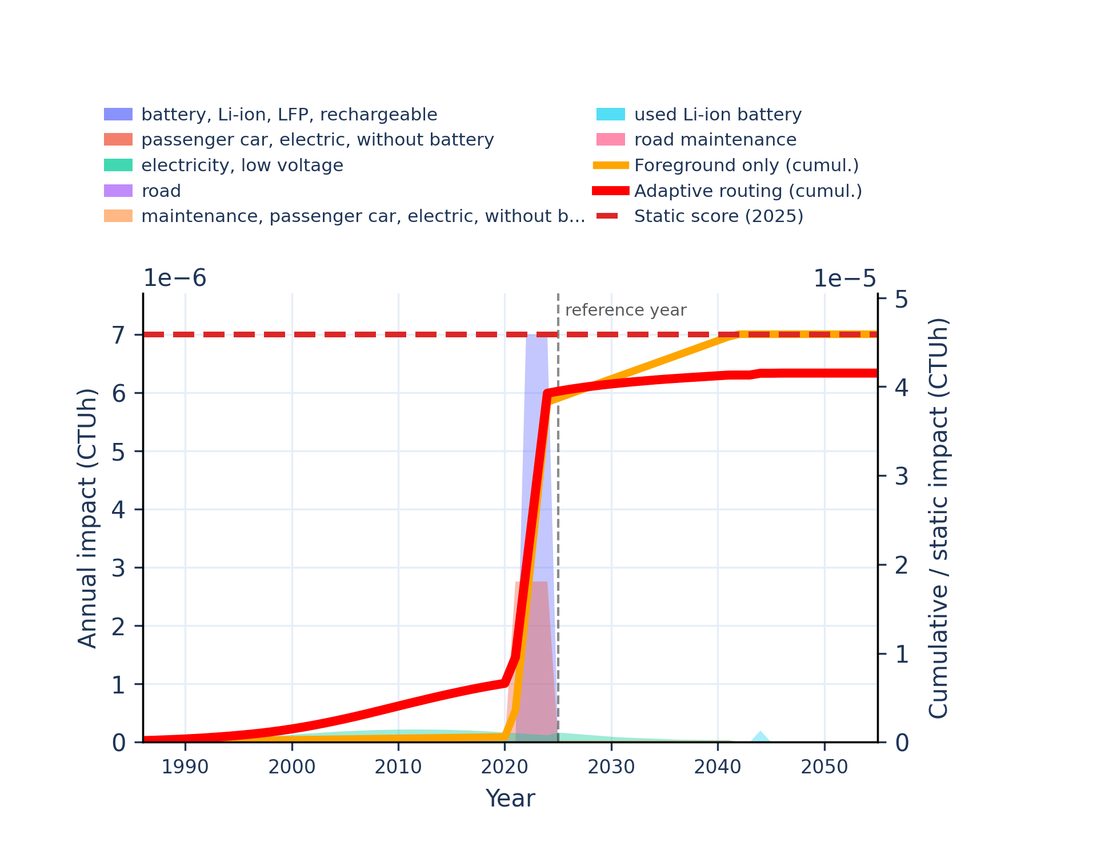 | 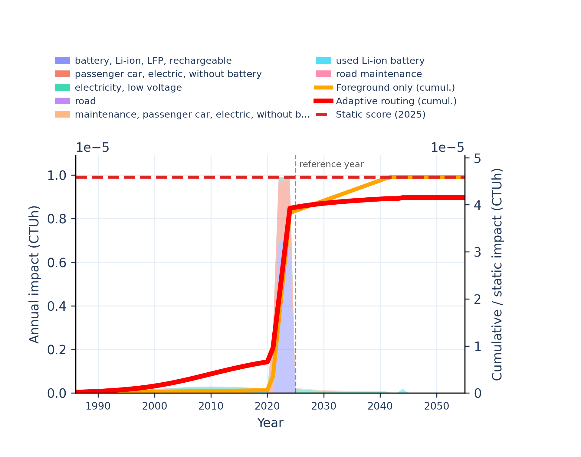
Figure S-routing-bev-19. ionising radiation: human health - human exposure efficiency relative to u235.
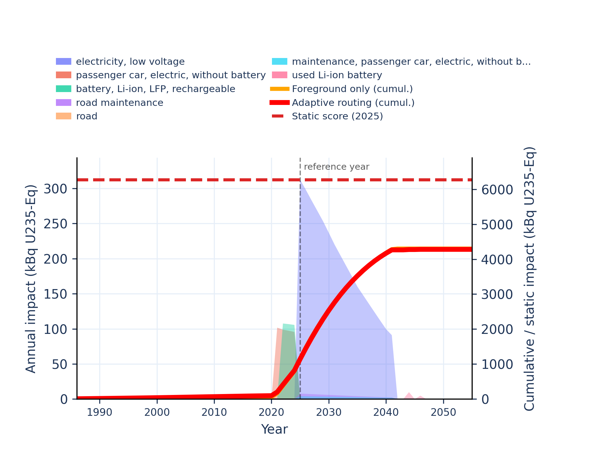 | 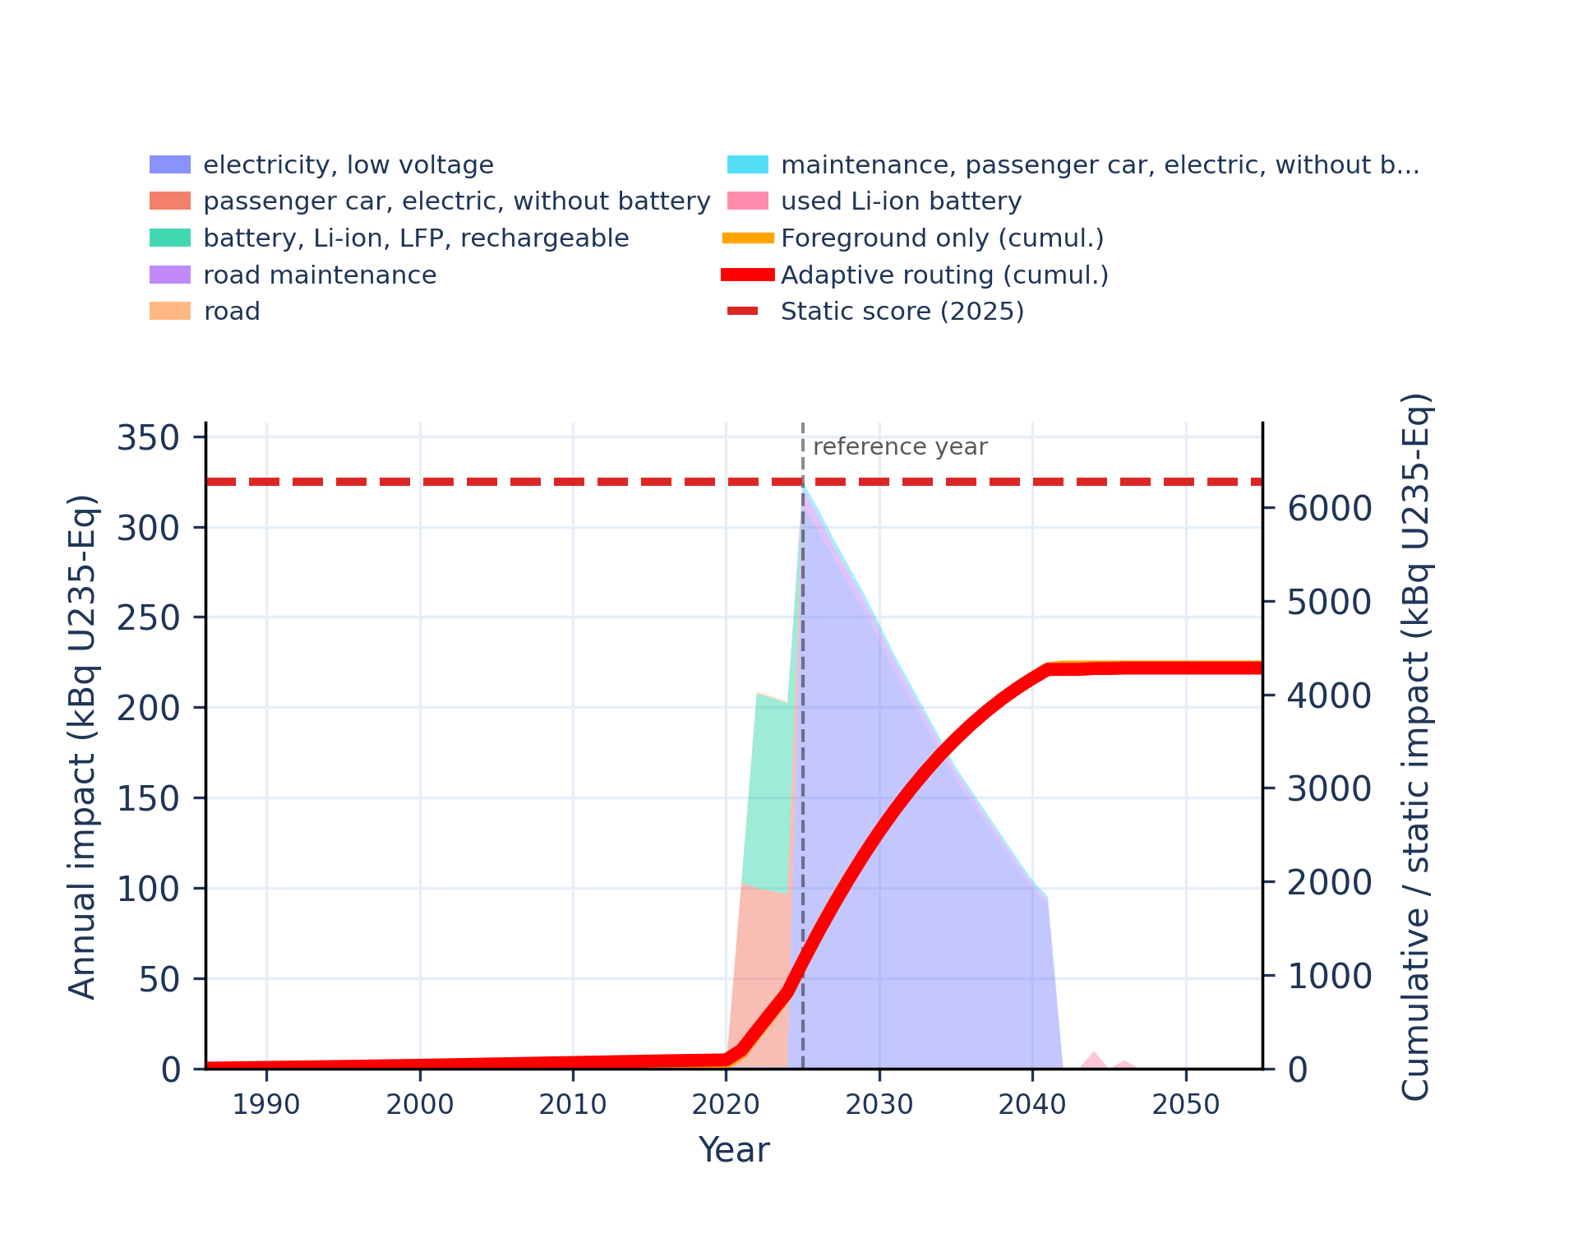
Figure S-routing-bev-20. land use - soil quality index.
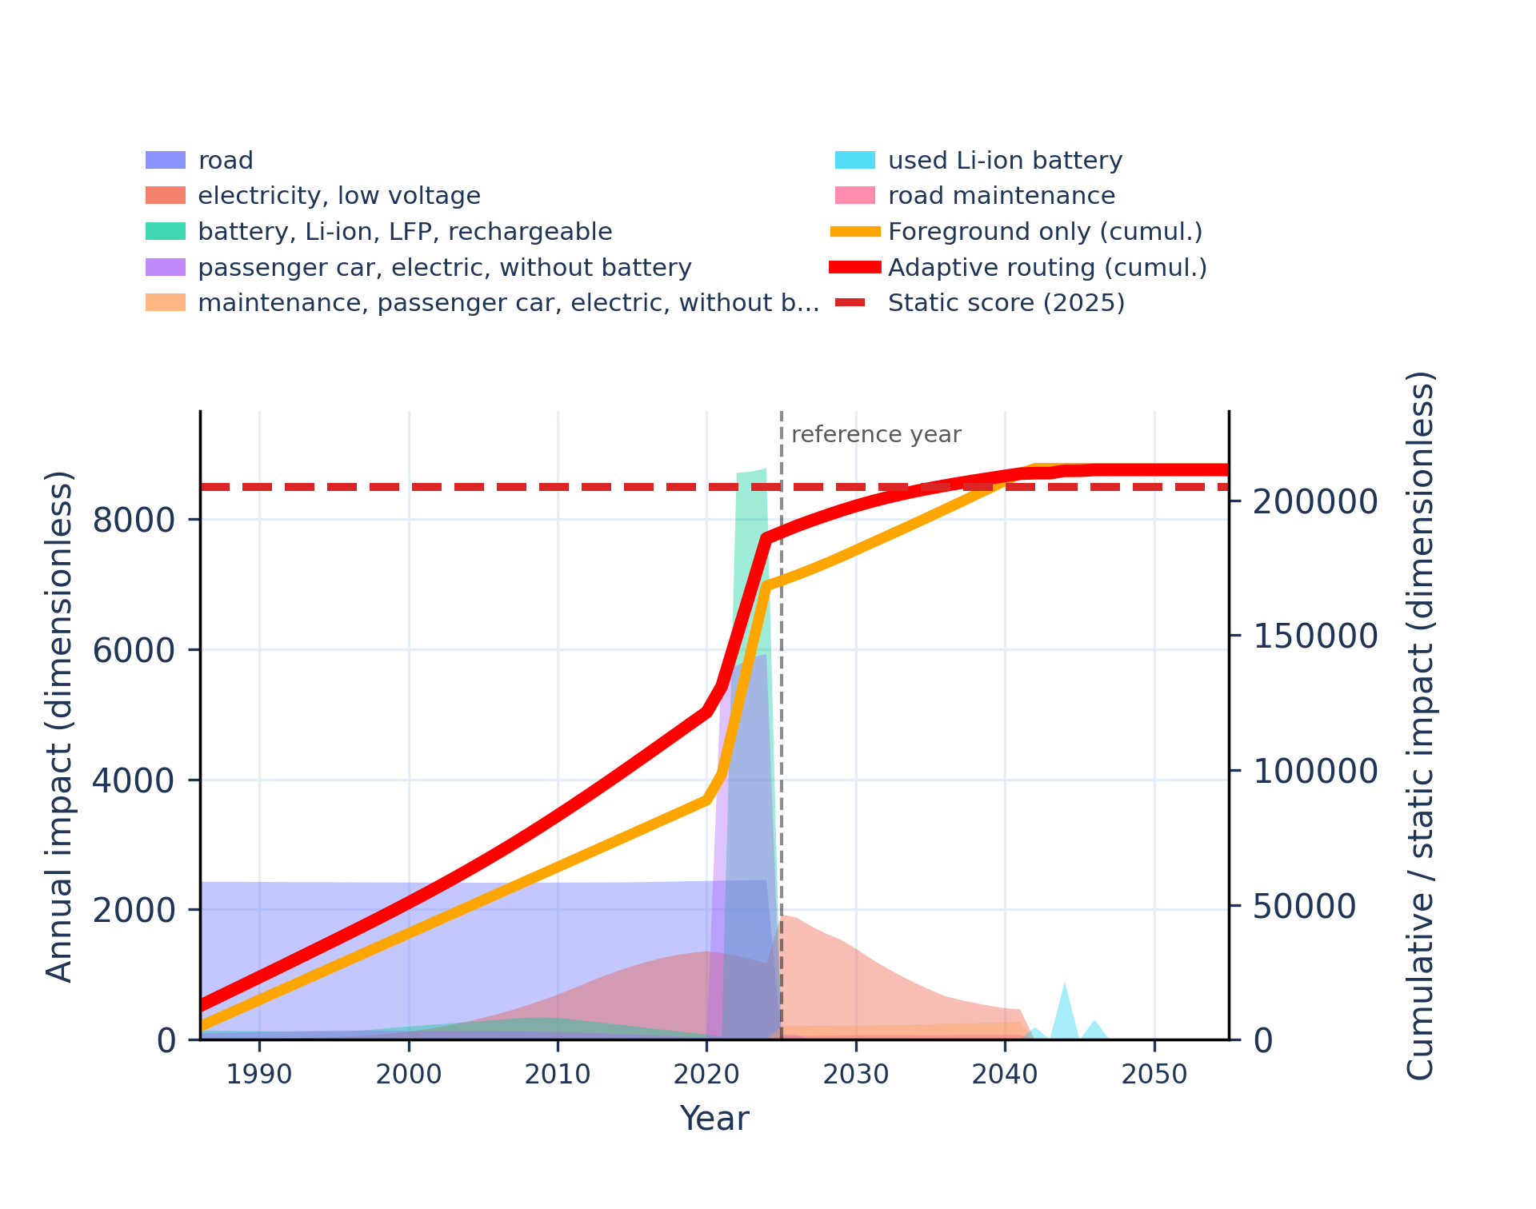 | 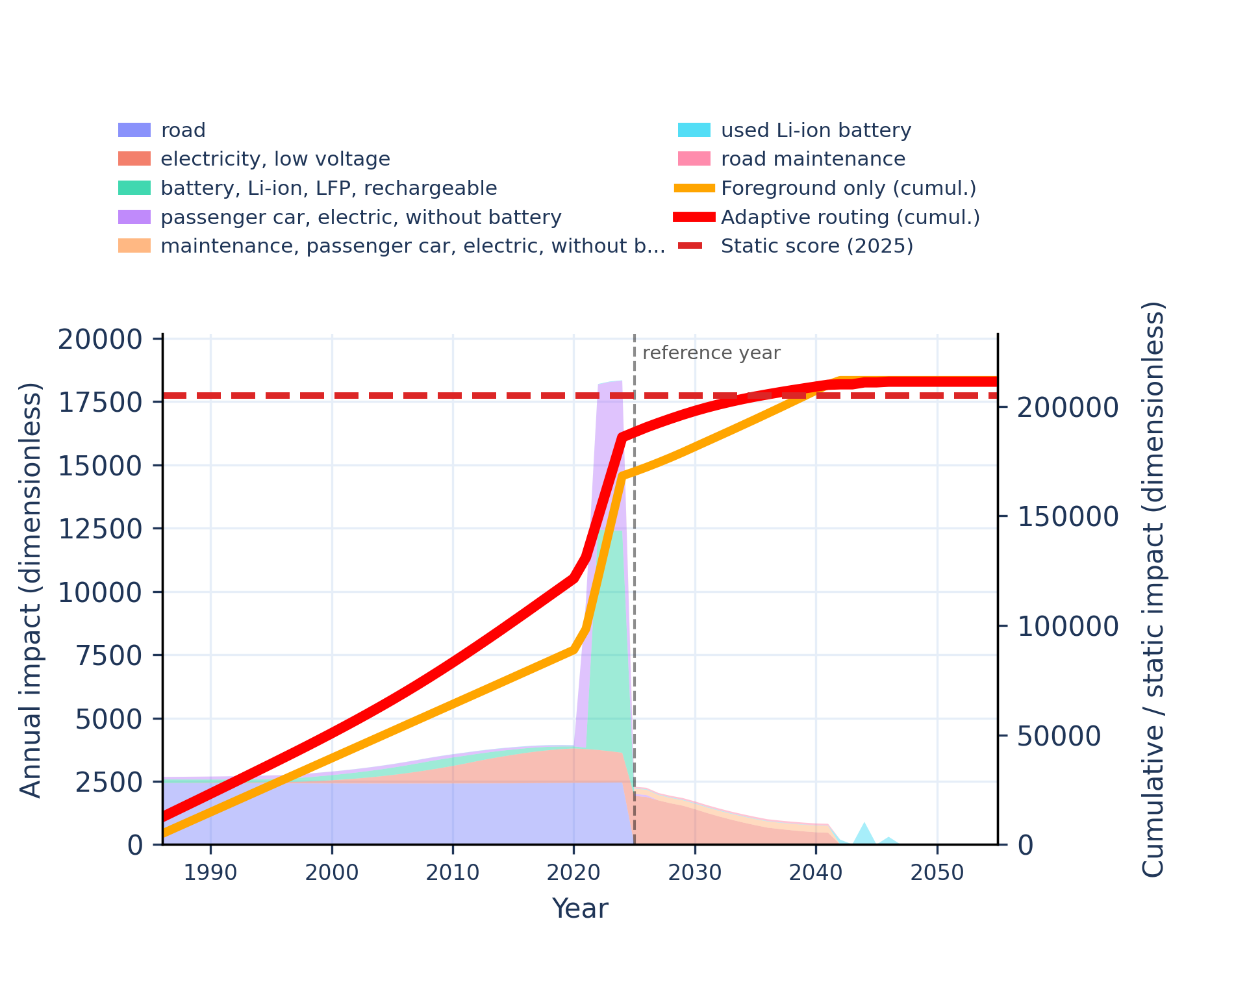
Figure S-routing-bev-21. material resources: metals/minerals - abiotic depletion potential (ADP): elements (ultimate reserves).
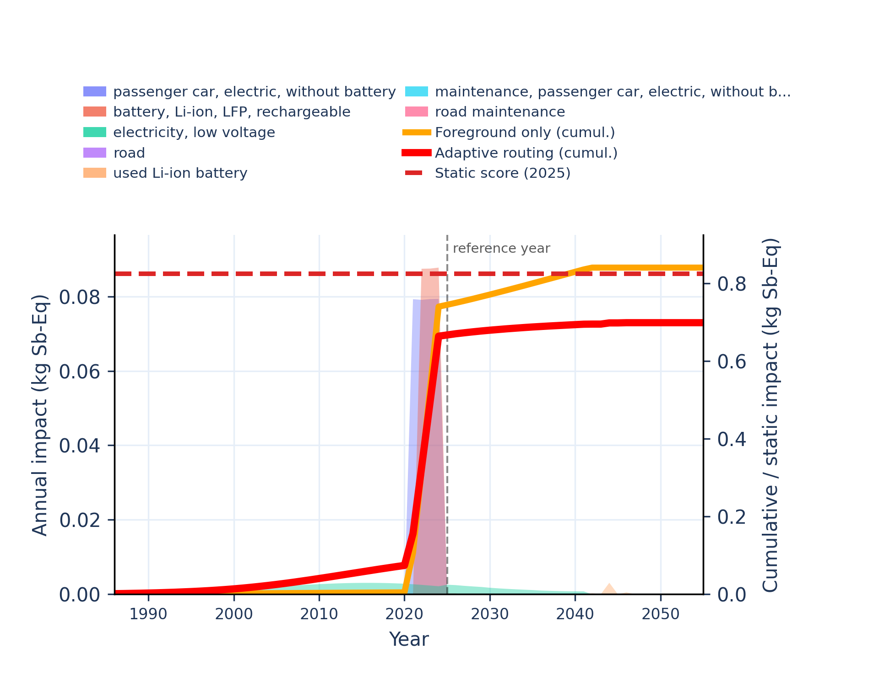 | 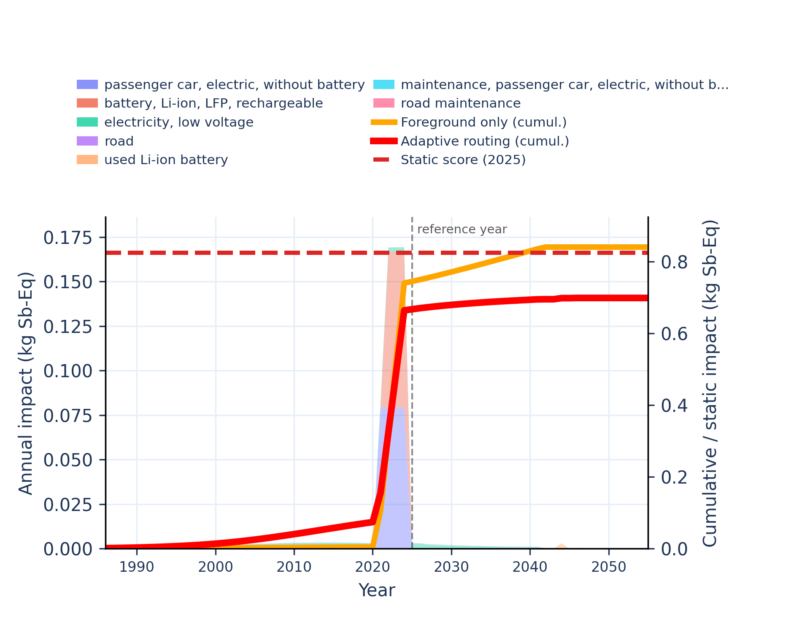
Figure S-routing-bev-22. ozone depletion - ozone depletion potential (ODP).
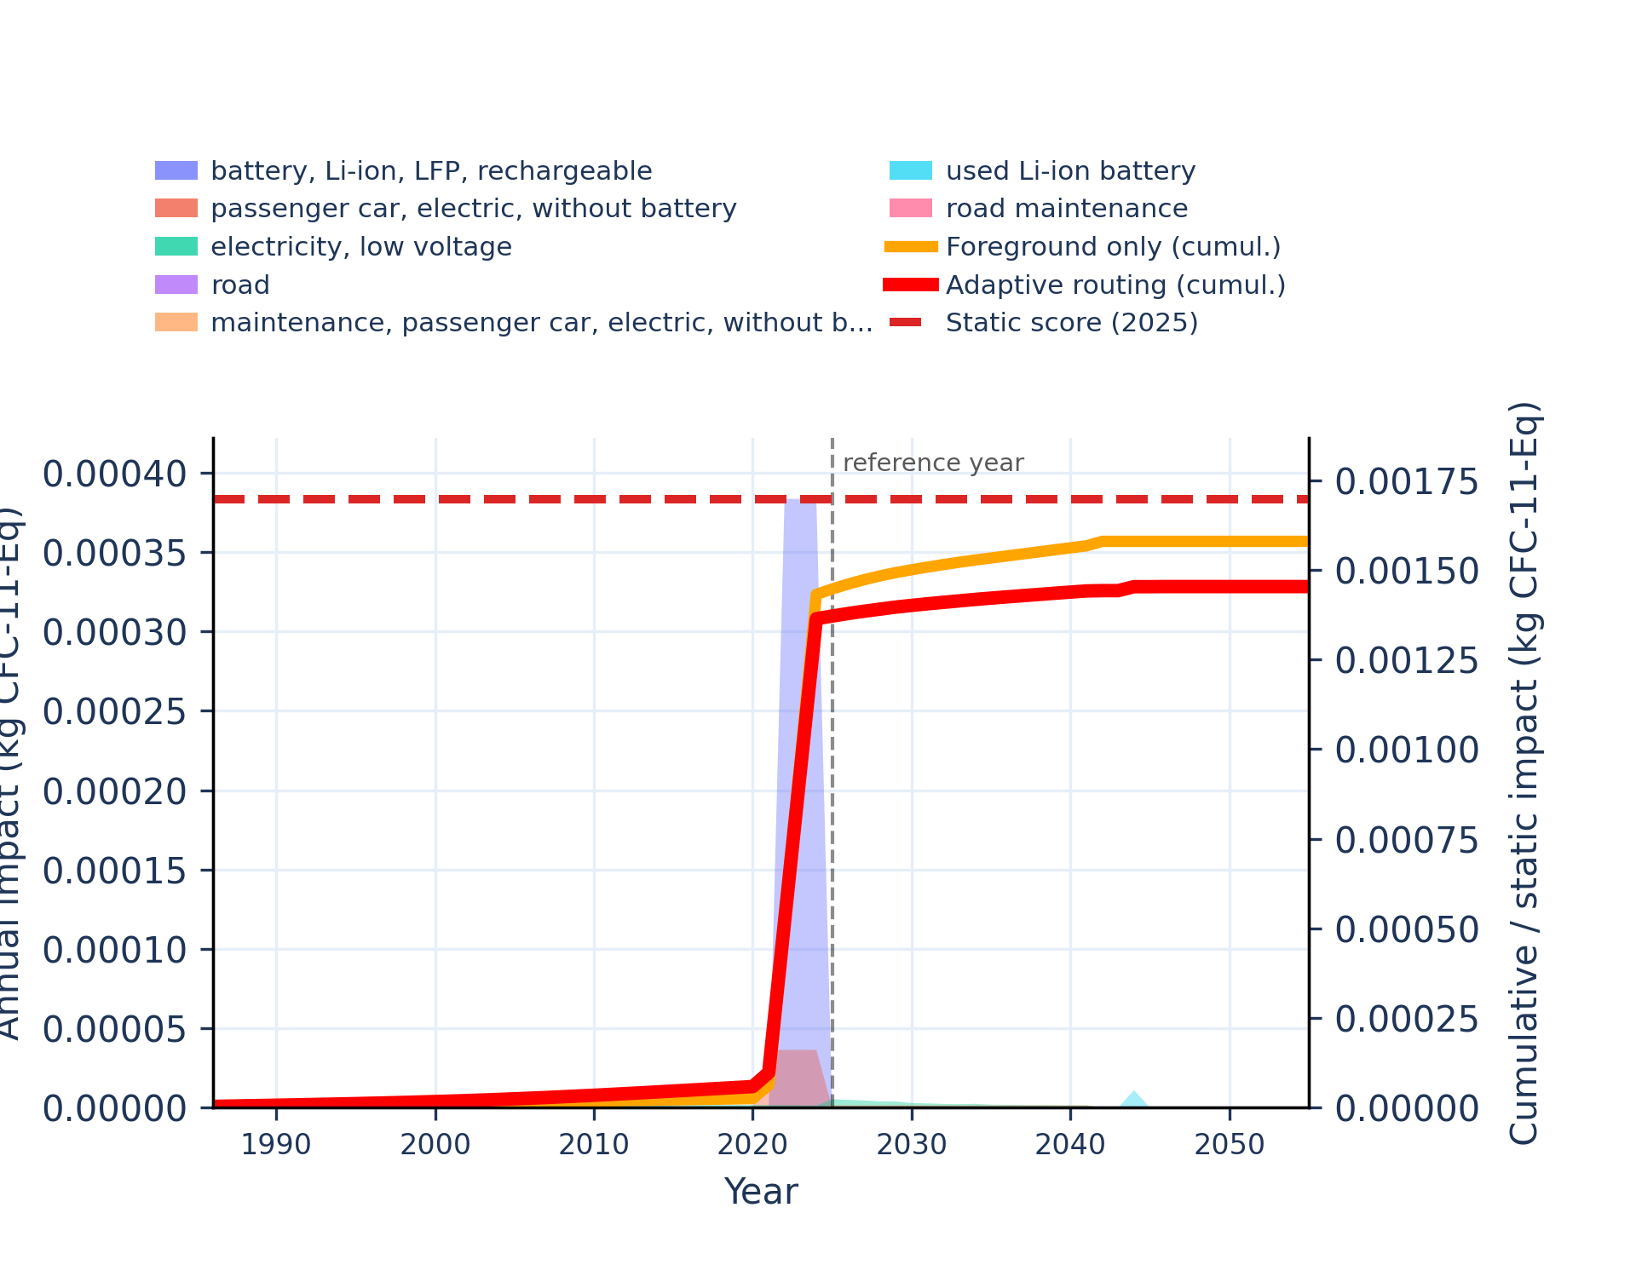 | 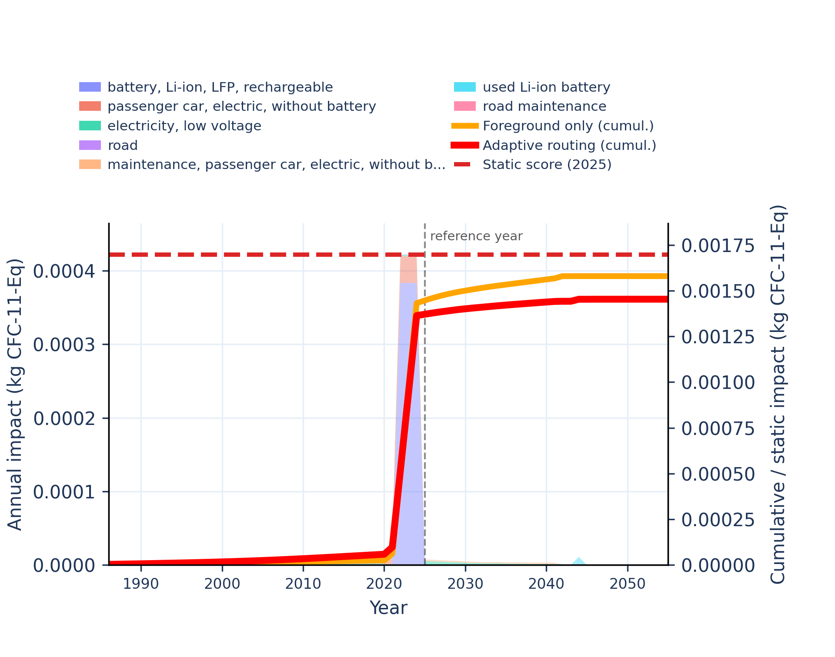
Figure S-routing-bev-23. particulate matter formation - impact on human health.
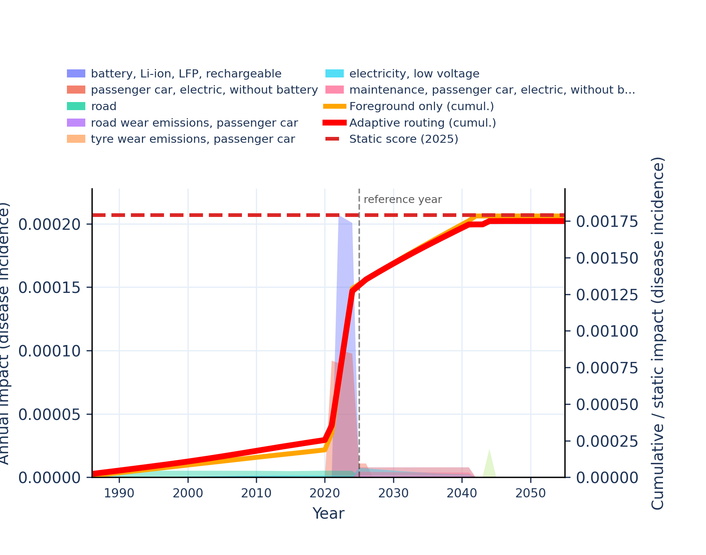 | 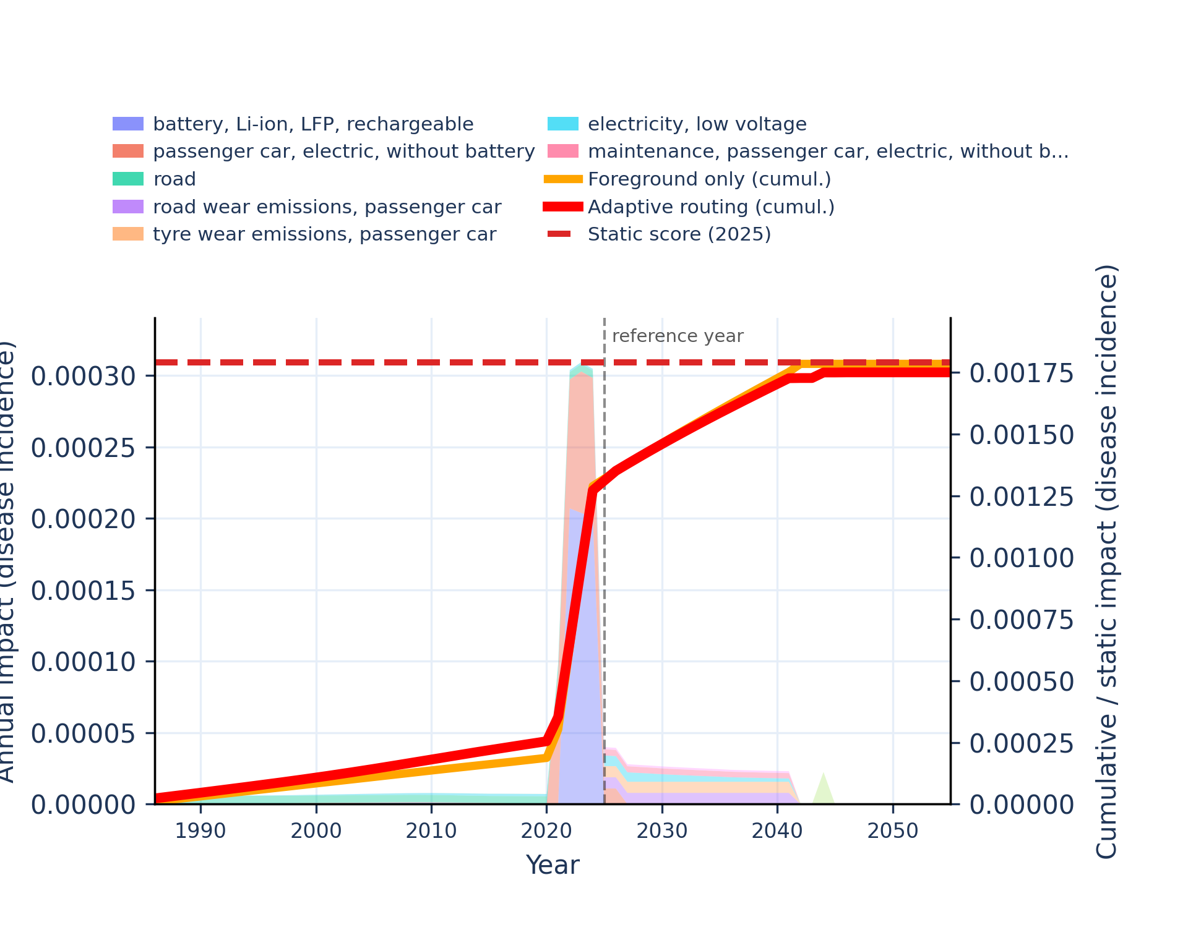
Figure S-routing-bev-24. photochemical oxidant formation: human health - tropospheric ozone concentration increase.
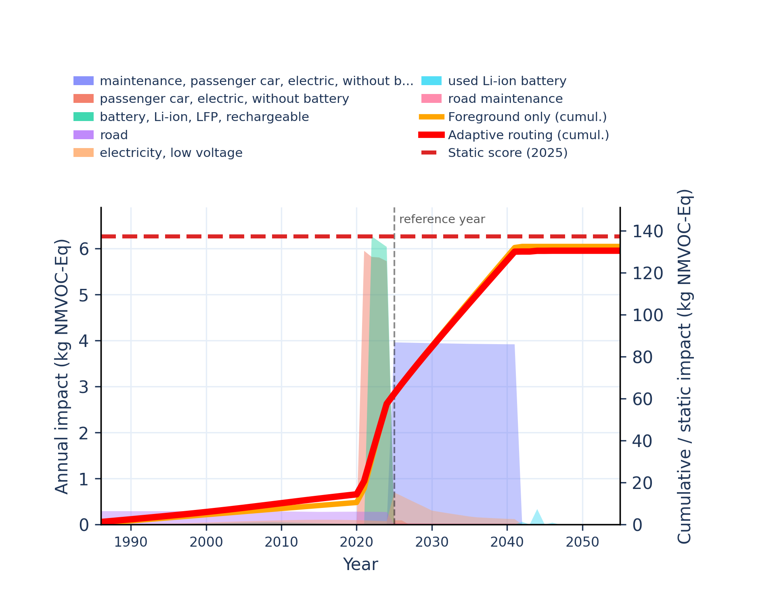 | 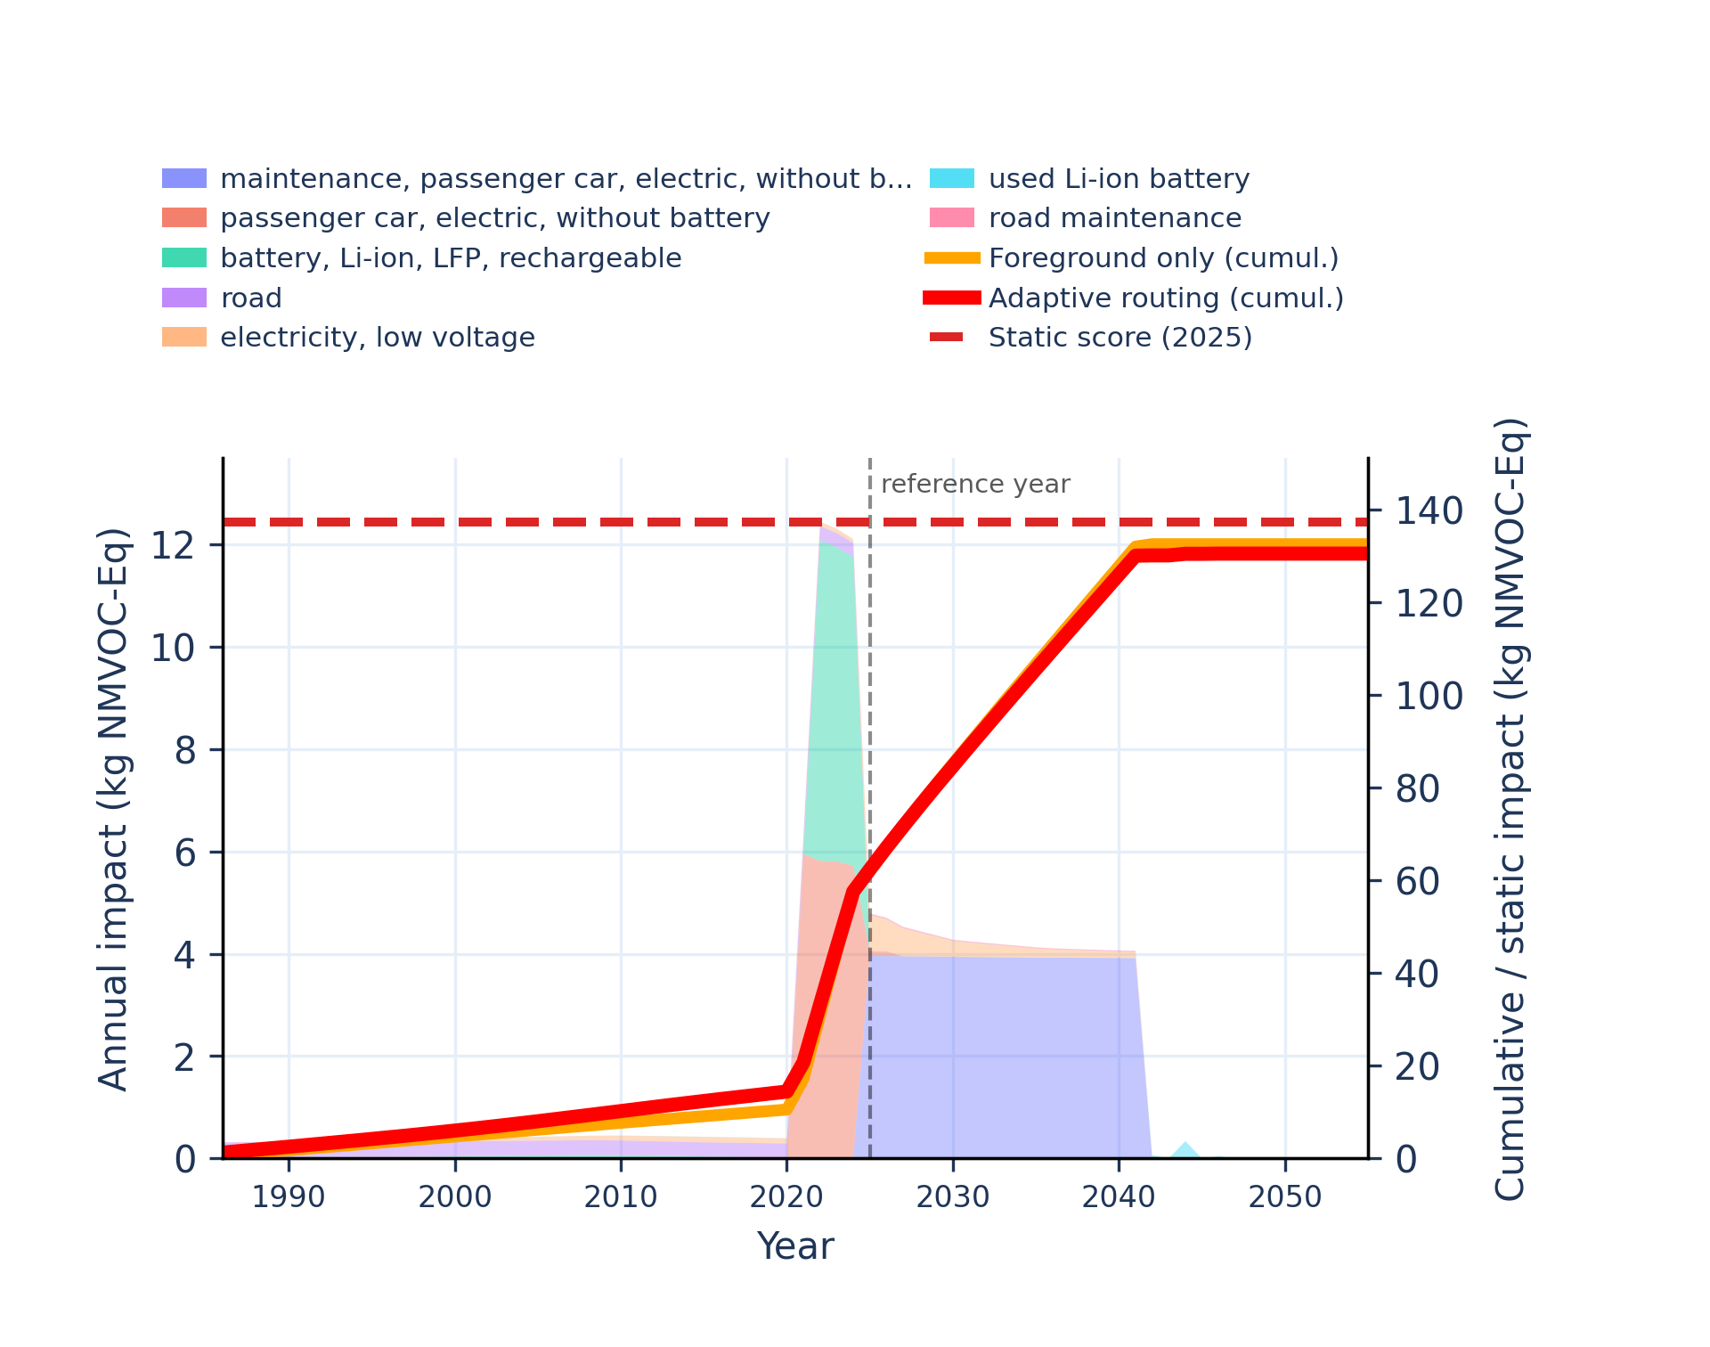
Figure S-routing-bev-25. water use - user deprivation potential (deprivation-weighted water consumption).
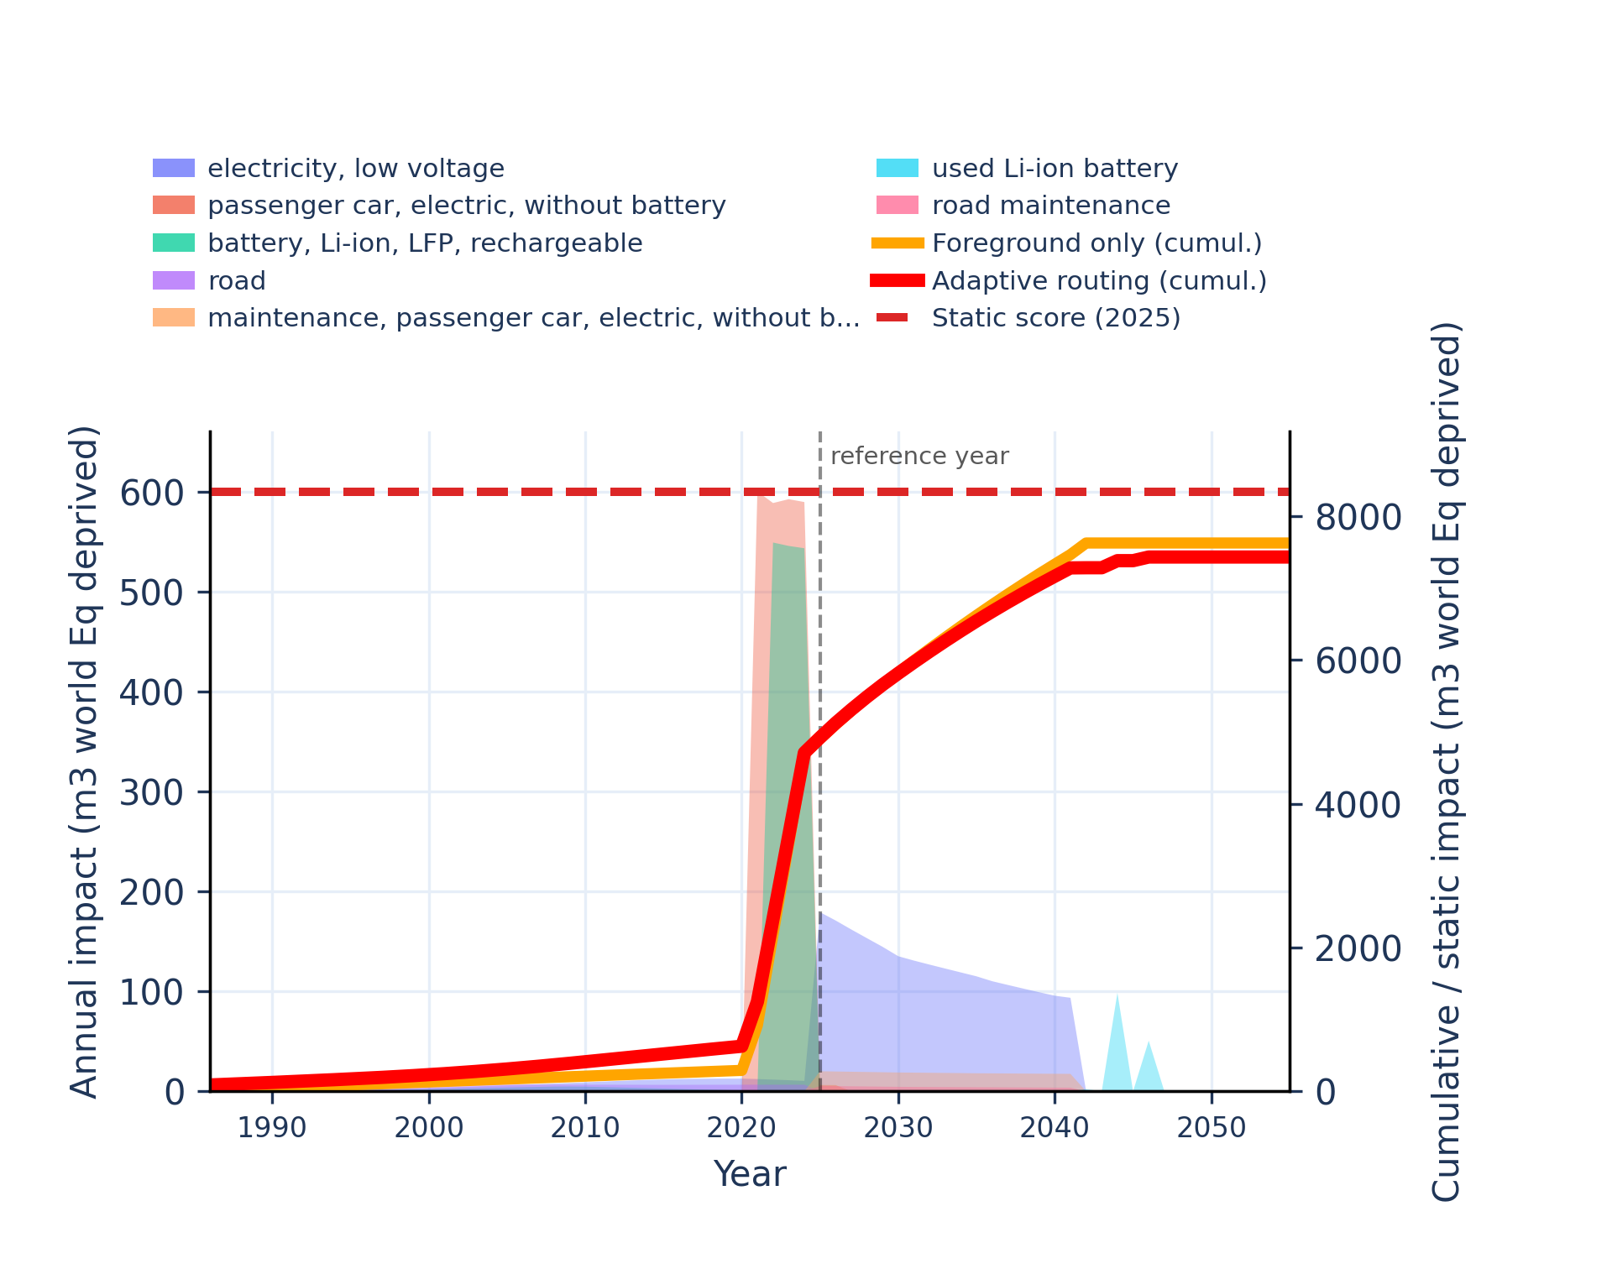 | 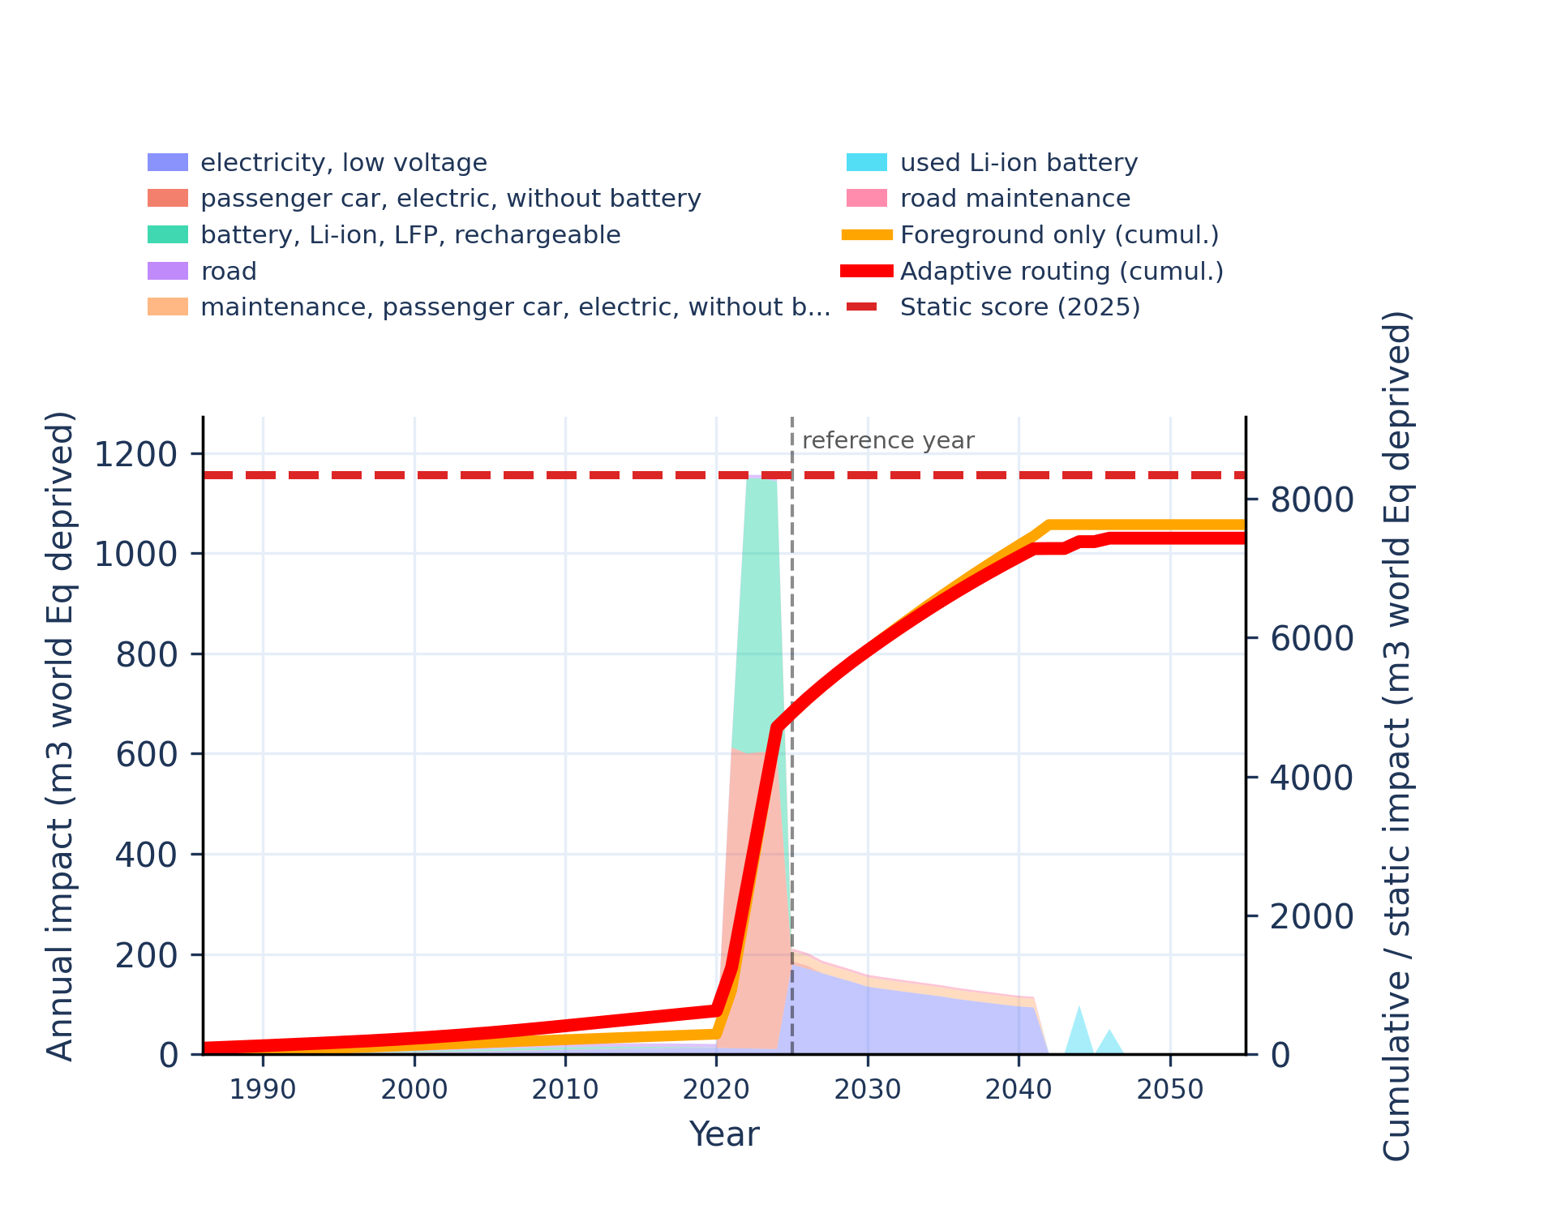

CCU polyol
Unstacked annual impacts | Stacked annual impacts
Figure S-routing-polyol-01. acidification - accumulated exceedance (AE).
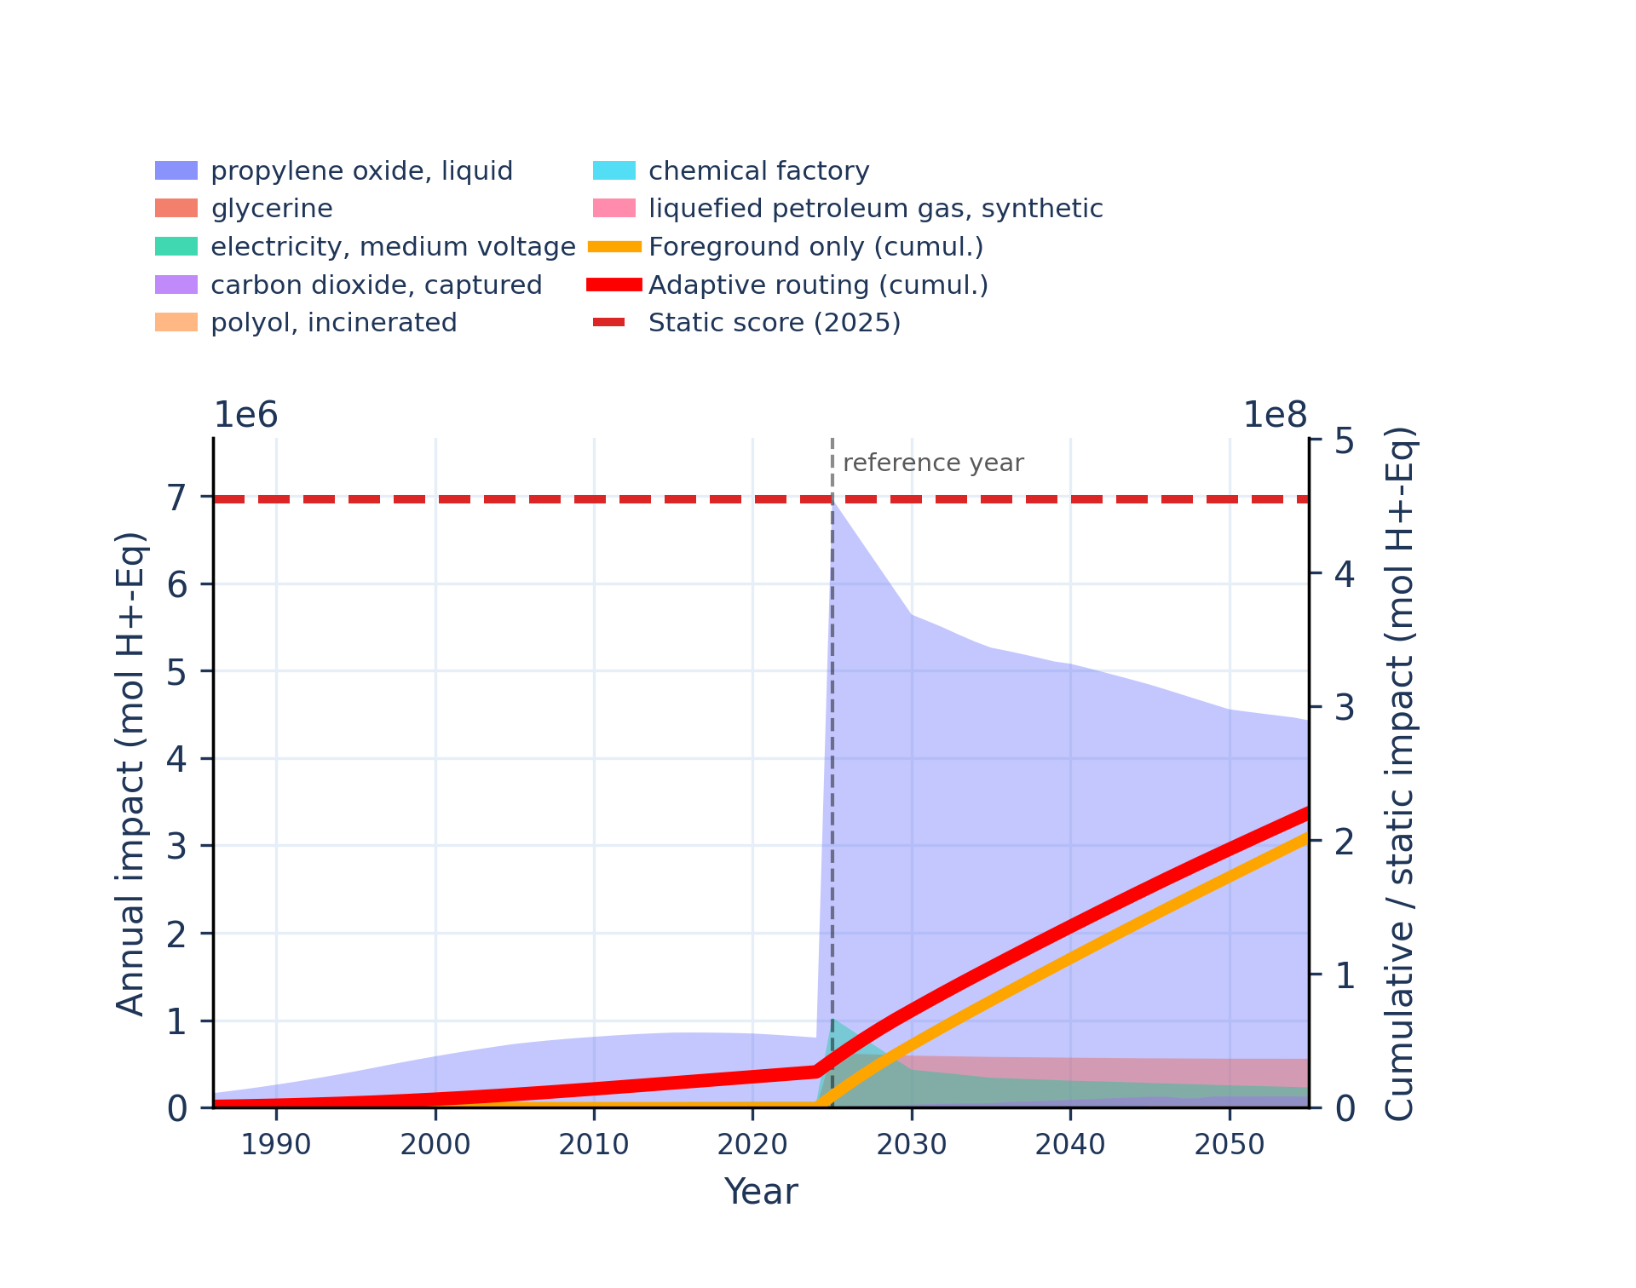 | 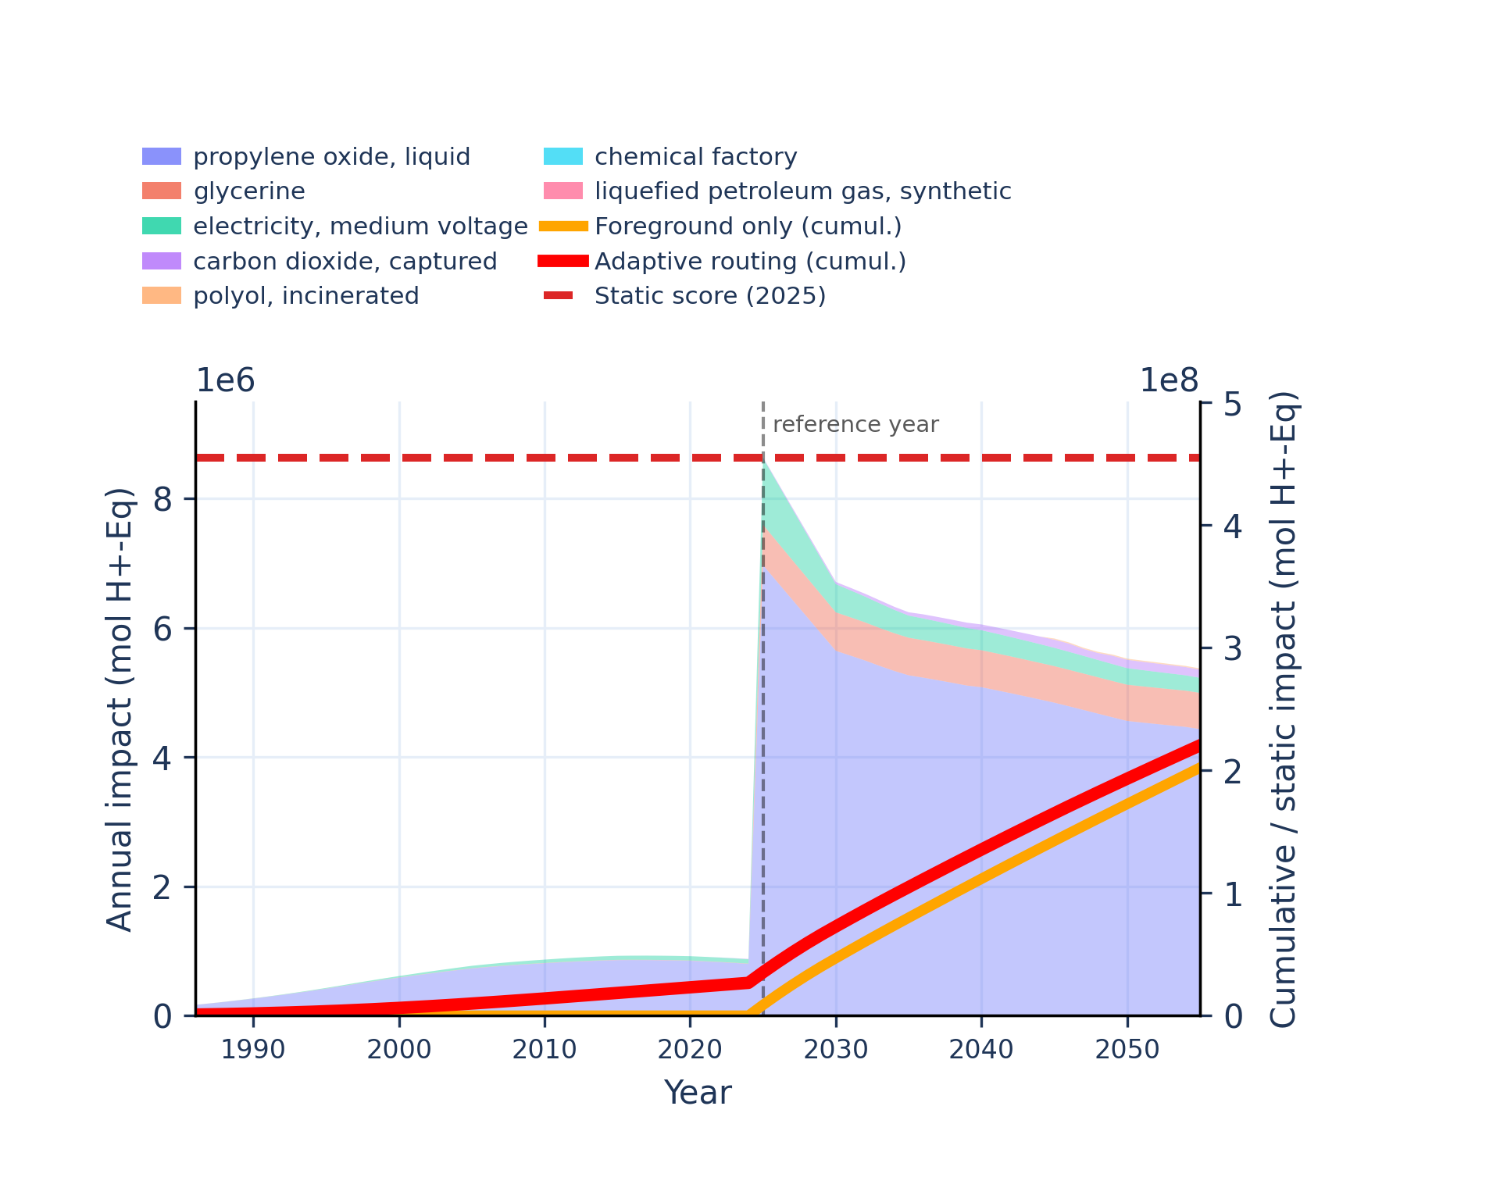
Figure S-routing-polyol-02. climate change - global warming potential (GWP100).
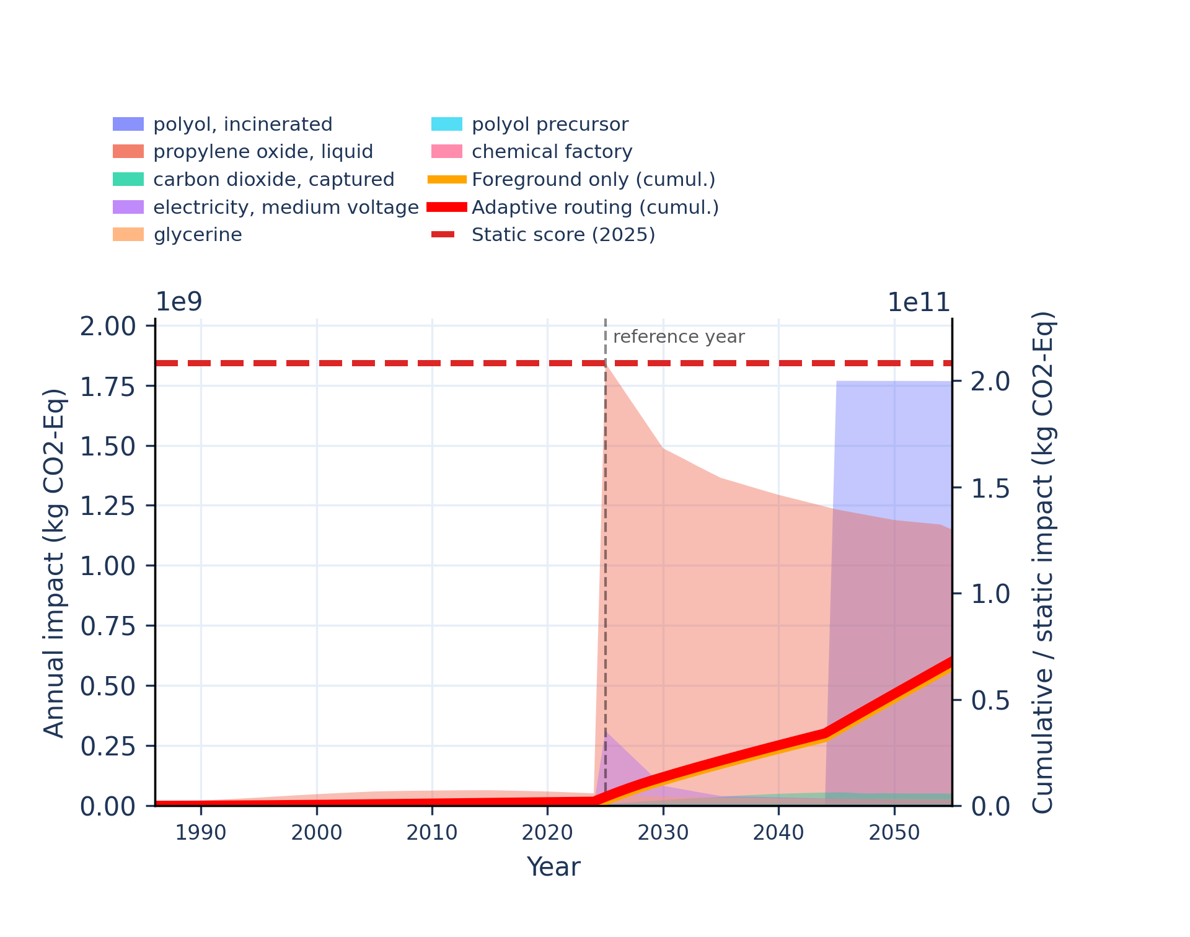 | 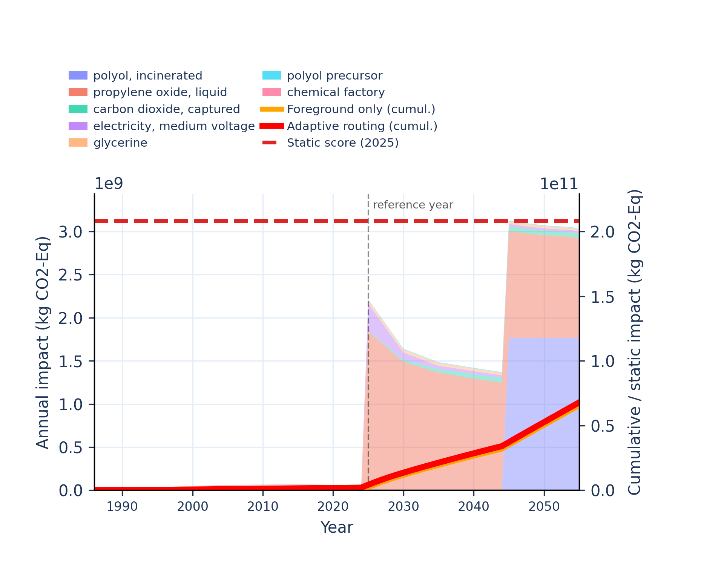
Figure S-routing-polyol-03. climate change: biogenic - global warming potential (GWP100).
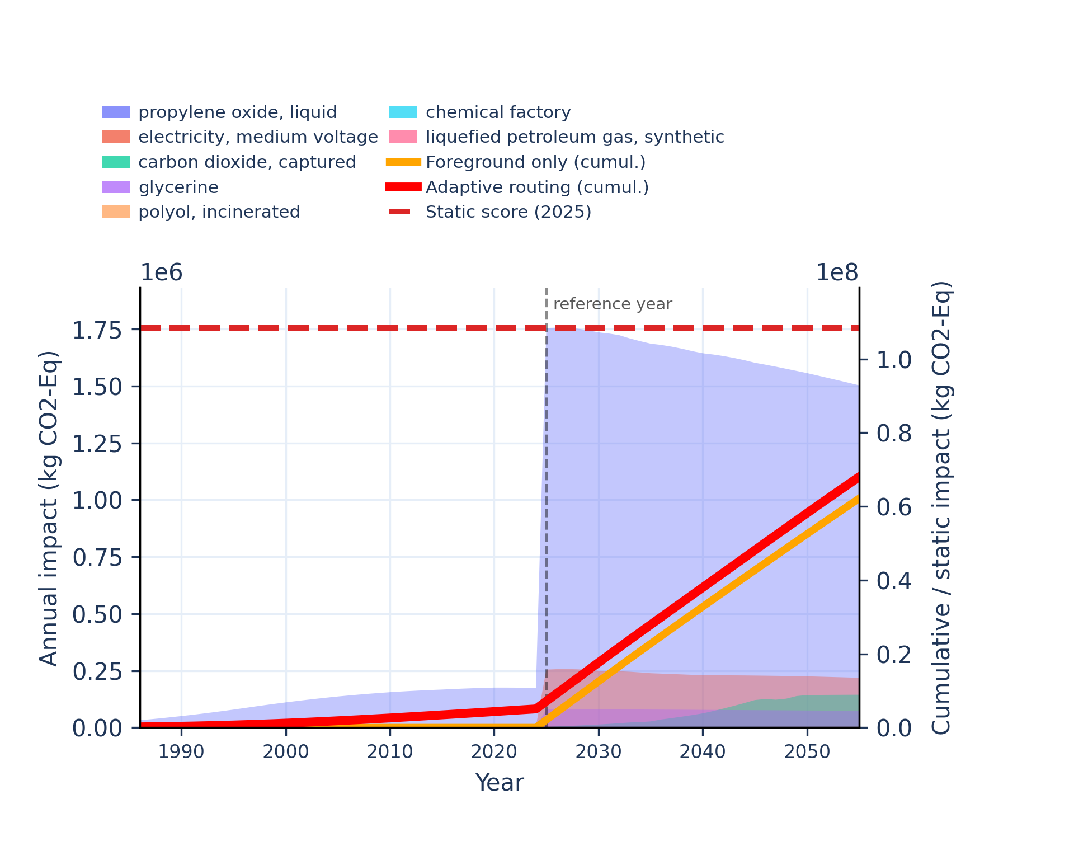 | 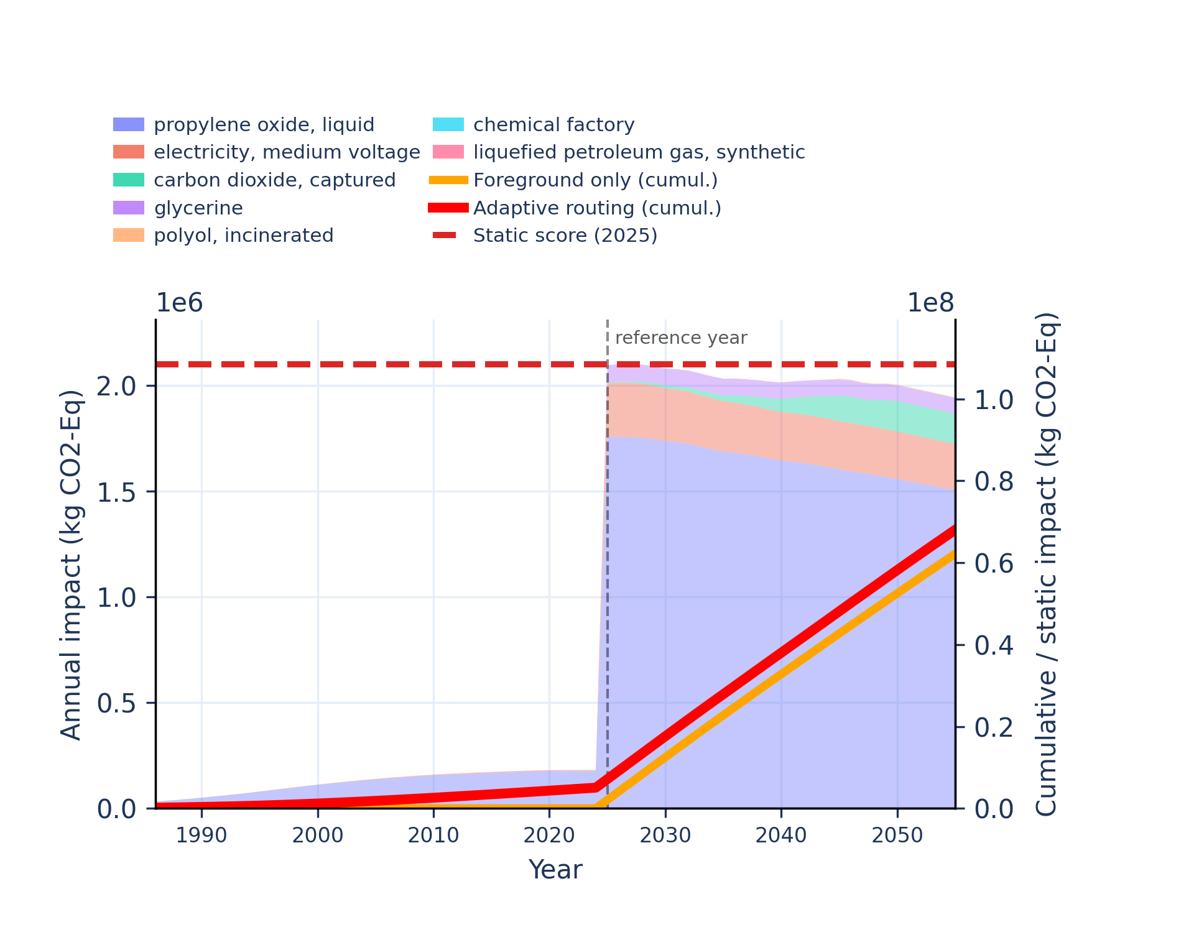
Figure S-routing-polyol-04. climate change: fossil - global warming potential (GWP100).
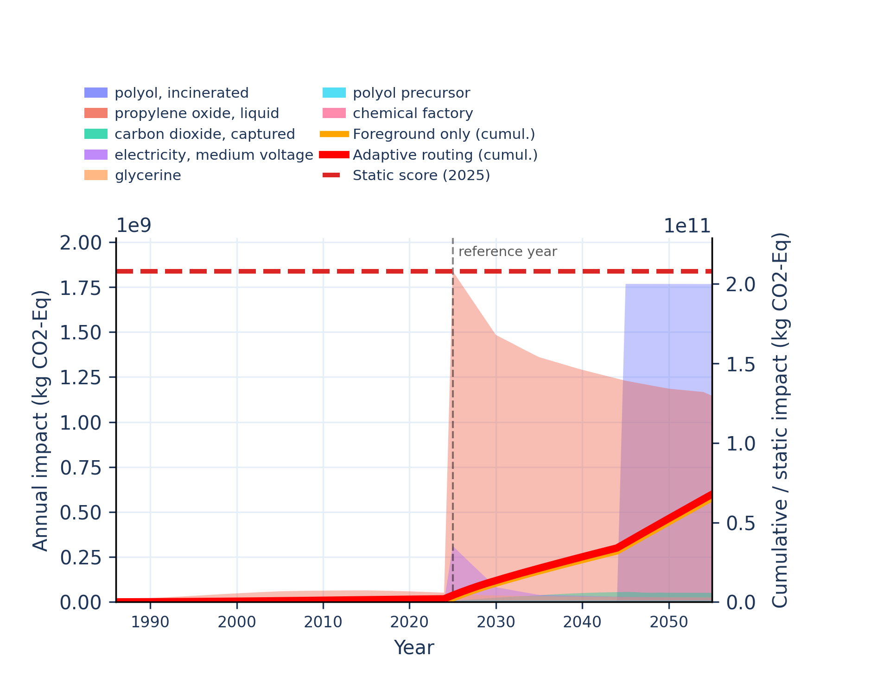 | 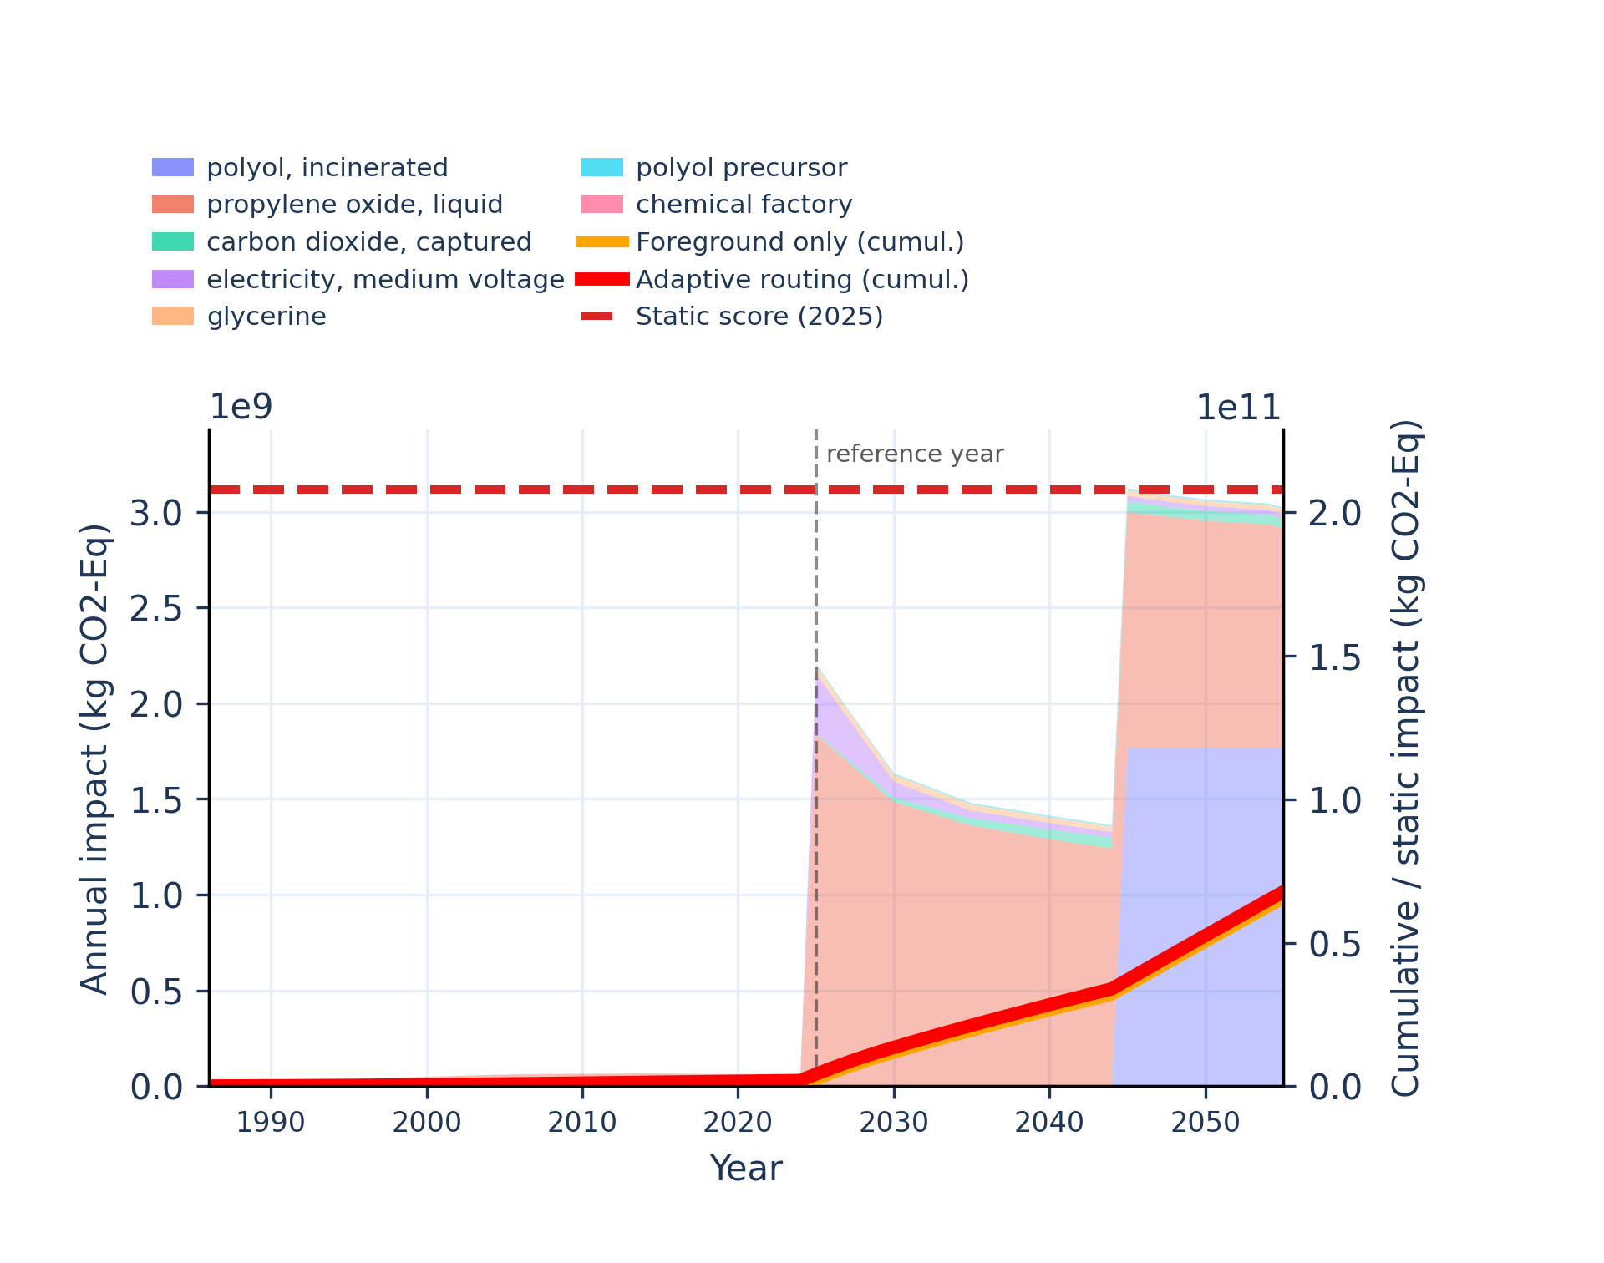
Figure S-routing-polyol-05. climate change: land use and land use change - global warming potential (GWP100).
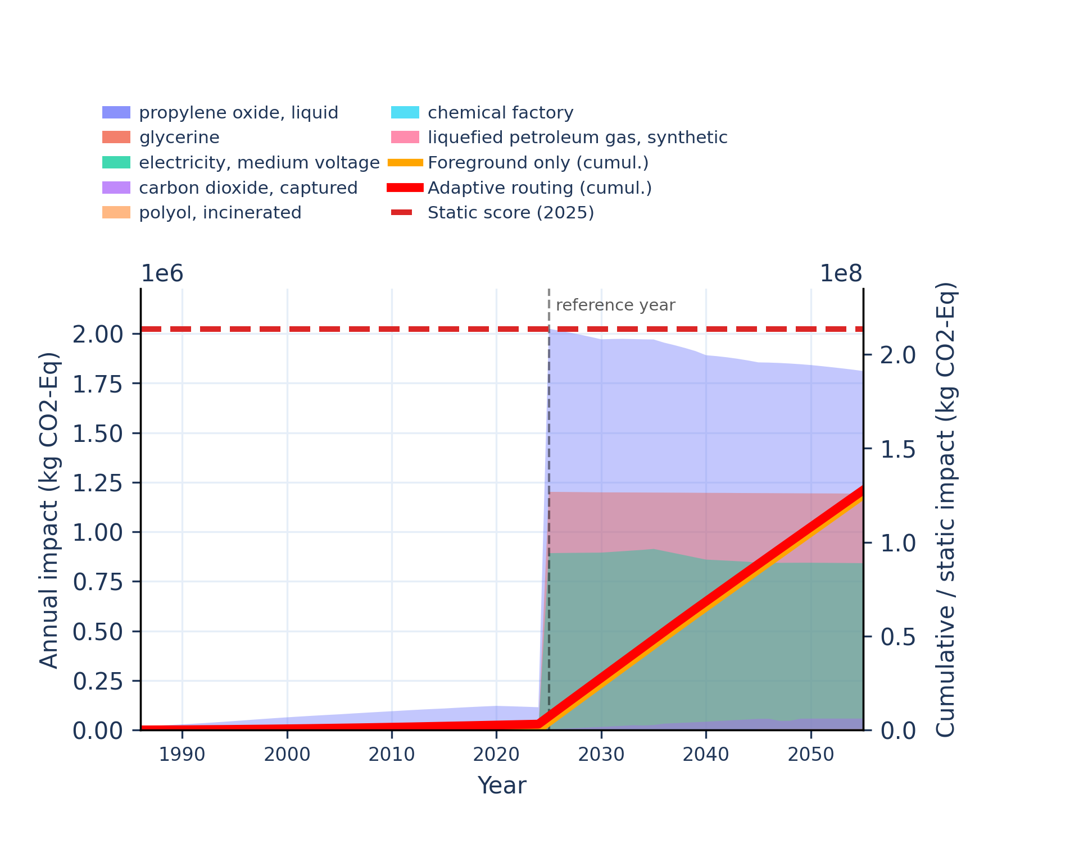 | 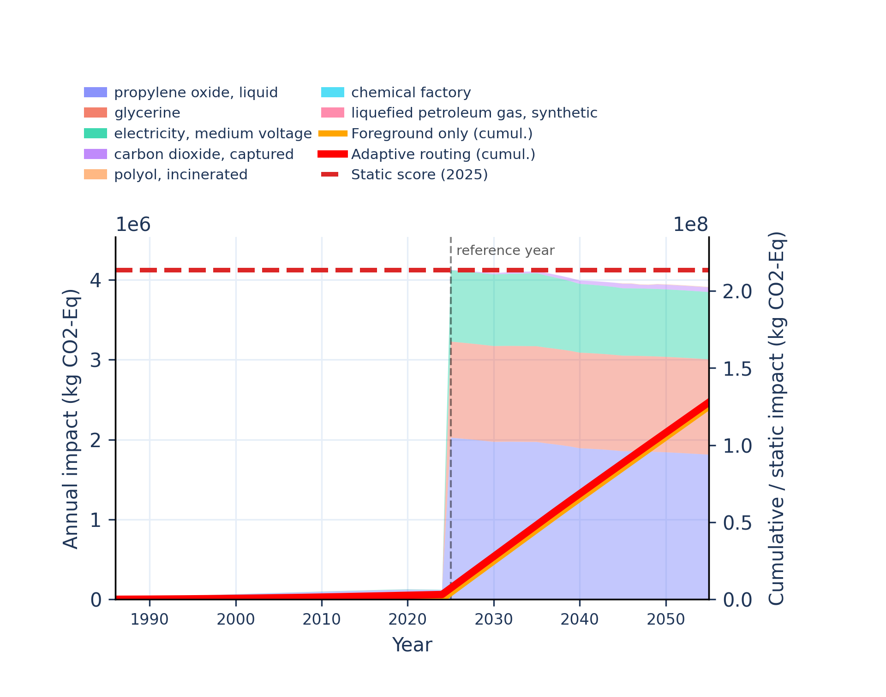
Figure S-routing-polyol-06. ecotoxicity: freshwater - comparative toxic unit for ecosystems (CTUe).
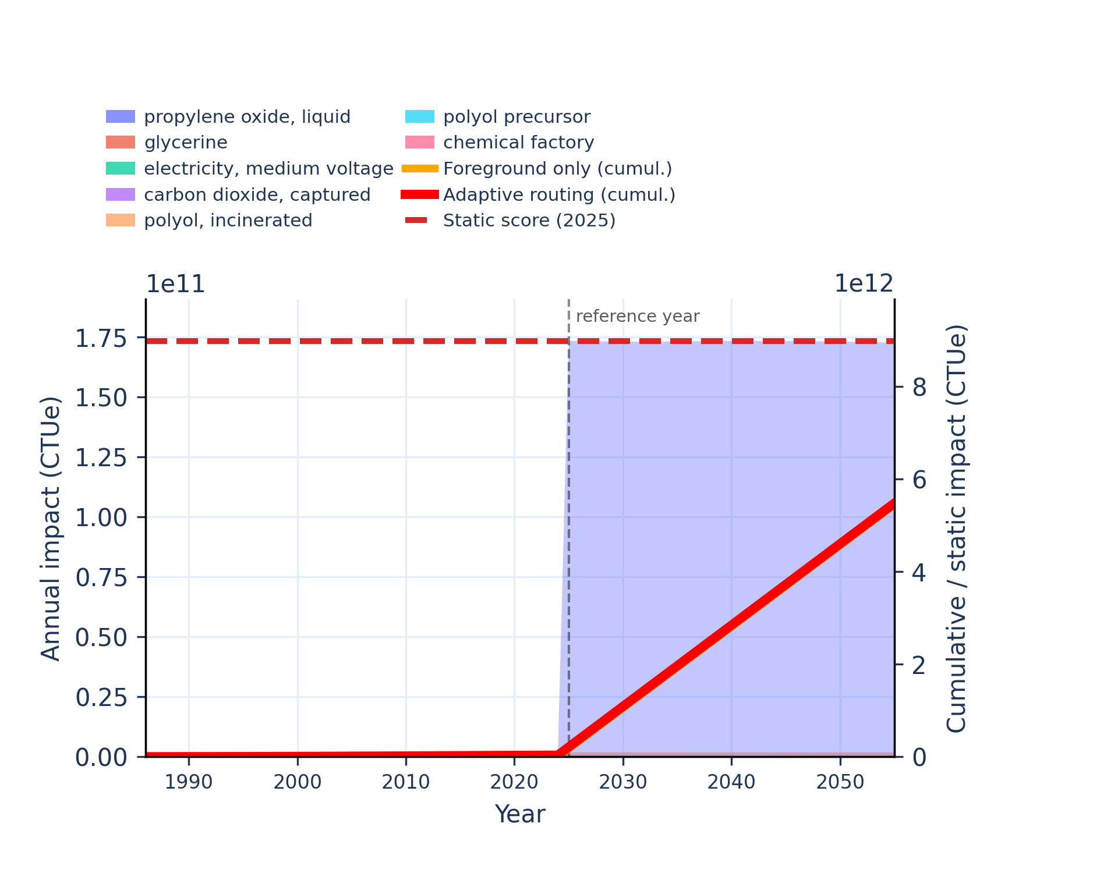 | 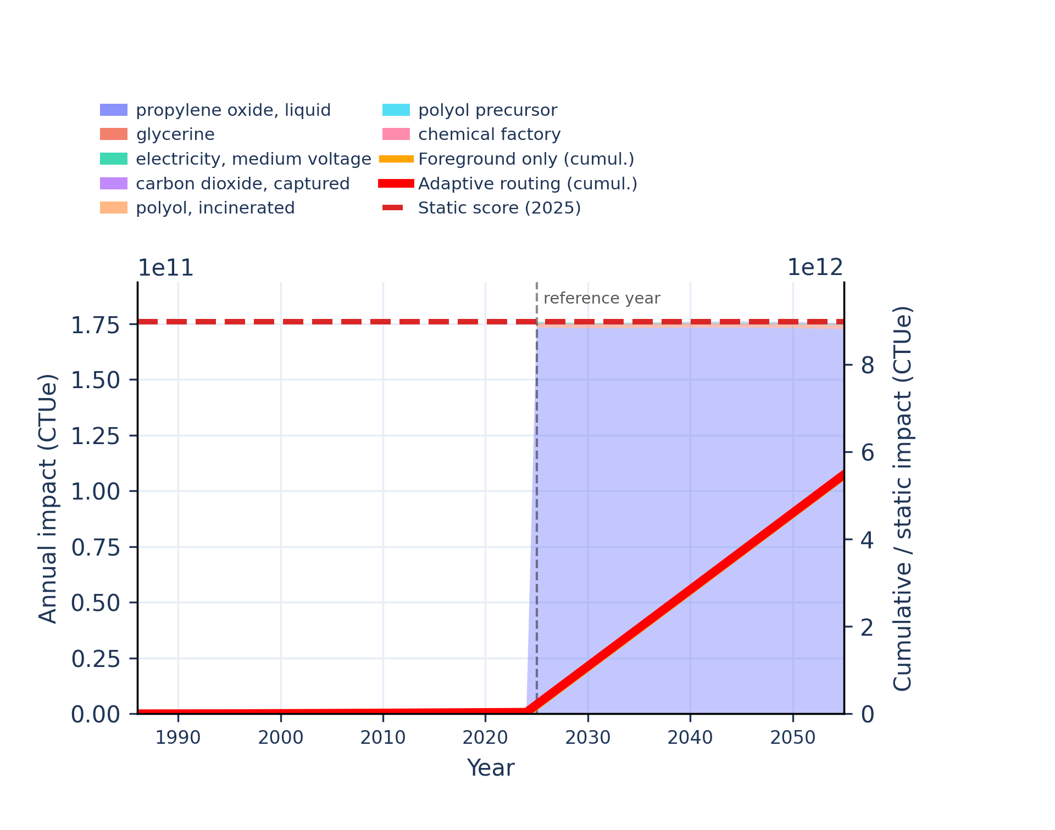
Figure S-routing-polyol-07. ecotoxicity: freshwater, inorganics - comparative toxic unit for ecosystems (CTUe).
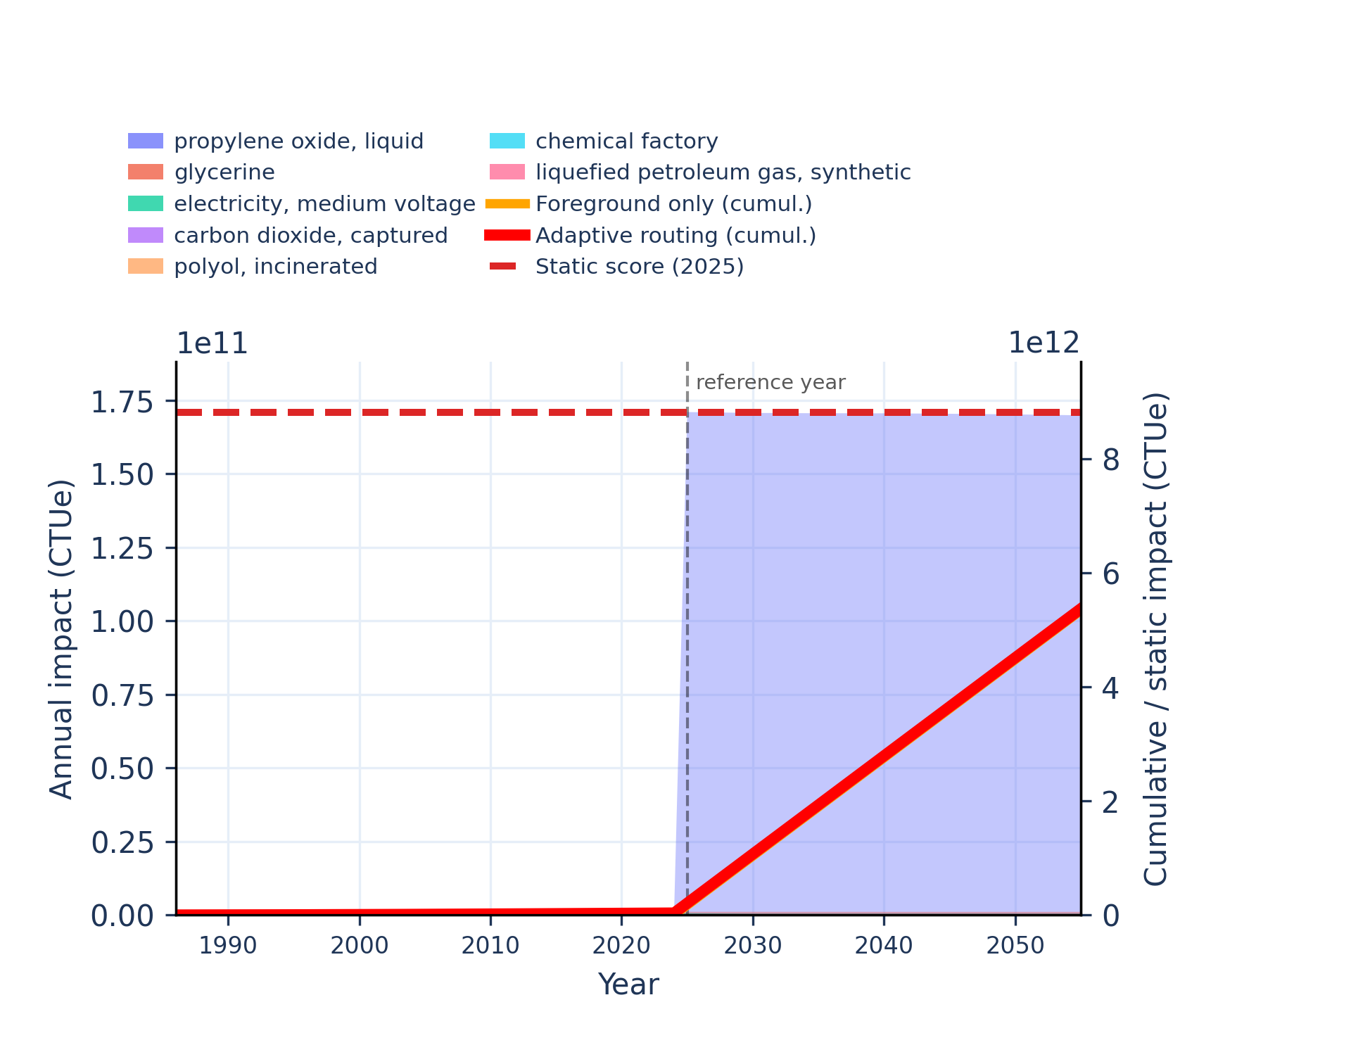 | 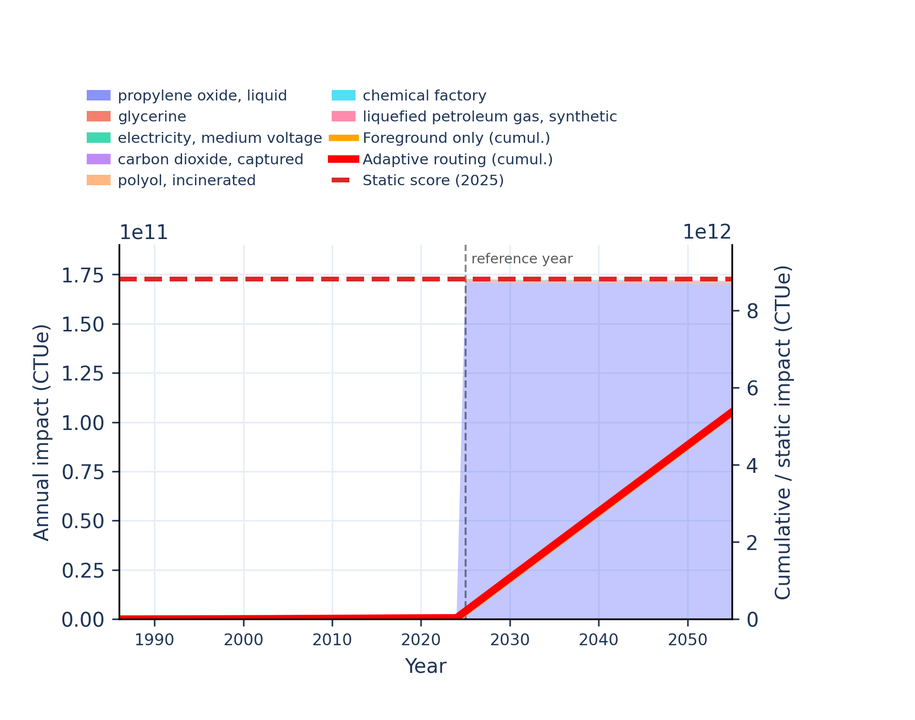
Figure S-routing-polyol-08. ecotoxicity: freshwater, organics - comparative toxic unit for ecosystems (CTUe).
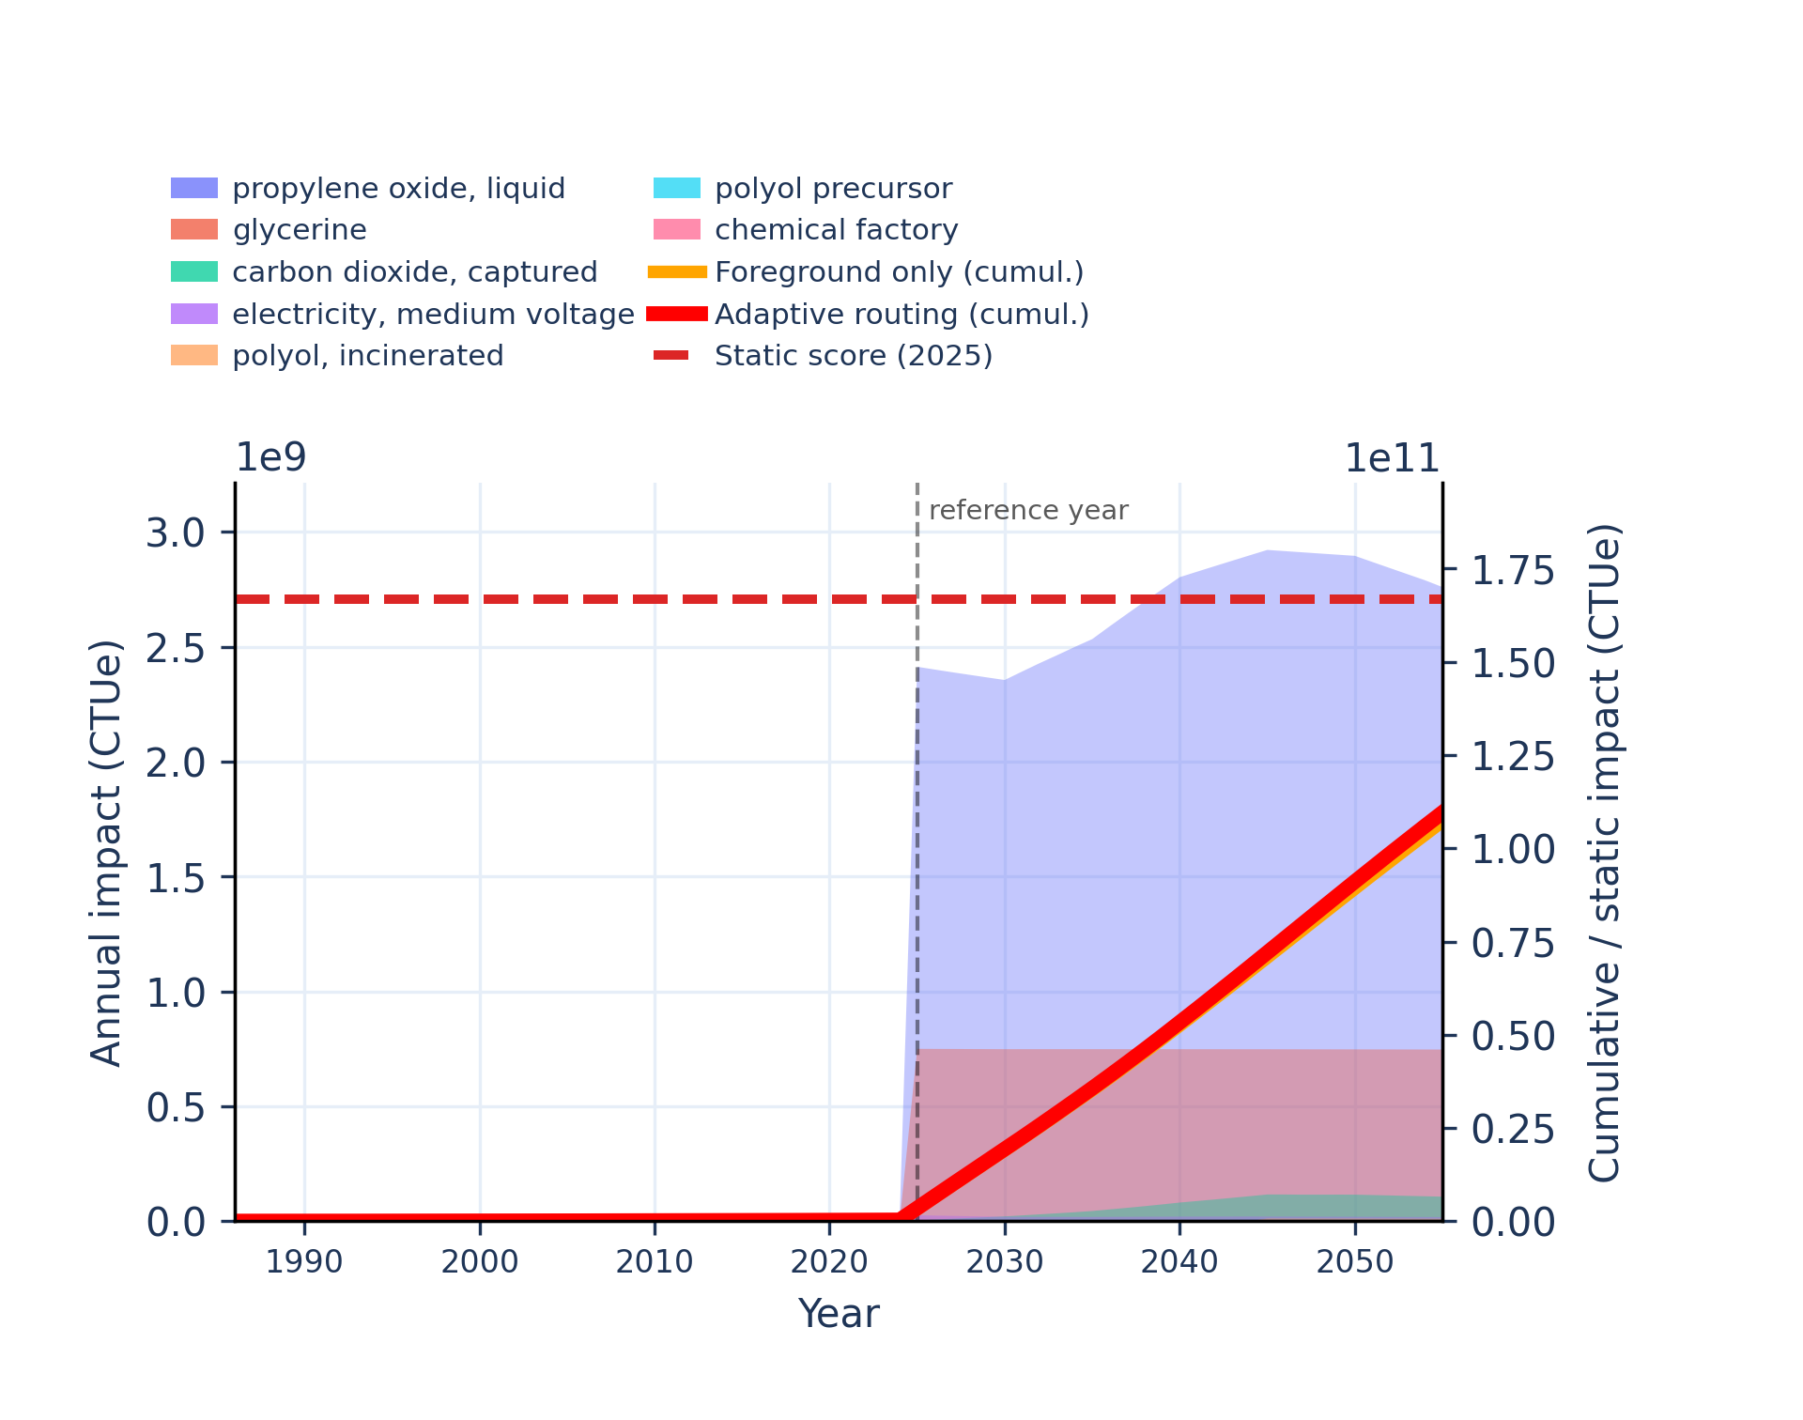 | 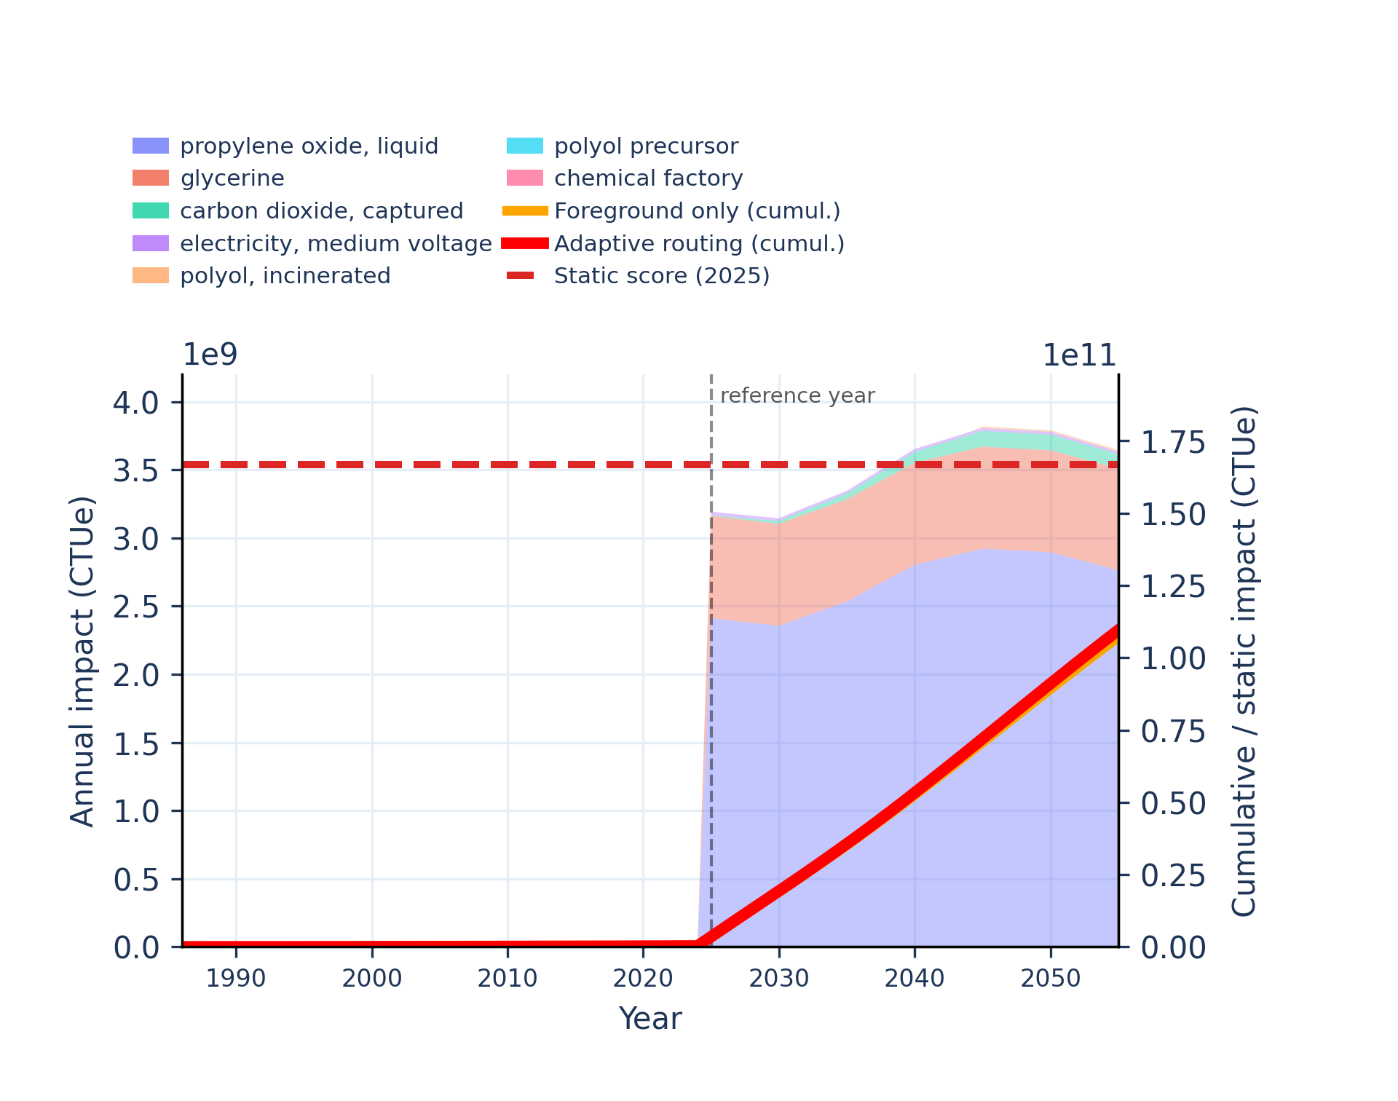
Figure S-routing-polyol-09. energy resources: non-renewable - abiotic depletion potential (ADP): fossil fuels.
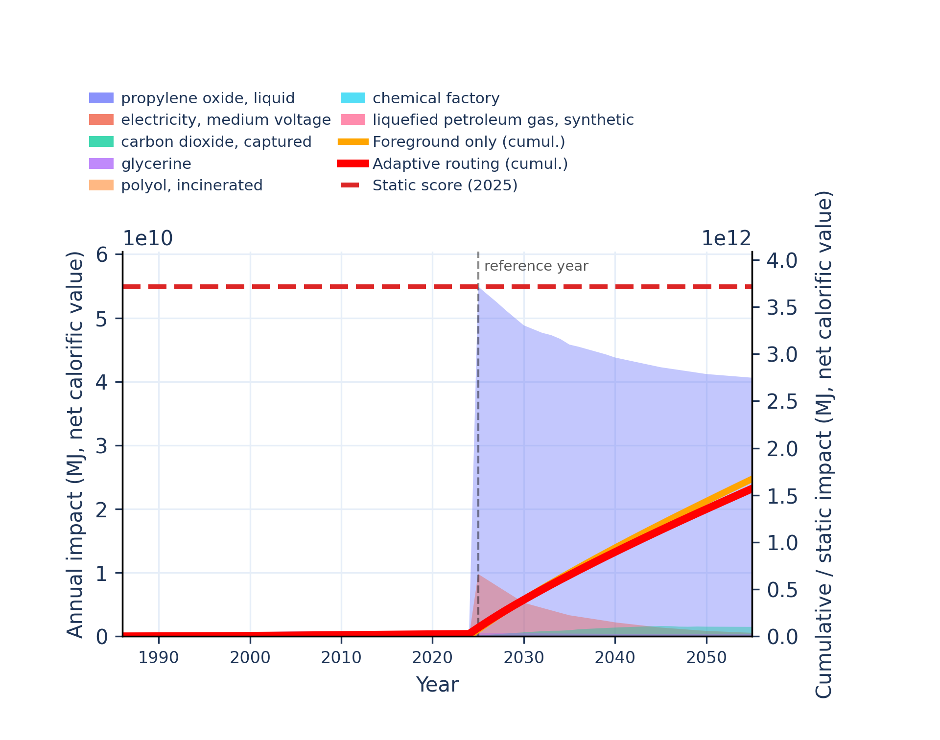 | 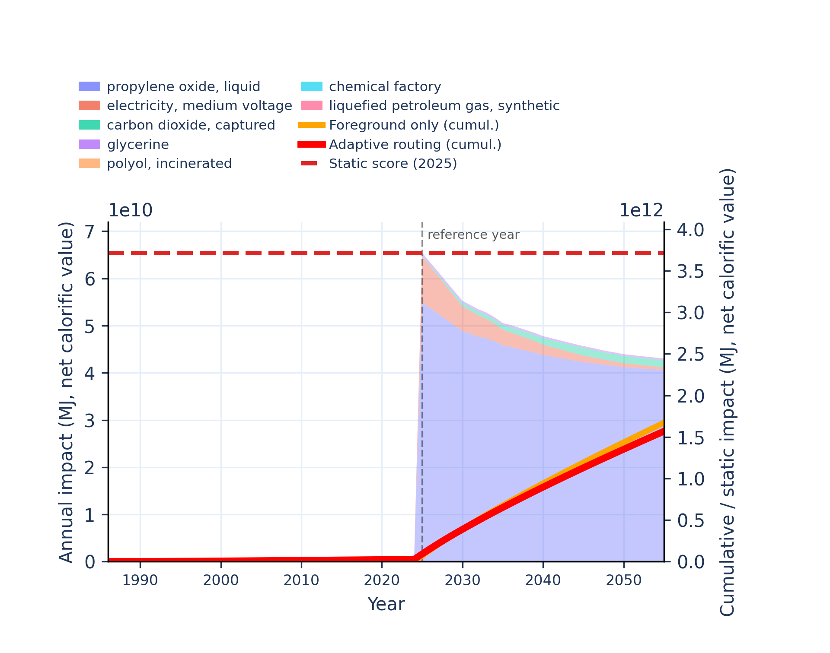
Figure S-routing-polyol-10. eutrophication: freshwater - fraction of nutrients reaching freshwater end compartment (P).
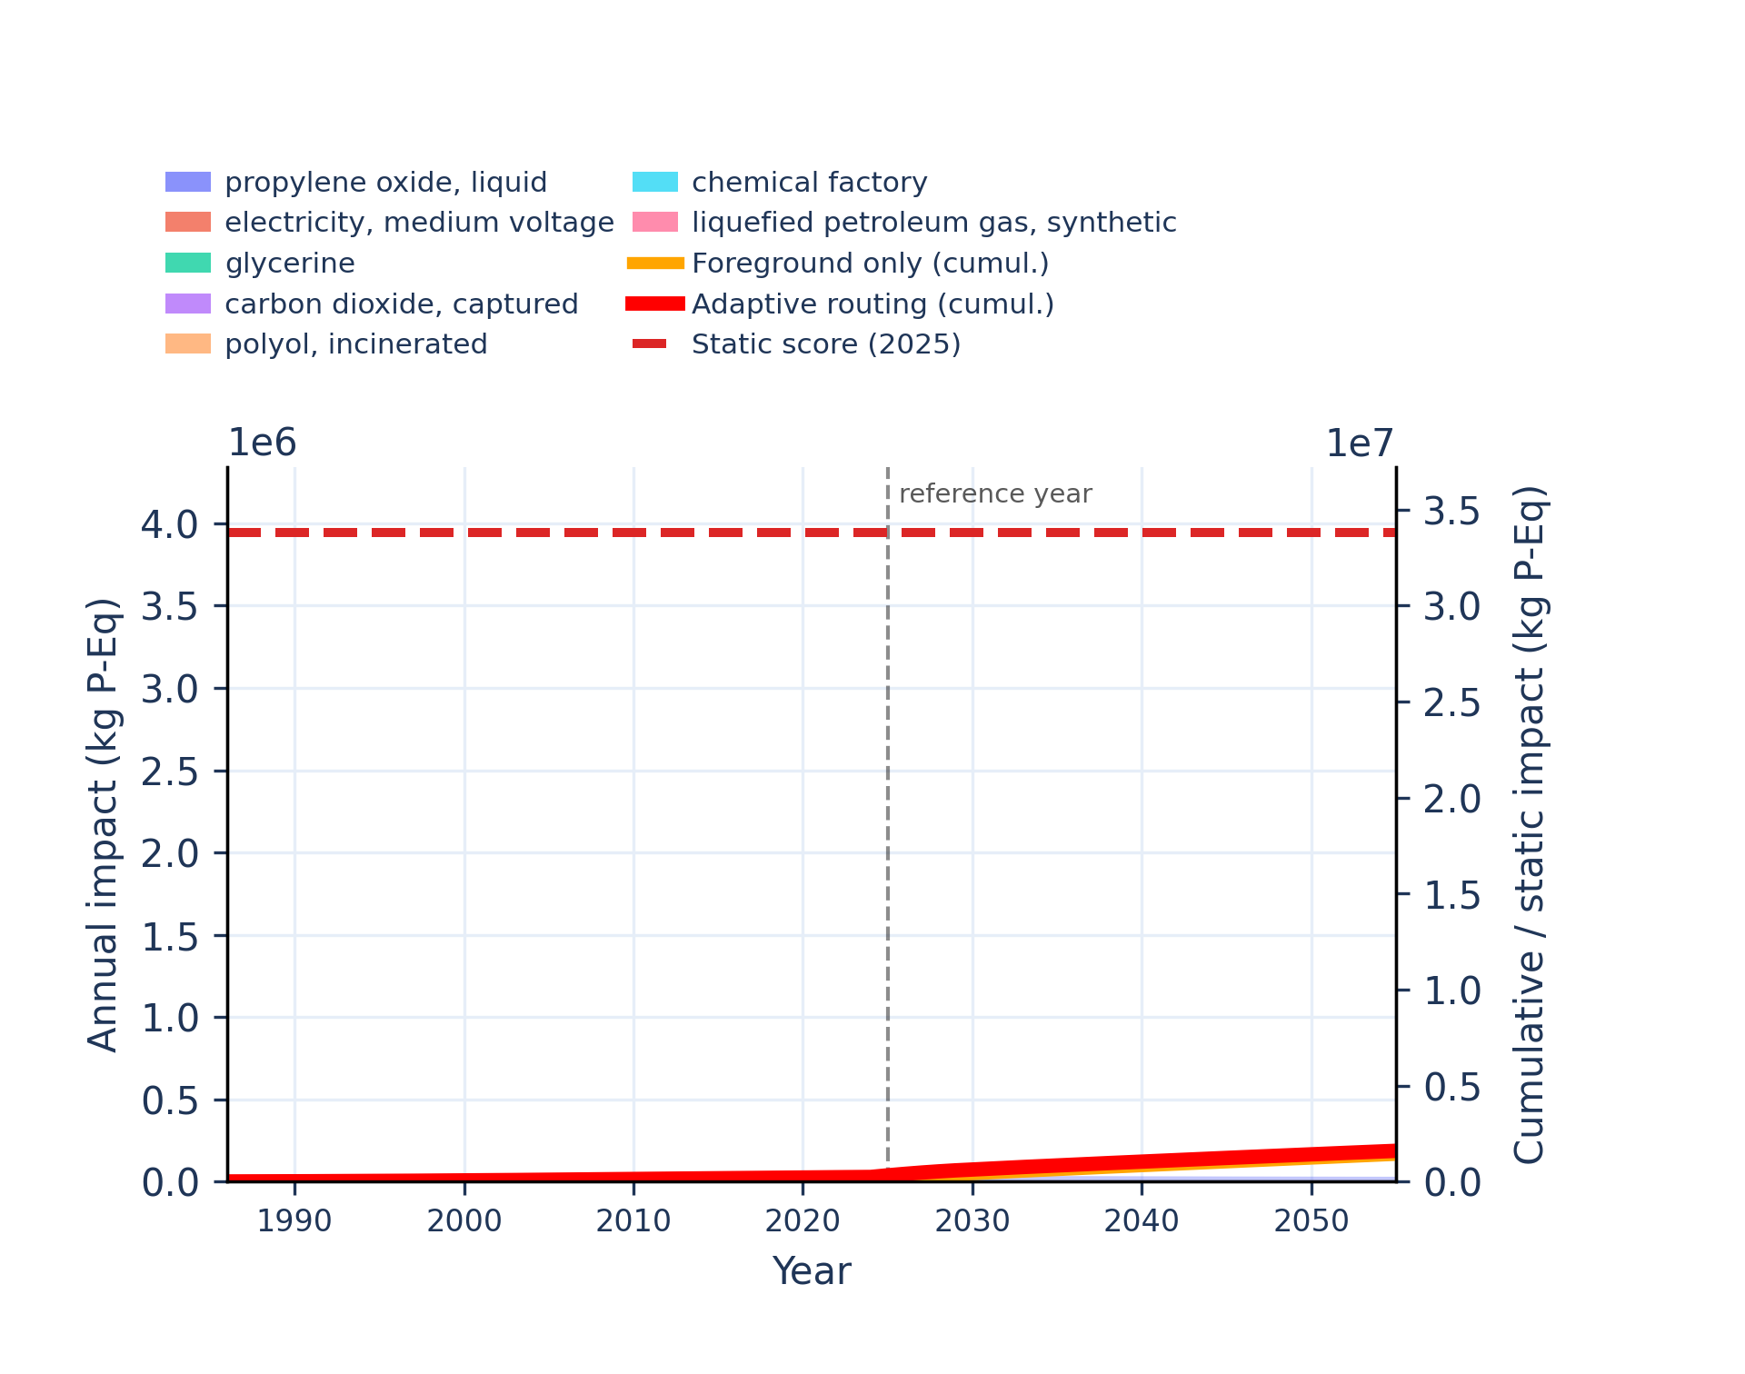 | 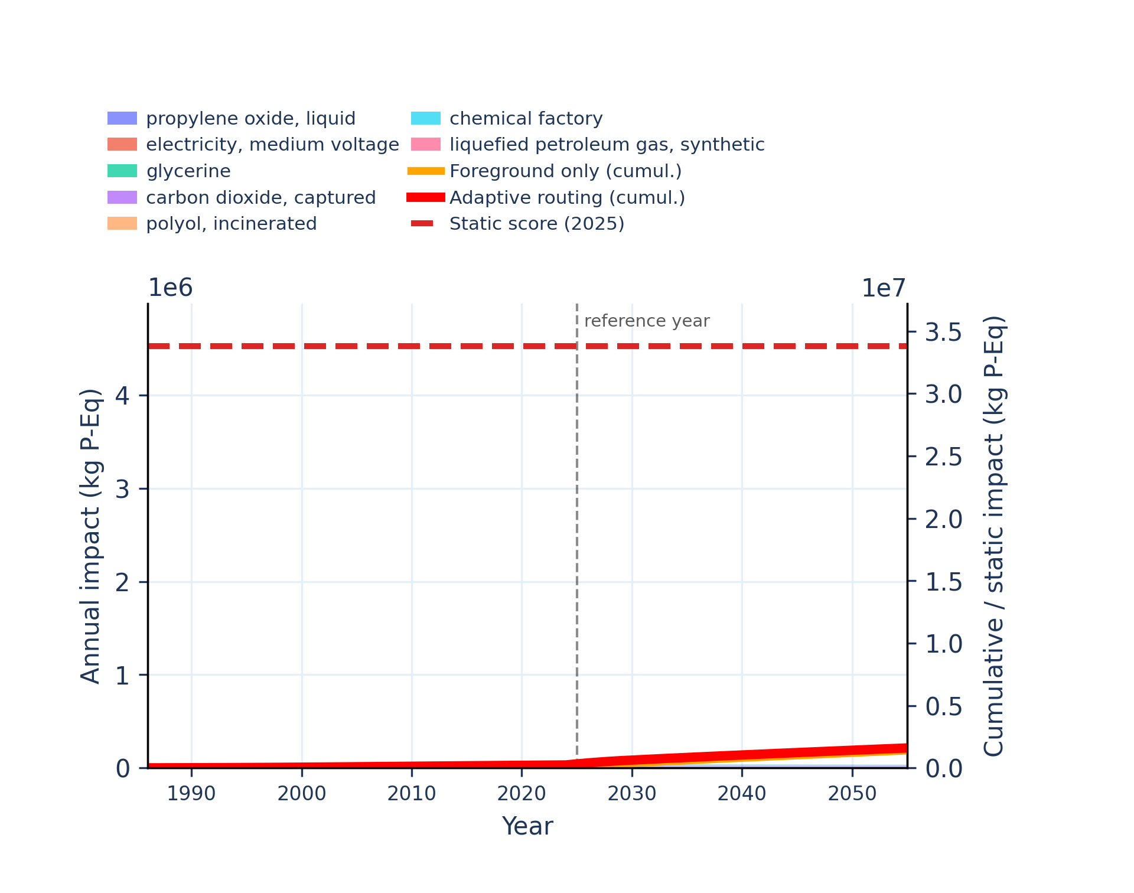
Figure S-routing-polyol-11. eutrophication: marine - fraction of nutrients reaching marine end compartment (N).
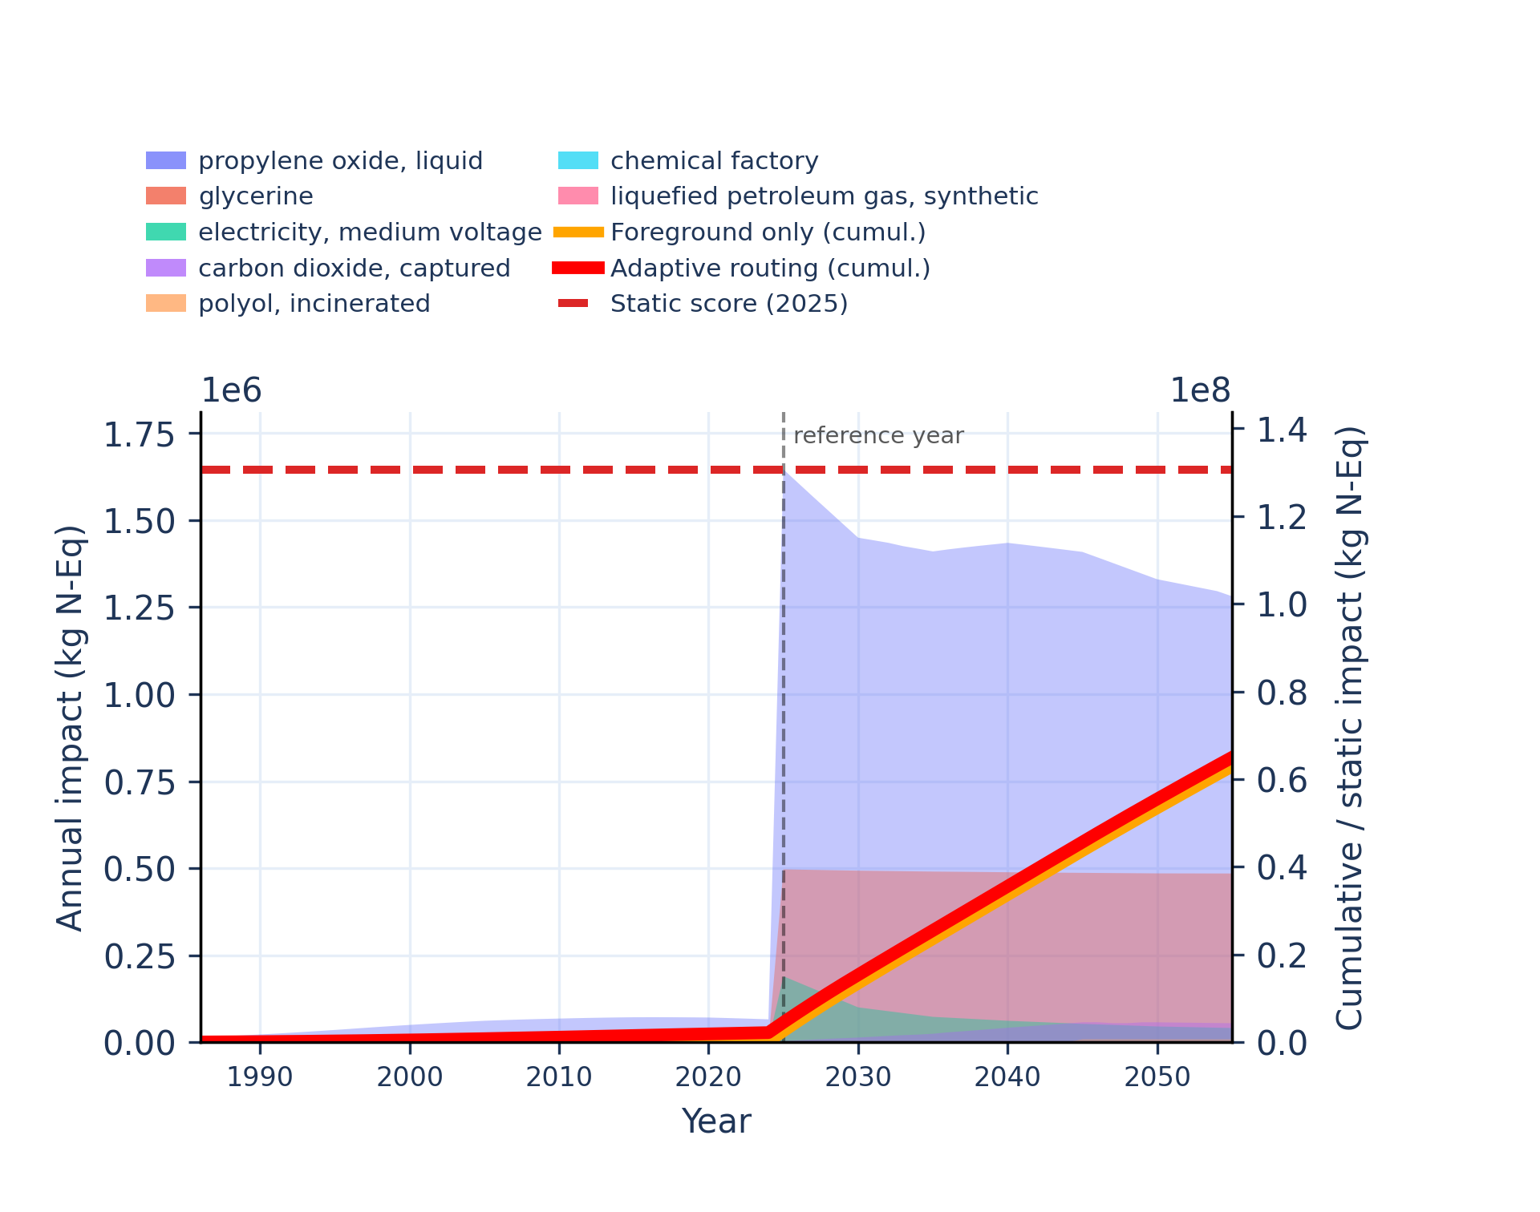 | 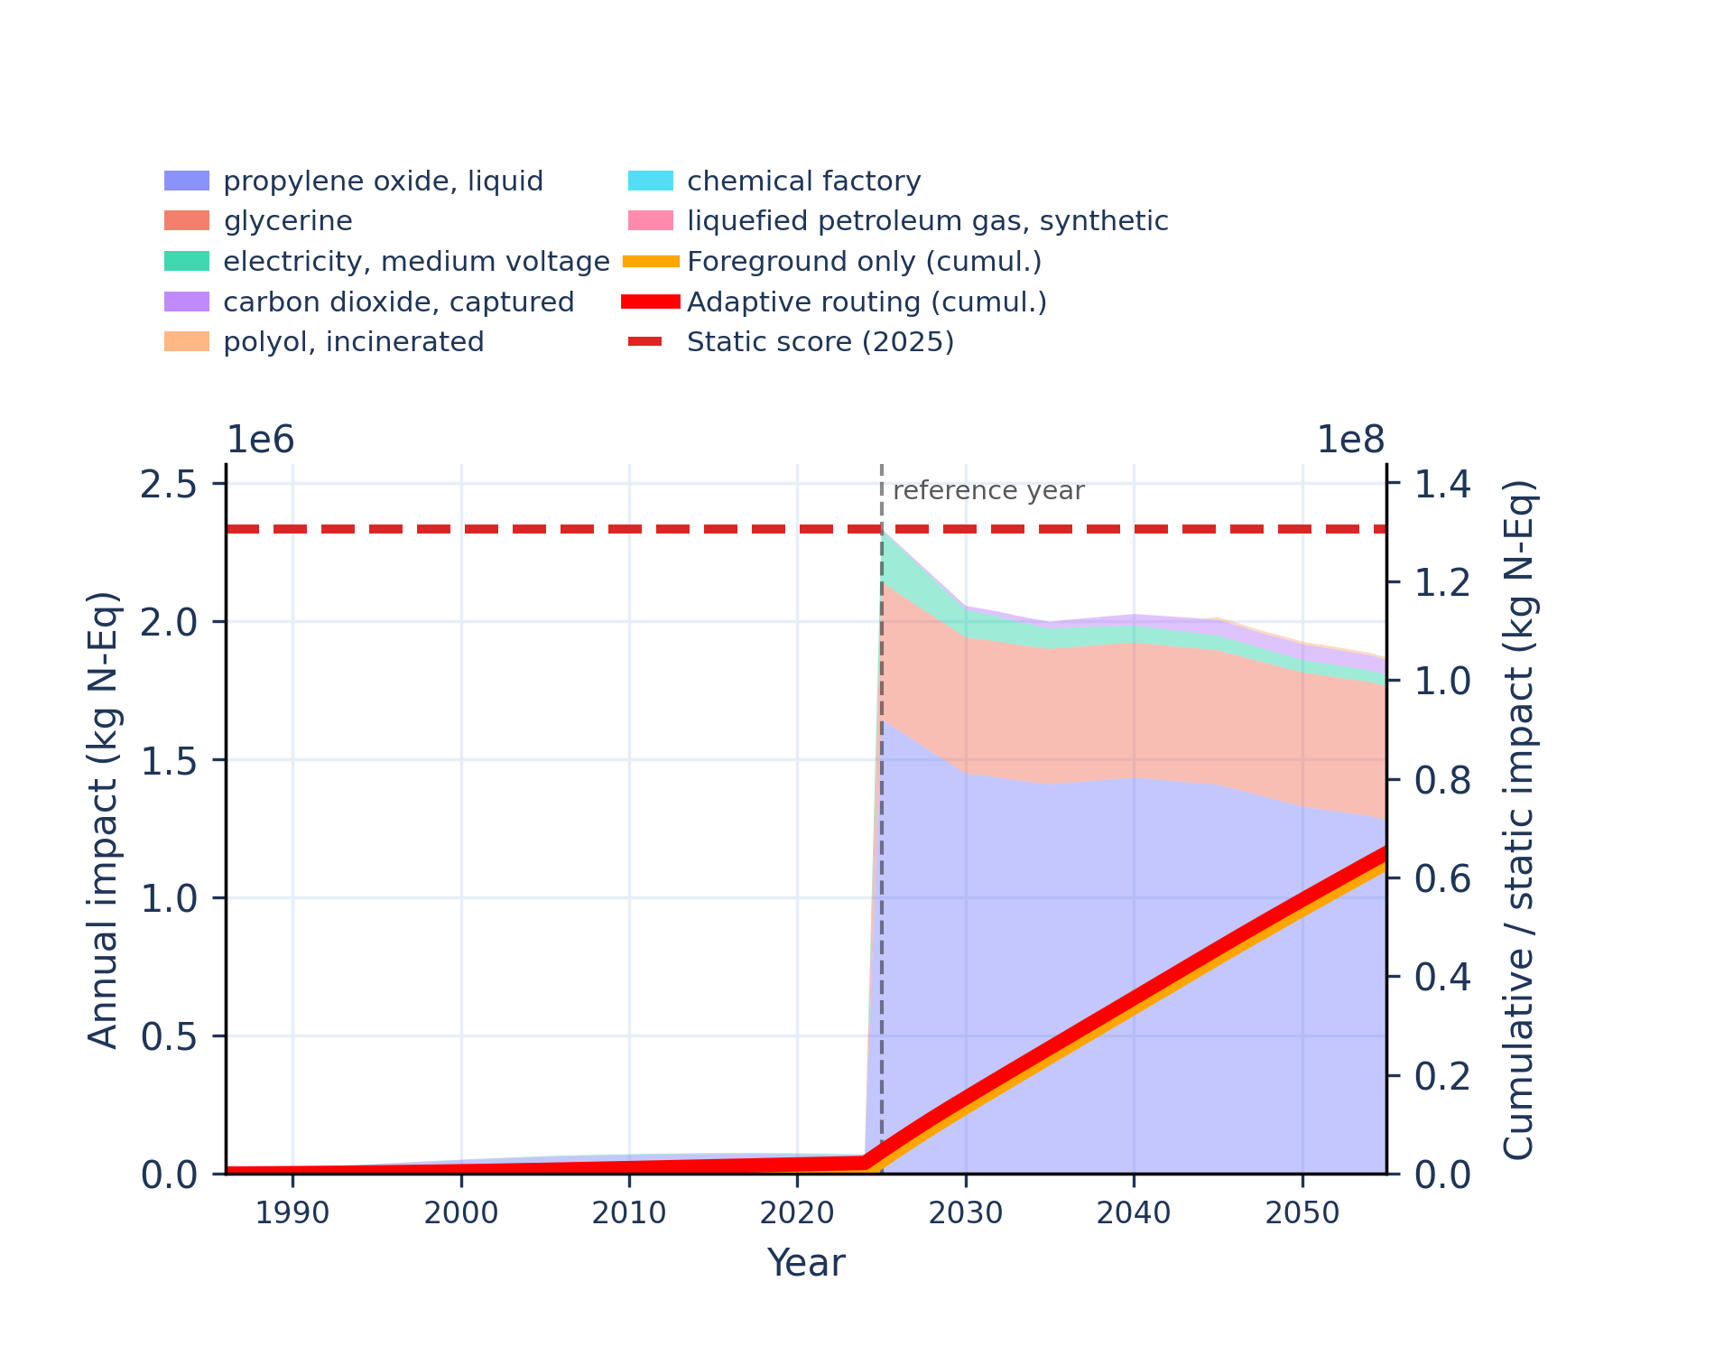
Figure S-routing-polyol-12. eutrophication: terrestrial - accumulated exceedance (AE).
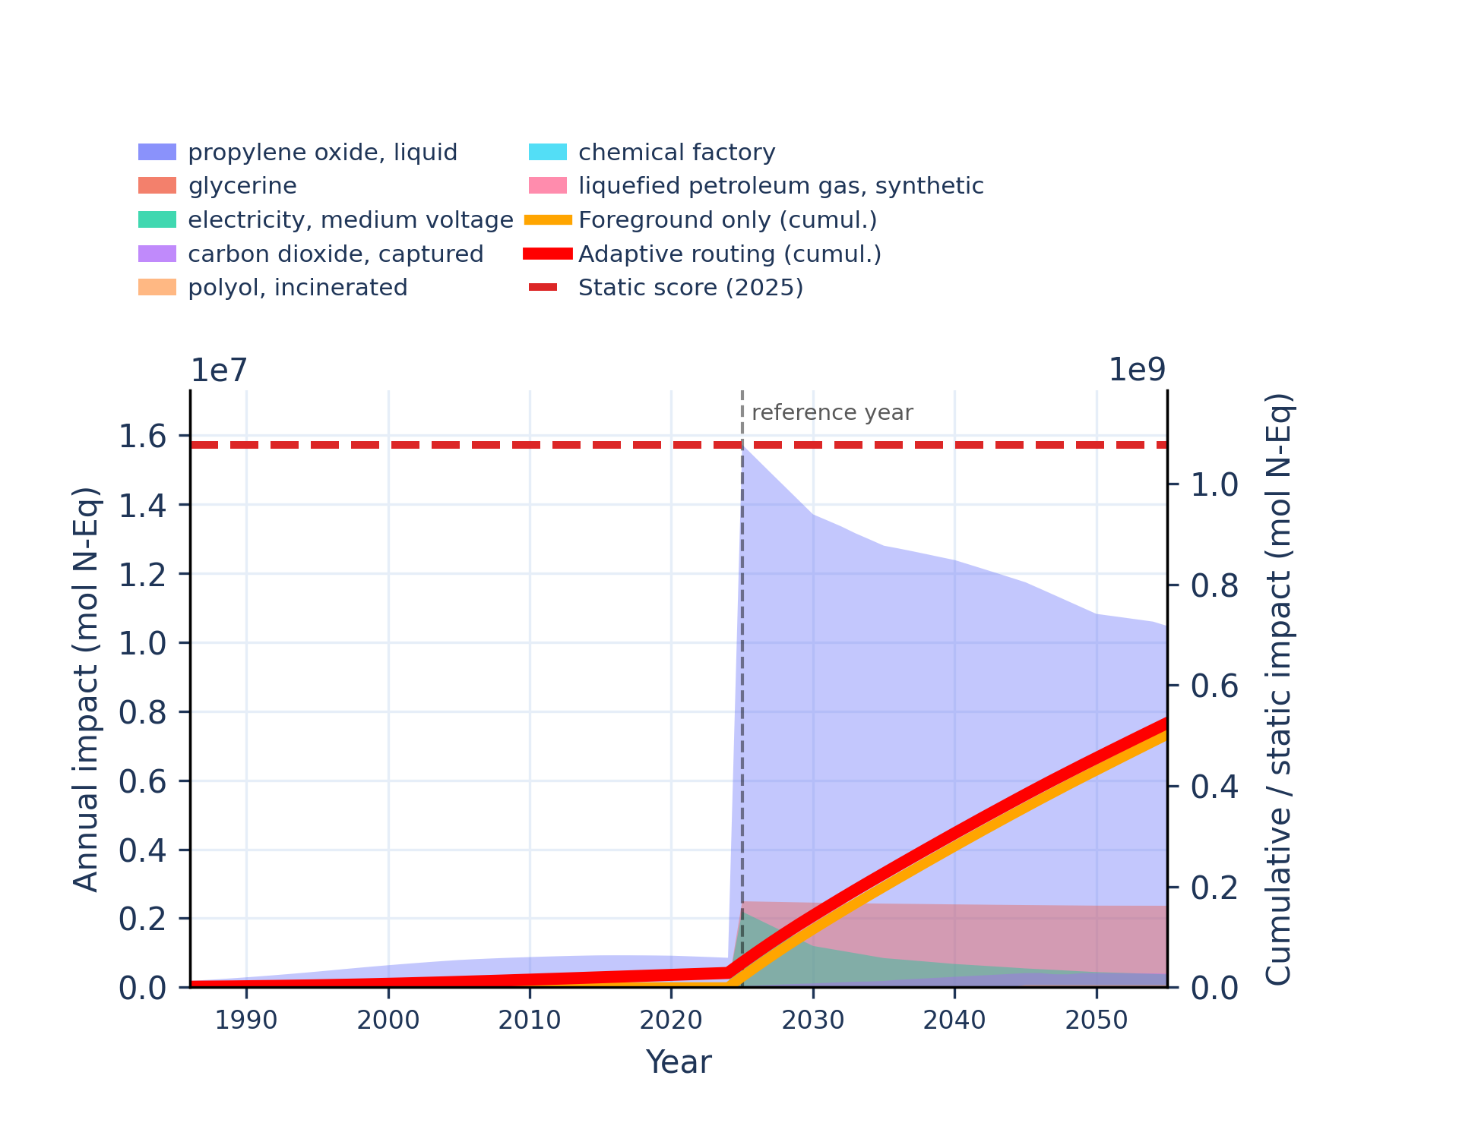 | 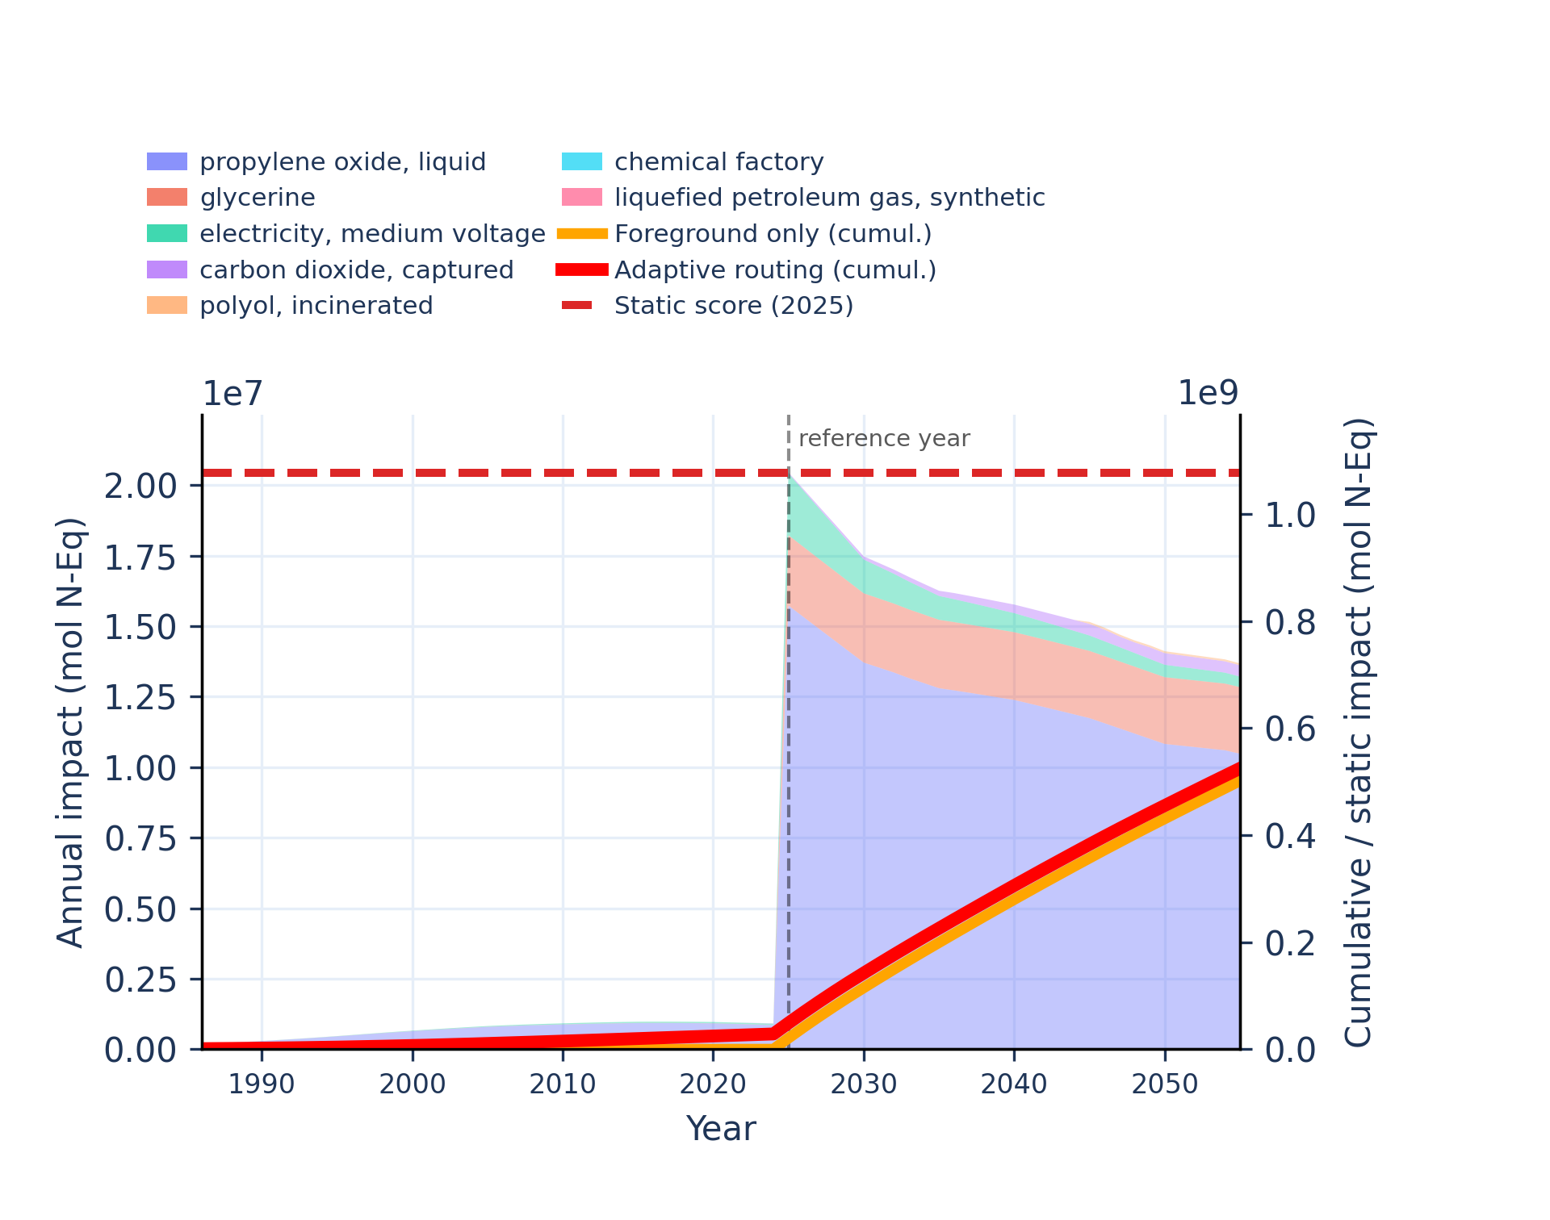
Figure S-routing-polyol-13. human toxicity: carcinogenic - comparative toxic unit for human (CTUh).
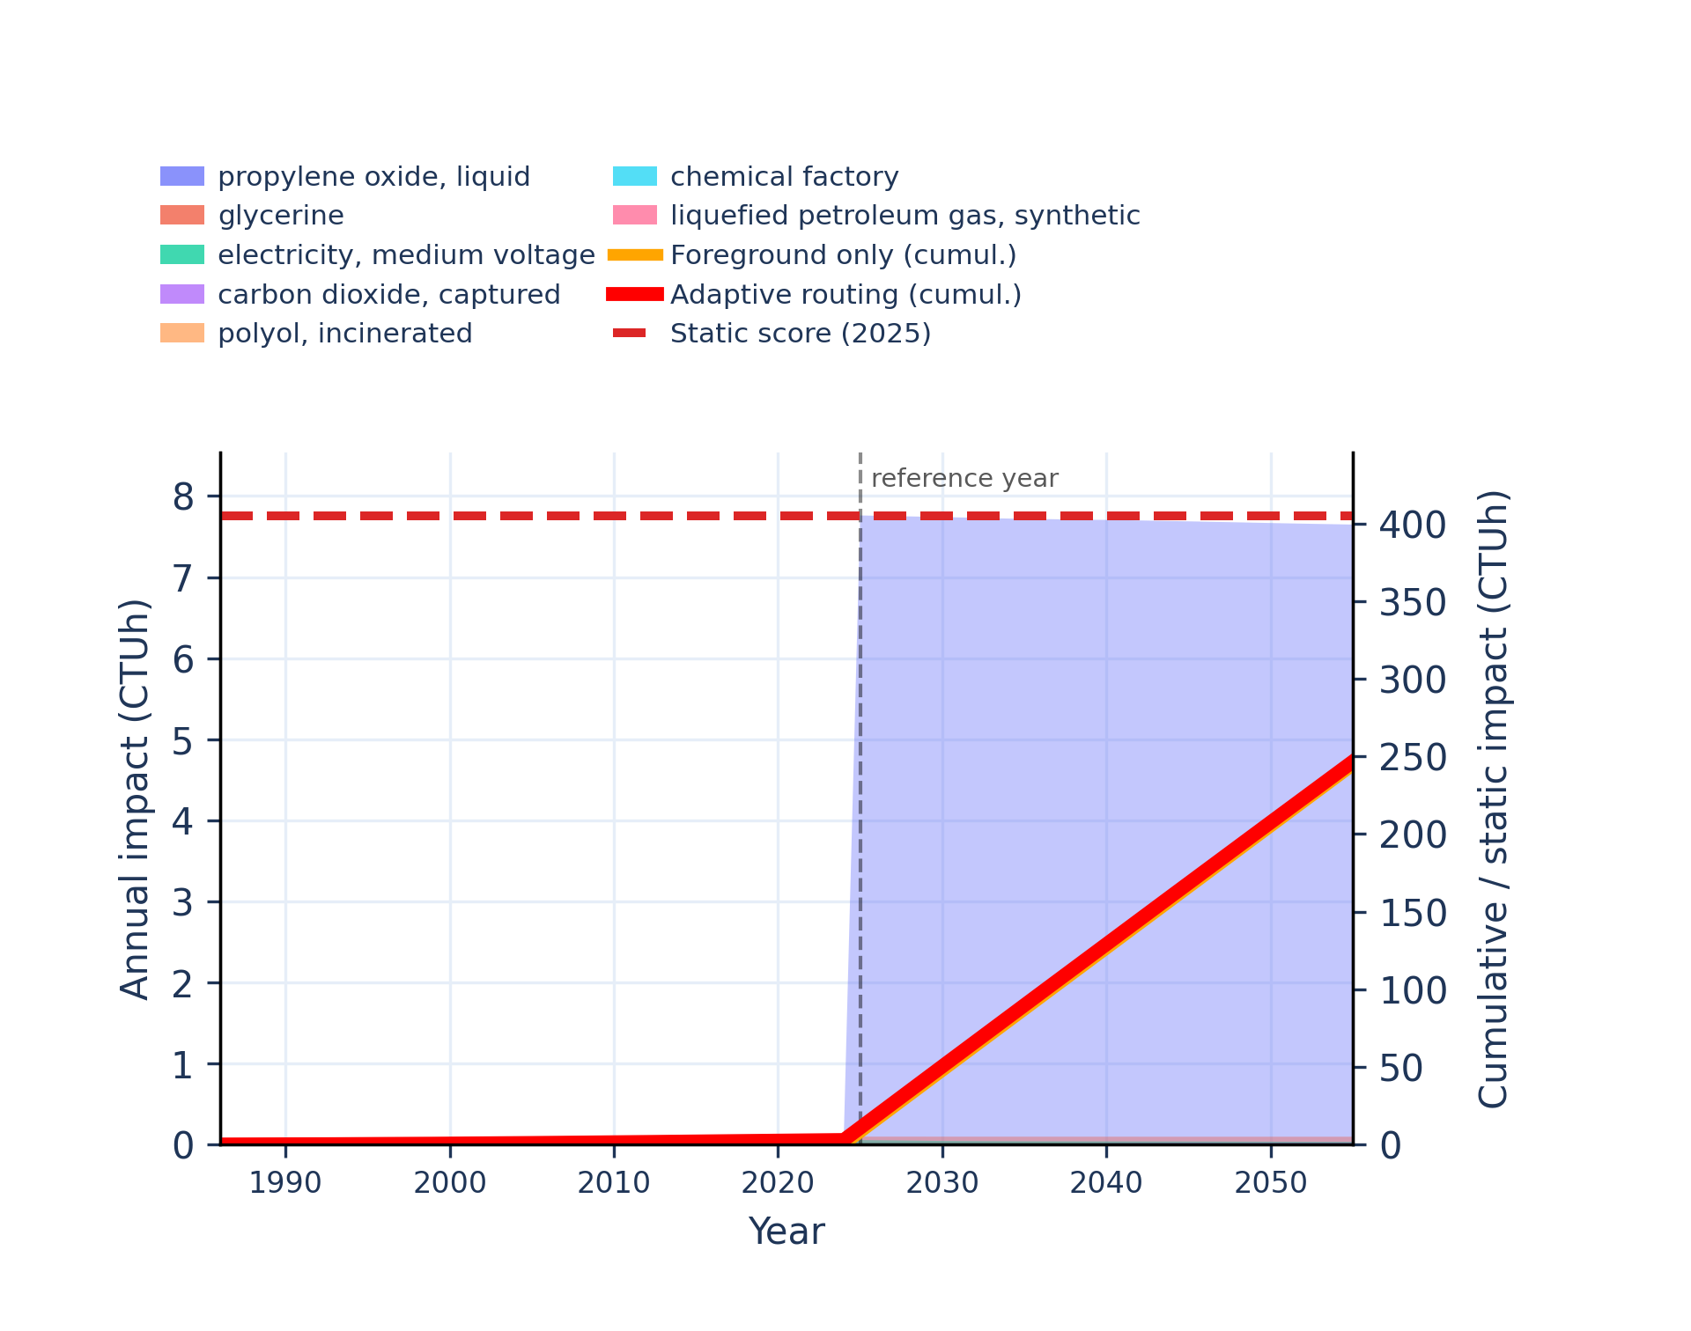 | 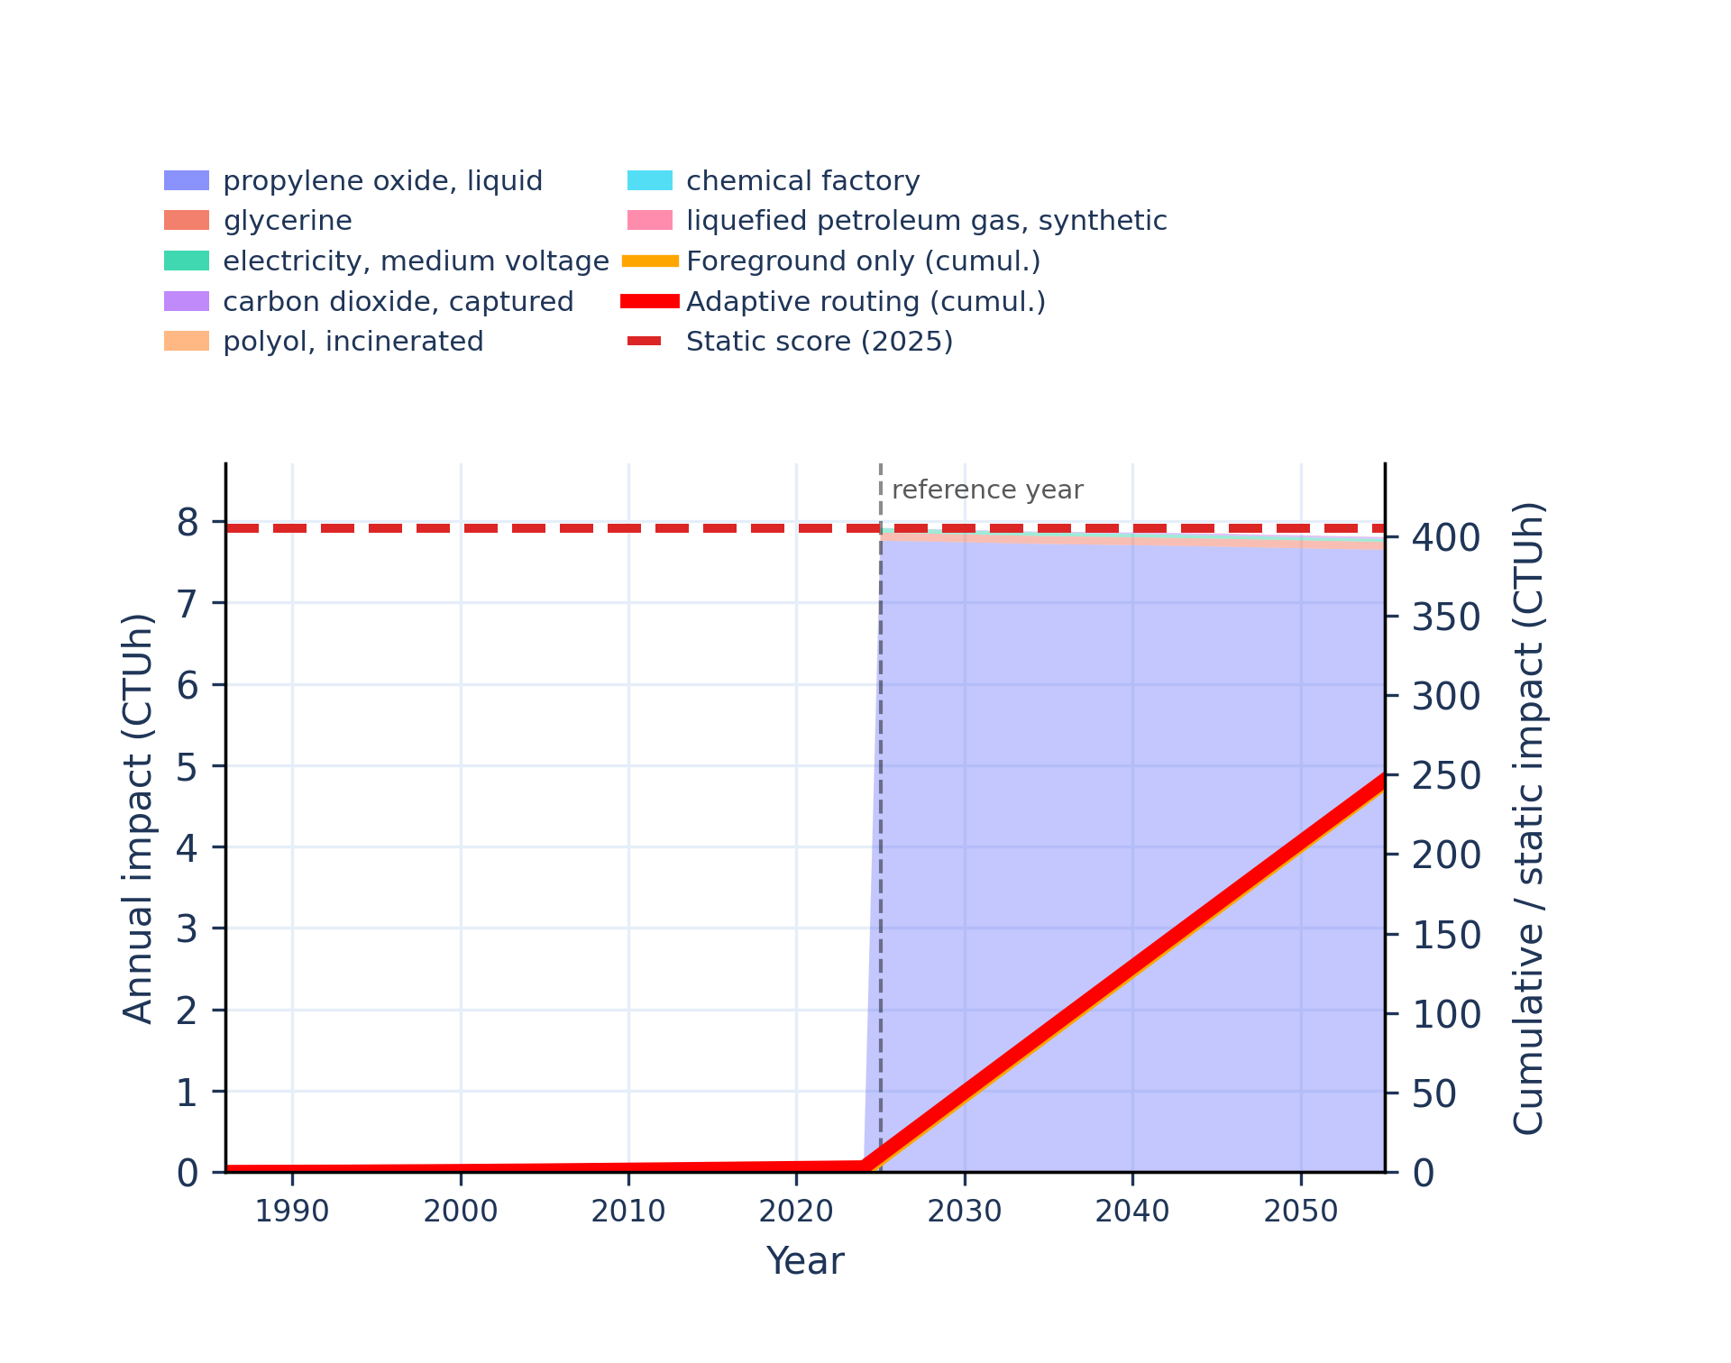
Figure S-routing-polyol-14. human toxicity: carcinogenic, inorganics - comparative toxic unit for human (CTUh).
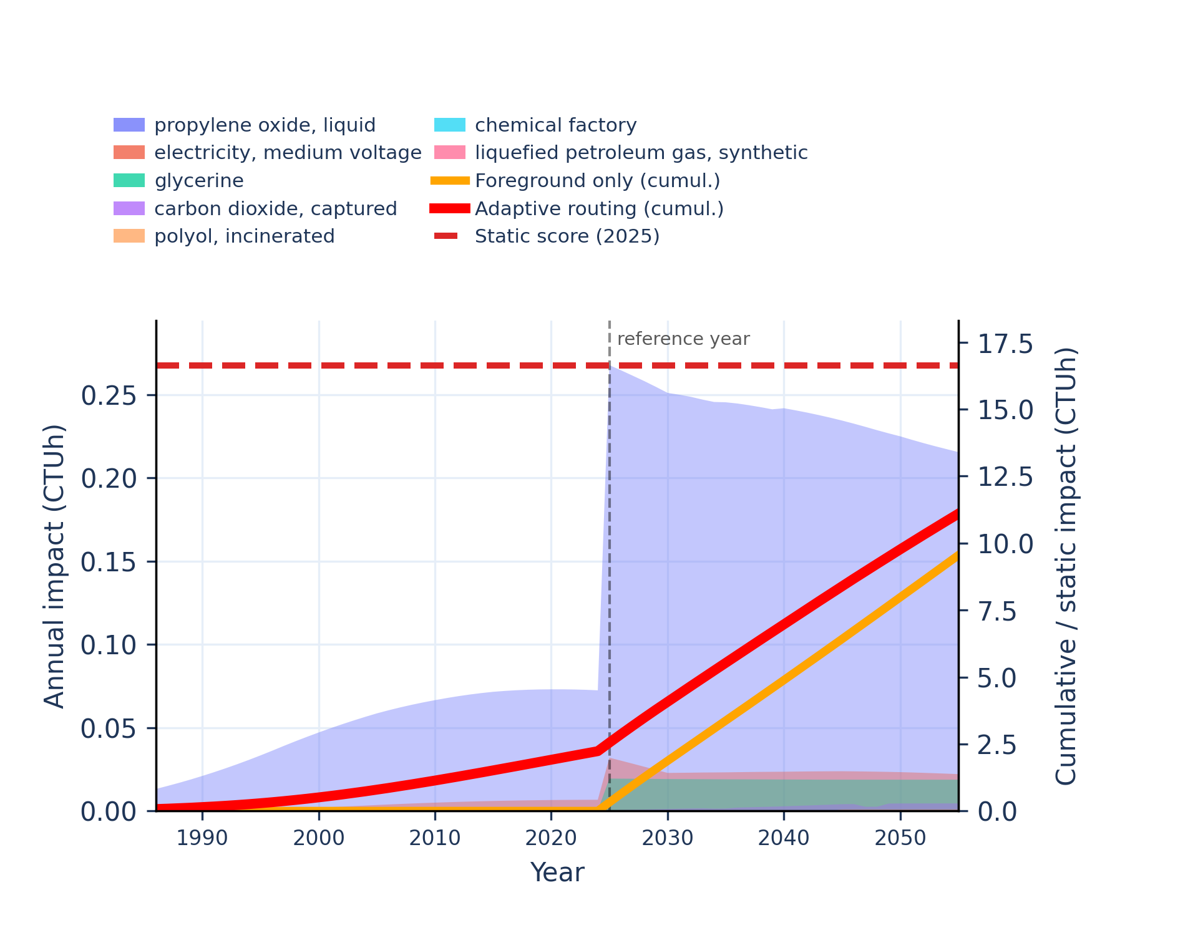 | 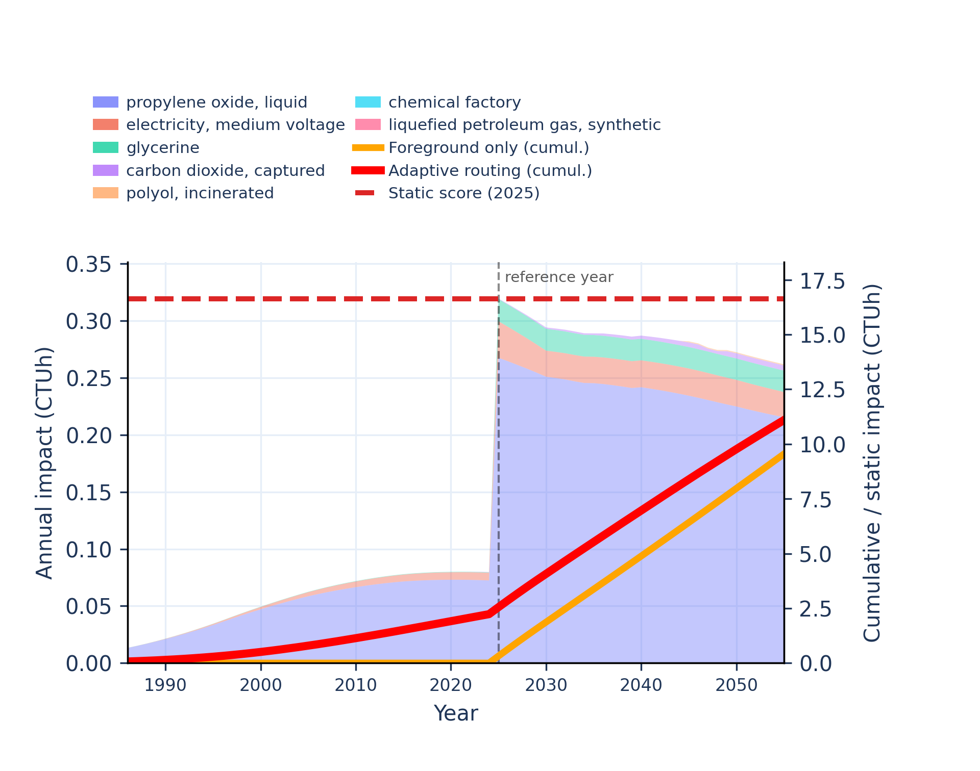
Figure S-routing-polyol-15. human toxicity: carcinogenic, organics - comparative toxic unit for human (CTUh).
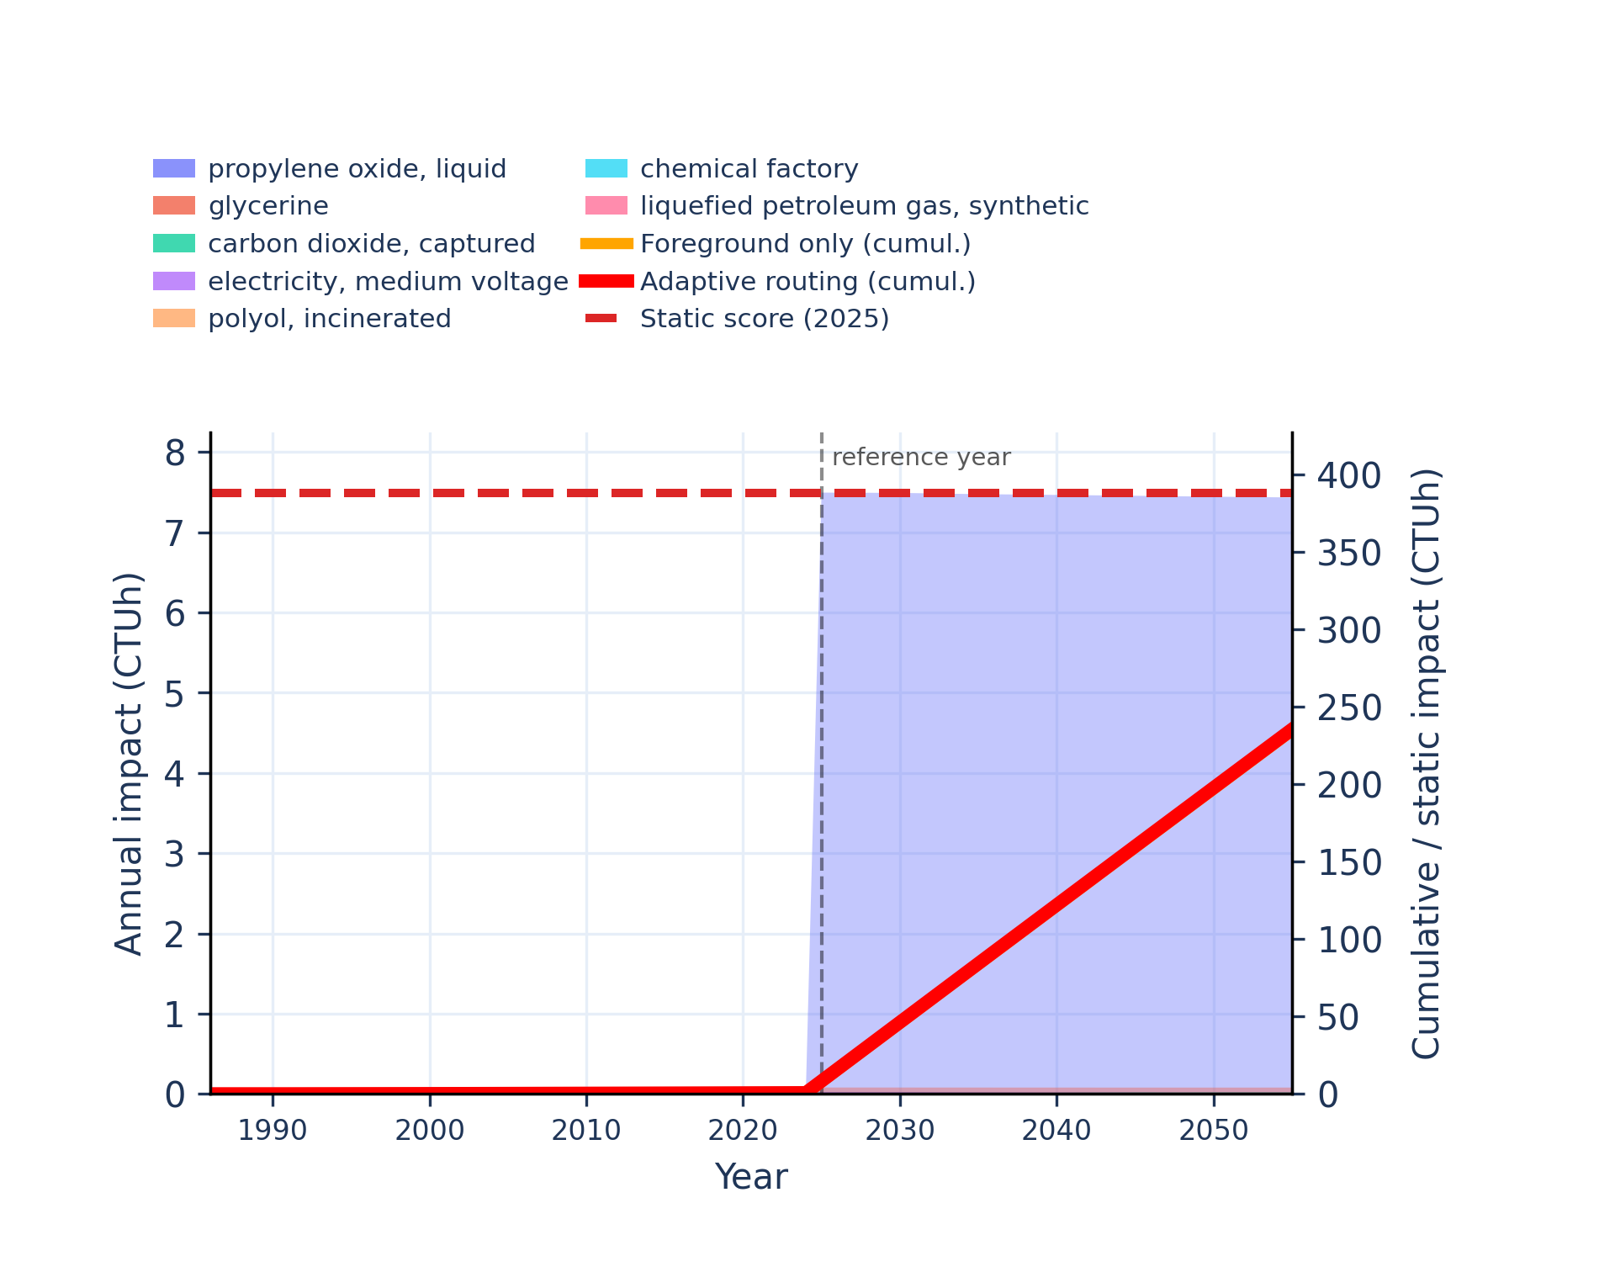 | 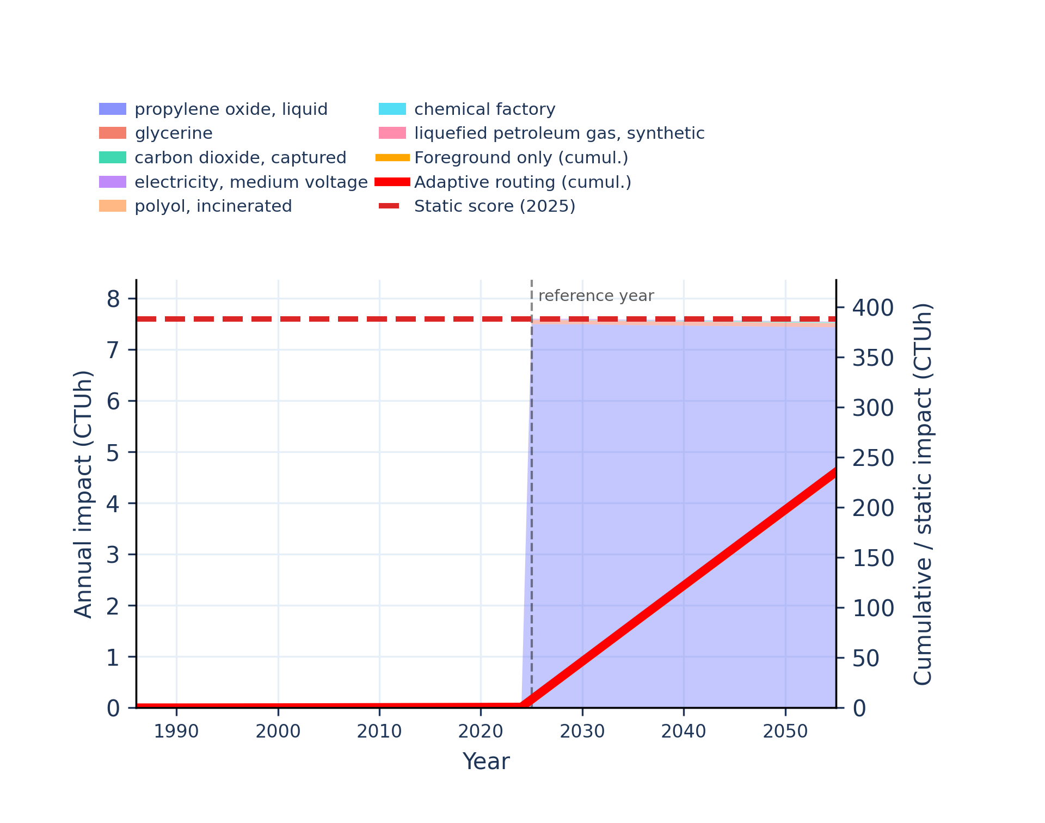
Figure S-routing-polyol-16. human toxicity: non-carcinogenic - comparative toxic unit for human (CTUh).
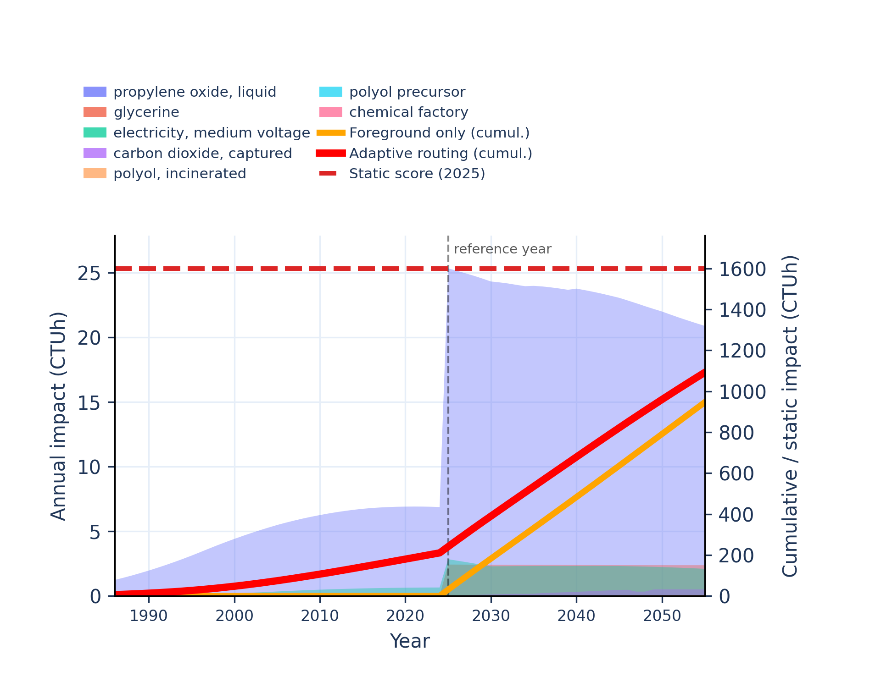 | 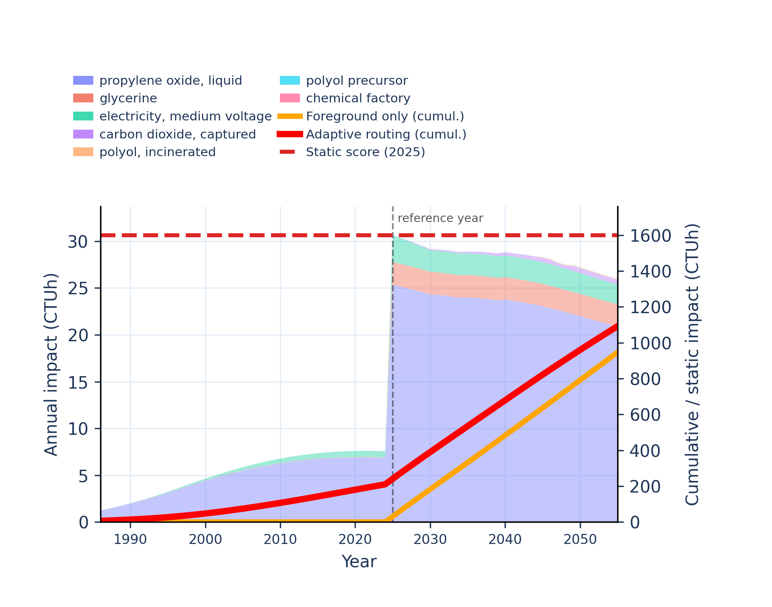
Figure S-routing-polyol-17. human toxicity: non-carcinogenic, inorganics - comparative toxic unit for human (CTUh).
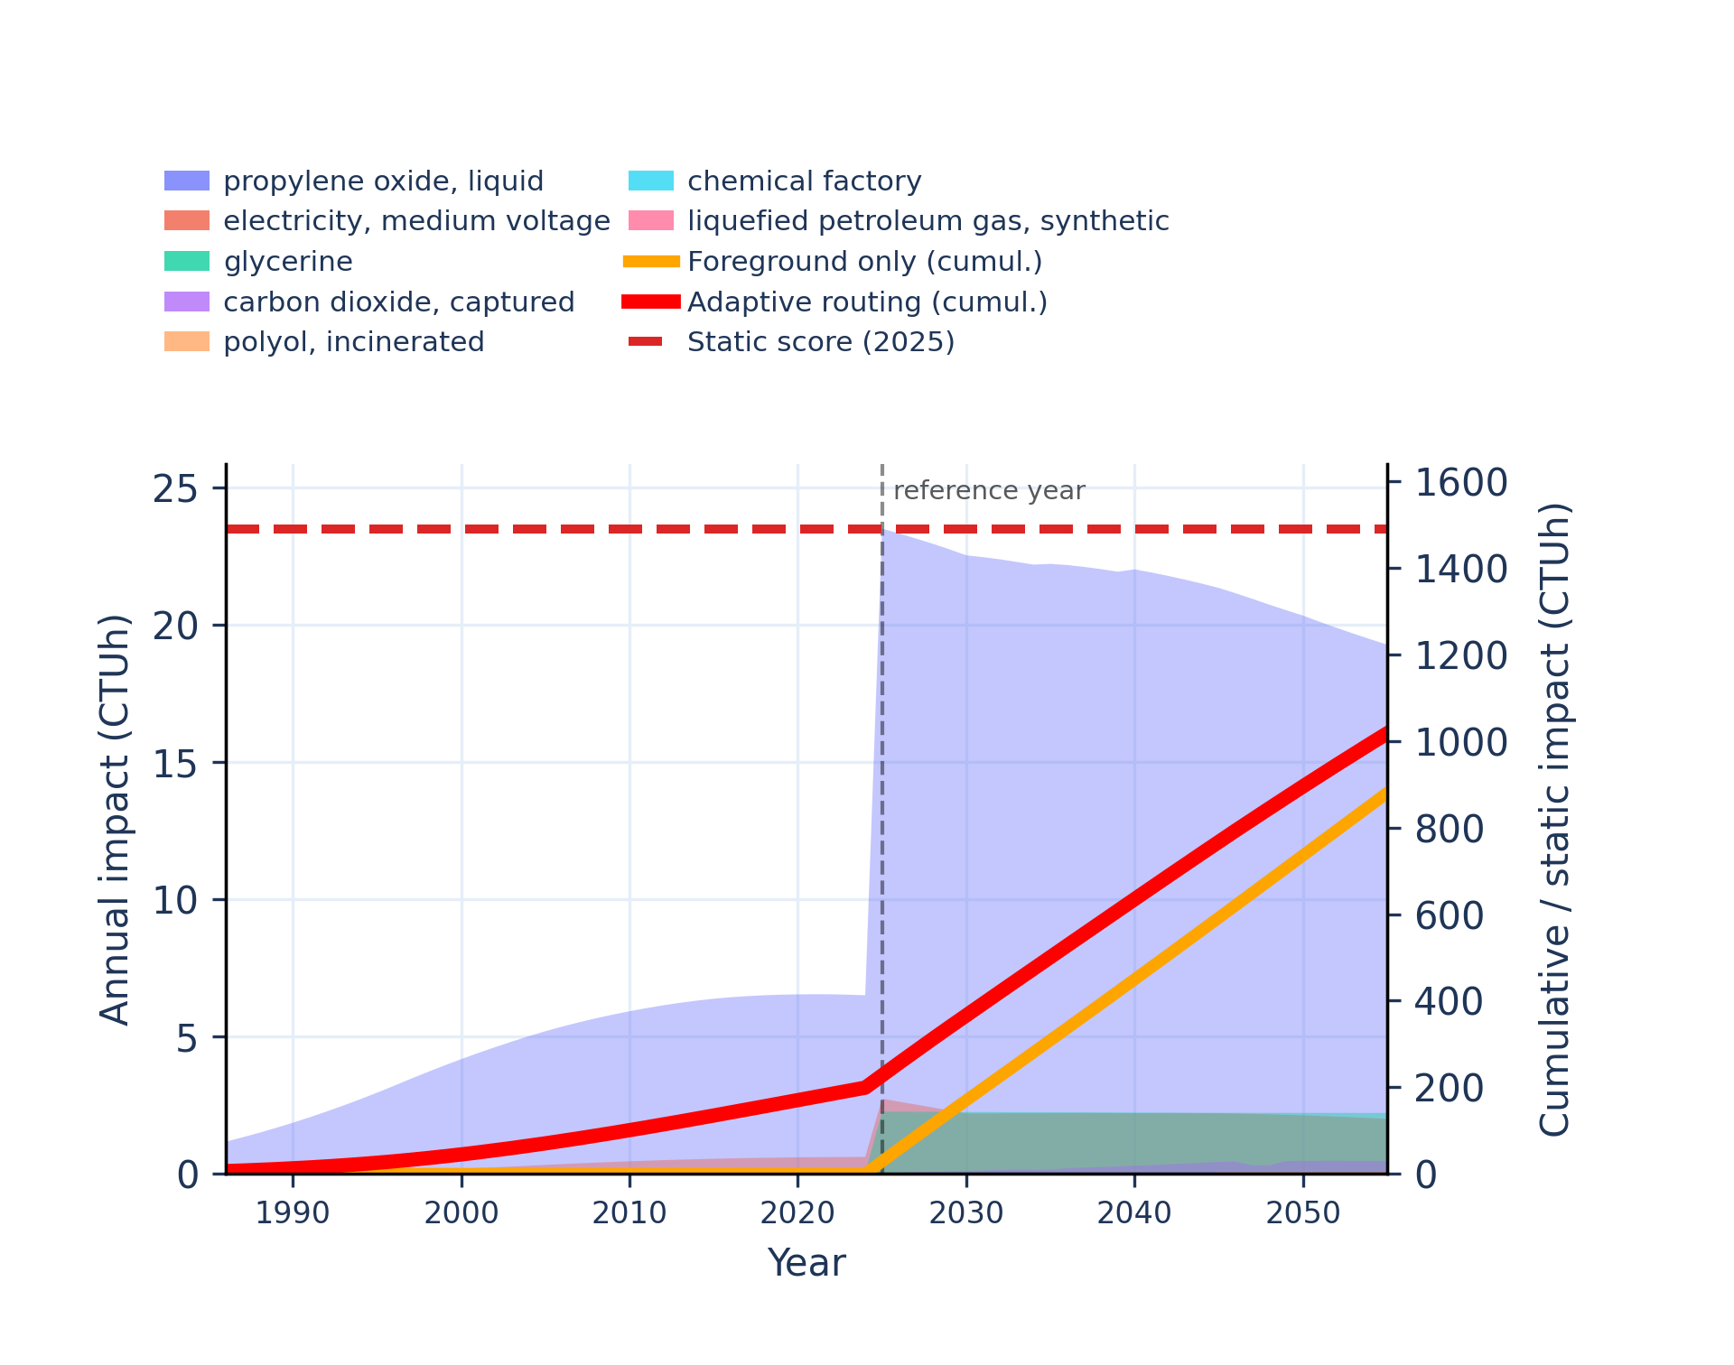 | 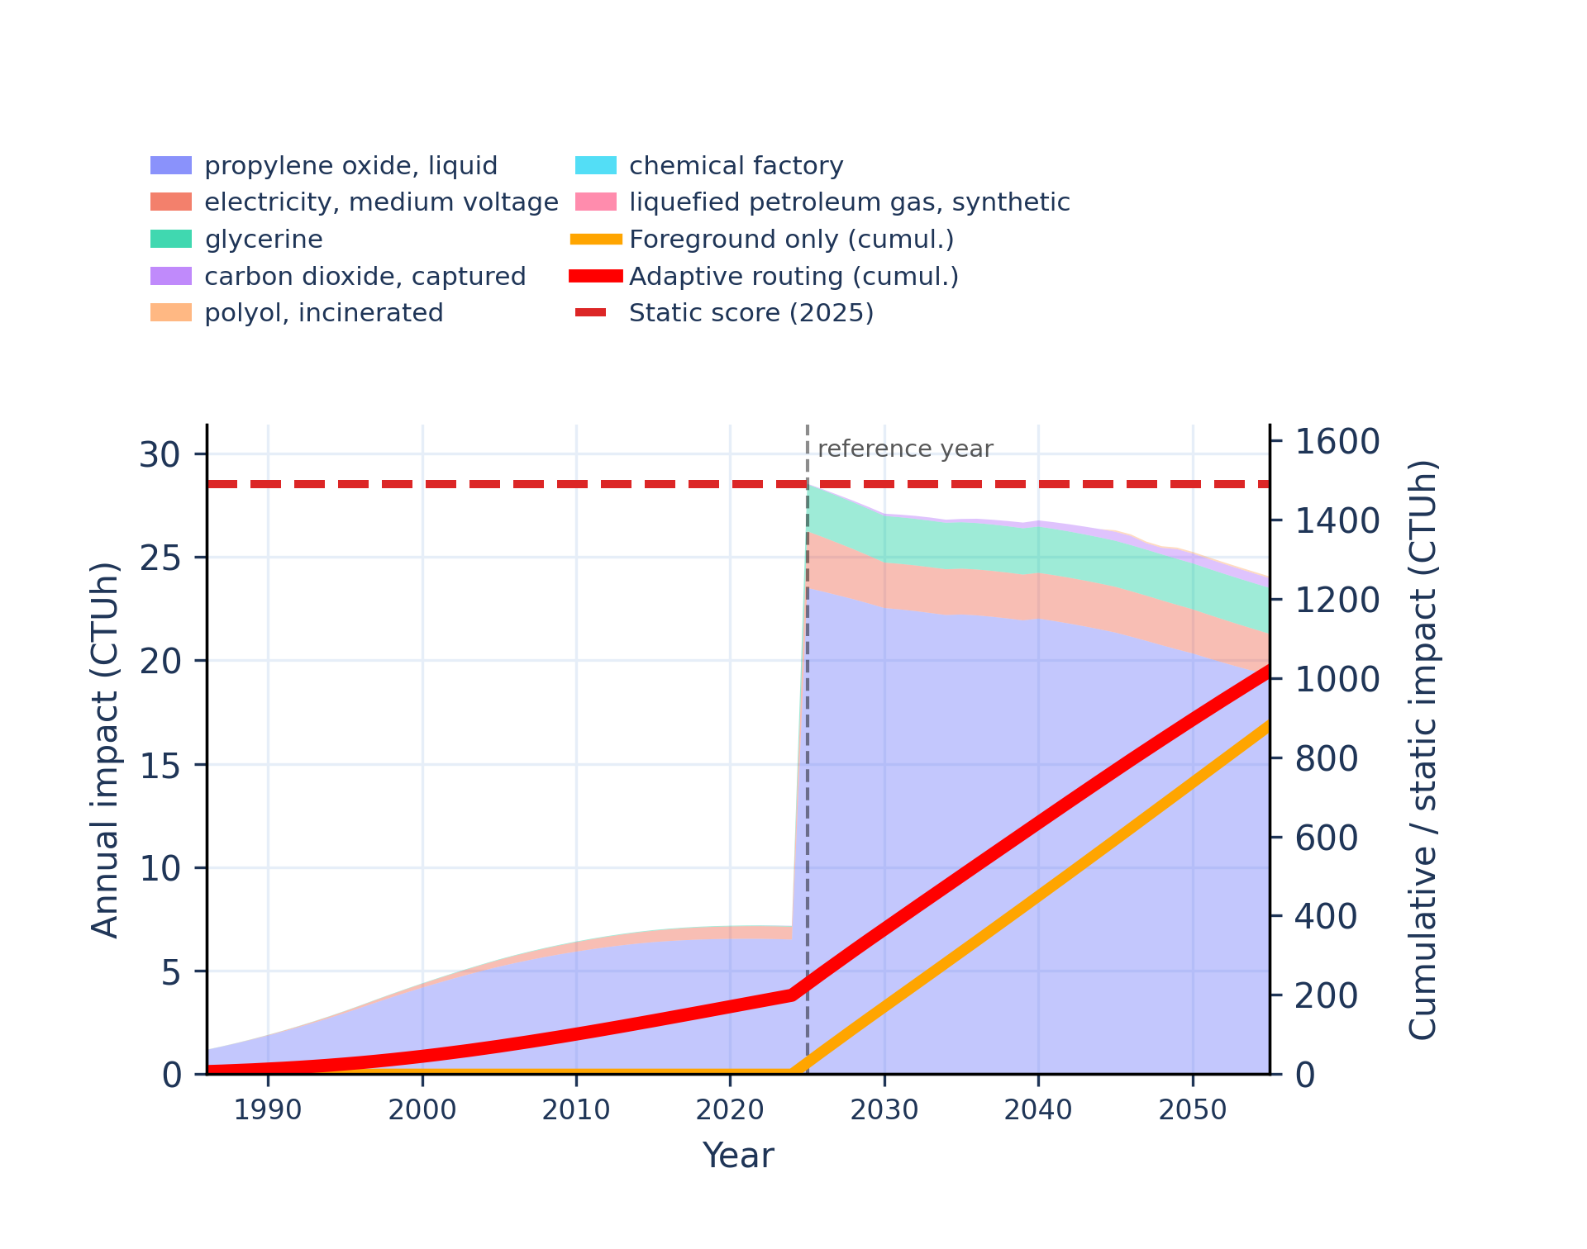
Figure S-routing-polyol-18. human toxicity: non-carcinogenic, organics - comparative toxic unit for human (CTUh).
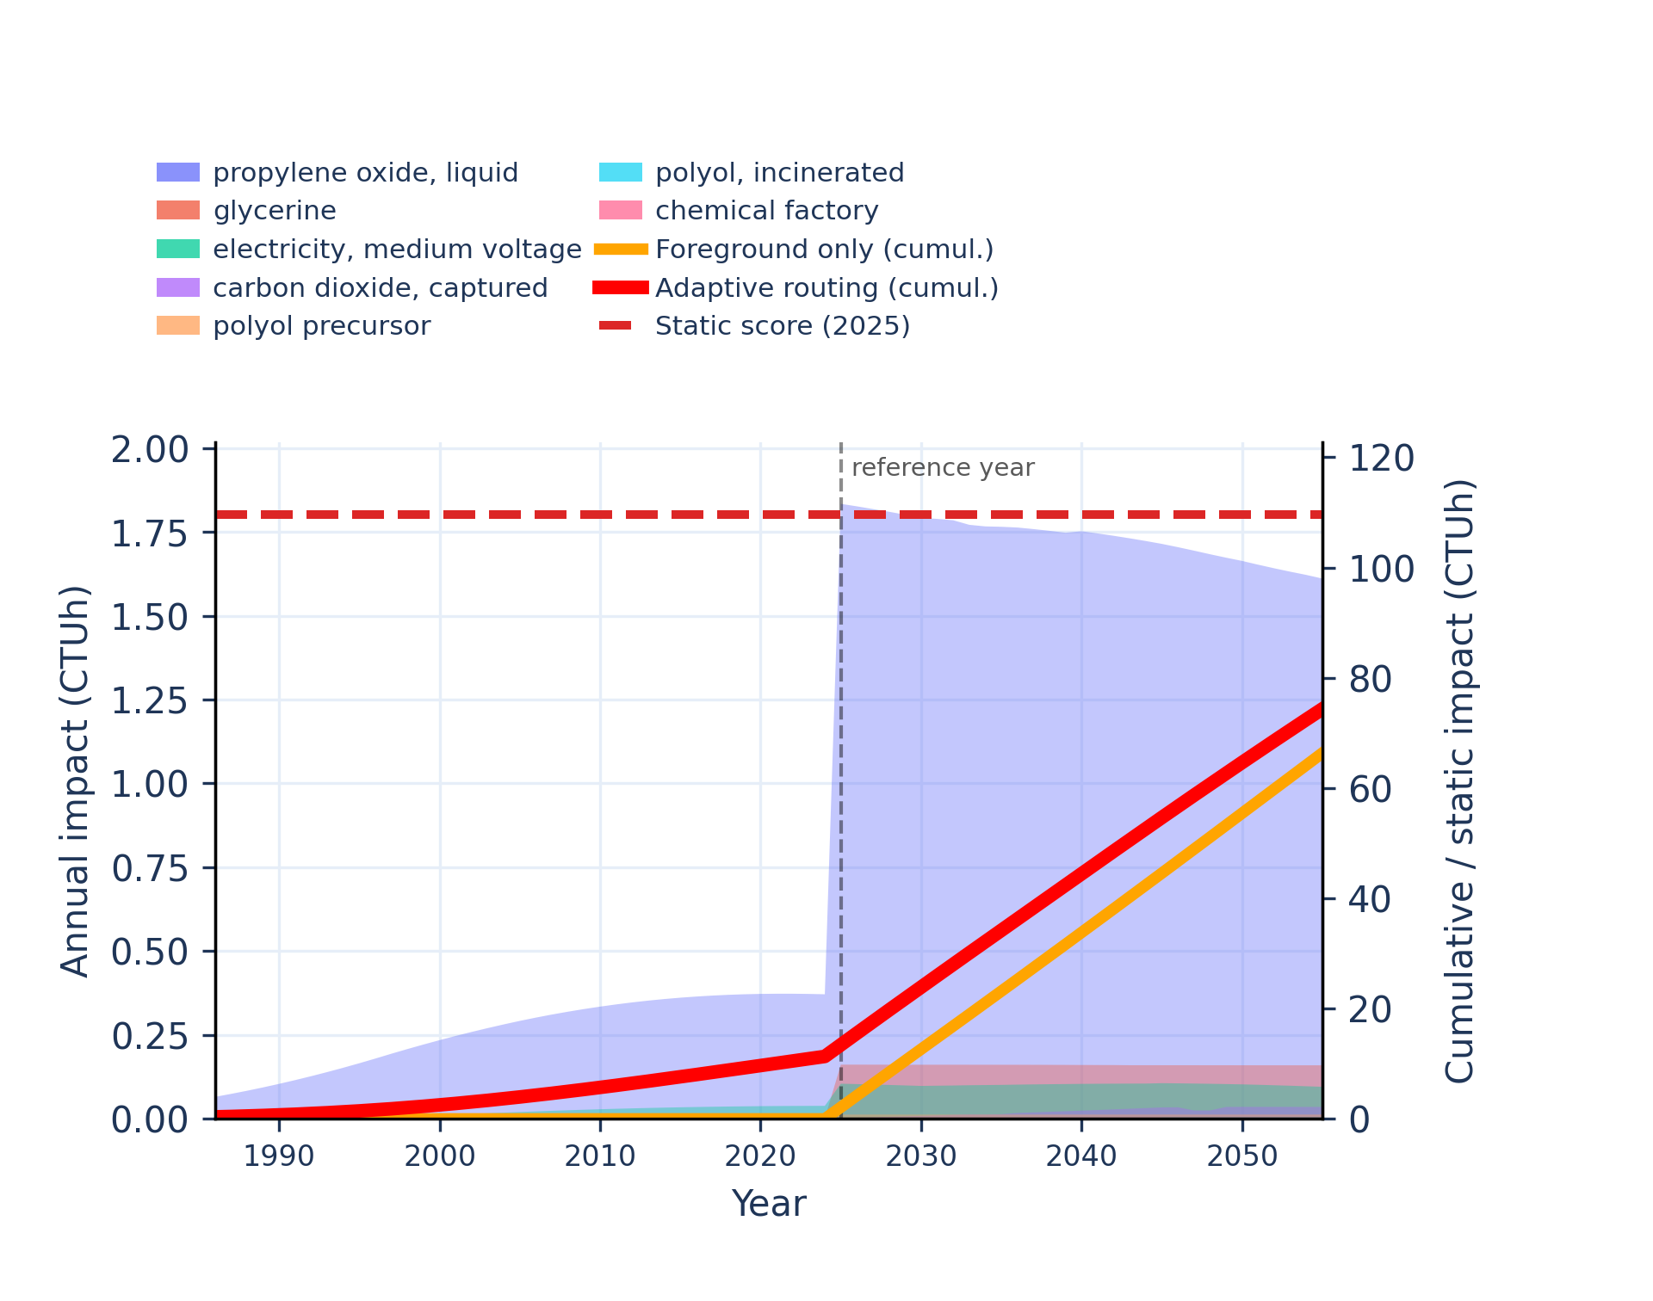 | 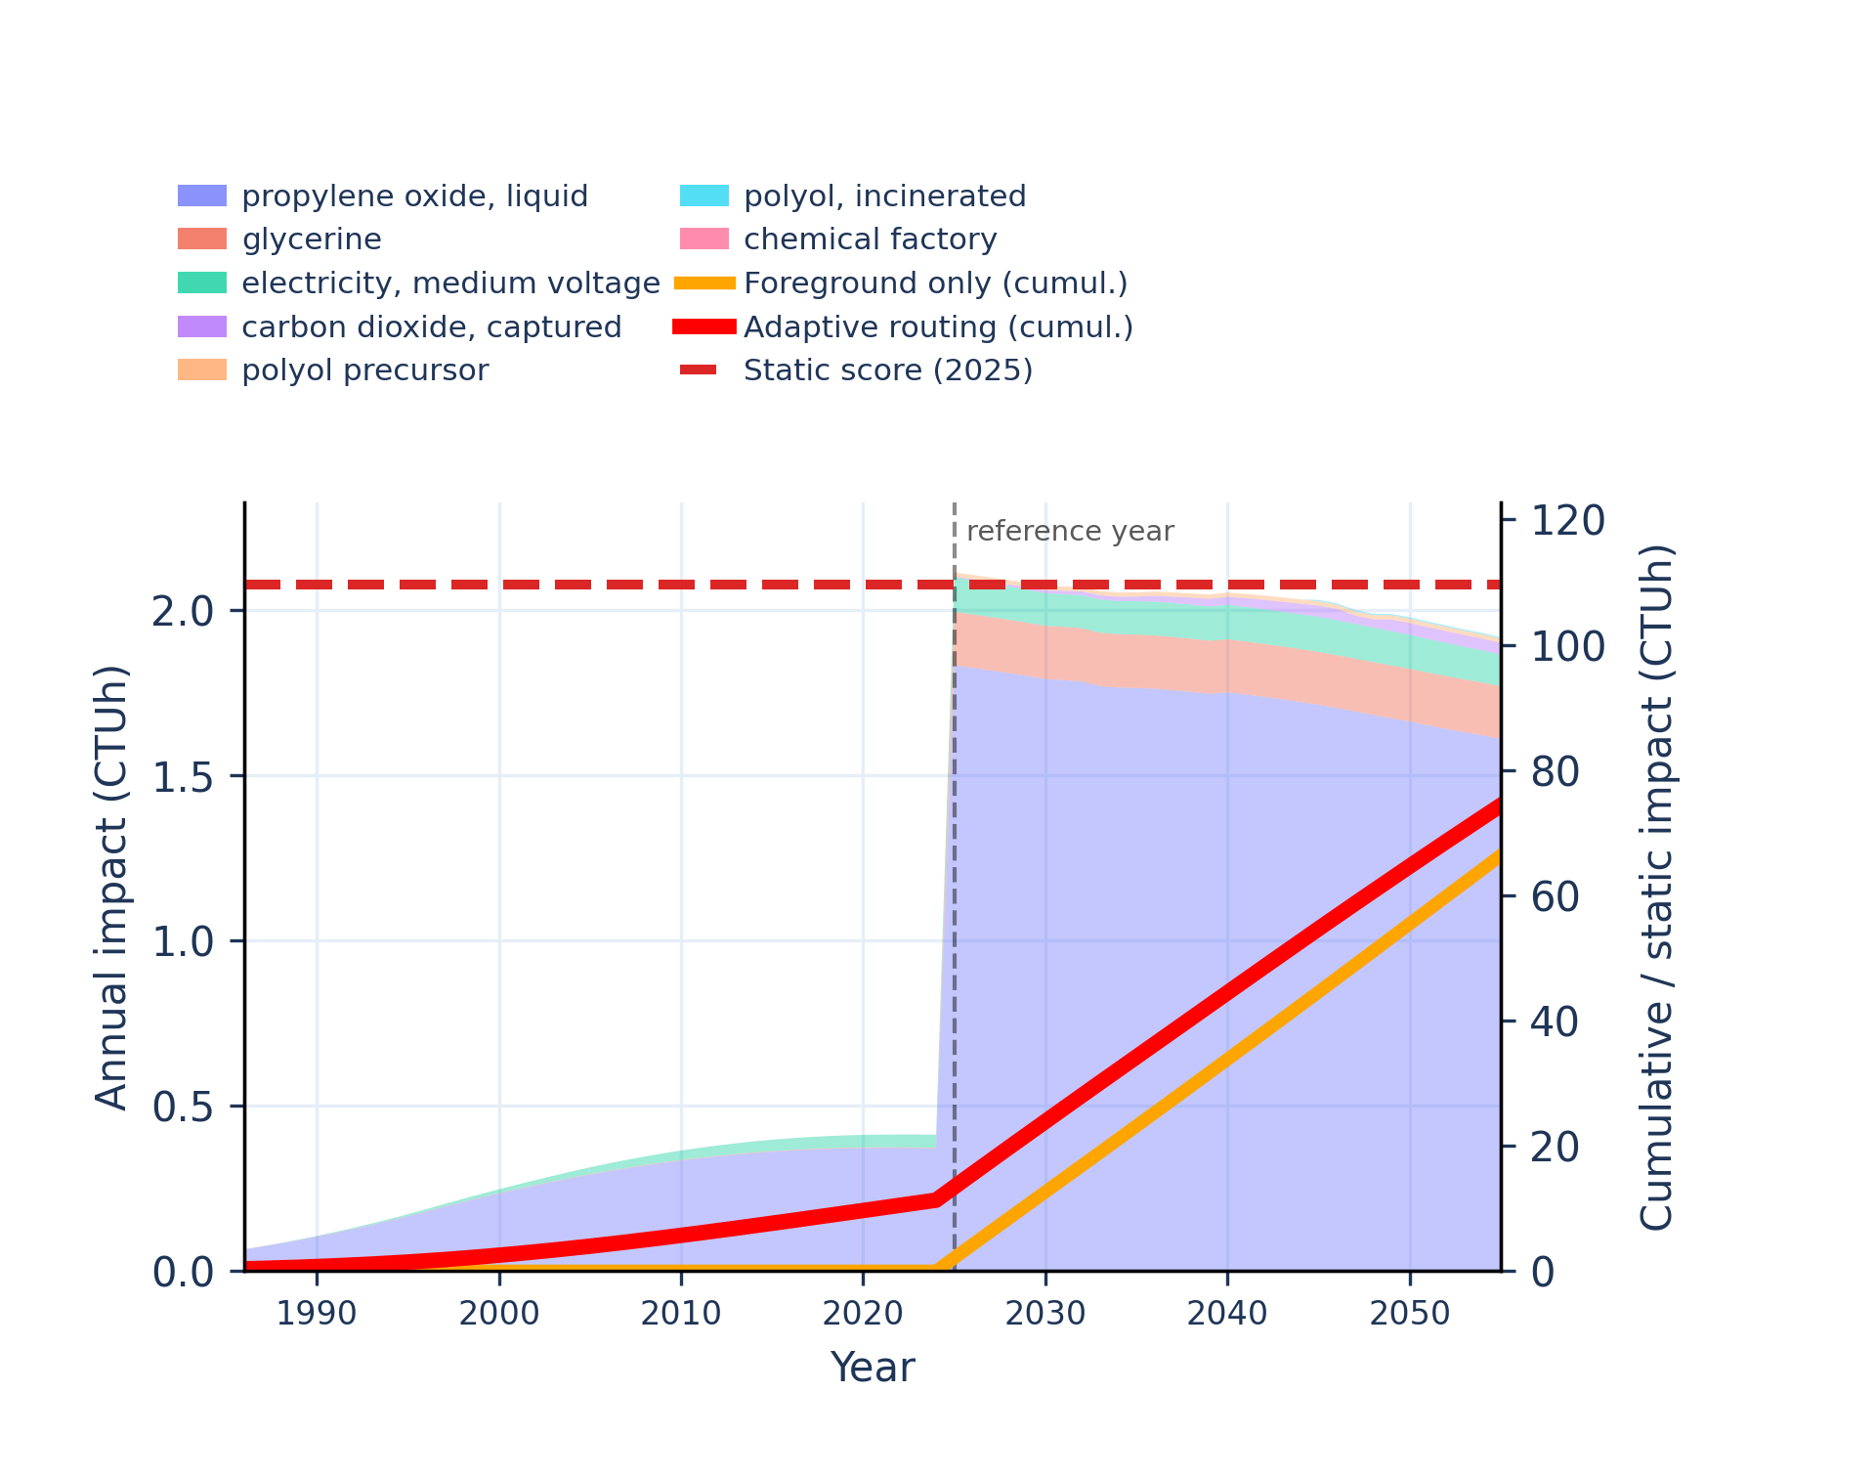
Figure S-routing-polyol-19. ionising radiation: human health - human exposure efficiency relative to u235.
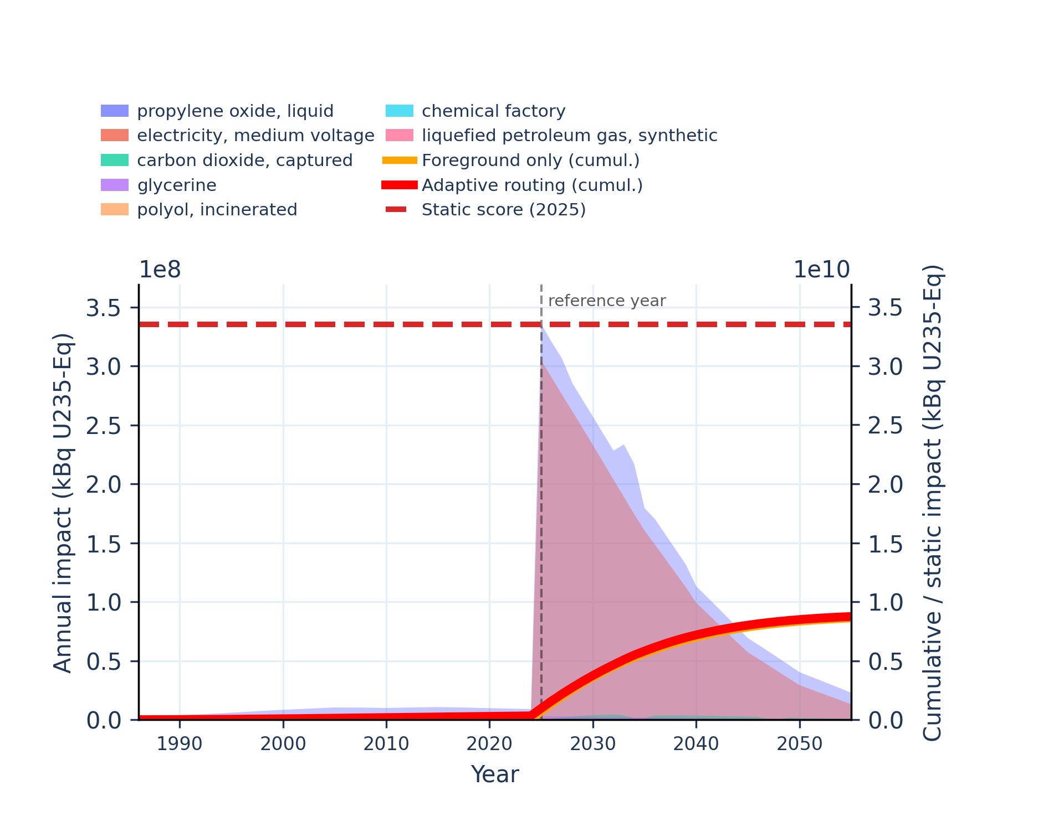 | 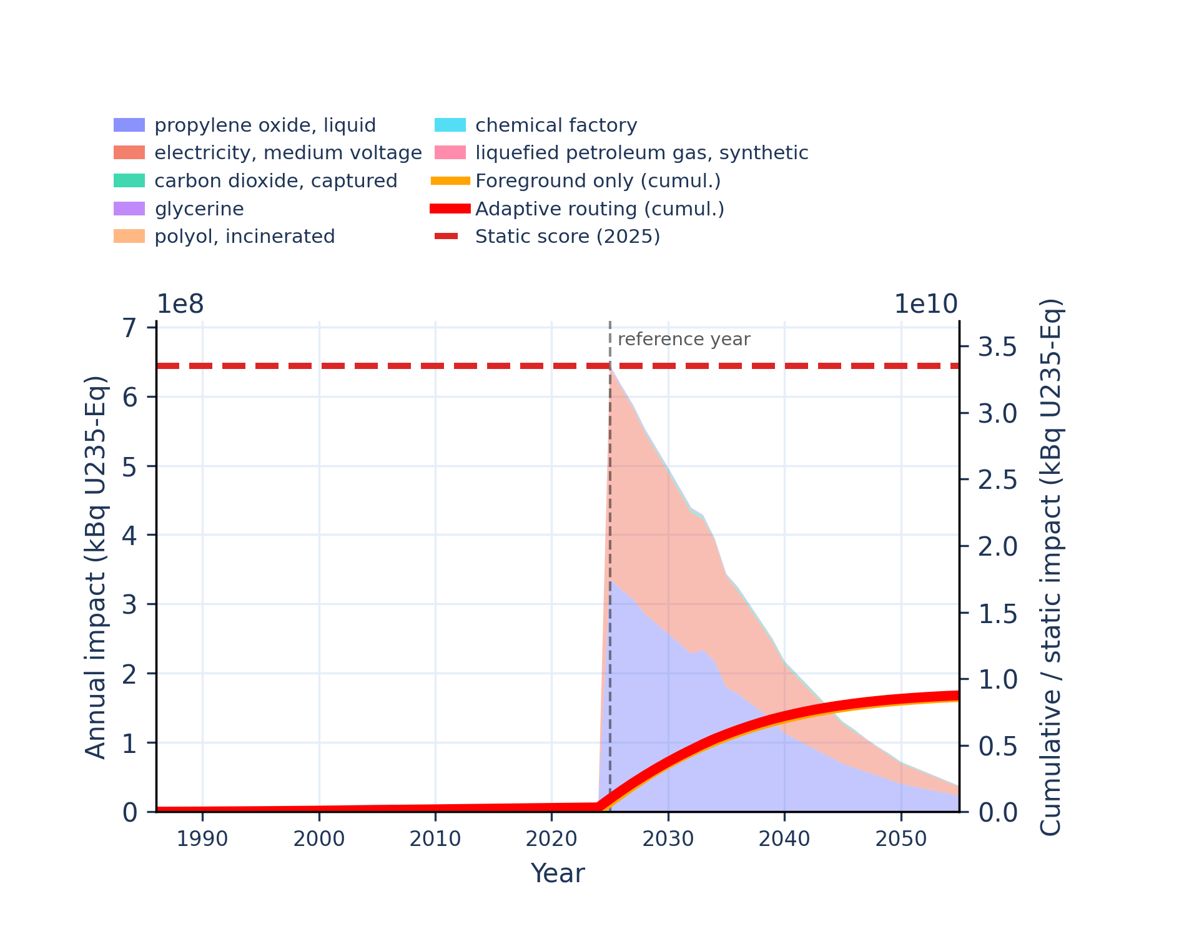
Figure S-routing-polyol-20. land use - soil quality index.
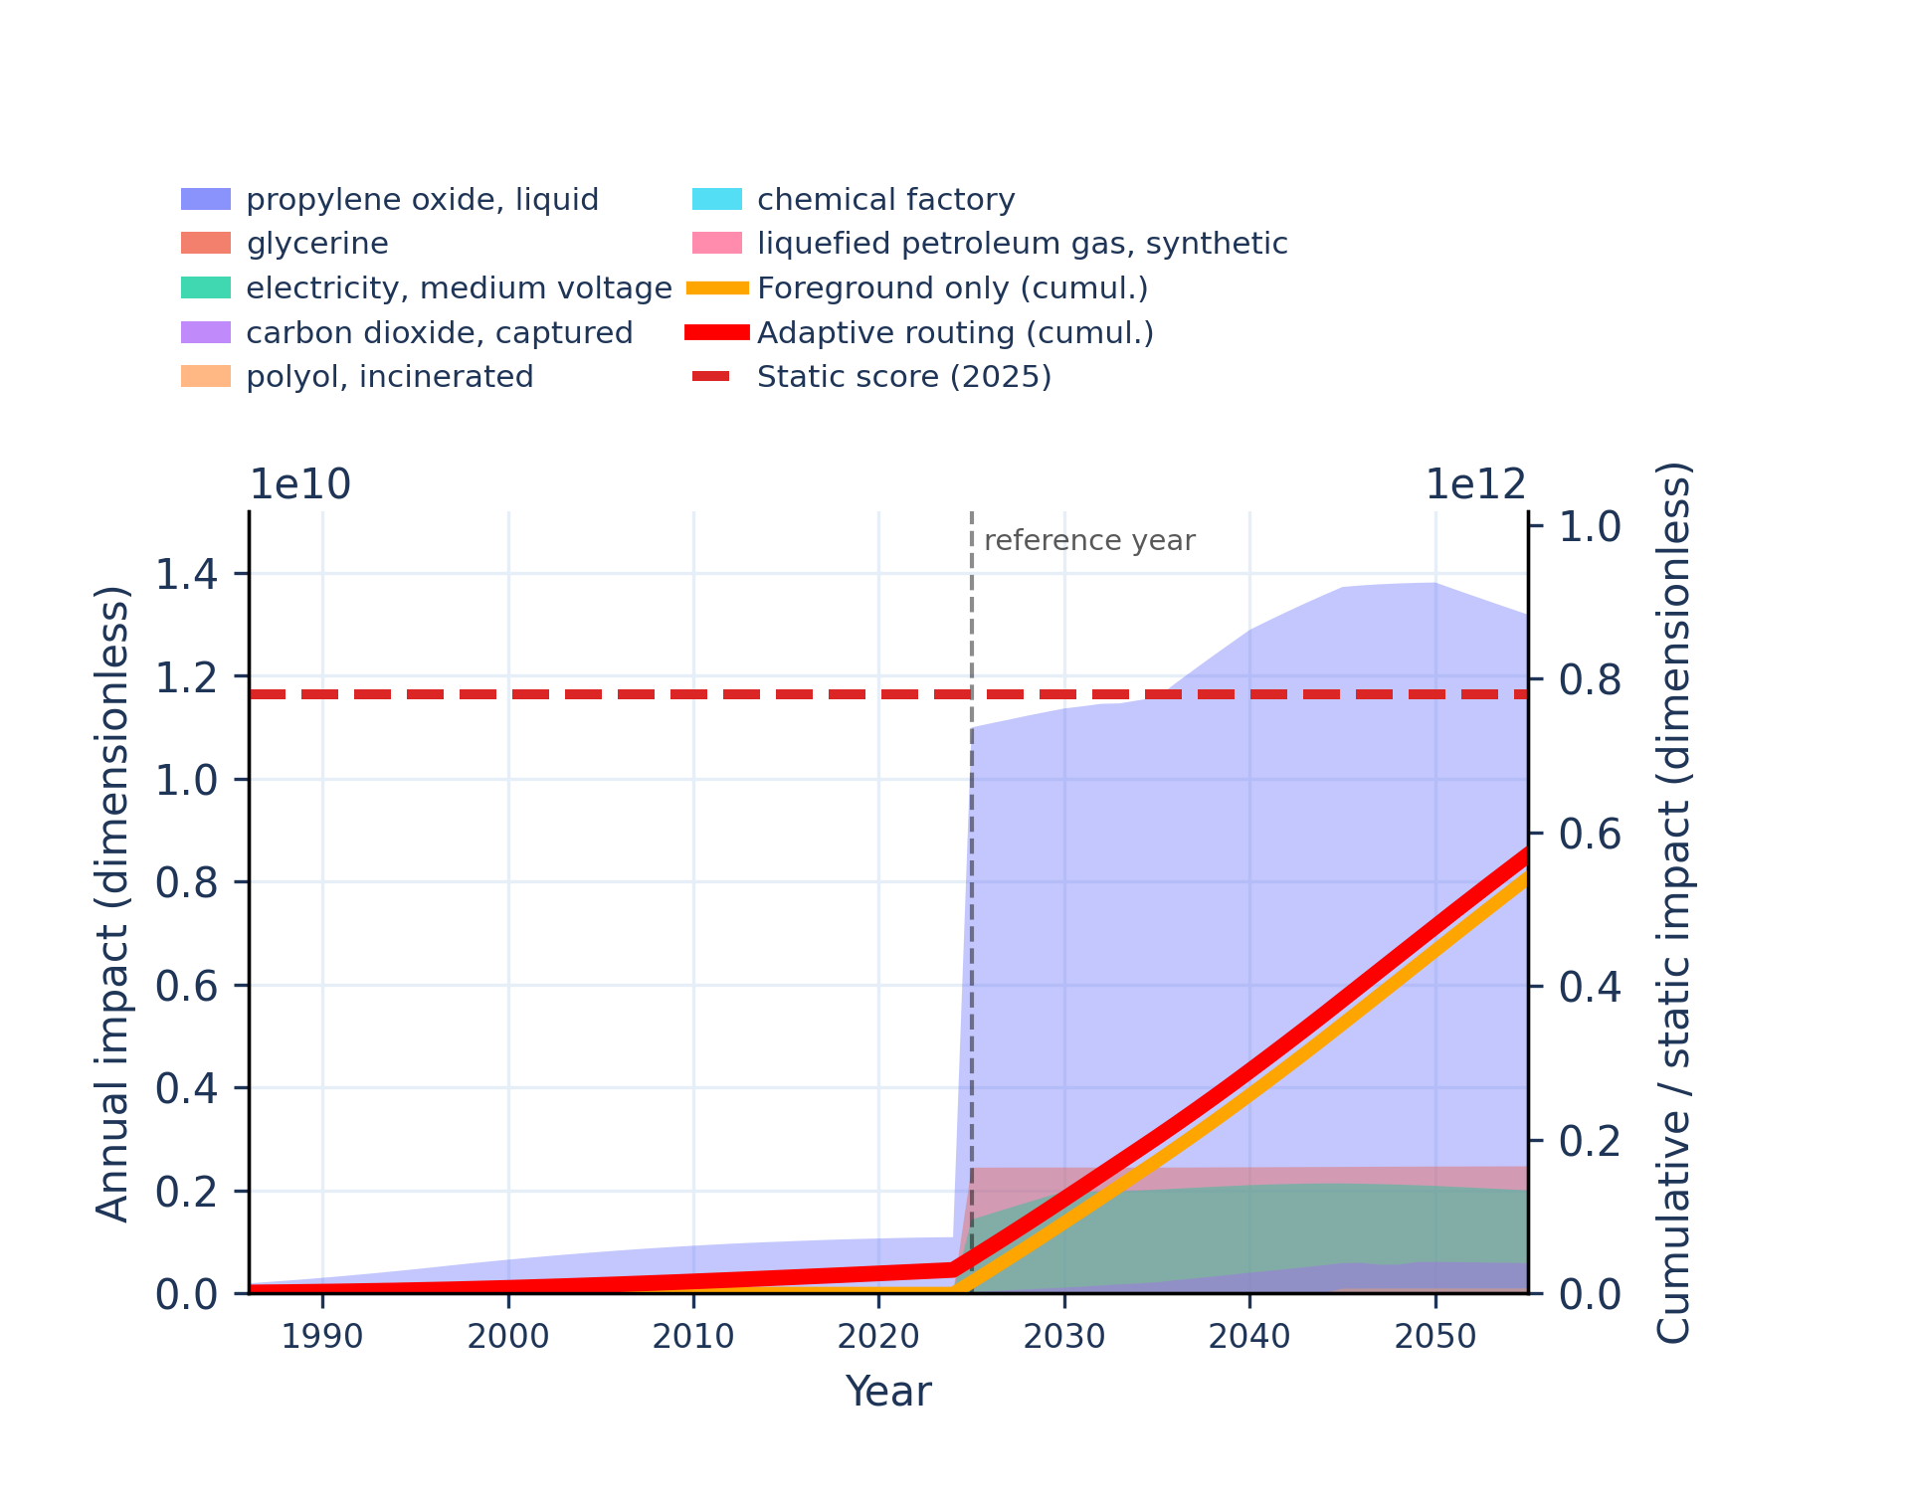 | 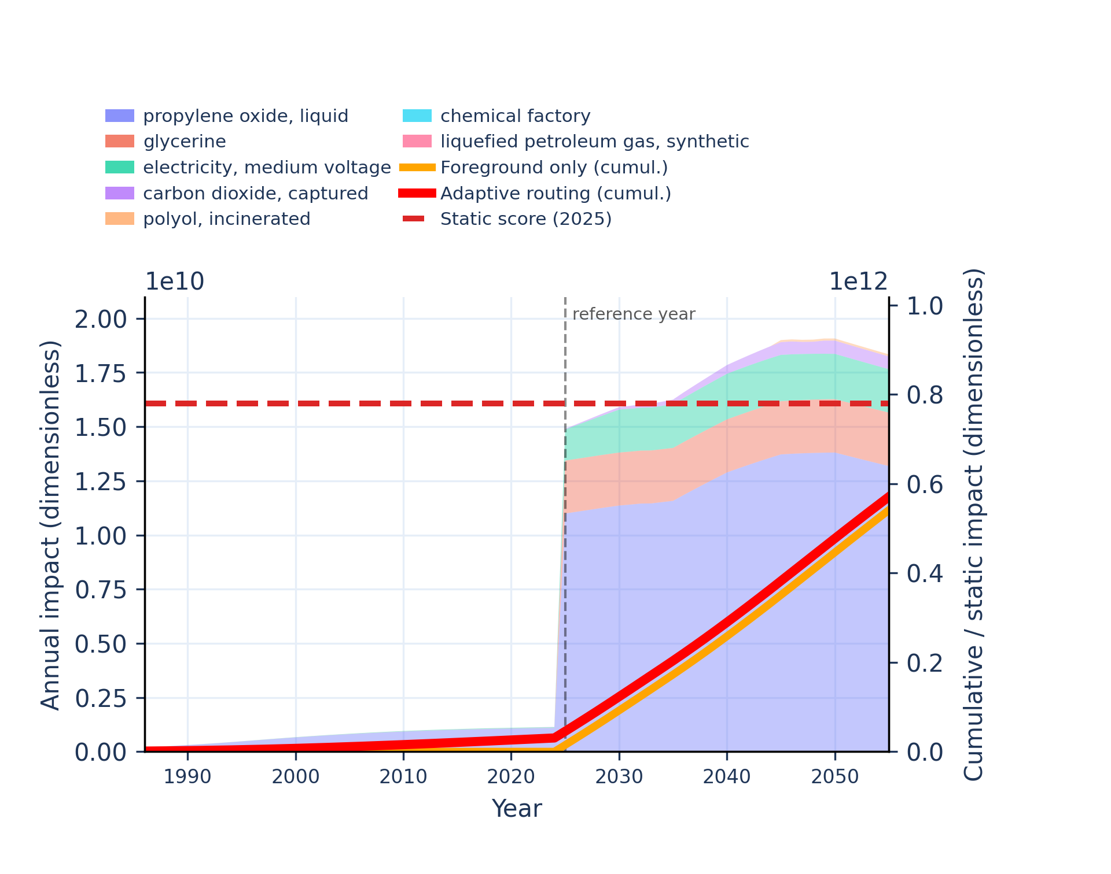
Figure S-routing-polyol-21. material resources: metals/minerals - abiotic depletion potential (ADP): elements (ultimate reserves).
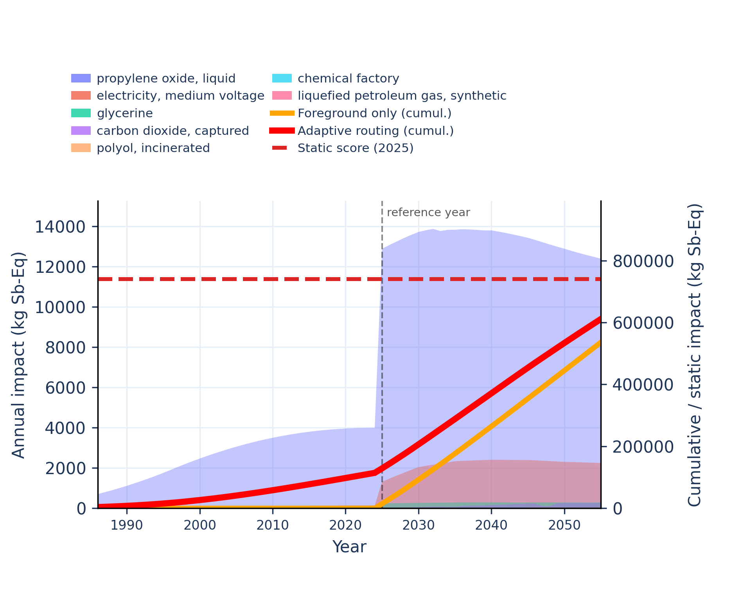 | 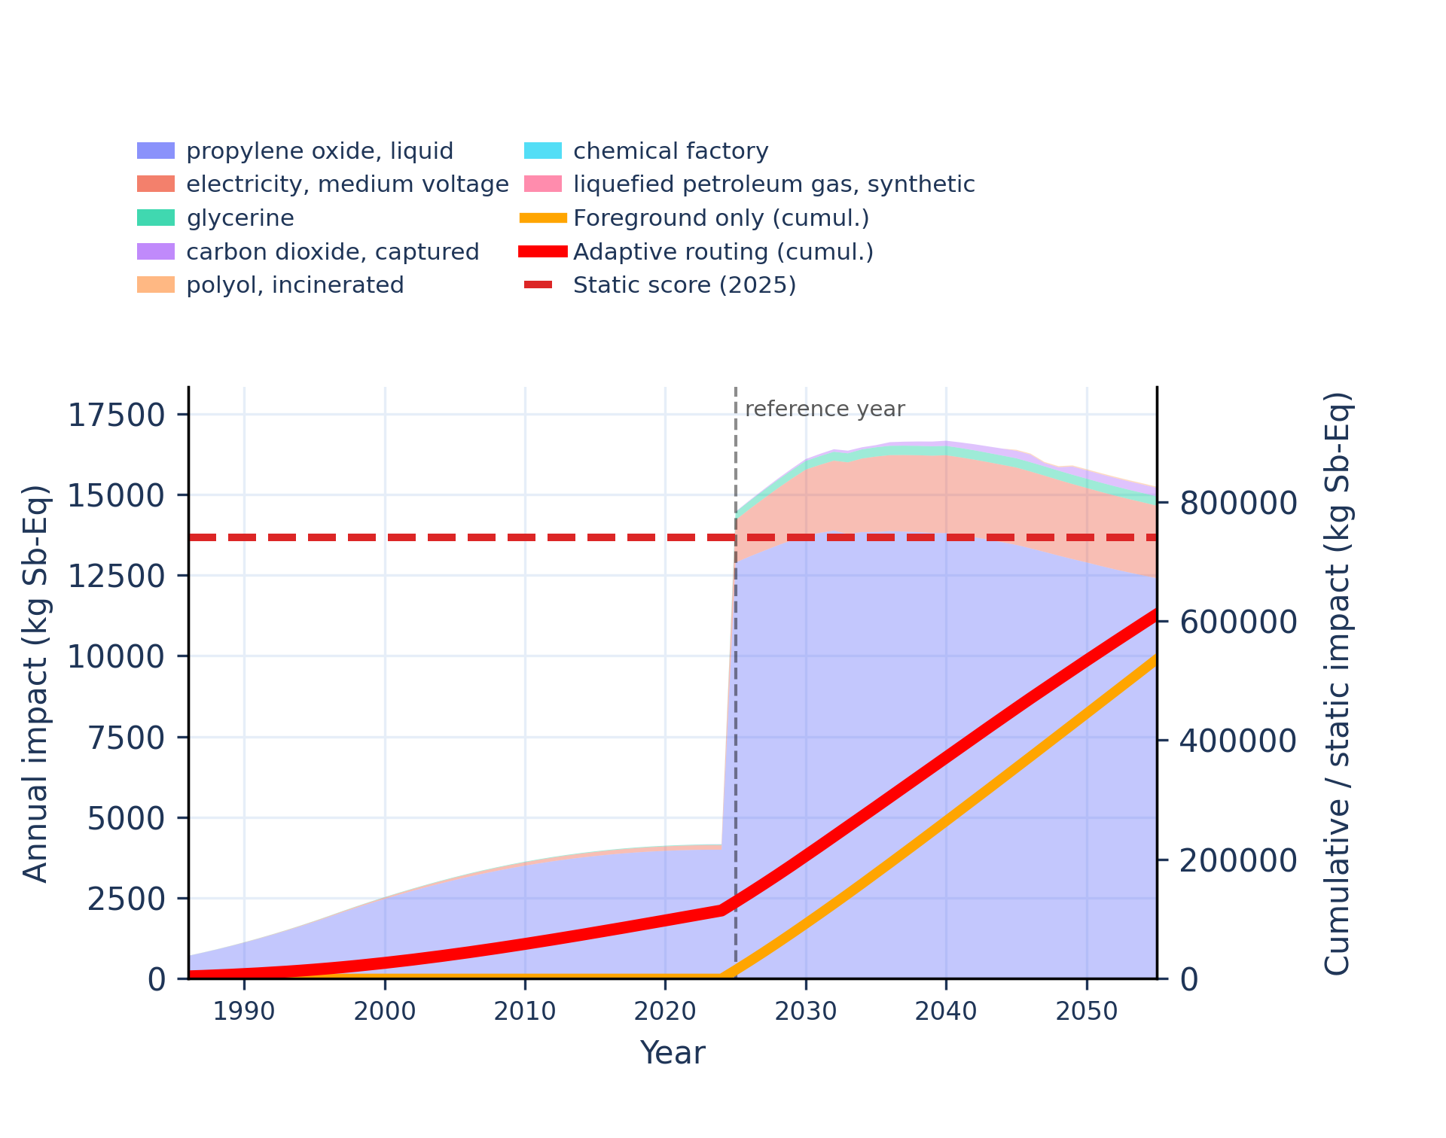
Figure S-routing-polyol-22. ozone depletion - ozone depletion potential (ODP).
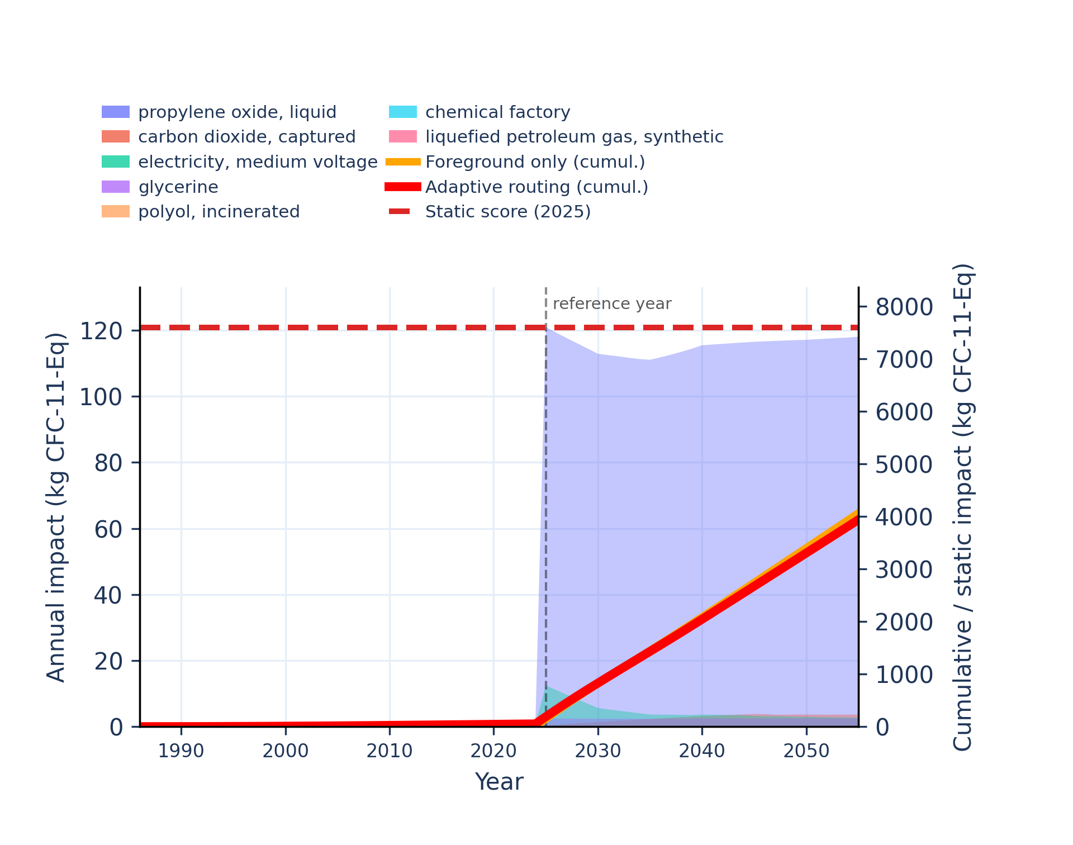 | 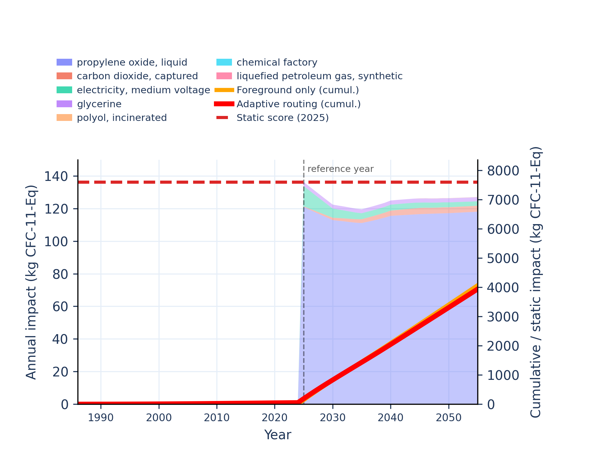
Figure S-routing-polyol-23. particulate matter formation - impact on human health.
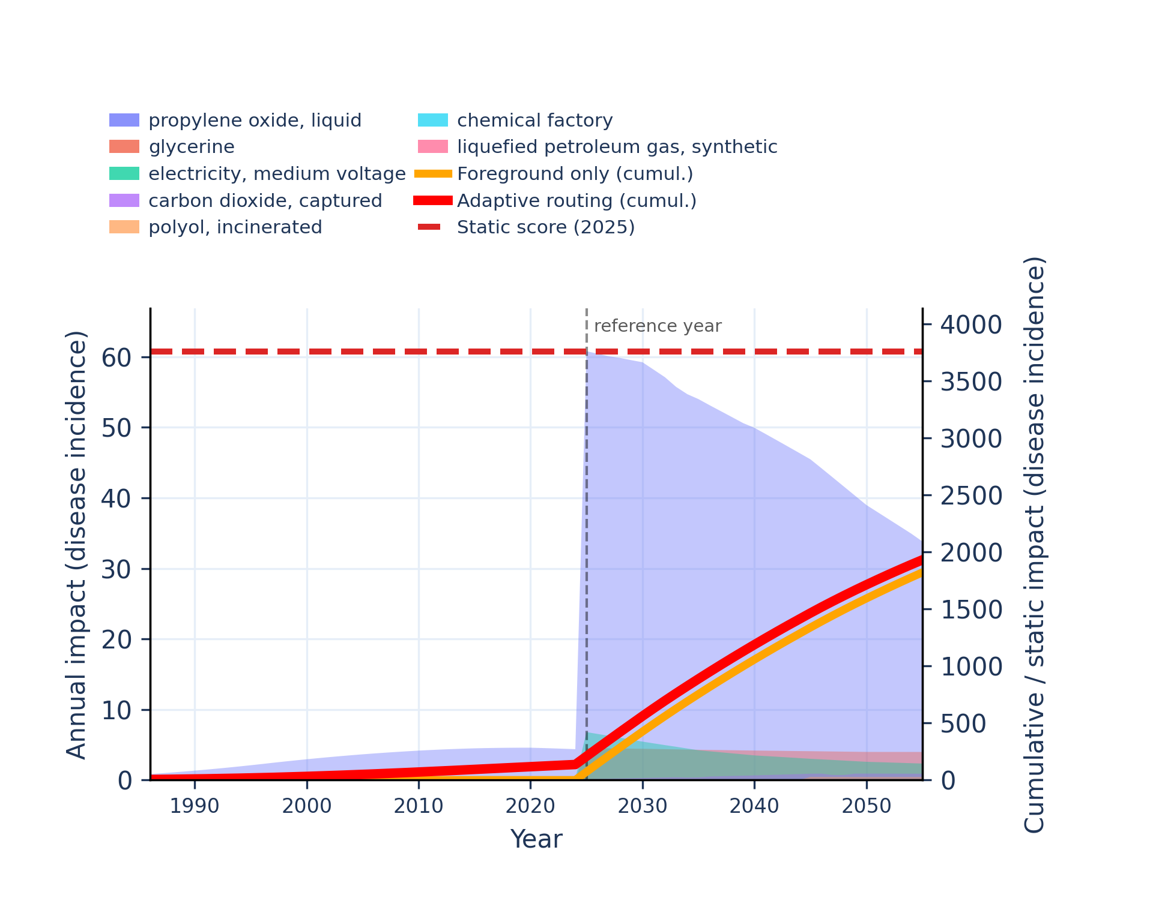 | 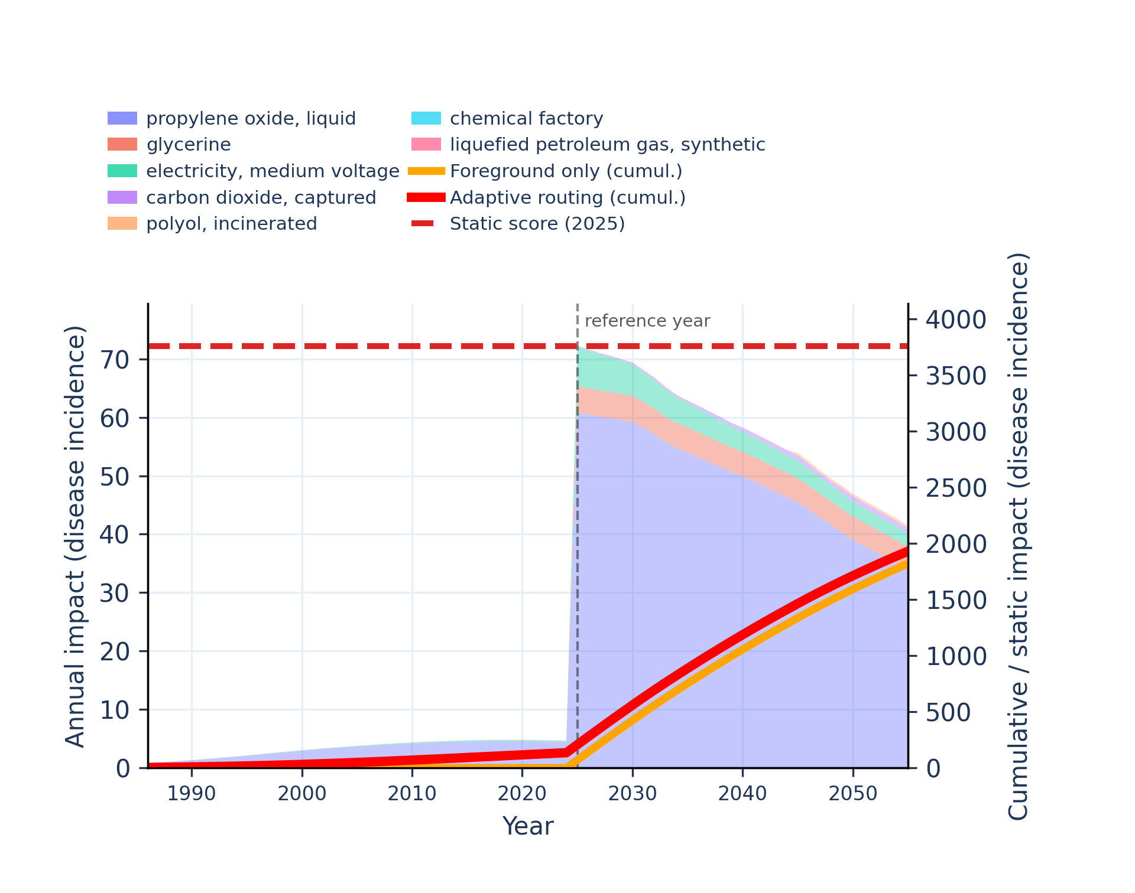
Figure S-routing-polyol-24. photochemical oxidant formation: human health - tropospheric ozone concentration increase.
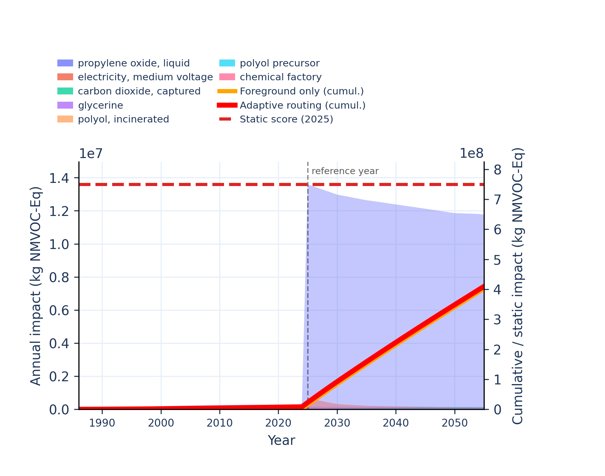 | 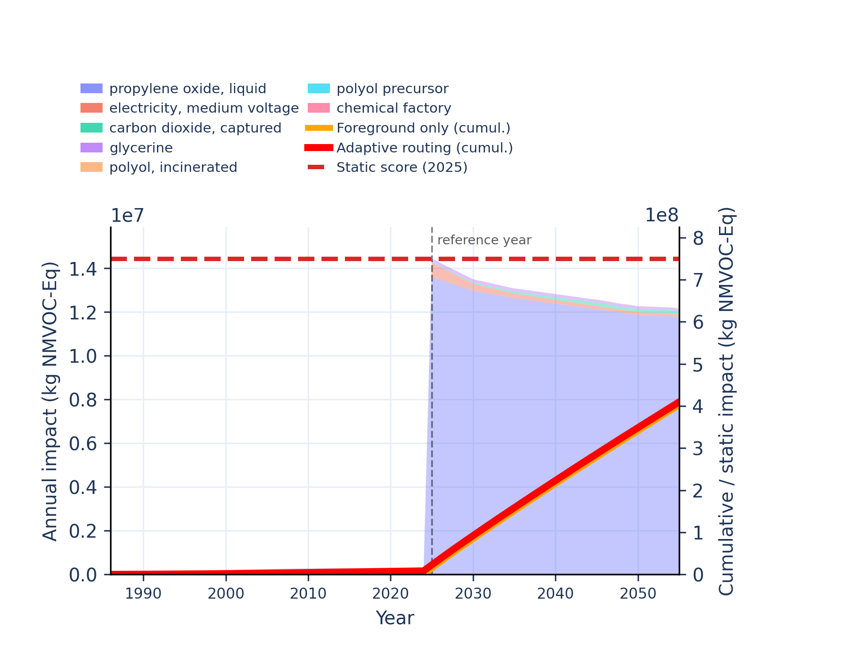
Figure S-routing-polyol-25. water use - user deprivation potential (deprivation-weighted water consumption).
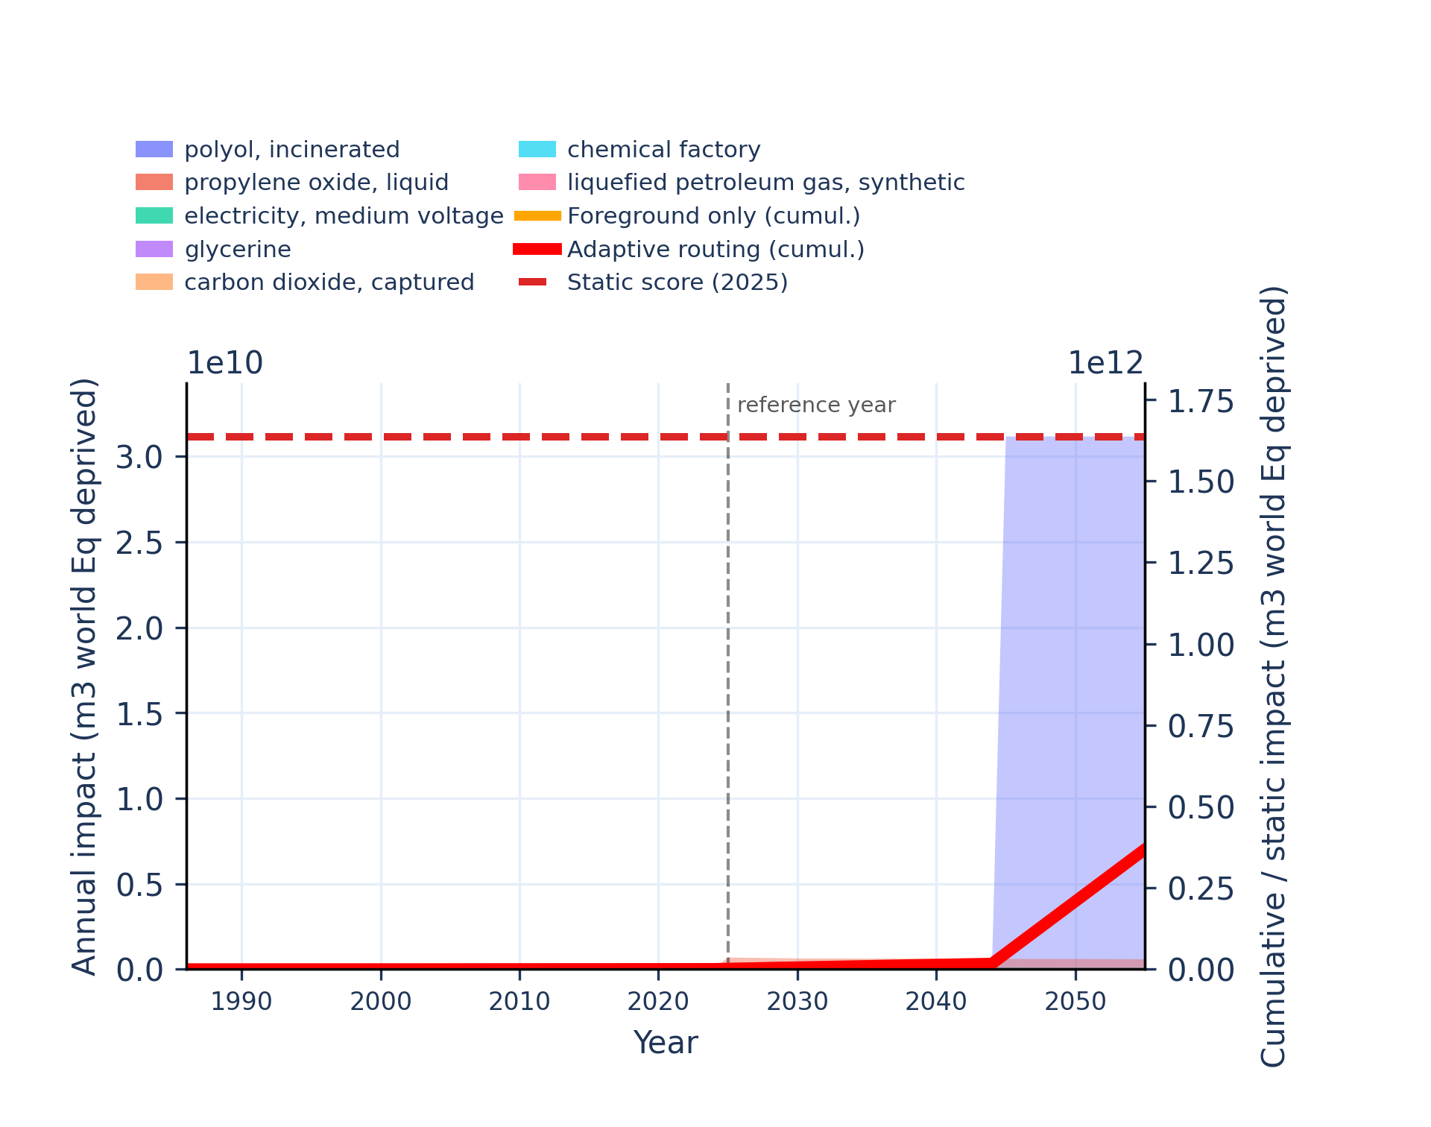 | 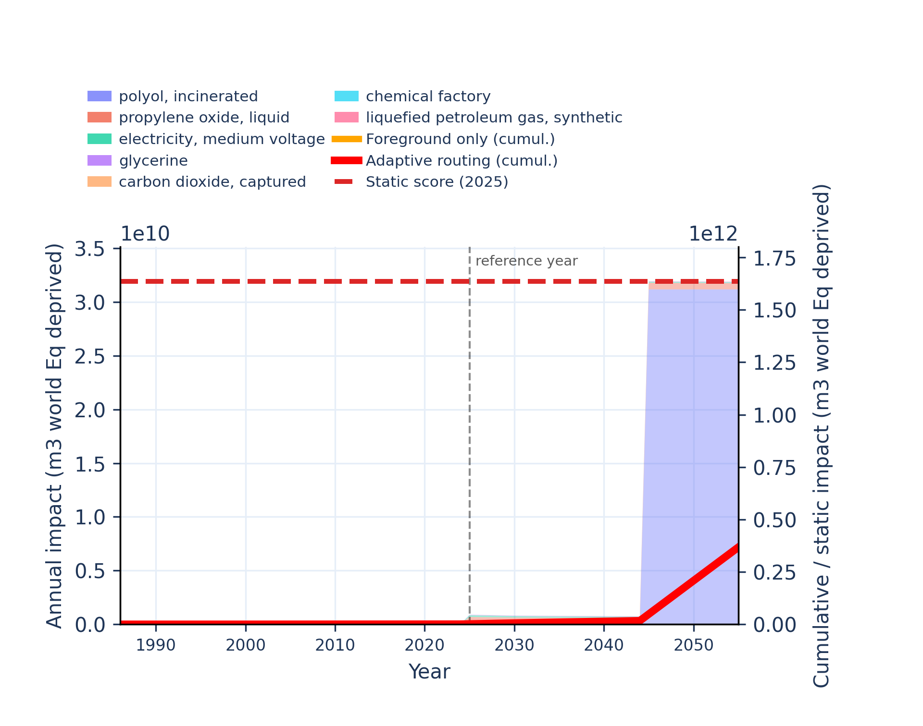

Marine fuel switch
Unstacked annual impacts | Stacked annual impacts
Figure S-routing-marine-01. acidification - accumulated exceedance (AE).
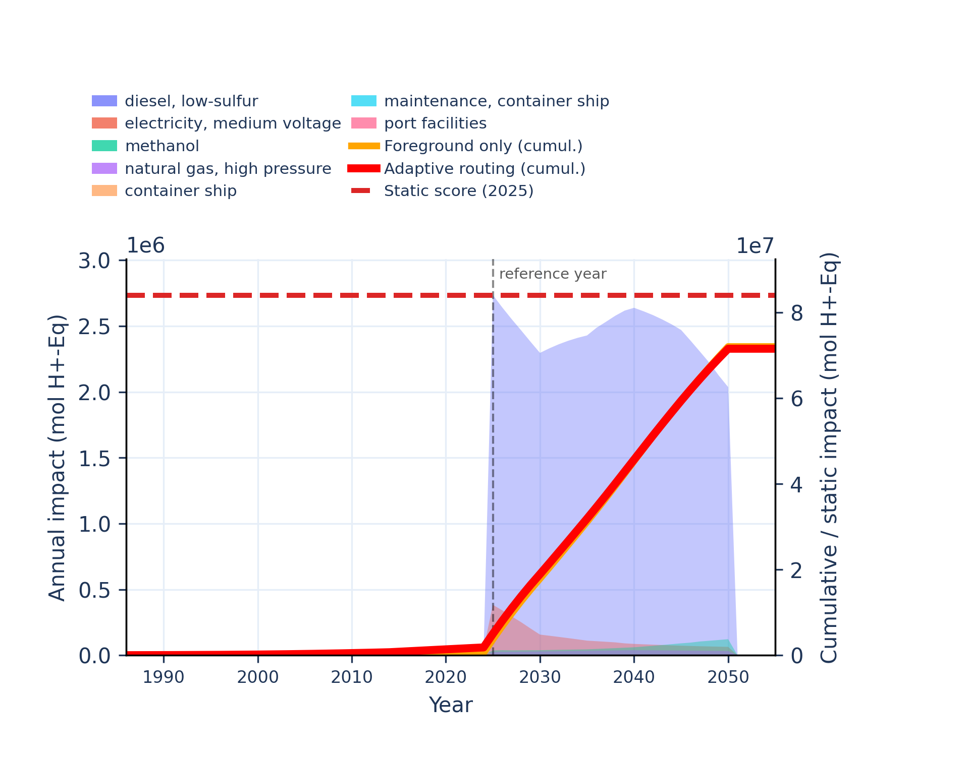 | 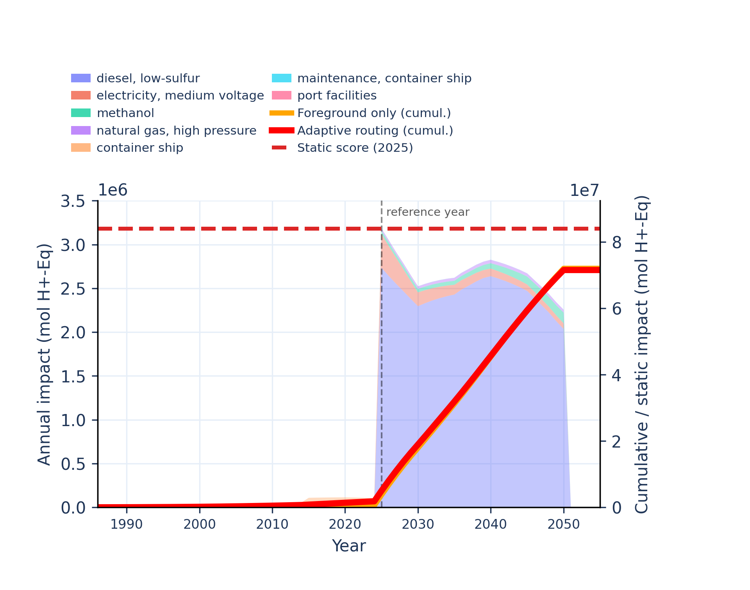
Figure S-routing-marine-02. climate change - global warming potential (GWP100).
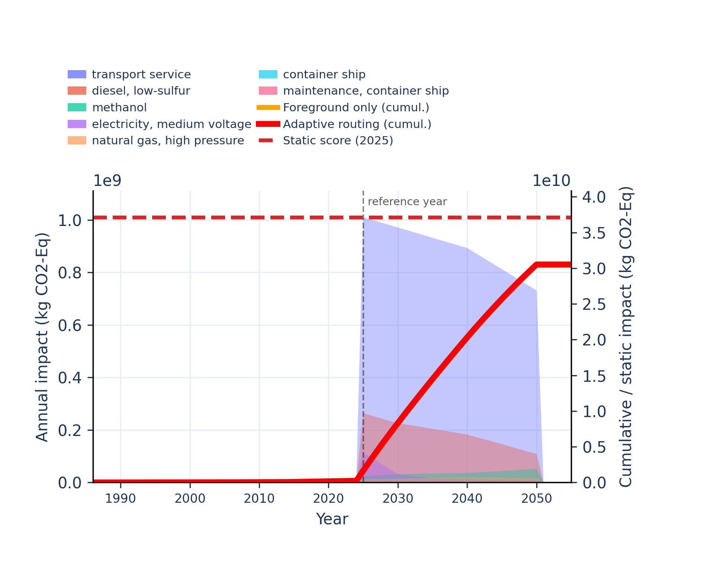 | 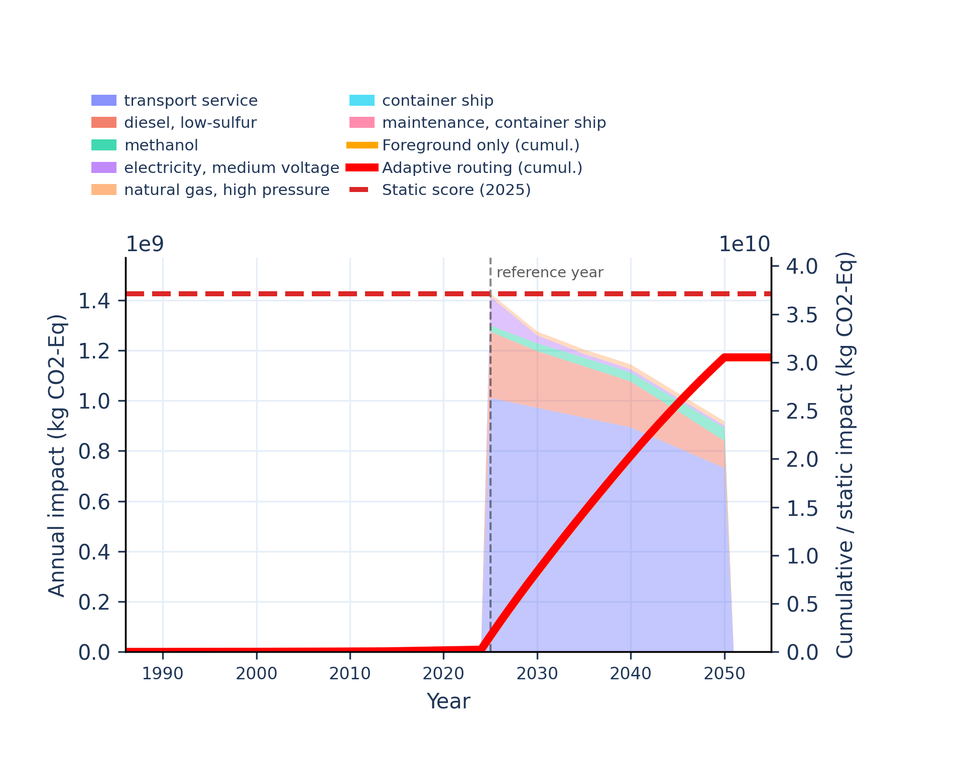
Figure S-routing-marine-03. climate change: biogenic - global warming potential (GWP100).
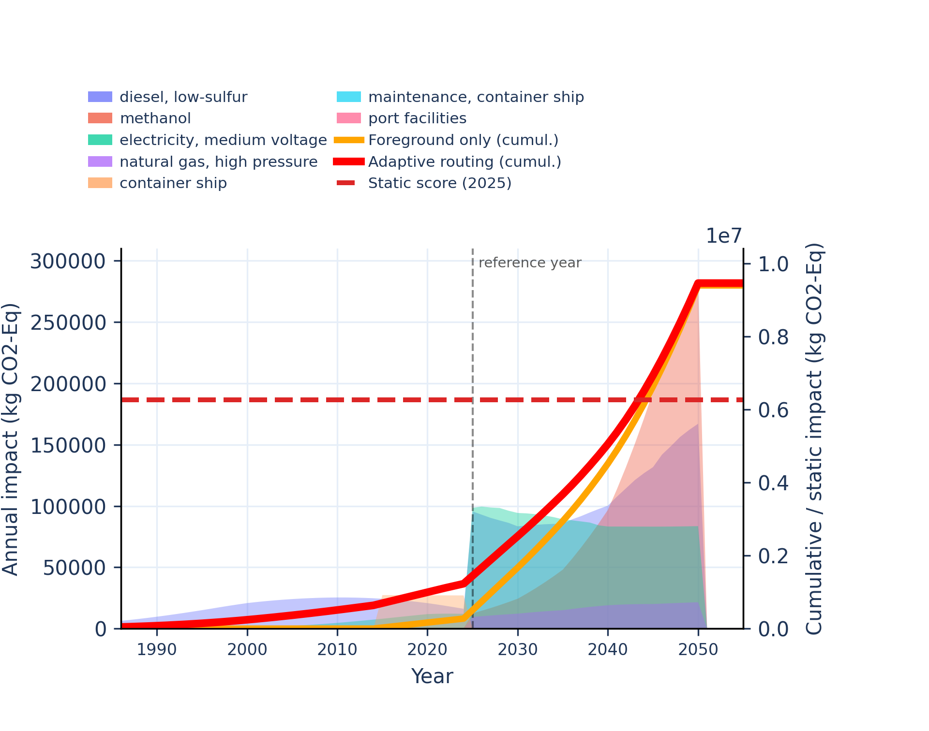 | 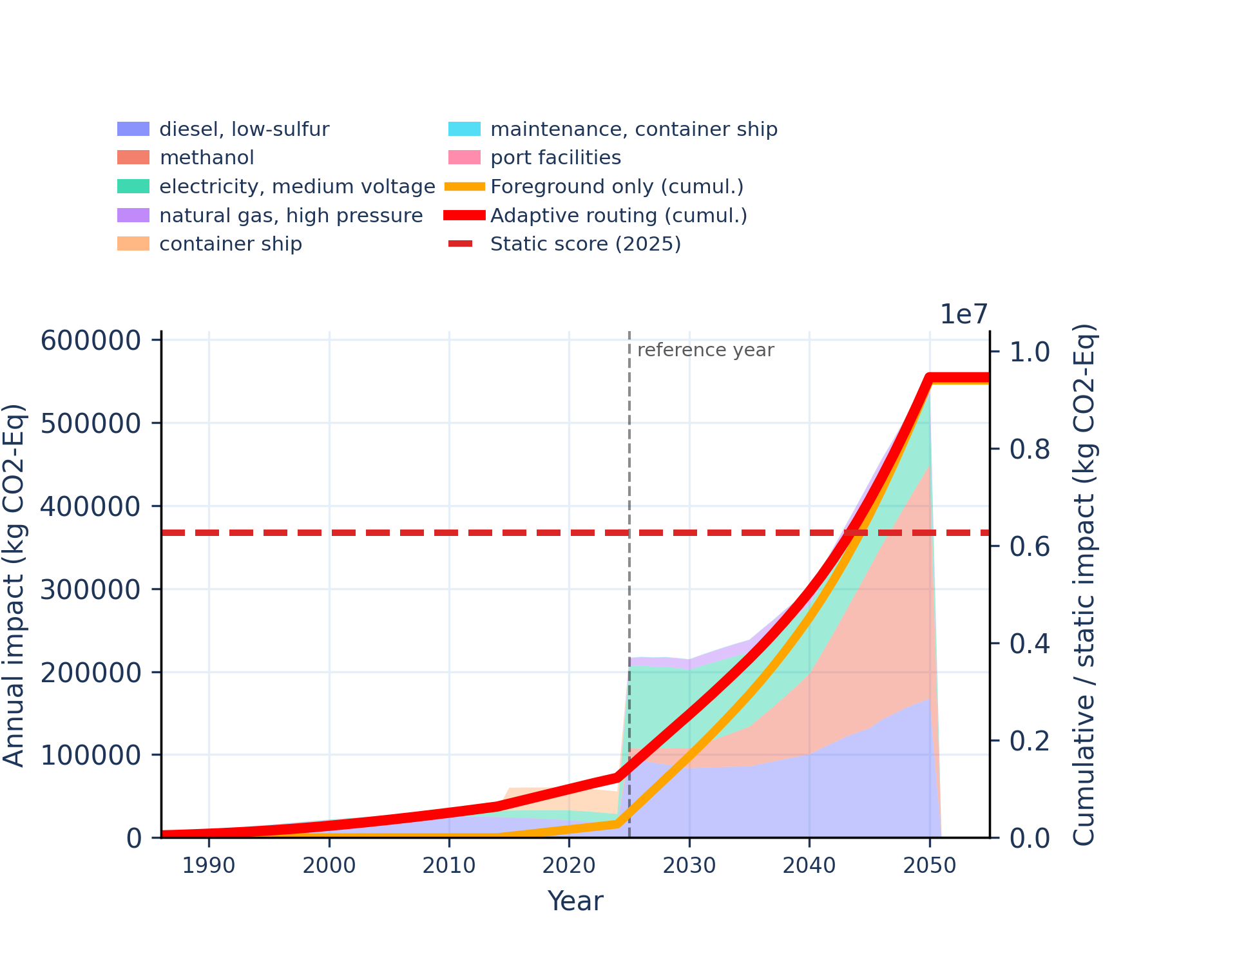
Figure S-routing-marine-04. climate change: fossil - global warming potential (GWP100).
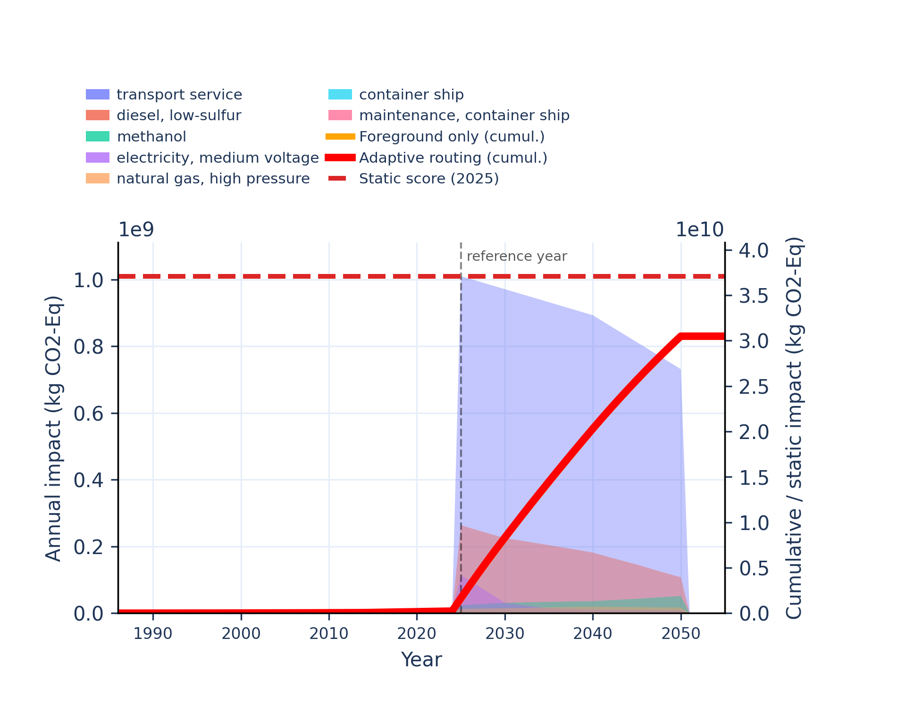 | 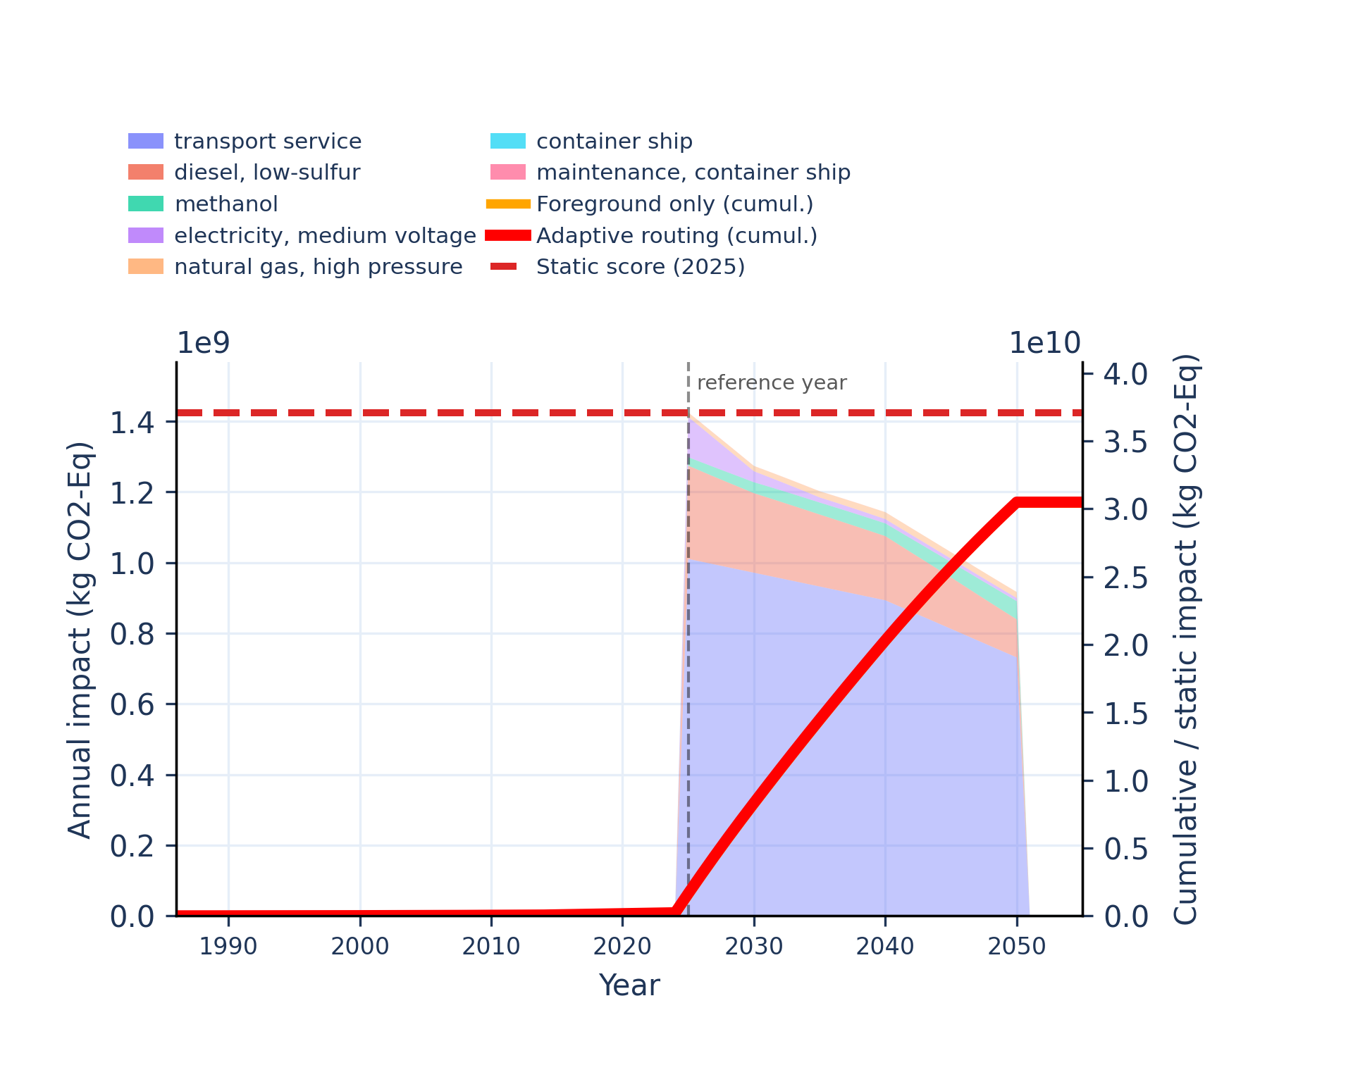
Figure S-routing-marine-05. climate change: land use and land use change - global warming potential (GWP100).
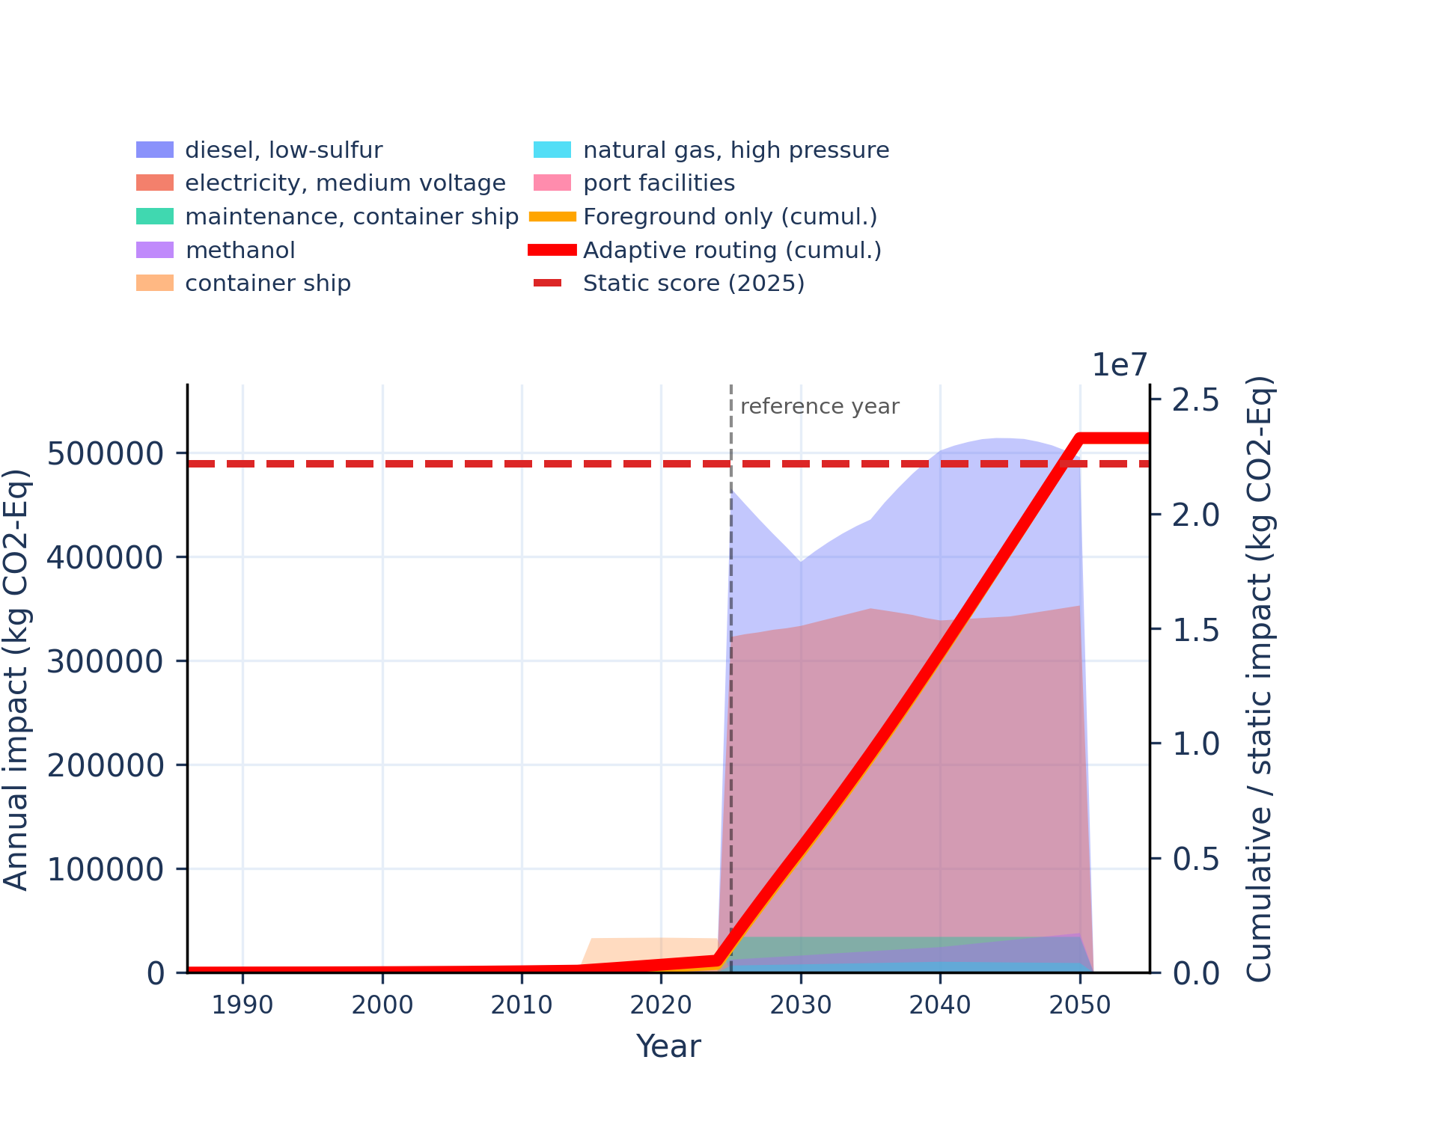 | 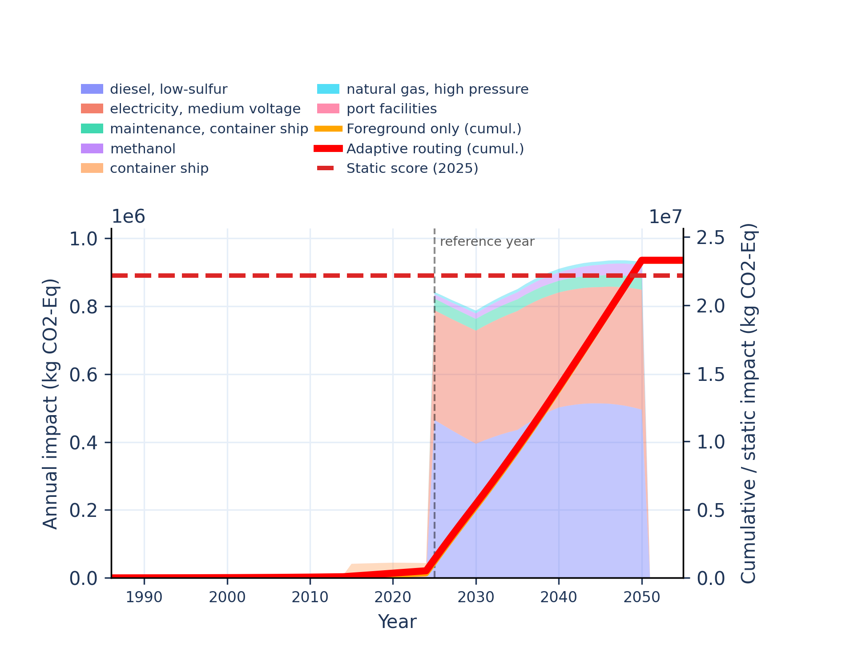
Figure S-routing-marine-06. ecotoxicity: freshwater - comparative toxic unit for ecosystems (CTUe).
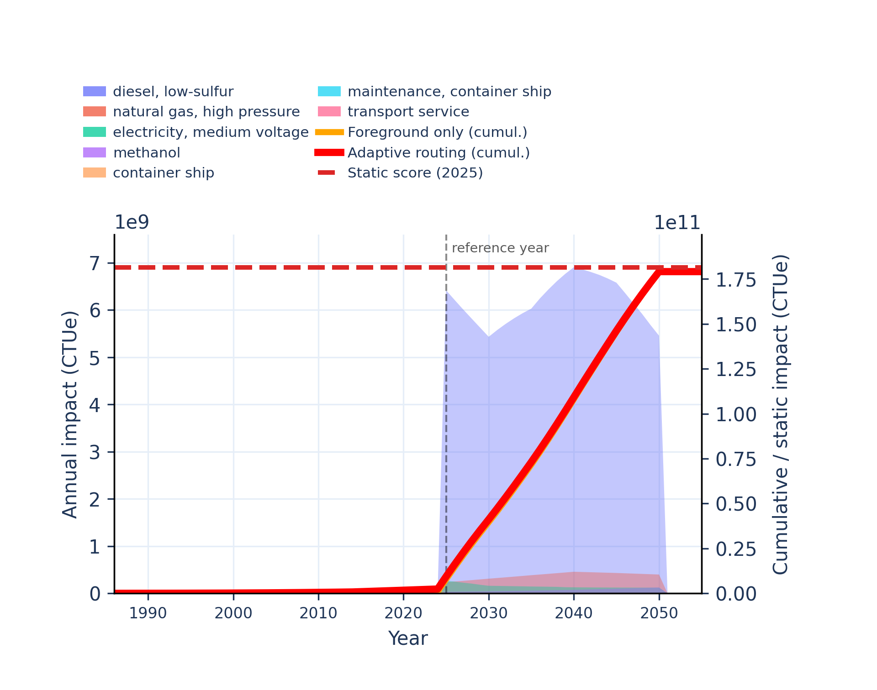 | 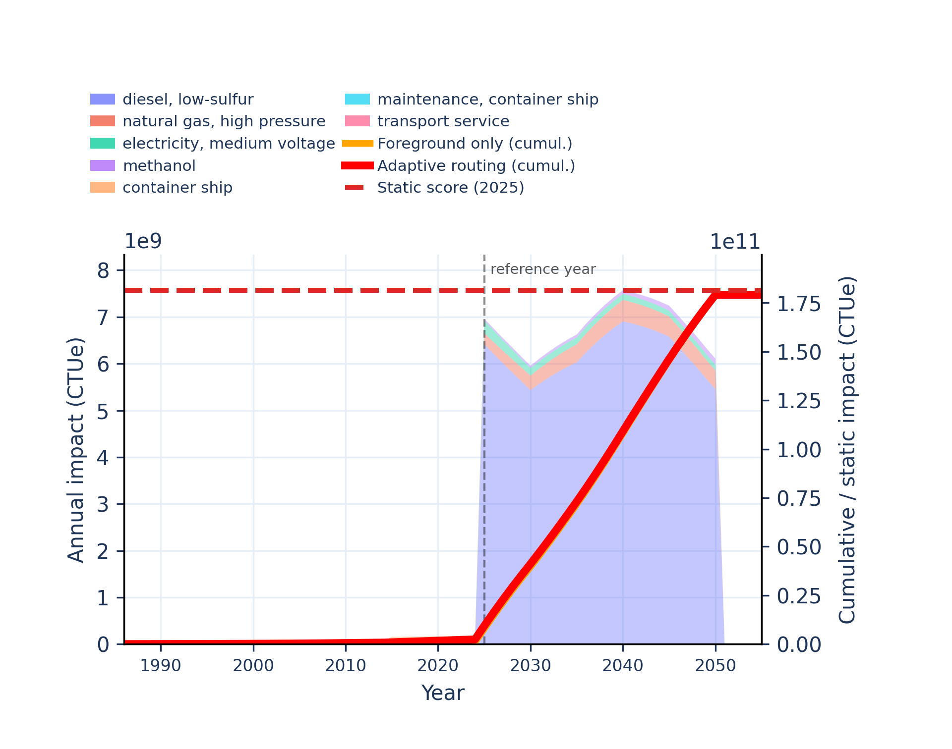
Figure S-routing-marine-07. ecotoxicity: freshwater, inorganics - comparative toxic unit for ecosystems (CTUe).
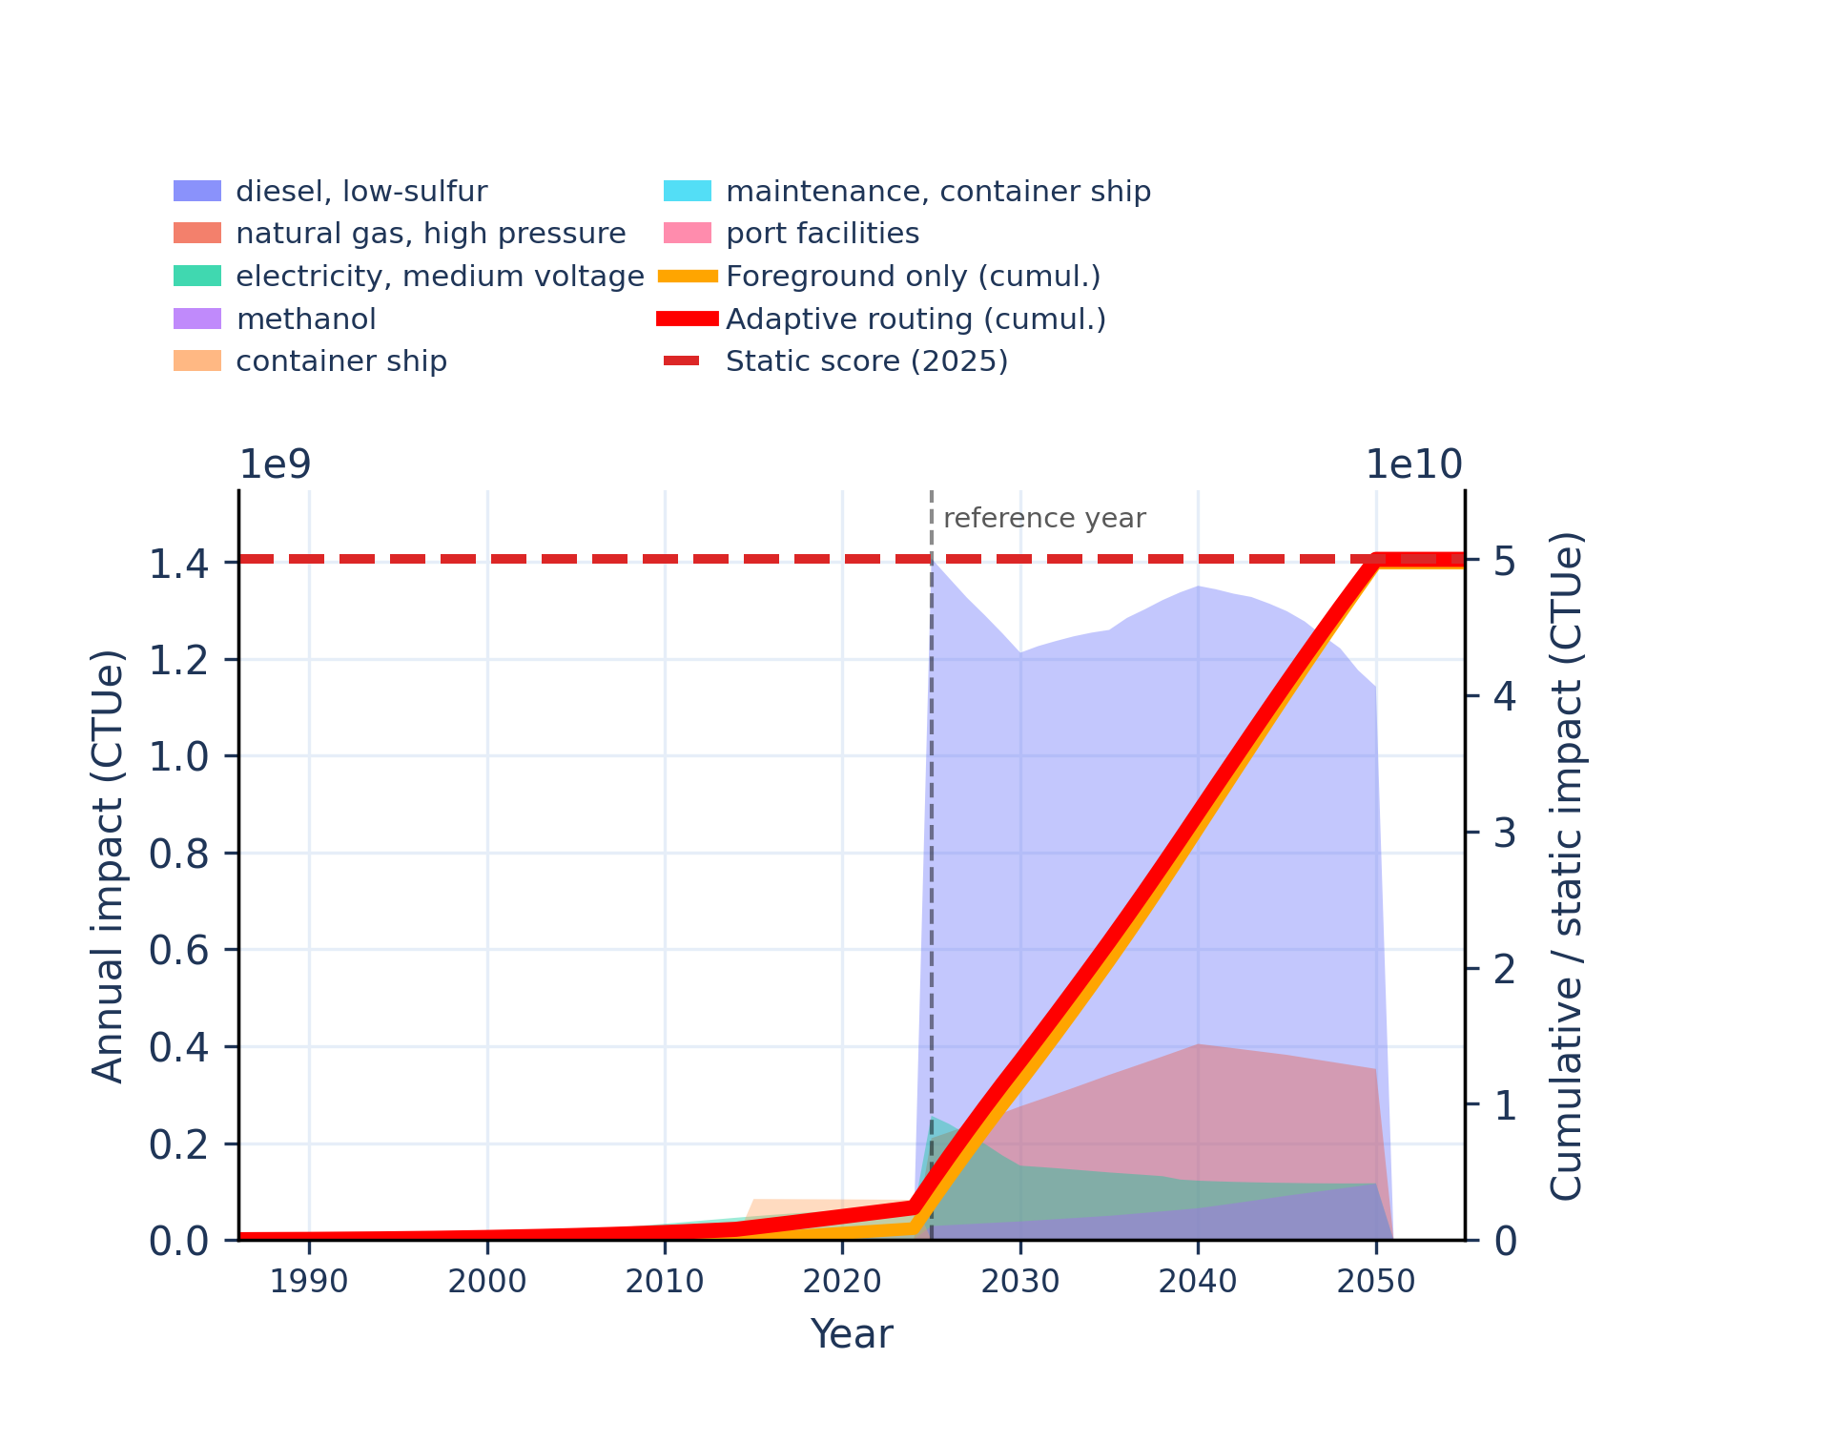 | 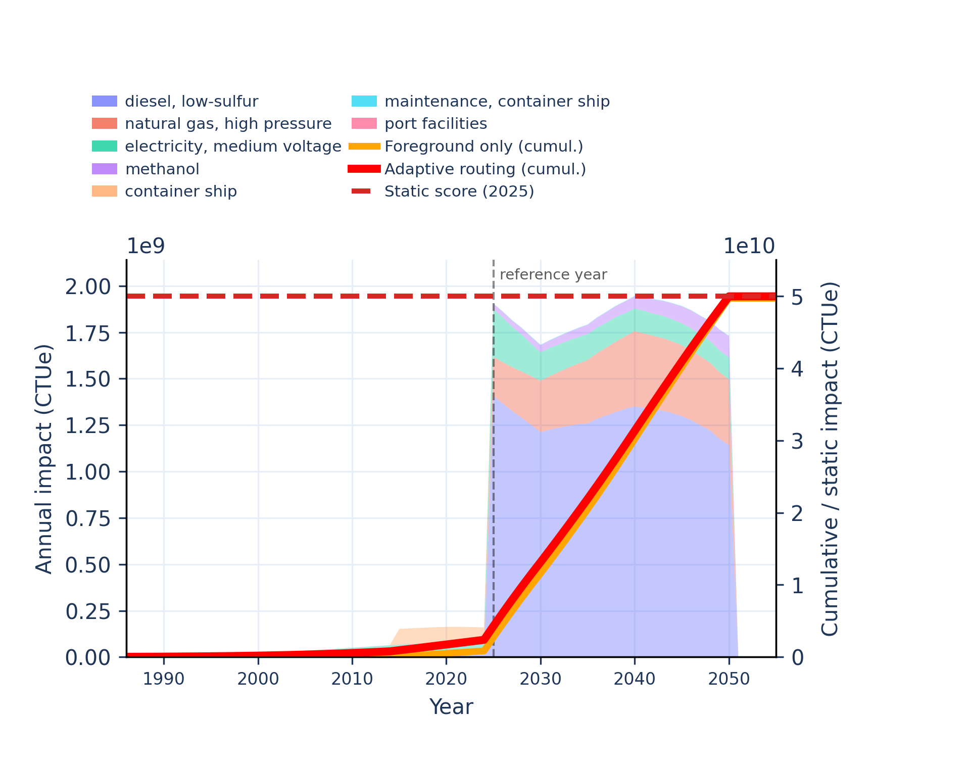
Figure S-routing-marine-08. ecotoxicity: freshwater, organics - comparative toxic unit for ecosystems (CTUe).
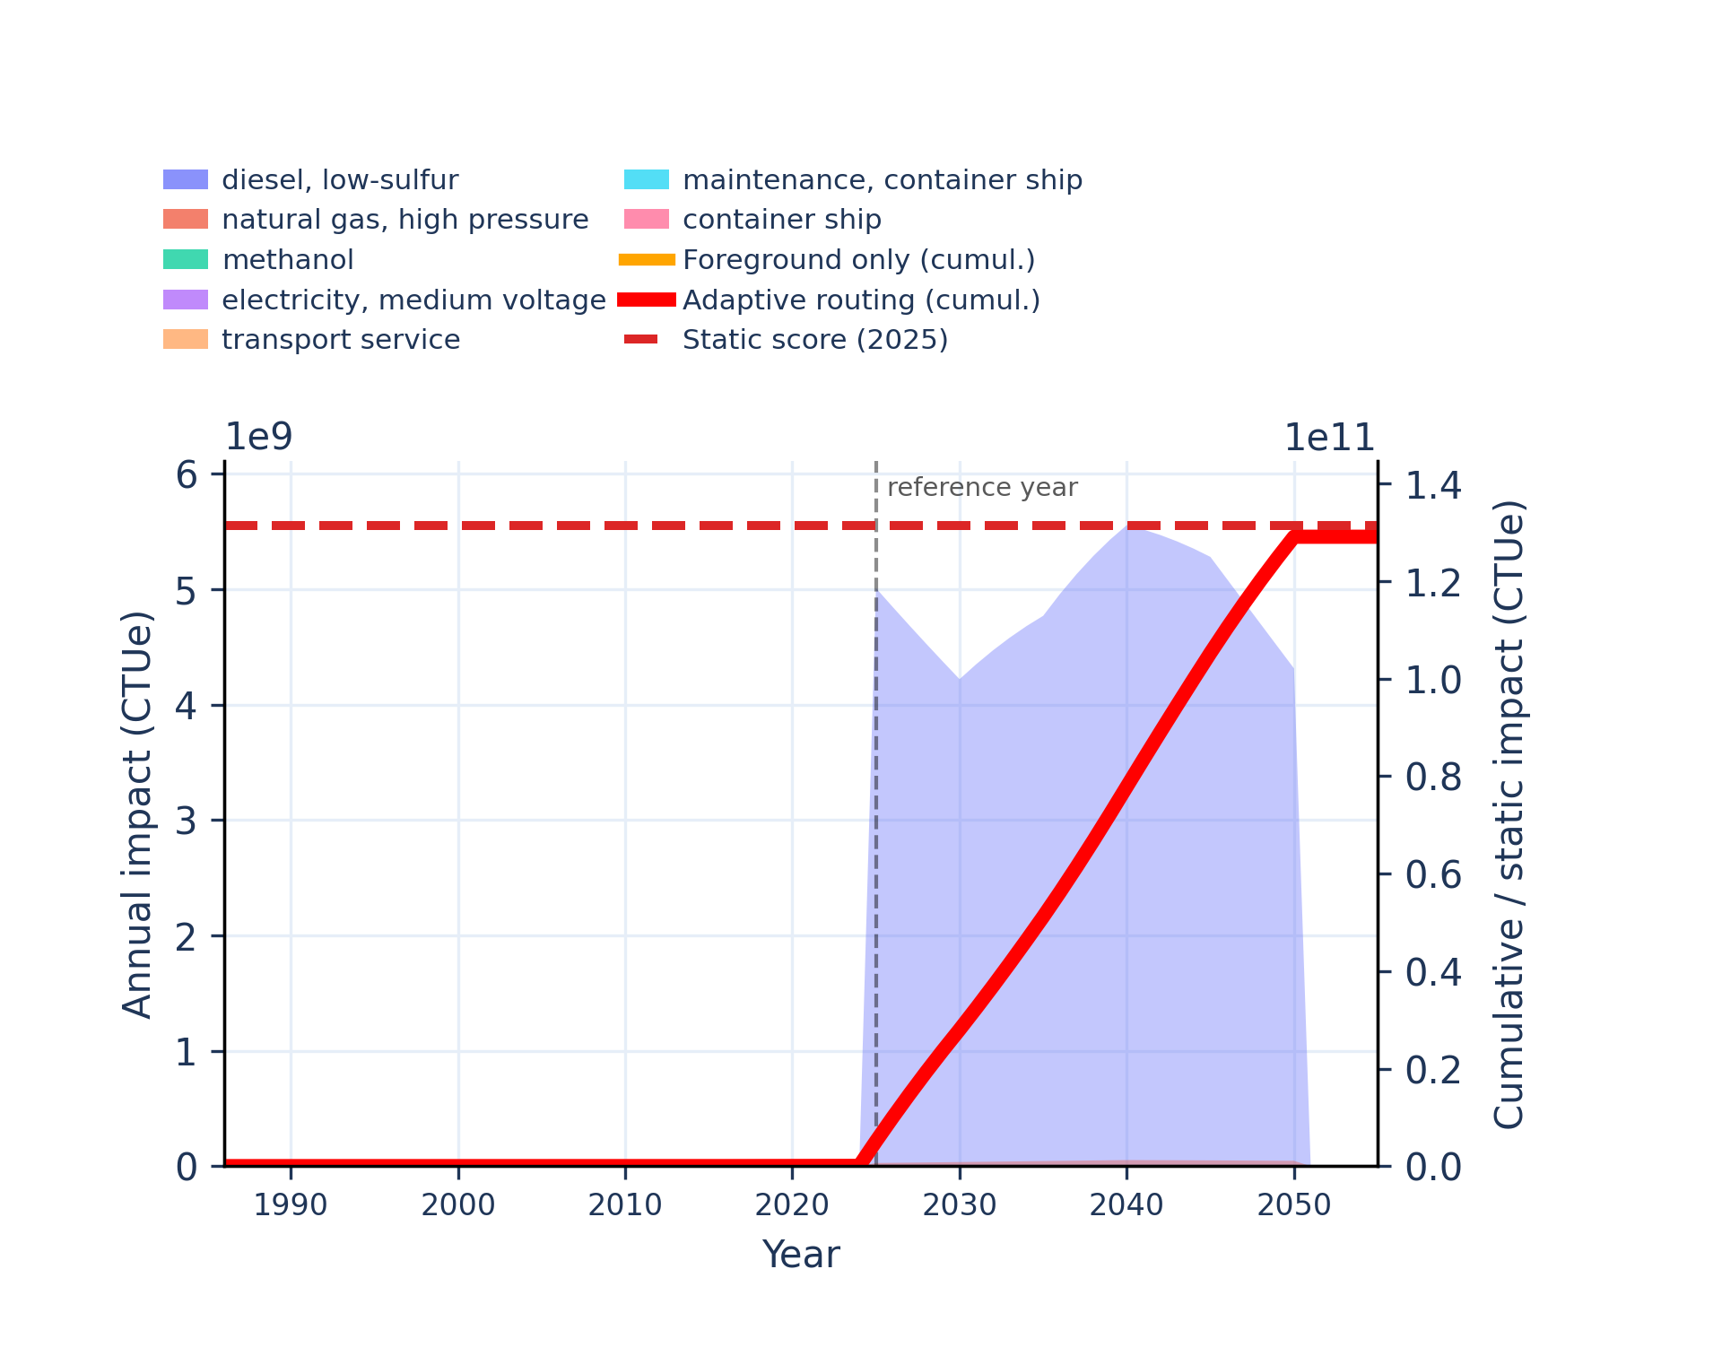 | 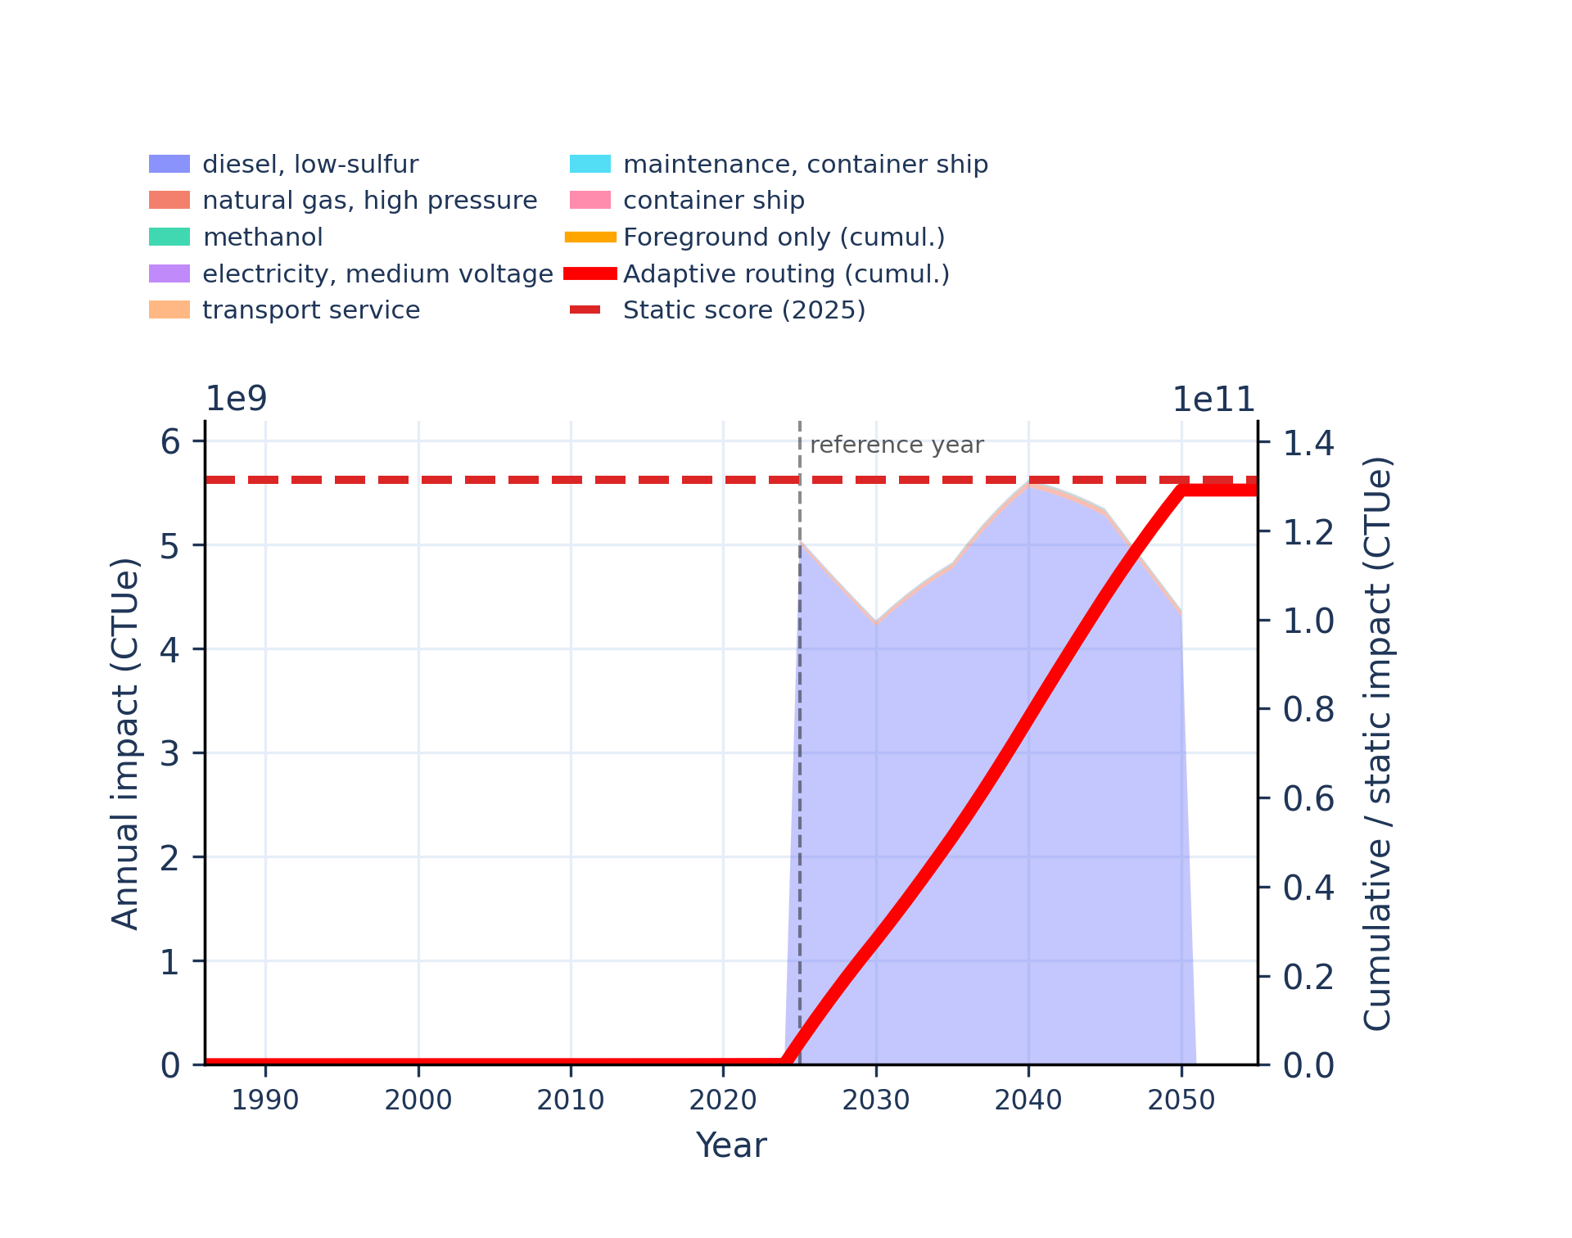
Figure S-routing-marine-09. energy resources: non-renewable - abiotic depletion potential (ADP): fossil fuels.
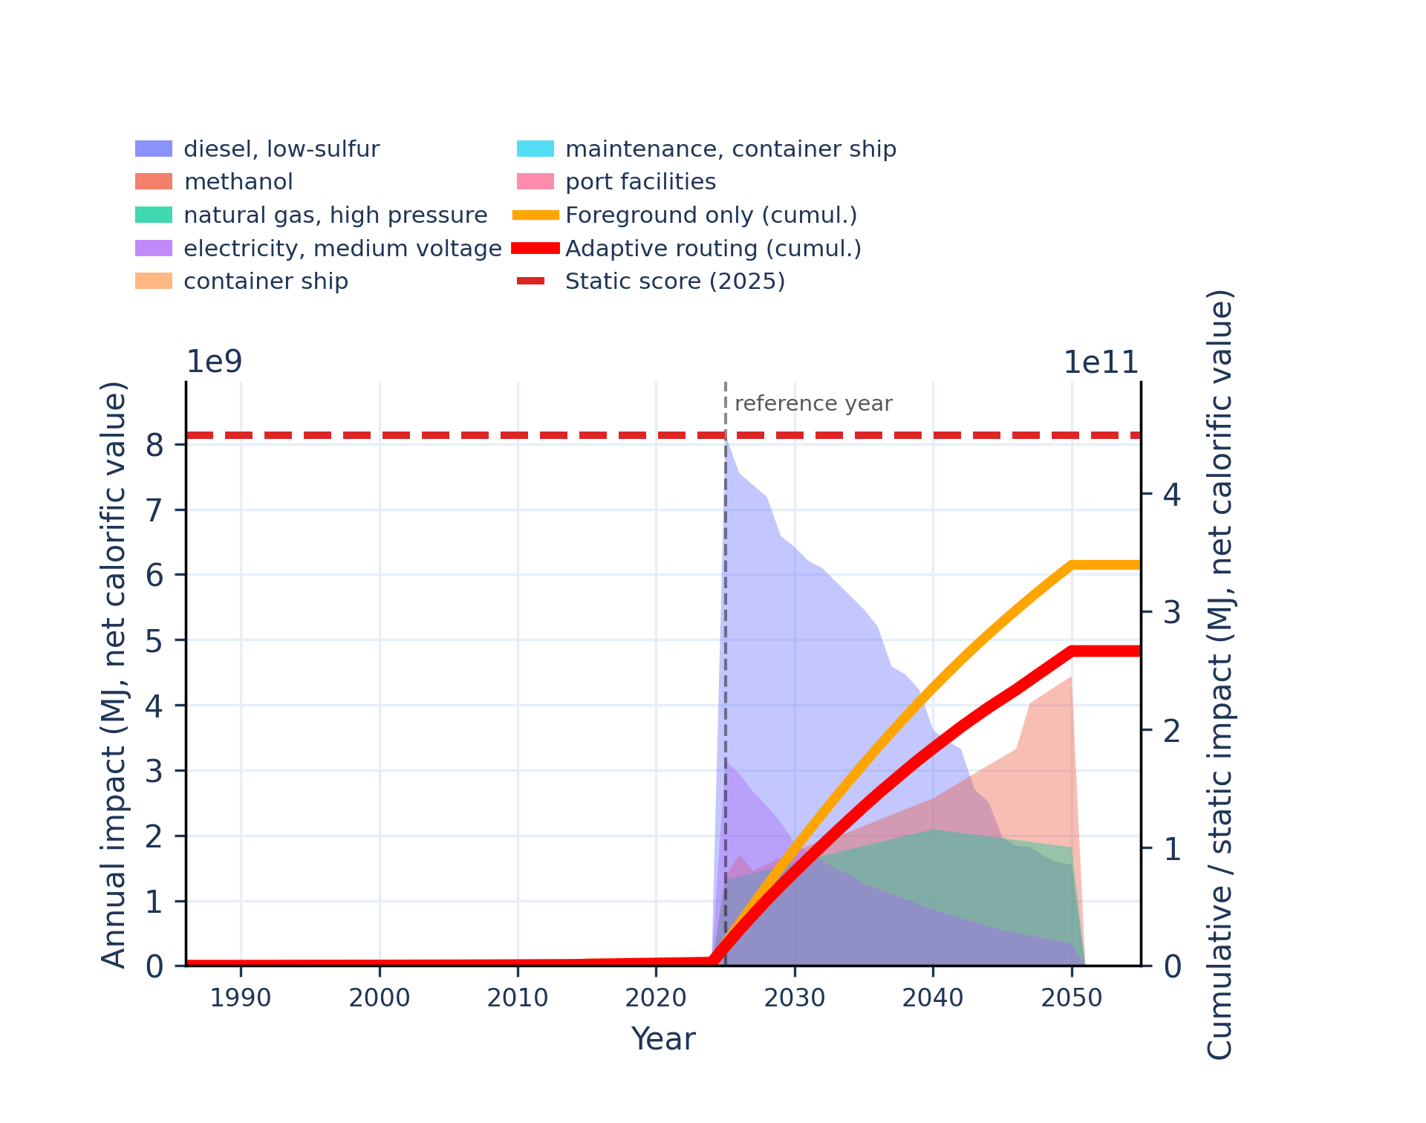 | 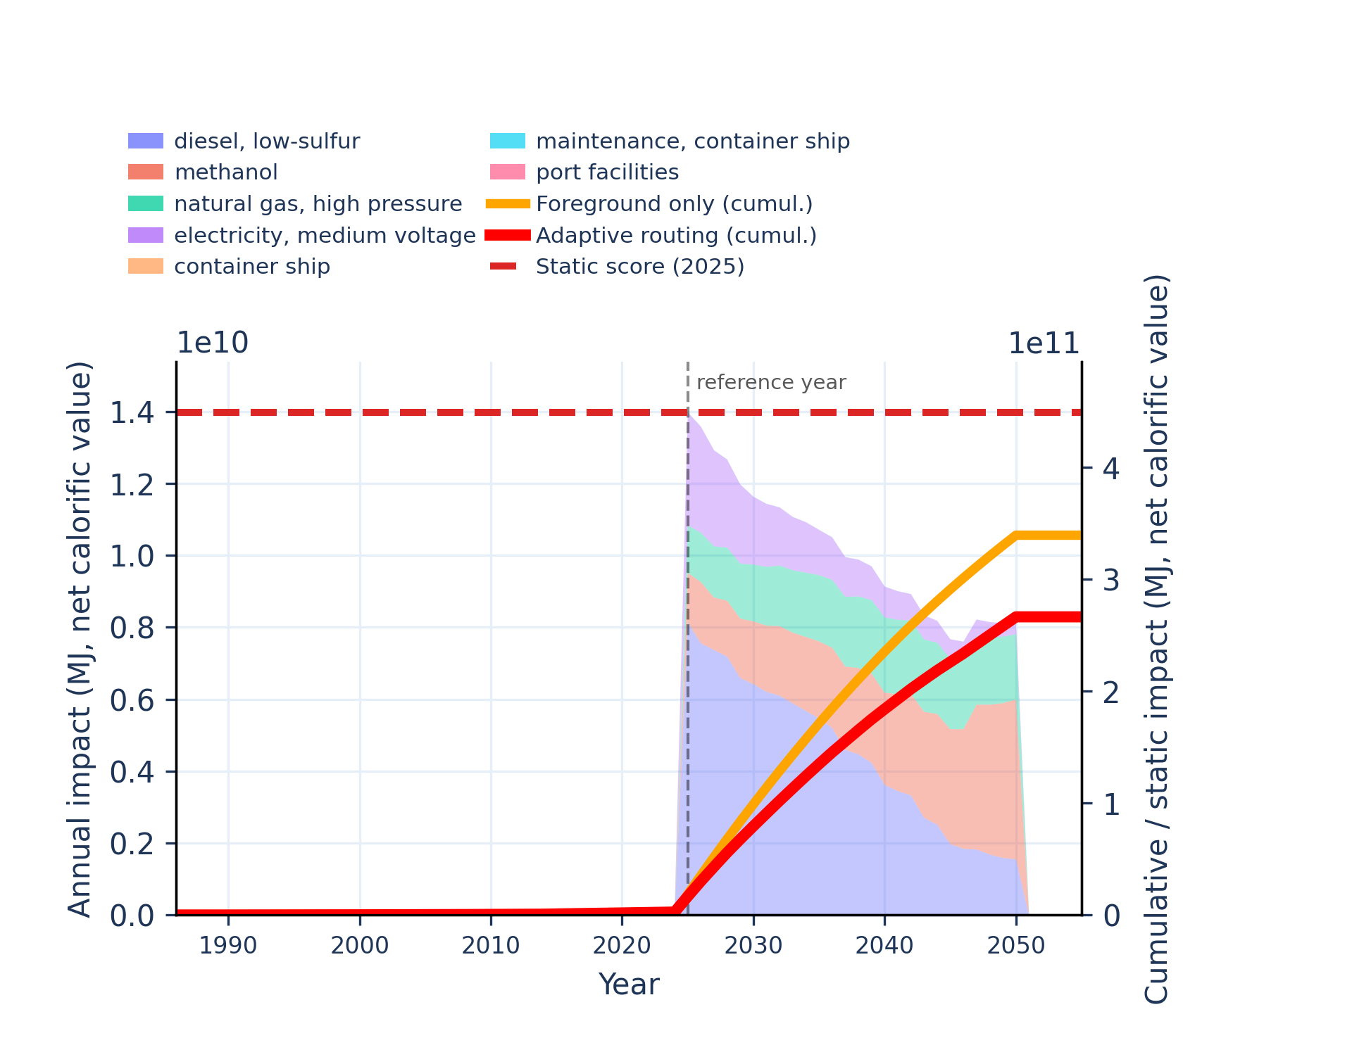
Figure S-routing-marine-10. eutrophication: freshwater - fraction of nutrients reaching freshwater end compartment (P).
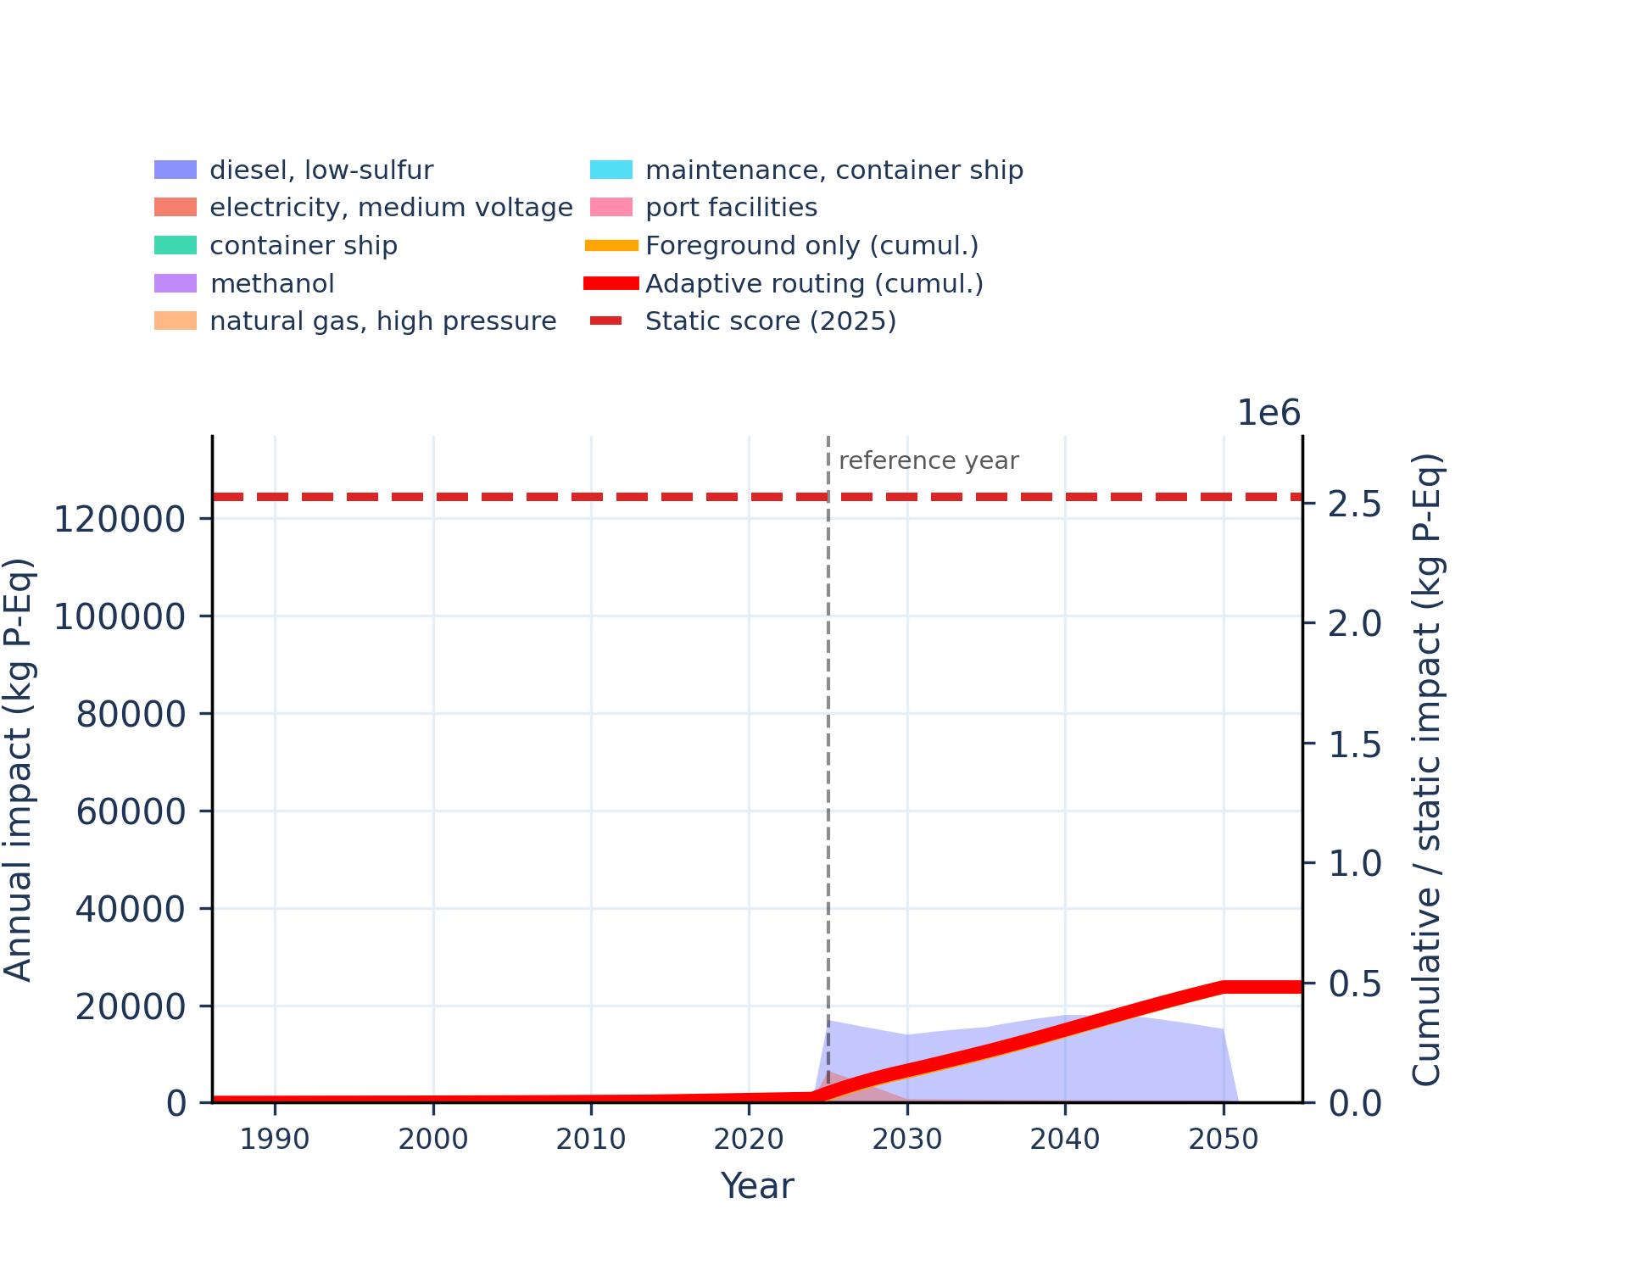 | 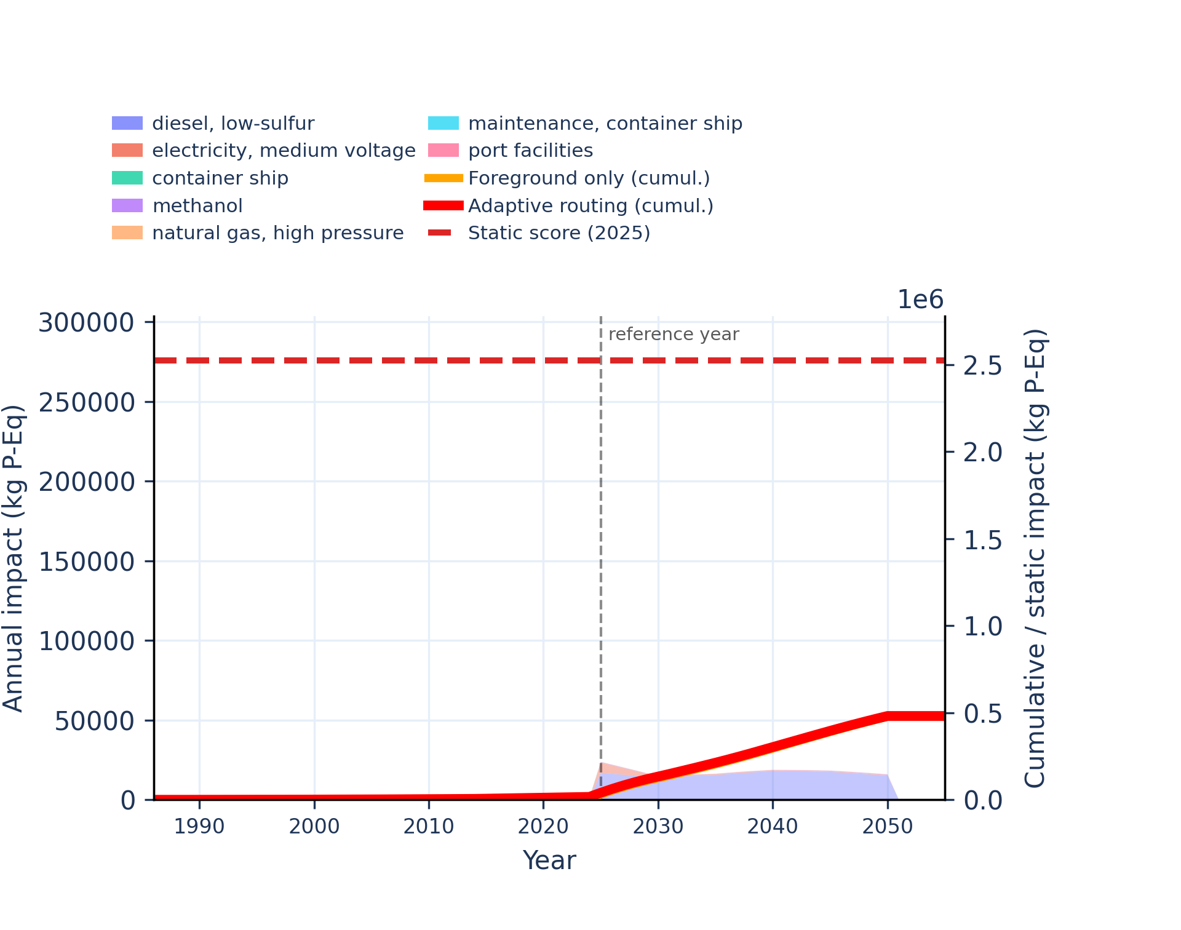
Figure S-routing-marine-11. eutrophication: marine - fraction of nutrients reaching marine end compartment (N).
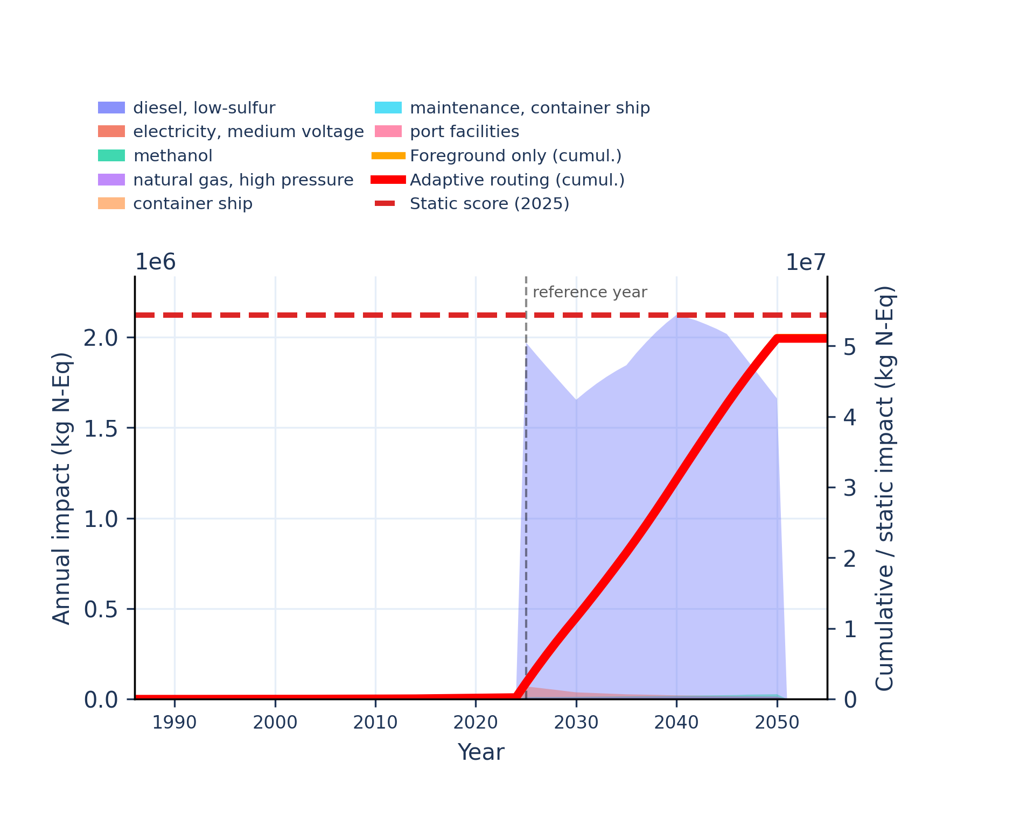 | 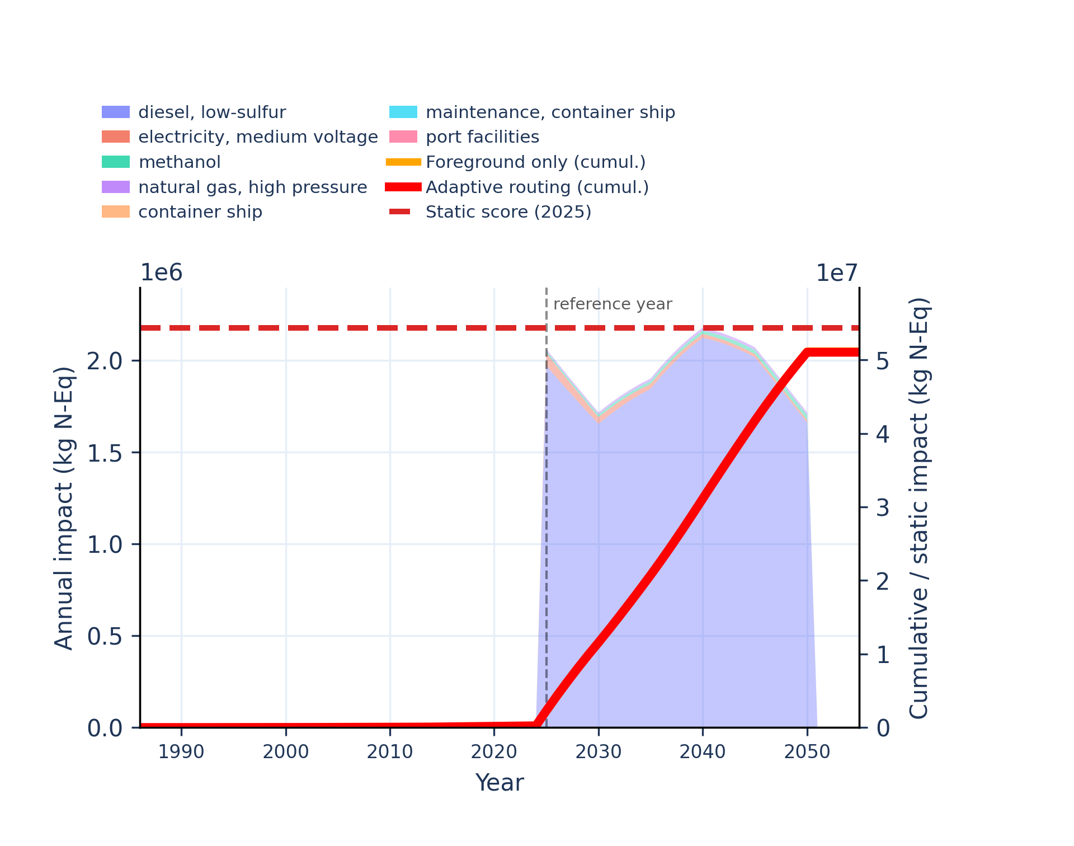
Figure S-routing-marine-12. eutrophication: terrestrial - accumulated exceedance (AE).
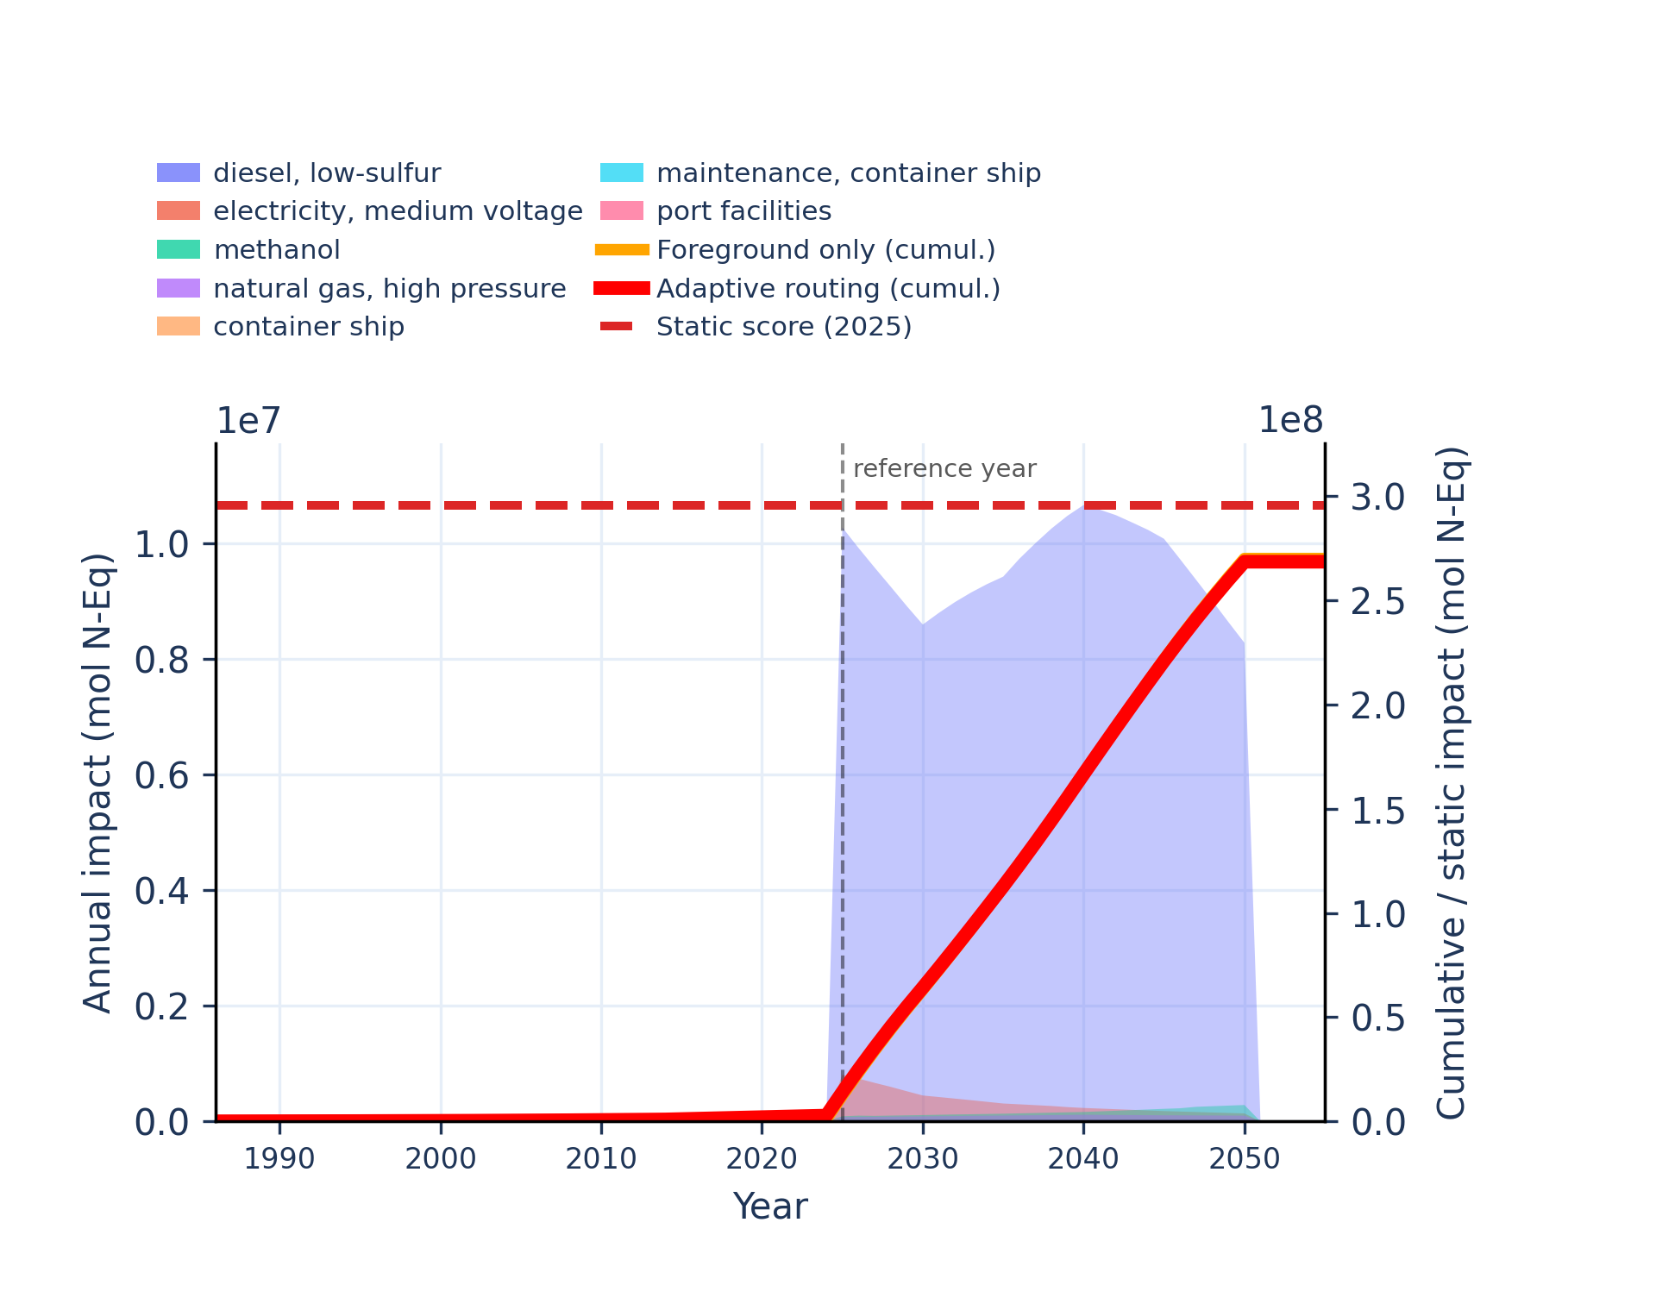 | 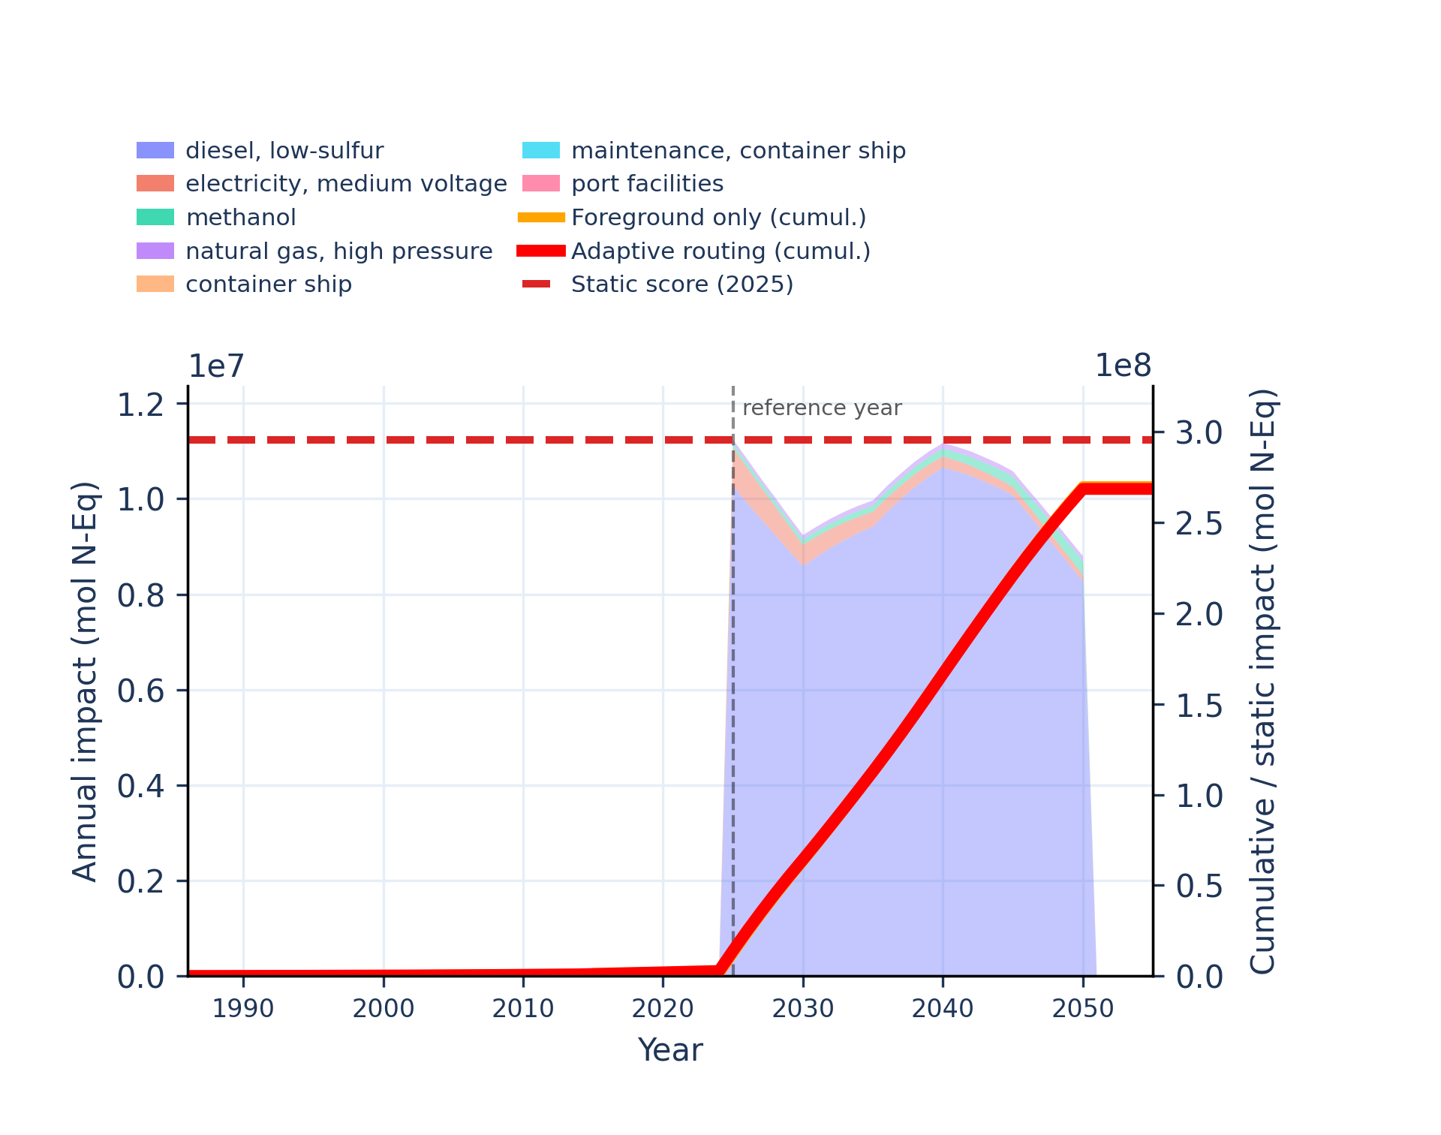
Figure S-routing-marine-13. human toxicity: carcinogenic - comparative toxic unit for human (CTUh).
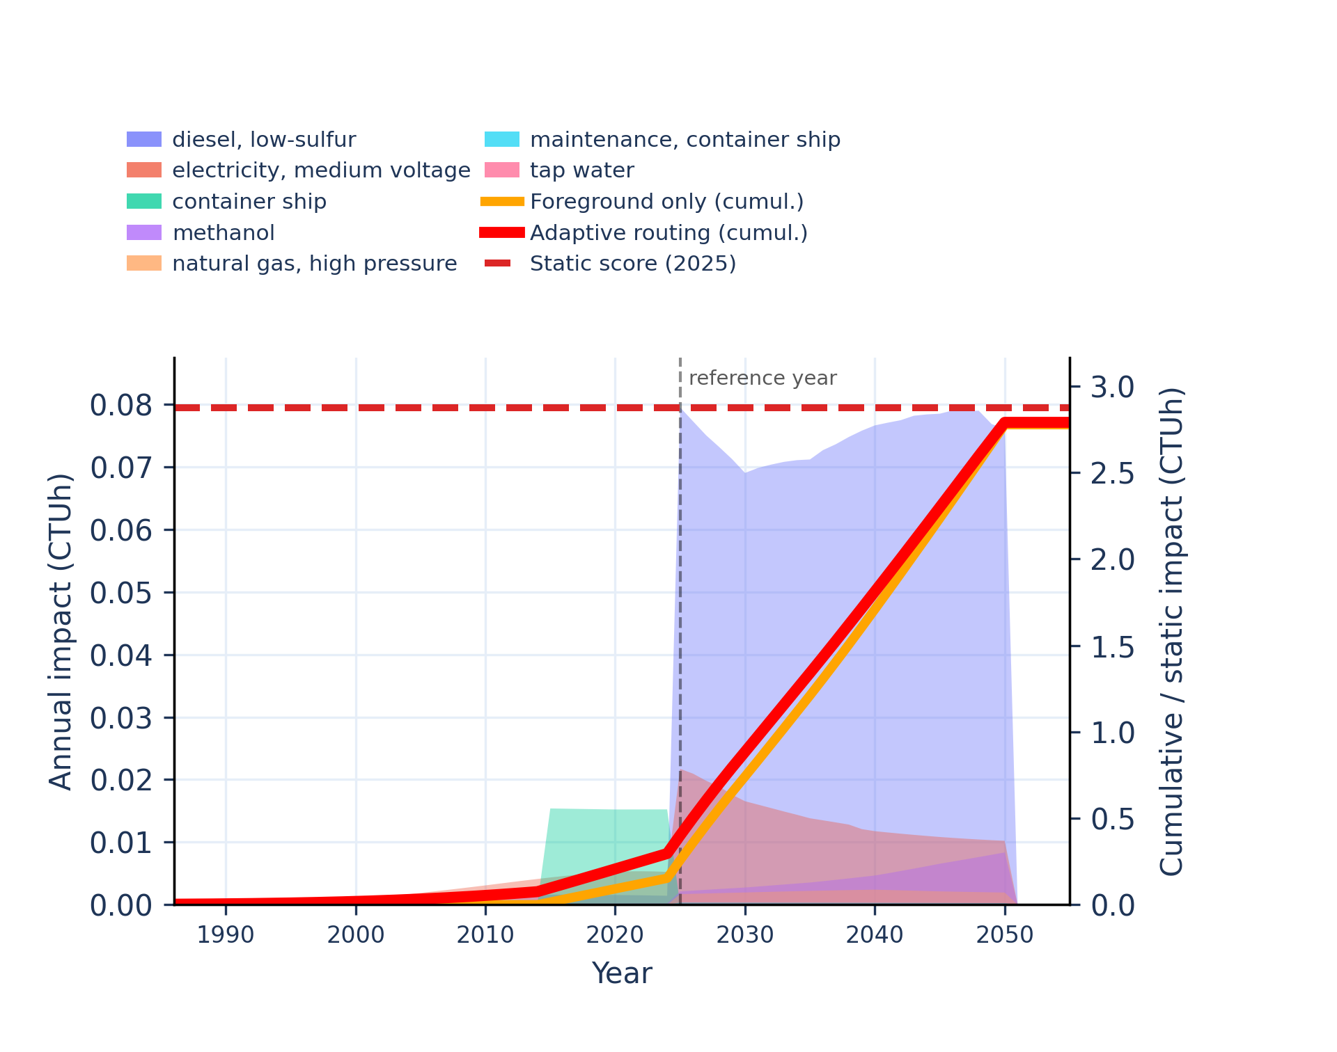 | 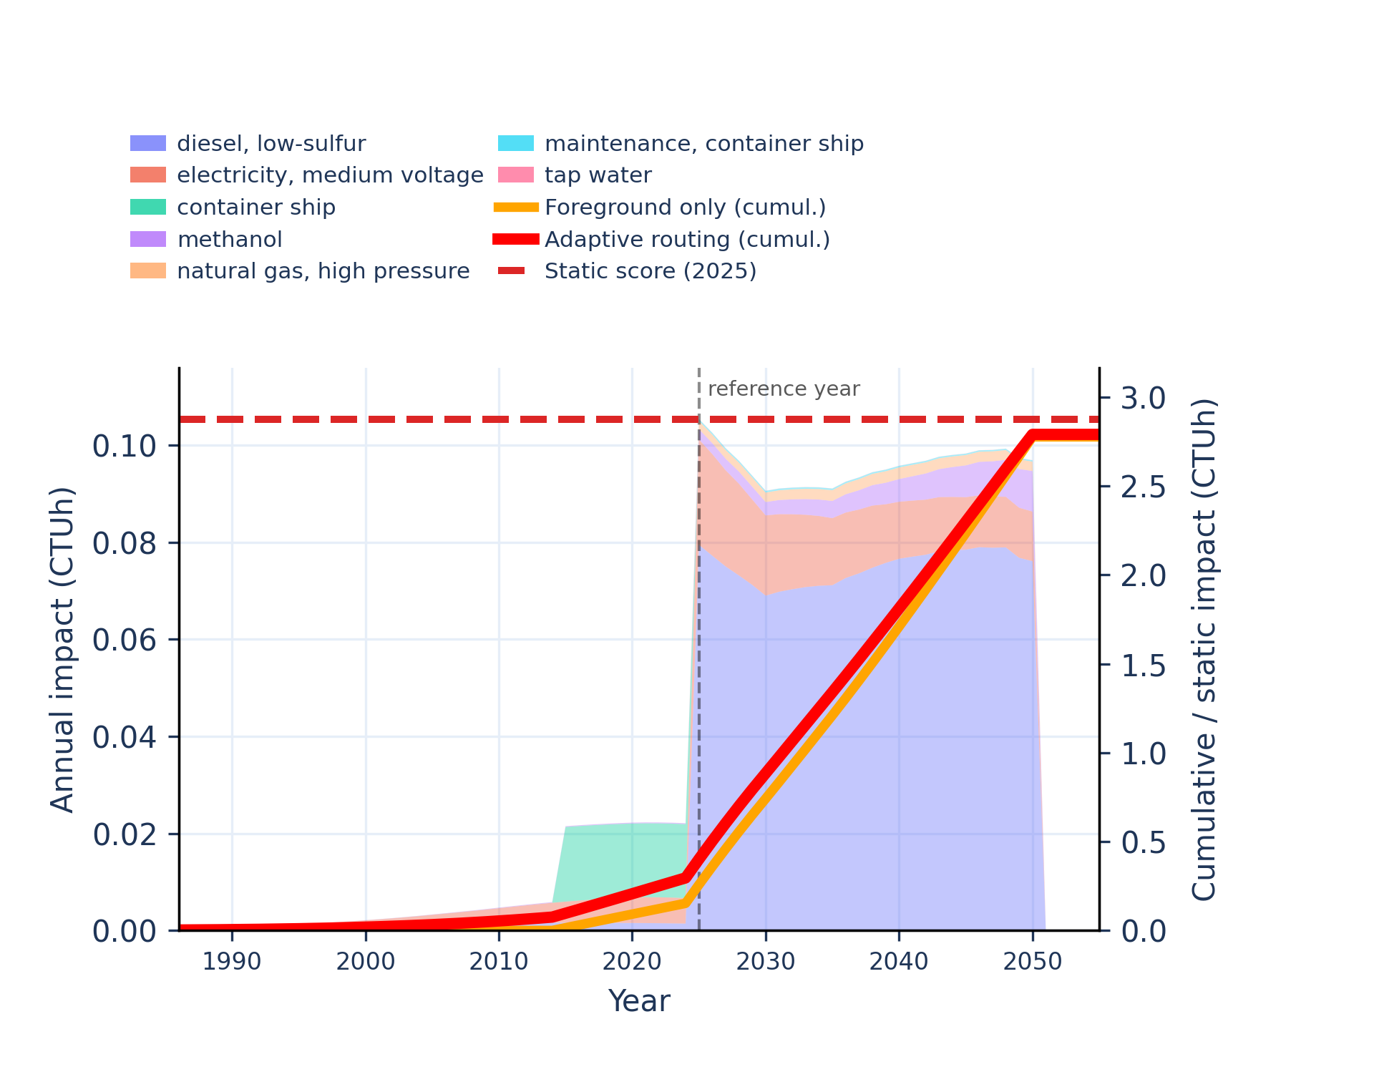
Figure S-routing-marine-14. human toxicity: carcinogenic, inorganics - comparative toxic unit for human (CTUh).
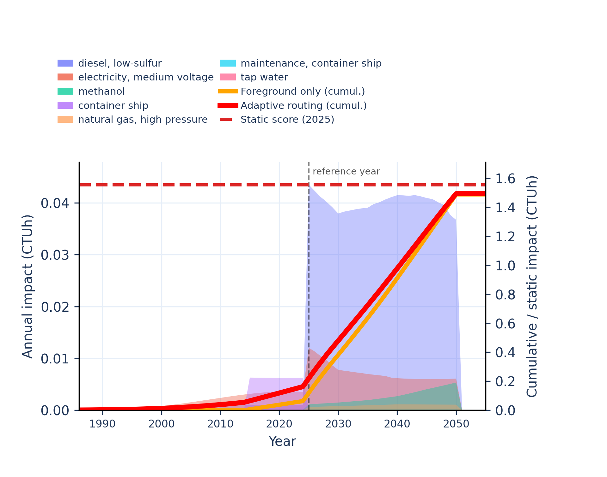 | 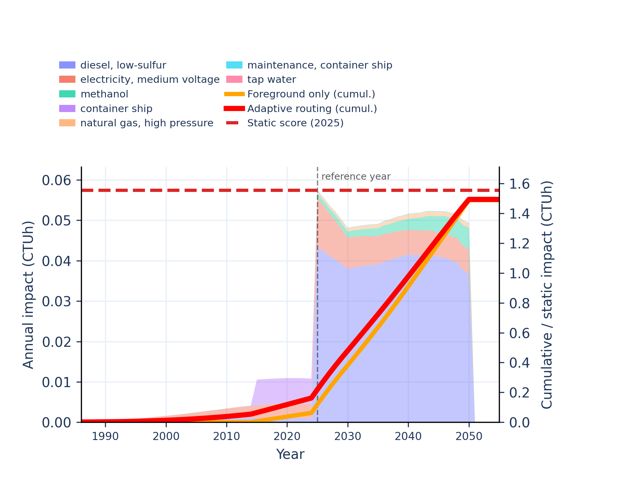
Figure S-routing-marine-15. human toxicity: carcinogenic, organics - comparative toxic unit for human (CTUh).
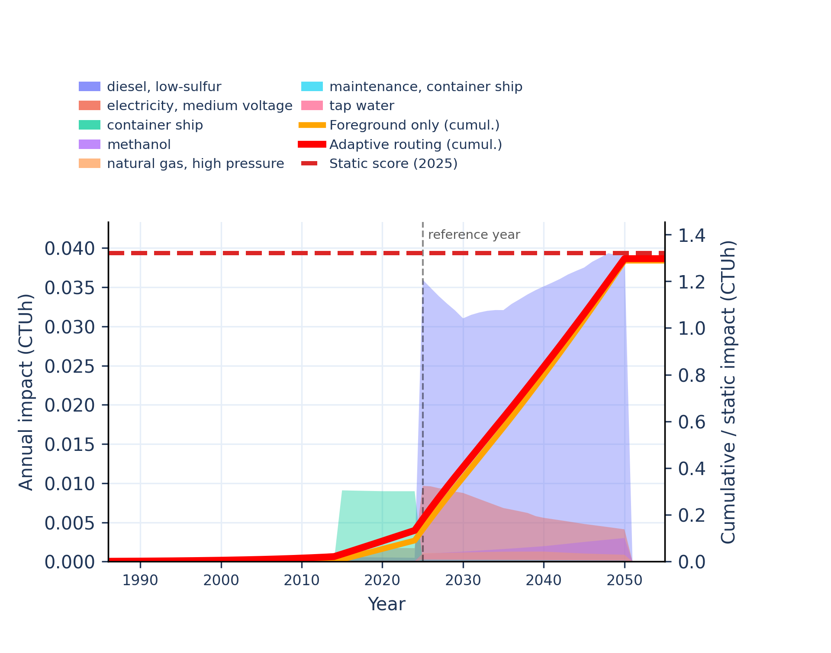 | 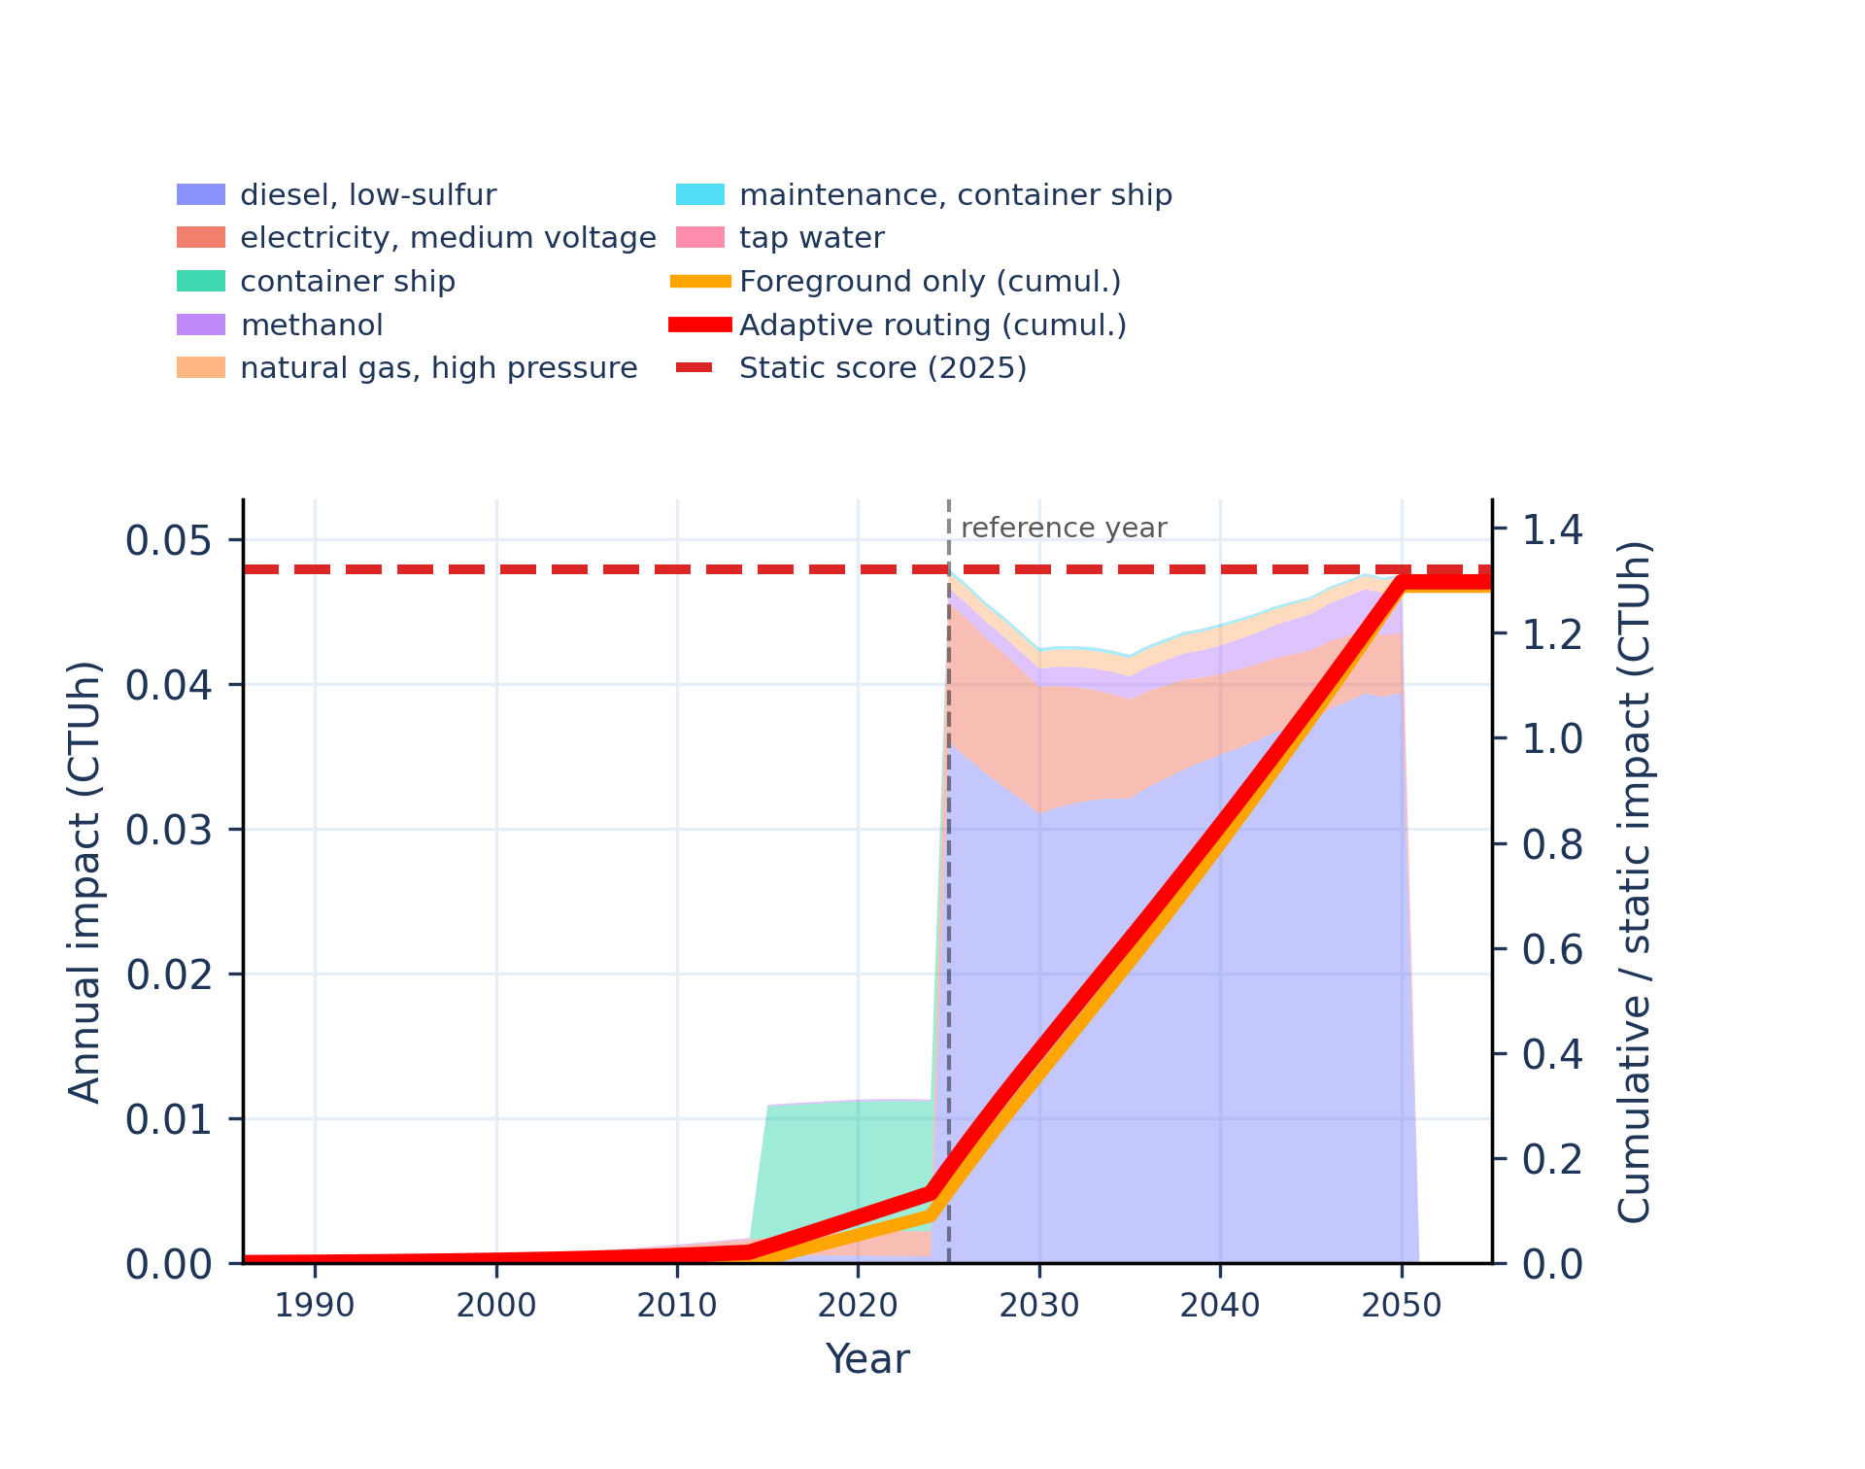
Figure S-routing-marine-16. human toxicity: non-carcinogenic - comparative toxic unit for human (CTUh).
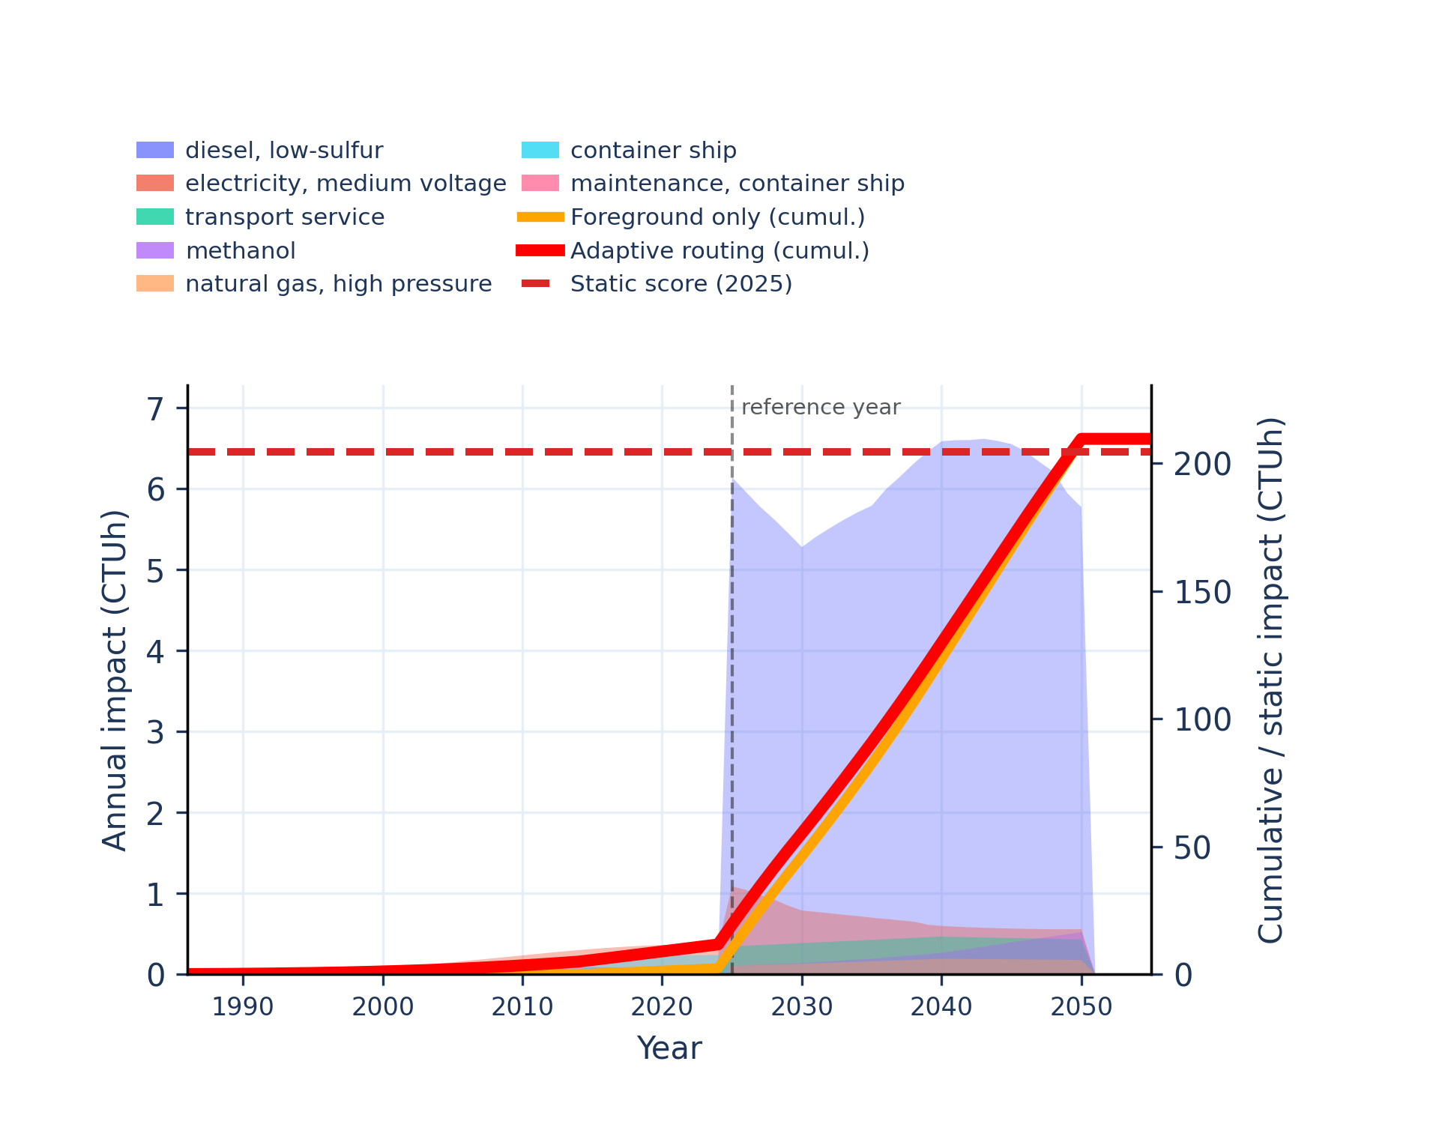 | 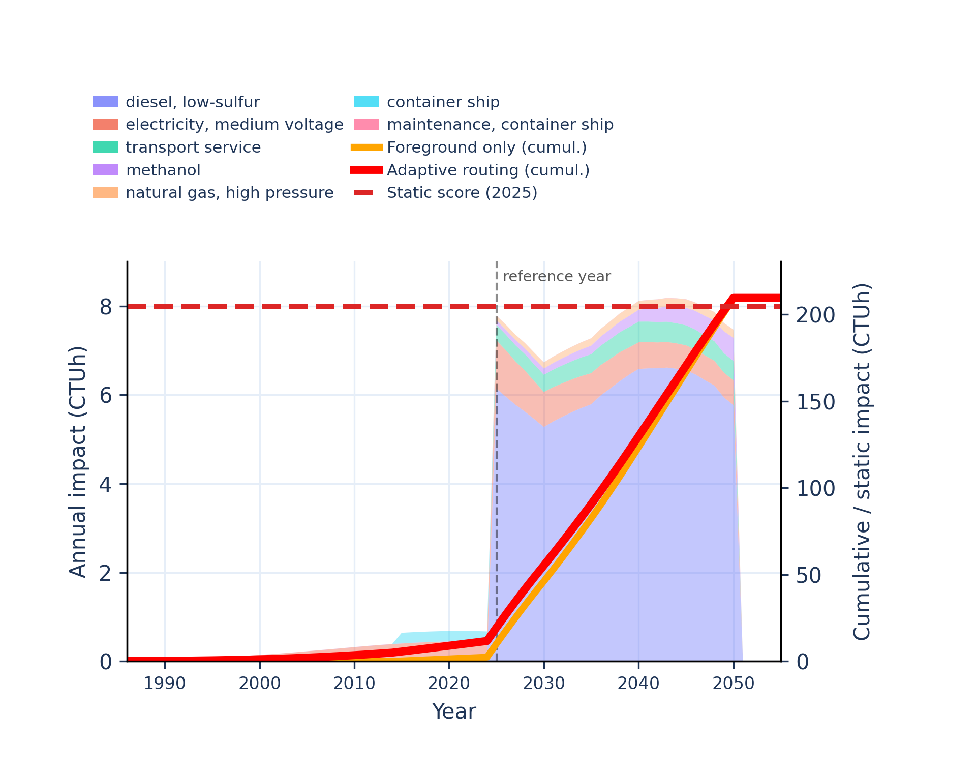
Figure S-routing-marine-17. human toxicity: non-carcinogenic, inorganics - comparative toxic unit for human (CTUh).
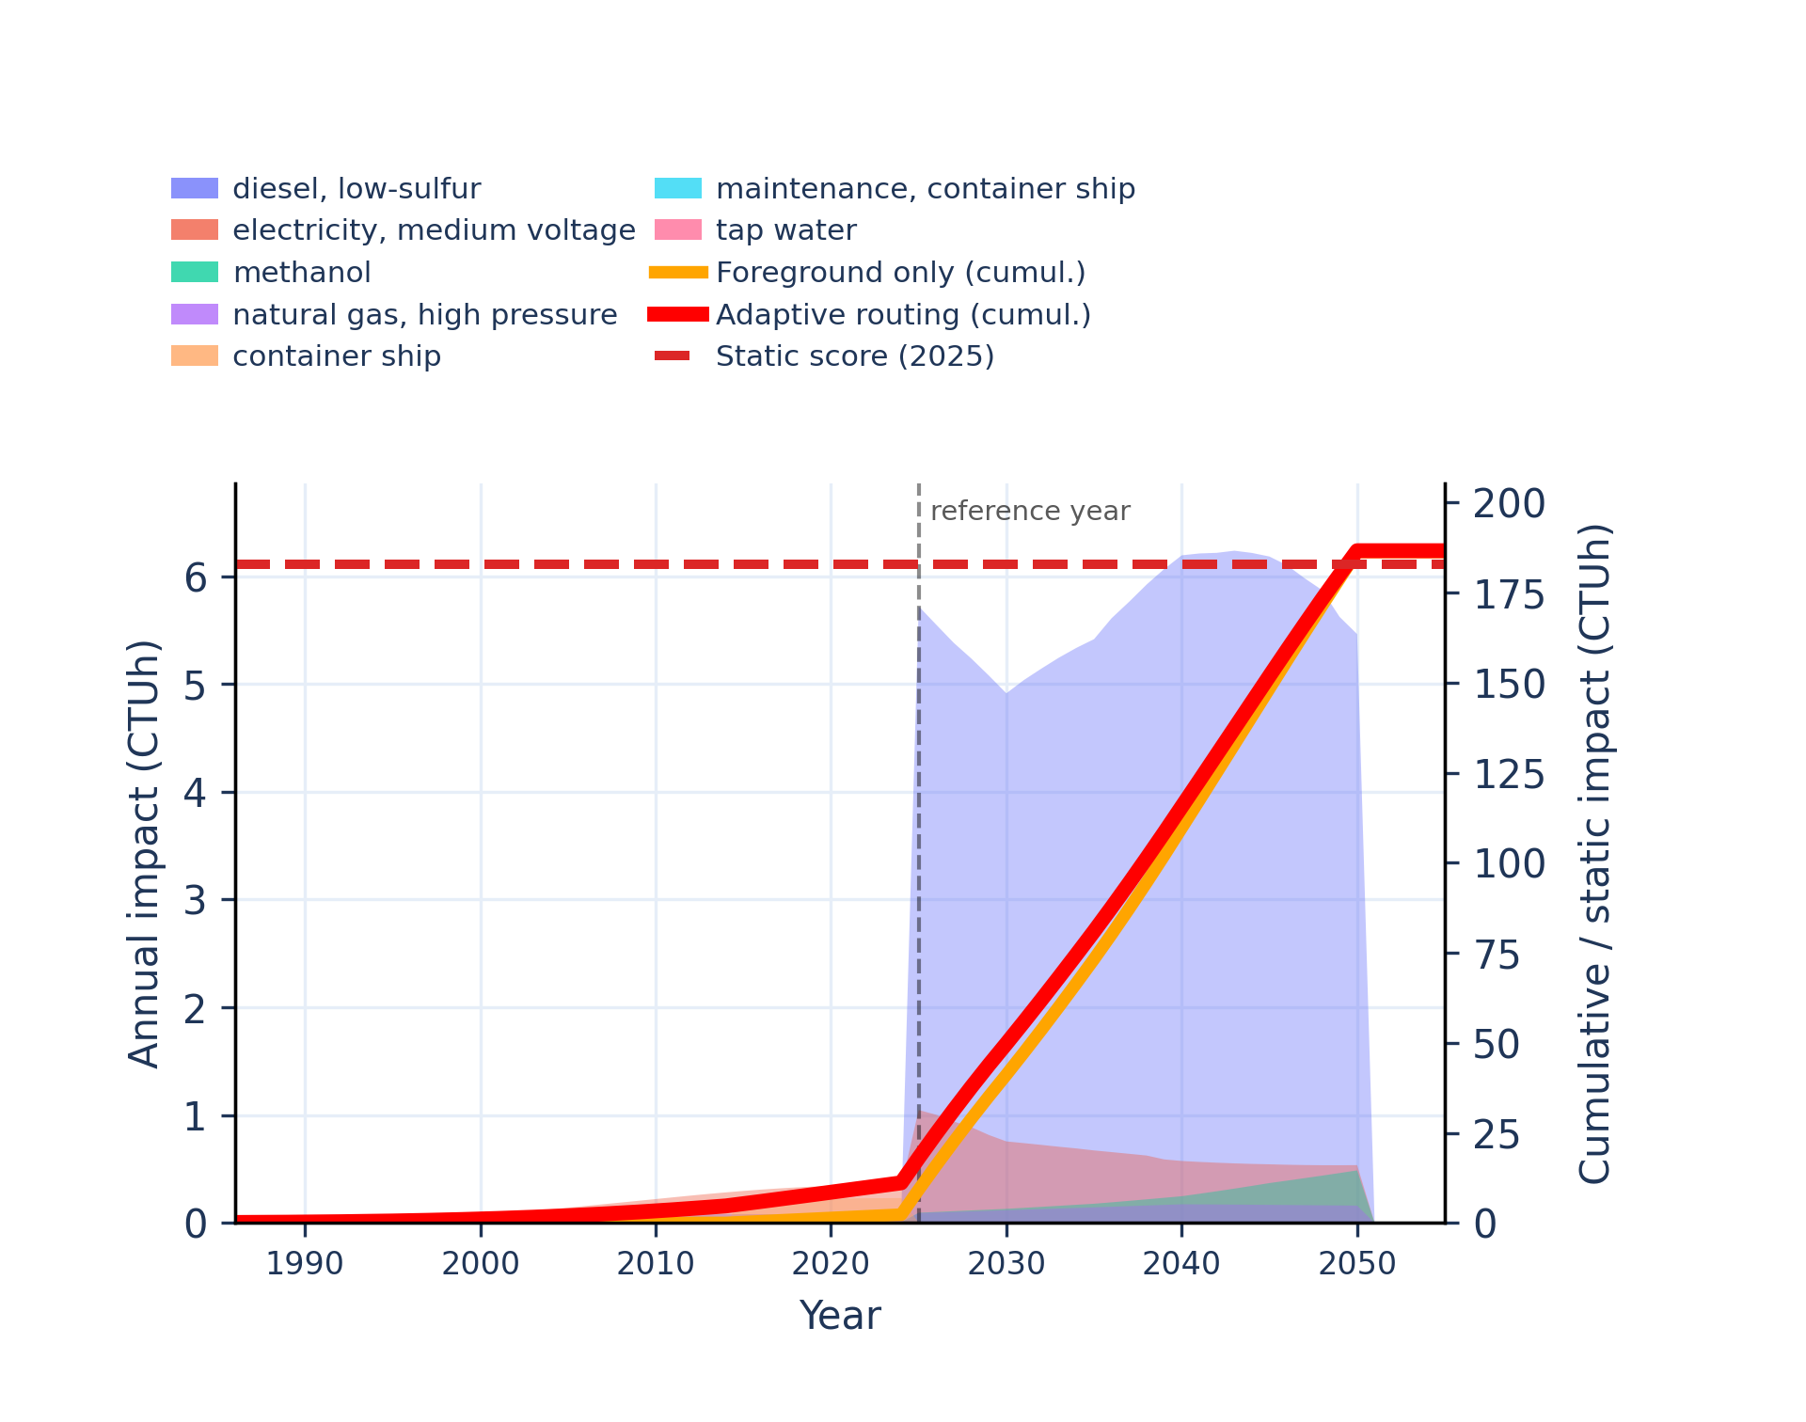 | 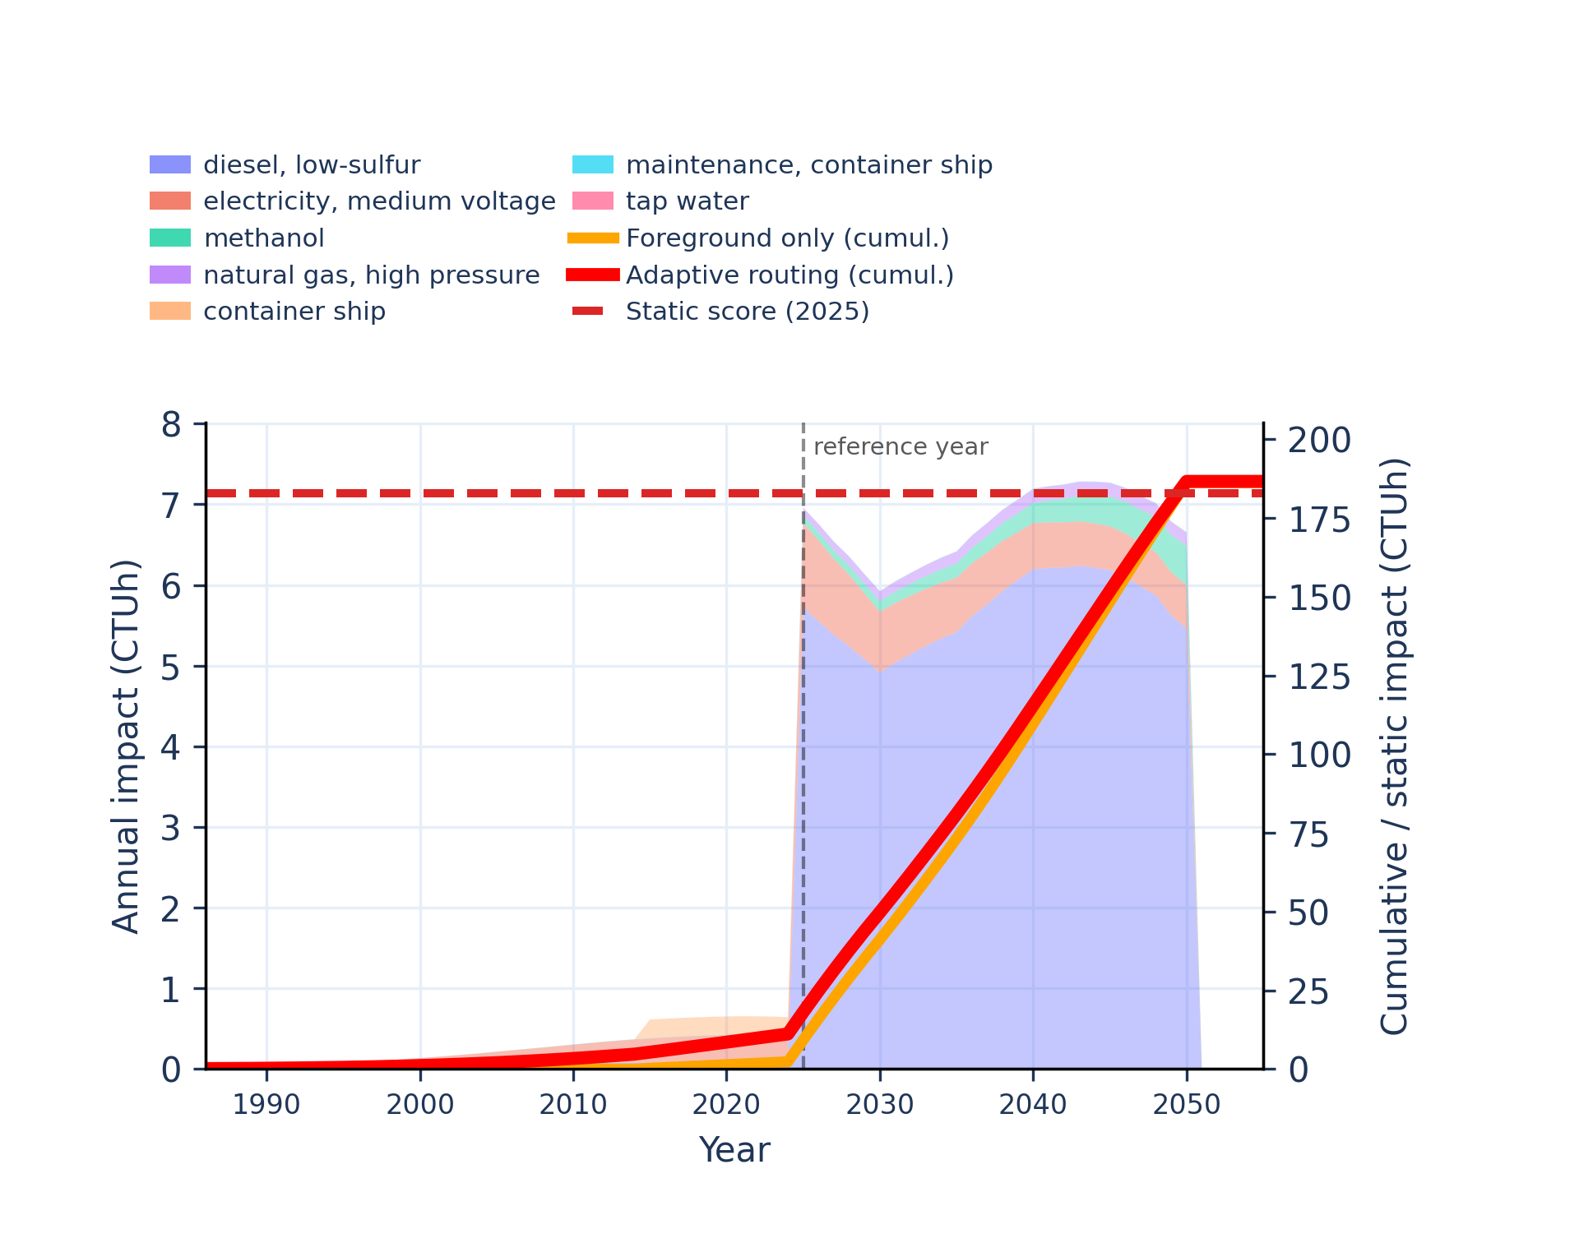
Figure S-routing-marine-18. human toxicity: non-carcinogenic, organics - comparative toxic unit for human (CTUh).
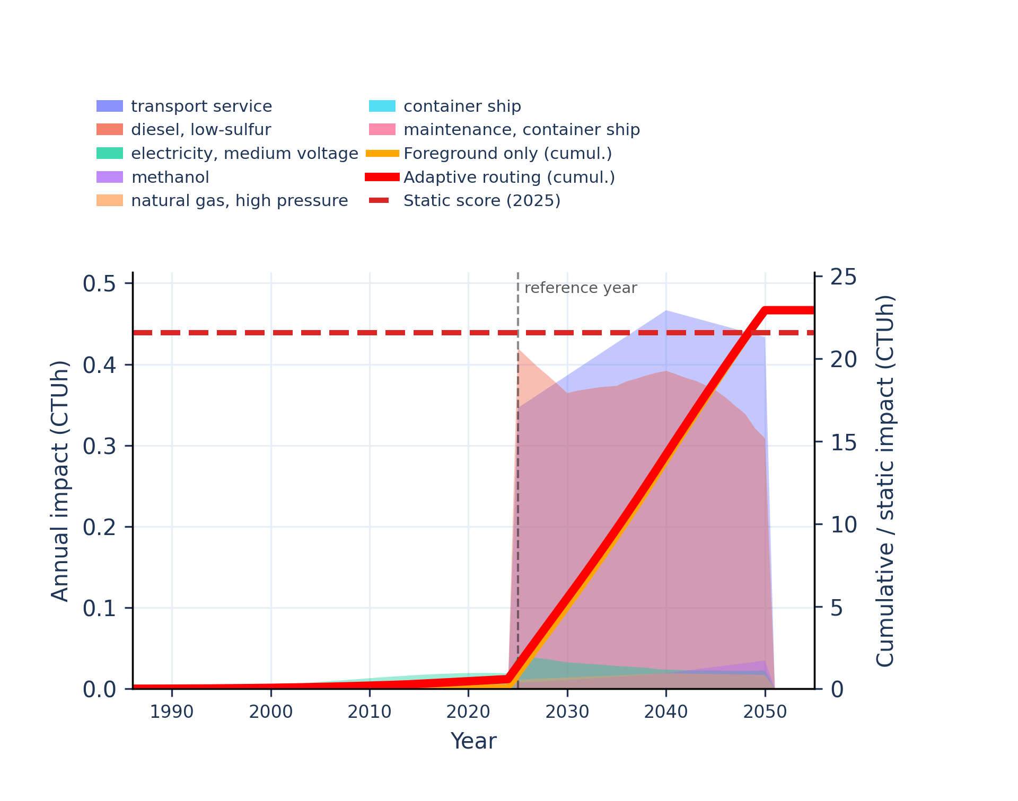 | 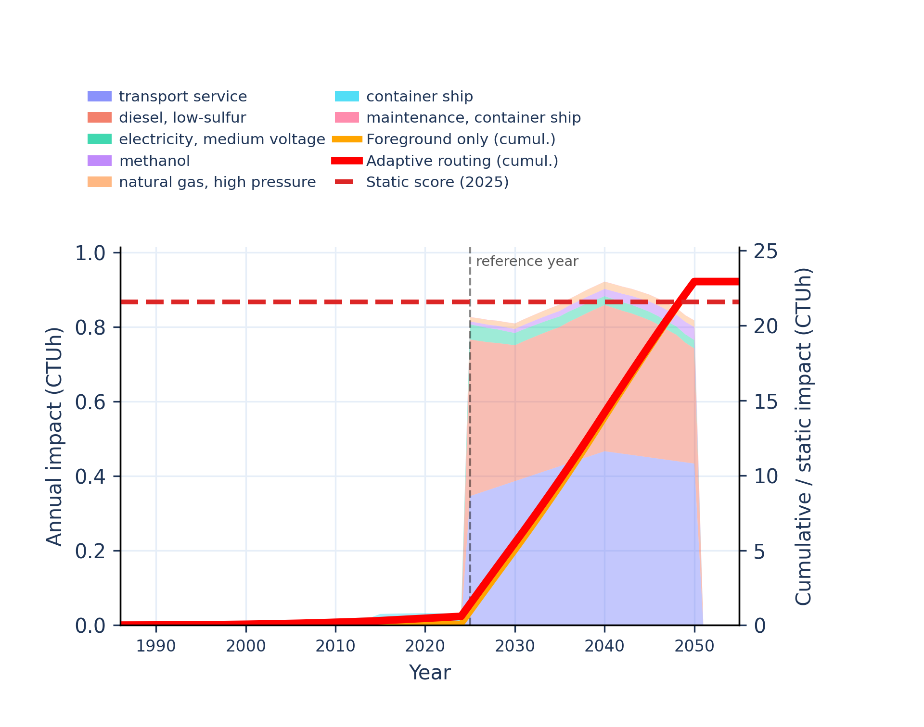
Figure S-routing-marine-19. ionising radiation: human health - human exposure efficiency relative to u235.
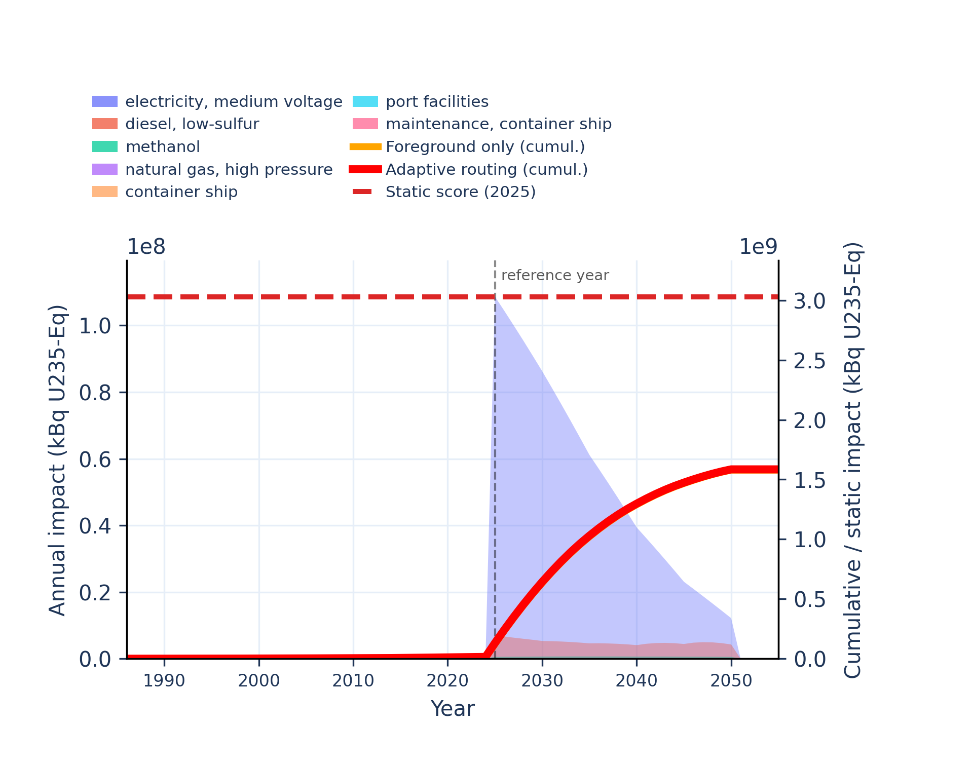 | 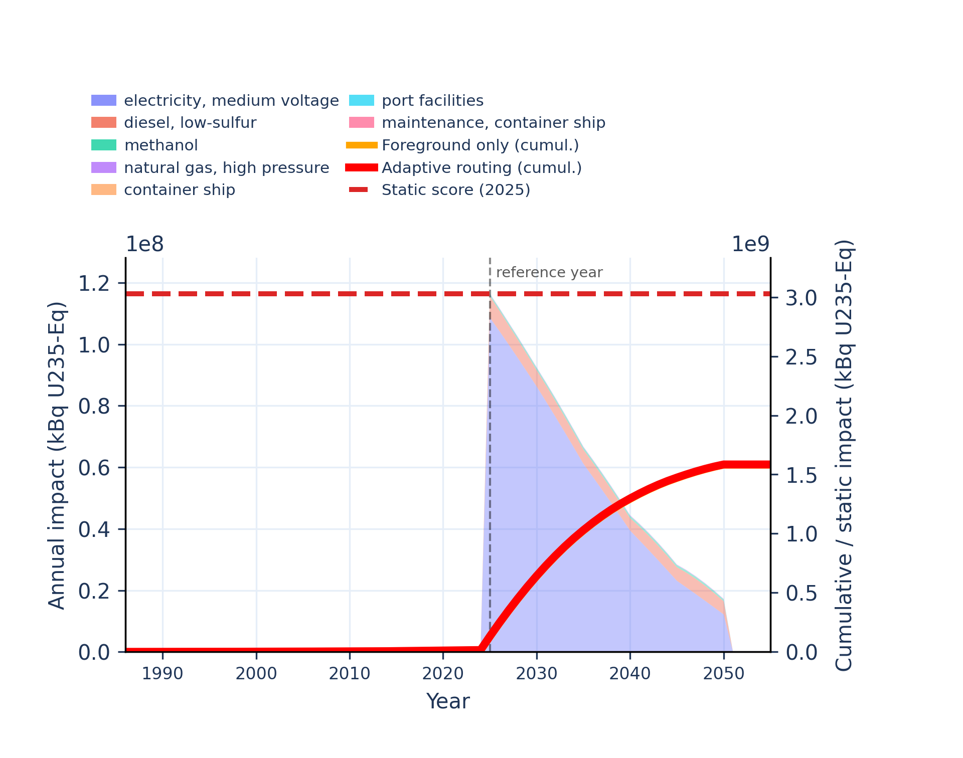
Figure S-routing-marine-20. land use - soil quality index.
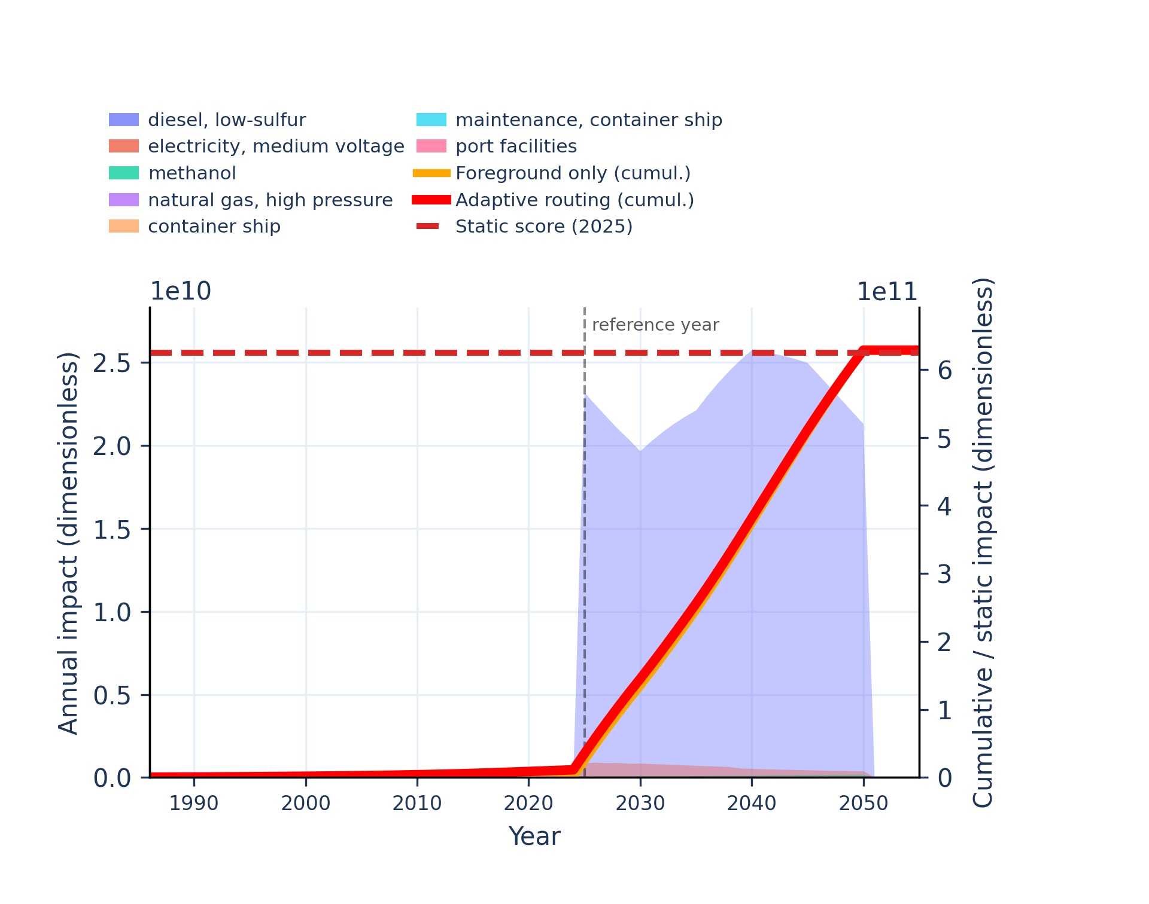 | 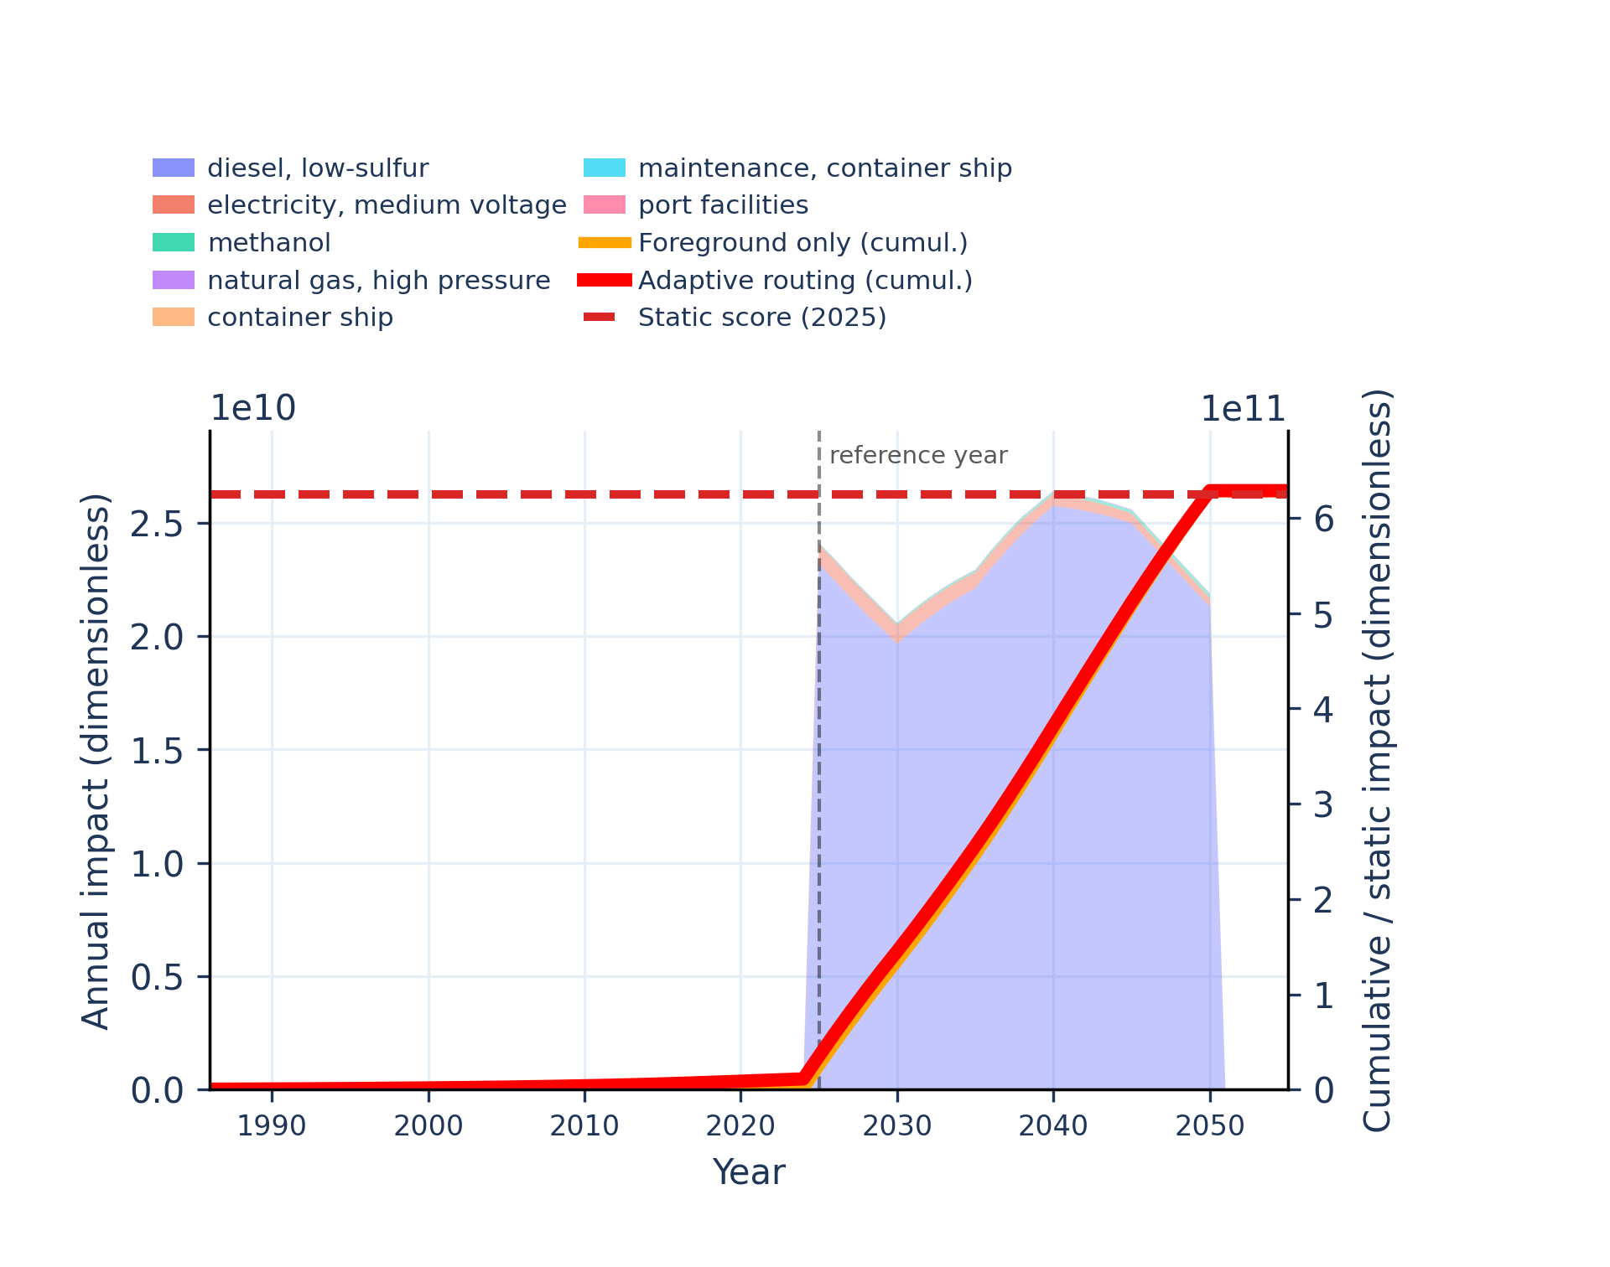
Figure S-routing-marine-21. material resources: metals/minerals - abiotic depletion potential (ADP): elements (ultimate reserves).
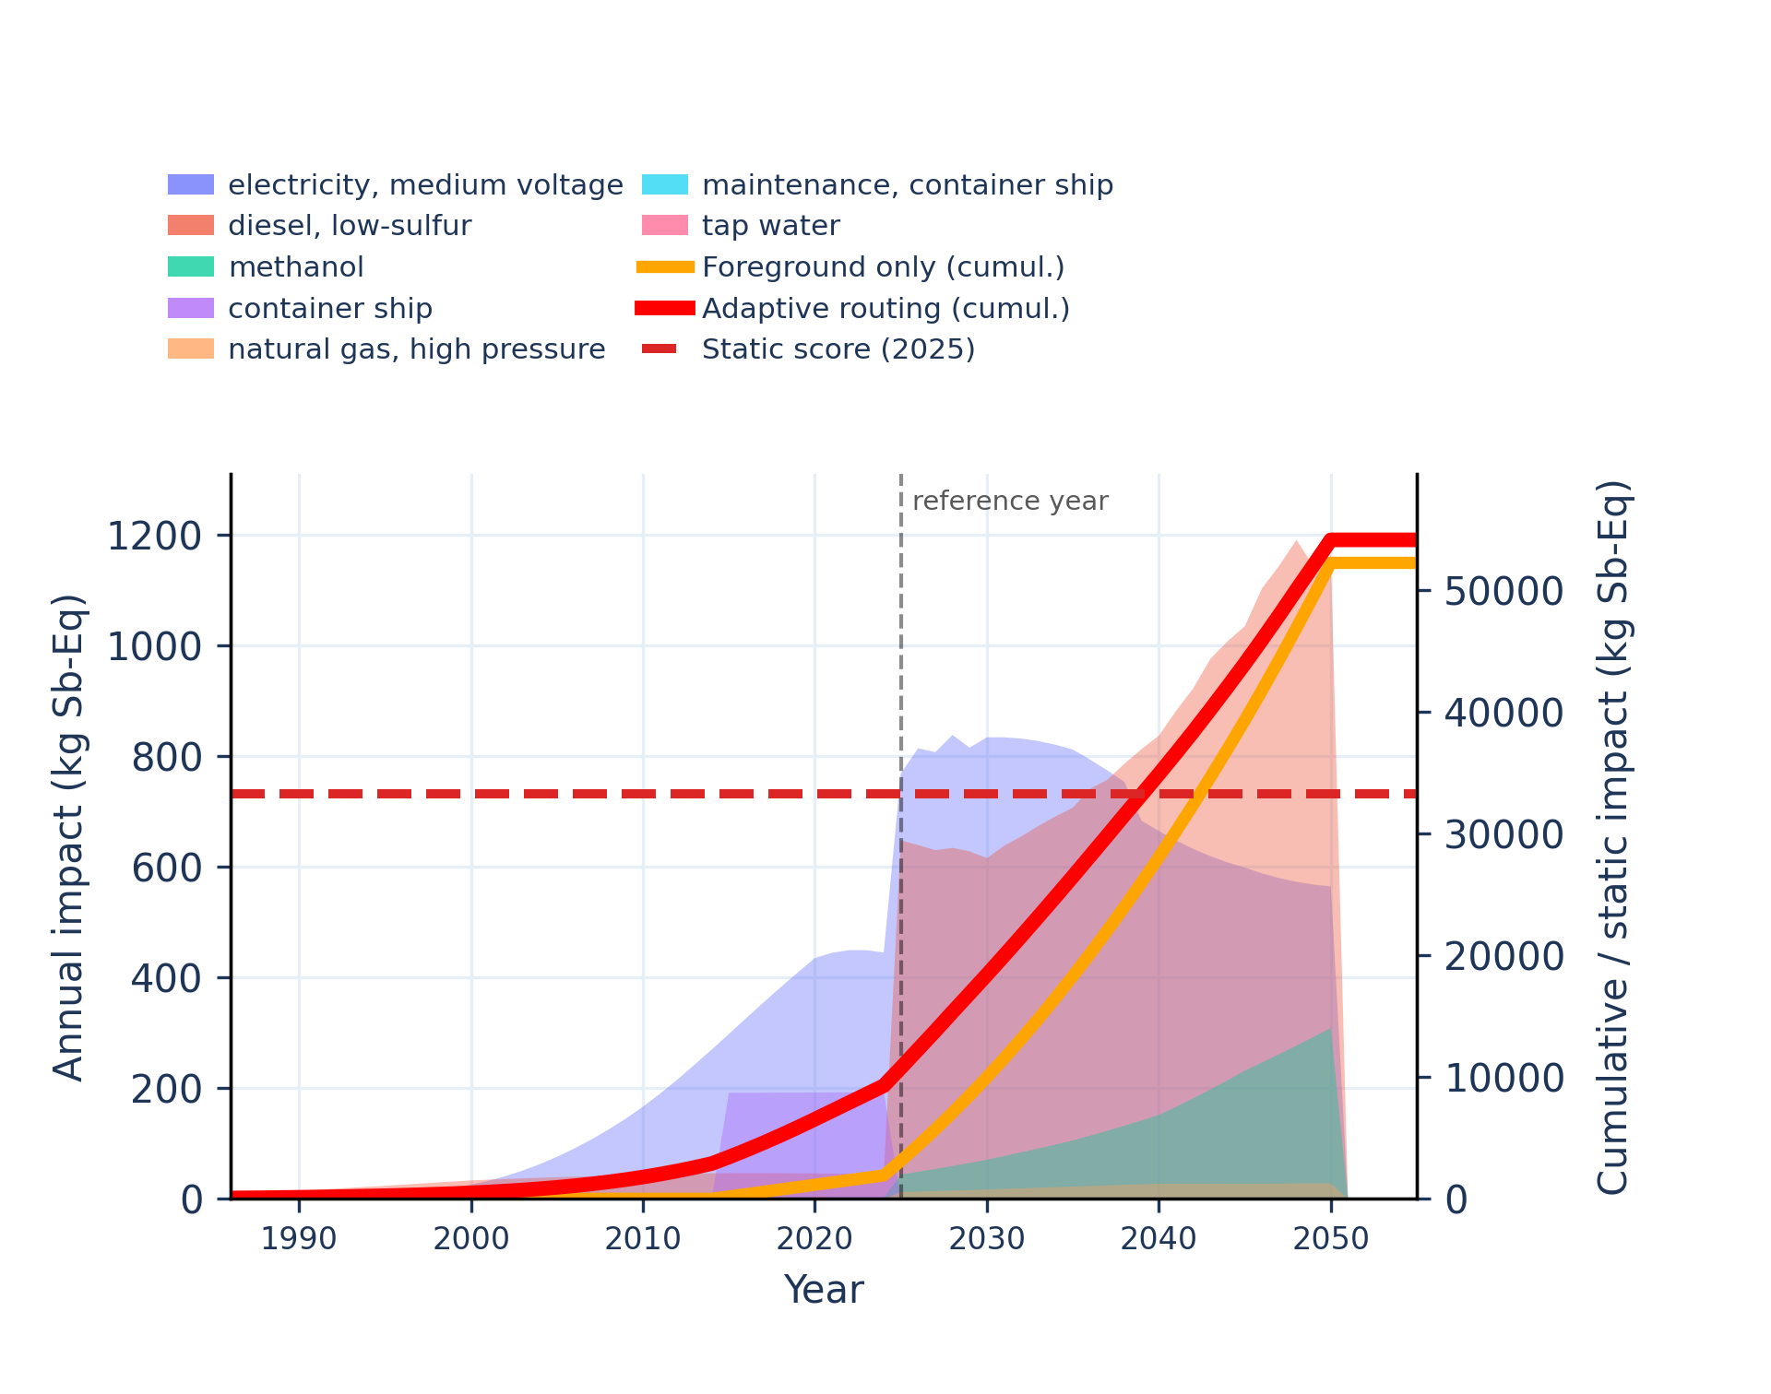 | 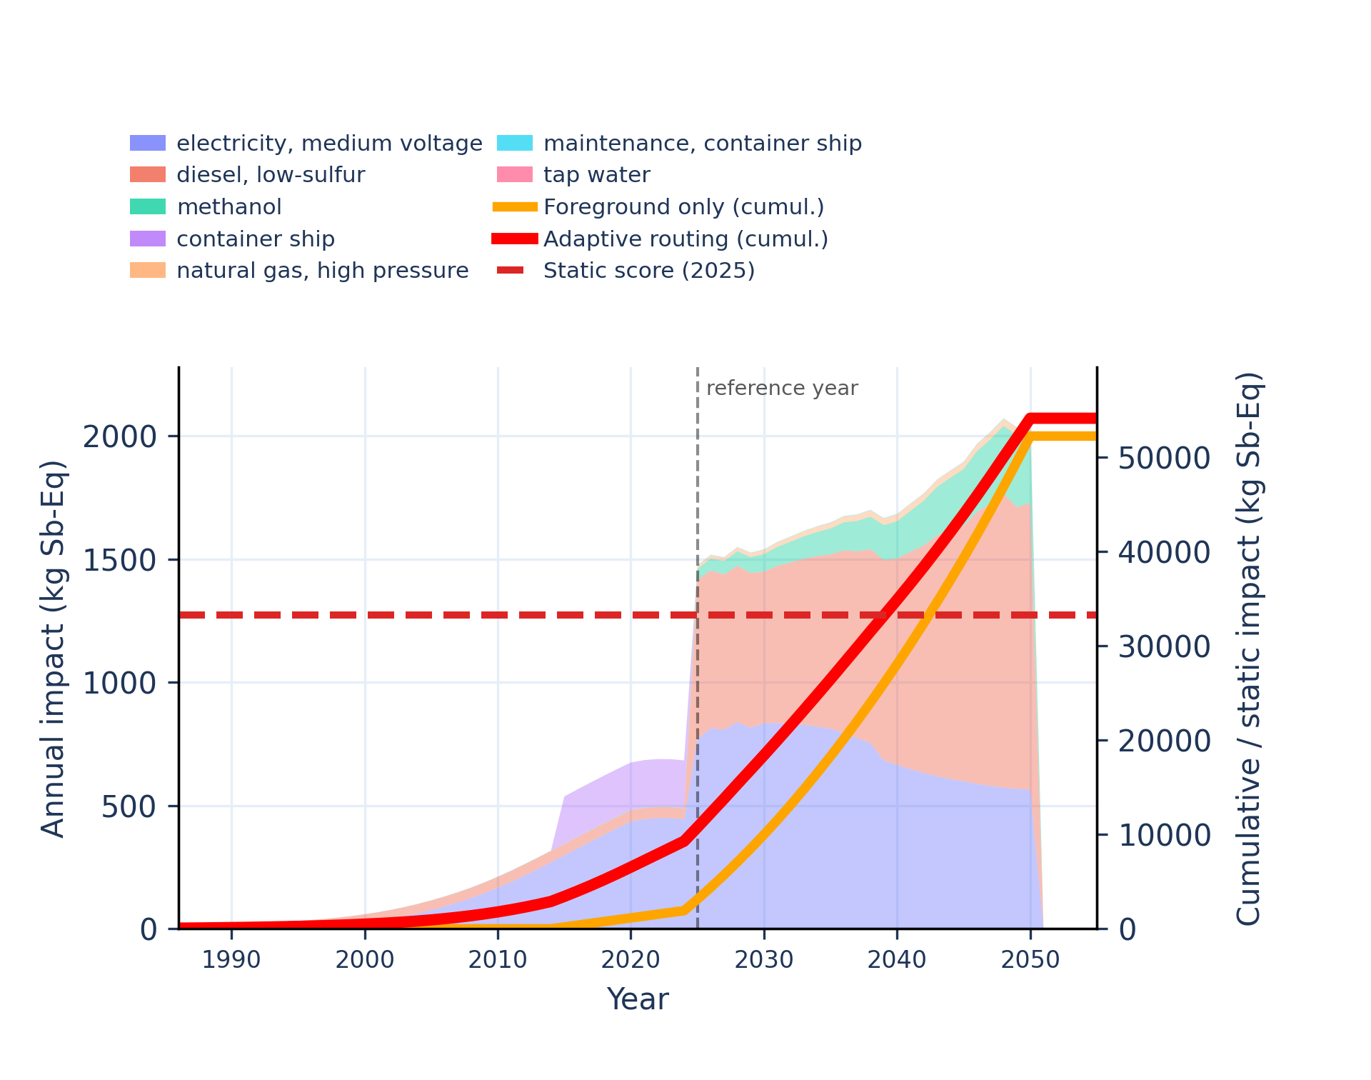
Figure S-routing-marine-22. ozone depletion - ozone depletion potential (ODP).
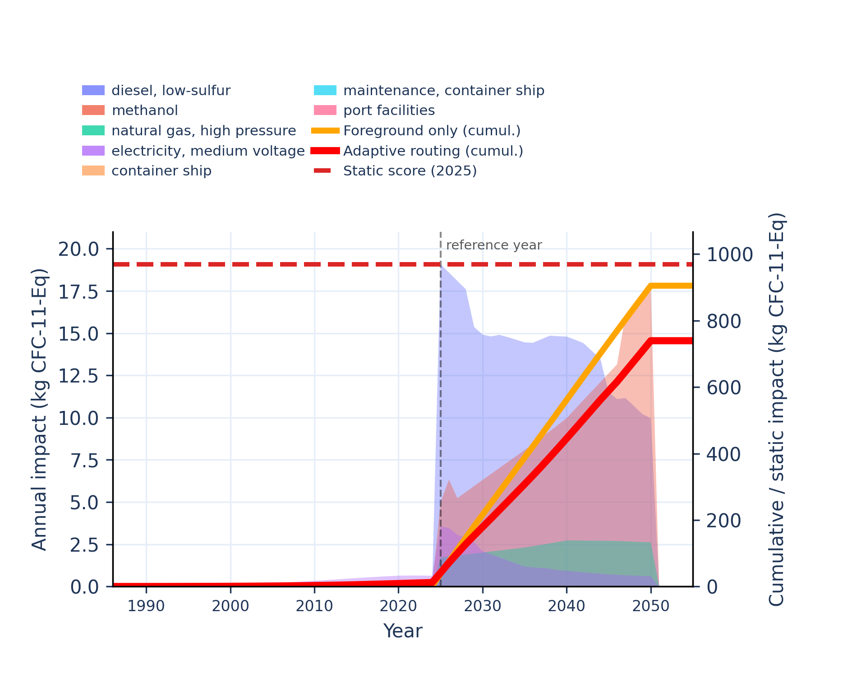 | 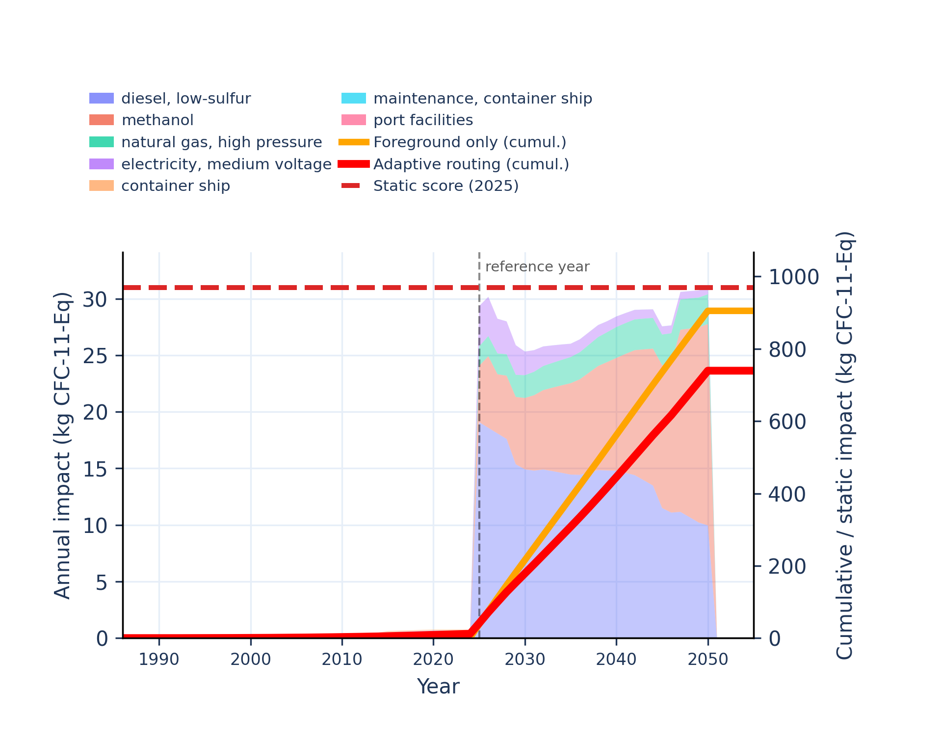
Figure S-routing-marine-23. particulate matter formation - impact on human health.
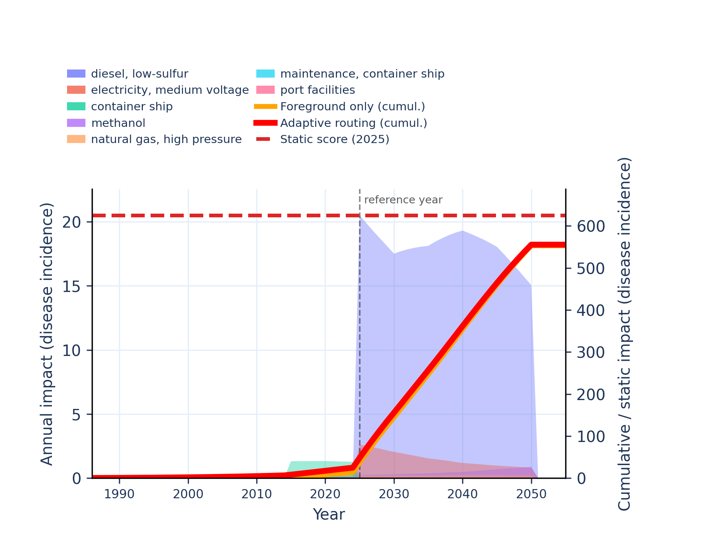 | 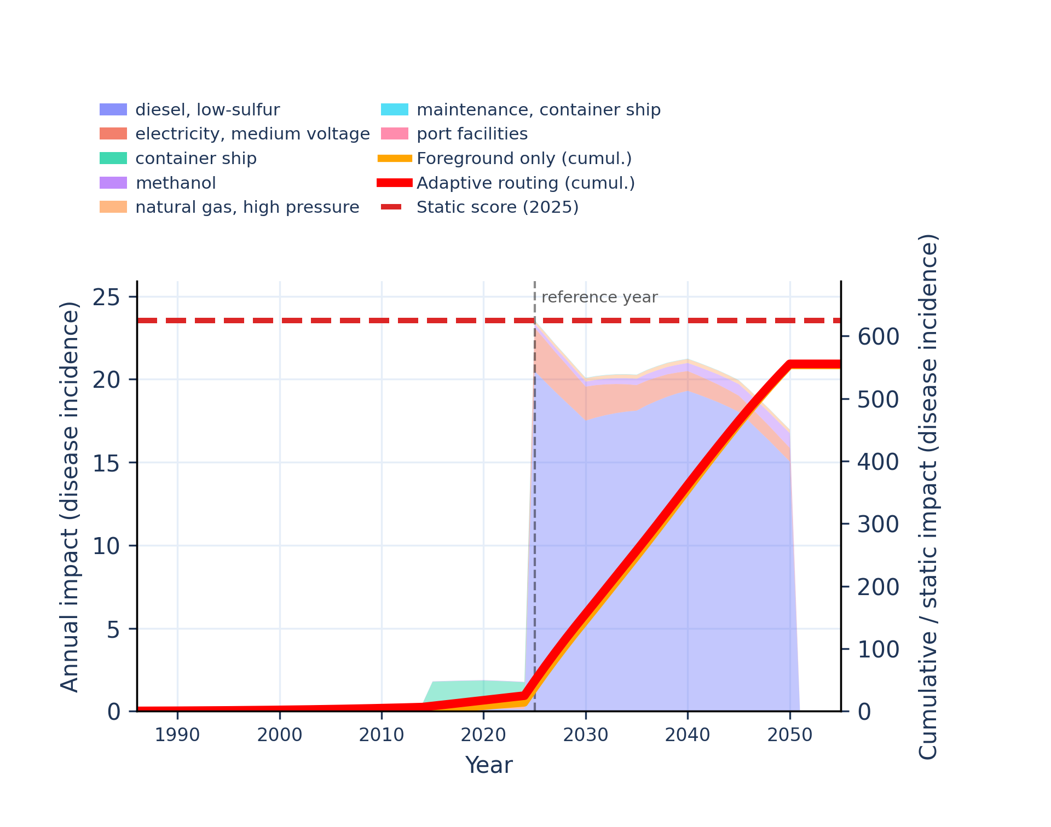
Figure S-routing-marine-24. photochemical oxidant formation: human health - tropospheric ozone concentration increase.
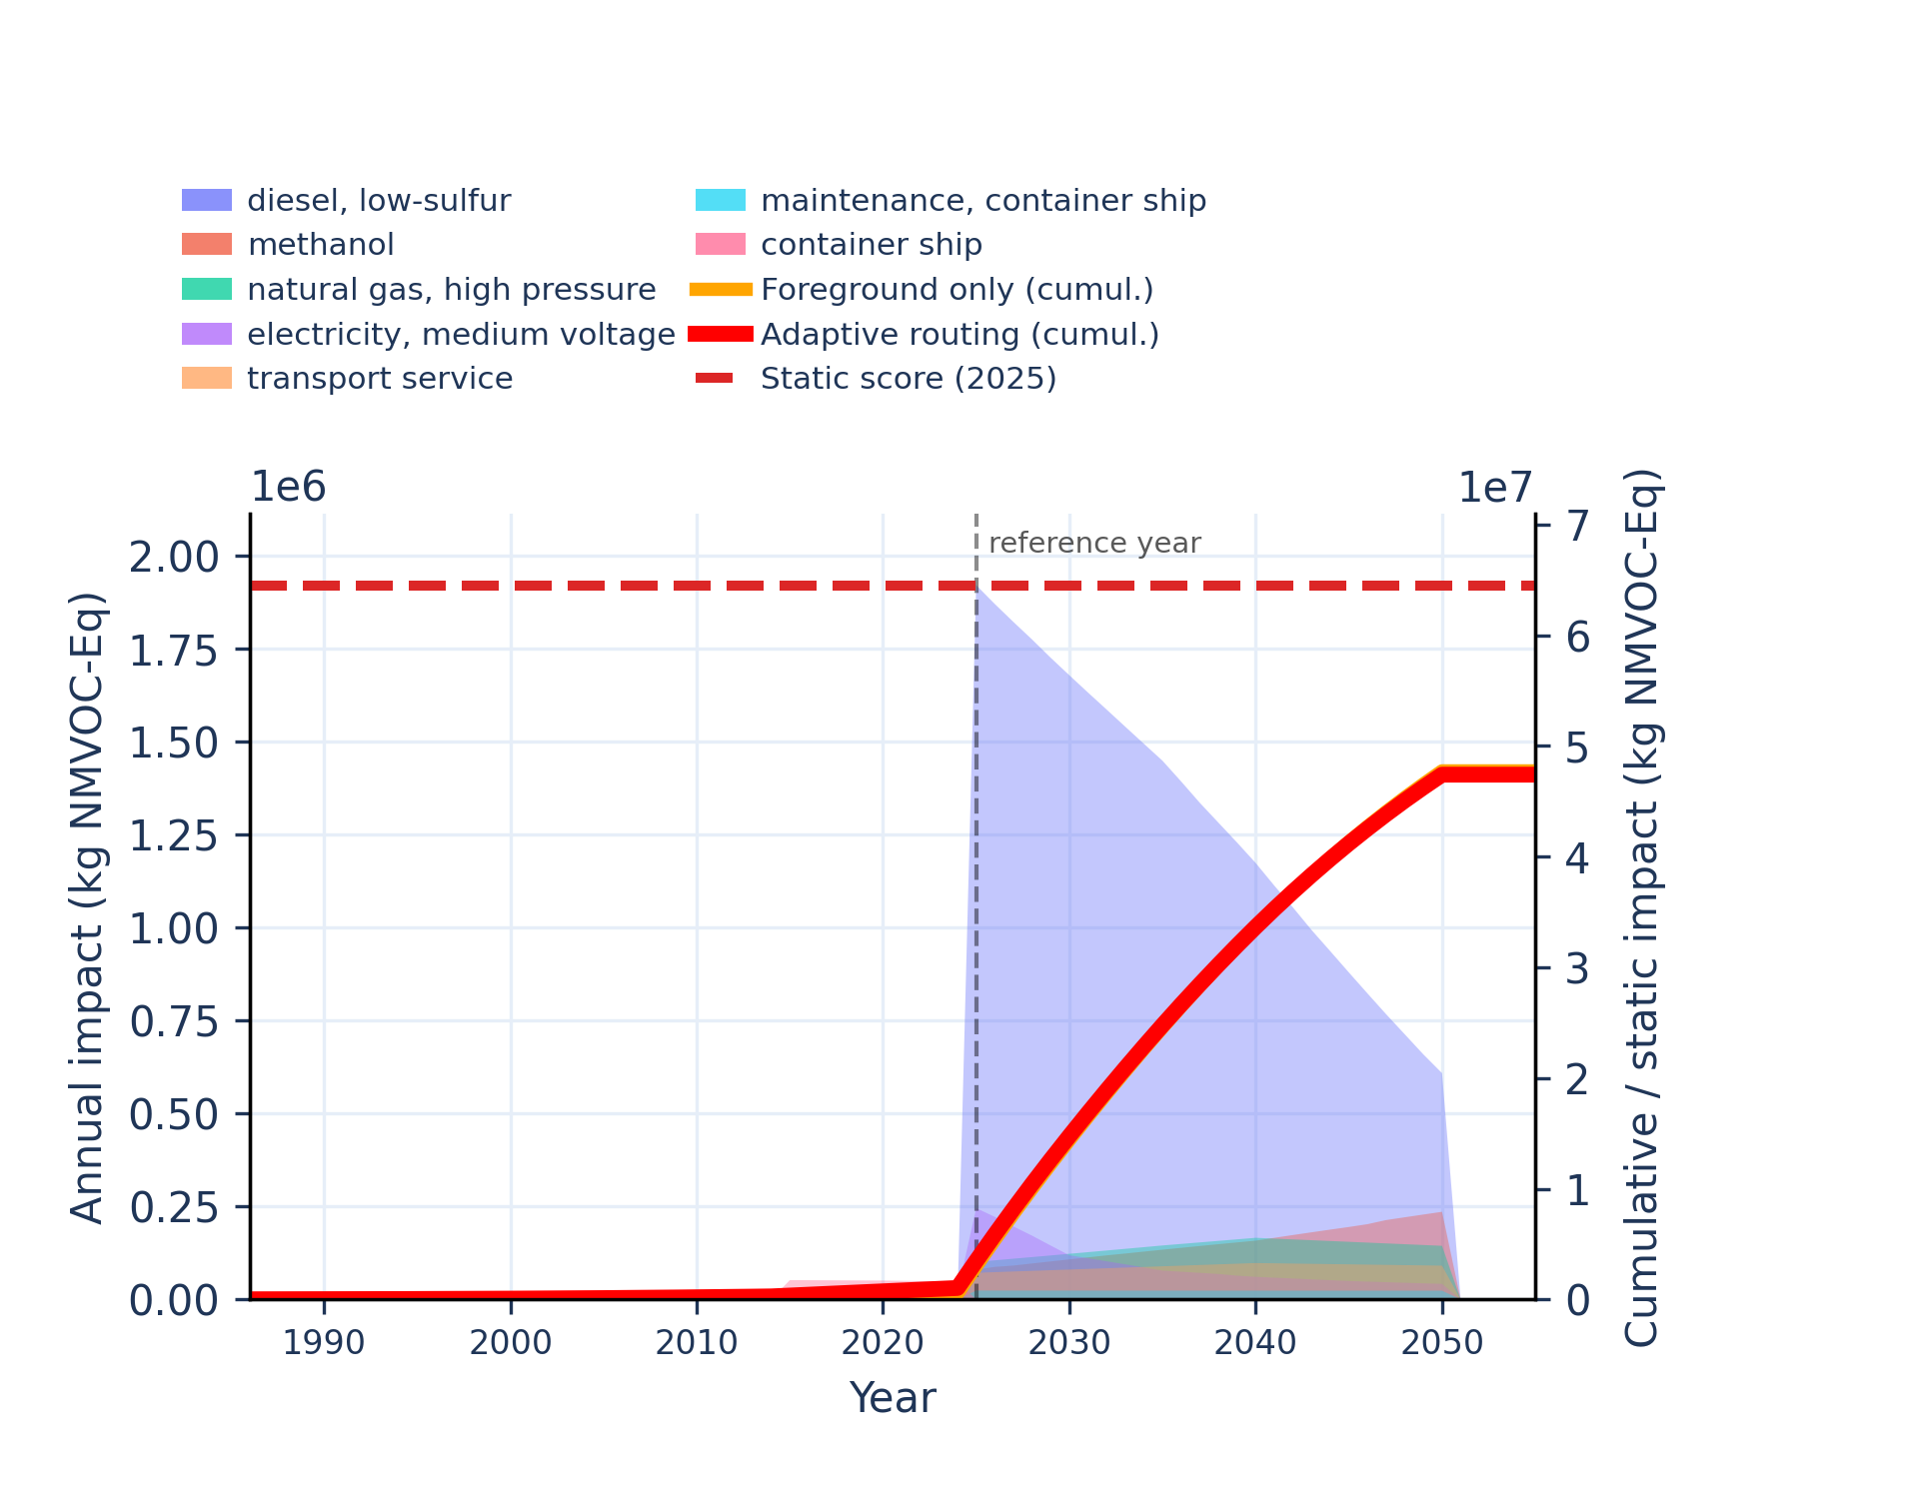 | 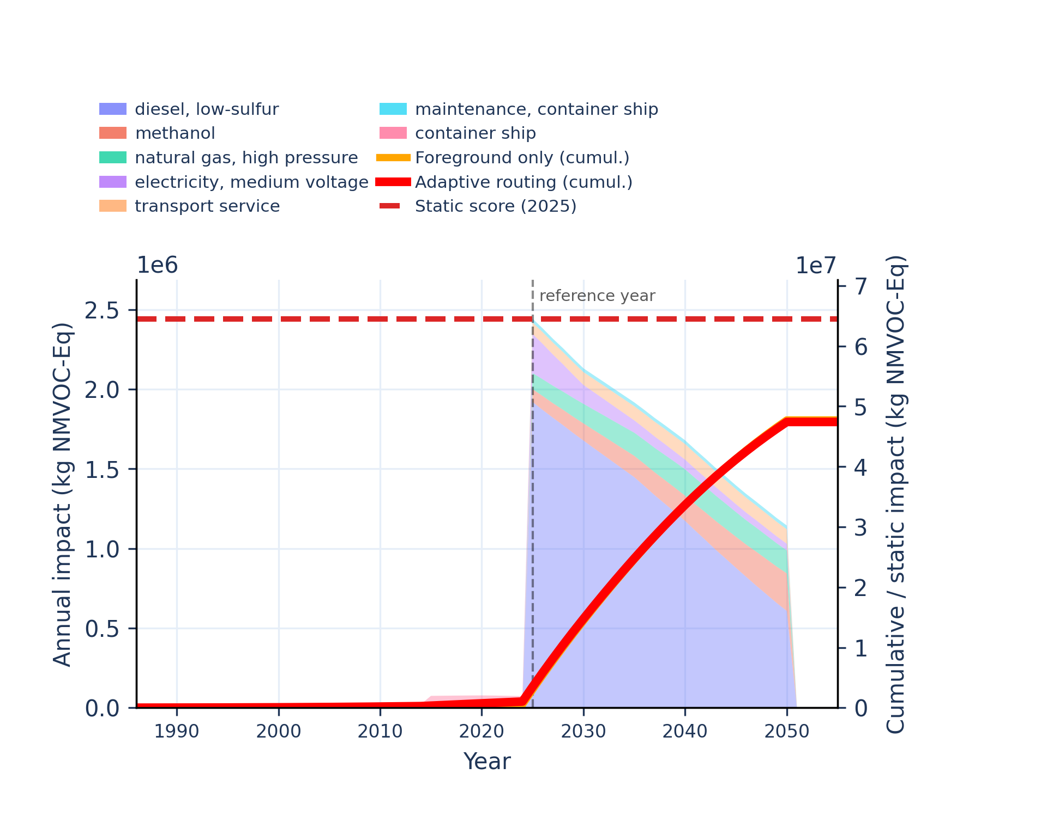
Figure S-routing-marine-25. water use - user deprivation potential (deprivation-weighted water consumption).
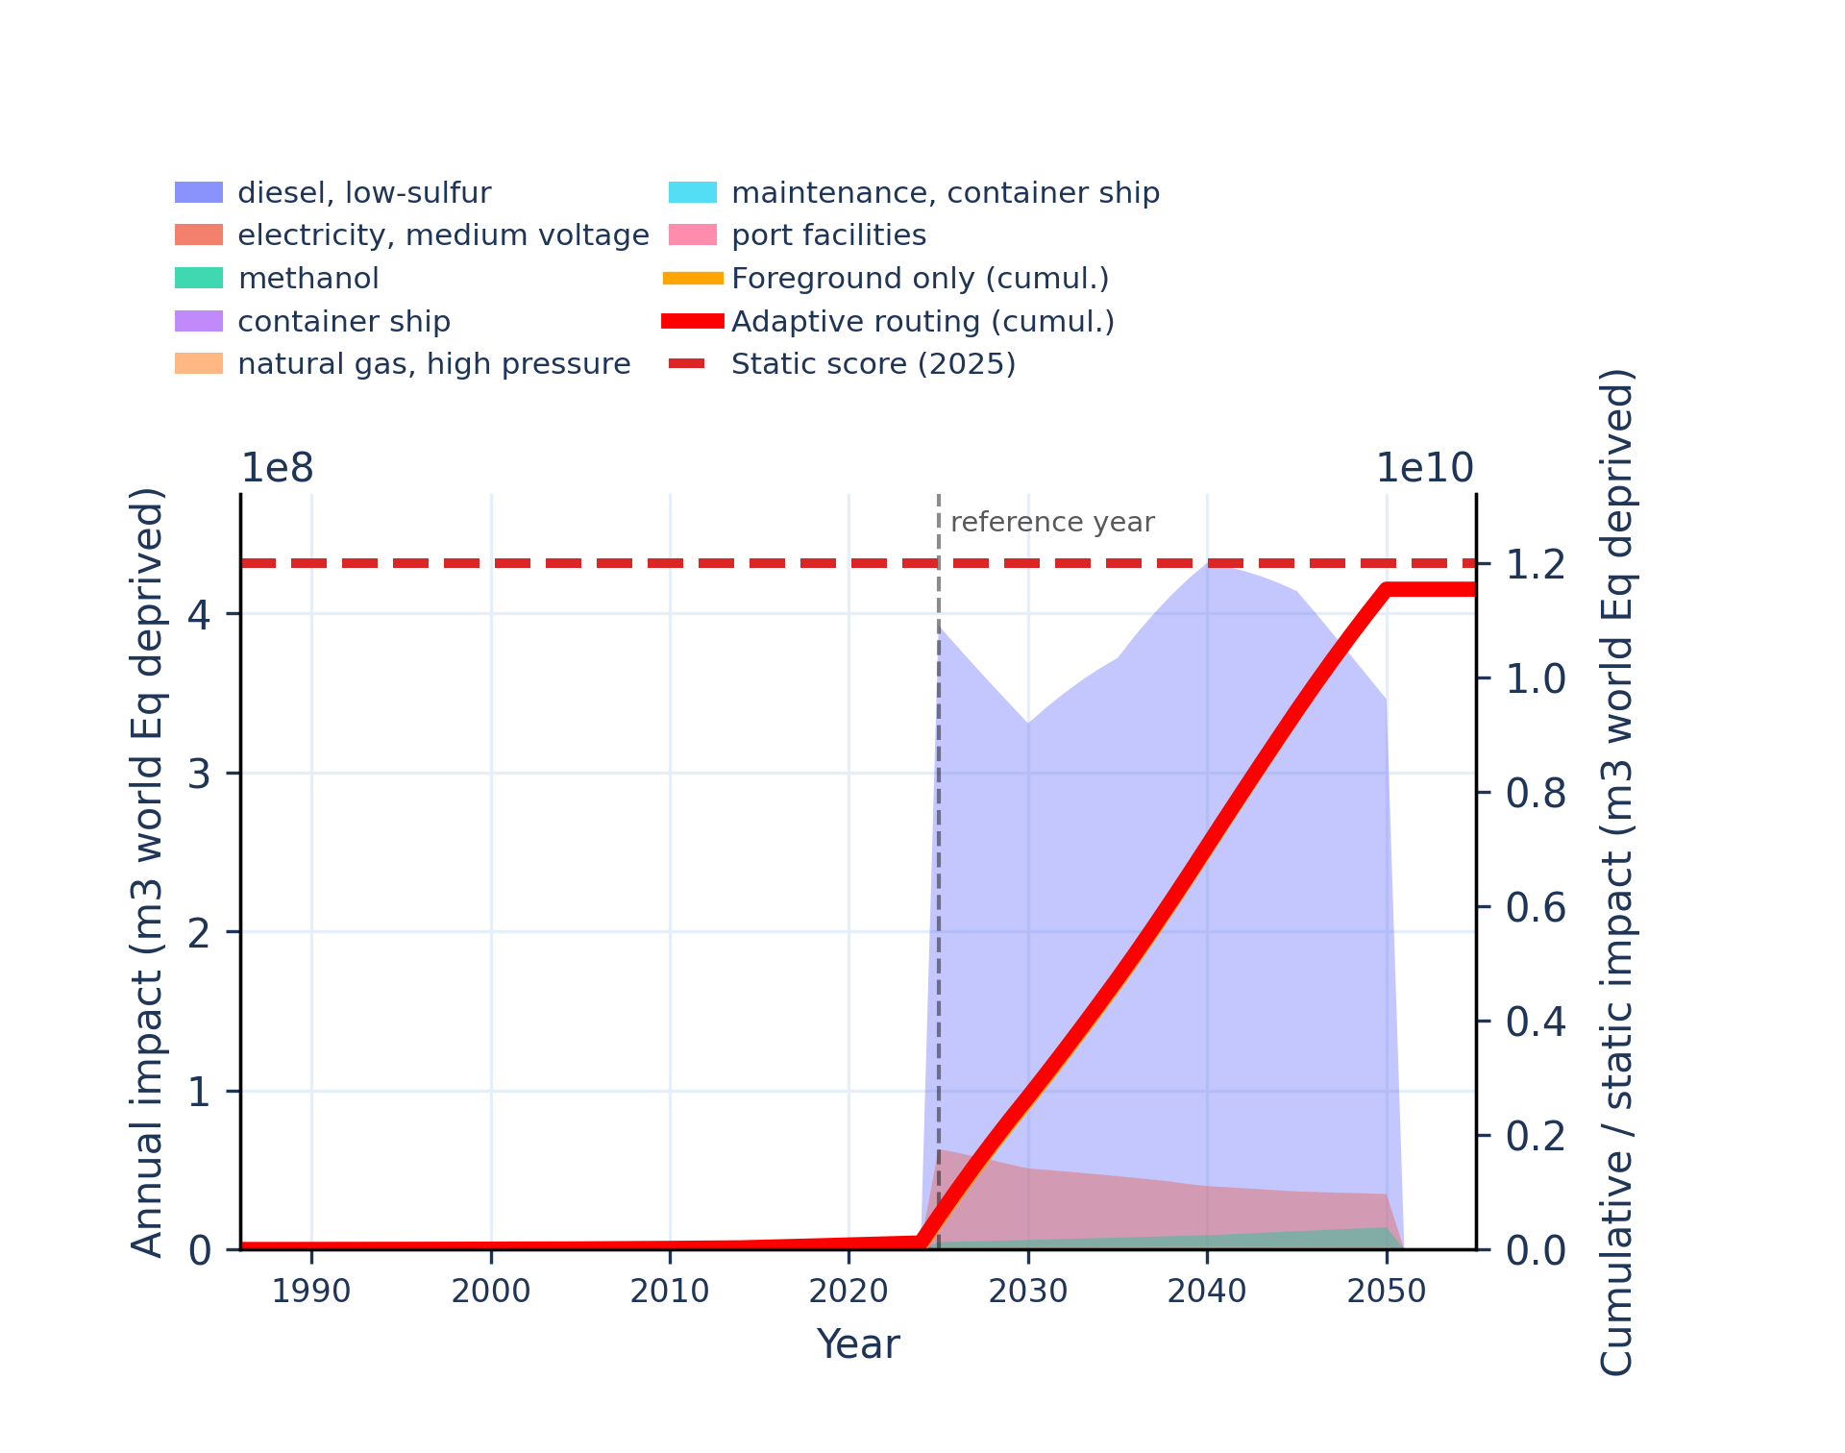 | 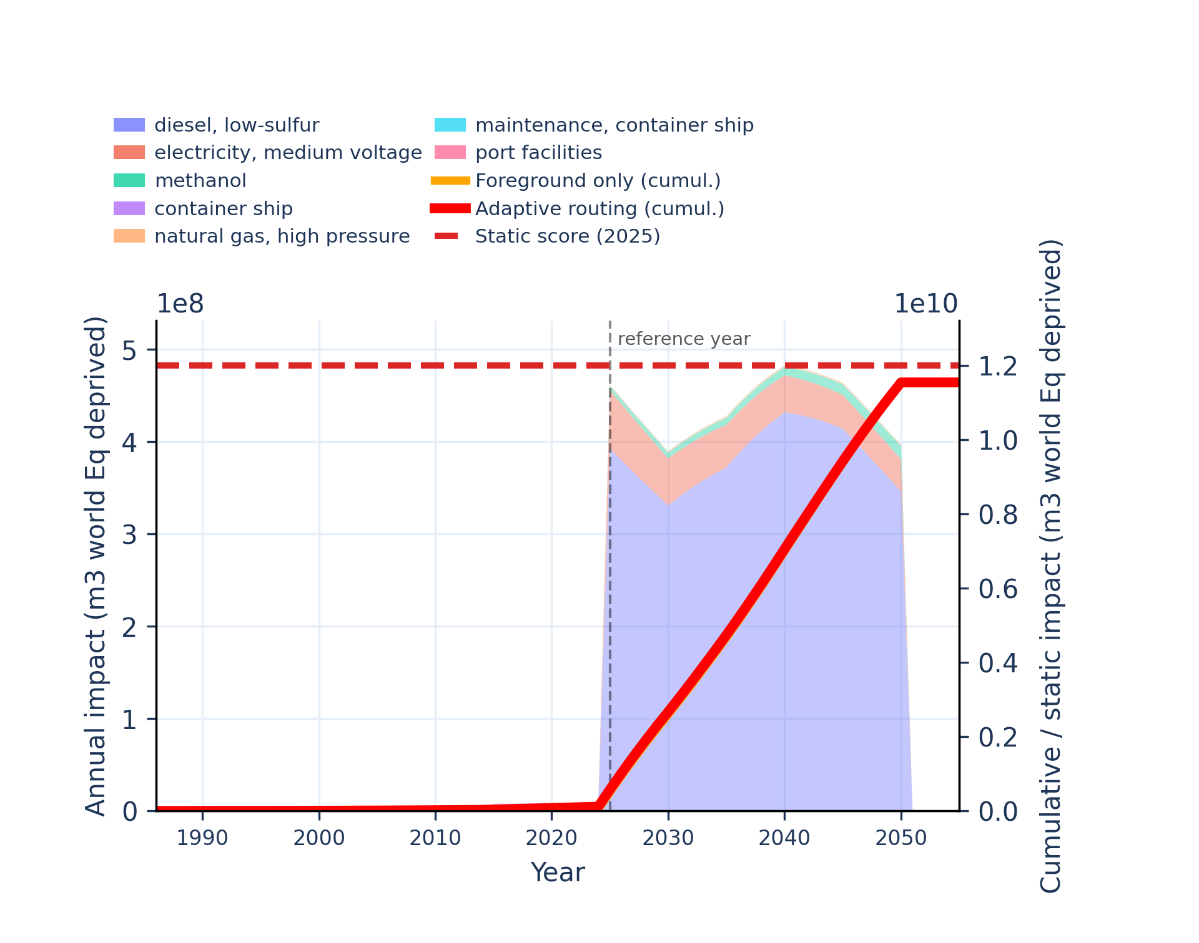

Direct air capture and carbon storage
Unstacked annual impacts | Stacked annual impacts
Figure S-routing-daccs-01. acidification - accumulated exceedance (AE).
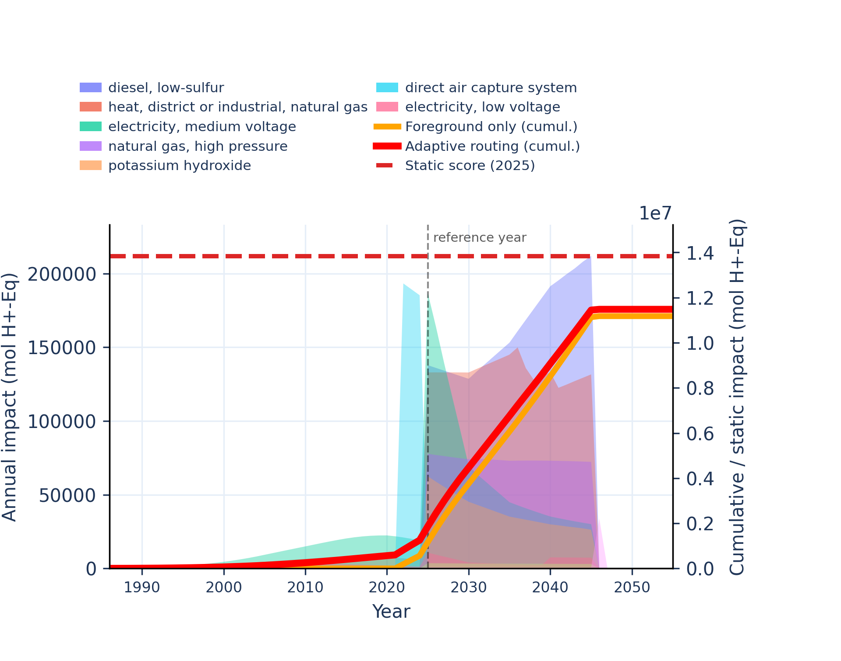 | 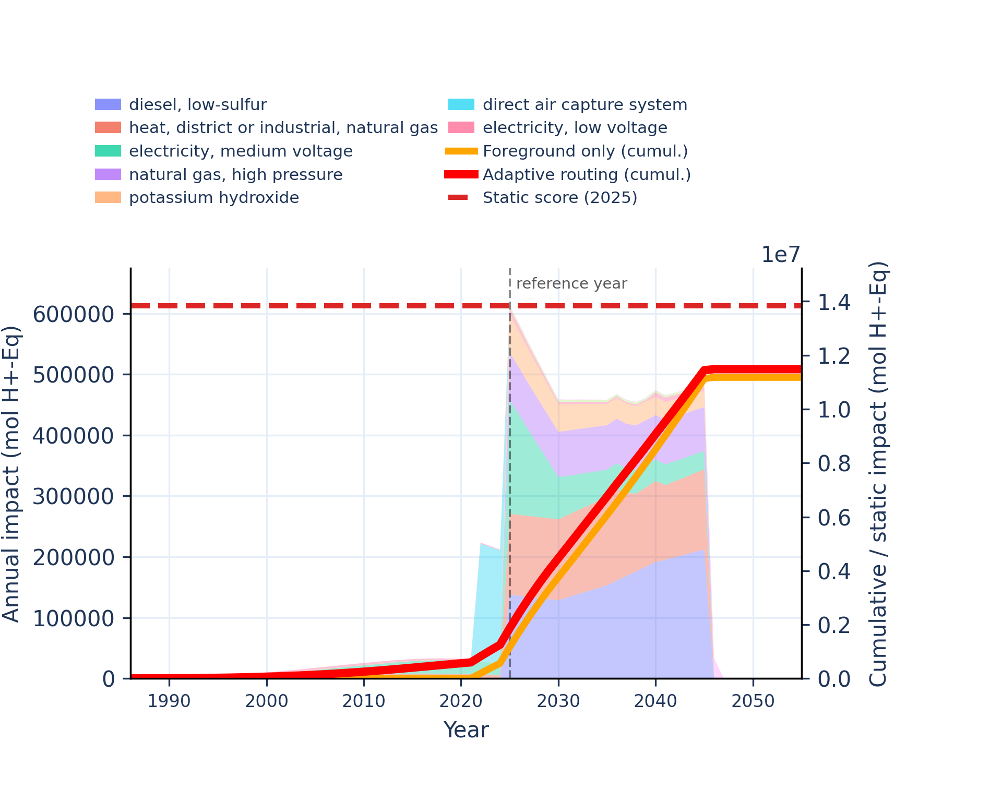
Figure S-routing-daccs-02. climate change - global warming potential (GWP100).
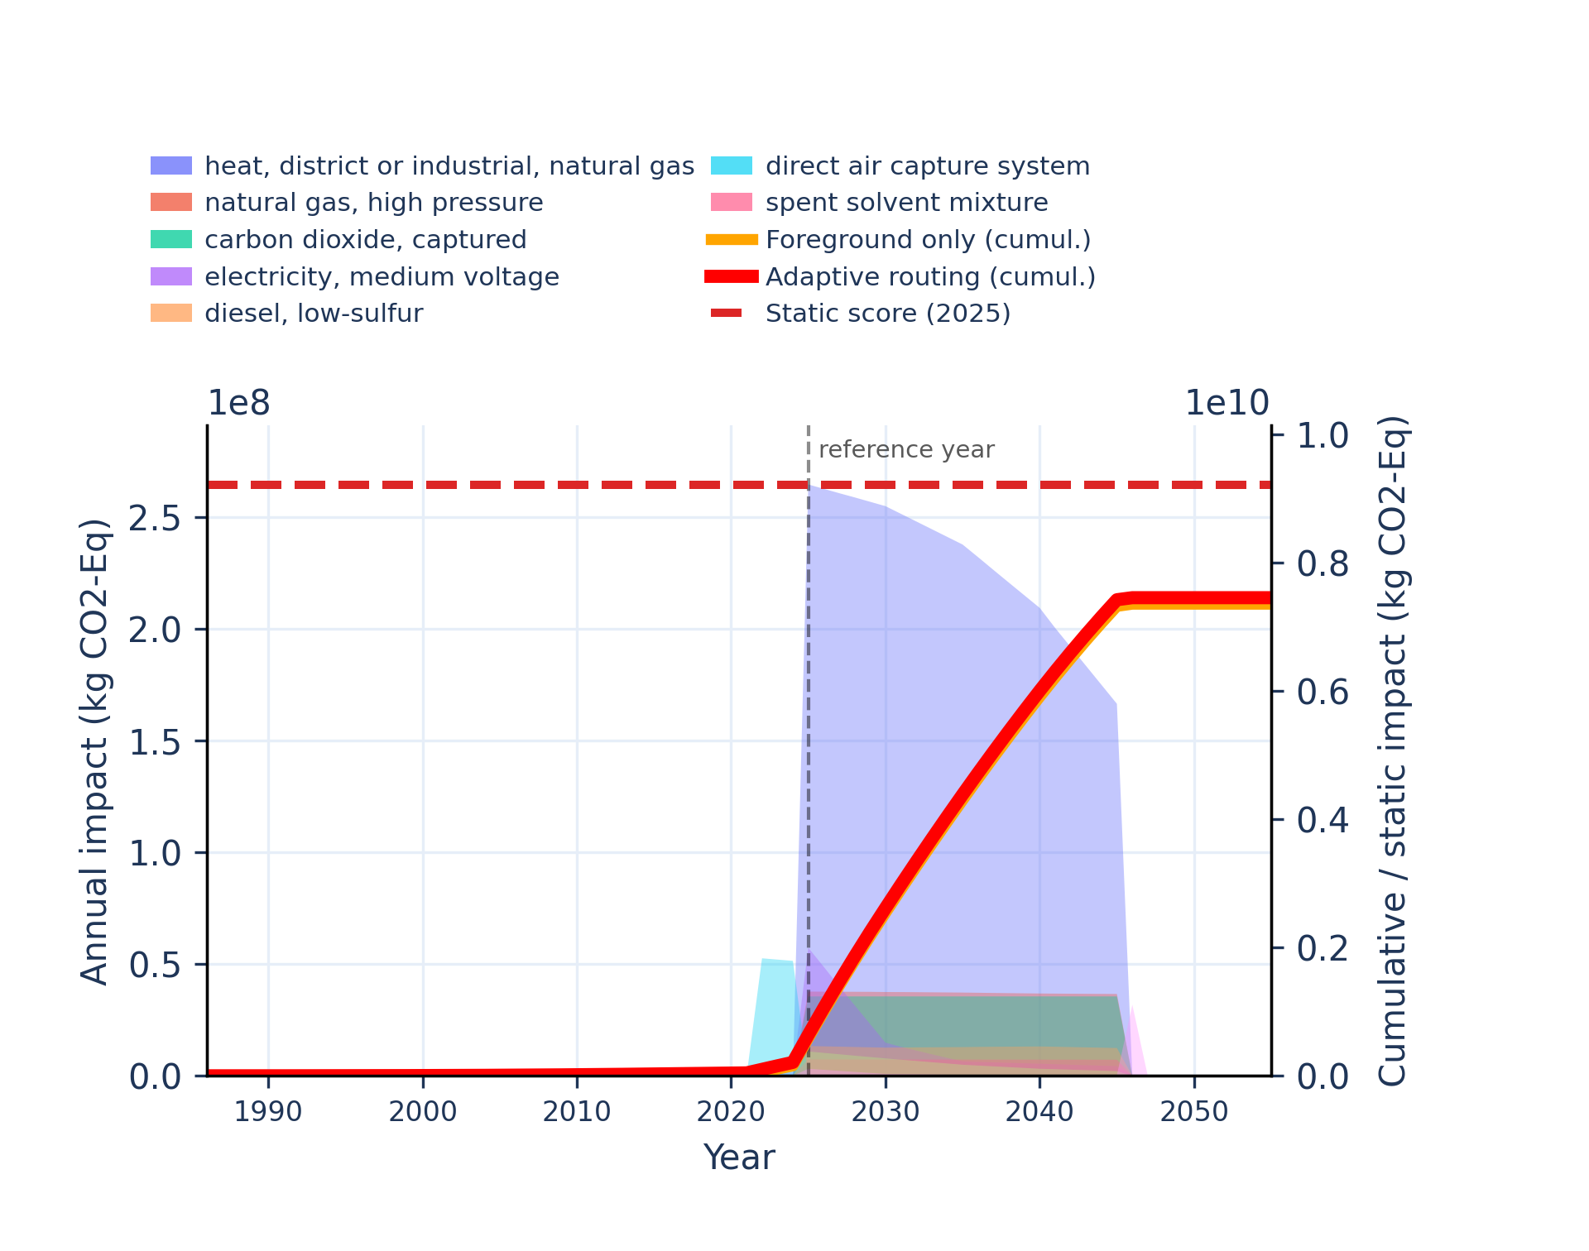 | 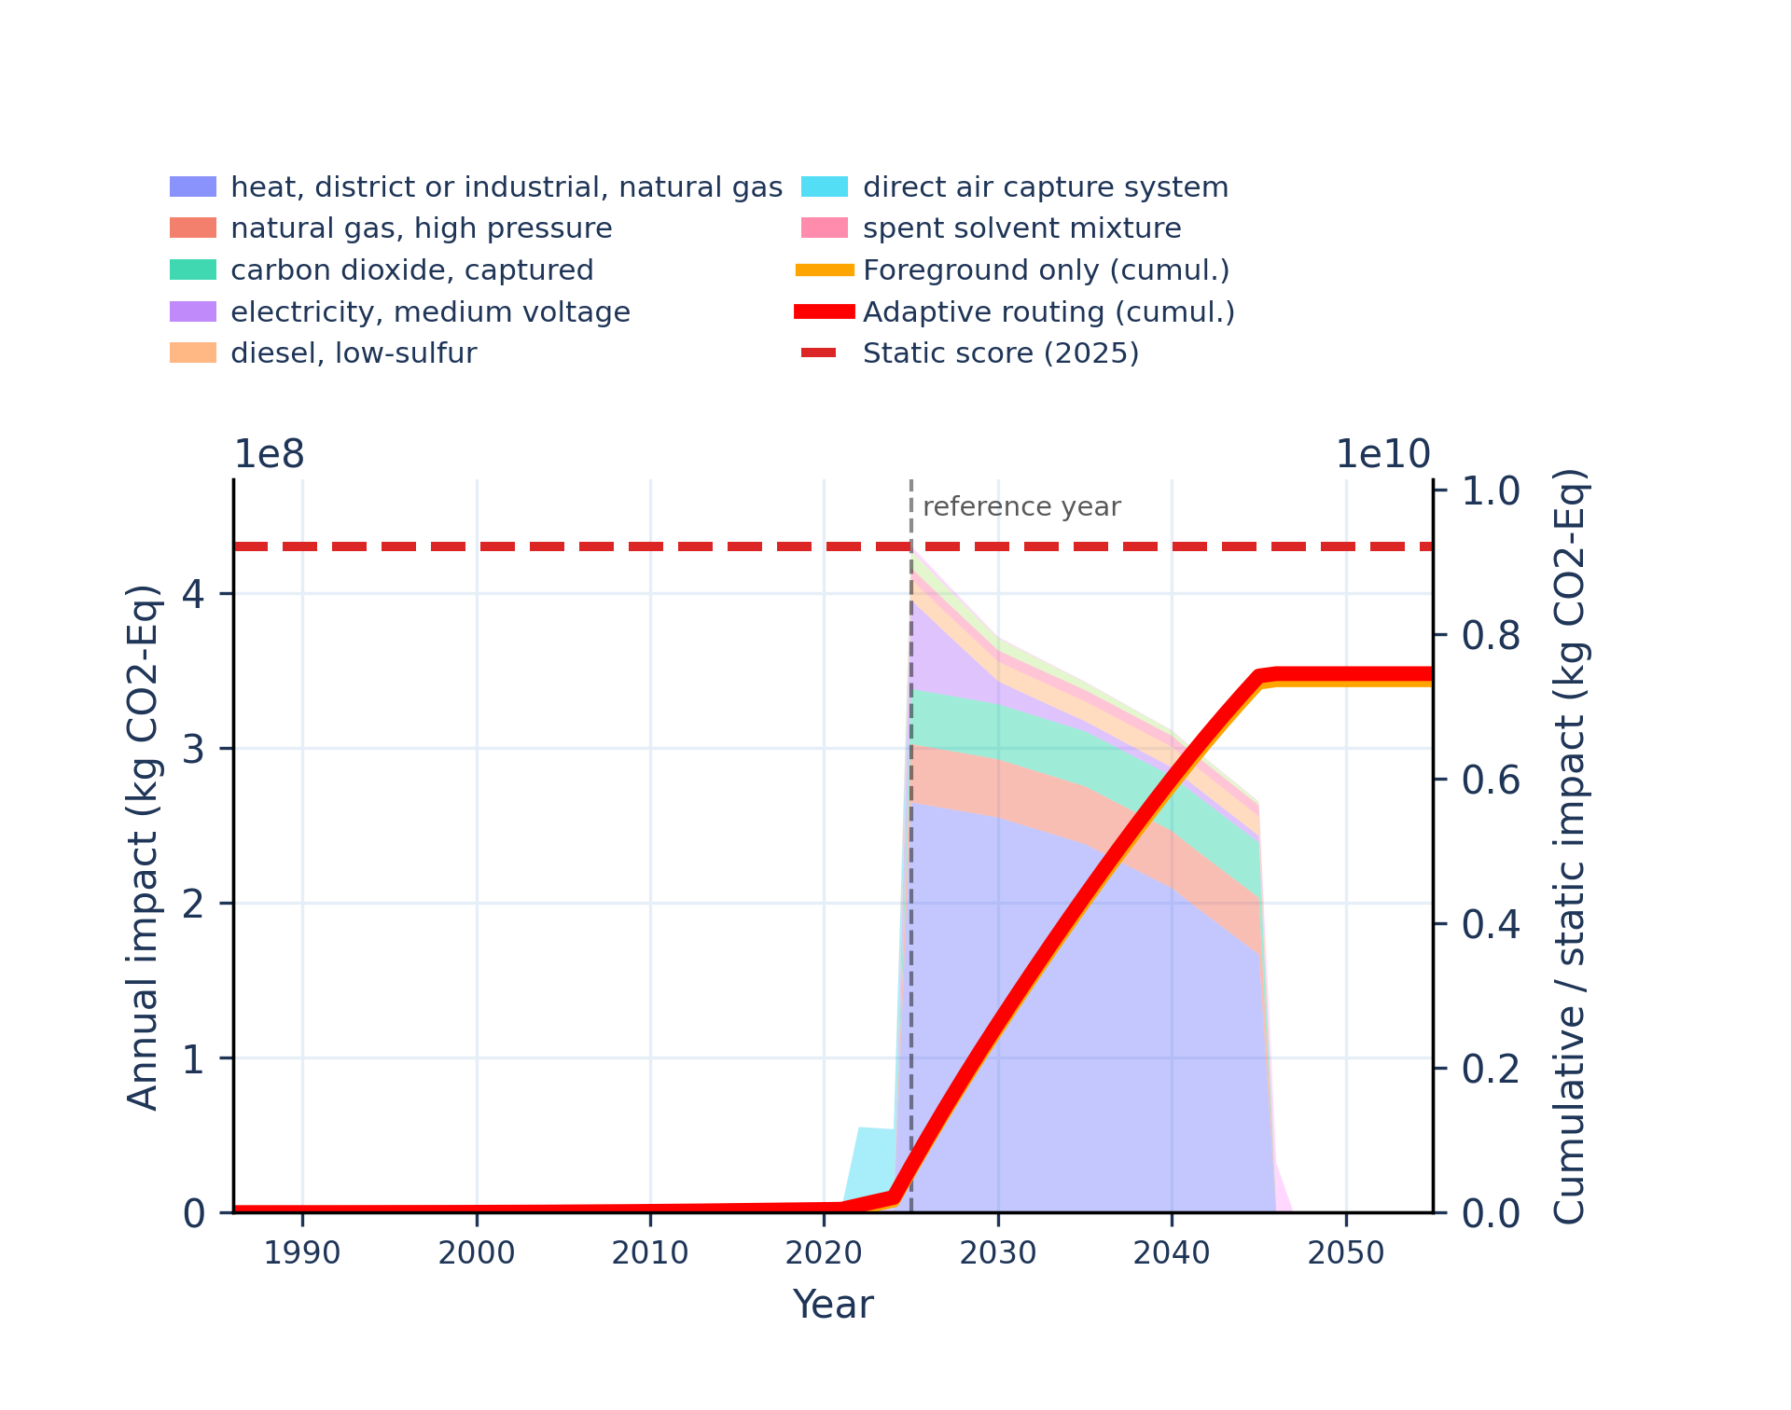
Figure S-routing-daccs-03. climate change: biogenic - global warming potential (GWP100).
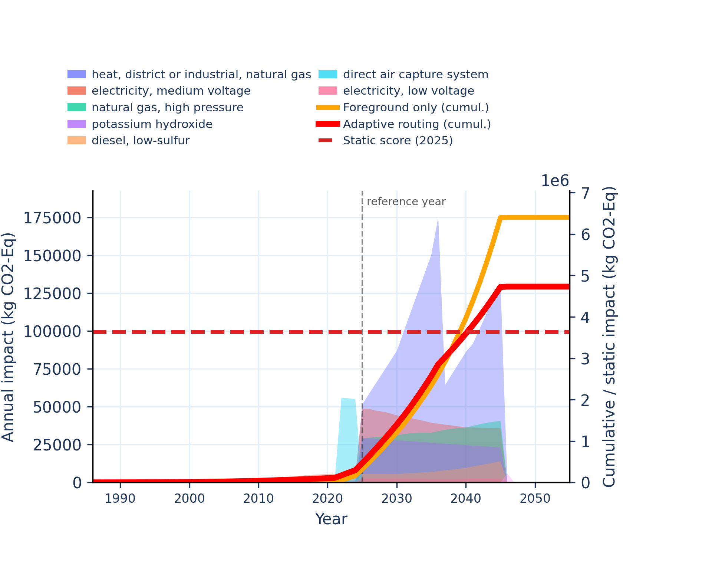 | 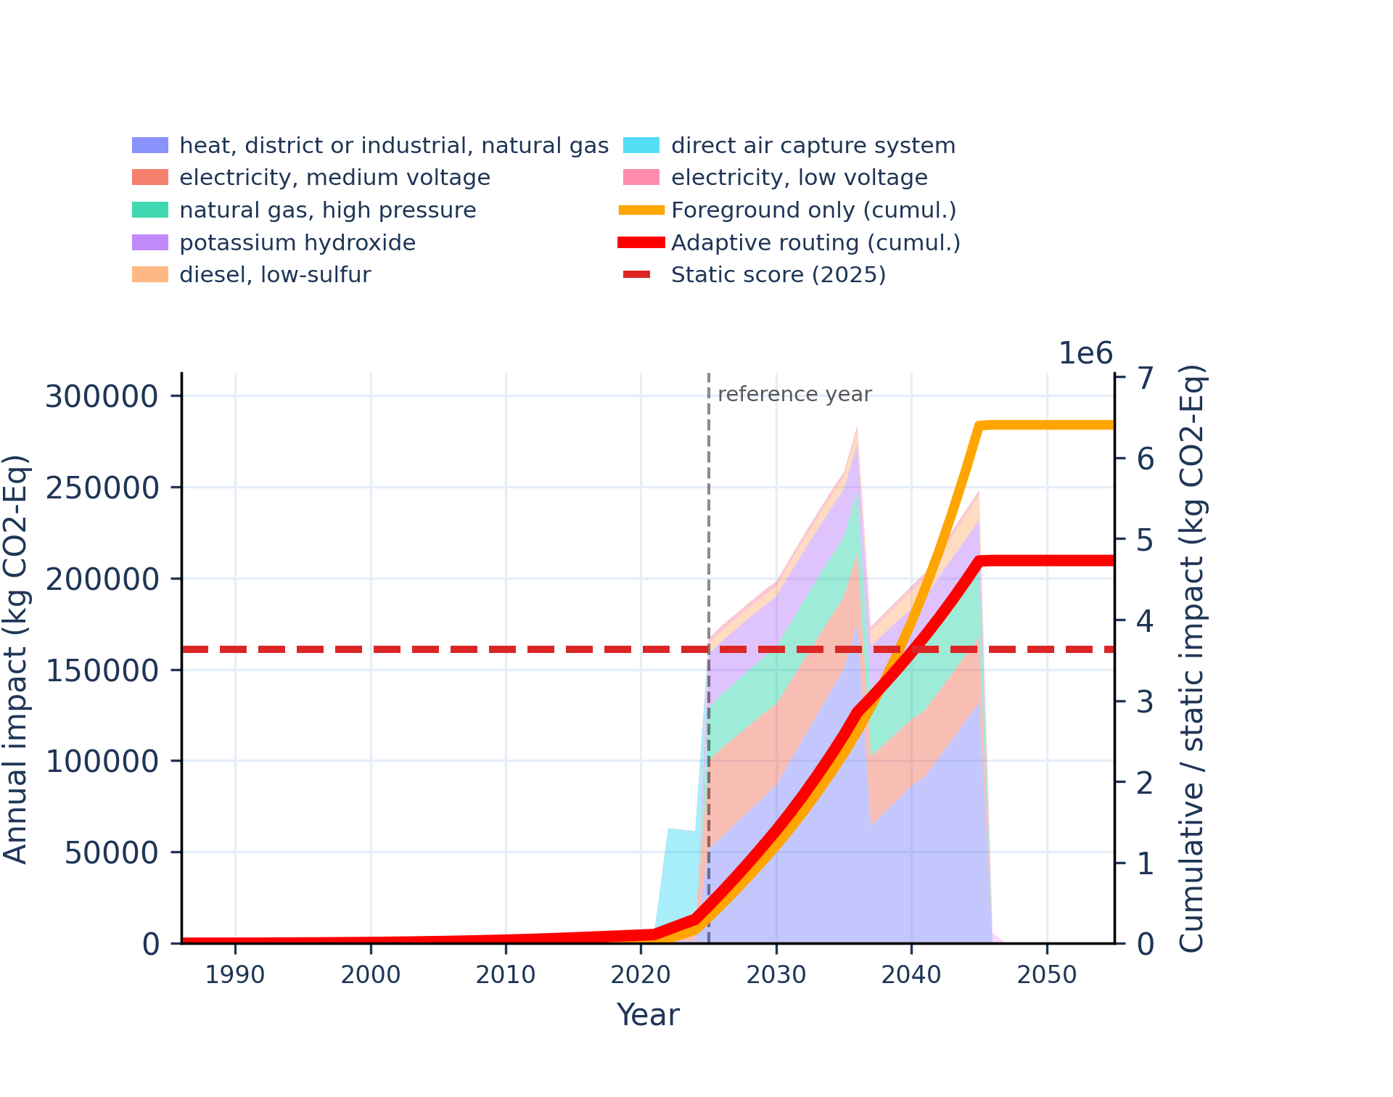
Figure S-routing-daccs-04. climate change: fossil - global warming potential (GWP100).
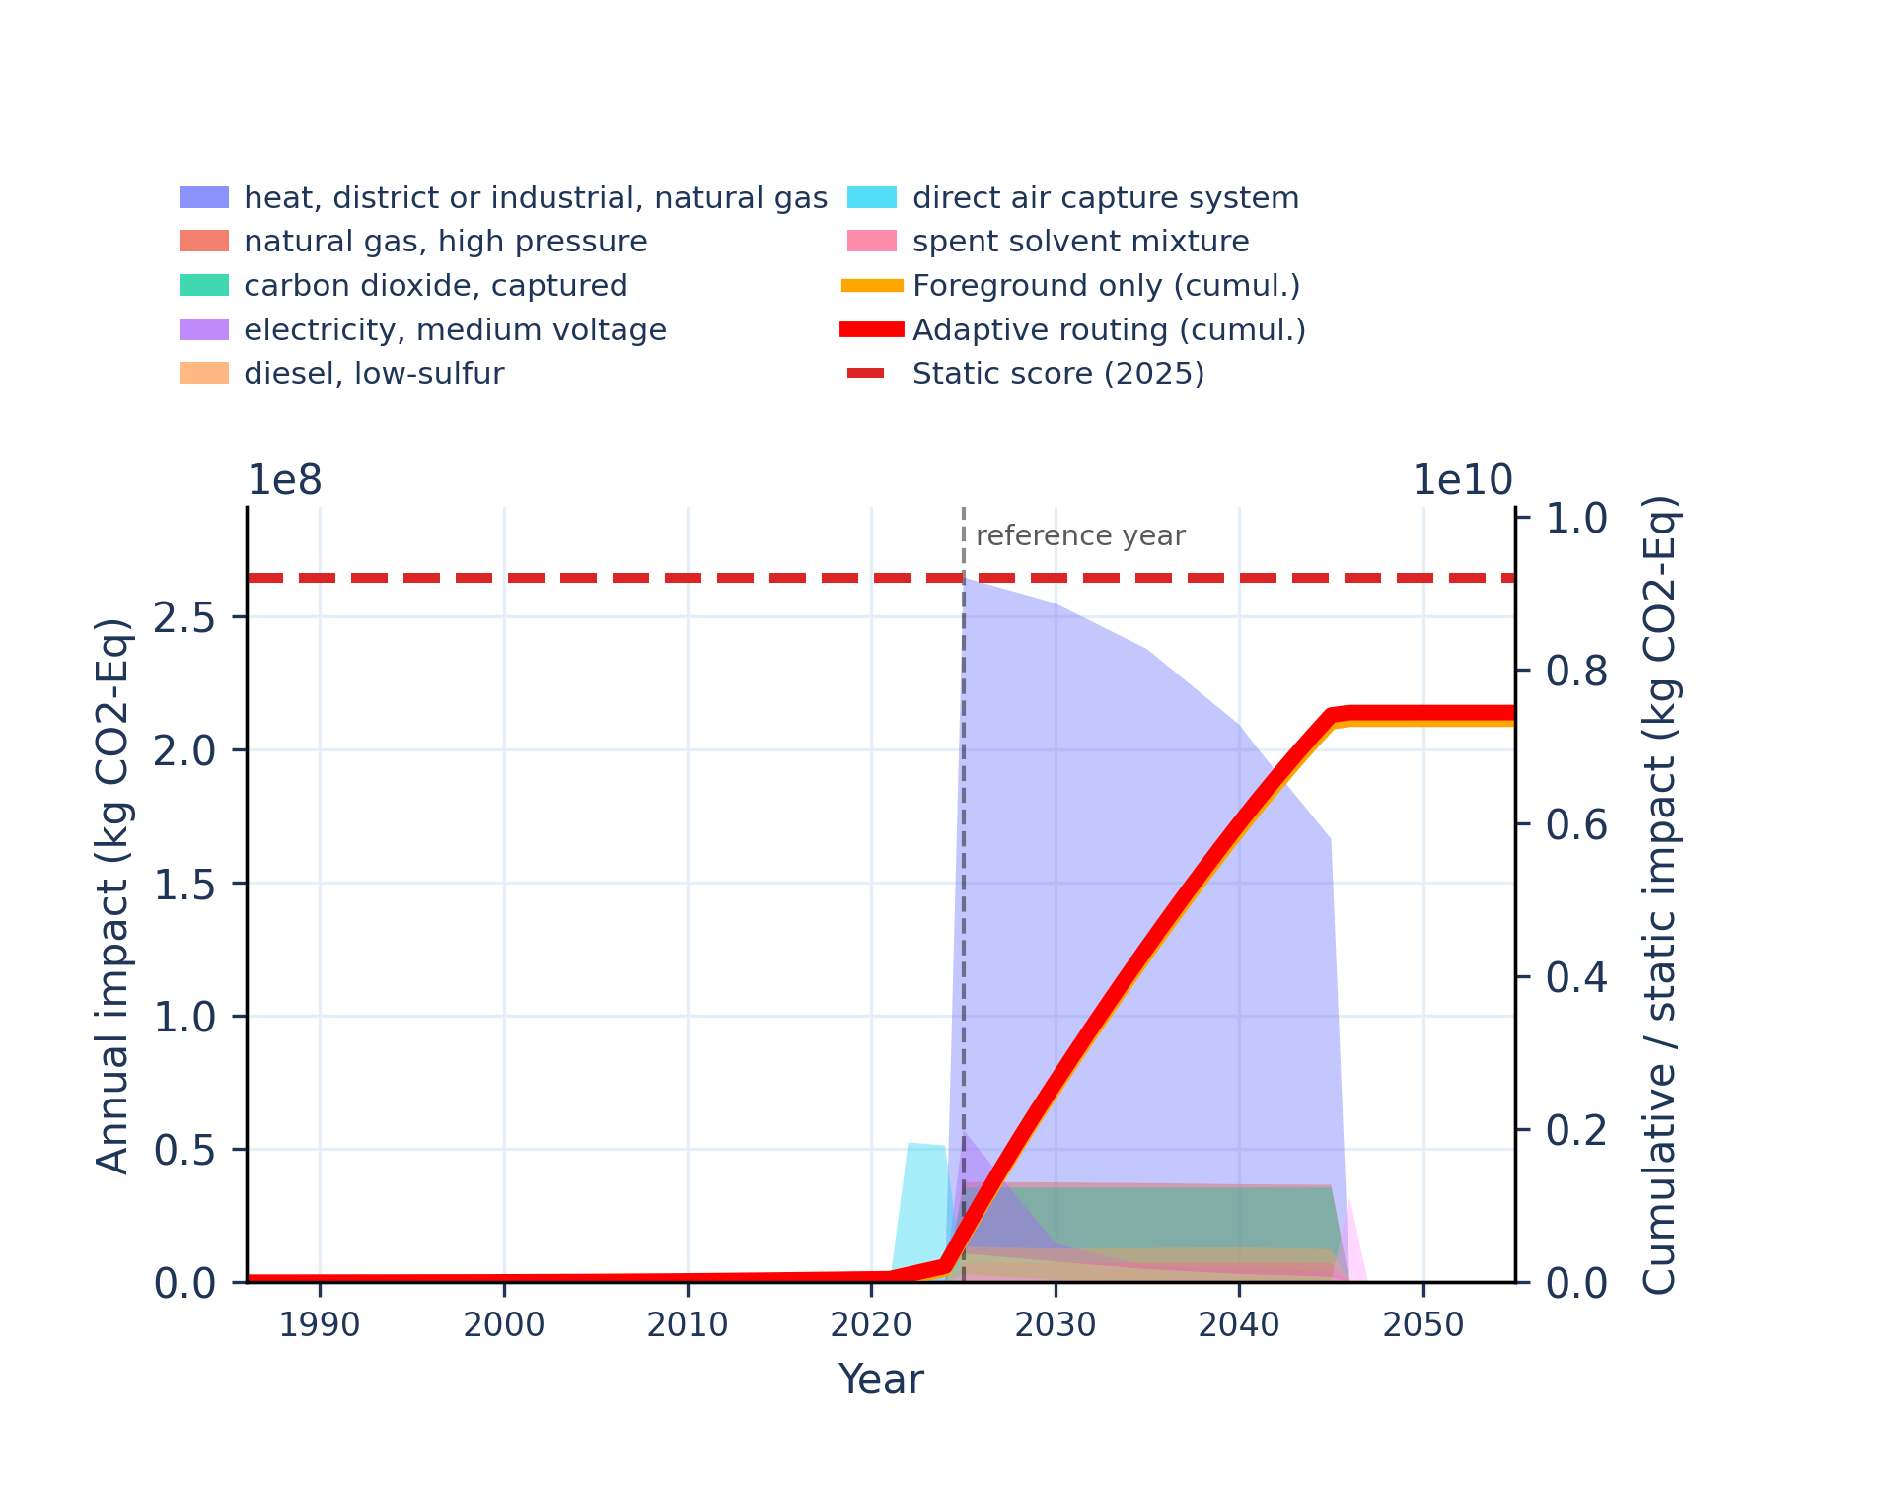 | 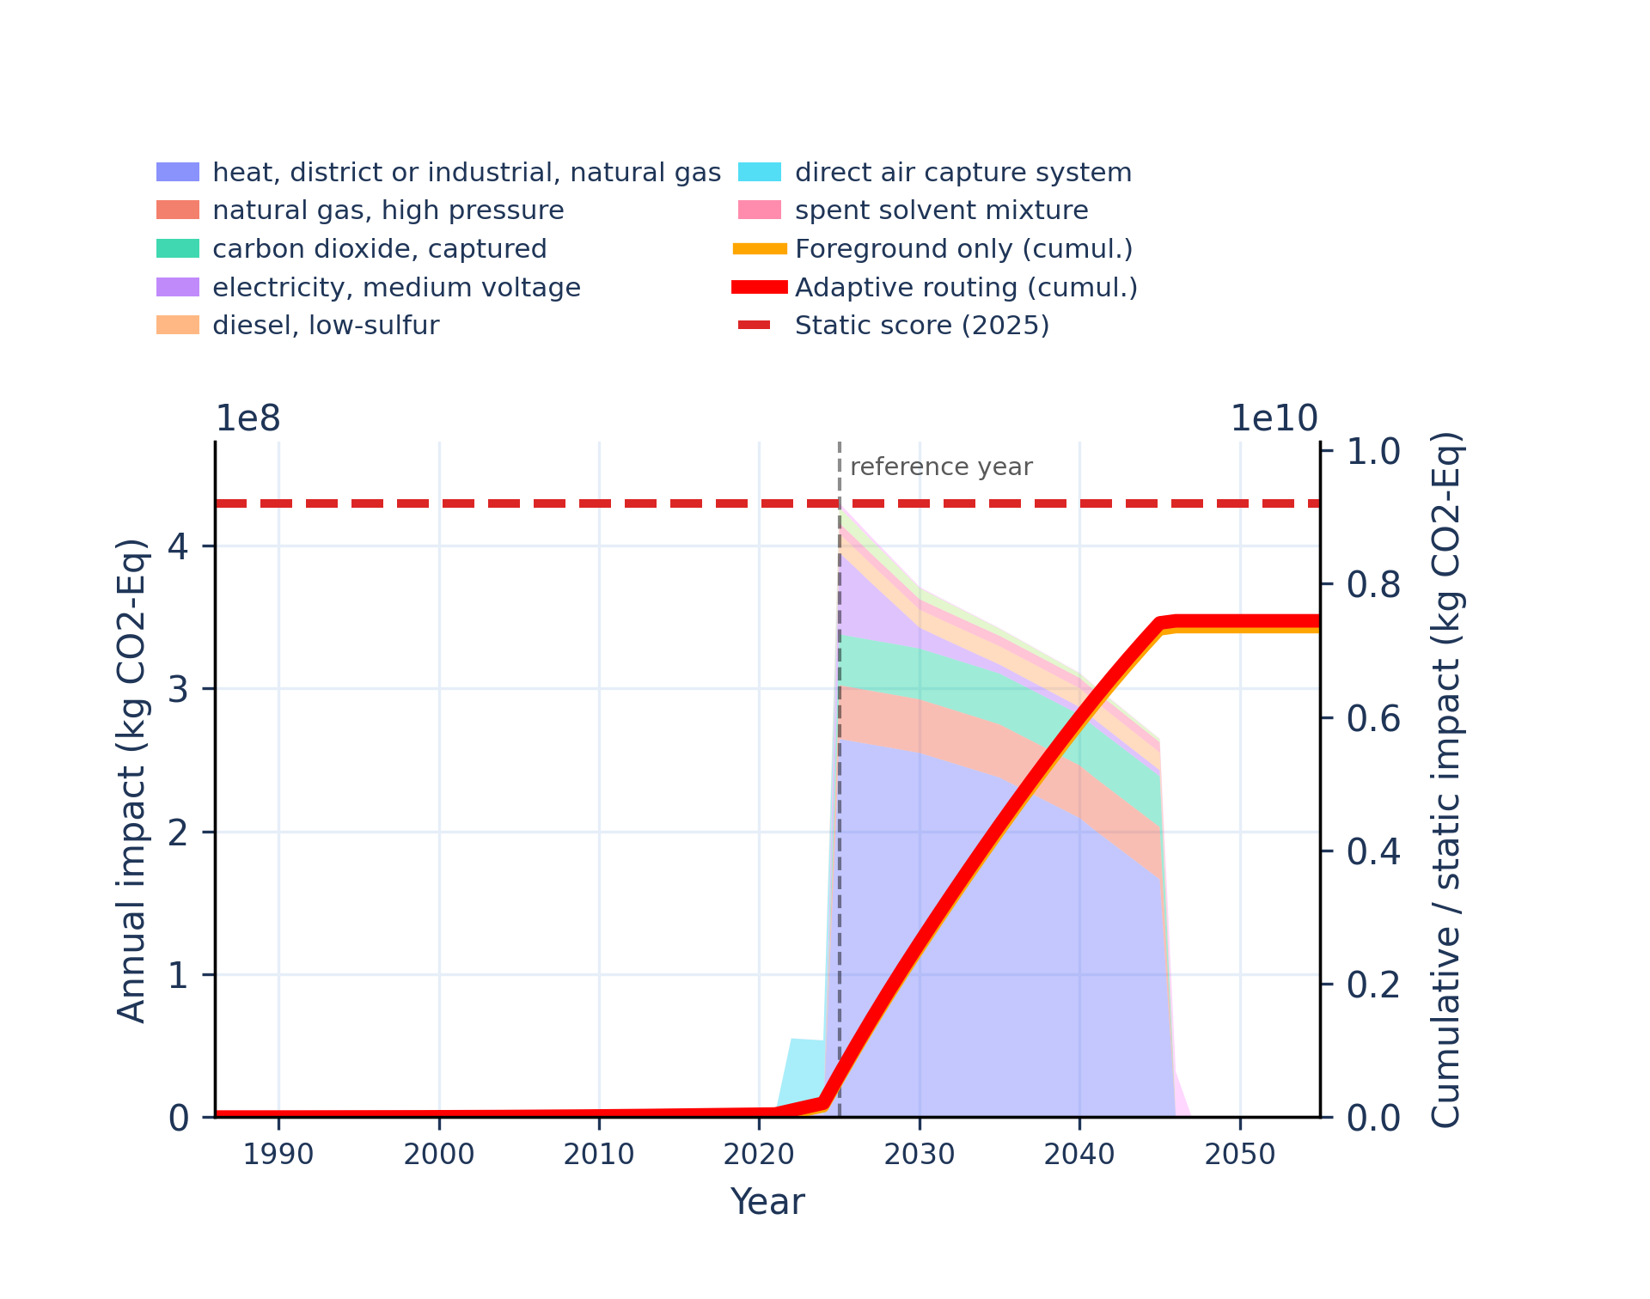
Figure S-routing-daccs-05. climate change: land use and land use change - global warming potential (GWP100).
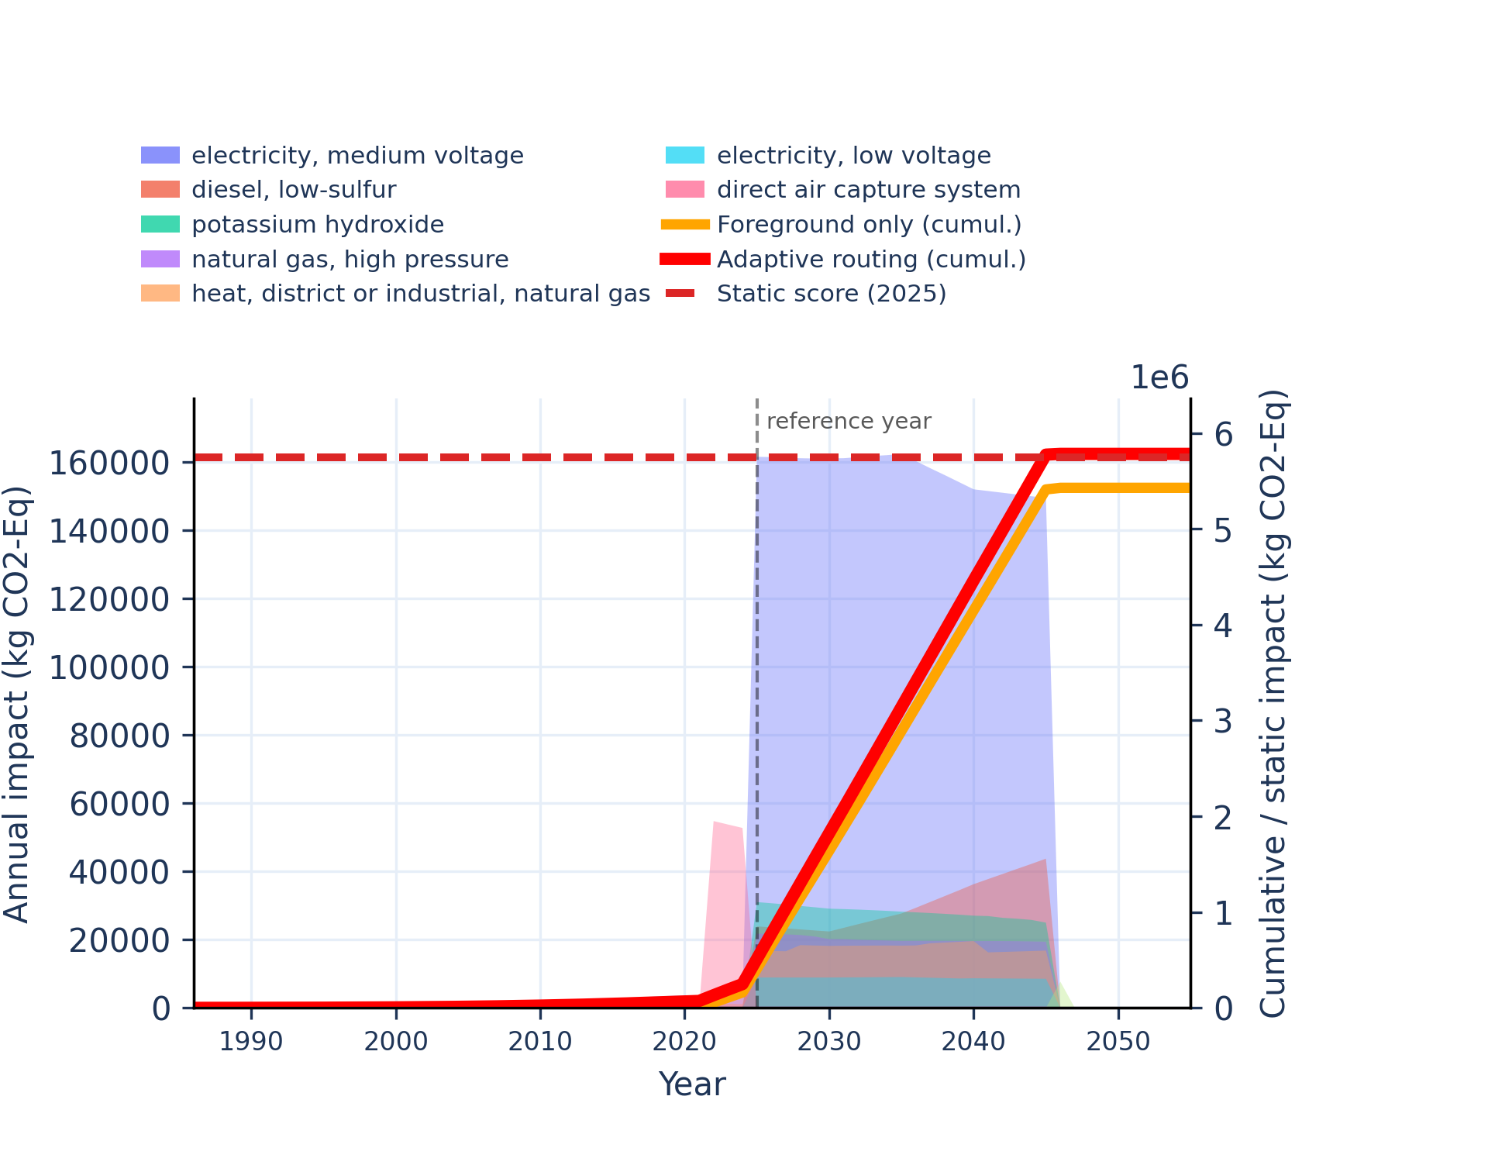 | 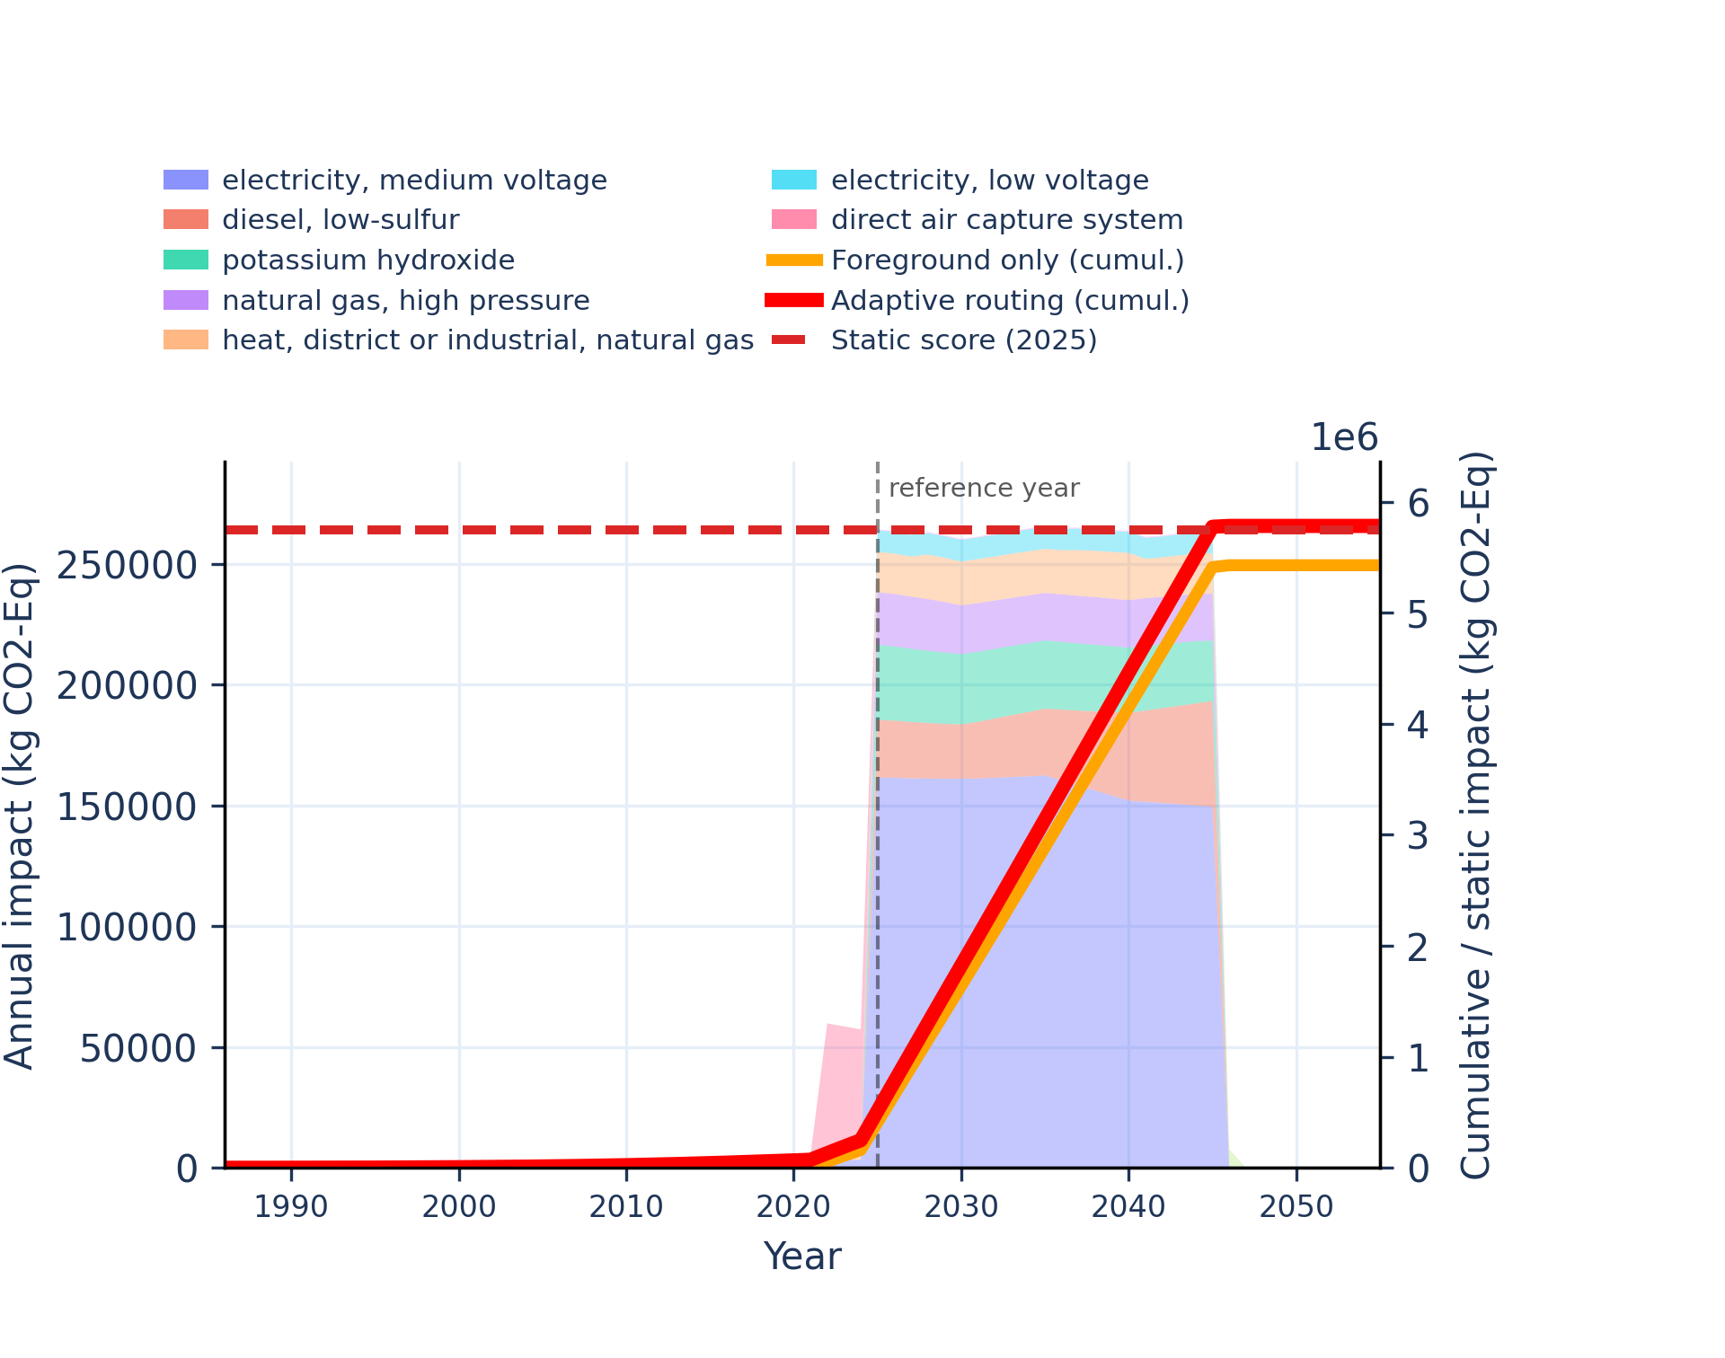
Figure S-routing-daccs-06. ecotoxicity: freshwater - comparative toxic unit for ecosystems (CTUe).
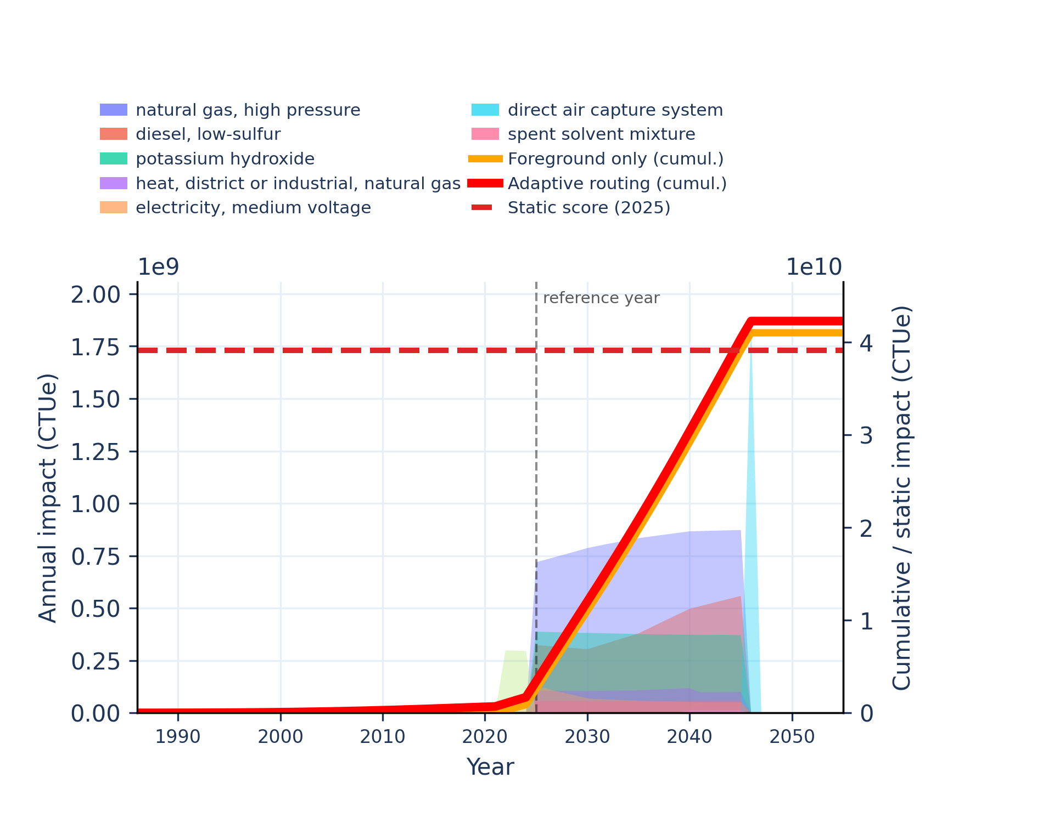 | 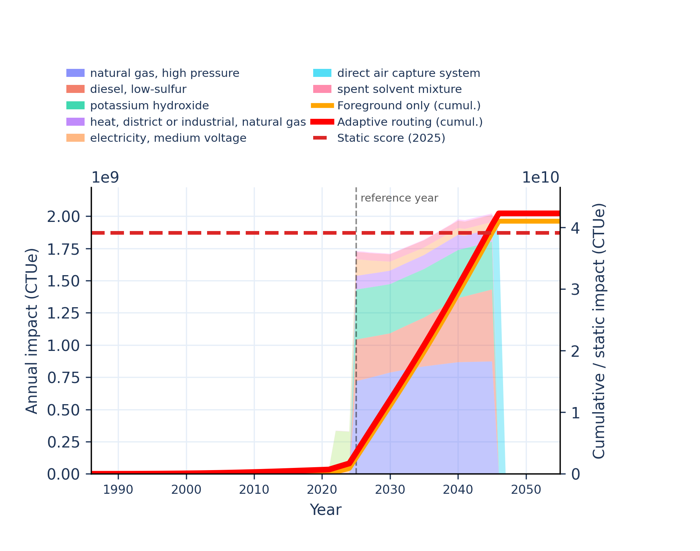
Figure S-routing-daccs-07. ecotoxicity: freshwater, inorganics - comparative toxic unit for ecosystems (CTUe).
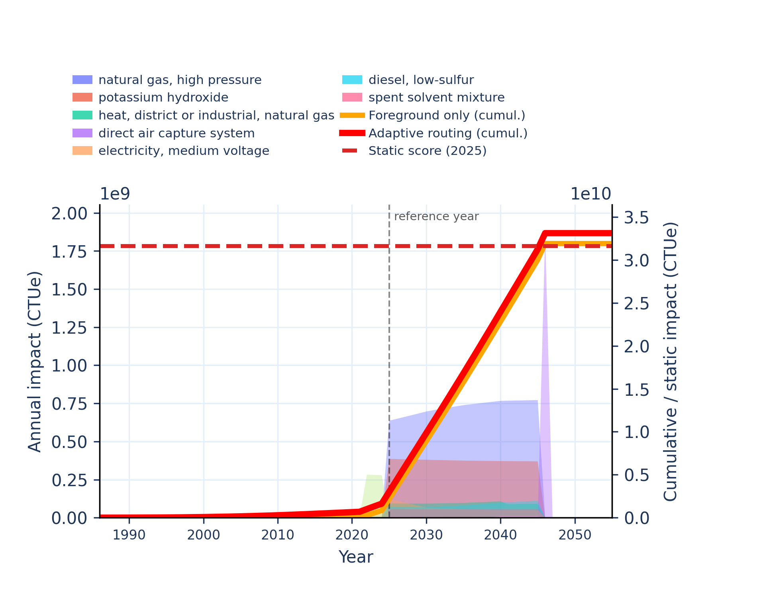 | 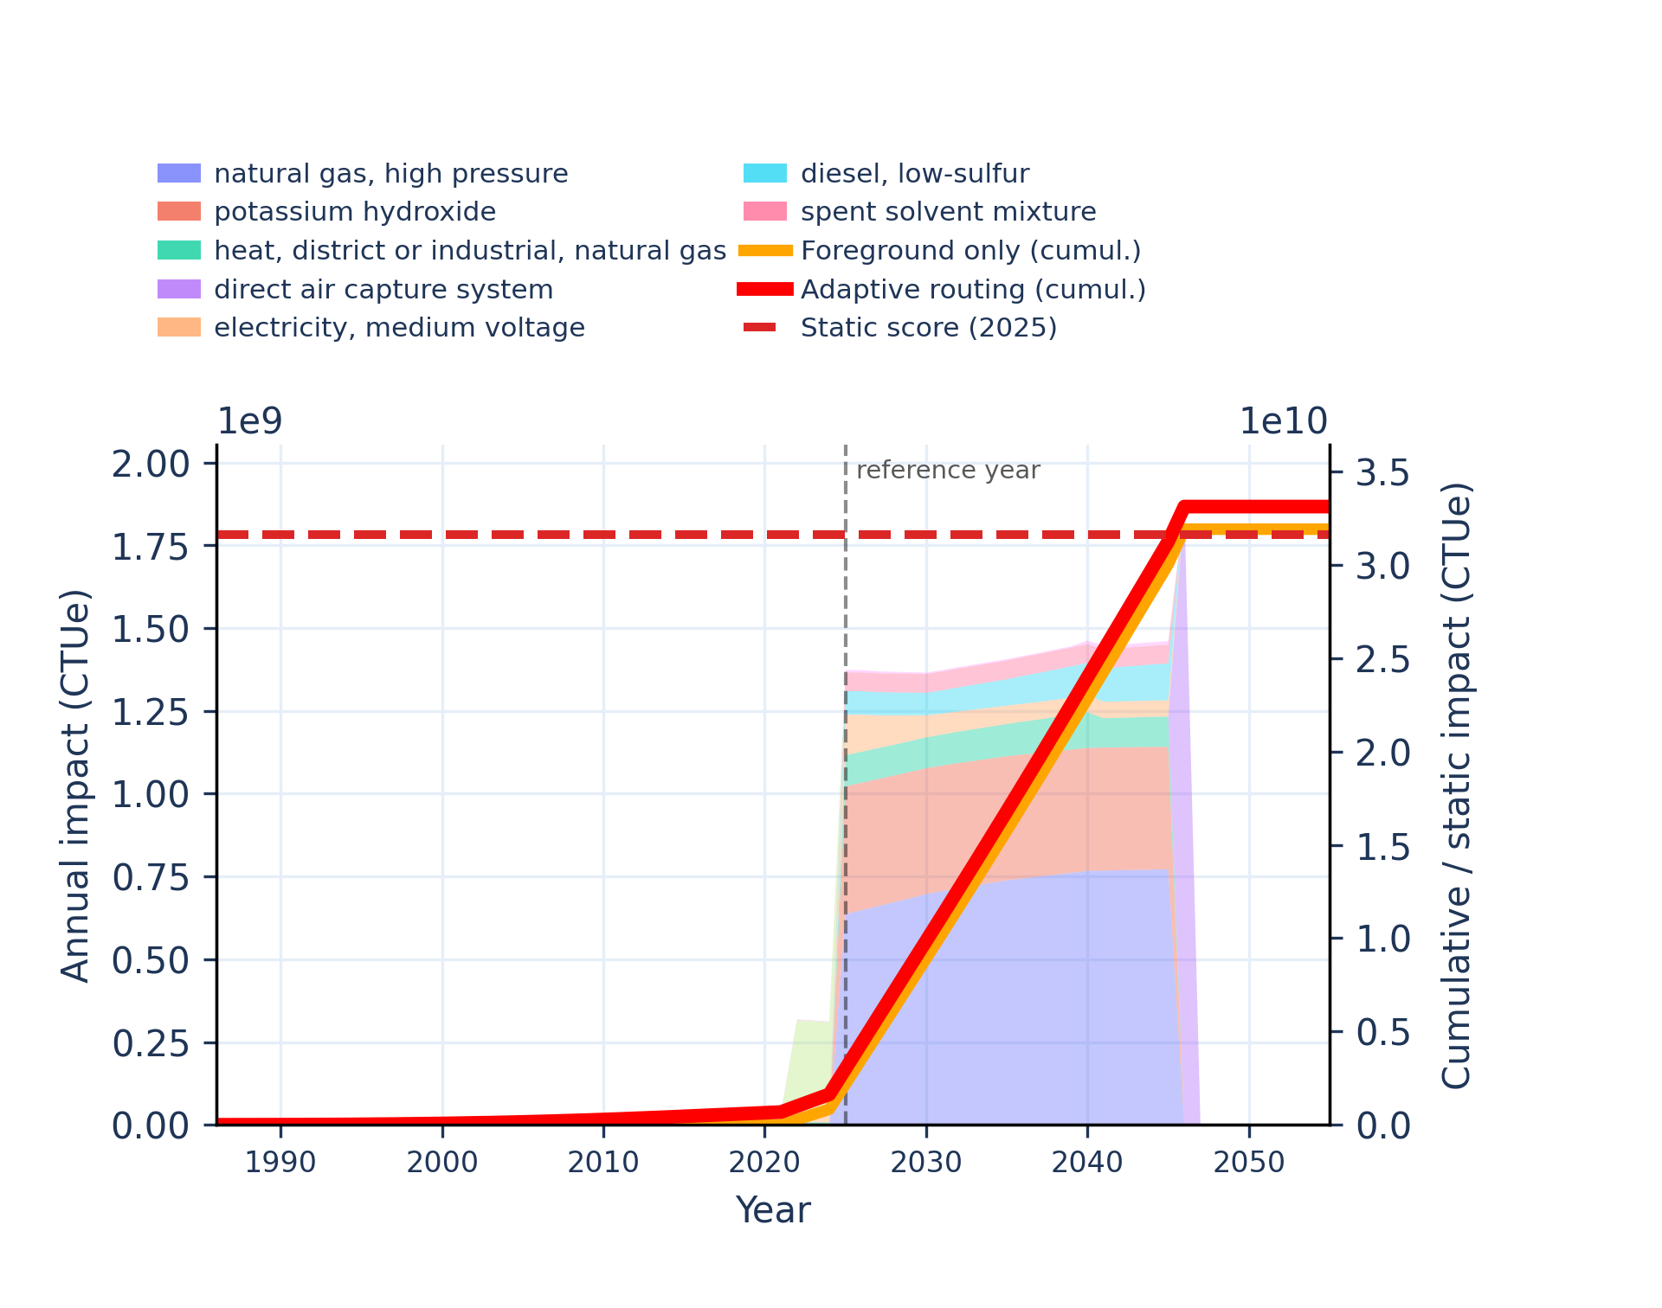
Figure S-routing-daccs-08. ecotoxicity: freshwater, organics - comparative toxic unit for ecosystems (CTUe).
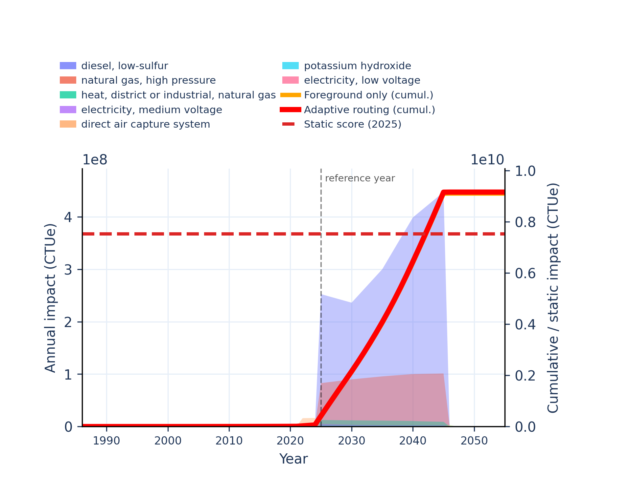 | 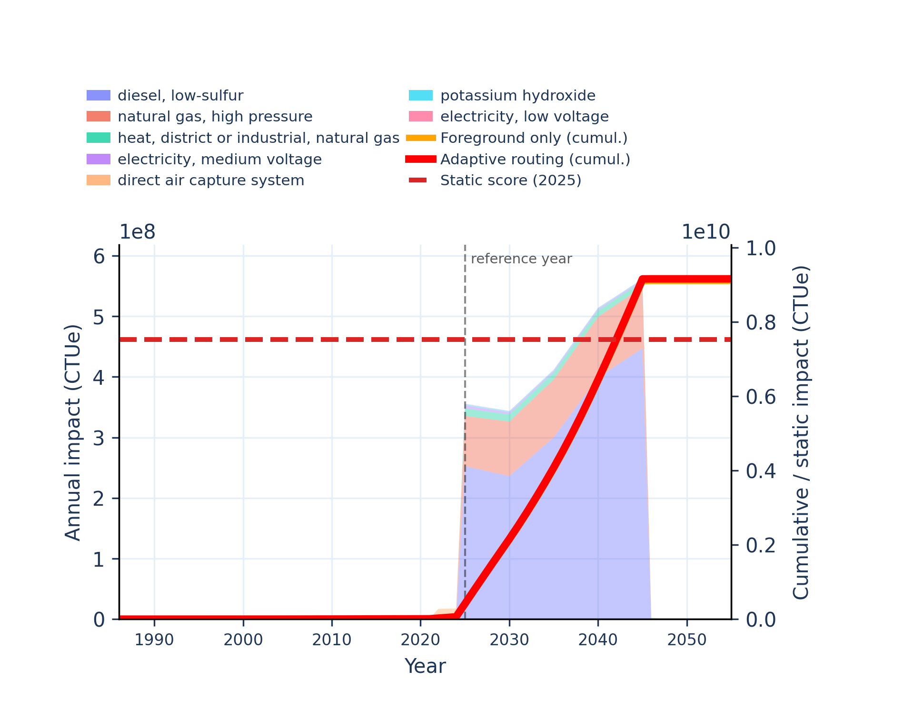
Figure S-routing-daccs-09. energy resources: non-renewable - abiotic depletion potential (ADP): fossil fuels.
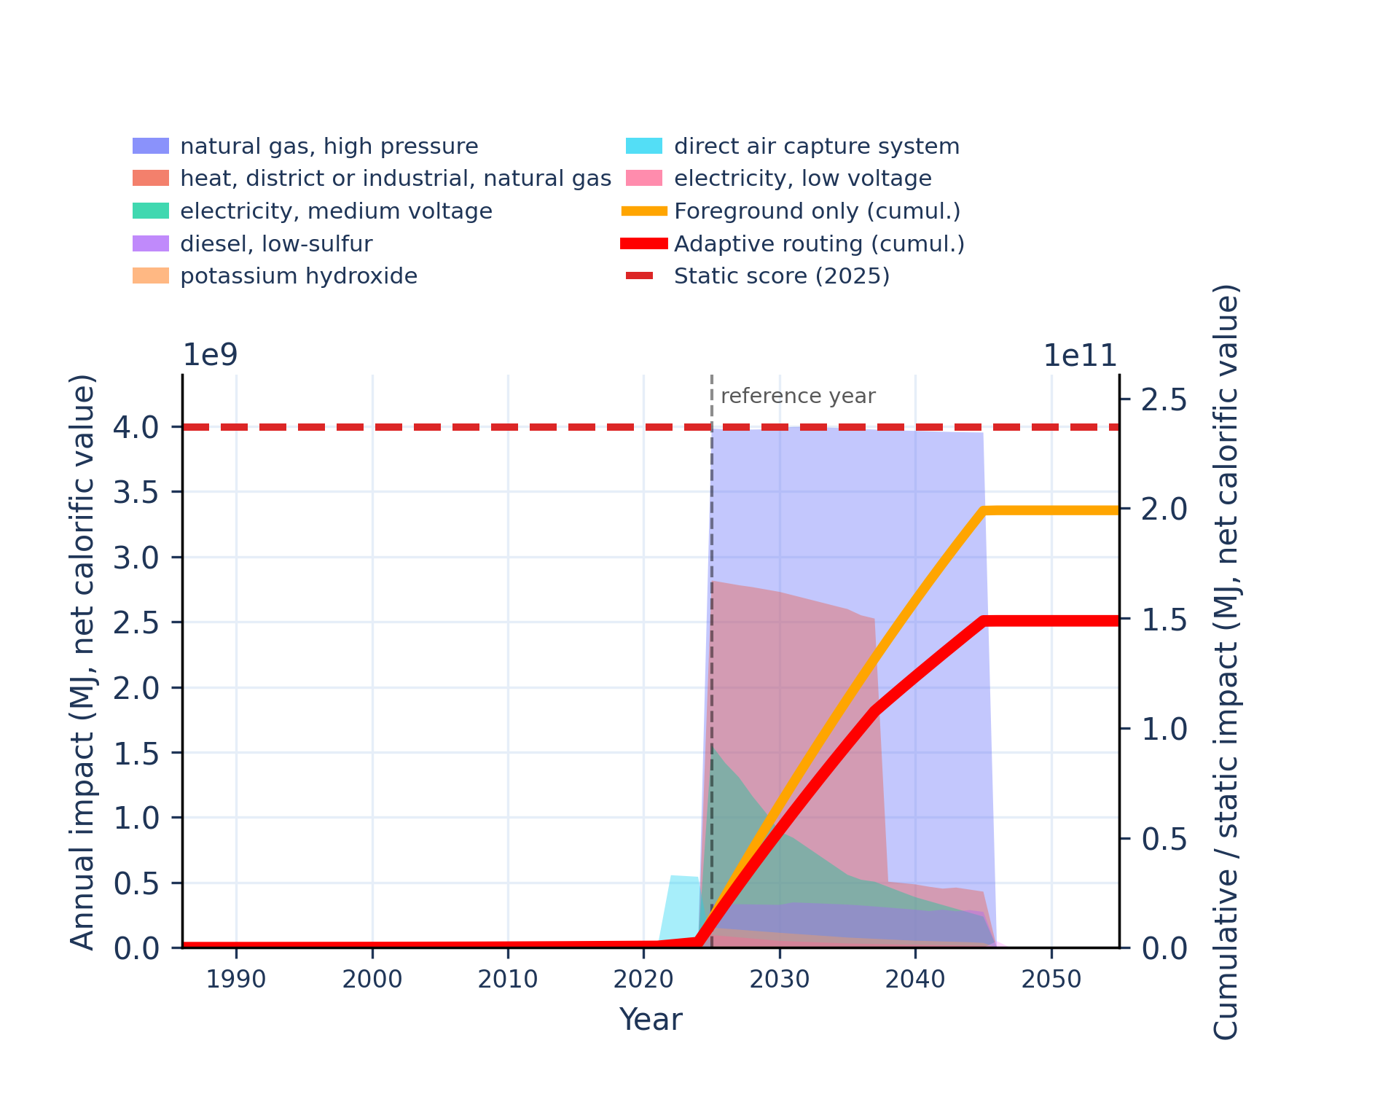 | 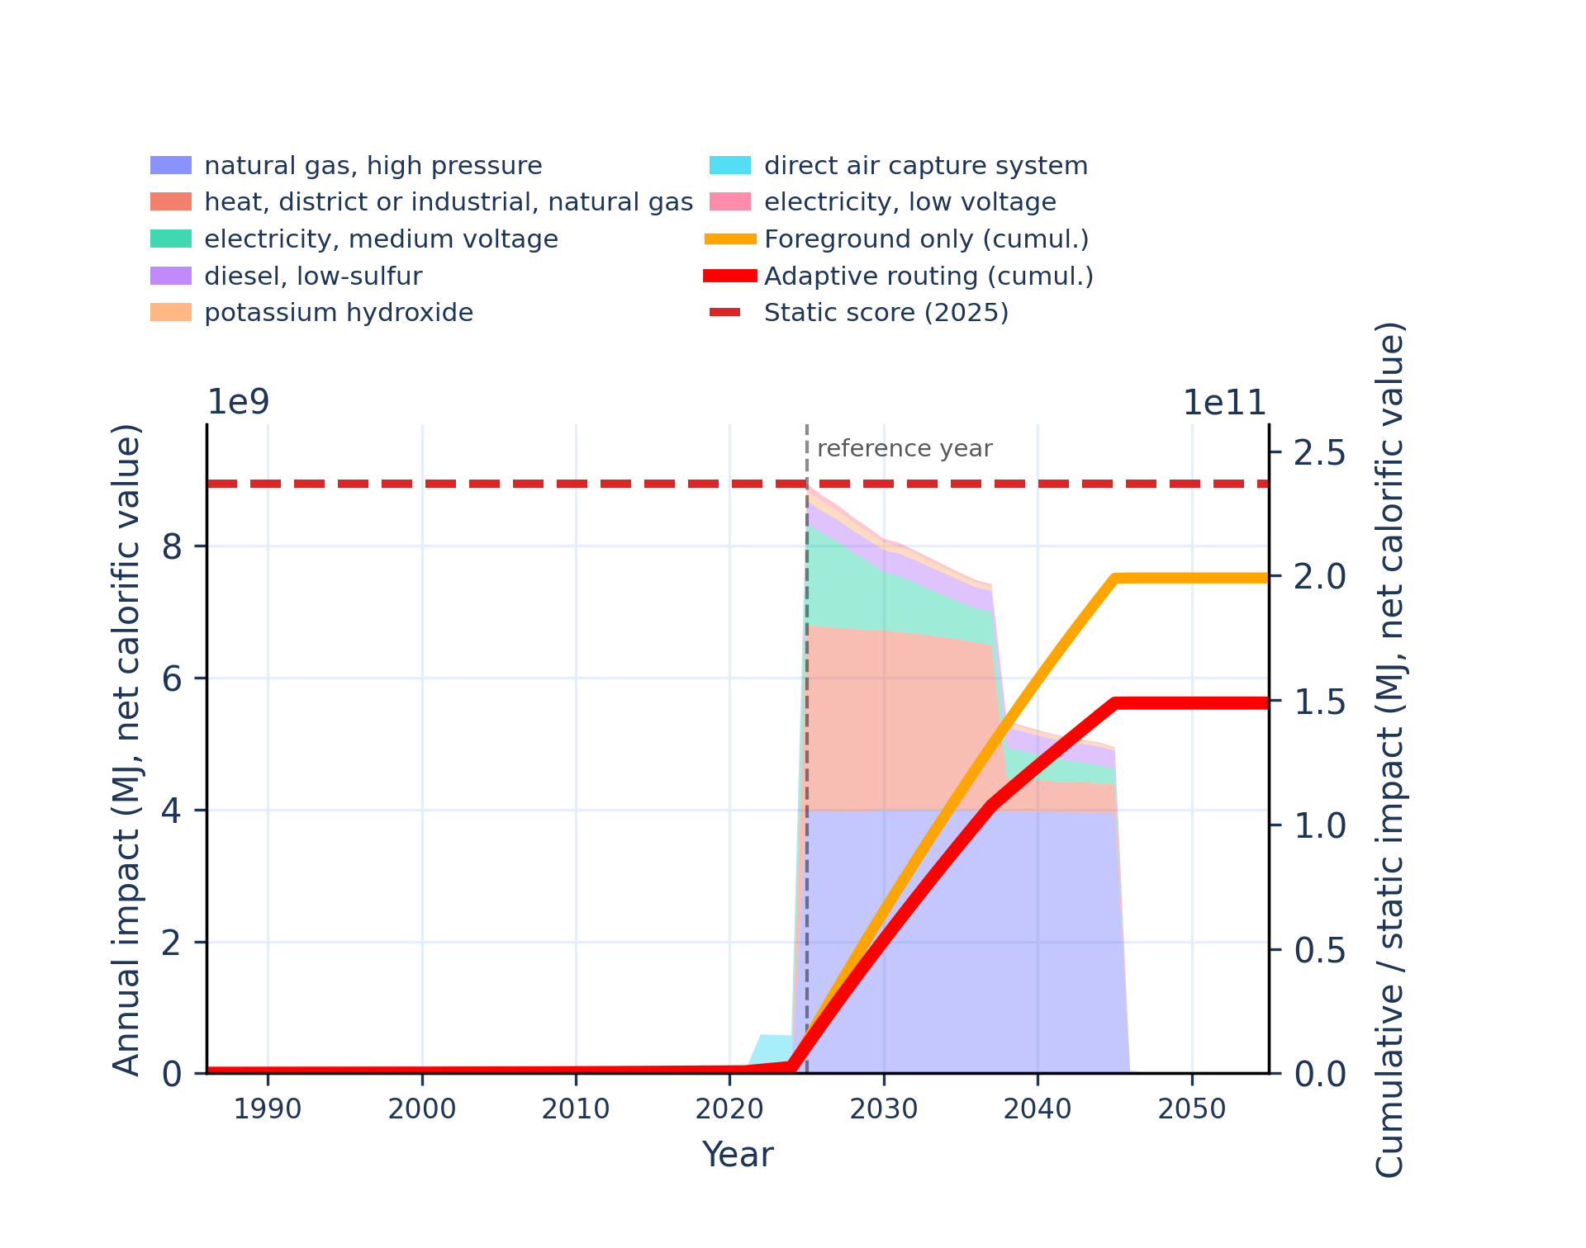
Figure S-routing-daccs-10. eutrophication: freshwater - fraction of nutrients reaching freshwater end compartment (P).
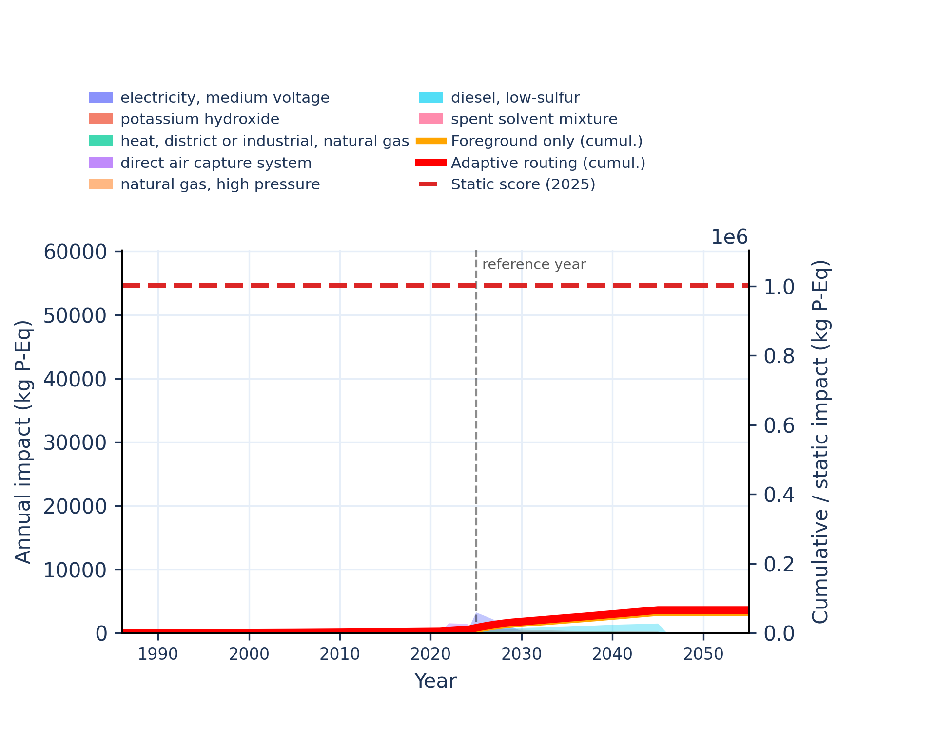 | 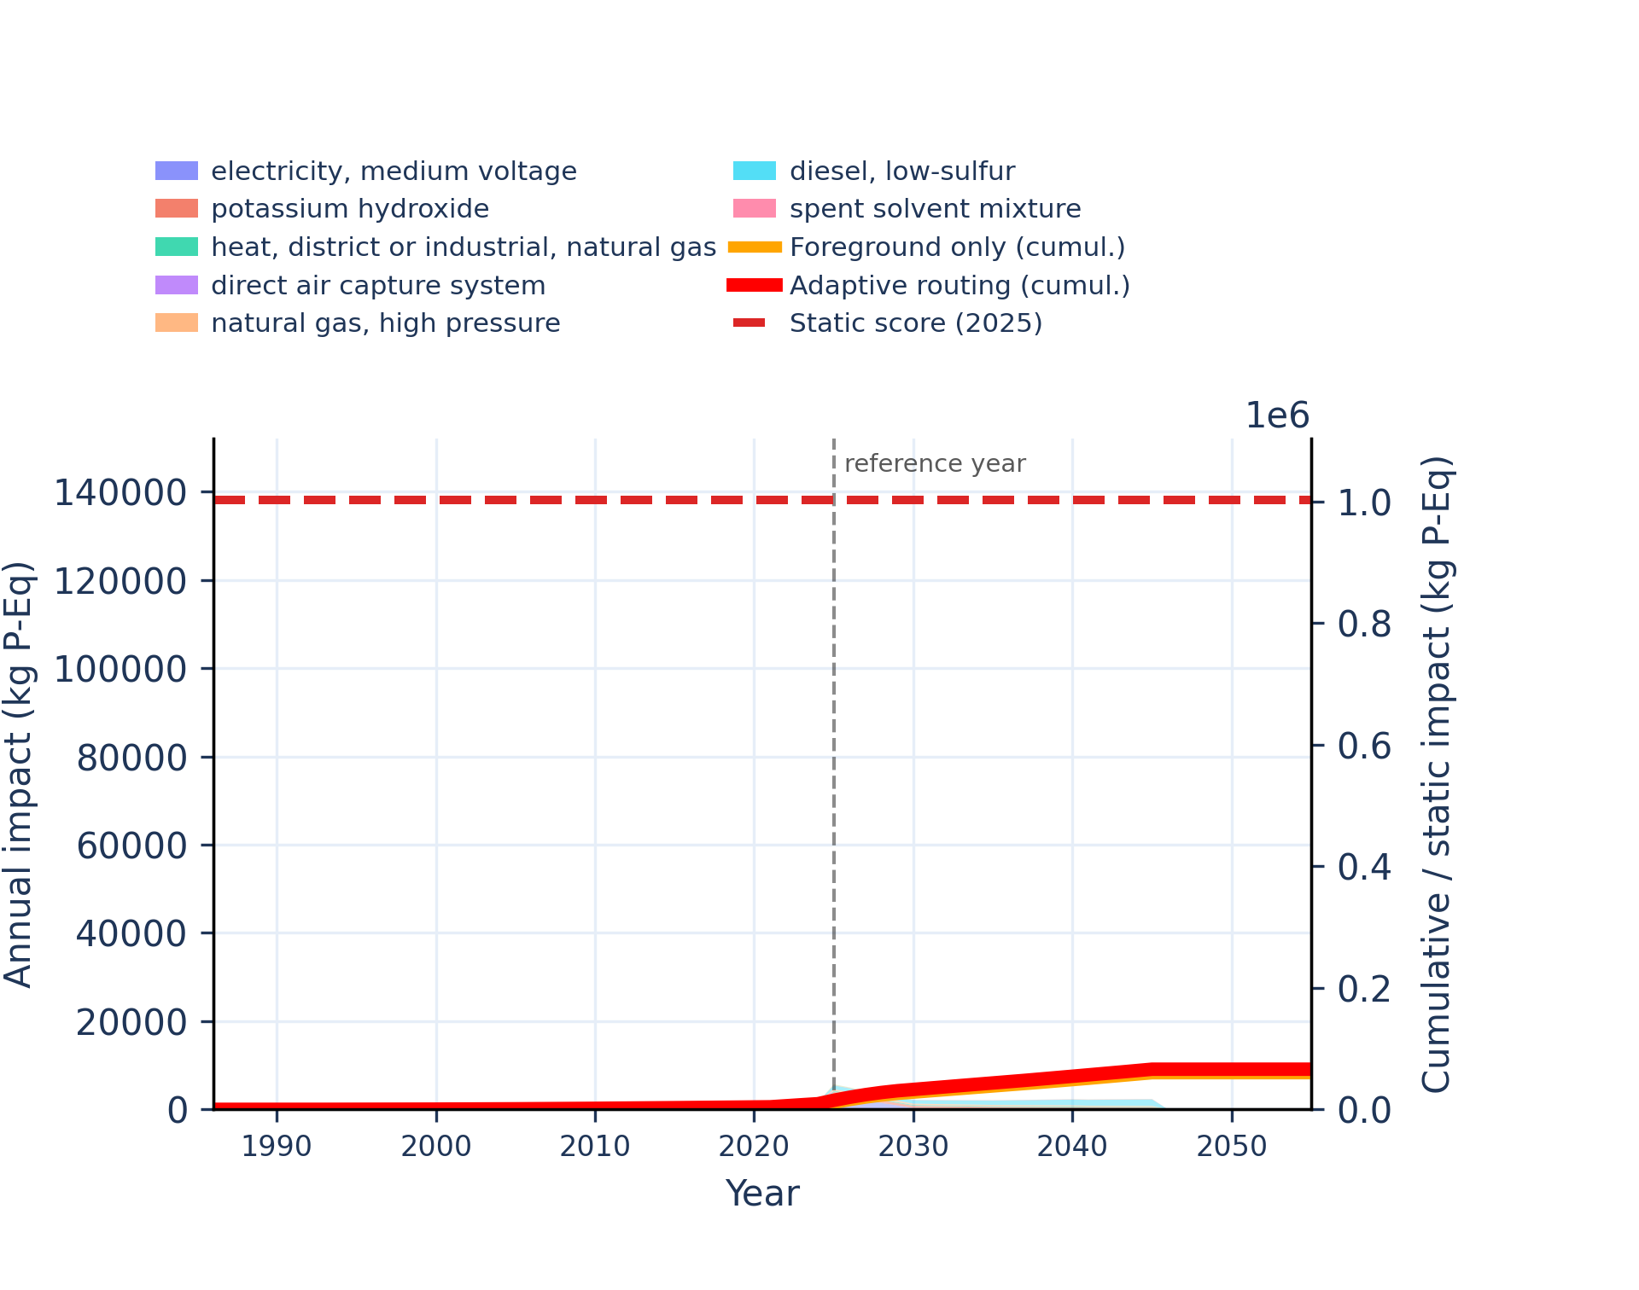
Figure S-routing-daccs-11. eutrophication: marine - fraction of nutrients reaching marine end compartment (N).
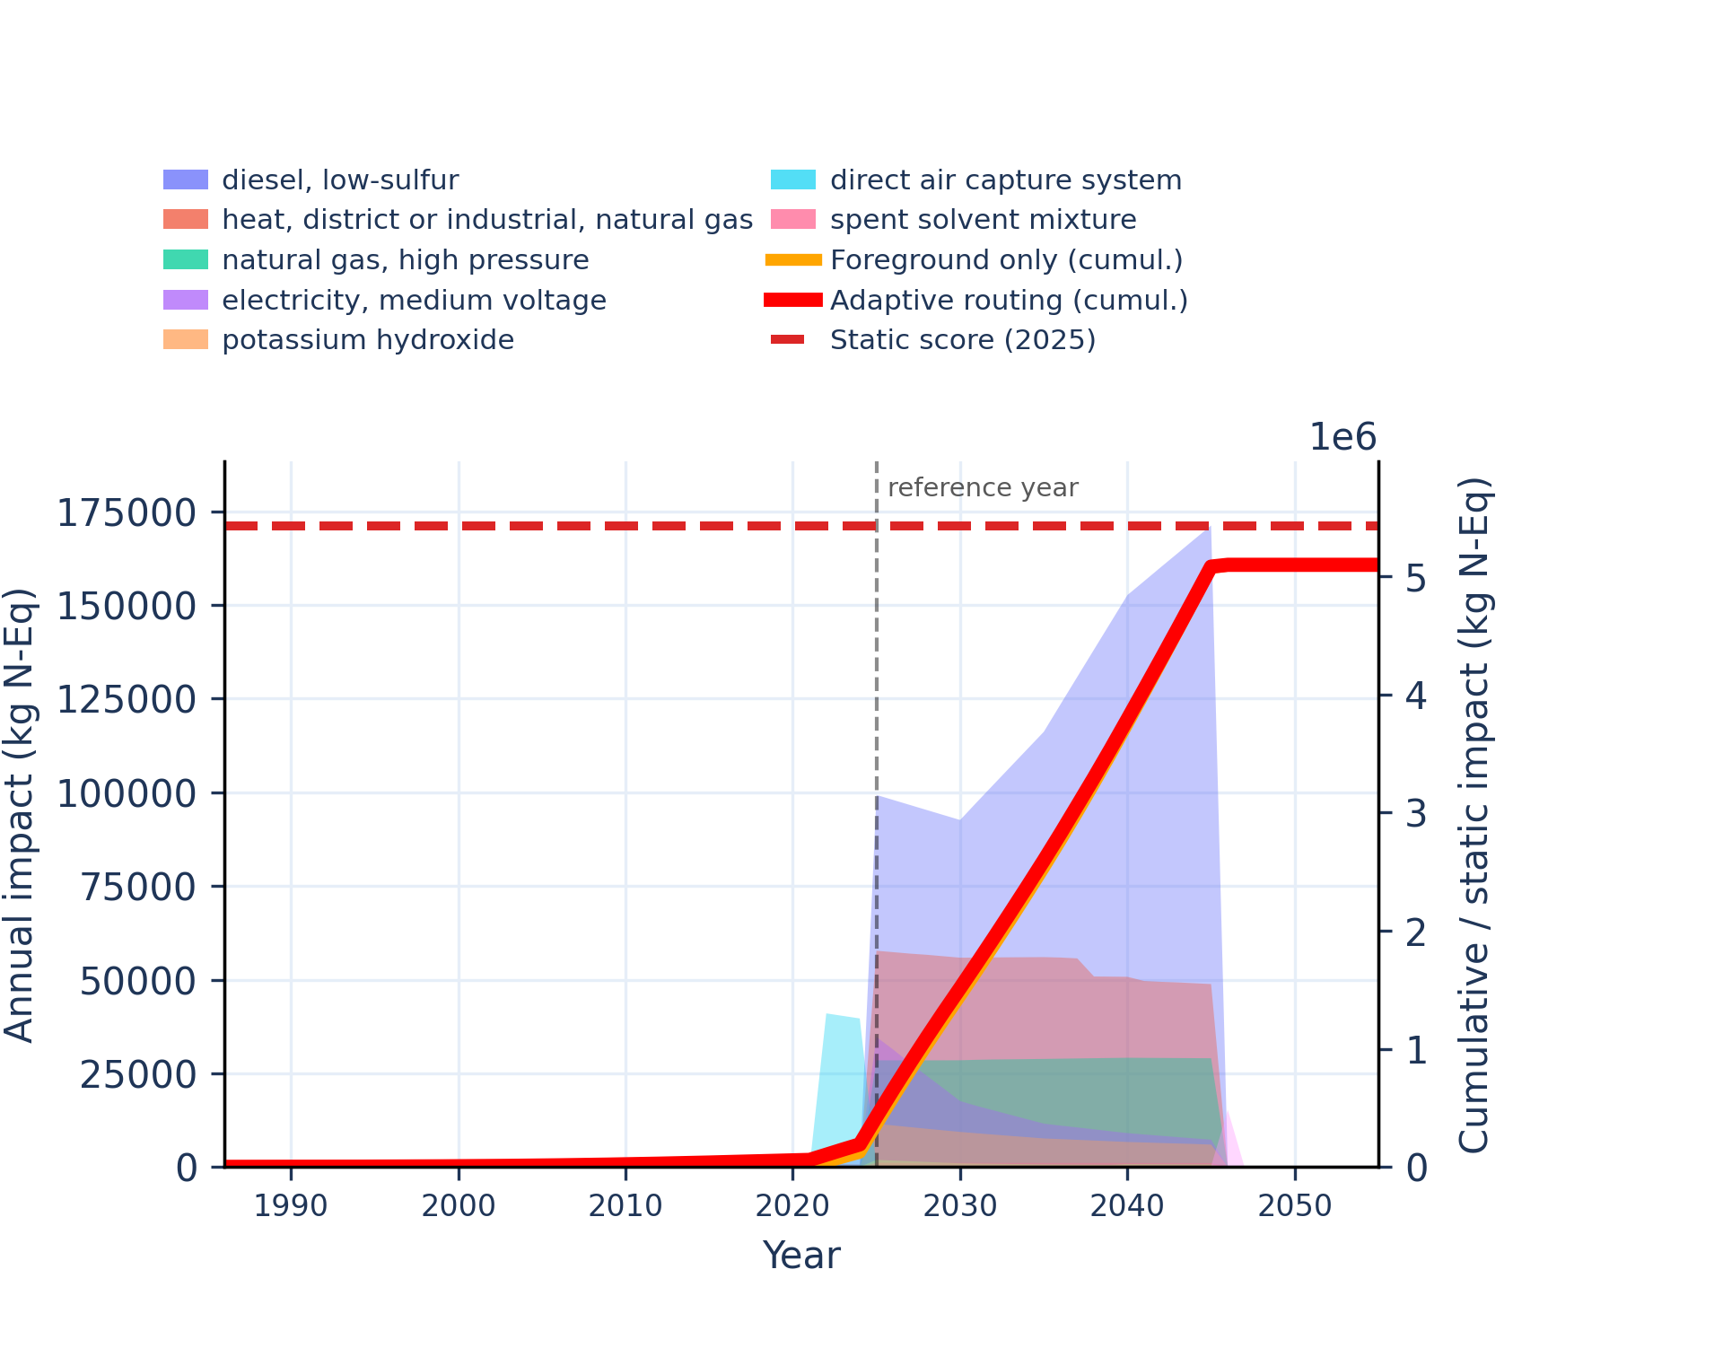 | 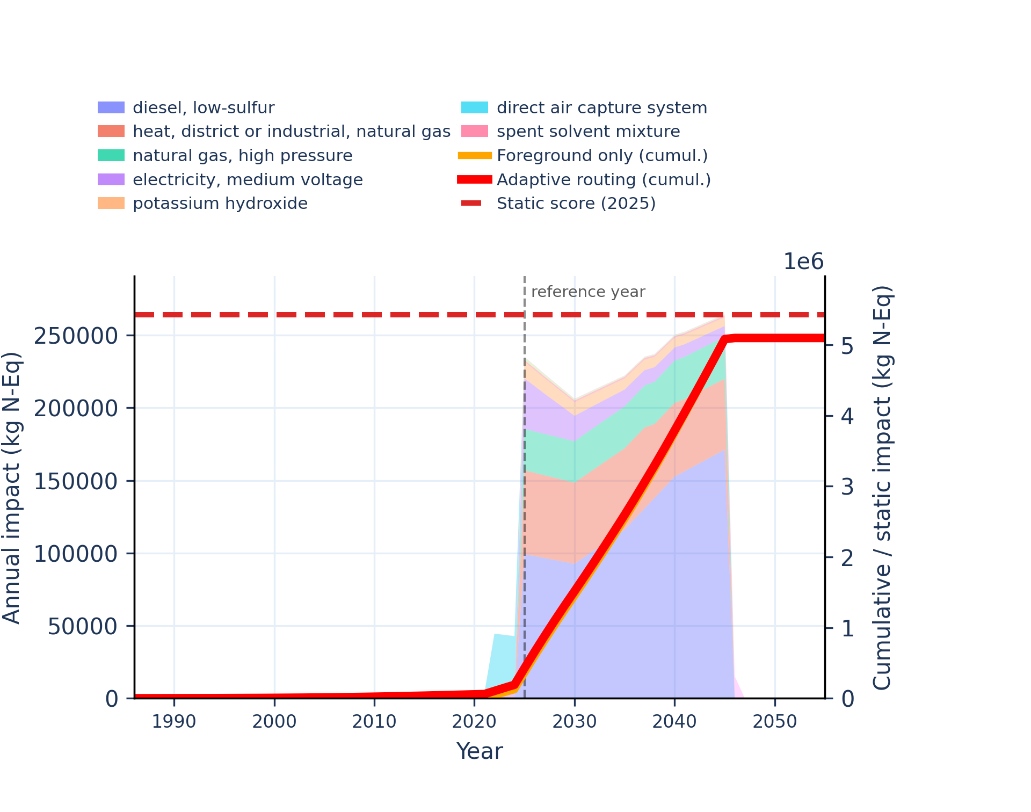
Figure S-routing-daccs-12. eutrophication: terrestrial - accumulated exceedance (AE).
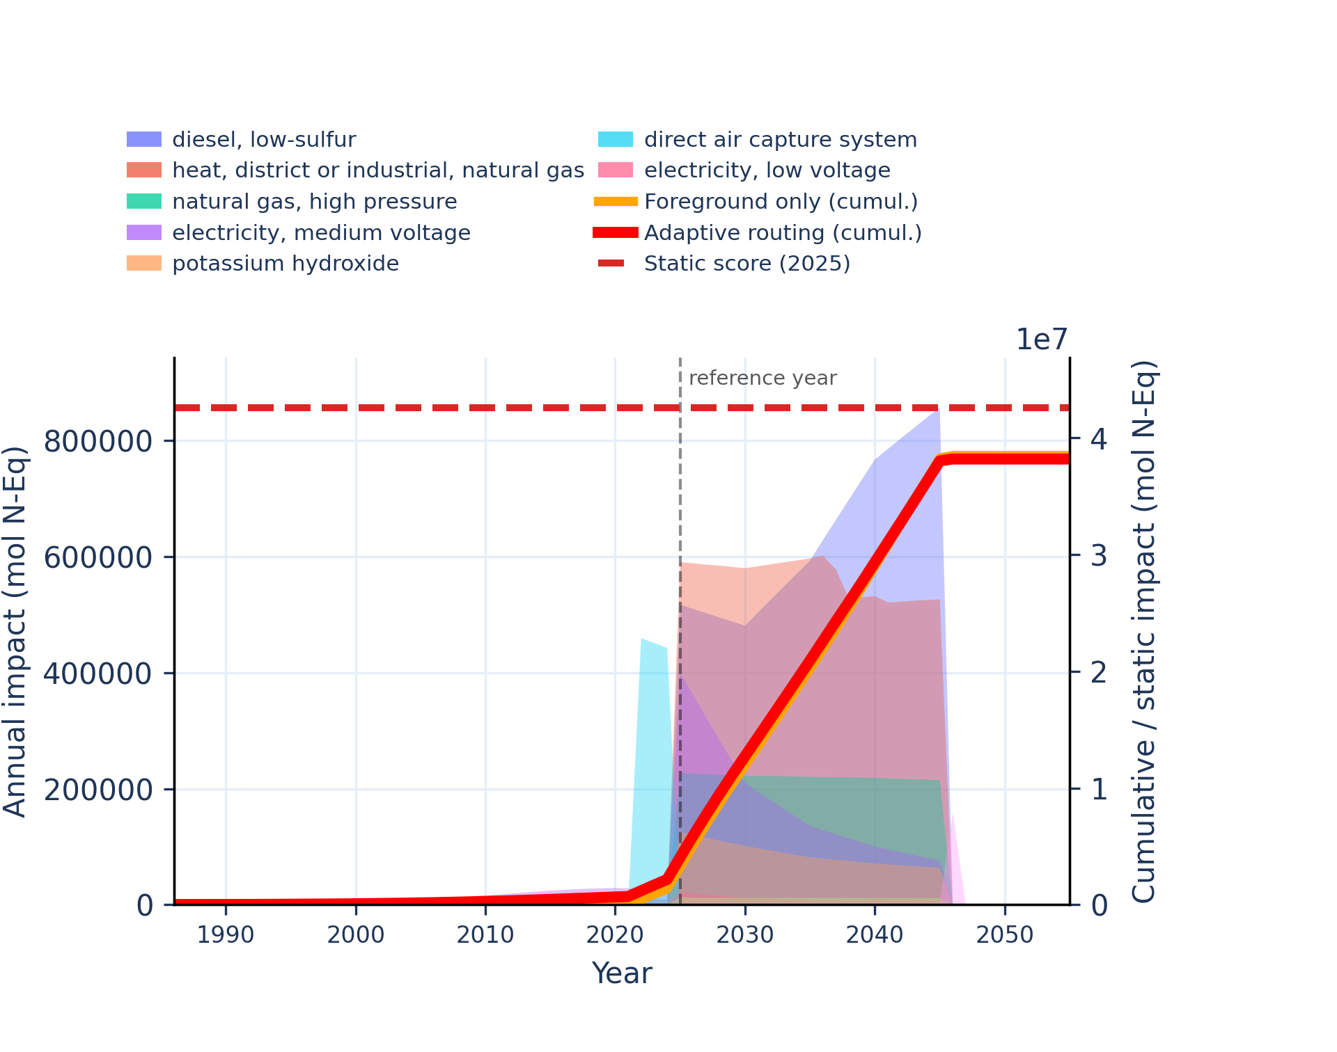 | 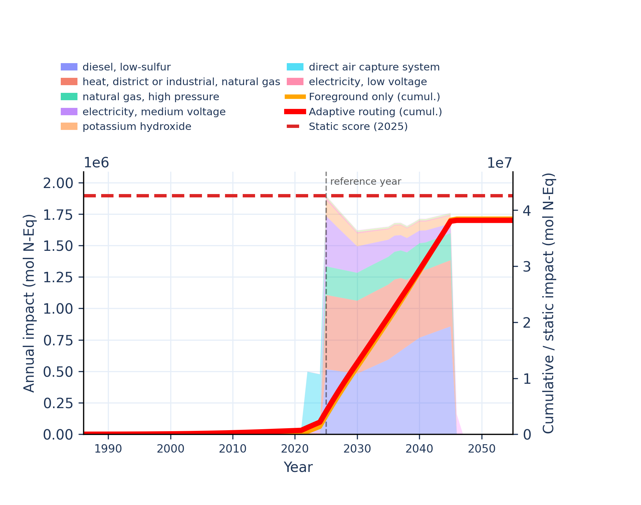
Figure S-routing-daccs-13. human toxicity: carcinogenic - comparative toxic unit for human (CTUh).
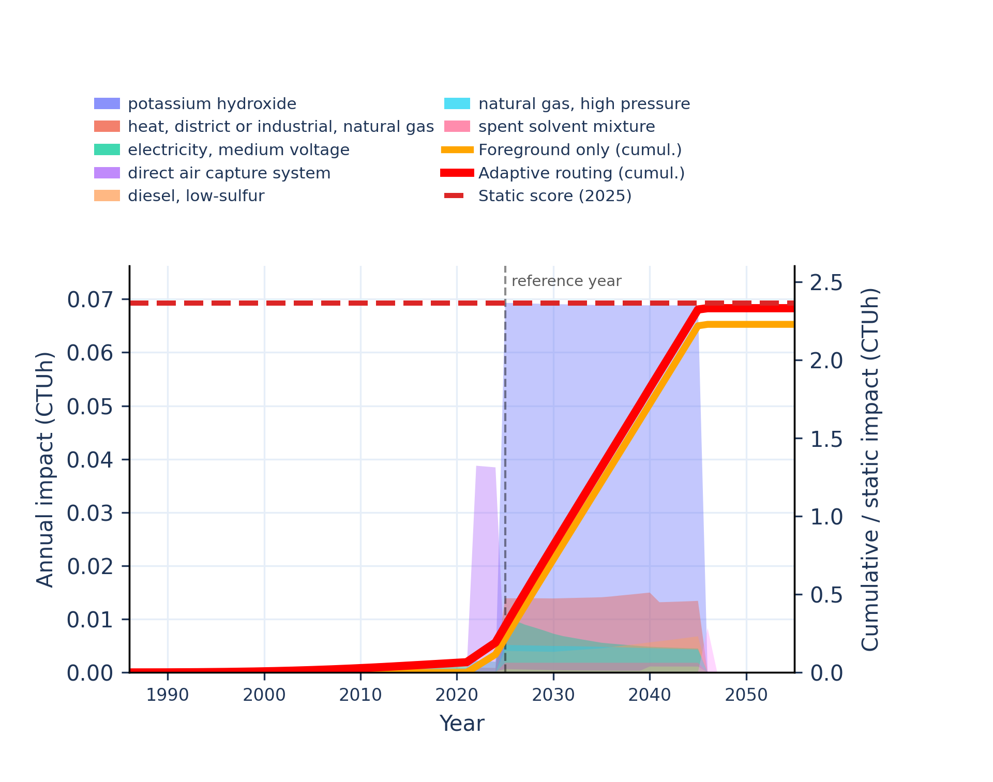 | 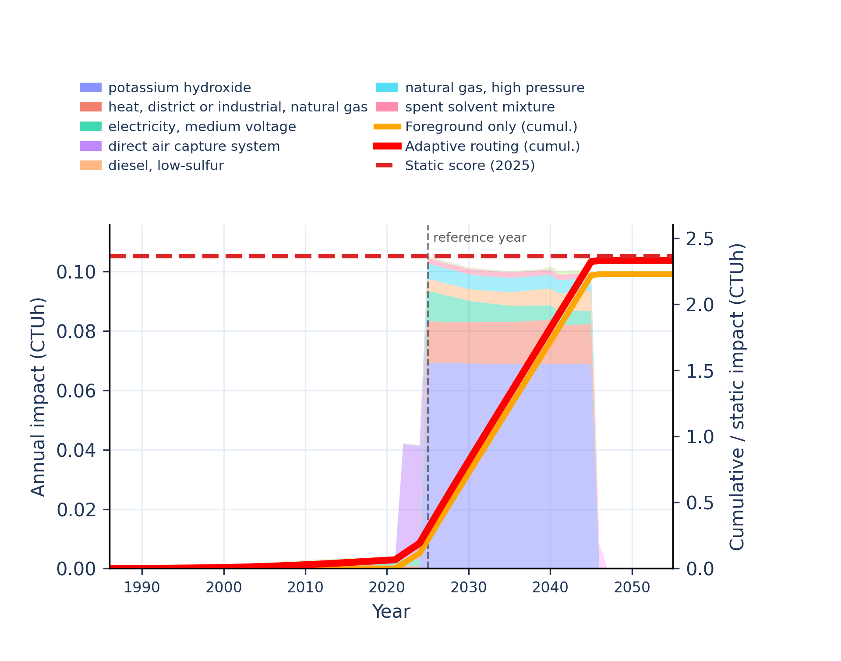
Figure S-routing-daccs-14. human toxicity: carcinogenic, inorganics - comparative toxic unit for human (CTUh).
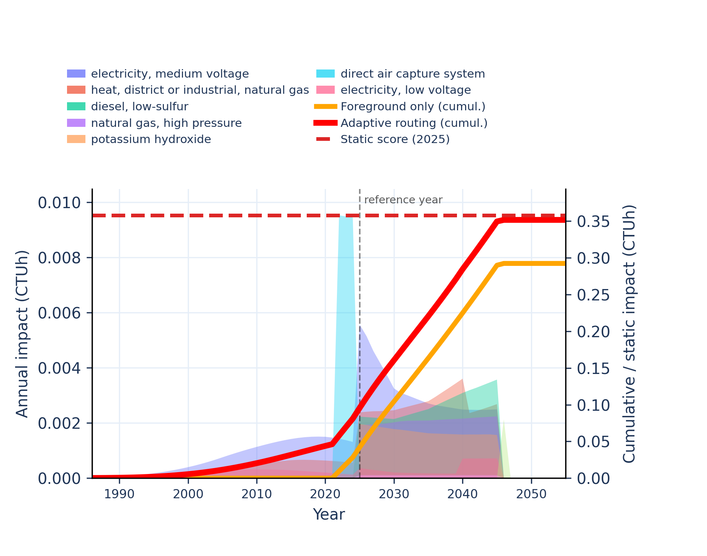 | 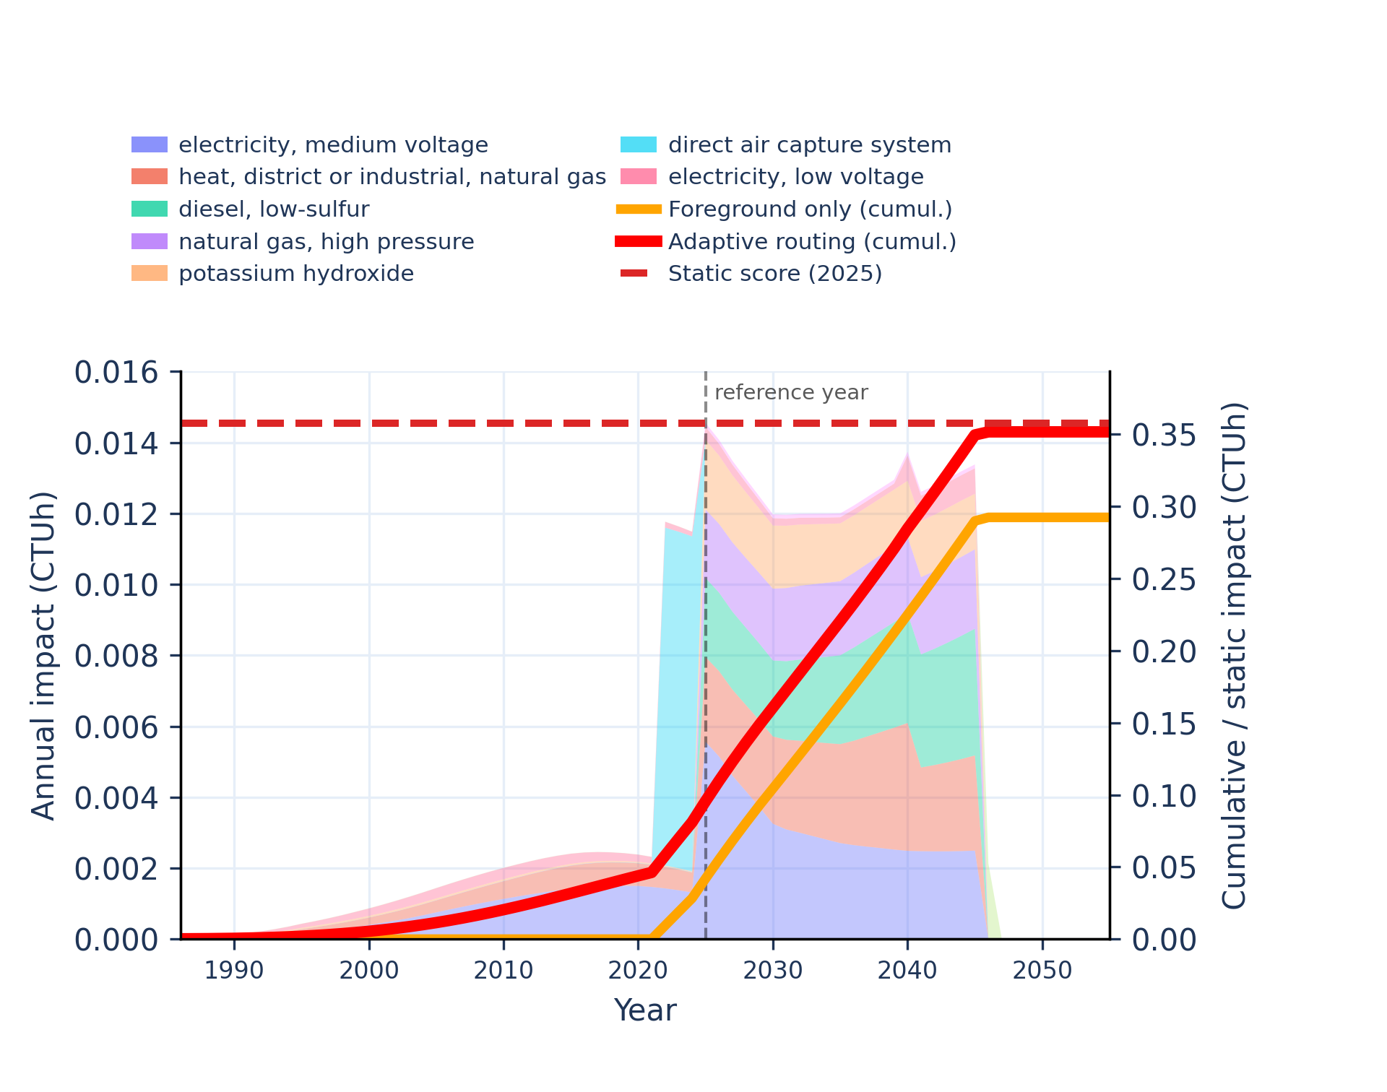
Figure S-routing-daccs-15. human toxicity: carcinogenic, organics - comparative toxic unit for human (CTUh).
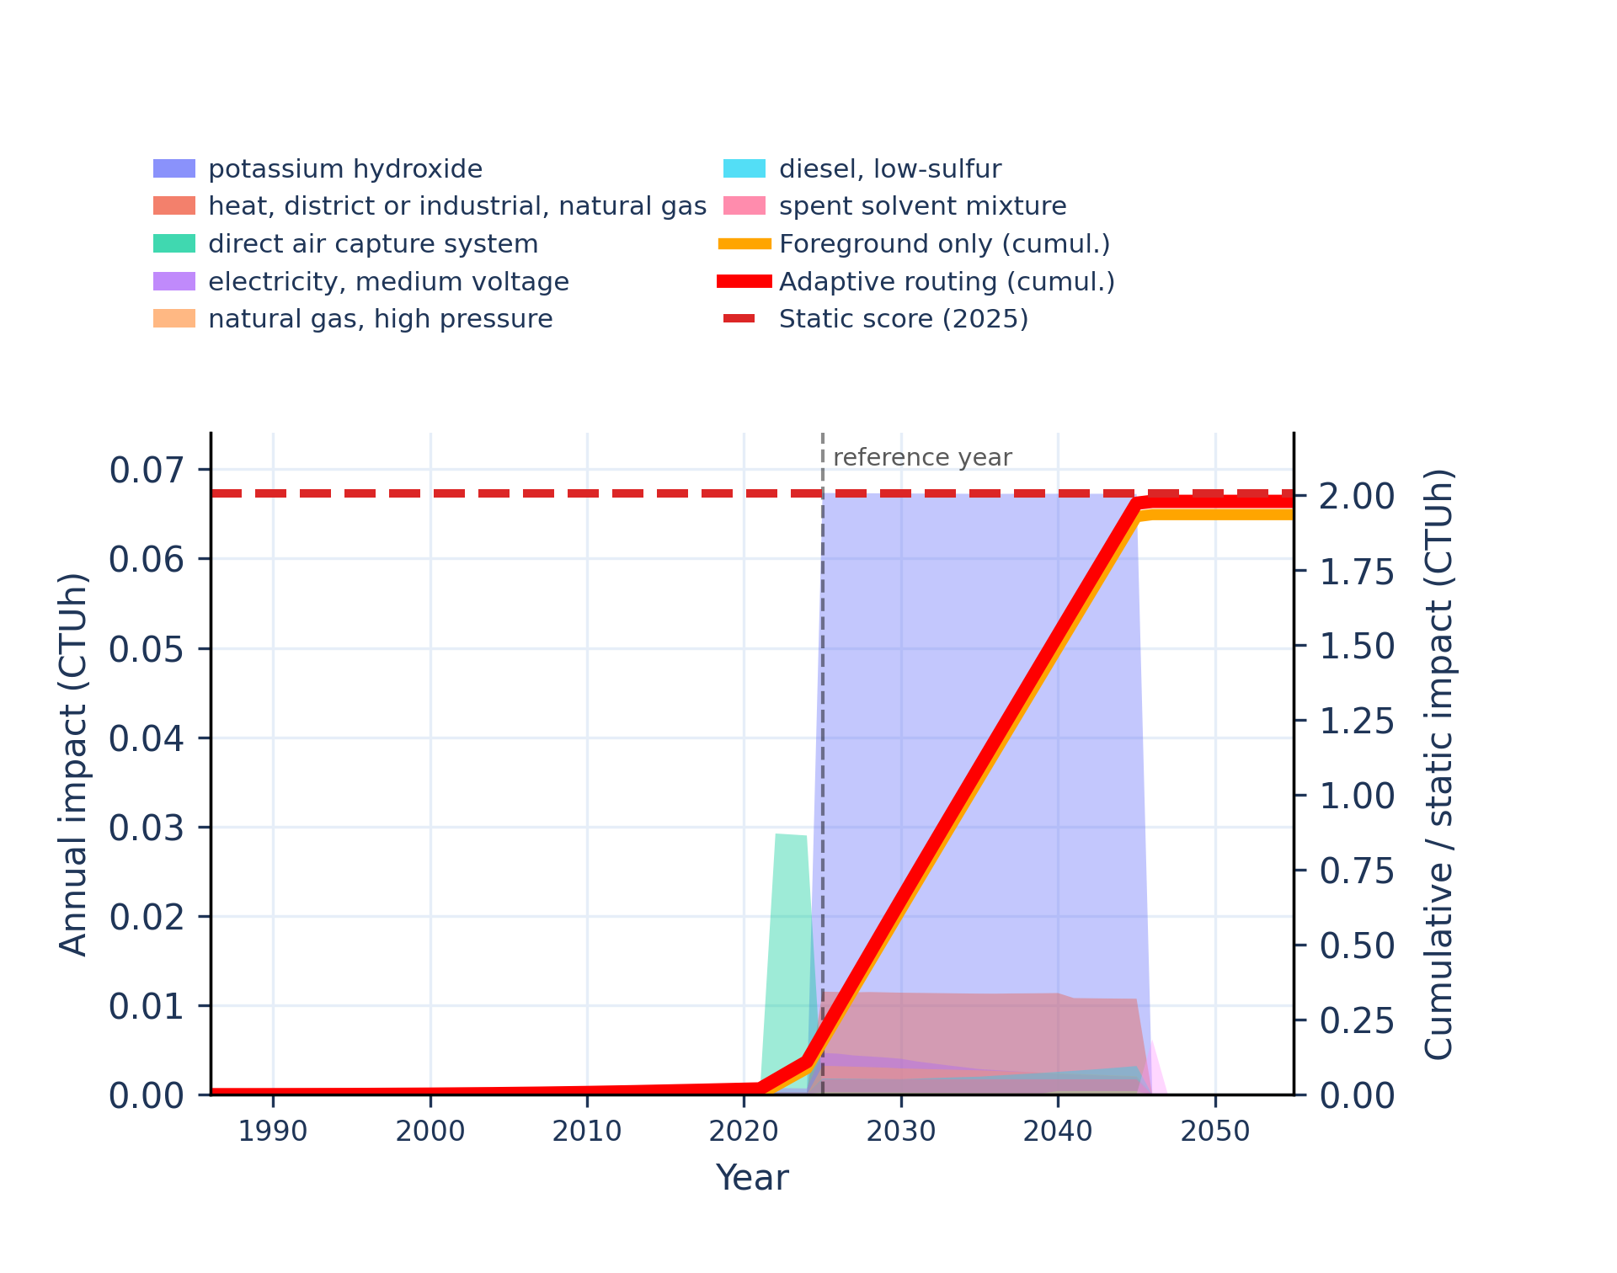 | 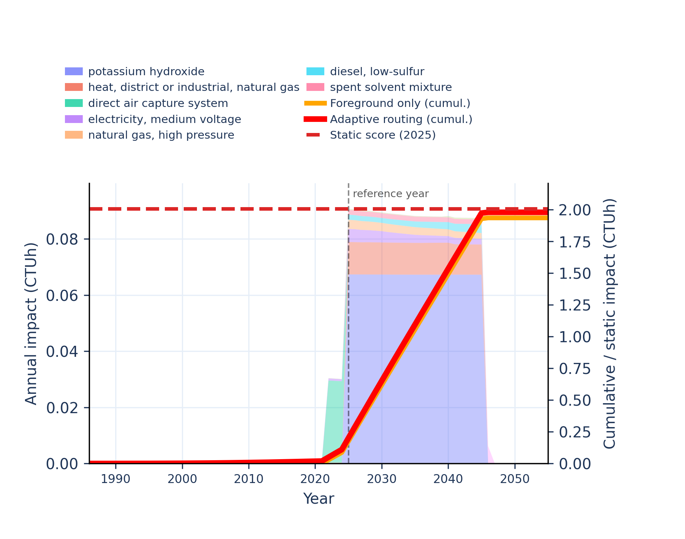
Figure S-routing-daccs-16. human toxicity: non-carcinogenic - comparative toxic unit for human (CTUh).
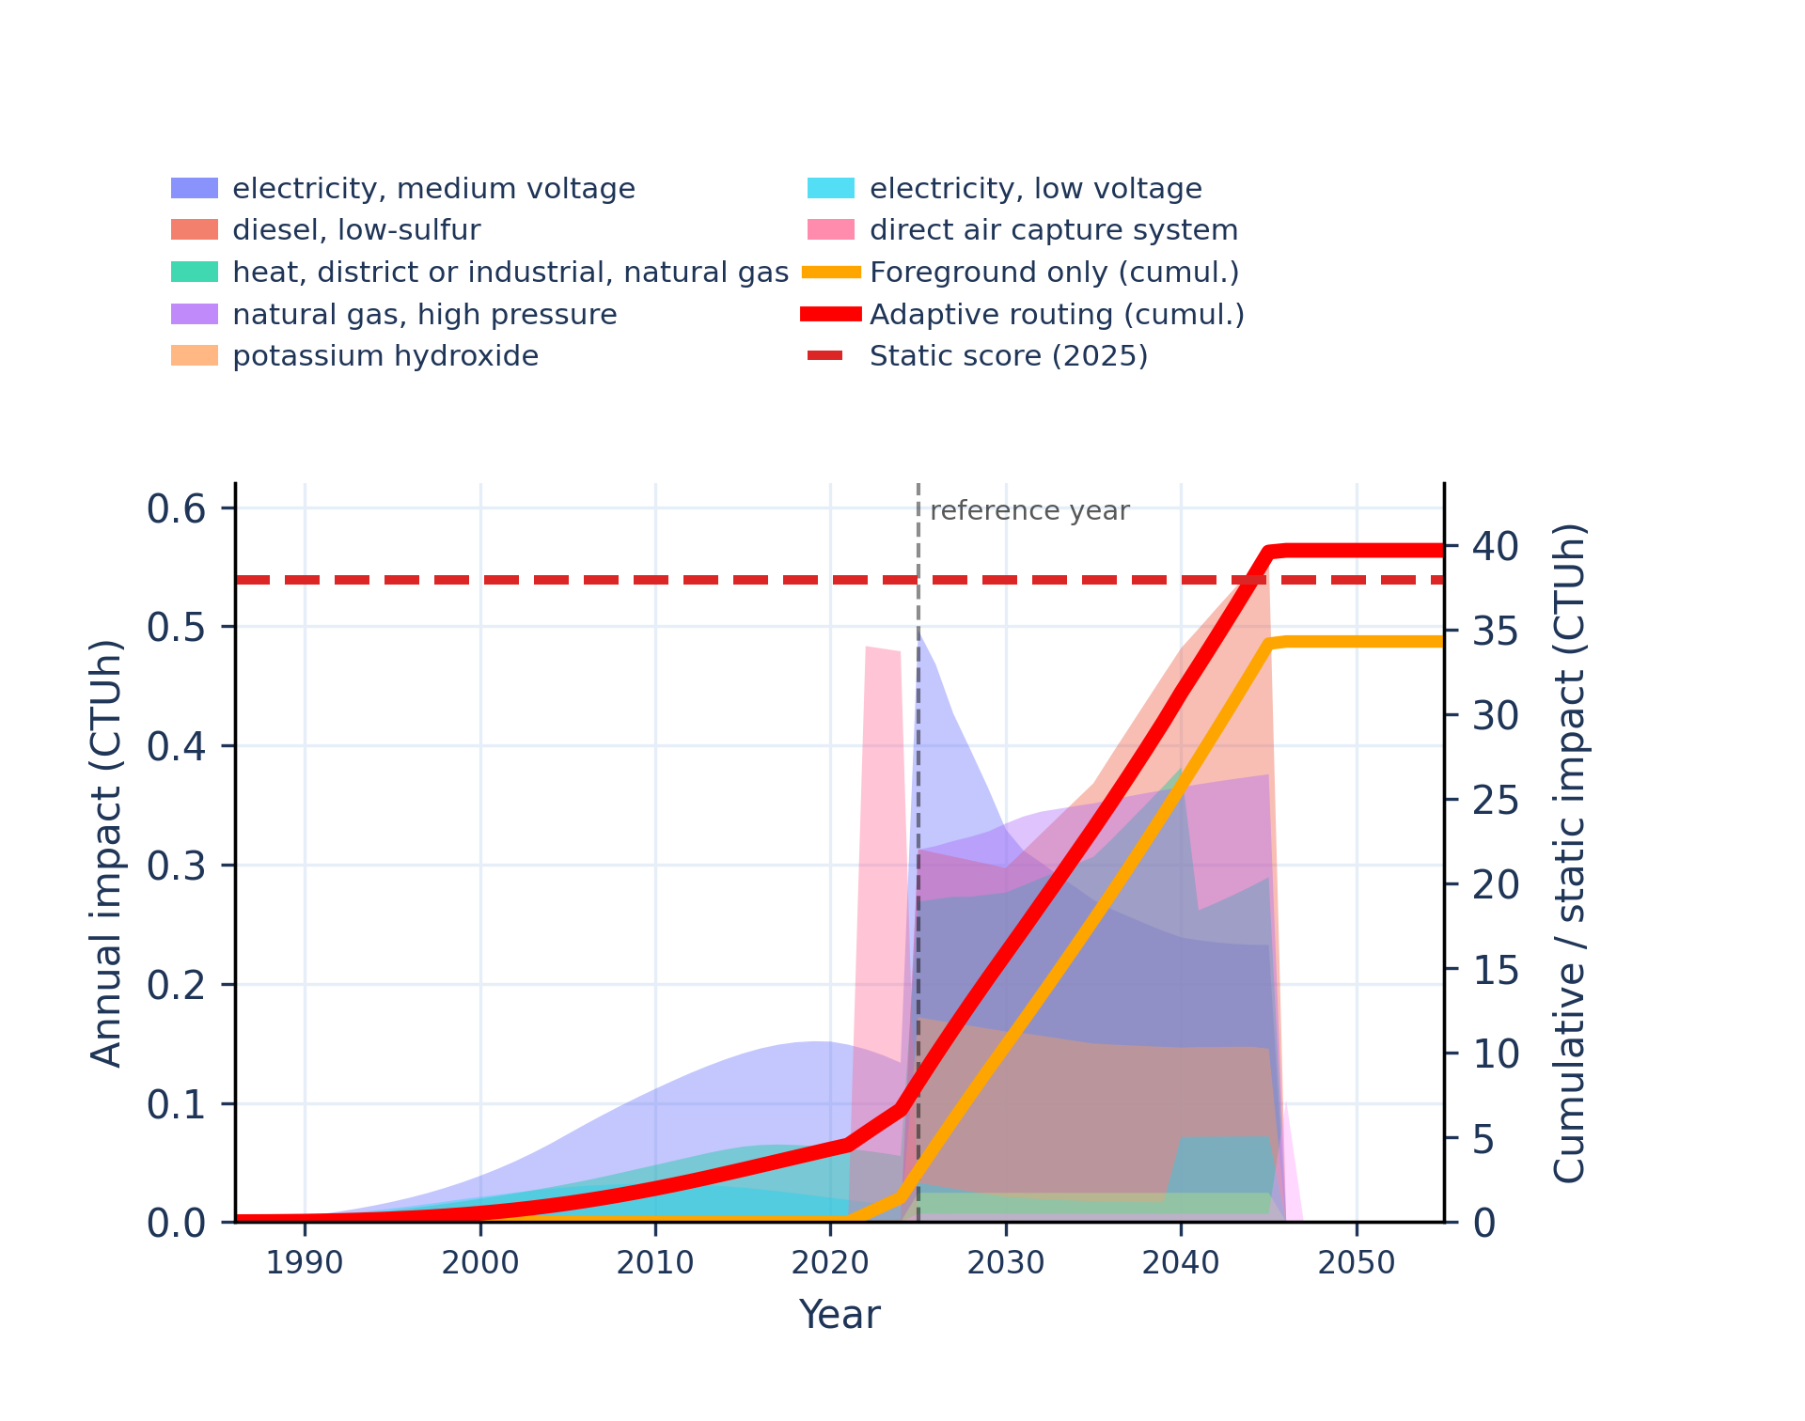 | 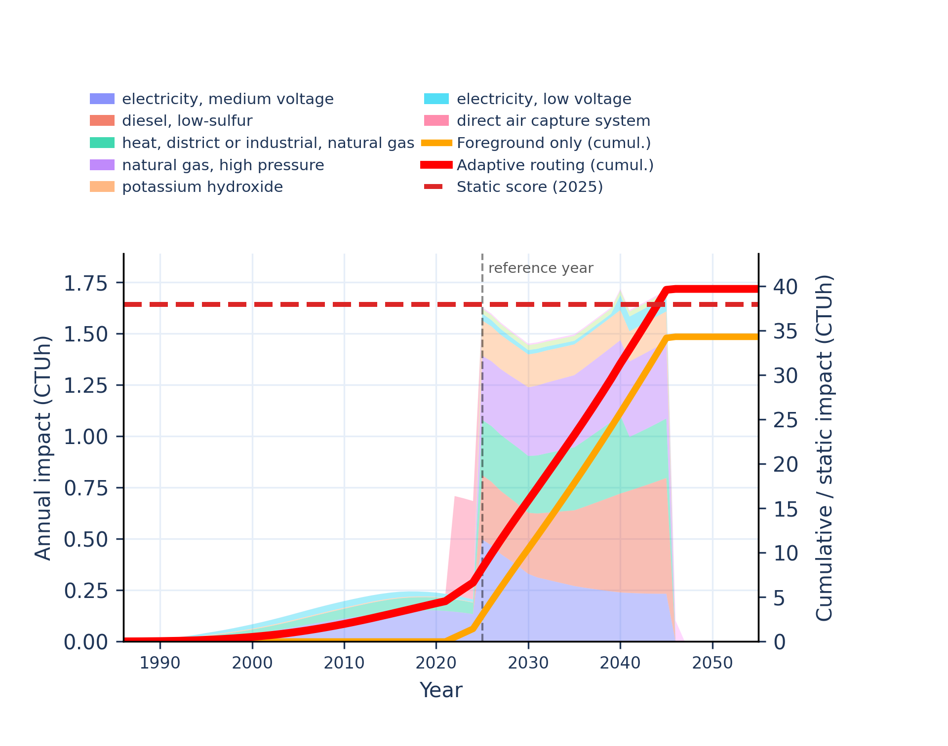
Figure S-routing-daccs-17. human toxicity: non-carcinogenic, inorganics - comparative toxic unit for human (CTUh).
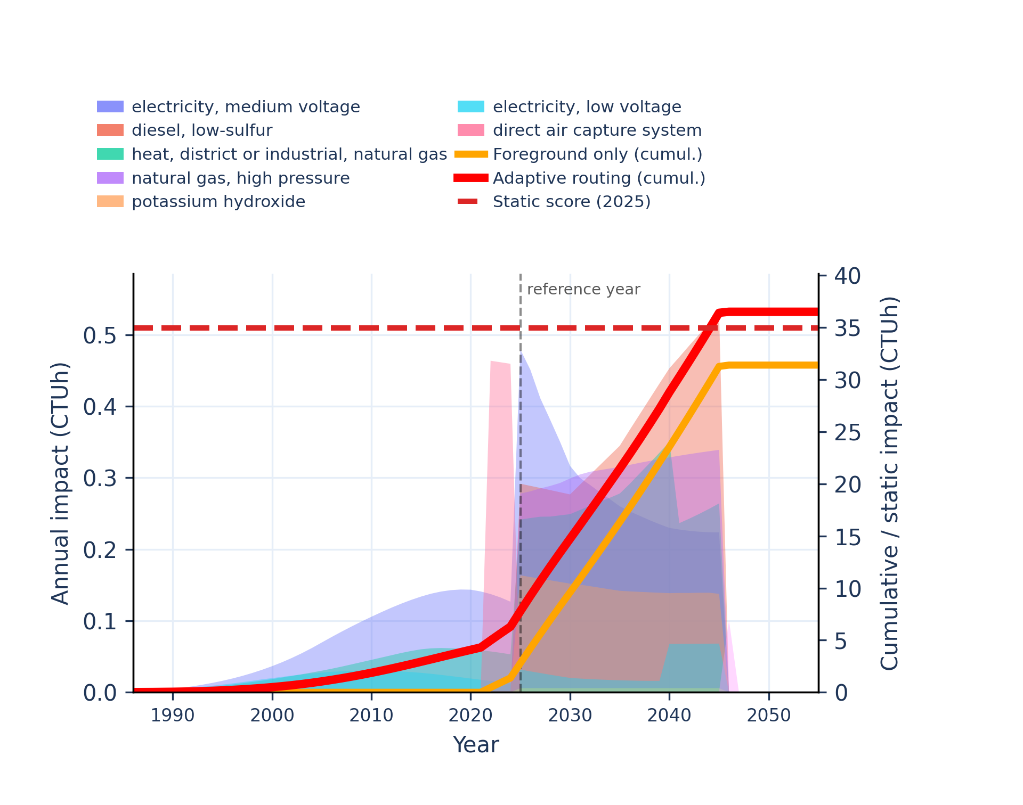 | 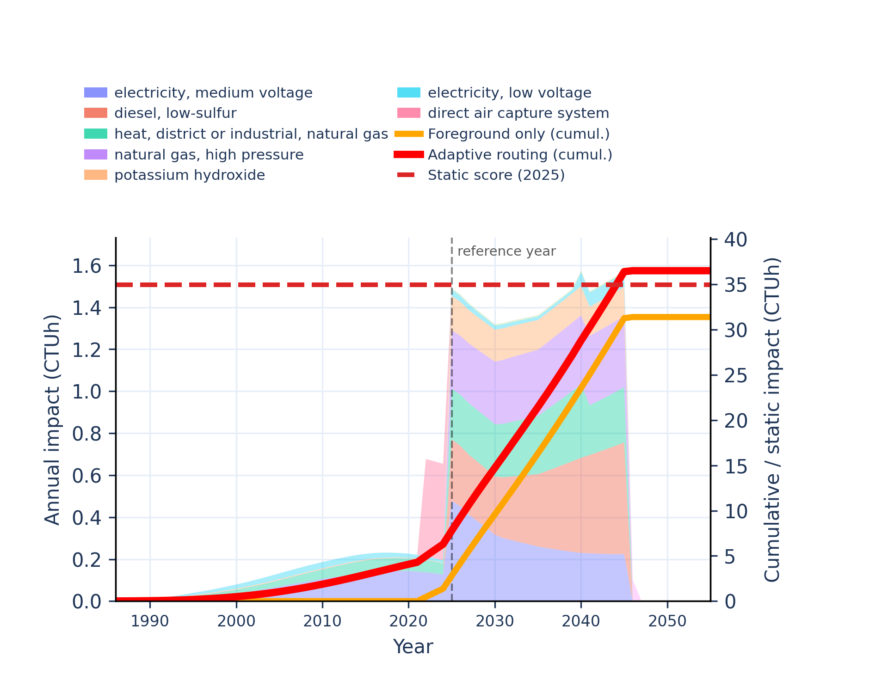
Figure S-routing-daccs-18. human toxicity: non-carcinogenic, organics - comparative toxic unit for human (CTUh).
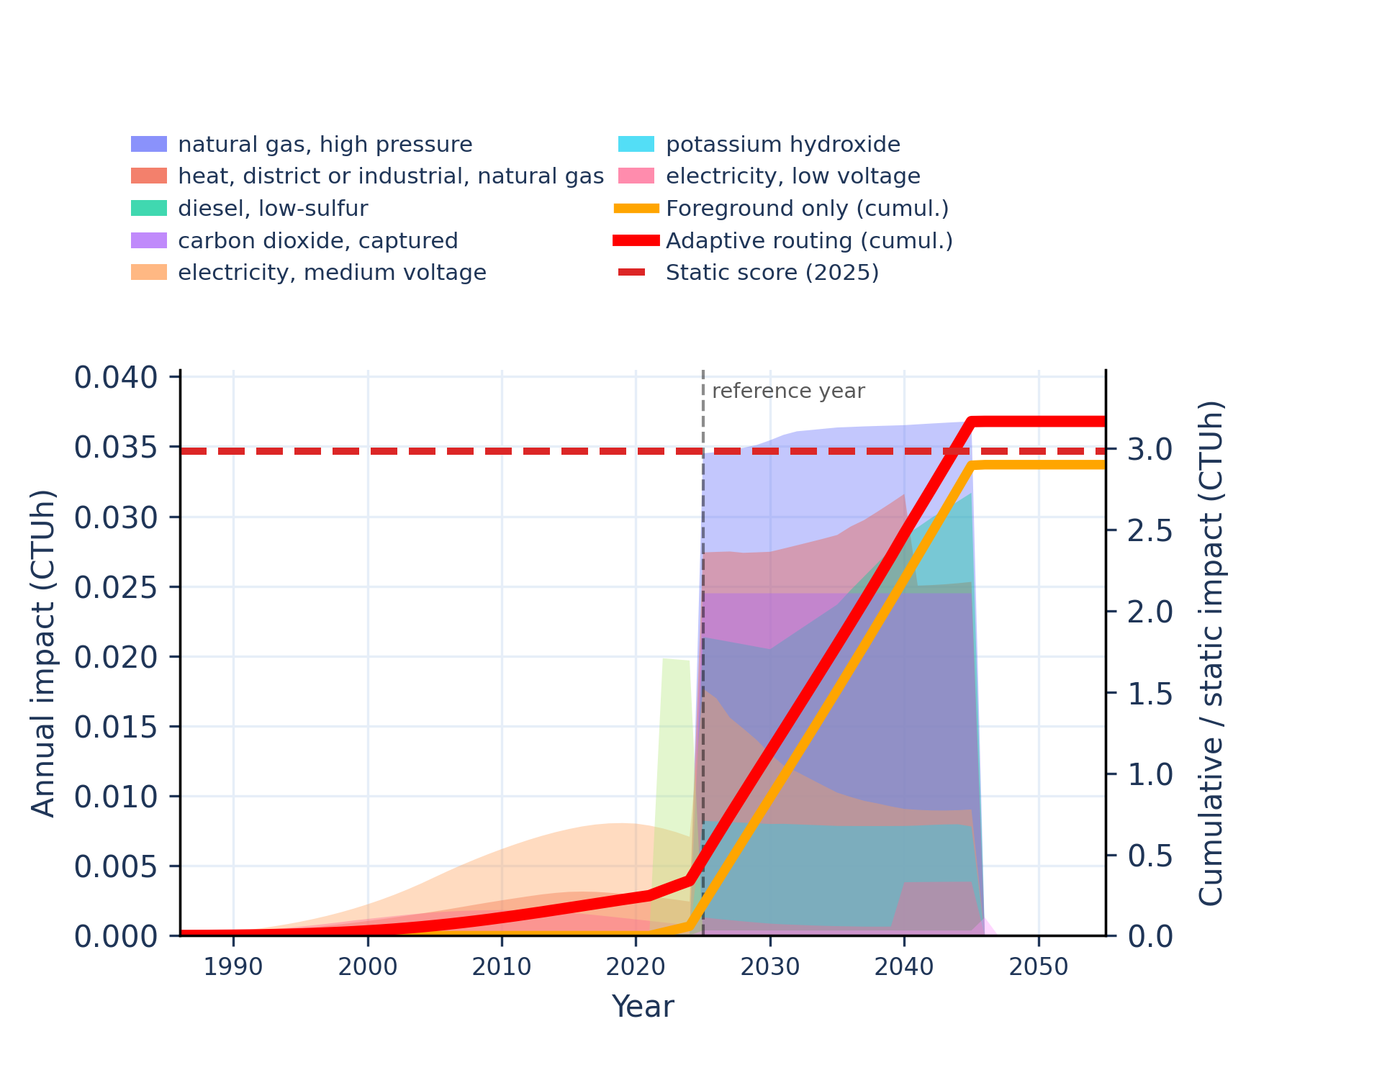 | 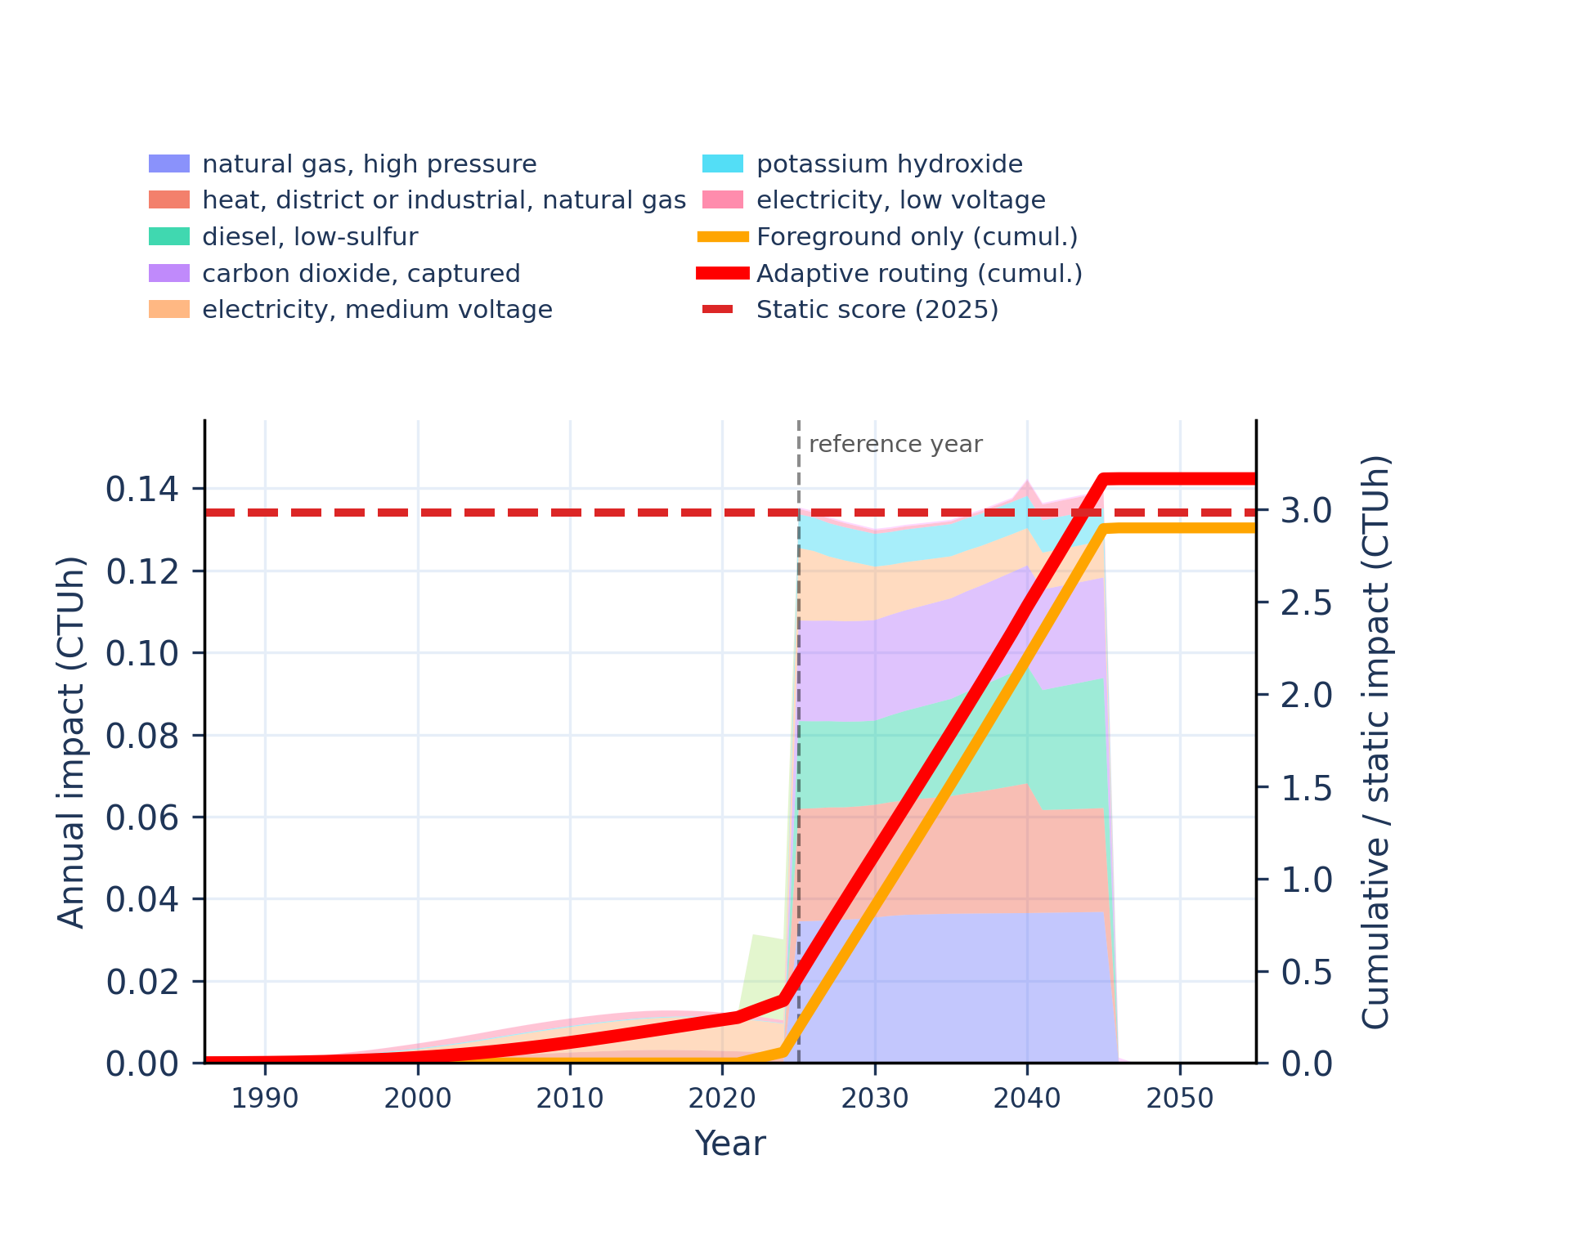
Figure S-routing-daccs-19. ionising radiation: human health - human exposure efficiency relative to u235.
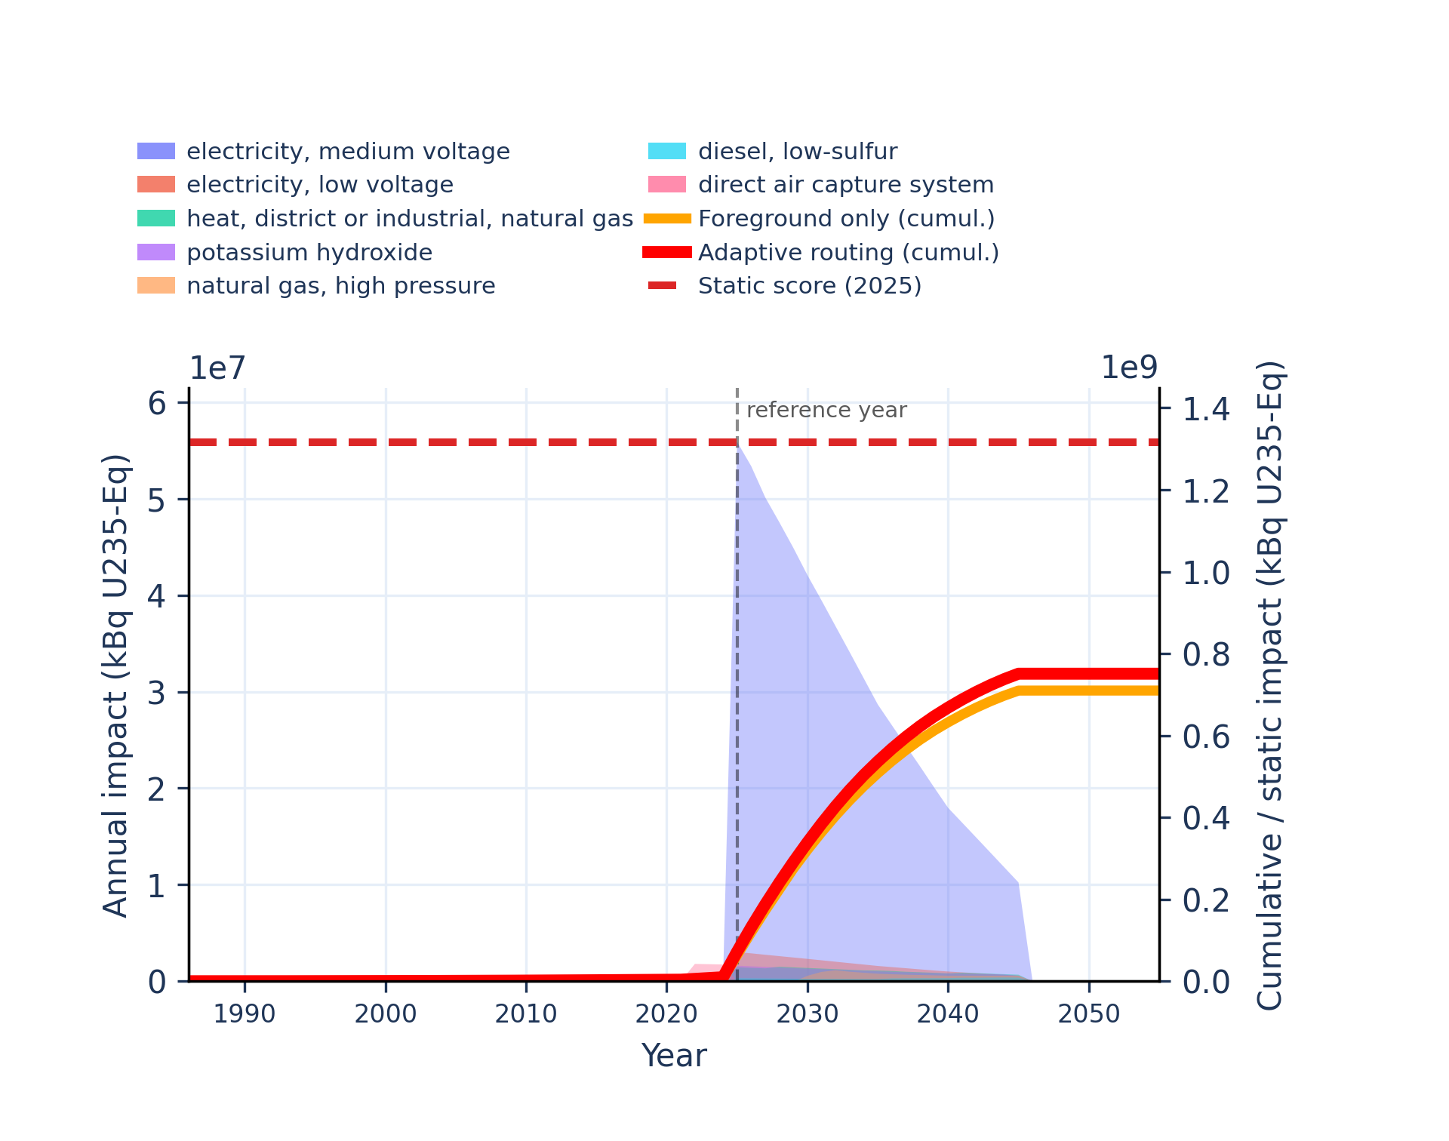 | 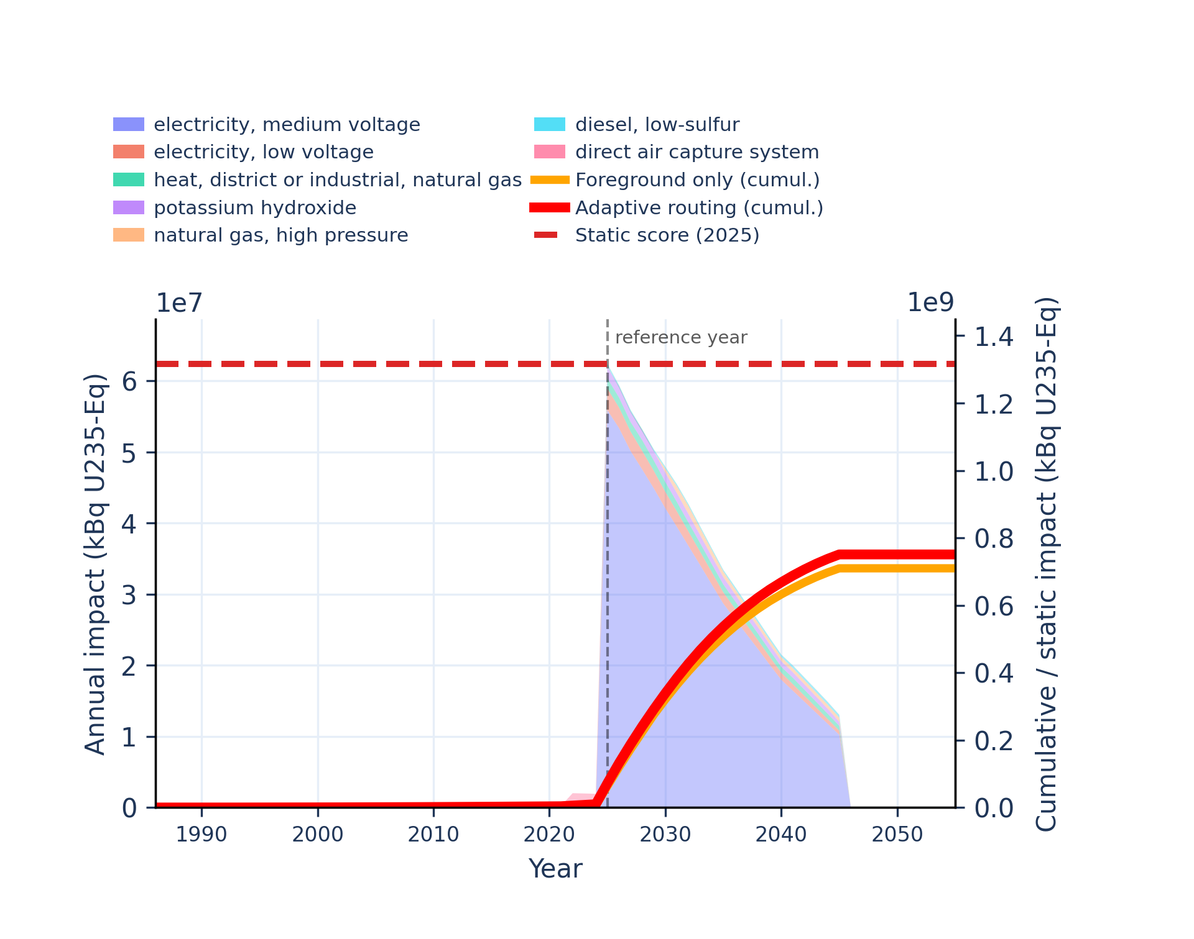
Figure S-routing-daccs-20. land use - soil quality index.
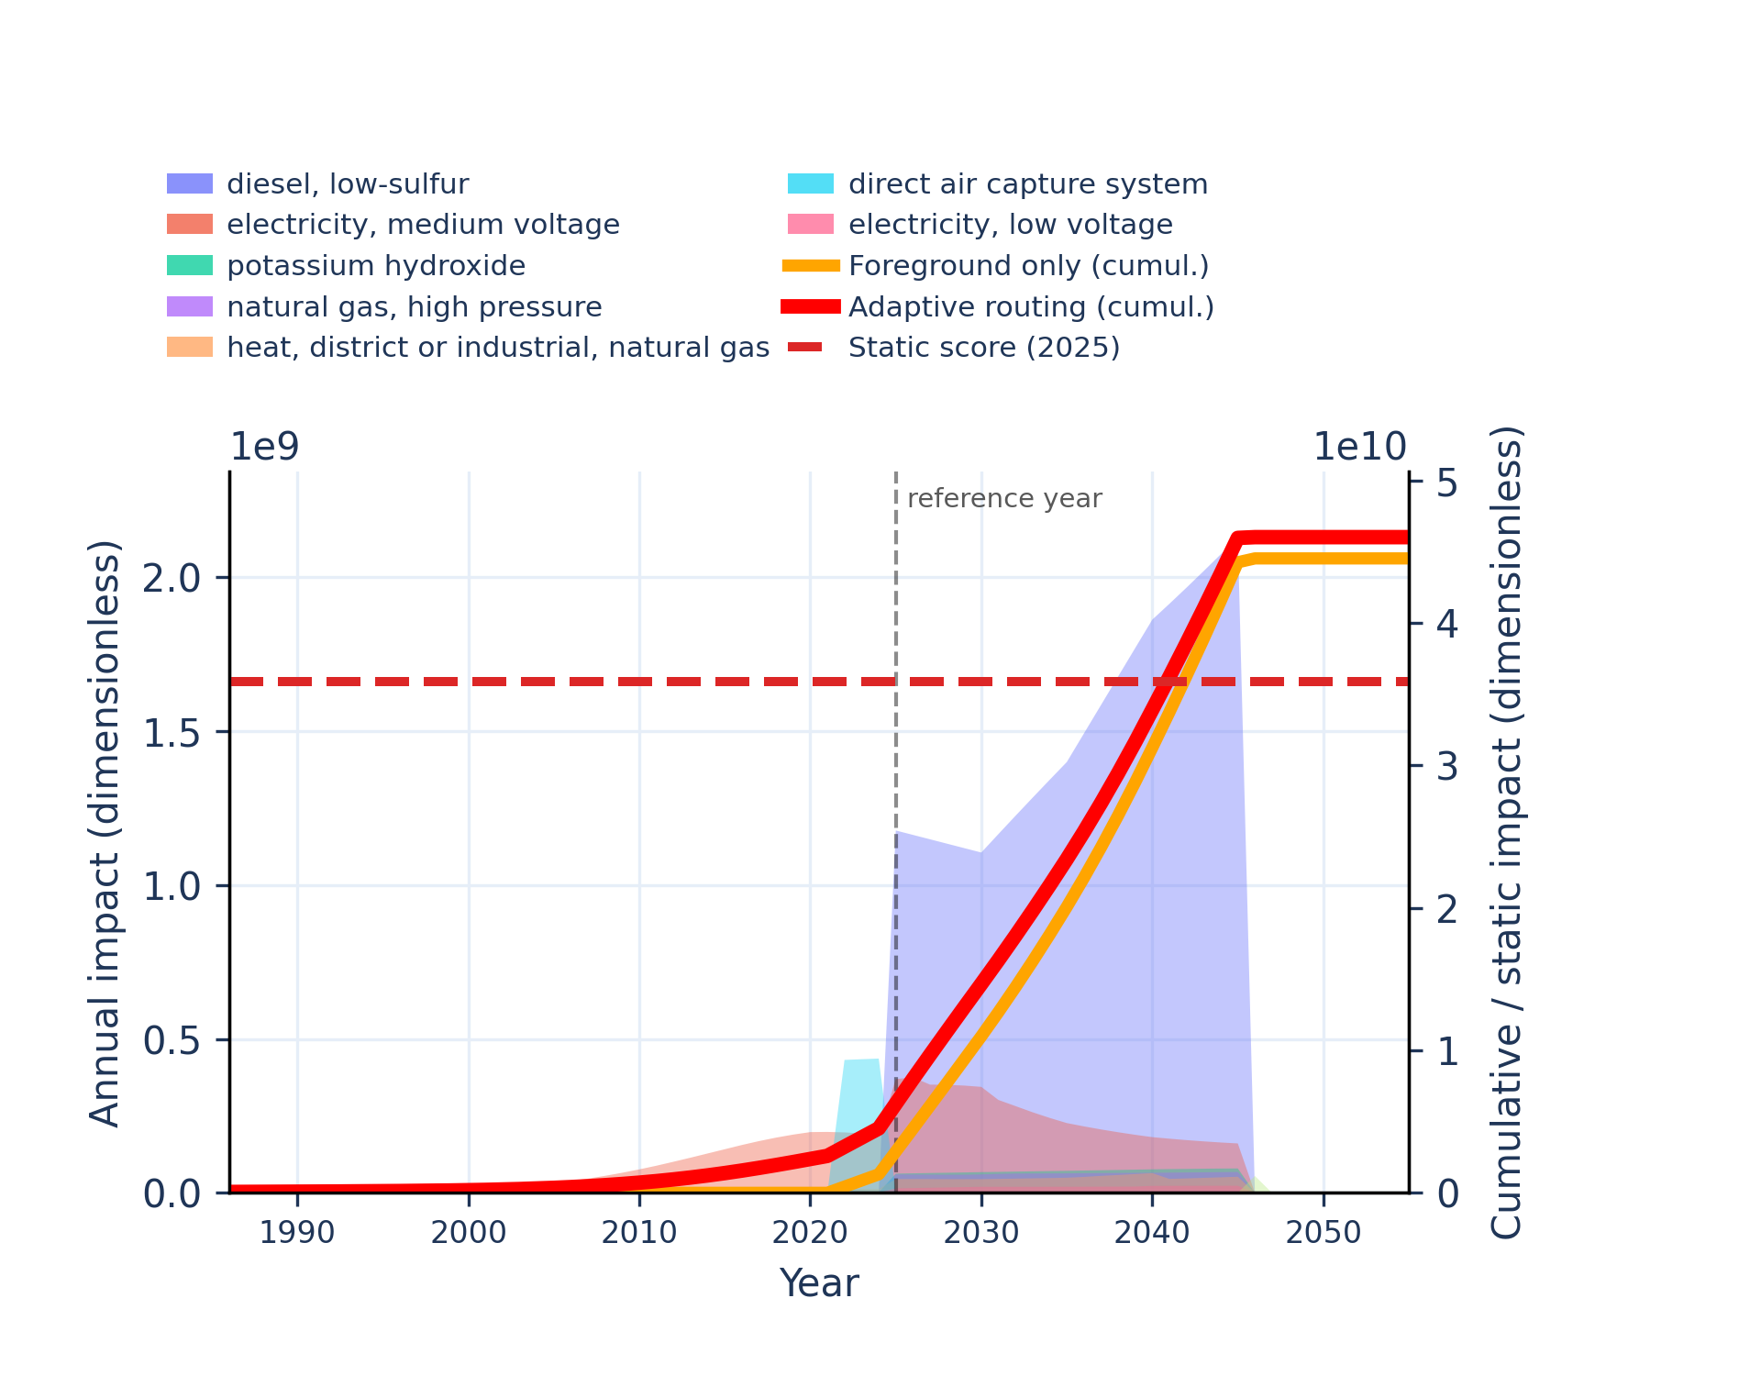 | 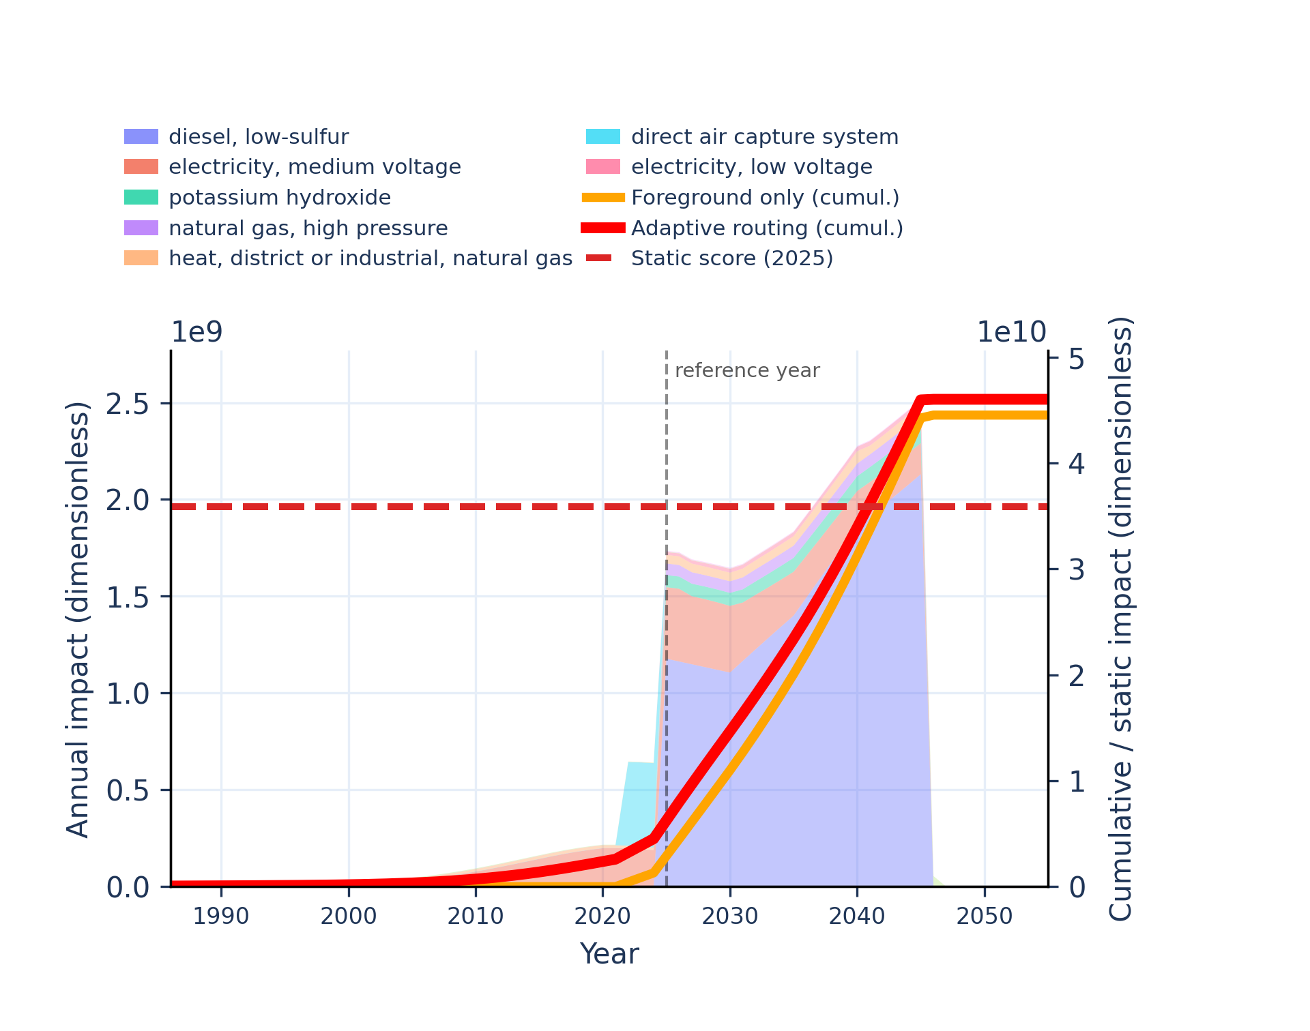
Figure S-routing-daccs-21. material resources: metals/minerals - abiotic depletion potential (ADP): elements (ultimate reserves).
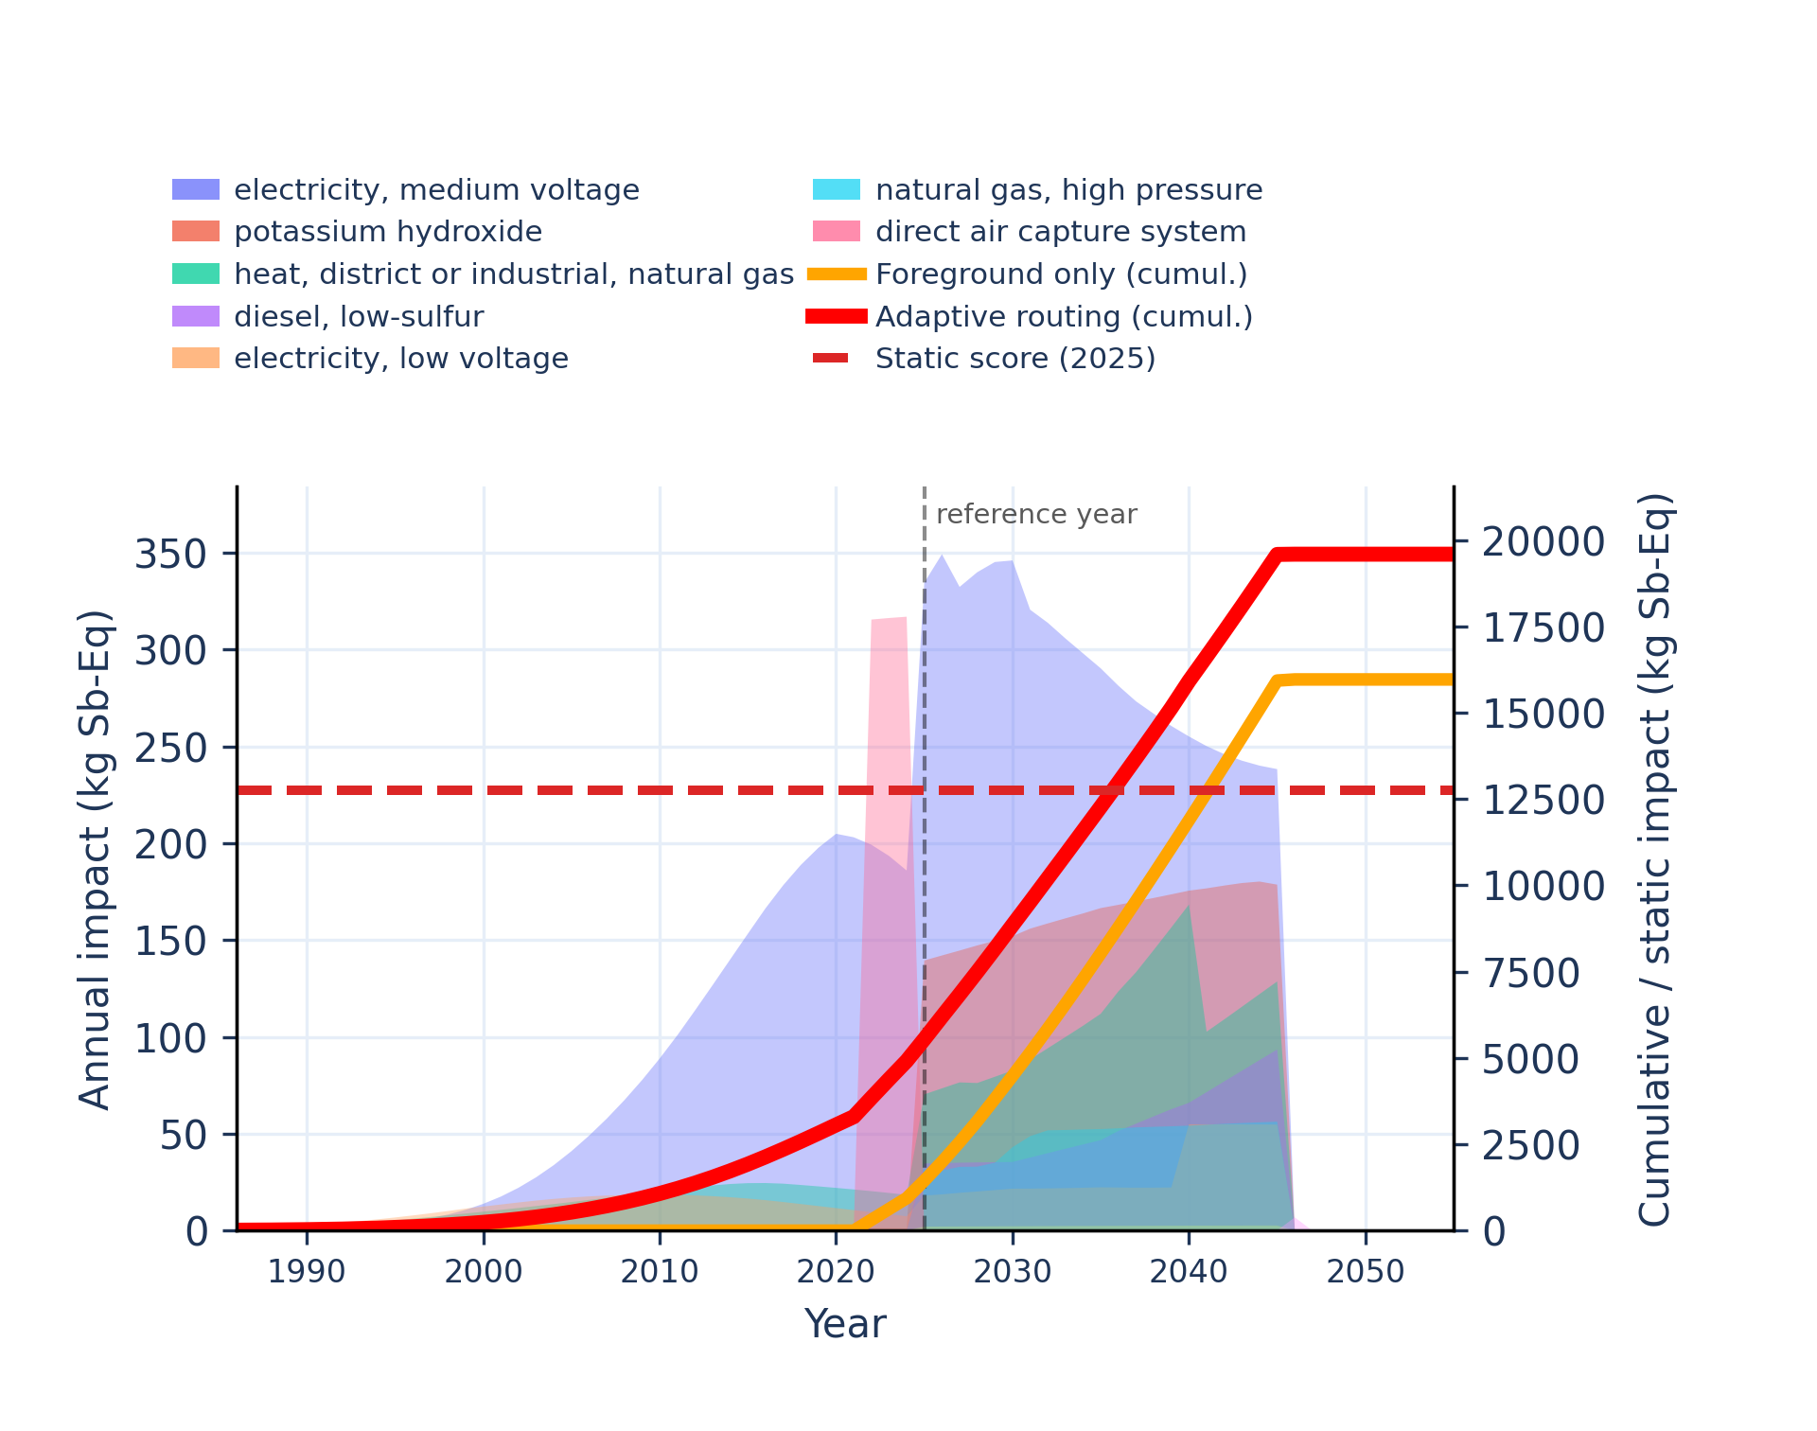 | 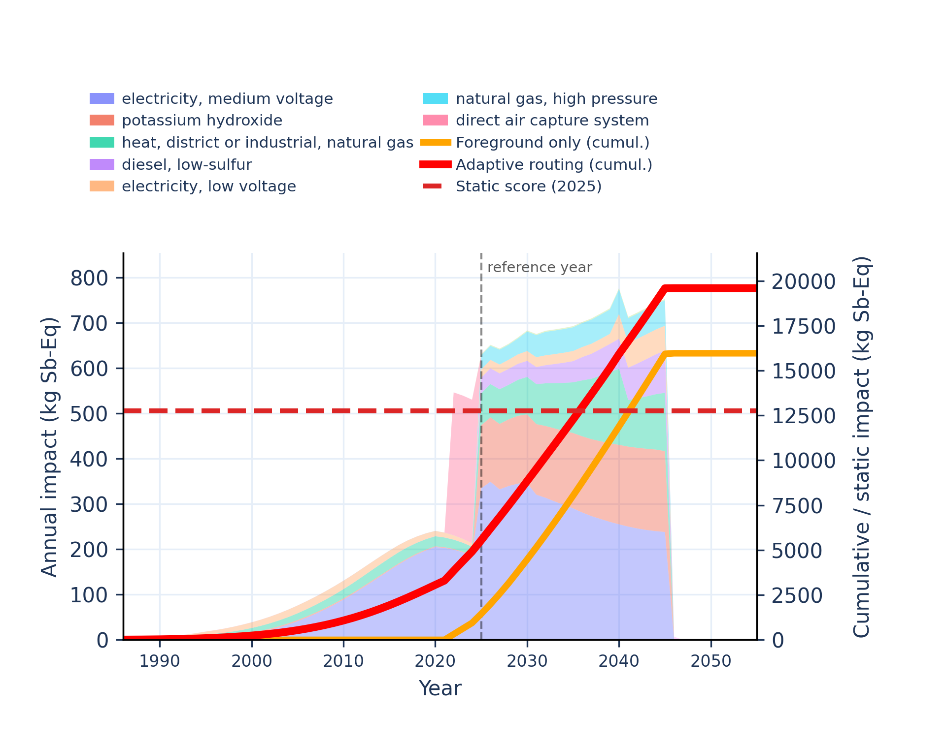
Figure S-routing-daccs-22. ozone depletion - ozone depletion potential (ODP).
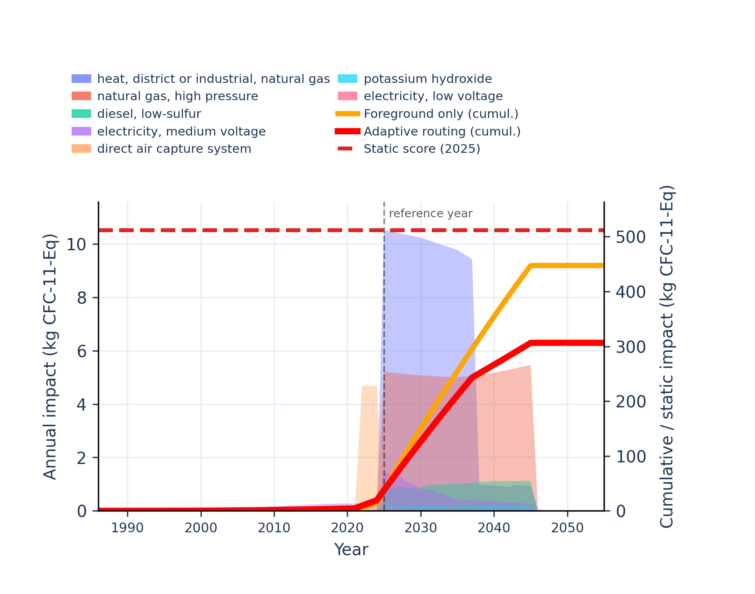 | 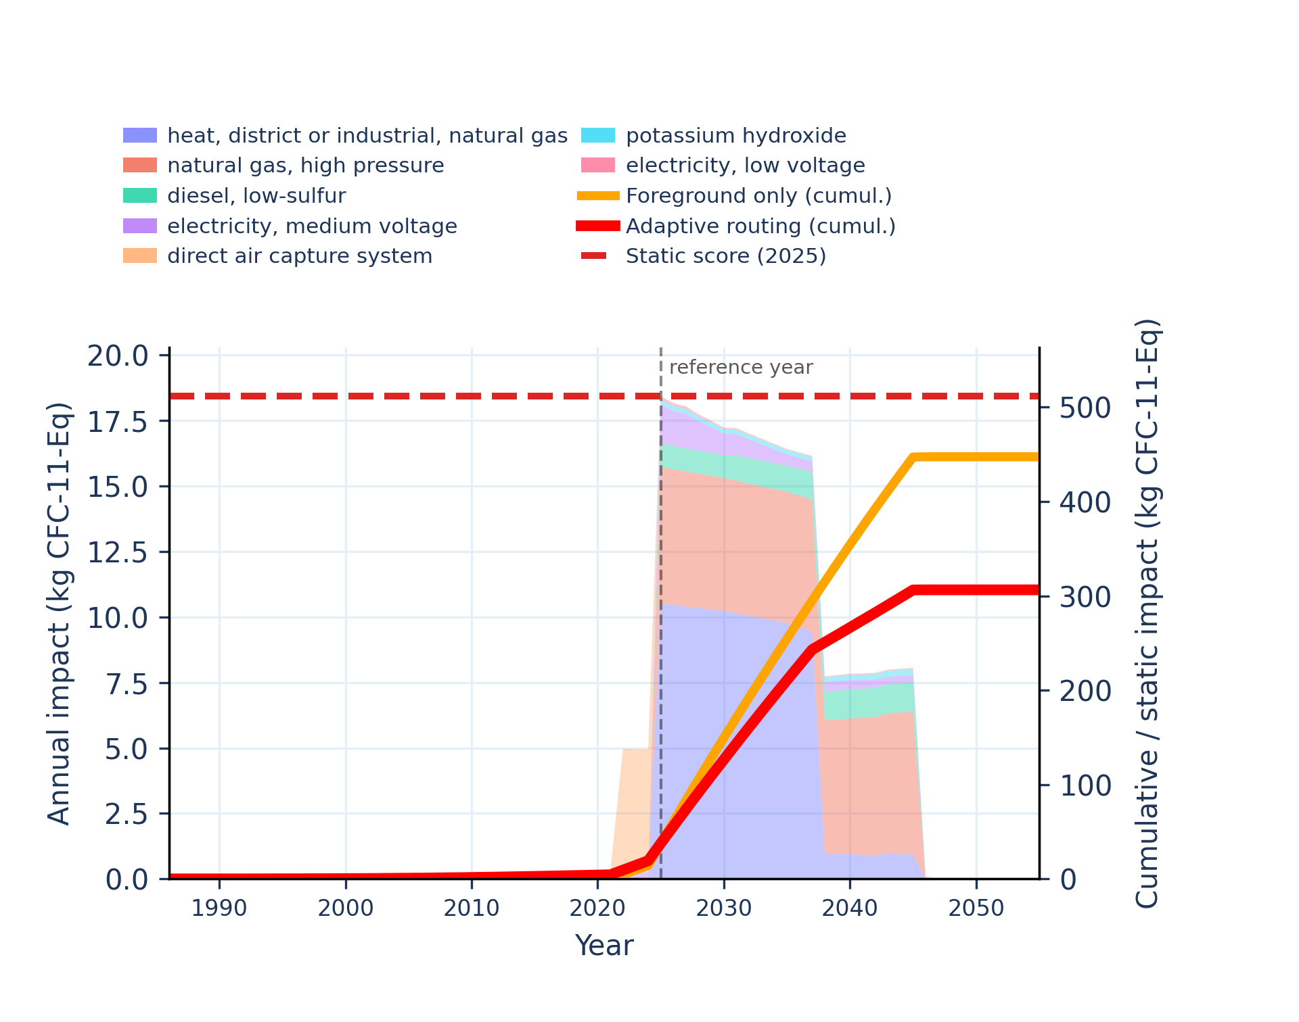
Figure S-routing-daccs-23. particulate matter formation - impact on human health.
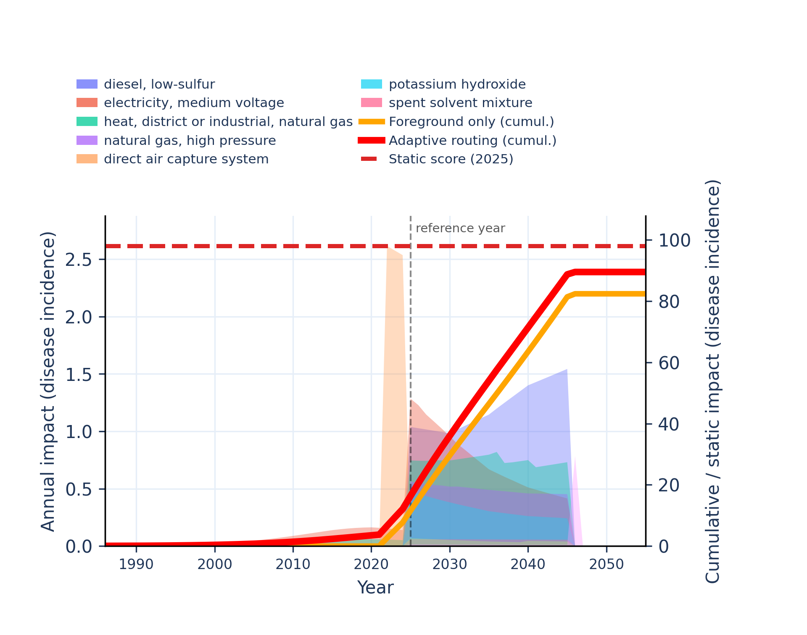 | 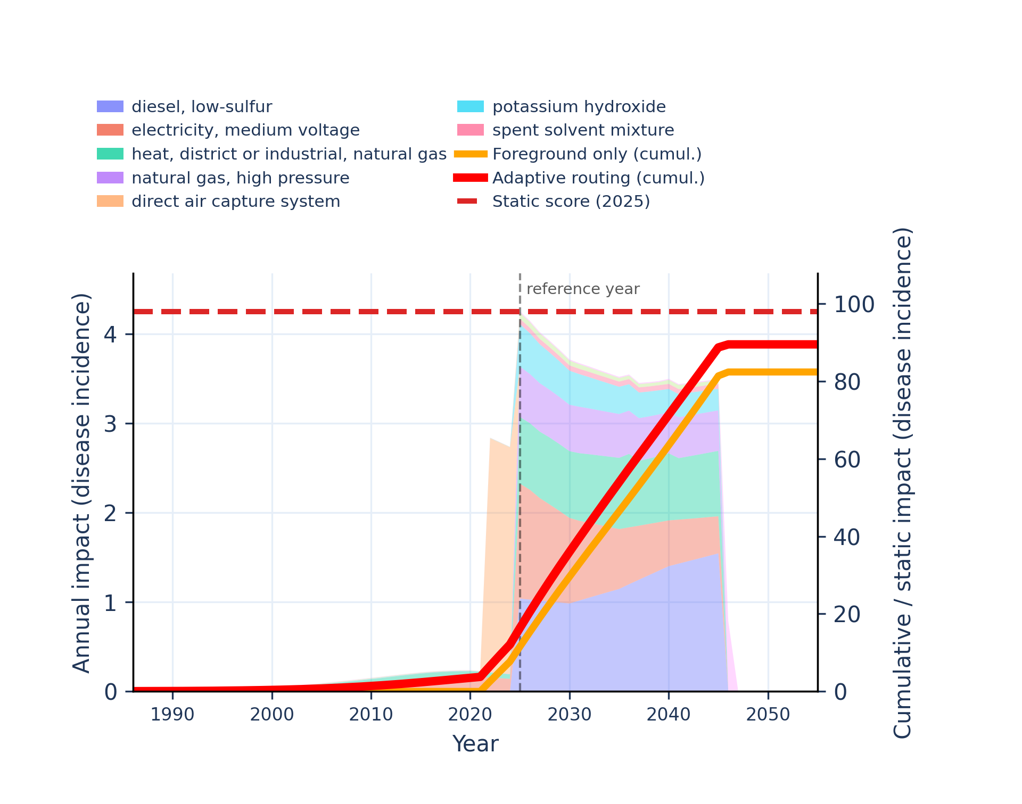
Figure S-routing-daccs-24. photochemical oxidant formation: human health - tropospheric ozone concentration increase.
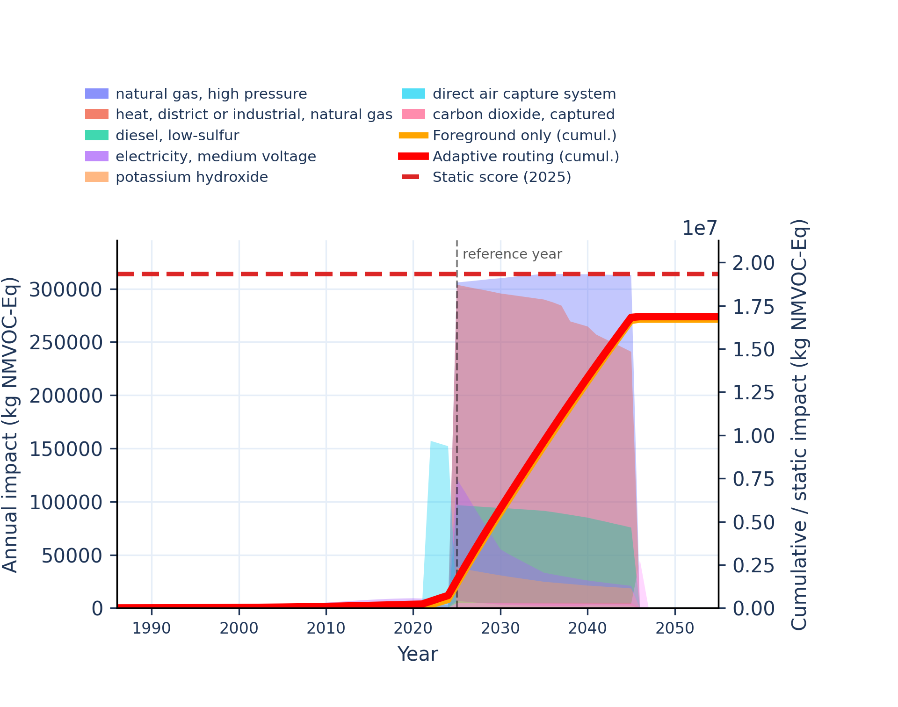 | 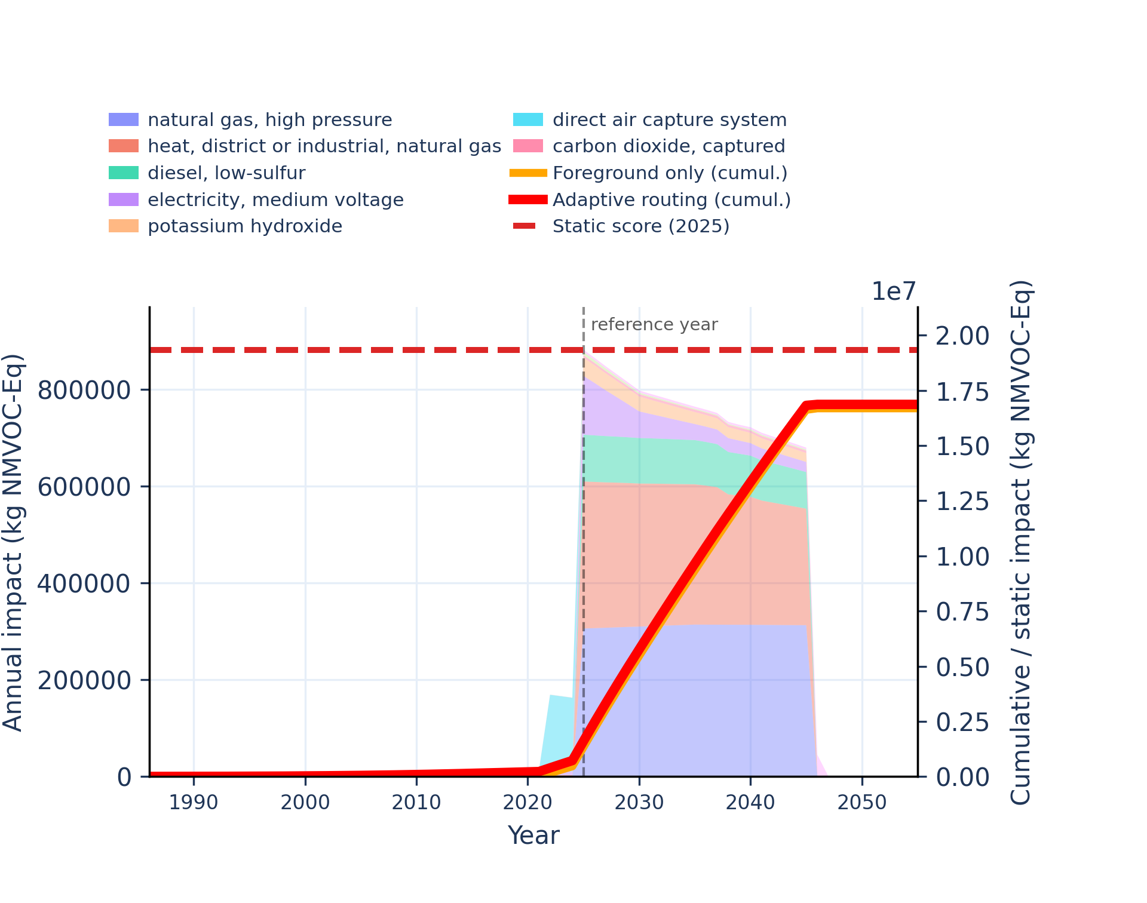
Figure S-routing-daccs-25. water use - user deprivation potential (deprivation-weighted water consumption).
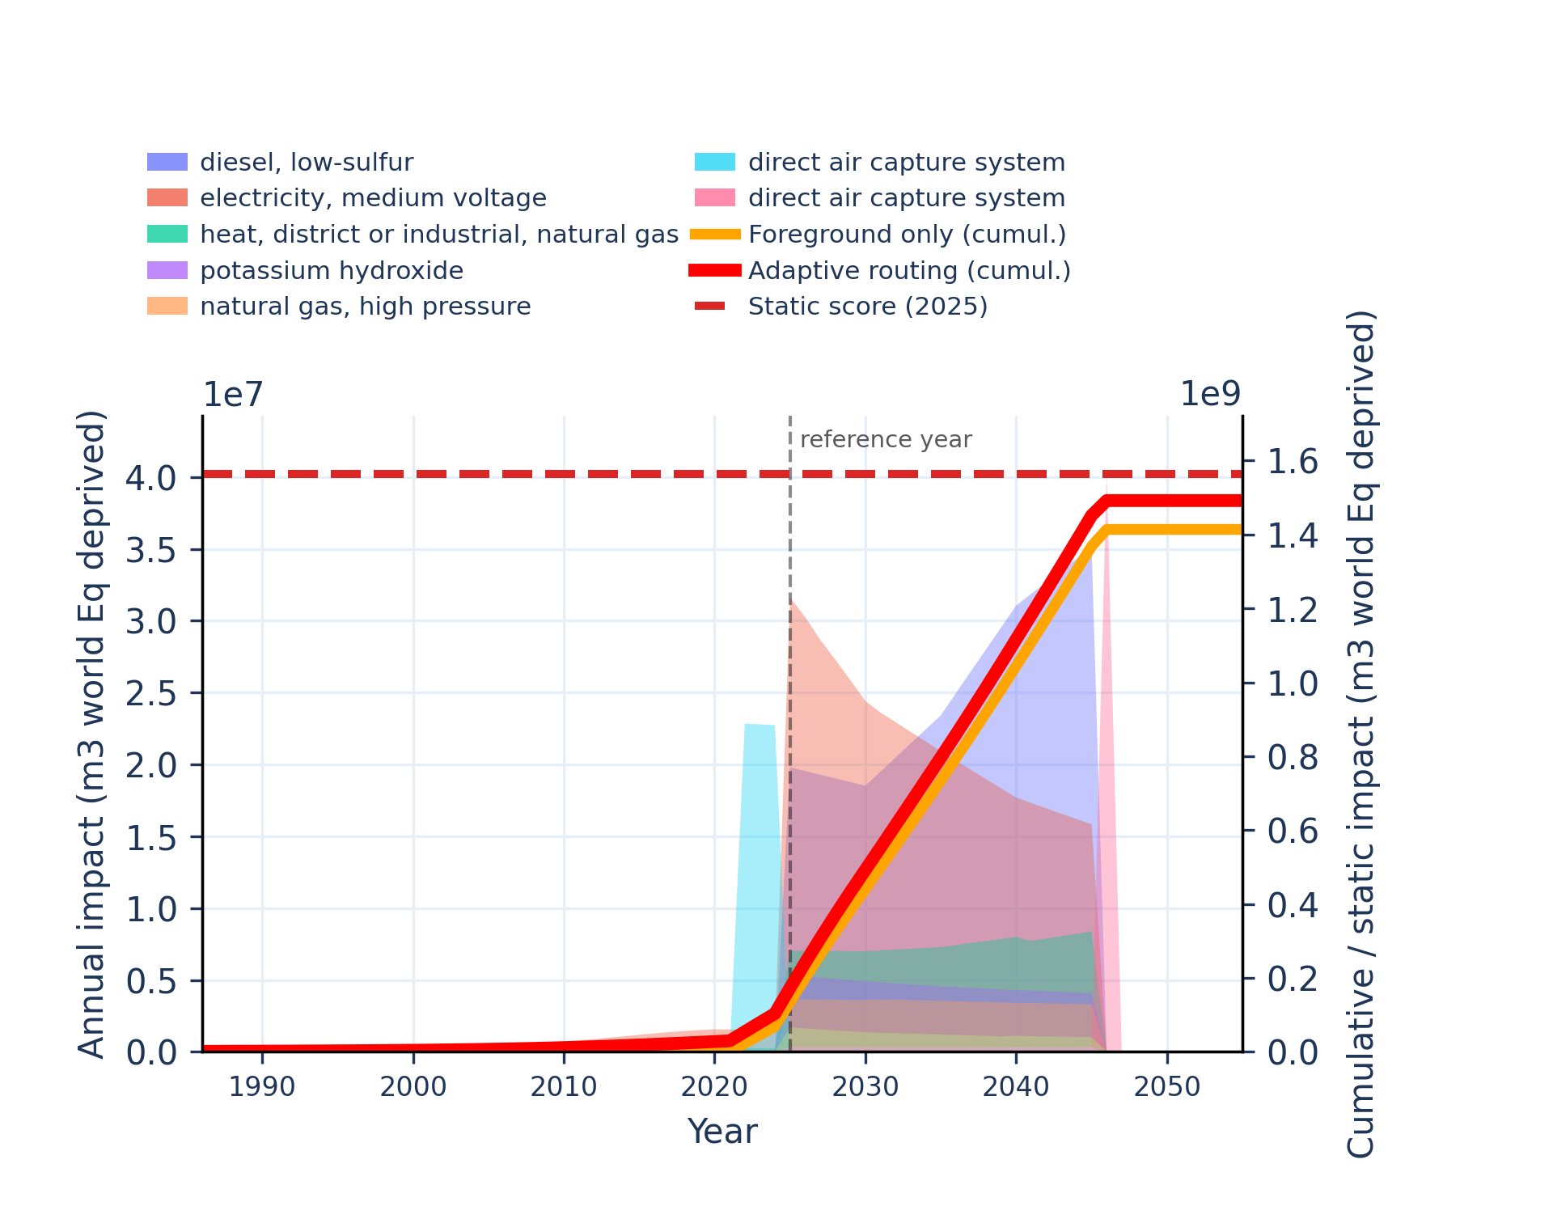 | 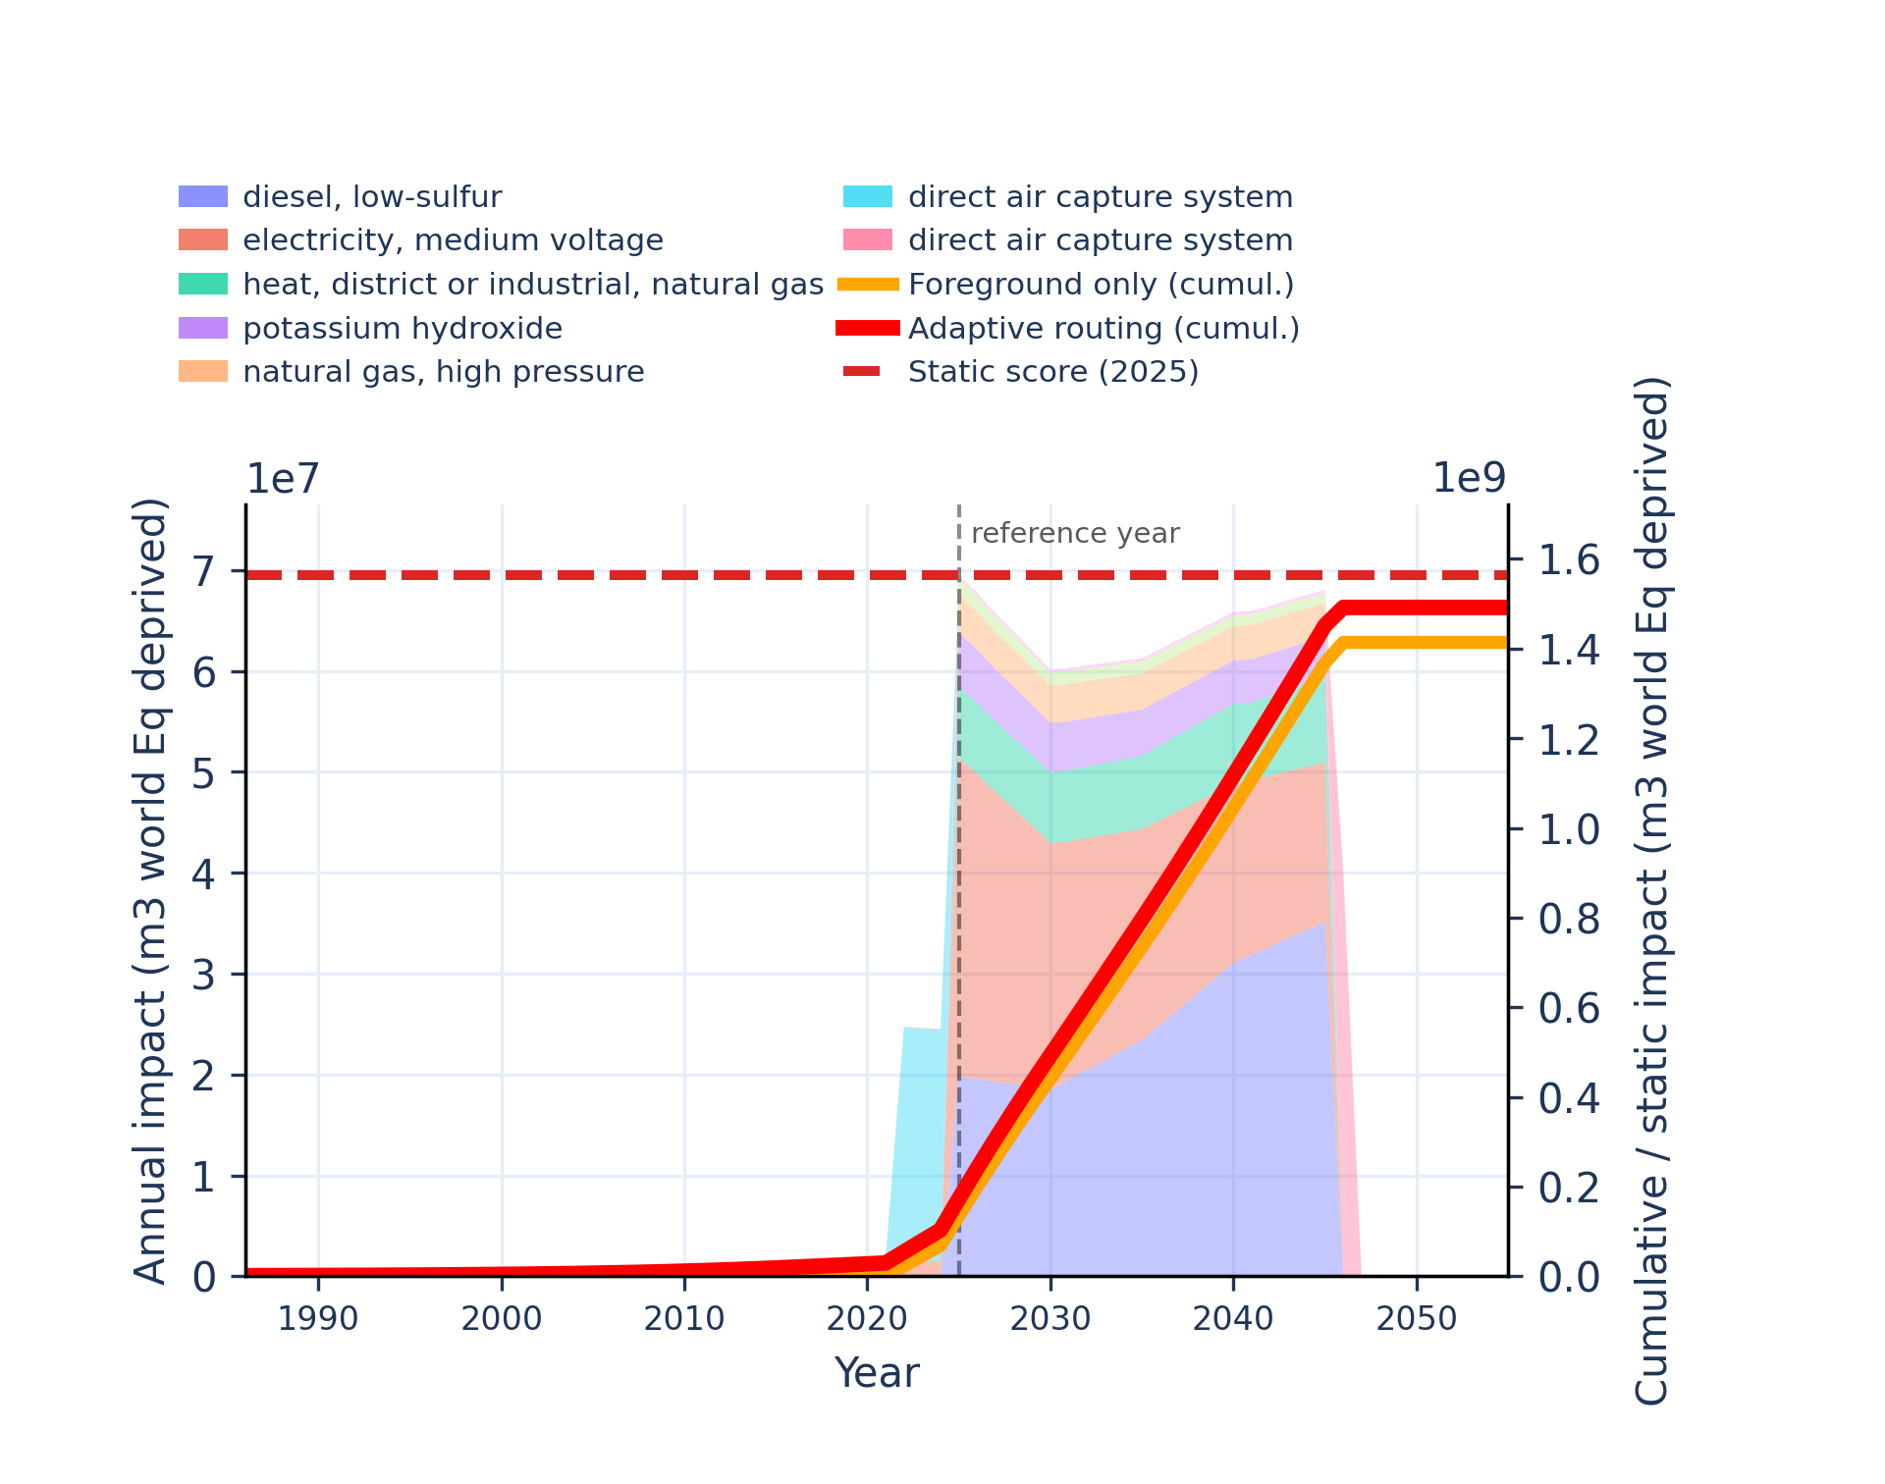

References
Diepers et al. (2026). bw_timex: A Python Package for Time-Explicit Life Cycle Assessment. Journal of Open Source Software, 11(120), 9621, https://doi.org/10.21105/joss.09621.
Astrup, T., Mosbaek, H., and Christensen, T. H. (2006). Assessment of long-term leaching from waste incineration air-pollution-control residues. Waste Management, 26(8), 803-814. https://doi.org/10.1016/j.wasman.2005.12.008.
Baun, D. L., and Christensen, T. H. (2004). Speciation of heavy metals in landfill leachate: A review. Waste Management & Research, 22(1), 3-23. https://doi.org/10.1177/0734242X04042146.
Christensen, T. H., Kjeldsen, P., Bjerg, P. L., Jensen, D. L., Christensen, J. B., Baun, A., Albrechtsen, H.-J., and Heron, G. (2001). Biogeochemistry of landfill leachate plumes. Applied Geochemistry, 16(7-8), 659-718. https://doi.org/10.1016/S0883-2927(00)00082-2.
Doka, G. (2003). Life Cycle Inventories of Waste Treatment Services. ecoinvent report No. 13. Swiss Centre for Life Cycle Inventories, Duebendorf.
Environment Agency. (2003). LandSim 2.5: groundwater risk assessment tool for landfill design (LIT 1773). Environment Agency.
Hischier, R., Weidema, B., Althaus, H.-J., Bauer, C., Doka, G., Dones, R., Frischknecht, R., Hellweg, S., Humbert, S., Jungbluth, N., Koellner, T., Loerincik, Y., Margni, M., and Nemecek, T. (2010). Implementation of Life Cycle Impact Assessment Methods. ecoinvent report No. 3, v2.2. Swiss Centre for Life Cycle Inventories.
Kjeldsen, P., Barlaz, M. A., Rooker, A. P., Baun, A., Ledin, A., and Christensen, T. H. (2002). Present and long-term composition of MSW landfill leachate: A review. Critical Reviews in Environmental Science and Technology, 32(4), 297-336. https://doi.org/10.1080/10643380290813462.
U.S. Environmental Protection Agency. (1999). Understanding Variation in Partition Coefficient, Kd, Values. Volume II: Review of Geochemistry and Available Kd Values for Cadmium, Cesium, Chromium, Lead, Plutonium, Radon, Strontium, Thorium, Tritium (3H), and Uranium (EPA 402-R-99-004B). U.S. EPA.
U.S. Environmental Protection Agency. (2004). Understanding Variation in Partition Coefficient, Kd, Values. Volume III: Review of Geochemistry and Available Kd Values for Americium, Arsenic, Curium, Iodine, Neptunium, Radium, and Technetium (EPA 402-R-04-002C). U.S. EPA.
Zhao, R., Gupta, A., Novak, J. T., and Goldsmith, C. D. (2017). Evolution of nitrogen species in landfill leachates under various stabilization states. Waste Management, 69, 392-401. https://doi.org/10.1016/j.wasman.2017.08.028

