SUPPLEMENTS

Supplementary figure 1. Bootstrapped CIs of estimated edge-weights for the estimated network

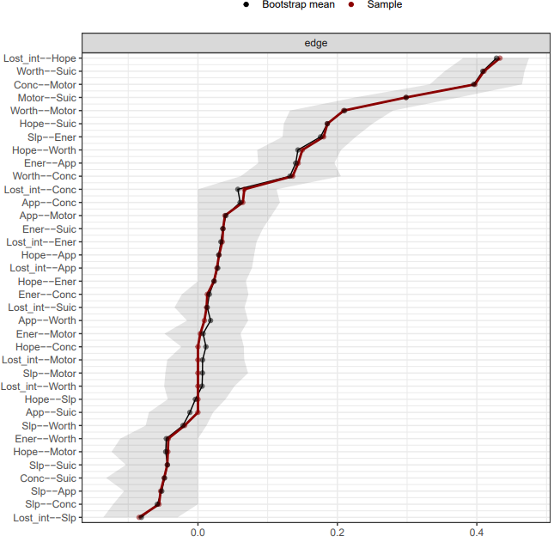
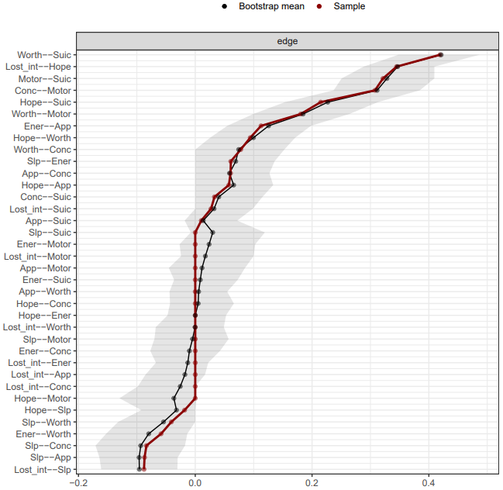
Left and right graph represents data from male and female samples, respectively.
Figure S1 shows the bootstrapped 95% CIs around edge-weights. The X-axis represents the strength of the edge-weights. The y-axis lists all possible edges (i.e., (n*(n-1))/2) = 36) between all items. The red line indicates the sample values, and the grey area indicates the bootstrapped CIs. Each horizontal line represents a specific edge-weight between two items. For an edge to be significant, it should have a narrow bootstrapped CI, which in turn could not contain zero.

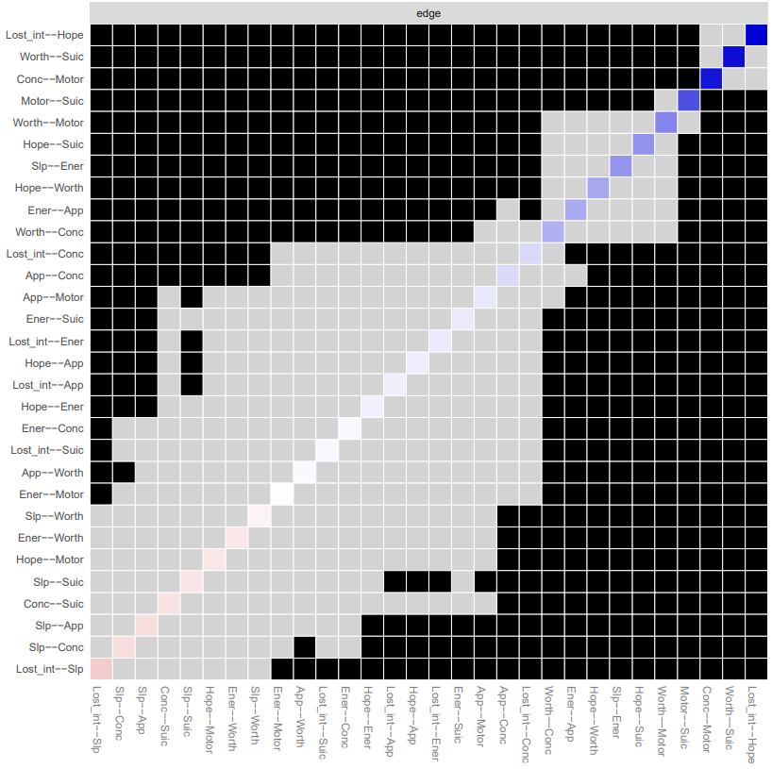
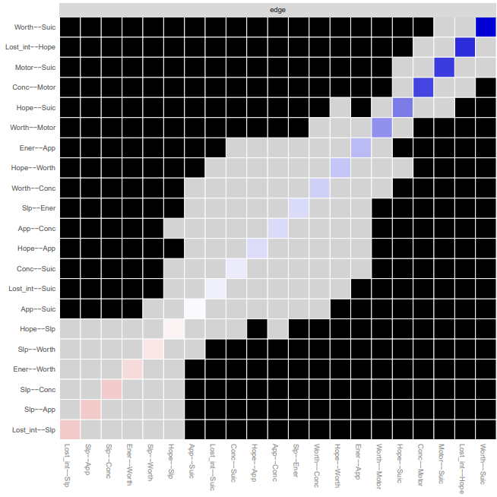
Supplementary figure 2. Plot of the different test for edge-weights

Left and right graph represents data from male and female samples, respectively.
Figure S2 shows the results of the bootstrapped difference tests (α = 0.05) for edge-weights. All possible edges (i.e., (n*(n-1))/2) = 36) between all items are shown at both axes. Grey-colored boxes represent non-significant differences, while black boxes represent significant differences. The diagonal line indicates the strength of edge-weights, shifting from red (negative associations), to white (representing weaker edges) and ultimately dark blue (representing stronger edge-weights).

Supplementary figure 3. Results of case-dropping bootstrap
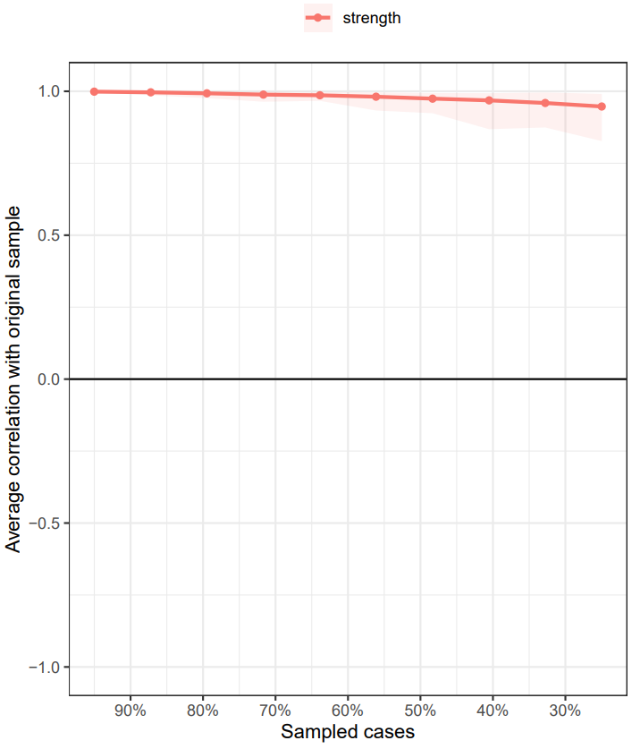
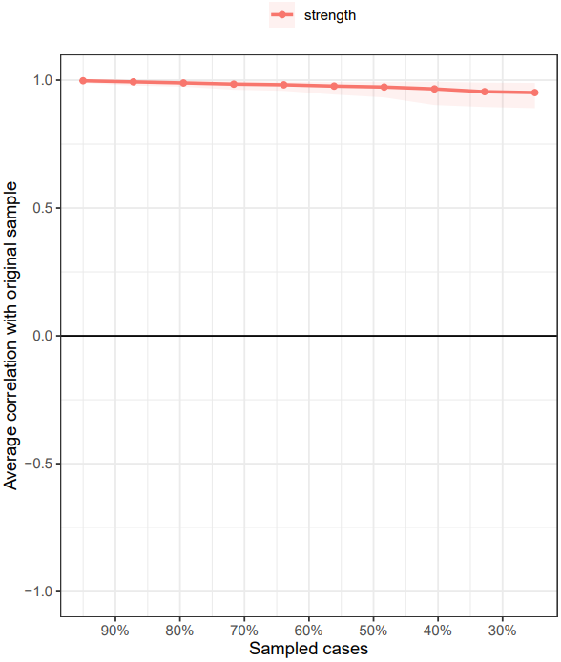

Left and right graph represents data from male and female samples, respectively.
Stability of the node strength centrality was quantified using the CS coefficient, which was used to calculate the maximum drop in proportions to retain a correlation of 0.7 in at least 95 % of the sample. We found that the CS coefficient for node strength was 0.75 for both male and female network.

Supplementary figure 4. Bootstrapped difference tests on the nodal strength of all the items in the network
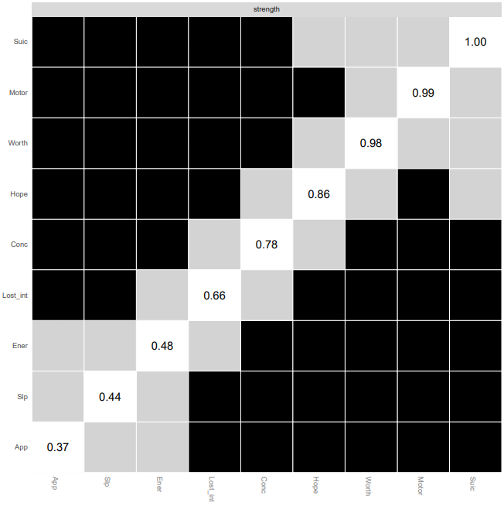
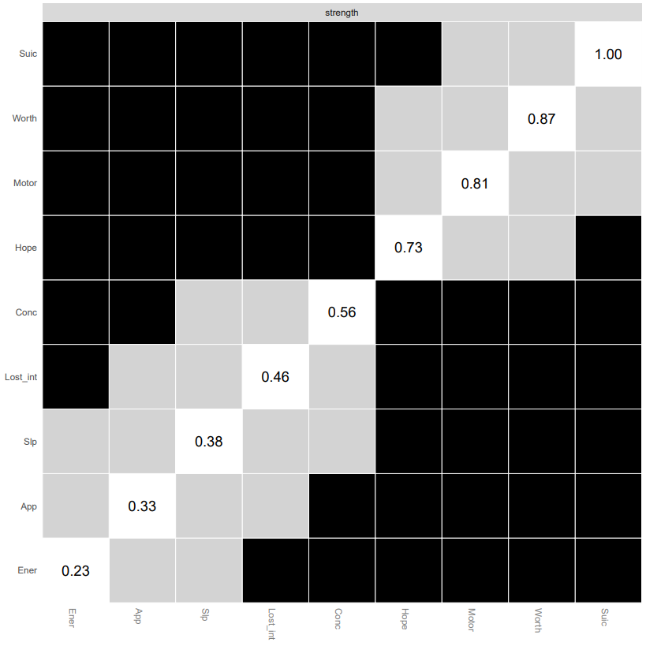

Left and right graph represents data from male and female samples, respectively.
Box colors connote significant difference between nodes (black boxes for significant differences and grey for no significant differences). The numbers in white boxes in the centrality plot indicate strengths of the corresponding nodes.

Supplementary table 1. Centrality table

Node | Male group |  |  | Female group
Node | Strength | Betweenness | Closeness | Strength | Betweenness | Closeness
Lost_int | -0.513 | -0.716 | 0.023 | -0.286 | 0.800 | 0.520
Hope | 0.476 | 0.895 | 0.810 | 0.518 | 1.249 | 0.658
Slp | -0.812 | -0.947 | -0.652 | -1.148 | 0.350 | -0.740
Ener | -1.347 | -0.947 | -1.714 | -0.991 | -0.550 | -1.548
App | -0.996 | -0.716 | -1.251 | -1.420 | -0.999 | -1.571
Worth | 0.995 | -0.026 | 0.414 | 0.948 | -1.899 | 0.499
Conc | -0.136 | -0.026 | 0.319 | 0.194 | 0.350 | 0.564
Motor | 0.771 | 0.435 | 0.888 | 1.004 | 0.800 | 0.731
Suic | 1.562 | 2.047 | 1.164 | 1.180 | -0.100 | 0.885

