Supplementary Table 1. The sequences of primers used for PCR.
Gene | Forward sequence | Reverse sequence
IL-6 | CTTCTTGGGACTGATGCTGGTGAC | TCTGTTGGGAGTGGTATCCTCTGTG
TNF-α | CGCTCTTCTGTCTACTGAACTTCGG | GTGGTTTGTGAGTGTGAGGGTCTG
IL-1β | GCATCCAGCTTCAAATCTCGC | TGTTCATCTCGGAGCCTGTAGTG
Hbb-bs | CAAAGTACCGCTGGGTCCAA | CTGCTTACCAGCAGGCACTA
Acta1 | GAGTCTGCGGGTGGTAATGG | GCTATTGAGCCTTGGGCTTG
Myl3 | AGTGTGGGTAGGGATCGTCT | GCTTCACAAACGCTGGAAGG

Supplementary Table 2. Annotation of mass spectrometry fragments of antibacterial active substances
Formula | m/z obs. | Calculated m/z | Mass error (Da) | Mass error (ppm)
C31H44O7P- | 559.2874 | 559.2830 | 0.0044 | 7.87
C30H44O5P- | 515.2971 | 515.2932 | 0.0039 | 7.57
H2O4P- | 96.9694 | 96.9696 | -0.0002 | -2.06
O3P- | 78.9592 | 78.9591 | 0.0001 | 1.27

Supplementary Table 3. Stability of Oxydifficidin to temperature, pH and enzyme.
pH | Retained  activity (%) | Temperature(◦C) | Retained  activity (%) | Proteolytic enzymes | Retained  activity (%)
3 | 0 | 25 | 100 | Neutral Protease | 90.9
4 | 43.1 | 40 | 100 | Alkaline Protease | 86.3
5 | 76.6 | 60 | 85.1 | Protease K | 63.6
6 | 80.9 | 80 | 46.9 | Control | 100
7 | 100 | 100 | 25.5 | — | —
8 | 100 | — | — | — | —
9 | 39.6 | — | — | — | —

Supplementary Table 4. MIC values of Oxydifficidin against various indicator bacteria.
Indicator bacteria | MIC (μg/mL)
Multidrug-resistant Escherichia coli | 32
Shigella spp. | 64
Klebsiella pneumoniae | 16
Multidrug-resistant Acinetobacter baumannii | 16
Escherichia coli ATCC 25922 | 32
Escherichia coli K88 | 32
Salmonella sp. H9812 | 16
Bacillus subtilis | 64
Methicillin-resistant Staphylococcus aureus | 128
Staphylococcus aureus ATCC 25923 | 128

Supplementary Table 5. Biochemical indicators of toxicity experiments in mice
Parameters | Unit | Reference range | Mean value
White blood cell count (WBC) | ×10⁹/L | 0.8-6.8 | 0.27
Red blood cell count (RBC) | ×10¹²/L | 6.36-9.42 | 6.87
Hemoglobin (HGB) | g/L | 110-143 | 100
Mean corpuscular volume (MCV) | fL | 48.2-58.3 | 56.8
Platelet count (PLT) | ×10⁹/L | 450-1590 | 424
Lymphocyte count (LYM) | ×10⁹/L | 0.7-5.7 | 0.27
Mid-sized cell count (MID) | ×10⁹/L | 0.1-1.8 | 0.01
Granulocyte count (GRA) | ×10⁹/L | 0.1-1.8 | 0.02
Lymphocyte percentage (LYM%) | % | 55.8-90.6 | 97.9
Mid-sized cell percentage (MID%) | % | 1.8-6 | 0.4
Granulocyte percentage (GRA%) | % | 8.6-38.9 | 1.7
Platelet distribution width (PDW) | % | 13-50 | 29.9
Large platelet count (P-LCC) | ×10⁹/L | 10-100 | 127
Hematocrit (HCT) | % | 34.6-44.6 | 39
Mean corpuscular hemoglobin concentration (MCHC) | g/L | 302-353 | 256
Red cell distribution width coefficient of variation (RDW-CV) | % | 11-17 | 11
Red cell distribution width standard deviation (RDW-SD) | fL | 33-50 | 67.8
Mean corpuscular hemoglobin (MCH) | pg | 15.8-19 | 14.6
Mean platelet volume (MPV) | fL | 3.8-6 | 9.8

Supplementary Figure 1. Secondary screening and morphological identification of the screened strain. (A) Secondary screening results of strain fermentation supernatants. (B) Colony morphology of the isolated strain. (C) Phylogenetic tree of strain Y4 based on 16S rRNA gene sequences.

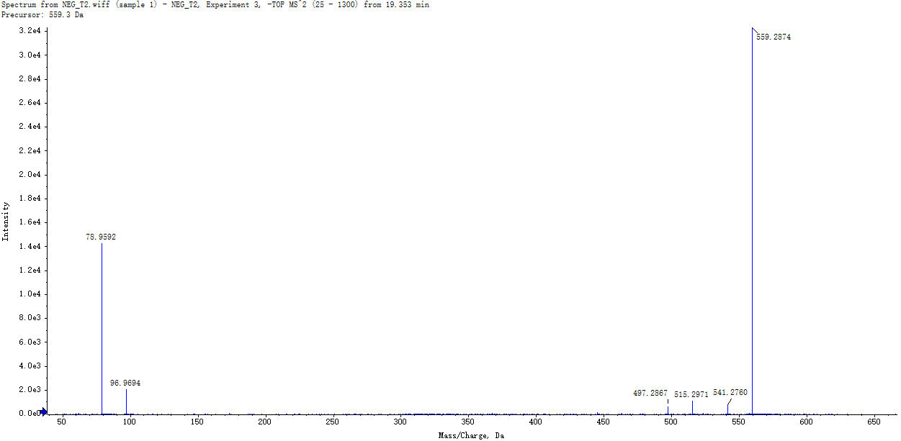
Supplementary Figure 2. LC–MS analysis of the purified bioactive compound produced by Bacillus subtilis Y4. Secondary mass spectrometry of bioactive compound Oxydifficidin.

Supplementary Figure 3. The long-term storage stability of Oxydifficidin
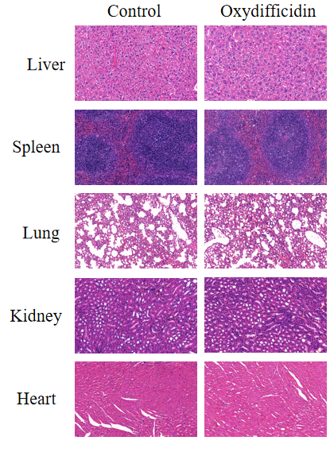
Supplementary Figure 4. In vivo toxicity assessment of Oxydifficidin. H&E staining of each tissue after Oxydifficidin treatment，Scale bar, 50 μm.
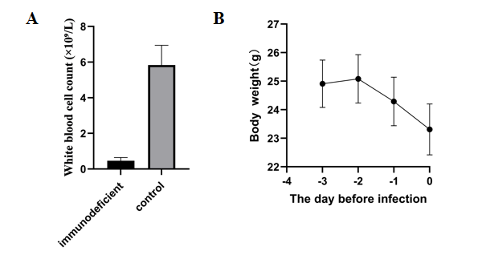

Supplementary Figure 5. White blood cell count and body weight changes in BALB/c mice during cyclophosphamide-induced immunosuppression modeling.(A) White blood cell counts in immunodeficient and control mice.(B) Body weight changes of mice during the modeling period.

