Supporting Information
Smartphone-assisted read result colorimetric and fluorescent dual readout mode immunosensor for the detection of ochratoxin A
based on MnO₂NS-TMB
Qian Zhang ª, Guohua Liu ª, Liping Luo ª, Bingjing Li ª, Hongzao He ^{b,} *

ª Guizhou Institute of Biology, Guizhou Academy of Sciences, 550009, People’s Republic of China
^{b} Guizhou Academy of Testing and Analysis, Guizhou Academy of Sciences, 550014, People’s Republic of China

¹ These authors contributed equally.
* Corresponding authors
E-mail address: 18384046929@163.com (H. He).
2. Material and methods
2.1 Reagents and consumables
Hydrochloric acid (HCl), acetic acid, ascorbic acid (AA), sodium acetate, rhodamine b, Tris, sodium chloride (NaCl), sodium bimetallic phosphate (Na₂HPO₄), muriate (KCl) and monopotassium phosphate (KH₂PO₄) were purchased from Sinopharm Chemical Reagent Co., Ltd (Shanghai, China)., Dimethyl sulfoxide（DMSO） and Tween-200 were obtained from Aladdin (Shanghai, China). Bovine serum albumin-conjugated Ochratoxin A (BSA-OTA) were got from Dalian Precision inspection Biotechnology Co., Ltd. The mouse anti-OTA monoclonal antibody (McAb) was got from Shandong Blue Capital Biotechnology Co., Ltd. Alkaline phosphatase conjugated-labeled goat anti-mouse IgG (ALP-IgG) was gained from ABclonal Biotechnology Co., Ltd. (Wuhan, China). T-2 toxin (T-2), fumonisin B₁ (FB₁), patulin (PTL), aflatoxin B₂ (AFB₂), ochratoxin A (OTA) and deoxynivalenol (DON) were purchased from Tanmo Inspection Technology Co., Ltd. Tetramethylbenzidine (TMB), Sodium Lauryl Sulfate (SDS) and Alkaline phosphatase (ALP) were purchased from Shanghai Macklin Biochemical Co., Ltd (Shanghai, China).

2.2 Instruments and equipment
Table S1 Instruments and equipment
Instrument | Manufacturer
Analytical balance | Mettler Toledo Technology (China) Co., Ltd
-20℃ refrigerator | Qingdao Haier Co. Ltd
Multifunction microplate reader | Shanghai Flash Spectrum Biotechnology Co., Ltd
High speed centrifuge | Eppendorf AG
Thermostatic magnetic stirrer | IKA (Guangzhou) Equipment Co., Ltd (IKA China)
Transmission electron microscopy | Hitachi, Ltd
Up water purification system | Merck KGaA
Microplate thermostatic incubator | Shanghai Huxi Industrial Co., Ltd
Ultrasonic processor | Ningbo Xinzhi Biotechnology Co., Ltd
2.3 Method
2.3.1The preparation of MnO₂ NS
Firstly, KMnO₄ (45 mL, 0.01 M) was added to 60 mL 2-morpholinoethanesulfonic acid (MES) solution (0.1 M, pH 6.0) and thoroughly mixed. Subsequently, the mixture was subjected to ultrasonic treatment for 5 minutes, followed by centrifugation to collect the resulting precipitate. Finally, the precipitate was washed three times with ultrapure water, resuspended in 100 mL of ultrapure water via ultrasonic treatment, and stored at 4 °C for subsequent use.
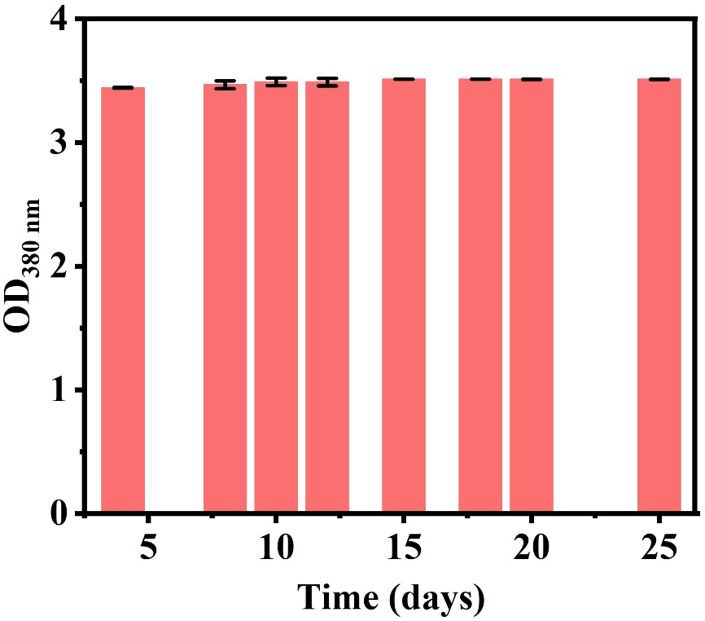
Figure S1. Stability of MnO₂ NS

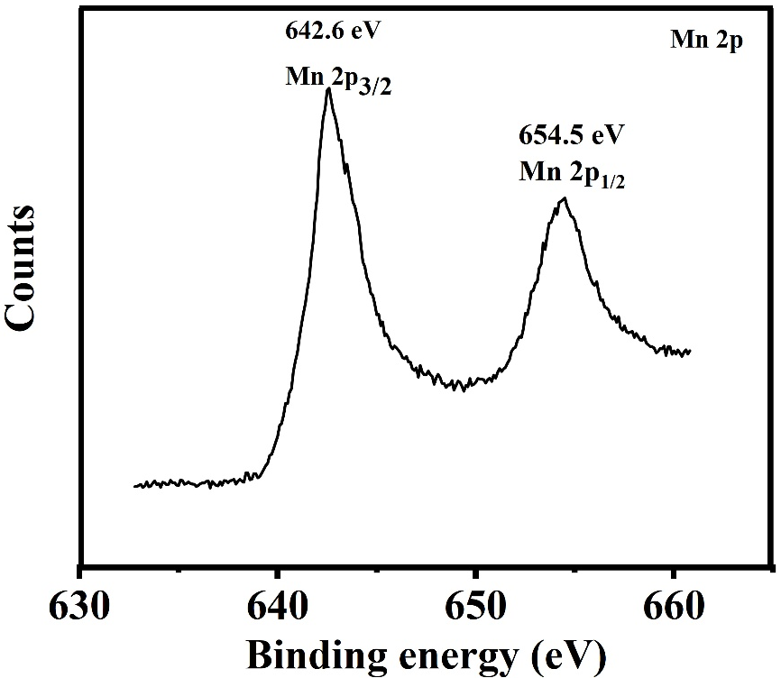
Figure S2. XPS spectrum of Mn 2p.

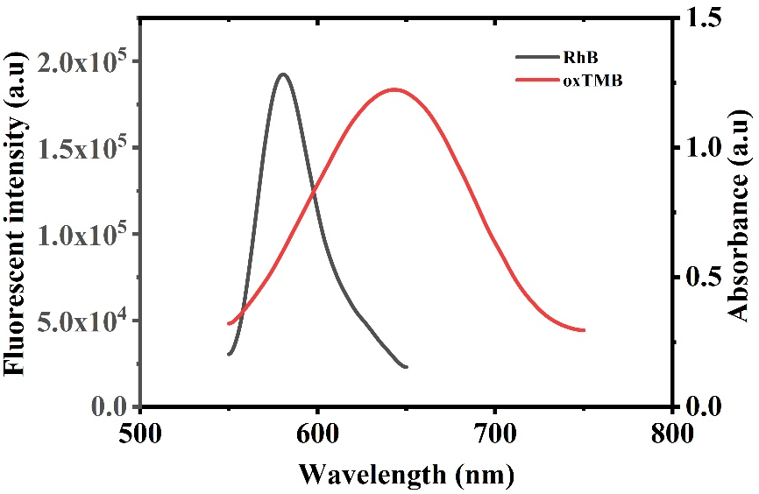
Figure S3. The UV-vis absorption spectrum of oxTMB and fluorescence emission spectrum of RhB.

