Supplementary Material

S1 2D SWE image acquisition
Blinded to clinical data, two radiologists with over 5 years of abdominal ultrasound experience performed two-dimensional (2D) shear wave elastography (SWE) using a Supersonic Aixplorer ultrasound system (SuperSonic Imagine, Aix-en-Provence, France) equipped with an SC6-1 convex probe. All patients fasted for ≥4 hours prior to the examination and were placed in a supine position with slight right lateral decubitus to optimize liver visualization. The operators strictly adhered to the guidelines of the Society of Radiologists in Ultrasound.
Measurements were acquired in the right hepatic lobe through intercostal spaces, with patients instructed to hold their breath gently during data acquisition to minimize motion artifacts. The elastography color scale was set to a maximum of 40 kPa, and all imaging parameters (e.g., probe frequency, depth, gain) were standardized and maintained consistent across all patients. A 4×3-cm rectangular elastography-derived region of interest (SWE ROI) was placed 1-2 cm below the liver capsule, with careful avoidance of large blood vessels, bile ducts, calcifications, and acoustic shadowing, and a corresponding gray-scale ultrasound ROI (gray-scale ROI) for anatomical and structural assessment, both ROIs are dynamically synchronized and spatially aligned to enable simultaneous analysis.
Each patient underwent five consecutive 2D SWE measurements in distinct regions of the right hepatic lobe. A circular Q-Box ROI (10-20 mm in diameter) was placed within the rectangular SWE ROI to automatically generate elasticity values (kPa). Only images meeting strict quality control criteria were retained for subsequent analysis: (1) ≥80% signal filling within the SWE ROI; (2) no motion artifacts or signal dropout; (3) compliance with the interquartile range/median ratio (IQR/M) ≤0.30. The final SWE value for each patient was defined as the average of the five valid mean elasticity measurements.

S2 Intrahepatic heterogeneity score calculation
The rectangular SWE and gray-scale ROIs in 2D SWE images were selected as the target region for extracting intrahepatic local radiomic features. A 5×5-mm square sliding window was implemented centered at each pixel within the ROI, and 104 radiomic features were extracted per window using PyRadiomics (version 3.1). These features included 19 first-order statistics features, 10 shape-based features, and 75 texture features. The definitions and calculation formulas for each feature are provided in the official documentation (https://pyradiomics.readthedocs.io/en/latest/features.html). All features were normalized to eliminate scale biases.
A K-means clustering algorithm was applied to the radiomic features of all pixels to identify subregions with homogeneous feature distributions within the liver. The number of clusters (k) determines the clustering resolution, and the optimal k was determined using the elbow method. This method entails the following sequential steps: first, defining a range of candidate k values (range 3 to 9 in this study); second, running the K-means algorithm for each candidate k and calculating the corresponding sum of squared errors (SSE), which is defined as the sum of squared Euclidean distances between each pixel and the center of its assigned cluster; third, plotting the SSE values against the candidate k values to generate an SSE-k curve. The optimal k is then identified as the elbow point on this curve, where the rate of SSE reduction slows sharply with increasing k, indicating that further increases in cluster number yield negligible improvements in clustering accuracy.
The calculation of the intrahepatic heterogeneity (IHH) score relies on the number of connected regions and their maximum area per cluster, with a higher score indicating greater heterogeneity of the clustering patterns and more pronounced spatial heterogeneity of the liver. Ultimately, each ROI was assigned a corresponding IHH score and the optimal number of clusters. After clustering, pixels in the same cluster were labeled with the same color to generate a cluster label map. This map provides an intuitive visualization of intrahepatic subregion distribution and heterogeneity.

S3 Conventional radiomic score development
Radiomic features were extracted from the original images of each SWE ROI and gray-scale ROI using Pyradiomics software (version 3.0.1), yielding 91 features per ROI. These features were categorized into two classes: first-order statistical features (n=18) and textural features (n=73), including those derived from the gray level co-occurrence matrix (GLCM), gray-level run-length matrix (GLRLM), gray-level size zone matrix (GLSZM), gray-level dependence matrix (GLDM), and neighborhood gray-tone difference matrix (NGTDM).
Subsequently, radiomic feature selection was performed on the training cohort via three sequential steps: initially, features with a Spearman’s rank correlation coefficient (r) > 0.8 were identified, and for each highly correlated feature cluster, the feature with the highest average inter-feature correlation was eliminated to avoid multicollinearity; this was followed by univariate Cox regression analysis, with only features meeting a p < 0.05 retained; and ultimately, a 10-fold cross-validated Cox proportional hazards model integrated with least absolute shrinkage and selection operator (LASSO) regression (Cox-LASSO) was applied for final feature selection, where the optimal λ parameter was determined by minimizing the mean squared error .
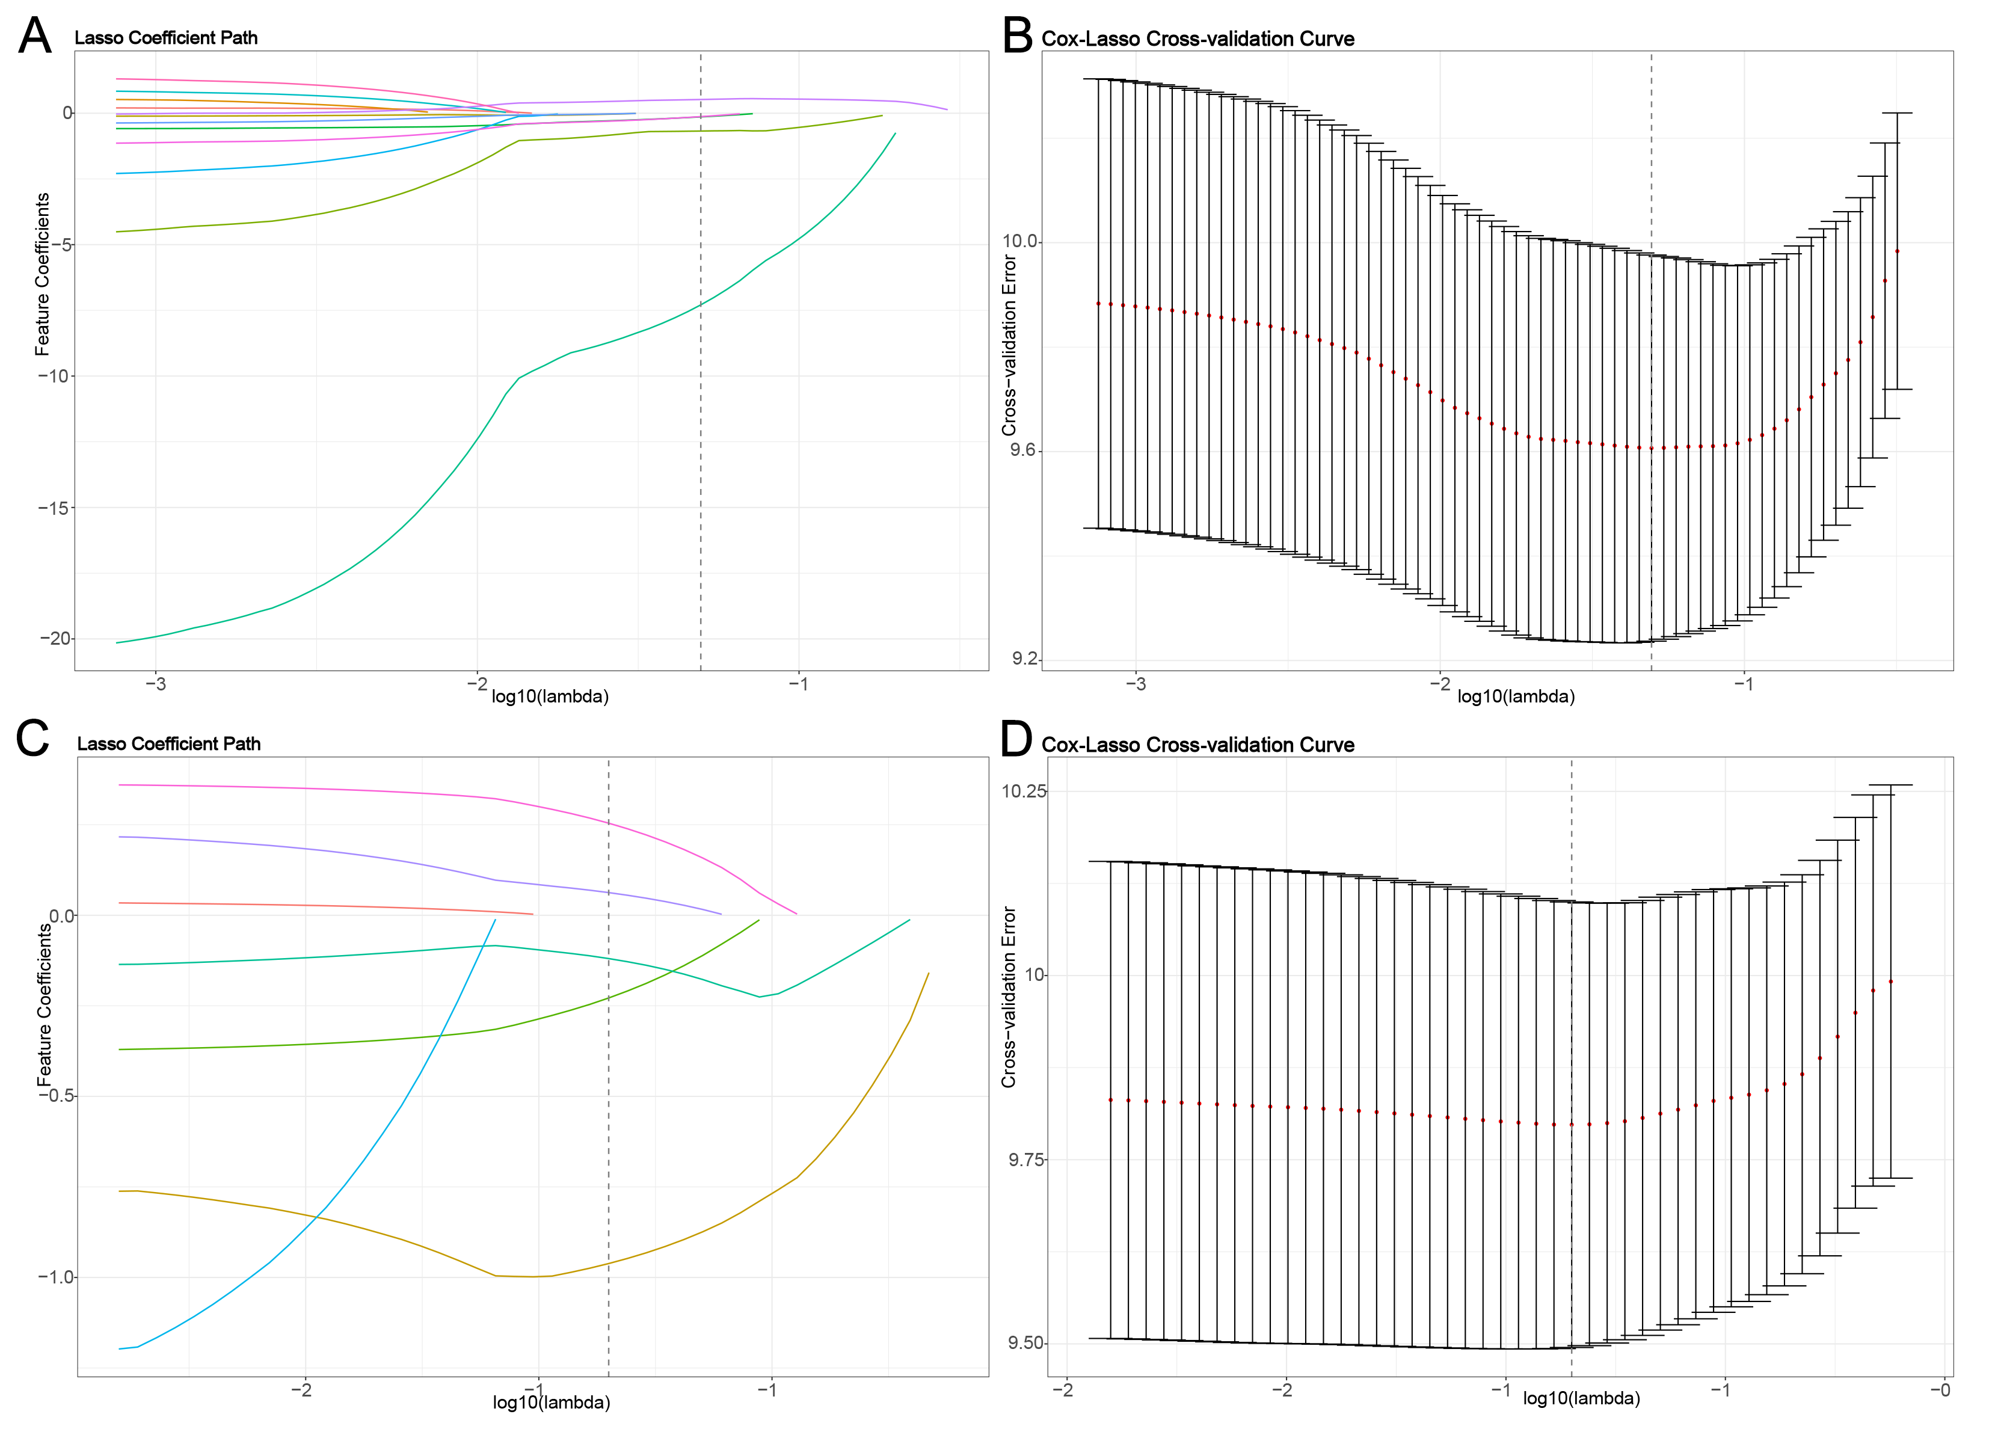
For radiomic features from the SWE ROI, 23 were retained via Spearman’s rank correlation analysis, filtered to 12 through univariate Cox regression, and narrowed to 5 with Cox-LASSO regression (λ = 0.049). These five features, were used to construct Rswe based on multivariate Cox regression, including firstorder_Range, glcm_Contrast, glcm_Imc2, ngtdm_Busyness, and ngtdm_Coarseness.
Similarly, for features from the gray-scale ROI, 16 were retained by correlation analysis, cut to 7 through univariate analysis, and finalized to 5 with Cox-LASSO (λ = 0.045). The five features, firstorder_RobustMeanAbsoluteDeviation, firstorder_Skewness, glcm_Contrast, gldm_GrayLevelNonUniformity, ngtdm_Busyness, were used to build Rgray using multivariate Cox regression.

S4 Clinical data-based models development
S4.1 Clinical model
Cox regression analyses were used to identify independent clinical predictors of 5-year mortality in the training cohort, with the hazard ratios (HR) and 95% confidence intervals (CI) computed. Parameters with p < 0.05 in univariate analysis were advanced to a stepwise multivariate model to adjust for potential confounders, and statistically significant parameters (p < 0.05) in the latter were included in the clinical model.
S4.2 Model for end-stage liver disease (MELD) score
$$MELD score = 9.57×Ln(Creatinine\{mg/dl\})+3.78×Ln(Bilirubin\{mg/dl\})+11.20×Ln(INR)+6.43$$
Note: If any score is <1, the MELD assumes the score is equal to 1; and, if hemodialysis, value for Creatinine is automatically set to 4.0.

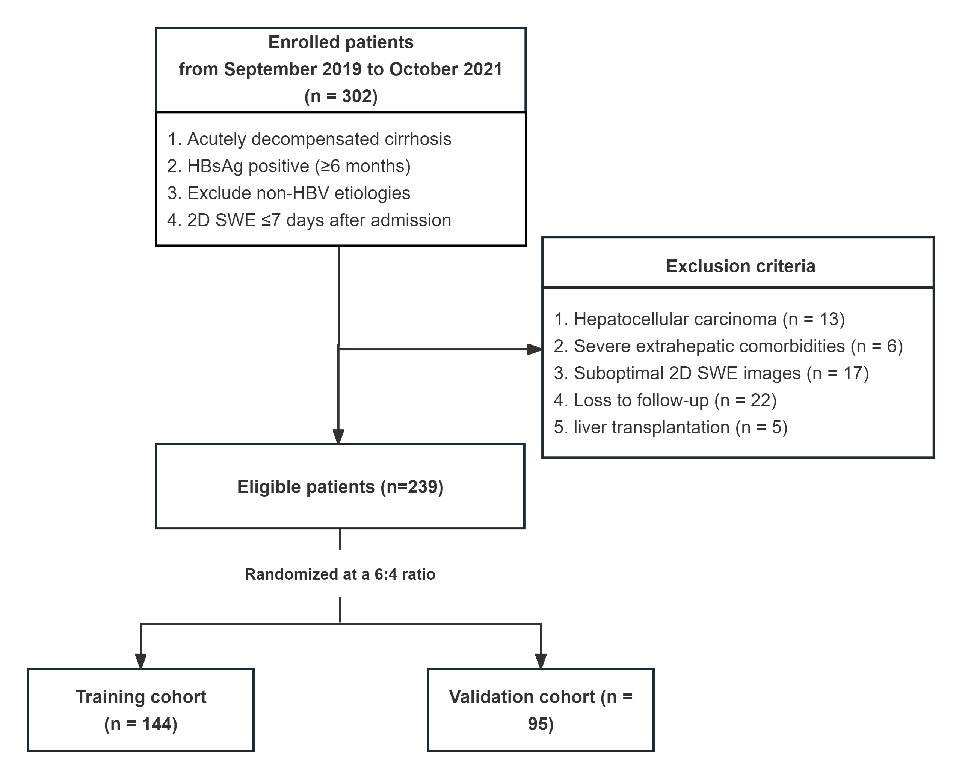

Supplementary Figure S1: Flowchart of the patient enrollment.
Abbreviations: 2D, two-dimensional; HBV, Hepatitis B virus; SWE, shear wave elastography.

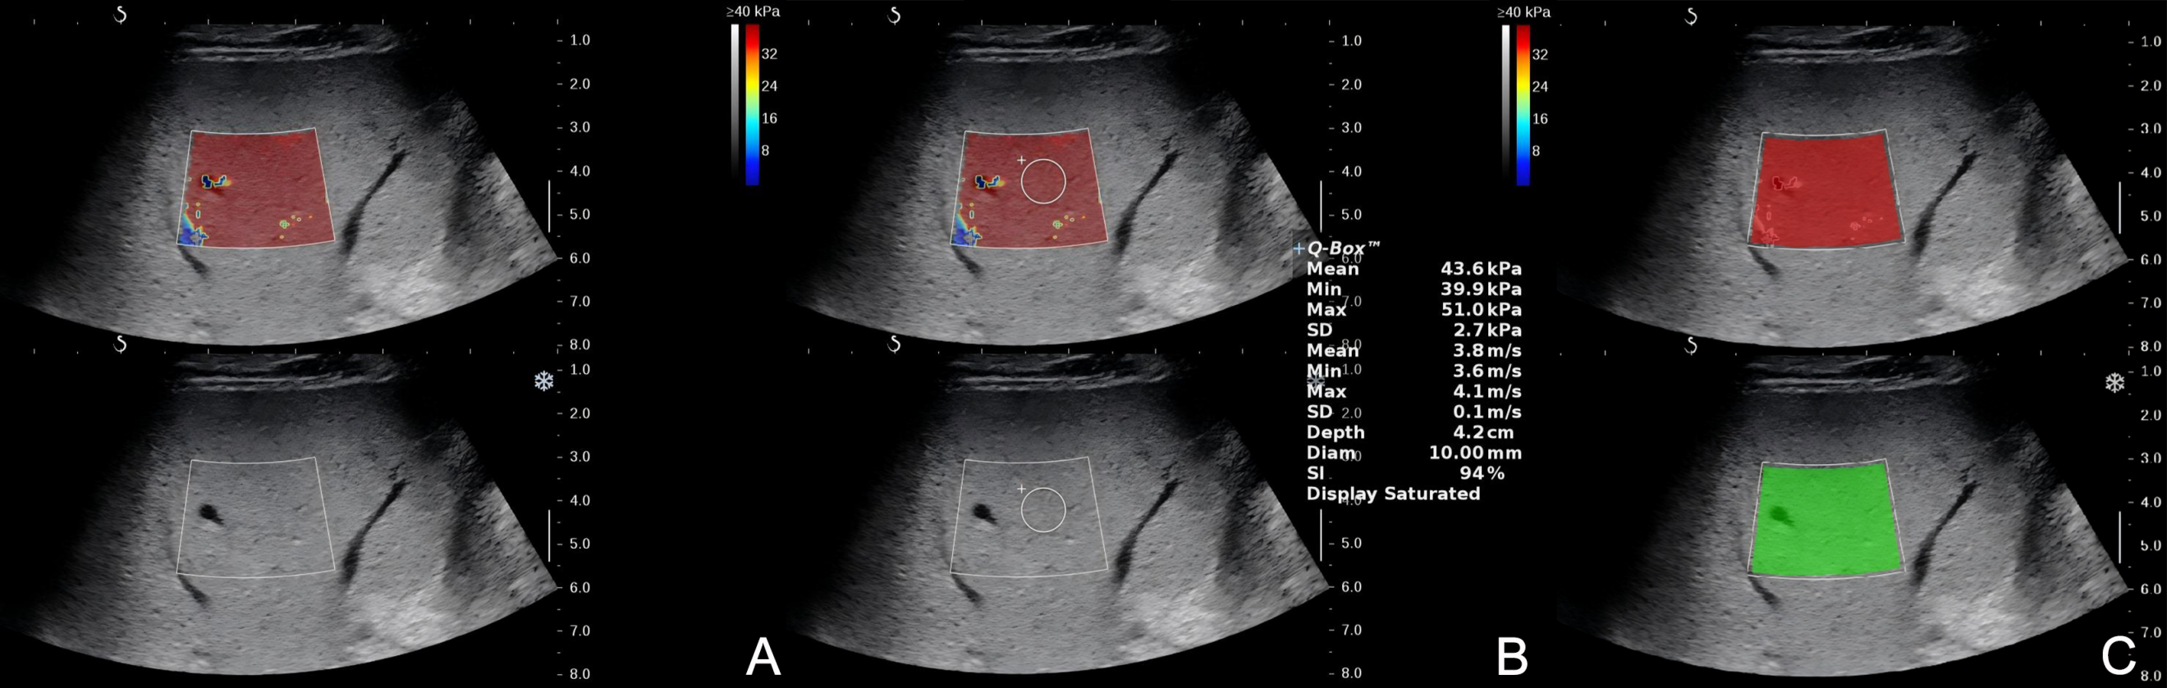

Supplementary Figure S2: Two-dimensional (2D) shear wave elastography (SWE) of the liver and delineation of dual-modality regions of interest (ROIs).
(A) Representative 2D SWE imaging. (B) Measurement of hepatic elasticity, with the mean elasticity value derived from the circular Q-box within the elastography box. (C) The SWE ROI (highlighted in red) displays the elastography map configured with a 40 kPa scale, which is spatially co-registered with the corresponding gray-scale ROI (highlighted in green).

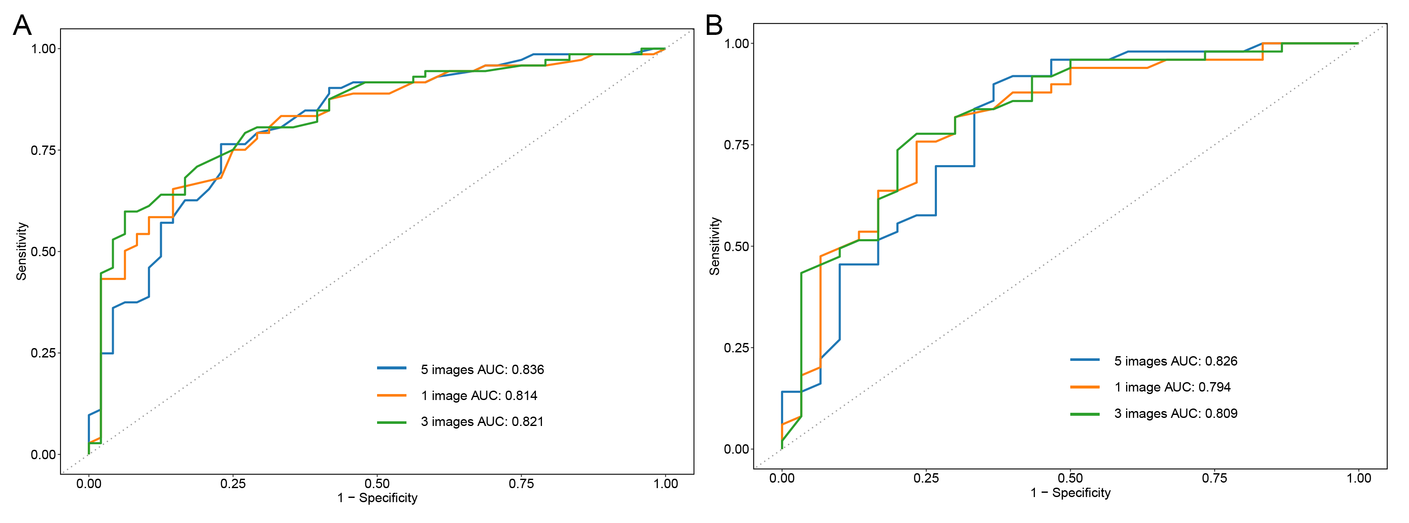

Supplementary Figure S3: Time-dependent ROC analysis of Hswe based on different numbers of IHH measurements.
Time-dependent ROC curves illustrating the discriminative ability of Hswe calculated from 1, 3, or 5 images in the training (A) and validation (B) cohorts.

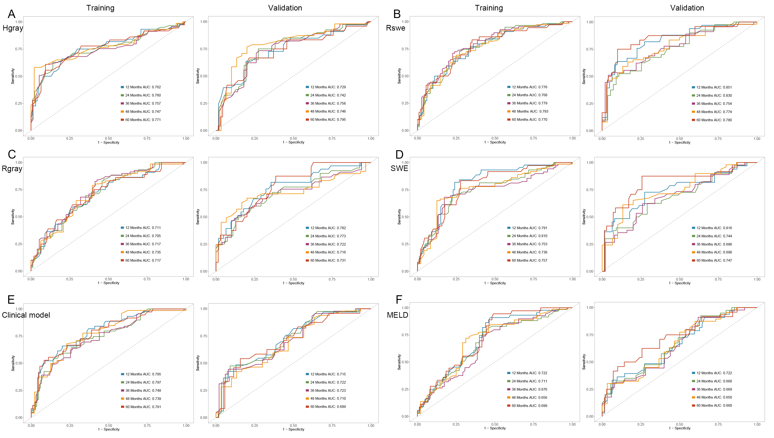

Supplementary Figure S4: Time-dependent ROC curves of the prognostic models.
The predictive discrimination across 1 to 5 years in the training and validation cohorts forthe following models: (A) Hgray, (B) Rswe, (C) Rgray, (D) SWE, (E) Clinical model, and (F) MELD. Abbreviations: MELD, model for end-stage liver disease; SWE, shear wave elastography.

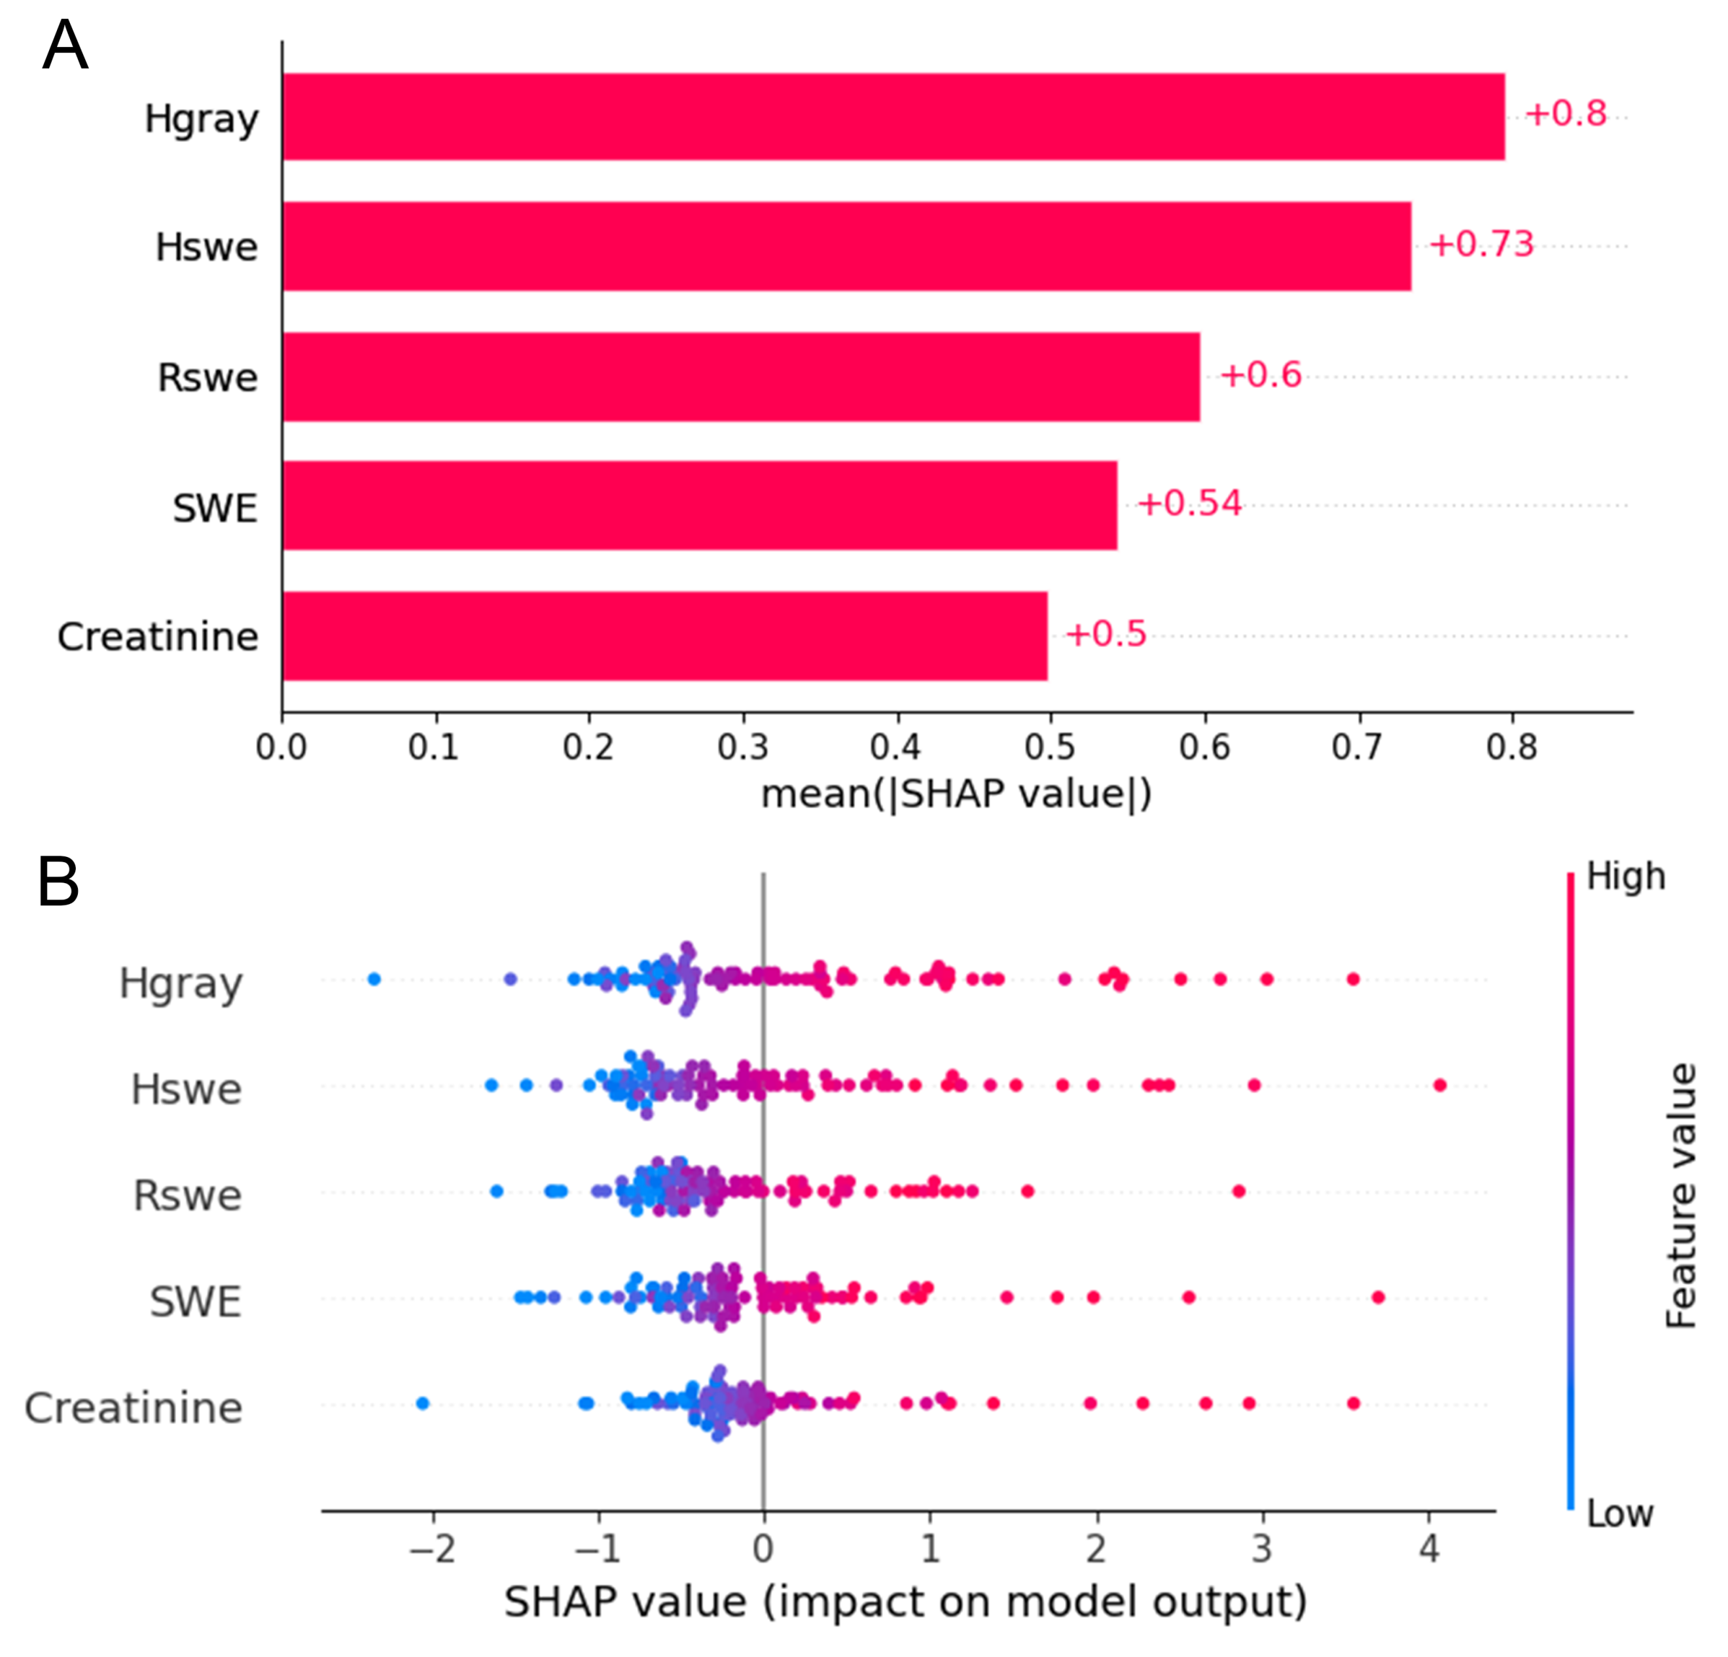

Supplementary Figure S5: SHAP analysis illustrating feature importance and directional impact within the multimodal model.
(A) Bar plot ranking the predictive features by their mean absolute SHAP values, demonstrating global feature importance. (B) Beeswarm plot detailing the impact of individual feature values on the model's prediction. The color scale (blue to red) corresponds to the feature value (low to high), revealing how specific values drive the model output. Abbreviation: SWE, shear wave elastography.

Table S1: Baseline characteristics of patients stratified by clinical outcomes.
 | Training cohort |  |  | Validation cohort
Characteristic | Survivors (n = 72) | Non-Survivors (n = 72) | p value | Survivors (n = 46) | Non-Survivors (n = 49) | p value
Demographic data
Age (years) | 52.00 (45.00-60.00) | 57.00 (49.00-63.50) | 0.023 | 51.50 (45.00-58.75) | 55.00 (47.00-61.00) | 0.299
Gender (female), n (%) | 24 (33.3) | 17 (23.6) | 0.196 | 8 (17.4) | 9 (18.4) | 0.901
Clinical data
MBP (mmHg) | 88.00 (80.25-96.92) | 86.50 (80.00-94.78) | 0.558 | 92.00 (82.00-99.33) | 86.33 (74.00-93.33) | 0.114
Ascites, n (%) | 62 (86.1) | 68 (94.4) | 0.091 | 36 (78.3) | 45 (91.8) | 0.062
Infection, n (%) | 51 (70.8) | 58 (80.6) | 0.174 | 27 (58.7) | 40 (81.6) | 0.014
Hepatic encephalopathy, n (%) | 2 (2.8) | 7 (9.7) | 0.166 | 1 (2.2) | 3 (6.1) | 0.618
Gastrointestinal hemorrhage, n (%) | 11 (15.3) | 8 (11.1) | 0.460 | 6 (13.0) | 9 (18.4) | 0.477
Laboratory data
HBeAg positive, n (%) | 25 (34.7) | 23 (31.9) | 0.860 | 12 (26.1) | 16 (32.7) | 0.634
HBV DNA (log10 IU/mL) | 5.19 (4.08-6.31) | 4.28 (3.31-5.29) | 0.082 | 4.64 (3.96-6.28) | 5.08 (3.37-6.48) | 0.922
WBC (*10^9/L) | 4.27 (3.26-5.75) | 4.81 (2.88-6.51) | 0.344 | 4.42 (2.80-5.70) | 4.19 (2.74-6.59) | 0.905
PLT (*10^9/L) | 90.50 (57.50-116.00) | 71.00 (44.75-123.75) | 0.169 | 88.50 (59.50-119.75) | 64.00 (44.00-102.00) | 0.066
Albumin (g/dl) | 3.29 (2.75-3.66) | 2.71 (2.41-3.15) | <0.001 | 2.96 (2.68-3.46) | 2.77 (2.30-3.61) | 0.130
Total bilirubin (mg/dl) | 2.61 (1.27-10.29) | 3.77 (1.80-12.02) | 0.072 | 5.66 (1.63-12.59) | 3.73 (2.06-14.20) | 0.829
Creatinine (mg/dl) | 0.69 (0.62-0.84) | 0.76 (0.66-0.97) | 0.036 | 0.75 (0.68-0.87) | 0.82 (0.70-1.01) | 0.178
Sodium (mmol/L) | 139.20 (137.28-140.83) | 136.90 (134.10-139.62) | <0.001 | 139.00 (137.33-140.78) | 138.40 (133.70-139.50) | 0.014
INR | 1.33 (1.19-1.67) | 1.48 (1.26-1.73) | 0.062 | 1.39 (1.21-1.48) | 1.62 (1.35-1.85) | 0.002
ALT (IU/L) | 41.50 (26.28-68.25) | 52.95 (27.00-138.00) | 0.139 | 32.80 (23.25-272.00) | 74.00 (39.00-159.10) | 0.165
AST (IU/L) | 64.90 (44.00-190.20) | 62.90 (40.00-115.10) | 0.126 | 94.00 (39.90-287.70) | 88.70 (44.40-148.30) | 0.465
GGT (IU/L) | 59.00 (23.75-111.00) | 38.00 (20.00-115.50) | 0.222 | 72.50 (26.00-111.75) | 66.00 (26.00-124.00) | 0.967
ALP (IU/L) | 121.25 (88.65-166.00) | 128.25 (94.10-178.45) | 0.285 | 128.00 (92.00-187.07) | 136.00 (110.40-210.00) | 0.211
LDH (IU/L) | 235.50 (195.50-292.25) | 242.95 (216.00-309.12) | 0.144 | 247.50 (209.25-330.75) | 259.00 (204.30-324.80) | 0.636
Liver stiffness measurement
2D SWE (kPa) | 23.60 (20.08-29.20) | 33.15 (26.15-36.85) | <0.001 | 27.60 (20.75-30.45) | 33.50 (26.50-36.80) | 0.001
Prognostic score
MELD | 12.45 (9.83-19.30) | 16.30 (13.05-23.50) | 0.002 | 15.25 (12.10-20.05) | 17.50 (14.00-24.40) | 0.022
Note: Data are expressed as the median (interquartile range) or n (%).
Abbreviations: 2D, two-dimensional; ALP, alkaline phosphatase; ALT, alanine aminotransferase; AST, aspartate aminotransferase; GGT, gamma-glutamyl transferase; HBV, hepatitis B virus; INR, international normalized ratio; LDH, lactate dehydrogenase; MBP, mean blood pressure; MELD, model for end-stage liver disease; PLT, platelet; SWE, shear wave elastography; WBC, white blood cell.

Table S2: Comparison of predictive discrimination according to the number of IHH score acquisitions.
 | Time-dependent AUC | p value | C-index | p value
Training cohort
1 measurement | 0.814 (0.729-0.887) | 0.697 | 0.714 (0.655-0.774) | 0.076
3 measurements | 0.821 (0.741-0.891) | 0.789 | 0.718 (0.658-0.778) | 0.364
5 measurements | 0.836 (0.763-0.899) | Reference | 0.738 (0.684-0.792) | Reference
Validation cohort
1 measurement | 0.795 (0.681-0.900) | 0.859 | 0.695 (0.621-0.769) | 0.649
3 measurements | 0.809 (0.698-0.907) | 0.848 | 0.714 (0.643-0.784) | 0.663
5 measurements | 0.826 (0.717-0.917) | Reference | 0.736 (0.671-0.802) | Reference

