Supplementary Materials for:

Palaeogenetic Insights into Kinship and Social Organization at the Early Bronze Age “Princely” Barrow Cemetery of Łęki Małe, Poland
Nicolas Antonio da Silva, Janusz Czebreszuk, Marzena Szmyt, Ben Krause-Kyora, Johannes Müller

This PDF file includes:
Supplementary Texts 1 to 2
Figs. S1 to S4

Other Supplementary Materials for this manuscript include the following:
Table S1-S2

Supplementary Text 1: Pedigree reconstruction
We reconstructed the pedigree in Barrow IV (Figure 4) by integrating multiple lines of evidence, including pairwise genetic relatedness inferred with READ and KIN, genetic sex determination, uniparental haplogroup assignments (mtDNA and Y chromosome), age-at-death estimates, and radiocarbon dating (Table S2). Together, these data provide complementary constraints that enable the resolution of plausible familial relationships. Estimation of identity-by-descent (IBD) segments (e.g., using ancIBD) was not feasible for the individuals included in the pedigree due to insufficient genomic coverage (Table S1).

Individuals 2a (female, 25–35 years) and 3 (male, 9–10 years) were identified as first-degree relatives by both READ and KIN, with KIN further classifying the relationship as full siblings. This is corroborated by their shared mtDNA haplogroup H18. Both 2a and 3 also show a first-degree relationship with individual 2b (male), classified by READ as parent-offspring. This is consistent with 2b being the father of both children, supported by the shared Y-chromosome haplogroup R1a1a1 between 2b and 3. The last individual to be incorporated to the pedigree is individual 1 (male, 12–14 years), which shows a second-degree relationship with both 2a and 3. Since individual 1 also carries mtDNA haplogroup H18, three relationship classes are initially consistent with the autosomal data: (i) grandparent–grandchild; (ii) avuncular; or (iii) maternal half-siblings.

Topology (i) can be excluded in all its possible directions. Individual 1 cannot be the grandparent of 2a or 3 given his age at death of 12–14 years, and individual 3 cannot be the grandparent of 1 given his age at death of 9–10 years. Individual 2a cannot be the grandmother of individual 1 because this would place individuals 1 and 3 in a great-uncle–great-nephew relationship, i.e. third-degree relatives — inconsistent with the observed second-degree kinship between them. To discriminate between topologies (ii) and (iii), we make use of the fact that X-chromosomal kinship carries relationship-specific information beyond what autosomes can provide. Under topology (ii), where 1 and 3 are uncle and nephew, their shared X traces back one additional generation relative to a sibling relationship, and X-chromosomal kinship is therefore expected to be lower than autosomal kinship. Under topology (iii), where 1 and 3 are maternal half-brothers, each inherits his single X chromosome directly from the same mother, and X-chromosomal kinship is therefore expected to be elevated relative to autosomal kinship. We observe an X-chromosomal kinship coefficient of 0.34 between individuals 1 and 3, compared to 0.14 on the autosomes — an elevation that is consistent with topology (iii) and inconsistent with topology (ii). Furthermore, the radiocarbon dates of all three individuals overlap substantially, offering no chronological support for the additional generation implied by topology (ii). We therefore present topology (iii) as the most parsimonious interpretation of the data.

Supplementary Text 2: AMS radiocarbon dates

Barrow IV
The model for Barrow IV is structured as a sequence reflecting the relative chronology of the burials, with individual 2b modelled separately from a later phase including individuals 2a, 1, and 3. Below is the OxCal code used for Fig. 5:

{
Sequence("barrow IV skeletons")
{
Boundary("Start upper skeletons death");
R_Date("skeleton 2b OxA-27967",3762,27);
Phase("Skeleton death 2a and 1 later")
{
R_Combine( "Skeleton 2a")
{
R_Date("Poz-98602",3695,35);
R_Date("Poz-122904",3680,30);
R_Date("Poz-112931",3670,35);
R_Date("Poz-122901",3690,35);
};
R_Combine ("Skeleton 1")
{
R_Date("Poz-112973",3620,30);
R_Date("Poz-122902",3700,35);
R_Date("Poz-98601",3725,35);
R_Date("Poz-122903",3745,50);
};
};
R_Combine ("Skeleton 3")
{
// R_Date("Poz-112976",3765,30);
R_Date("Poz-122900",3685,35);
R_Date("Poz-98603",3630,35);
R_Date("Poz-122984",3685,35);
};
Boundary("End lower barrow IV skeletons");
};
};

Barrow II
For Barrow II, multiple radiocarbon measurements were combined for the analysed individual using the R_Combine function in OxCal (Fig. S4):

R_Combine ("Barrow II, Inv.1933:1106/3")
{
R_Date("Poz-112977", 3445, 30);
R_Date("Poz-123318", 3500, 30);
};

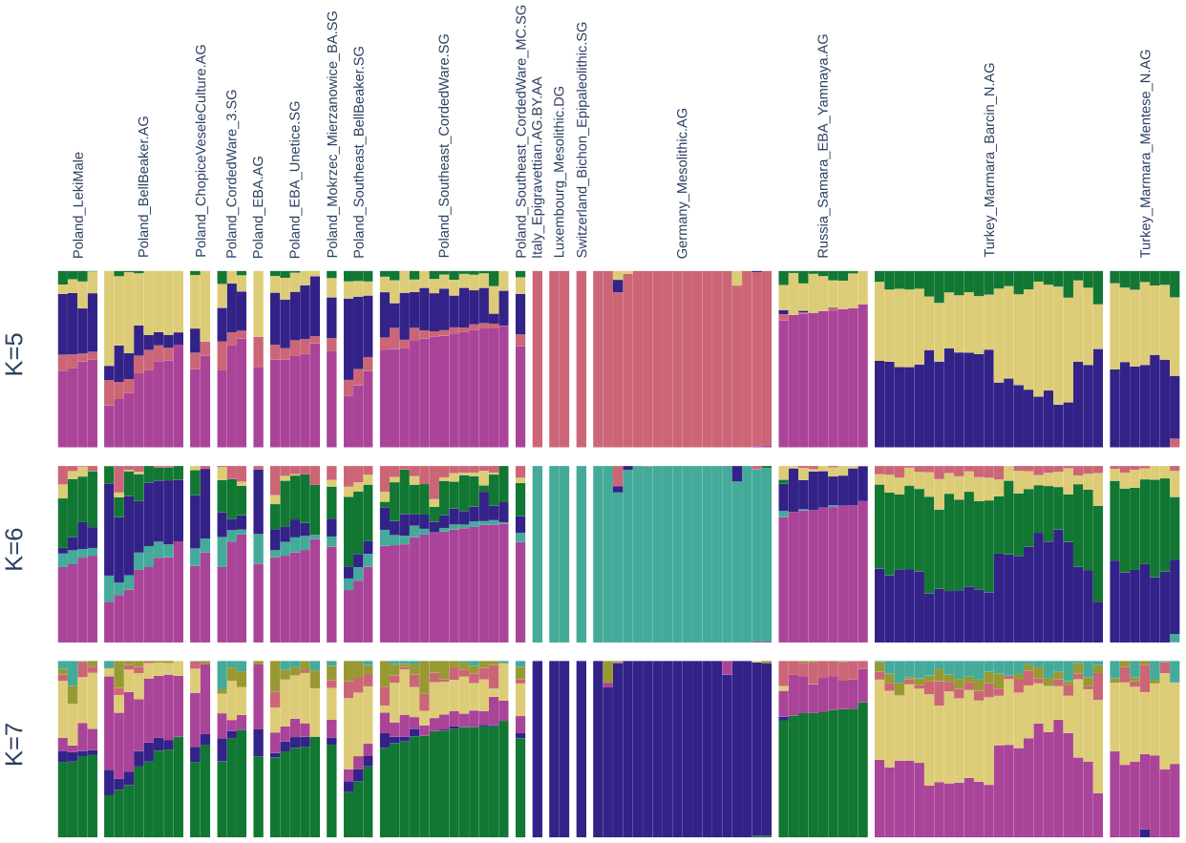
Fig. S1. Results of unsupervised ADMIXTURE analyses. Panels show individual ancestry proportions for the three models (K = 3, 4, 5) that yielded the lowest cross-validation errors among tested values (K = 2–13). Colours correspond to inferred ancestry components.

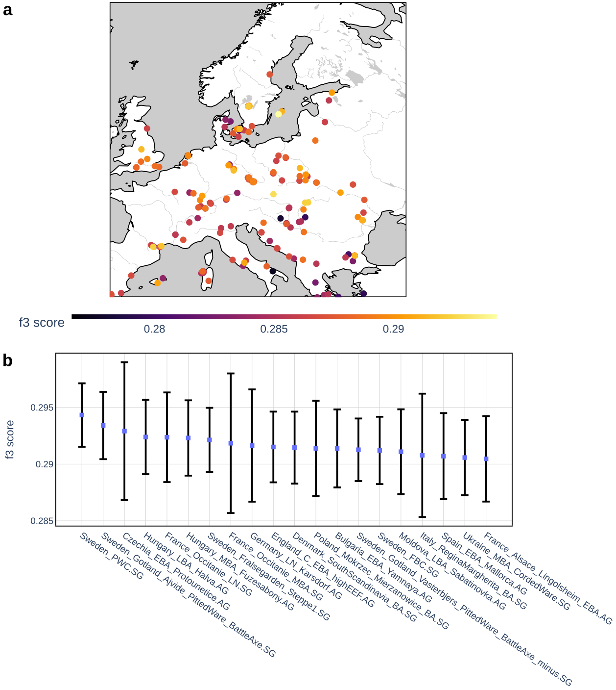
Fig. S2. Outgroup f₃-statistics of the form f₃(Mbuti; Łęki Małe, X) measuring shared genetic drift between the Łęki Małe individuals and contemporaneous populations from the surrounding regions. a. Geographic distribution of outgroup f₃ values, with markers colored according to the magnitude of genetic affinity to Łęki Małe. b. Top 20 populations with the highest affinity to Łęki Małe. Error bars represent one standard deviation.

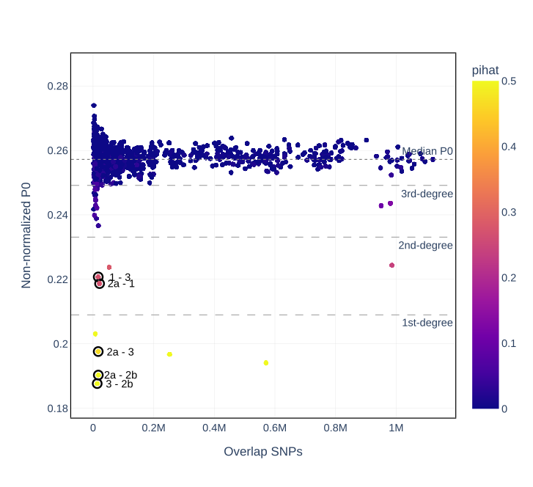
Fig. S3. Results from kinship analyses with READv2 and KIN. Each point represents a pair of individuals from Bronze Age sites in Poland for which both methods inferred the same degree of relatedness. Markers outlined in black denote related pairs identified within the Łęki Małe assemblage. The y-axis shows the READ kinship coefficient, the x-axis indicates the number of overlapping SNPs available for each pair, and the color scale corresponds to the pihat estimates from KIN.
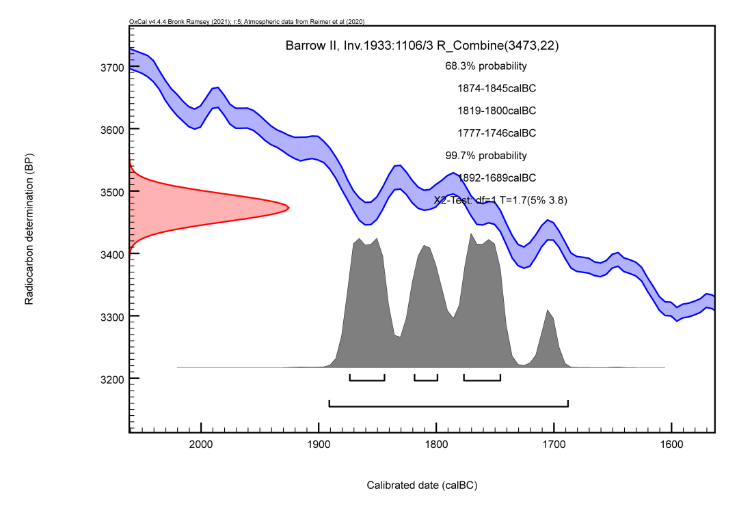
Fig. S4. Bayesian model of AMS radiocarbon dates for the single individual analysed from Barrow II.

